Step 1: Open a web browser and navigate to: https://www.techspot.com/downloads/189-vmware-workstation-for-windows.html
Step 2 : On the TechSpot page, locate the Download Now button and click it.
Step 3: From the list of download options, select Workstation Windows 25H2 (or the latest available version for Windows).
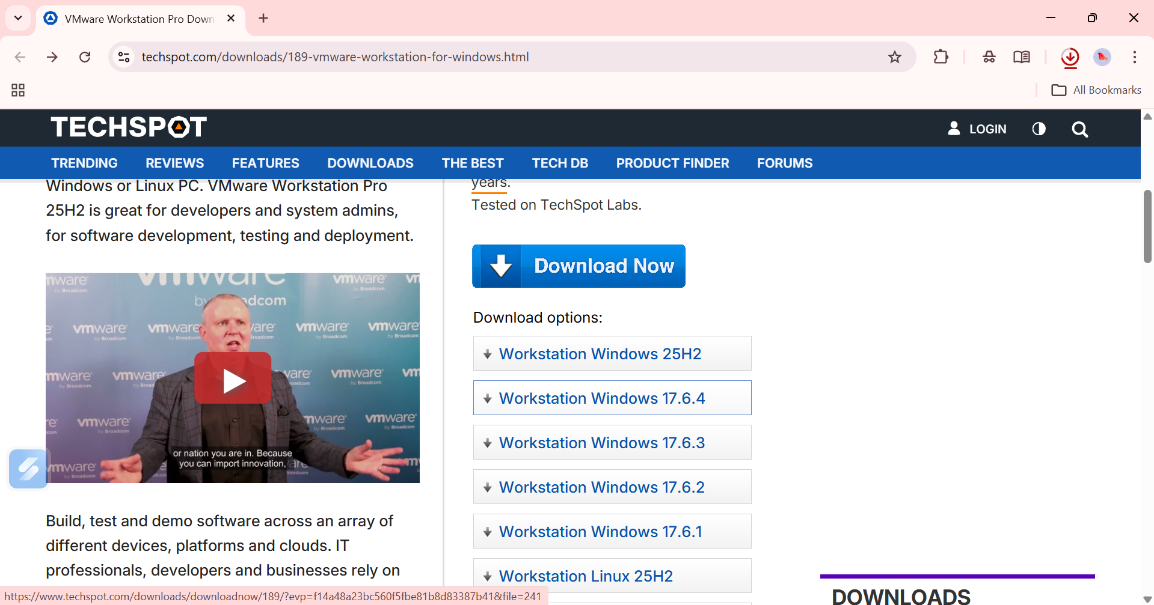

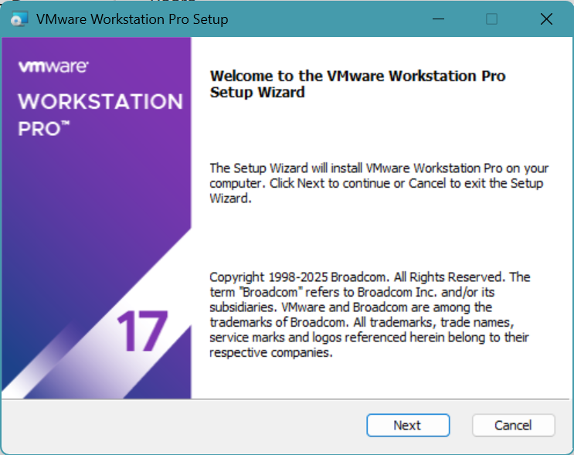
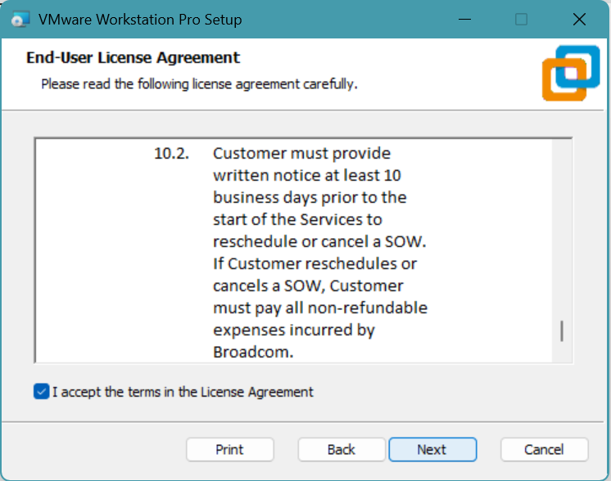
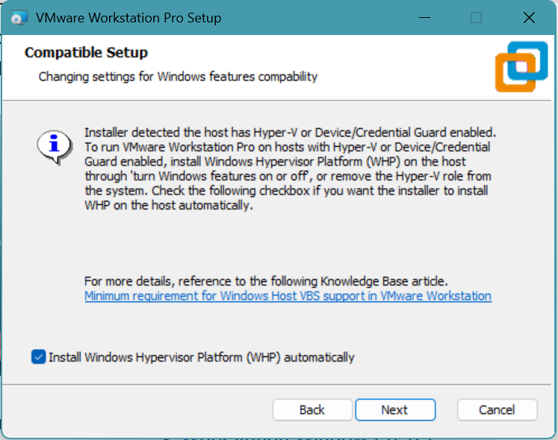

Step 4 : Save the installer file (e.g., VMware-workstation-full-17.x.x.exe) to a known location on your computer.
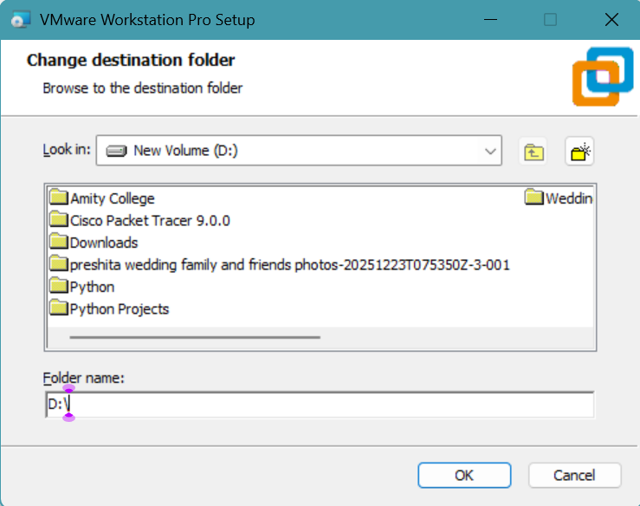
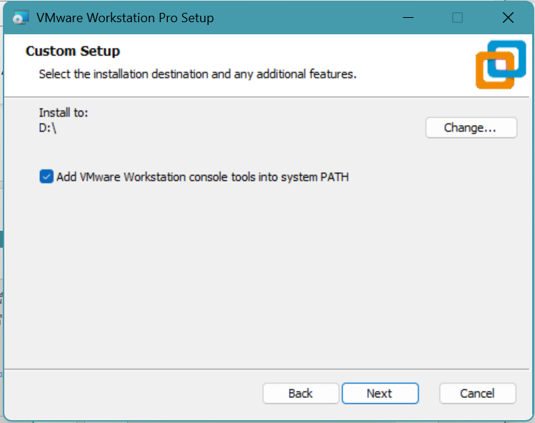
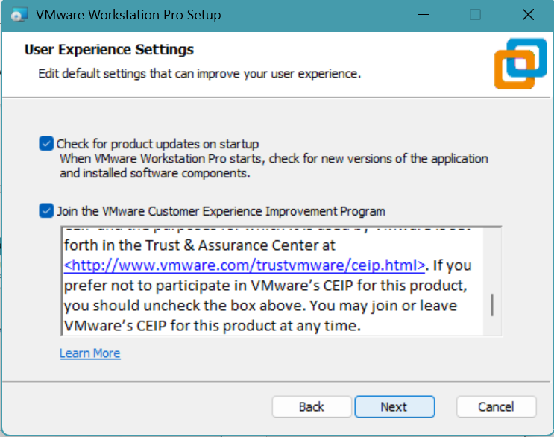
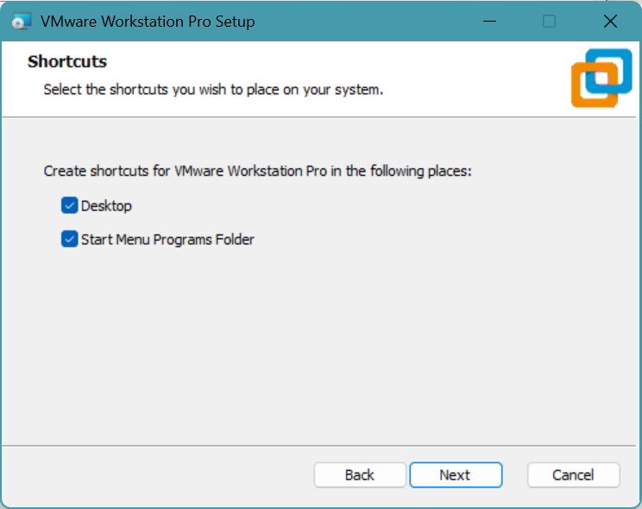
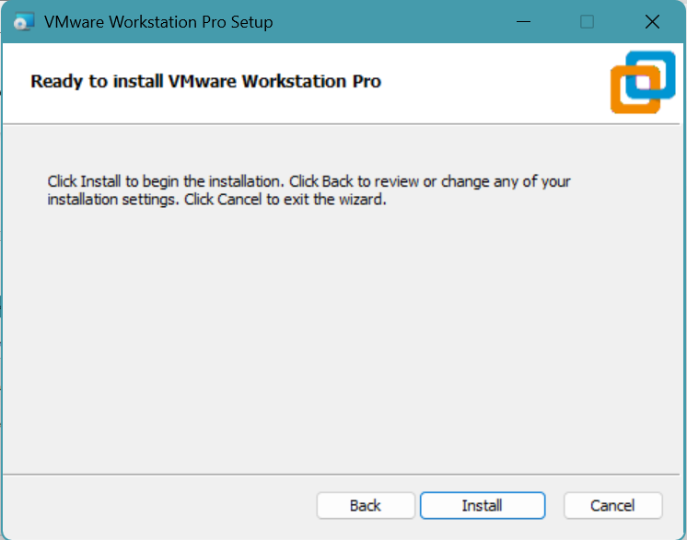
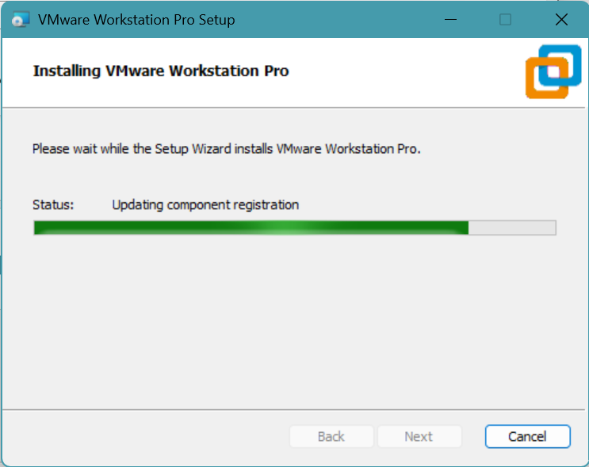
Step 5 : Once installation finishes, the Completed the VMware Workstation Pro Setup Wizard screen appears. Click Finish to exit the wizard.

