Step 1: Launch VMware Workstation Pro 17 from the Desktop or Start Menu.
Step 2: The VMware Workstation home screen will appear showing three options: Create a New Virtual Machine, Open a Virtual Machine, and Connect to a Remote Server.
Step 3: Click Create a New Virtual Machine. The New Virtual Machine Wizard will open.
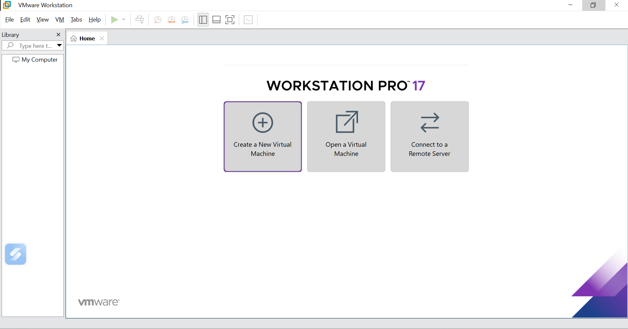
Step 4: Select Typical (recommended) and click Next.
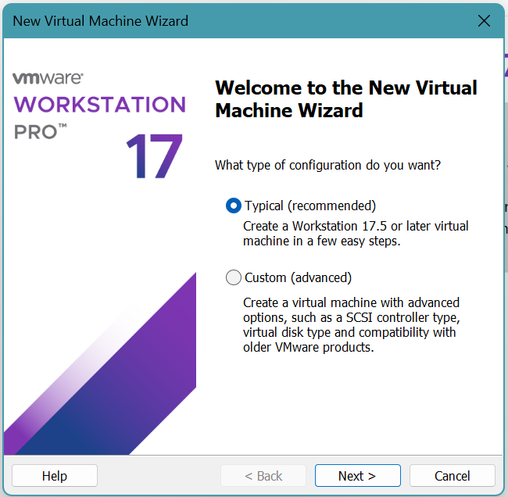
Step 5 : On the Guest Operating System Installation screen, select Installer disc image file (iso)
Step 6: Click Browse and navigate to the location of your Ubuntu ISO file (e.g., D:\ubuntu-24.04.4-live-server-amd64.iso).
Step 7 : VMware will automatically detect the OS: Ubuntu 64-bit Server 24.04.4 detected. Click Next.
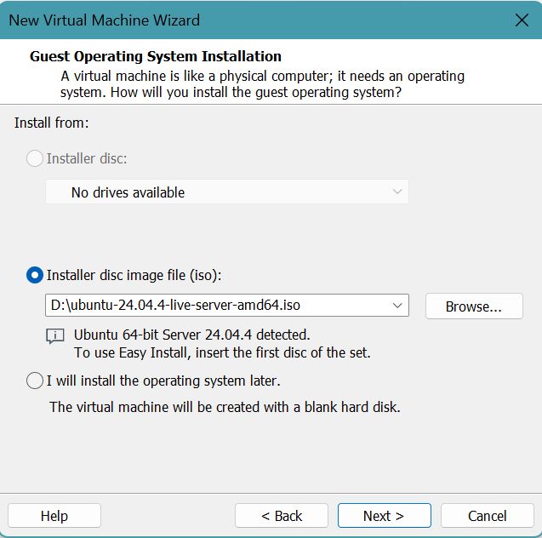
Step 8: n the Virtual machine name field, enter a name for your VM (e.g., Ubuntu_VM).
Step 9 : The Location field shows where the VM files will be stored (e.g., C:\Users\YourName\Documents\Virtual Machines\Ubuntu_VM). You may change this by clicking Browse. Click Next.
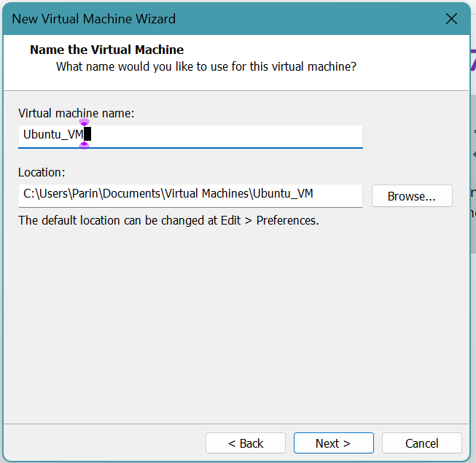
Step 10: On the Specify Disk Capacity screen, set the Maximum disk size (GB) to 20.0 GB (recommended for Ubuntu 64-bit).
Step 11: Select Store virtual disk as a single file for better performance. Click Next.

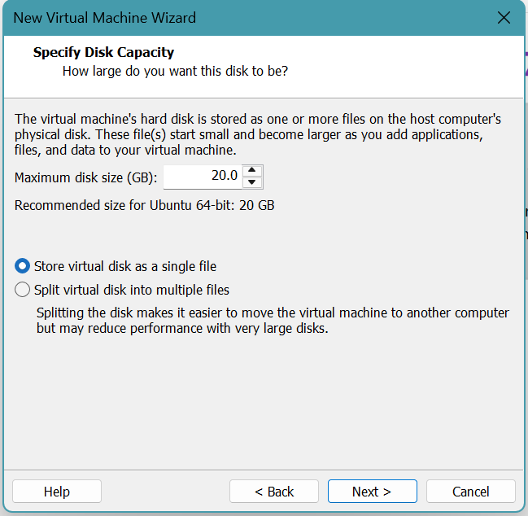
Step 12: The Ready to Create Virtual Machine screen displays a summary of your VM configuration: Name: Ubuntu_VM, Version: Workstation 17.5 or later, Operating System: Ubuntu 64-bit, Hard Disk: 20 GB, Memory: 4096 MB, Network Adapter: NAT, Other Devices: 2 CPU cores, CD/DVD, USB Controller, Sound Card.
Step 13: Ensure the checkbox Power on this virtual machine after creation is checked if you want to start the VM immediately.
Step 14: Click Finish. The virtual machine Ubuntu_VM will now appear in the VMware library panel.

