Step 1: In the VMware library panel on the left, select Ubuntu_VM.
Step 2: In the main panel, click Power on this virtual machine. Alternatively, you can click the green Play button in the toolbar.
Step 3: The VM screen will appear and show the VMware logo along with the boot message: Starting... Press F2 to enter SETUP, F12 for Network Boot, ESC for Boot Menu.
Step 4: The system will begin booting and loading Ubuntu from the ISO. You will see a stream of system messages in the console as services initialize

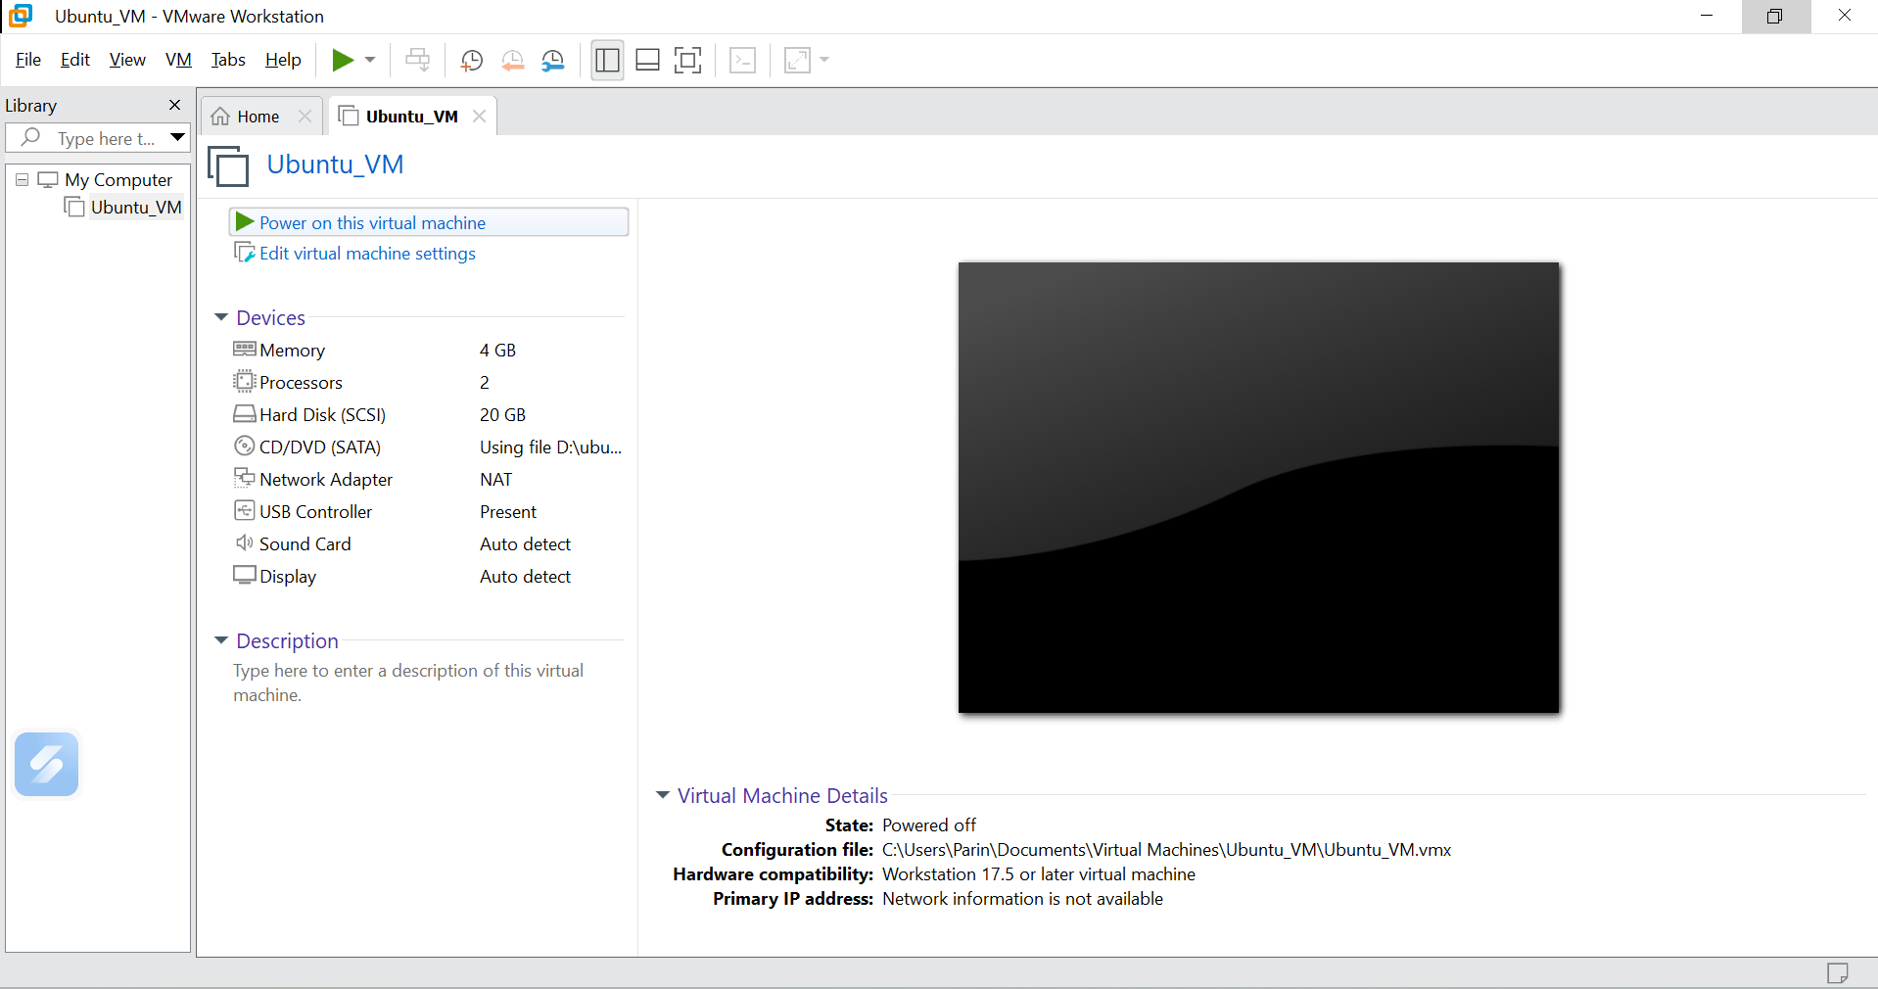
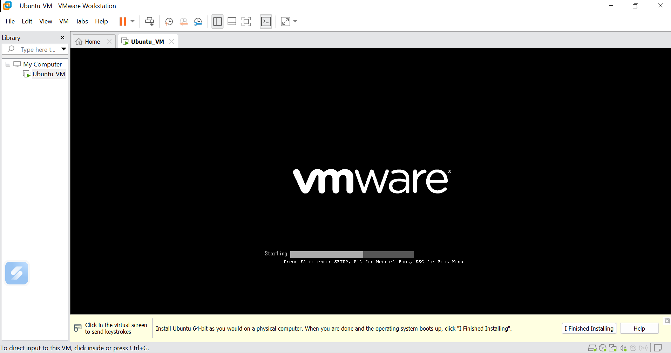
Step 5 : Click inside the VM window to direct keyboard and mouse input to the virtual machine.
Step 6: Follow the on-screen Ubuntu Server installation prompts. When asked to configure the system profile, enter the following: Your name (e.g., Admin), Your server's name (hostname), Your username (e.g., parin), A password, and Confirm the password.
Step 7: Press Done to continue through each section of the installer.
Step 8: Continue through the remaining Ubuntu installation steps (storage configuration, network setup, SSH options, etc.) accepting the defaults unless specific changes are required.
