Step 1: Open a web browser and go to: https://aws.amazon.com and sign in to your AWS account. Ensure you are signed in under the correct account
Step 2: Once logged in, click the grid icon (Services) in the top navigation bar, or use the Search bar and type EC2.
Step 3: On the All Services page, locate the Compute section and click EC2
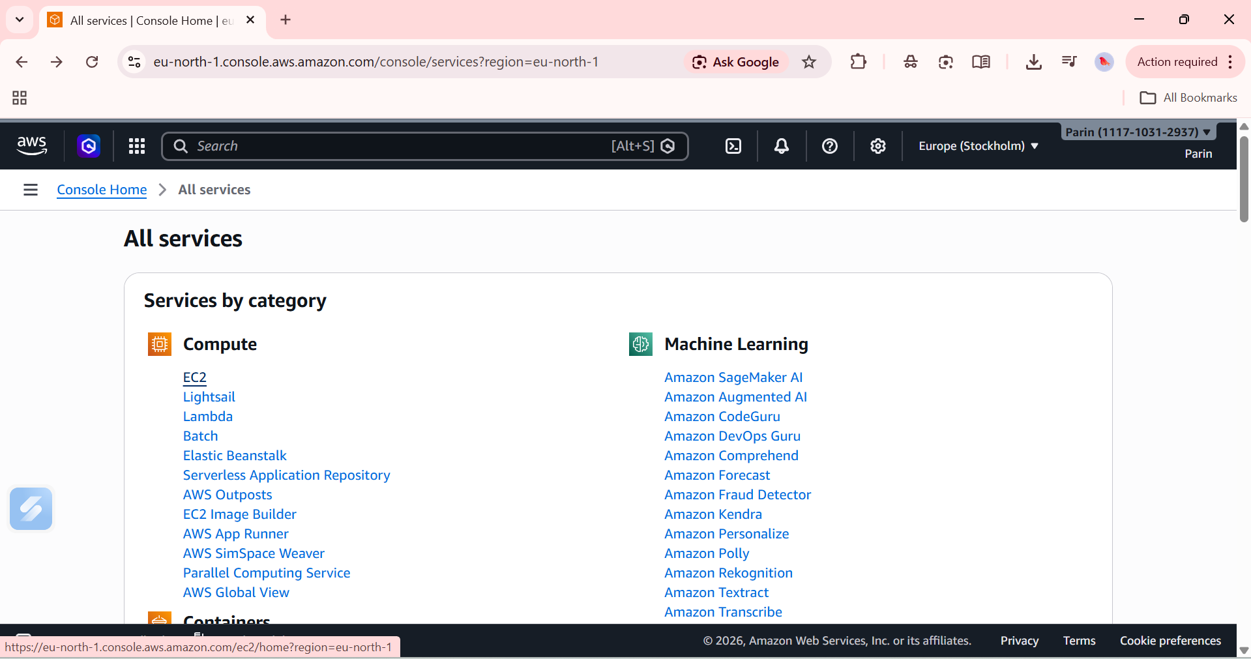
Step 4: You will be directed to the EC2 Dashboard. In the left sidebar, under Instances, click Instances
Step 5: On the Instances page, click the orange Launch instances button.
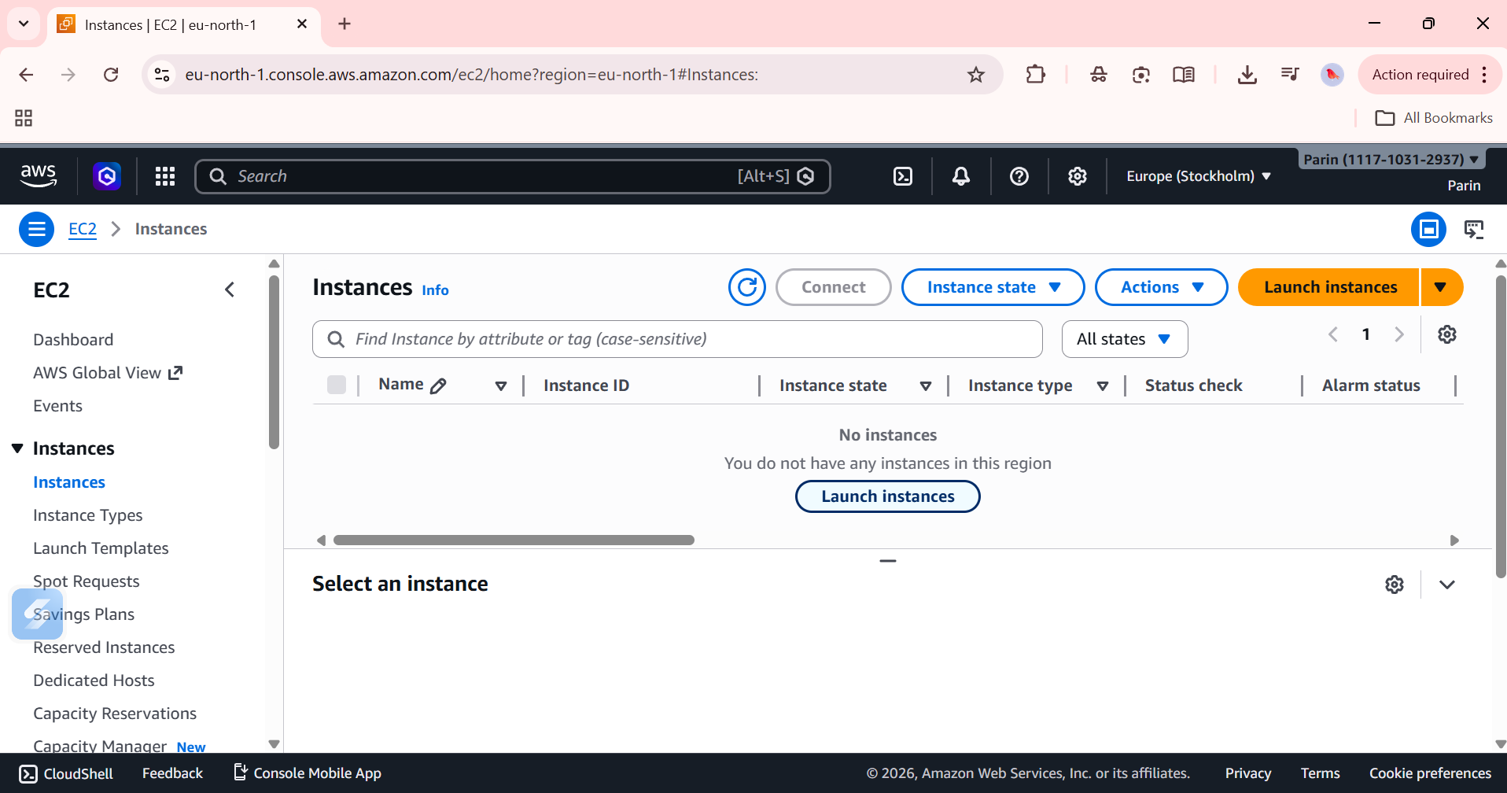

Step 7:Y ou will be taken to the Launch an instance page. Under the Quick Start tab, you will see several Amazon Machine Images (AMIs). The default selected is Amazon Linux 2023 AMI (kernel-6.1) – Free tier eligible.
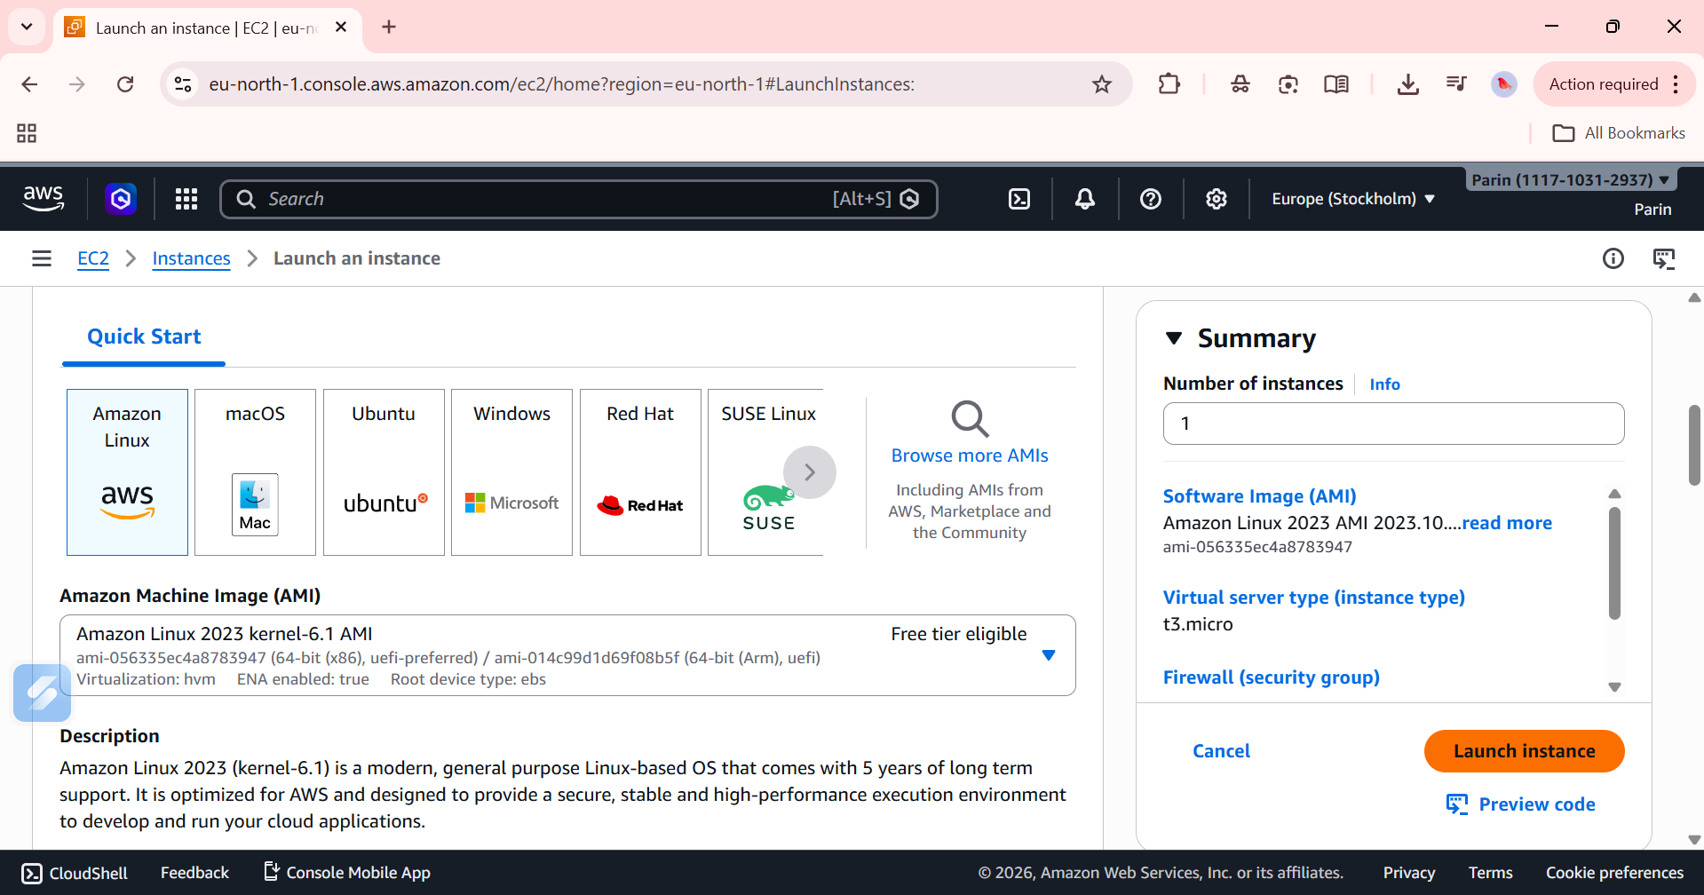
Step 8: Scroll down to the Key pair (login) section. Click Create a new key pair.
Step 9: Click the orange Launch instance button
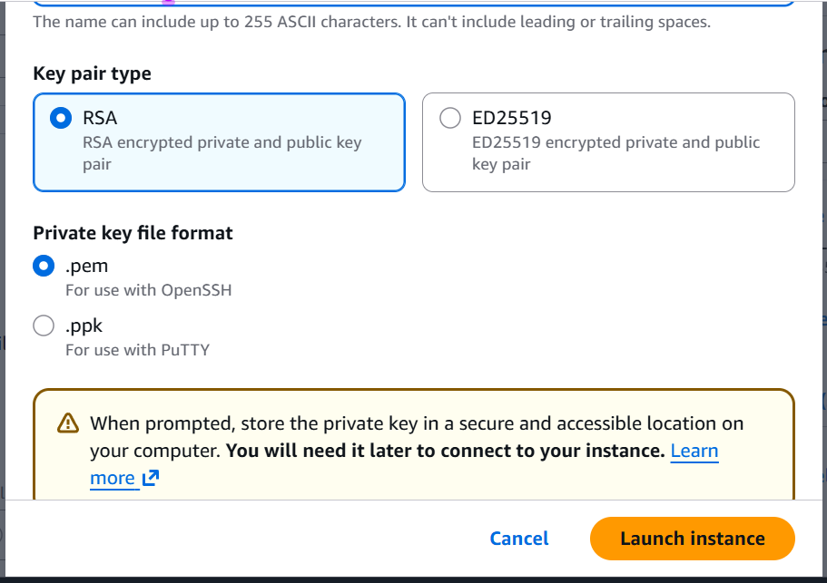
Step 10: A green Success banner will appear: 'Successfully initiated launch of instance’.
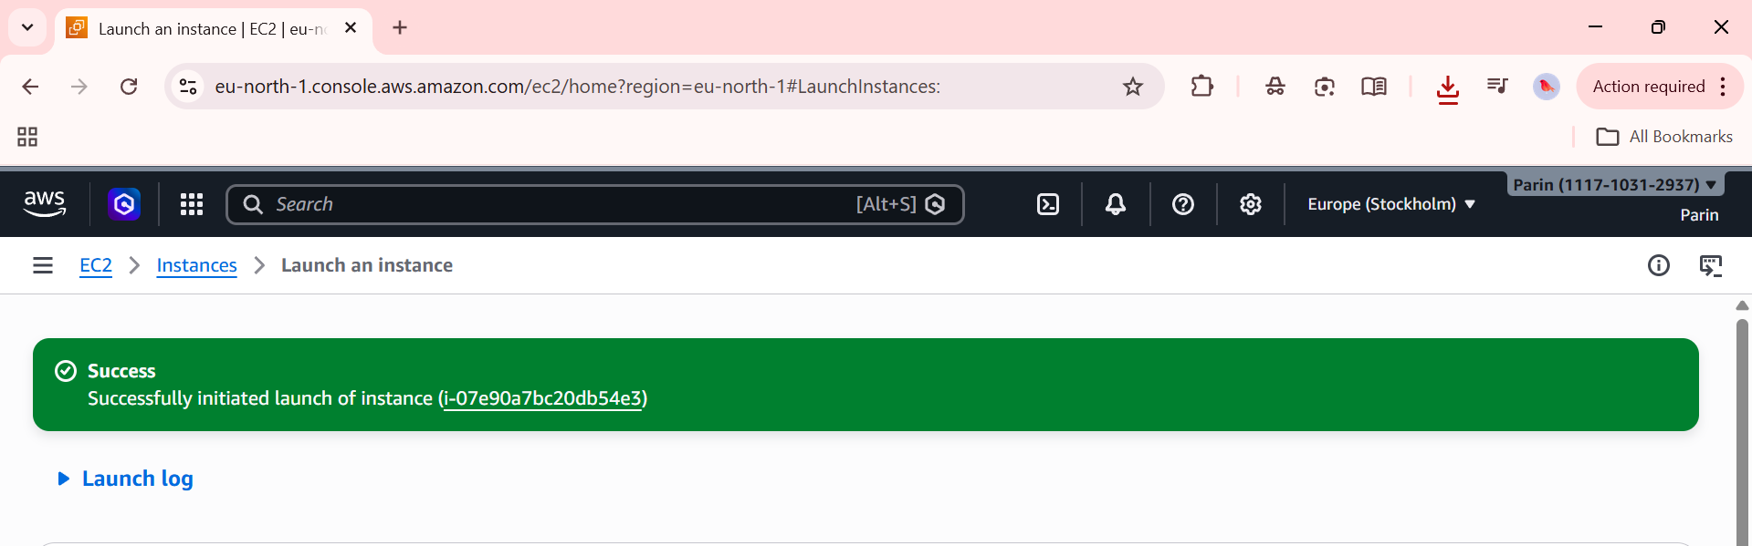
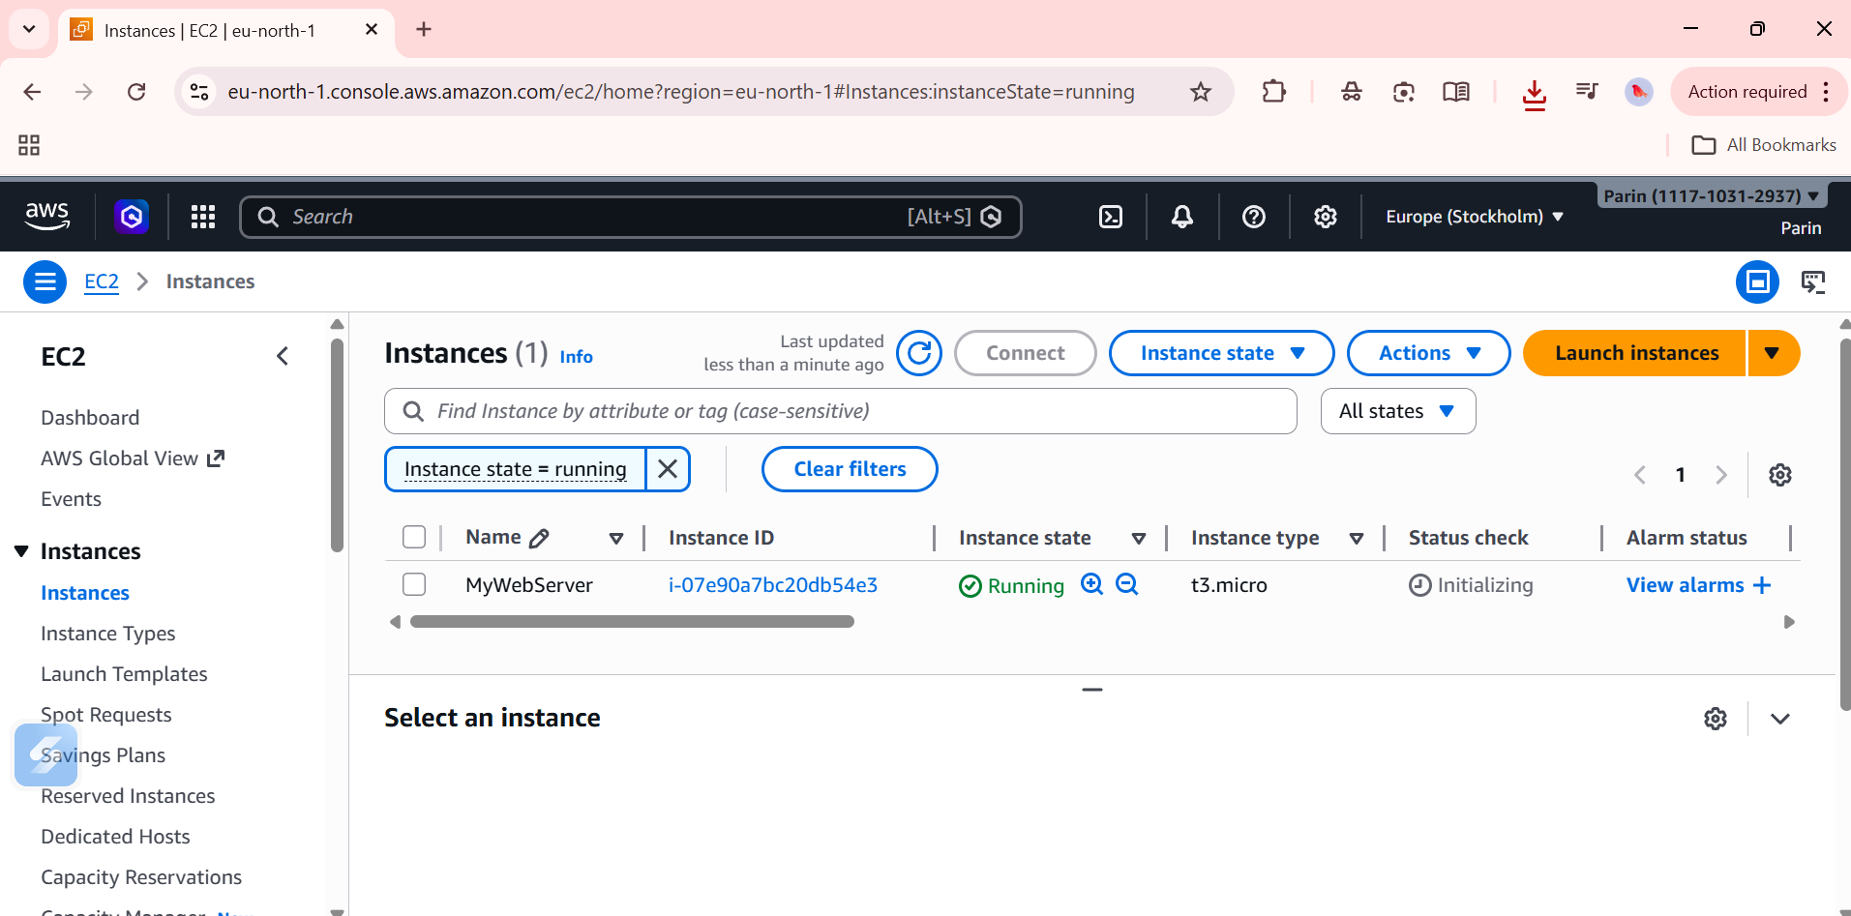
Step 11: In the Instances list, check the checkbox next to MyWebServer to select it.
Step 12: Click the Instance state dropdown button in the top toolbar.
Step 13: A dropdown menu will appear with options: Stop instance, Start instance, Reboot instance, Hibernate instance, Terminate (delete) instance. Click Terminate (delete) instance
Step 14: A confirmation dialog will appear. Confirm the termination. The instance state will change to Shutting down and then to Terminated.
