Step 1: Go to AWS Website
- Open your browser.
- Visit : https://aws.amazon.com
- Click on Create an AWS Account (top-right corner).
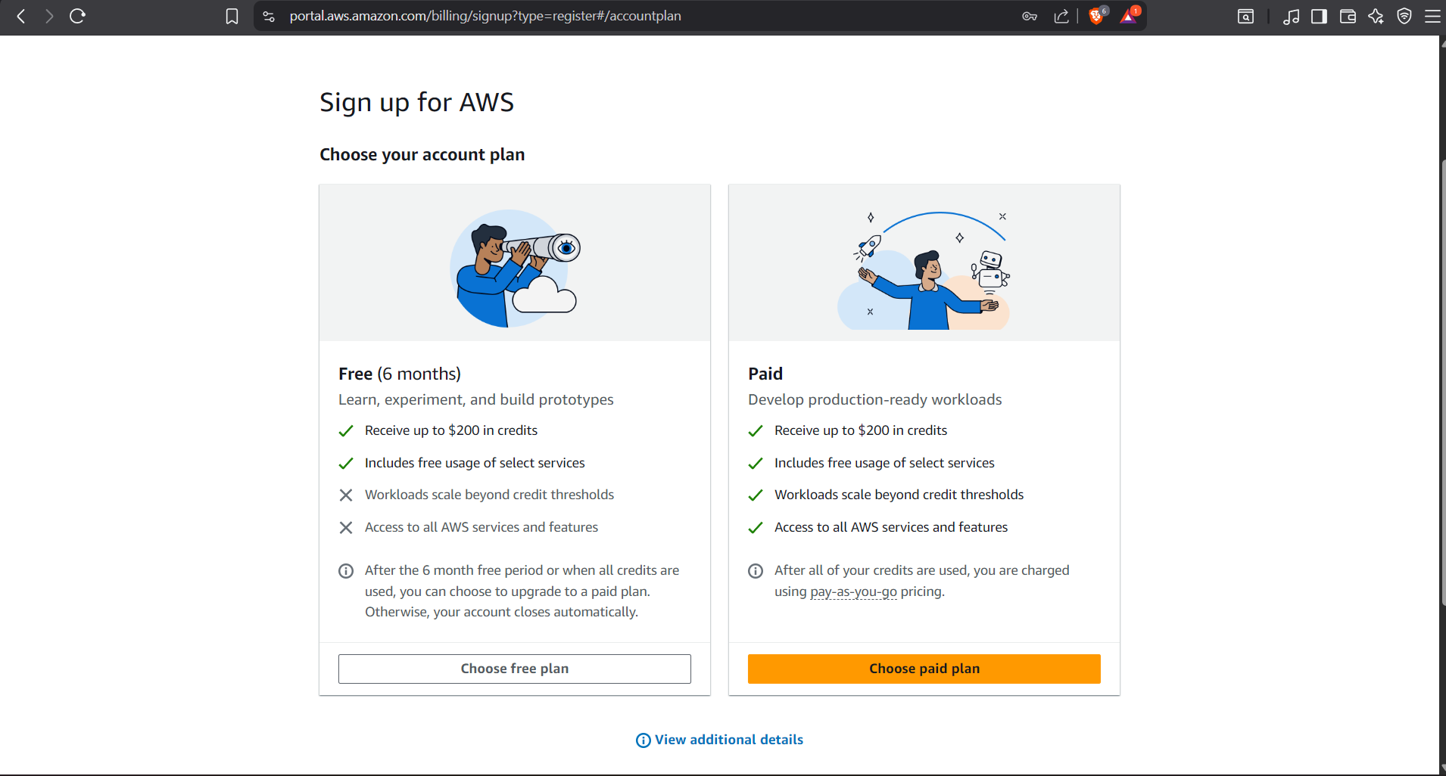 Step 2: Enter Account Details
- Enter your email address.
- Enter an AWS account name (example: Narayan-AWS-Account).
- Click Verify email address.
- Enter the OTP sent to your email.
Step 4: Contact Information
- Select Personal account type (for students/learning).
- Enter:
  - Full Name
  - Phone Number
  - Address
  - City, State, Country
- Accept AWS agreement.
- Click Continue.

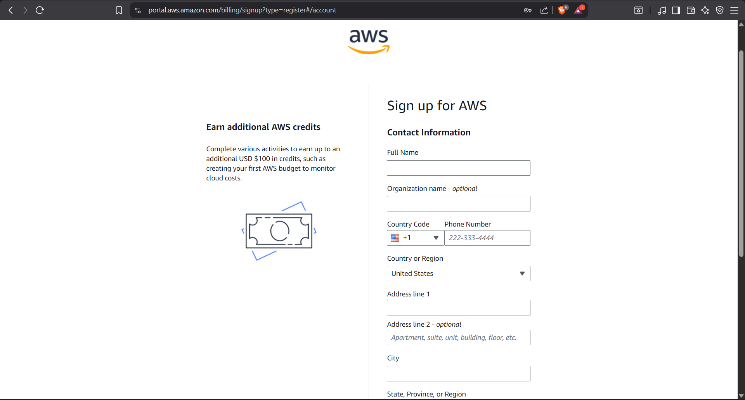Step 5: Add Payment Information
- Enter your Debit/Credit card details.
- AWS may charge a small temporary amount (₹2–₹5 approx) for verification.
- Click Verify and Continue.
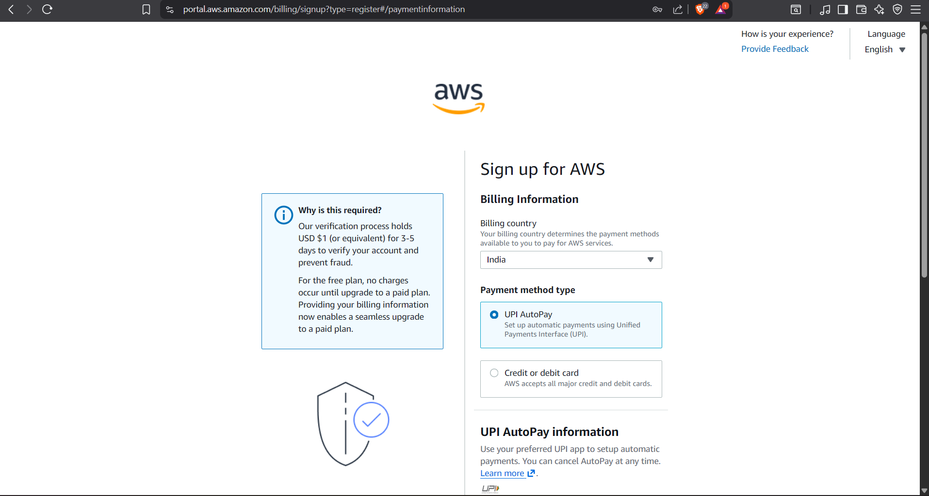

Step 6: Identity Verification
- Enter your phone number.
- Choose SMS or Voice call.
- Enter the OTP received.
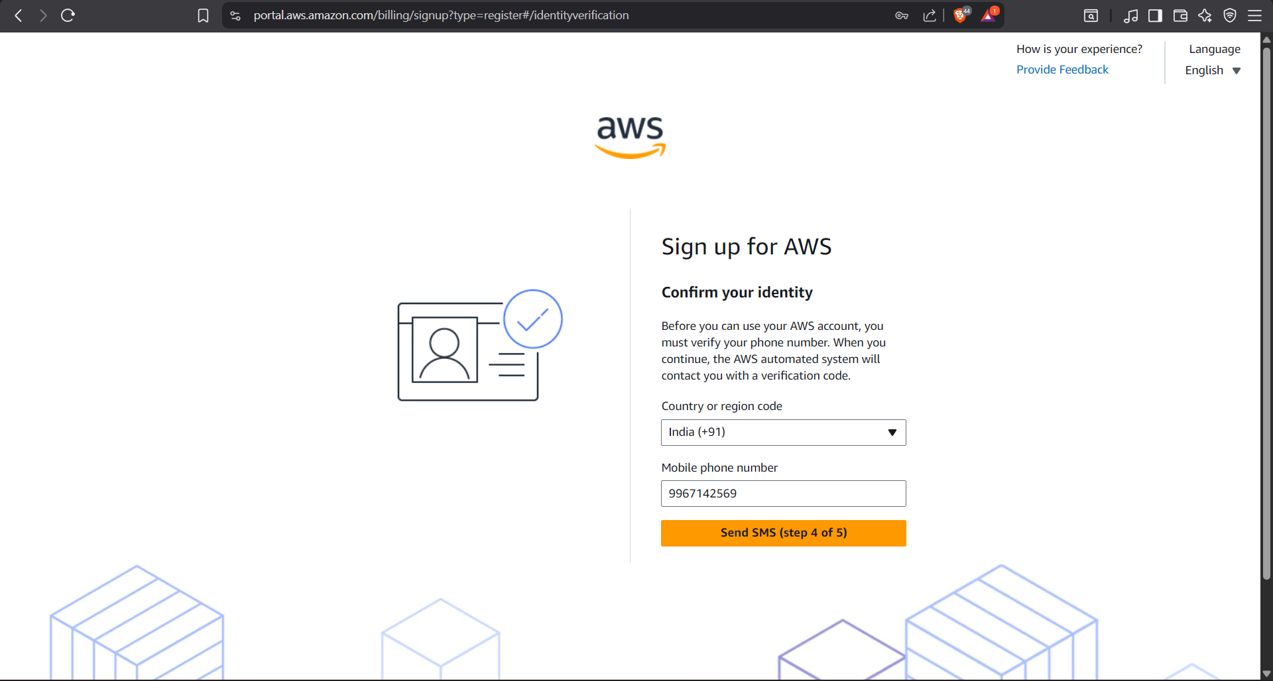Step 8: Login to AWS Console
- Go to : https://aws.amazon.com/console
- Click Sign in to the Console.
- Choose Root user.
- Enter email and password.
