🔹 Steps to Create an Instance on Amazon Web Services Amazon EC2
1️⃣ Login to AWS
- Go to https://aws.amazon.com
- Click Sign In to Console
- Enter your credentials
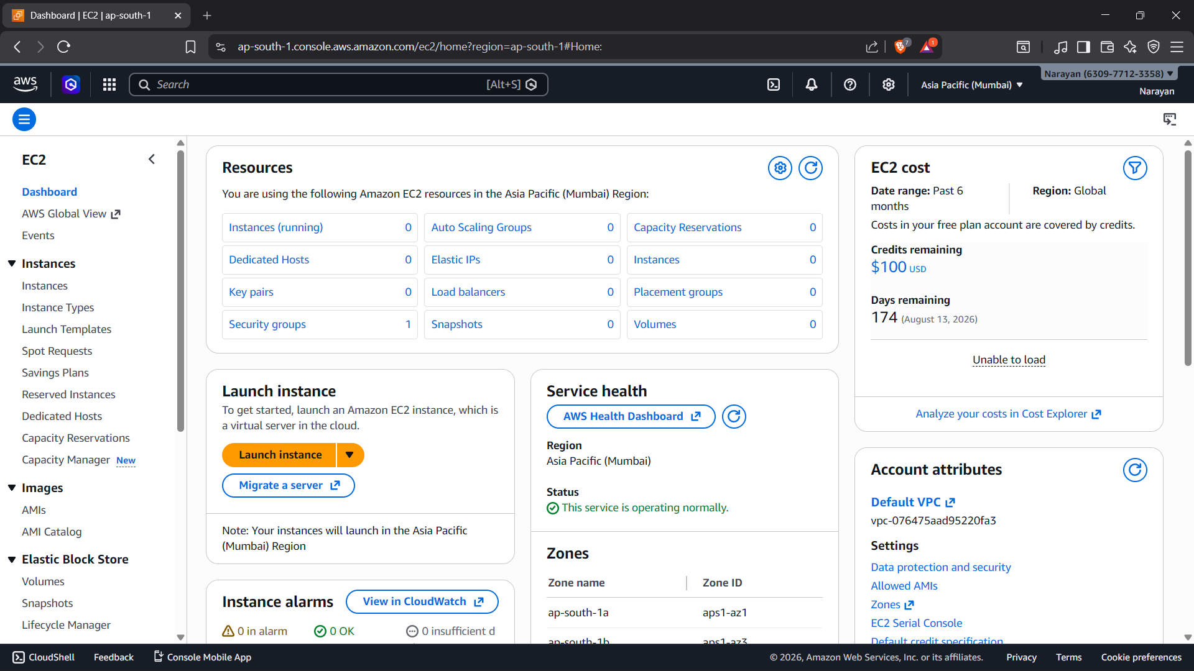2️⃣ Open EC2 Dashboard
- In the search bar, type EC2
- Click on EC2 under Services
- Click Launch Instance
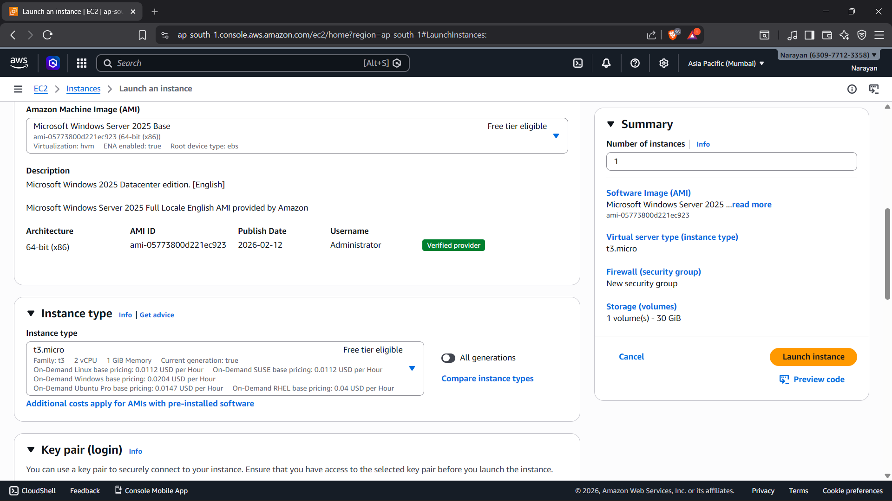4️⃣ Choose Instance Type
- Select instance type
Example:
  - t2.micro (Free Tier eligible)
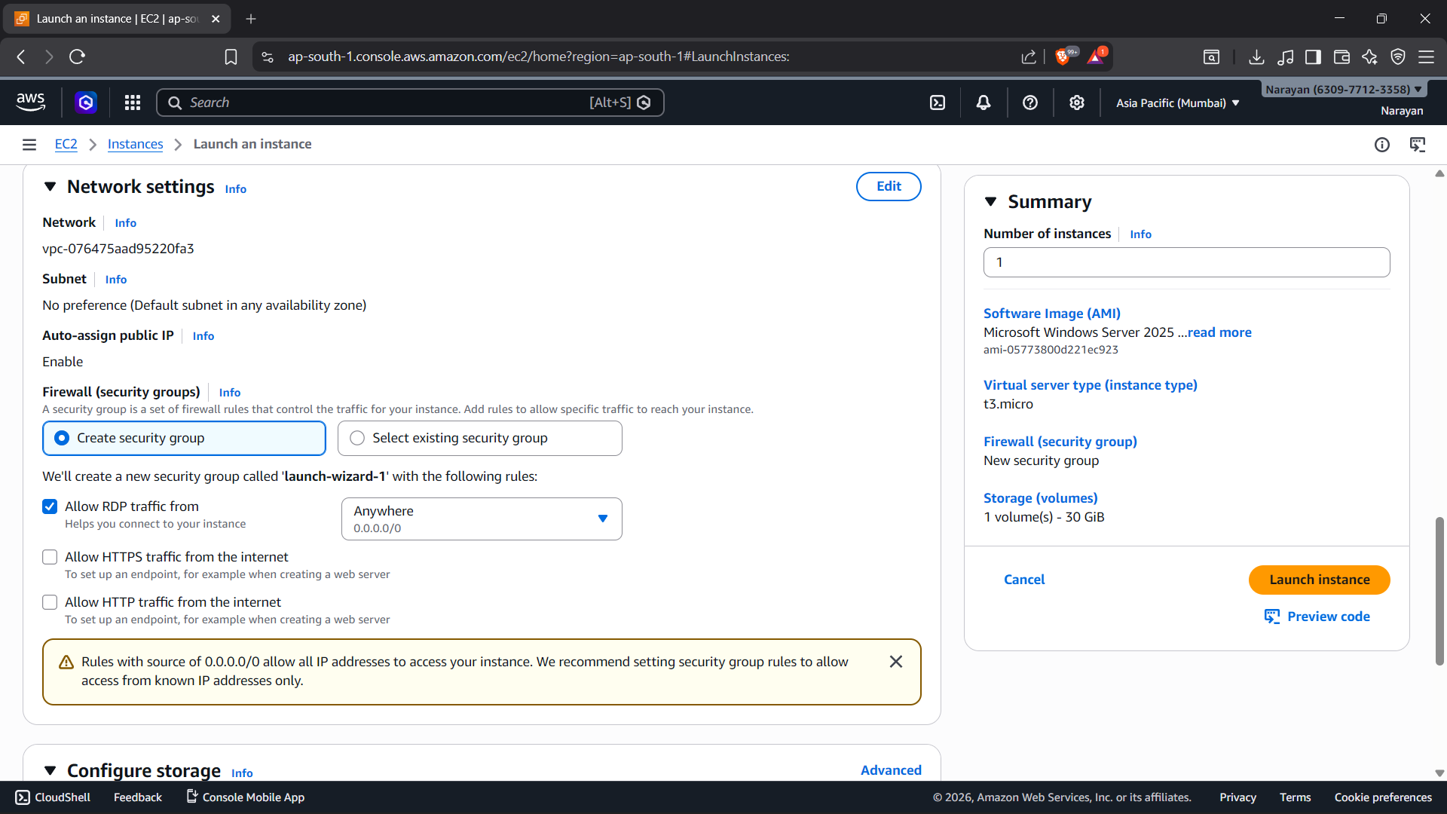5️⃣ Create / Select Key Pair
- Click Create new key pair
- Give name
- Choose:
  - RSA
  - .pem (for Linux/Mac)
  - .ppk (for Windows)
- Download and save it safely
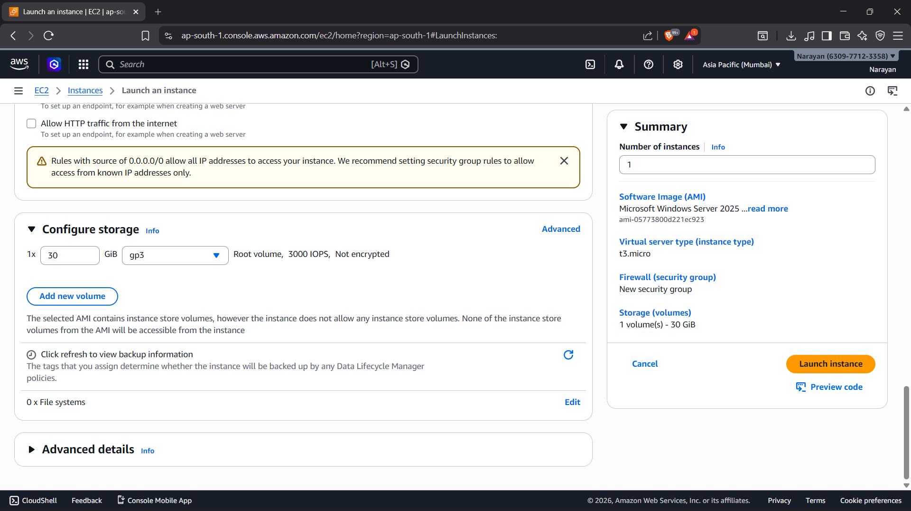6️⃣ Configure Network Settings
- Allow required ports:
  - SSH (Port 22)
  - HTTP (Port 80)
  - HTTPS (Port 443)
- Select or keep default VPC
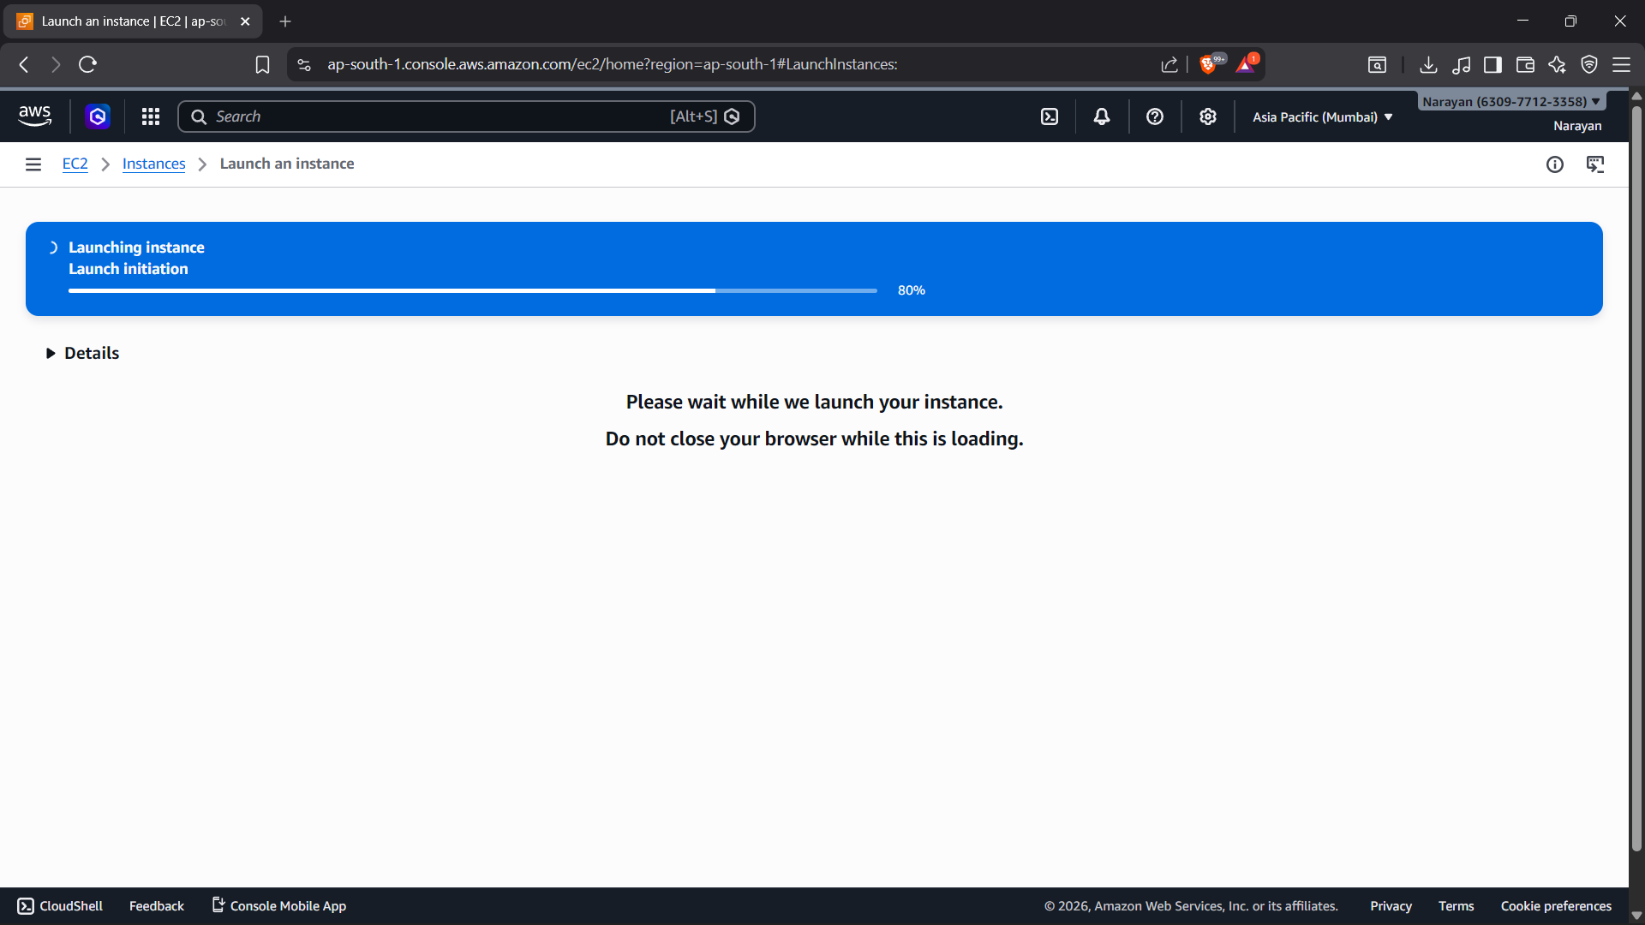8️⃣ Review & Launch
- Click Launch Instance
- Wait for instance state → Running
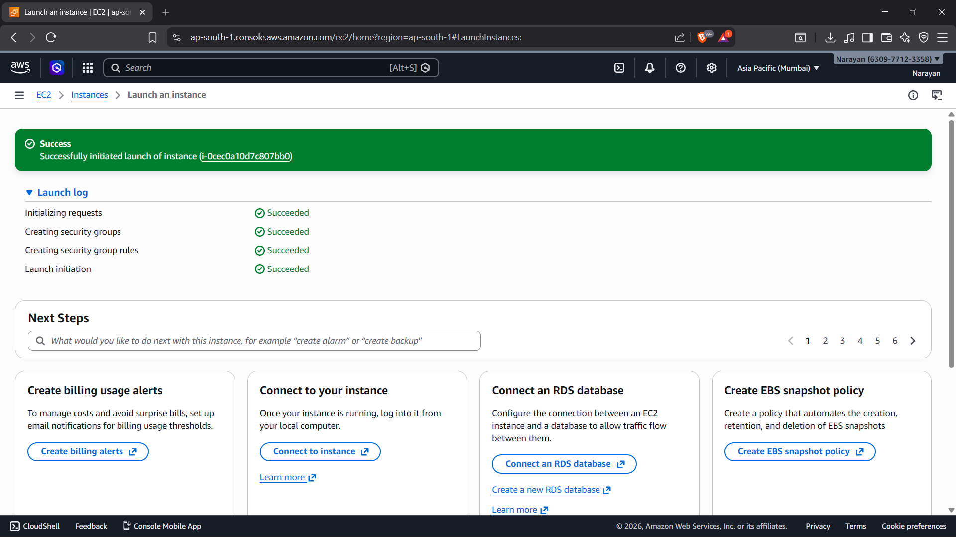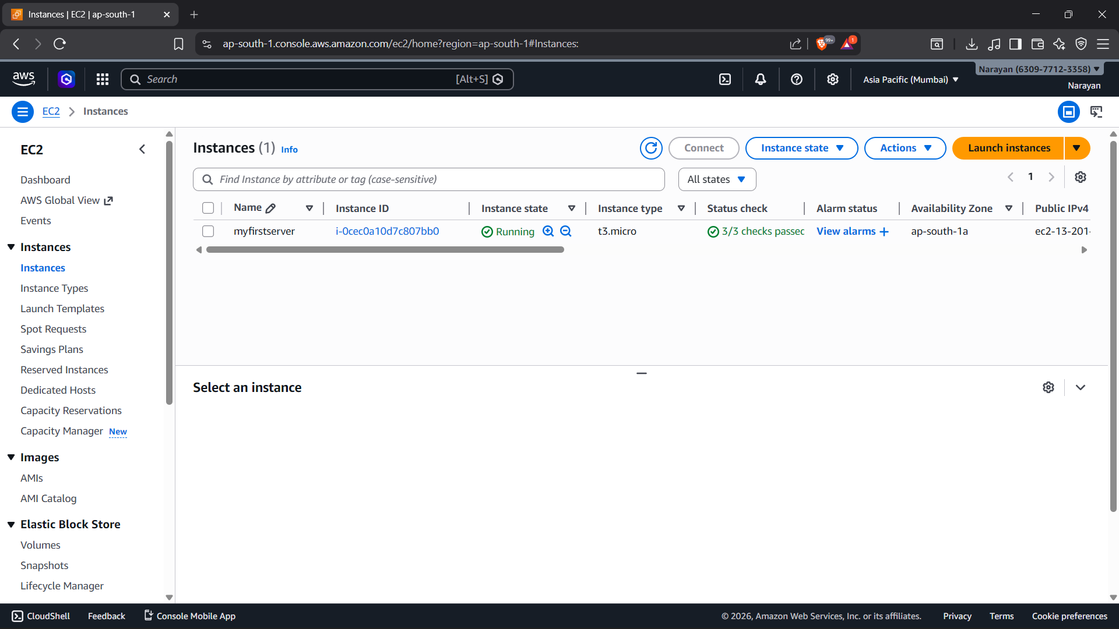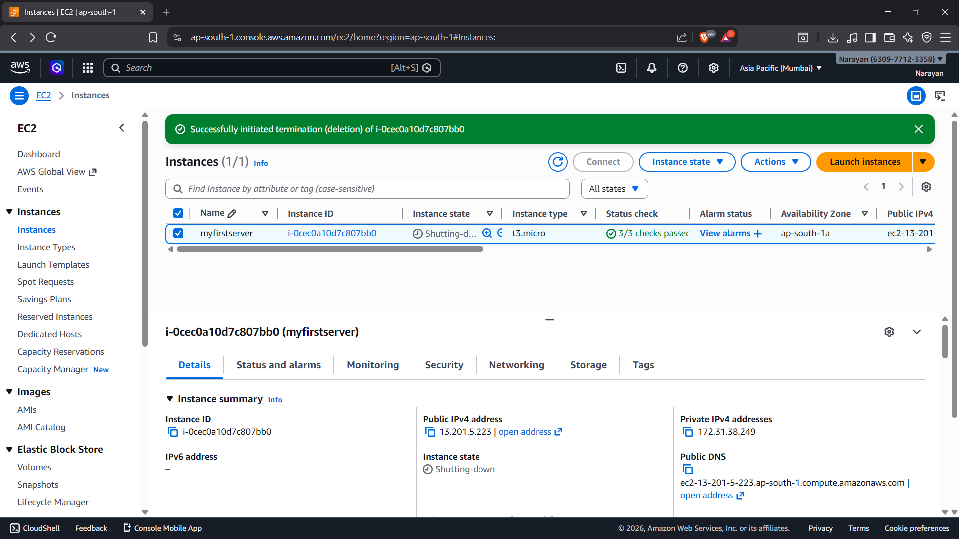3️⃣ Choose Name & AMI
- Enter Instance Name
- Choose an Amazon Machine Image (AMI)
Example:
  - Amazon Linux
  - Ubuntu
  - Windows Server
