VMwere Player Installation

Click The Given link and choose the respective OS to install the VMware player. I am installing for windows then I will click windows
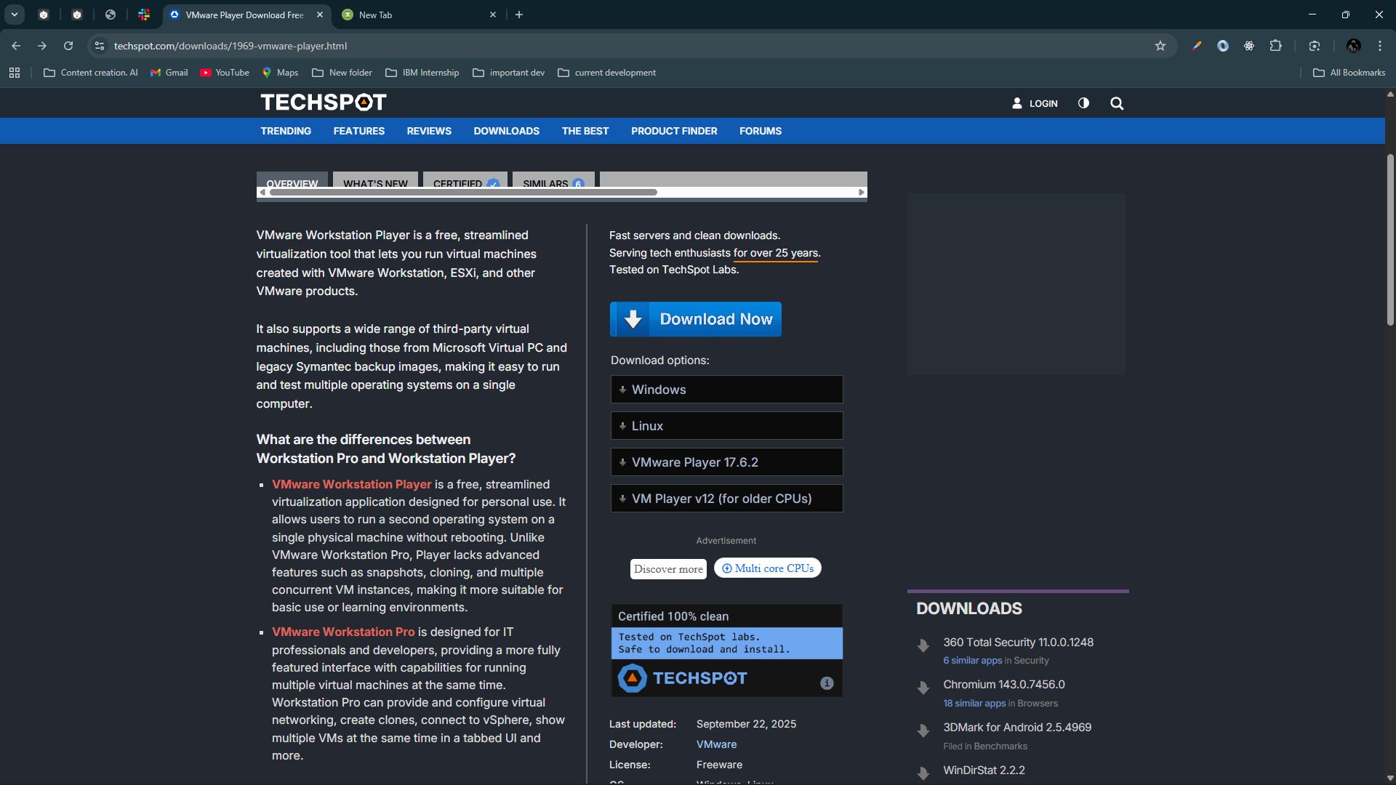
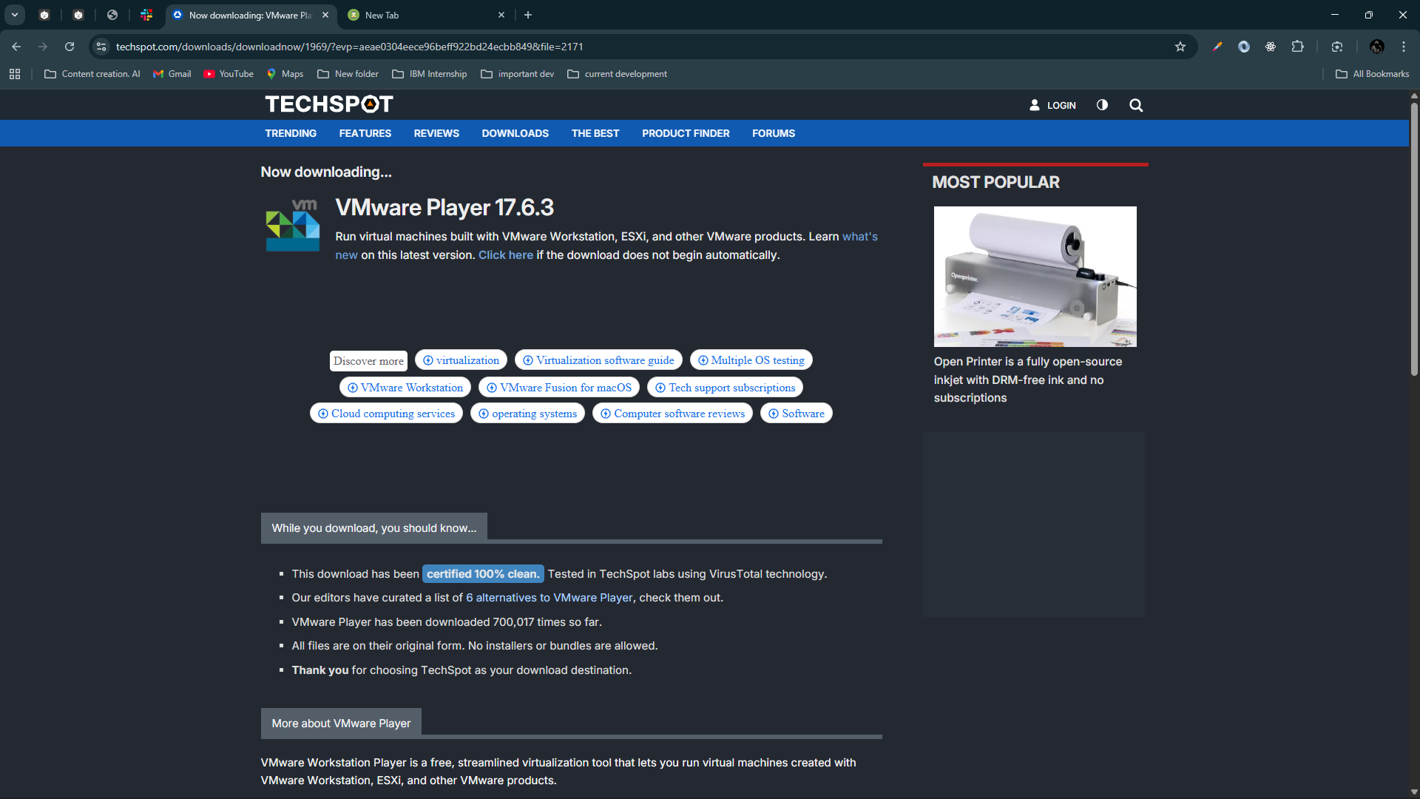
Download Link
And double click and install it.

Install Parrot OS

Go To Chrome and search Parrot OS and click first link
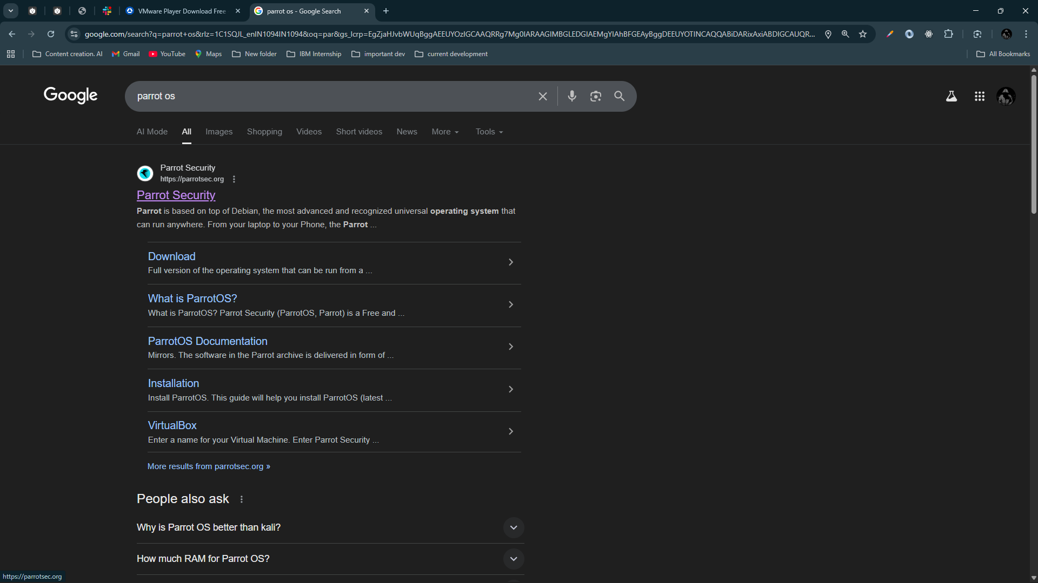
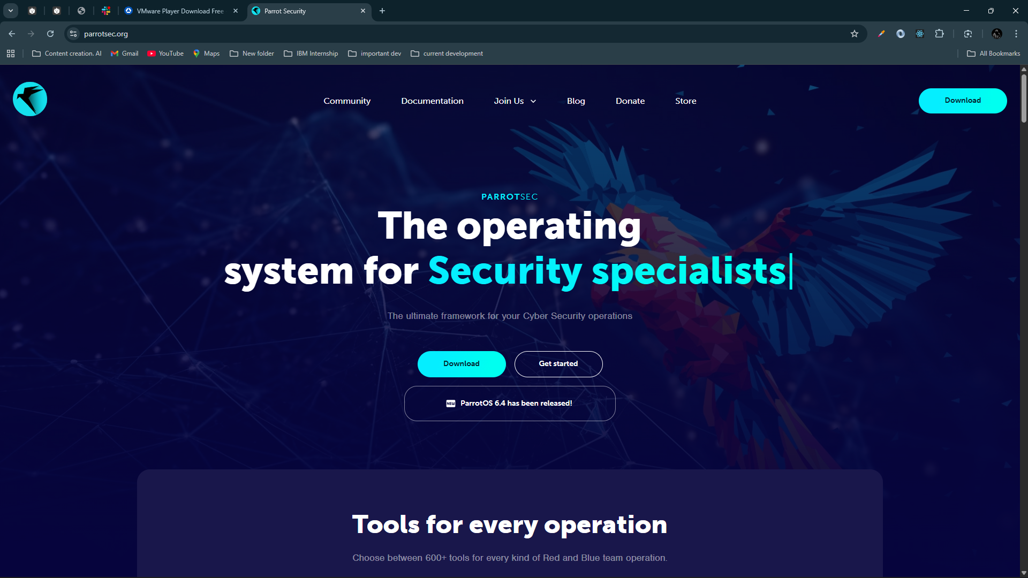
Then Click Download

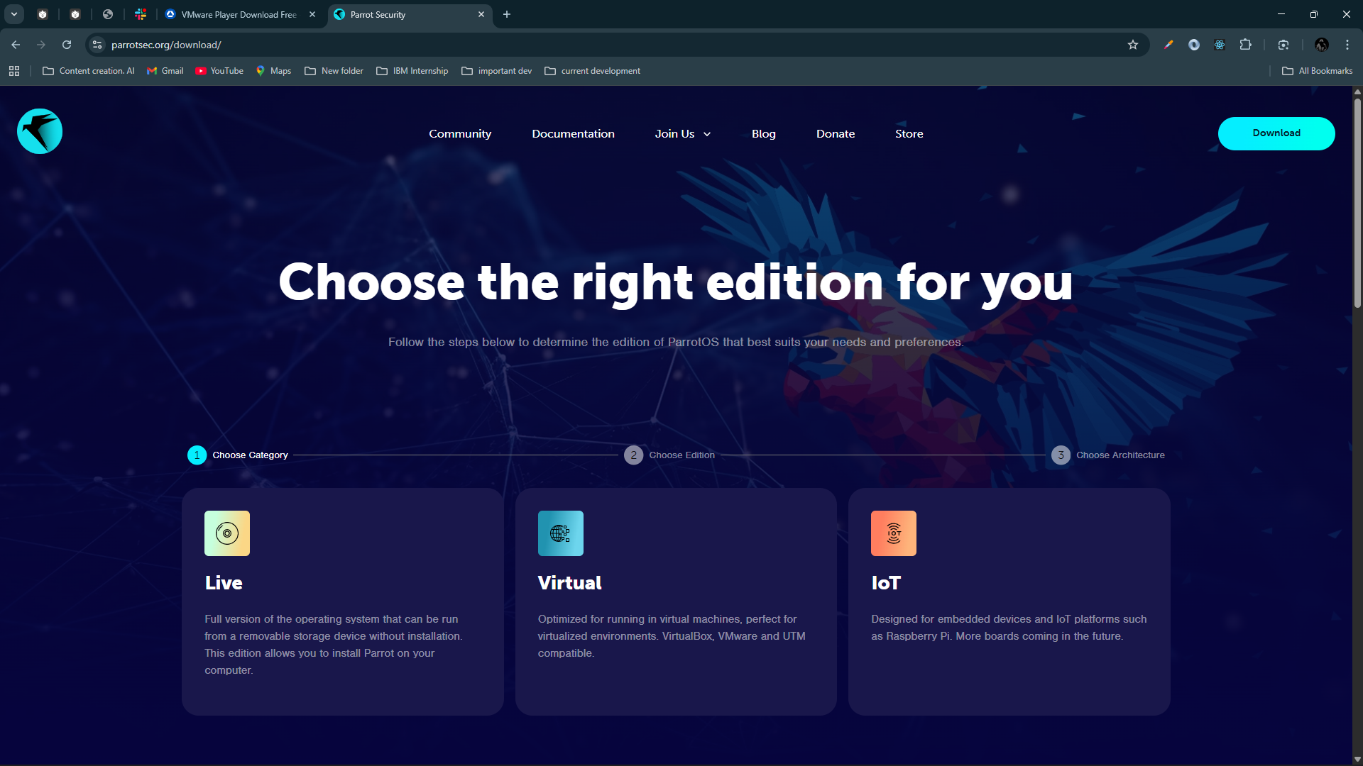
Click Live
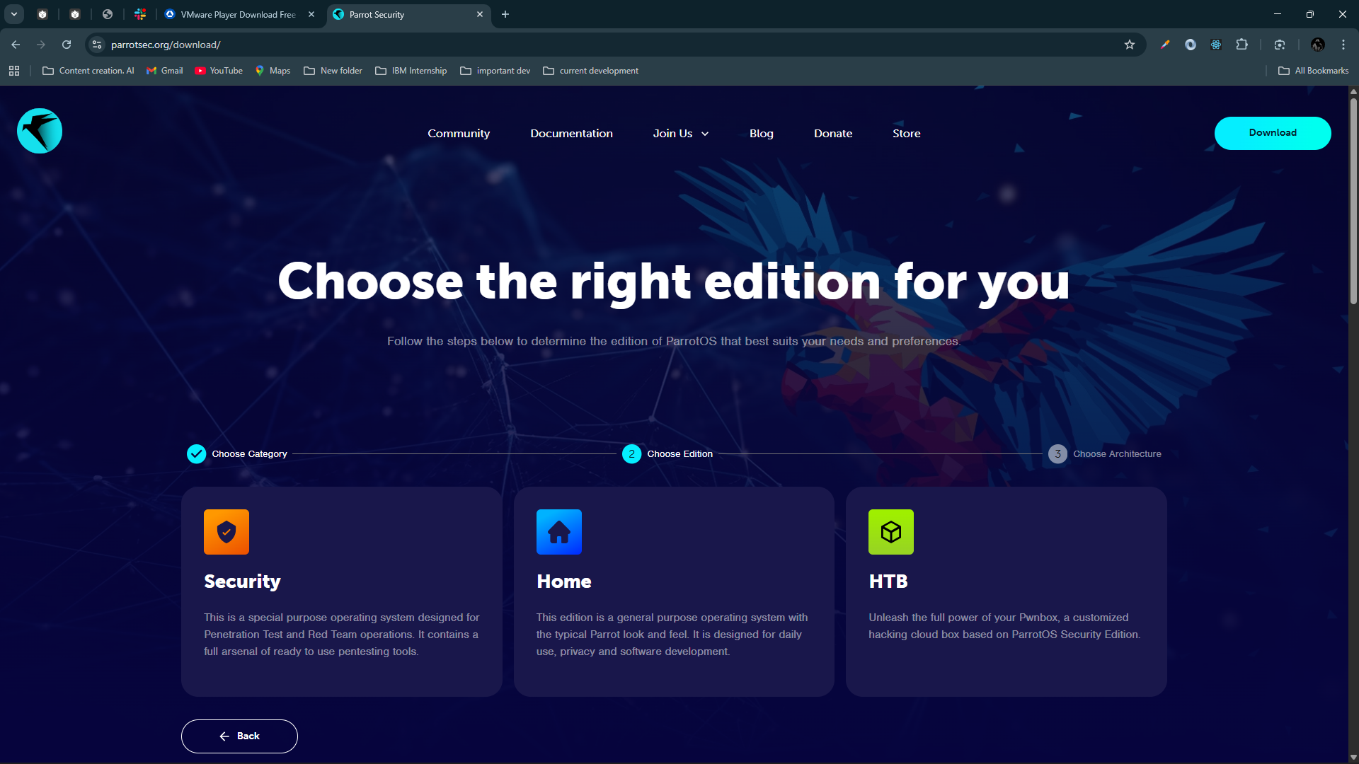
Click on Security Edition

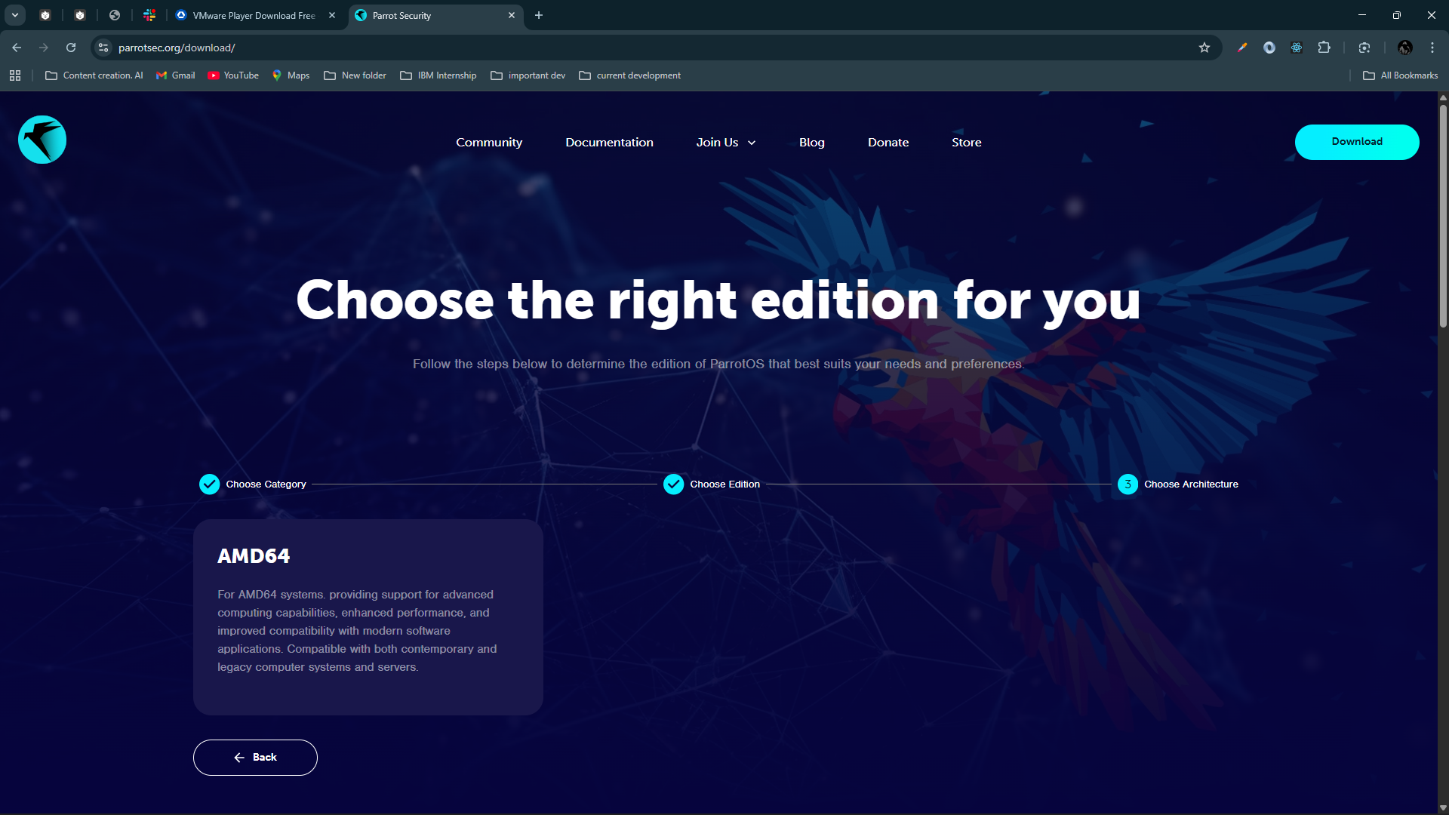
Click On AMD64
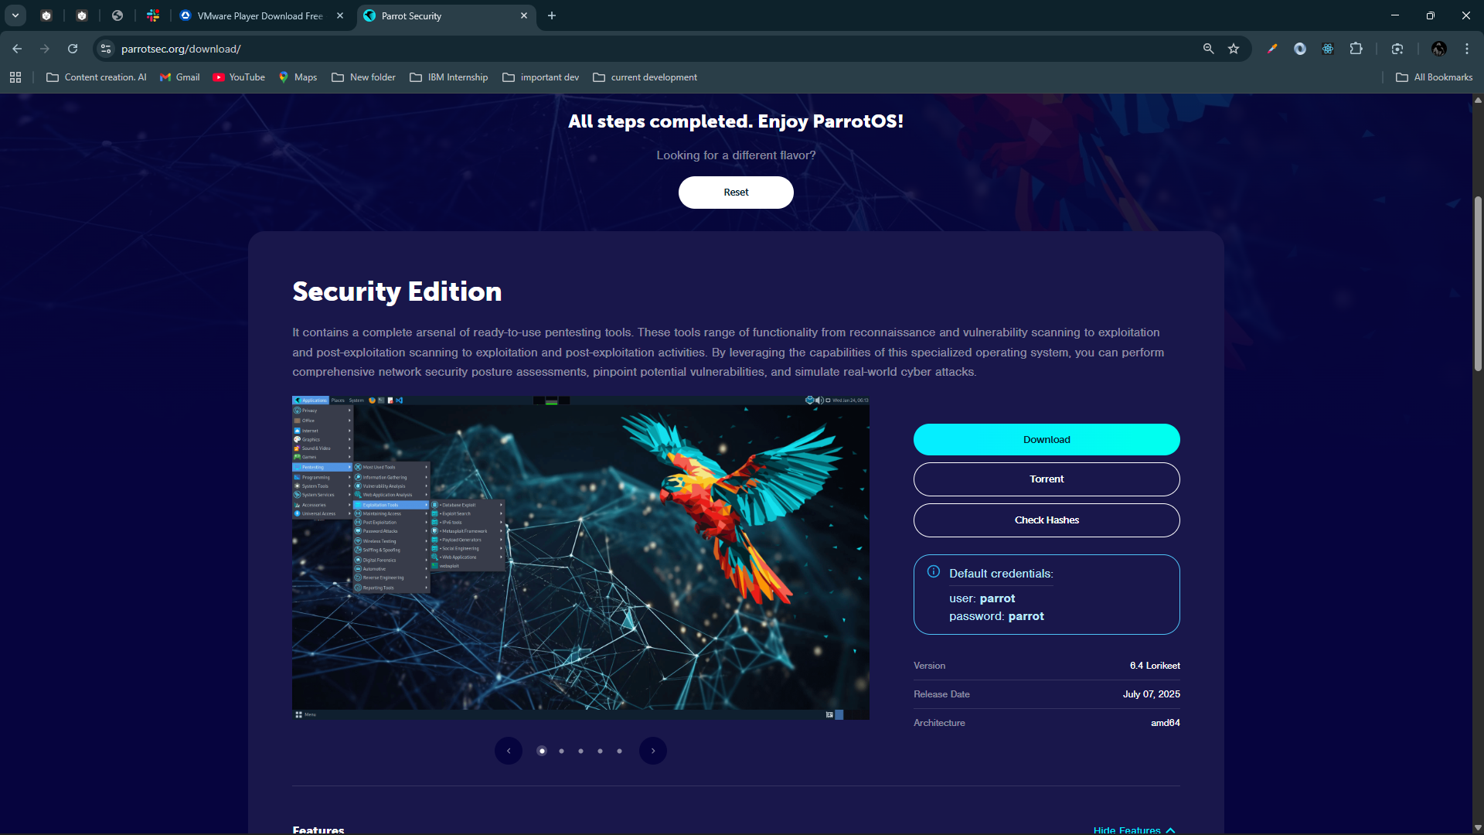
Scroll up and you will get this kind of interface and click Download button

Below is the default credential
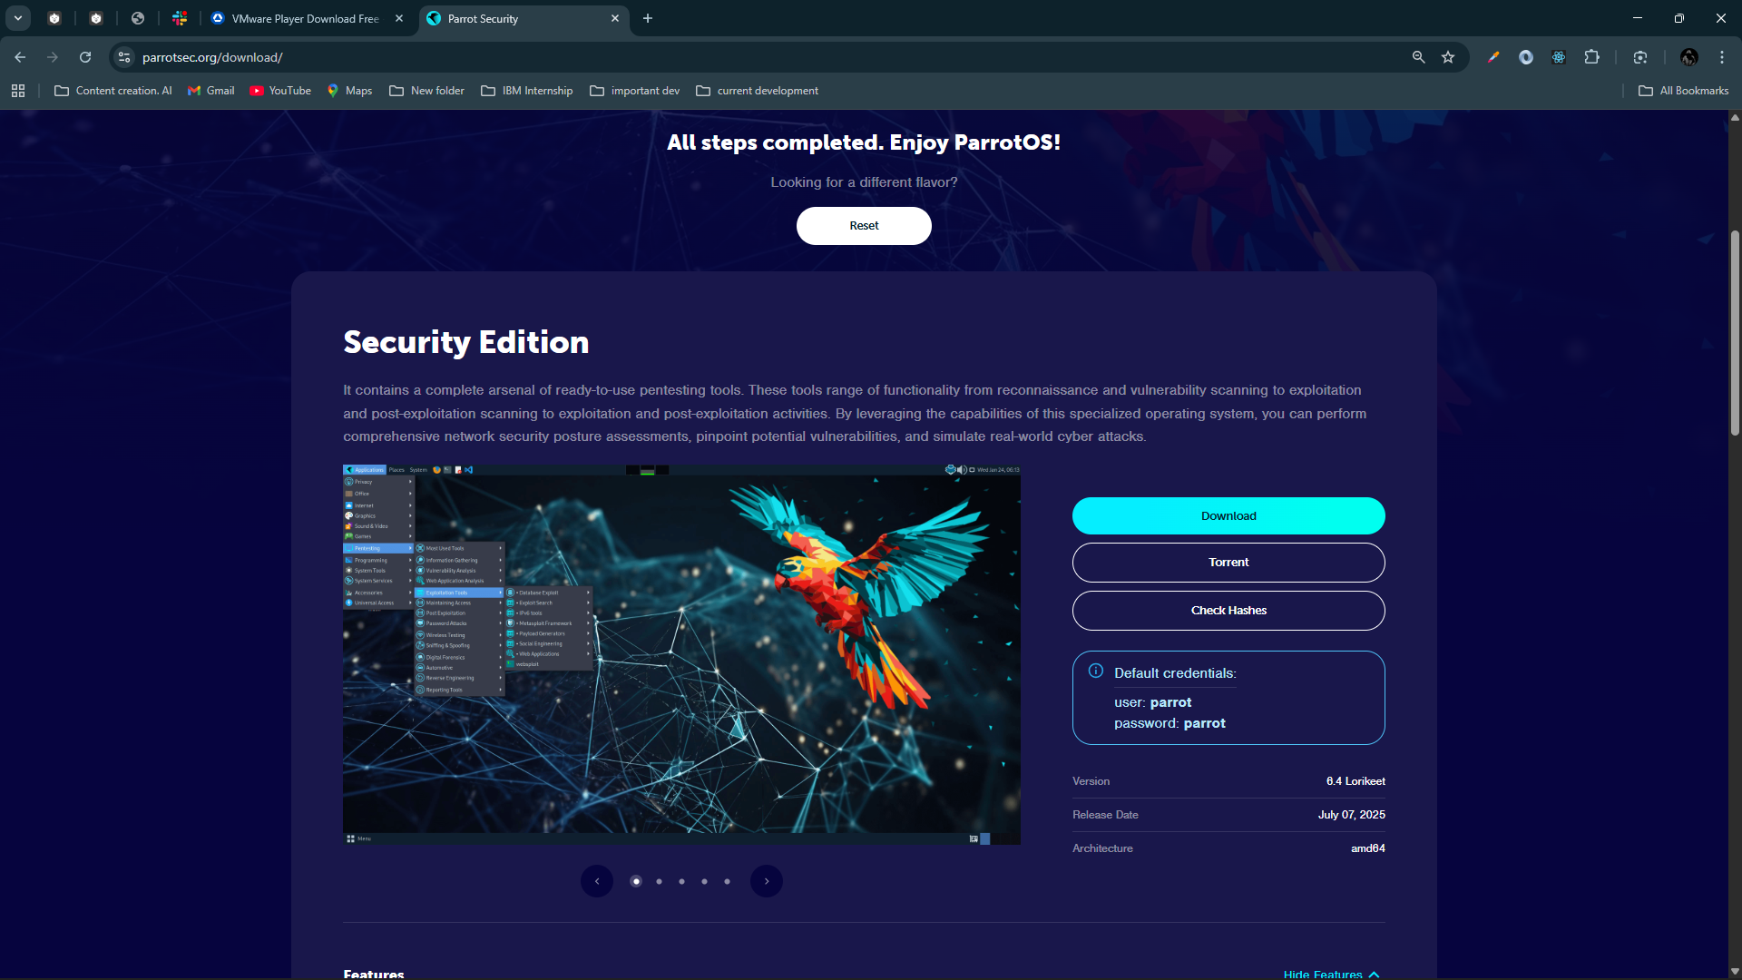

Create a New Virtual Machine
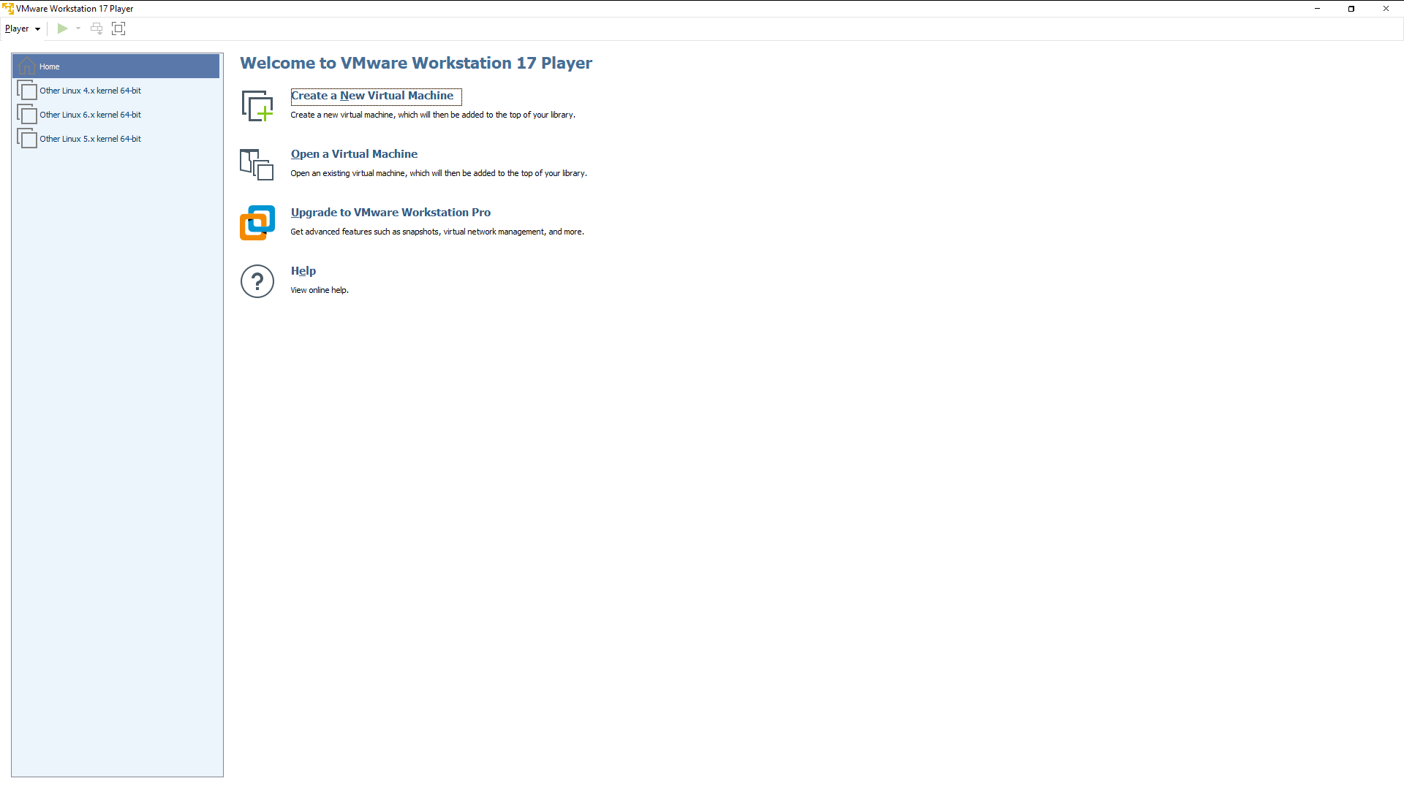
Click on Create a New Virtual Machine
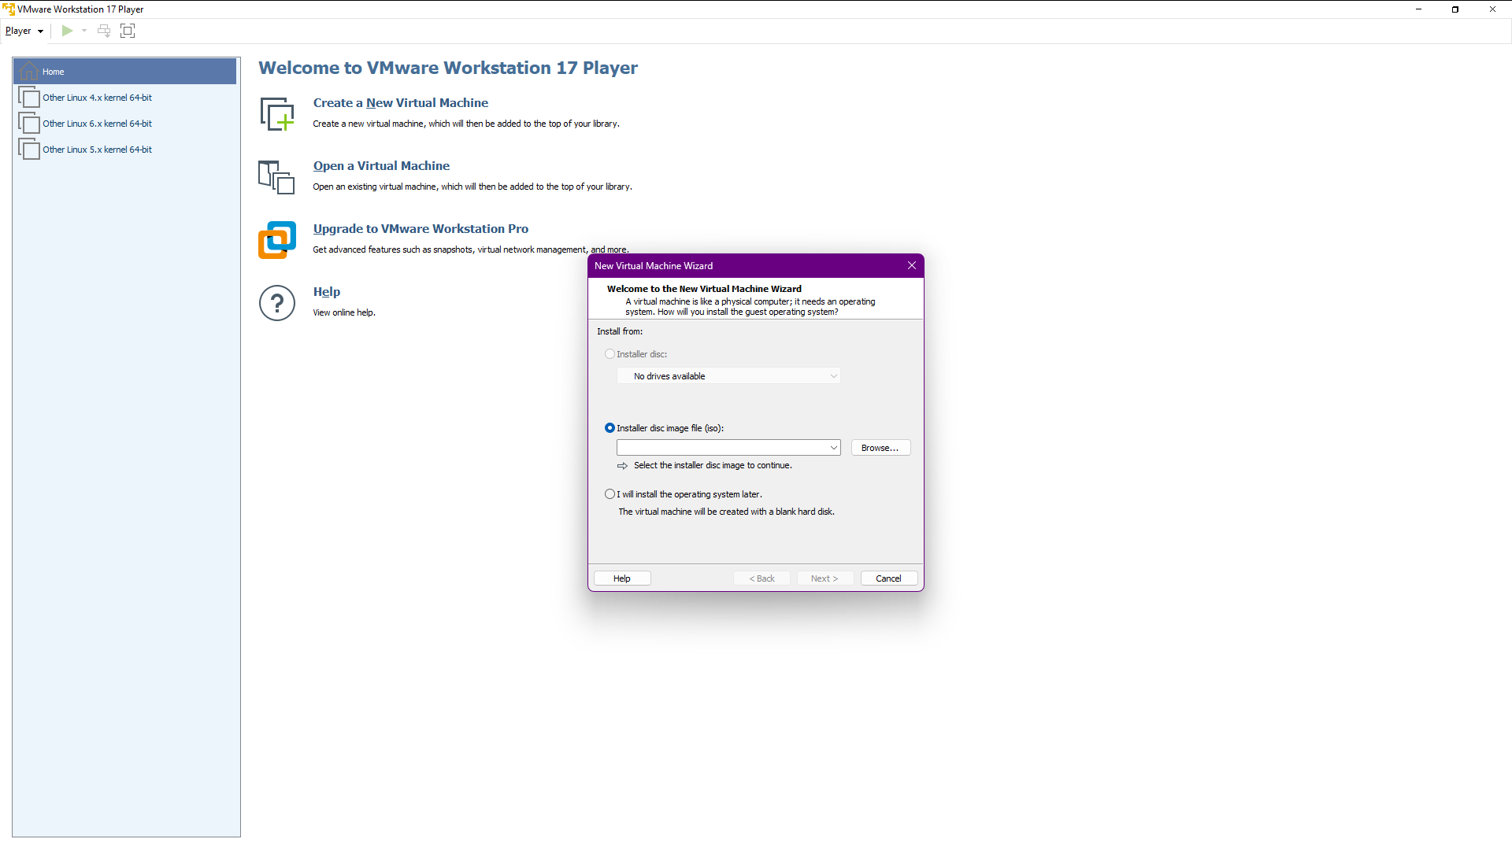

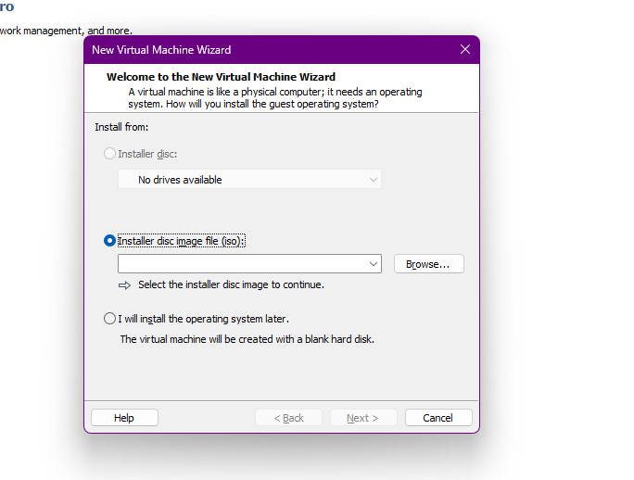
Click on Installer disc Image file(iso) and browse where the iso file is there
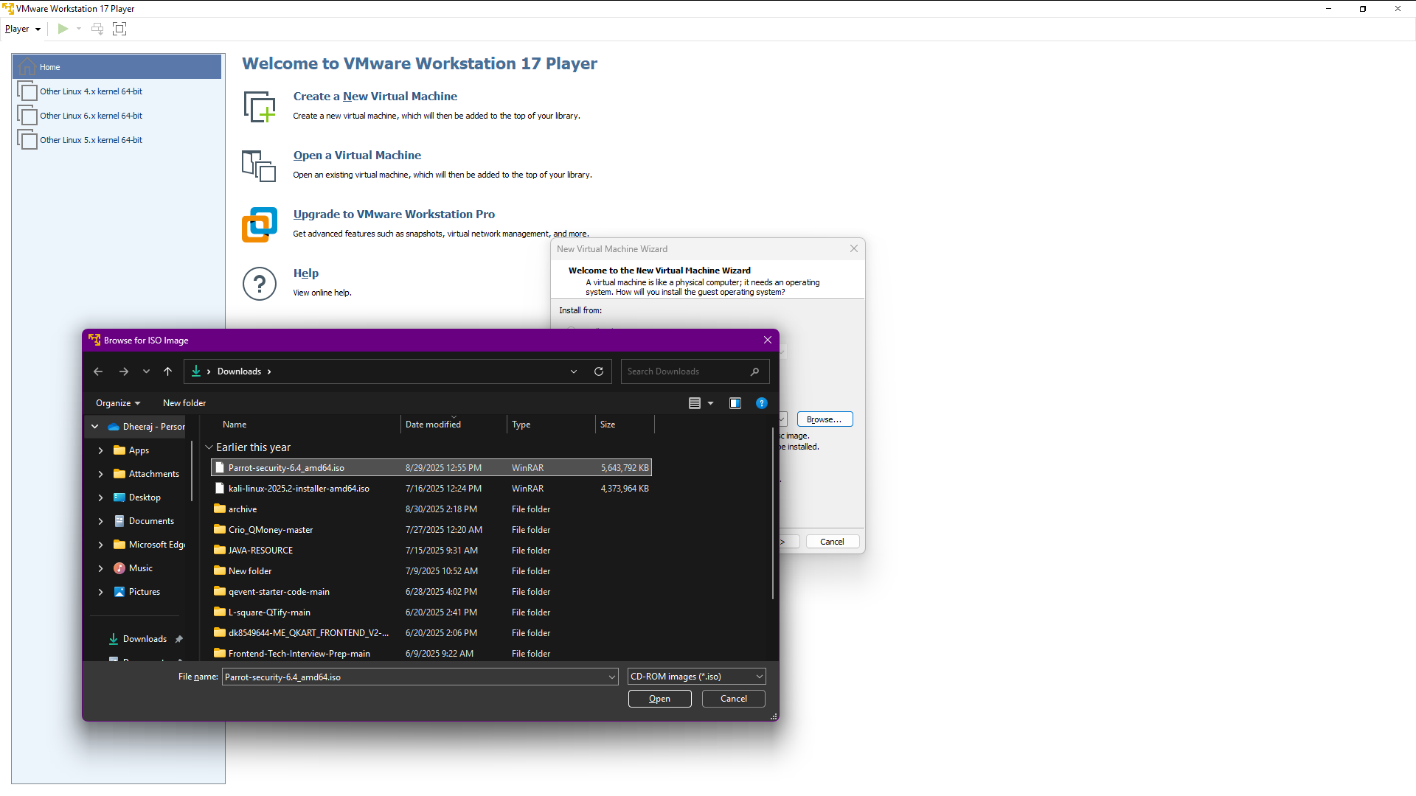
Chose the parrot OS iso file and click open
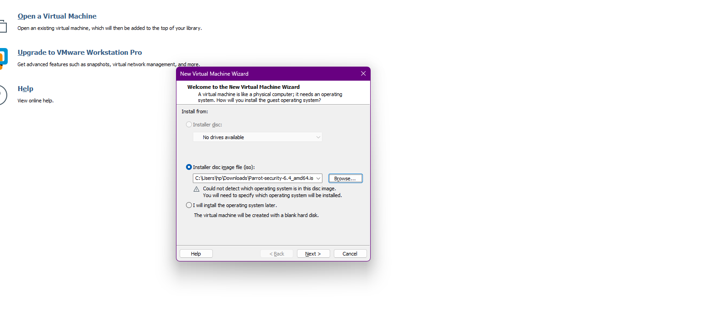
Click Next
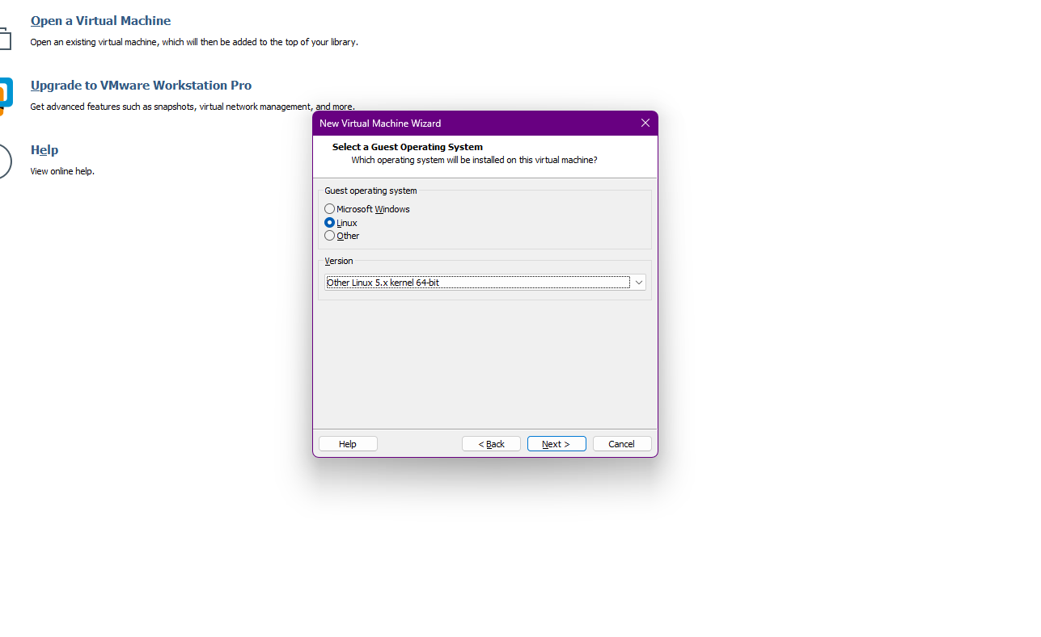
Choose Linux and choose Linux 5.x kernel and then next
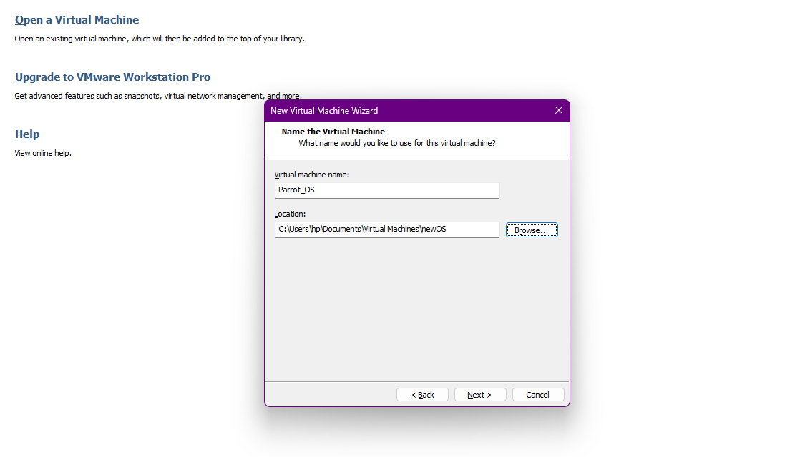
Give the virtual machine name and select where you want to store the virtual Machine file and then next
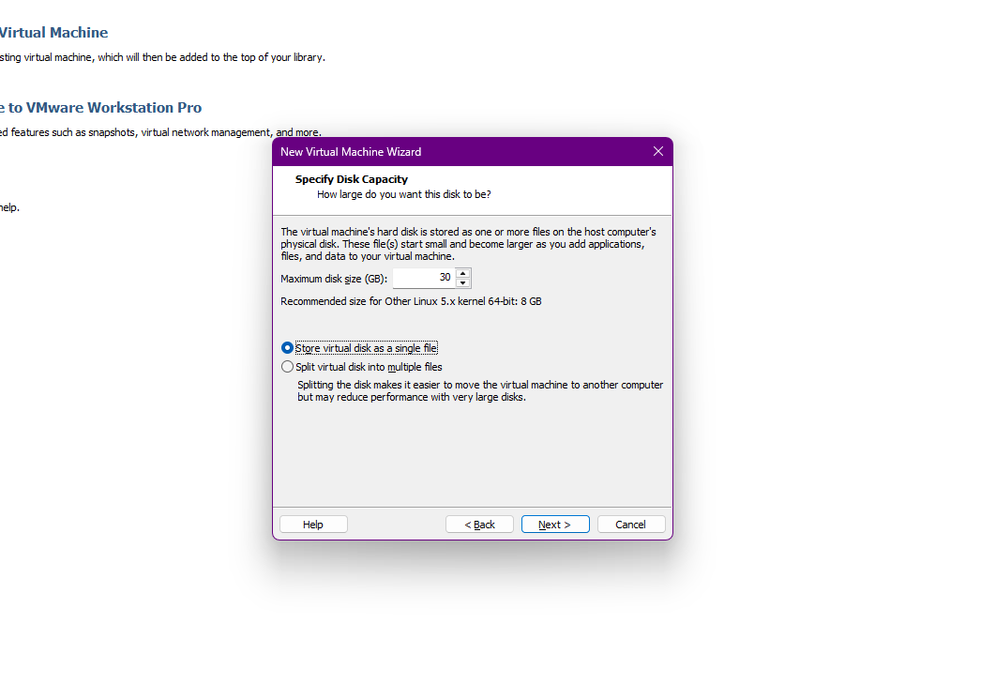
Give minimum 30 GB disk size and choose [Store virtual disk as a single file] and then next
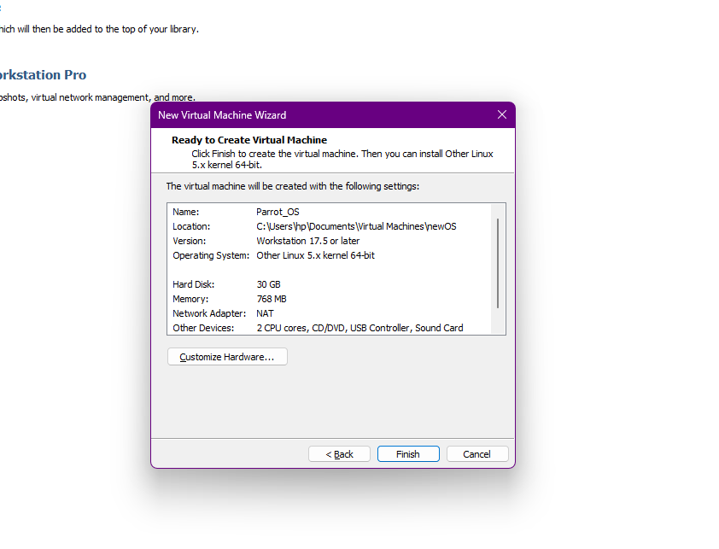
Click Customize Hardware
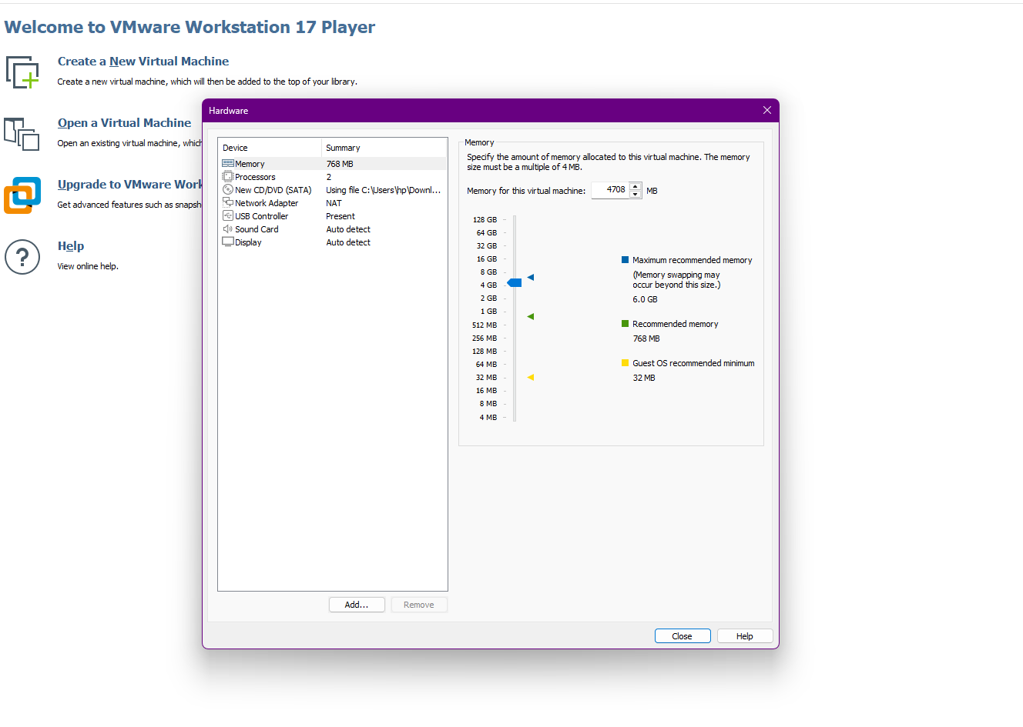
Give minimum 2 GB RAM memory but if you have 8 GB, 16GB or 32GB RAM in Your Laptop or computer then give more then 4GB and click Close
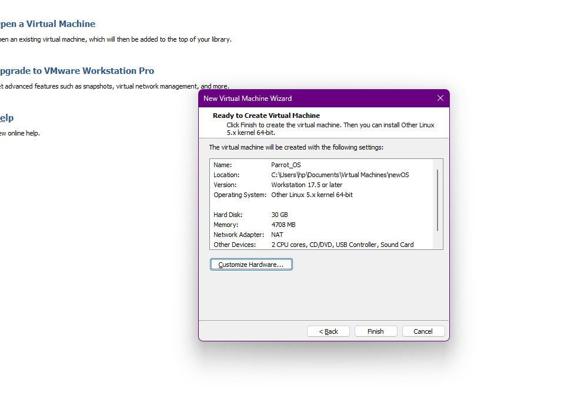
And then Finish
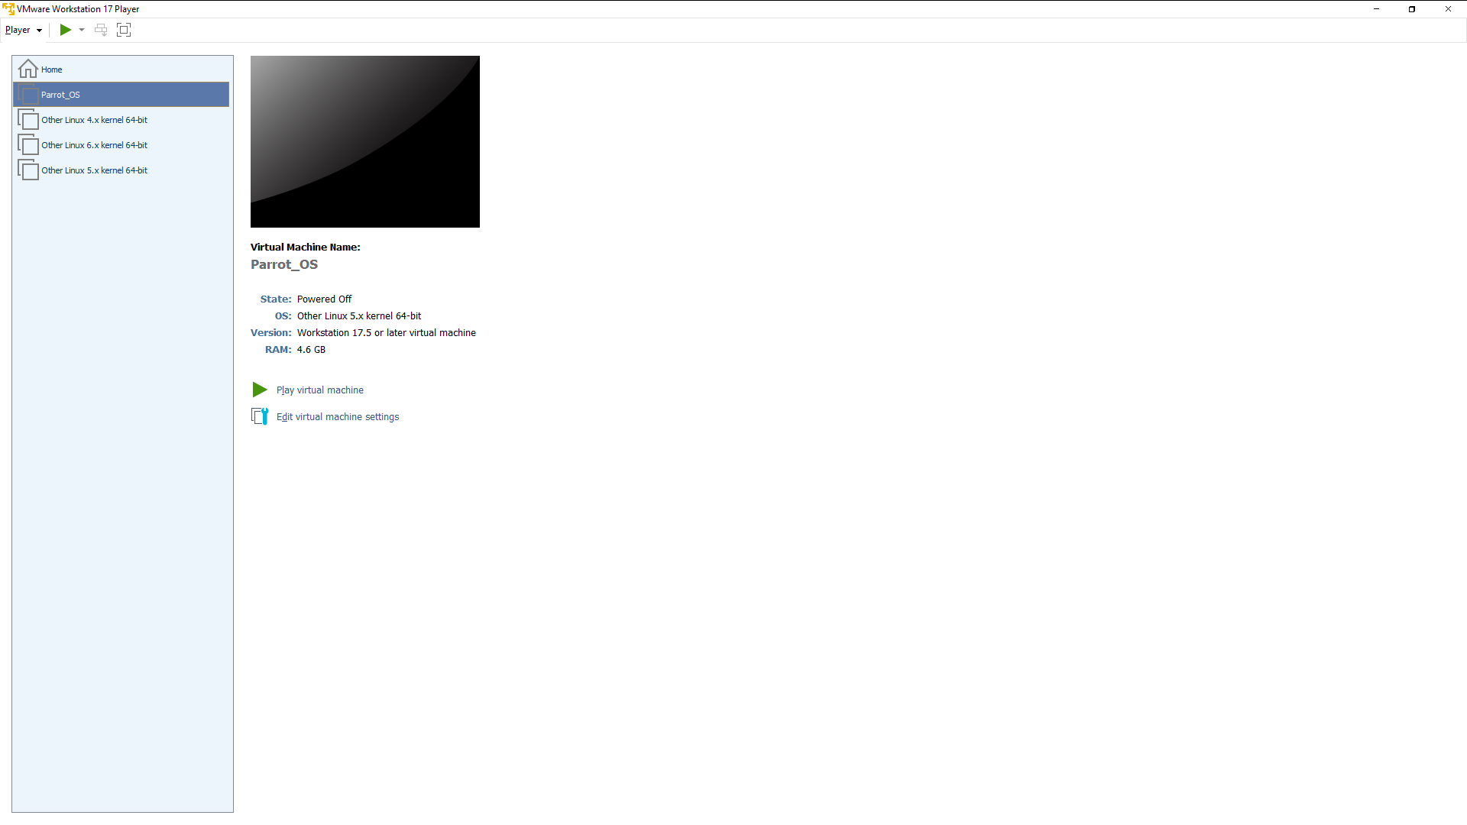
Click play Virtual Machine
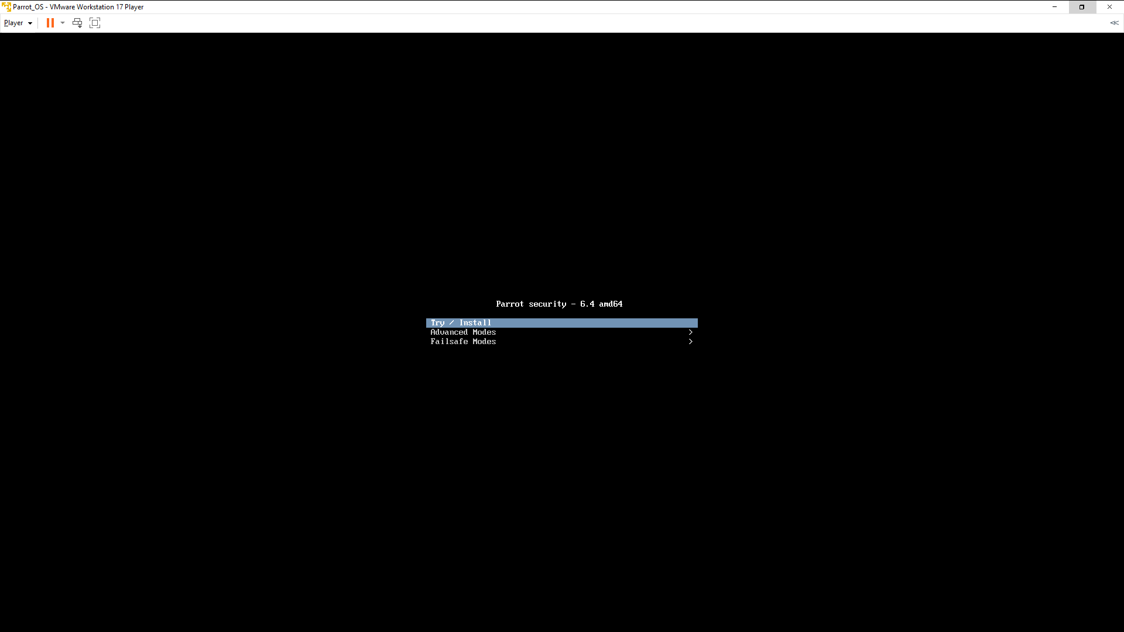
Click on first option [ Try / Install ]
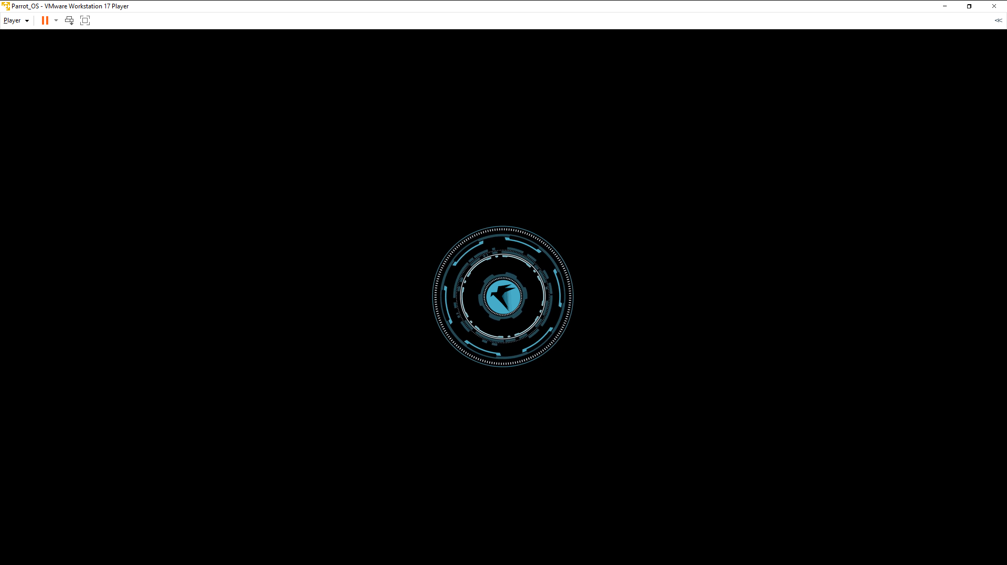
Now wait while parrot OS installing
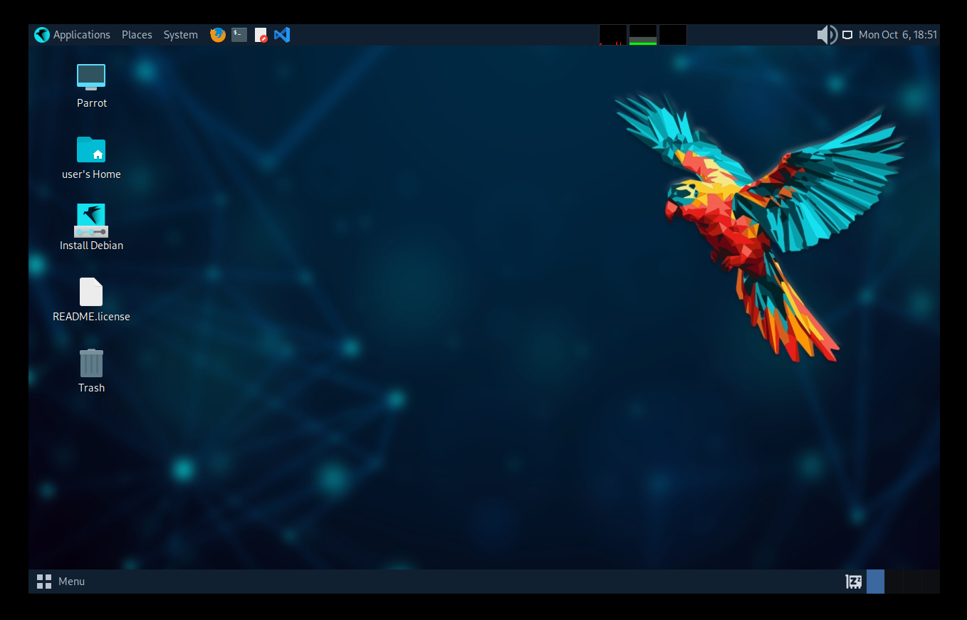
Now This is the Parrot OS Main page and installation is Complete.
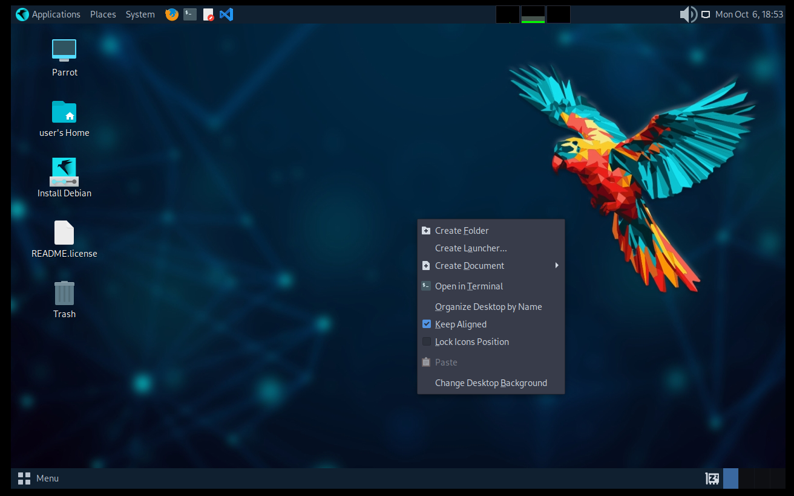
Right Click and open the terminal
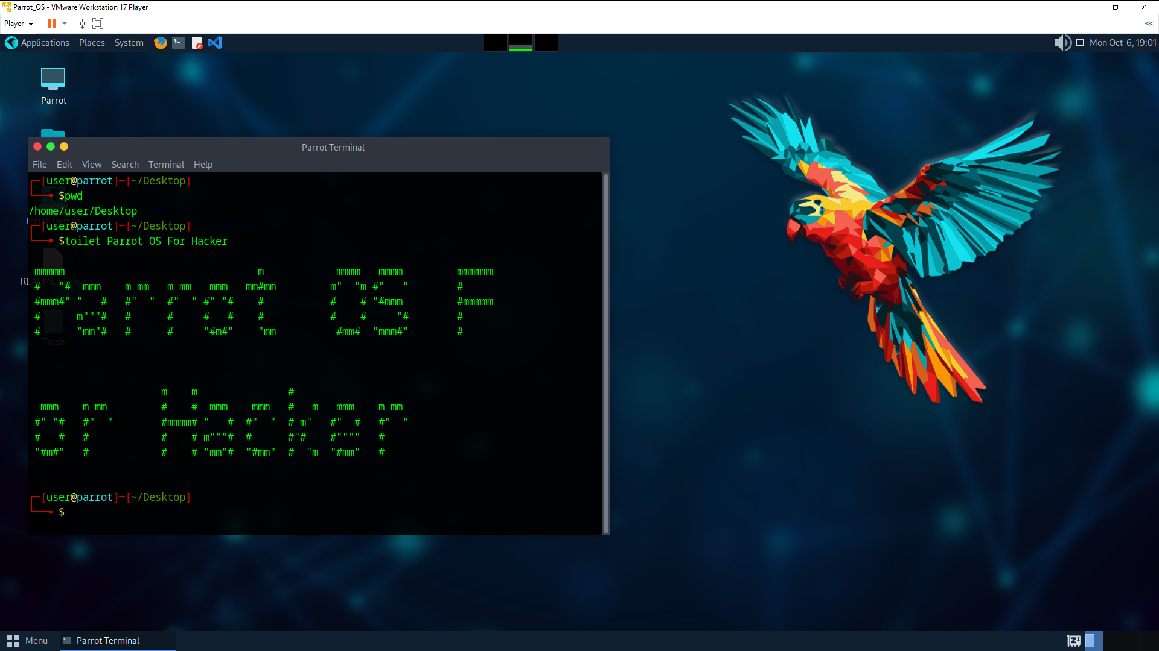
We can also run Bash Script and Linux OS is used in most of the server. As a Developer we will spend most of the time in Linux OS like Ubuntu Whenever we are working on DevOps team.

┌──(dheerajkumar㉿dheeraj)-[~]
└─$ ls
Desktop Documents Downloads Music Pictures Public Templates Videos

┌──(dheerajkumar㉿dheeraj)-[~]
└─$ cd Desktop

┌──(dheerajkumar㉿dheeraj)-[~/Desktop]
└─$ ls

┌──(dheerajkumar㉿dheeraj)-[~/Desktop]
└─$ mkdir MCA

┌──(dheerajkumar㉿dheeraj)-[~/Desktop]
└─$ cd MCA

┌──(dheerajkumar㉿dheeraj)-[~/Desktop/MCA]
└─$ mkdir Sem1 Sem2 Sem3 Sem4

┌──(dheerajkumar㉿dheeraj)-[~/Desktop/MCA]
└─$ ls
Sem1 Sem2 Sem3 Sem4

┌──(dheerajkumar㉿dheeraj)-[~/Desktop/MCA]
└─$ cd Sem1

┌──(dheerajkumar㉿dheeraj)-[~/Desktop/MCA/Sem1]
└─$ touch Android.txt

┌──(dheerajkumar㉿dheeraj)-[~/Desktop/MCA/Sem1]
└─$ touch Python.txt

┌──(dheerajkumar㉿dheeraj)-[~/Desktop/MCA/Sem1]
└─$ touch Java.txt

┌──(dheerajkumar㉿dheeraj)-[~/Desktop/MCA/Sem1]
└─$ touch DevOps.txt

┌──(dheerajkumar㉿dheeraj)-[~/Desktop/MCA/Sem1]
└─$ touch React.txt

┌──(dheerajkumar㉿dheeraj)-[~/Desktop/MCA/Sem1]
└─$ cd ../Sem2

┌──(dheerajkumar㉿dheeraj)-[~/Desktop/MCA/Sem2]
└─$ touch MachineLearning.txt

┌──(dheerajkumar㉿dheeraj)-[~/Desktop/MCA/Sem2]
└─$ touch NaturalLanguageProcessing.txt

┌──(dheerajkumar㉿dheeraj)-[~/Desktop/MCA/Sem2]
└─$ touch CloudComputing.txt

┌──(dheerajkumar㉿dheeraj)-[~/Desktop/MCA/Sem2]
└─$ touch ComputerNetwork.txt

┌──(dheerajkumar㉿dheeraj)-[~/Desktop/MCA/Sem2]
└─$ touch CPP.txt

┌──(dheerajkumar㉿dheeraj)-[~/Desktop/MCA/Sem2]
└─$ cd ../Sem3

┌──(dheerajkumar㉿dheeraj)-[~/Desktop/MCA/Sem3]
└─$ touch ImageProcessing.txt

┌──(dheerajkumar㉿dheeraj)-[~/Desktop/MCA/Sem3]
└─$ touch BigData.txt

┌──(dheerajkumar㉿dheeraj)-[~/Desktop/MCA/Sem3]
└─$ touch SoftwareProjectManagement.txt

┌──(dheerajkumar㉿dheeraj)-[~/Desktop/MCA/Sem3]
└─$ touch CyberSecurity.txt

┌──(dheerajkumar㉿dheeraj)-[~/Desktop/MCA/Sem3]
└─$ touch UIUXDesign.txt

┌──(dheerajkumar㉿dheeraj)-[~/Desktop/MCA/Sem3]
└─$ touch BlockchainArchitecture.txt

┌──(dheerajkumar㉿dheeraj)-[~/Desktop/MCA/Sem3]
└─$ touch DBMS.txt

┌──(dheerajkumar㉿dheeraj)-[~/Desktop/MCA/Sem3]
└─$ cd ../Sem4

┌──(dheerajkumar㉿dheeraj)-[~/Desktop/MCA/Sem4]
└─$ touch CyberForeignsic.txt

┌──(dheerajkumar㉿dheeraj)-[~/Desktop/MCA/Sem4]
└─$ touch ResearchMethodology.txt

┌──(dheerajkumar㉿dheeraj)-[~/Desktop/MCA/Sem4]
└─$ touch AdvancedJava_Spring.txt

┌──(dheerajkumar㉿dheeraj)-[~/Desktop/MCA/Sem4]
└─$ touch ASPNET.txt

┌──(dheerajkumar㉿dheeraj)-[~/Desktop/MCA/Sem4]
└─$ cd ../Sem1

┌──(dheerajkumar㉿dheeraj)-[~/Desktop/MCA/Sem1]
└─$ ls
Android.txt DevOps.txt Java.txt Python.txt React.txt

┌──(dheerajkumar㉿dheeraj)-[~/Desktop/MCA/Sem1]
└─$ cd ../Sem2

┌──(dheerajkumar㉿dheeraj)-[~/Desktop/MCA/Sem2]
└─$ ls
CloudComputing.txt CPP.txt NaturalLanguageProcessing.txt
ComputerNetwork.txt MachineLearning.txt

┌──(dheerajkumar㉿dheeraj)-[~/Desktop/MCA/Sem2]
└─$ cd ../Sem3

┌──(dheerajkumar㉿dheeraj)-[~/Desktop/MCA/Sem3]
└─$ ls
BigData.txt DBMS.txt UIUXDesign.txt
BlockchainArchitecture.txt ImageProcessing.txt
CyberSecurity.txt SoftwareProjectManagement.txt

┌──(dheerajkumar㉿dheeraj)-[~/Desktop/MCA/Sem3]
└─$ cd ../Sem4

┌──(dheerajkumar㉿dheeraj)-[~/Desktop/MCA/Sem4]
└─$ ls
AdvancedJava_Spring.txt CyberForeignsic.txt
ASPNET.txt ResearchMethodology.txt

┌──(dheerajkumar㉿dheeraj)-[~/Desktop/MCA/Sem4]
└─$

