1. Explain Different Components of Communication System.
A communication system is a system used for transferring data and information from one place to another. It consists of several components that work together for successful communication.

Components of Communication System

1. Sender (Source)
The sender is the device or person that sends the message or data.
Examples:
- Computer
- Mobile phone
- Server

2. Message
The message is the information that is transmitted from sender to receiver.
Examples:
- Text
- Audio
- Video
- Images
- Files

3. Transmission Medium
The transmission medium is the path through which data travels from sender to receiver.
Types:
- Wired media
  - Twisted pair cable
  - Coaxial cable
  - Fiber optic cable
- Wireless media
  - Radio waves
  - Wi-Fi
  - Bluetooth

4. Receiver (Destination)
The receiver is the device or person that receives the message.
Examples:
- Laptop
- Smartphone
- Printer

5. Protocol
Protocols are rules and standards used for communication between devices.
Examples:
- TCP/IP
- HTTP
- FTP

6. Encoder
The encoder converts data into signals for transmission.

7. Decoder
The decoder converts received signals back into understandable data.

Conclusion
All components of a communication system work together to ensure accurate and efficient data transmission. 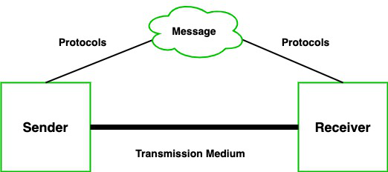

2. Describe Types of Networks.
A computer network is a collection of interconnected devices used for communication and sharing resources.

Types of Networks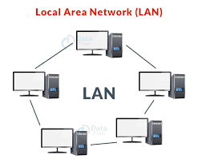

1. LAN (Local Area Network)
A LAN connects computers within a small geographical area.

Features
- High speed
- Low cost
- Easy maintenance

Examples
- School network
- Office network
- Home Wi-Fi

2. MAN (Metropolitan Area Network) 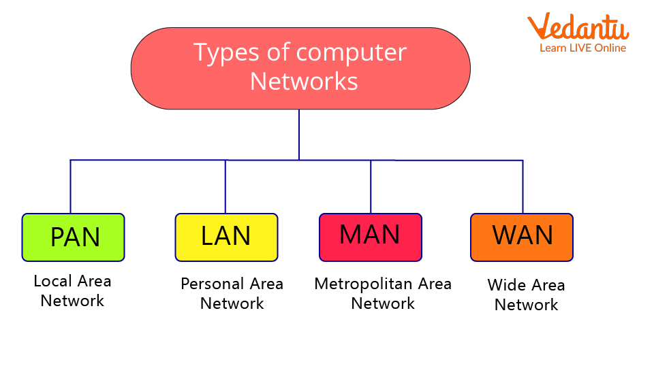
A MAN covers a city or metropolitan area.

Features
- Connects multiple LANs
- Medium speed
- Larger coverage than LAN

Examples
- Cable TV network
- City-wide internet network

3. WAN (Wide Area Network)
A WAN covers a very large geographical area such as countries or continents.

Features
- Long-distance communication
- Uses public networks
- Slower than LAN

Examples
- Internet
- Bank networks

4. PAN (Personal Area Network)
A PAN is a small network around an individual person.

Features
- Very short range
- Wireless communication

Examples
- Bluetooth
- Mobile hotspot

5. CAN (Campus Area Network)
A CAN connects multiple buildings within a campus or organization.

Features
- High speed
- Used in universities and industries

Examples
- College campus network

Conclusion
Different types of networks are used depending on geographical area, speed, and communication requirements. 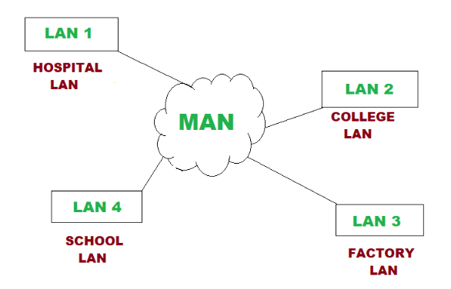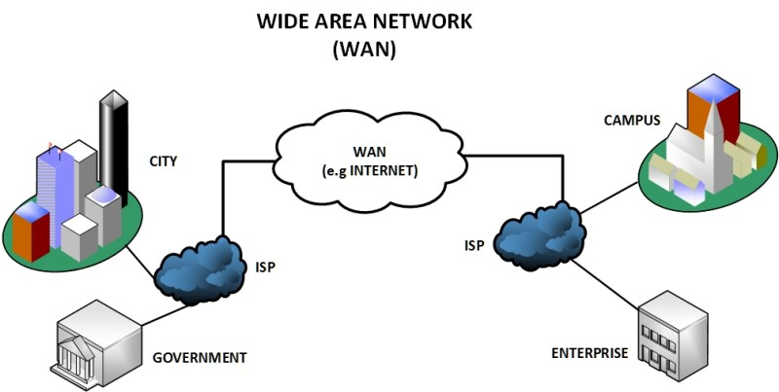

3. Explain Different Types of Communications.
Communication types describe how data is transmitted between devices.

Types of Communication

1. Simplex Communication
In simplex communication, data flows only in one direction.

Features
- One-way communication
- Receiver cannot send response

Examples
- Television broadcasting
- Radio broadcasting
- Keyboard to computer

Advantages
- Simple system
- Low cost

Disadvantages
- No feedback possible

2. Half Duplex Communication
In half duplex communication, data flows in both directions but only one direction at a time.

Features
- Two-way communication
- Not simultaneous

Examples
- Walkie-talkie

Advantages
- Better than simplex
- Saves communication cost

Disadvantages
- Delay in communication

3. Full Duplex Communication
In full duplex communication, data flows in both directions simultaneously.

Features
- Two-way simultaneous communication
- Faster communication

Examples
- Telephone
- Video call

Advantages
- Fast communication
- Efficient data transfer

Disadvantages
- Expensive system

Conclusion
Simplex, half duplex, and full duplex communication are used depending on the communication requirement and system design.

4. Describe Various Network Topologies such as Bus, Star, Ring, Mesh, and Tree Topology with Advantages and Disadvantages.
Network topology refers to the physical or logical arrangement of devices in a network.

A) Bus Topology
In bus topology, all devices are connected to a single communication cable called a backbone cable.

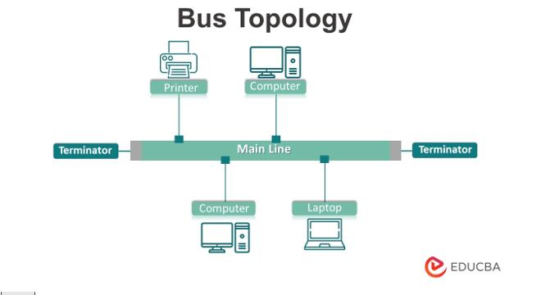

Advantages
- Easy to install
- Low cost
- Requires less cable
- Suitable for small networks

Disadvantages
- Backbone failure affects entire network
- Difficult troubleshooting
- Limited cable length
- Performance decreases with more devices

B) Star Topology
In star topology, all devices are connected to a central hub or switch.

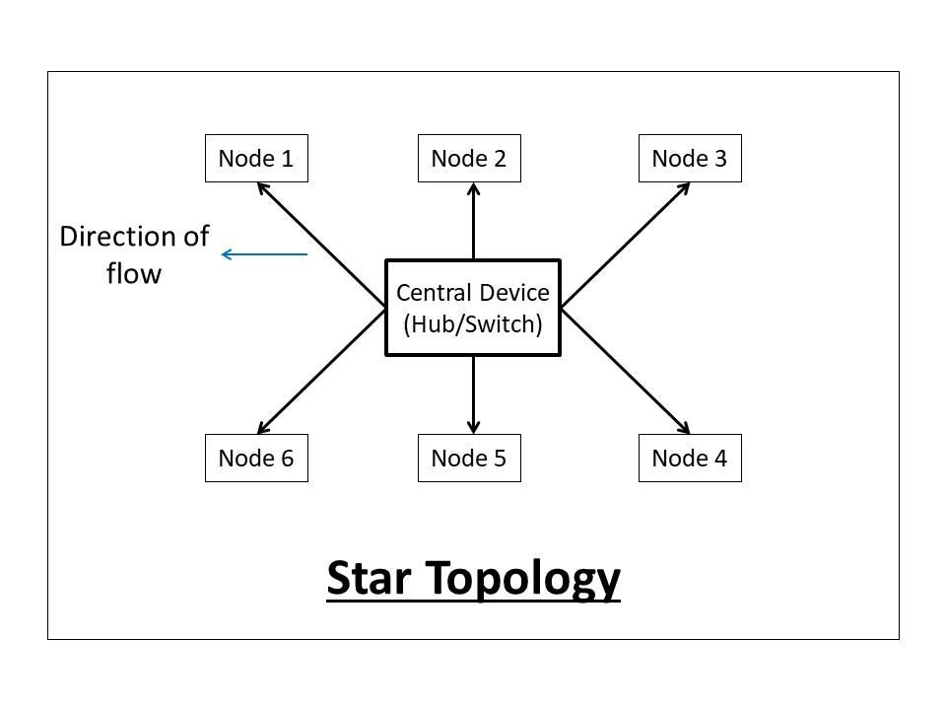

Advantages
- Easy to manage
- Easy fault detection
- Failure of one node does not affect others
- Better performance

Disadvantages
- Hub failure stops entire network
- More cable required
- Expensive compared to bus topology

C) Ring Topology
In ring topology, devices are connected in a circular form.
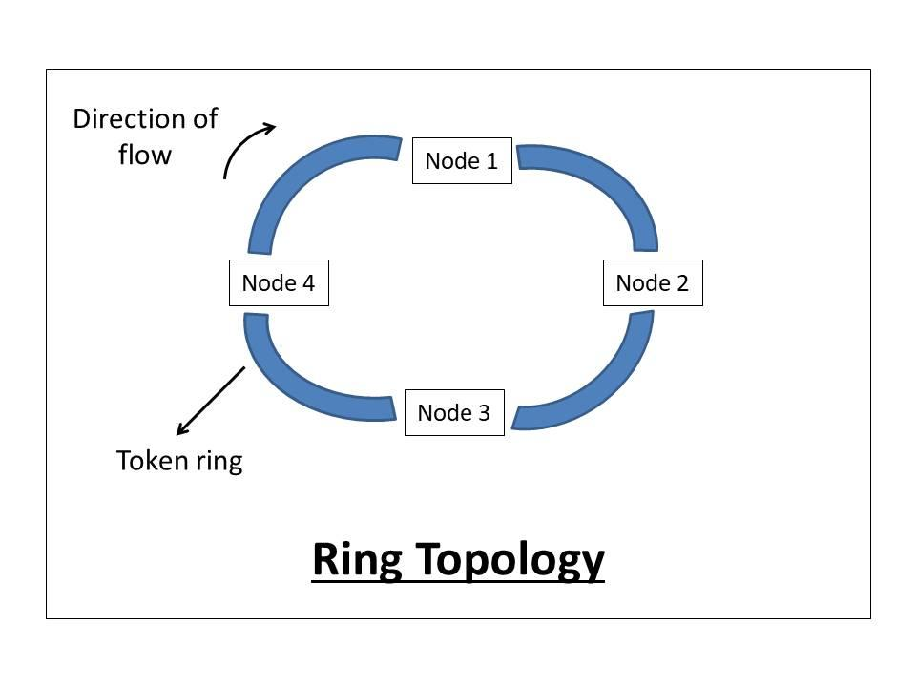

Advantages
- Equal access for all devices
- Better performance under heavy load
- No data collision

Disadvantages
- Failure of one node affects entire network
- Difficult troubleshooting
- Adding or removing devices is difficult

D) Mesh Topology
In mesh topology, every device is connected to every other device.
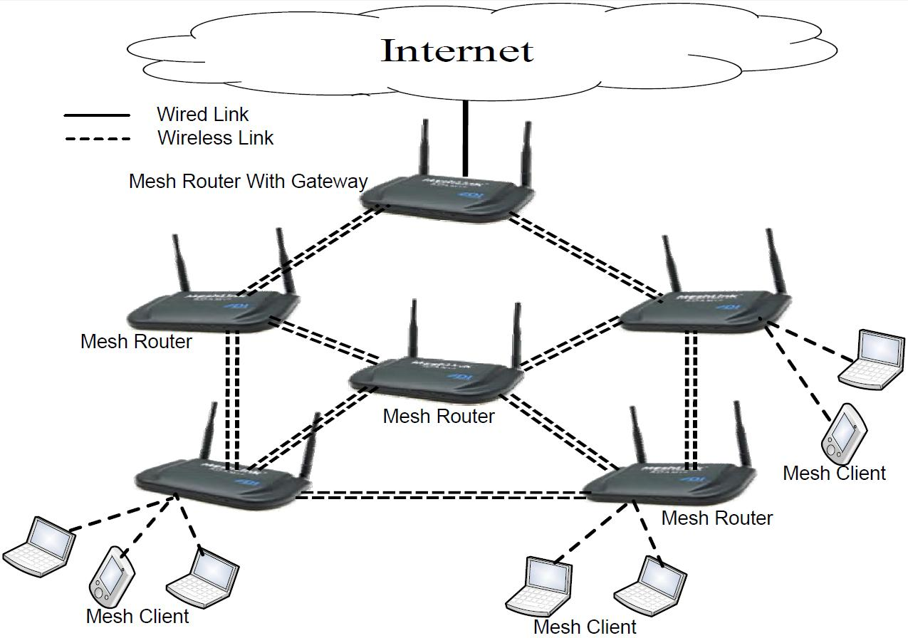

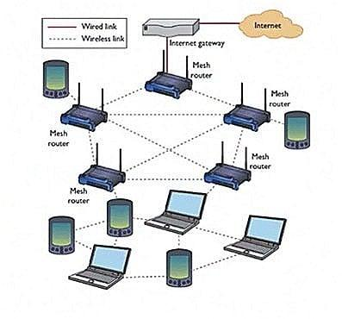

Advantages
- Highly reliable
- Fault tolerant
- Secure communication
- Fast data transfer

Disadvantages
- Expensive
- Complex installation
- Requires more cables

E) Tree Topology
Tree topology is a combination of bus and star topology.
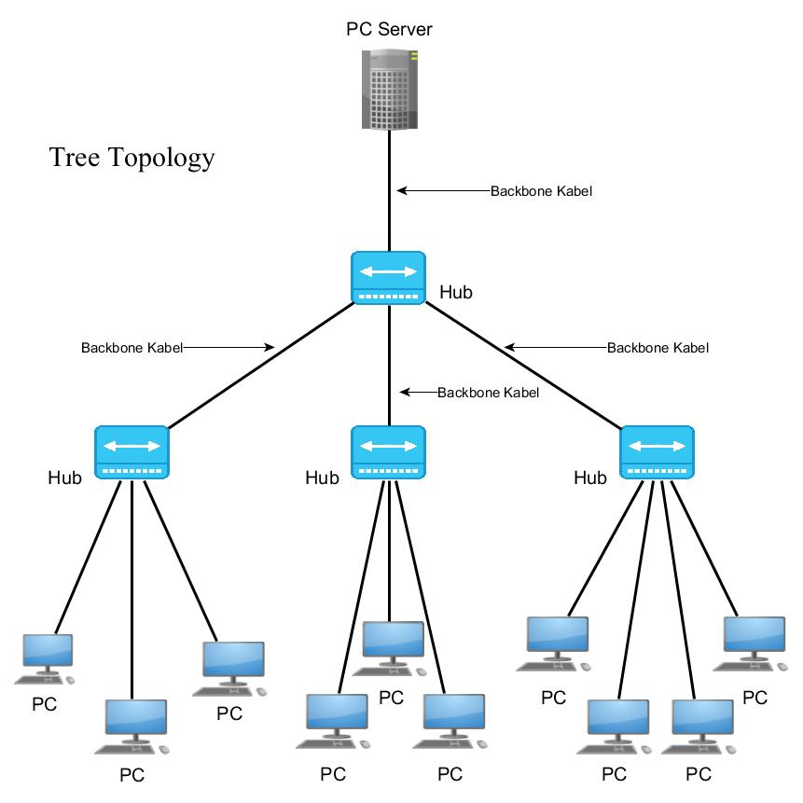
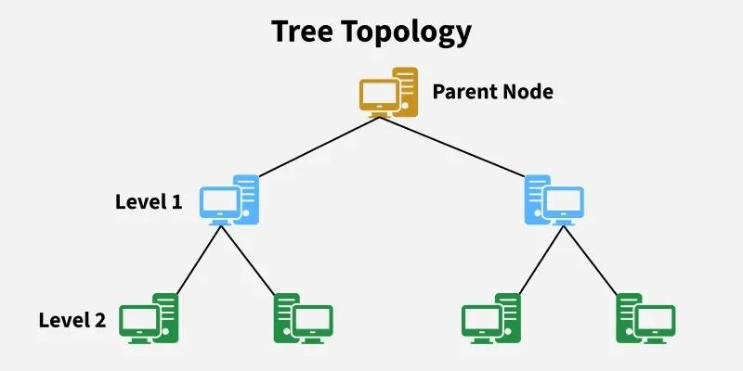

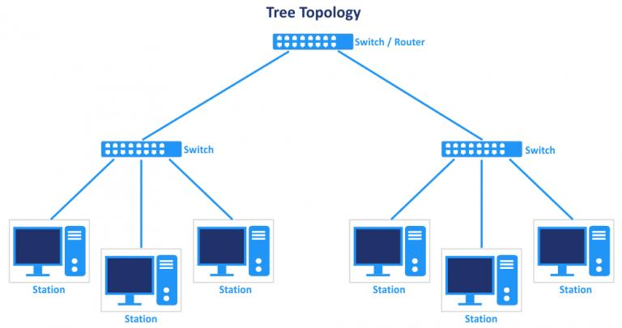

Advantages
- Easy expansion
- Suitable for large networks
- Easy management

Disadvantages
- Complex wiring
- Backbone failure affects network
- Expensive maintenance

Conclusion
Different topologies are selected based on cost, performance, reliability, and network size.

5. Explain the Architecture and Functions of the OSI Reference Model with a Neat Diagram.
The OSI (Open Systems Interconnection) model is a seven-layer reference model developed by ISO for network communication.

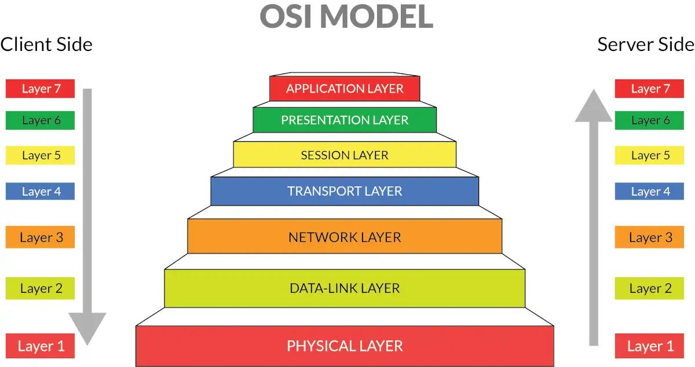

Layers of OSI Model
Layer Number | Layer Name | Function
7 | Application Layer | Provides services to user applications
6 | Presentation Layer | Data encryption and formatting
5 | Session Layer | Establishes and manages sessions
4 | Transport Layer | Reliable data transfer
3 | Network Layer | Routing and logical addressing
2 | Data Link Layer | Error detection and framing
1 | Physical Layer | Transmission of raw bits

Functions of Each Layer

1. Physical Layer
- Transfers raw bits through physical medium.
- Handles cables and connectors.

2. Data Link Layer
- Provides error detection.
- Controls data flow.

3. Network Layer
- Handles routing and IP addressing.

4. Transport Layer
- Ensures reliable communication.
- Performs segmentation.

5. Session Layer
- Establishes and terminates sessions.

6. Presentation Layer
- Data encryption and compression.
- Data format conversion.

7. Application Layer
- Provides network services to users.
- Examples: Email, web browser.

Conclusion
The OSI model standardizes network communication into seven layers for easy understanding and implementation.

6. Differentiate Between the OSI Model and TCP/IP Model with Suitable Examples.
OSI and TCP/IP are networking models used for communication.
OSI Model | TCP/IP Model
Developed by ISO | Developed by DoD
7 layers | 4 layers
Theoretical model | Practical model
Strict layer separation | Flexible layers
Session and Presentation are separate layers | Combined into Application layer
Used mainly for reference | Used on the Internet

TCP/IP Layers
- Application Layer
- Transport Layer
- Internet Layer
- Network Access Layer

Examples

OSI Model Example
Used for teaching and understanding network communication.

TCP/IP Model Example
Internet uses TCP/IP protocols such as:
- HTTP
- TCP
- IP
- FTP

Conclusion
OSI is mainly a reference model, while TCP/IP is the practical model used in real-world networking.

7. What is Subnetting? Explain Subnet Mask and Subnetting with a Suitable Example. 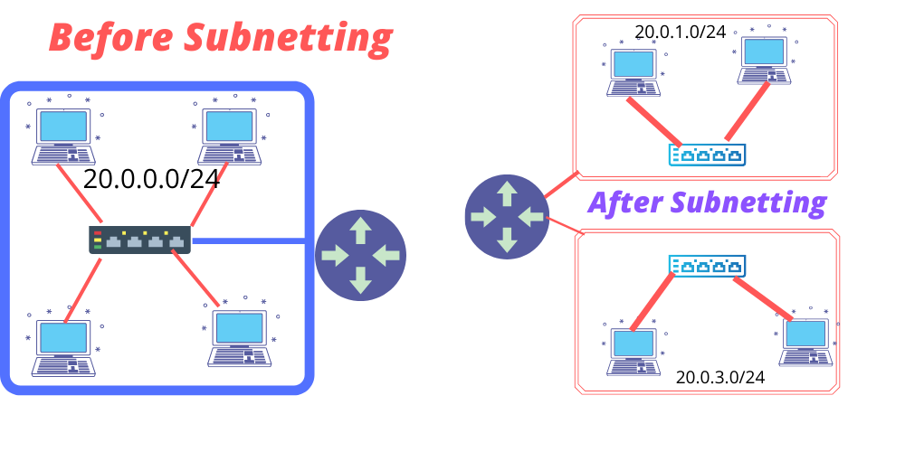

Subnetting
Subnetting is the process of dividing a large network into smaller subnetworks.

Advantages of Subnetting
- Better network management
- Reduced network traffic
- Improved security
- Efficient IP address usage

Subnet Mask
A subnet mask identifies the network portion and host portion of an IP address.

Example
IP Address:
192.168.1.10
Subnet Mask:
255.255.255.0
Network Portion:
- 192.168.1
Host Portion:
- 10

Subnetting Example
Given Network:
192.168.1.0/24
Borrow 2 bits.
New subnet mask:
255.255.255.192
Number of subnets:
2^2 = 4
Hosts per subnet:
2^6 - 2 = 62

Subnets
- 192.168.1.0
- 192.168.1.64
- 192.168.1.128
- 192.168.1.192

Conclusion
Subnetting improves network performance and efficient utilization of IP addresses.

8. Differentiate Between IPv4 and IPv6 Protocols.
IPv4 | IPv6
32-bit address | 128-bit address
Uses decimal notation | Uses hexadecimal notation
Limited addresses | Large number of addresses
Example: 192.168.1.1 | Example: 2001:db8::1
Supports broadcast | No broadcast
Less secure | More secure
Header is complex | Header is simpler

Advantages of IPv6
- More IP addresses
- Better security
- Faster routing
- Improved performance

Conclusion
IPv6 was developed to overcome the limitations of IPv4 and support future internet growth. 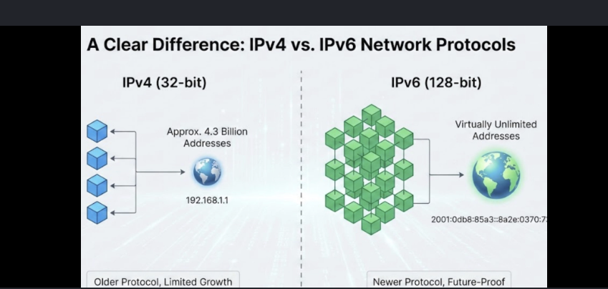

9. What is Routing? Explain Static Routing and Dynamic Routing Techniques and Routing Algorithms. 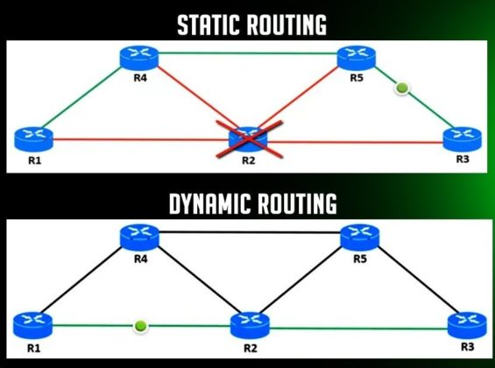

Routing
Routing is the process of selecting the best path for data transmission from source to destination.

Static Routing
In static routing, routes are manually configured by the network administrator.

Advantages
- Secure
- Less bandwidth usage
- Simple for small networks

Disadvantages
- Manual updates required
- Difficult for large networks

Dynamic Routing
In dynamic routing, routes are automatically updated using routing protocols.

Advantages
- Automatic updates
- Suitable for large networks
- Better fault tolerance

Disadvantages
- Complex configuration
- More bandwidth usage

Routing Algorithms

1. Distance Vector Algorithm
- Uses hop count.
- Example: RIP.

2. Link State Algorithm
- Uses shortest path calculation.
- Example: OSPF.

3. Path Vector Algorithm
- Maintains routing paths.
- Example: BGP.

Conclusion
Routing helps in efficient data transfer and network communication using different routing techniques and algorithms.

10. Explain Subnetting with Detailed Numerical Example.

Given Network
192.168.10.0/24
Requirement:
Create 4 subnets.

Step 1: Find Number of Borrowed Bits
Formula:
2^n \geq 4
n = 2 bits.

Step 2: Find New Subnet Mask
Original subnet mask:
255.255.255.0
New subnet mask after borrowing 2 bits:
255.255.255.192
CIDR notation:
/26

Step 3: Calculate Number of Hosts
Remaining host bits = 6
Hosts per subnet:
2^6 - 2 = 62

Step 4: Create Subnet Table
Subnet | Network Address | First Host | Last Host | Broadcast Address
1 | 192.168.10.0 | 192.168.10.1 | 192.168.10.62 | 192.168.10.63
2 | 192.168.10.64 | 192.168.10.65 | 192.168.10.126 | 192.168.10.127
3 | 192.168.10.128 | 192.168.10.129 | 192.168.10.190 | 192.168.10.191
4 | 192.168.10.192 | 192.168.10.193 | 192.168.10.254 | 192.168.10.255

Conclusion
Subnetting divides a network into smaller subnetworks for better performance, security, and efficient IP address management.

