1. Principles of Non-Verbal Communication
10 Key Points
- Non-verbal communication is expressing without words.
- Includes facial expressions, gestures, posture, eye contact, tone, and space.
- Conveys emotions more effectively than verbal communication.
- Body language complements or contradicts verbal messages.
- Culture influences non-verbal cues.
- Timing and context are important in interpreting signals.
- Non-verbal cues can build rapport or create misunderstandings.
- Consistency between verbal and non-verbal messages increases trust.
- Observing non-verbal cues helps understand unspoken feelings.
- Effective non-verbal communication enhances personal and professional relationships.
Diagram idea:
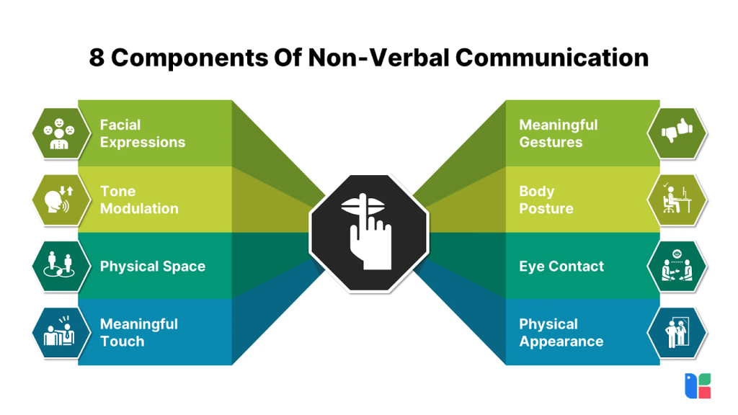
1.2 Kinesics (Body Language)
10 Key Points
- Kinesics is the study of body movements in communication.
- Includes gestures, facial expressions, posture, and eye contact.
- Open posture signals confidence; closed posture signals defensiveness.
- Smiling conveys friendliness; frowning conveys disagreement.
- Eye contact shows interest and honesty.
- Hand movements emphasize points while speaking.
- Nodding shows agreement, shaking head shows disagreement.
- Leaning forward shows engagement; leaning back shows disinterest.
- Facial expressions can be universal (happiness, anger, sadness).
- Observing kinesics helps read emotions and attitudes.
Diagram idea:
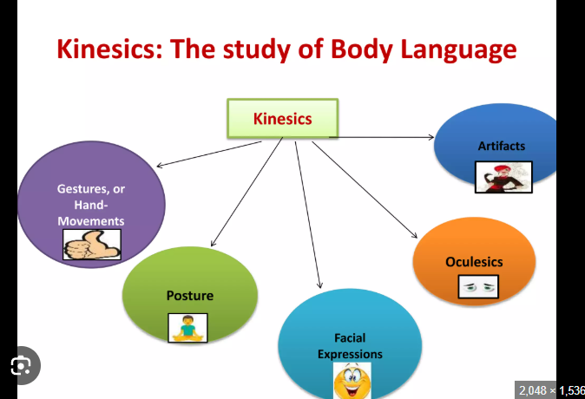
1.3 Proxemics, Paralanguage, and Visible Codes
10 Key Points
- Proxemics = use of space in communication.
- Intimate space: 0–18 inches (close relationships).
- Personal space: 1.5–4 feet (friends).
- Social space: 4–12 feet (colleagues).
- Public space: 12+ feet (audiences).
- Paralanguage = voice features like tone, pitch, volume, and speed.
- Voice expresses emotions, e.g., excitement or anger.
- Visible Codes = appearance, dress, color, symbols.
- Uniforms or attire convey status or professionalism.
- Combining space, voice, and appearance enhances understanding.
Diagram idea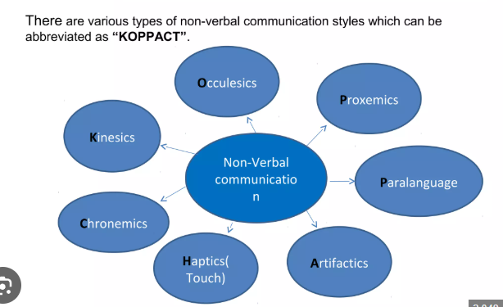
2. Speaking Skills
10 Key Points
- Speaking is conveying ideas clearly and confidently.
- Effective speaking needs clarity, volume, and tone.
- Avoid filler words (“um, like”) for professionalism.
- Pronunciation and articulation are essential.
- Use gestures and facial expressions for emphasis.
- Organize ideas logically before speaking.
- Listen actively to respond appropriately.
- Practice improves fluency and confidence.
- Speaking in public requires eye contact and engagement.
- Feedback helps refine speaking skills.
Diagram idea:
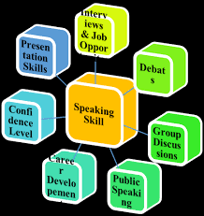
2.1 Pronunciation Drills
10 Key Points
- Practice difficult sounds repeatedly.
- Use tongue twisters to improve clarity.
- Record and listen to your own voice.
- Focus on stress and intonation patterns.
- Break words into syllables.
- Mimic native speakers for natural flow.
- Slow down to improve accuracy.
- Practice minimal pairs (ship vs sheep).
- Use pronunciation apps or dictionaries.
- Regular practice improves confidence and communication.
Diagram idea:
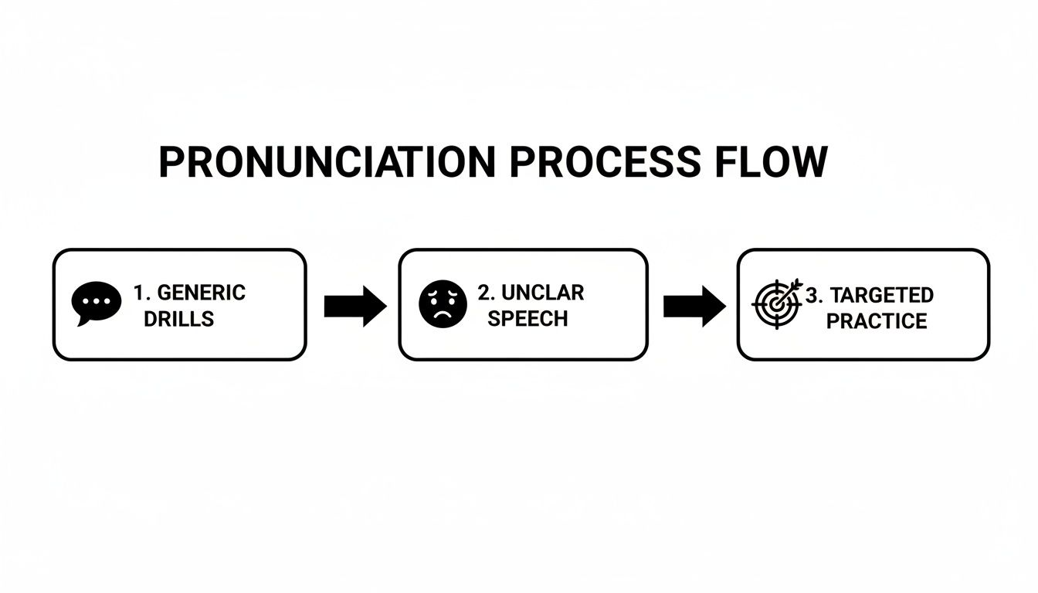
2.2 Importance of Oral and PowerPoint Presentation Guidelines
10 Key Points
- Oral presentations convey ideas verbally; PPT aids visually.
- PPT should support, not replace, speaking.
- Keep slides simple and uncluttered.
- Use bullet points, not long paragraphs.
- Include visuals: images, charts, graphs.
- Use consistent fonts and colors.
- Practice timing to fit presentation duration.
- Speak clearly, confidently, and maintain eye contact.
- Handle Q&A politely and professionally.
- Effective presentations engage, inform, and persuade audiences.
Diagram idea:
