8. Implement a recursive function in Java to calculate the height of a binary tree.
Answer:
The height of a binary tree is the number of nodes in the longest path from the root node to the leaf node.
Logic:
- If tree is empty, height = 0
- Otherwise:
height = 1 + max(height of left subtree, height of right subtree)
Diagram:
1
/ \
2 3
/ \
4 5

Height = 3
Longest path: 1 → 2 → 4
Java Program:
class Node {
int data;
Node left, right;
Node(int data) {
this.data = data;
left = right = null;
}
}
public class BinaryTreeHeight {
static int height(Node root) {
if (root == null)
return 0;
return 1 + Math.max(height(root.left), height(root.right));
}
public static void main(String[] args) {
Node root = new Node(1);
root.left = new Node(2);
root.right = new Node(3);
root.left.left = new Node(4);
root.left.right = new Node(5);
System.out.println("Height of tree = " + height(root));
}
}
Output:
Height of tree = 3

9. Explain the difference between time complexity and space complexity with a real-world example for each.
Answer:
Time complexity tells how much time an algorithm takes as input size increases.
Space complexity tells how much memory an algorithm uses as input size increases.
Difference Table:
Basis | Time Complexity | Space Complexity
Meaning | Time taken by program | Memory used by program
Focus | Speed | Storage
Measured in | Operations | Memory units
Example notation | O(n), O(log n) | O(n), O(1)
Real-Life Example for Time Complexity:
Suppose you search a student name in:
- Attendance register page by page → takes more time → O(n)
- Sorted computer record using binary search → faster → O(log n)
Real-Life Example for Space Complexity:
Suppose you store exam marks:
- Writing directly in one notebook → less space → O(1) extra space
- Making a duplicate copy of all marks in another register → more space → O(n)
Diagram:
Time Complexity:
More students → More time to search

10 students → small time
100 students → more time
1000 students → much more time

Space Complexity:
More data stored → More memory needed

10 records → small memory
100 records → more memory
1000 records → large memory
Conclusion:
- Time complexity = speed
- Space complexity = memory usage

10. Describe how the Master Theorem is used to solve recurrence relations. Provide one example where it applies and one where it does not.
Answer:
The Master Theorem is used to solve recurrence relations of the form:
T(n) = aT(n/b) + f(n)
Where:
- a = number of subproblems
- b = factor by which problem size is divided
- f(n) = extra work done outside recursion
It helps find the time complexity quickly without expanding again and again.
General Cases:
- If f(n) < n^logb(a)
then T(n) = Θ(n^logb(a))
- If f(n) = n^logb(a)
then T(n) = Θ(n^logb(a) log n)
- If f(n) > n^logb(a)
then T(n) = Θ(f(n))

Example Where Master Theorem Applies:
Merge Sort:
T(n) = 2T(n/2) + n
Here:
- a = 2
- b = 2
- f(n) = n
Now,
n^logb(a) = n^log2(2) = n
So,
f(n) = n^logb(a)
This is Case 2
Therefore,
T(n) = Θ(n log n)
Diagram:
Merge Sort:
n
/ \
n/2 n/2
/ \ / \
n/4 n/4 n/4 n/4

Example Where Master Theorem Does Not Apply:
T(n) = T(n/2) + n
This fits form, but let's give a better non-applicable one:
T(n) = T(n-1) + 1
This does not match:
T(n) = aT(n/b) + f(n)
because problem size decreases by 1, not by n/b.
So Master Theorem cannot be used.
Real-Life Example:
- Applies: Dividing a class into 2 equal groups every time
- Does not apply: Reducing one student at a time
Conclusion:
Master Theorem is useful only for divide-and-conquer recurrences of fixed form.

11. Explain why binary search is efficient on arrays but inefficient on linked lists.
Answer:
Binary search works by checking the middle element and dividing the data into two halves.
It is efficient on arrays because arrays support direct access by index.
It is inefficient on linked lists because linked lists do not support direct access. To reach the middle, we must move node by node.

In Array:
- Middle element can be found directly
- Access using index like arr[mid]
- Time complexity = O(log n)
In Linked List:
- Cannot directly jump to middle
- Must traverse from beginning
- Time complexity becomes O(n)

Diagram:
Array:
Index: 0 1 2 3 4 5 6
Value: 10 20 30 40 50 60 70

Can directly access middle:
arr[3] = 40
Linked List:
10 → 20 → 30 → 40 → 50 → 60 → 70 → null

To reach 40:
10 → 20 → 30 → 40
step by step traversal needed

Real-Life Example:
- Array: Like opening page 50 directly in a PDF
- Linked List: Like turning pages one by one in a notebook
Conclusion:
- Arrays are better for binary search
- Linked lists are better for insertion/deletion, not for binary search

12. Describe the concept of hashing. What is a collision? Explain how chaining and open addressing resolve collisions.
Answer:
Hashing is a technique used to store and search data quickly.
A hash function converts a key into an index of an array called a hash table.
Example:
Suppose:
Index = key % 10
For key 25:
25 % 10 = 5
So 25 is stored at index 5.

Collision:
A collision happens when two different keys get the same index.
Example:
25 % 10 = 5
35 % 10 = 5
Both want index 5, so collision occurs.

Real-Life Example of Hashing:
Suppose in a college library:
- Book ID is used to decide cupboard number
- Formula: Book ID % 10
- Book 25 and Book 35 both go to cupboard 5
- Now same cupboard gets two books = collision

1. Chaining Method:
In chaining, each table index stores a linked list of values.
If collision occurs, new element is added in the same index list.
Diagram:
Hash Table:

Index 0 → null
Index 1 → null
Index 2 → null
Index 3 → null
Index 4 → null
Index 5 → 25 → 35 → 15
Index 6 → null
Index 7 → null
Index 8 → null
Index 9 → null
Explanation:
All elements with same hash value are stored in one chain.
Real-Life Example:
Same cupboard has multiple book slots.
Books 25, 35, 15 are kept in the same cupboard shelf.

2. Open Addressing Method:
In open addressing, if one index is full, we search for another empty index.
Common method: Linear Probing
Example:
Hash function:
key % 10
Insert:
- 25 → index 5
- 35 → index 5 occupied → check 6
- 15 → index 5 occupied, 6 occupied → check 7
Diagram:
Index 0 → -
Index 1 → -
Index 2 → -
Index 3 → -
Index 4 → -
Index 5 → 25
Index 6 → 35
Index 7 → 15
Index 8 → -
Index 9 → -
Real-Life Example:
If cupboard 5 is full:
- keep next book in cupboard 6
- if 6 also full, keep in 7

Difference Between Chaining and Open Addressing
Method | Idea
Chaining | Same index stores multiple elements using list
Open Addressing | Find next empty position in table

Advantages of Hashing:
- Fast searching
- Fast insertion
- Fast deletion
- Used in dictionaries, phonebooks, caches

Final Conclusion:
- Hashing stores data using key to index conversion
- Collision occurs when two keys map to same index
- Chaining uses linked list
- Open addressing finds next empty slot

13. Explain step by step how Dijkstra's algorithm finds the shortest path in a weighted graph.
Answer:
Dijkstra’s algorithm finds the shortest path from a source node to all other nodes in a graph with non-negative weights.
Steps:
- Initialize distance of source = 0, others = ∞
- Mark all nodes as unvisited
- Select node with minimum distance
- Update distances of its neighbors
- Mark node as visited
- Repeat until all nodes visited
- Final distances are shortest paths
Diagram:
Graph:
A --1--> B --2--> C
\ |
4 3
\ |
--> D

Start from A

Step:
A=0
B=1, D=4
C=1+2=3
D=min(4,1+3=4)=4
Result:
Shortest Path:
A → B → C = 3
A → D = 4 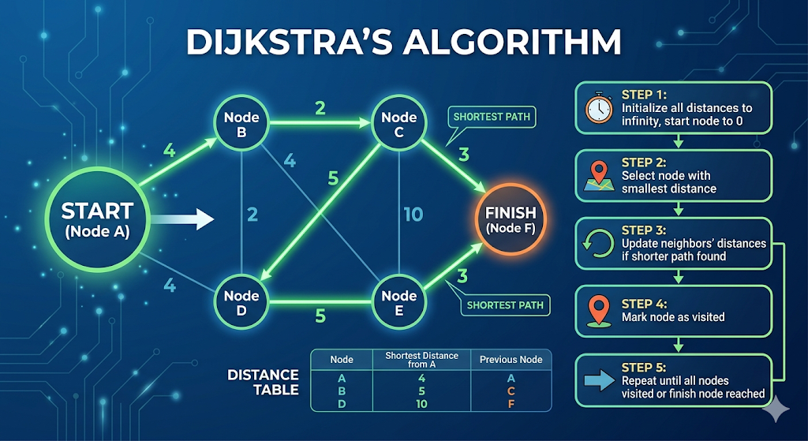

14. Why is recursion considered memory-intensive? Explain with a call stack diagram.
Answer:
Recursion uses function calls repeatedly, and each call is stored in the call stack, increasing memory usage.
Reasons:
- Each call stores variables and return address
- Stack grows with each recursive call
- Deep recursion → stack overflow
- Memory not released until function returns
- Extra overhead of function calls
- Uses more memory than iteration
- Slower due to stack handling
Call Stack Diagram:
Factorial(3)

Call Stack:
factorial(3)
factorial(2)
factorial(1)
factorial(0)

Now returning:
factorial(0)=1
factorial(1)=1
factorial(2)=2
factorial(3)=6
Real-Life Example:
Like stacking plates:
- More plates → more space used
- 

15. Explain the concept of an AVL tree and why rotations are necessary to maintain balance.
Answer:
An AVL tree is a self-balancing binary search tree where the difference between heights of left and right subtree ≤ 1.
Key Points:
- Balance factor = height(left) – height(right)
- Allowed values = -1, 0, 1
- If imbalance occurs → rotations used
- Maintains O(log n) operations
- Automatically balances after insert/delete
- Prevents skewed tree
- Improves search efficiency
Imbalance Example:
Insert: 10, 20, 30

Before Rotation:
10
\
20
\
30
Rotation (Left Rotation):
20
/ \
10 30
Why Rotation Needed:
- To maintain balance
- To avoid O(n) complexity
- To keep tree height minimal 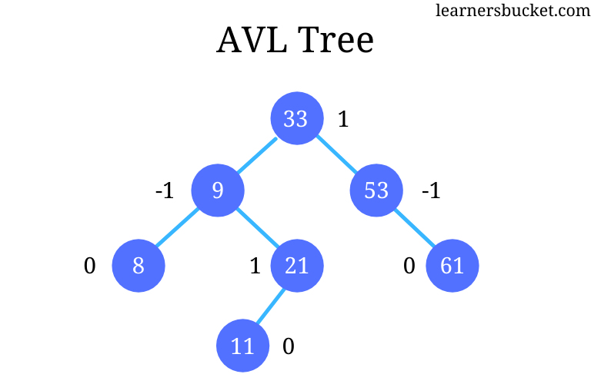

16. Compare recursion and iteration in terms of memory usage, performance, and code readability.
Answer:
Factor | Recursion | Iteration
Memory | High (stack used) | Low
Performance | Slower | Faster
Code Length | Short | Longer
Readability | Easy | Moderate
Debugging | Difficult | Easy
Risk | Stack overflow | No risk
Use case | Divide problems | Simple loops
Example:
- Recursion: factorial using function calls
- Iteration: factorial using loop
Conclusion:
- Recursion → better readability
- Iteration → better performance

17. Differentiate between a binary tree and a binary search tree. When is a BST preferred over a simple binary tree?
Answer:
Feature | Binary Tree | Binary Search Tree
Structure | Any order | Sorted order
Rule | No rule | Left < Root < Right
Searching | O(n) | O(log n)
Insertion | Anywhere | Based on value
Traversal | No order | Sorted output
Use case | General tree | Searching
Efficiency | Low | High
Diagram:
Binary Tree:
10
/ \
30 5
BST:
10
/ \
5 30
When BST Preferred:
- When fast search required
- When sorted data needed
- When dynamic insertion required 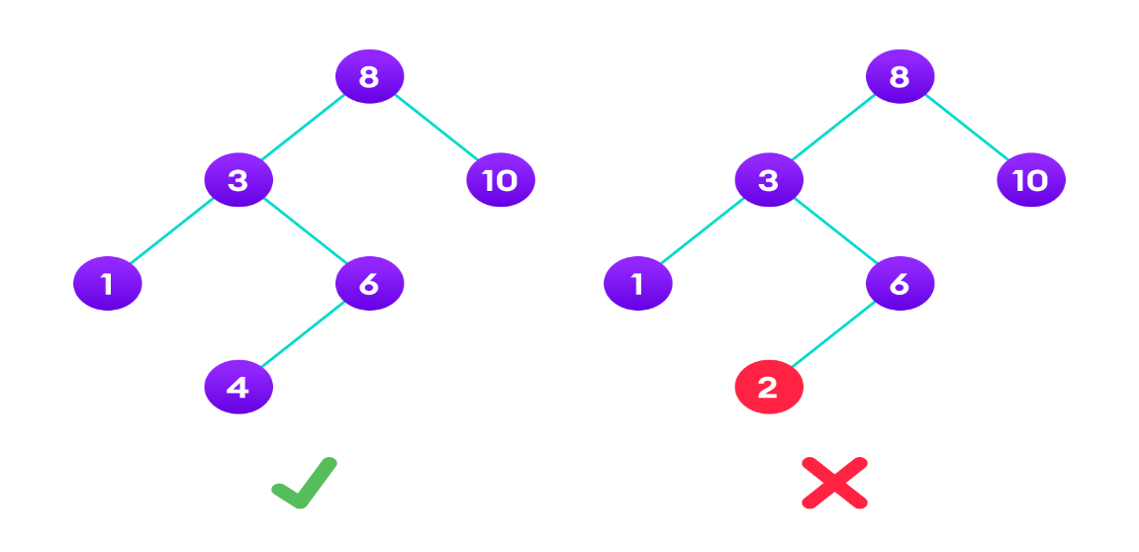

18. Compare the time complexity of searching, inserting, and deleting in a sorted array versus a balanced BST.
Answer:
Operation | Sorted Array | Balanced BST
Searching | O(log n) | O(log n)
Insertion | O(n) | O(log n)
Deletion | O(n) | O(log n)
Access | O(1) | O(log n)
Flexibility | Low | High
Memory | Contiguous | Pointer based
Use case | Static data | Dynamic data
Explanation:
- Array needs shifting → slow insert/delete
- BST adjusts automatically → faster operations

19. Differentiate between greedy algorithms and dynamic programming with one real-world example for each.
Answer:
Feature | Greedy | Dynamic Programming
Approach | Local optimal | Global optimal
Decision | One-time | Multiple stages
Complexity | Less | More
Memory | Low | High
Backtracking | No | Yes
Optimal solution | Not always | Always
Speed | Faster | Slower
Greedy Example:
Fractional Knapsack
Pick highest value item first
Real-Life:
Choosing biggest discount items first in shopping

Dynamic Programming Example:
Fibonacci / Shortest Path
Solve subproblems and store results
Real-Life:
Planning budget over months to maximize savings 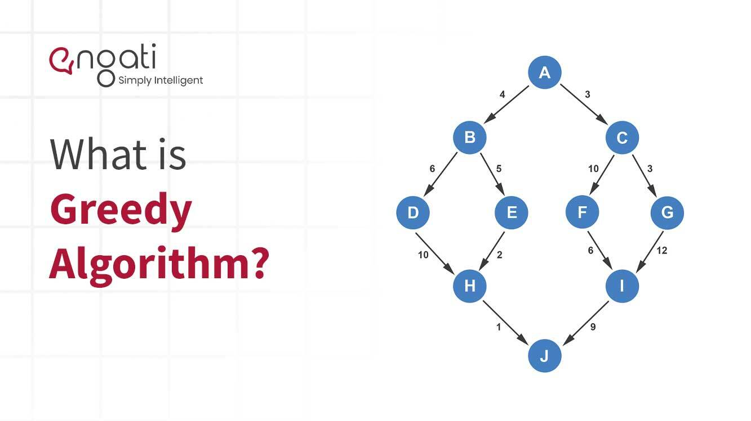

20. Compare the space complexity of merge sort (O(n)) and quick sort (O(log n)). When would you choose merge sort despite its higher space requirement?
Answer:
Factor | Merge Sort | Quick Sort
Space | O(n) | O(log n)
Stability | Stable | Not stable
Worst Case | O(n log n) | O(n²)
Average Case | O(n log n) | O(n log n)
Memory | High | Low
Recursion | Yes | Yes
Use case | Large data, linked list | In-place sorting

Diagram:
Merge Sort:
[4 2 6 1]
→ divide → [4 2] [6 1]
→ divide → [4][2] [6][1]
→ merge → [2 4] [1 6]
→ merge → [1 2 4 6]
Quick Sort:
Pivot = 4
[2 1] 4 [6]
→ recursively sort

When to Choose Merge Sort:
- When stable sorting needed
- When working with linked lists
- When guaranteed O(n log n) needed
- When data is very large
- When external sorting required
- When worst-case must be avoided
- When parallel processing used

Conclusion:
- Merge sort → reliable, stable
- Quick sort → faster, memory efficient
21. You are designing an autocomplete feature for a search engine. Which data structure would you use and why?
Answer:
For an autocomplete feature, the best data structure is a Trie.
Why Trie is used:
- Stores words character by character
- Fast prefix searching
- Easy to suggest matching words
- Search time depends on prefix length
- Efficient for dictionary-type data
- Good for autocomplete systems
- Saves repeated prefix storage
Diagram:
Words: cat, car, care, dog

root
/ \
c d
| |
a o
/ \ \
t r g
/
e
Example:
If user types:
ca
Trie gives suggestions:
cat, car, care
Real-Life Example:
Like mobile keyboard suggestions:
- type hel
- suggestions: hello, help, helmet
Why not array or linked list:
- Array: slower searching
- Linked list: no prefix advantage
- Trie: direct prefix-based search
Conclusion:
Trie is best for autocomplete because it supports fast prefix matching and word suggestions.

22. In a real-time system with limited memory, would you choose merge sort or quick sort? Justify your answer.
Answer:
In a real-time system with limited memory, I would choose Quick Sort.
Reasons:
- Quick sort uses less extra memory
- Space complexity is O(log n)
- Merge sort needs extra array space
- Merge sort space complexity is O(n)
- Quick sort is more memory efficient
- Good when RAM is limited
- Faster in practice for many cases
Comparison Table:
Feature | Merge Sort | Quick Sort
Extra Space | O(n) | O(log n)
Memory Use | High | Low
Speed | Good | Very good
Real-time use | Less suitable | More suitable
Diagram:
Merge Sort:
[4 2 6 1]
needs extra arrays while merging

Quick Sort:
[4 2 6 1]
uses pivot and partitions in place
Real-Life Example:
Suppose a small device like:
- ATM machine
- Embedded controller
- Sensor system
These have limited memory, so Quick Sort is better.
Note:
Quick sort worst case can become O(n²), but with good pivot selection it performs well.
Conclusion:
For limited memory systems, Quick Sort is preferred because it needs less extra space.

23. Explain how a browser's back and forward buttons can be implemented using two stacks.
Answer:
A browser’s Back and Forward buttons can be implemented using two stacks:
- Back stack
- Forward stack
Working:
- Current page is open
- When new page is visited, current page goes to back stack
- Forward stack is cleared
- When Back is pressed, current page goes to forward stack
- Top page from back stack becomes current
- When Forward is pressed, current page goes to back stack
- Top page from forward stack becomes current
Diagram:
Current Page: C

Back Stack: A, B
Forward Stack: Empty
When Back is pressed:
Move C to Forward Stack
Pop B from Back Stack

Current Page: B

Back Stack: A
Forward Stack: C
When Forward is pressed:
Move B to Back Stack
Pop C from Forward Stack

Current Page: C

Back Stack: A, B
Forward Stack: Empty
Real-Life Example:
Open pages in order:
Google → YouTube → ChatGPT
- Back stack stores old pages
- Forward stack stores pages you moved back from
Simple Python Code:
back_stack = []
forward_stack = []
current = "Google"

def visit(page):
global current
back_stack.append(current)
current = page
forward_stack.clear()

def back():
global current
if back_stack:
forward_stack.append(current)
current = back_stack.pop()

def forward():
global current
if forward_stack:
back_stack.append(current)
current = forward_stack.pop()

visit("YouTube")
visit("ChatGPT")
back()
print("Current:", current)
forward()
print("Current:", current)
Output:
Current: YouTube
Current: ChatGPT
Conclusion:
Two stacks are used because browser navigation works in LIFO order.

24. Design a parking lot system using a stack-based or queue-based approach. Explain your choice and how overflow and underflow would be handled.
Answer:
A parking lot system can be designed using a queue-based approach if cars leave in the same order they arrive.
A stack-based approach can be used if cars are parked in a single narrow lane and the last parked car leaves first.
Best Choice:
For a normal entry-exit system, Queue is better.
Why Queue:
- First car entered leaves first
- Follows FIFO rule
- Suitable for waiting line
- Easy to manage entry and exit
- Fair system for cars
- Good for token-based parking
- Matches real parking flow
Queue Diagram:
Entry → [Car1] [Car2] [Car3] → Exit
Operations:
- Enqueue = new car enters
- Dequeue = car exits
Overflow:
Overflow happens when parking lot is full.
Condition:
rear == max_size - 1
Action:
- Show message: Parking Full
- Do not allow new car
Underflow:
Underflow happens when no car is present.
Condition:
front > rear or queue empty
Action:
- Show message: Parking Empty
- No exit possible
Real-Life Example:
Cars enter:
Car1, Car2, Car3
Cars leave:
Car1 first, then Car2
Python Code:
parking = []
size = 3
def park(car):
if len(parking) == size:
print("Parking Full")
else:
parking.append(car)
print(car, "parked")
def leave():
if len(parking) == 0:
print("Parking Empty")
else:
print(parking.pop(0), "left")
park("Car1")
park("Car2")
park("Car3")
park("Car4")
leave()
leave()
print(parking)
Output:
Car1 parked
Car2 parked
Car3 parked
Parking Full
Car1 left
Car2 left
['Car3']
Stack Case:
If there is only one narrow lane:
[Car1, Car2, Car3]
Then Car3 must leave first.
So stack is suitable for:
- Single path parking
- Last in, first out cases
Conclusion:
- Queue for normal parking
- Stack for narrow one-way parking
- Overflow = full parking
- Underflow = empty parking

25. You are given a large dataset that does not fit into memory. Propose a sorting algorithm and explain how you would implement it.
Answer:
For a very large dataset that does not fit into memory, the best choice is External Merge Sort.
Why External Merge Sort:
- Works for huge files
- Does not require full data in RAM
- Sorts data in small parts
- Merges sorted parts later
- Efficient for disk-based data
- Used in databases and big data
- Suitable for large files
Steps of Implementation:
- Divide dataset into small chunks
- Load one chunk into memory
- Sort that chunk
- Save sorted chunk back to disk
- Repeat for all chunks
- Merge all sorted chunks
- Final merged file is fully sorted
Diagram:
Large File
|
v
Split into chunks
|
v
Chunk1 Chunk2 Chunk3
sort sort sort
| | |
save save save
\ | /
\ | /
Merge all
|
v
Final Sorted File
Real-Life Example:
Suppose you have:
- 100 GB student records
- RAM only 8 GB
Then:
- load small part
- sort it
- save it
- merge all sorted parts
Python Example:
data = [40, 10, 30, 20, 50, 15, 5, 35]
chunk1 = sorted(data[:4])
chunk2 = sorted(data[4:])
result = []
i = j = 0

while i < len(chunk1) and j < len(chunk2):
if chunk1[i] < chunk2[j]:
result.append(chunk1[i])
i += 1
else:
result.append(chunk2[j])
j += 1
result.extend(chunk1[i:])
result.extend(chunk2[j:])
print("Chunk1:", chunk1)
print("Chunk2:", chunk2)
print("Merged:", result)
Output:
Chunk1: [10, 20, 30, 40]
Chunk2: [5, 15, 35, 50]
Merged: [5, 10, 15, 20, 30, 35, 40, 50]
Use Cases:
- Large database records
- Search engine indexing
- Log files
- Big CSV files
Conclusion:
For data larger than memory, External Merge Sort is the best sorting method because it handles disk-based large data efficiently.

