1. Explain the Architecture and Working of a Natural Language Processing (NLP) System.
Natural Language Processing (NLP) is a branch of Artificial Intelligence that enables computers to understand, analyze, and generate human language.

Architecture of an NLP System
An NLP system mainly consists of the following components:

1. Input Module
- Accepts text or speech input from users.
- Example: Chat messages, voice commands.

2. Preprocessing Module
- Cleans and prepares text for processing.
- Removes stop words, punctuation, etc.

3. Lexical Analysis
- Converts text into words or tokens.
- Identifies vocabulary and word meanings.

4. Syntax Analysis
- Checks grammatical structure of sentences.
- Creates parse trees.

5. Semantic Analysis
- Determines the meaning of sentences.

6. Pragmatic Analysis
- Understands context and intention.

7. Output Generation
- Produces meaningful output such as translation, summary, or response.

Working of NLP System
- User provides input text or speech.
- Text is preprocessed.
- Words are tokenized.
- Grammar and sentence structure are analyzed.
- Meaning and context are identified.
- Final output is generated.

Applications of NLP
- Chatbots
- Language translation
- Sentiment analysis
- Voice assistants
- Text summarization

Conclusion
NLP systems help computers understand and process human language efficiently.
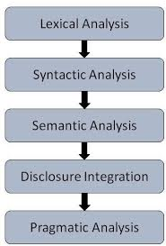

2. Describe the Different Levels of Natural Language Processing.
NLP processes language at different levels to understand text meaning and structure.

Levels of NLP

1. Phonological Level
- Deals with sound patterns in speech.
- Used in speech recognition systems.

Example
Recognizing spoken words in Google Assistant.

2. Morphological Level
- Studies structure of words.
- Identifies root words, prefixes, and suffixes.

Example
“Playing” → “Play” + “ing”

3. Lexical Level
- Analyzes words and vocabulary.
- Performs tokenization and POS tagging.

Example
Breaking sentence into words.

4. Syntactic Level
- Analyzes grammatical structure.
- Checks sentence correctness.

Example
“Ram eats mango” is grammatically correct.

5. Semantic Level
- Determines sentence meaning.

Example
Understanding meaning of “bank” based on context.

6. Discourse Level
- Analyzes relationship between sentences.

Example
Understanding references in paragraphs.

7. Pragmatic Level
- Understands real meaning using context.

Example
“Can you open the door?” is a request, not a question.

Conclusion
Different NLP levels help systems understand language from sound to context and meaning. 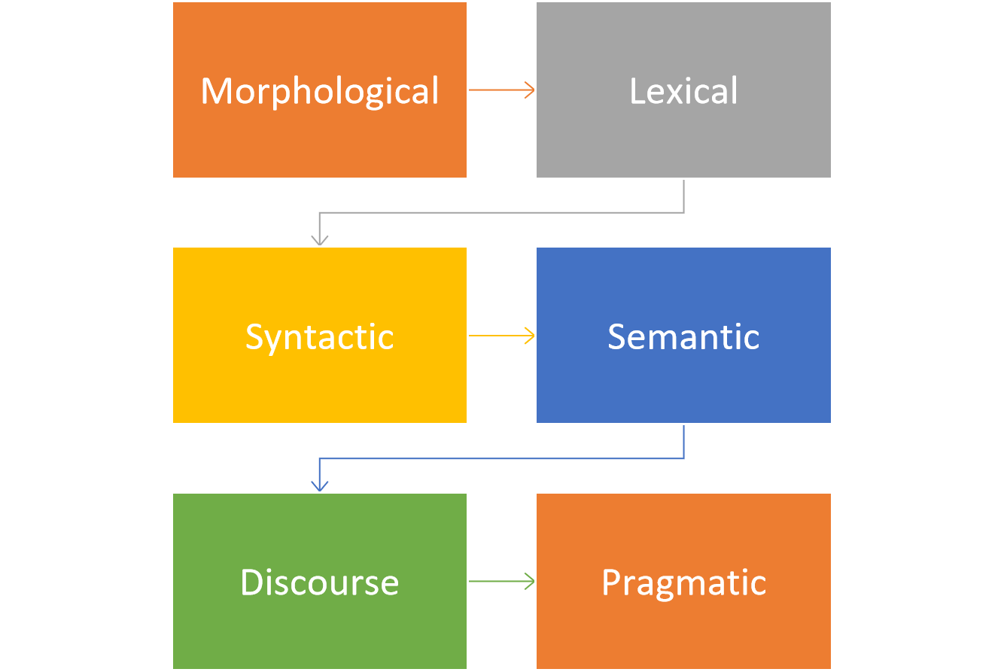

3. Explain the Process of Text Preprocessing in NLP with Suitable Example.
Text preprocessing is the process of cleaning and transforming raw text into useful format for NLP tasks.

Steps in Text Preprocessing

1. Tokenization
Splitting text into words or sentences.

Example
Sentence:
“I love NLP”
Tokens:
- I
- love
- NLP

2. Lowercasing
Converts text into lowercase.

Example
“NLP” → “nlp”

3. Removing Stop Words
Removes common words with little meaning.

Examples
- is
- the
- and

4. Removing Punctuation
Removes symbols like commas and periods.

Example
“Hello!” → “Hello”

5. Stemming
Reduces words to root form.

Example
“Playing” → “Play”

6. Lemmatization
Converts words into meaningful base form.

Example
“Better” → “Good”

7. Removing Numbers and Special Characters
Eliminates unnecessary symbols.

Example of Text Preprocessing
Original Sentence:
“Machine Learning is AMAZING!!!”
After preprocessing:
“machine learning amazing”

Applications
- Sentiment analysis
- Spam detection
- Chatbots

Conclusion
Text preprocessing improves NLP model accuracy and efficiency.

4. What is Part-of-Speech (POS) Tagging? Explain Different POS Tagging Approaches and Their Applications in Natural Language Processing.

Part-of-Speech (POS) Tagging
POS tagging is the process of assigning grammatical categories to words in a sentence.

Common POS Tags
- Noun
- Verb
- Adjective
- Adverb
- Pronoun

Example
Sentence:
“Ram plays cricket”
Word | POS Tag
Ram | Noun
plays | Verb
cricket | Noun

POS Tagging Approaches

1. Rule-Based POS Tagging
- Uses grammar rules and dictionaries.

Advantages
- Easy to understand

Disadvantages
- Difficult for complex languages

2. Statistical POS Tagging
- Uses probabilities from training data.

Example
Hidden Markov Model (HMM)

3. Machine Learning-Based POS Tagging
- Uses algorithms like SVM and Neural Networks.

Advantages
- High accuracy

Disadvantages
- Requires large dataset

Applications of POS Tagging
- Machine translation
- Speech recognition
- Information extraction
- Text summarization
- Chatbots

Conclusion
POS tagging helps NLP systems understand sentence structure and grammar. 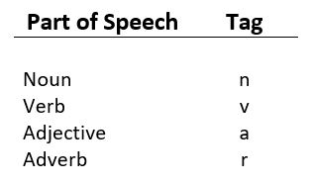 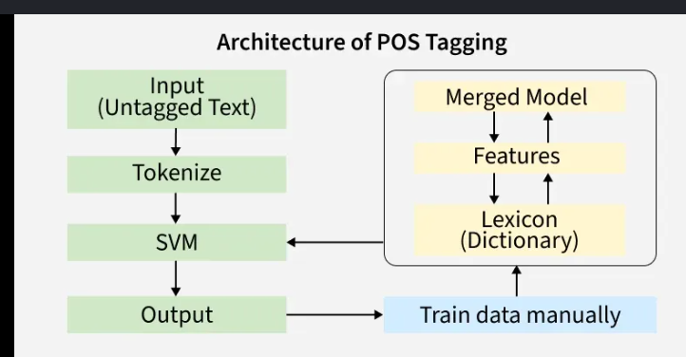

5. Describe the Working of the Bag of Words (BoW) Model in NLP. Explain its Advantages, Limitations, and Applications.

Bag of Words (BoW)
Bag of Words is a text representation model that converts text into numerical form based on word frequency.

Working of BoW Model

Step 1: Create Vocabulary
Collect unique words from all documents.

Step 2: Count Word Frequency
Count occurrences of each word.

Example
Documents:
- “I love NLP”
- “I love AI”
Vocabulary:
- I
- love
- NLP
- AI
Word | Doc1 | Doc2
I | 1 | 1
love | 1 | 1
NLP | 1 | 0
AI | 0 | 1

Advantages
- Simple implementation
- Easy to understand
- Works well for small datasets

Limitations
- Ignores word order
- Ignores context
- Creates sparse matrices

Applications
- Spam detection
- Sentiment analysis
- Document classification
- Text mining

Conclusion
BoW is a basic but powerful text representation method in NLP. 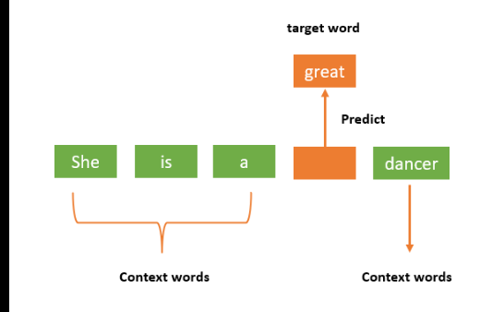

6. Explain the TF-IDF (Term Frequency–Inverse Document Frequency) Technique in Detail with Suitable Example.

TF-IDF
TF-IDF is a statistical technique used to determine the importance of a word in a document.

Components of TF-IDF

1. Term Frequency (TF)
Measures how frequently a word appears in a document.
Formula:
TF = \frac{\text{Number of times term appears in document}}{\text{Total number of words in document}}

2. Inverse Document Frequency (IDF)
Measures importance of a term across all documents.
Formula:
IDF = \log\left(\frac{\text{Total number of documents}}{\text{Number of documents containing the term}}\right)

3. TF-IDF Formula
TF\text{-}IDF = TF \times IDF

Example
Document 1:
“Machine learning is useful”
Document 2:
“Machine learning is powerful”
Word:
“useful”
TF of useful in Document 1:
TF = \frac{1}{4}
IDF:
IDF = \log\left(\frac{2}{1}\right)
TF-IDF gives higher importance to rare words.

Applications
- Search engines
- Document ranking
- Text mining
- Recommendation systems

Conclusion
TF-IDF helps identify important words in documents. 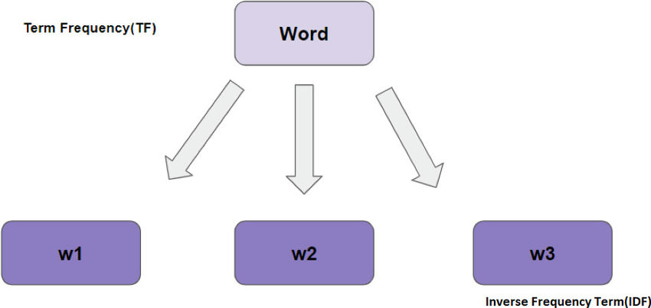

7. Discuss the Concept of Word Embedding in NLP. Explain Word2Vec, GloVe, and FastText Models with Examples. 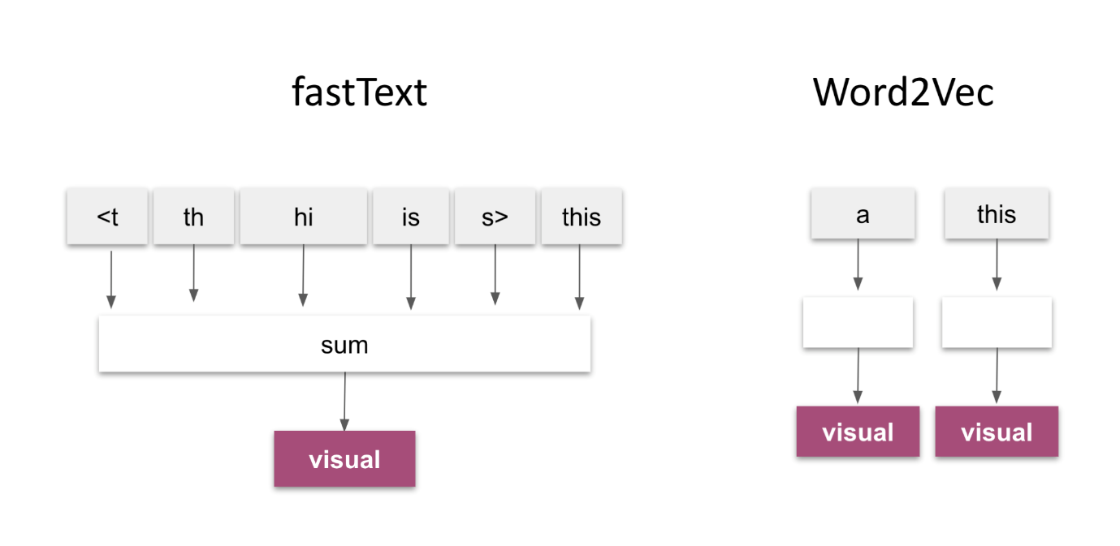

Word Embedding
Word embedding is a technique that converts words into dense numerical vectors.

Advantages
- Captures semantic meaning
- Reduces dimensionality
- Improves NLP accuracy

1. Word2Vec
Word2Vec converts words into vectors using neural networks.

Types
- CBOW (Continuous Bag of Words)
- Skip-Gram

Example
“King” and “Queen” vectors are closely related.

2. GloVe
GloVe (Global Vectors) uses global word co-occurrence statistics.

Features
- Captures semantic relationships
- Faster training

Example
“Paris” is related to “France”.

3. FastText
FastText represents words using character n-grams.

Advantages
- Handles unknown words
- Better for rare words

Example
“playing” and “played” have similar vectors.

Applications of Word Embedding
- Machine translation
- Chatbots
- Text classification
- Recommendation systems

Conclusion
Word embeddings help machines understand word meanings and relationships. 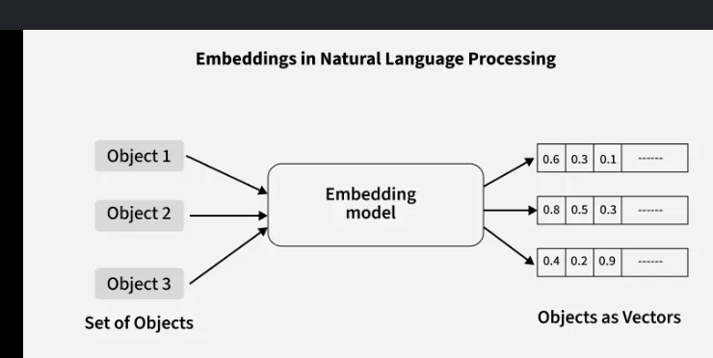

8. Explain the Working of the BERT Model in Natural Language Processing. Discuss its Advantages and Real-World Applications.

BERT
BERT is a deep learning model developed by Google for understanding natural language.

Working of BERT

1. Bidirectional Processing
- Reads text from both left and right directions.

2. Transformer Architecture
- Uses attention mechanism.

3. Pre-training
BERT is trained using:
- Masked Language Modeling
- Next Sentence Prediction

4. Fine-Tuning
Model is adjusted for specific NLP tasks.

Advantages of BERT
- High accuracy
- Understands context better
- Works for multiple NLP tasks
- Supports transfer learning

Applications of BERT
- Search engines
- Chatbots
- Question answering systems
- Sentiment analysis
- Language translation

Conclusion
BERT significantly improved NLP performance using bidirectional learning. 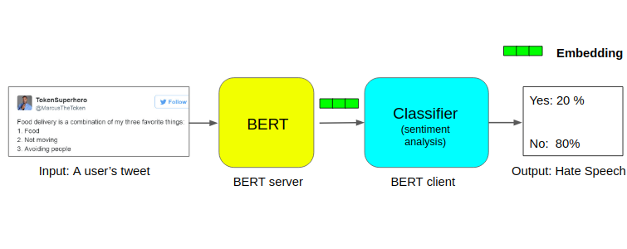

9. Explain Named Entity Recognition (NER) in Natural Language Processing. Discuss its Working and Practical Applications.

Named Entity Recognition (NER)
NER is an NLP technique used to identify and classify named entities in text.

Types of Entities
- Person
- Location
- Organization
- Date
- Money

Example
Sentence:
“Rahul works at Microsoft in Mumbai.”
Word | Entity
Rahul | Person
Microsoft | Organization
Mumbai | Location

Working of NER

Step 1: Text Preprocessing
Clean and tokenize text.

Step 2: Feature Extraction
Extract important features from text.

Step 3: Entity Detection
Identify named entities.

Step 4: Classification
Assign categories to entities.

Applications of NER
- Information extraction
- Search engines
- Chatbots
- Medical diagnosis systems
- Resume parsing

Conclusion
NER helps extract meaningful information from large text data. 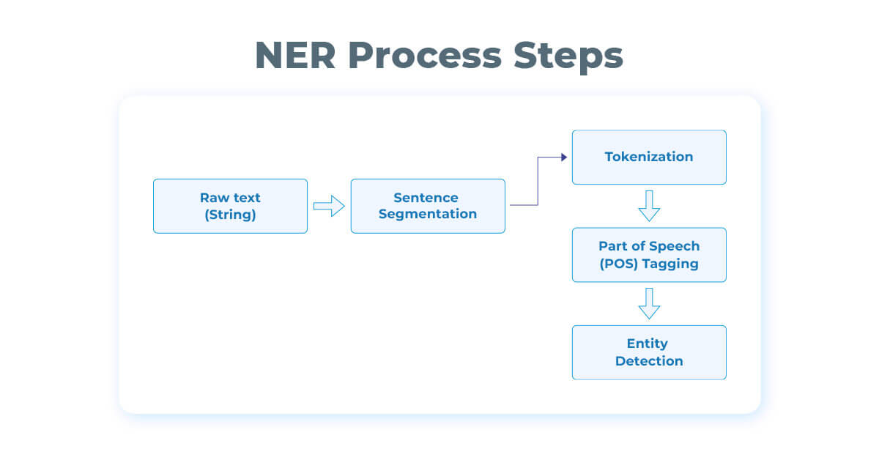

10. Describe Various Text Classification Techniques Used in NLP. Compare Naïve Bayes, Support Vector Machine (SVM), and Deep Learning Approaches.

Text Classification
Text classification is the process of categorizing text into predefined classes.

Techniques Used in NLP
- Naïve Bayes
- Support Vector Machine (SVM)
- Deep Learning
- Decision Trees
- Neural Networks

1. Naïve Bayes
Uses probability theory based on Bayes theorem.

Advantages
- Fast
- Simple
- Works well for spam filtering

Disadvantages
- Assumes feature independence

2. Support Vector Machine (SVM)
Separates data using hyperplanes.

Advantages
- High accuracy
- Effective for text classification

Disadvantages
- Slower for large datasets

3. Deep Learning
Uses neural networks for classification.

Examples
- RNN
- LSTM
- BERT

Advantages
- Very high accuracy
- Learns complex patterns

Disadvantages
- Requires large data and computation

Comparison Table
Feature | Naïve Bayes | SVM | Deep Learning
Speed | Fast | Medium | Slow
Accuracy | Medium | High | Very High
Complexity | Low | Medium | High
Data Requirement | Small | Medium | Large

Conclusion
Different text classification methods are selected based on dataset size, accuracy, and computational requirements. 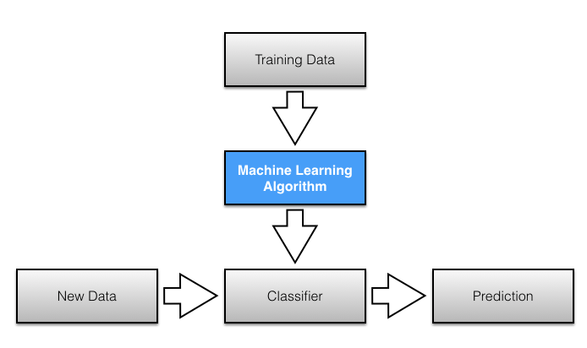

11. Explain the Concept of Regular Expression and Operators Used in RE.

Regular Expression (RE)
A regular expression is a pattern used for searching and matching text.

Uses of Regular Expression
- Text searching
- Data validation
- Information extraction
- Pattern matching

Operators Used in RE
Operator | Meaning
. | Matches any character
* | Zero or more occurrences
+ | One or more occurrences
? | Optional character
^ | Start of string
$ | End of string
[] | Character set
\d | Digit
\w | Word character

Examples

Example 1
Pattern:
[0-9]+
Matches numbers.

Example 2
Pattern:
^Hello
Matches strings starting with “Hello”.

Applications
- Email validation
- Password checking
- Data cleaning
- Web scraping

Conclusion
Regular expressions are powerful tools for text processing and pattern matching. 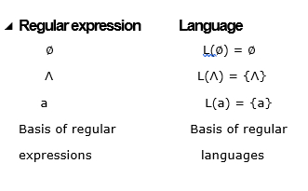

12. Elaborate the Term NFA and DFA with Example.

DFA (Deterministic Finite Automata)
DFA is a finite automaton where each state has exactly one transition for each input symbol.

Features
- Deterministic behavior
- One transition per input
- Faster execution

Example of DFA
Language:
Strings ending with “1”
States:
- q0
- q1
Transitions:
- q0 → q1 on input 1
- q1 → q1 on input 1

NFA (Non-Deterministic Finite Automata)
NFA is a finite automaton where multiple transitions are possible for one input.

Features
- Multiple transitions allowed
- Easier design
- Includes epsilon transitions

Example of NFA
Language:
Strings containing “ab”
State q0 can move to:
- q0 on input a
- q1 on input a

Difference Between DFA and NFA
DFA | NFA
One transition per symbol | Multiple transitions possible
No epsilon transition | Epsilon transition allowed
Faster execution | Easier to construct
More states required | Fewer states required

Applications
- Compiler design
- Pattern matching
- Text processing
- Lexical analysis

Conclusion
DFA and NFA are finite automata used for pattern recognition and language processing.
