**STUDENT EXAM PORTAL**

**Problem Statement**

Since the traditional have many drawbacks such as time consuming, Difficulty of analyzing the test manually, More observers are required to take exam of many students,Results are not accurate since calculations is done manually, The chance of losing exam's result is higher in current systems, Checking of result is time consuming since it done manually, Limitation of no of student can give examination at a time. with the development of information technology and use it in an orderly and properly helps to overcome the existing error in the manual system . Student Exam portal saves the exams information in a database, and this make it an easier way to give exam teachers can add theirs exams rules , and student can give exam in a totally automated system. Today , Student Exam portal is considered a fast developing examination method because of its accuracy and speed. It is also needed less manpower to handle the examination. Almost all organizations today, are managing their exams by online Student Exam portal, since it reduces student's time in examinations. Organizations can also easily monitor the progress of the student that they give through an examination. As a result of this, the result is calculated in less time. It also helps diminishing the need for paper. Online examination project in angular is very useful to learn it, According to today’s requirement Online examination system is significantly important to the educational institution to prepare the exams, saving the time and effort that is required to check the exam papers and to prepare the results reports. Student Exam portal helps the educational institutions to monitor their students and keep eyes on their progress. The best use of this system in Scholastic Institute and training centers because it helps in managing the exams and get the results in easy and an efficient manner. Until today the preparing for exams and preparing the results was performed manually, this required more time to complete. When a person enters the online test, a system will ask for a login id and password. If the person is authorized, by simply giving his login id and password he will enter filling the registration field based on the privilege. If the user is new he has to register as a user by filling in the registration details.

**Mandatory Modules:**

**login** -The Login Module is a portal module that allows students to type a user name and password to provide access to student to navigate through options writing the examination.

**Registration**: Provide registration for individual users to create account for Student Exam portal. The details are:

1. Name
2. Email
3. Mobile Number
4. City
5. Date Of Birth
6. Qualification
7. State
8. Year Of Completion
9. Password

**Add student**: This module is used to add the another student.

**Exam:** this is the main module which displays the courses for the student on which course he wants to take test after that it displays question.

**Report:** this module displays the overall student progress.

**Finish:** this module is responsible to allow the students to finish there test.

**Test:** this module allows the students to write the test.

**Technologies used :**

Javascript

HTML/CSS

Typescript

Java

**Frameworks:**

Angularjs

Springboot

Mongodb/MySQL

**Student Exam Portal**

**Project Abstract:**

Student Exam Portal is a web-based examination system which is designed and developed using angular fronted framework and springboot mongodb where examinations are given online. either through the internet or intranet using computer system. The main goal of this online examination system is to effectively evaluate the student thoroughly through a totally automated system that not only reduce the required time but also obtain fast and accurate results. online examination system save the exams information in a database , teachers can set the correct answers, specify the exam period, register students ,delete students , show questions for students randomly, calculate and show the final results for students.

**Project Flow:**

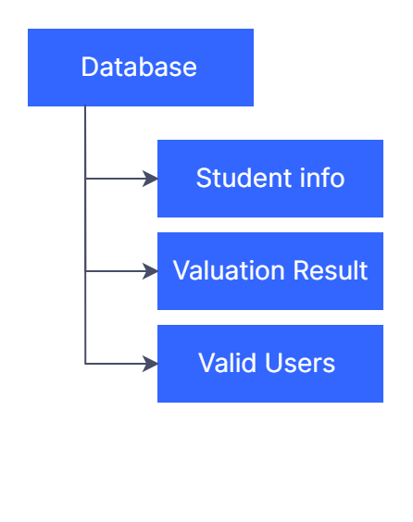

This project is designed and developed using angularjs and springboot .Angular is one of the most popular JavaScript frameworks with incredible tooling, speed and performance. This project Builds the Fully-Fledged Todo App with Spring Boot & MongoDB/MySQL in the Backend and Angular in the frontend.

**Validation Parameters:**

During registration student will required to enter password in a specified format like it should be more than 8 characters and in alphanumeric format and should contain one uppercase letter and one special character. This makes the password strong and difficult to crack.

student is required to enter there login details to login into the portal to write the exam . During login the credentials are checked to make sure that the user trying to login is authorized user and will be allowed to avail the services.And student have to select the course on which he wants to write the exam on.

**Module images :**

Home page:

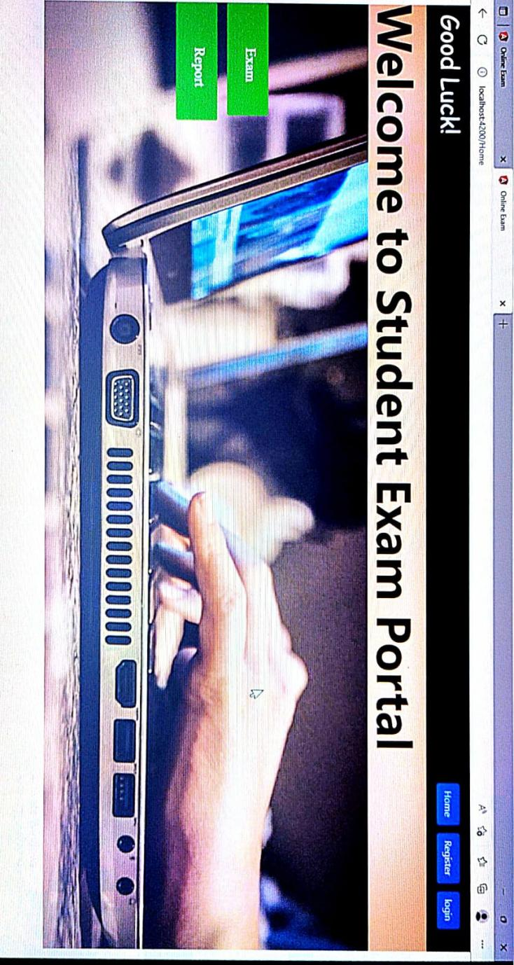

Register module:

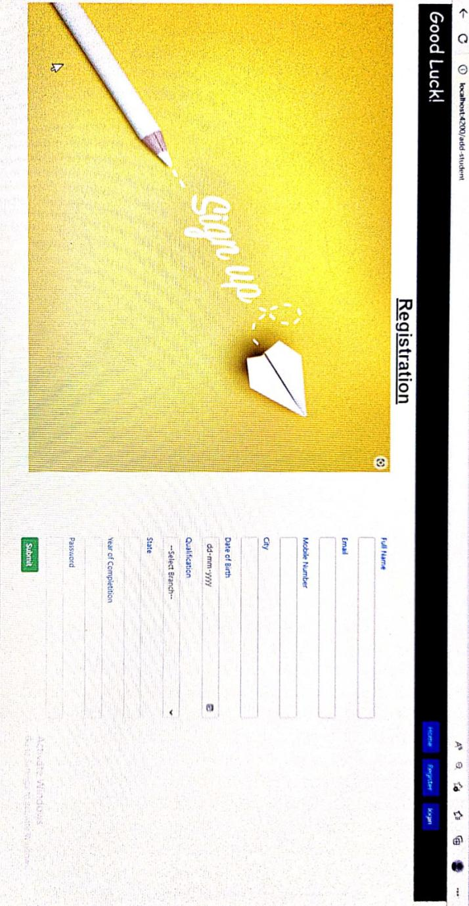

Login module:

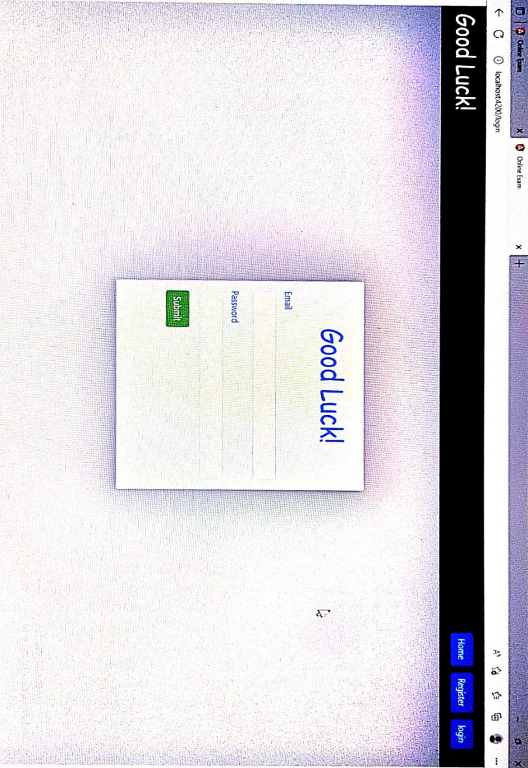

Exam Module:

