SLA Management Handbook

Volume 3
Service and Technology Examples

GB 917-3

Member Evaluated Version 2.1 January 2005

©TeleManagement Forum 2005

Notice
The TeleManagement Forum (“TM Forum”) has made every effort to ensure that the contents of this document are accurate. However, no liability is accepted for any errors or omissions or for consequences of any use made of this document.
This document is a draft working document of TM Forum and is provided to the public solely for comments and evaluation. It is not a Forum Approved Document and is solely circulated for the purposes of assisting TM Forum in the preparation of a final document in furtherance of the aims and mission of TM Forum. Any use of this document by the recipient is at its own risk. Under no circumstances will TM Forum be liable for direct or indirect damages or any costs or losses resulting from the use of this document by the recipient.
This document is a copyrighted document of TM Forum. Without the appropriate permission of the TM Forum, companies that are not members of TM Forum are not permitted to make copies (paper or electronic) of this draft document other than for their internal use for the sole purpose of making comments thereon directly to TM Forum.
This document may involve a claim of patent rights by one or more TM Forum members, pursuant to the agreement on Intellectual Property Rights between TM Forum and its members, and by non-members of TM Forum.
Direct inquiries to the TM Forum office:
89 Headquarters Plaza North - Suite 350
Morristown, NJ 07960 USA
Tel No. +1 973 292 1901
Fax No. +1 973 993 3131
TM Forum Web Page www.tmforum.org

Acknowledgements
TeleManagement Forum would like to thank the following individuals for contributing their time and expertise to the production of the SLA Management Handbook:
- Malcolm Sinton, QinetiQ, (Team Leader 2003)
- Greg Bain, National Communications System (NCS)
- Debbie Burkett, TeleManagement Forum
- Jane Hall, GMD FOKUS
- Peter Huckett, ACTERNA
- Ranveer (Ran) Rathore, NASA
- Tobey Trygar, Telcordia Technologies (Volume 3 Editor)
- Lightsey Wallace, Lightsey Enterprises (Team Leader 2001 - 2002)
A number of people have provided input and comments to the work of the team. Although not an exhaustive list, many thanks to the following individuals for their contributions:
- David Banes, TenTen Communications
- Sandro Borioni, Sodalia SpA
- Stephen Cross, Nortel Networks
- Bill DeYoung, Verizon (Team Sponsor to 2001)
- Jock Embry, Opening Technologies
- John Gormont, Spirent Communications
- Peter Jasion, Tivoli
- Håkan Kappelin, Ericsson
- Mahmood Karbasi, Oracle
- Veli Kokkonen, Sonera
- Han-Young Lee, Korea Telecom
- Hans Pettersson, EHPT
- Paul Short, TeleManagement Forum
- Alessandro Zorer, Sodalia SpA

About TeleManagement Forum
TeleManagement Forum is an international consortium of communications service providers and their suppliers. Its mission is to help service providers and network operators automate their business processes in a cost- and time-effective way. Specifically, the work of the TM Forum includes:
- Establishing operational guidance on the shape of business processes.
- Agreeing on information that needs to flow from one process activity to another.
- Identifying a realistic systems environment to support the interconnection of operational support systems.
- Enabling the development of a market and real products for integrating and automating telecom operations processes.
The members of TM Forum include service providers, network operators and suppliers of equipment and software to the communications industry. With that combination of buyers and suppliers of operational support systems, TM Forum is able to achieve results in a pragmatic way that leads to product offerings (from member companies) as well as paper specifications.

About this document
This is a TM Forum Guidebook. The guidebook format is used when:
- The document lays out a ‘core’ part of TM Forum’s approach to automating business processes. Such guidebooks would include the Telecom Operations Map and the Technology Integration Map, but not the detailed specifications that are developed in support of the approach.
- Information about TM Forum policy, or goals or programs is provided, such as the Strategic Plan or Operating Plan.
- Information about the marketplace is provided, as in the report on the size of the OSS market.
Document Life Cycle
GB 917-3 is the initial version of Volume 3 of the SLA Management Handbook Version 2.0. The four Volumes of Version 2.0 of the SLA Management Handbook supercede the previous versions of the SLA Management Handbook.
Document History

Version | Date | Purpose
Development Version 0.1 | October 2001 | 1st mapping of existing text into Vol 3
Development Version 1.0 | February 2003 | Output from Brussels Meeting
Development Version 1.1 | July 2003 | Revision from Malvern 1 Meeting
Development Version 1.2 | November 2003 | Input to Malvern 2 Meeting
Development Version 1.3 | January 2004 | Input to Dublin Meeting
Development Version 1.4 | May 2004 | Input to Bristol Meeting
SAC Review Version 1.8 | June 2004 | Submitted for SAC Review
Member Evaluation Version 2.0 | July 2004 | Cosmetic changes & fixes to match template etc.  Posted to web for Member Evaluation
Member Evaluated Version 2.1 | Jan 2005 | Modifications prior to public web posting
Time Stamp
This version of the SLA Management Handbook is valid until a revision is issued.
How to obtain a copy
This document version is available from the TMF Central Web Site.
How to comment on this document
Readers are encouraged to provide comments to the SLA Management Team via email.
Suggestions for comments:
- In order to reduce file size, comments should excerpt only relevant paragraphs, including identifying paragraph headers.
- Be specific. Consider that you might be on a team trying to produce a single text through the process of evaluating numerous comments. We appreciate significant specific input. We are looking for more input than a “word-smith”, however structural help is greatly appreciated where clarity benefits.
- What to look for: errors, omissions, lack of clarity and missing references to other accomplished work (please cite exact applicable section(s) of other documents).
- Questions that provide direction for the team to further develop or expand a specific area are welcome. However, the reader should be aware that this work is intended to be a handbook not an exhaustive thesis, and that we do not intend to duplicate other work.
- Email all comments to the document Editor, Tobey Trygar, ttrygar@telcordia.com, with a copy to the team leader, Malcolm Sinton, mjsinton@qinetiq.com.

Executive Summary
The Service Level Agreement (SLA) Management Handbook series consists of four volumes. These are Volume 1, Executive Overview, Volume 2, Concepts And Principles, Volume 3, Service And Technology Examples, and Volume 4, Enterprise Perspective. The series has a common conceptual base with each volume concentrating on specific topics. The volumes may be read in any order although it is suggested that Volumes 2 and 4 be read before Volume 3. It is expected that the readers of Volume 1 are interested in an overview of the SLA Management process that is sufficient to enable them to provide management guidance to their organizations. For reader convenience, the Executive Summaries for Volumes 1, 2, and 4 are in the Annexes to this document.
The objective of the SLA Management Handbook series is to assist two parties in developing a Service Level Agreement (SLA) by providing a practical view of the fundamental issues. The parties may be an “end” Customer, i.e., an Enterprise, and a Service Provider (SP) or two Service Providers. In the latter case one Service Provider acts as a Customer buying services from the other Service Provider. For example, one provider may supply network operations services to the provider that supplies leased line services to its customers. These relationships are described as the Customer-SP interface and the SP-SP interface.
This volume of the Handbook briefly reviews the essential elements of the concepts and principles presented in Volume 2. Using this as a base, a check list of items for potential inclusion in SLAs is presented. This is then followed by seven examples of the application of the SLA concepts and principles.
The SLA check list contains numerous lists of items that may be included in an SLA. These lists were derived from TMF member contributions, information provided by user groups and by standardization bodies. Not all of these items will be relevant to a specific SLA. The order of the items in the list does not imply a priority. These items may be consolidated or may be disaggregated as needed. Topics covered include service descriptions, service level and service quality specification, service monitoring and reporting, and tariffs and billing issues.
This volume concludes with high level examples of how the principles and concepts defined in Volume 2 can be applied. It should be noted that the services used in the examples can become quite complex in particular instances. The intent in this document is to retain only the essential aspects of the services while illustrating the use of the SLA Parameter Framework.
Note that all parameter values that appear in this document are for illustrative purposes only and are not intended to represent industry agreements or recommendations. Service parameter values are ultimately based on business needs and will be established via the SLA negotiation process.
The examples herein include lease line services, emergency and disaster relief services, ATM Cell Delivery and IP based virtual private networks (VPN).
The SLA Management Handbook series incorporate earlier work that appears in the Performance Reporting Concepts and Definitions Document [TMF 701], in the Service Provider to Customer Performance Reporting Business Agreement [NMF 503] and in Service Quality Management Business Agreement [TMF506].

Table of Contents
Notice iii
Acknowledgements v
About TeleManagement Forum vii
About this document ix
Document Life Cycle ix
Document History ix
Time Stamp x
How to obtain a copy x
How to comment on this document x
Executive Summary xi
Table of Contents xiii
List of Figures xvii
List of Tables xix
Chapter 1 – Introduction 1
1.1 Scope 1
1.2 SLA Relationships 2
1.3 Handbook Benefits 2
1.3.1 Service Providers 3
1.3.2 Customers 3
1.3.3 Equipment And Software Suppliers 3
1.4 Notes For Readers 3
1.5 Overview 4
Chapter 2 – Service Characterization 7
2.1 Service Concepts 7
2.2 Business Applications And Supporting Services 7
2.3 Service Components 8
2.4 Service Access Points 9
2.5 Service Level Agreements 10
2.6 Service Performance 11
2.7 Service Performance And Network Performance 12
2.8 Service Availability 12
2.9 The X.140 Perspective 13
Chapter 3 - Service Parameter Framework 15
3.1 The Service Parameter Framework 15
3.1.1 Service Views 16
3.1.2 Technology Specific Parameters 16
3.1.3 Service Specific Parameters 16
3.1.4 Service/Technology Independent Parameters 16
3.2 Performance Reporting 17
3.2.1 Service Data Sources 17
3.2.2 Performance Data Collected By Network Elements 18
3.2.3 Reporting Process 18
3.3 Parameters 18
Chapter 4 - SLA Contents 19
4.1 Points Of Contact 19
4.2 Services Provided 19
4.3 System Design Information 20
4.4 Supporting Equipment 20
4.5 Level And Quality of Service 20
4.6 Monitoring And Reporting 21
4.7 Service Center 22
4.8 SP Backup And Disaster Recovery Mechanisms 22
4.9 Terms And Conditions 22
4.10 Network And Delivery Upgrades 23
4.11 Change Procedures 23
4.12 Service Violations And Remedies 24
4.13 Tariffs And Billing 24
4.14 Service Termination 24
Chapter 5 - Applications And Examples 25
5.1 Introduction 25
5.2 Leased Lines 25
5.2.1 Trouble Ticket Data 27
5.2.2 Transport Signal Overhead Information 27
5.3 Leased Line Service 28
5.3.1 Trouble Ticket Data - Single Line Service 28
5.3.2 Trouble Ticket Data - Multiple Line Service 29
5.3.3 Network Element Data 30
5.3.4 Defining Service Availability Using NE Data 32
5.3.5 Calculating Service Retainability From NE Data 32
5.3.6 Calculating Service Integrity From NE Data 33
5.4 Emergency And Disaster Relief Services 34
5.5 Priority Service In Third Generation PLMNs 35
5.5.1 The 3GPP Foundation 37
5.5.2 Service Accessibility 37
5.5.3 enhanced Mulit-Level Precedence And Pre-emption 39
5.5.4 Guidelines For PLMN Priority Service 39
5.5.5 PLMN Priority Call Use Case 42
5.5.6 Customer – Service Provider SLA 43
5.5.7 Service Provider – Service Provider SLA 44
5.6 Frame Relay 45
5.7 Frame Relay Service 46
5.7.1 Frame Relay Service Parameters 47
5.7.2 Trouble Ticket Data – Frame Relay Service 48
5.7.3 Traffic Reports – Frame Relay Service 49
5.8 Asynchronous Transfer Mode Networking 50
5.9 ATM Cell Delivery Service 51
5.9.1 Cell Delivery Service Parameters 53
5.9.2 ATM Traffic Reports 54
5.10 Virtual Private Networks 55
5.11 IP-VPN Service 56
5.11.1 IP-VPN Service Parameters 58
5.12 IP Based Information Service 59
5.12.1 DSL Supported Information Service Parameters 61
5.12.2 Traffic Reports For The Information Service 62
5.13 Customer Help Desk Service 62
5.13.1 Help Desk Service Parameters 63
References 65
Acronyms 69
Annex A - Terms and Definitions 75
Annex B – Executive Summary Volume 1 83
Annex C - Executive Summary Volume 2 86
Annex D - Executive Summary For Volume 4 88

List of Figures
Figure 1-1 Structure of the SLA Management Handbook Series 1
Figure 1-2 Service Delivery Relationships 2
Figure 2-1 Relationships Between Applications And Services 7
Figure 2-2 Service Functions And Service Resources 9
Figure 2-3 SAP Locations 10
Figure 2-4 Enterprise SLAs 11
Figure 2-5 Network Performance – Service Performance Relationship 12
Figure 2-6 Relationship Of Service Availability To Service Performance 13
Figure 2-7 Mapping Between X.140 Functions And Performance Components 13
Figure 3-1 Service Parameter Category Framework 15
Figure 3-2 Service Functions-Parameter Categories Relationship 15
Figure 3-3 Performance Reporting Interface 17
Figure 5-1 Simple Leased Line Service 26
Figure 5-2 Representation Of Two Single Leased Circuit Services 26
Figure 5-3 Leased Circuit Service Parameters 31
Figure 5-4 Relation Between SA Components And NE Parameters 31
Figure 5-5 Relationship Between The Scope Of ETS And TDR 34
Figure 5-6 Functional View of 3G PLMN 35
Figure 5-7 Parameters For PLMN Priority Service / End User – Provider 44
Figure 5-8 Parameters For PLMN Priority Service / Provider - Provider 45
Figure 5-9 Frame Relay Base PVC Service 46
Figure 5-10 Frame Relay Service Parameter Framework Example 48
Figure 5-11 ATM Network Hierarchy 50
Figure 5-12 ATM Intra- And Inter- Level Relationships 51
Figure 5-13 Cell Delivery Service Interfaces 52
Figure 5-14 ATM Transfer Capabilities And QoS Classes 53
Figure 5-15 ATM Cell Delivery Service Parameter Framework Example 54
Figure 5-16 Generic VPN Reference Model 56
Figure 5-17 IP-VPN Network 57
Figure 5-18 IP-VPN Service Parameter Framework Example 59
Figure 5-19 Example Of A Composite Service 60
Figure 5-20 IP Service With DSL Access Service Example 61
Figure 5-21 Customer Care Help Desk Service Parameter Example 64

List of Tables
Table 2-1 Business Applications And Business Services 8
Table 5-1 Service Availability Data For Example 1 28
Table 5-2 Service Availability Data For Example 2 29
Table 5-3 Access Class Applications 38
Table 5-4 Access Class Applicability 38
Table 5-5 Frame Relay Service Availability Data 48

– Introduction

Scope
Volume 3 of the SLA Handbook series contains selected examples of the application of the SLA Concepts and Principles discussed in Volume 2. Figure 1-1 describes the relationship among the four volumes in SLA Handbook series. Annexes B through D contain the Executive Summaries from the other three volumes.
The SLA Handbook series was jointly developed by the TeleManagement Forum and the Open Group. Volumes 1 through 3 are available from the TeleManagement Forum. Volume 4 is available from the Open Group.

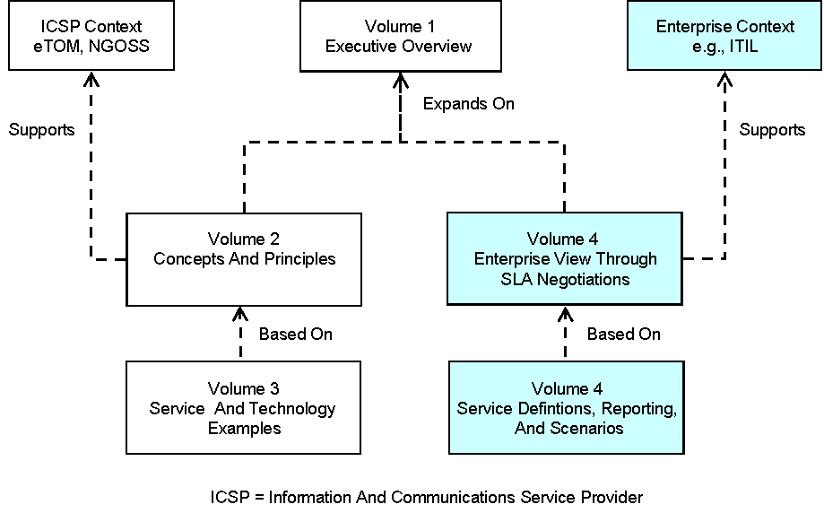
Figure 1-1 Structure of the SLA Management Handbook Series
The examples in this document are intended to be illustrative and readily comprehensible. As such, they are simpler than SLAs used in practice.

SLA Relationships
As defined in Volume 2, a Service Level Agreement (SLA) is a formal, negotiated contract between two parties, viz., a Service Provider (SP) and a Customer. It documents the common understanding of all aspects of the service and the roles and responsibilities of both parties from service ordering to service termination. SLAs can include many aspects of a service, such as performance objectives, customer care procedures, billing arrangements, service provisioning requirements, etc. Although an SLA can address such items, the specification of the service level commitments is the primary purpose of an SLA. Consequently, examples in this volume of the Handbook focus on specifying the Level of Service (LoS) and the Quality of Service (QoS) for an SLA.
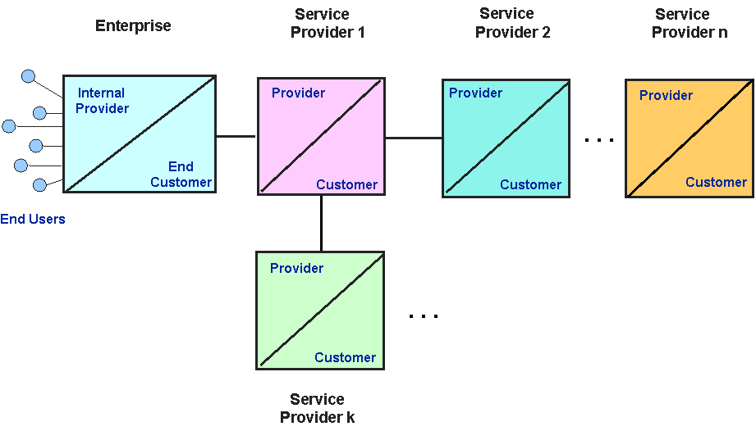
Figure 1-2 Service Delivery Relationships
In the previous paragraph, references are made to a SP and a Customer. The SP is the party providing the service and the Customer is the party ordering and using the service. Both SP and Customer may be in a value chain of service delivery as shown in Figure 1-2. In this case, a Customer in one SLA may be the SP in another SLA in the chain, and the SP in one SLA may be the Customer in another SLA. However, for any specific SLA, there will be one Customer and one SP. Consequently, these general roles will be used in this document.

Handbook Benefits
The SLA Handbook provides valuable information to three classes of readers, viz., Service Providers, Service Customers, and Telecommunications Equipment, Data Equipment, and Software Providers. Specific benefits to these readers are discussed in the following sections.

Service Providers
Service Provider is a general term that includes Information And Communications Service Providers (ICSP), Network Operators (NO), Internet Service Providers (ISP), Application Service Providers (ASP), etc.
This Handbook will assist SPs in developing new services with appropriate SLA parameters, aligning SLA parameters with Customer requirements and with an SP’s internal processes, assigning internal processes to support SLAs, and responding to SLA requirements from other SPs.
The Handbook helps an SP introduce operational changes, improve internal measurements and reporting processes, enrich Customer relations and differentiate itself from its competitors.

Customers
This Handbook will assist Customers in negotiating an SLA that satisfies their application requirements and in understanding the possibilities, limitations and options related to performance and to the cost of a service. The SLA parameter framework documents the needs of individual customers.
The Handbook provides the framework within which projects on “Customer Service” including SLA/QoS Management can function. The SLA framework provides Customers with the means to develop a working understanding of practical SLA parameters.

Equipment And Software Suppliers
The Handbook helps Suppliers, SPs, and Customers create uniform cost-effective SLA Management solutions. Such solutions consist of products and services needed to satisfy requirements. Equipment and software suppliers will gain insights into their client’s needs through examples of services to be managed and the identification of the performance parameters to be measured, reported, and processed.

Notes For Readers
The following conventions are used in this volume of the Handbook.
This volume restricts the term enterprise to business entities that do not provide Information and Communications services to the public.
Consistent with the usage in Volume 4, an end-to-end service is considered to be one that exists between application layer entities. These entities may reside in enterprise owned/managed equipment or in service provider equipment. An edge-to-edge service is one that spans a Service Provider’s network.
Many of the figures in this volume use the Unified Modeling Language (UML) notation. As this usage is limited to simple cases, familiarity with UML is not a prerequisite for reading this volume. However, UML knowledgeable readers may gain a deeper understanding of the information contained in the figures.
Parameter refers to the name of a quantifiable or concrete property of a service. Parameter value is used when referring to a specific quantity or property, i.e., the parameter values may be numerical or alphanumeric quantities. In general, this volume uses parameter and metric interchangeably.

Overview
The following paragraphs briefly describe the objectives and content of the remaining Chapters of this document.
Chapter 2 – Service Characterization
This chapter reviews the conceptual service model introduced in Volume 2. This model is used to identify service components and to specify the role of such components within a SP’s service offering.
The chapter also summarizes the various network and service performance concepts used in the industry. It then partitions service performance measures into Level Of Service (LoS) and Quality Of Service (QoS) parameters and relates these two concepts.
Service Availability is discussed and placed into the service performance context used in the Handbook.
Chapter 3 - Service Parameter Framework
The SLA Parameter Framework defined in Volume 2 is reviewed in this chapter. The framework is a tool to organize the large number of SLA parameters that are in use in the industry. The framework places parameters into one of three categories, i.e., a parameter may be technology specific, service specific or technology and service independent.
A commonly overlooked aspect of SLA parameters is the distinction between the “aggregated” requirements that apply on average to the total user community and the requirements that apply to a single user of the service. SLA Parameter Framework considers these two views of performance requirements.
These categories provide direction for developing the SLA specification. The framework is the basis for a structured process for SLA negotiation that can reduce the time required to reach a mutually satisfactory contract.
This chapter also briefly reviews those aspects of performance reporting that track commitments contained in an SLA. It addresses customer reporting interfaces, and the types, content, and frequency of reporting.
Chapter 4 - SLA Contents
This chapter provides a list of items that may be included in an SLA. It should be noted that not all of the items presented will necessarily be applicable to a specific SLA.
Chapter 5 - Applications And Examples
This chapter contains high level examples of how the principles and concepts defined in Volume 2 can be applied. It should be noted that services can become quite complex in practice. The intent in Chapter 5 is to retain only the essential aspects of the services while illustrating the use of the SLA Parameter Framework.
Note that all parameter values that appear in this chaper are for illustrative purposes only and are not intended to represent industry agreements or recommendations. Service parameter values are ultimately based on business needs and will be established via the SLA negotiation process.
Annex A
Annex A contains definitions for the key terms used in this document. Although an effort has been made to use well established industry definitions, in some instances it has been necessary to extend or restrict some terms. These cases are noted in the annex.
Annexes B - D
These annexes contain the Executive Summaries from the other three volumes in the SLA Management Handbook series.

– Service Characterization

Service Concepts
This chapter summarizes the service concepts presented in Volumes 2 and 4 of the Handbook.

Business Applications And Supporting Services
Figure 2-3 illustrates the relationships among Enterprise Business Applications, Enterprise Business Services, and Network Services as described in Volume 4.
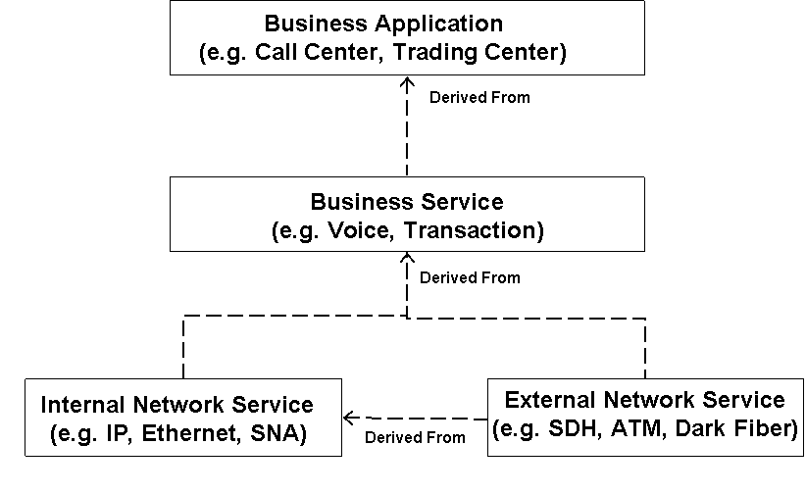
Figure 2-3 Relationships Between Applications And Services
Volume 4 also contains directions for deriving Network Service performance requirements from Business Application requirements. The Enterprise’s external network services are obtained from Information and Communications Service Providers (ICSP). The Enterprise may also outsource various Business Services and Business Applications.

Table 2-1 Business Applications And Business Services
 |  | Business Application
 |  | Emergency Management | Call  Center | Trading | Retail | Etail | Info  Delivery | Whole-  sale | Manu-facturing
B  u  s  i  n  e  s  s  S  e  r  v  i  c  e | Voice |  |  |  |  |  |  |  | 
B  u  s  i  n  e  s  s  S  e  r  v  i  c  e | Video Conferencing |  |  |  |  |  |  | 
B  u  s  i  n  e  s  s  S  e  r  v  i  c  e | Streaming |  |  |  |  |  | 
B  u  s  i  n  e  s  s  S  e  r  v  i  c  e | Telemetry |  |  |  |  |  |  |  | 
B  u  s  i  n  e  s  s  S  e  r  v  i  c  e | Transaction |  |  |  |  |  | 
B  u  s  i  n  e  s  s  S  e  r  v  i  c  e | Email |  |  |  |  |  |  | 
B  u  s  i  n  e  s  s  S  e  r  v  i  c  e | Office Auto. |  |  |  |  |  |  |  | 
B  u  s  i  n  e  s  s  S  e  r  v  i  c  e | Help Desk |  |  |  |  |  |  |  | 
B  u  s  i  n  e  s  s  S  e  r  v  i  c  e | Teleworking |  |  |  |  | 
B  u  s  i  n  e  s  s  S  e  r  v  i  c  e | Intranet |  |  |  |  |  |  |  | 
B  u  s  i  n  e  s  s  S  e  r  v  i  c  e | Extranet |  |  |  |  |  | 
B  u  s  i  n  e  s  s  S  e  r  v  i  c  e | Public Internet |  |  |  |  |  | 

Table 2-1 illustrates how business services support business applications. The check marks indicate typical support relationships

Service Components
A telecommunications service is a set of independent functions that are an integral part of one or more business processes. These functions are supported by hardware and software resources including the underlying communications transmission media. The Customer sees all of the functions as an amalgamated unit.

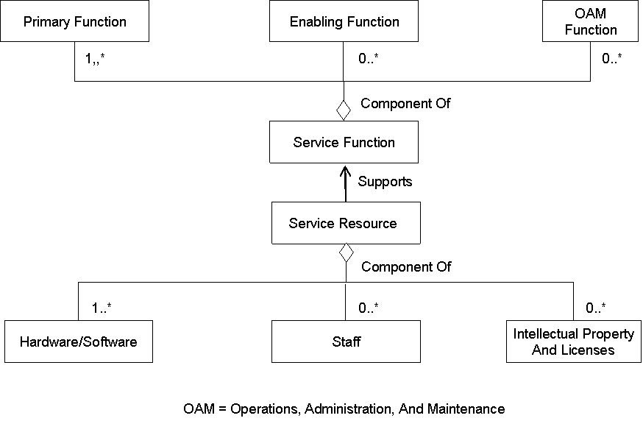
Figure 2-4 Service Functions And Service Resources
Figure 2-4 illustrates the relationship between service functions and service resources. Service functions are composed of three distinct types of elemental functions, viz., Primary Functions, Enabling Functions, and Operations, Administration, and Maintenance (OAM) Functions. As shown in Figure 2-4, service resources enable service functions. The three fundamental types of service resources are hardware/software resources, staff resources, and intellectual property/licenses resources.

Service Access Points
Service access points (SAP) are introduced and defined in Volume 2. The key definitions are repeated in the following paragraphs.
A service is “delivered” to a Customer at SAPs. SAPs are the conceptual points at which a service is provided by a "service provider" entity to a "service user" entity. The Service Provider’s responsibility therefore includes a service, i.e. its collection of service elements, that are provided at the specified SAPs.
The SAP concept is used to distinguish the boundary between the Customer domain and the Service Provider domain.
The Service Provider delivers a contracted service at the SAP(s). Each service is associated with at least one SAP. A SAP may only be associated with one service.
An integral part of defining and managing a service is the specification of the SAPs. In addition to service performance levels, SAP specifications frequently include market and physical network-related requirements. These latter items are mainly related to regulatory and equipment ownership issues rather than to the physical network configuration itself.
Figure 2-5 illustrates the location of the SAP between an internal network service and the external network service. This SAP is always between two distinct business entities. A SAP on this boundary is defined as the primary SAP to distinguish it from SAPs associated with other SLAs.
Note that at a primary SAP the Enterprise service requirements are transformed into requirements for the public network provider. This transformation is based on the SLA Parameter Framework defined in Volume 2.
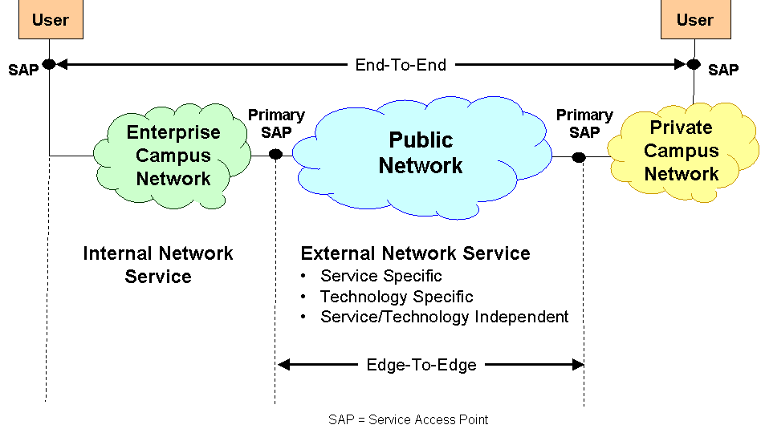
Figure 2-5 SAP Locations

Service Level Agreements
Figure 2-6 illustrates the various SLAs that may exist within an Enterprise. Depending on the Enterprise’s outsourcing policy and a Service Provider’s administrative structure, the SLAs in the figure may be internal, i.e., between organizational units within the same Enterprise or SP or external, i.e., between different business entities. See Figure 2-3 for an alternative view of the relationships among the service elements shown in Figure 2-6.
This volume of the Handbook focuses on examples of SLAs that apply between the Internal Network Service and External Network Services. See Volume 4 for examples of SLAs that apply within an Enterprise.
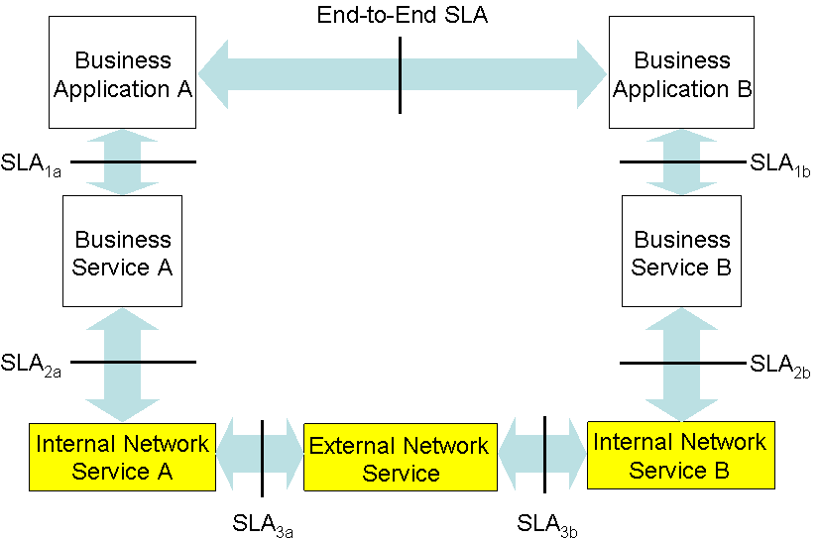
Figure 2-6 Enterprise SLAs

Service Performance
ITU-T Recommendation E.800 defines Quality of Service (QoS) as the collective effect of service performance which determines the degree of satisfaction of a user of the service. E.800 also notes that the term QoS does not express or imply a degree of excellence in a comparative sense, nor is it used in a quantitative sense for technical evaluations.
The E.800 QoS definition quoted in the preceding paragraph does not provide sufficient guidance for specifying quantifiable QoS targets. To address this need, ITU-T Recommendation E.860 has modified the E.800 definition as follows:
“QoS is the degree of conformance of the service delivered to a user by a provider in accordance with an agreement, i.e., an SLA, between them.”
The SLA Handbook uses the E.860 QoS definition. Specifically the Handbook view QoS as a measure of variation between a committed service parameter value and the observed value of this parameter.

Service Performance And Network Performance
Figure 2-7 illustrates the relationship between Network Performance factors and Service Performance factors. These factors are further discussed in Volume 2.

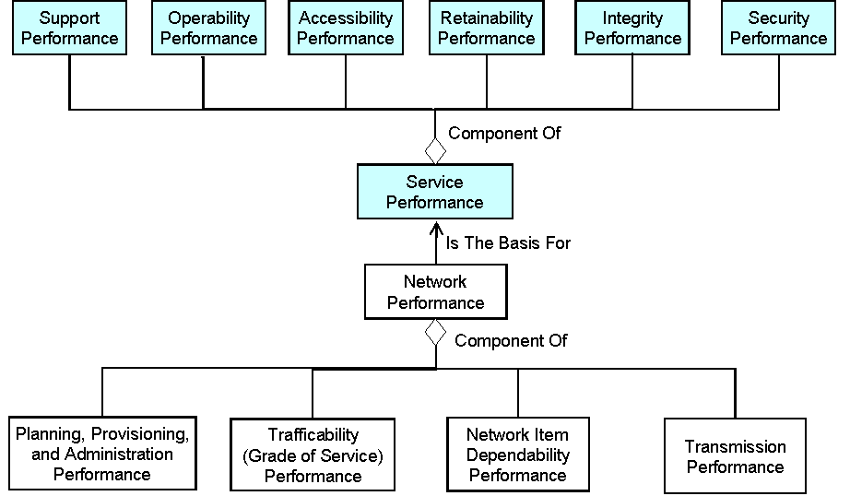
Figure 2-7 Network Performance – Service Performance Relationship

Service Availability
Figure 2-8 reproduces Figure 3-12 from Volume 2. In Volume 2 it is noted that service availability performance is composed of Accessibility, Retainability, and Integrity Performance.

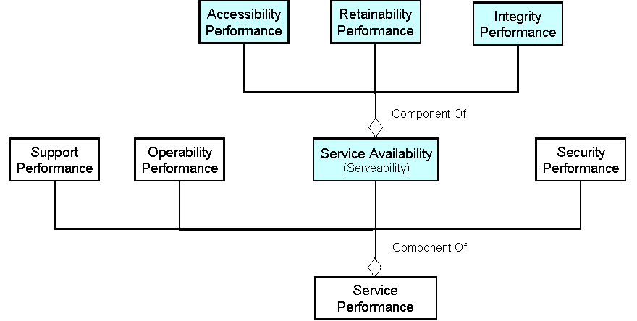
Figure 2-8 Relationship Of Service Availability To Service Performance

The X.140 Perspective
ITU-T Recommendation X.140, General Quality Of Service Parameters For Communication Via Public Data Networks, provides an alternative view of service performance parameters. X.140 is the base ITU-T Recommendation for data network and for ATM QoS definitions. The X.140 framework and the definition used in the Handbook for the components of service availability can be mapped as shown in Figure 2-9

 | X.140 Functions
Performance Components | Access | User Information Transfer | Disengagement
Service Accessibility | Speed, Accuracy, Dependability | Dependability | Speed
Service Retainability |  | Speed | Speed, Accuracy, Dependability
Service Integrity |  | Accuracy
Figure 2-9 Mapping Between X.140 Functions And Performance Components
The examples in Chapter 5 use the concepts and terminology of Figure 2-7 and Volume 2.

- Service Parameter Framework

The Service Parameter Framework
The SLA service parameter framework is introduced and described in detail in Volume 2 of the Handbook. Briefly, the parameter framework is a tool for categorizing service parameters. The framework organizes service parameters into six categories based upon service and delivery technology and upon measures of service performance as seen by an individual user and measures of average service performance. The framework is displayed in a tabular form as illustrated in Figure 3-10. A list of service performance parameters and the required values is compiled by the Customer for each cell in the table. This information is then used as the starting point in negotiations between Service Customers and Service Providers.

 |  | Service Parameter Categories
 |  | Technology Specific | Service Specific | Technology/Service Independent
Service View | Individual User View | Parameter  List 1 | Parameter  List 2 | Parameter  List 3
Service View | Aggregate View | Parameter  List 4 | Parameter  List 5 | Parameter  List 6
Figure 3-10 Service Parameter Category Framework
Figure 3-11 illustrates a typical relationship between the service functions defined in Section 2.3 and the three parameter categories. In most cases the Service Specific parameters refer to a service’s primary functions.

 | Technology Specific | Service Specific | Technology/Service Independent
Primary Functions | X | X | X
Enabling Functions | X | X
OAM Functions | X |  | X
Figure 3-11 Service Functions-Parameter Categories Relationship

Service Views
The rows in the service parameter table shown in Figure 3-10 distinguish between the individual user view of the service and the aggregated view. The individual user view is associated with a SAP or SAP Group and covers service properties such as the service interface or the maximum service down-time that an individual service user could experience during a specified time period. The aggregated view essentially captures the average performance over all service users during a specified time period and may include items such as service billing and aggregate availability. It is important to distinguish between single event requirements and aggregated requirements from the user’s perspective. For example, if only aggregated availability is specified over a specific period, it would be possible for a single user outage to shut down that user entirely while the aggregated service requirement is met. The single user view parameters can be used to define the maximum down time for a single event and the minimum up-time between events.

Technology Specific Parameters
Technology-specific service parameters are related to the telecommunications technology supporting the service, particularly when the service offered is a network bearer service. Examples of telecommunications technologies include PDH, SONET/ SDH, OTN, ATM, Frame Relay, etc. layer parameters. In addition, technology-specific layer parameters such as physical characteristics of the SAP may need to be specified.
Some of the technology-specific parameters may not be relevant to the service end user but need to be considered by the SP or between Network Operator and/or SP. The decision on which parameters to include in an SLA is made on a case-by-case basis for each service contract.

Service Specific Parameters
Service-specific performance parameters are typically related to the application supported and include service-specific or application-specific technology parameters such as reliability and availability of computer servers, databases, etc. For example, as ebusiness expands, computer server parameters will become increasingly important and impact the overall availability of the service offered.

Service/Technology Independent Parameters
Service/technology independent service parameters are those that are often, if not always, specified in an SLA. Examples include Percentage Availability, Mean Time Between Failures (MTBF), Outage Intensity (OI), Mean Time to Provision Service (MTPS), Mean Time to Restore Service (MTRS), time to first yield, average call response time, etc. These are sometimes referred to as “operational performance criteria,” and some are required to be reported to regulatory authorities by SPs on a regular basis, e.g., time to first yield.
Other parameters that may be Included in this set are integrated or consolidated billing for a set of services, accuracy of billing and payment terms, billing period, security for both service access and information transfer/delivery, and the specification of alternate routing/redundancy of network connections providing the service, possibly including avoidance of Common Points of Failure (CPoFs). For many mission-critical services, these factors are very important and need consideration. In an ebusiness environment, they may be critical to the survival of the business, particularly for large companies and financial institutions.

Performance Reporting

Service Data Sources
The three main sources of performance data are network measurements, Customer interviews, and Customer complaints – service center calls. The user perception of performance is based on both the provisioning and the operation of the service. To cover all aspects of performance, measurements should be carried out at, or as near as possible to, the service access points and at each network node. This guideline raises the issues of accuracy, scalability, and cost.
Monitoring at the Customer Premises Equipment (CPE) requires at least one service monitor per end point. This is desirable because the level of performance seen by the monitored traffic is nearly the same as that experienced by the Customer’s traffic. However, this is costly and difficult to apply to large networks. Additionally, it can result in large amounts of management traffic being transported across the network, thereby increasing the volume of carried traffic. Furthermore, the SP may not own the CPE and/or may not have continuous access to it. Measurements may be made manually, semi-automatically or completely automatically using test or live traffic.
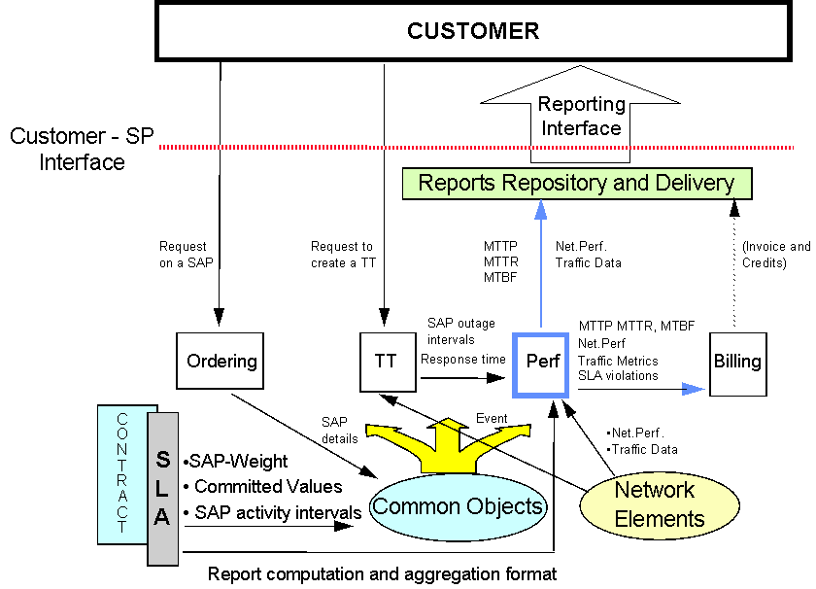
Figure 3-12 Performance Reporting Interface

Performance Data Collected By Network Elements
Figure 3-12 illustrates the use of Network Element (NE) logged performance data to support the Performance Monitoring and Trouble Ticketing functions. The NE data also provides a mechanism to measure degraded performance for leased circuit services.
Near-end and far-end path and line performance measures are defined in ITU-T Recommendations G.826, G.827, G.828, M.1340, M.2100 and M.2101 for PDH and SDH digital paths and leased circuits.
Standards-based PDH Network Elements (NEs) provide Unavailable Seconds, Severely Errored Seconds, and Errored Seconds. SDH/SONET technology provides equivalent measures based on errored blocks and frames.

Reporting Process
The Performance Reporting Process provides the service Customer with all of the performance reports specified in the SLA. Routine reports include reports of the performance of a service vis-à-vis the SLA specifications, reports of developing capacity problems, and reports of Customer usage patterns.
Performance Reporting is defined as one of the components of the Customer SLA/ QoS Management process in the eTOM Customer Relationship Management process. See [GB 921] for additional information on eTOM.

Parameters
The number of parameters that have been proposed to characterize QoS and Network Performance (NP) is very large. For example, ITU-T Recommendation E.800 lists over 370 terms related to QoS and NP concepts and the ITU-T Handbook on QoS and Network Performance identifies approximately 130 ITU-T Recommendations related to these topics.
Although Volume 2 of the Handbook provides tools to organize performance parameters for SLAs, specific parameters are best specified when specific services are being considered. Chapter 5 provides simple examples of service specific parameters that may be used in SLAs. However, service and technology performance documentation should be consulted before contracting for services.

- SLA Contents
This chapter contains numerous items that may be included in an SLA. These items were derived from TMF member contributions, information provided by user groups and by standardization bodies. Not all of these items will be relevant to a specific SLA. The order of presentation of the items does not imply a priority. Individual items may be consolidated with others or may be disaggregated as needed.

Points Of Contact
It is useful to specify a single point of contact for technical matters and a single point of contact for administrative manners. This information should be provided for both the Service Customer and the Service Provider. This information typically includes:
- Name of the contact,
- Work title or description,
- Telephone numbers, facsimile numbers, postal address, and email addresses.

Services Provided
The following may be included in the description of the service being obtained.
- A description of the service in terms meaningful to the Service Customer and the Service Provider.
- A description of the service access points at the Customer’s sites.
- A specification of the service interfaces requirements, e.g., electrical and mechanical specifications, data link layer protocols, etc.
- A specification of the Ready-for-Service (RFS) dates and, if appropriate, the lead times required for service provisioning. It is expected that the service will be available on or before the date specified, at the cost agreed, and performing to the specifications contained within the SLA.
- A description of the process for Customer notification in the event that the agreed RFS date cannot be met. Lead times for such notification may also be specified.

System Design Information
The following information concerning the design of the service infrastructure may be incorporated into an SLA.
- A description of how the system design will meet the following types of criteria, the absence of common failure points, the redundancy level required, alternative routing of facilities, transmission media restrictions, and restrictions on services that may be provided by other parties.
- A description of transmission media routing details may be required along with a requirement that the routing and/or the media will not be changed without prior discussion and agreement.
- Description of the process whereby the service customer may access the design information for periodic review or to review modifications.
- Specification of the techniques to be used for recording configuration and for configuration change control.
- A description of how the system design meets the stated scalability requirements.

Supporting Equipment
The specification of the following items related to the placement of Service Provider equipment on Service Customer’s premises may be included in an SLA.
- A description of the Service Provider equipment to be located on customer premises.
- The space requirements for this equipment.
- The power requirements for this equipment.
- The environmental control requirements for this equipment.
- The access procedures for SP maintenance and installation staff.

Level And Quality of Service
The SLA service parameter framework should be used as the mechanism for identifying and quantifying these parameters. Additionally, the times during which the service is ready for use may be specified. This may include specifying the following items.
- Out-of-service times such as the time required for routine maintenance. The process used to communicate changes in scheduled maintenance outages may also be defined. Lead times for such notices may also be specified.
- A description of force majeure and other events beyond the SP’s control when service may not be provided.
- Description of customer-caused outages that may impact the service.
- Specification of the priority/precedence for restoration of service
- Specification of restoration times.
- Description of the notification procedures for planned outages.

Monitoring And Reporting
The following should be considered when specifying reports in SLAs.
- Specifications of the content and frequency of performance reports.
- Specification of the performance report delivery mechanism, e.g., email, postal delivery, electronic retrieval, report distribution lists, and the number of copies.
- Specification of ad hoc reporting support.
- Definitions of the time points or intervals associated with performance events, e.g., defect detection time, outage interval, time to repair, etc.
- Definitions of parameter measurement intervals, data collection intervals, and data aggregation intervals.
- Specifications of report formats including customer information, service provider information, service information, and report type information.
- Specifications of the method for performance report data presentation, e.g., tables, histograms, charts, etc.
- Specifications of performance report data scope, e.g., summary data, trend data, exceptions only, comparison data, etc.
- Specifications of mechanisms for changing performance report content, format, frequency, distribution, or reporting media.
- Specification of the approach and extent to which the SP will monitor all necessary services e.g. network devices, circuits, servers and applications, to prevent service unavailability.
- Description of the mechanisms and processes the SP will use to detect and track downtime.
- Description of the process that the Customer may use to audit the SP’s tracking and reporting mechanisms.
- Specification of when and how Customer service monitoring data will be used to assess service performance.

Service Center
The following help desk /service center support capabilities may be described in the SLA.
- Description of the scope of services offered.
- Identification of the Customer staff that are authorized to use the service center.
- Specification of the periods when the service center is accessible to the service customer, including evening, week-end, and holiday coverage.
- Description of the means of contacting the service center, e.g., telephone, email, etc.
- Description of the mechanism for assigning severity levels to customer help requests or problem reports, e.g., severity 1, 2, etc.
- Description of the escalation process to be followed to change severity levels.
- Description of response times and resolutions times.
- Description of how the customer will be notified of the problem resolution.
- Description of the Customer’s responsibilities resolving reported problems.
- Description of training required by Customer staff.
- Description of the mechanisms and/or procedures for identifying systematic errors based on help desk analysis.

SP Backup And Disaster Recovery Mechanisms
Depending on the service provided, it may be desirable to include in the SLA a specification of the mechanisms the Service Provider will use to insure service continuity during and following the occurrence of a disaster.
- Description of the procedures for data and application backups.
- Description of the service delivery system redundancy.
- Description of recovery parameters, i.e. how quickly can data be restored.
- Description of the priority and process for SP disaster recovery.
- Description of the Customer support required to assist with disaster recovery.

Terms And Conditions
The following general terms and conditions may be included in the SLA.
- A indication of the fact that the SLA is subject to Terms and Conditions of other agreements between the SP and Customer. Note that if the SLA is subject to other agreements between the parties, certain legal provisions may be inherited by this SLA.
- Description of any contract or service-level impacts of an acquisition or merger.
- A specification of the extent, if any, to which the customer will indemnify the SP for third-party claims against the SP as a result of the customer's activities.
- Description of the SP’s ownership or interest in patents trademarks, trade names, inventions, copyrights and trade secrets relating to SP offerings.
- Description of the Customer’s information data ownership.
- Specification of the responsibility for software licensing and/or ownership.
- A specification of the extent, if any, to which the SP will indemnify the Customer for claims that services infringe upon the Intellectual Propertiy of others.
- Description of the information that may be disseminated openly.

Network And Delivery Upgrades
The following items relate to changes in the network or delivery mechanism upgrades that can occur during the life of the service.
- Specification of the upgrade expectations and procedures, including provisions to meet customer critical service availability requirements.
- Description of the recovery or back-out procedures in the event of an upgrade failure.
- Description of the procedures for releasing and installing patches and other minor upgrades.
- Description of how the SP will implement changes, e.g., over-the-air software upgrades, on site installation, etc.

Change Procedures
The following items relate to changes in the service. The distinction between a service change and an upgrade is determined by mutual service customer – service provider agreement.
- Description of the method for specifying changes to requirements.
- Description of the time required to change user requirements, such as, notice and response times.
- Description of any changes that the Customer is permitted to make, such as, additional software.

Service Violations And Remedies
The following items are related to service commitments.
- Description of the performance penalties in the event that SP fails to execute agreed service levels. Performance penalties could be administrative actions by the SP, monthly percentage fee rebates correlated to the degree of under performance, specific fee reductions or rebates, or contract termination if the under performance is chronic.
- Description of the performance bonuses in the event that the Service Provider exceeds the agreed service levels.
- Description of the procedures to resolve disputes, e.g., arbitration procedures.

Tariffs And Billing
It is expected that the following items will be mutually agreed between the Service Customer and the Service Provider.
- Description of the level of detail included in the bills.
- Description of the frequency of billing.
- Description of the media used to deliver the bill, e.g., suitable for use with software applications.

Service Termination
The following items are related to service termination.
- Specification of applicable time period for a return of data.
- Specification of the process for data transfer.
- Description of the process for unilateral termination.

- Applications And Examples

Introduction
The examples provided in this chapter cover a variety of service types. These examples are intended to illustrate the application of the SLA principles and concepts defined in Volume 2.
Note that all parameter values shown in this document are for illustrative purposes only and are not intended to represent industry agreements or recommendations. Service parameter values are ultimately based on business needs and will be established via the SLA negotiation process.

Leased Lines
A leased line / leased circuit service is typically provided over PDH, SDH/SONET, or Optical Transport Network (OTN) facilities. As such, the service is typically based on an E1, STS-1, or Optical Channel Digital Unit order k (ODUk) digital frame or on a concatenated group of such frames. A point-to-point leased circuit connects two path layer terminating functions. The functions may be implemented in simple connectors, or may be components of more sophisticated equipment such as Channel Service Units (CSU), Add-Drop Multiplexers (ADM), routers, or switches.
A leased circuit may provide a point-to-point or point-to-multipoint service. Point-to-point services are typically bi-directional whereas point-to-multipoint services are typically unidirectional. Typical uses of point-to-point leased circuits include serving as a transport path between a base station and switching center in a mobile network, as a transport path between a broadcasting center and a remote transmitter site for television signals, and as a broadband connection for an Internet Service Provider. Point-to-multipoint circuits may be used for a broadcast service. The main focus in this section is on PDH/asynchronous based point-to-point, symmetric, bi-directional leased circuits.
From an SLA point of view, a leased circuit service is a transport service that is provided between two Service Access Points (SAP), i.e., the leased circuit path termination points. The leased circuit SAPs are between Network Operators (NOs) or between an NO and an Enterprise Customer. This is illustrated in Figure 5-13 and Figure 5-14.

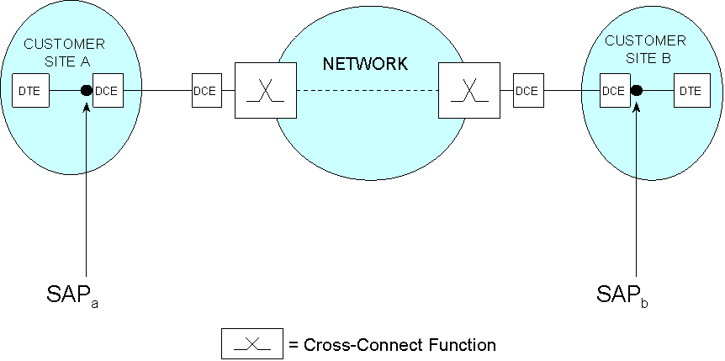
Figure 5-13 Simple Leased Line Service

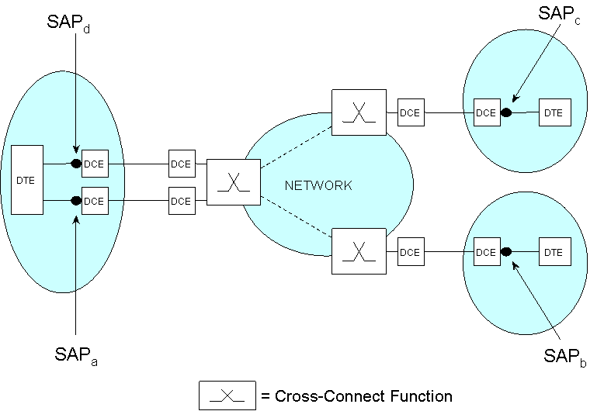
Figure 5-14 Representation Of Two Single Leased Circuit Services

Trouble Ticket Data
Although trouble ticket data is limited in detail, this data can be used to compute service availability (SA) and service unavailability (SUA) per the following formulas. The SUA formula assumes that SAP weighting is not applied. For additional information on these formulas see Section 3.9 in Volume 2.
Σ (Outage Interval x Service Degradation Factor)
SUA% = x 100%
Activity Time

SA% = 100% - SUA%
Equation 5-1 Basic Service Availability Formulas

Transport Signal Overhead Information
Modern transmission signals contain payload data and overhead information. The function of this latter information includes performance monitoring and maintenance support. However, an NO may not have access to the overhead information for In-Service Monitoring (ISM) purposes at the SAPs due to regulatory restrictions and/or commercial agreements.
Access limitations to overhead information are typically present when the Customer owns the device that contains the path terminating function. The Customer’s physical interface may be an electrical interface as described in ITU-T Recommendations G.703, G.707, and G.708 or an optical interface as described in ITU-T Recommendations G.707, G.709, and G.959.1. Where possible, the Customer should create the path overhead information as defined in the appropriate ITU-T Recommendations and should make this overhead information available to the NO for ISM. These details should be included in the SLA.
Portions of a leased circuit may be provided by more than one NO. In fact, the customer facing SP may own only part or none of the network equipment supporting the circuit. The responsible SP will negotiate with the various NOs to assign network paths that can deliver specified service performance levels and with the Customer to establish procedures for accessing the Customer’s premises to install circuit termination and test equipment and to perform circuit testing.
A network timing signal is normally used to synchronize the Customer’s termination equipment. Note that the timing signal at each end of a leased circuit should be derived from a primary reference clock operating in accordance with ITU-T Recommendation G.811. In general, leased circuit timing will be derived from an SP’s network timing source and not from the Customer’s equipment. If the leased circuit is provided by multiple NOs, an agreement must be reached on the source of the timing signal or on the mechanisms that will be used to account for the timing differences.
Availability performance is the key performance factor to consider for a PDH, SDH/SONET, or OTN leased circuit. More specifically, integrity performance factors such as bit error rates and transport delay are usually specified. If timing is part of the leased line service, then timing availability performance should also be specified.

Leased Line Service
The first two examples in this section demonstrate the use of trouble ticket for the calculation of service availability. The remaining examples use network element maintained data to calculate service availability.

Trouble Ticket Data - Single Line Service
Example one is a single leased line connecting two Customer sites with one SAP at each customer site. This case is shown in Figure 5-13. In this example, each SAP is defined at the DCE-DTE interface and represents the boundary between the Customer Domain and the Service Provider Domain.
The Service Parameters of interest are shown in Table 5-2.
Table 5-2 Service Availability Data For Example 1
Parameter | Values
Reporting Period | 30 days = 720 hours = 43,200 minutes.
SAP Activity Time / SAP Cover Time | For each SAP, the SAP Cover Time (SCT) is from 6:00 am to 6:00 pm every day; i.e., the SCT = 12 hrs a day for 30 days = 21,600 minutes. Note that the SAP Activity Time (SAT) may be longer than the SCT.
Service Degradation Factor (SDF) | Not used, i.e., set to 1.
Suppose that a fault, e.g. line failure, occurs from 4:30 pm to 8:30 pm on the thirteenth day of the report period. This creates an outage of four hours at each SAP. Since the Service Provider is responsible only from 6:00 am to 6:00 pm, the amount of outage at each SAP that falls within the SCT is 1 hour and 30 minutes or equivalently 90 minutes.
The following formula is derived from Equation 5-1.
SA = [1 - (outage time) / (Service Provider responsibility time)] x 100%
Using the preceding formula, SA is computed as follows.
SA = [1 - (1 x 90 x 1 + 1 x 90 x 1) / (1 x 21,600 + 1 x 21,600)] x 100%
SA = [1 – (90 / 21,600) ] x 100%
SA = 99.58%
The Service Availability is calculated based on the agreed, i.e., between the Service Provider and the Customer, Trouble Ticket time stamps at the SAPs.
It is assumed that the Trouble Ticketing System has an interface with other Service Monitoring Systems that provide time stamps and related information to service outage or service degradation.
    - Trouble Ticket Data - Multiple Line Service
Example 2 adds a new leased line to the previous example. This service configuration is illustrated in Figure 5-14. Additionally, Example 2 uses SAP weightings. Consequently, Equation 5-2 is used to compute SUA. The Service Parameters of interest in Example 2 are shown in Table 5-3.

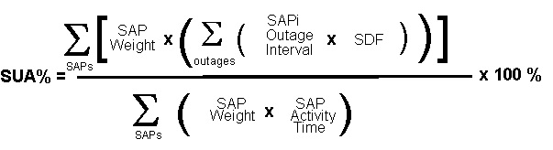
Equation 5-2 SUA With SAP Weighting

Table 5-3 Service Availability Data For Example 2
Parameter | Values
Reporting Period | 30 days = 720 hours = 43,200 minutes.
SAP Activity Time / SAP Cover Time | For SAP_{a} and SAP_{b}, the Service is required to be supported for 24 hours a day for 30 days. Then the SCT = SAT = 43,200 minutes.  For SAP_{c} and SAP_{d}, the Service is required to be supported from 6:00 am to 6:00 pm for 30 days. Then the SCT = 12 hours a day for 30 days = 21,600 minutes. Note that in this case the SAT may be longer than the SCT.
SAP Weighting | The SAP weighting can be used to differentiate the importance of a single SAP to the Customer’s business. In this example the SAP_{a} weight = SAP_{b} weight = 1, and the SAP_{c} weight = SAP_{d} weight = 2.
SDF | Not used, i.e., set to 1.

Assume that a fault, e.g. a line failure, occurs between SAP_{c} and SAP_{d} from 4:30 pm to 6:00 pm on the thirteenth day of the reporting period. This causes an outage at SAP_{c} and SAP_{d} of one hour and 30 minutes = 90 minutes.
Calculating the Service Availability according to Equation 5-4
(1 x 0 x 1) + (1 x 0 x 1) + (2 x 90 x 1) + (2 x 90 x 1)
SA = 100% - X 100%
(1 x 21600) + (1 x 21600) + (2 x 43200) + (2 x 43200)
SA = 100% - [ 360 / 216,000 ] x 100%
SA = 99.83 %.
The Service Availability for a group of SAPs can also be calculated if required. For example, considering only SAP_{a} and SAP_{d}, it is possible to calculate the Service Availability at one Customer’s site. Considering SAP_{a} and SAP_{b} yields the Service Availability for a single leased line. This gives a wider range of applications of the Service Availability concept.

Network Element Data
This subsection applies to leased circuit services where performance data is computed and stored in NEs. The Service Availability levels can then be computed without involving the Trouble Ticketing systems. The definition and measurement of degraded service is a distinct feature of this technique.
The performance parameters contained in an SLA can be related to PDH, SDH/SONET, or OTN path performance factors, such as the transmission delay between the end points of the circuit or number of path layer severely errored seconds measured at the SAP.
Figure 5-15 shows an example of an SLA parameter table for a generic leased circuit service that uses NE provided data.

 |  | Service Parameter Categories
 |  | Technology Specific | Service Specific | Technology/Service Independent
Service View | Individual User View | - Max. Errored Seconds Ratio  - Max. Severely Errored Seconds Ratio  - Max. Background Block Error Ratio (BBER)  - Max. Transfer Delay  - Max. Delay Variation |  | - Max. Unavailability Time  - Max. Time To Restore  - Minimum Time Between Failures
Service View | Aggregate View | - Mean Errored Seconds Ratio  - Mean Severely Errored Seconds Ratio  - Mean Transfer Delay  - Mean Bit Error Ratio |  | - Total Unavailability Seconds  - MTBF  - MTTR  - MTTP
Figure 5-15 Leased Circuit Service Parameters
shows the correlation between the SA components and the NE parameters that can be used to represent the component. Accessibility performance typically does not apply to leased circuit services. For leased circuit services, Service Retainability and Service Integrity can be defined in terns of the equations given in Section 3.9 of Volume 2. This approach is applicable for path layer network connections.

SA Component | Parameters
Service Retainability | Unavailable Seconds (UAS)
Service Integrity | Errored Seconds (ES)  Severely Errored Seconds (SES)

Figure 5-16 Relation Between SA Components And NE Parameters
Note that if the Service Availability (SA) level falls below a specified threshold, the service can be considered to be degraded. In this case, a Trouble Ticket can be opened automatically, thereby initiating maintenance procedures sooner than would have occurred if a manual process for opening a Trouble Ticket had been used. Trouble Ticket descriptions need further development to accommodate “degraded service” status.

Defining Service Availability Using NE Data
Equation 5-3 is based on the Service Availability (SA) equation found in Section 3.9.5 of Volume 2. Note that whereas the Service Availability equation in Volume 2 is generic and is defined in terms of fundamental events and their duration, Equation 5-3 only applies to point-to-point leased circuit services.
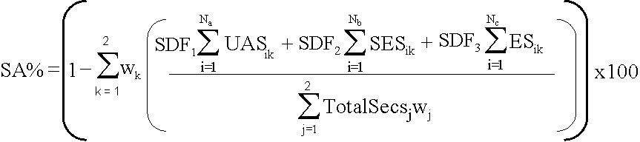
Equation 5-3 Service Availability For Leased Circuits
In Equation 5-3, the number of Unavailable Seconds for an event as experienced at SAP_{k} (UAS_{ik}) represents a loss of service interval. Similarly, Severely Errored Seconds (SES_{ik}) and Errored Seconds (ES_{ik}) represent periods of degraded performance. The three service degradation factors (SDF) are defined to account for the relative importance of the preceding parameters. Finally, W₁ and W₂ represent the weights of SAP₁ and SAP₂ respectively.

There are a number of ways that the preceding equation can be used. Consider first the assignment of SDF values.
- The most optimistic definition of Service Availability occurs when SDF₂ and SDF₃ are set to 0.
- The most pessimistic definition of Service Availability occurs when SDF₂ and SDF₃ are set to 1.
- Other definitions for Service Availability can be formulated by assigning SDF₁, SDF₂, and SDF₃ values between 0 and 1.
- Note that the values of SDF₁, SDF₂, and SDF₃ are independent of each other.

Calculating Service Retainability From NE Data
Equation 5-3 may be applied in several ways. One technique will provide a calculation of SA primarily using UAS, e.g., SDF₁= 1, SDF₂ = SDF₃ = 0 as shown in Equation 5-4.
The primary application of the SA measure is to achieve a summary over a period of time. This measure of SA may provide validation for the Trouble Ticket management process. Thresholds may be established to generate alerts about the (accumulated) down time. This process may be used for opening trouble tickets; however urgent ‘out of service’ alarms are usually generated without the delay associated with waiting for a threshold to be exceeded.
Since UASs are automatically determined within the NE, this measure of SA will record most short outages that may be missed by a trouble ticket system. The sum of all outage intervals is essential to an accurate measure of SA.
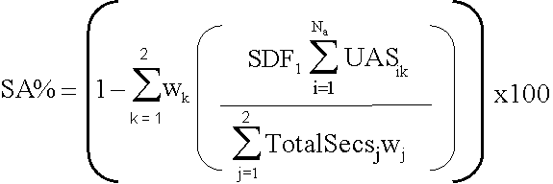
Equation 5-4 Service Availability Defined As Service Retainability

Calculating Service Integrity From NE Data
Another possibility is to define the calculation of SA in terms of ES and SES, e.g., SDF₁= 0 and SDF₂ and SDF₃ greater than zero as shown in Equation 5-5.
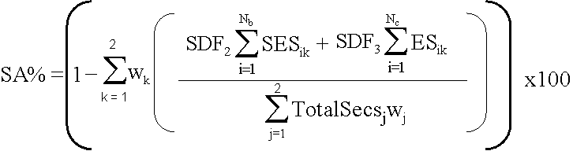
Equation 5-5 Service Availability Defined As Service Integrity
Degraded performance is difficult to measure with a Trouble Ticket mechanism since trouble tickets are not normally opened for degraded performance. They are opened for faults or in cases where performance thresholds are set and exception reporting is enabled.
“How well did it perform when it was available?” is answered by measuring Degraded Service. Degraded Service is usually difficult to detect or measure with a Trouble Ticket system. Therefore, a measure of Degraded Service is essential to confirm conformance to a SA requirement (i.e. in an SLA). While the service may still be available, but is approaching or below an SLA performance threshold, a Degraded Service alert may be quite useful to generate an input to a Trouble Ticket system. Total Seconds minus UAS equals Total Available Seconds. The SDF will be applicable to ES and SES.
SDH/SONET and other transmission technologies also derive an equivalent measure of UAS, SES and ES. This allows these technologies to use Equation 5-3 in a manner consistent with PDH technologies.
There are a number of other parameters indicative of service degradation such as Bipolar Violations and Code Violations. Any of these measures could be considered for inclusion in the Equation 5-3. The equation therefore is not limited to three or four terms. From a practical view point, there is a limit to the amount of performance related information that can be extracted from a large number of remote NEs and communicated economically to a management system. It is also the case that not all NEs will support all performance related parameters. Thus a common (small) set of measures may offer the most beneficial implementation. UAS, SES, and ES frequently satisfy this condition.

Emergency And Disaster Relief Services
At the present time work is preceding in the ITU-T to develop Recommendations on the Emergency Telecommunications Service (ETS) and on Telecommunications for Disaster Relief (TDR). Both ETS and TDR are intended for use during emergency situations. Although there are ongoing discussions in the ITU-T with respect to the scope of ETS and TDR, both are distinct from the widely deployed service whereby any member of the general public is provided rapid access to public agencies such as the police and fire departments and medical and rescue services. This later service has recently been named the Citizen Emergency Service Calling (CESC) to distinguish it from ETS and TDR.
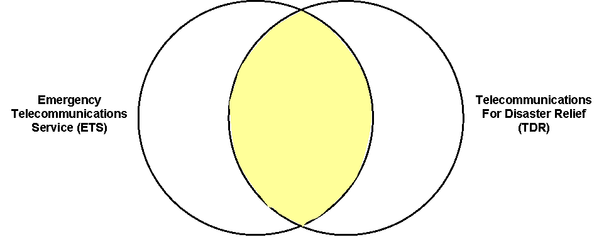
Figure 5-17 Relationship Between The Scope Of ETS And TDR
Both ETS and TDR are intended to be used to support and coordinate responses to emergency conditions. However, these services have unique aspects. Specifically, ETS is intended to support National Security and Emergency Preparedness (NS/EP) needs by providing priority access to in-place public telecommunications services. Consequently, ETS has a strong national focus with less emphasis on international communications requirements. TDR’s primary objective is to provide an international communications capability primarily in those cases where the infrastructure for such international communications may not be in-place prior to the onset of the emergency condition. TDR assumes that there may be limited local and national communications resources that can be used to support an emergency response effort. When available, these local and national resources may also be used for TDR purposes. Figure 5-17 illustrates the relative scopes of ETS and TDR.
ETS was described in general terms in Volume 2 of the Handbook and the on-going initiatives in the US to deploy this service were briefly discussed. As noted in the previous paragraph, priority access to in-place telecommunications services is an essential aspect of ETS and it may also play a role in TDR. The importance of such emergency services is constantly increasing in today’s world.
The following section contains an example of an SLA for priority access in third generation Public Land Mobile Networks (PLMN). Such service capabilities support both ETS and TDR objectives.

Priority Service In Third Generation PLMNs
Figure 5-18 contains a simplified functional view of a Third Generation PLMN. This figure illustrates the key elements that are involved in providing Priority Service.
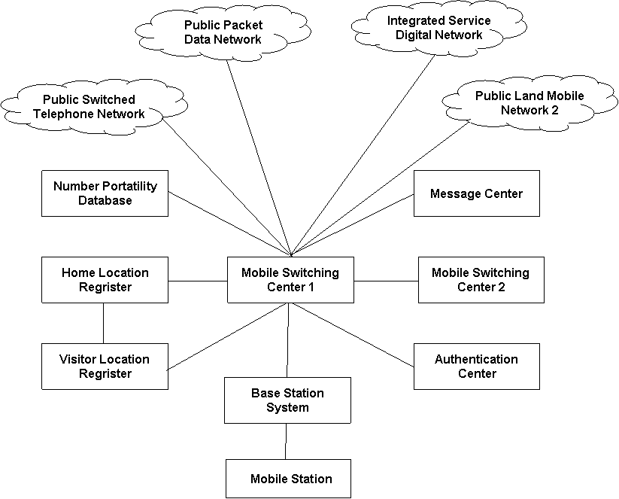
Figure 5-18 Functional View of 3G PLMN
As defined in [TR 22.950], Priority Service allows qualified and authorized users to obtain priority access to the next available radio channel, i.e., for voice or data, on a priority basis before other PLMN users during situations when congestion is blocking call attempts. In addition, Priority Service supports priority call progression and call completion to support an end-to-end priority call.
Priority Service is intended to be used by qualified and authorized users, i.e., emergency service personnel, only during times of emergency situations and network congestion. Access to Priority Service is limited to key response personnel and those with leadership responsibilities. It’s not intended for use by all emergency service personnel. This is to ensure that authorized users cannot monopolize the network and deny the other service subscribers a reasonable level of service.
Priority Service providers should adhere to uniform, nationwide operating access procedures. Priority Service can provide significant benefits for public safety.
Priority Service is to be available at all times in equipped markets in both the home PLMN and the visited PLMN within a country where the PLMN provider is offering the service. The capability for pre-emption should be supported, with the option to turn it on/off depending on regional requirements. Priority Service is applicable to both GERAN and UTRAN and is activated on a per call basis using Priority Service dialing procedures.
Priority Service, supported by the third Generation Partnership Program (3GPP) system set of services and features, is one means of delivering calls of a high priority nature from mobile to mobile networks, mobile to fixed networks, and fixed to mobile networks.
The requirements for priority service in 3GPP PLMN are given in [TR 22.950]. These are summarized in the following list.
- A call shall receive priority treatment, i.e., priority access to voice or traffic channels, on the originating side when the call is setup by a Service User.
- A call shall receive priority treatment, i.e., priority access to voice or traffic channels, on the terminating side when the call is setup by a Service User.
- The Priority Service user shall receive priority call treatment/progression through the mobile network(s). A priority call should be given higher priority than normal calls in the originating mobile network, in interconnected networks, including the PSTN, and in the terminating network.
- When a Priority Service call encounters a “no radio available” condition in the call path involving an access or egress air-interface or both, then
- at call origination, and upon recognition of the Priority Service dialling pattern, the Priority Service call is queued in the cell serving the calling party and processed for the next available radio channel.
- at call termination upon recognition of a priority call indication in an incoming call, the Priority Service call is queued in the cell serving the called party and processed for the next available radio channel.
- The Priority Service subscriber shall be assigned one of n priority levels with 1 being the highest priority level and n being the lowest priority level.
- Priority Service is invoked only when requested and an idle voice or traffic channel required for an origination request is not available.
- Priority Service shall be applicable to voice and data telecommunications services that require a voice or traffic channel assignment.
- A subscriber invoking Priority Service on call origination is authorized based on the caller’s subscription.
- Priority Service is manually requested by adding on the Priority Service code to the origination request.
- Priority Service shall be able to be supported during roaming when the roaming network supports Priority Service.
- Priority Service shall be able to be supported during handover.
- The system should record the following Priority Service charging data record (CDR) information, in addition to non-Priority Service CDR information:
- Priority Service invocation attempts,
- Call legs (origination and/or termination) on which Priority Service was used to gain access to the radio channel,
- Recording of appropriate Priority Service information (e.g., Priority Level, PIN usage indication). Note: The value of recording this information in CDRs is for further study.
- Priority Service shall be able to support queuing of Priority Service calls for trunk resources.
- As a service provider option, it shall be possible to offer Priority Service and the enhanced Multi-Level Precedence and Pre-emption (eMLPP) service within the same network, but not to the same user.

The 3GPP Foundation
There are four 3GPP capabilities that form the foundation for PLMN Priority Services. These are:
- Service Accessibility specifications,
- enhanced Mulit-Level Precedence and Pre-emption (eMLPP) service,
- Subscriber Identity Module (SIM) specifications,
- Assignment Request Priority Information Element (PIE).
The essential element of Service Accessibility specifications and the enhanced Multi-Level Precedence and Pre-emption (eMLPP) service will be discussed in the following paragraphs. See [TR 22.950] for additional information on the SIM and the Assignment Request PIE.

Service Accessibility
Service Accessibility specifications include access control specifications. PLMN service accessibility is specified in [TS 22.011]. This document states that during unusual conditions, it is desirable in specified areas of a PLMN to prevent some users from responding to pages or from making access requests, including emergency call attempts. Such conditions may occur during the occurrence of a catastrophic event, or when one, two, or more co-located PLMNs have failed.
Per [TS 22.011], broadcast messages should be available on a cell by cell basis indicating the classes of subscribers barred from network access.
The use of this facility allows the network operator to prevent overload of the access channel under critical conditions. It is not intended that access control be used under normal operating conditions.
In order to implement access control, mobile stations are assigned to one of ten randomly allocated mobile groups called Access Classes 0 to 9. This number is stored in the SIM/USIM. In addition, mobile stations may be members of one or more of five special groups called Access Classes 11 to 15. These are allocated to specific high priority users as shown in Table 5-4 and in Table 5-5. It should be noted that this list is not meant to be in priority order.

Table 5-4 Access Class Applications
Class 15 | PLMN Staff
Class 14 | Emergency Services
Class 13 | Public Utilities, e.g., water/gas suppliers
Class 12 | Security Services
Class 11 | For PLMN Use

If a mobile station is a member of at least one Access Class which corresponds to the permitted classes signaled over the air interface, and the Access Class is applicable in the serving network, access attempts are allowed. Otherwise access attempts are not allowed. The applicability of the various Access Classes is shown in the following table. Note that any number of these classes may be barred at any one time.

Table 5-5 Access Class Applicability
Classes 0 - 9 | Home and Visited PLMNs
Classes 11 and 15 | Home PLMN only
Classes 12, 13, 14 | Home PLMN and visited PLMNs of home country only

An additional control bit known as "Access Class 10" is also signaled over the air interface. This indicates whether or not network access for Emergency Calls is allowed for mobile stations with access classes 0 to 9 or without an International Mobile Subscriber Identity (IMSI). For mobile stations with access classes 11 to 15, Emergency Calls are not allowed if both "Access class 10" and the relevant Access Class (11 to 15) are barred, otherwise, Emergency Calls are allowed.

enhanced Mulit-Level Precedence And Pre-emption
The enhanced Mulit-Level Precedence and Pre-emption (eMLPP) service is specified in [TS 22.067], [TS 23.067], and [TS 24.067].
The eMLPP service is an optional service that a network operator may offer in a domain of its network. The domain can include its whole network. The eMLPP service applies to all network resources in the domain. eMLPP is provided for all basic services subscribed to and for which eMLPP applies.
The eMLPP service supports two capabilities: precedence and pre-emption.
Precedence involves the assignment of a priority level to a call. eMLPP supports a maximum of seven priority levels. The two highest eMLPP levels are reserved for network internal use. These are only used locally, i.e., in the domain of one MSC. The other five priority levels are offered for subscription and can be applied globally if the priority level is successfully passed from the originating end and processed at the terminating end.
For each priority level, the network operator can administer parameters that control the treatment of the service within its domain. For each priority level, the treatment includes the selection of target set-up times and pre-emption eligibility.
If pre-emption is allowed, then whenever idle resources are not available, resources currently in use by a lower-priority call are seized for use by a call that is of a higher priority. The network releases the lowest-priority call and seizes the necessary resources required to set up the higher-priority call. At handover to a congested cell, higher-priority calls replace existing calls of the lowest priority.
The eMLPP priority level for a given call depends on the calling subscriber. The maximum precedence level for each subscriber is set at subscription time and is stored on the SIM.
The default priority level is established via normal registration procedures. If the user does not explicitly select a precedence level at call set-up, the network applies the subscriber-specific default precedence level.
The priority level can be selected by the user on a per-call basis up to and including their maximum authorized precedence level.
The eMLPP service is invoked automatically by the network during the call set-up process. For mobile-terminated calls, the priority level is established based on the priority of the calling party, and is applied at the terminating end if the call’s priority is passed via signaling between the originating and terminating networks.

Guidelines For PLMN Priority Service
This section provides a summary of the PLMN priority service. The Priority Service is intended to be used in both Voice and Data applications. Currently however, the 3GPP specifications only address the circuit switched voice service. Data, multimedia and non-circuit switched aspects of Priority Service are for further study.
The Priority Service is intended to interwork with external networks to provide an end-to-end service. Therefore, service interactions with external networks must be considered. However, this version of the Handbook focuses on the PLMN aspects of the priority service.

Voice Call Requests
PLMN Priority Service users are the only subscribers that are allowed to invoke Priority Service. Priority Service is invoked on a per call basis. A Service User is assigned Access Classes in the range of 11 – 15 to insure priority access to the network.

Priority Radio Channel Queuing
A queuing mechanism is established to manage those cases where an air channel is unavailable to serve a PLMN Priority Service call request. Functionally, the queue for a cell is a collection of the Priority Service call requests that are waiting for an air channel. The maximum number of Priority Service requests held in the queue is set by the service provider. The maximum time that a Priority Service call request may remain in the queue for an air channel is also set by the service provider.

Use Of Directed Retry
If no radio resources are available for a Priority Service call in a cell, the Base Station Subsystem (BSS) may attempt to set up the call in a neighboring cell that has channels. If enabled, the handover with cause "directed retry" process is attempted in this case. The handover with cause "directed retry" should be attempted for Priority Service calls concurrently with the air channel queuing mechanism. If directed retry is not performed concurrently with queuing, handover with cause "directed retry", should be attempted prior to air channel queuing.

Call Progression Procedures
Call progression refers to procedures that are invoked to set up a call from an originating node through intermediate nodes to the terminating node.
Priority Service users receive priority call progression through the mobile networks. A Priority Service call is given higher priority than normal calls in the originating mobile network, in interconnected networks including the Public Switched Telephone Network (PSTN), and in the terminating network.

Enhanced Call-Completion Capabilities
To achieve end-to-end priority treatment, Priority Service introduces special call-progression requirements in the originating Service Provider’s network and also in the transit networks. Call-progression procedures are generally intended to increase the probability of Priority Service call completion through network transit nodes. Some of the more significant capabilities used include:
- Exemption from certain restrictive network management controls (NMCs),
- Trunk queuing,
- Treatment of glare conditions.

Call Termination
The terminating Service Provider applies enhanced call-completion capabilities to incoming Priority Service calls to increase the probability of successful call setup. Additionally, the terminating Service Provider passes the Service User’s priority level through the Service Provider’s network toward the destination node serving the called party.

Handover
Priority Service is supported during intra- Base Station Controller (BSC) and intra-Mobile Switching Center (MSC) handover. Established Priority Service calls follow standard handover procedures used for normal calls. Queued Priority Service calls follow standard intra-MSC Stand-alone Dedicated Control Channel (SDCCH) handover procedures.

eMLPP Interaction
A Service Provider should have the option of offering Priority Service and eMLPP within the same network, but not to the same user.
Priority Service call attempt overrides any eMLPP priority levels received from an eMLPP capable mobile phone. That is, Priority Service users only invoke their assigned priority level, even if the Service User indicates an eMLPP priority level when attempting a Priority Service call.
The TS 08.08 priority levels of Priority Service users are higher than the priority levels of any other eMLPP users.
It should be noted that eMLPP also provides the "A" priority level. This level is intended for use by Service Provider technicians engaged in sustaining service. The A priority level is not intended for subscription and is not considered part of the Priority Service specification. Service Provider technicians using the eMLPP A priority level are considered to be part of a Service Provider operations support system.

Call Forwarding and Call Redirection Interaction
Service Users are not allowed to invoke Priority Service calls through call forwarding or re-direction, e.g., "*SC + termination address" as a forwarded-to number, or Priority Service invocation through other re-direction services, such as IN DP12 Redirection etc.

Emergency Call Interaction
There is no interaction between Priority Service and emergency calls.

Call Origination Restrictions
Barring of Outgoing Calls (BAOC), Barring of outgoing International Calls (BOIC) and Barring of Outgoing International Calls except to Home PLMN Country (BOIC-exHC) are subscription-based features and take precedence over Priority Service.

Prepaid Service Interaction
Priority Service applies only to post-paid calls. Users are not allowed to subscribe to Priority Service and Prepaid.

Short Message Service Interaction
Priority Service is not applicable to Short Message Service transmissions.

Interworking Factors
There are two interworking factors to consider, viz., ISDN Multiple Level Precedence and Pre-emption (MLPP) and roaming interactions.
For the first factor, the call set-up signaling between networks must be such that it can guarantee correct handling in transit networks and in the terminating network. This means that the signaling has to be able to distinguish between Priority Service and eMLPP service offerings, by indicating the type of priority service and the priority level, as well as indicating whether pre-emption is allowed in transit nodes if not implicitly indicated by the priority service type and priority level.
Support for Priority Service during roaming is primarily controlled through roaming agreements between Service Providers. However, a Service Provider may also apply restrictions on the ability of incoming international roamers to invoke Priority Service.

PLMN Priority Call Use Case
The following call flow scenarios for the call placement use case illustrate the factors that influence level and quality for PLMN priority call requests.
- Priority Service Call Origination – Radio Resources Available, Call Not Queued,
- Priority Service Call Termination – Radio Resources Available, Call Not Queued,
- Priority Service Call Origination – Radio Resources Unavailable, Call Queued,
- Priority Service Call Termination – Radio Resources Unavailable, Call Queued,
- Priority Service Call Origination – Radio Resources Unavailable and Queue Full,
- Priority Service Call Termination – Radio Resources Unavailable and Queue Full,
- Priority Service Call Origination – Radio Resources Unavailable and Queue Timeout,
- Priority Service Call Termination – Radio Resources Unavailable and Queue Timeout,
- Priority Service Call Origination – Radio Resources Unavailable, Queue Full, but Higher Priority,
- Priority Service Call Termination – Radio Resources Unavailable, Queue Full, but Higher Priority,
- Priority Service Call Progression – MSC – Outgoing Trunk Queuing,
- Priority Service Call Progression – MSC – Outgoing Trunk Queuing – Timeout,
- Priority Service Call Attempt by a Non-Service User – Priority Service Denied.
The following two sections contain examples of SLA for PLMN Priority Services developed from the principles described in Volume 2.

Customer – Service Provider SLA
The service customer in this example is an individual emergency responder who is authorized to make PLMN priority service calls from his/her Mobile Station (MS). Service customers could be a member of a local/state/federal agency, e.g., police, fire, law enforcement. Note that in this case, the aggregate view is that of the national authority responsible for approving priority service users.
From a service customer perspective, access and core network technology and operations specific details are completely transparent. Any time a PLMN priority service customers experiences network congestion, they should be able to initiate the priority access service and receive preferential treatment vis-à-vis normal callers. To achieve this, the SLA parameter should reflect the following service customer visible features:
- Accessibility - Both temporal and spatial accessibility requirements.
- Set-up time - Given that access to the service may involve queuing, set-up times during periods of congestion may be longer than during normal periods. Also, set-up times for cases where both the calling party and the called party are in congested cells may be longer. Finally, set-up times for calls that pass though multiple core networks may be longer during periods of congestion.
- Retainability - Once established, the retainability of PLMN priority service calls is expected to be the same as that of calls placed during normal conditions.
- Integrity - Once established, the integrity of PLMN priority service calls is expected to be the same as that of calls placed during normal conditions.
- Service Support – Service billing will provide data to the service customer to help evaluate the degree to which the service contributed to the successful completion of the authorized user’s mission. Consequently, priority service billing information needs to be compete and timely.
- Security – Security features supplied by the service provider are for further study.

 |  | Service Parameter Categories
 |  | Technology Specific | Service Specific | Technology/Service Independent
Service View | Individual User View | - Speed  - Quality  - Reliability  - Availability  - Accuracy  - Security |  | - Max. unavailability of priority service  - Max. Time to restore priority service  - Minimum time between failures
Service View | Aggregate View | - Mean Availability ratio  - Mean Reliability ratio  - Mean Survivability ratio |  | - MTTP  - MTTR  - MTBF
Figure 5-19 Parameters For PLMN Priority Service / End User – Provider

Service Provider – Service Provider SLA
PLMN priority service users should not see any difference in service when roaming. This is possible only if the involved service providers enter into a contractual agreement and have a common view of service levels that need to be provided.

 |  | Service Parameter Categories
 |  | Technology Specific | Service Specific | Technology/Service Independent
Service View | Individual User View | - Max. priority service handover failure ratio  - Max. priority service queue overflow ratio  - Max. delay in handover of priority service call  - Max. priority service to normal call allocation ratio  - Max. time to provision priority service queue parameters  - Max. time to assign radio traffic channel to priority service call  - Max. priority service dropped calls before entering queue |  | - Max. unavailability of radio resources, e.g., BTS, BSC, MSC  - Max. time to restore  - Minimum time between failures
Service View | Aggregate View | - Mean priority service handover failure ratio  - Mean priority service queue overflow ratio  - Mean delay in handover of priority service calls  - Mean priority service to normal call allocation ratio  - Mean time to provision priority service queue parameters  - Mean time to assign radio traffic channel to priority service calls  - Mean priority service dropped calls before entering queue |  | - Mean unavailability  - Mean time to restore  - Mean time between failures
Figure 5-20 Parameters For PLMN Priority Service / Provider - Provider
The parameters that are listed in Figure 5-20 are as follows.
Maximum Priority Service call handover failure ratio can be defined as the absolute number of Priority Service calls that failed or dropped as a result of end-user moving from one cell to another or between MSCs. This parameter can be computed over the total number of Priority Service calls placed. This ratio can be calculated over a time interval and under different times of the day, e.g., peak busy hour, off peak, etc.
Maximum time to provision Priority Service call parameters starts when the organization signs up for the service and ends when successful notifications of the provisioning is received by the service provider.
Maximum Priority Service call to normal call allocation ratio can be defined as the absolute number of Priority Service calls assigned to a radio traffic channel to number of normal calls allocated to radio traffic channels. This ratio can be calculated over a time interval and under different times of the day, e.g., peak busy hour, off peak, etc.

Frame Relay
Frame Relay technology combines the main features of leased lines, e.g., short delay, high transmission capacity, protocol transparency, with those of packet switching, e.g., the efficient use of backbone network capacity. The use of statistical multiplexing and the short delay times in the backbone network make the Frame Relay service particularly suitable for data-intensive applications for which the demands for network transmission capacity can fluctuate widely over relatively short time periods.
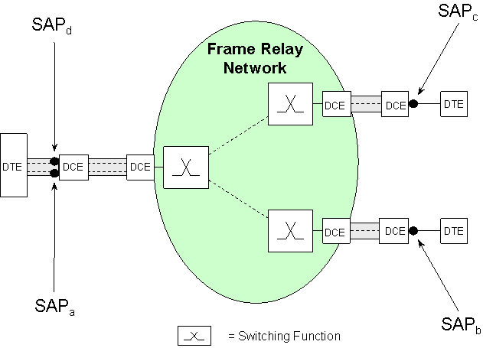
Figure 5-21 Frame Relay Base PVC Service
A Frame Relay core network consists of a number of network nodes interconnected by transport links. The SP normally supports a number of Service Access Points (SAP) that provide logical connections to the backbone network. Typically a Customer pays an access charge as well as a frame transfer charge. In physical terms, the Customer's communication equipment, e.g., a router, or frame relay access device (FRAD), is connected to a port on the nearest Frame Relay access node via a dedicated transmission line. The transmission speeds of the access line may not be identical to those of the Frame Relay port. The access line forms part of the Frame Relay service, i.e., the Frame Relay SP will, if necessary, obtain the required access line from a transport SP. Figure 5-21 illustrates a public frame relay network providing a permanent virtual connection (PVC) service.

Frame Relay Service
A Frame Relay service can be provided over various network technologies and data link layer protocols. Typically, the service provided to the Customer could be composed of two types of service elements, i.e., the physical access and the connectivity services.
The access service covers the access line, e.g. a T1 facility, connecting the CPE that may be owned by the Customer or by the SP with the frame relay backbone network. The connectivity service provides a transport path between two Customer access points by means of a PVC. A Customer typically purchases an access service at each site served by the frame relay service and a set of PVCs that provide the connectivity service.
Examples of SLA parameters for a Frame Relay service include the following:
- SAP based – Typical parameters include Error or Discarded Frame Ratio for a single SAP. These parameters may be measured at the user-network interface (UNI) between the Customer and the SP or at a network-node interface (NNI) between two frame relay backbone switching nodes.
- Service Element based – For a service element (SE) composed of multiple SAPs, i.e., when a connection is perceived by the Customer as one PVC between two end points, SAP-level parameters may be aggregated at the service level, such as Frame Loss Ratio of the PVC and the Frame Transfer Delay.
- Aggregated SE based – SLA parameters for multiple instances of the same service element include parameters such as the mean availability for all the PVCs, or for the combination of different SE types such as the availability of an access and all its linked PVCs.
- Service bundle based – These include parameters that are aggregated over the entire service bundle, such as Service Availability and the MTTR.

Frame Relay Service Parameters
A number of parameters may be negotiated between the Customer and the SP as part of the SLA, such as:
- Service Availability *
- Frame Transfer Delay*
- Frame Transfer Delay Variation
- Frame Delivery Ratio*
- Data Delivery Ratio*
- Minimum Information Rate
- Committed Information Rate
- Peak Information Rate
- Frame Error Ratio
- CRC Errors,
- Discarded Frames.
* As defined by the Frame Relay Forum in [FRF.13].
An example of a mapping of Frame Relay service parameters to the SLA parameter framework is provided in Figure 5-22.

 |  | Service Parameter Categories
 |  | Technology Specific | Service Specific | Technology/Service Independent
Service View | Individual User View | - Max. Frame Error Ratio for a specific PVC  - Max. Frame Transfer Delay for a specific PVC  - Frame Delivery Ratio for a specific PVC  - Max. Frame Delay Variation for a specific PVC |  | - Max. unavailability time for an access line  - Max. Time To Restore  - Minimum Time Between Failures
Service View | Aggregate View | - Max. Frame Error Ratio for all PVCs  - Mean Frame Error Ratio for a specific PVC  - Mean Frame Error Ratio for all PVCs  - Mean Frame Transfer Delay for a specific PVC  - Mean Frame Transfer Delay for all PVCs |  | - Max. unavailability time for all the access lines  - MTBF  - MTTR  - MTTP

Figure 5-22 Frame Relay Service Parameter Framework Example

Trouble Ticket Data – Frame Relay Service
Consider a Frame Relay Service provided on two PVCs as shown in Figure 5-21. In this case the SAPs are mapped on logical link ends at the DCE interfaces. The parameters of interest are given in Table 5-6.
Table 5-6 Frame Relay Service Availability Data
Parameter | Values
Reporting Period | 30 days = 720 hours = 43,200 minutes.
SAP Activity Time / SAP Cover Time | For all SAPs, the Service is required to be supported for 24 hours a day for 30 days. Then the SCT = SAT = 43,200 minutes.
SAP Weighting | The SAP weighting can be used to differentiate the importance of a single SAP to a Customer’s business. In this example the SAP_{a} weight = SAP_{b} weight = 1 and the SAP_{c} weight = SAP_{d} weight = 2.
SDF | Not used, i.e., set to 1.

Suppose that a physical transmission medium fault on the access line connecting the SAP_{a}-SAP_{d} site occurs from 4.30 pm to 6.00 pm on the thirteenth day of the reporting period. Further assume that this fault caused an outage at all SAPs of 1hour and 30 minutes = 90 minutes.
Service Availability for all SAPs can be calculated as following using Equation 5-2:

SA = 100% - (1 x 90 x 1) + (1 x 90 x 1 + (2 x 90 x 1) + (2 x 90 x 1) x 100%
(1 x 43,200) + (1 x 43,200) + (2 x 43,200) + (2 x 43,200)
SA = [1 - 540/259,200] x 100%
SA = 99.79 %.
As before, Service Availability can be computed for groups of SAPs if required.

Traffic Reports – Frame Relay Service
Traffic Reports are used by Customers to determine how efficiently the contracted services are being used. This allows the Customer and the Service Provider to asses future service requirements based on the observed traffic patterns and to verify any over/under-utilization of their in-place services.
Traffic Reports for Frame Relay PVC services may include:
- Frames Transmitted - in either direction,
- Frames Transmitted with discard eligible (DE) = 0 - in either direction,
- Frames Received - in either direction,
- Frames Received with DE = 0 - in either direction,
- Frames Discarded - in either direction,
- Frames Discarded with DE = 0 - in either direction,
- Bytes Transmitted - in either direction,
- Bytes Received - in either direction.
Average Utilization is the utilization of a PVC based upon the traffic between SAPs during a specified time interval divided by the Committed Information Rate (CIR). Traffic is normally defined as the number of bytes transmitted. This is an average over a time period determined by the Service Provider. The average utilization is normally available for each direction of transmission. Equation 5-6 is used to compute the average utilization per direction of transmission for a frame relay PVC.

Average Utilization = Bytes Transferred

CIR
Equation 5-6 Average Utilization
Peak Utilization is the peak, i.e., the maximum value, of the average utilization of the PVC. The time intervals used to compute the peak utilization are significantly shorter than those used for average utilization calculations. This interval is specified in the SLA. This peak may be an hourly peak over one month. This is normally available for each direction of transmission for a PVC.

Asynchronous Transfer Mode Networking
Asynchronous Transfer Mode (ATM) is a transport and switching technology that can be used for a variety of telecommunications applications. ATM is a fast, cell-based technology that can support customer applications requiring high bandwidth, high-performance transport, and multiples destinations. ATM is designed to support both constant and variable bit rate user applications, e.g., video, voice, data, and image, and to provide a more flexible use of bandwidth than is available with leased line technologies. International standards for ATM have been developed in the ITU-T. In addition, the ATM Forum, an industry association with representatives from several hundred companies throughout the telecommunications industry, the computer industry, and service customer communities, has developed and is maintaining implementation agreements to ensure interoperability of ATM equipment.

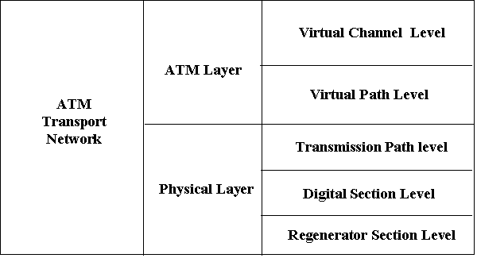
Figure 5-23 ATM Network Hierarchy
Figure 5-23 contains a description of the ATM layer structure. Note that for ATM transport, there are several Physical Layer technologies that may be used.
Figure 5-24 provides additional information on ATM intra- and inter-layer relationships. This volume of the Handbook uses the phrase virtual channel connection (VCC) to specify an end-to-end ATM service. The phrase virtual channel link represents that segment of a VCC between virtual channel switches. VCCs are occasionally referred to as virtual circuits.
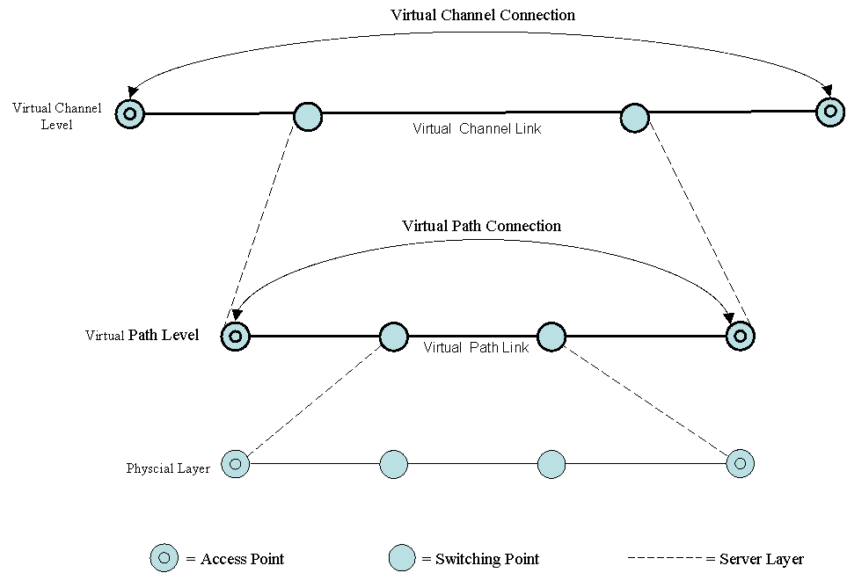
Figure 5-24 ATM Intra- And Inter- Level Relationships

ATM Cell Delivery Service
ATM Cell Delivery Service (CDS) is a cell transport service that provides the transport of ATM cells across Virtual Channel Connections (VCC) among service customers. Permanent Virtual Connection (PVC) based CDS provides for ATM cell transport across VCCs that have been defined by the service provider’s provisioning process. Switched Virtual Connection (SVC) based CDS provides ATM cell transport across VCCs established in real-time via signaling messages exchanged between the service customer and the service provider.
CDS is a public service that can be offered by any service provider for cell transport between end users in a single metropolitan area or between end users in different metropolitan areas. CDS is a connection-oriented communications service. It uses native-mode ATM technology to provide service customers with a high-speed, low-delay networking capability. These characteristics make it well suited for data-intensive business computing applications that require near-real-time, mixed-media communications among multiple locations.
The PVC based CDS permits a service customer to define logical connections among multiple locations using a single network access line per location. Multiple logical connections can be established that provide connectivity to many remote locations. Service customers interact with the network via User-Network Interfaces (UNI). From the perspective of the service customers, it is at those interfaces that all of the features of CDS are defined. From those interfaces, service customers can reach other locations whether or not those locations are served by the same network operation or service provider.
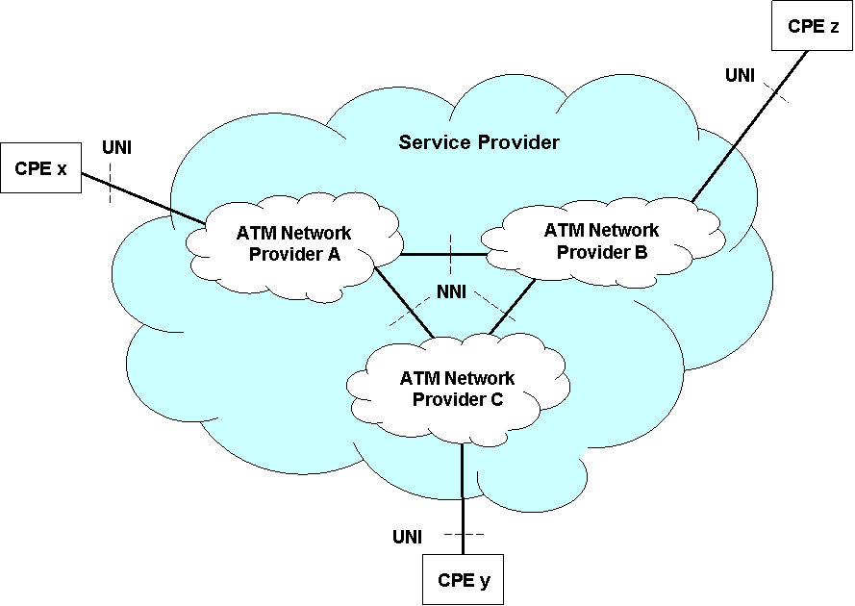
Figure 5-25 Cell Delivery Service Interfaces
ATM Cell Delivery Service is similar to the Frame Relay service previously discussed. It requires access lines from the service customer sites to the service provider’s ATM access switches. VCCs are then provisioned from the Customer Premises Equipment (CPE) through the network of ATM switches to other ATM Cell Delivery Service Customer sites. In some cases, the CPE itself may be an ATM access switch owned by the Customer that supports a range of service applications, e.g., voice, video, data, etc., to the Customer’s end users.
ATM technology identifies several generic transfer capabilities. The transfer capabilities range from Deterministic Bit Rate (DBR), with speeds up to the access line rate, to a “best effort” available bit (ABR) class. Figure 5-26 illustrates the relationships among Traffic Characteristics, ATM Transfer Capabilities, and ATM QoS Classes. See ITU-T Recommendations I.356 and I.371 for more information on these topics.

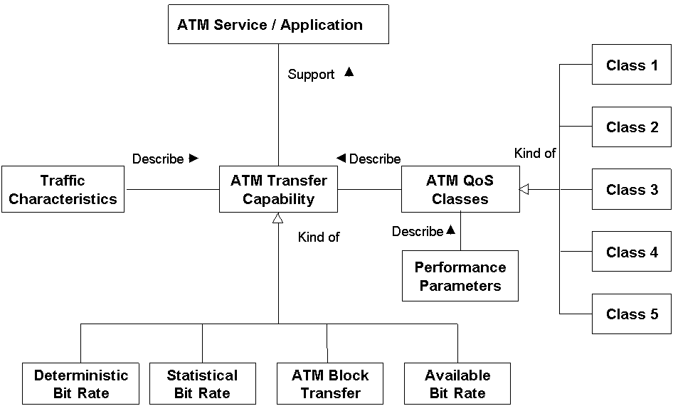
Figure 5-26 ATM Transfer Capabilities And QoS Classes
Customers typically negotiate several access parameters as well as PVC parameters for the CDS. For switched circuits, SLAs include additional parameters that characterize setting-up SVCs. Typical CDS parameters include the following:
- Service Availability,
- Access Line Speed,
- Cell Rate per VCC,
- Cell Propagation Delay per VCC,
- Cell Delay Variation per VCC,
- Cell Error Ratio per VCC,
- Cell Loss Ratio per VCC,
- Call Setup time per SVC,
- Blocked Calls per SVC.

Cell Delivery Service Parameters
The same considerations that apply to frame relay service elements also apply to the ATM Cell Delivery Service. The distinction between access service and connectivity services can be used to help define SLA parameters for the different components of the CDS.
An example of SLA parameters for the ATM Cell Delivery service that may be used in the SLA parameter framework is given in Figure 5-27.

 |  | Service Parameter Categories
 |  | Technology Specific | Service Specific | Technology/Service Independent
Service View | Individual User View | - Max. Cell Error Ratio for a specific PVC  - Max. Cell Transfer Delay for a specific PVC  - Max. Cell Loss Ratio for a specific PVC  - Max. Cell Delay Variation for a specific PVC |  | - Max. unavailability time for a PVC  - Max. Time To Restore  - Minimum Time Between Failures
Service View | Aggregate View | - Max. Cell Error Ratio for all the PVCs  - Mean Cell Error Ratio for a specific PVC  - Mean Cell Error Ratio for all the PVCs  - Mean Cell Transfer Delay for a specific PVC  - Mean Cell Transfer Delay for all the PVCs |  | - Max. unavailability time for all the PVCs  - MTBF  - MTTR  - MTTP

Figure 5-27 ATM Cell Delivery Service Parameter Framework Example

ATM Traffic Reports
Traffic Reports are used by Customers to determine how efficiently the contracted services are being used. This allows the Customer and the Service Provider to asses future service requirements based on the observed traffic patterns and to verify any over/under-utilization of their in-place services.
Traffic Reports for ATM services may include:
- Cells Transmitted per transmission direction,
- Cells Transmitted with CLP = 0 in either transmission direction,
- Cells Received in either transmission direction,
- Cells Received with CLP = 0 in either transmission direction,
- Cells Discarded in either transmission direction,
- Cells Discarded with CLP = 0 in either transmission direction.
Average Utilization is the utilization of a VCC based upon the traffic between SAPs during a specified time interval divided by the Sustainable Information Rate (SIR). Traffic is normally defined as the number of bytes transmitted, i.e., the number of cells transmitted multiplied by 53 bytes per cell. This is an average over a time period determined by the Service Provider. The average utilization is normally available for each direction of transmission. Equation 5-7 is used to compute the average utilization per direction of transmission for a frame relay PVC.
Average Utilization = Bytes Transferred

SIR
Equation 5-7 ATM Average Utilization
Peak Utilization is the peak, i.e., the maximum value, of the average utilization of the VCC. The time intervals used to compute the peak utilization are significantly shorter than those used for average utilization calculations. This interval is specified in the SLA. This value may be derived from the hourly peak observed over a one month period. Peak Utilization is normally available for each direction of transmission for a VCC.

Virtual Private Networks
ITU-T Recommendation Y.1311 describes the generic architectural aspects of network-based (NB) Virtual Private Networks (VPN). It also specifies a number of generic service requirements for these networks.
A network-based VPN is that part of a broader network that provides connectivity among a limited and specific set of the users of the broader network. From the VPN users’ perspective, the VPN appears to be a network that is dedicated specifically to its use. The VPN functionality is achieved through logical rather than physical means. Users of a specific VPN cannot communicate via the VPN with users of other VPNs or users of the underlying network.
Y.1311 identifies three classes of network based VPNs, viz., Layer 1 VPNs, Layer 2 VPNs, and Layer 3 VPNs. Note that layer is understood to be the OSI protocol layer. Specifically, the Recommendation defines a network based IP VPN as a VPN that uses the IP addressing scheme, the IP forwarding and routing protocols, the IP data encapsulation protocols, the IP signaling protocol, and IP routers as the basis for providing the VPN.

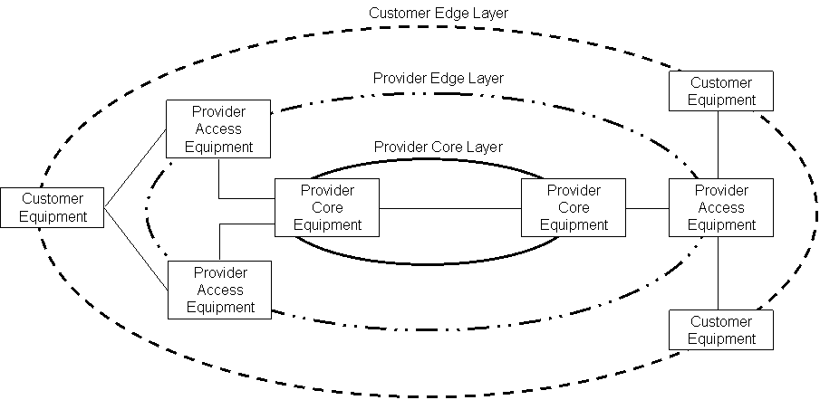
Figure 5-28 Generic VPN Reference Model

IP-VPN Service
An IP VPN service enables the transport of IP packets between a specified set of end points with a statistically based service level, e.g., loss, delay, availability, and a security level equivalent to that of a network composed of dedicated facilities.
The IP-VPN service has been developed to enable Customers to use IP networking between all of its locations independent of the distance between these sites. A router is required at each Customer site to interconnect to a Service Provider’s IP core network. An IP VPN is illustrated in Figure 5-29.
The IP core may be a publicly accessible network which provides connectivity to the global Internet. Tunnels are used to segregate the IP VPN traffic from normal Internet traffic as well as from other VPNs. In this way, an IP VPN provides a Service Customer with a Closed User Group service that provides any-to-any connectivity. The users of an IP VPN can only interact via the VPN with members of their own user group.
In addition to the basic connection service, an IP VPN can provide supplementary services. These include:
- Support for service customer defined VPN membership,
- Support for service customer defined VPN addressing schemes,
- Support for transparent transport of service customer data,
- Support for a customer site belonging to more than one VPN,
- Support for service customer defined VPN topologies, e.g., point to point, hubbed, etc.,
- Support for transparently transporting different service customer layer 3 protocols,
- Support for multi-homing,
- Access support for mobile users,
- Support for IP broadcasting,
- Support for security requirements,
- Support for switched access to the VPN,
- Support for VPN scaling, i.e., in terms of the number of users per site and the number of sites.

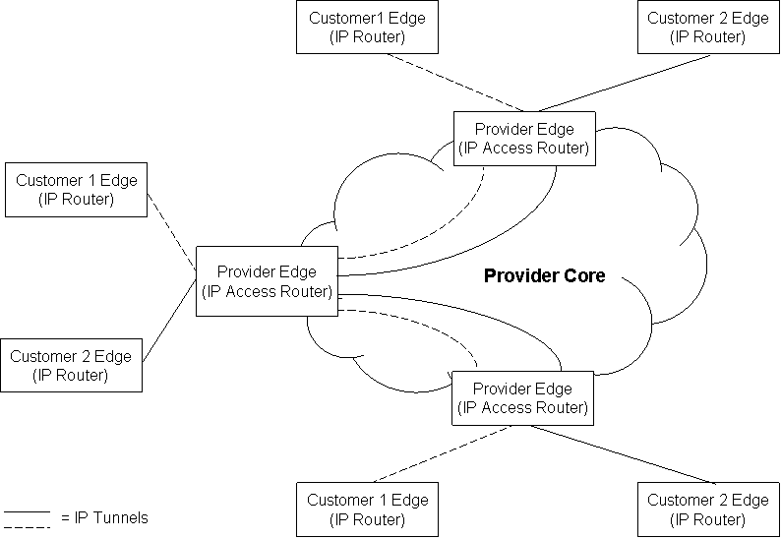
Figure 5-29 IP-VPN Network
A number of parameters can be negotiated between the Customer and the SP for inclusion in an IP VPN SLA. The following are typical parameters:
- Service Availability,
- IP Packet Transfer Delay,
- IP Packet Delay Variation,
- IP Packet Loss Ratio,
- IP Packet Error Ratio,
- Utilization.

IP-VPN Service Parameters
The IP VPN service requires a set of access transport connections from the routers located at Customer sites to the Service Provider’s access routers at the edge of the IP backbone network. As was the case for frame relay and ATM CDS, the IP VPN service element (SE) may be decomposed into the access service and the IP backbone connectivity service.
Examples of parameters for an IP-VPN service include the following:
- SAP based – These include IP Packet Loss Ratio for a single SAP at the access point to the VPN.
- Customer site bases – Since a Customer site may require multiple SAPs, e.g., for connecting different sites, SAP parameters such as availability may be aggregated to obtain a value that applies to a specific site.
- SE based – For a service element composed of multiple SAPs, e.g., a connection between two SAPs, the parameters such as the IP Packet Loss Ratio or the Packet Transfer Delay, may be aggregated to obtain a service level parameter.
- Aggregated SE based – SLA parameters for multiple instances of the same service element may be used, such as the mean availability of all the access services.
- Service bundle based – Parameters may be aggregated over the entire IP-VPN service bundle, such as Service Availability and the MTTR.
IP-VPN parameters may be mapped to the SLA parameter framework as shown in Figure 5-30.
 |  | Service Parameter Categories
 |  | Technology Specific | Service Specific | Technology/Service Independent
Service View | Individual User View | - Speed | - Max. IP Packet Transfer Delay for a specific access  - Max. IP Packet Delay Variation  - Max. IP Packet Loss Ratio | - Max. unavailability time for an access line  - Max. Time To Restore  - Minimum Time Between Failures
Service View | Aggregate View | - Total UAS | - Max. IP Packet Transfer Delay for all the accesses  - Mean IP packet Transfer Delay for a specific Customer site  - Mean IP packet Transfer Delay for a specific access  - Mean IP Packet Delay Variation  - Mean IP Packet Throughput | - Max. unavailability time for a specific Customer site  - Max. unavailability time for all the access lines  - MTBF  - MTTR  - MTTP
Figure 5-30 IP-VPN Service Parameter Framework Example

IP Based Information Service
Figure 5-31 contains an example of an information service, e.g., access to Internet web pages, provided by an ISP over a Telecom Service Provider’s (TSP) network to a group of subscribers. It should be noted that it is the role these business entities play that is important rather than their traditional service functions. For example, the TSP acts as a network bearer service provider and the network operator by providing the connectivity between the ISP and its Customers. The ISP is the provider of the application service where the service is information/Internet access. However, the TSP could also play the ISP role as well and vice versa.

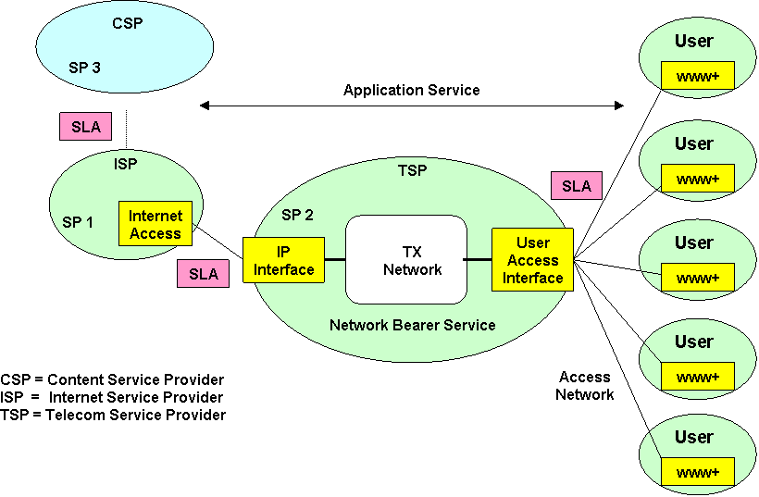
Figure 5-31 Example Of A Composite Service
There are at least two services involved in this example - a network bearer service provided by the TSP to the ISP and an application service provided by the ISP to its Customers. This is a classic example of a service comprised of service elements, each of which is a service itself and is comprised of other service elements.
In the example in Figure 5-31, the TSP, acting as SP 2, may transport the service over a number of different network technologies including SONET/SDH or ATM. The ISP, acting as SP1, on the other hand uses the network bearer service as a service element supporting its overall service to end Customers. As illustrated in Figure 5-31, there is a SAP group with an SLA between SP1 and SP2 and another SAP group between SP1 and its Customers.
There is also a third service involved in this example and that is of content provider. This may be the ISP itself or another business entity, such as suppliers of film libraries, music, games, etc. The ISP may act purely as a portal giving access to these content providers, whether they are companies or individuals with web home pages.
The implications for SLA management include the possibility that there exists an SLA between the TSP and the ISP as well as an SLA between the ISP and its Customers. One is dependent on the other. In assessing the level and quality of service delivered to the end Customer, it is important to consider the close coupling between the level and quality of service provided by the TSP and the level and quality of service of the information systems and technology used by the ISP, e.g. servers, databases, video stores, etc. For an entity doing most of its business via the Internet, this interdependence becomes critical. No amount of duplication or redundancy in the telecommunications network can compensate for weaknesses in the technology used by the ISP. This leads to the concept of two orthogonal axes of business survivability and telecom dependence where the further along the telecom dependence scale reliance is placed, the greater the risk to business survivability becomes.

DSL Supported Information Service Parameters
The IP based information service, as described in Section 5.12, is a bundle of network bearer services, e.g., IP connectivity to the ISP, application services, e.g., web hosting and security, and content services, e.g., news and music. Multiple SPs may be involved in providing the service to an end Customer. Different SLAs may be defined throughout the value chain, e.g., between the TSP and the ISP as well as between the ISP and the end Customer.
 |  | Service Parameter Categories
 |  | Technology Specific | Service Specific | Technology/Service Independent
Service View | Individual User View | - Max. IP Packet Transfer Delay From Customer Access  - Max. IP Packet Delay Variation  - Max. IP Packet Loss Ratio | - Max. Web Server Unavailability Time  - Max. Service Content Transfer Delay  - Max. Service Content Delay Variation | - Max. Unavailability Time For An Access Line  - Max. Time To Restore  - Minimum Time Between Failures
 | Aggregate View | - Mean IP Packet Transfer Delay From Customer Access  - Mean IP Packet Delay Variation  - Mean IP Packet Throughput | - Mean Web Server Unavailability Time  - Mean Service Content Transfer Delay  - Mean Service Content Delay Variation | - Mean Unavailability Time For All The Service Bundle  - MTBF  - MTTR  - MTTP

Figure 5-32 IP Service With DSL Access Service Example
The end Customer is interested in the level and quality of the overall service. Consequently, the SLA between the ISP and the end Customer may address all aspects of the service bundle. In this case the SLA includes parameters that cover the network, the application and the content aspects of the service. For example, in addition to the IP-related technology-specific parameters, such as IP packet delay and jitter, application parameters, such as the web server availability, e.g., the specification that the web server is reachable from the Customer site via HTTP Get request, or content parameters, such as service content delay, i.e., delay in transferring a minimum amount of content, could all be provided in the SLA for this service bundle.
An example of SLA parameters for the IP Service with DSL Access service that may be used in the SLA parameter framework is given in Figure 5-32.

Traffic Reports For The Information Service
Traffic Reports are used by Customers to determine how efficiently the contracted services are being used. This allows the Customer and the Service Provider to assess future service requirements based on the observed traffic patterns and to verify any over/under-utilization of their in-place services.
Traffic Reports for the information service may include:
- Total number of bytes into and out of SAP,
- Incoming and outgoing IP Packets traffic statistics at the SAP,
- Incoming and outgoing IP packets by source-destination address,
- Incoming and outgoing bytes in all IP packets by source-destination address,
- Incoming and outgoing IP packets discarded,
- Packet Loss during a specific period,
- Internet Service Availability over a specified period (Note that the measurement of availability may include the Customer’s SAP as well as the availability of the shared Internet.),
- Round trip latency to all Customer sites averaged over a specific predefined interval,
- Number of Performance/Utilization thresholds exceeded alerts/notifications e.g. threshold exceeded warning of excessive inbound and outbound packet errors, performance degradations and outages, increased utilization, etc.

Customer Help Desk Service
The Help Desk is an integral part of the overall service provided by SPs. Since Customers need to be well informed about the nature of any service related problem, the impact of these problems on their contracted service, the status of resolution, and anticipated time to restore the service to full operational status, the Customer Help Desk plays a very important part in complying with an SLA contract.
A customer support service, such as extended Help Desk support, enables a SP to customize its service offering for different Customers. For example, a network bearer service, such as an Internet access to an ISP via DSL, could be offered as a stand-alone service with limited Help Desk support, e.g., 8 a.m. to 5 p.m Monday through Friday. A Small Office Home Office (SOHO) Customer who uses the Internet for business purposes beyond the usual office hours may need, and therefore pay for, an added service providing extended Help Desk support.
The Customer Help Desk service is an example of a supplementary service. That is, its utility depends on the fact that a customer is using a primary service such as a network bearer service. Supplementary services are normally sold as an add-on to the primary services.
A set of time-of-day-based parameters can capture the essence of this type of service. For example, the following parameters may be used in an SLA for Customer Help Desk Services:
- Service Availability,
- Mean Time to Respond – i.e. wait for an available operator,
- Maximum Time to Respond for a Single Call,
- Mean Time to Examine Requests - i.e. entire time to process the request,
- Maximum Time to Examine a Single Request.

Help Desk Service Parameters
This service is an example of a simple SE that is provided to the Customer. The SAP related to this service is an abstraction of the means the Customer uses to contact the Help Desk support organization, e.g., a conceptual representation of a free toll number. SLA parameters, such as Mean Time To Respond to a Customer request, could be defined only at the service level. This example illustrates a Customer Help Desk service that has only technology/service-independent parameters.
An example of SLA parameters for the Customer Help Desk Service that may be used in the SLA parameter framework is given in Figure 5-33.
 |  | Service Parameter Categories
 |  | Technology Specific | Service Specific | Technology/Service Independent
Service View | Individual User View | - Not applicable | - Not applicable | - Max. Unavailability  - Max. Time to Respond, i.e., wait for an available operator. for a single call  - Max. Time to Examine a single Request, i.e., process the request
Service View | Aggregate View | - Not applicable | - Not applicable | - Mean Time to Respond  - Mean Time to Examine Requests
Figure 5-33 Customer Care Help Desk Service Parameter Example

References
[E.800] Terms and Definitions Related to Quality of Service and Network Performance including Dependability, ITU-T Recommendation E.800, Geneva, August 1994.
[E.801] Framework For Service Quality Agreement, ITU-T Recommendation E.801, Geneva, October 1996.
[FRF.13] Service Level Definitions Implementation Agreement, FRF.13, Frame Relay Forum Technical Committee, Freemont, CA, August 1998.
[G.703] Physical/Electrical Characteristics Of Hierarchical Digital Interfaces, ITU-T Recommendation G.703, Geneva, November 2001.
[G.707] Network Node Interface For The Synchronous Digital Hierarchy (SDH), ITU-T Recommendation G.707, Geneva, December 2003.
[G.708] Sub STM-0 Network Node Interface For The Synchronous Digital Hierarchy (SDH), ITU-T Recommendation G.708, Geneva, July 1999.
[G.709] Interfaces For The Optical Transport Network (OTN), ITU-T Recommendation G.709, Geneva, March 2003.
[G.811] Timing Characteristics Of Primary Reference Clocks, ITU-T Recommendation G.811, Geneva, September 1997.
[G.826] End-To-End Error Performance Parameters And Objectives For International, Constant Bit-Rate Digital Paths And Connections, ITU-T Recommendation G.826, Geneva, December 2002.
[G.827] Availability Performance Parameters And Objectives For End-To-End International Constant Bit-Rate Digital Paths, ITU-T Recommendation G.827, Geneva, September 2003.
[G.827.1] Availability Performance Objectives For End-To-End International Constant Bit-Rate Digital Paths At Or Above The Primary Rate, ITU-T Recommendation G.827.1, Geneva, November 2000.
[G.828] Error Performance Parameters And Objectives For International, Constant Bit Rate Synchronous Digital Paths, ITU-T Recommendation G.828, Geneva, March 2000.
[G.959.1] Optical Transport Network Physical Layer Interfaces, ITU-T Recommendation G.959.1, Geneva, December 2003.
[GB 910] Telecom Operations Map, GB 910, Approved Version 2.1, TeleManagement Forum, Morristown, NJ, March 2000.
[GB 917-1] SLA Management Handbook – Executive Overview, GB917-1, Version 2.0, TeleManagement Forum, Morristown, NJ, June 2004.
[GB 917-2] SLA Management Handbook – Concepts and Principles, GB917-2, Version 2.0, TeleManagement Forum, Morristown, NJ, April 2004.
[GB 917-4] SLA Management Handbook – Enterprise Perspective, GB917-4, Version 2.0, The Open Group, 2004.
[GB 921] enhanced Telecom Operations Map, GB921, Approved Version 3.0, TeleManagement Forum, Morristown, NJ, June 2002.
[I.211] B-ISDN Service Aspects, ITU-T Recommendation I.211, Geneva, March 1993.
[I.311] B-ISDN General Network Aspects, ITU-T Recommendation I.311, Geneva, August 1996.
[I.350] General Aspects Of Quality Of Service And Network Performance In Digital Networks Including ISDNs, ITU-T Recommendation I.350, Geneva, March 1993.
[I.356] BISDN ATM layer Cell Transfer Performance, ITU-T Recommendation I.356, Geneva, March 2000.
[I.371] Traffic Control And Congestion Control In B-ISDN, ITU-T Recommendation I.371, Geneva, March 2000.
[ITU-Hbk] Handbook on Quality of Service and Network Performance, ITU-T, Geneva, 1984, revised 1993.
[M.1301] General Description And Operational Procedures For International SDH Leased Circuits, ITU-T Recommendation M.1301, Geneva .
[M.1340] Performance Objectives, Allocations And Limits For International PDH Leased Circuits And Supporting Data Transmission Links And Systems, ITU-T Recommendation M.1340, Geneva, February 2000.
[M.2100] Performance Limits For Bringing-Into-Service And Maintenance Of International Multi-Operator PDH Paths And Connections, ITU-T Recommendation M.2100, Geneva, April 2003.
[M.2101] Performance Limits For Bringing-Into-Service And Maintenance Of International Multi-Operator SDH Paths And Multiplex Sections, ITU-T Recommendation M.2101, Geneva, June 2003.
[M.2101.1] Performance Limits For Bringing-Into-Service And Maintenance Of International SDH Paths And Multiplex Sections, ITU-T Recommendation M.2101.1, Geneva, April 1997.
[M.2140] Transport Network Event Correlation, ITU-T Recommendation M.2140, Geneva, February 2000.
[M.3208.1] TMN Management Services For Dedicated And Reconfigurable Circuits Network: Leased Circuit Services, ITU-T Recommendation M.3208.1, Geneva, October 1997.
[M.60] Maintenance Terminology and Definitions, ITU-T Recommendation M.60, Geneva, March 1993.
[NMF 503] Service Provider to Customer Performance Reporting Business Agreement, NMF 503, Issue 1.0, TeleManagement Forum, Morristown, NJ, March 1997.
[P806] Project P806, Deliverable 1, The EQoS Framework – Version 2, EURESCOM, September 1999.
[rfc2990] Next Steps For The IP QoS Architecture, IETF Informational RFC 2990, November 2000.
[SANCHO] ITU-T Sector Abbreviations and defiNitions for a teleCommunications tHesaurus Oriented database, http://www.itu.int/sancho/index.asp.
[TMF 701] Performance Reporting Concepts & Definitions Document, TMF 701, Evaluation Version Issue 1.1, TeleManagement Forum, Morristown, NJ, May 1999.
[TR 21-905] 3GPP TR 21.905 V6.5.0 3rd Generation Partnership Project; Technical Specification Group Services and System Aspects; Vocabulary for 3GPP Specifications, (Release 6).
[TR 22-950] 3GPP TR 22.950 V6.2.0 3rd Generation Partnership Project; Technical Specification Group Services and System Aspects; Priority Service Feasibility Study; (Release 6).
[TR 22-952] 3GPP TR 22.952 V2.0.0 (2003-10) 3rd Generation Partnership Project; Technical Specification Group Services and System Aspects; Priority Service Guide; (Release 6).
[TS 22.067] TS 22.067 V6.1.0 (2003-06), 3rd Generation Partnership Project; Technical Specification Group Services and System Aspects; enhanced Multi-Level Precedence and Pre-emption service (eMLPP) - Stage 1, (Release 6).
[TS 22-011] 3GPP TS 22.011 V6.3.0 (2004-03) 3rd Generation Partnership Project; Technical Specification Group Services and System Aspects; Service Accessibility, (Release 6).
[TS 23.067] 3GPP TS 23.067 V6.0.0 (2003-03) 3rd Generation Partnership Project; Technical Specification Group Core Network; enhanced Multi-Level Precedence and Pre-emption service (eMLPP) - Stage 2, (Release 6).
[TS 24.067] 3GPP TS 24.067 V5.0.0 (2002-06) 3rd Generation Partnership Project; Technical Specification Group Core Network; enhanced Multi-Level Precedence and Pre-emption service (eMLPP) - Stage 3, (Release 5).
[WP-SLA] White Paper on Service Level Agreements, Best Practices Committee, Application Service Provider Industry Consortium, 2000.
[X.134] Portion Boundaries And Packet-Layer Reference Events: Basis For Defining Packet-Switched Performance Parameters, ITU-T Recommendation X.134, Geneva, August 1997.
[X.140] General Quality Of Service Parameters For Communication Via Public Data Networks, ITU-T Recommendation X.140, Geneva, September 1992.
[X.141] General Principles For The Detection And Correction Of Errors In Public Data Networks, ITU-T Recommendation X.141, Geneva, November 1988.
[X.142] Quality Of Service Metrics For Characterizing Frame Relay /ATM Service Interworking Performance, ITU-T Recommendation X.142, Geneva, October 2003.
[X.144] User Information Transfer Performance Parameters For Public Frame Relay Data Networks, ITU-T Recommendation X.144, Geneva, October 2003.
[X.145] Connection Establishment And Dis-Engagement Performance Parameters For Public Frame Relay Data Networks Providing Svc Services, ITU-T Recommendation X.145, Geneva, October 2003.
[X.146] Performance Objectives And Quality Of Service Classes Applicable To Frame Relay, ITU-T Recommendation X.146, Geneva, October 2000.
[X.147], Frame Relay Network Availability, ITU-T Recommendation X.147, Geneva, October 2003.
[Y.1271] Framework(s) On Network Requirements And Capabilities To Support Emergency Communications Over Evolving Circuit-Switched And Packet-Switched Networks, draft ITU-T Recommendation Y.1271, Geneva, October 2004.
[Y.1291] An Architectural Framework For Support Of Quality Of Service (QoS) In Packet Networks, ITU-T Recommendation Y.1291, Geneva, May 2004.
[Y.1311] Network-Based VPNs – Generic Architecture And Service Requirements, ITU-T Recommendation Y.1311, Geneva, March 2002.

Acronyms
3GPP Third Generation Partnership Project
ABR Available Bit Rate
ABT ATM Block Transfer
ADM Add-Drop Multiplexer
AIP Application Infrastructure Provider
ANSI American National Standards Institute
ANT Access Network Transport
API Application Programming Interface
ASP Application Service Provider
ASPIC Application Service Provider Industry Consortium
ASR Answer/Seize Ratio
ATC ATM Transfer Capability
ATIS Alliance for Telecommunications Industry Solutions
ATM Asynchronous Transfer Mode
BBE Background Block Error
BBER Background Block Error Ratio
BER Bit Error Ratio
BICC Bearer-Independent Call Control
B-ISDN Broadband Integrated Services Digital Network
BSC Base Station Controller
BSS Base Station Subsystem
BTS Base Transceiver Station
CATV Cable Television (Community Antenna Television)
CBR Constant Bit Rate
CCR Call Completion Record
CD Cell Delay
CDR Call Data Record
CDS Cell Delivery Service
CDV Cell Delay Variation
CDVT Cell Delay Variation Tolerance
CE Cell Error
CER Cell Error Ratio
CESC Citizen Emergency Service Calling
CIM Common Information Model
CIR Committed Information Rate
CL Cell Loss
CLI Calling Line Identifier
CLP Cell Loss Priority
CLR Cell Loss Ratio
CM Cell Misinsertion
CMR Cell Misinsertion Ratio
CN Core Network
CNM Customer Network Management
COPS Common Open Policy Service
CPE Customer Premises Equipment
CPoF Common Point of Failure
CRC Cyclic Redundancy Check
CSU Channel Service Unit
CTD Cell Transfer Delay
DBR Deterministic Bit Rate
DCE Data Circuit Terminating Equipment
DE Discard Eligible
DiffServ Differentiated Services
DLCI Data Link Connection Identifier
DMTF Distributed Management Task Force
DNS Domain Naming Service
DPL Degraded Performance Limit
DS Differentiated Services
DSCP DiffServ Code Point
DSL Digital Subscriber Line
DSS Digital Subscriber SIgnalling System
DTE Data Terminal Equipment
ECBP End-to-end Connection Blocking Probability
EDC Error Detection Code
EDGE Enhanced Data rates for GSM Evolution
EFS Error Free Seconds
eMLPP Enhanced Mulit-Level Precedence And Pre-Emption
EQoS EURESCOM Quality of Service
ES Errored Second
ESR Errored Second Ratio
eTOM Enhanced Telecom Operations Map
ETS Emergency Telecommunications Service
ETSI European Telecommunications Standards Institute
EURESCOM European Institute for Research and Strategic Studies in Telecommunications
FDD Frequency Division Duplex
FR Frame Relay
FRAD Frame Relay Access Device
FSA Framework Study Area
FTD Frame Transfer Delay
G-CDR Gateway GPRS Support Node – Call Detail Record
GERAN GSM/EDGE Radio Access Network
GFR Guaranteed Frame Rate
GGSN GPRS Gateway Support Node
GII Global Information Infrastructure
GoS Grade of Service
GPRS General Packet Radio Service
GSM Global System for Mobile communication
HCPN Hybrid Circuit-switched/Packet-based Network
HTTP Hyper Text Transfer Protocol
IAB Internet Architecture Board
ICSP Information And Communications Service Provider
IESG Internet Engineering Steering Group
IETF Internet Engineering Task Force
IMSI International Mobile Subscriber Identity
IMT International Mobile Telecommunications
IN Intelligent Network
INMD In-service Non-intrusive Measuring Device
IntServ Integrated Services
IOPS.ORG Internet Operators Group
IP Internet Protocol
IPDV IP Packet Delay Variation
IPER IP Packet Error Ratio
IPLR IP Packet Loss Ratio
IPPM IP Performance Metrics
IPTD IP Packet Transfer Delay
IRTF Internet Research Task Force
ISDN Integrated Services Digital Network
ISM In-Service Monitoring
ISO International Organization for Standardization
ISP Internet Service Provider
IST Information Society Technologies
ISV Independent Software Vendor
IT Information Technology
ITAA Information Technology Association of America
ITU-R International Telecommunication Union – Radiocommunication Sector
ITU-T International Telecommunication Union – Telecommunication Standardization Sector
LAN Local Area Network
LDP Label Distribution Protocol
LSR Label Switching Router
MBS Maximum Burst Size
MCR Mean Cell Rate
MIB Management Information Base
MLPP Multiple Level Precedence And Pre-Emption
MOS Mean Opinion Score
MPEG Moving Picture Coding Experts Group
MPLS Multiprotocol Label Switching
MSC Mobile Switching Center
MTBF Mean Time Between Failures
MTBO Mean Time Between Outages
MTIE Maximum Time Interval Error
MTPS Mean Time to Provide Service
MTRS Mean Time to Restore Service
MTTP Mean Time to Provision
MTTR Mean Time To Repair
NE Network Element
NER Network Effectiveness Ratio
NGN Next Generation Network
NII National Information Infrastructure
N-ISDN Narrow band Integrated Services Digital Network
NM Network Management
NMC Network Management Control
NMDG Network Measurement Development Group
NMF Network Management Forum
NNI Network-Node Interface
NO Network Operator
NP Network Performance
NP&D Network Planning and Development
NPC Network Parameter Control
NSP Network Service Provider
NTE Network Terminating Equipment
OAM Operations, Administration & Maintenance
ODUk Optical Channel Digital Unit –Order K
OI Outage Intensity
ONP Open Network Provision
OS Operations System
OSI Open Systems Interconnection
OSS Operations Support System
OTN Optical Transport Network
PC Personal Computer
PCR Peak Cell Rate
PDH Plesiochronous Digital Hierarchy
PDH Plesiochronous Digital Hierarchy
PDN Public Data Network
PDN Public Data Network
PDP Packet Data Protocol
PDU Protocol Data Unit
PEI Peak Emission Interval
PHB Per Hop Behavior
PIB Policy Information Base
PIE Priority Information Element
PIN Personal Identity Number
PIR Peak Information Rate
PLM Product Line Management
PLMN Public Land Mobile Network
PNO Public Network Operator
POH Path OverHead
PRM Performance Report Message
PS Packet Switched
PSTN Public Switched Telephone Network
PVC Permanent Virtual Circuit
QoS Quality of Service
QOSF Quality of Service Forum
QSDG Quality of Service Development Group
RAN Radio Access Network
RFC Request for Comments
RFI Request for Information
RFP Request for Proposal
RFS Ready For Service
RFSD Ready For Service Date
RSVP Resource Reservation Protocol
SA Service Availability
SAP Service Access Point
SAT SAP Activity Time
SBR Statistical Bit Rate
S-CDR Serving GPRS Support Node – Call Detail Record
SCR Sustainable Cell Rate
SCT SAP Cover Time
SDF Service Degradation Factor
SDH Synchronous Digital Hierarchy
SE Service Element
SECB Severely Errored Cell Block
SECBR Severely Errored Cell Block Ratio
SEP Severely Errored Period
SEPI Severely Errored Period Intensity
SES Severely Errored Second
SESR Severely Errored Second Ratio
SGSN Serving GPRS Support Node
SIM Subscriber Identity Module
SIR Sustainable Information Rate
SLA Service Level Agreement
SLO Service Level Objective
SLS Service Level Specification
SLSU Service Level Specification and Usage
SMI Structure of Management Information
SOHO Small Office Home Office
SONET Synchronous Optical Network
SP Service Provider
SP&D Service Planning and Development
SQM Service Quality Management
STS-1 Synchronous Transport Signal – Level 1
SVC Switched Virtual Circuit
TCA Traffic Conditioning Agreement
TCP Transmission Control Protocol
TDD Time Division Duplex
TDM Time-Division Multiplexing
TDR Telecommunications For Disaster Relief
TEWG Traffic Engineering Working Group
TFT Traffic Flow Template
TIE Time Interval Error
TIPHON Telecommunications and Internet Protocol Harmonization over Networks
TMF TeleManagement Forum
TMN Telecommunications Management Network
TOM Telecom Operations Map
TSAG Telecommunication Standardization Advisory Group
TSP Telecom Service Provider
TT Trouble Ticket
TV Television
UAS Unavailable Seconds
UBR Unspecified Bit Rate
UML Unified Modeling Language
UMTS Universal Mobile Telecommunications System
UNI User-Network Interface
UPC User Parameter Control
UPL Unacceptable Performance Limit
USIM Universal Subscriber Identity Module
UTC Universal Time, Coordinated
UTRA UMTS Terrestrial Radio Access
UTRAN Universal Terrestrial Radio Access Network
VAR Value Added Reseller
VC Virtual Circuit
VCC Virtual Channel Connection
VCI Virtual Circuit Identifier
VOD Video On Demand
VoIP Voice over IP
VPI Virtual Path Identifier
VPN Virtual Private Network
WAN Wide Area Network
WAP Wireless Access Protocol
WTSA World Telecommunications Standardization Assembly
XIWT Cross-Industry Working Team
XML Extensible Markup Language

Annex A - Terms and Definitions
The terms and definitions used in the Handbook are mainly based on the TM Forum Performance Reporting Concepts and Definitions Document [TMF 701] and internationally agreed definitions published by the ITU. For example, ITU-T Recommendation M.60 [M.60] contains Maintenance Terminology and Definitions. In this annex, only some key terms related to SLAs, QoS, and performance are defined and their sources identified. For the purposes of the Handbook, some definitions have been modified and/or extended. Where multiple definitions are in use within the industry, all are given. Not all of the terms and definitions in this annex, are necessarily used in this version of the Handbook but are included as they are expected to be relevant in later versions. For further information, please consult TMF 701, ITU-T and other references.
Active (condition) – condition (e.g. alarm) not cleared (ITU-T Rec. M.2140).
*Administration (task) – a broad group of functions that sustain telecommunication services once they have been established. Administration generally consists of network administration and service administration. Network administration ensures that the network is used efficiently and that Grade of Service (GoS) objectives are met. Service administration includes such diverse support functions as billing, collecting and switching service evaluation (ITU-T Rec. M.3010).
Administrative Domain – a collection of systems and sub-networks operated by a single organization or administrative authority. It may be subdivided into a number of routing domains (ITU-T Rec. X.400).
*Aggregate Interval – the time period over which raw data is summarized in a particular report. For example, raw 15-minute data may be aggregated into one-hour or 24-hour intervals for reporting purposes (TMF 701 modified).
Alarm – an alerting indication of a condition that may have immediate or potential negative impact on the state of service resources, e.g. network element, application, system, etc. (ITU-T Rec. M.3010 modified).
*Alarm Surveillance – a set of TMN management functions which provide, in near real-time, detection and indication of failures (ITU-T Rec. M.3010).
*Anomaly – a discrepancy between the actual and desired characteristic of an item. The desired characteristic may be expressed in the form of a specification. An anomaly may or may not affect the ability of an item to perform a required function (ITU-T Rec. M.20).
Availability Performance – the ability of an item to be in the state to perform a required function at a given instant of time or at any instant of time within a given time interval, assuming that the external resources, if required, are provided. Note that this ability depends on the combined aspects of the reliability performance, the maintainability performance and the maintenance support performance of an item. In the definition of the item, the external resources required must be delineated. The term availability is used as an availability performance measure (ITU-T Rec. M.60).
Bearer Service – a type of telecommunication service that provides the capability for the transmission of signals between user-network interfaces (ITU-T Rec. I.112).
Clear – the end of a fault; the termination of a standing condition (ITU-T Rec. M.2140).
Connection – an association of transmission channels, circuits or flows, switching and other functional units set up to provide a means for a transfer of information between two or more points in a telecommunication network (ITU-T Rec. Q.9 modified).
*Connection Quality – the collective effect of service performance, which determines the degree of satisfaction of a user with the particular connection (ITU-T Rec. M.3010).
Customer – a Customer is an entity which receives services offered by a Service Provider based on a contractual relationship. It may include the role of a network user (ITU-T Rec. M.3010).
The term Customer refers to companies or organizations that make use of telecommunication services provided by a Service Provider. The Customer is the ultimate buyer of a network service, but the end user may or may not be the one who pays for the service (TMF 701 modified).
Customer Contact Point – a physical or conceptual point at which a Service Provider can interact with any Customer of the offered service for the purpose of maintaining communication services (TMF 701 modified).
Customer Details – information about the Customer, sometimes called Customer profile.
Customer Premises Equipment (CPE) – any network equipment sited at the Customer’s premises used to provide the contracted service. Note that the CPE may be owned and operated by the Customer or the Service Provider (extracted from TMF 701).
Customer SLA Performance Data – correlation of the service quality and performance data against specific Customer service instances to provide specific performance data against individual service instances and SLAs.
Customer to Service Provider Interface – the boundary of information exchange between the Customer (whether end Customer or another Service Provider/Network Operator) and their Service Provider (TMF 701 modified).
*Data Collection Interval – the period over which performance parameters are accumulated to compute each stored measurement and detect maintenance threshold crossings (ITU-T Rec. M.2140).
The time interval when statistics are retrieved from the network. This interval does not have to be the same as the measurement interval because the network devices may buffer statistics so that a number of them may be collected later (TMF 701).
Defect – a defect is a limited interruption of the ability of an item to perform a required function. It may or may not lead to a maintenance action depending on the results of additional analysis (ITU-T Rec. M.20).
Degradation – the presence of anomalies or defects in the absence of a fault (ITU-T Rec. M.2140).
Degraded Service – the presence of anomalies or defects that cause a degradation in QoS, but do not result in total failure of the service.
Event – an instantaneous occurrence that changes the global status of an object. This status change may be persistent or temporary, allowing for surveillance, monitoring, and performance measurement functionality, etc. Events may or may not generate reports; they may be spontaneous or planned; they may trigger other events or may be triggered by one or more other events (ITU-T Rec. X.700).
*Event Correlation Process – a process that accepts events as input, performs one or more event correlation sub-processes, and reports events as output (ITU-T Rec. M.2140).
*Event Correlation Sub-process – a single step in an event correlation process (ITU-T Rec. M.2140).
*Event Report Message – a message sent from one physical system to another that contains information about an event (ITU-T Rec. M.2140).
*Event Set – the set of all events that are grouped by a selection process for direct comparison or patterning (ITU-T Rec. M.2140).
Failure – the termination of the ability of an item to perform a required function. Note that after a failure the item has a fault (ITU-T Rec. M.20).
Fault – the inability of an item to perform a required function, excluding that inability due to preventive maintenance, lack of external resources or planned actions. Note that a fault is often the result of a failure of the item itself, but may exist without prior failure (ITU-T Rec. M.20).
*Fault Management (FM) – a set of TMN management functions which enable the detection and localization of faults, the scheduling of repairs, and the testing out and return to service of repaired equipment (ITU-T Rec. M.3010).
Grade of Service (GoS) – the designed service quality, also known as guaranteed QoS, used as a comparison with delivered (measured) QoS. A Service Provider commits a particular GoS to their Customers and then the QoS is a measurement of what was actually delivered (TMF 701 modified).
An alternative definition is offered below based on ITU-T Study Group 2 work.
GoS is the minimum level of service quality designed into the network supporting the service and maintained by traffic planning and engineering management actions depending on traffic densities over the duration the service is offered or used. As such, GoS represents a guaranteed expected level of service quality for any connection in the same QoS class of a specified service at any instant, and may in fact be improved upon depending on traffic loading of the network.
*Impairment – a condition that causes anomalies or defects without causing a failure (degrades the performance of a resource without causing a failure) (ITU-T Rec. M.2140).
Indication – an intermediate output of the event correlation process. A notification, indicating a persistent network, application or system-detected trouble condition. The three types of indication are fault indication, impairment indication, and trend indication (ITU-T Rec. M.2140 modified).
*Independent Event – an event that is not currently superceded by another event (ITU-T Rec. M.2140).
Mean Time Between Failures (MTBF) – the average time between failures of the service.
Mean Time Between Outages (MTBO) – the average time between outages of the service.
Mean Time to Provide Service (MTPS) – the average time to actually provide a specified service from the date of signing a contract to provide service. This may or may not be specified in the SLA.
Mean Time To Repair (MTTR) – the average time to repair service resources.
Mean Time to Restore Service (MTRS) – the average time to restore service after reporting a fault; this time includes the time to sectionalize and locate the fault. This may or may not be specified in the SLA.
Measurement Interval – the time interval over which each performance parameter is measured. For example, a parameter may be the number of errored seconds which occurred over a fifteen minute measurement interval (TMF 701 modified).
Network Operator (NO)/Provider – a company or organization which operates and provides telecommunication network paths and connections as a business. These may be direct to end Customers (in which case the NO is also a Service Provider) or under contract to Service Providers who in turn provide services to end Customers.
Network Performance (NP) – the ability of a network or network portion to provide the functions related to communications between users. Note that NP applies to the Network Provider’s planning, development, operations and maintenance and is the detailed technical part of QoS, excluding service support performance and human factors. NP is the main influence on serveability performance. NP measures are meaningful to Network Providers and are quantifiable at the part of the network to which they apply. QoS measures are only quantifiable at a Service Access Point (SAP) (ITU-T Rec. E.800).
Notification – information emitted by a managed object relating to an event that has occurred within the managed object; information passed from one Management Application Function (MAF) to another regarding an event (ITU-T Rec. X.710 and M.3010).
Operations – these include the operation of work centers, technical support centers, support systems, test equipment, methods and procedures, as well as the personnel and training required to install and maintain all the elements that constitute the network capability underlying the relevant services (ITU-T Rec. M.3010).
*Operations System – the OS is the stand-alone system which performs Operations Systems Functions (OSFs). For operational purposes, the management functionality may be considered to be partitioned into layers, such as network element management layer, network layer, service layer and business layer (ITU-T Rec. M.3010).
Performance Management (PM) – a set of TMN management functions which enable the performance (i.e. the ability to reproduce the signal) of the network services to be measured and corrective actions to be taken (ITU-T Rec. M.3010).
Performance Report – a statement of performance achieved over a given measurement interval and made available to the Customer by a variety of methods. These include printed or electronic reports provided on a regular basis, stored reports in a database accessible by the Customer or on-demand reports. Two basic types of reports are normally available – QoS performance against SLA guaranteed values and traffic data/utilization reports (extracted from TMF 701).
Quality of Service (QoS) – the collective effect of service performances which determine the degree of satisfaction of a user of the service. Note that the quality of service is characterized by the combined aspects of service support performance, service operability performance, service integrity and other factors specific to each service (ITU-T Rec. E.800).
Quality of Service Reports – reports generated from the service quality and performance data to report the performance of the service as a whole.
Raw Performance Data – raw performance data collected from various data sources including the network and service resources, such as network elements, network and element management systems, and network and application servers. In addition, data collected for the SP’s OSSs, such as trouble ticketing, order processes, maintenance and support, Customer care, etc.
*Ready for Service Date (RFSD) – the specified date in the contract at which the contracted service is ready for operation.
Reporting Period – the period at which performance reports are generated. It is defined independently for each SAP Group within the associated SLA (TMF 701).
Service – a telecommunication service is a set of independent functions that are an integral part of one or more business processes. This functional set consists of the hardware and software components as well as the underlying communications medium. The Customer sees all of these components as an amalgamated unit (TMF 701 modified).
Service Access Point (SAP) – a logical or physical element located on the interface between a Customer’s domain and the Service Provider’s domain, representing the point at which a service is delivered. A SAP can be weighted in accordance with a business-critical factor that is defined in the SLA (TMF 701 modified).
Service Access Point Group – a group of SAPs against which Service Availability must be reported. Each SAP normally belongs to one (or more than one) SAP Group and each SAP Group contains at least one SAP. The association between SAP Groups and SAPs is defined within the associated SLA, according to the required computation and aggregation format (TMF 701).
Service Availability (SA) – a measure of the fraction of time during a defined period when the service provided is deemed to be better than a defined QoS threshold. SA is measured in the context of an SLA between the Customer and the Service Provider concerned. It is expressed as a percentage (SA%) to indicate the time during which the contracted service (e.g. SVCs, PVCs, end-to-end circuits including protocols, applications, etc.) at the respective SAPs is operational. Operational means that the Customer has the ability to use the service as specified in the SLA (TMF 701 modified).
Note that the calculation of the SA may include weighting of the SAPs as noted above. The detailed formula is contained in TMF 701 and ITU-T Rec. M.1539.
*Service Degradation Factor (SDF) – a factor agreed between the Customer and the Service Provider used to weight the service availability calculation when the service is still available, but degraded from its contracted QoS (extracted from (TMF 701).
Service Descriptions - details of the service product catalogue offered by the SP.
Service Element – a service element comprises one or more network or service resources that are combined with other service elements to provide a service (TMF 701 modified).
Service Instance – a service that has been instantiated for a Customer.
Service Level Agreement (SLA) – a formal negotiated agreement between two parties, sometimes called a Service Level Guarantee. It is a contract (or part of one) that exists between the Service Provider and the Customer, designed to create a common understanding about services, priorities, responsibilities, etc. (TMF 701 modified).
An SLA or Contract is a set of appropriate procedures and targets formally or informally agreed between Network Operators/Service Providers (NOs/SPs) or between NOs/SPs and Customers, in order to achieve and maintain specified Quality of Service (QoS) in accordance with ITU (ITU-T and ITU-R) Recommendations. The SLA may be an integral part of the Contract. These procedures and targets are related to specific circuit/service availability, error performance, Ready for Service Date (RFSD), Mean Time Between Failures (MTBF), Mean Time to Restore Service (MTRS), Mean Time To Repair (MTTR) (ITU-T Rec. M.1340).
Service Level Agreement Contracts – individual-specific SLA contracts between the SP and the Customer with the specific service details, agreed levels of service quality, reporting schedules, and details of actions to be taken when the service quality guarantees are not met.
Service Level Agreement Reports – reports generated from the Customer SLA quality and performance data to report the performance of the specific service instance for a specific Customer against an SLA.
Service Level Agreement Templates – definitions of the standard grades of service which can be offered with an SLA, for example templates to describe gold and silver service characteristics.
Service Provider (SP) – a company or organization that provides telecommunication services as a business. SPs may operate networks, or they may simply integrate the services of other providers in order to deliver a total service to their Customers. Providing a telecommunication service to any one end Customer may involve multiple SPs, where one provider may “sub-contract” with other providers to fulfil the Customer’s needs (TMF 701).
Note that the term Service Provider is now being used generically and may include Telecom Service Providers (TSPs), Internet Service Providers (ISPs), Application Service Providers (ASPs) and other organizations that provide services, e.g. internal IT organizations that need or have SLA capabilities or requirements.
Service QoS and Performance Data – aggregated service quality and performance data combined from the many disparate raw data sources.
*Service Support Performance – the ability of an organization to provide a service and assist in its utilization. Note that an example of service support performance is the ability to provide assistance in commissioning a basic service, or a supplementary service such as the call waiting service or directory enquiries service (ITU-T Rec. E.800).
*Standing Condition – a condition that has duration, beginning with a failure and ending with a clear (ITU-T Rec. M.2140).
Telecommunications Management Network (TMN) – a TMN provides the means used to transport and process information related to management of the telecommunication network (ITU-T Rec. M.3010).
Telecommunication Service – that which is offered by a Service Provider to its Customers in order to satisfy a specific telecommunication requirement. Note that bearer services and teleservices are types of telecommunication service. Other types of telecommunication service may be identified in the future (ITU-T Rec. I.112 modified).
*Threshold Crossing Alert – a transient condition declared when a performance monitoring parameter reaches or exceeds a preset threshold (ITU-T Rec. M.2140).
*Thresholding – a process which is involved in decision making and which compares the actual value of a parameter with a predetermined value to decide whether an alarm action needs to be initiated (ITU-T Rec. M.3010).
Time to First Yield – the time interval between initiating service and the first reportable service-impacting event.
Transient Condition – a condition that has no duration, a one-time report (ITU-T Rec. M.2140).
Trouble – the perception of a fault or degradation that is judged to require maintenance attention (ITU-T Rec. M.2140).
User – a person or a machine delegated by a Customer to use the services and/or facilities of a telecommunication network or service offering. (ITU-T Rec. I.112 modified).

Annex B – Executive Summary Volume 1
Demonstrably in the modern business world e-business has either a direct or indirect impact on all business enterprises. More and more companies are increasingly dependent on telecommunication services as a core component of business strategy. The quality of telecommunication services is therefore rapidly becoming a significant factor in the success or failure of businesses, particularly with regard to availability and reliability. It is the Service Level Agreement (SLA) that defines the availability, reliability and performance quality of delivered telecommunication services and networks to ensure the right information gets to the right person in the right location at the right time, safely and securely. The rapid evolution of the telecommunications market is leading to the introduction of new services and new networking technologies in ever-shorter time scales. SLAs are tools that help support and encourage Customers to use these new technologies and services as they provide a commitment from SPs for specified performance levels.
The TM Forum SLA Handbook (GB 917 Version 1.5) was released by the TM Forum in June 2001. The objective of GB 917 was to assist Customers and Telecommunication Service Providers (SP) with understanding the fundamental issues involved with developing telecommunication services SLAs and SLA management. GB 917 Version 1.5 incorporates the concepts within the Performance Reporting Concepts and Definitions Document (TMF 701) and the Telecommunication SP to Customer Performance Reporting Business Agreement (NMF 503) documents. These two documents offer a valuable extension to GB 917.
GB 917 Version 1.5 was based on the traditional telecommunications SP to Customer relations embedded within the International Telecommunication Union (ITU) Telecommunication Management Network (TMN) Framework model and the TM Forum generated Telecommunications Operating Model (TOM) functional processes. Since GB 917 Version 1.5 there have been many significant advances within the telecommunications SP industry. There is now a need to address these recent advances in the context of how telecommunication SP to Customer relations are managed and the impacts on SLAs and SLA management.
The more important external and internal telecommunication SP advances that have made significant influential impact and need to be taken into consideration are, inter alia:
- A new breed and types of Service Providers such as, Internet, Application and Content;
- New services enablers such as Security and Mobility;
- A move towards network centric architectures enabling e-commerce;
- A realization that Enterprise Customer issues need to be given greater consideration and prominence;
- Increased Enterprise Customer and SP expectations;
- A significant increase in the number of interconnections and interfaces to enable end-to-end services;
- The need for greater and improved use of automation;
- An awareness of the limitations of SP internal processes such as, improvements to Operational Support Systems (OSS);
- The need to address deregulation within the telecommunications industry;
- Moves towards a more seamless SP to Customer Service Access Point (SAP) or Service Delivery Point (SDP).
The main impact of recent telecommunication advances is added complexity to SP-Customer relations. Added complexity was recognized by the TM Forum in 2001 by acknowledging that the TOM model lacked sufficient detail to account for recent telecommunication advances and embarked on a new SP and Customer relation management paradigm. This new management paradigm has evolved into what is now referred to as the enhanced TOM (eTOM). The eTOM includes those processes necessary to manage SLAs and Quality of Service (QoS).
The TM Forum SLA/QoS Handbook Team also realized that the first GB 917 SLA Management Handbook lacks sufficient detail and management processes to cater for the breadth of SLAs needed within a modernized Telecommunication SP industry. GB 917 Version 1.5 has therefore been revised to include the SLA management processes necessary to handle recent telecommunication advances as well as the TMF instigated eTOM.
The revised TM Forum SLA Handbook is designated GB 917 Version 2 and structured as a four Volume suite. Volumes 1, 2 and 3 focus on telecommunication services SPs, Suppliers and Customers whereas Volume 4 focuses on Enterprise business applications and associated telecommunication services. The four volumes are entitled:
- Volume 1 – SLA Management Handbook - Executive Overview;
- Volume 2 – SLA Management Handbook - Concepts and Principles;
- Volume 3 – SLA Management Handbook - Service and Technology Examples;
- Volume 4 – SLA Management Handbook - Enterprise Perspective.
Volume 1 is written for Chief Executive Officers (CEO) and Board of Directors members. It is a concise introduction to SLA Concepts, Business Case, Benefits, Consequences for telecommunication service customers, SPs, and hardware and software suppliers. Volume 1 also addresses where SLAs reside within the modern market place.
Volume 2 is written for the telecommunication and supplier managers. It provides the detail behind SLA principles such as Service Access Point (SAP), Service Delivery Point (SDP), SLA management process mapping onto eTOM, service parameter framework, and measurement and reporting strategies.
Volume 3 is written for Telecommunication and Supplier implementers. It describes how to apply the SLA principles defined in Volume 2 to a representative set of technologies. Volume 3 also includes a checklist of items typically included within telecommunication service SLAs.
Volume 4 is written for enterprise managers and implementers. It addresses business application and services as well as internal and external network services. In this context it generically describes enterprise performance requirements for end-to-end services. A number of enterprise business applications of SLAs are described in detail.
For business enterprises, be they end Customers, SPs or Suppliers, to embrace SLAs a business case must be made. Volume 1 approaches the business case from the point of view that information related to product lines and transfer of information enabled by telecommunication services and networks is the life blood of business enterprises. It is business enterprise information that must be properly understood, managed and assured for business enterprises to sustain growth and not fail.
Understanding business information is termed Information Management (IM). Protecting business information is termed Information Assurance (IA). Telecommunication services and networks are indispensable for conducting commercial, government and academia business. However, service and network Level of Service (LoS) and QoS performance is only as good as that supported by the service and network architecture design. This limitation may result in telecommunication services and networks under performing against the desired business enterprise requirement thereby introducing business risks that may have far reaching consequences to the survival of business enterprises. Therefore for enterprises to be assured of business survival, business application LoS and QoS performance requirements must be accurately mapped into the telecommunication services and networks QoS performance parameters, metrics and thresholds incorporated within business enterprise internal and external SLAs. Ultimately, it is the CEO that is responsible for corporate business enterprise IM, IA and determining business application LoS and QoS performance. The telecommunication service and networks supporting business enterprises must provide capability to meet the required LoS and QoS performance needs. For business enterprises to commit to and embrace SLAs there is a need to conduct a Balance of Investment (BoI) to be assured that SLAs will benefit the business. The SLA BoI must into account all factors associated with SLA benefits, consequences, incurred whole life costs, improved revenue and profitability, understanding the content of business information as well as the required level of LoS and QoS performance. Volume 1 introduces some of the major benefits and consequences for end Customers, SPs and Suppliers when implementing, embracing and supporting SLAs. The listed benefits and consequences is not intended to be all inclusive.
For end Customers, SPs and Suppliers CEOs and Board members accepting that adopting SLAs is considered a progressive adjunct to business enterprise strategy, Volume 1 provides suggested possible next steps towards implementing, embracing and supporting SLAs. These next steps range from a review of business strategies, gap analysis, information content, processes, cost-benefit analysis, current services and supporting SLAs, training needs analysis to future service plans, marketing strategies and outsourcing strategies.
For convenience Volumes 2, 3 and 4 Executive Summaries are at Annexes A, B and C to this Volume 1 Executive Overview.

Annex C - Executive Summary Volume 2
The Service Level Agreement (SLA) Management Handbook series consists of four volumes. These are Volume 1, Executive Overview, Volume 2, Concepts and Principles, Volume 3, Applications and Examples and Volume 4, Enterprise and Applications. The series has a common conceptual base with each volume concentrating on specific topics. The volumes may be read in any order although it is suggested that Volumes 2 and 4 be read before Volume 3. It is expected that the readers of Volume 1 are interested in an overview of the SLA Management process that is sufficient to enable them to provide management guidance to their organizations. For reader convenience, the Executive Summaries for Volumes 1, 2, and 4 are in the Annexes to this document.
The objective of the SLA Management Handbook series is to assist two parties in developing a Service Level Agreement (SLA) by providing a practical view of the fundamental issues. The parties may be an “end” Customer, i.e., an Enterprise, and a Service Provider (SP) or two Service Providers. In the latter case one Service Provider acts as a Customer buying services from the other Service Provider. For example, one provider may supply network operations services to the provider that supplies leased line services to its customers. These relationships are described as the Customer-SP interface and the SP-SP interface.
The perspective of the SLA Management Handbook series is that the end Customer, i.e., an Enterprise, develops its telecommunication service requirements based on its Business Applications. These requirements are presented to a Service Provider and the two parties begin negotiating the specific set of SLA parameters and parameter values that best serves both parties. For the SP, the agreed-upon SLA requirements flow down through its organization and become the basis for its internal management and control of its Quality of Service (QoS) processes. For the Enterprise Customers, the SLA requirements serve as a foundation or a component of its internal network services or business services.
This volume of the Handbook contains two tools that provide the foundation for clarifying management roles, processes, responsibilities and expectations. These are the Life Cycle of the Service and the SLA Parameter Framework.
A service and its associated SLA are divided into six Life Cycle Stages to clarify the roles of the Customer and the SP. The six Life Cycle Stages are as follows: product/service development, negotiation and sales, implementation, execution, assessment and decommissioning. Each life cycle stage addresses specific operations processes in the enhanced Telecom Operations Map (eTOM) [GB 912]. The SLA Life Cycle provides a complete process description by delineating interactions between well-defined stages.
Many performance parameters exist that have similar names yet have drastically different definitions. The SLA Parameter Framework is a useful tool for categorizing parameters. The framework organizes SLA parameters into six categories based upon service and delivery technology and upon measures of individual instance and average performance. The specification of specific values for service performance parameters is part of a specific contract negotiation and is beyond the scope of the Handbook.
The SLA Management Handbook series incorporate earlier work that appears in the Performance Reporting Concepts and Definitions Document [TMF 701], in the Service Provider to Customer Performance Reporting Business Agreement [NMF 503] and in Service Quality Management Business Agreement [TMF506].

Annex D - Executive Summary For Volume 4
This volume addresses the enterprise issues in the provision of end-to-end Service Level Agreements (SLA) and comes as a collaboration between the Open Group, representing the enterprise, and the Telemanagement Forum, addressing the service provider markets. This work was further inspired by survey data gathered on behalf of the Open Group by Sage Research which indicated great interest in SLAs in the enterprise but a large gap between where enterprises are considering SLAs and where standards bodies, such as the IETF, are currently concentrating their efforts.
The scope of the market addressed by ‘enterprise’ is very broad and business practices diverse. It was therefore necessary generalize the applications used by an enterprise that SLA metrics could be applied, measured and reported in a contractual manner.
In the attempt to describe enterprises generically, an application is considered as a collection of applications that fulfill the enterprise objectives. Such objectives would include raising revenue (commercial), giving taxes (government), curing patients (healthcare) and defending a nation (operational defense). In support of these objectives the enterprise needs to deploy a number of business applications. These applications would include call center, trading, information delivery, manufacture, distribution etc.
To enable the business applications, a number of business services, e.g., voice, video conferencing, email, transaction processing and telemetry and network services (IP, Ethernet, DSL etc.) need to be deployed to an agreed level (the service level), maintained and reported. There is some cases a hierarchical or peer to peer relationship between these services that must be considered.
This work uses the concept of key quality and performance indicators (KQI/KPI) developed by the TMF Wireless Services Measurement Handbook (GB 923). The importance of the KQI/KPI concept is that it allows the provider of the service to concentrate on the quality, rather than the performance of a service as in the past. The relationship between the KQI and the performance metrics, KPI could be identical for the simple case or complex, derived empirically or inferred from a number of KPI and other data. The mapping between the KQI and KPI forms an important part of the SLA negotiation.
For each of the generic business services discussed, the KQI are determined and then KPI for the services and methods tabulated.
The form of an SLA is discussed and special attention is made between the form of an SLA between internal parties and external parties, especially in terms of penalties. A monitored and reporting process is then discussed allowing for real time, near real time and historical reporting of both asynchronous events and polled parameters.
A number of use cases are considered to validate the approach. The first is a common example where Voice over IP (VoIP) is used to connect remote sites of an enterprise to a corporate HQ. Data is also supported but only on a best effort basis. The second scenario is from the Open Groups Mobile Management Forum’s work on the ‘Executive on the Move’ where an executive is considered to have voice and data connectivity wherever they are, in the office, in transit (car, airplane), at home or at a remote site. Voice, data and video (conferencing) are also supported for the executive. The final scenario is a naval application where voice, data and video applications are supported in a highly distributed and arduous environments. The VoIP and naval scenarios envisage a common IP infrastructure and uses a differentiated services (DiffServ) marking scheme to separate the different service domains for prioritization.

The Network Performance factors shown in Figure 2-7 are associated with External Networks.
Figure 3-3 is a reproduction of Figure 6-3 of Volume 2.
In this chapter, the date terminating equipment (DTE) and data circuit terminating equipment (DCE) are intended to be functional descriptions. The DCE and the DTE may be physically implemented in the same or in different hardware devices.
In this case, the transport function is considered to be the primary service and the timing function is considered to be an enabling or supporting service. See Chapter 3 of Volume 2 for additional information on service functions.
This description of a leased line service is based largely on ITU-T Recommendations for International Leased Circuits, e.g., Recommendations M.1301 and M.3208.1.
See Section 3.2.2 for a discussion of performance data collected by network elements.
Because of the 10-second hysteresis associated with declaring unavailable time, short breaks of less than 10 seconds will go undetected as short breaks although most NEs will record the ESs. These events are now defined by the ITU-T as Severely Errored Periods (SEP), and measures and limits for them are being defined. Such short breaks have been known for some time to affect applications, e.g., SNA, running over leased circuits where the Customer experiences failures, but the Service Provider sees no network fault.
In this section emergency calls refers to the Citizen Emergency Service Calling (CESC) introduced in Section 5.4.
The Frame Relay service was one of the services selected by the SLA Management Wholesale and Retail Services catalyst team (SLA catalyst team). The information in this section is based upon that team’s specification of the service.
The number of PVCs needed to connect all sites is (N-1) for each access.
This type of SAP is needed when access services and backbone PVCs are provided by different SPs.
This parameter can be quite complex for non-real-time and real-time streams.
The IP-VPN service was one of the services selected by the SLA Management Wholesale and Retail Services catalyst team. (SLA catalyst team). This section is based on that team’s specification of the service.
Terms and definitions not yet used are marked with a *.

