Information Framework (SID)
Concepts and Principles

GB922
TM Forum Approved Version 7.4


October, 2012

Notice
This material, including documents, code and models, has been through review cycles; however, due to the inherent complexity in the design and implementation of software and systems, no liability is accepted for any errors or omissions or for consequences of any use made of this material.
Under no circumstances will the TM Forum be liable for direct or indirect damages or any costs or losses resulting from the use of this specification. The risk of designing and implementing products in accordance with this specification is borne solely by the user of this specification.
This material bears the copyright of TM Forum and its use by members and non-members of TM Forum is governed by all of the terms and conditions of the Intellectual Property Rights Policy of the TM Forum (http://www.tmforum.org/Bylaws/1094/home.html) and may involve a claim of patent rights by one or more TM Forum members or by non-members of TM Forum.

Direct inquiries to the TM Forum office:
240 Headquarters Plaza,
East Tower – 10th Floor,
Morristown, NJ 07960 USA
Tel No. +1 973 944 5100
Fax No. +1 973 944 5110
TM Forum Web Page: www.tmforum.org

Table of Contents
Notice 2
Table of Contents 3
List of Figures 4
Executive Summary 5
1. Introduction 8
1.1. Information Framework Business View Overview 8
1.2. Definitions 10
1.2.1. Domain 10
1.2.2. Aggregate Business Entity 11
1.2.3. Business Entity 11
1.2.4. Attribute 11
1.2.5. Relationship 11
1.3. Information Framework Documents 11
1.4. Relationship to other TM Forum Documents 12
2. The Information Framework 13
2.1. Introduction 13
2.2. Information Framework – Level 1 ABEs 14
2.3. ABE Categorization 17
3. Relationship to Business Process Framework 20
3.1. Domain definitions, ABE Definitions, and Mapping to Business Process Framework Level 2 Processes 20
3.1.1. Scope and Context 20
3.1.2. Principles for Mapping 20
3.1.3. Regarding ABEs Supporting Two Level 2 Business Process Framework Processes 21
3.1.4. Market/Sales Domain 21
3.1.5. Product Domain 23
3.1.6. Customer Domain 25
3.1.7. Service Domain 28
3.1.8. Resource Domain 31
3.1.9. Supplier/Partner Domain 36
3.2.0. Common Business Entities Domain 39
4. Information Framework Snapshot 41
4.1. Introduction 41
5. Annexes 55
5.1. Annex 1: Abbreviations and References 55
5.1.1. Abbreviations 55
5.1.2. Non Normative References 55
6. Administrative Appendix 56
6.1. About this document 56
6.2. Document History 56
6.2.1. Version History 56
6.2.2. Release History 58
6.3. Company Contact Details 58
6.4. Acknowledgments 59

List of Figures
Figure 1 - Views of the Frameworx Knowledge Base 5
Figure 2 - Information Framework Domains & Business Process Framework Process Linkages 8
Figure 3 - Information Framework Domains & Level1 ABEs 9
Figure 4- The relationship to other TM Forum documents 13
Figure 5- Business Process Framework/Information Framework Concepts/Domains 14
Figure 6 - Information Framework Business View Framework 14
Figure 7 - Level Two ABEs identified in the Service Domain 15
Figure 8 – Initial Level Three ABEs identified within the Service Level 1 ABE 16
Figure 9 – Initial Service Level Three ABEs. 17
Figure 10 - Information Framework Common Categories 19
Figure 11 - Party and Related Entities 43
Figure 12 – Location (Place) and Related Entities 44
Figure 13 – Business Interaction and Related Entities 45
Figure 14 – Agreement and Related Entities 46
Figure 15 - Calendar and Related Entities 47
Figure 16 – Project and Related Entities 48
Figure 17 – Policy and Related Entities 49
Figure 18 – Customer and Related Entities 50
Figure 19 – Customer Order and Related Entities 51
Figure 20 – Product, Service Resource Associations 52
Figure 21 – Product Offering and Related Entities 53
Figure 22 – Product and Related Entities 54

Executive Summary
The Frameworx (formerly known as NGOSS) knowledge base contains a number of elements, including
- Business processes
- Business process flows
- Business application contracts
- Shared data and information
- Reference code and interfaces
This guidebook focuses on the shared data and information elements of the Frameworx knowledge base. These two elements are commonly referred to as the Information Framework (also known as the SID) in this guidebook.
Frameworx knowledge elements can be viewed in many different ways as shown in the figure below. A business process analyst may be interested in a business view of the knowledge elements. For example, the definition of a business entity used by a process. From a systems point of view, a contract designer may desire to know the operations that act on a business entity. From an implementation point of view a component builder may be interested in a view of the realized information model.
System
View
Implementation
View
NGOSS
Knowledge
Base
Need
Model
Validate
Run
Business
View
Customer
OSS
Thu Apr 05 12:47:19 2001
Ordering 3 Use Case
Use Case Diagram
Gateway Services
Gateway
Interface
Provider Services
Customer
Management
Interface
Customer Management Services
Product Management Services
ProductRequest
<<SDM>>
CustomerContact
<<SDM>>
Customer
<<SDM>>
InvoiceInquiry
<<SDM>>
CreditViolation
<<SDM>>
ProductCatalog
<<SDM>>
ProductService
<<SDM>>
Customer
Order
Manager
Product
Fulfillment
Manager
Ordering 3
Process
*
*
*
Customer
Relationship
Management
Resource
Infras'ture
Dev't and
Mngmnt
Supplier/
Partner
Service
Development
and Op'ns
Management
Information
Customer
Assess Service
Availability
Provide Service
Availability Date
Determine
Resource
Availability
Provide Availability
Date
Qualify
Customer
Identify Solution
Alternatives
Update Customer
Contact Record
Solution
Alternatives
Available
No Action
Required
Pre-Order
Feasibility
Request Made
Receive Pre-Order
Feasibility Request
Contract Interface
Service
Implementation
Run
-
Time
View
System
View
Implementation
View
Solution
Framework
Knowledge
Base
Need
Model
Validate
Run
Business
View
Customer
OSS
Thu Apr 05 12:47:19 2001
Ordering 3 Use Case
Use Case Diagram
Gateway Services
Gateway
Interface
Provider Services
Customer
Management
Interface
Customer Management Services
Product Management Services
ProductRequest
<<SDM>>
CustomerContact
<<SDM>>
Customer
<<SDM>>
InvoiceInquiry
<<SDM>>
CreditViolation
<<SDM>>
ProductCatalog
<<SDM>>
ProductService
<<SDM>>
Customer
Order
Manager
Product
Fulfillment
Manager
Ordering 3
Process
*
*
*
Customer
Relationship
Management
Resource
Infras'ture
Dev't and
Mngmnt
Supplier/
Partner
Service
Development
and Op'ns
Management
Information
Customer
Assess Service
Availability
Provide Service
Availability Date
Determine
Resource
Availability
Provide Availability
Date
Qualify
Customer
Identify Solution
Alternatives
Update Customer
Contact Record
Solution
Alternatives
Available
No Action
Required
Pre-Order
Feasibility
Request Made
Receive Pre-Order
Feasibility Request
Contract Interface
Service
Implementation
Contract Interface
Service
Implementation
Run
-
Time
View
Figure 1 - Views of the Frameworx Knowledge Base

This document, Information Framework, Concepts and Principles, covers the following topics:
- Concepts and definitions key to understanding Information Framework business view content
- Information Framework concepts used to model and organize Information Framework business view content
The detailed Information Framework business view content can be found in the associated GB922 Addenda.
This guidebook provides an insight into the organizing framework for the contents of the Information Framework business view, one of the three views referred to above.
A similar guidebook for the implementation view has been deemed to be out of scope for this version of the Information Framework deliverable.
The Information Framework not only satisfies the Frameworx information and data needs, but also satisfies another need – a mechanism to bring the business and IT communities into a closer understanding.
For many years the Business Process Framework (formerly known as the eTOM), and its predecessor the Telecom Operations Map (TOM), have provided a business process reference framework and common business process vocabulary. This framework and vocabulary have provided the communications and information industry enterprises an effective way to organize their business processes and communicate with each other.
The Information Framework (aka. SID) business view model can be viewed as a companion model to the Business Process Framework, in that it provides an information/data reference model and a common information/data vocabulary from a business entity perspective. The business view model uses the concepts of domains and aggregate business entities (or sub-domains) to categorize business entities, so as to reduce duplication and overlap. Based on data affinity concepts, the categorization scheme is necessarily layered, with each layer identifying in more detail the “things” associated with the immediate parent layer. This partitioning of the Information Framework business view model also allows distributed work teams to build out the model definitions while minimizing the flow-on impacts across the model.
Teamed with the Business Process Framework, the Information Framework provides enterprises with not only a process view of their business but also an entity view. That is to say, the Information Framework provides the definition of the ‘things’ that are to be affected by the business processes defined in the Business Process Framework. The Information Framework and Business Process Framework in combination offer a way to explain ‘how’ things are intended to fit together to meet a given business need. It should be noted that while both the Business Process Framework and the Information Framework business view model are layered, there is not necessarily a one-one relationship between the layers in each model, i.e., Business Process Framework Level 3 process elements do not only have relationships assigned to Information Framework Level 3 ABEs.
The relationship between the Information Framework and the Business Process Framework is outlined in more detail in Chapter 4. However, in brief, two sorts of relationships are identified – primary and secondary.
The primary relationship identifies the element of the Business Process Framework, which is responsible for creating instances of the Information Framework business entity. The presumption is that only one primary relationship exists between any Information Framework business entity and a Business Process Framework process element. In other words an enterprise should only use one process to create and delete instances of a specific business entity, to reduce the risks of misaligned and/or non-unique information within the enterprise. This relationship underpins the concept of the single database of record or master database.
Secondary relationships are assigned between Business Process Framework process elements that use the information contained in the instantiated Information Framework business entities as part of their operation. There can be many secondary relationships identified, and this simply represents the reality that many enterprise processes rely on the same shared information, i.e. customer information is used by many business processes in different ways, but without changing the source information.

Introduction

Information Framework Business View Overview
The Information Framework business view addresses the information and communication service industry’s need for shared information/data definitions and models. The definitions in the business view focus on business entity definitions and associated attribute definitions. A business entity is a thing of interest to the business, while its attributes are facts that further describe the entity. Together the definitions provide a business-oriented perspective of the information and data. When combined with business oriented UML class models, the definitions provide the business view of the information and data.
The content in the Information Framework Business View is organized using the Information Framework Model The Information Framework was developed by the application of data affinity concepts to an enterprise’s processes and data to derive a non-redundant view of the enterprise’s, shared information and data. The result of this analysis is a layered framework, which partitions the shared information and data.
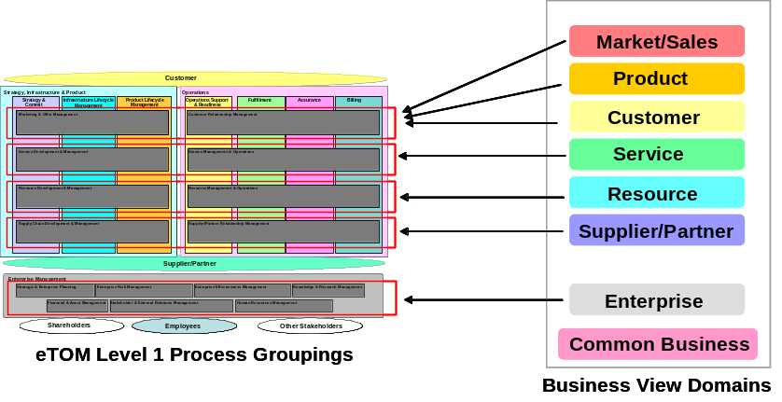
Figure 2 - Information Framework Domains & Business Process Framework Process Linkages
At the top layer, a set of domains is identified which are broadly aligned with the Business Process Framework business process framework as shown in Figure 2. Within each domain there is a high degree of cohesion between the identified business entities, and loose coupling between different domains. This enables segmentation of the total business problem and allows resources to be focused on a particular domain of interest. It is envisioned that the use of the resultant business entity definitions within each domain, when used in conjunction with the Business Process Framework, will provide a business view of the shared information and data.
Within each domain, further partitioning of the information is achieved through the identification of Aggregate Business Entities (ABE’s). Figure 3 shows the currently identified Level 1 ABE’s. As the Information Framework business view is further expanded and defined, further partitioning of the ABE’s occurs as more explicit business entities are identified.
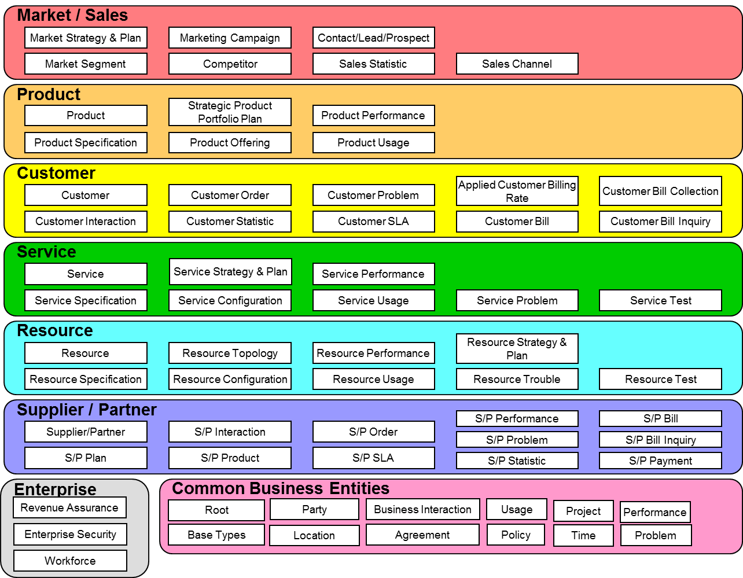
Figure 3 - Information Framework Domains & Level1 ABEs
The business entities along with the attributes and relationships that characterize the entities provide a view of the model that is easily understood from a business perspective. The business entities, attributes, and relationships are presented progressively developed using textual descriptions in each Information Framework addendum and in a consolidated Rational Rose UML-based model. The UML model provides an architecturally oriented business view of business entities, their attributes, and relationships to other business entities.
All domains are not yet covered in the Information Framework. As at the current revision of this document, only a subset of the identified domains has been defined. Domains included in this release are: Customer, Product (Product and Product Instance), Service, Resource (Physical and Logical), and Common Business Entities, such as Party, Location, Business Interaction, and Agreement that cross more than one domain. Domains not covered in this release include: Sales, Marketing, Supplier/Partner and Enterprise. Addenda to this document contain definitions of the business entities within each of these domains.
Domains and business entities contained in the Information Framework will expand as the Information Framework project progresses. Within each domain, TM Forum project needs were used to help scope the business entities defined and modeled in this document. The other domains and further definition of the five included domains will be presented in subsequent versions of this document or in other Information Framework documents.
The sources for the Information Framework include a variety of industry models, as well as models contributed by TM Forum member organizations. Where time permitted the contents of the Information Framework was mapped to the source models. Complete synthesis of the content of all models to find a common term for a concept was not possible. A best attempt was made to list cross-references to source models and synonyms for terms as part of the definition of the Information Framework business entities.

Definitions

Domain
A Domain is a collection of Aggregate Business Entities associated with a specific management area. Domains that make up the Information Framework are consistent with Business Process Framework level 0 concepts.
Domains are derived from an analysis of Process and Information Frameworks and have the following properties:
- Contain Business Entities that encapsulate both operations and corporate/enterprise information.
- Are relatively stable collections of corporate/enterprise data and associated operations (in comparison with processes)
- Provide for robustness of corporate/enterprise data formats.
- Provide clear responsibility and ownership.

Aggregate Business Entity
An Aggregate Business Entity (ABE) is a well-defined set of information and operations that characterize a highly cohesive, loosely coupled set of business entities.

Business Entity
A Business Entity represents something of interest to the business that may be tangible things (such as a Customer), active things (such as a Customer Order), or conceptual things (such as a Customer Account). Business entities are characterized by attributes and participate in relationships with other business entities. Business entity instances typically move through a well-defined life cycle.

Attribute
An attribute is a fact that describes a business entity.

Relationship
A relationship is an association of business interest between two business entities, or between a business entity and itself.

Information Framework Documents
The Information Framework business view model set of documents consists of the following documents:

Reference | Title | Included Aggregate Business Entities
GB922 | Concepts and Principles (this document) describing the organizing structure of the Information Framework Business View shared information/data, the relationship to other TMF deliverables, and views of the contents of the model.
GB922 Addendum 1P | Party | Party
GB922 Addendum 1L | Location | Location
GB922 Addendum 1BI | Business Interaction | Business Interaction
GB922 Addendum 1A | Agreement (including Service Level Agreement) | Agreement
GB922 Addendum 1BT | Base Types | Base Types
GB922 Addendum 1T | Calendar | Calendar
GB922 Addendum 1J | Project | Project
GB922 Addendum 1POL | Policy | Policy
GB922 Addendum 1R | Root Business Entities | Root Business Entities
GB922 Addendum 2 | Customer | Customer, Customer Order, Customer SLA
GB922 Addendum 3 | Product | Product Specification, Product Offering, Product, Product Offering Price
GB922 Addendum 4SO | Service | Service Specification, Service
GB922 Addendum 4-QoS | Service Quality of Service | Quality of Service
GB922 Addendum 5PR | Physical Resource | Physical Resource
GB922 Addendum 5LR | Logical Resource | Logical Resource

Relationship to other TM Forum Documents
The relationships that the Information Framework document has with a number of other TM Forum documents are shown below:

 | Document |  | Scope |  | Purpose
 | Business Process Framework (GB921)  (enhanced Telecom  Operations Map) |  | Specifies service, network, element, and business management processes that are candidates for implementation using process flow components |  | Provides a high-level process framework describing typical transaction and data flows.
Figure 4- The relationship to other TM Forum documents
- The Information Framework

2.1. Introduction
This chapter describes the Information Framework that is used to organize the Information Framework model. The Information Framework provides a high-level view into the Information Framework entities as well as providing an organizing structure in which the Information Framework business entities reside.
Figure 5 below shows how the domains contained within the Information Framework align with Business Process Framework level one domains/concepts. Whether taking a process or information perspective, it is important to be viewing the same set of concepts. The alignment is also a necessary enabler when mapping Business Process Framework processes to Information Framework business entities.
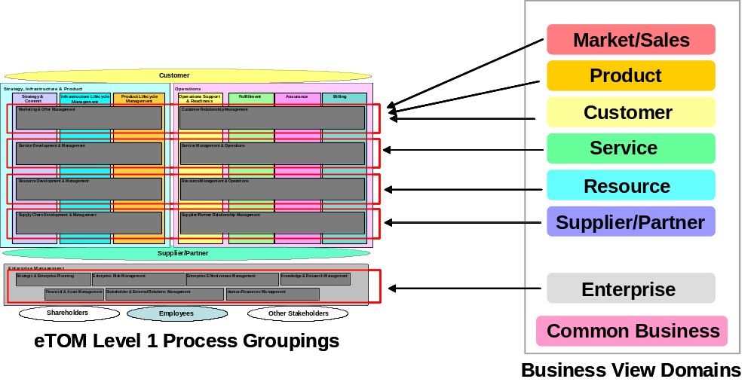
Figure 5- Business Process Framework/Information Framework Concepts/Domains

2.2. Information Framework – Level 1 ABEs
Figure 6 shows the Information Framework. The framework depicts the domains and level 1 aggregate business entities (ABE) contained within each domain.
Figure 6 - Information Framework Business View Framework
As the development of the Information Framework has progresed, subsequent levels of ABEs have been identified. As an example, Figure 7 below shows level 2 ABEs identified within the Service domain.
ServiceMechanisms
ServiceTransport
Service Management
Applications
Service Domain Level 2
Service
Package
Service
Bundle
S
e
r
v
i
c
e
Specification
ServiceSpec
ServiceLevel
Spec
ServiceChecking
S
e
r
v
i
c
e
Test
ServiceDiagnosis
Service
CustomerFacing
Service
ResourceFacing
Service
S
e
r
v
i
c
e
Configuration
CustomerFacing
ServiceConfig
ResourceFacing
ServiceConfig
ServicePackage
Config
ServiceBundle
Config
S
e
r
v
i
c
e
Usage
CustomerFacing
ServiceUsage
ResourceFacing
ServiceUsage
S
e
r
v
i
c
e
Trouble
CustomerFacing
ServiceFault
ResourceFacing
ServiceFault
CustomerFacing
ServiceAlarm
ResourceFacing
ServiceAlarm
CustomerFacing
ServiceOutage
ResourceFacing
ServiceOutage
Service
Strategy & Plan
Service
Applications
ServiceTransport
ServiceMechanisms
Service Management
Applications
Service Order
ServiceStatistics
ServiceTraffic
S
e
r
v
i
c
e
Performance
ServicePerformance
ServiceSLA
Performance
ServiceQuality
Service Domain Level 2
Service
Package
Service
Bundle
S
e
r
v
i
c
e
Specification
ServiceSpec
ServiceLevel
Spec
Service
Package
Service
Package
Service
Bundle
Service
Bundle
S
e
r
v
i
c
e
Specification
ServiceSpec
ServiceSpec
ServiceLevel
Spec
ServiceLevel
Spec
ServiceChecking
S
e
r
v
i
c
e
Test
ServiceDiagnosis
ServiceChecking
ServiceChecking
S
e
r
v
i
c
e
Test
ServiceDiagnosis
ServiceDiagnosis
Service
CustomerFacing
Service
ResourceFacing
Service
CustomerFacing
Service
Service
Service
CustomerFacing
ResourceFacing
Service
ResourceFacing
Service
S
e
r
v
i
c
e
Configuration
CustomerFacing
ServiceConfig
ResourceFacing
ServiceConfig
ServicePackage
Config
ServiceBundle
Config
S
e
r
v
i
c
e
Configuration
CustomerFacing
ServiceConfig
CustomerFacing
ServiceConfig
ResourceFacing
ServiceConfig
ResourceFacing
ServiceConfig
ServicePackage
Config
ServicePackage
Config
ServiceBundle
Config
ServiceBundle
Config
S
e
r
v
i
c
e
Usage
CustomerFacing
ServiceUsage
ResourceFacing
ServiceUsage
S
e
r
v
i
c
e
Usage
CustomerFacing
ServiceUsage
CustomerFacing
ServiceUsage
ResourceFacing
ServiceUsage
ResourceFacing
ServiceUsage
S
e
r
v
i
c
e
Trouble
CustomerFacing
ServiceFault
ResourceFacing
ServiceFault
CustomerFacing
ServiceAlarm
ResourceFacing
ServiceAlarm
CustomerFacing
ServiceOutage
ResourceFacing
ServiceOutage
S
e
r
v
i
c
e
Trouble
CustomerFacing
ServiceFault
CustomerFacing
ServiceFault
ResourceFacing
ServiceFault
ResourceFacing
ServiceFault
CustomerFacing
ServiceAlarm
CustomerFacing
ServiceAlarm
ResourceFacing
ServiceAlarm
ResourceFacing
ServiceAlarm
CustomerFacing
ServiceOutage
CustomerFacing
ServiceOutage
ResourceFacing
ServiceOutage
ResourceFacing
ServiceOutage
Service
Strategy & Plan
Service
Strategy & Plan
ServiceStatistics
ServiceTraffic
S
e
r
v
i
c
e
Performance
ServicePerformance
ServiceSLA
Performance
ServiceQuality
ServiceStatistics
ServiceStatistics
ServiceTraffic
ServiceTraffic
S
e
r
v
i
c
e
Performance
ServicePerformance
ServicePerformance
ServiceSLA
Performance
ServiceSLA
Performance
ServiceQuality
ServiceQuality
Figure 7 - Level Two ABEs identified in the Service Domain
Figure 8 and Figure 9 below provide an initial development view of level three ABEs with the Service domain.
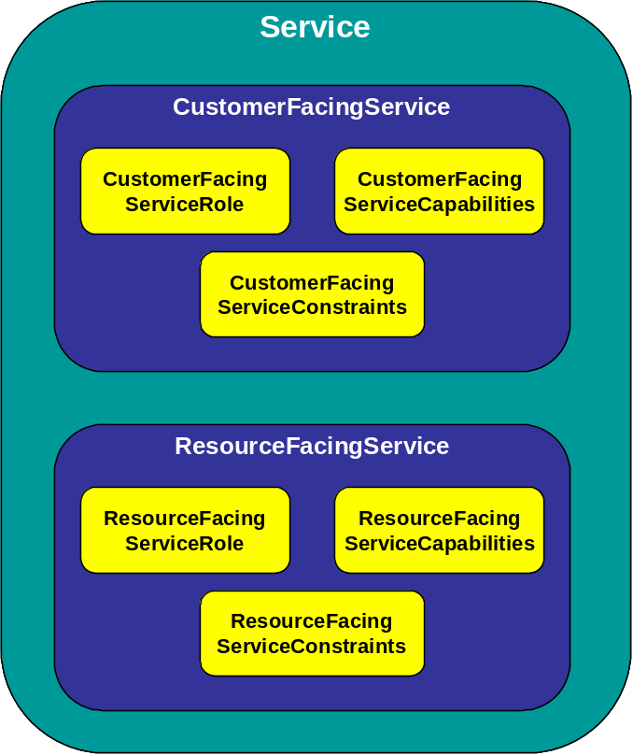
Figure 8 – Initial Level Three ABEs identified within the Service Level 1 ABE

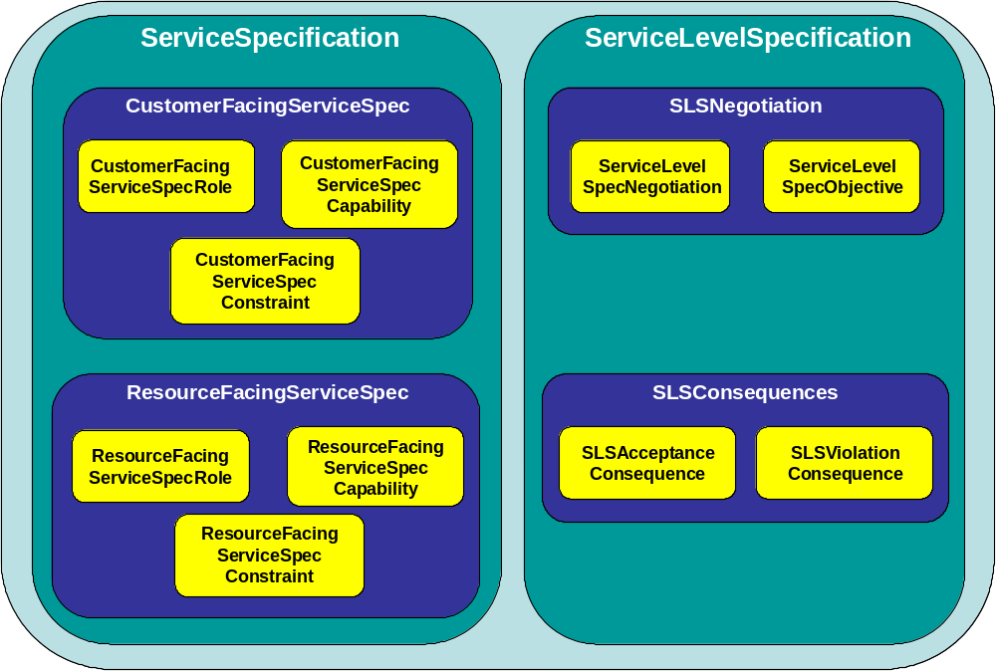
Figure 9 – Initial Service Level Three ABEs.

2.3. ABE Categorization
The ABE content and structure within each domain should be somewhat consistent. To ensure this, each ABE is aligned with a categorization pattern as described below. The pattern can also be used to confirm the completeness of each domain’s ABE.
ABE categories include:
- Strategy and Plan
- Managed Entity
- Managed Entity Specification – A description of a ManagedEntity that might allow it to be built.
- Interaction – A communication with a ManagedEntity. This is a type of BusinessInteraction.
- Configuration – The internal structure of a ManagedEntity.
- Performance – The measure of ManagedEntity quality.
- Test – A means of interrogating a ManagedEntity in order to understand its state(s).
- Trouble – A problem associated with a ManagedEntity. Alarms, Outages and Faults are examples
- Price – The cost of a ManagedEntity.
- Usage – A period of time during which a ManagedEntity is in use.
Note: ABEs in Market/Sales and Common Business Domains have not yet been categorized.

 |  |  | ABE Category
 |  |  | Managed Entity ABE |  |  |  |  |  | Management Entity ABE
 |  |  | Strategy and Plan |  | Managed Entity |  | Managed Entity Specification |  | Interaction |  | Configuration |  | Performance |  | Test |  | Trouble |  | Financial |  | Usage
Customer |  |  |  | Customer |  | Customer SLA |  | Customer Interaction,  Customer Bill Inquiry |  | Customer Order |  | Customer Statistic, |  |  |  | Customer Problem |  | Customer Bill Collection,  Applied Customer Billing Rate |  | Customer Bill
Product |  | Strategic Product Portfolio Plan |  | Product |  | Product Specification |  |  |  | Product Offering |  | Product Performance |  |  |  |  |  | Product Price (Product Offering Level 2) |  | Product Usage Statistic
Service |  | Service Strategy and Plan |  | Service |  | Service Specification |  |  |  | Service Configuration |  | Service Performance |  | Service Test |  | Service Problem |  |  |  | Service Usage
Resource |  | Resource Strategy and Plan |  | Resource |  | Resource Specification |  | Resource Communication |  | Resource Configuration,  Resource Topology |  | Resource Performance |  | Resource Test |  | Resource Trouble |  |  |  | Resource Usage
Supplier/ Partner |  | Supplier / Partner Plan |  | Supplier / Partner,  Supplier Partner Product |  | S/P SLA |  | Supplier / Partner Interaction,  S/P Bill Inquiry |  | S/P Order |  | Supplier / Partner Performance,  S/P Statistic |  |  |  | S/P Problem |  | S/P Payment
Figure 10 - Information Framework Common Categories
Notes: 1. The absence of an ABE in a particular category means either that the domain does not exactly fit the pattern or that an ABE has not yet been identified for the category.
2. The Resource Communication ABE is currently under investigation for inclusion as a Resource domain ABE.

- Relationship to Business Process Framework

3.1. Domain definitions, ABE Definitions, and Mapping to Business Process Framework Level 2 Processes

3.1.1. Scope and Context
This section provides definitions for domains and ABEs, as well as a mapping of Information Framework ABEs to Business Process Framework Level 2 processes. It is based on the following sources:
- Information Framework/Business Process Framework Cross-referencing – Coupling of Information Framework-components to Business Process Framework level 2 processes, November 27, 2002, Roland Asztalos, Thomas Tenevall, Ki Consulting.
- Information Framework Business Process Framework Mapping (incomplete).xls, Wayne Sigley, Telstra.
- ABE Definitions for the Policy, Service, and Resource Domains, June 2003, John Strassner.
- Comments and input from core Information Framework team, notably John Reilly and John Strassner.

3.1.2. Principles for Mapping
The following principles and delimitations are used for coupling Information Framework ABEs to Business Process Framework business processes.
- When possible, an ABE is coupled to only one level 2 Business Process Framework process. This specific process is denoted as “primary”.
- Primary level 2 Business Process Framework processes manage the complete life cycle of an ABE, by creating, reading, updating, and deleting (CRUD) entity instances contained within the ABE.
- Information is considered to flow both in the process layer as well as the systems (read ABE) layer
- If a one-to-one pairing is not attainable, an ABE is mapped to at most two level 2 Business Process Framework processes. If an ABE is mapped to two level 2 Business Process Framework processes, both level 2 processes are considered as primary.
- Processes requiring information feeds from ABEs or read an ABE’s entities to function properly are termed as “secondary”.

3.1.3. Regarding ABEs Supporting Two Level 2 Business Process Framework Processes
Some ABEs are coupled to two or more level 2 Business Process Framework processes. This occurs because of as the result of:
- Duality phenomenon: implies that an arbitrary ABE supports two primary level 2 Business Process Framework processes, whereas the two primary processes belong to separate process areas. Thus, three combinations are available, [1] Operations & SIP, [2] Operations & EM or [3] SIP & EM. The duality phenomenon takes place because the ABE in question is regarded as unclear in terms of “core functionality”, since it does not explicitly support only one primary level 2 Business Process Framework process.
- Ambiguity phenomenon: is similar to the duality phenomenon, however, here an arbitrary ABE supports two primary level 2 Business Process Framework processes which both belong to only one of the three available process areas.
These phenomena may have any number of causes, such as
- The ABE may be separated into two ABEs, each supporting a single level 2 Business Process Framework process.
- There may be a missing ABE that supports one of the level 2 Business Process Framework processes.
- There may be a missing Business Process Framework level 2 process that aggregates the two processes.
- A mistake could have been made in the mapping.
The phenomena will be investigated and, if possible, resolved in subsequent phases of the Information Framework project via the continued collaboration between the Information Framework team and the Business Process Framework team.

3.1.4. Market/Sales Domain
The Market/Sales Domain includes data and contract operations that support the sales and marketing activities needed to gain business from customers and potential customers. On the Sales side, this includes sales contacts/leads/prospects through to the sales-force and sales statistics. Market includes market strategy and plans, market segments, competitors and their products, through to campaign formulation.
Market/Sales ABEs | Primary Vertical Business Process Framework Process Groupings | Primary Business Process Framework Level 2 Processes | Secondary Business Process Framework Level 2 Processes
Market Segment  Supports market segments, market statistics, and forecasts. | M&OM – SC | Market Strategy & Policy | Sales Development
 | M&OM – SC | Market Strategy & Policy | Product & Offer Portfolio Planning
 | M&OM – SC | Market Strategy & Policy | Product & Offer Development & Retirement
 | M&OM – SC | Market Strategy & Policy | Supply Chain Strategy & Planning
Market Strategy and Plan  Supports the business plans and strategies on how to address the market with appropriate products and channels. | M&OM – SC | Market Strategy & Policy | Resource Strategy & Planning
 | M&OM – SC | Market Strategy & Policy | Supply Chain Strategy & Planning
 | M&OM – SC | Market Strategy & Policy | Product & Offer Portfolio Planning
Competitor  Identifies other providers who compete in the same market segments, accumulates intelligence about the competitors, including products (price, Key Performance Indicators and so forth). | M&OM – SC | Market Strategy & Policy | Product & Offer Portfolio Planning
 | M&OM – SC | Market Strategy & Policy | Enterprise Performance Assessment
Marketing Campaign  Supports marketing new or existing product offerings to identified target markets. For example, the launch of a pre-paid product with multiple promotions across distribution channels, market segments and so forth; a new campaign for an existing product; a re-launch of a campaign for an existing product. | M&OM – PLM | Product Marketing Communications & Promotion | CRM Support & Readiness
 | M&OM – PLM | Product Marketing Communications & Promotion | Marketing Fulfillment Response
 | M&OM – PLM | Product Marketing Communications & Promotion | Marketing Capability Delivery
Sales Statistics  Maintains sales forecasts, new service requirements, customer needs, and customer education, as well as calcuating key performance indicators about Sales & Marketing revenue and sales channel performance. | CRM – OSR | CRM Support & Readiness | Market Strategy & Policy
 | CRM – OSR | CRM Support & Readiness | Product & Offer Portfolio Planning
 | CRM – OSR | CRM Support & Readiness | Sales Development
Sales Channel  Keeps track of distribution channels and sales activities, sales quotas, sales contests, commission/bonus plans, commissions/bonuses, and maintains groups of individuals that make up the sales force. | M&OM – PLM | Sales Development | S/P Performance Management
 | M&OM – PLM | Sales Development | S/P Settlements & Billing Management
 | M&OM – PLM | Sales Development | Marketing Capability Delivery
 | M&OM – PLM | Sales Development | CRM Support & Readiness
Contact/Lead/Prospect  Provides the ability to track sales leads through their life cycle up until the time the leads become customers, including lead and contact information, sales prospects, proposals made to potential customers, and the amount of potential revenue the leads represent in the form of a sales pipeline. | CRM – F | Marketing Fulfillment Response^
 | CRM – F | Selling^
Notes:
^ Due to ABE ambiguity

3.1.5. Product Domain
The Product Domain is concerned with the lifecycle of products and information and contract operations related to products’ lifecycle. The Domain contains Aggregate Business Entities that deal with the strategic portfolio plans, products offered, product performance, product usage statistics, as well as the product instances delivered to a customer.
Product ABEs | Primary Vertical Business Process Framework Process Groupings | Primary Business Process Framework Level 2 Processes | Secondary Business Process Framework Level 2 Processes
Strategic Product Portfolio Plan  Is concerned with the plans of the product portfolio, which product offerings to make available to each market segment and the plans to development and deploy product offerings, as well as retirement of products. | M&OM – SC | Product & Offer Portfolio Planning | Market Strategy & Policy
 | M&OM – SC | Product & Offer Portfolio Planning | Product & Offer Development & Retirement
Product Specification  Defines the functionality and characteristics of product offerings made available to the market. | M&OM – PLM | Product & Offer Development & Retirement | Product & Offer Capability Delivery
 | M&OM – PLM | Product & Offer Development & Retirement | Service Configuration & Activation
 | M&OM – PLM | Product & Offer Development & Retirement | SM&O Support & Readiness
Product Offering  Represents tangible and intangible goods and services made available for a certain price to the market in the form of product catalogs. This ABE is also responsible for targeting market segments based on the appropriate market strategy. | M&OM – PLM | Product & Offer Development & Retirement | Marketing Fulfillment Response
 | M&OM – PLM | Product & Offer Development & Retirement | Product Marketing Communications & Promotion
 | M&OM – PLM | Product & Offer Development & Retirement | Product & Offer Capability Delivery
 | M&OM – PLM | Product & Offer Development & Retirement | Selling
 | M&OM – PLM | Product & Offer Development & Retirement | Order Handling
Product  Represents an instance of a product offering subscribed to by a party, such as a customer, the place where the product is in use, as well as configuration characteristics, such as assigned telephone numbers and internet addresses. The Product ABE also tracks the services and/or resources through which the product is realized. | CRM – F | Order Handling | Selling
 | CRM – F | Order Handling | Service Configuration & Activation
 | CRM – F | Order Handling | Problem Handling
 | CRM – F | Order Handling | Customer QoS/SLA Management
 | CRM – F | Order Handling | Billing & Collections Management
 | CRM – F | Order Handling | Service Problem Management
 | CRM – F | Order Handling | Service Quality Management
 | CRM – F | Order Handling | Service Guiding & Mediation
 | CRM – F | Order Handling | SM&O Support & Readiness
Product Usage  Represents usage of products associated with Customers used for charging that may appear on a Customer Bill. | CRM – OSR | CRM Support & Readiness | Product & Offer Development & Retirement
 | CRM – OSR | CRM Support & Readiness | Problem Handling
 | CRM – OSR | CRM Support & Readiness | Customer QoS/SLA Management
 | CRM – OSR | CRM Support & Readiness | Enterprise Performance Assessment
Product Performance  The Product Performance ABE handles product performance goals, the results of end-to-end product performance assessments, and the comparison of assessments against goals. The results may include the identification of potential capacity issues. | CRM – OSR | CRM Support & Readiness | Product & Offer Development & Retirement
 | CRM – OSR | CRM Support & Readiness | Customer QoS/SLA Management
 | CRM – OSR | CRM Support & Readiness | Service Quality Management
 | CRM – OSR | CRM Support & Readiness | Resource Performance Management
 | CRM – OSR | CRM Support & Readiness | Enterprise Performance Assessment

3.1.6. Customer Domain
The Customer Domain includes all data and contract operations associated with individuals or organizations that obtain products from an enterprise, such as a service provider. It represents of all types of contact with the customer, the management of the relationship, and the administration of customer data. The Customer Domain also includes data and contract operations related to the customer bills for products, collection of payment, overdue accounts, and the billing inquiries and adjustments made as a result of inquiries.
Customer ABEs | Primary Vertical Business Process Framework Process Groupings | Primary Business Process Framework Level 2 Processes | Secondary Business Process Framework Level 2 Processes
Customer  Is the focus for the Customer domain. Customer data is the enterprise’s knowledge of the customer and accounts held by a customer. | CRM – F | Selling | Product Marketing Communications & Promotion
 | CRM – F | Selling | Order Handling
 | CRM – F | Selling | Problem Handling
 | CRM – F | Selling | Customer QoS/SLA Management
 | CRM – F | Selling | Billing & Collections Management
 | CRM – F | Selling | Retention & Loyalty
 | CRM – F | Selling | Customer Interface Management
Customer Interaction  Represents communications with customers, and the translation of customer requests and inquiries into appropriate “events” such as the creation of an customer order, the creation of a customer bill inquiry, or the creation of a customer problem. | CRM – FAB | Customer Interface Management | Selling
 | CRM – FAB | Customer Interface Management | Order Handling
 | CRM – FAB | Customer Interface Management | Problem Handling
 | CRM – FAB | Customer Interface Management | Customer QoS/SLA Management
 | CRM – FAB | Customer Interface Management | Billing & Collections Management
 | CRM – FAB | Customer Interface Management | Retention & Loyalty
Customer Statistic  Represents the analysis of customer usage patterns, customer profitability statistics and churn and retention statistics. | CRM – FAB | Retention & Loyalty | CRM Support & Readiness
 | CRM – FAB | Retention & Loyalty | Selling
 | CRM – FAB | Retention & Loyalty | Order Handling
 | CRM – FAB | Retention & Loyalty | Problem Handling
 | CRM – FAB | Retention & Loyalty | Customer QoS/SLA Management
 | CRM – FAB | Retention & Loyalty | Billing & Collections Management
Customer Problem  Focuses on technical assistance and problem handling for customers. | CRM – A | Problem Handling | Retention & Loyalty
Customer SLA  Is a special case of the Service Level Agreement ABE where an involved party in the agreement is a Customer. See the Agreement ABE in the Common Business Entity Domain for details. | CRM – A | Customer QoS/SLA Management | Selling
 | CRM – A | Customer QoS/SLA Management | Retention & Loyalty
 | CRM – A | Customer QoS/SLA Management | Billing & Collections Management
Customer Order  Handles single customer orders and the various types thereof, such as regulated and non-regulated orders. | CRM – F | Order Handling | Retention & Loyalty
 | CRM – F | Order Handling | Service Configuration & Activation
Customer Bill  Handles real-time and non-real-time Call Detail Records (CDRs) and other sources of data that result in invoice items. The Customer Bill ABE also represents the format of a bill, schedule the production of bills, customer invoicing profiles, all the financial calculations necessary to determine the total of the bill (except for rating and rating discounts), and credits and adjustments to bills. | CRM – B | Billing & Collections Management | Retention & Loyalty
 | CRM – B | Billing & Collections Management | Service Guiding & Mediation
Applied Customer Billing Rates  Deals with the correlation of related usage for subsequent rating, rates applied to the usage (both regulated and non-regulated), discounts to usage, and any taxes due on the rated usage. | CRM – B | Charging | Retention & Loyalty
 | CRM – B | Charging | Billing & Collections Management
Customer Bill Collections  Handles credit violations, actions for overdue debts, and facility billing audits. | CRM – B | Billing & Collections Management | Retention & Loyalty
 | CRM – B | Billing & Collections Management | Financial Management
Customer Bill Inquiry  Represents invoice inquiries associated with invoices sent to customers and handles disputes and adjustments on individual charges, invoices, and accounts. | CRM – B | Billing & Collections Management | Retention & Loyalty

3.1.7. Service Domain
The Service Domain consists of a set of layered ABEs that are used to manage the definition, development, and operational aspects of Services provided by a Frameworx system. Entities in this domain support various Business Process Framework processes that deal with the definition, development and management of services offered by an enterprise. This includes agreement on Service levels to be offered, deployment and configuration of Services, management of problems in Service installation, deployment, usage, or performance, quality analysis, and rating. Finally, this domain also includes entities to perform planning for future offerings, service enhancement or retirement, and capacity.
Service ABEs | Primary Vertical Business Process Framework Process Groupings | Primary Business Process Framework Level 2 Processes | Secondary Business Process Framework Level 2 Processes
Service Specification  The Service Specification ABE contains entities that define the invariant characteristics and behavior of both types of Service entities. This enables multiple instances to be derived from a single specification entity. In this derivation, each instance will use the invariant characteristics and behavior defined in its associated template.  Entities in this ABE focus on adherence to standards, distinguishing features of a Service, dependencies (both physical and logical, as well as on other services), quality, and cost. In general, entities in this ABE enable Services to be bound to Products and run using Resources. | SD&M – PLM | Service Development & Retirement | Service Capability Delivery
 | SD&M – PLM | Service Development & Retirement | Service Configuration & Activation
 | SD&M – PLM | Service Development & Retirement | Service Problem Management
 | SD&M – PLM | Service Development & Retirement | Service Quality Management
 | SD&M – PLM | Service Development & Retirement | Service Guiding & Mediation
 | SD&M – PLM | Service Development & Retirement | SM&O Support & Readiness
Service  The Service ABE contains entities that are used to represent both customer-facing and resource-facing types of services. Entities in this ABE provide different views to examine, analyze, configure, monitor and repair Services of all types. Entities in this ABE are derived from Service Specification entities. | SM&O – F | Service Configuration & Activation | Service Capability Delivery
 | SM&O – F | Service Configuration & Activation | Service Problem Management
 | SM&O – F | Service Configuration & Activation | Service Development & Retirement
 | SM&O – F | Service Configuration & Activation | SM&O Support & Readiness
 | SM&O – F | Service Configuration & Activation | Service Quality Management
 | SM&O – F | Service Configuration & Activation | Service Guiding & Mediation
 | SM&O – F | Service Configuration & Activation | Service Capability Delivery
 | SM&O – F | Service Configuration & Activation | Service Development & Retirement
 | SM&O – F | Service Configuration & Activation | Service Quality Management
 | SM&O – F | Service Configuration & Activation | Service Guiding & Mediation
Service Configuration  The Service Configuration ABE contains entities that are used to represent and manage configurations of CustomerFacingService and ResourceFacingService entities. This set of entities also provides details on how the configuration of each of these types of Services can be changed. The entities in this ABE depend on entities in the Resource Domain, which provide the physical and logical infrastructure for implementing a Service. They all define dependencies between a higher-level Service and any sub-Services that are used by the higher-level Service. | SM&O – F | Service Configuration & Activation | Service Capability Delivery
 | SM&O – F | Service Configuration & Activation | SM&O Support & Readiness
 | SM&O – F | Service Configuration & Activation | Resource Provisioning
Service Performance  The Service Performance ABE collects, correlates, consolidates, and validates various performance statistics and other operational characteristics of customer and resource facing service entities. It provides a set of entities that can monitor and report on performance. Each of these entities also conducts network performance assessment against planned goals, performs various aspects of trend analysis, including error rate and cause analysis and Service degradation.  Entities in this ABE also manage the traffic generated by a Service, as well as traffic trend analysis. This is important for newer technologies that separate data, control and management functions for a given Service. | SM&O – A | Service Quality Management | Service Problem Management
 | SM&O – A | Service Quality Management | SM&O Support & Readiness
 | SM&O – A | Service Quality Management | Service Development & Retirement
 | SM&O – A | Service Quality Management | Resource Performance Management
Service Test  The Service Test ABE contains entities that are used to test customer and resource facing service entities. These entities are usually invoked during installation, as a part of trouble diagnosis, or after trouble repair has been completed. | SM&O – F | Service Configuration & Activation | Service Problem Management
 | SM&O – F | Service Configuration & Activation | Service Quality Management
Service Problem  The Service Problem ABE manages faults, alarms, and outages from a Service point-of-view. This is then correlated to trouble tickets, regardless of whether the cause is physical or logical.  Other entities in this ABE are used to direct the recovery from each of these three types of problems. They provide the ability to associate Resource faults and alarms to degradation and outages of Services that run on those Resources. These functions are independent of the Resources and technologies used to build the Service.  A third set of entities in this ABE is used to differentiate between customer-reported problems and network-induced problems. | SM&O – A | Service Problem Management | SM&O Support & Readiness
 | SM&O – A | Service Problem Management | Problem Handling
 | SM&O – A | Service Problem Management | Service Quality Management
 | SM&O – A | Service Problem Management | Resource Trouble Management
Service Usage  The Service Usage ABE collects Service consumption data, and generates Service usage records, for use by other business entities. The entities in this ABE provide physical, logical, and network usage information. | SM&O – B | Service Guiding & Mediation | Resource Data Collection & Processing
 | SM&O – B | Service Guiding & Mediation | Service Quality Management
 | SM&O – B | Service Guiding & Mediation | Service Development & Retirement
Service Strategy & Plan  The Service Strategy and Plan ABE contains entities that are used to address the need for enhanced or new Services, as well as the retirement of existing Services, by the enterprise. These entities have a strong dependency to both entities in the Resource and Product domains. Resulting efforts, such as deciding what Resources to use to host a Service, or what Services are used to support new Product Specifications, are also supported, as are service demand forecasts. | SD&M – SC | Service Strategy & Planning | Product & Offer Portfolio Planning
 | SD&M – SC | Service Strategy & Planning | Service Capability Delivery
 | SD&M – SC | Service Strategy & Planning | Service Development & Retirement
 | SD&M – SC | Service Strategy & Planning | Resource Strategy & Planning

3.1.8. Resource Domain
The Resource Domain consists of a set of layered ABEs that are used to manage the definition, development, and operational aspects of the information computing and processing infrastructure of a Frameworx system. It supports the Business Process Framework processes that deal with the definition, development and management of the infrastructure of an enterprise. This includes the components of the infrastructure as well as Products and Services that use this infrastructure.
The Resource Domain has three important objectives. The first is to associate Resources to Products and Services, and provide a detailed enough set of Resource entities (organized as ABEs) to facilitate this association. The second is to ensure that Resources can support and deliver Services offered by the enterprise. Management of resources involves planning, configuration, and monitoring to capture performance, usage, and security information. This also includes the ability to reconfigure Resources in order to fine tune performance, respond to faults, and correct operational deficiencies in the infrastructure. Resources also provide usage information which is subsequently aggregated to the customer level for billing purposes. The final objective of the Resource domain is to enable strategy and planning processes to be defined. Entities in the Resource domain may be associated with processes that involve planning new and/or enhanced Services, or even the retirement of Services, offered by the Enterprise.
Resource ABEs | Primary Vertical Business Process Framework Process Groupings | Primary Business Process Framework Level 2 Processes | Secondary Business Process Framework Level 2 Processes
Resource Strategy & Plan  The Resource Plan ABE is used to plan networks and resource elements both initially and for growth. It will coordinate both logical and physical resource growth. Inputs are budgets from business sources, service forecasts, current and projected network utilization, new technologies, and retiring technologies. It handles the lifecycle (installation, modification, removal, and retirement) for both logical and physical resources. | RD&M – SC | Resource Strategy & Planning | Resource Development & Retirement
 | RD&M – SC | Resource Strategy & Planning | Service Strategy & Planning
 | RD&M – SC | Resource Strategy & Planning | Resource Capability Delivery
 | RD&M – SC | Resource Strategy & Planning | RM&O Support & Readiness
Resource Specification  The Resource Specification ABE contains entities that define the invariant characteristics and behavior of each type of Resource entities. This enables multiple instances to be derived from a single specification entity. In this derivation, each instance will use the invariant characteristics and behavior defined in its associated template. | RD&M – PLM | Resource Development & Retirement | RM&O Support & Readiness
 | RD&M – PLM | Resource Development & Retirement | Resource Provisioning
 | RD&M – PLM | Resource Development & Retirement | Resource Capability Delivery
 | RD&M – PLM | Resource Development & Retirement | Resource Trouble Management
 | RD&M – PLM | Resource Development & Retirement | Resource Performance Management
 | RD&M – PLM | Resource Development & Retirement | Resource Data Collection & Processing
Resource  The Resource ABE contains entities that are used to represent the various aspects of a Resource. This includes four sets of entities that represent: the physical and logical aspects of a Resource; show how to aggregate such resources into aggregate entities that have physical and logical characteristics and behavior; and show how to represent networks, sub-networks, network components, and other related aspects of a network. | RM&O – F | Resource Provisioning | RM&O Support & Readiness
 | RM&O – F | Resource Provisioning | Resource Trouble Management
 | RM&O – F | Resource Provisioning | Resource Capability Delivery
 | RM&O – F | Resource Provisioning | Resource Performance Management
 | RM&O – F | Resource Provisioning | Resource Data Collection & Processing
Resource Topology  The Resource Topology ABE contains entities that define physical, logical, and network topological information. This information is critical for assessing the current state of the network, as well as providing information on how to fix problems, tune performance, and in general work with the network (both as a whole and with its components). Each of these topological views provides its own physical, logical, or network related information that can be used to manage one or more layers in a layered network. | RD&M – ILM | Resource Capability Delivery | Resource Development & Retirement
 | RD&M – ILM | Resource Capability Delivery | RM&O Support & Readiness
Resource Configuration  The Resource Configuration ABE contains entities that are used to represent and manage configurations of PhysicalResource, LogicalResource, and CompoundResource entities. It should be noted that configurations themselves are managed entities. This set of entities also provides details on how the configuration of each of these types of resources is changed in order to meet product, service, and resource requirements, including activation, deactivation, and testing. Areas covered include verifying resource availability, reservation and allocation of resource instances, configuring and activating physical and logical resource instances, testing and updating of the resource inventory database. | RM&O – F | Resource Provisioning | Resource Capability Delivery
 | RM&O – F | Resource Provisioning | RM&O Support & Readiness
Resource Trouble  The Resource Trouble ABE manages problems found in allocated resource instances, regardless of whether the problem is physical or logical. Entities in this ABE detect these problems, act to determine their root cause, resolve these problems and maintain a history of the activities involved in diagnosing and solving the problem. Detecting problems can be done via software (e.g. responding to an alarm) and/or by hardware (e.g. a measurement or probe) and/or manually (e.g. visual inspection). This includes tracking, reporting, assigning people to fix the problem, testing and verification, and overall administration of repair activities. | RM&O – A | Resource Trouble Management | RM&O Support & Readiness
 | RM&O – A | Resource Trouble Management | Resource Performance Management
 | RM&O – A | Resource Trouble Management | Service Problem Management
Resource Test  The Resource Test ABE contains entities that are used to test PhysicalResources, LogicalResources, CompoundResources, and Networks. These entities are usually invoked during installation, as a part of trouble diagnosis, or after trouble repair has been completed. | RM&O – F | Resource Provisioning | Resource Capability Delivery
 | RM&O – F | Resource Provisioning | Resource Trouble Management
 | RM&O – F | Resource Provisioning | Resource Performance Management
Resource Performance  The Resource Performance ABE collects, correlates, consolidates, and validates various performance statistics and other operational characteristics of Resource entities. It provides a set of entities that can monitor and report on performance. The entities in this ABE provide physical, logical, and performance information. Each of these entities also conducts network performance assessment against planned goals, performs various aspects of trend analysis, including error rate and cause analysis and Resource degradation. Entities in this ABE also manage traffic in a Resource. This includes statistics defining Resource loading, and traffic trend analysis. | RM&O – AB | Resource Performance Management | RM&O Support & Readiness
 | RM&O – AB | Resource Performance Management | Resource Development & Retirement
 | RM&O – AB | Resource Performance Management | Resource Data Collection & Processing
Resource Usage  The Resource Usage ABE collects Resource consumption data, and generates Resource usage records, for use by other business entities. The entities in this ABE provide physical, logical, and network usage information. | RM&O – B | Resource Data Collection & Processing | Billing & Collections Management
 | RM&O – B | Resource Data Collection & Processing | Service Guiding & Mediation

3.1.9. Supplier/Partner Domain
The SupplierPartner Domain includes all SupplierPartner-oriented data and contract operations associated with a SupplierPartner. Its scope encompasses, planning of strategies vs. SupplierPartners, handling of all types of contact with the SupplierPartner, the management of the relationship, and the administration of SupplierPartner data. The SupplierPartner Domain also includes data and contract operations related to the SupplierPartner Bills, disputes and inquiries.
SupplierPartner ABEs | Primary Vertical Business Process Framework Process Groupings | Primary Business Process Framework Level 2 Processes | Secondary Business Process Framework Level 2 Processes
SupplierPartner Plan  The SupplierPartner Plan ABE handles the strategies and the planning of the business relation with the SupplierPartner with input from other ABEs, such as  MarketSales, S/P Performance and Competitor Analysis. | SCD&M – SC | Supply Chain Strategy & Planning | Market Strategy & Policy
 | SCD&M – SC | Supply Chain Strategy & Planning | Service Strategy & Planning
 | SCD&M – SC | Supply Chain Strategy & Planning | Resource Strategy & Planning
 | SCD&M – SC | Supply Chain Strategy & Planning | Sales Development
 | SCD&M – SC | Supply Chain Strategy & Planning | Strategic Business Planning
 | SCD&M – SC | Supply Chain Strategy & Planning | S/P Performance Management
 | SCD&M – SC | Supply Chain Strategy & Planning | Business Development
 | SCD&M – SC | Supply Chain Strategy & Planning | Enterprise Performance Assessment
SupplierPartner  Is the focus for the SupplierPartner Domain. SupplierPartner represents the enterprise’s knowledge of the SupplierPartner, their accounts and the relations the Enterprise has with the SupplierPartner. It also contains all Supplier Partner agreements and negotiations. | SCD&M – ILM  and/or  SCD&M – PLM and/or  S/PRM –S&R | Supply Chain Capability Delivery^ * | Business Development
 | SCD&M – ILM  and/or  SCD&M – PLM and/or  S/PRM –S&R | Supply Chain Development & Change Management^ * | Service Configuration & Activation
 | SCD&M – ILM  and/or  SCD&M – PLM and/or  S/PRM –S&R | S/PRM Support & Readiness* | S/P Problem Reporting & Management
 | SCD&M – ILM  and/or  SCD&M – PLM and/or  S/PRM –S&R | S/PRM Support & Readiness* | S/P Settlements & Billing Management
SupplierPartner Interaction  Represents communication with SupplierPartners, and translating SupplierPartner requests and inquiries into appropriate “events”.  Initiated by the Service Provider as a Customer such as the requisition for the Wholesale Service, the quotation order for the End-Customer instance, the quotation update Confirmation, requisition for Service Instance Problem reporting or Inititiated by the Supplier_Partner such as the proposal for a Wholesale Service Purchase, the quotation proposal, the quotation update proposal, the requisition confirmation the order executed and the problem report answer. | S/PRM – FAB | S/P Interface Management | Supply Chain Development & Change Management
 | S/PRM – FAB | S/P Interface Management | S/PRM Support & Readiness
 | S/PRM – FAB | S/P Interface Management | S/P Requisition Management
 | S/PRM – FAB | S/P Interface Management | S/P Problem Reporting & Management
 | S/PRM – FAB | S/P Interface Management | S/P Settlements & Billing Management
SupplierPartner Product  The SupplierPartner Product ABE represents the Service Provider’s knowledge of the Products that the Service Provider may order from the SupplierPartner | SCD&M – ILM | Supply Chain Development & Change Management | S/P Requisition Management
 | SCD&M – ILM | Supply Chain Development & Change Management | Product & Offer Development & Retirement
 | SCD&M – ILM | Supply Chain Development & Change Management | Service Development & Retirement
 | SCD&M – ILM | Supply Chain Development & Change Management | Resource Development & Retirement
 | SCD&M – ILM | Supply Chain Development & Change Management | Supply Chain Capability Delivery
SupplierPartner Problem  Deals with problem associated with the Supplier Partner such as a request for technical assistance, Bill disputes etc. | S/PRM – A | S/P Problem Reporting & Management | Problem Handling
 | S/PRM – A | S/P Problem Reporting & Management | Service Problem Management
 | S/PRM – A | S/P Problem Reporting & Management | S/PRM Support & Readiness
 | S/PRM – A | S/P Problem Reporting & Management | S/P Performance Management
SupplierPartner SLA  Manages SLA Specification that contain standard components used to negotiate and define SLAs with SupplierPartners both for the Wholesale Service SP-SP and the End-Customer instances within the Wholesale service. The SupplierPartner SLA ABE also supports the negotiation and establishment of SLA instances. It also measures performance against the SLAs, and handles inquiries (both internal & external) about SLAs and the performance of Supplier Partner service with respect to the Supplier Partner SLA. It also handles SLA violations and the notification of the appropriate parties regarding violations. The ABE also identifies discount reasons for SLA violations and notifies S/P Payment of the discount reasons. The ABE also reads the notifications from the SupplierPartner, analyse the data and identifies the rigth party to deal with the data and sends out a notification. | SCD&M – ILM  and/or S/PRM – S&R | Supply Chain Capability Delivery* | S/P Problem Reporting & Management
 | SCD&M – ILM  and/or S/PRM – S&R | S/PRM Support & Readiness* | Supply Chain Capability Delivery
 | SCD&M – ILM  and/or S/PRM – S&R | S/PRM Support & Readiness* | S/P Requisition Management
 | SCD&M – ILM  and/or S/PRM – S&R | S/PRM Support & Readiness* | S/P Performance Management
SupplierPartner Performance  Reads the SupplierPartners performance data for each End-Customer instance running in the infrastructure of the Service Provider and for which performance parameters are established by the Supplier/Partner SLA ABE. Only data that lies above the agreed tresholds and that may jeopardise the Service Providers service to the End Customer is sent by the SupplierPartner. The performance data from the SupplierPartner is analysed and redirected to the correct Service Mgmt process/actor for them to decide on appropriate actions. Based on SLA violation persistance of supplier/patners, their relation with the organizaton is terminated. | S/PRM – A | S/P Performance Management | Service Problem Management
 | S/PRM – A | S/P Performance Management | Service Quality Management
 | S/PRM – A | S/P Performance Management | S/PRM Operations Support & Readiness
 | S/PRM – A | S/P Performance Management | Supply Chain Development & Change Management
 | S/PRM – A | S/P Performance Management | S/P Problem Reporting & Management
SupplierPartner Order  Handles single SupplierPartner orders and supervises various types thereof. This includes the quotation and order for the SupplierPartner Wholesale Service as well as the quotation and order for the EndCustomer instances within the Wholesale service. | CRM – F and/or  S/PRM – F | Order Handling^ | Supply Chain Development & Change Management
 | CRM – F and/or  S/PRM – F | S/P Requisition Management^ | S/P Interface Management
 | CRM – F and/or  S/PRM – F | S/P Requisition Management^ | S/PRM Support & Readiness
SupplierPartner Bill  Monitors the collection process and initiates different actions for overdue bills. It also handles credit violations. The ABE also provides the functionality to register disputes and adjustments on individual charges, invoices, and accounts. | S/PRM – B | S/P Settlements & Billing Management | S/P Performance Management
 | S/PRM – B | S/P Settlements & Billing Management | Service Guiding & Mediation
SupplierPartner Bill Inquiry  The Supplier Partner Bill Inquiry ABE monitors the bill Disputes towards the Supplier Partner. | S/PRM – B | S/P Settlements & Billing Management | S/P Performance Management
 | S/PRM – B | S/P Settlements & Billing Management | S/PRM Support & Readiness
Supplier Partner Payment  This ABE monitors the payment process versus the Supplier/Partner. | S/PRM – B | S/P Settlements & Billing Management | S/P Performance Management
SupplierPartner Statistic  The Supplier/Partner Statisitics ABE represents the usage analysis of services purchased from the SupplierPartner, SupplierPartner profitability statistics and the overall performance of the Supplier/partner. | S/PRM – A | S/P Performance Management | S/P Settlements & Billing Management
 | S/PRM – A | S/P Performance Management | S/PRM Support & Readiness
Notes:
* Due to process duality
^ Due to ABE ambiguity

3.2.0. Common Business Entities Domain
Common Business Entities were not mapped to Business Process Framework processes since these entities use is spread across a number of Business Process Framework processes.

Domain Name | Common Business Entities
Description | The Common Business Entities Domain represents business entities shared across two or more other domains. As such, these business entities are not “owned” by any particular domain. In some cases a common business entity represents a generic abstraction of other real-world business entities. For example, Business Interaction is an abstraction (super-class) of business entities such as Customer Order and Supplier/Partner SLA.
Aggregate Business Entity | Party  The Party ABE represents the abstract concept of organization or individual that can play varying roles during interactions with an enterprise. Roles include customer, supplier/partner, employee, and so forth.
ABE | Agreement  The Agreement ABE represents a contract or arrangement, either written or verbal and sometimes enforceable by law, such as a service level agreement or a customer price agreement. An agreement involves a number of other business entities, such as products, services, and resources and/or their specifications.
ABE | Location  The Location ABE represents the site or position of something, such as a customer’s address, the site of equipment where there is a fault and where is the nearest person who could repair the equipment, and so forth. Locations can take the form of coordinates and/or addresses and/or physical representations.
ABE | Business Interaction  The Business Interaction ABE represents an arrangement, contract, or communication between an enterprise and one or more other entities such as individuals and organizations (or parts of organizations). Interactions take on the form of requests, responses, and notifications.
ABE | Policy  Policy consists of a set of layered ABEs that define specifications (for example, templates) and definitions of Policy entities that can be used in managing the behavior and definition of entities in other Domains. Policy takes three primary forms. The first is the definition of how policy is used to manage the definition, change, and configuration of other entities. The second is the definition of how policy itself is managed. The third is how applications use policies to manage entities.
ABE | Project  The Project ABE represents the tools used by project managers to ensure that enterprise objectives of quality, cost, and time are achieved by planning and scheduling work. It uses common industry definitions of Project, Work Breakdown Structure and Activity to provide support to project managers.
ABE | Time  The Time ABE represents Entities used to provide time related functions. This includes scheduling, time conflicts and time based presentation support. Currently the Calendar model is the only part of the Time ABE.

- Information Framework Snapshot

4.1. Introduction
This chapter provides a summary of the key Information Framework business entities representative of Aggregate Business Entities (ABEs) contained within each domain. Also shown in the figures are the entities’ associations with key entities associated with ABEs in other domains. This demonstrates that, while ABEs are groups of closely related entities, the entities contained within a domain and an ABE within a domain are naturally related to entities in other domains and their respective ABEs. Each diagram shown in this chapter was taken from Information Framework addenda.
The figures include
- Party
- Location (Place)
- Interaction
- Agreement
- Calendar
- Project
- Policy
- Customer
- Customer Order
- Product, Service, Resource
- Product Offering
- Product
- Service
- Resource
The associations depicted in the diagrams in this chapter are those currently identified by Information Framework development to date. As the Information Framework evolves further, additional associations may be found and current associations may be modified.
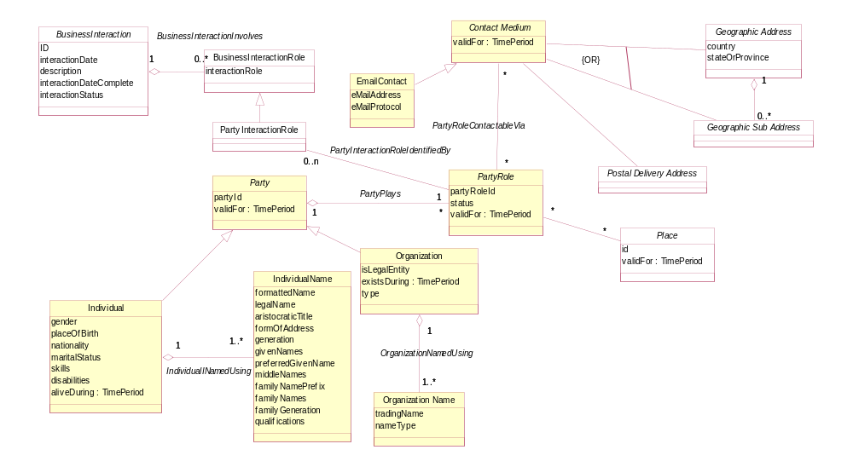
Figure 11 - Party and Related Entities

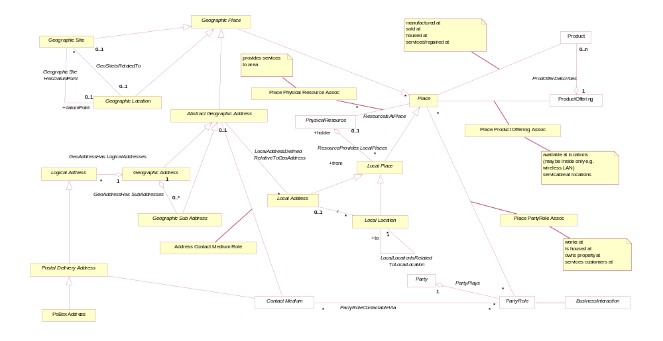
Figure 12 – Location (Place) and Related Entities

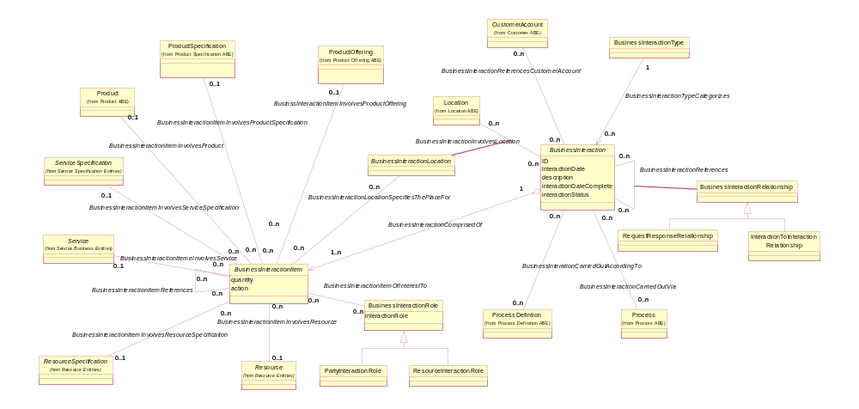
Figure 13 – Business Interaction and Related Entities

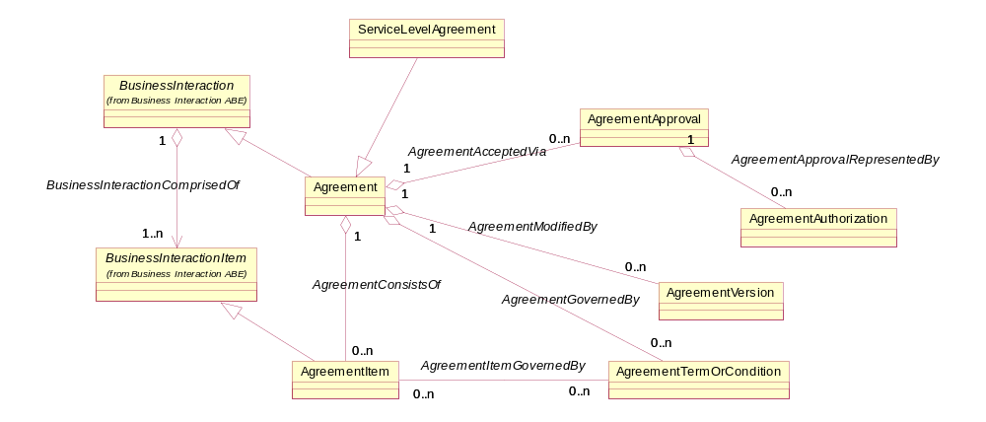
Figure 14 – Agreement and Related Entities

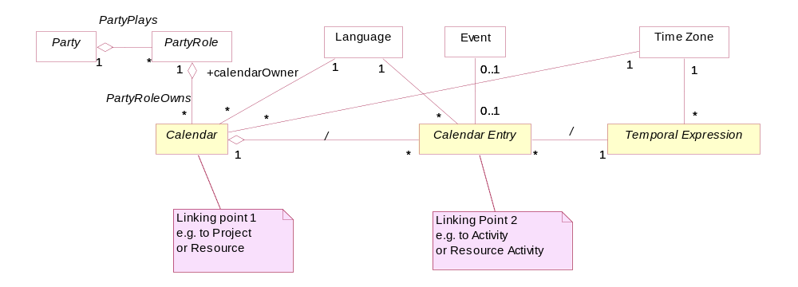
Figure 15 - Calendar and Related Entities

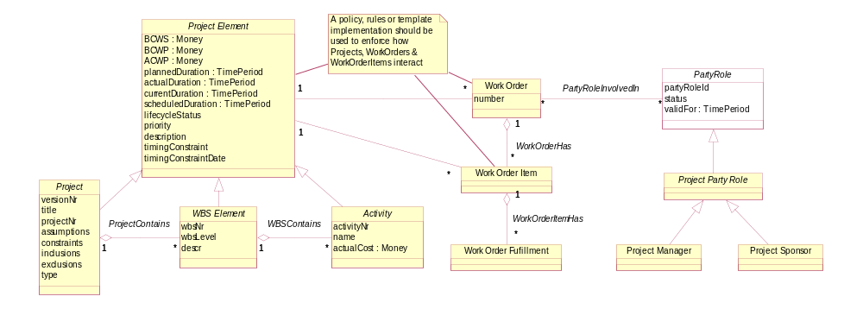
Figure 16 – Project and Related Entities

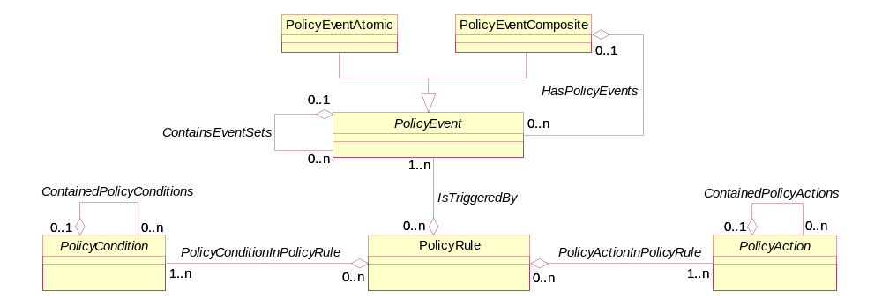
Figure 17 – Policy and Related Entities
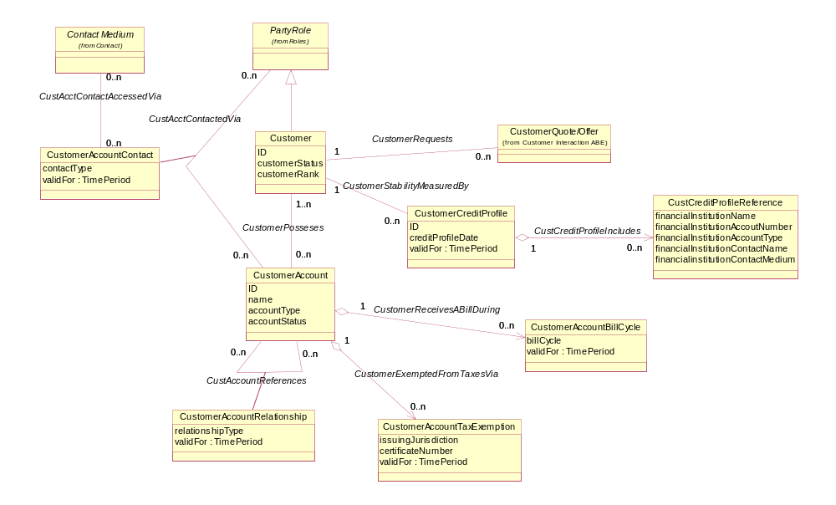
Figure 18 – Customer and Related Entities

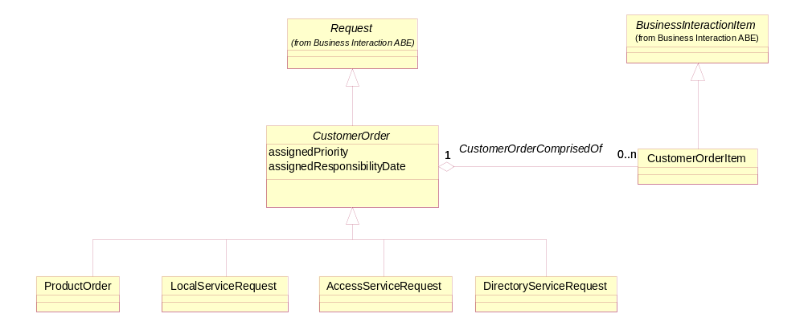
Figure 19 – Customer Order and Related Entities

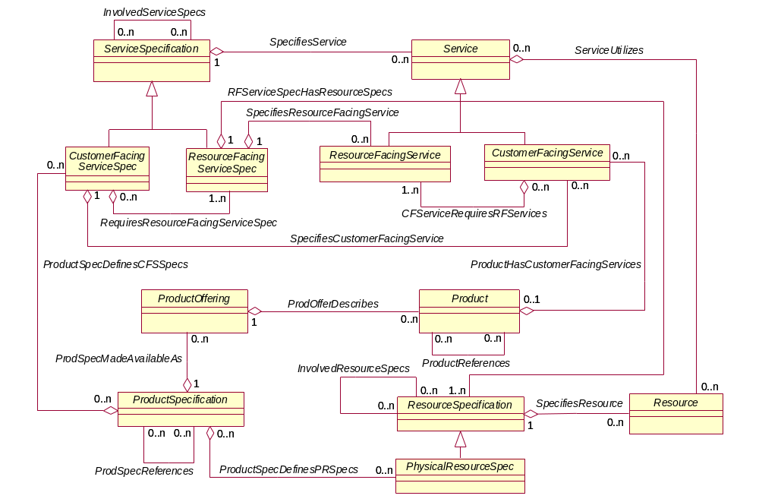
Figure 20 – Product, Service Resource Associations

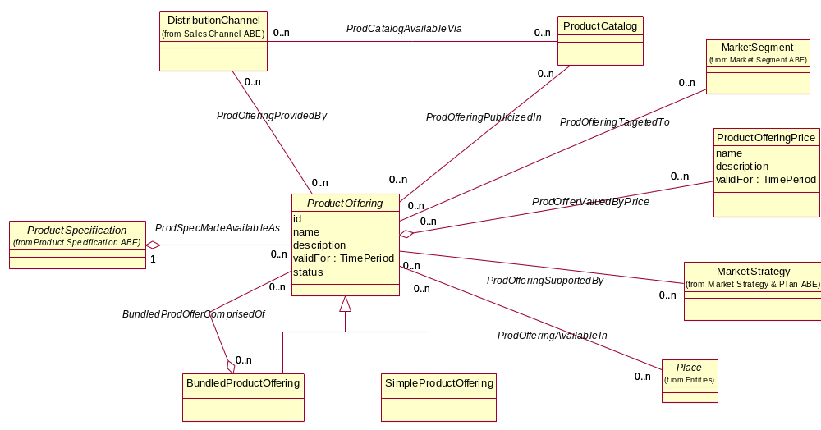
Figure 21 – Product Offering and Related Entities

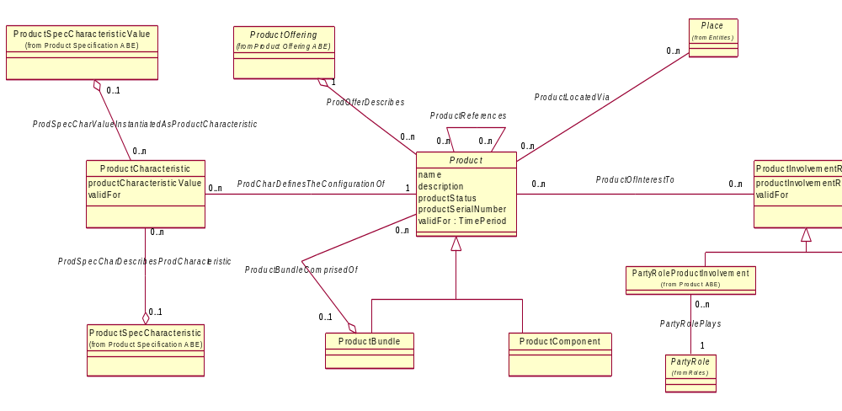
Figure 22 – Product and Related Entities

- Annexes

5.1. Annex 1: Abbreviations and References

5.1.1. Abbreviations
OOAD | Object-Oriented Analysis and Design
OSS | Operational Systems and Software
UML | Unified Modeling Language

5.1.2. Non Normative References
The Business Process Framework(eTOM) – GB921 V7.0

Administrative Appendix
This Appendix provides additional background material about the TM Forum and this document. In general, sections may be included or omitted as desired, however a Document History must always be included.

6.1. About this document
This is a TM Forum Guidebook. The guidebook format is used when:
- The document lays out a ‘core’ part of TM Forum’s approach to automating business processes. Such guidebooks would include the Telecom Operations Map and the Technology Integration Map, but not the detailed specifications that are developed in support of the approach.
- Information about TM Forum policy, or goals or programs is provided, such as the Strategic Plan or Operating Plan.
- Information about the marketplace is provided, as in the report on the size of the OSS market.

6.2. Document History

6.2.1. Version History

Version Number | Date Modified | Modified by: | Description of changes
0.1 | Feb 2002 |  | Initial sample of document format and content
0.5 | May 2002 |  | Updates based on review and feedback; this is the initial member review version
1.1 | Oct 2002 |  | Updates based on review and feedback from members.
1.2 | Oct 2002 |  | Further updates based on review by team members.
3.0 | June 2003 |  | Updates to Information Framework, added Information Framework/Business Process Framework mapping, inter-ABE diagrams
5.0 | August 2004 | John Reilly | Updated Business Process Framework/Information Framework mappings
6.0 | July 2005 | John Reilly | Updated with comments from Greg Fidler and Business Process Framework/Information Framework mappings
6.1 | November 2005 | Tina O'Sullivan | Converted to new template and corrected various administrative items.
6.2 |  | Tina O'Sullivan | Updated Notice Statement & document status
7.5 | January 2008 | John Reilly | Updates for ITU-T submission
7.6 | May 2008 | Tina O’Sullivan | Made corrections prior to posting.
7.7 | May 2009 | Alicja Kawecki | Minor updates to reflect TM Forum Approved status
7.8 | January 2010 | Ken Dilbeck | Nameing changes per Marketing
7.9 | March 2010 | Pascale Pecha | Minor edits and correction of release number
7.10 | March 2010 | Alicja Kawecki | Minor cosmetic corrections for web posting
7.11 | April 2010 | John Reilly | Removed Service Applications ABE and changed Service & Instance Specific Rating to Service Guiding & Mediation
7.12 | Apr 2010 | Alicja Kawecki | Minor cosmetic corrections for web posting and ME
7.13 | Jun 2010 | Alicja Kawecki | Updated Notice
7.14 | December 2010 | John Wilmes | Removed reference to GB926, fixed CR 2092
7.15 | March 2011 | Alicja Kawecki | Minor formatting corrections prior to web posting and ME
7.16 | September 2011 | Alicja Kawecki | Updated to reflect TM Forum Approved status
7.2 | January 2012 | John Reilly | Updated SID Framework figures
7.3 | March 2012 | Alicja Kawecki | Minor formatting corrections prior to web posting and ME
7.4 | October 2012 | Alicja Kawecki | Updated to reflect TM Forum Approved status

6.2.2. Release History

Release Number | Date Modified | Modified by: | Description of changes
Release 7.5 | March 2008 | J. Reilly | For ITU-T submission
Release 8.1 | March 2010 | Ken Dilbeck | To reflect change from Solution Frameworks to Frameworx
Release 9.0 | April 2010 | J. Reilly | ABE update and eTOM mapping updates.
Release 9.5 | December 2010 | J. Wilmes | Updated Notice
Release 12 | January 2012 | John Reilly | Updated SID Framework figures

6.3. Company Contact Details
Company | Team Member Representative
Include all involved companies adding lines as necessary. | Name  Title  Email  Phone  Fax
Name
Title
Email
Phone
Fax

6.4. Acknowledgments
This document was prepared by the members of the TM Forum Information Framework team.

