Shared Information/Data (SID) Model
Addendum 1L - Common Business Entity Definitions – Location

GB922 Addendum 1L
TM Forum Approved Version 3.5


September, 2011

Notice
This material, including documents, code and models, has been through review cycles; however, due to the inherent complexity in the design and implementation of software and systems, no liability is accepted for any errors or omissions or for consequences of any use made of this material.
Under no circumstances will the TM Forum be liable for direct or indirect damages or any costs or losses resulting from the use of this specification. The risk of designing and implementing products in accordance with this specification is borne solely by the user of this specification.
This material bears the copyright of TM Forum and its use by members and non-members of TM Forum is governed by all of the terms and conditions of the Intellectual Property Rights Policy of the TM Forum (http://www.tmforum.org/Bylaws/1094/home.html) and may involve a claim of patent rights by one or more TM Forum members or by non-members of TM Forum.

Direct inquiries to the TM Forum office:
240 Headquarters Plaza,
East Tower – 10th Floor,
Morristown, NJ 07960 USA
Tel No. +1 973 944 5100
Fax No. +1 973 944 5110
TM Forum Web Page: www.tmforum.org

Acknowledgments
This document was prepared by the members of the TeleManagement Forum SID team:
The Shared Information/Data Model is a genuinely collaborative effort. The TM Forum would like to thank the following people for contributing their time and expertise to the production of this document. It is just not possible to recognize all the organizations and individuals that have contributed or influenced the introduction. We apologize to any person or organization we inadvertently missed in these acknowledgments.
Key individuals that reviewed, provided input, managed, and determined how to utilize inputs coming from all over the world, and really made this document happen were:

Name | Affiliation
Cliff Faurer | TeleManagement Forum
Chris Hartley | Telstra
Helen Hepburn | British Telecom
Dan Matheson | Hewlett-Packard
John Reilly | MetaSolv Software
Wayne Sigley | Telstra
John Strassner | Intelliden
Johan Vandenberghe | Lucent Technologies

About this document
This is a TM Forum Guidebook. The guidebook format is used when:
- The document lays out a ‘core’ part of TM Forum’s approach to automating business processes. Such guidebooks would include the Telecom Operations Map and the Technology Integration Map, but not the detailed specifications that are developed in support of the approach.
- Information about TM Forum policy, or goals or programs is provided, such as the Strategic Plan or Operating Plan.
- Information about the marketplace is provided, as in the report on the size of the OSS market.

Document Life Cycle
This document is being issued for Member Evaluation. The purpose of an Evaluation Version is to encourage input based on experience of members and the public as they begin to use the document. Following the Evaluation Period, documents that are seen to deliver value are candidates for formal approval by the TM Forum. All documents approved by the TM Forum undergo a formal review and approval process.
This document will continue under formal change control. Supporting work will be issued as companions to this document. A document of this type is a “living document,” capturing and communicating current knowledge and practices. Further inputs will be made because of detailed work ongoing in the TM Forum and the industry.

Document History
Version | Date | Purpose
0.1 | Jan 2002 | Document created. Location copied from old template.
0.2d | Apr 2002 | Updated for TMW Nice
0.5b | Apr 2002 | Final TMW Nice Version
3.0 | Jun 2003 | Updated for phase 3 release
3.1 | July 2003 | Formatted for Member Review with NGOSS R3.5
3.2 | Aug 2004 | To reflect TMF Approval Status
3.3 | Jan 2011 | Update Notice
3.4 | Mar 2011 | Updated Notice, minor formatting corrections prior to web posting and ME
3.5 | Sep 2011 | Updated to reflect TM Forum Approved status

Time Stamp
This version of this document can be considered valid until furhter notice.

How to obtain a copy
An electronic copy of this document can be downloaded at the TM Forum Web Site (www.tmforum.org) at Publications or through a link to Publications from a specific team’s public project area.
If the document version has only been released to members for review and comment, the document can only be downloaded from the TM Forum Web Site in the Members Only Area. Depending upon the document, it could be accessible from New Items, Evaluation Versions, or a team’s Members Only project area.
If you would like a paper version of this document, please order via the TM Forum Web Site or contact the TM Forum office. If you are not a member, please contact the TM Forum office on +1.973.292.1901.

How to comment on the document
Comments must be in written form and addressed to the SIM team leaders and TMF staff sponsor for review with the project team. Please send your comments to the contacts shown below:

John Reilly | Jreilly@metasolv.com | +1 972-403-8408
John Strassner | John.Strassner@intelliden.com | +1 719-785-0648
Cliff Faurer | Cfaurer@tmforum.org | +1 303-367-1443

Team email: SID_team@tmforum.org

Table of Contents
Notice 2
Acknowledgments 3
About this document 4
Document Life Cycle 4
Document History 4
Time Stamp 5
How to obtain a copy 5
How to comment on the document 5
Table of Contents 6
Table of Figures 8
Business Entities 10
Location Domain 11
Disclaimer 11
Introduction 11
Using this model for Process Analysis 54
Model Implementation Using Components 55
Further Work Required in Later Releases 56
Notes: 59
Standard citation for this document 59
References 60
Examples 63
Place 81
Geographic Place 82
Geographic Site 83
Geographic Site Role 84
Geographic Location 85
GeographicLocationType 86
Geographic Location Name 87
Geographic Location Relationship 88
Geographic Address 90
Geographic SubAddress 91
Country 92
State 93
Geographic Area 94
Administrative Area 95
Property 96
Urban Property Address 98
Urban Property SubAddress 100
Place PartyRole Association 102
Local Place 103
Local Location 104
Local Address 105
ocal Continuative Location 106
Absolute Local Location 107
Relative Local Location 108
Grid Local Location 109
Local Coordinate System 110
Local Continuative Coordinate System 111
Local Grid Coordinate System 112

Table of Figures
fig 0 – Showing how Location fits in 12
fig 1 – Possible Service Provider Spatial data 15
fig 2a – Binary Topological Relationship Examples (1) 17
fig 2b – Binary Topological Relationship Examples (2) 18
fig 2c – Interlinking Geographic & Local Place 21
Figure 3 – types of Places (overview hierarchy diagram) 22
Figure 4 - Location 24
Figure 5 – Address 27
Fig 5.a – logical & physical addresses 28
Fig 6 – logical addresses 29
Figure7 - Site 31
Figure 8 – Place, Geographic Location, Address & Site 33
Figure 9 – Geographic Geometry [OGIS] 35
fig 10a – examples of possible geographic locations 36
fig 10b –geographic location symbology 38
fig 11a – local coordinate system 43
fig 11b – example bounding volume 44
fig 11c – example of rack placement 45
fig 11d – Local places are defined using local coordinate systems 46
fig 12 – types of address 49
fig 13 – Example of a rack 50
fig 14 – Example of a network inventory naming graph 51
fig 15 – links to other parts of the SID model 54
Figure 16 Implement using Pluggable Components 56
fig E.1.1 – A simple Place 63
fig E.1.2 – Class Diagram 1 64
fig E.1.3 – Object Diagram 1 65
fig E.1.4 – A simple Site 66
fig E.1.5 – A simple Local Place 67
fig E.1.6 – Class Diagram 2 68
fig E.1.7 – Object Diagram 2 69
fig E.2.1 – Network Diagram 71
Figure E.2.2 Cable Route Class Diagram 72
Figure E.2.3 Cable Route Object Diagram 73
Figure E.4.1 Multistorey Building 75
Figure E.4.2 Multistorey Building Class Diagram 76
Figure E.4.3 Multistorey Building Object Diagram 77
Figure E.5.1 Nearest “Pizza Barn” 78
Figure E.5.2 Location Based Service Class Diagram 79
Figure E.5.3 Location Based Service Object Diagram 80

Business Entities

Location Domain

Disclaimer
This Location model is complex and has a number of subtleties. It provides a high level framework, explains broad concepts and gives illustrative examples. Actual solutions for particular requirements will be dependant factors such as
- country address standards
- state/ country / province map standards
- Service Provider addressing standards
- Equipment vendor equipment naming & addressing conventions
- whether textual only or graphical representations will be provided
It is expected that when this model is used in NGOSS Catalyst projects, the feedback will clarify its application & usage in particular situations.
There is obviously a limit to the amount of detail that can be included in a document like this. Those wishing to delve into more detail should consult the references used as the basis for this document.

Introduction
At the most fundamental level [Zachman], [Coad-Archetypes] the world can be thought of as comprising of entities that answer the 5 fundamental questions.
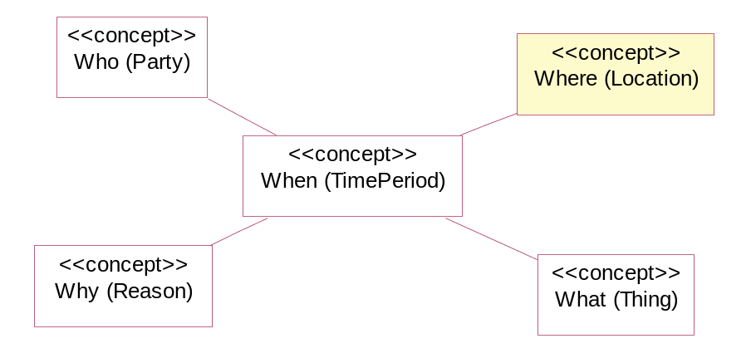
fig 0 – Showing how Location fits in

This section of the SID answers the question “where ?” and deals with locations in the context of the eTOM, which looks at processes from a Service Provider’s point of view.
“The eTOM is a business process model or framework that provides the enterprise processes required for a service provider.” [eTOM]

A Service Provider will not be interested in planetary and galactic positioning, our interest in location will be earth centered.
We may not only be interested in places on or near the earth’s surface however. For example, we may also be interested in undersea locations of submarine cables and in the positions of communications satellites, and airplanes with mobile phone interfaces.
A Service Provider will be interested in the location of many things, and may ask:
- Where is the customer (more on this later) ?
- Where is our equipment ?
- Where is the fault and where is the nearest person who could repair the equipment ?
- Where did the cyclone pass (and what equipment may have been affected) ?
- Where is growth for this product ?
- Where can we expand our business operations ?
- Where are our service vans and the work sites (to optimize work dispatch) ?
- Where (which shops) do we require products to be shipped ?
- Where do I send the bill for Customer X’s use of product Y?
- Where do I need additional employees ?
- Who owns this property (to advise of digging) ? {note property may be rented, i.e. customer living at property may not be owner}

Note that the business requirements will not just be Network related but will also be required by marketing, corporate strategic, etc processes.
In some cases these locations will be well defined points. In others they may be fuzzily defined regions of interest.
The Location model enables us to answer questions like “What is the nearest network access point to the Customer’s location that can provide this product ?”. Network, Customer and Product Capability should not just be seen as separate location views, but as an integrated view.

eTOM Requirements
While the eTOM has many indirect references that may imply location functionality (e.g. “product delivery”) the only explicit location reference in the eTOM processes is in Workforce Strategy (HR – EM)
“These processes create the strategies needed to ensure that the correct type, quantity and quality of staff will be available in right locations for future business.” [eTOM]
The only other eTOM references to location are in the figure “Services in the ICS Industry are Multiplying” which has an arrow marked “Location based services” and at the start of chapter 1 “Everything, Everywhere, Everytime”.
This model will provide a level of Location functionality that could be reasonably be expected to be required by the eTOM use cases.

Customer Location / Location Based Services
In most cases, we will not know the actual location of a Customer (person). For example, even if we tracked the location of their mobile phone, they may have left it at home or lent it to a friend. Legal reasons may also restrict us from determining a Customer’s actual location (except in special circumstances – e.g. emergency calls).
From a Service Provider view we are probably asking “Where does the Customer require service ?”.
There are a set of services called “Location based services” [OLS]. These utilize the Customer Premises Equipment (CPE) location to provide additional Customer value. An example may be a service allowing a Customer to call using their mobile phone and find the closest “Pizza Barn”. The service could return the three closest Addresses as a SMS message or as WML or send a simple map on a 3G phone, showing the CPE location and the closest fast food locations. Note that this service would use the actual CPE location, not just the cell that the mobile phone is working off (see example 5).

Graphical or Textual ?
This section introduces the concept of spatial representation and algorithms. It is felt that explaining these concepts ahead of the model definitions will make the model easier to understand.
This facet of the SID model will provide for spatial (i.e. map display) manipulation of locations as this is widely used in operations centers, customer service and network planning areas of a Service Provider’s business.
From a service Provider’s point of view, GeoSpatial data can be categorized similar to the layers on a map, as shown in fig 1 below.

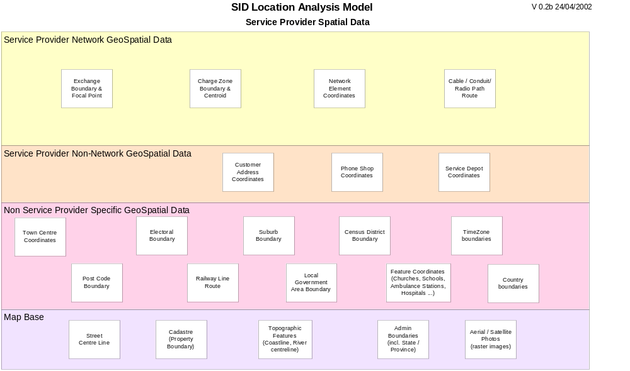
fig 1 – Possible Service Provider Spatial data

This model has been designed to be able to be used in textual only or textual/spatial situations, however it is recommended that spatial presentation is provided.
A common problem with a textual only environment is that spatial relationships are inappropriately approximated (e.g. hierarchies of regions are created, where the region boundaries don’t match). [Hay]
Figs 2a and 2b show examples of binary spatial relationships for simple point, line and region geometries [OGIS], [Clementini], [Egenhofer], [JTS]. Readers who wish to learn more about this topic should consult these references.
If locations are to be related using associations, then the associations should match the spatial binary interactions (e.g. as an association type).
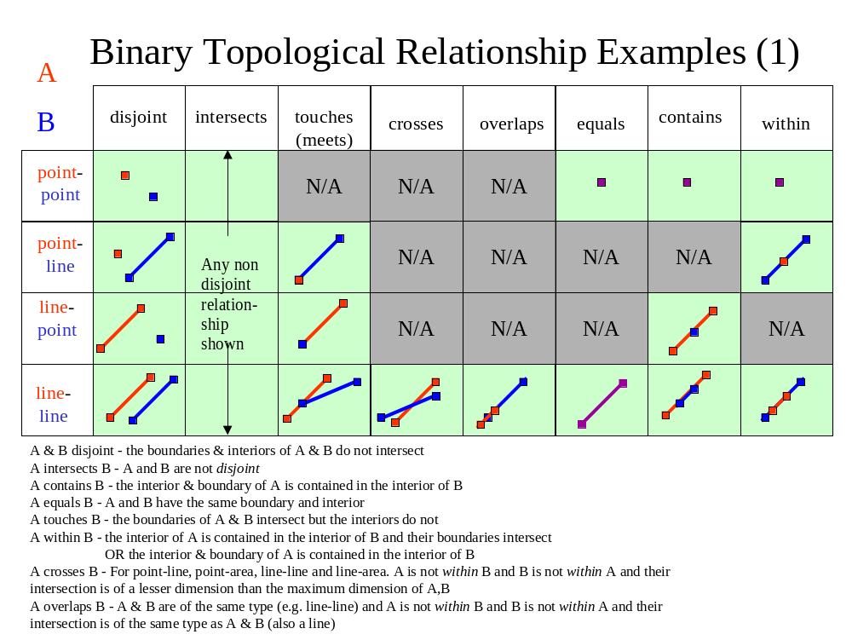
fig 2a – Binary Topological Relationship Examples (1)

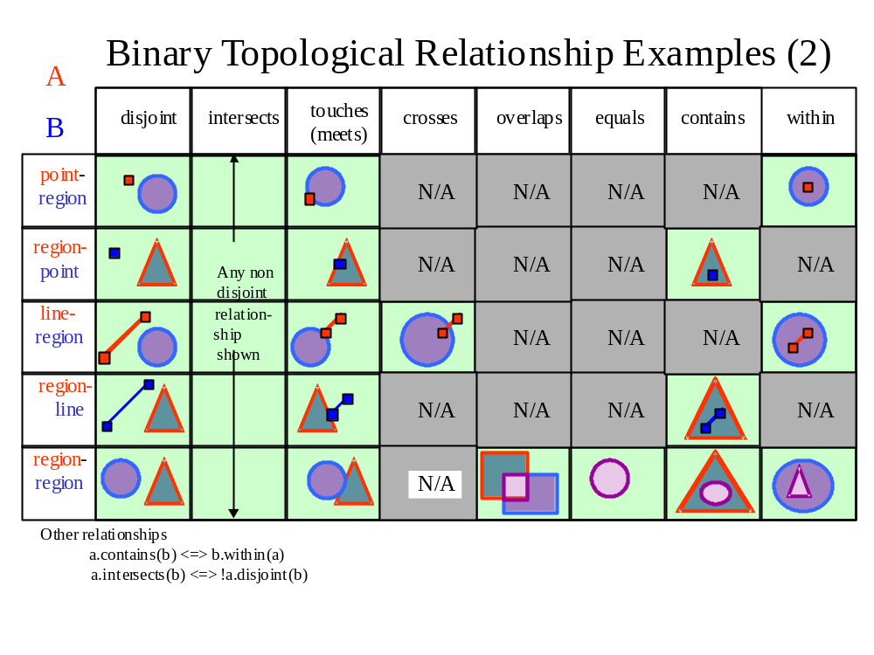
fig 2b – Binary Topological Relationship Examples (2)
We can see that the actual relationships are dependant on the types of geometries and that there are numerous variations, even with only two very simple objects.
This section has highlighted that spatial functionality is more than just a map pictorial presentation, but is fundamental to the data storage and how the data can be analyzed. This should be kept in mind while reading the rest of the document to determine whether a textual only representation can accurately support particular business requirements.

Place
We will define Place as a generic concept that can answer the question “Where ?”
We will define two types of Places:
- Geographic (External) – drawn on a map, defined using a geographic co-ordinate system (absolute world centered datum and projection), typically maintained using a GIS
- Local – drawn on floor-plans (suite / rack positions), defined using a Cartesian coordinate system relative to a local datum, typically maintained using CAD packages
Also see the section “Contrasting Geographic & Local places” for further discussion of this.

Places are an abstract modeling concept, used to generalize Location, Address and Site. In later sections we will explore these three different concepts. Figure 3 shows the main concepts and how they are related.
This model provides four options for locating something geographically:
- With a defined (named) location {sub class of Geographic Location}
- With an address of a location {Geographic Address}
- With a (named) site {Geographic Site}
- With a survey location (geocode) e.g. a GPS position for an offshore oil rig {Simple Geographic Location}

The way that the Place hierarchy is defined is the key to this model. The high level concepts are broken up into two levels of granularity, Geographic and Local, rather than by Address, Location & Site.
Note that various names for “Local” were considered. The following were considered ( the reason for not using it is bracketed):
- internal place (is awkward when referring to things that are attached, not enclosed)
- relative place (confusing due to the use of relative geographic places)
- structural place (confusing if there is no structure)
So the term Local may not be perfect, but it is the best found to date.

Fig 2c shows how different types of Geographic and Local Places can be combined together.
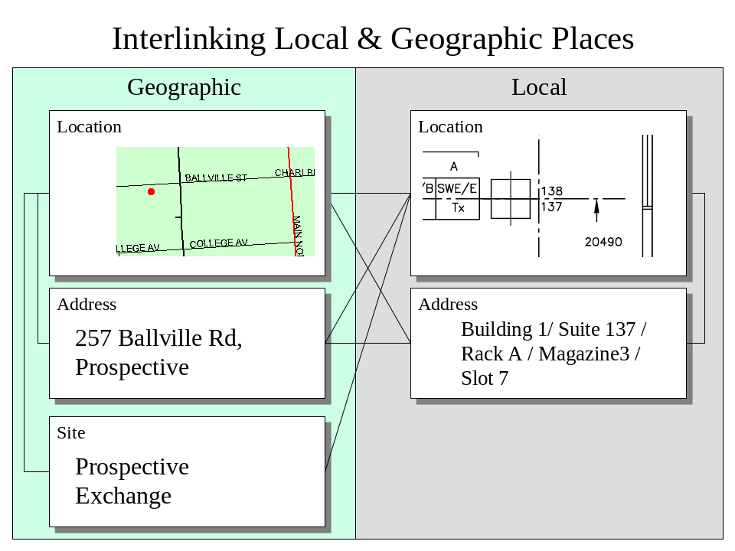
fig 2c – Interlinking Geographic & Local Place

If we need to communicate information about a Geographic Place, we can mark it on a map or give its address. If an address is given, then we will often need to look it up in a street directory (map).
We can specify a Local place as a Address or as a Location (by marking it on a drawing) and link it either to a Geographic Location, Address or Site.
Local Places are defined relative to a Geographic Place and we could choose as the Geographic reference point a Geographic Location, Address or Site.
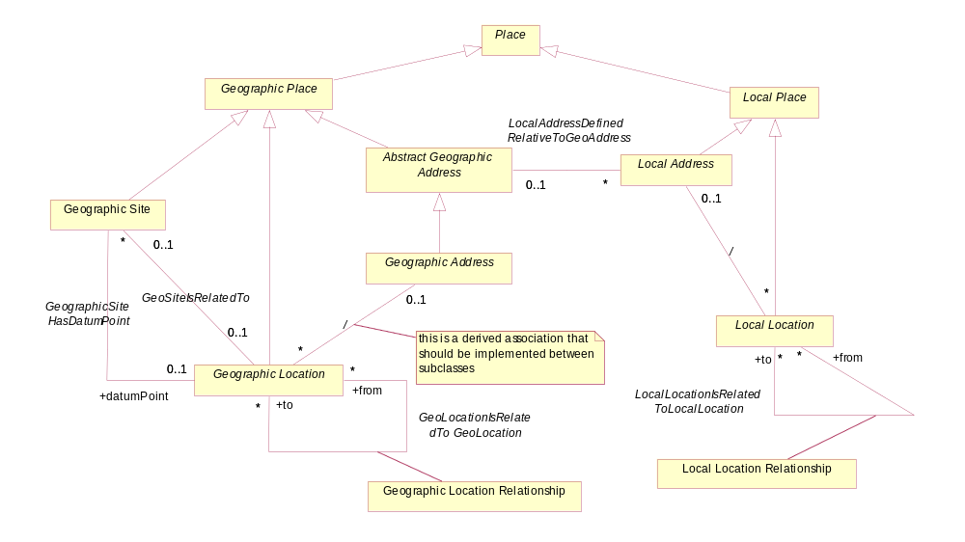
Figure 3 – types of Places (overview hierarchy diagram)

If a spatial engine is not available, then it is likely that only Point geometries will be used (e.g. latitude, longitude, elevation) as this is the easiest geometry type to store textually.

Location
This model defines Location as:
“A defined place”
A location usually has a unique code or name to allow textual identification.
Location is split into Geographic Location that relates to world centric places and Local Location, that relates to locally defined coordinate systems (usually defined relative to man-made features).
A Geographic Location has an optional Geometry attribute, allowing it to be displayed on a map.

As shown in fig 4 we will allow a Geographic Location to have many names. A name may change over time and could be defined in more than one language. Also a location may have more than one name in the same language, or a European and native name (Ayers Rock is also known as Uluru).
“A name is an informal way of identifying an entity” [Fowler-AP].

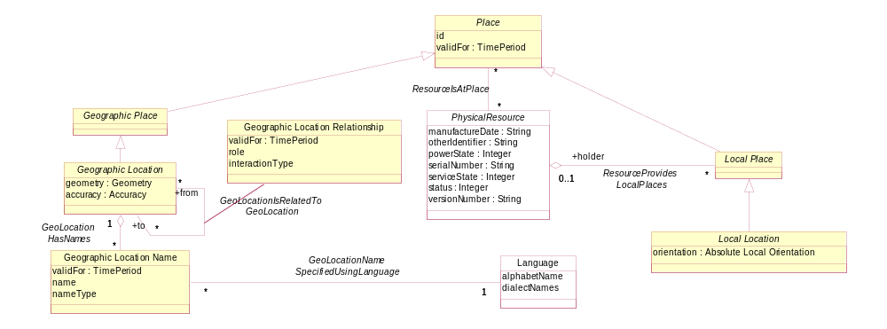
Figure 4 - Location

Address
This model defines Address as:
“An address is a structured textual way of describing how to find a Location. It is usually composed of an ordered list of Location names based on context specific rules.”

Address is split up into Geographic Address and Local Address. Geographic Addresses describe Geographic Locations and Local Addresses describe Local Locations.
Geographic Address caters for Property and (physical) postal Addresses.
Geographic Sub Address caters for Property Sub Addresses.
Local Address caters for a level of granularity smaller than Geographic Address
While it may be possible to derive a Geographic Address from a map point using Geographic Location names [Hay], there are advantages in storing Geographic Address as a separate entity.
Geographic Addresses may be required:
- if the Address cannot always be calculated reliably from a map (e.g. to Post Office standards)
- if a spatial engine is not available
- if suitable spatial street, suburb, post code data is not available
- for logical addresses (e.g. PO Box)
- to achieve required response times. It takes a lot of computation & spatial facilities to derive the address from a map position, so storing it redundantly as text makes sense (easy for selection etc.)

Country specific standards should be implemented using Policies, Templates & Rules.

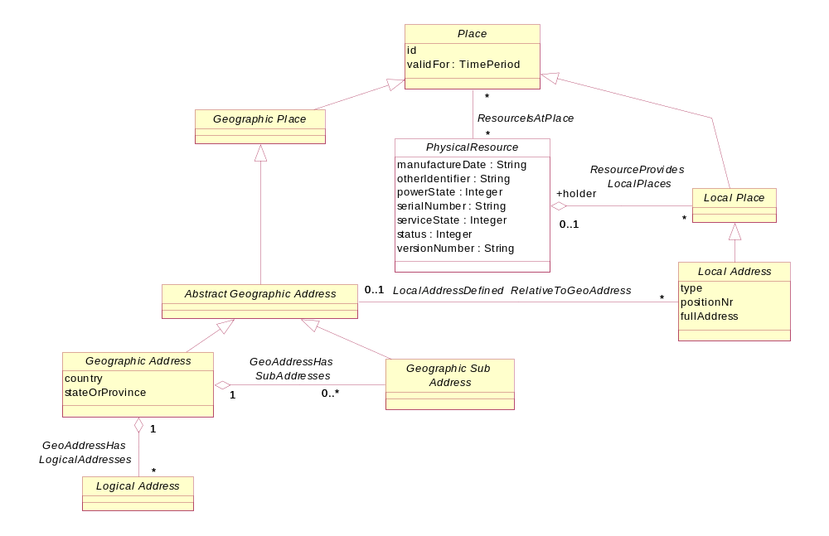
Figure 5 – Address

Logical Address
The term Address is often used to describe:
- Addresses that enable you to find a location (e.g. Street Address), which we will define as a physical address
- Addresses that don’t (e.g. PO Box address, email Address), which we will define as a logical address
A logical address allows us to send something (tangible or intangible) to a central point where it can be retrieved. With email, a message is sent to the recipient’s ISP mail server. The recipient can then connect to the server from anywhere in the world and retrieve the message. The intermediate location is not of interest to the message sender.
Only logical addresses that relate to Location (e.g. Po Box Address), will be covered in this model (see SID Party Domain model / Contact Medium for e-mail addresses etc.).
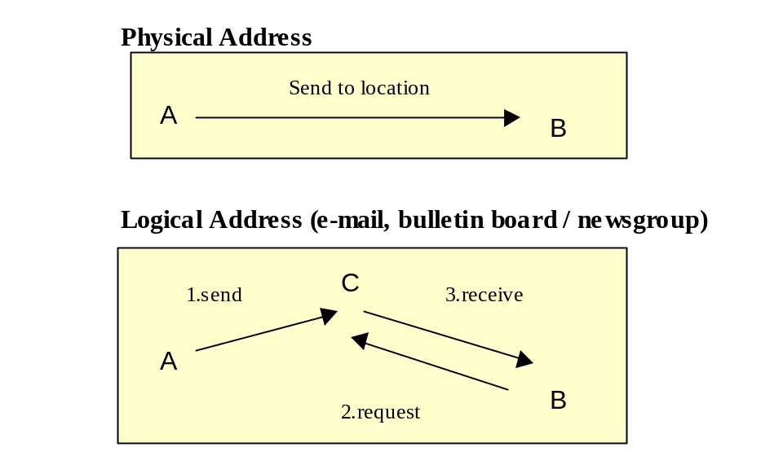
Fig 5.a – logical & physical addresses

Note that Network Addresses (e.g. IP Address, Phone Number) are not Location related (as per our definition) and hence are not covered in this model. They will be covered in a later version of either the SID Service or Resource model.

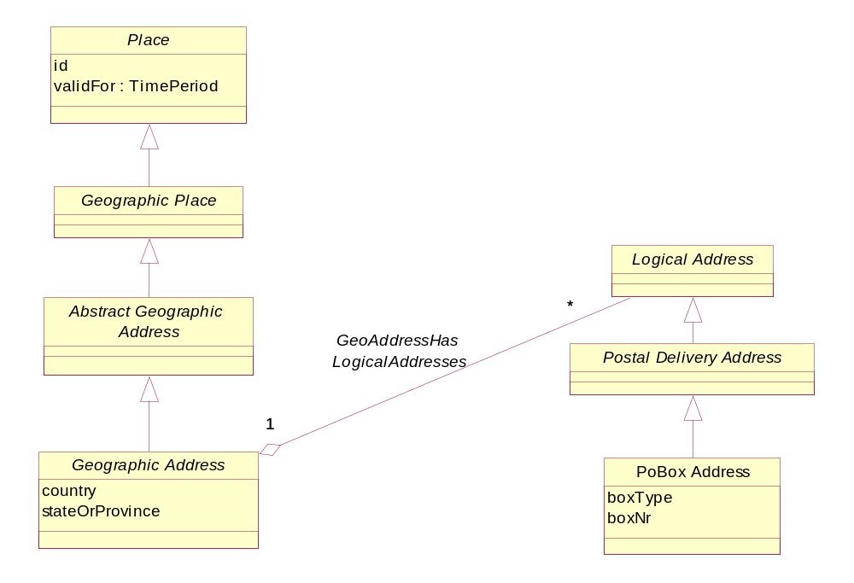
Fig 6 – logical addresses

Site & Site Role
This model defines a Site as:
“A place that has (existing, planned or former) physical things or characteristics of interest to the Service Provider.
Things of interest include Product Instance(s, Service Instance(s)) and Physical Resource Instance(s).
Characteristics of interest include associated Parties (property owner, property lessee)”
Site provides a convenient linking point to other parts of the SID model.
A Site may be assigned many roles (or functions).
Site Role types should be restricted to functions that cannot be easily derived from entities linked to the site.

Some examples of Site Roles are:
- Asset Location
- Transmission Access Point
- Competitor Access Point
- Customer Access Point
- Equipment Delivery Point
- Cultural Site
- Protected Area
- Exchange Site

Site Roles should NOT be used for:
- Network Equipment Types (e.g. ADSL site)
- Network Equipment Roles (e.g. CCS7 Node – this is a role of the Resource)

Later in the document we will also define Geographic Location and Geographic Address roles. These other roles are modeled differently, which is why there isn’t a generic “Place Role” entity defined.
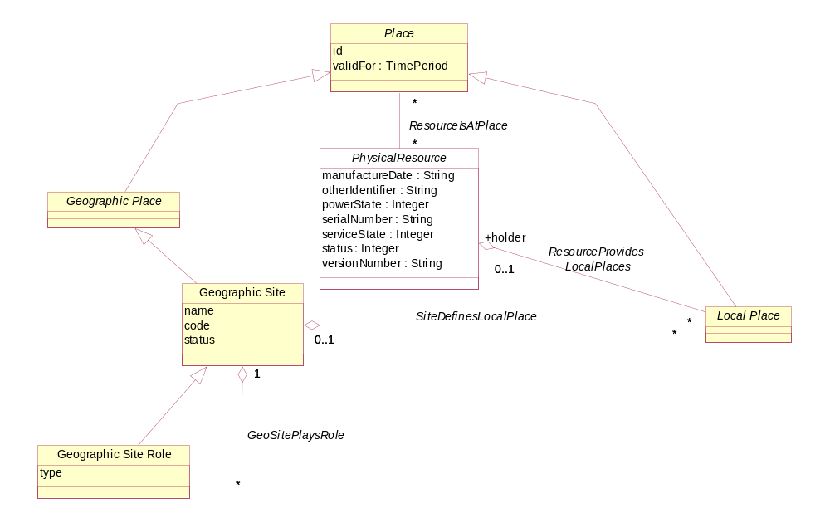
Figure7 - Site

Place, Location, Address & Site
Figure 8 summarizes the main entities shown in figures 4-7
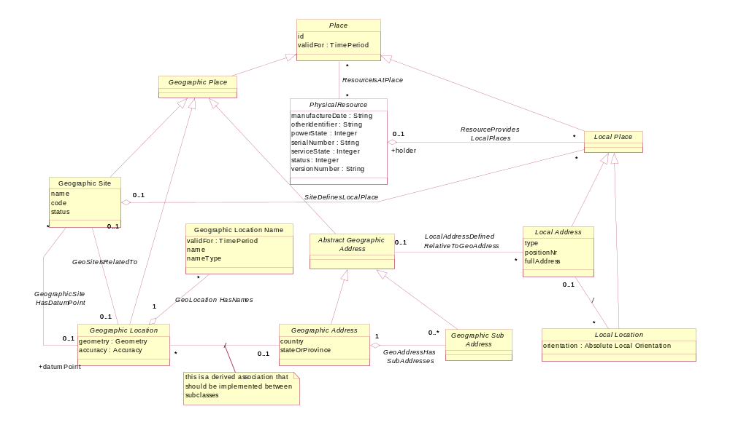
Figure 8 – Place, Geographic Location, Address & Site
This model allows for changes in location detail over time. A Service Provider may start by having external address or Geographic Location information. Then other information, including Local information, can be added later as required (refer example 1).

Geographic Geometry
This model adopts the Open GIS Consortium Geometry model [OGIS].
Whilst in theory any spatial engine / model could be used, use of a standard interface allows for component interworking.

Refer to document “OpenGIS® Simple Features Specification for SQL” at http://www.opengis.org/techno/implementation.htm for an explanation of the model. Note that the Geometry classes are not documented in the “data dictionary” section at the back of this document.

For messaging and data interchange of Geographic information, the GML standard is recommended.
“The Geography Markup Language (GML) is an XML encoding for the transport and storage of geographic information, including both the spatial and non-spatial properties of geographic features.” [GML]

The Geometry classes should be considered as a closed set, with Geometry as the root class and no subclassing of any of the classes shown in fig 9. This aligns with the proposed ISO standard [ISO / DIS 19109].
If a spatial engine is not available, but geocodes are required, then a Point entity could be substituted.

The SID model uses Geometry as an attribute of the Geographic Location entity.

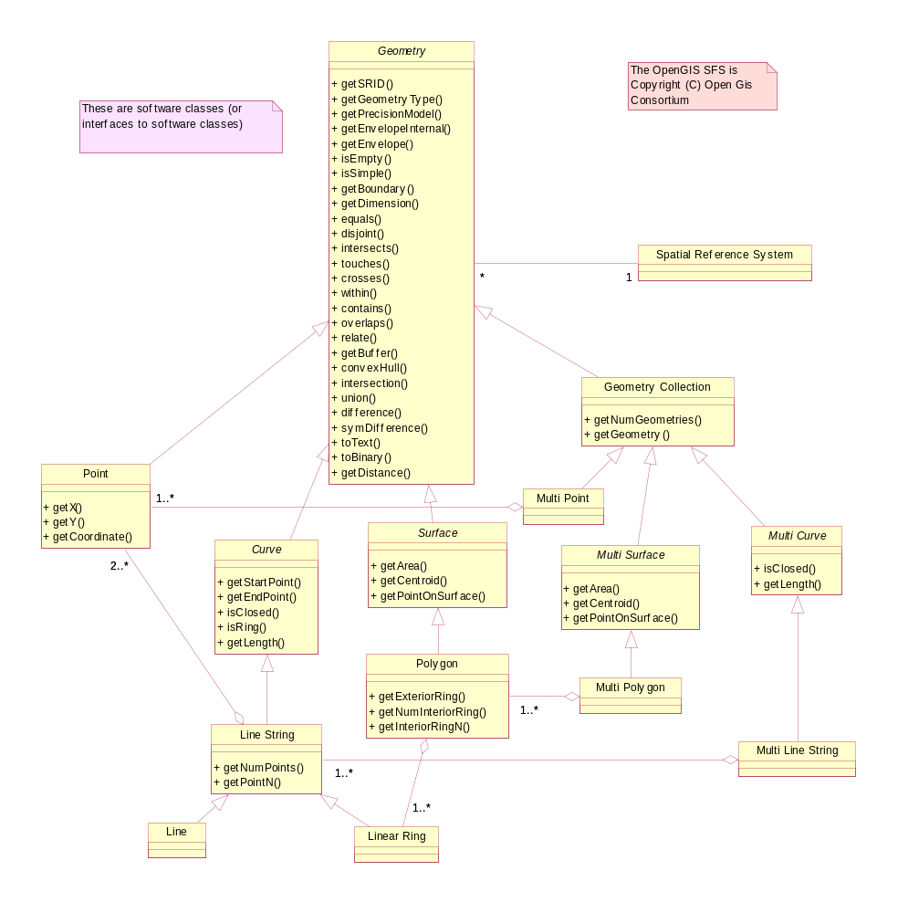
Figure 9 – Geographic Geometry [OGIS]
Astute readers will have noticed that the OGIS Geometry class implements the Binary Topological Relationships shown in figs 2a & 2b.

Geographic Locations
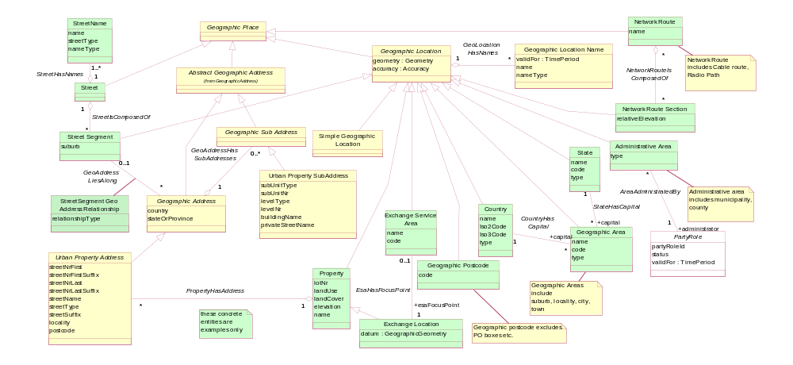
fig 10a – examples of possible geographic locations

Figure 10 shows as an example, an Exchange Service Area, which models an Exchange (Central Office) and the area that it serves. Other examples of Service Areas include Digital Radio Concentrator Systems (DRCS), Fixed Radio Access (FRA) service areas & Pay TV service areas. For wireless service areas (e.g. WiFi, 3G mobile), it may be useful to model the signal strength contours as a collection of areas.
A Simple Geographic Location entity should only be used (fig 3) when there is no unique textual identifier (name or code).
Note that there is a Spatial Data Standard [SDSFIE/FMSFIE] that defines around 1,500 feature types. It is not recommended that NGOSS uses its data model, but NGOSS should try and align with their attributes (feature type, name , symbology). It would also be useful if the SDSFIE/FMSFIE standard defined a set of XML schemas that could be used for data interchange (perhaps utilizing the GML [GML] standard).
To display features on a map we need to define the display format. Fig 10b shows how each type of Geographic Location can be assigned a symbology definition.
Figure 10 has two options for naming of GeographicLocations. If a GeographicLocation type only has a single name, then the name should be included as a simple attribute (e.g. Country). If the GeographicLocation type is likely to have names that change over time, or has alternative names (e.g. native names), then the GeographicLocartionName entity should be used (e.g. Administrative Area).
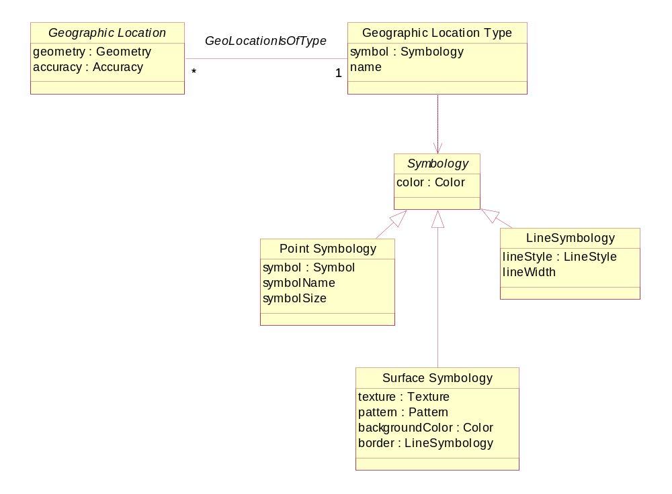
fig 10b –geographic location symbology

Contrasting Geographic & Local Places
We will now look at the contrasts between Geographic & Local Places.
In map representations, many of the features that we display are unique. For example
- country boundaries
- municipal boundaries
- railway lines
- property boundaries
are influenced by natural features (coastlines, hills, rivers etc.) .
In the Local (artificial) world, many of the features that we wish to represent are made to specification.

On a map we are usually interested in where something is (e.g. where is the hospital ?) and want to limit the detail so that the result is not too cluttered.
For Local places we are usually interested in both the position (placement) and orientation of features (where is the modem cabinet and which way does the front face ?) as shown in fig. 11c.

On a map we use a two dimensional planar representation as we wish to view large numbers of features at a low level of detail.
For Local places, three dimensional modeling is required to accurately represent:
- multistory buildings
- rack layouts
- card positions
- things mounted on walls
- obstructions like low ceilings, windows, air conditioning vents

So we can see that we have different needs between Geographic and Local Places and that our model representation needs to reflect this.

Local Places
[Oracle Spatial Concepts] defines Local Coordinate Systems (Non Earth) as:
“Local coordinates are Cartesian coordinates in a non-Earth (non-georeferenced) coordinate system.
…
Local coordinate systems are often used in CAD systems, and they can also be used in local surveys where the relationship between the surveyed site and the rest of the world is not important.”

Local Places are provided by a type of Physical Resource that we shall call an EquipmentHolder. An EquipmentHolder could be an Enclosure, that encloses the places inside it or a Structure that provides support for things to be attached. EquipmentHolders can be inside other EquipmentHolders, forming a hierarchy.
Structures can be attached to other structures, also forming a hierarchy (where the structure providing the support is the parent).
Structures can be contained in EquipmentHolders and EquipmentHolders can be attached to Structures, forming a mixed hierarchy (e.g. a single channel radio transceiver subrack is installed in a weatherproof box which is attached to a tower).
Local Places are defined relative to their EquipmentHolder.
A rack/ card position can have a status of empty or filled and this can change over time.
e.g. an EquipmentHolder is installed with a card position empty. A card is later installed, and the card position is filled. The card fails and is removed and sent off for repairs and a replacement card is installed in the same position.
The SID Physical Resource model keeps track of the card; the SID Location model keeps track of the position.

We will define a Housing as an Enclosure that is not contained in anything (i.e. the outermost level of containment).
We will define a primary structure as a free standing structure (i.e. the outermost level of attachment).
Housings and Primary Structures may be related to a geographic location (i.e. be located on a map).
Some common Housing types are building, equipment cabinet, street cabinet, pit (underground utility box), housing, rack, sub-rack.
Some common Structure types are tower, pole, power pole, radio mast. A radio tower may have a number of rails with positions that can be used to attach antennas and dishes. Each of these rails could also be modeled as a structure.

Local Places are dependant on the SID Physical Resource model definitions. The Physical Resource model will only model to the “field replaceable unit (FRU)” level (i.e. it will not model individual resistors and ICs).
Local Places can be categorized in various ways. Some things to consider are:
- Above ground (mast), on ground (building, street cabinet) or underground (pit)
- Containment (inside) versus attachment (on)
- EquipmentHolders, which are contained in something (rack), versus those that aren’t (street cabinet). A street cabinet could be thought of as a weatherproof rack that also secures the equipment (from theft).
- Logical versus physical Holders (e.g. suite versus rack)
- Ownership. A housing may or may not be owned by the Service Provider (e.g. Leased building, shared site with leased space)

An EquipmentHolder may provide:
- “General space/ free form space” (e.g. floor space in a building – can be used for almost anything)
- “Managed / restricted / pre-defined space” (e.g. card position – restrictions on what can be plugged in)
A managed space EquipmentHolder entity, on instantiation, should create its Local places e.g. CMUX universal card (SPEC 227L - width & height, pin-out)

We will use a Cartesian local coordinate system for Local Locations. The Local coordinate system need not be north-south or earth surface aligned. This means that the local coordinate system definition will need to document a position & orientation of up to six degrees of freedom. In most cases the Holder or Structure will be aligned to the earth’s surface (i.e. not tilting like the tower of Piza) and we will only require a position & orientation 4 degrees of freedom as shown in fig 11a.
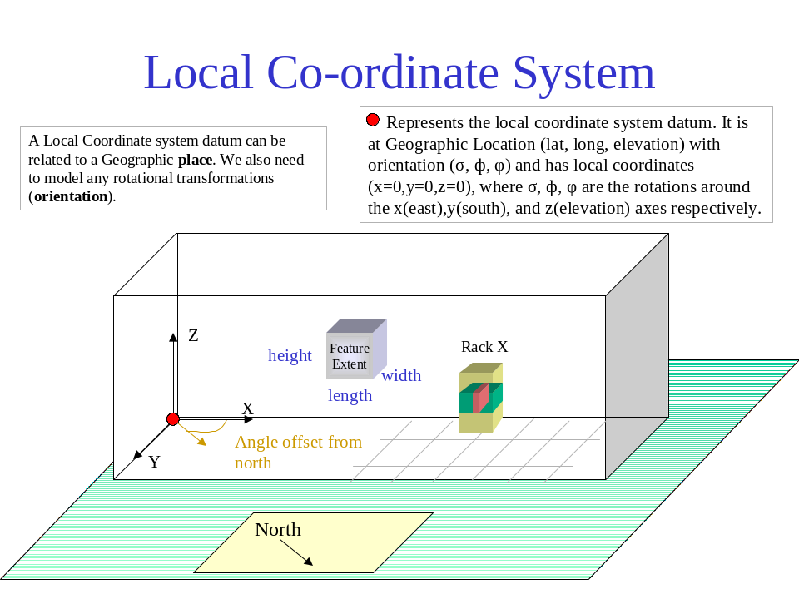
fig 11a – local coordinate system

Physical Resource specifications (in the SID Physical Resource model) should include three dimensional geometric representation(s). The geometric representation should include a minimum bounding volume and also allow for two dimensional representations (each face of the minimum bounding volume) and provide reference point(s) for the shape (for placement).
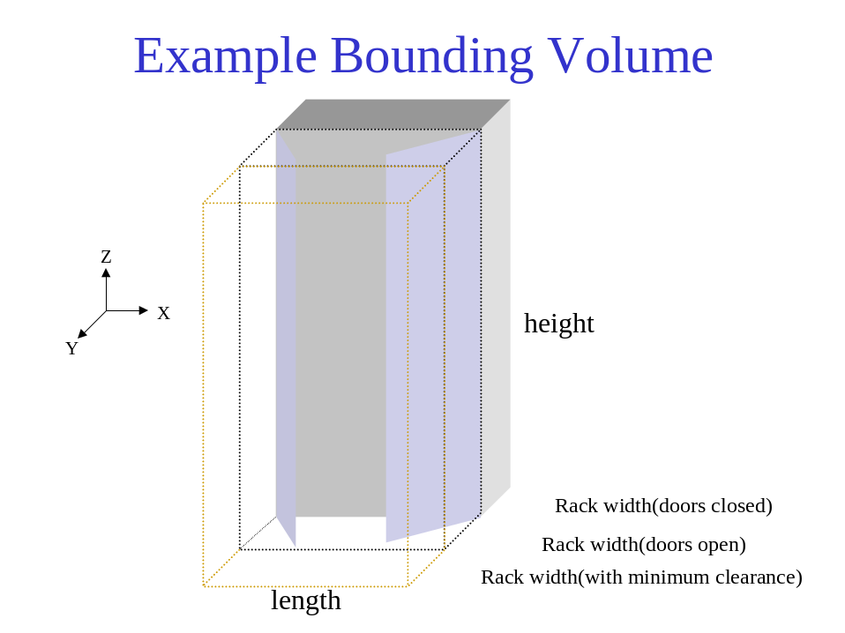
fig 11b – example bounding volume

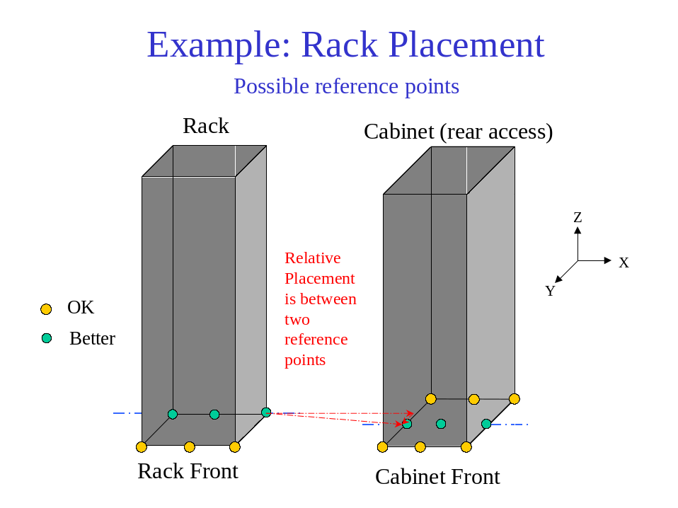.
fig 11c – example of rack placement

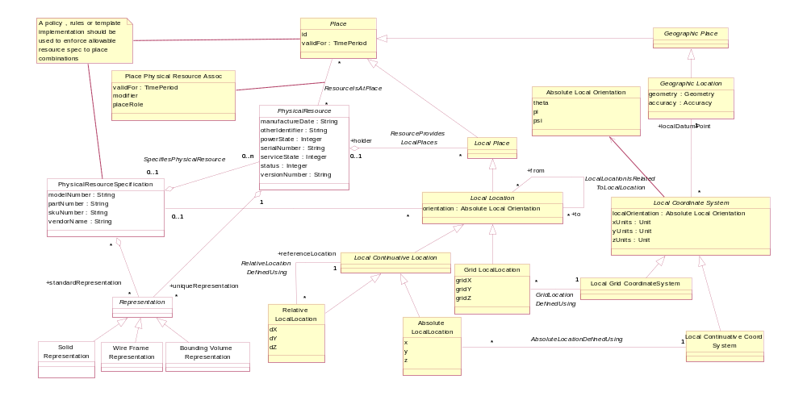
fig 11d – Local places are defined using local coordinate systems
Note that a Grid Layout would be especially useful for rooms with raised floors where cabinets are installed in floor tile positions, card positions in a subrack, or subrack positions in a rack with rack unit connection points.
Note that we allow for both Physical Resources and Physical Resource Specifications to have representations. It would be expected that only unique physical resources (e.g. buildings) would need individual representations.
Note that in figure 11, we don’t enforce the concepts of holders and housings in the static model. This is because the concepts are dependant on the status of the static resource. For instance, it may appear that a card can only exist in a card position (in a sub-rack etc.). This may be correct for a card with a status of “installed”, but if the status is “spare” then it may exist in a store or if the status is “faulty-returned” then it may exist at a manufacturer’s repair center.

Types of Geographic Address (and Sub Address)
Addresses may have aliases, such as corner properties having more than one street frontage, or properties with rear entrances. We will require, however, that one of the addresses is chosen to be the Principal Address and the others are marked as aliases. Also roads and localities may have name aliases that will lead to address aliases.
We also have “vanity address aliases”, where people use a different address to appear to live in a classier suburb. These will be modeled as Address aliases.
A location may have many addresses. An address may also be used as a location name if no distinctive location name (e.g. Buckingham Palace, The Pentagon) exists.
As well as simple “household” addresses, we need to be able to handle complex Addresses, which exist where a Property has multiple owners, tenants, access points or facility points. These are handled using Geographic SubAddress.
Examples of places that have complex addresses are:
- private streets
- caravan parks
- universities and other large educational institutions
- hospitals
- military bases
- retirement villages and other community developments
- entertainment / recreational parks
- marinas
- (marine) harbors / ports
- airports
- resorts
- shopping centers
- sporting venues
- townhouse developments
- industrial complexes, business/ commercial parks

It is likely that we will require different Geographic address rules for each country. This is represented by the entity Address Policy and the subclassing of Geographic Address in fig 12. Note that the address rules could be implemented using templates, or policy or rules engines.

A SubAddress is used for addressing within a property. It may refer to a building, a building cluster, or a floor of a multistory building.
e.g. a property with address 53 Malvern road may have 3 units, with subaddresses unit 1, unit 2 & unit 3.
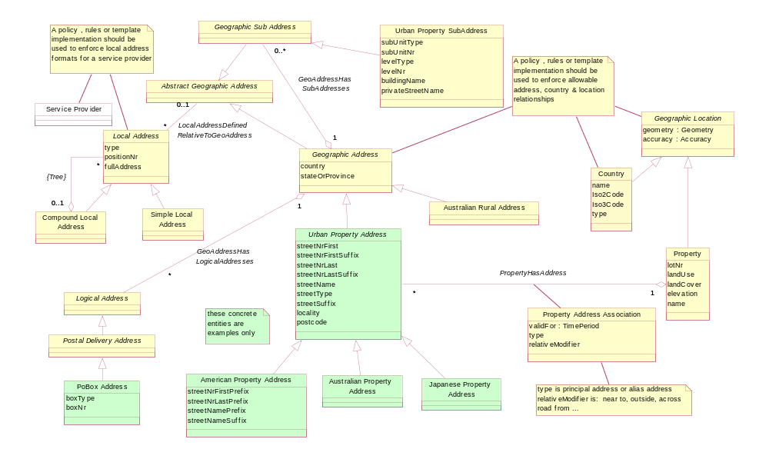
fig 12 – types of address
Note that in figure 12 that a full set of Addresses has not been shown. The example entities have been shown for example only, on how the core model can be extended in particular situations.

Types of Local Address
A Local address could be of the form: Building 1 / Floor 6 / Suite 25 / rack 12 / subrack 1 / card 7
The Local Address Policy should enforce Service Provider specific Local address business rules.
A possible naming graph is shown in fig 14. This would form the basis of a naming policy.
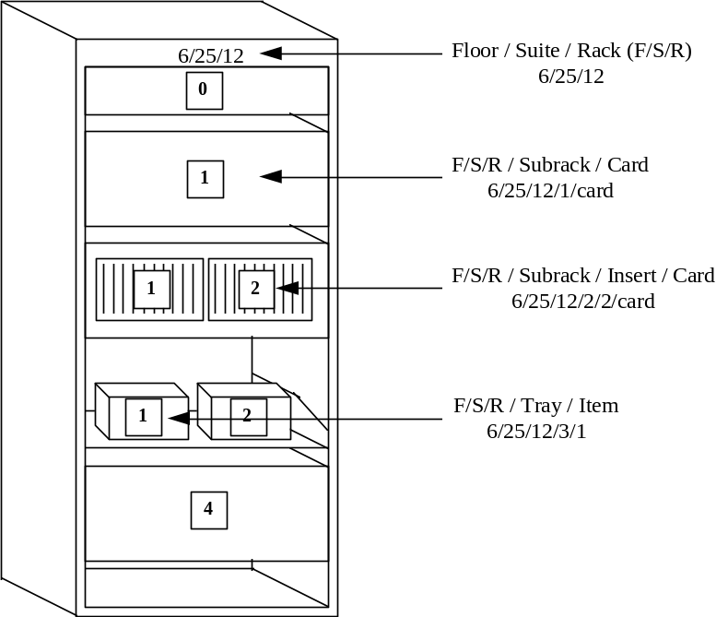
fig 13 – Example of a rack
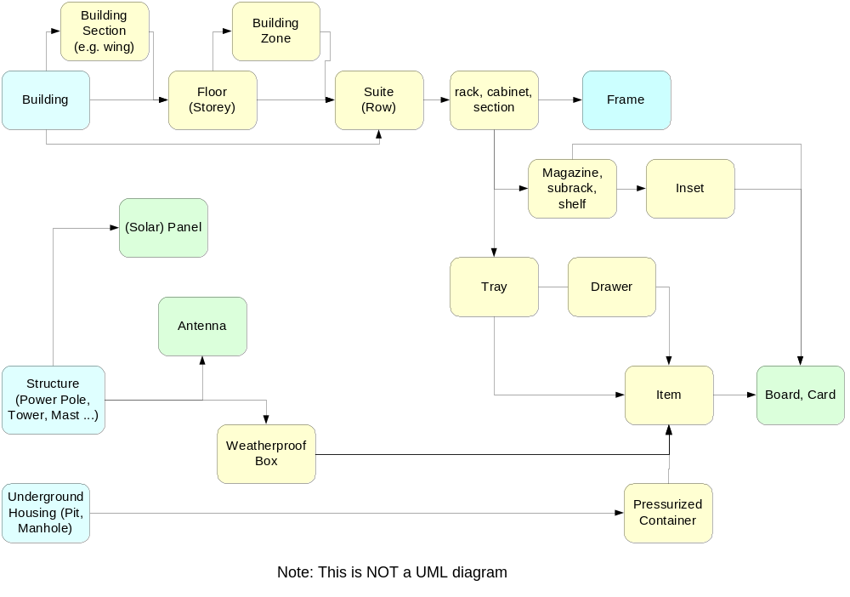
fig 14 – Example of a network inventory naming graph

Location & Address Role
In the Party SID model facet, we defined roles that parties (people and organizations) may play. In a similar fashion, we may find it useful to define location and address roles. This will allow us to use a single location or address for different purposes, e.g. a single address may be a:
- Customer billing address
- Phone directory address
- CPE equipment location address and a
- Geographic plant reference address (pillar outside the front of …) .
Because the role requirements are simpler than in the Party SID model facet, Location roles have been modeled as associations. [Fowler-role]
Care should be taken not to confuse when to create address & location subtypes versus address & location roles.

Interworking with the rest of the SID model
Fig 15 shows some possible connections from Location to other parts of the SID model. This diagram is intended to be illustrative rather than prescriptive.
The SID model doesn’t store GeoSpatial information as a part of every entity. As each entity is modeled, we determine whether the entity has GeoSpatial attributes or refers to GeoSpatial attributes. For network equipment, we create abstract GeoSpatial entities of location and route section etc. and reference these from the network elements.
To reiterate; Location information should not be stored in Product, Party or Network Resource entities but associated with a Place.
If a Place exists, it should be shared and not duplicated.
This allows queries that would otherwise require GeoSpatial queries to be done textually, i.e. to check if two network elements are at the same location, just see if the place ids are the same.
When placing a Resource or a Product, the choice is to associate to an:
- address, or
- site, or
- location

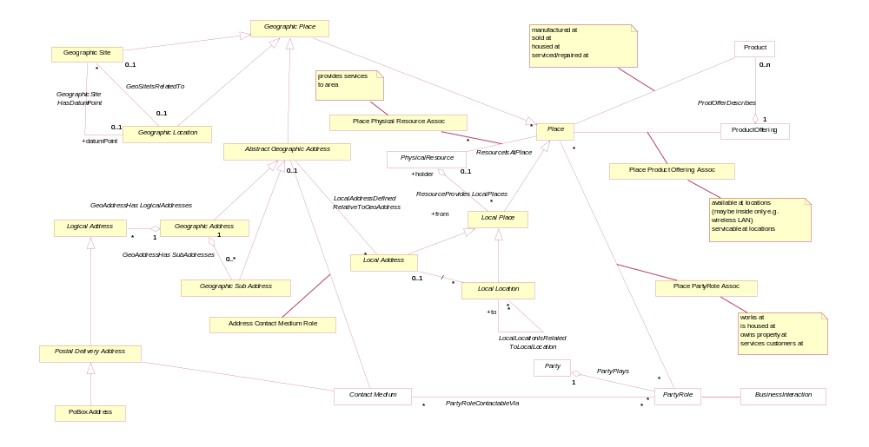
fig 15 – links to other parts of the SID model

Using this model for Process Analysis
When using these entity definitions in process or use case analysis, the most useful entities will be
- Geographic Address
- Geographic sub address
- Postal Delivery Address
- Geographic Site & Role
- and the concrete example Geographic Locations (Street, Property, Country, State …)

If a generic term for “where ?” is required and the answer could be an Address a defined Site or a Location, then the term Place should be used.
In common language the Geographic / Local prefix is usually not used as it is assumed that it is clear from the context. During process analysis it is probably worthwhile to explicitly note this information.
It will also be useful to note whether an address is a Postal Address or not.
If more detailed entities are referenced, then they should be defined and related back to the entities in this model. e.g. “a Council Area is a type of Administrative Area that …”

Model Implementation Using Components
This model should not be implemented as a monolithic component, but in such a way that functionality can be plugged in as required.
This is shown conceptually in fig 16
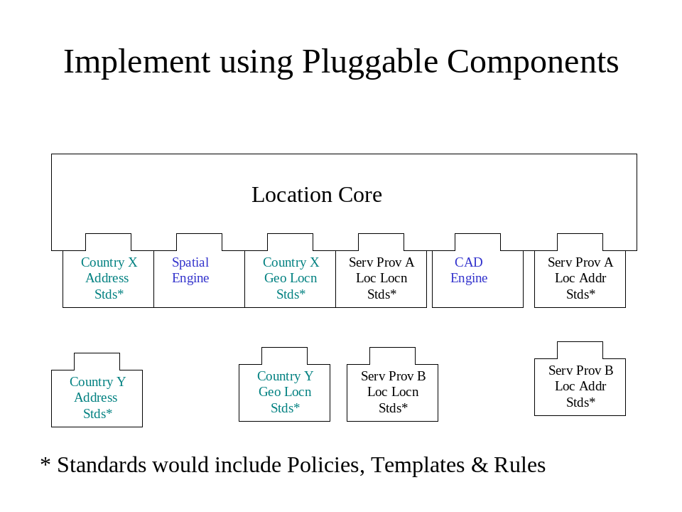
Figure 16 Implement using Pluggable Components

Note that a Service Provider may need to have multiple standard sets plugged in at the one time.

Further Work Required in Later Releases
This section documents some issues that have not been resolved in this version.
- Need to ensure that we have a clear interface with the Physical Resource model. As the Location and Physical Resource models are being defined in parallel, this interface will be refined with successive model versions. In particular, if we should allow arbitrary local place definitions by the definition of a reference point, not requiring any PhysicalResource to be present.
- Need to investigate the use of IAI / IFC 2.x model for Local places [IAI/IFC]
- Should try to make concrete location entities compliant with Spatial Data Standard SDSFIE/FMSFIE Release 2.10 [SDSFIE/FMSFIE]
- Need to validate how an equipment suite (row) should be handled, should we make it a new local coordinate system, or an absolute Local place, that fixes one of the x or y coordinates and allows placement relative to it ?
- The current model has some overlap between Geographic sub address and Local address, we need to think more about this (refer fig 5). Local Address should probably only be defined where Geographic address finishes. This means that Local Address will not have a standard starting point.
- Investigate the removal of the Street and Network Route specializations to Geographic Place.
- Re-look at Site Role and how this is expected to be used
- Should add CAD discussions to “Graphical or Textual“ section
- Need to look at Local Location again to see if it can be made less dependant on EquipmentHolder. This will also fit in with local Place definitions for sites. Also we will need Graphical Representations for Local Places like suite, which aren’t defined by Physical Resource.
- Determine if a limited Composite pattern should be used for Symbology (ie. add simple and compound symbology entities to fig. 10b) to allow for GeographicLocation types with multiple Geometry attributes.
- Consider if LogicalAddress should link into GeographicAddress, AbstractGeographicAddress or higher up un the hierarchy

What about things like a technician’s van containing card spares ?? Should we model these ??
- we could model a van as a holder with an Local location. We may not know where the van is, but just know that the item is "in the van”. Some service providers may keep track of a van location and be able to send the closest van with the required capability to fix a fault or install a service.

Notes:
- Note that these entities represent business concepts in a Service Provider that conforms to the eTOM process model [eTOM].
- Entities that are outside the scope of this model facet are shown with a white fill color.
- This is intended as a “minimalist” model. Subtypes and attributes should be added as required. The attributes shown should be considered as suggested, not required.
- Parent attributes are not repeated in the sub entities
- In most cases relationships are not documented as attributes
- Only significant entities are shown in the “related business entities” cells

Standard citation for this document
TeleManagement Forum SID GB922 Addendum 1L (Location)
Chris Hartley, Helen Hepburn, et al.
URL: http://www.tmforum.org/

References

Fowler-AP | Analysis Patterns – Reusable Object Models  by Martin Fowler ISBN 0-201-89542-0  http://martinfowler.com/articles.html
Fowler-Role | Dealing with Roles  http://www.awl.com/cseng/titles/0-201-89542-0/apsupp/roles2-1.html
Fowler-Time | Patterns for things that change with time  http://martinfowler.com/ap2/timeNarrative.html
ACIA | Alliance Common Information Architecture (AT&T, BT & Concert) version 3.1, 15 Dec 2000
eTOM | GB921 version 2.5
OGIS | Open GIS Consortium  http://www.opengis.org/
GML | Geographic Markup Language V2.0  http://opengis.net/gml/01-029/GML2.html  Introduction to Geography Markup Language (GML)  http://www.jlocationservices.com/company/galdos/articles/introduction_to_gml.htm
Zachman | Zachman Framework  http://www.zifa.com/frmwork2.htm
Coad-Roles | Coad Letter 76 – January 2001  http://www.togethercommunity.com/coad-letter/Coad-Letter-0076.html
Coad-Archetypes | Modeling with Color  http://www.togethersoft.com/services/tutorials/jmcu/index.html
ANZLIC-STREET | draft Australian and New Zealand Rural and Urban Addressing Standard  http://www.anzlic.org.au/icsm/street/data_model.pdf
ADDRESS-XML | Postal Address Version 1.1  http://www.xml.org/
ISO-3166 | ISO 3166 Country Codes (2 Character)  http://www.din.de/gremien/nas/nabd/iso3166ma/
COUNTRY-CODES | Countries or areas, codes and abbreviations (3 char)  http://www.un.org/Depts/unsd/methods/m49alpha.htm
Bus-Patterns | Business Modeling with UML, Business Patterns at Work  Hans-Erik Eriksson, Magnus Penker ISBN 0-471-29551-5
M3100 | Generic network information model – Recommendation M.3100 (07/95)  http://www.itu.int/rec/recommendation.asp?type=folders&lang=e&parent=T-REC-M.3100
AS4590 | Australian Standard AS 4590-1999 : Interchange of client information  http://www.standards.com.au/catalogue/script/Details.asp?DocN=stds000023947
Baumer | The Role Object (Design) Pattern. Download PDF from  http://www.riehle.org/computer-science-research/1997/plop-1997-role-object.html
Hay | Data Model Patterns , Conventions of Thought  http://www.dorsethouse.com/books/dmp.html
Cadastre | Commission 7 Working Group 1 “Reforming the Cadastre”  http://www.swisstopo.ch/fig-wg71/cad2014.htm  Cadastre 2014 – A VISION FOR A FUTURE CADASTRAL SYSTEM  http://www.swisstopo.ch/fig-wg71/cad2014/download/cad2014_eng.pdf
Oracle Spatial Concepts | Oracle Spatial User’s Guide and Reference Release 9.2  http://download-west.oracle.com/docs/cd/B10501_01/appdev.920/a96630.pdf
OLS | Open Location Services Initiative  http://www.openls.org/
AP ADDR STDS | Australia Post – Presentation Standards Booklet.  http://www.auspost.com.au/futurepost/index.asp?link_id=9.1575
LAND USE | US Geological Survey – LAND USE/LAND COVER CLASSIFICATION –Modified Anderson Classification  http://rockyweb.cr.usgs.gov/public/mrgb/mrgblulcdefs.html
Clementini | E. Clementini, P. Di Felice, and P. van Oosterom. A Small Set of Formal Topological Relationships for End-User Interaction  http://dsiaq1.ing.univaq.it/hpage/eliseo/research.htm – s1
Egenhofer | Max J. Egenhofer’s List of Publications  http://www.spatial.maine.edu/~max/pubs.html
ISO / DIS 19109 | Draft International Standard. Geographic Information – Rules for Application Schema
ANSI T1.253-1999 | American National Standard for Telecommunications - Information Interchange -  Code Description and Codes for the Identification of Location Entities for the North American Telecommunications System
USPS-28 | Postal Addressing Standards - Publication 28, November 2000  http://pe.usps.gov/cpim/ftp/pubs/Pub28/pub28.pdf
Land Use Database | The Land Use Database Manual  http://www.itc.nl/education/larus/landuse/landuse.html
SDSFIE/FMSFIE | Spatial Data Standard SDSFIE/FMSFIE Release 2.10 : (ANSI Standard NCITS 353)  http://tsc.wes.army.mil/products/tssds-tsfms/tssds/sdsnews.asp
IAI/IFC | International Alliance for Interoperability (IAI). http://iaiweb.lbl.gov/
ISO 10303 | ISO 10303 : Industrial automation systems and integration  Around 60 parts have been published, many of these are of interest for Location
Composite Pattern | Articles: Composite à la Java, Part I & II  http://www.research.ibm.com/designpatterns/publications.htm
JTS | Java Topology Suite http://www.vividsolutions.com/jts/jtshome.htm
ESRI Models | ESRI Data Models  http://support.esri.com/index.cfm?fa=downloads.dataModels.gateway
Calgary Model | An ArcGIS Address Data Model for the City of Calgary  http://downloads.esri.com/support/datamodels/Address/An_ArcGIS_Address_Data_Model_for_the_City_of_Calgary.pdf

Examples

Example 1 – A place increasing in complexity over time
In this example we will look at a simple Place that changes over time and how the model allows for these changes.
At the start we have a simple church that has two POTS lines. The Service Provider initially just records the Geographic Location of the property boundary and the address of the property.
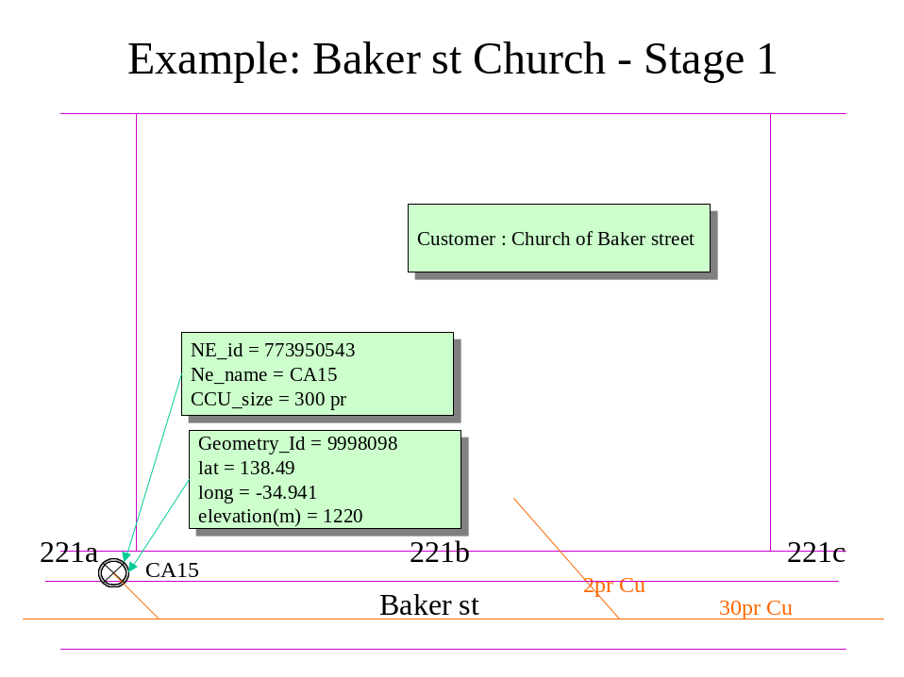
fig E.1.1 – A simple Place

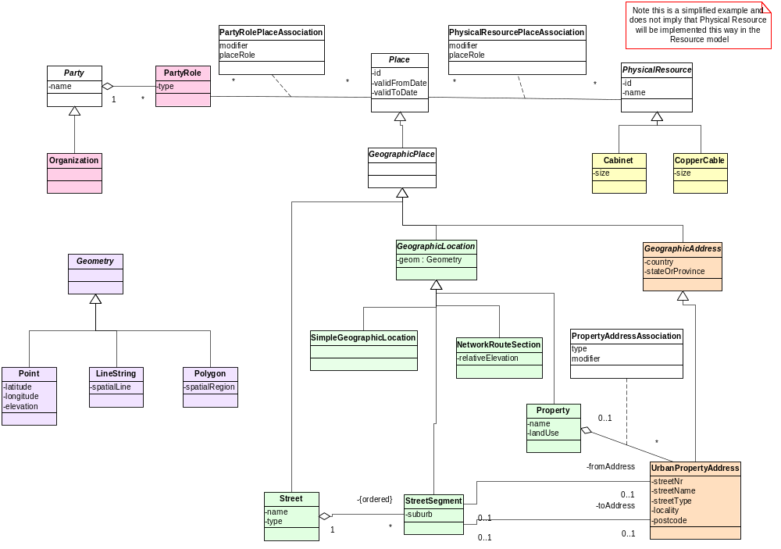
fig E.1.2 – Class Diagram 1

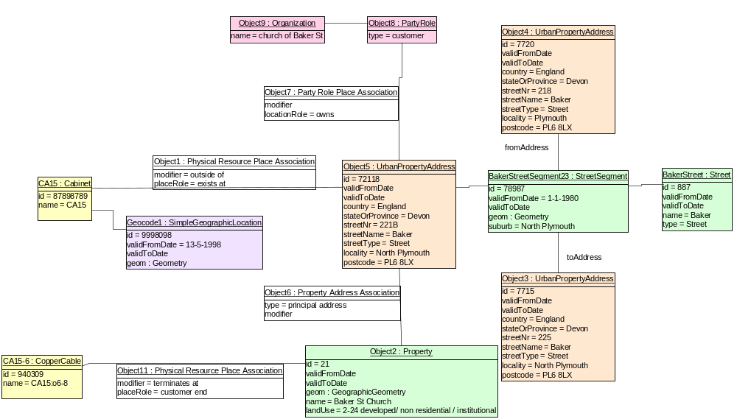
fig E.1.3 – Object Diagram 1

The church builds a second (administration) building and comes to an agreement to lease use of the steeple space to house a mobile phone antenna. Mobile base station equipment is housed in a room of the new administration building. The service provider produces CAD drawings of the Site and their equipment room and stores additional information about site access, contacts, keys …
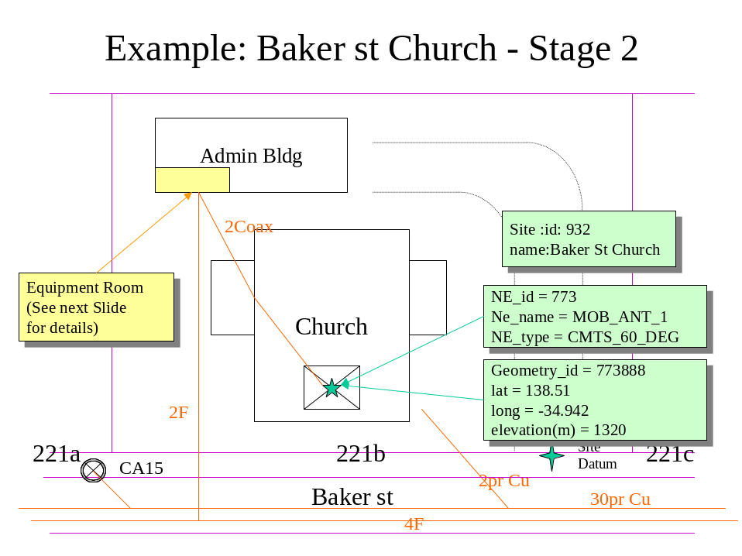
fig E.1.4 – A simple Site

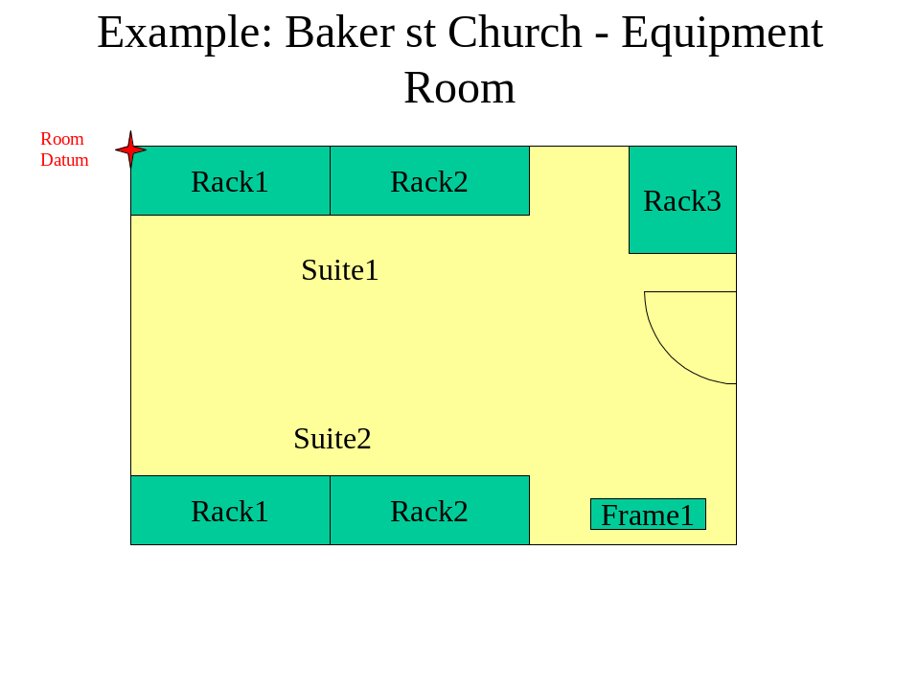
fig E.1.5 – A simple Local Place

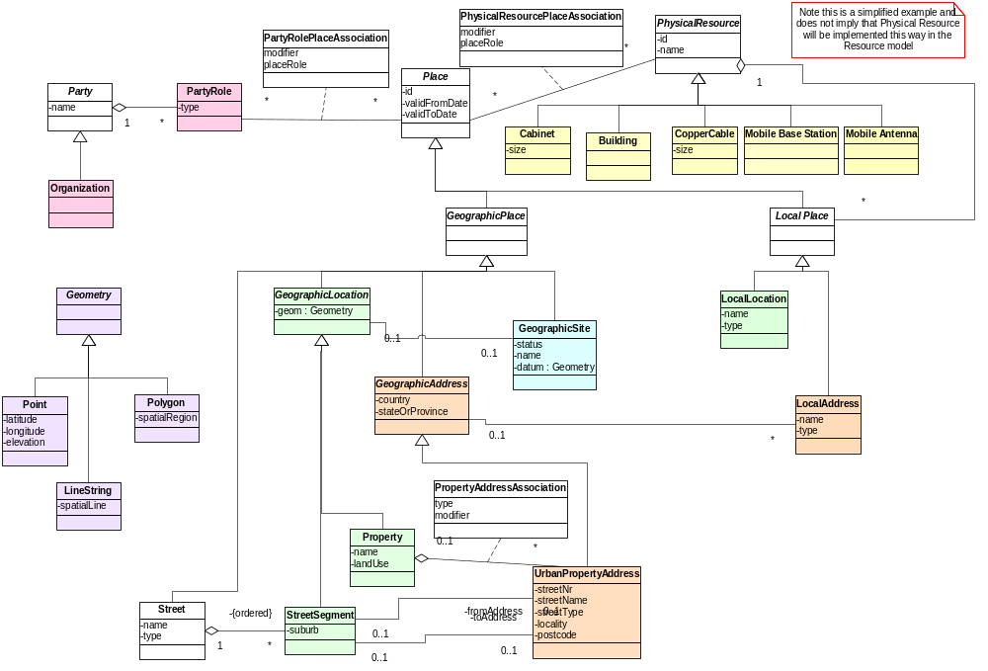
fig E.1.6 – Class Diagram 2

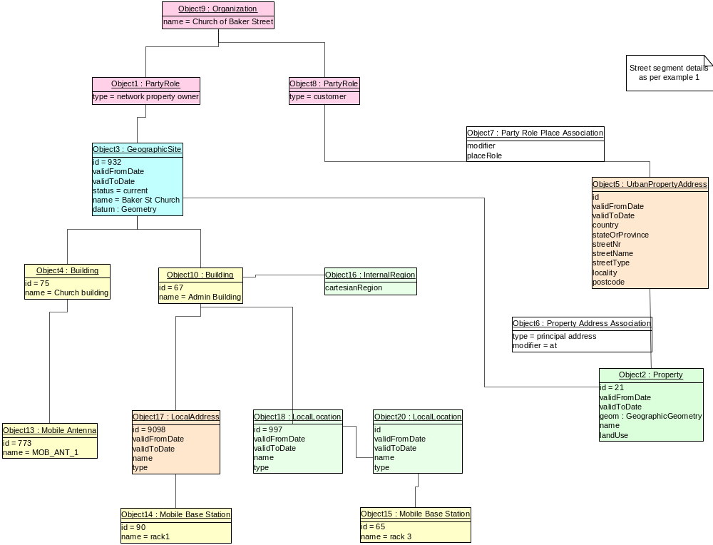
fig E.1.7 – Object Diagram 2

Example 2 – A Cable Route
This is a simple example showing how Network Elements should be separated from their geographic attributes.
Route sections are defined with geographic attributes and can be shared by any Resources on that route.
Routes are defined as an ordered collection of route sections. As defined here, routes have no geographical attributes of their own.
Cables are associated to the Route. In this example our copper cable takes route AB1.
Note that other cables (not shown) may share a route.
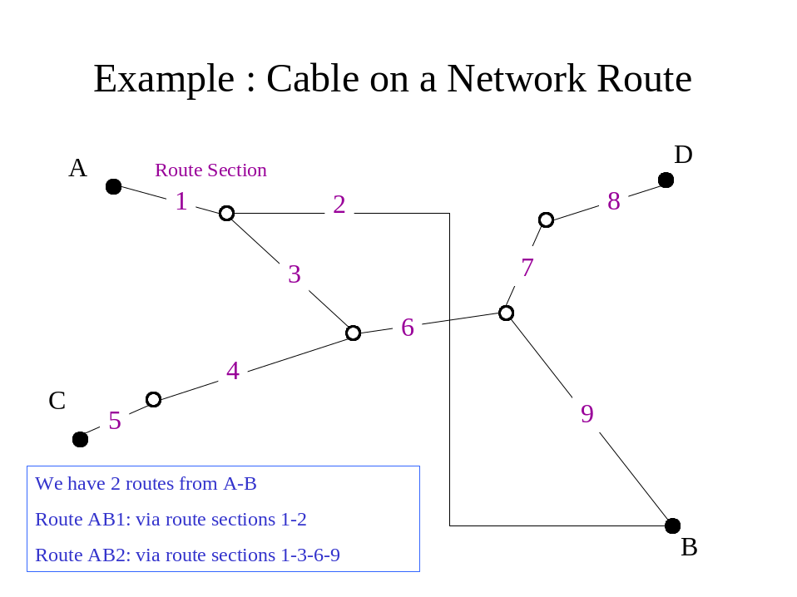
fig E.2.1 – Network Diagram

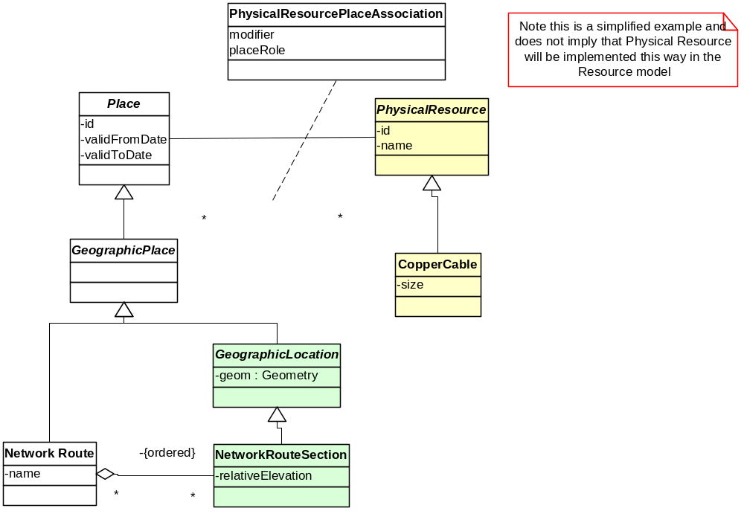
Figure E.2.2 Cable Route Class Diagram

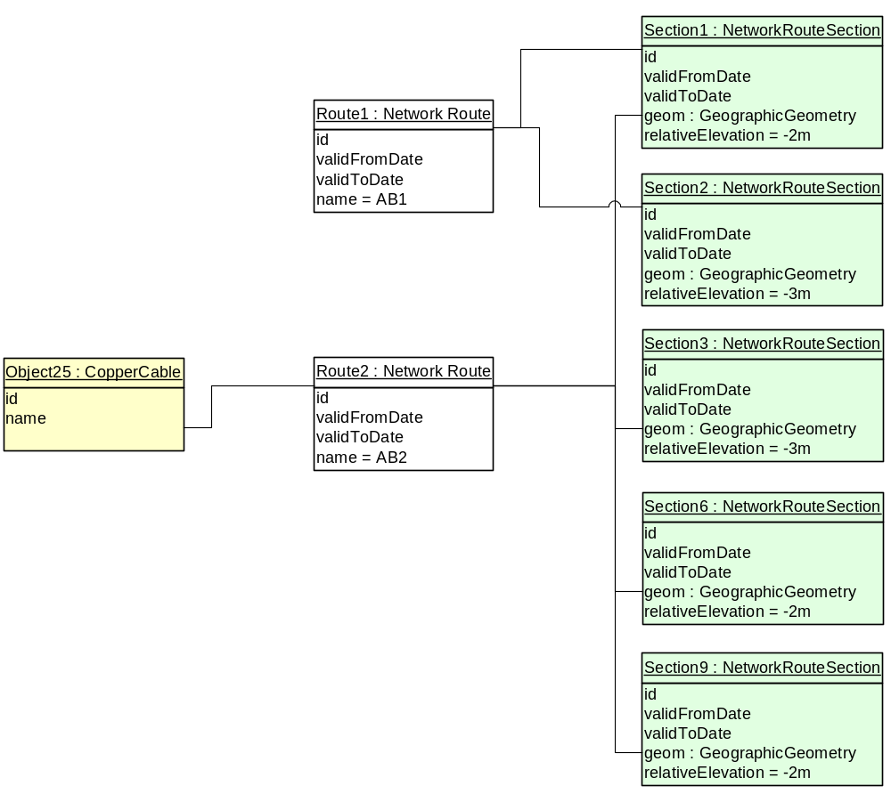
Figure E.2.3 Cable Route Object Diagram

Example 3 – A Complex Address
<<This example will be provided in a later version>>

Example 4 – A Multi Story / Multi Tenanted Building
“Green & Gold” house is a multistory building in the central business district. This Service Provider has some human resources staff on the 5th floor.
Janet Green is employed in the “Vitality Enablement” section of HR.
On the 3rd floor there is a consulting group, which is a customer of this Service Provider. One of the Service Provider’s Products terminates there. If the place was deemed important enough, then a site & building entity could also be created.
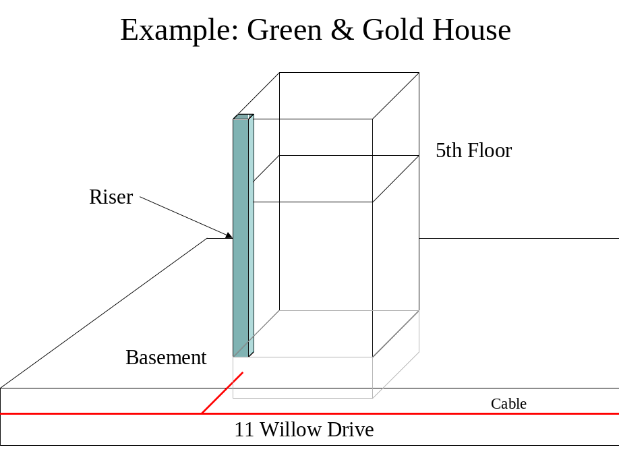
Figure E.4.1 Multistorey Building

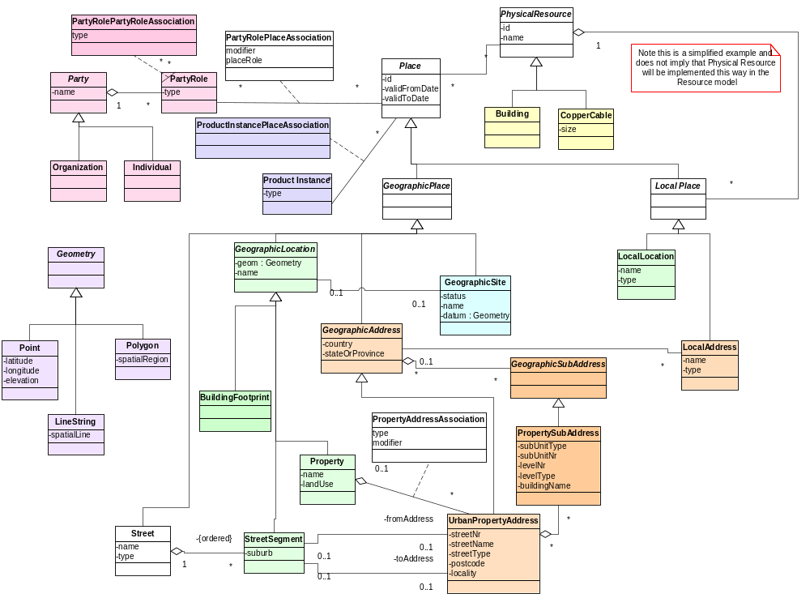
Figure E.4.2 Multistorey Building Class Diagram

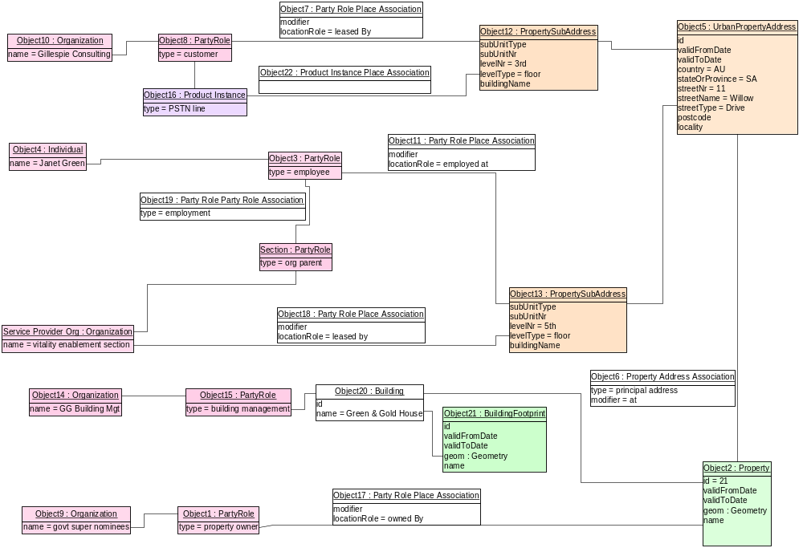
Figure E.4.3 Multistorey Building Object Diagram

Example 5 – Location based Service Support
This example shows how the SID Location model can support location based services.
A customer rings up the “Find the Nearest Pizza Barn” number using her mobile phone.
The mobile phone network determines the approximate position of the calling phone.
Using a spatial engine, the two closest “Pizza Barn” restaurants are calculated.
This information can now be returned to the caller as a map, as text or using synthesized voice.
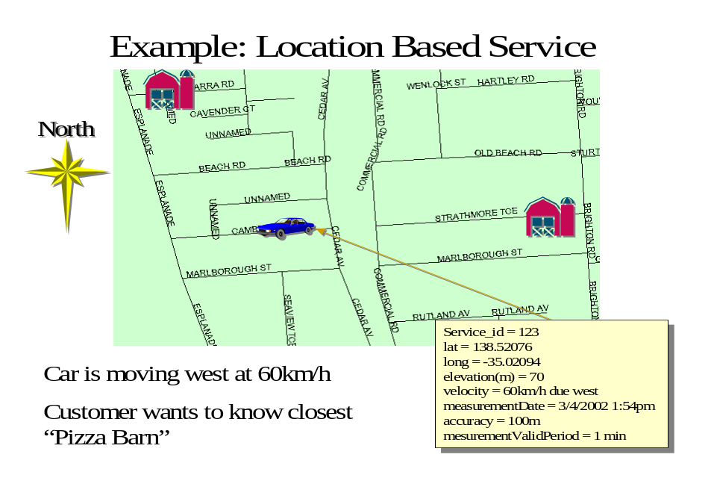
Figure E.5.1 Nearest “Pizza Barn”
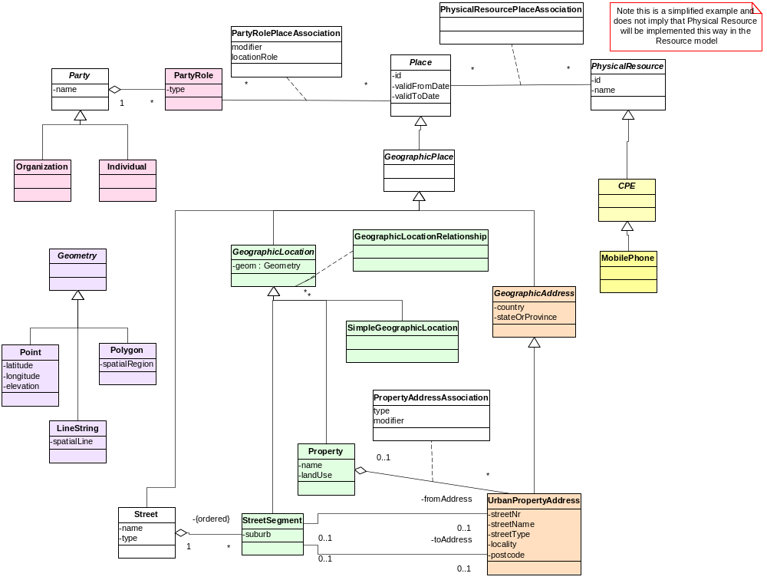
Figure E.5.2 Location Based Service Class Diagram

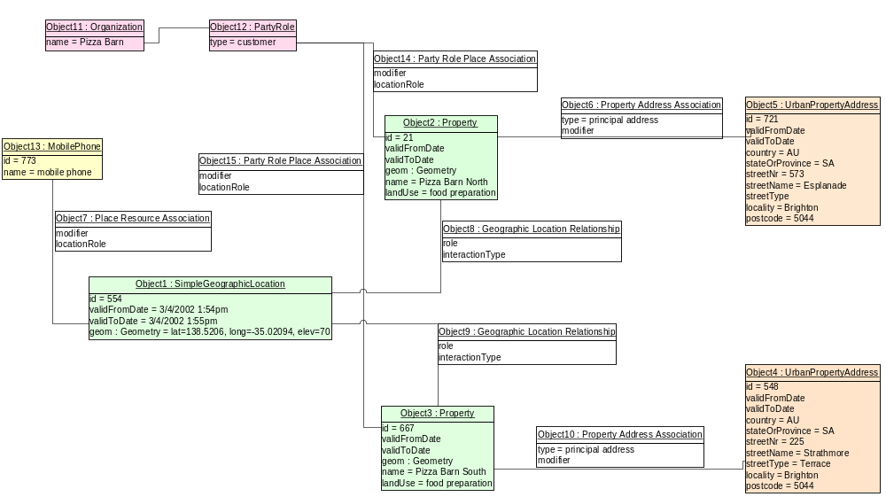
Figure E.5.3 Location Based Service Object Diagram

Place

Business Entity Definition
Business Entity Name | Place
Description | Place answers the question “where ?”  It is an abstract modeling concept that provides a linking point to other parts of the SID model.
Sources |  | Cross- References |  |  | Synonyms / Aliases
Related Business Entities
Business Rules

Business Entity Attributes Definition
Business Entity Name | Place
Attribute Name | Description | Data Type | Characteristics, Permitted Values & Units | Required/  Optional | Notes
validFor | the time period that the Place is valid for | Time Period | Refer Time Period class | required
Id | Unique identifier for Place | integer |  | Required

Geographic Place

Business Entity Definition
Business Entity Name | Geographic Place
Description | Allows us to determine where things are in relation to the earth’s surface.  It is an abstract modeling concept that provides a linking point to other parts of the SID model.
Sources |  | Cross- References |  |  | Synonyms / Aliases
Related Business Entities
Business Rules

Business Entity Attributes Definition
Business Entity Name | Geographic Place
Attribute Name | Description | Data Type | Characteristics, Permitted Values & Units | Required/  Optional | Notes

Geographic Site

Business Entity Definition
Business Entity Name | Geographic Site
Description | A convenience class that allows us to easily refer to Places important to the Service Provider
Sources |  | Cross- References |  |  | Synonyms / Aliases
Related Business Entities
Business Rules

Business Entity Attributes Definition
Business Entity Name | Geographic Site
Attribute Name | Description | Data Type | Characteristics, Permitted Values & Units | Required/  Optional | Notes
name | the name that the site is known by | Text |  | Required
status | possible values are: planned, existing, former | Text |  | Required
code | a code that may be used for some addressing schemes e.g. [ANSI T1.253-1999] |  |  | Optional

Geographic Site Role

Business Entity Definition
Business Entity Name | Geographic Site Role
Description | The part played by a Site in a given context with any characteristics, such as expected pattern of behavior, attributes, and/or associations that it entails.
Sources |  | Cross- References |  |  | Synonyms / Aliases
Related Business Entities
Business Rules

Business Entity Attributes Definition
Business Entity Name | Geographic Site Role
Attribute Name | Description | Data Type | Characteristics, Permitted Values & Units | Required/  Optional | Notes
type | the type of the role e.g. asset location | Text |  | Required

Geographic Location

Business Entity Definition
Business Entity Name | Geographic Location
Description | A defined place on or near the earth’s surface.  It is an abstract modeling concept that provides a linking point to other parts of the SID model.  It holds attributes common to all Geographic Location subclasses.
Sources |  | Cross- References |  |  | Synonyms / Aliases
Related Business Entities | Geographic Location Name
Business Rules

Business Entity Attributes Definition
Business Entity Name | Geographic Location
Attribute Name | Description | Data Type | Characteristics, Permitted Values & Units | Required/  Optional | Notes
geometry | the two dimensional graphical representation of the Location allowing it to be displayed on a map and to be used for spatial calculations | Geometry |  | optional | Since Geometry is abstract, the attribute will actually be one of the concrete subclasses.
accuracy | e.g. this GPS measurement is accurate to +-20 metres.  This attribute allows us to determine when two points close to each other could be the same point. Refer “[OGIS] Abstract Specification, Topic 9: Quality” for details of this complex subject. | Accuracy |  | optional | this should be provided if the geometry attribute is not null
Other attributes may be handy, for example measurement method (GPS) & data source (bought from vendor X)

GeographicLocationType

Business Entity Definition
Business Entity Name | GeographicLocationType
Description | This is a simple specification entity used to provide a list of allowable geographic location types. These types correspond to the concrete entity names shown on fig 10a
Sources |  | Cross- References |  |  | Synonyms / Aliases
Related Business Entities
Business Rules

Business Entity Attributes Definition
Business Entity Name | GeographicLocationType
Attribute Name | Description | Data Type | Characteristics, Permitted Values & Units | Required/  Optional | Notes
symbol | the symbol used to represent the GeographicLocationType on a map | Symbology |  | Optional
name | the name of the LocationType | Text |  | Required | e.g. COUNTRY, PRINCIPALITY, WI-FI-SERVICE-AREA …

Geographic Location Name

Business Entity Definition
Business Entity Name | Geographic Location Name
Description | A word, term, or phrase by which a Geographic Location is known and distinguished from other Geographic Locations.  A name is an informal way of identifying an object [Fowler]  Separating Location Name from Location allows for a Location to have many names at the same time and for names to change over time.
Sources |  | Cross- References |  |  | Synonyms / Aliases
Related Business Entities | Geographic Location
Business Rules

Business Entity Attributes Definition
Business Entity Name | Geographic Location Name
Attribute Name | Description | Data Type | Characteristics, Permitted Values & Units | Required/  Optional | Notes
validFor | the time period that the name is valid for | TimePeriod | Refer Time Period class | required
name | the name that is used to refer to the location | Text |  | required
language | the Language that the name is in | Language
nameType | indicates if th is is the main name or a type of alternative name | Text | “MAIN” or “ALIAS” or …

Geographic Location Relationship

Business Entity Definition
Business Entity Name | Geographic Location Relationship
Description | This association allows us to show direct relationships between Geographic Locations.  This should be used with care to ensure that the association reflects reality
Sources |  | Cross- References |  |  | Synonyms / Aliases
Related Business Entities
Business Rules

Business Entity Attributes Definition
Business Entity Name | Geographic Location Relationship
Attribute Name | Description | Data Type | Characteristics, Permitted Values & Units | Required/  Optional | Notes
interaction Type | the type of relationship between the locations. This could be a binary topological relationship type (touches, crosses, overlaps, equals, contains, within) if a spatial engine is not available and the spatial relationships are being modeled directly, or some more general relationships | Text
validFor | the time period that the relationship is valid for | TimePeriod | Refer Time Period class | required
role | the role that the FROM entity is playing | Text

Geographic Address

Business Entity Definition
Business Entity Name | Geographic Address
Description | A structured textual way of describing how to find a Geographic Location. It is usually composed of an ordered list of Geographic Location names based on context specific rules  It is an abstract modeling concept that provides a linking point to other parts of the SID model.  It holds attributes common to all Geographic Address subclasses.
Sources |  | Cross- References |  |  | Synonyms / Aliases
Related Business Entities
Business Rules

Business Entity Attributes Definition
Business Entity Name | Geographic Address
Attribute Name | Description | Data Type | Characteristics, Permitted Values & Units | Required/  Optional | Notes
country | the Country that the address is in | Country |  | required
stateOrProvince | the State that the Address is in |  |  | required

Geographic SubAddress

Business Entity Definition
Business Entity Name | Geographic SubAddress
Description | A Geographic Sub Address “contains information in addition to that generally found in a standard single address [ANZLIC-STREET]  It is an abstract modeling concept that provides a linking point to other parts of the SID model.  It holds attributes common to all Geographic Sub Address subclasses.
Sources |  | Cross- References |  |  | Synonyms / Aliases
Related Business Entities
Business Rules

Business Entity Attributes Definition
Business Entity Name | Geographic SubAddress
Attribute Name | Description | Data Type | Characteristics, Permitted Values & Units | Required/  Optional | Notes

Country

Business Entity Definition
Business Entity Name | Country
Description | This is an example of a concrete Geographic Location entity.
Sources |  | Cross- References |  |  | Synonyms / Aliases | principality
Related Business Entities
Business Rules

Business Entity Attributes Definition
Business Entity Name | Country
Attribute Name | Description | Data Type | Characteristics, Permitted Values & Units | Required/  Optional | Notes
name | the name that the Country is known by | Text |  | Required | the standard name as defined in ISO-3166 should be used
iso2code | ISO 2 letter country abbreviation | Text |  | Optional | refer ISO-3166
iso3code | ISO 3 letter country abbreviation | Text |  | Optional | refer ISO-3166
type | the type of country | Text | COUNTRY or PRINCIPALITY | Required | this can be used to differentiate places like Holy See (Vatican city state) and Monaco if required

State

Business Entity Definition
Business Entity Name | State
Description | This is an example of a concrete Geographic Location entity.  It can be used to represent States and their equivalents
Sources |  | Cross- References |  |  | Synonyms / Aliases | province, territory
Related Business Entities
Business Rules

Business Entity Attributes Definition
Business Entity Name | State
Attribute Name | Description | Data Type | Characteristics, Permitted Values & Units | Required/  Optional | Notes
name | the official state name | Text |  | Required | this should be defined by the Country that the state is in
code | abbreviation for the name e.g. SA, NT, WA, QLD, NSW, VIC, TAS | Text |  | Optional | see [ANSI T.253] for US codes
type | the type of state | Text | STATE, PROVINCE or TERRITORY | Required

Geographic Area

Business Entity Definition
Business Entity Name | Geographic Area
Description | This is a generic entity, used to represent areas defined on maps that relate to areas of settlement.  This is an example of a concrete Geographic Location entity.
Sources |  | Cross- References |  |  | Synonyms / Aliases
Related Business Entities
Business Rules

Business Entity Attributes Definition
Business Entity Name | Geographic Area
Attribute Name | Description | Data Type | Characteristics, Permitted Values & Units | Required/  Optional | Notes
name | the defined name of the municipality | Text |  | Required
type | SUBURB, LOCALITY, CITY, TOWN or VILLAGE or BOROUGH or HAMLET or … | Text |  | Required
code | used if a standard code set has been defined for the GeographicArea type | Text |  | Optional | see [ANSI T.253] for US codes

Administrative Area

Business Entity Definition
Business Entity Name | Administrative Area
Description | Administrative Area represents the many areas that are controlled or managed by an Administration. Administrations could include councils, governments …  This is an example of a concrete Geographic Location entity.
Sources |  | Cross- References |  |  | Synonyms / Aliases
Related Business Entities | Administrative Area Name
Business Rules | An Administrative Area can have more than one name at a point in time.

Business Entity Attributes Definition
Business Entity Name | Administrative Area
Attribute Name | Description | Data Type | Characteristics, Permitted Values & Units | Required/  Optional | Notes
type | MUNICIPALITY, CENSUS DISTRICT, ELECTORAL AREA, COUNTY, PARISH or … | Text |  | Required

Property

Business Entity Definition
Business Entity Name | Property
Description | A piece of land with defined legal boundaries. This is an example of a concrete Geographic Location entity.
Sources |  | Cross- References |  |  | Synonyms / Aliases | Land Parcel
Related Business Entities
Business Rules

Business Entity Attributes Definition
Business Entity Name | Property
Attribute Name | Description | Data Type | Characteristics, Permitted Values & Units | Required/  Optional | Notes
landUse | "A series of operations on land, carried out by humans, with the intention to obtain products and/or benefits through using land resources." [Land Use Database] | Text |  | optional
landCover | "The vegetation (natural or planted) or man made constructions (buildings, etc.) which occur on the earth surface. Water, ice, bare rock, sand and similar surfaces also count as land cover." [Land Use Database] | Text |  | optional
name | the property name, if it exists | Text |  | optional
elevation | the height above sea level, in the indicated units | Quantity |  | optional

Urban Property Address

Business Entity Definition
Business Entity Name | Urban Property Address
Description | An UrbanPropertyAddress is a structured textual way of describing how to find a Property in an urban area (country properties are often defined differently). It is usually composed of an ordered list of Location names based on context specific rules  This is an example of a concrete Geographic Location entity.
Sources |  | Cross- References |  |  | Synonyms / Aliases
Related Business Entities
Business Rules

Business Entity Attributes Definition
Business Entity Name | Urban Property Address
Attribute Name | Description | Data Type | Characteristics, Permitted Values & Units | Required/  Optional | Notes
streetNrFirst | number identifying a specific property on a public street. It may be combined with streetNrLast for ranged addresses | Text |  |  | A ranged address could be “26-28 XXX Street”
streetNrFirstSuffix | the first street number suffix | Text |  |  | e.g. “A” for address “101A”
streetNrLast | the last number in a range of street numbers allocated to a property | Text |  |  | only entered for ranged addresses, otherwise left blank
streetNrLastSuffix | the last street number suffix for a ranged address | Text
streetName | the name of the street or other street type | Text
streetType | alley, avenue, boulevard, brae, crescent, drive, highway, lane, terrace, parade, place, tarn, way, wharf … | Text |  |  | may need to store a set of abbreviations as well
streetSuffix | A modifier denoting a relative direction | Text |  |  | e.g. CENTRAL, EAST, LOWER, NORTH, NORTH EAST, NORTH WEST, SOUTH, SOUTH EAST, SOUTH WEST, UPPER, WEST
locality | “An area of defined or undefined boundaries within a local authority or other legislatively defined area, usually rural or semi rural in nature.” [ANZLIC-STREET], or a suburb  “a bounded locality within a city, town or shire principally of urban character ” [ANZLIC-STREET] | Text
postcode | A descriptor for a postal delivery area, used to speed and simplify the delivery of mail. | Text |  |  | also known as ZIP code

Urban Property SubAddress

Business Entity Definition
Business Entity Name | Urban Property SubAddress
Description | An UrbanPropertySubAddress is used for addressing within a property in an urban area (country properties are often defined differently).. It may refer to a building, a building cluster, or a floor of a multistory building.  This is an example of a concrete Geographic Location entity.
Sources |  | Cross- References |  |  | Synonyms / Aliases
Related Business Entities
Business Rules

Business Entity Attributes Definition
Business Entity Name | Urban Property SubAddress
Attribute Name | Description | Data Type | Characteristics, Permitted Values & Units | Required/  Optional | Notes
subUnitType | the type of subunit | Text |  |  | e.g.BERTH, FLAT, PIER, SUITE, SHOP, TOWER, UNIT, WHARF
subUnitNr | the discriminator used for the subunit | Text |  |  | often just a sumple number e.g. FLAT 5, may also be a range
levelType | describes level types within a building | Text |  |  | e.g. BASEMENT, FLOOR, LOWER GROUND, LEVEL, MEZZANINE, UPPER GROUND
levelNr | used where a level type may be repeated e.g. BASEMENT 1, BASEMENT 2 | Text |  |  | some level Types do not require a level Nr e.g. BASEMENT, LOWER GROUND, MEZZANINE, UPPER GROUND
buildingName | allows for buildings that have well known names | Text |  |  | e.g. Telstra house, Parliament house
privateStreetName | private streets internal to a property (e.g. a university) may have internal names that are not recorded by the land title office. | Text

Place PartyRole Association

Business Entity Definition
Business Entity Name | Place PartyRole Association
Description | This is an example of an association linking Place to another part of the SID model.
Sources |  | Cross- References |  |  | Synonyms / Aliases
Related Business Entities
Business Rules

Business Entity Attributes Definition
Business Entity Name | Place PartyRole Association
Attribute Name | Description | Data Type | Characteristics, Permitted Values & Units | Required/  Optional | Notes
validFor | the time period that the association is valid for | TimePeriod | Refer Time Period class | required
relativeModifier | if the association is relative to the location (not at it) then use a modifier NEAR-TO or OUTSIDE or ACROSS-ROAD-FROM … | Text |  | optional
placeRole | the role that the place plays in the association | Text |  | required

Local Place

Business Entity Definition
Business Entity Name | Local Place
Description | Allows us to determine where things are in relation to a local coordinate system.  It is an abstract modeling concept that provides a linking point to other parts of the SID model.
Sources |  | Cross- References |  |  | Synonyms / Aliases
Related Business Entities
Business Rules

Business Entity Attributes Definition
Business Entity Name | Local Place
Attribute Name | Description | Data Type | Characteristics, Permitted Values & Units | Required/  Optional | Notes

Local Location

Business Entity Definition
Business Entity Name | Local Location
Description | A defined place defined by a local coordinate system.  It is an abstract modeling concept that provides a linking point to other parts of the SID model.  It holds attributes common to all Local Location subclasses.
Sources |  | Cross- References |  |  | Synonyms / Aliases
Related Business Entities
Business Rules

Business Entity Attributes Definition
Business Entity Name | Local Location
Attribute Name | Description | Data Type | Characteristics, Permitted Values & Units | Required/  Optional | Notes
orientation | the angle of rotation from the axes of the local coordinate system | Orientation |  | Required

Local Address

Business Entity Definition
Business Entity Name | Local Address
Description | A structured textual way of describing an internal location.  It is an abstract modeling concept that provides a linking point to other parts of the SID model.  It holds attributes common to all Local Address subclasses.
Sources |  | Cross- References |  |  | Synonyms / Aliases
Related Business Entities
Business Rules

Business Entity Attributes Definition
Business Entity Name | Local Address
Attribute Name | Description | Data Type | Characteristics, Permitted Values & Units | Required/  Optional | Notes
type | the type of LocalAddress | Text |  | Required | e.g RACK, SUITE
positionNr | the position within the type | Text |  | Required | often a number with a suffix, e.g. “5B”
fullAddress | a denormalised string showing the type and position numbers up the hierarchy with separator characters | Text |  | Required | provide if required for performance purposes.  e.g. SUITE 5 / RACK 7B / SUBRACK 2 / CARD 3

ocal Continuative Location

Business Entity Definition
Business Entity Name | Local Continuative Location
Description | This is an abstract modeling concept that provides a linking point to other parts of the SID model.  Its subclasses are entities that are locations that are defined using floating point Cartesian coordinates
Sources |  | Cross- References |  |  | Synonyms / Aliases
Related Business Entities
Business Rules

Business Entity Attributes Definition
Business Entity Name | Local Continuative Location
Attribute Name | Description | Data Type | Characteristics, Permitted Values & Units | Required/  Optional | Notes

Absolute Local Location

Business Entity Definition
Business Entity Name | Absolute Local Location
Description | A LocalLocation that is defined using Cartesian coordinates that relate back to a LocalCoordinateSystem.  The coordinate units are defined in the LocalCoordinateSystem.
Sources |  | Cross- References |  |  | Synonyms / Aliases
Related Business Entities
Business Rules

Business Entity Attributes Definition
Business Entity Name | Absolute Local Location
Attribute Name | Description | Data Type | Characteristics, Permitted Values & Units | Required/  Optional | Notes
x | the x Cartesian coordinate | Number |  | Required
y | the y Cartesian coordinate | Number |  | Required
z | the z Cartesian coordinate | Number |  | Optional | required for 3D representations

Relative Local Location

Business Entity Definition
Business Entity Name | Relative Local Location
Description | A LocalLocation that is defined using coordinates that are relative to another LocalLocation.  The coordinate units are defined in the LocalCoordinateSystem.
Sources |  | Cross- References |  |  | Synonyms / Aliases
Related Business Entities
Business Rules

Business Entity Attributes Definition
Business Entity Name | Relative Local Location
Attribute Name | Description | Data Type | Characteristics, Permitted Values & Units | Required/  Optional | Notes
dX | the x Cartesian coordinate relative to the referenceLocation | Number |  | Required
dY | the y Cartesian coordinate relative to the referenceLocation | Number |  | Required
dZ | the z Cartesian coordinate relative to the referenceLocation | Number |  | Optional | required for 3D representations
referenceLocation | the location that these coordinates are relative to | Local Continuative Location |  | Required

Grid Local Location

Business Entity Definition
Business Entity Name | Grid Local Location
Description | A LocalLocation that is defined using Grid coordinates that relate back to a LocalGridCoordinateSystem  This would be used when locations are not defined in inches or millimeters but rather in terms of things like floor tile positions.  The grid units are defined in the LocalCoordinateSystem.
Sources |  | Cross- References |  |  | Synonyms / Aliases
Related Business Entities
Business Rules

Business Entity Attributes Definition
Business Entity Name | Grid Local Location
Attribute Name | Description | Data Type | Characteristics, Permitted Values & Units | Required/  Optional | Notes
gridX | the grid x coordinate | Integer |  | Required
gridY | the grid y coordinate | Integer |  | Required
gridZ | the grid z coordinate | Integer |  | Optional | not normally used

Local Coordinate System

Business Entity Definition
Business Entity Name | Local Coordinate System
Description | A local coordinate system allows us to position things in a small area where the curvature of the Earth can be ignored. It would commonly be used to define placement in an Exchange building (Central Office)  It is an abstract entity that holds common attributes and relationships.  For continuative locations, the Units will usually be unity for a given measure (e.g. 1 metre). For grid coordinate systems, the unit will often be a non unity measure (e.g. 600mm)
Sources |  | Cross- References |  |  | Synonyms / Aliases
Related Business Entities
Business Rules

Business Entity Attributes Definition
Business Entity Name | Local Coordinate System
Attribute Name | Description | Data Type | Characteristics, Permitted Values & Units | Required/  Optional | Notes
xUnits | the unit for a number in the X direction in a local location | Unit |  |  | units could be metres, feet, inches …
yUnits | the unit for a number in the Y direction in a local location | Unit |  |  | units could be metres, feet, inches …
zUnits | the unit for a number in the Z direction in a local location | Unit |  |  | units could be metres, feet, inches …

Local Continuative Coordinate System

Business Entity Definition
Business Entity Name | Local Continuative Coordinate System
Description | A coordinate system for LocalLocations that are defined using floating point Cartesian coordinates
Sources |  | Cross- References |  |  | Synonyms / Aliases
Related Business Entities
Business Rules

Business Entity Attributes Definition
Business Entity Name | Local Continuative Coordinate System
Attribute Name | Description | Data Type | Characteristics, Permitted Values & Units | Required/  Optional | Notes

Local Grid Coordinate System

Business Entity Definition
Business Entity Name | Local Grid Coordinate System
Description | A coordinate system for LocalLocations that are defined using Grid coordinates
Sources |  | Cross- References |  |  | Synonyms / Aliases
Related Business Entities
Business Rules

Business Entity Attributes Definition
Business Entity Name | Local Grid Coordinate System
Attribute Name | Description | Data Type | Characteristics, Permitted Values & Units | Required/  Optional | Notes

