Shared Information/Data (SID) Model
Addendum 1-POL
Common Business Entity Definitions – Policy

GB922 Addendum 1-POL
TM Forum Approved Version 1.4


September, 2011

Notice

This material, including documents, code and models, has been through review cycles; however, due to the inherent complexity in the design and implementation of software and systems, no liability is accepted for any errors or omissions or for consequences of any use made of this material.
Under no circumstances will the TM Forum be liable for direct or indirect damages or any costs or losses resulting from the use of this specification. The risk of designing and implementing products in accordance with this specification is borne solely by the user of this specification.
This material bears the copyright of TM Forum and its use by members and non-members of TM Forum is governed by all of the terms and conditions of the Intellectual Property Rights Policy of the TM Forum (http://www.tmforum.org/Bylaws/1094/home.html) and may involve a claim of patent rights by one or more TM Forum members or by non-members of TM Forum.

Direct inquiries to the TM Forum office:
240 Headquarters Plaza,
East Tower – 10th Floor,
Morristown, NJ 07960 USA
Tel No. +1 973 944 5100
Fax No. +1 973 944 5110
TM Forum Web Page: www.tmforum.org

Table of Contents
Notice 2
Table of Contents 3
Table of Figures 8
Business Entities 11
Common Business Entities – Policy Domain 11
Introduction 11
Approach 24
Use Cases 25
Important Future Use Cases 25
Scope 26
Fundamental Policy Terminology 28
Basic Terminology 29
DEN 29
DEN-ng 29
Information Model 29
Data Model 29
Model Mapping 29
Terms Defining the Representation of Policy 31
Policy 31
PolicyRule 31
PolicyEvent 31
PolicySet 32
PolicyCondition 32
Policy Action 32
Terms Defining the Usage of Policy 32
Policy Domain 32
Policy Conflict 33
Policy Decision 33
Policy Decision Point (PDP) 33
Policy Enforcement Point (PEP) 33
Policy Evaluation 33
Policy Execution Point (PXP) 33
Policy Repository 34
Policy Server 35
Policy Subject 35
Policy Target 35
Policy-Aware Entity 36
Policy-Unaware Entity 36
Policy-Enabled System 36
Terms Defining the Use of Roles With Respect to Policy 37
Role Attribute 37
Role Object 37
Role-Combination 37
Role-Selector 37
Changes From Policy Information Exchange 38
Representing a PolicyRule 43
Representing a PolicyRule 43
PolicyGroup 49
PolicySet – Generalizing PolicyRules and PolicyGroups 50
PolicyEvents 55
PolicyStatements 57
PolicyOperators 59
PolicyVariables 60
PolicyValues 63
PolicyConditions 65
PolicyConditionAtomic 68
PolicyConditionComposite 69
PolicyActions 70
PolicyActionAtomic 73
PolicyActionComposite 74
PolicyActionVendor 75
Reusable vs. Ad-Hoc Policy Entities 76
The Policy Application ABE 77
PolicyApplication 78
Introduction 78
The PolicyApplication Class 80
PolicyServer 81
PolicyBroker 83
PolicyDecisionPoint (PDP) 84
PolicyExecutionPoint (PXP) 86
PolicyEnforcementPoint (PEP) 88
Putting It All Together 90
The Policy Management ABE 93
The PolicySpecification ABE 96
PolicyEventSpecs 97
PolicyEventSpecType 98
PolicySetSpec 99
PolicyRuleSpec 101
PolicyConditionSpec 102
PolicyActionSpec 103
PolicyStatementSpec 104
PolicyRules Used in Policy Management Applications 106
References 108
Business Entity Definitions 110
Policy Business Entity Definition 111
Policy Business Entity Attributes Definition 112
Business Entity Model – Policy 113
PolicySet Business Entity Definition 114
PolicySet Business Entity Attributes Definition 115
Business Entity Model – PolicySet 116
PolicyGroup Business Entity Definition 117
PolicyGroup Business Entity Attributes Definition 117
Business Entity Model – PolicyGroup 118
PolicyRule Business Entity Definition 119
PolicyRule Business Entity Attributes Definition 120
Business Entity Model – PolicyRule 120
PolicyEvent Business Entity Definition 121
PolicyEvent Business Entity Attributes Definition 122
Business Entity Model – PolicyEvent 123
PolicyEventAtomic Business Entity Definition 124
PolicyEventAtomic Business Entity Attributes Definition 125
Business Entity Model – PolicyEventAtomic 125
PolicyEventComposite Business Entity Definition 126
PolicyEventComposite Business Entity Attributes Definition 127
Business Entity Model – PolicyEventComposite 127
PolicyCondition Business Entity Definition 128
PolicyCondition Business Entity Attributes Definition 129
Business Entity Model – PolicyCondition 129
PolicyConditionAtomic Business Entity Definition 130
PolicyConditionAtomic Business Entity Attributes Definition 131
Business Entity Model – PolicyConditionAtomic 131
PolicyConditionComposite Business Entity Definition 132
PolicyConditionComposite Business Entity Attributes Definition 133
Business Entity Model – PolicyConditionComposite 133
PolicyAction Business Entity Definition 134
PolicyAction Business Entity Attributes Definition 134
Business Entity Model – PolicyAction 135
PolicyActionAtomic Business Entity Definition 136
PolicyActionAtomic Business Entity Attributes Definition 137
Business Entity Model – PolicyActionAtomic 138
PolicyActionComposite Business Entity Definition 139
PolicyActionComposite Business Entity Attributes Definition 140
Business Entity Model – PolicyActionComposite 140
PolicyActionVendor Business Entity Definition 141
PolicyActionVendor Business Entity Attributes Definition 142
Business Entity Model – PolicyActionVendor 143
PolicyStatement Business Entity Definition 144
PolicyStatement Business Entity Attributes Definition 145
Business Entity Model – PolicyStatement 145
PolicyVariable Business Entity Definition 146
PolicyVariable Business Entity Attributes Definition 147
Business Entity Model – PolicyVariable 147
PolicyValue Business Entity Definition 148
PolicyValue Business Entity Attributes Definition 149
Business Entity Model – PolicyValue 149
VariableCustom Business Entity Definition 150
VariableCustom Business Entity Attributes Definition 151
Business Entity Model – VariableCustom 152
VariableStandard Business Entity Definition 153
VariableStandard Business Entity Attributes Definition 154
Business Entity Model – VariableStandard 154
PolicyConditionTimePeriod Business Entity Definition 155
PolicyConditionTimePeriod Business Entity Attributes Definition 156
Business Entity Model – PolicyConditionTimePeriod 161
PolicyConditionVendor Business Entity Definition 162
PolicyConditionVendor Business Entity Attributes Definition 163
Business Entity Model – PolicyConditionVendor 164
ValueStandard Business Entity Definition 165
ValueStandard Business Entity Attributes Definition 166
Business Entity Model – ValueStandard 166
ValueCustom Business Entity Definition 167
ValueCustom Business Entity Attributes Definition 168
Business Entity Model – ValueCustom 168
PolicyOperator Business Entity Definition 169
PolicyOperator Business Entity Attributes Definition 170
Business Entity Model – PolicyOperator 170
PolicyDomain Business Entity Definition 171
PolicyDomain Business Entity Attributes Definition 172
Business Entity Model – PolicyDomain 172
PolicyApplication Business Entity Definition 173
PolicyApplication Business Entity Attributes Definition 173
Business Entity Model – PolicyApplication 174
PolicyServer Business Entity Definition 175
PolicyServer Business Entity Attributes Definition 175
Business Entity Model – PolicyServer 176
PolicyDecisionPoint Business Entity Definition 177
PolicyDecisionPoint Business Entity Attributes Definition 178
Business Entity Model – PolicyDecisionPoint 178
PolicyExecutionPoint Business Entity Definition 179
PolicyExecutionPoint Business Entity Attributes Definition 180
Business Entity Model – PolicyExecutionPoint 180
PolicyEnforcementPoint Business Entity Definition 181
PolicyEnforcementPoint Business Entity Attributes Definition 182
Business Entity Model – PolicyEnforcementPoint 182
PolicyBroker Business Entity Definition 183
PolicyBroker Business Entity Attributes Definition 184
Business Entity Model – PolicyBroker 184
PolicyApplicationRole Business Entity Definition 185
PolicyApplicationRole Business Entity Attributes Definition 186
Business Entity Model – PolicyApplicationRole 186
PolicySetSpec Business Entity Definition 187
PolicySetSpec Business Entity Attributes Definition 187
Business Entity Model – PolicySetSpec 188
PolicyRuleSpec Business Entity Definition 189
PolicyRuleSpec Business Entity Attributes Definition 190
Business Entity Model – PolicyRuleSpec 191
PolicyConditionSpec Business Entity Definition 192
PolicyConditionSpec Business Entity Attributes Definition 193
Business Entity Model – PolicyConditionSpec 193
PolicyActionSpec Business Entity Definition 194
PolicyActionSpec Business Entity Attributes Definition 195
Business Entity Model – PolicyActionSpec 195
PolicyStatementSpec Business Entity Definition 196
PolicyStatementSpec Business Entity Attributes Definition 197
Business Entity Model – PolicyStatementSpec 197
PolicyEventSpec Business Entity Definition 198
PolicyEventSpec Business Entity Attributes Definition 199
Business Entity Model – PolicyEventSpec 199
PolicyEventSpecAtomic Business Entity Definition 200
PolicyEventSpecAtomic Business Entity Attributes Definition 201
Business Entity Model – PolicyEventSpecAtomic 201
PolicyEventSpecComposite Business Entity Definition 202
PolicyEventSpecComposite Business Entity Attributes Definition 203
Business Entity Model – PolicyEventSpecComposite 203
2.1 About this document 204
2.2 Document Life Cycle 205
2.3 Document History 205
2.3.1 Version History 205
2.3.2 Release History 205
Acknowledgments 206

Table of Figures
Figure 1P- 1. Frameworx Viewpoints 12
Figure 1P- 2. Policy as one of the Common Business Entities Sub-Domains of the SID Framework 14
Figure 1P- 3. The Policy Continuum 16
Table 1P- 1. Alignment Between Frameworx Viewpoints and the Policy Continuum 18
Figure 1P- 4. Level 0 Concepts and Domains of the eTOM 20
Figure 1P- 5. Level One of the Policy Domain of the SID Framework 21
Figure 1P- 6. Level Two of the Policy Domain of the SID Framework 23
Figure 1P- 7. The Concept of Model Mapping 30
Figure 1P- 8. A Conceptual Representation of a PolicyRule 44
Figure 1P- 9. PolicyRule in More Detail 47
Figure 1P- 10. PolicyGroups 49
Figure 1P- 11. The Concept of a PolicySet 50
Figure 1P- 12. PolicySet in More Detail 51
Figure 1P- 13. Common Evaluation Semantics for PolicyGroups and PolicyRules 53
Figure 1P- 14. PolicyEvents and PolicySets 55
Figure 1P- 15. Overview of the PolicyStatement Concept 58
Figure 1P- 16. PolicyVariables in More Detail 61
Figure 1P- 17. PolicyValues in More Detail 63
Figure 1P- 18. PolicyCondition in More Detail 67
Figure 1P- 19. PolicyAction in More Detail 71
Figure 1P- 20. Interaction of PolicyApplication with the Rest of the Managed Environment 78
Figure 1P- 21. PolicyApplication and Its Subclasses 80
Figure 1P- 22. Anatomy of a PolicyServer 82
Figure 1P- 23. PolicyBroker Functionality 83
Figure 1P- 24. Principal Relationships of a PolicyDecisionPoint 84
Figure 1P- 25. Principal Relationships of a PolicyExecutionPoint 86
Figure 1P- 26. Principal Relationships of a PolicyEnforcementPoint 88
Figure 1P- 27. Policy Application Framework 90
Figure 1P- 28. Definition of PolicyApplicationRoles 92
Figure 1P- 29. Different Types of PolicyApplicationRoles 92
Figure 1P- 30. Using Policy and PartyRoles to Manage Resources and Services 94
Figure 1P- 31. PolicyEvent Specifications 97
Figure 1P- 32. Types of PolicyEvents 98
Figure 1P- 33. Definition of a PolicySetSpec 99
Figure 1P- 34. Definition of a PolicyRuleSpec 101
Figure 1P- 35. Definition of a PolicyConditionSpec 102
Figure 1P- 36. Definition of a PolicyActionSpec 103
Figure 1P- 37. Definition of a PolicyStatementSpec 105
Figure 1P- 38. Interaction Between Policy and PolicyApplication ABE Entities 107
Figure 1P- 39. Policy Business Entity Model 113
Figure 1P- 40. PolicySet Business Entity Model 116
Figure 1P- 41. PolicyGroup Business Entity Model 118
Figure 1P- 42. PolicyEvent Business Entity Model 123
Figure 1P- 43. PolicyCondition Business Entity Model 130
Figure 1P- 44. PolicyAction Business Entity Model 135
Figure 1P- 45. PolicyStatement Business Entity Model 145
Figure 1P- 46. VariableCustom Business Entity Model 152
Figure 1P- 47. ValueStandard Business Entity Model 166
Figure 1P- 48. PolicyDomain Business Entity Model 172
Figure 1P- 49. PolicyApplication Business Entity Model 174
Figure 1P- 50. PolicyServer Business Entity Model 176
Figure 1P- 51. PolicyApplicationRole Business Entity Model 186
Figure 1P- 52. PolicySetSpec Business Entity Model 188

Business Entities

Common Business Entities – Policy Domain

Introduction
Policy management has been portrayed as an effective mechanism to orchestrate the behavior of distributed systems. Different versions of policy management have concentrated on different aspects of this problem, ranging from defining business goals to specifying low-level configuration changes in a device. Unfortunately, such efforts have been scattered and uncoordinated.
In contrast, the DEN-ng policy model, as described in [PBNM] and [DEN-ng], is a set of information models that provide business, system, and implementation viewpoints of a managed system. It was built to support the needs of Frameworx architectures, as defined in the 053 series of TM Forum specifications.
The Frameworx (formerly known as NGOSS) specifications prescribe an architectural framework, supplemented with principles and procedures, which can be used to guide the development of distributed computing solutions through the creation and re-use of Frameworx artifacts. The set of Frameworx artifacts, available through the Frameworx Knowledge Base, form a comprehensive set of information that enables business needs to drive the implementation of Frameworx using commercial off the shelf software. The concept of the knowledge base is central to the methodology because it provides a way to “link” work efforts and activities as the progressive views of the system solution are developed. The reader is encouraged to read [053Main], which describes the Frameworx architecture as a whole and the Frameworx viewpoints in particular.
This approach is shown in Figure 1P- below.
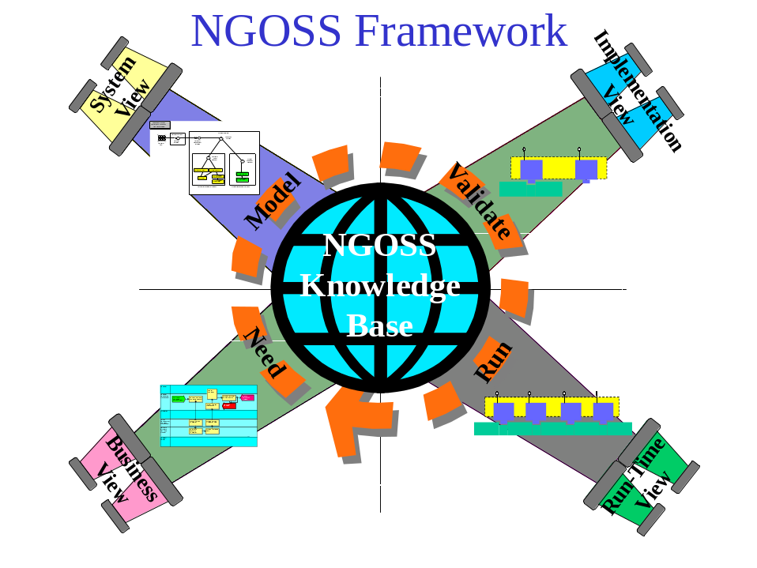
Figure 1P- . Frameworx Viewpoints
Policy, of course, plays a critical role across all four Frameworx viewpoints. The purpose of this specification is to integrate the DEN-ng policy information model into the SID Framework. Since policy can be used to represent, define and manage entities of all types, its integration into the SID framework takes the form of defining a new Common Business Entities sub-domain to contain the policy information model. This is shown in Figure 1P- below.
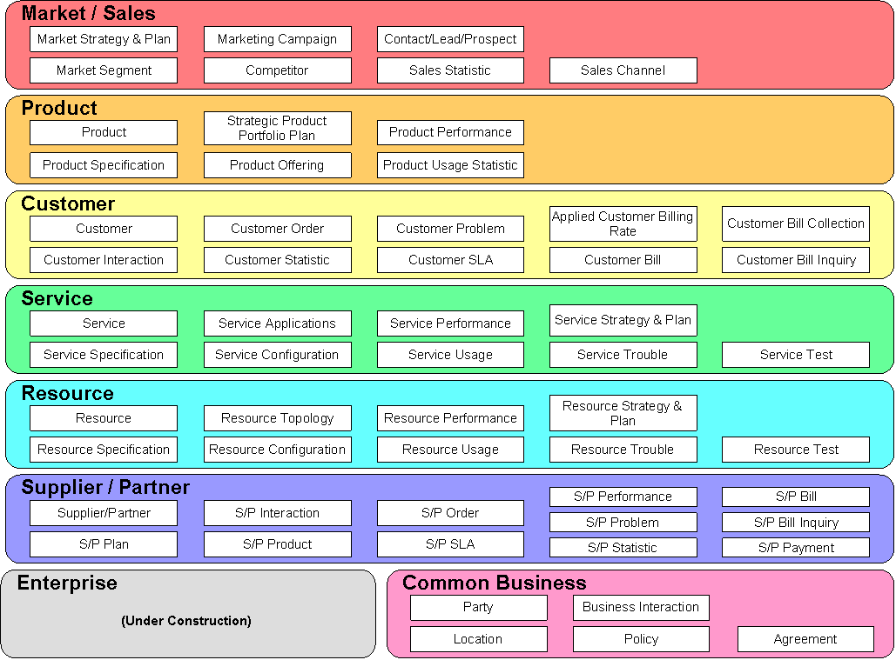
Focus of this Addendum
Figure 1P- . Policy as one of the Common Business Entities Sub-Domains of the SID Framework
The purpose of this phase of the SID is to define a set of business entities that can be used to describe Frameworx business artifacts. One of the goals of the SID model is to enable a seamless transition from business concepts and definitions to other domains, such as networking. This becomes critical in order for business people to be able to properly leverage highly technical concepts, as well as concepts that are critical to the operation of the business. Policy is one of those concepts that has the potential to be used in multiple domains, and for multiple purposes. Thus, what is needed is the ability to define:
- A common representation that can be used for all four Frameworx viewpoints
- How management applications can use policy
- How policy entities of one viewpoint can specify and interact with policy entities of another viewpoint
This addendum covers the business definition of the DEN-ng Policy model. This model is used to define formal definitions for entities that are part of a policy management methodology, be it an application, the issuing of a command, or something in-between.
Policy management means many things to many people. The most common categorizations of Policy are for business use, networking use, and architectural use. To point out the important link between policy and Frameworx (specifically, the work in [053C] and [053D] ), these three categorizations will be rephrased as follows:
- Policy is a set of business rules and is meant for use by business people
- Policy is a means to control Quality of Service (QoS), and is meant for use by networking people
- Policy is a means to scale the system, and is meant for use by systems architects
These three definitions all have a common theme: policy is used only by a specific set of users. In contrast, the Frameworx Behavior and Control Specification ( [053C] ) posits that an Frameworx system must simultaneously address the needs of different constituencies of users. This is addressed by the use of a Policy Continuum, which is shown in Figure 1P- below.
Briefly, the purpose of the Policy Continuum is to provide a semantic linkage between different types of policies that exist at different levels of abstraction. In Figure 1P- , five such levels of abstraction are defined: the business, administrator, network, device, and instance views. But even more importantly, the Policy Continuum defines a semantic relationship between each of these levels, so that each level represents one set of related policies. In other words, the notion of a single policy is rejected; there is always a set of policies that exist at different levels of the Policy Continuum. Furthermore, one of the most important things required to translate policies at one level of the Policy Continuum to another level of the Policy Continuum is to align the needs of the user at each of the different levels of the Policy Continuum. When this is done, it is easier to align the inputs to, outputs from, and behavior of each set of policies at each level of the Policy Continuum.

Business View: SLAs, Processes, Guidelines, and Goals
Administrator View: Device- and Technology-Independent Operation
Network View: Device-Independent, Technology-Specific Operation

Device View: Device- and Technology-Specific Operation

Instance View: Instance-Specific Operation (MIBs, CLI, etc.)

Figure 1P- . The Policy Continuum
Each of the above five views is optimized for a different type of user that needs and/or uses slightly different information. For example, a business user may need SLA information. That user isn’t interested in how the network is programmed to deliver QoS, just that the network is in fact delivering the right type of QoS to the right people. Conversely, the network administrator may want to “translate” the QoS that is implied by different SLAs into sets of different CLI commands to program the appropriate devices. This is a completely different representation of the same policy that governs the SLA commands. The network administrator doesn’t care about all of the financial or other contractual information in the SLAs – the network administrator only cares that the sets of CLI commands governed by network policies are correct.
Clearly, both of these views are correct. This is a simple case of why the Policy Continuum is used – it enables different policies that have different syntaxes to be related to each other. Thus, the requirement is for policy to be treated as a continuum, where different policies take different forms and address the needs of different users.
The above five levels of the Policy Continuum overlap with the four Frameworx viewpoints. This is shown in Table 1P-1 below.

 | Business View | Systems View | Network View | Device View | Instance View
Frameworx Business Viewpoint | X
Frameworx System Viewpoint |  | X
Frameworx Implementation Viewpoint |  |  | X | X
Frameworx RunTime Viewpoint |  |  |  |  | X
Table 1P- . Alignment Between Frameworx Viewpoints and the Policy Continuum

Table 1P- shows how the four Frameworx viewpoints are aligned against the five levels of the DEN-ng Policy Continuum. Either approach can be used to define the scope and function of an Frameworx policy. Both exist because they serve slightly different purposes. The four Frameworx viewpoints are used to define artifacts that exist in an Frameworx system, and to help manage their lifecycle. The five DEN-ng policy views exist because they help define the representation of policy as well as the function of policy. When the Frameworx viewpoints are intersected with the DEN-ng policy domains, then one can formally define how policy can be used to manage a system and its components.
If a business wants to look at a device, then it can use the Frameworx viewpoints and/or the DEN-ng policy views. The Frameworx viewpoints will relate the device to an Frameworx architecture and/or system, while the DEN-ng policy views will concentrate more on representing the functionality used to define a device or define how that device should be managed.
The purpose of the DEN-ng policy information model is to define a set of managed entities that can be used to relate these different forms of policy to each other. This provides an infrastructure to enable a set of mappings to be defined that transform the data between each type of policy in the Policy Continuum. Specifically, it provides a layered set of policies with different levels of abstractions, and model mappings to translate between them.
It is the job of the Policy system to translate these entities and concepts between layers of the Policy Continuum. This will be covered more in [053P]. The DEN-ng policy model is used to represent policies as well as to enable policies to be treated as managed entities. From the SID point-of-view, this means that policies can interoperate with and manage other managed entities defined in the SID.
Note that the DEN-ng policy model is the only information model that uses the concept of a Policy Continuum.
This Addendum abstracts the representation and application of policy into a set of concepts that are appropriate for use by business people. This set of abstractions, which are defined by the business view of the DEN-ng Policy model, can then be used for the following tasks:
- Define a canonical model for policy
- Standardize the representation of policy independent of the content of the policy
- Provide an infrastructure that supports extending policy to support application-specific domain information
This Addendum will also start to explore the rich set of interactions and relationships with other business entities defined in the SID. This is meant to be a very comprehensive work, and as such will proceed over several SID phases. This is necessary because of two reasons. First, the business entities in other SID Addenda are evolving. As more detail is added to them, richer relationships are uncovered. Second, the model described in this Addendum is a high-level framework for policy. As more experience is gained using this model, more relationships and entities will be defined.
In the SID, the following Addenda will be examined first for defining applicable policy entities and relationships:
- Addendum 1P – the Party model
- Addendum 5LR – the modeling of the logical aspects of a device
- Addendum 4SO – the modeling of high-level services, including a link between these services and QoS
- Addendum 4S-QoS – the modeling of QoS mechanisms
- Addendum 5PR – the modeling of the physical aspects of a device
- Addendum 3 – the modeling of products that deliver services
Note that other business entities from other Addenda are also involved in minor ways. Again, more detail for all of these entities will be provided over the course of the next few SID phases.
The reader conversant with other SID Addenda will note that other SID Addenda have a strong correspondence with the eTOM [eTOM]. This is harder to do for policy, as policy is only defined in a very high-level, abstract sense in the current version (3.5) of the eTOM. This can be seen in Figure 1P- below. Policy doesn’t appear as a top-level process, and it shouldn’t. This is because policy is an infrastructural component that affects ALL of the SIP and Operations processes of the eTOM.
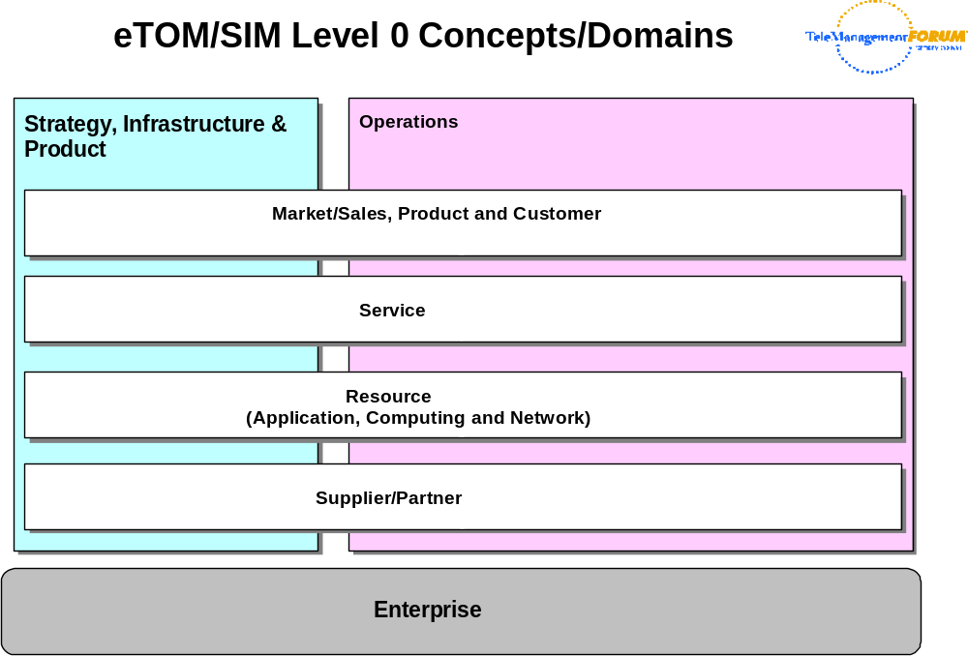
Figure 1P- . Level 0 Concepts and Domains of the eTOM
The reader is encouraged to refer to [eTOM] for an explanation of the various business processes that are defined to support the concepts in the above domains.
The SID Framework [GB922] is used by the SID team to define a formal mapping between the eTOM domains and the SID domains. The SID Framework is also used to define and organize collections of business entities, called Aggregate Business Entities (ABEs), which are further defined in the SID Addenda. Level 1 of the Policy Domain of the SID Framework is shown in Figure 1P- below. Please note that this is subject to change over time.
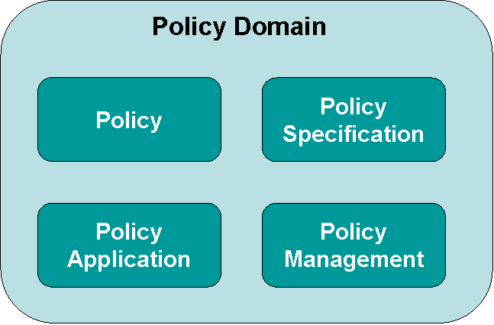
Figure 1P- . Level One of the Policy Domain of the SID Framework
In Figure 1P- , the outermost rounded rectangle represents the Policy Domain as a whole. Referring back to Figure 1P- , this outermost rectangle represents the single “Policy” sub-domain in the Common Business Entities Domain of the SID Framework.
The four rounded rectangles inside the outermost rounded rectangle are the four level one ABEs that make up the Policy Domain.
The Policy ABE from Figure 1P- above is used to define the four core groups of entities that are used to represent policy, independent of the content of the policy. The Policy Specification ABE uses the Entity-EntitySpecification pattern used throughout the SID to templatize these five entities. The Policy Application ABE defines how policy applications can be built, and the Policy Management ABE is used to associate policy entities with other SID entities. These are shown in Figure 1P- below.
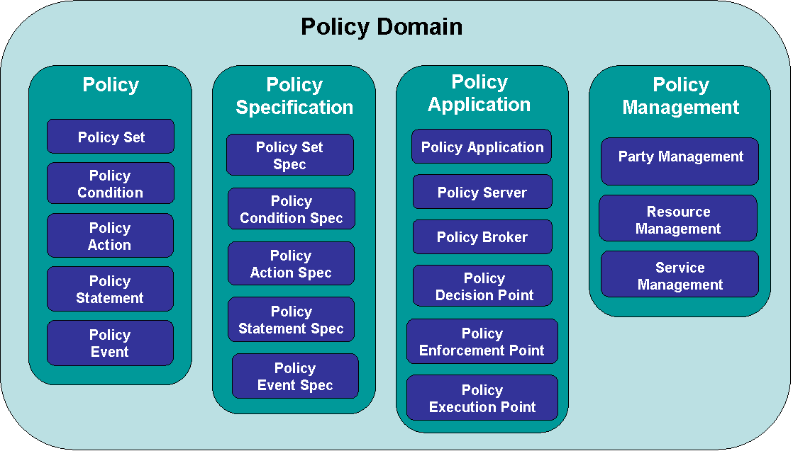
Figure 1P- . Level Two of the Policy Domain of the SID Framework
Figure 1P- shows two levels of Policy ABEs. Again, the Policy Domain is represented by the outermost rounded rectangle. The first level of Policy ABEs is defined by the four rounded rectangles labeled “Policy”, “Policy Specification”, “Policy Application”, and “Policy Management”. Each of these four level one Policy ABEs has three or more level two ABEs. In other words, the Policy level one ABE is in reality made up of five different ABEs – Policy Set, Policy Condition, Policy Action, Policy Statement, and Policy Event.
Put another way, the five level two Policy ABEs just mentioned define the level one Policy ABE in greater detail. The ABEs not only group similar managed entities together, but also help define important relationships between different ABEs (not just in the Policy Domain, but between the Policy Domain and other Domains).
This Addendum defines the simplest business aspects of each of the entities defined in Figure 1P- above. Please note that the Policy Application and Policy Management ABEs, and each of their level two ABEs, are still under construction as of this writing (Phase III of the SID).

Approach
Refer again to Figure 1P- above. In this figure, the Policy Specification ABE and Policy ABE are unique in the Policy Applications sub-domain, in that their entities provide the ability to represent policy rules independent of the content of the policy rules. That is, the same representation can be used regardless of what the policy is managing or being used to control. Thus, they form a “core” functionality that can be used by other policy ABEs. In this respect, the Policy Specification ABE provides the ability to build policy templates, and the Policy ABE represents instances of those templates. Templates are a very important concept in policy management, as they provide a means to standardize how policy is applied and used independent of the contents of the policy.
The Policy Application and Policy Management ABEs therefore use the Policy Specification and Policy ABEs to provide a standard representation of policy, and add business entities to model the application and management of policy, respectively.
As can be seen in Figure 1P- above, the second level of the Policy Domain is complex. The nature of this complexity lies both in the nature of each of the Aggregate Business Entities (ABEs) that are in the Policy Domain as well as in the interaction between entities of different ABEs in the Policy domain. A third area of complexity is the interaction between entities in the Policy Domain and managed entities in other Domains.
Conceptually, the Policy Domain entities must achieve two different goals:
- Demonstrate that the Policy Specification and Policy ABEs can indeed represent policy in a standard way regardless of the content of the policies
- Demonstrate that the managed entities that each Policy Domain ABE defines can be easily extended to meet the needs of different applications
The approach is to use the DEN-ng Policy model, which has been developed to meet the needs of Frameworx in general and [053C] in particular. The DEN-ng Policy model is loosely based on the DEN and IETF policy models, but significantly extends each in order to serve the needs of Frameworx.
This model reflects policy from a business-oriented point-of-view, and uses the best of standard modeling patterns for this area to build in extensibility. For example, patterns are used to capture common relationships and occurrences of policy for managing and controlling SID entities. This helps make the model inherently extensible.
Three important patterns utilized in this Addendum are:
- Composite pattern, which provides a common structure for stand-alone and aggregate objects of a given type
- Entity-EntitySpecification pattern, which separates the common and invariant characteristics and behavior of an object from its individual characteristics and behavior
- Role Object pattern, which uses the notion of roles to dynamically extend the behavior of an object by delegation

Use Cases
The following are the most important use cases that drove the design of the DEN-ng Policy model:
- Standardize the representation of policy for any application or use
- Show how policy can be used to manage other managed entities
- Show how formal policy models can be used to:
- Define how policy decisions are made
- Define how policy can be enforced
- Define how policy can be triggered

Important Future Use Cases
Two important areas exist that will help further integrate Policy with Frameworx. These are:
- Define in detail how Policy is related to eTOM processes, and
- Define how Policy is used to manage and control the behavior of an Frameworx system
As previously stated, policy is not defined at a detailed level in the eTOM. The Behavior and Control Frameworx Addendum ( [053C] ) states that policy and process should be able to be used together to manage an Frameworx system. One way of doing this is to use an active policy to select the appropriate process, and use the result of the executing process to affect the set of policies that are active at any current time. In order to do this work, additional work in the Frameworx Metamodel ( [053D] ) must first be done. For example, this will enable defining policies to manage how Services and Resources (and even Products!) can be configured, accessed, and used in a standard way to support service creation, activation, measurement, and other processes defined by the eTOM.
Once the Metamodel work is done, this use case ties into the second use case, which is to define how policy is used to manage and control managed entities in an Frameworx system. This will be the subject of the Frameworx Policy Addendum ( [053P] ). Part of this work will be to provide a set of abstractions that can be used in all four of the Frameworx viewpoints [053 Main] to represent the appropriate aspects of policy in each of these viewpoints.
For example, the Frameworx computational viewpoint focuses on functional decomposition of the system into a set of managed objects which interact at interfaces. Policy can be used to manage and/or control how these interactions occur.
Once the Frameworx 053D Addendum is extended, and the Frameworx 053P Addendum is written, the above two use cases can be defined in detail as a new part of this Addendum.
There are countless examples of dependent use cases that come into play when considering the above two use cases. For example, one important use case is to be able to understand how policy interacts with process, and how policy can be used to automate (or support the automation of) managing Frameworx system components.

Scope
This Addendum will focus on defining a framework for representing policy, and specify two uses of policy: management of a system using policy, and management of SID entities using policy. These conform to the Policy Application and Policy Management level two ABEs in Figure 1P- .
An important goal of the SID effort is to reuse standards (as opposed to reinventing the same concepts) wherever possible. There are several important sources of information for these concepts used in this Addendum. This model represents the business view of the DEN-ng information model (which is in the process of being documented in [DEN-ng]). This is based on the original [DEN] specification, and contains insight from BT as well as some elements of various IETF drafts and RFCs (specifically, [RFC3060], [RFC3460], [SGAI], [QPIM], and [QDDIM] ). Note, however, that the DEN-ng policy information model departs significantly from previous IETF work. For more on this, see [PBNM], which also provides several chapters on the DEN-ng policy model and its relation to policy management.
The SID and Frameworx teams have elected to start with the DEN-ng policy model. The rationale for this decision is as follows:
- DEN-ng was built to be integrated with other SID models as a starting point
- Considerable implementation experience was provided by BT and Intelliden
- The DEN model was already taken into account and enhanced with the building of DEN-ng
- Experience with version 1 of this model has helped improve and enhance it
Using the DMTF CIM policy model was examined and rejected for several reasons. First, the CIM is not UML compliant, and the TM Forum bases its work on UML (the DEN-ng models are UML compliant). Second, there are many open defects against the CIM Core and Physical models, as documented in [CIMPROB]. Third, there are significant modeling inconsistencies and errors that were found in the 2.7 release of CIM. Finally, the CIM policy model isn’t tightly connected to any of the other CIM domains.
Consistent terminology in a federated model is critical. This terminology, as the model itself, will be introduced in stages. This enables more complex ideas to build on simpler concepts, thereby enabling both an easier as well as a more thorough understanding of the Policy Domain and its relationship to other Domains as defined in the SID Framework [GB922].
Regarding terminology, it is important to be able to relate this view (i.e., the “business” view) of the Policy model to other views (e.g., the “system” and the “implementation” views) of these same concepts. By doing this, we achieve the important goal of being able to connect the business requirements to the system representation to how the system is implemented.
Thus, the next section (up to the References Section) first discusses policy terminology, and then leads the reader step by step through the design of the DEN-ng Policy framework model (e.g., the Policy and Policy Specification level two ABEs). The Policy Application and Policy Management ABEs are then briefly discussed.
The final section of this document contains a detailed data dictionary that defines the derivation of classes, attributes, relationships (e.g., associations, aggregations and compositions) presented in this model. Note that this section has a special “synonyms / aliases” section to provide easy correlation to these external documents. This section also presents the results of mining information from other models into the baseline provided by the DEN-ng Policy model.

Fundamental Policy Terminology
The purpose of this section is to define important policy terminology as used in the rest of this Addendum. The authoritative source of reference for these terms is [PBNM].

Basic Terminology
The purpose of this section is to define basic terminology that this Addendum depends on and uses.

DEN
DEN, or Directory Enabled Networks, is two things. First and foremost, it is a specification of an object-oriented information model describing the elements and entities in a managed environment, and how they are related to each other. Second, it also specifies a model mapping to a format that can be stored in a directory that uses (L)DAP as its access protocol.

DEN-ng
DEN-ng is the next version of the DEN standard. It is being constructed in the TeleManagement Forum (TM Forum), not the DMTF, because it is very strongly tied to the Frameworx architecture effort. In addition, DEN-ng, like DEN, are both UML-compliant. The DMTF CIM is not UML compliant (see [UMLProb] for detailed information concerning this).
DEN-ng is an object-oriented information model that describes the business and system views of managed entities and their relationships. This definition is done using UML, and is strongly tied to the definition of Frameworx.

Information Model
An information model is an abstraction and representation of the entities in a managed environment. This includes definition of their attributes, operations and relationships. It is independent of any specific type of repository, software usage, or access protocol.

Data Model
A data model is a concrete implementation of an information model in terms appropriate to a specific type of repository that uses a specific access protocol or protocols. It includes data structures, operations, and rules that define how the data is stored, accessed and manipulated.

Model Mapping
A model mapping is a translation from one type of model to another type of model. Model mapping changes the representation and/or level of abstraction used in one model to another representation and/or level of abstraction in another model.
Model mapping is an important concept, and is used to enable different types of models to be related to each other. The most common form of model mapping is from an information model to a data model; another important form is from a vendor-neutral data model to a vendor-specific data model. Figure 1P- below illustrates the concept of model mapping.
Standard (e.g., SID Business View)
Standard (e.g., SID System View)
Vendor-Specific Implementation
Data Model
(platform 1)
Data Model
(platform n)
Data Model
(vendor 1)
Data Model
(vendor m)
Information Model
Figure 1P- . The Concept of Model Mapping

Figure 1P- shows one form of model mapping. In this Figure, a particular Data Model (for example, a Directory) is defined as a mapping from an information model (for example, the SID). This mapping produces a directory implementation that is conformant with the appropriate standards (e.g., LDAP or X.500 as well as the SID). The second tier of mapping accounts for the fact that different vendors provide varying degrees of compliance with the directory standards. Thus, from the TM Forum point-of-view, a mapping must be able to integrate the standard system aspects (in this case, LDAP and/or X.500) with the Frameworx entity representations (as defined by the SID).

Terms Defining the Representation of Policy
The purpose of this section is to define terms that are used in the DEN-ng Policy model to build a standard representation of policy.

Policy
Policy is a set of rules that are used to manage and control the state and state transitions of one or more managed objects.
Note that the DEN-ng model differentiates between the management of policy vs. controlling a managed entity using policy. Specifically, the former refers to managing policy rules, groups and components, while the latter signifies using policy entities to control the state of a managed entity (or set of managed entities). Note the emphasis in the above definition on the phrase “changing and/or maintaining of the state”. The notion of state is central to the DEN-ng model, and is noticeably lacking in other policy models. Specifically, DEN-ng uses a Finite State Machine for representing state.

PolicyRule
A PolicyRule is an intelligent data container. It contains data that define how the PolicyRule is used in a managed environment as well as a specification of behavior that dictates how the managed entities that it applies to will interact. The contained data is of four types: (1) data and metadata that define the semantics and behavior of the policy rule and the behavior that it imposes on the rest of the system, (2) a group of events that can be used to trigger the evaluation of the condition clause of a policy rule, (3) a group of conditions aggregated by the PolicyRule, and (4) a group of actions aggregated by the PolicyRule.
The DEN-ng policy model is deceptively simple. It is a triplet, defined as an event clause, a condition clause, and an action clause. Here, “clause” simply means that one or more expressions can be used to define events, conditions and actions. Simply put, events are used to trigger the evaluation of one or more conditions. If the set of conditions evaluates to TRUE, then one or more of the set of actions associated with this PolicyRule may be executed.

PolicyEvent
A PolicyEvent is an occurrence of an important event, and can be used to trigger the evaluation of a PolicyCondition or PolicyCondition clause in a PolicyRule. <what is an event, who generates them – alarms, inserting a card, etc.>

PolicySet
This class represents an aggregation of PolicyEvents, constrained according to the eventConstraint attribute of the EventDetails aggregation class. This set of PolicyEvents is then presented to one or more PolicyRules to trigger the evaluation of their condition clauses. This enables an external application, such as a Policy Server, to dynamically adjust the set of events that are being used to trigger the evaluation of a PolicyRule.

PolicyCondition
A PolicyCondition clause is an aggregation of individual PolicyConditions, and is treated as an atomic object that is aggregated by a PolicyRule. It is represented as a Boolean expression, and defines the necessary state and/or prerequisites that define whether the actions aggregated by that same PolicyRule should be performed. This is signified when the PolicyCondition clause associated with a PolicyRule evaluates to TRUE.

Policy Action
A PolicyAction clause is an aggregation of individual PolicyActions, and is treated as an atomic object that is aggregated by a PolicyRule. It represents the necessary actions that should be performed if the PolicyCondition clause evaluates to TRUE. These actions are applied to a set of managed objects, and have the effect of either maintaining an existing state, or transitioning to a new state, of those managed object.

Terms Defining the Usage of Policy
The purpose of this section is to define terms that are used in the DEN-ng Policy model to represent how policies are used in a policy based management system.

Policy Domain
A PolicyDomain is a collection of managed entities that are operated on using a set of policies. The policies are used to administer and control the set of characteristics and behavior of these managed entities.
The purpose of defining a Domain is to define a set of managed entities that are all operated on in the same way. While administration is important, it is only one of a set of operations that are targeted on entities in a domain.

Policy Conflict
A policy conflict occurs when the conditions of two or more PolicyRules that apply to the same set of managed objects are simultaneously satisfied, but the actions of two or more of these PolicyRules conflict with each other.

Policy Decision
A Policy Decision is the determination that one or more PolicyActions that are aggregated by a PolicyRule should be applied to a set of managed objects. These PolicyActions correspond to either maintaining the current state, or transitioning to a new state, of each of the managed objects that it is affecting.

Policy Decision Point (PDP)
A PDP is an entity that makes Policy Decisions for itself or for other entities that request such decisions.
Note that a PDP is not a role. Rather, it is an architectural concept defined in TMF053P.

Policy Enforcement Point (PEP)
An entity that is used to verify that a prescribed set of PolicyActions have been successfully executed on a collection of PolicyTargets.
Note that a PEP is not a role. Rather, it is an architectural concept defined in TMF053P.

Policy Evaluation
A Policy Evaluation is the set of computations necessary to determine if the PolicyCondition clause is satisfied.

Policy Execution Point (PXP)
An entity that is used to execute a prescribed set of PolicyActions on a set of PolicyTargets.
Note that a PXP is not a role. Rather, it is an architectural concept defined in TMF053P.

Policy Repository
A policy repository is an administratively-defined logical container that is used to hold policy information. For the purposes of this definition:
- logical container means that it may be implemented as either a separate data store, or a special area of a data store
that is used expressly to contain policy information
- policy information means policy rules and groups, their constituent elements, and related data that may be used in the
evaluation and/or execution of policy conditions and actions

Policy Server
A Policy Server is a collective set of entities that can be used to replicate core policy management functionality in a distributed implementation. It consists of at least one Policy Decision Point, one Policy Execution Point, control logic to detect and resolve policy conflicts, and optionally one or more proxies to communicate to the external world.

Policy Subject
A policy subject is a set of entities that is the focus of the policy. The subject can make policy decision and information requests, and it can direct policies to be enforced at a set of policy targets.
Note that a Policy Subject is an architectural concept, as defined in the literature. However, DEN-ng defines a role to implement the concept of a PolicySubject.

Policy Target
A policy target is a set of entities that a set of policies will be applied to. The objective of applying policy is to manage the state transitions of the policy target.
A policy target could be a device (e.g., power it on), a device interface (e.g., check if it is up or down) or a device configuration (e.g., define traffic conditioning, protocols, and other operations). Note that this definition uses the notion of using a finite state machine to control the behavior of the policy target.
Note that a Policy Subject is an architectural concept, as defined in the literature. However, DEN-ng defines a role to implement the concept of a PolicySubject.

Policy-Aware Entity
A policy-aware entity is one that can understand and use policies to make present and future decisions. These decisions are used to manage and control the changing and/or maintaining of the state of one or more managed objects that are the targets of the policy.

Policy-Unaware Entity
A policy-unaware entity is one that can neither understand nor use policies to make present and future decisions. A policy-unaware entity cannot use policies to manage and control the changing and/or maintaining of the state of one or more managed objects.

Policy-Enabled System
A policy-enabled system is one that can operate using policies to make present and future decisions. These decisions are used to manage and control the changing and/or maintaining of the state of one or more managed objects that are the targets of the policy.

Terms Defining the Use of Roles With Respect to Policy
The purpose of this section is to define terms that are used in the DEN-ng Policy model to represent how roles are used in conjunction with policies in a policy based management system.

Role Attribute
A role attribute is a fundamental characteristic of an object that is used to define the purpose or function of that object.
This definition has been included for compatibility with the DMTF CIM and IETF policy models. Please note that DEN-ng and the SID do not use role attributes – rather, they use the more powerful concept of the role object pattern, which by definition includes one or more role attributes.

Role Object
A role object is an object that is not meant to stand on its own; rather, it is meant to supply a combination of common and unique functionality that can augment the basic definition of another object. The unique functionality may be supplied in the form of additional attributes, methods, constraints, and/or relationships. (Note that this latter isn’t specifically identified in [Bäumer], but is a characteristic of DEN-ng and the work in the SID.) Roles are contextual and define behavior in a context, and are not absolute.

Role-Combination
A role-combination is a set of Roles that exist as an atomic entity.
Note that when a role-combination is queried on, the entities selected are those which have ALL roles in the specified role-combination. This concept is included for compatibility with the DMTF CIM and IETF policy models. This represents the special case of using multiple role attributes to function as a role-selector.

Role-Selector
A role-selector is a means of grouping together a set of objects, so that a set of policies can be applied to them. Multiple role-selectors can be combined to select a set of objects, in which case only those objects that contain all attributes specified by the role-selector will be selected.

Changes From Policy Information Exchange
This section describes changes made by introducing support for the Policy Information Exchange (PIE) model into the Policy ABE. These changes are reflected in the diagrams throughout this document and in all formats of the SID model. Changes to other sections of this guidebook will be made in the next release of the SID.
The next release of the SID will move all entity and attribute definitions from domain/ABE addenda to a single addendum containing all definitions. The definitions will be generated from the SID UML model.
Refactoring the PolicyRule class

The PIE team uses PolicyRule which is a subset of the existing PolicyRule. The PolicyRule class was refactored as described in the following diagram:
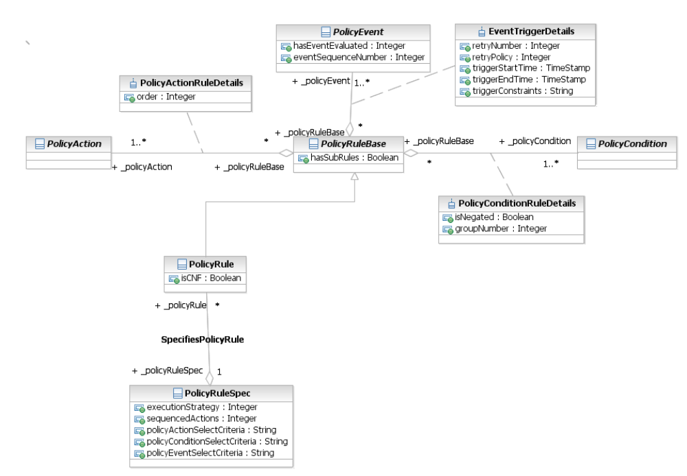
The abstract class PolicyRuleBase holds the associations to PolicyCondition, PolicyEvent and PolicyAction and the attribute hasSubRules. The subclass PolicyRule includes the isCNF attribute and the association to PolicyRuleSpec. The PolicyRule class is now identical to the existing PolicyRule class. Not shown in the diagram is the fact that PolicyRuleBase is a subclass of PolicySet, as is the existing PolicyRule class.
Refactoring the PolicyEvent class

The PIE team uses a PolicyEvent which is simpler than the existing PolicyEvent class. The Policy Event class was refactored as described in the following diagram:

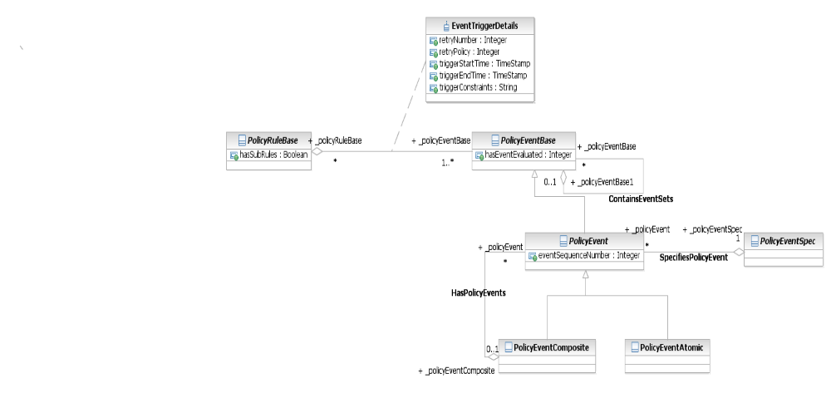

This refactoring supports subclassing the new classes PolicyRuleBase and PolicyEventBase. The new classes (XXXBase) are abstract and therefore do not have impact on conformance certification.

Impact on Certification

As a result of the changes listed above the policy model now becomes a harmonization of two models (POL – the original model and PIE). This could cause difficulties when trying to certify against the model if this harmonization is not taken into account. Therefore entities which belong only to a single model and not to both have been moved to a separate ABE in order for members to certify against them. The PolicyRule, PolicyEvent, PolicyEventComposite and PolicyEventAtomic have been moved to a new L3 ABE. Since PolicyRule and PolicyEvent reside in two different ABEs, two new L3 ABEs were created, one for PolicyRule and one for PolicyBase and its subclasses.

Representing a PolicyRule
The purpose of this section is to show how the DEN-ng Policy model can be used to represent policy in a standard format that is independent of the content of the PolicyRule.

Representing a PolicyRule
As stated previously, a PolicyRule is a triplet, containing an event clause, a condition clause, and an action clause. In addition, a PolicyRule itself has additional data and metadata that enable behavior to be associated with a PolicyRule. Conceptually, a PolicyRule can be thought of as follows:
In the simple representation shown in Error: Reference source not found, a PolicyRule is really an intelligent data container that serves to aggregate one or more PolicyEvents, one or more PolicyConditions, and one or more PolicyActions. Note that the cardinality of the three aggregations that define the characteristics of this intelligent data container (i.e., PolicyConditionInPolicyRule, IsTriggeredBy, and PolicyActionInPolicyRule) are each 1..n on the composite side. This means that a PolicyRule must contain at least one or more PolicyConditions, PolicyEvents, and PolicyActions in order to be instantiated. Since the cardinality of these three aggregations is 0..n on the aggregate side, this means that a PolicyCondition, a PolicyEvent, and a PolicyAction can exist on their own without being bound to a PolicyRule. This enables PolicyEvents, PolicyConditions, and PolicyActions to be designed and stored in a PolicyRepository and then bound to a PolicyRule at run-time.
Naming in this figure has been adjusted to be backwards compatible to the IETF model. Thus, instead of the usual “RuleHasConditions” that one would expect out of DEN-ng and the SID, “PolicyConditionInPolicyRule” was the name chosen in RFC 3060.
This is a very important point, as it enables the concept of reusable Policy components to be defined. This is discussed later in this Addendum in the section titled Reusable vs. Ad-Hoc Policy Entities.
Figure 1P- . A Conceptual Representation of a PolicyRule
Like all DEN-ng and SID entities, PolicyRules are built from PolicyRuleSpecifications (called PolicyRuleSpec in the model). A PolicyRuleSpec acts as a mechanism to specify the invariant (i.e., non-changeable) features and behavior that makes up a Policy. Thus, all PolicyRules use the attributes, methods, constraints, and relationships that are contained in the PolicyRuleSpec from which they are derived. A PolicyRuleSpec has two important attributes that all PolicyRules have, called executionStrategy and sequencedActions.
The executionStrategy attribute is an enumerated integer that defines the strategy to be used when executing the sequenced actions aggregated by this PolicyRule. Defined execution strategies include:
- 1: Do Until Success
- 2: Do All
- 3: Do Until Failure
- 4: Do All Without Failure or Do Nothing
"Do Until Success" means that actions should be executed according to their predefined priority, until successful execution of a single action. At that point, the process should stop (even if there are additional actions that could be executed).
"Do All" means that all actions should be executed that are part of the set, according to their predefined priority. This should continue, even if one or more of the actions fails.
"Do Until Failure" means that all actions should be executed according to their predefined priority until an action fails to execute. At that point, the entire sequence should be stopped.
Finally, "Do All Without Failure or Do Nothing" means that all actions specified should be performed. However, if a failure occurs, then NONE of the actions should be performed. This implies EITHER the ability to look-ahead and ensure that the actions will be able to be performed successfully, or the ability to perform a rollback of that action and all previous actions in the PolicyRule when an error is encountered.
The sequencedActions attribute is an enumerated integer that defines how the ordering of the PolicyActions associated with this PolicyRule is to be interpreted. Values include:
- 1: Mandatory
- 2: Recommended
- 3: Best Effort
Mandatory means that the actions must be done in the indicated order, or else don't do them at all. Recommended means that the actions should be done in the indicated order if possible; if this is not possible, then it is permissible for them to be done in another order. Best effort means that the actions should be done irrespective of whether they can be done in the specified order.
The combination of the executionStrategy and the sequencedActions attributes enables the behavior of PolicyActions to be specified. Note that this is a special case, compared to how PolicyConditions and PolicyEvents are handled. From the perspective of the PolicyRule, a single clause (i.e., a set of expressions) is used to represent conditions as well as events. For the case of the PolicyCondition, the PolicyRule need only check to see if the condition clause evaluated to TRUE – if it evaluated to FALSE, then no action need be taken. For the case of the PolicyEvent, the PolicyRule sees a trigger to start the evaluation of its condition clause. It usually doesn’t care which event or how many events triggered the evaluation of the condition – it simply cares that something happened and now a check needs to be made to see if this PolicyRule is applicable or not.
There are three other important attributes of a PolicyRuleSpec. These are the policyEventSelectCriteria, policyConditionSelectCriteria, and policyActionSelectCriteria attributes. These attribute contain OCL expressions to prescribe any limitations on the types of PolicyEvents, PolicyConditions, and PolicyActions that can be used with any PolicyRules that are derived from this particular PolicyRuleSpec. This enables a PolicyRuleSpec to be built that defines what types of PolicyEvents, PolicyConditions, and PolicyActions can be used to build a particular set of PolicyRules. This in turn ensures that a given set of PolicyRules carry standard functionality. (Nothing further will be said about these three attributes, as they come into play more in the system view).
Conceptually, Figure 1P- below shows a more detailed view of the PolicyRuleSpec and PolicyRule.
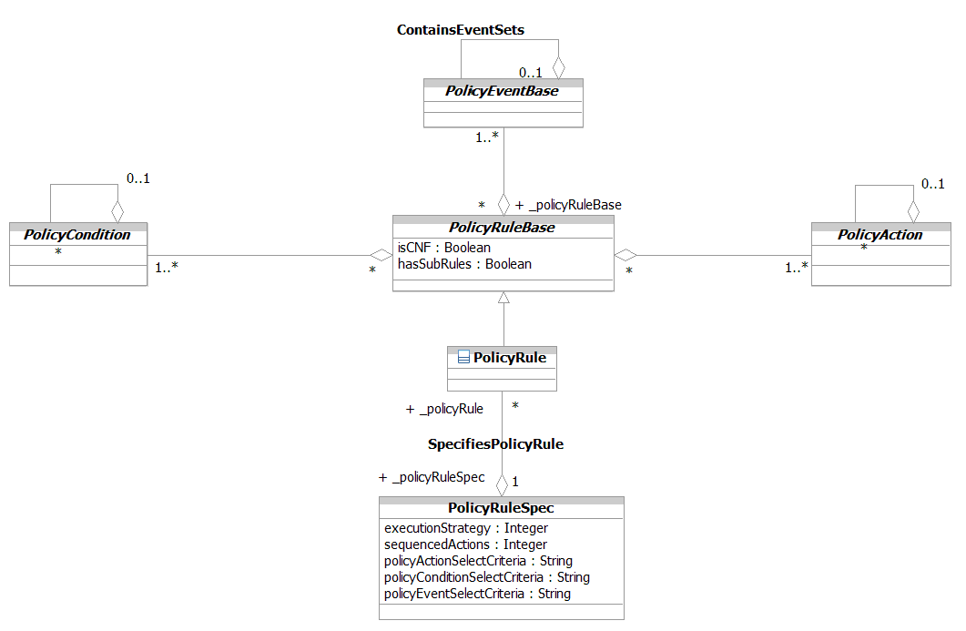
Figure 1P- . PolicyRule in More Detail
The PolicyRule entity itself is therefore very simple. It defines two attributes, isCNF and hasSubRules. PolicyConditions can be represented in two different forms, called Conjunctive Normal Form (an AND of ORs) and Disjunctive Normal Form (an OR of ANDs). The isCNF attribute defines which one of these forms the PolicyCondition clause is to be represented in.
The hasSubRules attribute is for querying convenience. As we will soon see, a PolicyRule can contain other PolicyRules. Nested PolicyRules have slightly different evaluation and action execution semantics. This attribute enables the user of a PolicyRule to quickly determine if this is a simple PolicyRule, or if this PolicyRule has nested PolicyRules.
The PolicyRuleSpec was built so that external entities, such as Policy Servers, could build a particular type of PolicyRule dynamically. To see how this works, imagine that a set of Policy components, including one or more PolicyConditions, PolicyActions, and PolicyEvents, exist in a PolicyRepository. Now, given a PolicyRuleSpec, a PolicyRule can be built dynamically that has the exact behavior that is desired by using the three criteria attributes of the PolicyRuleSpec (i.e., policyActionSelectCriteria, policyConditionSelectCriteria, and policyEventSelectCriteria).

PolicyGroup
A PolicyRule is designed to be used for a single purpose. Sometimes, a management system needs multiple separate policy decisions and actions to be conducted in concert. A PolicyGroup is a generalized aggregation container. It enables PolicyRules and/or PolicyGroups to be aggregated in a single container. Note that loops, including the degenerate case of a PolicyGroup that contains itself, are not allowed when PolicyGroups contain other PolicyGroups. PolicyGroups do not have associated specifications, as they are “just” containers.
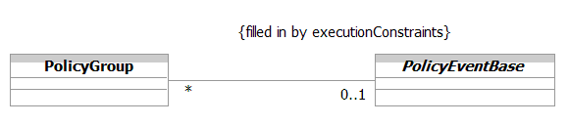
A PolicyGroup, being a container, is a perfect way to distribute notifications of events to other components of the PolicyServer. This is done by associating one or more PolicyEvents with a PolicyGroup, as shown in Figure 1P- below.

Figure 1P- . PolicyGroups
The ControlsExecutionOf association defines the PolicyEvent that controls the execution of PolicyRules in the PolicyGroup. It is implemented as an association class to enable a filtered subset of elements in the PolicyGroup (that are selected by the set of PolicyEvents received by each PolicyGroup) to be executed.

PolicySet – Generalizing PolicyRules and PolicyGroups
Both a PolicyGroup as well as a PolicyRule can act as intelligent containers. Therefore, DEN-ng abstracts this common capability and generalizes this into a common superclass, called PolicySet. A PolicySet can therefore be used to define common semantics for PolicyRules and PolicyGroups. It is shown in Figure 1P- below.
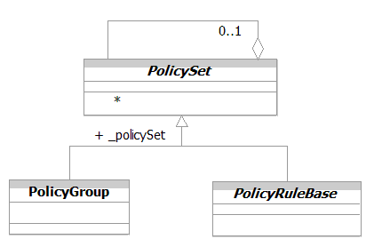
Figure 1P- . The Concept of a PolicySet
The name “PolicySet” is kept to ensure backward compatibility with the IETF model (RFC 3060 and those derived from it). A PolicySet is a type of collection class. This makes sense, since PolicyRules and PolicyGroups are also collection classes. Specifically, a PolicyRule collects PolicyEvents, PolicyConditions, and PolicyActions, while a PolicyGroup collects PolicyRules and PolicyGroups. Thus, a PolicySet can capture the common semantics (attributes, methods, relationships, and constraints) for policy collection classes.
Note that the composite pattern is not used. This is because the entities shown in Figure 1P- above are each collections, and therefore naturally have the ability to aggregate information.
Instead, what is important about these classes is their ability to form nested relationships (i.e., a PolicyRule within a PolicyRule as well as a PolicyGroup within a PolicyRule). There are important semantics that come into play, especially in the field of networking, that mandate the ability to have a set of nested PolicyRules (e.g., a rule : sub-rule relationship) as well as the ability to have a group of PolicyRules execute within the context of another PolicyRule. Similarly, one can have a PolicyGroup contain another PolicyGroup (thereby forming a hierarchical group of containers) as well as a PolicyGroup contain a PolicyRule. Thus, instead of the standard composite pattern, the pattern shown in Figure 1P- is used instead. This pattern will be repeated for other structures, including PolicyConditions and PolicyActions.
PolicySets are shown in more detail Figure 1P- below.
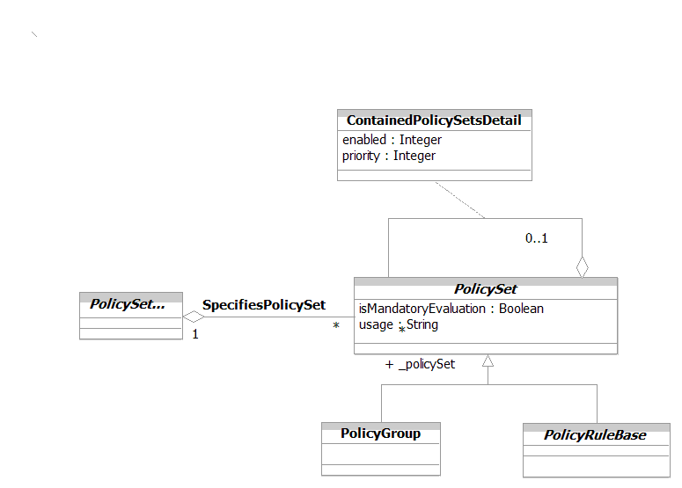
Figure 1P- . PolicySet in More Detail
A PolicySet has two attributes. The isMandatoryEvaluation attribute is a Boolean attribute that, if TRUE, signifies that evaluation (and possibly action execution) of this entity is mandatory and must be attempted. If the Mandatory property value of this entity is FALSE, then the evaluation of this entity is considered to be "best effort" and may be ignored.
The usage attribute is a free-form string attribute that recommends how this policy object should be used.
The ContainedPolicySets aggregation is used to gather together discrete PolicySet objects to form a group of PolicySet objects. Such a group must share the same DecisionStrategy. Its semantics are implemented by the ContainedPolicySetsDetail association class.
The ContainedPolicySetsDetail association class represents the semantics of the ContainedPolicySets aggregation. It provides additional semantics that enable this grouping of PolicySets to be prioritized and enabled, so that they can interwork with other PolicyRules and PolicyGroups. Note that each object in this aggregation must have the exact same decision strategy. It defines two attributes. The first, enabled, is an enumerated integer. If its value is 1 (which means enabled), then this signifies that this object is enabled for evaluation. If its value is 3 (which means that it is enabled for debugging), then this rule can be used in test or debug scenarios. If its value is 2, then this object is disabled and cannot be used or evaluated.
Note that this object still might end up being disabled, even if this attribute is TRUE. For example, an associated PolicyTimePeriodCondition might evaluate to FALSE, effectively disabling this object.
The second attribute, priority, is a non-negative integer that is used to prioritize PolicyRules among each other, and/or PolicyGroups that are contained within a PolicyRule. Larger integer values indicate higher priority
Priorities apply to PolicySets (e.g., PolicyGroups and PolicyRules) and are to be used at the same level of scoping. That is, if a PolicyGroup contains n PolicyGroups or PolicyRules, the priority of the outermost (or parent) PolicyGroup can be compared with either stand-alone PolicyRules or PolicyGroups (at that same level of nesting).
The default setting of this attribute is zero.
Prioritization among policy rules provides a basic mechanism for resolving policy conflicts.
Common behavior for PolicyGroups and PolicyRules (in this view, this is shown as common attributes; in the system view, it includes other common artifacts) is defined using a PolicySet. One of the most important common behaviors that is defined for a PolicySet is its ability to treat PolicyRules and PolicyGroups in a common way when evaluating a decision tree.
For example, Figure 1P- below shows an example where nodes are made up of both PolicyGroups as well as PolicyRules:
PolicyGroup1
Priority 7
PolicyGroup2
Priority 3
PolicyRuleA
Priority 10
PolicyRuleB
Priority 5
PolicyRule1-1
Priority 8
PolicyRule1-2
Priority 100
PolicyGroup1A
Priority 9
PolicyRule1A-1
Priority 50
PolicyRule2-1
Priority 200
Figure 1P- . Common Evaluation Semantics for PolicyGroups and PolicyRules
Figure 1P- above shows three hierarchies of PolicySets. The first hierarchy consists of PolicyRuleA, PolicyGroup1, PolicyGroup2, and PolicyRuleB. The second hierarchy consists of PolicyRule1-1, PolicyRule1-2, PolicyGroup1A, and PolicyRule2-1. The third hierarchy consists of PolicyRule1A-1.
PolicySets are evaluated in hierarchies, with the highest priority (e.g., the PolicySet that is most important to the business, or the PolicySet that should be executed in the event of a conflict) being executed first. In other words, the absolute priority of a given Policyset isn’t important initially – we instead look at the priorities of the PolicySets at the same level in the hierarchy. Therefore, in our first hierarchy, the execution order is PolicyRuleA, PolicyGroup1, PolicyRuleB, and PolicyGroup2, because they are all at the same hierarchy, and their priorities are 10, 7, 5, and 3, respectively.
PolicyRuleA will execute first. Next in priority is PolicyGroup1. Since it is a PolicyGroup, we must stop and look into its contents to figure out what should be executed in what order, since a PolicyGroup can’t be executed by itself. Note that the contents of PolicyGroup1 will all execute before the contents of PolicyGroup2 or PolicyRuleB, even though PolicyGroup2 and PolicyRuleB are both on the first level of the policy hierarchy.
Looking at the contents of PolicyGroup1, we see that the execution order is PolicyRule1-2, PolicyGroup1A, and PolicyRule1-1. Note that PolicyRule2-1 wasn’t considered. This is because although it is at the second level of the hierarchy, it is contained within a PolicyGroup whose priority was lower than that of the PolicyGroup that we are currently evaluating. Since PolicyGroup1A is a group, its contents will be executed before PolicyRule1-2 is executed. This effectively moves the execution of PolicyRule1A-1 between PolicyRule1-2 and PolicyRule1-1.
Finally, PolicyRuleB will execute, followed by PolicyGroup2, which means that PolicyRule2-1 will be the last to execute.
This example shows the following key points:
- Grouping compares the priority of PolicySets at the same level
- Whenever a new hierarchy is entered through a PolicyGroup, its PolicySets are compared with each other at that level of the hierarchy, before further evaluation of the previous hierarchy is continued
- The absolute priority of a PolicySet has nothing to do with its final execution order – it only serves to determine when it will be executed with respect to other PolicySets of its same hierarchy level.PolicySets do not have associated specifications, since they are abstract containers, and serve only to facilitate the grouping of PolicyRules and PolicyGroups.
It is important to note that the semantics of a PolicyRule in a PolicyGroup are different than those of a PolicyRule in a PolicyRule. However, this is beyond the scope of a business view – please see either the system view or [PBNM] for more information. The business reader should realize, however, that this model is very generic, and can support any type of execution strategy desired.

PolicyEvents
PolicyEvents are significant occurrences that trigger the evaluation of one or more PolicyRules. The composite pattern is used to define atomic and composite PolicyEvents, as shown in Figure 1P- below.
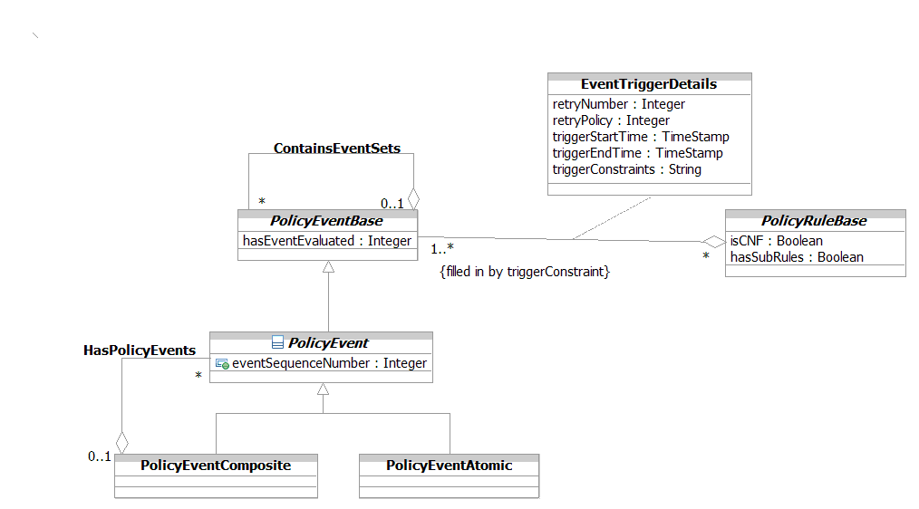
Figure 1P- . PolicyEvents and PolicySets
A PolicyEvent is a base class that represents the occurrence of an event, which is used to trigger the evaluation of the condition clause of a PolicyRule. It has two attributes, which are used by an external system (such as a Policy Server or policy control logic) to track individual events and to ensure that they have been evaluated.
The composite pattern is used to build atomic and composite PolicyEvents. A PolicyEventAtomic is a base class that represents the occurrence of a single atomic event, which is used to trigger the evaluation of the condition clause of a PolicyRule. In contrast, a PolicyEventComposite is a base class that represents the occurrence of a composite event. A composite event is an event that is made up of a set of PolicyEventAtomic and/or PolicyEventComposite entities. Like a PolicyEventAtomic, a PolicyEventComposite can also be used to trigger the evaluation of the condition clause of a PolicyRule.
In the system view, the HasPolicyEvents aggregation is implemented as a class. This class has an attribute that contains an OCL expression that can be used to filter the set of PolicyEvents that are aggregated by the PolicyEvent. This enables an external application, such as a Policy Server, to dynamically adjust the set of events that are being used to trigger the evaluation of a PolicyRule.
The EventTriggerDetails class is an association class. Though arguably a system entity, it is shown in Figure 1P- to provide the reader with a better understanding of the power and inherent flexibility of this model. This class defines five attributes that implement the semantics needed for the IsTriggeredBy aggregation, and defines the set of Events that can be used to trigger the evaluation of this PolicyRule.
The retryNumber attribute specifies the number of times that this PolicyEvent should be resent to the specified PolicyRule. If the triggerEndTime elapses, then the PolicyEvent will not be resent anymore, even if the retryNumber indicates that additional retries should be attempted. Instead, the hasEventEvaluated attribute of this PolicyEvent must be set to the value of 2 (failed to be evaluated).
The retryPolicy attribute is an enumerated integer that defines the policy for retrying triggers. An enumeration enables the policy application to choose among a set of pre-defined policies for determining how many times to retry sending this PolicyEvent to its associated PolicyRule.
The triggerConstraints attribute contains the specific OCL expression to constrain how a given set of PolicyEvents are used to trigger the evaluation of the condition clause of a particular PolicyRule. Defining this as an attribute enables external applications to populate the constraint that will be applied to this PolicyRule.
Finally, the triggerStartTime and triggerEndTime attributes specify the start and end of the time period in which this PolicyEvent can be sent to the associated PolicyRule.

PolicyStatements
There is significant similarity between the most common types of PolicyConditions and PolicyActions. Specifically:
- PolicyConditions are of the form: “IF <policy-condition> is TRUE”
- PolicyActions are of the form: “SET <action-target> to <value>
Both the condition clause and the action clause are in reality of the same form:
{ variable, operator, value }
where the braces are used to denote a tuple. To see this, we can write a PolicyCondition as:
IF <variable> <operator> <value> is TRUE (1)
For example, consider:
IF sourcePort == 21 (2)
In equation (2), sourcePort is an example of a variable, “==” is an example of an operator, and “21” is an example of a value. More formally, equation (2) tests the value of the sourcePort variable, to see if it is equal to the value 21 or not.
Similarly, a PolicyAction can be represented as:
<operator <variable> to <value>
For example, consider:
SET ToS = 5 (3)
In equation (3), ToS is an example of a variable, “=” is an example of an operator, and “5” is an example of a value. More formally, equation (3) sets the value of the ToS (type of service) field in the IP header to the value of 5.
Clearly, values can have different data types besides integers, and variables can represent any concept, not just fields in the IP header. In fact, the DEN-ng policy model provides a standard set of variables and values, as well as the ability to represent custom variables and values, so that different applications can use the same set of classes to represent different policy expressions (which are called PolicyStatements in this model).
More specifically, this enables the model to generalize the standard form of a PolicyCondition and a PolicyAction into an object that is called a PolicyStatement. This has important implications, since a Policy Decision Point, a Policy Enforcement Point, and a Policy Execution Point can now share the same basic syntax. Both PolicyConditions as well as PolicyActions share the same variables and values; the difference in semantics is reflected in the types of operators that are allowed to be used for PolicyConditions versus PolicyActions. For conditions, we want the semantics of "variable relates to value", where "relates to" is usually the match operator, but could also be other applicable operators (e.g., a comparison operator). For actions, we want the semantics of "set variable to value".These semantics are enforced using OCL, but that is beyond the scope of this Addendum. Please see either the DEN-ng system view or [PBNM]. A simplified representation of the PolicyStatement entity is shown in Figure 1P-15 below.
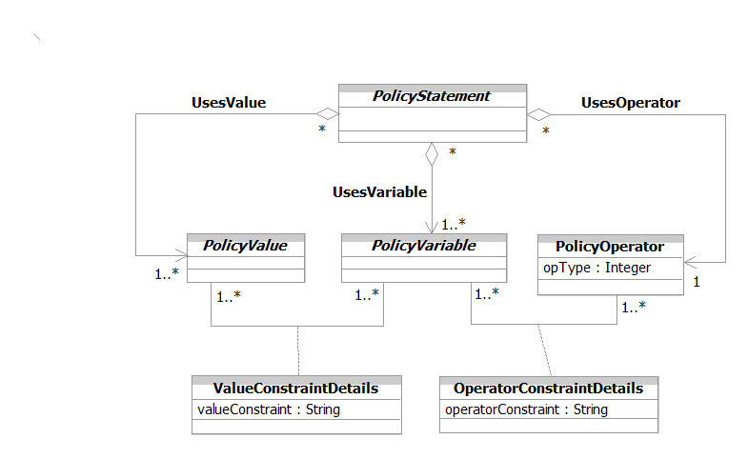
Figure 1P- . Overview of the PolicyStatement Concept
The cardinality of each of the three aggregations that involve PolicyStatement (i.e., UsesValue, UsesOperator, and UsesVariable) are each 0..n on the PolicyStatement side. This means that a given PolicyValue, PolicyOperator, and PolicyVariable can be used in zero or more PolicyStatement entities, respectively. The 0..n is used to enable the design of each of these three entities independent of the PolicyStatement.
The cardinality on the PolicyValue and PolicyVariable ends of the UsesValue and UsesVariable compositions is each 1..n. This means that a PolicyStatement must contain at least one or more PolicyValue and PolicyVariable entities, respectively, in order to be a valid PolicyStatement. Similarly, the cardinality on the PolicyOperator end of the UsesOperator composition is 1, because a PolicyStatement is a single clause, and therefore requires only a single PolicyOperator.
The ValueConstraintInVariable association enables a PolicyVariable to use a constrained, or limited, set of PolicyValues, compared to what it would normally use. Similarly, the OperatorConstraintInVariable association limits the type of operators that could be used with a given PolicyVariable to a smaller subset. The power of these two association classes lies in the fact that an external policy application can adjust these constraints at run-time by populating the attributes of these classes. This enables the same generic model to be used for multiple applications for consistency. At the same time, it enables the effects of the changing environment to be taken into account at run-time in the form of these constraints.

PolicyOperators
A PolicyOperator is a concrete class for modeling different types of operators in a PolicyStatement. By restricting the type of operator used in a PolicyStatement, one can effectively restrict the semantics of that PolicyStatement. This is done using the OperatorConstraintInVariable association, shown in Figure 1P- above.

PolicyVariables
A PolicyVariable is an abstract class for modeling different types of variables that can be used to form a PolicyStatement. The variable specifies an attribute or concept that should either be matched or in some way compared to a value when the condition is evaluated.
There are three important factors that must be taken into account in the design of variables. The first is that not every combination of a variable and a value creates a meaningful condition. For example, port numbers cannot be negative. Rather, the type of variable in the condition defines the set of matchable value types.
Second, just because a value has the correct data type does not mean that it can be meaningfully compared to a variable. To continue the above example, a port of 1,000,000 is meaningless. This is handled in this model by specifying constraints (using OCL) that apply to a particular variable that must be obeyed by any value that it is being compared to. The ValueConstraintInVariable association binds a PolicyVariable to a PolicyValue; any constraints that are required in this binding are added to an instance of this association using OCL.
Third, while the DEN-ng model defines a set of useful PolicyVariables, there is a high likelihood that specific applications will need extensions to these variables. This is accommodated through the notion of standard and custom PolicyVariable classes.
There are two subclasses of PolicyVariable, called VariableCustom and VariableStandard. The VariableCustom class defines a set of standardized policy variables for use in an application-specific manner. The term "custom" means that such variables are explicitly designed to work with attributes that are not in any of the DEN-ng VariableStandard subclasses. This means that the particular semantics (including any applicable constraints) are not known to DEN-ng.
The VariableCustom class is an abstract base class that provides two basic attributes to define custom variables that can be used in an application-specific fashion. The variableModelAttribute attribute is a string that defines the name of the attribute within the class specified in the variableModelClass attribute that is to be evaluated or set as a PolicyVariable. Similarly, the variableModelClass attribute is a string that defines the class name whose attribute is to be evaluated or set as a PolicyVariable. This enables the VariableCustom class to point to other attributes of other classes that can be defined as extensions of the standard DEN-ng model.
A simplified overview of PolicyVariables is shown in Figure 1P- below.
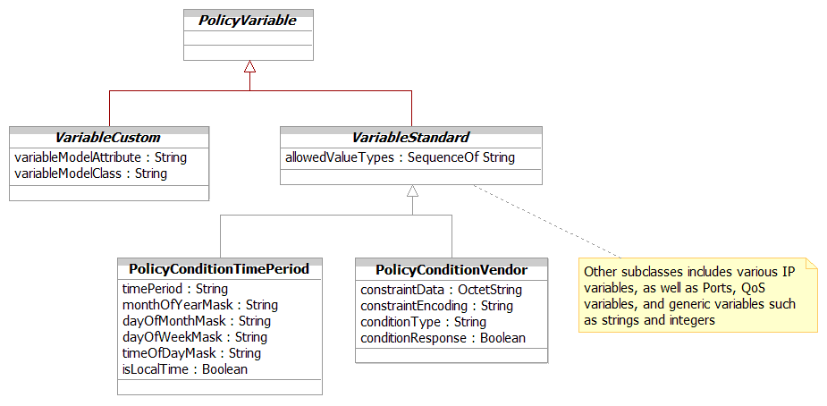
Figure 1P- . PolicyVariables in More Detail

Thus, the combination of variableModelClass and variableModelAttribute enable an application to define a new class that contains an attribute to be used as a PolicyVariable. This provides important extensibility, and enables an application to define its own set of classes and attributes to extend the DEN-ng framework.
The VariableStandard class is an abstract base class for defining a standard set of PolicyVariable objects that are common to most PBNM applications. This is the superclass for a standard set of PolicyVariable subclasses that are part of the DEN-ng model.
Currently, the DEN-ng model defines fifteen different subclasses of the VariableStandard class. Two of the more important ones are shown in Figure 1P- above – these are the PolicyConditionTimePeriod and the PolicyConditionVendor classes.
PolicyConditionTimePeriod is based on [RFC 2445], and is used to enable or disable a PolicyCondition according to a pre-determined time schedule. The various attributes enable a simple or complex recurring time period to be defined.
PolicyConditionVendor is a concrete base class that provides a general extension mechanism for representing PolicyConditions that have not been modeled with the attributes specified in this model. This class uses two of its properties (constraintData and constraintEncoding) for defining the content and format of a vendor-specific condition. Thus, an application can define a set of encodings which determine how to interpret complex data. Each of these encodings can be given its own OID, enabling them to be registered with some external agency, such as IANA. Its other two attributes are used to describe the type of condition that this represents, and to provide a standard definition of a TRUE or FALSE response. This latter enables this object to interoperate with other PolicyVariableStandard objects as part of a PolicyConditon clause. Standardized extensions are not expected to use this class.
Please see the DEN-ng system view for more detail about the other standard Variable classes defined.

PolicyValues
The PolicyValue class is an abstract base class for modeling different types of values that occur in a PolicyStatement. The PolicyValue specifies an attribute that should either be set or cleared (if used in a PolicyAction) or matched or compared in some way to a value of the PolicyVariable in a PolicyCondition. It is shown in Figure 1P- below.
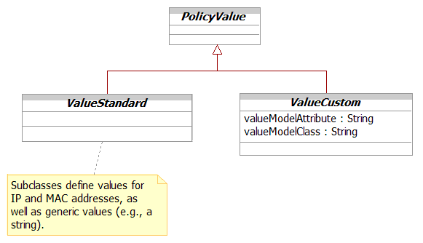
Figure 1P- . PolicyValues in More Detail
Note the similarity in the basic design approach between PolicyVariables (shown in Figure 1P- above) and PolicyValues (shown in Figure 1P- above).
The ValueStandard class is an abstract base class for defining a set of standardized PolicyValues. This set of PolicyValues will be added to over time, and represents a set of common values that are useful in a variety of PBNM applications. The subclasses of ValueStandard are a set of classes that define the semantics of commonly occurring variables that occur in PBNM applications. There are currently six subclasses of the ValueStandard object defined in the DEN-ng model.
The ValueCustom class is an abstract base class that provides two basic attributes to define custom value objects that can be used in an application-specific fashion. These two attributes are called valueModelAttribute and valueModelClass. The valueModelAttribute is a string attribute that defines the name of the attribute within the class specified in the valueModelClass attribute that is to be evaluated or set as a PolicyValue. The valueModelClass is a string attribute that defines the class name whose attribute is to be evaluated or set as a PolicyValue. This combination enables new custom subclasses of ValueCustom to be defined that specify the class and attribute that they are modeling. These new subclasses can be found by users of the current DEN-ng schema by searching for these two properties. That also enables DEN-ng users to immediately understand the purpose of new extensions.
Thus, the combination of valueModelClass and valueModelAttribute enable an application to define a new class that contains an attribute to be used as a PolicyValue. This provides important extensibility, and enables an application to define its own set of classes and attributes to extend the DEN-ng framework.

PolicyConditions
A PolicyCondition is an abstract base class that represents how to form the condition clause of a PolicyRule. This class can be used to represent rule-specific or reusable policy conditions, which are discussed in the sub-section titled Reusable vs. Ad-Hoc Policy Entities later in this section.
Policy conditions are of the form:
{variable, operator, value}
where the operator is usually the MATCH operator, but could be another type (e.g., compare) of operator. This gives the semantics of "IF the condition is TRUE (or FALSE)".
The subclasses of PolicyCondition, along with its recursive aggregation, enable simple and compound (e.g., nested) PolicyConditions to be supported by the same structure.
The ContainedPolicyConditions aggregation is used for two distinct purposes. First, it is used to gather together discrete PolicyConditions to form a PolicyCondition clause. In this usage, a set of individual PolicyConditionAtomic objects are aggregated by one or more PolicyConditionComposite objects.
The second use is to form compound PolicyConditions. In this case, the PolicyConditionAtomic object aggregates PolicyConditionAtomic and/or PolicyConditionComposite objects. The former provides a simple nested PolicyCondition, while the latter provides structure for grouping the sub-conditions. The reason that these two types of entities exist is to provide different evaluation semantics for different types of conditions. This is beyond the scope of this Addendum, but is covered in the system view of the policy model and in [PBNM].
Note that the composite pattern was explicitly not used, so as to enable these rich semantics.
PolicyConditions are shown in Figure 1P- below.
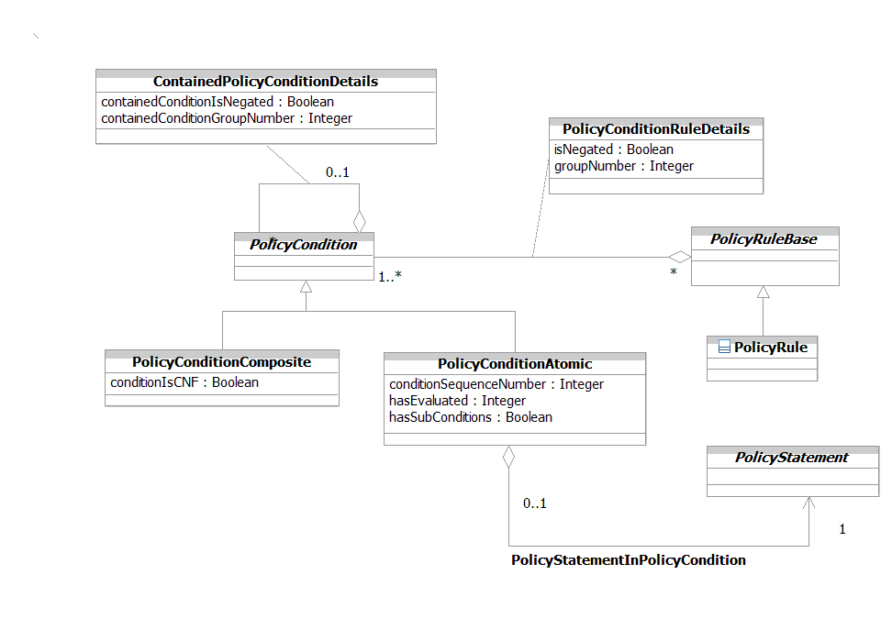
Figure 1P- . PolicyCondition in More Detail

PolicyConditionAtomic
A PolicyConditionAtomic object is the base class for all simple policy conditions. A simple policy condition consists of a single Boolean clause, which is used to test a single condition. This consists of a single occurrence of a PolicyStatement.
This design relies on the PolicyStatement to supply the actual terms to make up the condition clause. Thus, since everything is normalized to a condition clause, no subclasses of PolicyConditionAtomic are needed. Instead, subclasses of the appropriate PolicyStatement classes are provided.
This class has three attributes. The first, conditionSequenceNumber, is a non-negative integer and represents the particular sequence in which this element is parsed as part of the overall policy structure. This will allow a policy engine to reference externally supplied arguments to this object as it is evaluated.
The hasEvaluated attribute is an enumerated integer that is set by a policy application to define the state of evaluation of this policyCondition. This is crucial for realizing the semantics of the DEN-ng finite state machine. This will be documented more in TMF053P.
Finally, the hasSubConditions is a Boolean attribute that, if TRUE, signifies that this PolicyCondition has one or more sub-conditions. Sub-conditions are used to enforce a hierarchical nesting of conditions, so that parent conditions may control the evaluation and other semantics of the sub-conditions that they contain.

PolicyConditionComposite
A PolicyConditionComposite entity consists of one or more PolicyConditions contained inside a higher-level PolicyConditionComposite entity. This is also called a compound PolicyCondition.
Conceptually, this is a stand-alone object that consists of one PolicyCondition that provides an overall context for either a nested or a group of subordinate PolicyConditions to be evaluated.
The PolicyConditionComposite class is designed to be an intelligent container. The PolicyConditionComposite class is the base class for all complex policy conditions. A complex policy condition consists of an aggregation of PolicyConditionAtomic and/or PolicyConditionComposite objects, which in turn form a complex Boolean statement. It is important to note that such an object still evaluates to a single Boolean TRUE or FALSE value.
The conditionIsCNF attribute is used to define the overall structure of the PolicyCondition. If this attribute is TRUE, then the structure is defined to be conjunctive normal form (i.e., an AND of ORs). Otherwise, it is disjunctive normal form (an OR of ANDs).
The PolicyConditionRuleDetails class is used to implement the semantics needed for the PolicyConditionInPolicyRule aggregation. This aggregation defines the set of PolicyConditions that are contained in this PolicyRule. In other words, this class describes how the overall condition clause appears to the PolicyRule.
In contrast, the ContainedPolicyConditionDetails class is used to implement the semantics needed for the ContainedPolicyConditions aggregation. This aggregation defines the set of PolicyConditions that are contained in this PolicyCondition.
Note that the ContainedPolicyConditionDetails class and the PolicyConditionRuleDetails class have conceptually the same attributes. This is because they both provide semantics to form a condition expression. The difference lies in their placement relative to the PolicyRule class. That is, the ContainedPolicyConditionDetails class is used to combine individual expressions within a condition clause, whereas the PolicyConditionRuleDetails class is used to describe how the completed condition clause appears to the PolicyRule. These attributes are described in the Data Dictionary section of this Addendum.

PolicyActions
PolicyAction is an abstract base class that represents how to form the action clause of a PolicyRule. This consists of a single occurrence of a PolicyStatement, which is of the form: {variable, operator, value}. It is shown in Figure 1P- below.
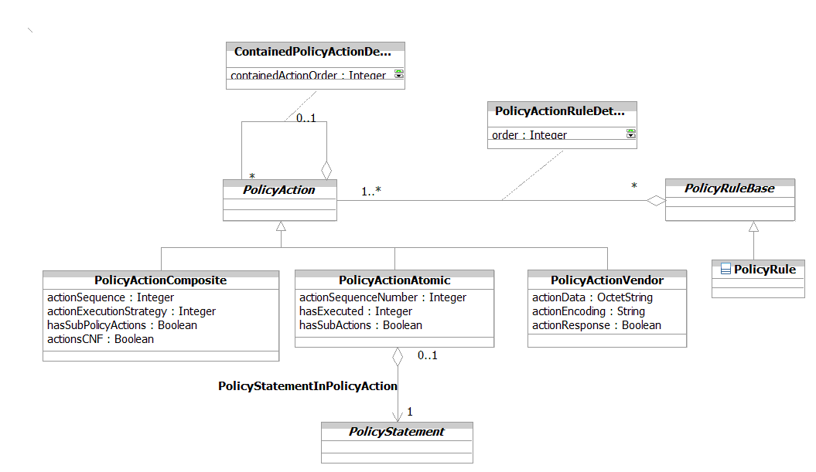
Figure 1P- . PolicyAction in More Detail
Policy actions have the semantics of "SET variable to value", which is implemented by a PolicyStatement. In order to provide flexibility, DEN-ng defines two types of actions:
- pass actions are invoked if the condition clause was TRUE
- fail actions are invoked if the condition clause was FALSE

For simplicity, this Addendum will discuss the former type of actions (i.e., “pass actions”) only.
The ContainedPolicyActions aggregation is used for two distinct purposes. First, it is used to gather together discrete PolicyActions to form a PolicyAction clause. In this usage, the set of individual PolicyActionAtomic objects are aggregated by a PolicyActionComposite object.
The second use is to form compound PolicyActions. In this case, the PolicyActionAtomic object aggregates PolicyActionAtomic and/or PolicyActionComposite objects. The former provides a simple nested PolicyAction, while the latter provides structure for grouping the sub-actions that are dependent on a higher-level action.
The PolicyActionInPolicyRule aggregation defines the set of PolicyActions that are contained in this PolicyRule. This aggregation is implemented as a class in order to capture additional semantics that define how the PolicyActions operate.
A PolicyRule is considered malformed unless it defines at least one PolicyAction term. This is because otherwise, there is nothing for the PolicyRule to do.
The PolicyActionRuleDetails and ContainedPolicyActionDetails implement the semantics of the PolicyActionInPolicyRule and ContainedPolicyActions aggregations, respectively. Both of these classes define an attribute (order and containedActionOrder, respectively) that can be used to prioritize the execution order of PolicyActions in a PolicyRule. The difference is that the ContainedPolicyActionDetails is used to prioritize the execution of PolicyActions for nested and grouped PolicyActions.

PolicyActionAtomic
The PolicyActionAtomic class is the base class for all simple PolicyActions. A simple PolicyAction consists of a single Boolean clause, which is used to perform a single action. This consists of a single occurrence of a PolicyStatement, which is of the form:
{SET | CLEAR} PolicyVariable to PolicyValue
The above is an example of an action type of PolicyStatement. The fact that a PolicyActionAtomic contains a PolicyStatement is a distinguishing characteristic of the PolicyActionAtomic class. It is distinctly different from the PolicyActionVendor, which does not use a PolicyStatement, and from PolicyActionComposite, which contains multiple PolicyAction objects.
The PolicyActionAtomic class has three attributes. The actionSequenceNumber attribute is a non-negative integer and represents the particular sequence in which this element is executed as part of the overall policy structure. This will allow a policy engine to reference externally supplied arguments to this object as it is executed.
The hasExecuted attribute is an enumerated integer that is set by a policy application to define the state of execution of this policyAction. Different values define whether this entity has executed or not, and whether any errors were associated with its execution.
Finally, hasSubActions is a Boolean attribute that, if TRUE, signifies that this PolicyAction has one or more sub-actions. Sub-actions are used to enforce a hierarchical nesting of actions, so that parent actions may control the evaluation and other semantics of the sub-actions that they contain.
The PolicyStatementInPolicyAction aggregation models the binding of a PolicyStatement object to a PolicyActionAtomic object. It is implemented as an aggregation (instead of an association) to emphasize the whole-part nature of this relationship.
The PolicyStatement serves as the main body of the PolicyActionAtomic object. This means that the design of the PolicyActionAtomic object is simplified - the PolicyActionAtomic object becomes an intelligent container that adds semantics to the PolicyStatement.

PolicyActionComposite
PolicyActionAtomic objects can also be used to form more complex action structures. A PolicyActionComposite object can be used to contain a group of PolicyActionAtomic objects - this grouping enables multiple PolicyActionAtomic objects to be executed as a group. Alternatively, a PolicyActionAtomic object can contain one or more PolicyActionAtomic objects (and also PolicyActionComposite groups if desired) to provide the semantics of a nested PolicyAction. The difference is that a group of PolicyActions (i.e., PolicyActions contained in a PolicyActionComposite) are executed as a discrete set of actions, whereas a nested PolicyAction (i.e., PolicyActions embedded in another PolicyAction) execute as sub-actions of one larger action.
The PolicyActionComposite class is the base class for serving as a generic container in which to place PolicyActionAtomic, PolicyActionVendor, or PolicyActionComposite classes. The first two provide actions that this container groups, while the latter establishes a hierarchy in which to order the execution of PolicyActions. Each of these objects is linked to this object using the ContainedPolicyActions association.
The actionSequence attribute fulfills the same purpose as the actionSequenceNumber attribute of the PolicyActionAtomic class; the difference is that the actionSequence attribute applies to the entire PolicyActionComposite object.
The actionExecutionStrategy attribute is an enumerated integer that defines the execution strategy to be used upon the sequenced actions aggregated by this PolicyActionComposite object. Four different execution strategies are defined in this version of this spec. "Do Until Success" means that actions should be executed according to their predefined order, until successful execution of a single action. At that point, the process should stop (even if there are additional actions that could be executed). "Do All" means that all actions should be executed that are part of the set, according to their predefined order. This should continue, even if one or more of the actions fails. In contrast, "Do Until Failure" means that actions should be executed according to their predefined order until an action fails to execute. At that point, the entire sequence should be stopped. Finally, "Do All Without Failure or Do Nothing" means that ALL actions specified should be performed. However, if a failure occurs, then NONE of the actions should be performed. This implies EITHER the ability to look-ahead and ensure that the actions will be able to be performed successfully, or the ability to perform a rollback of that action and all previous actions when an error is encountered.
Finally, hasSubPolicyActions is a Boolean attribute that, if TRUE, signifies that this PolicyAction has one or more sub-actions. Sub-actions are used to enforce a hierarchical nesting of actions, so that parent actions may control the evaluation and other semantics of sub-actions that they contain.

PolicyActionVendor
The PolicyActionVendor class is a concrete base class that provides a general extension mechanism for representing PolicyActions that have not been modeled with the attributes specified in this model. This class uses two of its properties (actionData and actionEncoding) for defining the content and format of a vendor-specific condition. Its third property (actionResponse) is used to provide a standard result, so that this object can be placed with other PolicyAction objects in a PolicyRule object. Standardized extensions are not expected to use this class.

Reusable vs. Ad-Hoc Policy Entities
There are two fundamental ways in which a particular policy element (i.e., a PolicyCondition, PolicyAction, PolicyEvent, PolicyStatement, PolicyRule, or PolicyGroup, or any of their subclasses) is intended to be used. A reusable policy element is one that is designed to be used by multiple applications (or even multiple other policy elements). In contrast, an ad-hoc policy element is one that is not designed to be reusable. Conceptually, ad-hoc policy elements are designed to be used in a stand-alone fashion. An ad-hoc PolicyCondition, PolicyAction, or PolicyEvent can be thought of as being embedded inside a PolicyRule. Similarly, an ad-hoc PolicyStatement can be thought of as being embedded within either a PolicyCondition or a PolicyAction, and so forth.
The different class hierarchies reviewed up to this point are all inherently suitable as either reusable or ad hoc policy elements. This means that the only difference between building a reusable versus an ad-hoc policy element is in how that policy element is accessed and used.
Reusable policy elements need to be generally accessible by multiple applications. This is subject, of course, to access control and other security requirements. Therefore, it makes sense to define the concept of a Reusable Policy Container – a common repository that can be used to contain policy elements that are intended to be reusable. This enables such reusable policy elements to be easily managed and queried for. In contrast, ad-hoc policy elements should probably be placed in the same area of the local data store that contains the containing policy element.
It should be emphasized that this does not change the design of any of the previously described class hierarchies. Reusability is in the eye of the developer, and the only thing that changes is the intent of the developer to treat this policy element as a reusable policy element.
The fact that a policy element is reusable means that it will be accessed from a common repository. This means that potentially, a reusable PolicyRule whose elements are all reusable will take multiple accesses from this repository in order to retrieve all of its reusable policy elements so that it can then be processed. This is compared with an ad hoc PolicyRule, which could conceivably be stored and retrieved as a single atomic object.

The Policy Application ABE
The purpose of this section is to describe how policy can be used to build a policy based management system. The reader is encouraged to read [PBNM] and [053P] when they are available.

PolicyApplication
A PolicyApplication is a special type of entity for use in policy-based management applications (please see [PBNM] for a thorough treatment of the classes mentioned in this section).

Introduction
Figure 1P- shows how policy applications interact with managed entities.
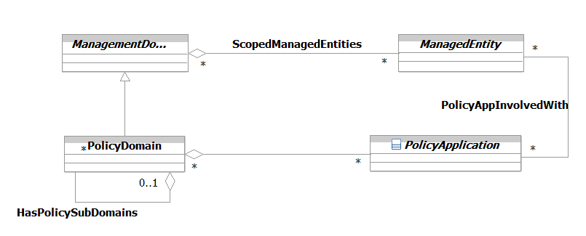
Figure 1P- . Interaction of PolicyApplication with the Rest of the Managed Environment
The ScopedManagedEntities aggregation defines the set of ManagedEntities that are contained in a particular ManagementDomain.
The ScopedPolicyApplication aggregation defines which PolicyApplications are scoped by a particular PolicyDomain. This is an important concept, as this controls what PolicyApplications can work on what ManagedEntities. Note that containment in a ManagementDomain implies the ability for said ManagedEntities to be managed by a particular PolicyApplication. The HasPolicySubDomains recursive aggregation enables hierarchies of PolicyDomains to be constructed. This is particularly useful for associating organizational hierarchies to PolicyApplications.
The logic behind scoping in general, and the ScopedPolicyApplication and ScopedManagedEntities aggregations, is complicated and not suitable to a business discussion. This will be documented in the system view of this Addendum and in [053P] as well. In addition, reference [PBNM] discusses applications of this logic and provides some useful examples.
The PolicyAppInvolvedWith association defines the set of PolicyApplications that are involved with processing policy decisions and performing policy actions on a set of ManagedEntities. Note that this association does NOT imply an action being taken on a ManagedEntity. Rather, it shows that a PolicyApplication is involved with applying policy to a particular ManagedEntity. For example, a policy-based management system may be measuring the performance of a particular ManagedEntity, so that policy can be used to change its configuration if the performance violates an associated SLA. The monitoring PolicyApplication is not applying actions to the ManagedEntity – rather, it is performing monitoring on the ManagedEntity so that another PolicyApplication can correct the operation of the ManagedEntity if needed.

The PolicyApplication Class
The PolicyApplication class is used as a convenient point for defining relationships to different managed entities. It has four principal subclasses: PolicyServer, PolicyDecisionPoint (PDP), PolicyExecutionPoint (PXP) and PolicyEnforcementPoint (PEP). This is shown in Figure 1P- below.
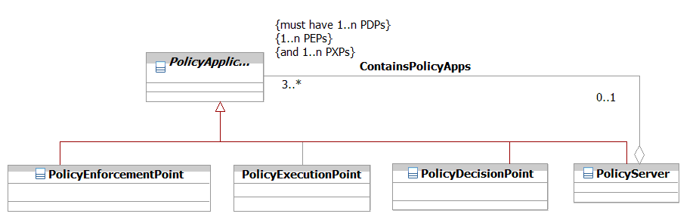
Figure 1P- . PolicyApplication and Its Subclasses

Figure 1P- has been simplified by removing all relationships except the ContainsPolicyApps aggregation. The OCL expression shown in the ContainsPolicyApps aggregation ensures that a PolicyServer has at least one or more PolicyDecisionPoints, PolicyExecutionPoints, and PolicyEnforcementPoints. This is the minimum amount of functionality required to specify a PolicyServer. Note that a PolicyServer can have additional functionality specified; however, that is only relevant in the system view, and hence will not be discussed further in this document.

PolicyServer
Of the four subclasses of PolicyApplication, the PolicyServer is the application that operates at the highest level. A PolicyServer is a fundamental building block of a policy-based management system. It represents both a set of core functionality for implementing policy as well as a unit of distribution in a distributed implementation.
With respect to functionality, a PolicyServer is an entity that is either manufactured or is constructed by integrating the functionality of different PDPs, PXPs, PEPs, and other applications. These other applications provide the logic to manage and control the set of PDPs, PXPs, and PEPs that constitute a PolicyServer. For example, conflict detection and resolution need to be applied. The ContainsPolicyApps aggregation defines the set of PolicyApplications that are contained in this particular PolicyServer. Please refer to [PBNM] and to [053P] for more information.
The cardinality of this relationship is 0..1 on the PolicyServer side and 3..n on the PolicyApplication side. This means that PolicyApplications can be developed independently of a PolicyServer. However, a PolicyServer must at least have a PolicyDecisionPoint, a PolicyEnforcementPoint, and a PolicyExecutionPoint (PDP, PEP, and PXP, respectively) in order to have the functionality of a PolicyServer. This is indicated by the OCL expression in the figure.
Therefore, a PolicyServer is in reality an intelligent container that contains its own management logic that is supplemented by the functionality of the PEP, PXP, and PDP applications. It usually corresponds to a single PolicyDomain. While this is not strictly necessary, doing otherwise greatly complicates the resulting management logic.
Figure 1P- shows a simplified view of the primary functions present in a PolicyServer. This functionality is beyond the scope of this Addendum – the reader is encouraged to read TMF053 and [PBNM].

Technology
PDP #1
Technology
PDP #1
Technology
PDP #1
Technology
PDP #1
Technology
PDP #1
Technology
CDR #1
Technology
PDP #1
Technology
CDR #1
Technology
PDP #1
Technology
PDP #1
Policy
Execution
Policy
Enforcement
Policy
Enforcement
Policy
Enforcement
Input Policy
Translation Logic
Policy
Validation Logic
Local Server Conflict Resolution
Local Server Control Logic
Policy
Repository
Figure 1P- . Anatomy of a PolicyServer

PolicyBroker
PolicyServers affect ManagedEntities in a particular PolicyDomain, and are coordinated through a PolicyBroker. The purpose of the PolicyBroker is to control how different PolicyServers interact with each other. In this regard, it has two different functions.
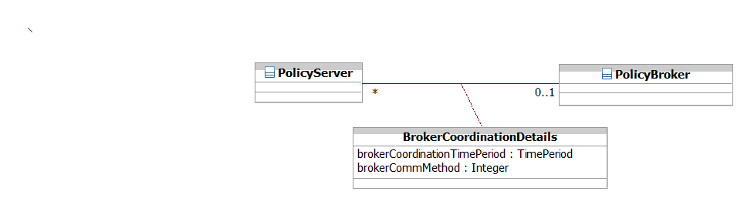
The first function is to ensure that conflicts between different policy rules don't exist when different Policy Servers are asked to work together. The second is to coordinate the application of different policies in different Policy Servers.

Figure 1P- . PolicyBroker Functionality
The BrokerCoordinates association defines the set of PolicyServers that this PolicyBroker coordinates the actions of. The semantics of this association are implemented by an association class, called BrokerCoordinationDetails. Two of its attributes are shown for illustrative purposes. The brokerCoordinationTimePeriod attribute defines the time during which a PolicyBroker is allowed to coordinate the actions of a particular PolicyServer. This is defined in more detail in the DEN-ng system view. Basically, there is another association between the BrokerCoordinationDetails class and an entity that contains policies to define the details of how the coordination is made (e.g., how the PolicyServer and PolicyBroker authenticate with each other, and so forth. Clearly, these are system issues and beyond the scope of this Addendum.
The brokerCommMethod defines the particular protocol used between the PolicyBroker and a particular PolicyServer. While in principle multiple communication protocols could be supported, it is most common for a single protocol to be used.

PolicyDecisionPoint (PDP)
A PolicyDecisionPoint is a type of PolicyApplication. It makes policy decisions for itself or for other entities that request such decisions, such as PolicyEnforcementPoints (PEPs) and PolicyExecutionPoints (PXPs). One or more PolicyDecisionPoints are contained in a PolicyServer.
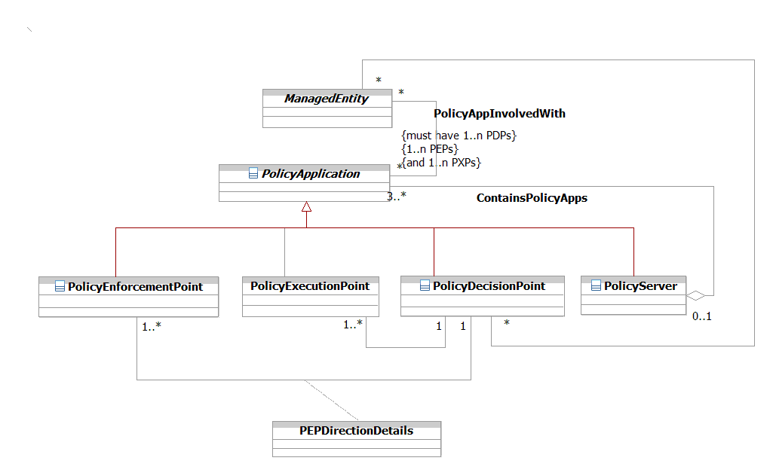
Figure 1P- . Principal Relationships of a PolicyDecisionPoint
PDPs use policies to configure or answer queries from policy-capable network elements or from an operator of the PBNM system. An example of a query is an RSVP admission request – a decision must be made to either accept or reject the request by the receiving network element. Since the network element doesn’t have any idea about the overall state of the network, it makes a request of the PDP, asking the PDP if the RSVP request should be allowed. Thus, the PDP serves as the interface between the network and higher level processes.
The PolicyDecisionRequestedBy association defines the set of PolicyDecisions that are requested by a ManagedEntity. The semantics of this association are implemented by the DecisionRequestedDetails association class (not shown in the figure). This starts the management closed loop system by a request for a policy decision. Note that the full model allows for events and other entities to request policy decisions, not just ManagedEntities.
The DirectsExecutionOf association defines the set of PolicyExecutionPoints that a given PolicyDecisionPoint can direct.
The cardinality of this association is 1 on the PolicyDecisionPoint side and 1..n on the PolicyExecutionPoint side. This means that a PolicyDecisionPoint can provide decisions for one or more PolicyExecutionPoints (note that without a PolicyExecutionPoint, a PolicyDecisionPoint is useless). However, if multiple PolicyDecisionPoints are allowed to tell a given PolicyExecutionPoint what to do, then there is no guarantee that the PolicyDecisionPoints won't conflict with each other. Thus, there can only be one PolicyDecisionPoint for a given PolicyExecutionPoint.
Similarly, the DirectsEnforcementOf association defines the set of PolicyEnforcementPoints that a given PolicyDecisionPoint can direct.
Note that there are separate associations that define which PolicyExecutionPoints and PolicyEnforcementPoints a particular PDP can control. This is because in the system view, there is a difference between instructing an application to change the configuration of a managed object versus instructing an application to monitor a particular managed object. Modern systems need the flexibility to define different roles and responsibilities for these two functions. Therefore, the semantics of the three associations that involve a PDP (i.e., the DirectsExecutionOf, DirectsEnforcementOf, and PolicyActionPerformedOn associations) are implemented as association classes. The interested reader is referred to [PBNM] for more details.

PolicyExecutionPoint (PXP)
A PolicyExecutionPoint is an entity that is used to execute a prescribed set of PolicyActions on a set of PolicyTargets. The PolicyExecutionPoint is an entity that executes a policy decision given to it by a PDP. A high-level drawing of the PXP and its important relationships is shown in Figure 1P- below.
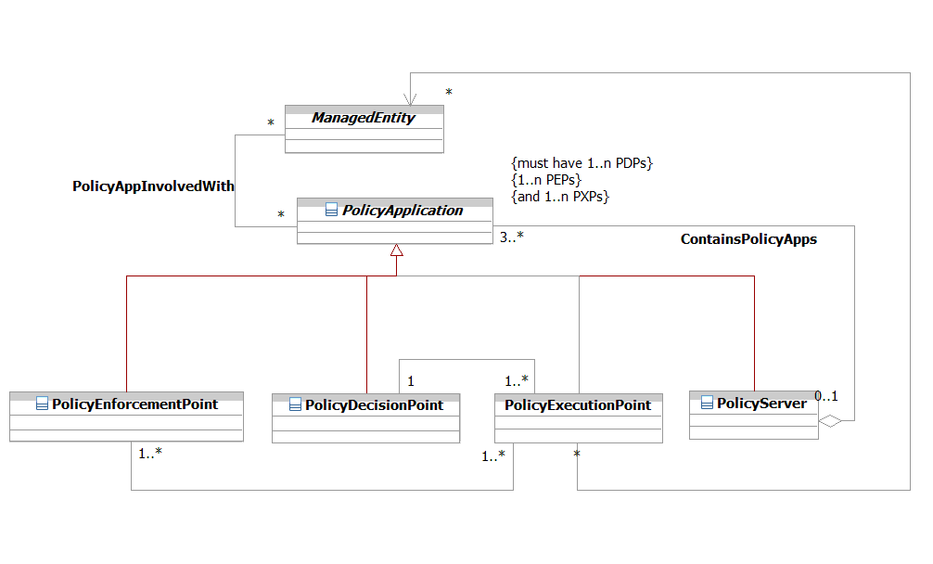
Figure 1P- . Principal Relationships of a PolicyExecutionPoint
The PolicyActionPerformedOn association defines the set of PolicyActions that are performed on a ManagedEntity as a part of the policy management process. The semantics of this association are implemented by the PolicyActionPerformedDetails association class (not shown in the figure). The system view of the DEN-ng model defines much more detailed semantics to implement this association, such as policies that control what types of actions can be performed on which entities during what time periods. However, this is beyond the scope of this Addendum, and consequently is not shown in Figure 1P- above. The interested reader is encouraged to read TMF053P and [PBNM] for more information.
The EnforcesExecutionOf association defines the set of PolicyExecutionPoints whose actions are enforced by a particular PolicyEnforcementPoint.
In contrast to the DirectsExecution association, the cardinality of this association is 1..n on both sides. Each side is 1..n because all PolicyExecutionPoints must have at least one associated PolicyEnforcementPoint, but may have more (if, for example, different PolicyEnforcementPoints are used for different functions that are controlled in a PolicyExecutionPoint). This ensure that the PolicyActions sent by a PolicyExecutionPoint can be checked (by the PolicyEnforcementPoint). Some PolicyEnforcementPoints, however, are capable of enforcing multiple PolicyExecutionPoints, and a PolicyEnforcementPoint is only relevant if it enforces the actions of a PolicyExecutionPoint.
The semantics of the EnforcesExecutionOf association are implemented by the PXPEnforcementDetails association class (not shown in the figure). This association defines the set of PolicyExecutionPoints whose actions are enforced by this PolicyEnforcementPoint. However, its description is beyond the scope of this Addendum, and consequently is not shown in Figure 1P- above.
Note that the EnforcesExecutionOf, DirectsExecutionOf, and PolicyActionPerformedOn associations are all implemented by association classes. This is because each of these associations has rich semantics that require a class to be properly expressed. The interested reader is encouraged to read TMF053P and [PBNM] for more information.

PolicyEnforcementPoint (PEP)
A PolicyEnforcementPoint is a type of PolicyApplication, and is used to verify that a prescribed set of PolicyActions have been successfully executed on a set of PolicyTargets. A high-level drawing of the PEP and its important relationships is shown in Figure 1P- below.
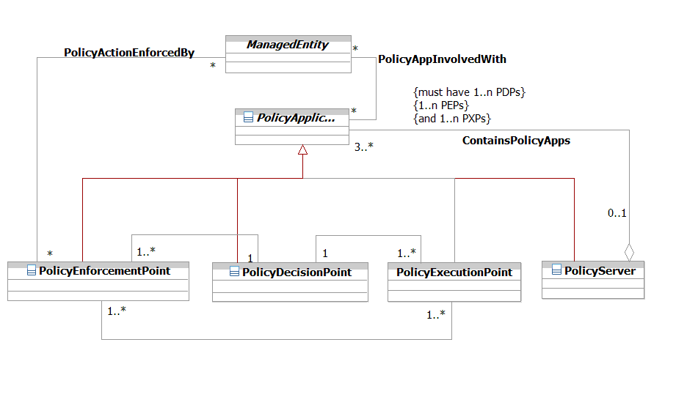
Figure 1P- . Principal Relationships of a PolicyEnforcementPoint
A PolicyEnforcementPoint serves as an interface between the devices that policy is executed on and the policy decision-makers (such as the PolicyDecisionPoint) of the policy. PolicyEnforcementPoints request work to be performed from PolicyDecisionPoints, and then enforce decisions made by PolicyExecutionPoints on their PolicyTargets. One or more PolicyEnforcementPoints are contained in a PolicyServer.
The combination of a PolicyExecutionPoint and a PolicyEnforcementPoint enable the act of executing a decision (made by a PolicyExecutionPoint) to be separated from the act of ensuring that the executing actions were performed correctly, and had the desired results (both of these latter two functions are performed by the PolicyEnforcementPoint).
The EnforcesExecutionOf association defines the set of PolicyExecutionPoints that are enforced by a particular PolicyEnforcementPoint. This association was defined in the previous section, titled PolicyDecisionPoint (PDP).
Note that the DirectsEnforcementOf, EnforcesExecutionOf, and PolicyActionEnforcedBy associations are all implemented by association classes. This is because each of these associations has rich semantics that require a class to be properly expressed. The interested reader is encouraged to read TMF053P and [PBNM] for more information.

Putting It All Together
Figure 1P- shows a combined view of the PolicyApplication entity. All association classes have been suppressed to simplify the figure.
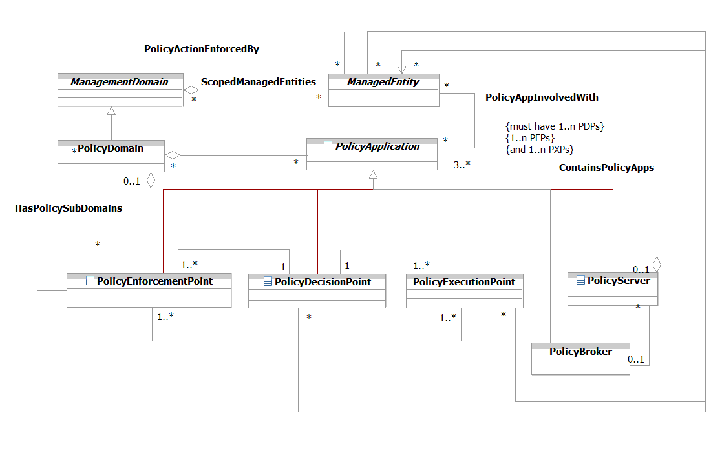
Figure 1P- . Policy Application Framework
Figure 1P- shows a combined view of the PolicyApplication entity, its main subclasses, and important relationships involving them. This is a convenient place to define roles that facilitate defining interactions between policy entities and the rest of the managed environment.
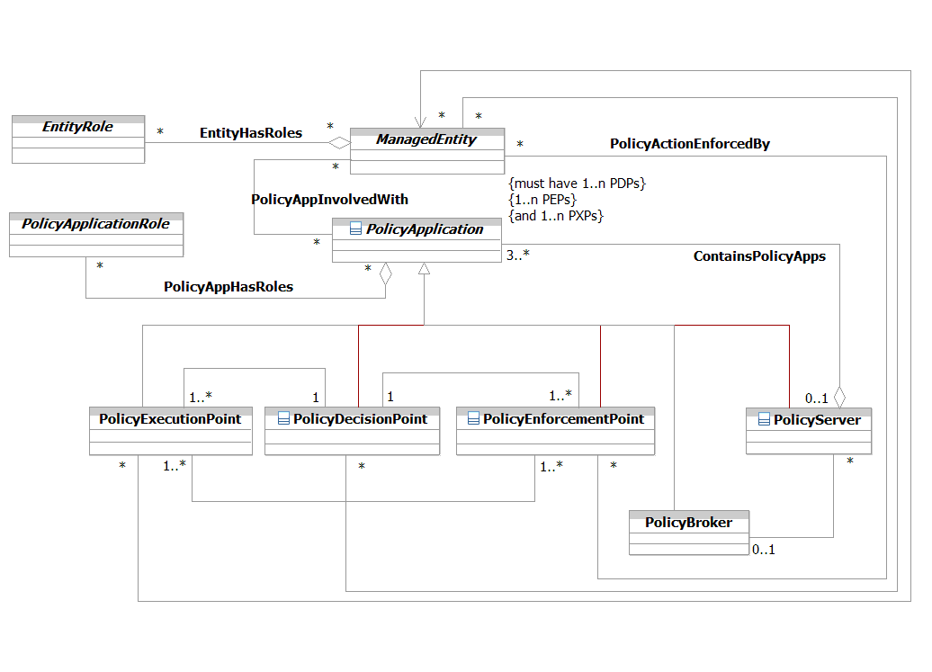
Figure 1P- . Definition of PolicyApplicationRoles
PolicyApplicationRole is an abstract base class that defines the concept of various types of roles used to describe PolicyApplications and their use in the DEN-ng model. This facilitates the use and management of Policy by defining functionality in terms of roles that are played in the managed environment.
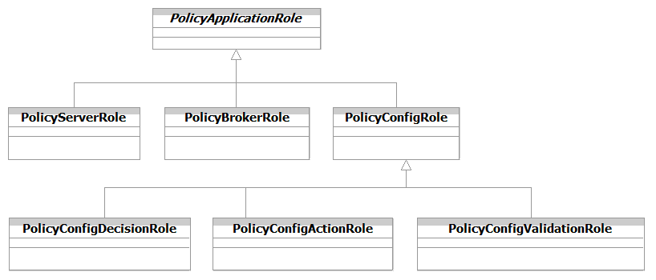
Figure 1P- . Different Types of PolicyApplicationRoles
The above excerpt from the DEN-ng PolicyApplicationRole hierarchy shows a close correspondence between the structure of the PolicyApplication class hierarchy and this hierarchy. This makes perfect sense, as roles are simply a convenient way to represent different sets of functionality. This adds additional flexibility and extensibility to the DEN-ng policy model, as it enables the functionality of different applications to be described using one or more roles. More detail on this concept, as well as PolicyApplicationSpecs, will be available in SID Phase IV and in the SID system view.

The Policy Management ABE
The purpose of this section is to describe how policy can be used to manage different types of managed entities. This version of this Addendum will describe a simple example in which Policy can be used to manage Resources and Services using a PartyRole. The next version of this Addendum will add detail to each of these sections and provide a more detailed definition of these as well as other SID domains. The reader is encouraged to read [PBNM] and [053P] when they are available.
A PartyRole defines the function that a Party takes on. PartyRoles can represent the ability to manage, configure, use, and perform other types of interactions with LogicalResources. A simple starting model is shown in Figure 1P- below. One can see that the Service and Resource management methods are symmetrical.
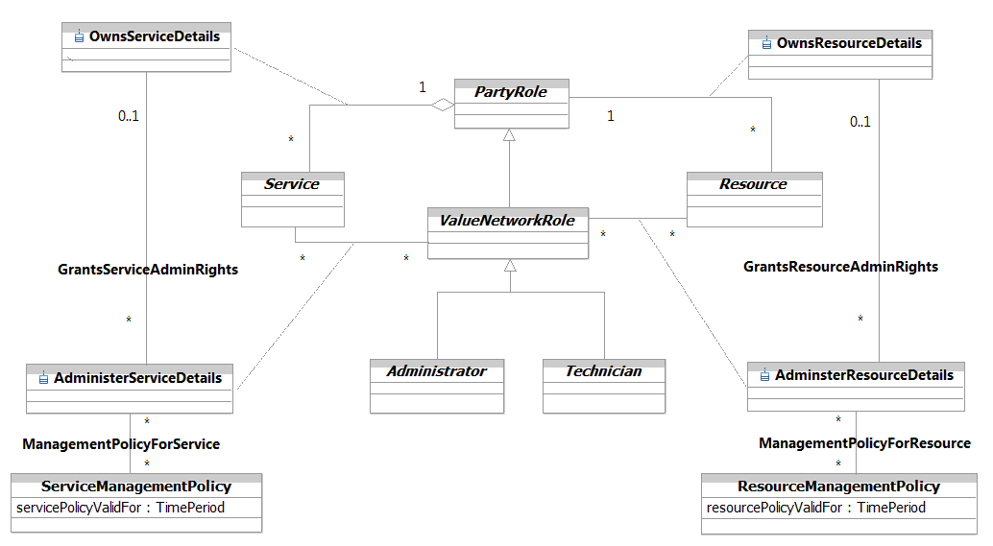
Figure 1P- . Using Policy and PartyRoles to Manage Resources and Services

The OwnsResource association defines the set of Resources (PhysicalResources and/or LogicalResources) that a particular PartyRole owns. Note that this is a very different relationship than the AdministersResource association. The OwnsResource association defines the PartyRole that is the owner of the Resource. Here, “owner” is the person or group that is responsible (e.g., organizational, financial, and so forth) for the Resource. Note that the cardinality of the OwnsResource association on the PartyRole side is 1 - this means that a Resource MUST have at least one PartyRole to manage it. Furthermore, the cardinality of this association on the Resource side is 0..n, which ensures that a PartyRole doesn’t have to own a Resource.
The AdministersResource association defines the set of Resources (PhysicalResources and/or LogicalResources) that a particular Party, playing the role of ValueNetworkRole, administers. From a business perspective, the Owner has to either appoint or give permission to the Administrator to administer the Resource that is owned. This is done using the GrantsResourceAdminRights association. Note that a ValueNetworkRole, not just a PartyRole, is required to administer the Service. This is because a ValueNetworkRole possesses additional skills that a PartyRole doesn’t necessarily have.
The GrantsResourceAdminRights association defines which ValueNetworkRoles are allowed to administer a particular owned Resource. Different ValueNetworkRoles will in general have different administration rights for the same Resource. For example, different types of Administrators will in general each have the ability to make more changes than different types of Technicians.
Policies can be defined for controlling the specific rights of administering a Resource. This is the function of the ResourceManagementPolicy class. Since this is the business view of this relationship, only a simple single attribute is shown.
The ResourceManagementPolicy class defines the particular policies that are used to define how different aspects of the Resource are managed and maintained. For example, assume that a Resource is made up of several different Equipment entities. One of these Equipment entities might require multiple PartyRoles to approve changes to its configuration, whereas another Equipment entity might not require any approvals to change its configuration. Since Policy uses the composite pattern, if a set of Policies are needed, these can be aggregated into a single Policy.
Note the power of this pattern - the ManagementPolicyForResource association, along with its ResourceManagementPolicy class, provide a generic template for defining which set of PartyRoles can perform which type of management function for which type of Resource. Figure 1P- shows that Services and Resources can be managed using the same pattern, even though the contents of the classes will be different.
There is a lot more to the model, but this will be developed further in Phase IV of the SID.

The PolicySpecification ABE
The purpose of this section is to describe how policy templates can be defined. This provides a very important advantage – the ability to define standard templates, or specifications, that can be used to manage different types of managed entities.
Note that there is no PolicySpecification class, since the Policy class is used to define common attributes and relationships that all Policy entities inherit.
The main purpose of all entities in the PolicySpecification ABE, from the business point-of-view, is to provide a standardized structure of the entity that the Spec refers to.

PolicyEventSpecs
PolicyEvents have invariant as well as instance-specific characteristics and behavior. This gives rise to the concept of a PoliicyEventSpec, which is shown in Figure 1P- below.
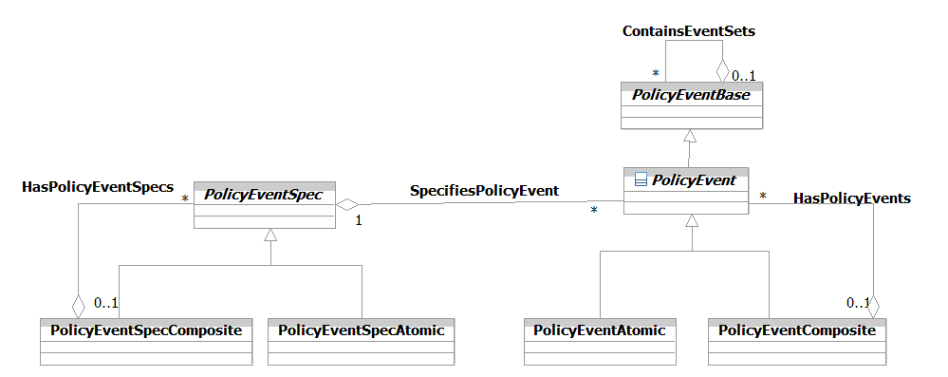
Figure 1P- . PolicyEvent Specifications
A PolicyEventSpec is an abstract base class that is used to define the invariant characteristics and behavior (attributes, methods, constraints, and relationships) of a PolicyEvent. The composite pattern is used to define stand-alone and aggregated PolicyEventSpecs.

PolicyEventSpecType
There are multiple types of PolicyEvents. These may be categorized according to their type, which is shown in Figure 1P- below.
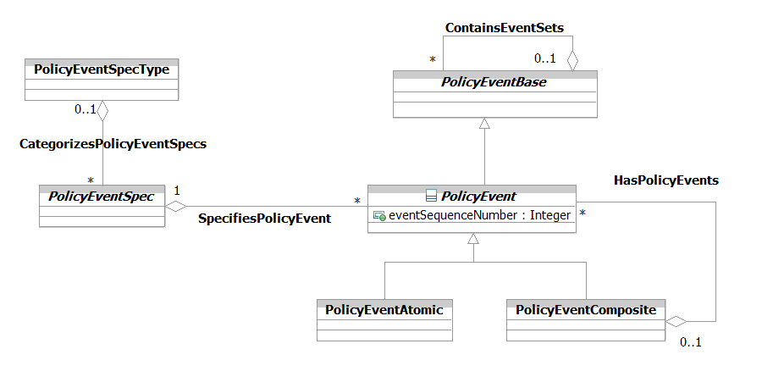
Figure 1P- . Types of PolicyEvents
The PolicyEventSpecType class defines a generic category of PolicyEventSpecs. Each PolicyEventSpecType serves to group a set of particular PolicyEventSpecs that share the same behavior and other semantics. One result of this is to be able to more efficiently define a set of related PolicyEventSpecs that can be grouped together to form a higher-level, or composite, PolicyEventSpec.

PolicySetSpec
This aggregation defines the set of PolicySets that can be defined from a particular PolicySetSpec. This enables the PolicySetSpec to define the invariant attributes, methods, relationships, and constraints that different PolicySets all contain. This standardizes the construction and usage of a PolicySet, and enables different PolicySets to define different variations of the PolicySetSpec to suit the needs of different applications. This is shown in Figure 1P- below.
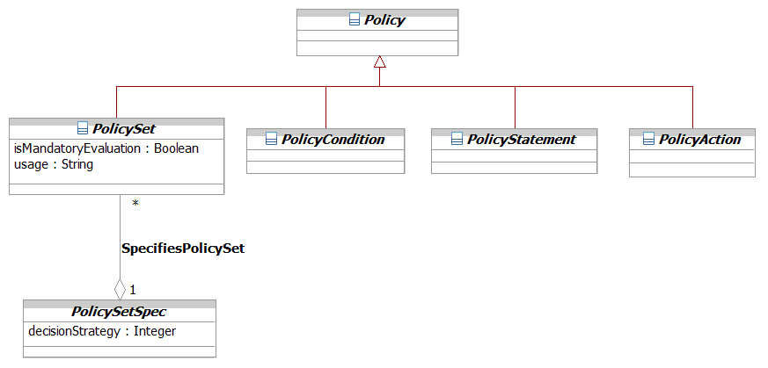
Figure 1P- . Definition of a PolicySetSpec
The PolicySetSpec defines a single attribute called decisionStrategy. This attribute is an enumerated integer that specifies the particular decision strategy to be used in this PolicySet. This attribute defines how PolicyRules in a PolicyGroup or a PolicyRule are to be evaluated.
The values of this attribute can include:
- 0: Unknown
- 1: MatchFirst
- 2: MatchAll
Unknown can be used at initialization time, or if an error occurs, as an easy way to signify that an error in this PolicySet has occurred, since the two legal values of this attribute are MatchFirst and MatchAll.
MatchFirst looks for the first PolicyRule whose condition clause evaluates to TRUE in a PolicySet; and then evaluates that PolicyRule. Policy evaluation in this PolicySet then STOPS, and all subsequent PolicySets are no longer evaluated.
In contrast, MatchAll evaluates all PolicyRules. Those whose condition clauses evaluate to TRUE are (conceptually) put in a bucket. When all PolicyRules have been evaluated, a second pass is performed that executes all of the PolicyRules that are in the (conceptual) bucket. Execution of these rules is controlled through the Priority attribute, which is defined as part of the PolicySetComponent aggregation, and prescribes the order in which the PolicyRules execute.
Thus, a PolicySet can be configured to either execute the first PolicyRule whose condition clause evaluates to TRUE, or to execute all PolicyRules whose condition clauses evaluate to TRUE.
The semantics of this attribute are identical for PolicyGroups as well as for PolicyRules. In a PolicyGroup, this attribute defines how to evaluate the set of PolicyRules that are contained in a PolicyGroup. In a PolicyRule, this attribute defines how to evaluate nested PolicyRules within a higher-level PolicyRule.

PolicyRuleSpec
A PolicyRuleSpec is a concrete base class that is used to define the invariant characteristics (attributes, methods, constraints and relationships) of a PolicyRule entity.
The executionStrategy attribute defines the approach used to execute the actions contained in a given PolicyRule. The sequencedActions attribute defines how the ordering of the contained PolicyActions is to be interpreted (e.g., must execute the PolicyActions in the indicated order or not at all). The last three attributes are generic containers that external applications can use to prescribe any limitations on the types of PolicyActions, PolicyConditions, and PolicyEvents. The external application does this by defining the limitations using an OCL expression, and populating these attributes with that OCL expression. This in turn ensures that a given set of PolicyRules carry standard functionality. This is shown in Figure 1P- below.
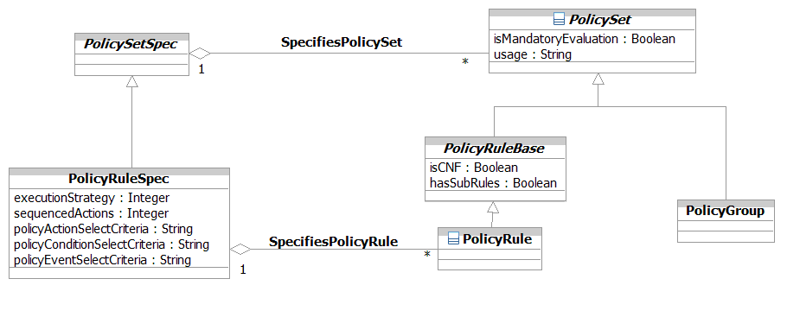
Figure 1P- . Definition of a PolicyRuleSpec

PolicyConditionSpec
A PolicyConditionSpec is a concrete base class that is used to define the invariant characteristics (attributes, methods, constraints and relationships) of a PolicyCondition entity.
There are no business attributes that are currently defined for the PolicyConditionSpec. Its primary function is to define the appropriate structure of PolicyConditions for a given application. This is shown in Figure 1P- below.
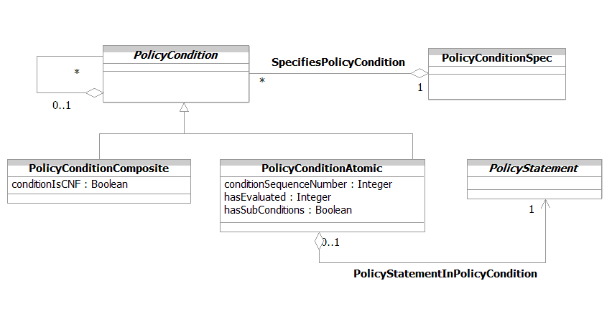
Figure 1P- . Definition of a PolicyConditionSpec

PolicyActionSpec
A PolicyActionSpec is a concrete base class that is used to define the invariant characteristics (attributes, methods, constraints and relationships) of a PolicyAction entity.
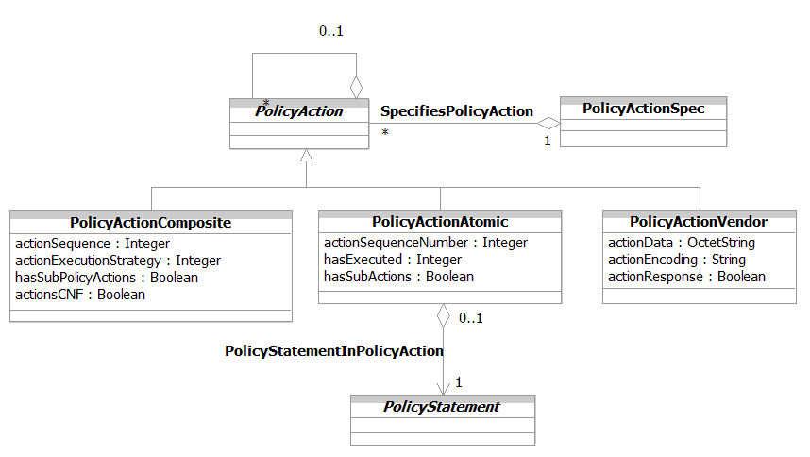
There are no business attributes that are currently defined for the PolicyActionSpec. Its primary function is to define the appropriate structure of PolicyActions for a given application. This is shown in Figure 1P- below.

Figure 1P- . Definition of a PolicyActionSpec

PolicyStatementSpec
A PolicyStatementSpec is a concrete base class that is used to define the invariant characteristics (attributes, methods, constraints and relationships) of a PolicyStatement entity.
There are no business attributes that are currently defined for the PolicyStatementSpec. Its primary function is to define the appropriate structure of PolicyStatements for a given application. This is shown in Figure 1P- below.

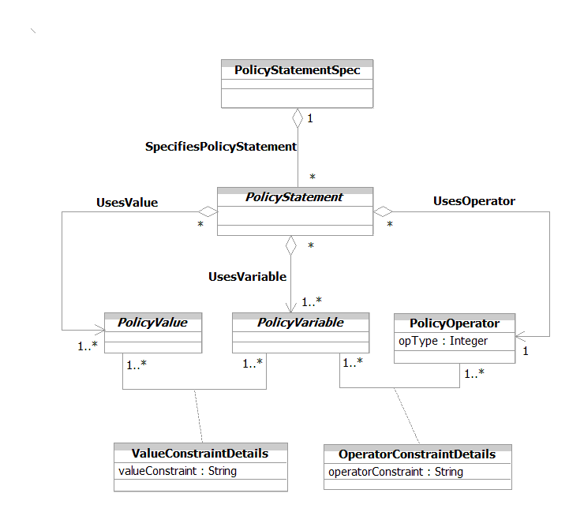
Figure 1P- . Definition of a PolicyStatementSpec

PolicyRules Used in Policy Management Applications
At the highest level of abstraction, the DEN-ng Policy Model consists of four distinct class hierarchies. This corresponds to the structure of the Policy Domain, shown in Figure 1P- .
There are many Policy ABE interactions. However, the relationship between entities in the Policy ABE and entities in the Policy Application ABE is arguably the most important of these.
Conceptually, entities in the Policy Application ABE define how policy is used in the managed environment. Entities in the Policy ABE define how policy is represented. This enables Policies to be defined and used by different management applications. This fundamental relationship is shown in Figure 1P- below, and centers around the definition of the PolicyContainedIn association.
This association defines the set of Policies that reside in a particular PolicyDomain. This single association links Policy and its subclasses to PolicyDomain. PolicyApplications are related to a PolicyDomain throught the ScopesPolicyApplication aggregation. Thus, different subclasses of PolicyApplication, such as PolicyServer, PDP, PEP, and PXP, can be placed in the same PolicyDomain as different Policies. This facilitates their use by different PolicyApplications.
The PolicyAppUsesPolicy association defines the set of Policies that are used by a particular PolicyApplication.
The interested reader is referred to TM Forum 053P and the system view of this Addendum for more details.
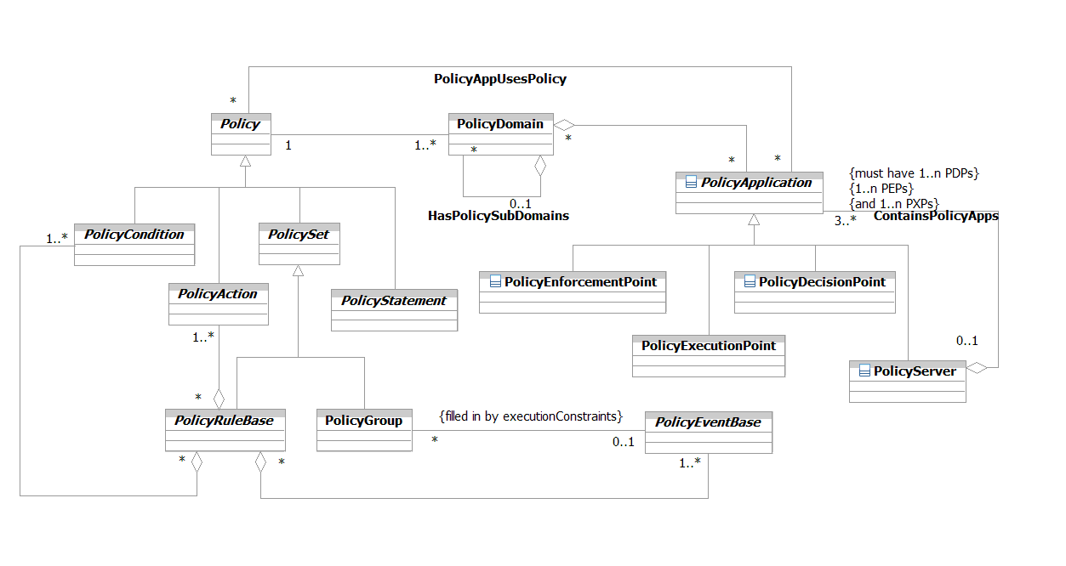
Figure 1P- . Interaction Between Policy and PolicyApplication ABE Entities

References
The following table provides a list of references used in this Addendum.

[PBNM] | J. Strassner, “Policy Based Network Management”, Morgan Kaufman Publishing, ISBN: 1-55860-859-1
[DEN-ng] | J. Strassner, “Directory Enabled Networks New Generation”, to be published
[053Main] | TMF053, “The Frameworx Technology Neutral Architecture”, TM Forum
[053C] | TMF053C, “Frameworx Architecture Technology Neutral Specification – Behavior and Control Services”, TM Forum
[053D] | TMF053D, “Frameworx Architecture Technology Neutral Specification – Metamodel”, TM Forum
[053P] | TMF053P, “Frameworx Architecture Technology Neutral Specification – Policy Management”, to be published Q403
[BDDM] | J. Strassner, “A New Paradigm for Network Management: Business Driven Device Management”, Proceedings of the International Conference on Advances in Infrastructure for e-Business, e-Education, e-Science, e-Medicine, and Mobile Technologies on the Internet, July 2002
[DEN] | J. Strassner, “Directory Enabled Networks”, Macmillan Technical Publishing, ISBN 1-57870-140-6
[eTOM] | GB921 version 2.5
[RFC3060] | B. Moore, E. Ellesson, J. Strassner, A. Westerinen, “Policy Core Information Model -- Version 1 Specification”,  RFC 3060, February 2001
[SGAI] | S. Gai, J. Strassner, D. Durham, S. Herzog, H. Mahon, F. Reichmeyer, “QoS Policy Framework Architecture”,  draft-sgai-policy-framework-00.txt, February 1999
[RFC3460] | B. Moore, L. Rafalow, Y. Ramberg, Y. Snir, J. Strassner, R. Chadha, M. Brunner, R. Cohen, “Policy Core Information Model (PCIM) Extensions”, RFC 3460, January 2003
[QPIM] | Y. Snir, Y. Ramberg, J. Strassner, R. Cohen, B. Moore, “Policy QoS Information Model”, draft-ietf-policy-qos-info-model-05.txt, May 2003
[QDDIM] | B Moore, D. Durham , J. Strassner, A. Westerinen, W. Weiss, “Information Model for Describing Network Device QoS Datapath Mechanisms”, draft-ietf-policy-qos-device-info-model-10.txt, May 2003
[Add 3] | SID Product Model, GB922, Addendum 3
[Add 4SO] | SID Service Overview Model, GB922, Addendum 4SO
[Add 4S-QoS] | SID Quality of Service Overview Model, GB922, Addendum 4S-QoS
[Add 5LR] | SID LogicalResource Model, GB922, Addendum 5LR
[Add 5PR] | SID PhysicalResource Model, GB922, Addendum 5PR
[GB922] | SID Concepts and Principles, GB922 (main document)
[Fowler-AP] | Analysis Patterns – Reusable Object Models by Martin Fowler ISBN 0-201-89542-0  http://martinfowler.com/articles.html
[Fowler-Role] | Dealing with Roles  http://www.awl.com/cseng/titles/0-201-89542-0/apsupp/roles2-1.html
[CIM] | Common Information Model, DMTF  http://www.dmtf.org/standards/standard_cim.php
[CIMPROB] | Mining Information from the DMTF CIM into the TM Forum SID, ed by John Strassner (This was a deliverable from the TM Forum-DMTF liaison)
[N+I2002] | J. Strassner, J. Wheeler, “Policy, DEN, and QoS Workshop”, a two-day tutorial for the  Network World + Interop conference, 2002
[RFC2445]

Business Entity Definitions
NOTE: Entity and attribute definitions, including changes from PIE, can be found in all available Information Framework (SID) model formats. The next release of the SID will move all entity and attribute definitions from domain/ABE addenda to a single addendum containing all definitions. The definitions will be generated from the SID UML model. All model formats will continue to contain definitions.
The following sections will define the business entities referred to in the preceding portion of this Addendum. This section will consist of a business entity definition, definition of any attributes appropriate for the business level, and finally provide a business model in UML of that entity and its main relationships.

Policy Business Entity Definition

Business Entity Name | Policy
Description | This is an abstract base class, and is the root of the Policy DEN-ng model. As such, it defines common attributes, methods and relationships that all policy subclasses use and take part in.
Sources | DEN-ng; BT | Cross- References |  |  | Synonyms / Aliases | This concept is not present in the ITU specs. A simpler version of this class is present in the original DEN spec, as well as in CIM 2.7. However, the structure of the CIM policy model (e.g., superclasses and subclasses) is significantly different than the structure of the DEN-ng policy model.
Related Business Entities | ManagedEntity, ResourceSpecification, Resource, Product, ProductComponent, ProductBundle, Software, Protocol, ResourceLogic, ResourceRole, Service, Party, PartyRole, Location, BusinessInteraction
Business Rules | To be determined

Policy Business Entity Attributes Definition
Business Entity Name | Policy
Attribute Name | Description | Data Type | Characteristics, Permitted  Values & Units | Required/  Optional | Notes (used to map to other models; blank is other models don’t have it)
keywords | This is a string attribute that defines a set of one or more keywords that a policy administrator may use to assist in characterizing or categorizing a policy object to facilitate search operations. | String | Unknown InstallPermissions  ConfigChange InstallMethod  Default Error  Usage InternalError  Security ExternalError  Authentication Notification  Authorization Publish  Accounting Subscribe  Auditing Publish-Subscribe  Service Exception  CustomerFacingService  ResourceFacingService | Optional | Not present in the ITU specs; the CIM defines a PolicyKeyword attribute, but its semantics are very different.
policyName | This is a generic naming attribute that can be used to identify different policy entities. This enables commonName to be used to enforce enterprise or service provider generic naming and this attribute to be used to fine tune the naming of policy entities. Thus, commonName is public in scope and policyName is private to policy. | String |  | Required | Not present in the ITU specs or CIM specs.

Business Entity Model – Policy
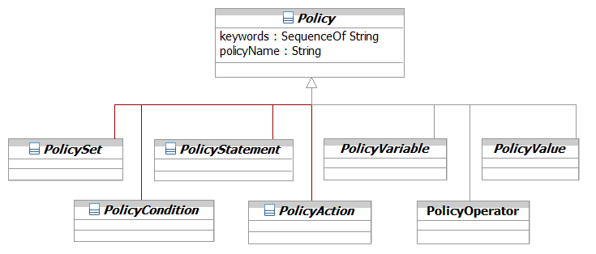
Figure 1P- . Policy Business Entity Model

PolicySet Business Entity Definition

Business Entity Name | PolicySet
Description | This is an abstract class for defining two types of collection classes. PolicyRule collects PolicyEvents, PolicyConditions, and PolicyActions, while PolicyGroup collects PolicyRules and PolicyGroups.  Two important and powerful features of this arrangement are that a PolicySet defines a common decision strategy and a common set of PolicyRoles to be used by the PolicyGroups and the PolicyRules that inherit from it.
Sources | DEN-ng; BT | Cross- References |  |  | Synonyms / Aliases | This concept is not present in the ITU specs. A simpler version of this class is present in the original DEN spec, as well as in CIM 2.7. However, the structure of the CIM policy model (e.g., superclasses and subclasses) is significantly different than the structure of the DEN-ng policy model.
Related Business Entities | ManagedEntity, ResourceSpecification, Resource, Product, ProductComponent, ProductBundle, Software, Protocol, ResourceLogic, ResourceRole, Service, Party, PartyRole, Location, BusinessInteraction, Policy (superclass), PolicyRule (subclass), PolicyGroup (subclass), PolicySetSpec, PolicyRuleSpec
Business Rules | To be determined

PolicySet Business Entity Attributes Definition
Business Entity Name | PolicySet
Attribute Name | Description | Data Type | Characteristics, Permitted  Values & Units | Required/  Optional | Notes (used to map to other models; blank is other models don’t have it)
isMandatoryEvaluation | This is a Boolean attribute that, if TRUE, signifies that evaluation (and possibly action execution) of this entity is mandatory and must be attempted. If the Mandatory property value of this entity is FALSE, then the evaluation of this entity is considered to be "best effort" and may be ignored. | Boolean |  | Required | Not present in the ITU or CIM specs.
Usage | This is a free-form string attribute that recommends how this policy object should be used. | String |  | Optional | Not present in the ITU specs or CIM specs.

Business Entity Model – PolicySet
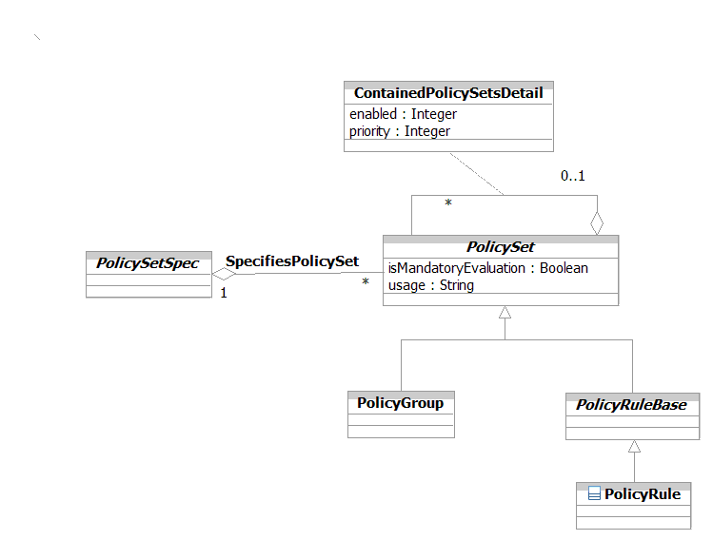
Figure 1P- . PolicySet Business Entity Model

PolicyGroup Business Entity Definition

Business Entity Name | PolicyGroup
Description | This class is a generalized aggregation container. It enables PolicyRules and/or PolicyGroups to be aggregated in a single container. Note that loops, including the degenerate case of a PolicyGroup that contains itself, are not allowed when PolicyGroups contain other PolicyGroups.
Sources | DEN-ng; BT | Cross- References |  |  | Synonyms / Aliases | This concept is not present in the ITU specs. A similar version of this class is present in the original DEN spec, as well as in CIM 2.7. However, the structure of the CIM policy model (e.g., superclasses and subclasses) is significantly different than the structure of the DEN-ng policy model.
Related Business Entities | ManagedEntity, ResourceSpecification, Resource, Product, ProductComponent, ProductBundle, Software, Protocol, ResourceLogic, ResourceRole, Service, Party, PartyRole, Location, BusinessInteraction, Policy, PolicySet (superclass), PolicyRule (sibling), PolicyEvent, PolicySetSpec, PolicyRuleSpec
Business Rules | To be determined

PolicyGroup Business Entity Attributes Definition
There are no business attributes of a PolicyGroup that are currently defined.

Business Entity Model – PolicyGroup
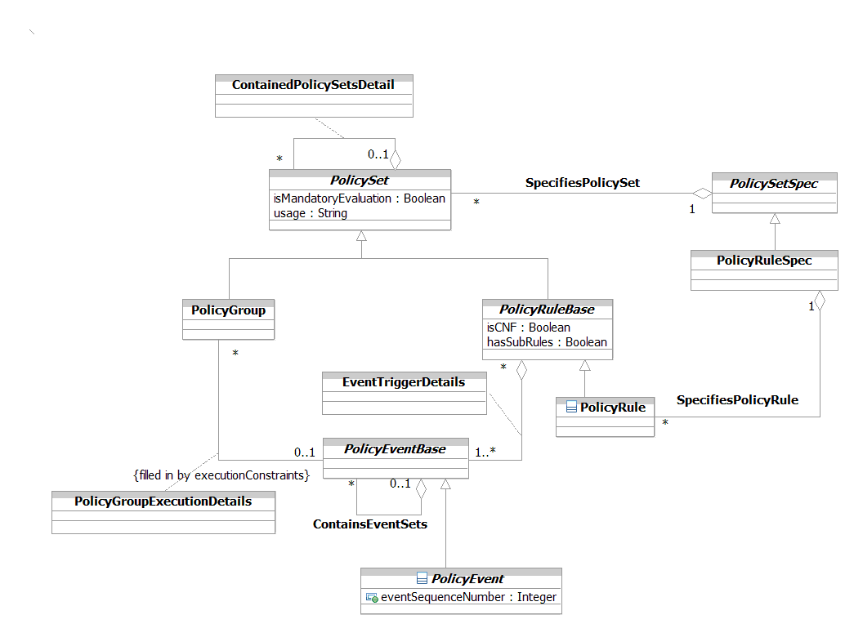
Figure 1P- . PolicyGroup Business Entity Model

PolicyRule Business Entity Definition

Business Entity Name | PolicyRule
Description | This is a concrete base class for realizing the "event-condition-passaction-failaction" semantics that form a DEN-ng policy rule. The semantics of this rule are that the rule is evaluated when an event occurs. If the condition clause is satisfied, then the pass-action clause will be executed (otherwise, the fail-action clause will be executed).  PolicyRules may be nested within PolicyRules. This is often needed in networking (e.g., bandwidth allocation). However, their execution semantics are different than if a PolicyGroup is contained by a PolicyRule.
Sources | DEN-ng; BT | Cross- References |  |  | Synonyms / Aliases | This concept is not present in the ITU specs. A simpler version of this class is present in the original DEN spec, as well as in CIM 2.7. However, the structure of the CIM policy model (e.g., superclasses and subclasses) is significantly different than the structure of the DEN-ng policy model. In addition, the CIM defines attributes as part of a PolicyRule that should instead be defined on associations to a PolicyRule.
Related Business Entities | ManagedEntity, ResourceSpecification, Resource, Product, ProductComponent, ProductBundle, Software, Protocol, ResourceLogic, ResourceRole, Service, Party, PartyRole, Location, BusinessInteraction, Policy, PolicySet (superclass), PolicyRule (sibling), PolicyEvent, PolicySetSpec, PolicyRuleSpec
Business Rules | To be determined

PolicyRule Business Entity Attributes Definition
Business Entity Name | PolicyRule
Attribute Name | Description | Data Type | Characteristics, Permitted Values & Units | Required/  Optional | Notes (used to map to other models; blank is other models don’t have it)
isCNF | This is a Boolean attribute that, if TRUE, defines the condition clause of this rule to be represented in Conjunctive Normal Form (e.g., an AND of ORs). If the value of this attribute is FALSE, then the condition clause will be represented in Disjunctive Normal Form (e.g., an OR of ANDs).  This attribute controls the setting of how multiple condition clauses (as represented by multiple PolicyConditionComposite objects) are treated in the PolicyRule. As such, it is different from the attribute PolicyConditionComposite.IsCNF, which controls how multiple PolicyConditionAtomic objects are treated in a (single) PolicyConditionComposite object. | Boolean |  | Required | Not present in the ITU specs. CIM 2.7 calls this attribute ConditionListType.
hasSubRules | This is a Boolean attribute that, if TRUE, signifies that this PolicyRule has one or more sub-rules. Sub-rules are used to enforce a hierarchical nesting of rules, so that parent rules may control the execution and other semantics of sub-rules that they contain. | Boolean |  | Optional | Not present in the ITU specs or CIM specs.

Business Entity Model – PolicyRule
The business entity model of a PolicyRule is the same as that for a PolicyGroup, which was shown in Figure 1P- above.

PolicyEvent Business Entity Definition

Business Entity Name | PolicyEvent
Description | This class represents a single PolicyEvent or an aggregation of PolicyEvents, constrained according to the eventConstraint attribute of the EventDetails aggregation class. This set of PolicyEvents is then presented to one or more PolicyRules to trigger the evaluation of their condition clauses. This enables an external application, such as a Policy Server, to dynamically adjust the set of events that are being used to trigger the evaluation of a PolicyRule
Sources | DEN-ng; BT | Cross- References |  |  | Synonyms / Aliases | This concept is not present in the ITU or CIM specs.
Related Business Entities | ManagedEntity, ResourceSpecification, Resource, Product, ProductComponent, ProductBundle, Software, Protocol, ResourceLogic, ResourceRole, Service, Party, PartyRole, Location, BusinessInteraction, Policy, PolicySet, PolicyGroup, PolicyRule, PolicyEvent, PolicyEventAtomic (subclass), PolicyEventComposite (subclass), PolicySetSpec, PolicyRuleSpec, PolicyEventSpec, PolicyEventSpecAtomic, PolicyEventSpecComposite
Business Rules | To be determined

PolicyEvent Business Entity Attributes Definition

Business Entity Name | PolicyEvent
Attribute Name | Description | Data Type | Characteristics, Permitted Values & Units | Required/  Optional | Notes (used to map to other models; blank is other models don’t have it)
hasEventEvaluated | This is an enumerated integer that is set by a policy application to define the state of evaluation of this event. | Integer | 0: not yet evaluated  1: evaluated as TRUE  2: evaluated as FALSE | Required | Not present in the ITU or CIM specs.
eventSequenceNumber | This attribute is a non-negative integer and represents the particular sequence in which this event is parsed as part of the overall event clause. This will allow a policy engine to reference externally supplied arguments to this object as it is evaluated. | Integer |  | Required | Not present in the ITU or CIM specs.

Business Entity Model – PolicyEvent
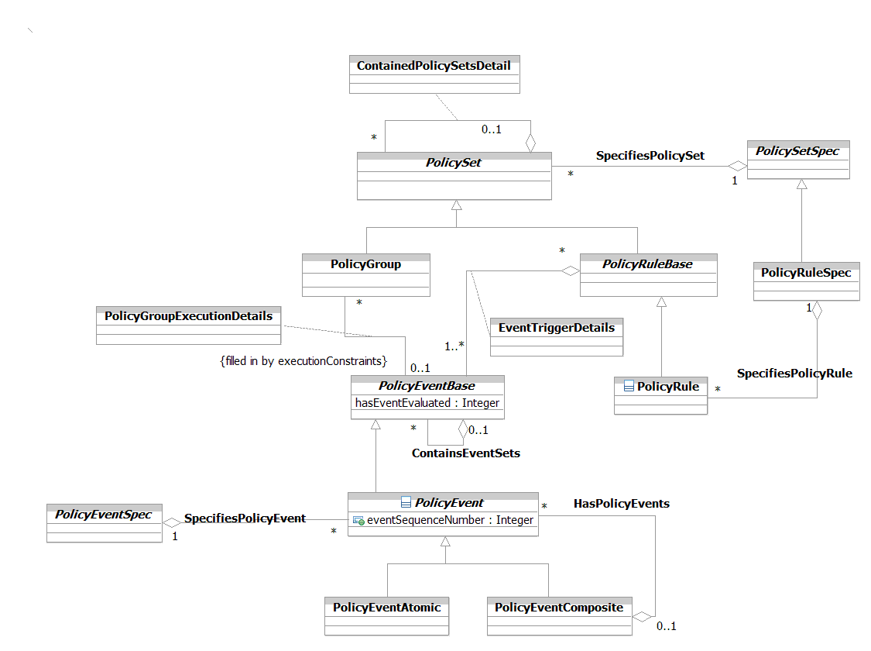
Figure 1P- . PolicyEvent Business Entity Model

PolicyEventAtomic Business Entity Definition

Business Entity Name | PolicyEventAtomic
Description | This is a base class that represents the occurrence of a single atomic event, which is used to trigger the evaluation of the condition clause of a PolicyRule.
Sources | DEN-ng; BT | Cross- References |  |  | Synonyms / Aliases | This concept is not present in the ITU or CIM specs.
Related Business Entities | ManagedEntity, ResourceSpecification, Resource, Product, ProductComponent, ProductBundle, Software, Protocol, ResourceLogic, ResourceRole, Service, Party, PartyRole, Location, BusinessInteraction, Policy, PolicySet, PolicyGroup, PolicyRule, PolicyEvent, PolicyEventComposite (sibling), PolicySetSpec, PolicyRuleSpec, PolicyEventSpec, PolicyEventSpecAtomic, PolicyEventSpecComposite
Business Rules | To be determined

PolicyEventAtomic Business Entity Attributes Definition
At this time, there are currently no business attributes defined for this class.

Business Entity Model – PolicyEventAtomic
The business entity model for a PolicyEventAtomic is the same as that for a PolicyEvent, and was shown in Figure 1P- above.

PolicyEventComposite Business Entity Definition

Business Entity Name | PolicyEventComposite
Description | This is a base class that represents the occurrence of a composite event. A composite event is an event that is made up of a set of PolicyEventAtomic and/or PolicyEventComposite entities. Like a PolicyEventAtomic, a PolicyEventComposite can also be used to trigger the evaluation of the condition clause of a PolicyRule.
Sources | DEN-ng; BT | Cross- References |  |  | Synonyms / Aliases | This concept is not present in the ITU or CIM specs.
Related Business Entities | ManagedEntity, ResourceSpecification, Resource, Product, ProductComponent, ProductBundle, Software, Protocol, ResourceLogic, ResourceRole, Service, Party, PartyRole, Location, BusinessInteraction, Policy, PolicySet, PolicyGroup, PolicyRule, PolicyEvent, PolicyEventAtomic (sibling), PolicySetSpec, PolicyRuleSpec, PolicyEventSpec, PolicyEventSpecAtomic, PolicyEventSpecComposite
Business Rules | To be determined

PolicyEventComposite Business Entity Attributes Definition
At this time, there are currently no business attributes defined for this class.

Business Entity Model – PolicyEventComposite
The business entity model for a PolicyEventComposite is the same as that for a PolicyEvent, and was shown in Figure 1P- above.

PolicyCondition Business Entity Definition

Business Entity Name | PolicyCondition
Description | This is an abstract base class that represents how to form the condition clause of a PolicyRule. This class can be used to represent rule-specific or reusable policy conditions.  Policy conditions are of the form:  {variable, operator, value}  where the operator is usually the MATCH operator, but could be another type (e.g., compare) of operator. This gives the semantics of "IF the condition is TRUE (or FALSE)".  The subclasses of PolicyCondition, along with its recursive aggregation, enable simple and compound (e.g., nested) PolicyConditions to be supported by the same structure.
Sources | DEN-ng; BT | Cross- References |  |  | Synonyms / Aliases | This concept is not present in the ITU specs. The CIM spec doesn’t use the composite pattern, and the structure of the model is significantly different than the structure of the DEN-ng model.
Related Business Entities | ManagedEntity, ResourceSpecification, Resource, Product, ProductComponent, ProductBundle, Software, Protocol, ResourceLogic, ResourceRole, Service, Party, PartyRole, Location, BusinessInteraction, Policy, PolicySet, PolicyGroup, PolicyRule, PolicyEvent, PolicyEventAtomic, PolicyEventComposite, PolicyAction (sibling), PolicyConditionAtomic (subclass), PolicyConditionComposite (subclass), PolicySetSpec, PolicyRuleSpec, PolicyEventSpec, PolicyEventSpecAtomic, PolicyEventSpecComposite, PolicyConditionSpec, PolicyConditionSpecAtomic, PolicyConditionSpecComposite
Business Rules | To be determined

PolicyCondition Business Entity Attributes Definition
At this time, there are currently no business attributes defined for this class. Its primary purpose is to be a convenient point for defining relationships and constraints. Its two subclasses, PolicyConditionAtomic and PolicyConditionComposite, do define attributes.

Business Entity Model – PolicyCondition
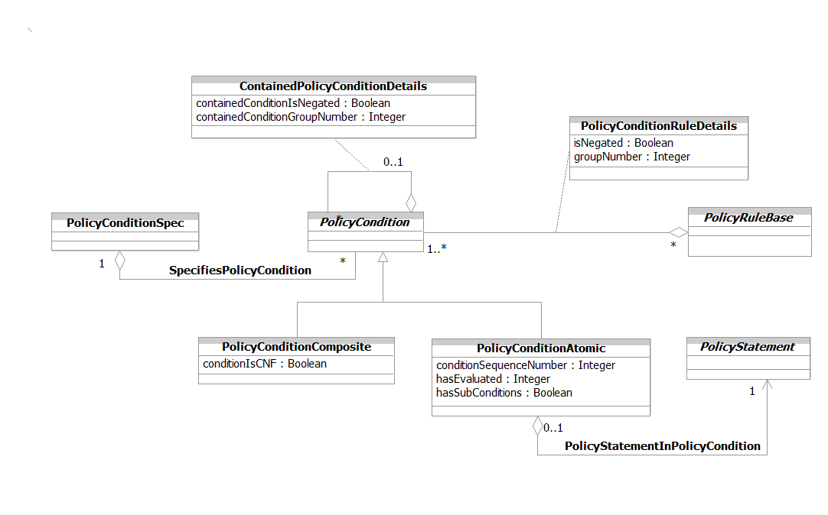
Figure 1P- . PolicyCondition Business Entity Model

PolicyConditionAtomic Business Entity Definition

Business Entity Name | PolicyConditionAtomic
Description | This is the base class for all simple policy conditions. A simple policy condition consists of a single Boolean clause, which is used to test a single condition. This consists of a single occurrence of a PolicyStatement, which is of the form:  {variable, operator, value}  This design relies on the PolicyStatement to supply the actual terms to make up the condition clause. Thus, since everything is normalized to a condition clause, no subclasses of PolicyConditionAtomic are needed. Instead, subclasses of the appropriate PolicyStatement classes are provided.  A compound PolicyCondition consists of one or more PolicyConditions contained inside a higher-level PolicyCondition. These can optionally be grouped by a PolicyConditionComposite object if desired.
Sources | DEN-ng; BT | Cross- References |  |  | Synonyms / Aliases | This concept is not present in the ITU or CIM specs (the CIM spec doesn’t use the composite pattern, and the structure of the model is significantly different than the structure of the DEN-ng model).
Related Business Entities | ManagedEntity, ResourceSpecification, Resource, Product, ProductComponent, ProductBundle, Software, Protocol, ResourceLogic, ResourceRole, Service, Party, PartyRole, Location, BusinessInteraction, Policy, PolicySet, PolicyGroup, PolicyRule, PolicyEvent, PolicyEventAtomic, PolicyEventComposite, PolicyAction, PolicyCondition (superclass), PolicyConditionComposite (sibling), PolicySetSpec, PolicyRuleSpec, PolicyEventSpec, PolicyEventSpecAtomic, PolicyEventSpecComposite, PolicyConditionSpec, PolicyConditionSpecAtomic, PolicyConditionSpecComposite
Business Rules | To be determined

PolicyConditionAtomic Business Entity Attributes Definition

Business Entity Name | PolicyConditionAtomic
Attribute Name | Description | Data Type | Characteristics, Permitted Values & Units | Required/  Optional | Notes (used to map to other models; blank is other models don’t have it)
conditionSequenceNumber | This attribute is a non-negative integer and represents the particular sequence in which this element is parsed as part of the overall policy structure. This will allow a policy engine to reference externally supplied arguments to this object as it is evaluated. | Integer |  | Required | Not present in the ITU specs. CIM 2.7 has a subset of these values.
hasEvaluated | This is an enumerated integer that is set by a policy application to define the state of evaluation of this PolicyCondition. | Integer | 0: not yet evaluated  1: evaluated as TRUE  2: evaluated as FALSE | Optional | Not present in the ITU or CIM specs.
hasSubConditions | This is a Boolean attribute that, if TRUE, signifies that this PolicyCondition has one or more sub-conditions. Sub-conditions are used to enforce a hierarchical nesting of conditions, so that parent conditions may control the evaluation and other semantics of the sub-conditions that they contain. | Boolean |  | Required | Not present in the ITU or CIM specs.

Business Entity Model – PolicyConditionAtomic
The business entity model for a PolicyConditionAtomic is the same as that for a PolicyCondition, and was shown in Error: Reference source not found above.

PolicyConditionComposite Business Entity Definition

Business Entity Name | PolicyConditionComposite
Description | The PolicyConditionComposite class is designed to be an intelligent container. The PolicyConditionComposite class is the base class for all complex policy conditions. A complex policy condition consists of an aggregation of PolicyConditionAtomic and/or PolicyConditionComposite objects, which in turn form a complex Boolean statement. It is important to note that such an object still evaluates to a single Boolean TRUE or FALSE value.  Conceptually, this is a stand-alone object that consists of one PolicyCondition that provides an overall context for either a nested or a group of subordinate PolicyConditions to be evaluated.
Sources | DEN-ng; BT | Cross- References |  |  | Synonyms / Aliases | This concept is not present in the ITU or CIM specs (the CIM spec doesn’t use the composite pattern, and the structure of the model is significantly different than the structure of the DEN-ng model).
Related Business Entities | ManagedEntity, ResourceSpecification, Resource, Product, ProductComponent, ProductBundle, Software, Protocol, ResourceLogic, ResourceRole, Service, Party, PartyRole, Location, BusinessInteraction, Policy, PolicySet, PolicyGroup, PolicyRule, PolicyEvent, PolicyEventAtomic, PolicyEventComposite, PolicyAction, PolicyCondition (superclass), PolicyConditionAtomic (sibling), PolicySetSpec, PolicyRuleSpec, PolicyEventSpec, PolicyEventSpecAtomic, PolicyEventSpecComposite, PolicyConditionSpec, PolicyConditionSpecAtomic, PolicyConditionSpecComposite
Business Rules | To be determined

PolicyConditionComposite Business Entity Attributes Definition

Business Entity Name | PolicyConditionComposite
Attribute Name | Description | Data Type | Characteristics, Permitted Values & Units | Required/  Optional | Notes (used to map to other models; blank is other models don’t have it)
conditionIsCNF | This is a Boolean attribute that, if TRUE, defines the condition clause of this PolicyConditionComposite object to be represented in Conjunctive Normal Form (e.g., an And of Ors). If the value of this attribute is FALSE, then the condition clause will be represented in Disjunctive Normal Form.  This attribute controls the setting of how multiple condition clauses (as represented by individual PolicyConditionAtomic objects) are treated in the PolicyConditionComposite object. As such, it is different from the attribute PolicyRule.IsCNF, which controls how multiple PolicyConditionComposite objects are treated in a PolicyRule object. | Integer |  | Required | Not present in the ITU or CIM specs.

Business Entity Model – PolicyConditionComposite
The business entity model for a PolicyConditionComposite is the same as that for a PolicyCondition, and was shown in Figure 1P- above.

PolicyAction Business Entity Definition

Business Entity Name | PolicyAction
Description | This is an abstract base class that represents how to form the action clause of a PolicyRule. This consists of a single occurrence of a PolicyStatement, which is of the form:  {variable, operator, value}  Policy actions have the semantics of "SET variable to value". There are two types of actions:  - pass actions are invoked if the condition clause was TRUE  - fail actions are invoked if the condition clause was FALSE
Sources | DEN-ng; BT | Cross- References |  |  | Synonyms / Aliases | This concept is not present in the ITU specs. The CIM spec doesn’t use the composite pattern, and the structure of the model is significantly different than the structure of the DEN-ng model.
Related Business Entities | ManagedEntity, ResourceSpecification, Resource, Product, ProductComponent, ProductBundle, Software, Protocol, ResourceLogic, ResourceRole, Service, Party, PartyRole, Location, BusinessInteraction, Policy, PolicySet, PolicyGroup, PolicyRule, PolicyEvent, PolicyEventAtomic, PolicyEventComposite, PolicyCondition (sibling), PolicyActionAtomic (subclass), PolicyActionComposite (subclass), PolicyActionVendor (subclass), PolicySetSpec, PolicyRuleSpec, PolicyEventSpec, PolicyEventSpecAtomic, PolicyEventSpecComposite, PolicyActionSpec, PolicyActionSpecAtomic, PolicyActionSpecComposite
Business Rules | To be determined

PolicyAction Business Entity Attributes Definition
At this time, there are currently no business attributes defined for this class. Its primary purpose is to be a convenient point for defining relationships and constraints. Its two subclasses, PolicyActionAtomic and PolicyActionComposite, do define attributes.

Business Entity Model – PolicyAction
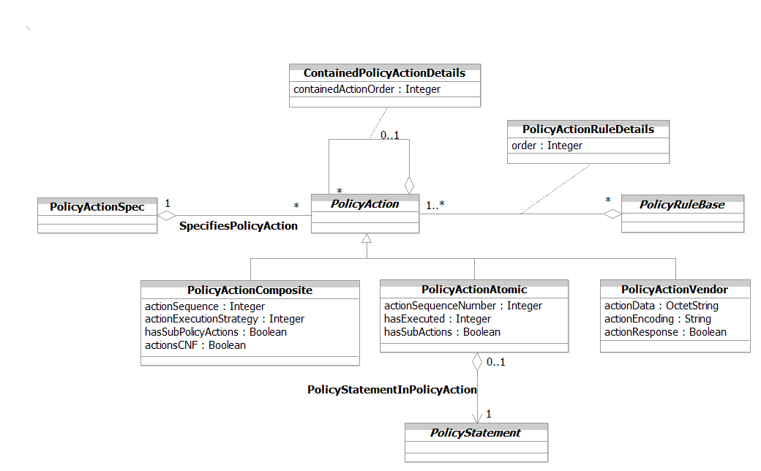
Figure 1P- . PolicyAction Business Entity Model

PolicyActionAtomic Business Entity Definition

Business Entity Name | PolicyActionAtomic
Description | This is the base class for all simple PolicyActions. A simple PolicyAction consists of a single Boolean clause, which is used to perform a single action. This consists of a single occurrence of a PolicyStatement, which is of the form:  {SET | CLEAR} PolicyVariable to PolicyValue  This is distinctly different from the PolicyActionVendor, which does not use a PolicyStatement.  PolicyActionAtomic objects can also be used to form more complex action structures. A PolicyActionComposite object can be used to contain a group of PolicyActionAtomic objects - this grouping enables multiple PolicyActionAtomic objects to be executed as a group. Alternatively, a PolicyActionAtomic object can contain one or more PolicyActionAtomic objects (and also PolicyActionComposite groups if desired) to provide the semantics of a compound PolicyAction. In either case, the aggregation is done using the containedPolicyActions aggregation.
Sources | DEN-ng; BT | Cross- References |  |  | Synonyms / Aliases | This concept is not present in the ITU or CIM specs (the CIM spec doesn’t use the composite pattern, and the structure of the model is significantly different than the structure of the DEN-ng model).
Related Business Entities | ManagedEntity, ResourceSpecification, Resource, Product, ProductComponent, ProductBundle, Software, Protocol, ResourceLogic, ResourceRole, Service, Party, PartyRole, Location, BusinessInteraction, Policy, PolicySet, PolicyGroup, PolicyRule, PolicyEvent, PolicyEventAtomic, PolicyEventComposite, PolicyCondition, PolicyAction (superclass), PolicyActionComposite (sibling), PolicySetSpec, PolicyRuleSpec, PolicyEventSpec, PolicyEventSpecAtomic, PolicyEventSpecComposite, PolicyActionSpec, PolicyActionSpecAtomic, PolicyActionSpecComposite
Business Rules | To be determined

PolicyActionAtomic Business Entity Attributes Definition
Business Entity Name | PolicyActionAtomic
Attribute Name | Description | Data Type | Characteristics, Permitted Values & Units | Required/  Optional | Notes (used to map to other models; blank is other models don’t have it)
actionSequenceNumber | This attribute is a non-negative integer and represents the particular sequence in which this element is executed as part of the overall policy structure. This will allow a policy engine to reference externally supplied arguments to this object as it is executed. | Integer |  | Required | Not present in the ITU specs; CIM 2.7 has a subset of these values.
hasExecuted | This is an enumerated integer that is set by a policy application to define the state of execution of this policyAction. | Integer | 0: not yet executed  1: executed with no errors  2: executed with errors but  successfully rolled back  3: executed with errors and  did not roll back  4: did not complete execution  but successfully rolled back  5: did not complete execution  and did not roll back | Optional | Not present in the ITU or CIM specs.

Business Entity Name | PolicyActionAtomic (continued)
Attribute Name | Description | Data Type | Characteristics, Permitted Values & Units | Required/  Optional | Notes (used to map to other models; blank is other models don’t have it)
hasSubActions | This is a Boolean attribute that, if TRUE, signifies that this PolicyAction has one or more sub-actions. Sub-actions are used to enforce a hierarchical nesting of actions, so that parent actions may control the evaluation and other semantics of the sub-actions that they contain. | Boolean |  | Required | Not present in the ITU or CIM specs.

Business Entity Model – PolicyActionAtomic
The business entity model for a PolicyActionAtomic is the same as that for a PolicyAction, and was shown in Figure 1P- above.

PolicyActionComposite Business Entity Definition

Business Entity Name | PolicyActionComposite
Description | The PolicyActionComposite class is the base class for serving as a generic container in which to place PolicyActionAtomic, PolicyActionVendor, or PolicyActionComposite classes. The first two provide actions that this container groups, while the latter establishes a hierarchy in which to order the execution of PolicyActions.  Both simple as well as complex PolicyActions can be placed in this container.  Each PolicyActionAtomic and PolicyActionVendor object is linked to this object using the containedPolicyActions association.
Sources | DEN-ng; BT | Cross- References |  |  | Synonyms / Aliases | This concept is not present in the ITU or CIM specs (the CIM spec doesn’t use the composite pattern, and the structure of the model is significantly different than the structure of the DEN-ng model).
Related Business Entities | ManagedEntity, ResourceSpecification, Resource, Product, ProductComponent, ProductBundle, Software, Protocol, ResourceLogic, ResourceRole, Service, Party, PartyRole, Location, BusinessInteraction, Policy, PolicySet, PolicyGroup, PolicyRule, PolicyEvent, PolicyEventAtomic, PolicyEventComposite, PolicyCondition, PolicyAction (superclass), PolicyActionAtomic (sibling), PolicySetSpec, PolicyRuleSpec, PolicyEventSpec, PolicyEventSpecAtomic, PolicyEventSpecComposite, PolicyActionSpec, PolicyActionSpecAtomic, PolicyActionSpecComposite
Business Rules | To be determined

PolicyActionComposite Business Entity Attributes Definition

Business Entity Name | PolicyActionComposite
Attribute Name | Description | Data Type | Characteristics, Permitted Values & Units | Required/  Optional | Notes (used to map to other models; blank is other models don’t have it)
actionSequence | This is an enumerated integer that defines how the ordering of the PolicyActions associated with this PolicyActionComposite object is to be interpreted. | Integer |  | Required | Not present in the ITU or CIM specs.
actionExecutionStrategy | This is an enumerated integer that defines the execution strategy to be used upon the sequenced actions aggregated by this PolicyActionComposite object. | Integer | 0: Unknown  1: Do Until Success  2: Do All  3: Do Until Failure  4: Do All Without  Failure or Do  Nothing | Required | Not present in the ITU specs. Similar attribute in the CIM, but it has a subset of these values.
hasSubPolicyActions | This is a Boolean attribute that, if TRUE, signifies that this PolicyAction has one or more sub-actions. Sub-actions are used to enforce a hierarchical nesting of actions, so that parent actions may control the evaluation and other semantics of sub-actions that they contain. | Boolean |  | Required | Not present in the ITU or CIM specs.

Business Entity Model – PolicyActionComposite
The business entity model for a PolicyActionComposite is the same as that for a PolicyAction, and was shown in Figure 1P- above.

PolicyActionVendor Business Entity Definition

Business Entity Name | PolicyActionVendor
Description | The PolicyActionVendor class is a concrete base class that provides a general extension mechanism for representing PolicyActions that have not been modeled with the attributes specified in this model.  This class uses two of its properties (Constraint and ConstraintEncoding) for defining the content and format of a vendor-specific condition. Its third property (actionResponse) to provide a standard result, so that this object can be placed with other PolicyAction objects in a PolicyRule object. Standardized extensions are not expected to use this class.
Sources | DEN-ng; BT | Cross- References |  |  | Synonyms / Aliases | This concept is not present in the ITU specs. The CIM spec has different superclasses and relationships, and lacks an important attribute – hence, its semantics are different.
Related Business Entities | ManagedEntity, ResourceSpecification, Resource, Product, ProductComponent, ProductBundle, Software, Protocol, ResourceLogic, ResourceRole, Service, Party, PartyRole, Location, BusinessInteraction, Policy, PolicySet, PolicyGroup, PolicyRule, PolicyEvent, PolicyEventAtomic, PolicyEventComposite, PolicyCondition, PolicyAction (superclass), PolicyActionAtomic (sibling), PolicyActionComposite (sibling), PolicySetSpec, PolicyRuleSpec, PolicyEventSpec, PolicyEventSpecAtomic, PolicyEventSpecComposite, PolicyActionSpec, PolicyActionSpecAtomic, PolicyActionSpecComposite
Business Rules | To be determined

PolicyActionVendor Business Entity Attributes Definition

Business Entity Name | PolicyActionVendor
Attribute Name | Description | Data Type | Characteristics, Permitted Values & Units | Required/  Optional | Notes (used to map to other models; blank is other models don’t have it)
actionData | This attribute provides a general extension mechanism for representing policy actions that have not been modeled with the specific properties contained in this model. The format of this attribute is determined by the OID value stored in the ActionEncoding attribute.  A policy decision point can readily determine whether it supports the values stored in an instance of ActionData by checking the OID value from ActionEncoding against the set of OIDs it recognizes. The action for the policy decision point to take in case it does not recognize the format of this data could itself be modeled as a PolicyRule, governing the behavior of the policy decision point. | OctetString |  | Required | Not present in the ITU specs. The CIM defines a similar attribute called ActionData.

Business Entity Name | PolicyActionVendor (continued)
Attribute Name | Description | Data Type | Characteristics, Permitted Values & Units | Required/  Optional | Notes (used to map to other models; blank is other models don’t have it)
actionEncoding | This is a string attribute. It is used to represent an OID that in turn identifies the encoding and semantics of the ActionData attribute value array in this instance. The value of this property is a single string, representing a single OID. | String |  | Required | Not present in the ITU specs. The CIM defines a similar attribute called ActionEncoding.
actionResponse | This is a Boolean attribute that is used to allow a 'standard' definition of a TRUE/FALSE response to be made by an external system attached to the model at this point. This will allow integration with a generalized policy processing engine. | Boolean |  | Required | Not defined in the ITU or CIM specs.

Business Entity Model – PolicyActionVendor
The business entity model for a PolicyActionVendor is the same as that for a PolicyAction, and was shown in Figure 1P- above.

PolicyStatement Business Entity Definition

Business Entity Name | PolicyStatement
Description | This class models the triplet {variable, operator, value} that is used by both the PolicyCondition and PolicyAction classes. Note that the semantics are reflected in the types of operators that are allowed to be used in each case.  For conditions, we want the semantics of "variable relates to value", where "relates to" is usually the match operator, but could also be other applicable operators (e.g., a comparison operator).  For actions, we want the semantics of "set variable to value". Here, the only operator allowed is the set operator.  Both of these semantics are enforced using OCL.  The ability to use the same basic form for writing PolicyConditions and PolicyActions greatly simplifies the design and implementation of a policy management system by enabling such statements to be automatically generated.
Sources | DEN-ng; BT | Cross- References |  |  | Synonyms / Aliases | This concept is not present in the ITU specs. The CIM spec doesn’t use the composite pattern, and the structure of the model is significantly different than the structure of the DEN-ng model.
Related Business Entities | ManagedEntity, ResourceSpecification, Resource, Product, ProductComponent, ProductBundle, Software, Protocol, ResourceLogic, ResourceRole, Service, Party, PartyRole, Location, BusinessInteraction, Policy (superclass), PolicySet, PolicyGroup, PolicyRule, PolicyEvent, PolicyEventAtomic, PolicyEventComposite, PolicyCondition, PolicyConditionAtomic, PolicyAction, PolicyActionAtomic, PolicyVariable, PolicyOperator, PolicyValue, PolicySetSpec, PolicyRuleSpec, PolicyEventSpec, PolicyEventSpecAtomic, PolicyEventSpecComposite, PolicyActionSpec, PolicyActionSpecAtomic, PolicyActionSpecComposite
Business Rules | To be determined

PolicyStatement Business Entity Attributes Definition
At this time, there are currently no business attributes defined for this class. Its primary purpose is to be a convenient point for defining relationships and constraints.

Business Entity Model – PolicyStatement
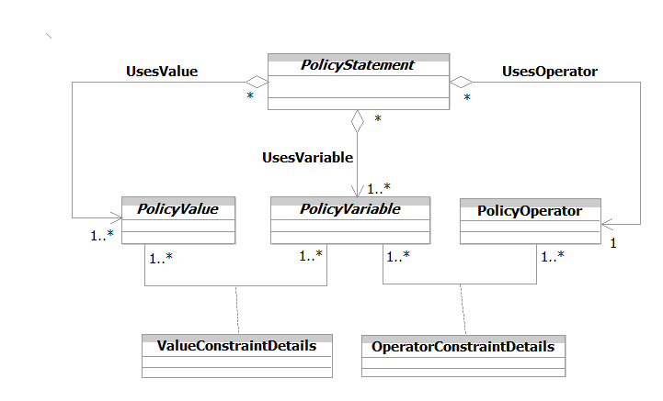
Figure 1P- . PolicyStatement Business Entity Model

PolicyVariable Business Entity Definition

Business Entity Name | PolicyVariable
Description | This is an abstract class for modeling different types of variables that can be used to form a PolicyStatement. The variable specifies an attribute or concept that should either be matched or in some way compared to a value when the condition is evaluated.  There are three important factors that must be taken into account in the design of variables. The first is that not every combination of a variable and a value creates a meaningful condition. For example, port numbers cannot be negative. Rather, the type of variable in the condition defines the set of matchable value types.  Second, just because a value has the correct datatype does not mean that it can be meaningfully compared to a variable. To continue the above example, a port of 1,000,000 is meaningless. This is handled in this model by specifying constraints (using OCL) that apply to a particular variable that must be obeyed by any value that it is being compared to. The ExpectedPolicyValuesForVariable association binds a PolicyVariable to a PolicyValue; any constraints that are required in this binding are added to an instance of this association using OCL.  Third, while the DEN-ng model defines a set of useful PolicyVariables, there is a high likelihood that specific applications will need extensions to these variables. This is accommodated through the notion of implicit and explicit PolicyVariable classes.
Sources | DEN-ng; BT | Cross- References |  |  | Synonyms / Aliases | This concept is not present in the ITU or CIM specs. It is present in the IETF RFCs, but has been modified to increase its extensibility.
Related Business Entities | ManagedEntity, ResourceSpecification, Resource, Product, ProductComponent, ProductBundle, Software, Protocol, ResourceLogic, ResourceRole, Service, Party, PartyRole, Location, BusinessInteraction, Policy (superclass), PolicySet, PolicyGroup, PolicyRule, PolicyEvent, PolicyEventAtomic, PolicyEventComposite, PolicyCondition, PolicyConditionAtomic, PolicyAction, PolicyActionAtomic, PolicyOperator, PolicyValue, PolicySetSpec, PolicyRuleSpec, PolicyEventSpec, PolicyEventSpecAtomic, PolicyEventSpecComposite, PolicyActionSpec, PolicyActionSpecAtomic, PolicyActionSpecComposite
Business Rules | To be determined

PolicyVariable Business Entity Attributes Definition
At this time, there are currently no business attributes defined for this class. Its primary purpose is to be a convenient point for defining relationships and constraints. Most of its subclasses do define attributes; however, these are beyond the scope of this Addendum.

Business Entity Model – PolicyVariable
The business entity model for a PolicyVariable is the same as that for a PolicyStatement, and was shown in Figure 1P- above.

PolicyValue Business Entity Definition

Business Entity Name | PolicyValue
Description | The PolicyValue class is an abstract base class for modeling different types of values that occur in a PolicyStatement. The PolicyValue specifies an attribute that should either be set or cleared (if used in a PolicyAction) or matched or compared in some way to a value of the PolicyVariable in a PolicyCondition.
Sources | DEN-ng; BT | Cross- References |  |  | Synonyms / Aliases | This concept is not present in the ITU or CIM specs. It is present in the IETF RFCs, but has been modified to increase its extensibility.
Related Business Entities | ManagedEntity, ResourceSpecification, Resource, Product, ProductComponent, ProductBundle, Software, Protocol, ResourceLogic, ResourceRole, Service, Party, PartyRole, Location, BusinessInteraction, Policy (superclass), PolicySet, PolicyGroup, PolicyRule, PolicyEvent, PolicyEventAtomic, PolicyEventComposite, PolicyCondition, PolicyConditionAtomic, PolicyAction, PolicyActionAtomic, PolicyOperator, PolicyVariable, PolicySetSpec, PolicyRuleSpec, PolicyEventSpec, PolicyEventSpecAtomic, PolicyEventSpecComposite, PolicyActionSpec, PolicyActionSpecAtomic, PolicyActionSpecComposite
Business Rules | To be determined

PolicyValue Business Entity Attributes Definition
At this time, there are currently no business attributes defined for this class. Its primary purpose is to be a convenient point for defining relationships and constraints. Most of its subclasses do define attributes; however, these are beyond the scope of this Addendum.

Business Entity Model – PolicyValue
The business entity model for a PolicyValue is the same as that for a PolicyStatement, and was shown in Figure 1P- above.

VariableCustom Business Entity Definition

Business Entity Name | VariableCustom
Description | There are two subclasses of PolicyVariable, called VariableCustom and VariableStandard. The VariableCustom class defines a set of standardized policy variables for use in an application-specific manner. The term "custom" means that such variables are explicitly designed to work with attributes that are not in any of the DEN-ng VariableStandard subclasses. This means that the particular semantics (including any applicable constraints) are not known to DEN-ng.  This is an abstract base class that provides two basic attributes to define custom variables that can be used in an application-specific fashion.
Sources | DEN-ng | Cross- References |  |  | Synonyms / Aliases | This concept is not present in the ITU or CIM specs. It is present in the IETF RFCs, but has been modified to increase its extensibility.
Related Business Entities | ManagedEntity, ResourceSpecification, Resource, Product, ProductComponent, ProductBundle, Software, Protocol, ResourceLogic, ResourceRole, Service, Party, PartyRole, Location, BusinessInteraction, Policy, PolicySet, PolicyGroup, PolicyRule, PolicyEvent, PolicyEventAtomic, PolicyEventComposite, PolicyCondition, PolicyConditionAtomic, PolicyAction, PolicyActionAtomic, PolicyOperator, PolicyVariable (superclass), VariableStandard (sibling), PolicyValue, PolicySetSpec, PolicyRuleSpec, PolicyEventSpec, PolicyEventSpecAtomic, PolicyEventSpecComposite, PolicyActionSpec, PolicyActionSpecAtomic, PolicyActionSpecComposite
Business Rules | To be determined

VariableCustom Business Entity Attributes Definition

Business Entity Name | VariableCustom
Attribute Name | Description | Data Type | Characteristics, Permitted Values & Units | Required/  Optional | Notes (used to map to other models; blank is other models don’t have it)
variableModelAttribute | This is a string attribute that defines the name of the attribute within the class specified in the variableModelClass attribute that is to be evaluated or set as a PolicyVariable. This enables the VariableCustom class to point to other attributes of other classes that can be defined as extensions of the standard DEN-ng model. | String |  | Required | Not present in the ITU or CIM specs. The IETF RFCs only define “MATCH”.
variableModelClass | This is a string attribute that defines the class name whose attribute is to be evaluated or set as a PolicyVariable. This enables the VariableCustom class to point to other attributes of other classes that can be defined as extensions of the standard DEN-ng model. | String |  | Required | Not present in the ITU or CIM specs. The IETF RFCs only define “MATCH”.

Business Entity Model – VariableCustom
Figure 1P- . VariableCustom Business Entity Model

VariableStandard Business Entity Definition

Business Entity Name | VariableStandard
Description | This is an abstract base class for defining a standard set of PolicyVariable objects that are common to most PBNM applications. This is the superclass for a standard set of PolicyVariable subclasses that are part of the DEN-ng model.
Sources | DEN-ng | Cross- References |  |  | Synonyms / Aliases | This concept is not present in the ITU or CIM specs. It is present in the IETF RFCs, but has been modified to increase its extensibility.
Related Business Entities | ManagedEntity, ResourceSpecification, Resource, Product, ProductComponent, ProductBundle, Software, Protocol, ResourceLogic, ResourceRole, Service, Party, PartyRole, Location, BusinessInteraction, Policy, PolicySet, PolicyGroup, PolicyRule, PolicyEvent, PolicyEventAtomic, PolicyEventComposite, PolicyCondition, PolicyConditionAtomic, PolicyAction, PolicyActionAtomic, PolicyOperator, PolicyVariable (superclass), VariableCustom (sibling), PolicyConditionTimePeriod (subclass), PolicyConditionVendor (subclass), PolicyValue, PolicySetSpec, PolicyRuleSpec, PolicyEventSpec, PolicyEventSpecAtomic, PolicyEventSpecComposite, PolicyActionSpec, PolicyActionSpecAtomic, PolicyActionSpecComposite
Business Rules | To be determined

VariableStandard Business Entity Attributes Definition

Business Entity Name | VariableStandard
Attribute Name | Description | Data Type | Characteristics, Permitted Values & Units | Required/  Optional | Notes (used to map to other models; blank is other models don’t have it)
allowedValueTypes | This is an array of string attributes that define the set of class names (which correspond to a set of datatypes) that are allowed to be used in conjunction with this PolicyVariable. Each string provides a class name, which corresponds to a particular subclass of PolicyValue. Each allowed subclass defines an object with a compatible datatype and semantics. | String Array |  | Required | Not present in the ITU or CIM specs. The IETF RFCs only define “MATCH”.

Business Entity Model – VariableStandard
The business entity model for a VariableStandard is the same as that for a VariableCustom, and was shown in Figure 1P- above.

PolicyConditionTimePeriod Business Entity Definition

Business Entity Name | PolicyConditionTimePeriod
Description | This is a concrete class that provides the capability of enabling or disabling a PolicyCondition according to a pre-determined time schedule. This enables this class to effectively enable or disable evaluation of the entire condition clause. The simplest way to do this is to specify a value for the TimePeriod class attribute; this may of course be modified by other class attributes as necessary.
Sources | DEN-ng | Cross- References |  |  | Synonyms / Aliases | This concept is not present in the ITU specs. The CIM defines a similar class called PolicyTimePeriodCondition, but the structure of its superclasses and relationships are very different.
Related Business Entities | ManagedEntity, ResourceSpecification, Resource, Product, ProductComponent, ProductBundle, Software, Protocol, ResourceLogic, ResourceRole, Service, Party, PartyRole, Location, BusinessInteraction, Policy, PolicySet, PolicyGroup, PolicyRule, PolicyEvent, PolicyEventAtomic, PolicyEventComposite, PolicyCondition, PolicyConditionAtomic, PolicyAction, PolicyActionAtomic, PolicyOperator, PolicyVariable, VariableStandard (superclass), VariableCustom, PolicyConditionVendor (sibling), PolicyValue, PolicySetSpec, PolicyRuleSpec, PolicyEventSpec, PolicyEventSpecAtomic, PolicyEventSpecComposite, PolicyActionSpec, PolicyActionSpecAtomic, PolicyActionSpecComposite
Business Rules | To be determined

PolicyConditionTimePeriod Business Entity Attributes Definition

Business Entity Name | PolicyConditionTimePeriod
Attribute Name | Description | Data Type | Characteristics, Permitted Values & Units | Required/  Optional | Notes (used to map to other models; blank is other models don’t have it)
timePeriod | This is a string attribute that defines an overall range of calendar dates and times over which a PolicyRule is valid. As such, this is the most basic way to use date and/or time to enable or disable a given PolicyRule. Date/times are expressed as substrings of the form: "yyyymmddThhmmss".  This attribute is based on time as defined in RFC 2445. This calls for a string to represent a starting date and time, in which the character 'T' indicates the beginning of the time portion, followed by the solidus character ('/'), followed by a similar string representing an end date and time. The first date indicates the beginning of the range, while the second date indicates the end. The second date and time must be later than the first.  There are also two special cases in which one of the date/time strings is replaced with a special string defined in RFC 2445. If the first datetime is replaced with the string "THISANDPRIOR", then the property indicates that a policy rule is valid, from now until the date/time that appears after the '/'. If the second datetime is replaced with the string "THISANDFUTURE", then the property indicates that a policy rule becomes valid on the date/time that appears before the '/', and remains valid from that point on. | String |  | Required | Not present in the ITU specs. The CIM defines a similar attribute called TimePeriod.

Business Entity Name | PolicyConditionTimePeriod (continued)
Attribute Name | Description | Data Type | Characteristics, Permitted Values & Units | Required/  Optional | Notes (used to map to other models; blank is other models don’t have it)
monthOfYearMask | The monthOfYearMask attribute is a string that refines the definition of the valid time period that is defined by the timePeriod attribute. This is done by explicitly specifying the months when the policy is valid. Thus, the timePeriod attribute is used to specify the overall time period during which the policy might be valid, and the monthOfYearMask attribute is used to pick out the specific months within that time period when the PolicyRule is valid. This attribute consists of a fixed string of 16 bits. The first 12 bits correspond to the 12 months of the year, beginning with January and ending with December. The last 4 bits are always set to "0". For each month, the value "1" indicates that the policy is valid for that month, and the value "0" indicates that it is not valid.  If this attribute is not specified, then the PolicyRule is treated as valid for all twelve months. | String |  | Required | Not present in the ITU specs. The CIM defines a similar attribute called MonthOfYearMask.

Business Entity Name | PolicyConditionTimePeriod (continued)
Attribute Name | Description | Data Type | Characteristics, Permitted Values & Units | Required/  Optional | Notes (used to map to other models; blank is other models don’t have it)
dayOfMonthMask | This is a string attribute that refines the definition of the valid time period that is defined by the timePeriod attribute. This is done by explicitly specifying the days of the month when the policy is valid. These attributes work together, with the timePeriod attribute used to specify the overall time period during which the PolicyRule might be valid, and the dayOfMonthMask attribute used to pick out the specific days of the month within that time period when the PolicyRule is valid.  This property is formatted as a fixed string of 64 bits. The first 31 bits correspond to the days of the month counting from the beginning, followed by 31 more bits identifying the days of the month counting from the end, followed by 2 bits that are always set to '0'. For months with fewer than 31 days, the digits corresponding to days that the months do not have (counting in both directions) are ignored.  For each day, the value '1' indicates that the policy is valid for that day, and the value '0' indicates that it is not valid.  The encoding of the 62 significant bits in the octet string matches that used for the schedDay object in the DISMAN-SCHEDULE-MIB.  If this attribute is not specified, then the PolicyRule is treated as valid for all days in the months specified by the timePeriod attribute. | String |  | Required | Not present in the ITU specs. The CIM defines a similar attribute called DayOfMonthMask.

Business Entity Name | PolicyConditionTimePeriod (continued)
Attribute Name | Description | Data Type | Characteristics, Permitted Values & Units | Required/  Optional | Notes (used to map to other models; blank is other models don’t have it)
dayOfWeekMask | This is a string attribute that refines the definition of the valid time period that is defined by the timePeriod attribute. This is done by explicitly specifying the days of the week when the PolicyRule is valid. These attributes work together, with the timePeriod attribute used to specify the overall time period when the policy might be valid, and the DayOfWeekMask used to pick out the specific days of the week in that time period when the PolicyRule is valid.  This property is formatted as a fixed length string of 8 bits. The first 7 bits identify the 7 days of the week, beginning with Sunday and ending with Saturday, followed by 1 bit that is always set to '0'. For each day of the week, the value '1' indicates that the PolicyRule is valid for that day, and the value '0' indicates that it is not valid.  If this attribute is not specified, then the PolicyRule is treated as valid for all 7 days in the weeks specified by the timePeriod attribute. | String |  | Required | Not present in the ITU specs. The CIM defines a similar attribute called DayOfWeekMask.

Business Entity Name | PolicyConditionTimePeriod (continued)
Attribute Name | Description | Data Type | Characteristics, Permitted Values & Units | Required/  Optional | Notes (used to map to other models; blank is other models don’t have it)
timeOfDayMask | This is a string attribute that refines the definition of the valid time period that is defined by the timePeriod attribute. This is done by explicitly specifying a range of times in a day the PolicyRule is valid for. These attributes work together, with the timePeriod attribute used to specify the overall time period that the PolicyRule is valid for, and the timeOfDayMask attribute used to pick out which range of time periods in a given day of that time period the PolicyRule is valid for.  This attribute is formatted in the style of RFC 2445: a time string beginning with the character 'T', followed by the solidus character ('/'), followed by a second time string. The first time indicates the beginning of the range, while the second time indicates the end. Times are expressed as substrings of the form "Thhmmss".  The second substring always identifies a later time than the first substring. To allow for ranges that span midnight, however, the value of the second string may be smaller than the value of the first substring. Thus, "T210000/T080000" identifies the range from 2100 until 0800 of the following day.  If this attribute is not specified, then the PolicyRule is treated as valid for the entire day, for all days specified by the timePeriod attribute. | String |  | Required | Not present in the ITU specs. The CIM defines a similar attribute called TimeOfDayMask.

Business Entity Name | PolicyConditionTimePeriod (continued)
Attribute Name | Description | Data Type | Characteristics, Permitted Values & Units | Required/  Optional | Notes (used to map to other models; blank is other models don’t have it)
isLocalTime | This is a Boolean attribute that, if TRUE, signifies that the times represented in the timePeriod attribute and in the various Mask attributes represent local times. If the value of this attribute is FALSE, then this means that the times represented in the timePeriod attribute and in the various Mask attributes represent UTC times.  There is no provision for mixing of local times and UTC times: the value of this attribute applies to all of the other time-related attributes. | String |  | Required | Not present in the ITU specs. The CIM defines a similar attribute called LocalOrUtcTime.

Business Entity Model – PolicyConditionTimePeriod
The business entity model for a PolicyConditionTimePeriod is the same as that for a VariableCustom, and was shown in Figure 1P- above.

PolicyConditionVendor Business Entity Definition

Business Entity Name | PolicyConditionVendor
Description | This is a concrete base class that provides a general extension mechanism for representing PolicyConditions that have not been modeled with the attributes specified in this model. This class uses two of its properties (constraintData and constraintEncoding) for defining the content and format of a vendor-specific condition. Its other two attributes are used to describe the type of condition that this represents, and to provide a standard definition of a TRUE or FALSE response. This latter enables this object to interoperate with other PolicyVariableStandard objects as part of a PolicyConditon clause.  Standardized extensions are not expected to use this class.
Sources | DEN-ng | Cross- References |  |  | Synonyms / Aliases | This concept is not present in the ITU specs. The CIM defines a similar class called VendorPolicyCondition, but the structure of its superclasses and relationships are very different.
Related Business Entities | ManagedEntity, ResourceSpecification, Resource, Product, ProductComponent, ProductBundle, Software, Protocol, ResourceLogic, ResourceRole, Service, Party, PartyRole, Location, BusinessInteraction, Policy, PolicySet, PolicyGroup, PolicyRule, PolicyEvent, PolicyEventAtomic, PolicyEventComposite, PolicyCondition, PolicyConditionAtomic, PolicyAction, PolicyActionAtomic, PolicyOperator, PolicyVariable, VariableStandard (superclass), VariableCustom, PolicyConditionVendor (sibling), PolicyValue, PolicySetSpec, PolicyRuleSpec, PolicyEventSpec, PolicyEventSpecAtomic, PolicyEventSpecComposite, PolicyActionSpec, PolicyActionSpecAtomic, PolicyActionSpecComposite
Business Rules | To be determined

PolicyConditionVendor Business Entity Attributes Definition

Business Entity Name | PolicyConditionVendor
Attribute Name | Description | Data Type | Characteristics, Permitted Values & Units | Required/  Optional | Notes (used to map to other models; blank is other models don’t have it)
constraintData | The constraintData attribute is a string that provides a general extension mechanism for representing PolicyConditions that have not been modeled with specific attributes (as specified in this model). The format of this attribute is determined by the OID value stored in the constraintEncoding attribute of this class. The constraintEncoding attribute provides a convenient and simple mechanism by which a Policy Server can determine whether it supports the values stored in an instance of constraintData. If it doesn't recognize any of the OID values in the constraintEncoding attribute, then it will not know how to interpret the data in the corresponding constraintData attributes. The action for the policy decision point to take in case it does not recognize the format of this data could itself be modeled as a PolicyRule, governing the behavior of the Policy Server. | OctetString |  | Required | Not present in the ITU specs. The CIM defines a similar attribute called Constraint.
constraintEncoding | The constraintEncoding attribute is a string that is used to represent an OID that in turn identifies the encoding and semantics of the constraintData attribute in this instance. | String |  | Required | Not present in the ITU specs. The CIM defines a similar attribute called ConstraintEncoding.

Business Entity Name | PolicyConditionVendor (continued)
Attribute Name | Description | Data Type | Characteristics, Permitted Values & Units | Required/  Optional | Notes (used to map to other models; blank is other models don’t have it)
conditionType | This is a free-form string that can be used to define the type of condition that this instance is checking. | String |  | Optional | Not present in the ITU or CIM specs.
conditionResponse | This is a Boolean attribute that is used to allow a 'standard' definition of a TRUE/FALSE response to be made by an external system attached to the model at this point. This will allow integration with a generalized policy processing engine. | Boolean |  | Required | Not present in the ITU or CIM specs.

Business Entity Model – PolicyConditionVendor
The business entity model for a PolicyConditionVendor is the same as that for a VariableCustom, and was shown in Figure 1P- above.

ValueStandard Business Entity Definition

Business Entity Name | ValueStandard
Description | ValueStandard is the abstract base class for defining a set of standardized PolicyValues. This set of PolicyValues will be added to over time, and represents a set of common values that are useful in a variety of PBNM applications. The subclasses of ValueStandard are a set of classes that define the semantics of commonly occurring variables that occur in PBNM applications.
Sources | DEN-ng | Cross- References |  |  | Synonyms / Aliases | This concept is not present in the ITU or CIM specs. It is present in the IETF RFCs, but has been modified to increase its extensibility.
Related Business Entities | ManagedEntity, ResourceSpecification, Resource, Product, ProductComponent, ProductBundle, Software, Protocol, ResourceLogic, ResourceRole, Service, Party, PartyRole, Location, BusinessInteraction, Policy, PolicySet, PolicyGroup, PolicyRule, PolicyEvent, PolicyEventAtomic, PolicyEventComposite, PolicyCondition, PolicyConditionAtomic, PolicyAction, PolicyActionAtomic, PolicyOperator, PolicyVariable, PolicyValue (superclass), ValueCustom (sibling), PolicySetSpec, PolicyRuleSpec, PolicyEventSpec, PolicyEventSpecAtomic, PolicyEventSpecComposite, PolicyActionSpec, PolicyActionSpecAtomic, PolicyActionSpecComposite
Business Rules | To be determined

ValueStandard Business Entity Attributes Definition
At this time, there are currently no business attributes defined for this class. Its primary purpose is to be a convenient point for defining relationships and constraints.

Business Entity Model – ValueStandard
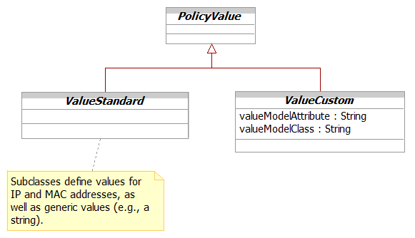
Figure 1P- . ValueStandard Business Entity Model

ValueCustom Business Entity Definition

Business Entity Name | ValueCustom
Description | ValueCustom is an abstract base class that provides two basic attributes to define custom value objects that can be used in an application-specific fashion. These two attributes are called valueModelAttribute and valueModelClass. The valueModelAttribute is a string attribute that defines the name of the attribute within the class specified in the valueModelClass attribute that is to be evaluated or set as a PolicyValue. The valueModelClass is a string attribute that defines the class name whose attribute is to be evaluated or set as a PolicyValue. This combination enables new custom subclasses of ValueCustom to be defined that specify the class and attribute that they are modeling. These new subclasses can be found by users of the current DEN-ng schema by searching for these two properties. That also enables DEN-ng users to immediately understand the purpose of new extensions.
Sources | DEN-ng | Cross- References |  |  | Synonyms / Aliases | This concept is not present in the ITU or CIM specs. It is present in the IETF RFCs, but has been modified to increase its extensibility.
Related Business Entities | ManagedEntity, ResourceSpecification, Resource, Product, ProductComponent, ProductBundle, Software, Protocol, ResourceLogic, ResourceRole, Service, Party, PartyRole, Location, BusinessInteraction, Policy, PolicySet, PolicyGroup, PolicyRule, PolicyEvent, PolicyEventAtomic, PolicyEventComposite, PolicyCondition, PolicyConditionAtomic, PolicyAction, PolicyActionAtomic, PolicyOperator, PolicyVariable, PolicyValue (superclass), ValueStandard (sibling), PolicySetSpec, PolicyRuleSpec, PolicyEventSpec, PolicyEventSpecAtomic, PolicyEventSpecComposite, PolicyActionSpec, PolicyActionSpecAtomic, PolicyActionSpecComposite
Business Rules | To be determined

ValueCustom Business Entity Attributes Definition

Business Entity Name | ValueCustom
Attribute Name | Description | Data Type | Characteristics, Permitted Values & Units | Required/  Optional | Notes (used to map to other models; blank is other models don’t have it)
valueModelAttribute | This is a string attribute that defines the name of the attribute within the class specified in the valueModelClass attribute that is to be evaluated or set as a PolicyValue. | String |  | Required | Not present in the ITU or CIM specs.
valueModelClass | This is a string attribute that defines the class name whose attribute is to be evaluated or set as a PolicyValue. | String |  | Required | Not present in the ITU or CIM specs.

Business Entity Model – ValueCustom
The business entity model for a PolicyConditionVendor is the same as that for a VariableCustom, and was shown in Figure 1P- above.

PolicyOperator Business Entity Definition

Business Entity Name | PolicyOperator
Description | This is a concrete class for modeling different types of operators in a PolicyStatement. By restricting the type of operator used in a PolicyStatement, one can effectively restrict the semantics of that PolicyStatement.
Sources | DEN-ng; BT | Cross- References |  |  | Synonyms / Aliases | This concept is not present in the ITU or CIM specs. It is present in the IETF RFCs, but has been modified to increase its extensibility.
Related Business Entities | ManagedEntity, ResourceSpecification, Resource, Product, ProductComponent, ProductBundle, Software, Protocol, ResourceLogic, ResourceRole, Service, Party, PartyRole, Location, BusinessInteraction, Policy (superclass), PolicySet, PolicyGroup, PolicyRule, PolicyEvent, PolicyEventAtomic, PolicyEventComposite, PolicyCondition, PolicyConditionAtomic, PolicyAction, PolicyActionAtomic, PolicyVariable, PolicyValue, PolicySetSpec, PolicyRuleSpec, PolicyEventSpec, PolicyEventSpecAtomic, PolicyEventSpecComposite, PolicyActionSpec, PolicyActionSpecAtomic, PolicyActionSpecComposite
Business Rules | To be determined

PolicyOperator Business Entity Attributes Definition

Business Entity Name | PolicyOperator
Attribute Name | Description | Data Type | Characteristics, Permitted Values & Units | Required/  Optional | Notes (used to map to other models; blank is other models don’t have it)
opType | This is an enumerated integer that specifies the various types of operators that are allowed for this PolicyStatement. | Integer | 1: Match  2: Greater than  3: Greater than or equals  4: Less than  5: Less than or equals  6: Equals  7: Not equals  8: IN  9: NOT IN  10: SET  11: CLEAR | Required | Not present in the ITU or CIM specs. The IETF RFCs only define “MATCH”.

Business Entity Model – PolicyOperator
The business entity model for a PolicyOperator is the same as that for a PolicyStatement, and was shown in Figure 1P- above.

PolicyDomain Business Entity Definition

Business Entity Name | PolicyDomain
Description | A PolicyDomain is a collection of entities and services that are administered in a coordinated fashion using a set of policies. The policies are used to control the set of services and entities according to a common methodology, such as a finite state machine.
Sources | DEN-ng | Cross- References |  |  | Synonyms / Aliases | This concept is not present in the ITU or CIM specs.
Related Business Entities | ManagedEntity, ResourceSpecification, Resource, Product, ProductComponent, ProductBundle, Software, Protocol, ResourceLogic, ResourceRole, Service, Party, PartyRole, Location, BusinessInteraction, ManagementDomain (superclass), Policy, PolicyApplication
Business Rules | To be determined

PolicyDomain Business Entity Attributes Definition
At this time, there are currently no business attributes defined for this class. Its primary purpose is to be a convenient point for defining relationships and constraints.

Business Entity Model – PolicyDomain
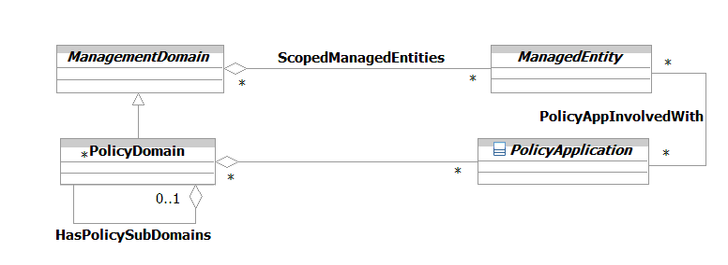
Figure 1P- . PolicyDomain Business Entity Model

PolicyApplication Business Entity Definition

Business Entity Name | PolicyApplication
Description | A PolicyApplication is a special type of entity (usually a Product) for use in policy-based management applications. This class is used as a convenient place for defining relationships to different managed entities. It has four principal subclasses: PolicyServer, PolicyDecisionPoint (PDP), PolicyExecutionPoint (PXP) and PolicyEnforcementPoint (PEP).  The principal role of a PolicyApplication is to define generic relationships that its subclasses can participate in.
Sources | DEN-ng | Cross- References |  |  | Synonyms / Aliases | This concept is not present in the ITU or CIM specs.
Related Business Entities | ManagedEntity, ResourceSpecification, Resource, Product, ProductComponent, ProductBundle, Software, Protocol, ResourceLogic, ResourceRole, Service, Party, PartyRole, Location, BusinessInteraction, PolicyDomain, Policy, PolicyServer, PolicyBroker, PolicyDecisionPoint, PolicyExecutionPoint, PolicyEnforcementPoint
Business Rules | To be determined

PolicyApplication Business Entity Attributes Definition
At this time, there are currently no business attributes defined for this class. Its primary purpose is to be a convenient point for defining relationships and constraints.

Business Entity Model – PolicyApplication
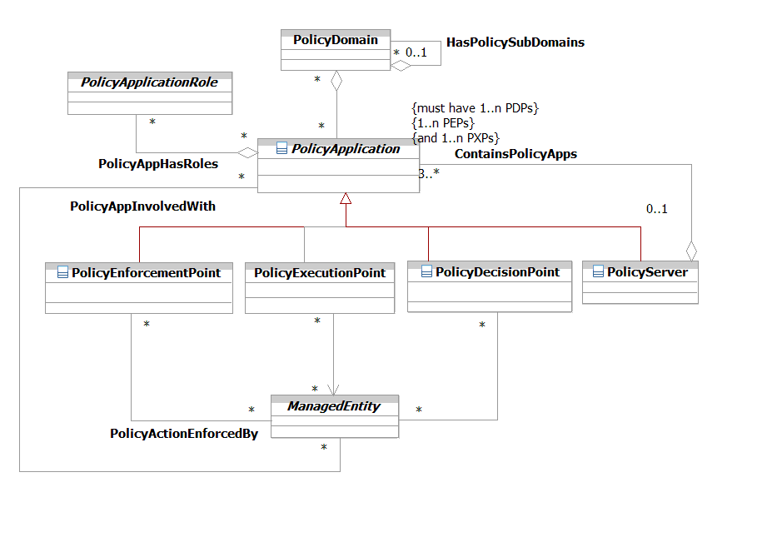
Figure 1P- . PolicyApplication Business Entity Model

PolicyServer Business Entity Definition

Business Entity Name | PolicyServer
Description | A PolicyServer is a fundamental building block of a policy-based management system. It represents both a set of core functionality for implementing policy as well as a unit of distribution in a distributed implementation.  With respect to functionality, a PolicyServer is an entity that is either manufactured or is constructed by integrating the functionality of different PDPs, PXPs, PEPs, and other applications. These other applications provide the logic to manage and control the set of PDPs, PXPs, and PEPs that constitute a PolicyServer. For example, conflict detection and resolution need to be applied.  Therefore, a PolicyServer is in reality an intelligent container that contains its own management logic that is supplemented by the functionality of the PEP, PXP, and PDP applications. It usually corresponds to a single PolicyDomain. While this is not strictly necessary, doing otherwise greatly complicates the resulting management logic.
Sources | DEN-ng | Cross- References |  |  | Synonyms / Aliases | This concept is not present in the ITU or CIM specs.
Related Business Entities | ManagedEntity, ResourceSpecification, Resource, Product, ProductComponent, ProductBundle, Software, Protocol, ResourceLogic, ResourceRole, Service, Party, PartyRole, Location, BusinessInteraction, PolicyDomain, Policy, PolicyApplication (superclass), PolicyBroker, PolicyDecisionPoint, PolicyExecutionPoint, PolicyEnforcementPoint
Business Rules | To be determined

PolicyServer Business Entity Attributes Definition
At this time, there are currently no business attributes defined for this class. Its primary purpose is to be a convenient point for defining relationships and constraints.

Business Entity Model – PolicyServer
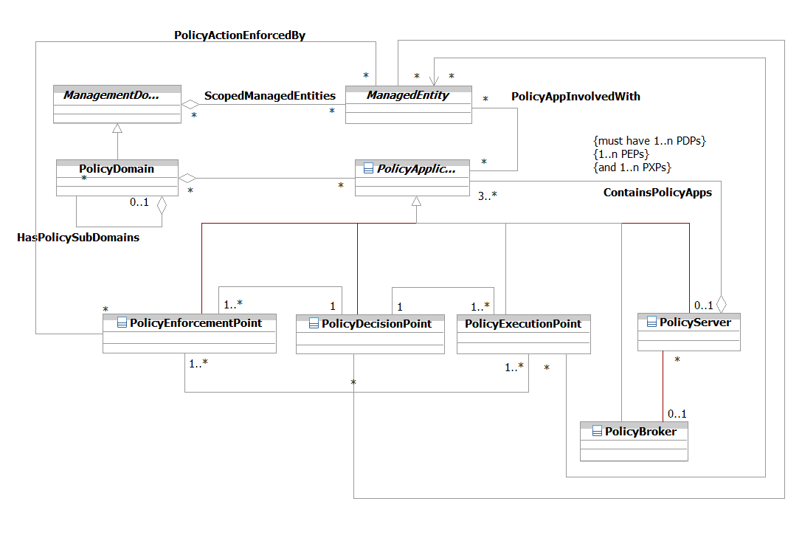
Figure 1P- . PolicyServer Business Entity Model

PolicyDecisionPoint Business Entity Definition

Business Entity Name | PolicyDecisionPoint
Description | A PolicyDecisionPoint is a type of PolicyApplication. It makes policy decisions for itself or for other entities that request such decisions, such as PolicyEnforcementPoints (PEPs) and PolicyExecutionPoints (PXPs). One or more PolicyDecisionPoints are contained in a PolicyServer.  PDPs use policies to configure or answer queries from policy-capable network elements or from an operator of the PBNM system. An example of a query is an RSVP admission request - a decision must be made to either accept or reject the request by the receiving network element. Since the network element doesn't have any idea about the overall state of the network, it makes a request of the PDP, asking the PDP if the RSVP request should be allowed. Thus, the PDP serves as the interface between the network and higher level processes.
Sources | DEN-ng | Cross- References |  |  | Synonyms / Aliases | This concept is not present in the ITU or CIM specs.
Related Business Entities | ManagedEntity, ResourceSpecification, Resource, Product, ProductComponent, ProductBundle, Software, Protocol, ResourceLogic, ResourceRole, Service, Party, PartyRole, Location, BusinessInteraction, PolicyDomain, Policy, PolicyApplication (superclass), PolicyBroker, PolicyServer, PolicyExecutionPoint, PolicyEnforcementPoint
Business Rules | To be determined

PolicyDecisionPoint Business Entity Attributes Definition
At this time, there are currently no business attributes defined for this class. Its primary purpose is to be a convenient point for defining relationships and constraints.

Business Entity Model – PolicyDecisionPoint
The business entity model for a PolicyDecisionPoint is the same as that for a PolicyApplication, and was shown in Figure 1P- above.

PolicyExecutionPoint Business Entity Definition

Business Entity Name | PolicyExecutionPoint
Description | A PolicyExecutionPoint is an entity that is used to execute a prescribed set of PolicyActions on a set of PolicyTargets.  The combination of a PolicyExecutionPoint and a PolicyEnforcementPoint enable the act of executing a decision (made by a PolicyDecisionPoint) to be separated from the act of ensuring that the executing actions were performed correctly, and had the desired results.
Sources | DEN-ng | Cross- References |  |  | Synonyms / Aliases | This concept is not present in the ITU or CIM specs.
Related Business Entities | ManagedEntity, ResourceSpecification, Resource, Product, ProductComponent, ProductBundle, Software, Protocol, ResourceLogic, ResourceRole, Service, Party, PartyRole, Location, BusinessInteraction, PolicyDomain, Policy, PolicyApplication (superclass), PolicyBroker, PolicyServer, PolicyDecisionPoint, PolicyEnforcementPoint
Business Rules | To be determined

PolicyExecutionPoint Business Entity Attributes Definition
At this time, there are currently no business attributes defined for this class. Its primary purpose is to be a convenient point for defining relationships and constraints.

Business Entity Model – PolicyExecutionPoint
The business entity model for a PolicyExecutionPoint is the same as that for a PolicyApplication, and was shown in Figure 1P- above.

PolicyEnforcementPoint Business Entity Definition

Business Entity Name | PolicyEnforcementPoint
Description | A PolicyEnforcementPoint is a type of PolicyApplication, and is used to verify that a prescribed set of PolicyActions have been successfully executed on a set of PolicyTargets.  A PolicyEnforcementPoint serves as an interface between the devices that policy is executed on and the policy decision-makers (such as the PolicyDecisionPoint) of the policy. PolicyEnforcementPoints request work to be performed from PolicyDecisionPoints, and then enforce decisions made by PolicyExecutionPoints on their PolicyTargets. One or more PolicyEnforcementPoints are contained in a PolicyServer.  The combination of a PolicyExecutionPoint and a PolicyEnforcementPoint enable the act of executing a decision (made by a PolicyExecutionPoint) to be separated from the act of ensuring that the executing actions were performed correctly, and had the desired results (both of these latter two functions are performed by the PolicyEnforcementPoint).
Sources | DEN-ng | Cross- References |  |  | Synonyms / Aliases | This concept is not present in the ITU or CIM specs.
Related Business Entities | ManagedEntity, ResourceSpecification, Resource, Product, ProductComponent, ProductBundle, Software, Protocol, ResourceLogic, ResourceRole, Service, Party, PartyRole, Location, BusinessInteraction, PolicyDomain, Policy, PolicyApplication (superclass), PolicyBroker, PolicyServer, PolicyDecisionPoint, PolicyExecutionPoint
Business Rules | To be determined

PolicyEnforcementPoint Business Entity Attributes Definition
At this time, there are currently no business attributes defined for this class. Its primary purpose is to be a convenient point for defining relationships and constraints.

Business Entity Model – PolicyEnforcementPoint
The business entity model for a PolicyEnforcementPoint is the same as that for a PolicyApplication, and was shown in Figure 1P- above.

PolicyBroker Business Entity Definition

Business Entity Name | PolicyBroker
Description | PolicyServers affect ManagedEntities in a particular PolicyDomain, and are coordinated through a PolicyBroker. The purpose of the PolicyBroker is to control how different PolicyServers interact with each other. In this regard, it has two different functions.  The first function is to ensure that conflicts between different policy rules don't exist when different Policy Servers are asked to work together. The second is to coordinate the application of different policies in different Policy Servers.
Sources | DEN-ng | Cross- References |  |  | Synonyms / Aliases | This concept is not present in the ITU or CIM specs.
Related Business Entities | ManagedEntity, ResourceSpecification, Resource, Product, ProductComponent, ProductBundle, Software, Protocol, ResourceLogic, ResourceRole, Service, Party, PartyRole, Location, BusinessInteraction, PolicyDomain, Policy, PolicyApplication (superclass), PolicyServer, PolicyDecisionPoint, PolicyExecutionPoint, PolicyEnforcementPoint
Business Rules | To be determined

PolicyBroker Business Entity Attributes Definition
At this time, there are currently no business attributes defined for this class. Its primary purpose is to be a convenient point for defining relationships and constraints.

Business Entity Model – PolicyBroker
The business entity model for a PolicyBroker is the same as that for a PolicyApplication, and was shown in Figure 1P- above.

PolicyApplicationRole Business Entity Definition

Business Entity Name | PolicyApplicationRole
Description | This is an abstract base class that defines the concept of various types of roles used to describe PolicyApplications and their use in the DEN-ng model. This facilitates the use and management of Policy by defining functionality in terms of roles that are played in the managed environment.  The DEN-ng model defines many different types of PolicyApplicationRoles. These will be further defined in Phase IV of the SID.
Sources | DEN-ng | Cross- References |  |  | Synonyms / Aliases | This concept is not present in the ITU or CIM specs.
Related Business Entities | ManagedEntity, ResourceSpecification, Resource, Product, ProductComponent, ProductBundle, Software, Protocol, ResourceLogic, ResourceRole, Service, Party, PartyRole, Location, BusinessInteraction, PolicyDomain, Policy, PolicyApplication, PolicyServer, PolicyDecisionPoint, PolicyExecutionPoint, PolicyEnforcementPoint  Role (superclass), EntityRole, PolicyBrokerRole, PolicyConfigRole
Business Rules | To be determined

PolicyApplicationRole Business Entity Attributes Definition
At this time, there are currently no business attributes defined for this class. Its primary purpose is to be a convenient point for defining relationships and constraints.

Business Entity Model – PolicyApplicationRole
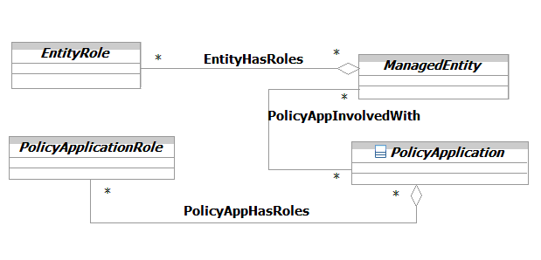
Figure 1P- . PolicyApplicationRole Business Entity Model

PolicySetSpec Business Entity Definition

Business Entity Name | PolicySetSpec
Description | This is an abstract base class that is used to define the invariant characteristics (attributes, methods, constraints and relationships) of a PolicySet entity. It is further refined by the PolicyRuleSpec.
Sources | DEN-ng | Cross- References |  |  | Synonyms / Aliases | This concept is not present in the ITU or CIM specs.
Related Business Entities | ManagedEntity, ResourceSpecification, Resource, Product, ProductComponent, ProductBundle, Software, Protocol, ResourceLogic, ResourceRole, Service, Party, PartyRole, Location, BusinessInteraction, PolicyDomain, Policy, PolicyRule, PolicyGroup, PolicyCondition, PolicyConditionAtomic, PolicyConditionComposite, PolicyAction, PolicyActionAtomic, PolicyActionComposite, PolicyApplication, PolicyRole, Specification (superclass), PolicyRuleSpec (subclass), PolicyConditionSpec, PolicyActionSpec, PolicyStatementSpec, PolicyEventSpec
Business Rules | To be determined

PolicySetSpec Business Entity Attributes Definition

Business Entity Name | PolicySetSpec
Attribute Name | Description | Data Type | Characteristics, Permitted Values & Units | Required/  Optional | Notes (used to map to other models; blank is other models don’t have it)
decisionStrategy | This is an enumerated integer that specifies the particular decision strategy to be used in this PolicySet. | Integer | 0: Unknown  1: MatchFirst  2: MatchAll | Required | Not present in the ITU or CIM specs (the CIM defined this as an attribute in the PolicySet).

Business Entity Model – PolicySetSpec
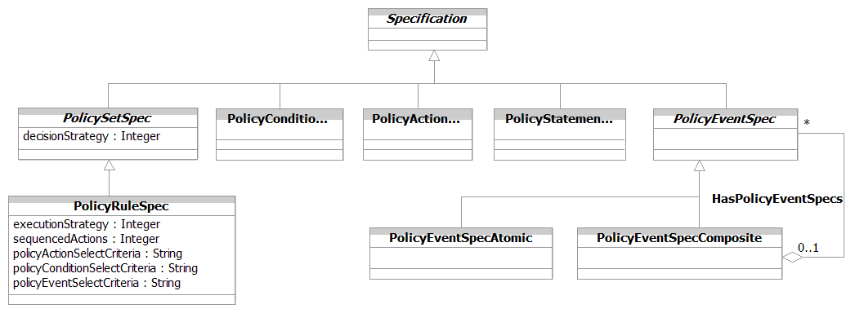
Figure 1P- . PolicySetSpec Business Entity Model

PolicyRuleSpec Business Entity Definition

Business Entity Name | PolicyRuleSpec
Description | This is a concrete base class that is used to define the invariant characteristics (attributes, methods, constraints and relationships) of a PolicyRule entity.
Sources | DEN-ng | Cross- References |  |  | Synonyms / Aliases | This concept is not present in the ITU or CIM specs.
Related Business Entities | ManagedEntity, ResourceSpecification, Resource, Product, ProductComponent, ProductBundle, Software, Protocol, ResourceLogic, ResourceRole, Service, Party, PartyRole, Location, BusinessInteraction, PolicyDomain, Policy, PolicyRule, PolicyGroup, PolicyCondition, PolicyConditionAtomic, PolicyConditionComposite, PolicyAction, PolicyActionAtomic, PolicyActionComposite, PolicyApplication, PolicyRole, Specification, PolicySetSpec (superclass), PolicyConditionSpec, PolicyActionSpec, PolicyStatementSpec, PolicyEventSpec
Business Rules | To be determined

PolicyRuleSpec Business Entity Attributes Definition

Business Entity Name | PolicyRuleSpec
Attribute Name | Description | Data Type | Characteristics, Permitted Values & Units | Required/  Optional | Notes (used to map to other models; blank is other models don’t have it)
executionStrategy | This is an enumerated integer that defines the strategy to be used when executing the sequenced actions aggregated by this PolicyRule. | Integer | 0: Unknown  1: Do Until Success  2: Do All  3: Do Until Failure  4: Do All Without Failure or  Do Nothing | Required | Not present in the ITU or CIM specs (the CIM defined a subset of these values as an attribute in the PolicyRule).
sequencedActions | This is an enumerated integer defines how the ordering of the PolicyActions associated with this PolicyRule is to be interpreted. | Integer |  | Required | Not present in the ITU or CIM specs (the CIM defined a subset of these values as an attribute in the PolicyRule).
policyActionSelectCriteria | This is an attribute that contains an OCL expression to prescribe any limitations on the types of PolicyActions that can be used with any PolicyRules that are derived from this particular PolicyRuleSpec. This enables a PolicyRuleSpec to be built that defines what types of PolicyActions can be used to build PolicyRules. This in turn ensures that a given set of PolicyRules carry standard functionality. | String |  | Required | Not present in the ITU or CIM specs.

Business Entity Name | PolicyRuleSpec (continued)
Attribute Name | Description | Data Type | Characteristics, Permitted Values & Units | Required/  Optional | Notes (used to map to other models; blank is other models don’t have it)
policyConditionSelectCriteria | This is an attribute that contains an OCL expression to prescribe any limitations on the types of PolicyConditions that can be used with any PolicyRules that are derived from this particular PolicyRuleSpec. This enables a PolicyRuleSpec to be built that defines what types of PolicyConditions can be used to build PolicyRules. This in turn ensures that a given set of PolicyRules carry standard functionality. | String |  | Required | Not present in the ITU or CIM specs.
policyEventSelectCriteria | This is an attribute that contains an OCL expression to prescribe any limitations on the types of PolicyEvents that can be used with any PolicyRules that are derived from this particular PolicyRuleSpec. This enables a PolicyRuleSpec to be built that defines what types of PolicyEvents can be used to trigger the evaluation of PolicyRules. This in turn ensures that a given set of PolicyRules carry standard functionality. | String |  | Required | Not present in the ITU or CIM specs.

Business Entity Model – PolicyRuleSpec
The business entity model for a PolicyRuleSpec is the same as that for a PolicySetSpec, and was shown in Figure 1P- above.

PolicyConditionSpec Business Entity Definition

Business Entity Name | PolicyConditionSpec
Description | This is a concrete base class that is used to define the invariant characteristics (attributes, methods, constraints and relationships) of a PolicyCondition entity.
Sources | DEN-ng | Cross- References |  |  | Synonyms / Aliases | This concept is not present in the ITU or CIM specs.
Related Business Entities | ManagedEntity, ResourceSpecification, Resource, Product, ProductComponent, ProductBundle, Software, Protocol, ResourceLogic, ResourceRole, Service, Party, PartyRole, Location, BusinessInteraction, PolicyDomain, Policy, PolicyRule, PolicyGroup, PolicyCondition, PolicyConditionAtomic, PolicyConditionComposite, PolicyAction, PolicyActionAtomic, PolicyActionComposite, PolicyApplication, PolicyRole, Specification, PolicySetSpec, PolicyRuleSpec, PolicyActionSpec, PolicyStatementSpec, PolicyEventSpec
Business Rules | To be determined

PolicyConditionSpec Business Entity Attributes Definition
At this time, there are currently no business attributes defined for this class. Its primary purpose is to be a convenient point for defining relationships and constraints.

Business Entity Model – PolicyConditionSpec
The business entity model for a PolicyConditionSpec is the same as that for a PolicySetSpec, and was shown in Figure 1P- above.

PolicyActionSpec Business Entity Definition

Business Entity Name | PolicyActionSpec
Description | This is a concrete base class that is used to define the invariant characteristics (attributes, methods, constraints and relationships) of a PolicyAction entity.
Sources | DEN-ng | Cross- References |  |  | Synonyms / Aliases | This concept is not present in the ITU or CIM specs.
Related Business Entities | ManagedEntity, ResourceSpecification, Resource, Product, ProductComponent, ProductBundle, Software, Protocol, ResourceLogic, ResourceRole, Service, Party, PartyRole, Location, BusinessInteraction, PolicyDomain, Policy, PolicyRule, PolicyGroup, PolicyCondition, PolicyConditionAtomic, PolicyConditionComposite, PolicyAction, PolicyActionAtomic, PolicyActionComposite, PolicyApplication, PolicyRole, Specification, PolicySetSpec, PolicyRuleSpec, PolicyConditionSpec, PolicyStatementSpec, PolicyEventSpec
Business Rules | To be determined

PolicyActionSpec Business Entity Attributes Definition
At this time, there are currently no business attributes defined for this class. Its primary purpose is to be a convenient point for defining relationships and constraints.

Business Entity Model – PolicyActionSpec
The business entity model for a PolicyActionSpec is the same as that for a PolicySetSpec, and was shown in Figure 1P- above.

PolicyStatementSpec Business Entity Definition

Business Entity Name | PolicyStatementSpec
Description | This is a concrete base class that is used to define the invariant characteristics (attributes, methods, constraints and relationships) of a PolicyStatement entity.
Sources | DEN-ng | Cross- References |  |  | Synonyms / Aliases | This concept is not present in the ITU or CIM specs.
Related Business Entities | ManagedEntity, ResourceSpecification, Resource, Product, ProductComponent, ProductBundle, Software, Protocol, ResourceLogic, ResourceRole, Service, Party, PartyRole, Location, BusinessInteraction, PolicyDomain, Policy, PolicyRule, PolicyGroup, PolicyCondition, PolicyConditionAtomic, PolicyConditionComposite, PolicyAction, PolicyActionAtomic, PolicyActionComposite, PolicyApplication, PolicyRole, Specification, PolicySetSpec, PolicyRuleSpec, PolicyConditionSpec, PolicyActionSpec, PolicyEventSpec
Business Rules | To be determined

PolicyStatementSpec Business Entity Attributes Definition
At this time, there are currently no business attributes defined for this class. Its primary purpose is to be a convenient point for defining relationships and constraints.

Business Entity Model – PolicyStatementSpec
The business entity model for a PolicyStatementSpec is the same as that for a PolicySetSpec, and was shown in Figure 1P- above.

PolicyEventSpec Business Entity Definition

Business Entity Name | PolicyEventSpec
Description | This is a concrete base class that is used to define the invariant characteristics (attributes, methods, constraints and relationships) of a PolicyEvent entity.
Sources | DEN-ng | Cross- References |  |  | Synonyms / Aliases | This concept is not present in the ITU or CIM specs.
Related Business Entities | ManagedEntity, ResourceSpecification, Resource, Product, ProductComponent, ProductBundle, Software, Protocol, ResourceLogic, ResourceRole, Service, Party, PartyRole, Location, BusinessInteraction, PolicyDomain, Policy, PolicyRule, PolicyGroup, PolicyCondition, PolicyConditionAtomic, PolicyConditionComposite, PolicyAction, PolicyActionAtomic, PolicyActionComposite, PolicyApplication, PolicyRole, Specification, PolicySetSpec, PolicyRuleSpec, PolicyConditionSpec, PolicyActionSpec, PolicyStatementSpec, PolicyEventSpecAtomic, PolicyEventSpecComposite
Business Rules | To be determined

PolicyEventSpec Business Entity Attributes Definition
At this time, there are currently no business attributes defined for this class. Its primary purpose is to be a convenient point for defining relationships and constraints.

Business Entity Model – PolicyEventSpec
The business entity model for a PolicyEventSpec is the same as that for a PolicySetSpec, and was shown in Figure 1P- above.

PolicyEventSpecAtomic Business Entity Definition

Business Entity Name | PolicyEventSpecAtomic
Description | This is a concrete base class that is used to define the invariant characteristics and behavior (attributes, methods, constraints, and relationships) of a PolicyEventAtomic entity.  PolicyEventSpecAtomic entities are stand-alone specifications that define the invariant characteristics and behavior of single (i.e., atomic) PolicyEvents.
Sources | DEN-ng | Cross- References |  |  | Synonyms / Aliases | This concept is not present in the ITU or CIM specs.
Related Business Entities | ManagedEntity, ResourceSpecification, Resource, Product, ProductComponent, ProductBundle, Software, Protocol, ResourceLogic, ResourceRole, Service, Party, PartyRole, Location, BusinessInteraction, PolicyDomain, Policy, PolicyRule, PolicyGroup, PolicyCondition, PolicyConditionAtomic, PolicyConditionComposite, PolicyAction, PolicyActionAtomic, PolicyActionComposite, PolicyApplication, PolicyRole, Specification, PolicySetSpec, PolicyRuleSpec, PolicyConditionSpec, PolicyActionSpec, PolicyStatementSpec, PolicyEventSpec (superclass), PolicyEventSpecComposite
Business Rules | To be determined

PolicyEventSpecAtomic Business Entity Attributes Definition
At this time, there are currently no business attributes defined for this class. Its primary purpose is to be a convenient point for defining relationships and constraints.

Business Entity Model – PolicyEventSpecAtomic
The business entity model for a PolicyEventSpecAtomic is the same as that for a PolicySetSpec, and was shown in Figure 1P- above.

PolicyEventSpecComposite Business Entity Definition

Business Entity Name | PolicyEventSpecComposite
Description | This is a concrete base class that is used to define the invariant characteristics and behavior (attributes, methods, constraints, and relationships) of a PolicyEventComposite entity.  PolicyEventSpecComposite entities are specifications that define the invariant characteristics and behavior of a group of related PolicyEvents. These PolicyEvents can be PolicyEventAtomic and/or PolicyEventComposite entities. The instance that is represented by the PolicyEventSpecComposite entity is a named managed object.
Sources | DEN-ng | Cross- References |  |  | Synonyms / Aliases | This concept is not present in the ITU or CIM specs.
Related Business Entities | ManagedEntity, ResourceSpecification, Resource, Product, ProductComponent, ProductBundle, Software, Protocol, ResourceLogic, ResourceRole, Service, Party, PartyRole, Location, BusinessInteraction, PolicyDomain, Policy, PolicyRule, PolicyGroup, PolicyCondition, PolicyConditionAtomic, PolicyConditionComposite, PolicyAction, PolicyActionAtomic, PolicyActionComposite, PolicyApplication, PolicyRole, Specification, PolicySetSpec (superclass), PolicyConditionSpec, PolicyActionSpec, PolicyStatementSpec, PolicyEventSpec (superclass), PolicyEventSpecAtomic
Business Rules | To be determined

PolicyEventSpecComposite Business Entity Attributes Definition
At this time, there are currently no business attributes defined for this class. Its primary purpose is to be a convenient point for defining relationships and constraints.

Business Entity Model – PolicyEventSpecComposite
The business entity model for a PolicyEventSpecComposite is the same as that for a PolicySetSpec, and was shown in Figure 1P- above.
Administrative Appendix
This Appendix provides additional background material about the TeleManagement Forum and this document. In general. sections may be included or omitted as desired, however a Document History must always be included..

2.1 About this document
This is a TM Forum Guidebook. The guidebook format is used when:
- The document lays out a ‘core’ part of TM Forum’s approach to automating business processes. Such guidebooks would include the Telecom Operations Map and the Technology Integration Map, but not the detailed specifications that are developed in support of the approach.
- Information about TM Forum policy, or goals or programs is provided, such as the Strategic Plan or Operating Plan.
- Information about the marketplace is provided, as in the report on the size of the OSS market.

2.2 Document Life Cycle
This document is being issued for Member Evaluation. The purpose of an Evaluation Version is to encourage input based on experience of members and the public as they begin to use the document. Following the Evaluation Period, documents that are seen to deliver value are candidates for formal approval by the TM Forum. All documents approved by the TM Forum undergo a formal review and approval process.
This document will continue under formal change control. Supporting work will be issued as companions to this document. A document of this type is a “living document,” capturing and communicating current knowledge and practices. Further inputs will be made because of detailed work ongoing in the TM Forum and the industry.

2.3 Document History

2.3.1 Version History

Version | Author | Date | Purpose
0.1 | J. Strassner | April 2003 | First rough draft
0.2 | J. Strassner | May 2003 | Released to Policy sub-team
0.3 | J. Strassner | June 2003 | Incorporated review edits and added clarifications
0.4 | J. Strassner | June 2003 | Finalized data dictionary; added PolicySpec entities
1.0 | J. Strassner | July 2003 | Formatted for 1.0 release
1.0a | TM Forum Staff | July 2003 | Formatted for Member Review with Frameworx R3.5
1.0b | J. Strassner | August 2003 | Minor fixes for inconsistencies submitted by Cliff
1.1 | TM Forum | Aug 2004 | To reflect TM Forum Approval Status
1.2 | J. Wilmes | Dec 2010 | Added Policy Information Exchange changes using Ron Roman’s updates to the model, fixed CR 2209
1.3 | A. Kawecki | Mar 2011 | Minor formatting corrections prior to web posting and ME
1.4 | A. Kawecki | Sep 2011 | Updated to reflect TM Forum Approved status

2.3.2 Release History

Release Number | Date Modified | Modified by: | Description of changes
Release 6.0 | 31-Oct-2005 | J. Reilly
Release 9.5 | 28Dec2010 | John Wilmes | Updated Notice and template

Acknowledgments
This document was prepared by the members of the TM Forum SID team.
The Shared Information/Data Model is a genuinely collaborative effort. The TM Forum would like to thank the following people for contributing their time and expertise to the production of this document. It is just not possible to recognize all the organizations and individuals that have contributed or influenced the introduction. We apologize to any person or organization we inadvertently missed in these acknowledgments.
Key individuals that reviewed, provided input, managed, and determined how to utilize inputs coming from all over the world, and really made this document happen were:

Name | Affiliation
Cliff Faurer | TeleManagement Forum
Steve Fisher | British Telecom
Ram Garg | MetaSolv
Chris Hartley | Telstra
Helen Hepburn | British Telecom
Matt Izzo | Agilent Technologies
Xi Jiang | Johns Hopkins University – Applied Physics Laboratory
Andrew J. Mayer | Telcordia
Stephen Chris Mccarron | Defense Information Systems Agency
Mike McLoughlin | British Telecom
Dave Raymer | Motorola
John Reilly  Ron Roman | MetaSolv Software  Telcordia
Josh Salomon | Amdocs
Wayne Sigley | Telstra
John Strassner | Intelliden

Actually, the DEN-ng Policy model enables actions to be taken when the PolicyCondition clause evaluates to FALSE. However, this is optional and, due to the complexity that arises from it, will not be discussed further in this Addendum.

