Information Framework (SID)
Addendum 1R - Common Business Entity Definitions – Root Business Entities

GB922 Addendum 1R
TM Forum Approved Version 9.7


September, 2011

Notice
This material, including documents, code and models, has been through review cycles; however, due to the inherent complexity in the design and implementation of software and systems, no liability is accepted for any errors or omissions or for consequences of any use made of this material.
Under no circumstances will the TM Forum be liable for direct or indirect damages or any costs or losses resulting from the use of this specification. The risk of designing and implementing products in accordance with this specification is borne solely by the user of this specification.
This material bears the copyright of TM Forum and its use by members and non-members of TM Forum is governed by all of the terms and conditions of the Intellectual Property Rights Policy of the TM Forum (http://www.tmforum.org/Bylaws/1094/home.html) and may involve a claim of patent rights by one or more TM Forum members or by non-members of TM Forum.

Direct inquiries to the TM Forum office:

240 Headquarters Plaza,
East Tower – 10th Floor,
Morristown, NJ 07960 USA
Tel No. +1 973 944 5100
Fax No. +1 973 944 5110
TM Forum Web Page: www.tmforum.org

Table of Contents
Notice 2
Table of Contents 3
List of Figures 6
1. Common Business Entities – Root Business Entities 9
1.1. Introduction 9
1.1.1. Rationale for Rooting the Business View 10
1.2. RootEntity 11
1.3. Entity 13
1.3.1. Entity Overview 13
1.3.2. ManagedEntity Overview 14
1.3.3. UnManagedEntity Overview 18
1.3.4. Examples 19
1.4. Specification 21
1.4.1. Specification Overview 21
1.4.2. EntitySpecification Overview 22
1.5. Identification 25
1.5.1. Identification Overview 25
1.5.2. PartyIdentification Overview 25
1.5.3. EntityIdentificationSpecification 28
1.5.4. EntityIdentification 36
1.6. Additional Entity Identification Examples 37
1.6.1. Customer Site Format 37
1.6.2. Equipment Entity Identification Format 38
1.7. Role 43
1.7.1. Role Overview 43
1.7.2. Different Types of Roles in the SID 47
1.8. RoleSpecification 48
1.8.1. RoleSpecification Overview 48
1.9. EntityRole 49
1.10. ManagementDomain 50
1.11. ManagementInfo 51
1.12. ManagementMethodEntity 52
1.13. Root Business Entities/Characteristic ABE 54
1.14. Policy 81
2. References 82
3. Data Dictionary 83
3.1. Words 83
3.1.1. Business Definition – RootEntity 84
3.2. Business Attributes Definition – RootEntity 85
3.2.1. Business Model – RootEntity 86
3.2.2. Business Definition – Entity 87
3.3. Business Attributes Definition – Entity 88
3.3.1. Business Model – Entity 88
3.3.2. Business Definition – RootEntityType 89
3.3.3. Business Definition – ManagedEntity 89
3.4. Business Attributes Definition – ManagedEntity 91
3.4.1. Business Model – ManagedEntity 92
3.4.2. Business Definition – Product 93
3.4.3. Business Definition – Resource 94
3.4.4. Business Definition – Service 95
3.4.5. Business Definition – UnManagedEntity 96
3.5. Business Attributes Definition – UnManagedEntity 97
3.5.1. Business Model – UnManagedEntity 97
3.5.2. Business Definition – Specification 98
3.6. Business Attributes Definition – Specification 99
3.6.1. Business Model – Specification 99
3.6.2. Business Definition – EntitySpecification 100
3.7. Business Attributes Definition – EntitySpecification 101
3.7.1. Business Model – EntitySpecification 101
3.7.2. Business Definition – EntityIdentification 102
3.8. Business Attributes Definition – EntityIdentification 103
3.8.1. Business Definition – CompositeEntityIdentification 103
3.8.2. Business Definition – ComponentEntityIdentification 103
3.8.3. Business Model – EntityIdentification 104
3.8.4. Business Definition – EntityIdentificationSpecification 104
3.9. Business Attributes Definition – EntityIdentificationSpecification 105
3.9.1. Business Definition – CompositeEntityIdentificationSpec 106
3.9.2. Business Definition – ComponentEntityIdentificationSpec 106
3.10. Business Attributes Definition – ComponentEntityIdentificationSpec 107
3.10.1. Business Definition – EntityIdentficationSpecFormat 107
3.11. Business Attributes Definition – EntityIdentificationSpecFormat 108
3.11.1. Business Definition – RootyEntityTypeIdentificationSpec 108
3.12. Business Attributes Definition – RootyEntityTypeIdentificationSpec 109
3.12.1. Business Definition – Role 110
3.13. Business Attributes Definition – Role 111
3.13.1. Business Model – Role 113
3.13.2. Business Definition – RoleSpecification 114
3.14. Business Attributes Definition – RoleSpecification 115
3.14.1. Business Model – RoleSpecification 116
3.14.2. Business Definition – EntityRole 117
3.15. Business Attributes Definition – EntityRole 118
3.15.1. Business Model – EntityRole 118
3.15.2. Business Definition – Party 119
3.15.3. Business Definition – ManagementDomain 120
3.16. Business Attributes Definition – ManagementDomain 121
3.16.1. Business Model – ManagementDomain 121
3.16.2. Business Definition – ManagementInfo 122
3.17. Business Attributes Definition – ManagementInfo 123
3.17.1. Business Model – ManagementInfo 124
3.17.2. Business Definition – ManagementMethodEntity 125
3.18. Business Attributes Definition – ManagementMethodEntity 126
3.18.1. Business Model – ManagementMethodEntity 126
3.18.2. CharacteristicSpecification 127
3.19. Business Entity Definition 127
3.20. Business Entity Attributes Definition 127
3.20.1. CharacteristicSpecValue 129
3.21. Business Entity Definition 129
3.22. Business Entity Attributes Definition 130
3.22.1. CharacteristicSpecRelationship 132
3.23. Business Entity Definition 132
3.24. Business Entity Attributes Definition 132
3.25. Business Entity Definition 133
3.26. Business Entity Attributes Definition 134
3.26.1. EntitySpecCharUse 135
3.27. Business Entity Definition 135
3.28. Business Entity Attributes Definition 135
3.28.1. EntitySpecCharValueUse 137
3.29. Business Entity Definition 137
3.30. Business Entity Attributes Definition 138
3.30.1. RootEntityTypeCharUse 139
3.31. Business Entity Definition 139
3.32. Business Entity Attributes Definition 140
3.32.1. RootEntityTypeCharValueUse 142
3.33. Business Entity Definition 142
3.34. Business Entity Attributes Definition 142
3.35. Business Entity Definition 143
3.36. Business Entity Attributes Definition 144
3.36.1. CharacteristicPriceDependency 144
3.37. Business Entity Definition 144
3.38. Business Entity Attributes Definition 145
3.38.1. CharPriceDepMember 146
3.39. Business Entity Definition 146
3.40. Business Entity Attributes Definition 146
3.40.1. Business Definition – Policy 147
4. Administrative Appendix 148
4.1. About this document 148
4.2. Document History 148
4.2.1. Version History 148
4.2.2. Release History 150
4.3. Company Contact Details 151
4.4. Acknowledgments 152

List of Figures
Figure 1. Business View of the RootEntity Class 12
Figure 2. Business View of the Entity Class Hierarchy 13
Figure 3. Business View of ManagedEntities 14
Figure 4. ManagementInformation and Methods for Obtaining Management Data 15
Figure 5. Basic Service Model – A Starting Point 17
Figure 6. Associating Management Information with UnManagedEntities 18
Figure 7. Business View of the Specification Class Hierarchy 21
Figure 8. The EntitySpecification – Entity Pattern 22
Figure 9. Interaction Between Specification and Entity Classes 23
Figure 10. PartyIdentification Excerpt (taken from GB922, Addendum 1P) 26
Figure 11. Beginning of the Entity Identification ABE Model 28
Figure 12. The Composite Pattern Applied to EntityIdentificationSpecification 29
Figure 13. EntityIdentificationSpecification Examples 30
Figure 14. The EntityIdentificationSpecificationFormat Association Class 31
Figure 15. Identifying Entities Using an Associated EntitySpecification 32
Figure 16. Identifying Entities Using the RootEntityType Entity 33
Figure 17. Use of an Entity Identification Specification 34
Figure 18. EntitySpecification Association With EntityIdentificationSpecification 35
Figure 19. Entity and Entity Identification 36
Figure 20. EntityIdentificationSpec Example 41
Figure 21. Additional EntityIdentification Examples 42
Figure 22. The Basics of Roles – An Example 46
Figure 23. Associating EntityRoles with a ManagedEntity 49
Figure 24. ManagementInfo Class Hierarchy 51
Figure 25. ManagementMethodEntity Class Hierarchy 52
Figure 26. Gathering Management Information 53
Figure 27. Characteristic Specification 57
Figure 28. Characteristic Value 61
Figure 29. Characteristic Spec Instance – Example 1 63
Figure 30. Characteristic Spec Instance – Example 2 64
Figure 31.Partial View of Characteristic Model 66
Figure 32 . Content Characteristic Specs 67
Figure 33. Updated Characteristic Use Entities 70
Figure 34. Characteristic Specs and Pricing 72
Figure 35. Content Charging Offer Price 73
Figure 36. Complex Content Charging Offer Price 74
Figure 37. Content Charging Product Offer Example 75
Figure 38. Characteristic Value and Pricing 76
Figure 39. Content Charging Product Price 77
Figure 40. Content Charging Usage Specification Example 79
Figure 28. Business Model of a Role 113
Figure 29. Business Model of a RoleSpecification 116

Common Business Entities – Root Business Entities

Introduction
The purpose of this Addendum is to define a set of common business entities that collectively serve as the foundation of the SID business view. This set of entities enables the entities in different domains of the SID Framework to be associated with each other, providing greater overall coherence to the information framework.
The overall SID information framework contains entities that model the business, system, implementation and deployment views of NGOSS. This is described in greater detail in the Lifecycle work as described in [LIFE] and [LIFEPRES]. Thus, this Addendum is concerned solely with a business view of these entities.

Rationale for Rooting the Business View
The SID business view is part of an analysis model. This means that the business view is not constrained to only contain entities that are recognizable by a business person.
An analysis model doesn’t just contain classes that represent real-world objects – it also must model concepts. This is because the focus of an analysis model is to elaborate the managed environment and apply knowledge to specify a solution. The SID calls this a business view, because every effort is taken to describe these objects and concepts in terms recognizable by a business person.
There are four main motivations for presenting a rooted view of business concepts. First, during our analysis of business-oriented use cases, we often find that certain characteristics and behavior are common across a number of business entities. The SID Business Framework, as documented in GB922, divides the managed environment into eight different problem domains. Unfortunately, common characteristics and behavior are often independent of any one particular problem domain, much less an ABE (Aggregated Business Entity) that first defines the concept. Thus, the first two motivations are:
- to be able to reuse and share the definition of common characteristics (and behavior in the system and other views)
- to ensure that multiple incompatible definitions of the same concept or entity are not created
Business entities within the Root Business Entities ABE represent characteristics that are common to all entities in the information model, independent of the specific knowledge domain that they originate in. Such abstractions belong in the business view/analysis model documented in GB922 addenda and the Rose information model.
The third motivation is that, as the NGOSS Lifecycle team has shown, the lifecycle of NGOSS components and managed objects occurs in four coordinated phases, which have been called the business, system, implementation, and deployment views. The latter three views must be rooted, as this is fundamental to their object-oriented design. If the business view is not rooted, then it will be exceedingly difficult, if not impossible, to relate multiple entities that describe essentially the same concept in the business view to a single entity in other views. The whole point of the Lifecycle approach is that analysis and design are related to each other, not separate. Conversely, if the business view is rooted, then it enables and facilitates the association of business view concepts and objects to concepts and objects in other views.
The final motivation is that as an object-oriented analysis model, each of the knowledge domains describes and classifies knowledge. They have, up until this fourth phase, been constructed as parallel hierarchies. Rooting the model is a natural evolution of object-oriented analysis, and serves to strengthen the classification of knowledge, making the SID more cohesive.

RootEntity
This is the top of the SID business view class hierarchy. The purpose of the RootEntity is to define a set of attributes that are common to select SID entities in the Service and Resource domains, such as Service, Service Specification, Resource, and Resource Specification, as well as Policy entities in the Common Business Entities domain. These properties enable us to name and describe all objects (manageable and unmanageable) in the environment. It is shown in Figure 1 below.
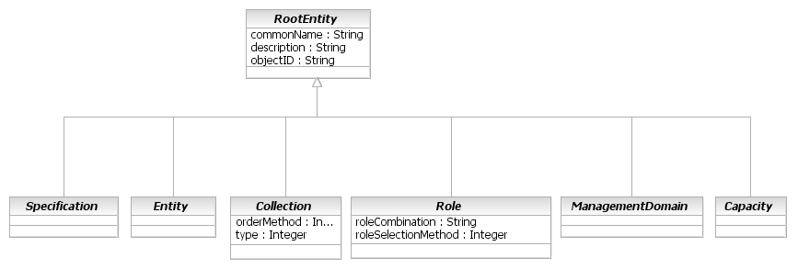
Figure 1. Business View of the RootEntity Class
Note that all six classes shown in Figure 1 are abstract. This is because they are all conceptual in nature, and exist in order to organize information and concepts. The commonName attribute is a generic attribute that enables users of the SID to refer to an object using terminology defined by their application-specific needs. The description attribute is an optional attribute that enables users of the SID to customize the description of a SID object. The objectID attribute provides a unique identity to each entity.
The following subsections will expand on each of the six main subclasses of RootEntity.

Entity
This section describes the three main Entity classes (Entity, ManagedEntity, and UnManagedEntity) in the business view of the SID.

Entity Overview
This is an abstract class that extends the RootEntity class in order to represent classes of objects that play a business function. Entities can be either managed or unmanaged. NGOSS is about Business and Operations Support Systems, which means computer-assisted handling of the business. Therefore, it is important to know which entities within the business are in play, with what capabilities, so as to best leverage computer-assisted control of the managed environment. The top-level Entity class hierarchy is shown in Figure 2 below.
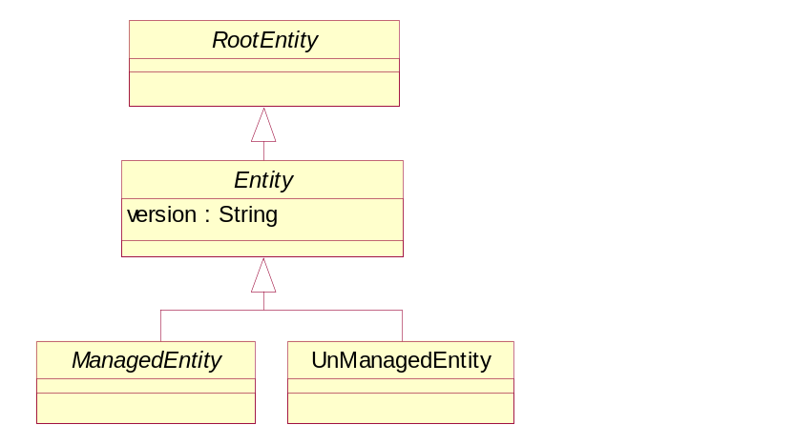
Figure 2. Business View of the Entity Class Hierarchy
The version attribute is a string that identifies the version of the object.

ManagedEntity Overview
ManagedEntity is an abstract class that extends the Entity class in order to represent entities in a managed environment that have the following semantics in common: (1) a business entity owns or is otherwise responsible for them, (2) management of the entity is critical for providing a service and/or maintaining the environment, and (3) the entity is "important" from both a business as well as a management point-of-view. As such, ManagedEntity is a point at which semantically important relationships can be created. This is codified in the system view of the SID.
Entity
version : String
ManagedEntity
managementMethodCurrent : Integer
managementMethodSupported : SequenceOf Integer
UnManagedEntity
Resource
Service
UnManagedResource
Figure 3. Business View of ManagedEntities
ManagedEntity defines two attributes. The set of different management methods (e.g., using CLI or SNMP, or even using Web Services) that can be used to manage this Entity is contained in the managementMethodSupported attribute, while the current management method that is being used is contained in the managementMethodCurrent enumerated attribute. This is shown in Figure 4 below.
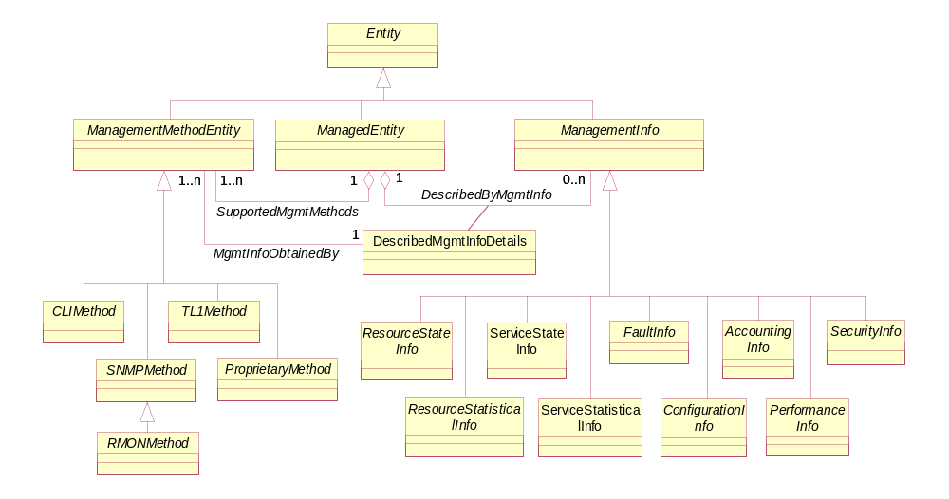
Figure 4. ManagementInformation and Methods for Obtaining Management Data
This figure is taken from GB922, Addendum 5LR, Figure 5LR-39. A fundamental characteristic of a ManagedEntity is that it can perform management functions and/or collect management information. ManagementMethodEntity represents the means in which management information is obtained, and ManagementInfo represents the specific type of management data obtained.
The two principal types of ManagedEntities are Resource and Service. These are defined in Addendum 3, Addendum 4SO, and Addendum 5RO, respectively, of GB922. They are each types of managed entities, and in fact exist in close support of each other. This is illustrated in Figure 5 (which is excerpted from Addendum 4SO, Figure 6) – a Product can be implemented by zero or more CustomerFacingServices and zero or more PhysicalResources. Products are also related to Resources to support a relationship with Logical and Compound Resources. Note that all three have business uses and, more importantly, either perform management functions and/or collect management information.
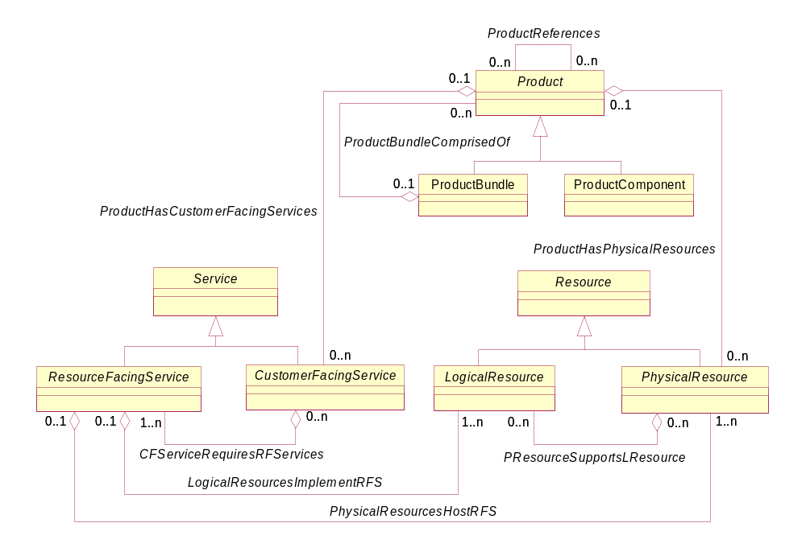
Figure 5. Basic Service Model – A Starting Point

UnManagedEntity Overview
The UnManagedEntity class is a concrete class that extends the Entity class in order to represent Entities that are not manageable. Specifically, this means that an UnManagedEntity is one that cannot generate management information by itself. Note that this does NOT mean that management information cannot be associated with it – this is accomplished by associating ManagedEntities with the UnManagedEntity as shown in Figure 6. Associating Management Information with UnManagedEntities below. It also means that an UnManagedEntity cannot perform management functions and collect management information.
A corollary of the above is that an UnManagedEntity is a type of Entity that can only be manually controlled. Specifically, an UnManagedEntity cannot be controlled remotely using any management protocol.
Note that UnManagedEntity is an optional class.
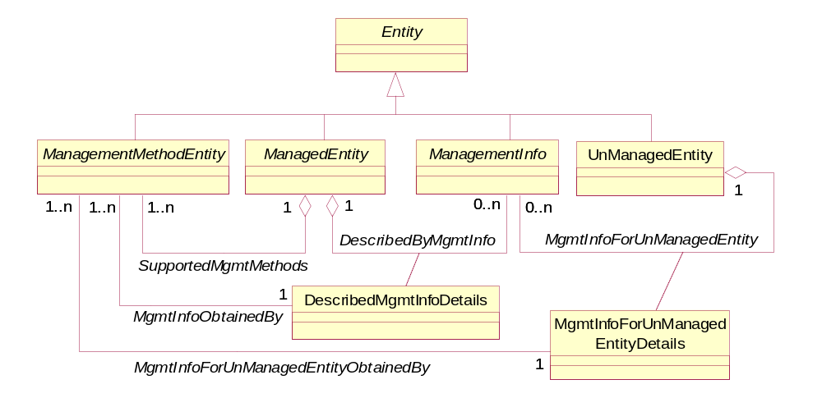
Figure 6. Associating Management Information with UnManagedEntities

Examples
UnManagedEntities are often useful because many Entities exist that are of business value to the Service Provider, yet do not have the innate capability to perform management functions themselves. For example, consider an inventory application. A Cable Duct does not have the ability to manage itself or to report its management state – however, it (possibly) could be instrumented (e.g., using sensors) to do so. It is incorrect to model the Cable Duct as a ManagedEntity, because it doesn’t have the semantics that are associated with ManagedEntities. Thus, the SID models this as a type of UnManagedEntity, and if there are sensors associated with the Cable Duct to provide management information, then the sensors are modeled as ManagedEntities, and associations are created that link the sensors (and the management information that they provide) to the Cable Duct.
Note that if management information was required for the Cable Duct, but the only way of obtaining said management information was by human inspection, then this can be accommodated as well. Referring to Figure 6 above, the management information is modeled as a separate entity from the object that the management information is describing. This is true for ManagedEntities as well as UnManagedEntities. Thus, a PartyRole (i.e., the human) could manually obtain management information and populate the ManagementInfo class of Figure 6 above, and then associate this information to the UnManagedEntity.
Another example of an UnManagedEntity is a legacy hub - it doesn't support communication with a management application, so the user must go to the hub and physically change its connections. In contrast, manageable Services and Resources can be controlled using protocols and applications, and Products can be managed by remote processes as well as using applications. The above manual population of management information for the legacy hub could be done in this case as well.
A third example of an UnManagedEntity is a Tower. The Tower itself is just a piece of concrete or metal. Thus, it cannot perform management functions or collect management information, because there is no intelligence inherent in the concrete or metal. However, the Tower could host LogicalResources that provide management information on either the Tower itself, conditions affecting the Tower, or equipment contained within the Tower. The SID would model this as follows.
Figure 5LR-39 of GB922, Addendum 5LR (the LogicalResource model) explains a simple yet elegant and extensible model for obtaining management information. Error: Reference source not found above takes this basic model (consisting of the ManagementMethodEntity, ManagedEntity, and ManagementInformation classes, which was also shown earlier in Figure 4 of this Addendum) and shows how an UnManagedEntity can be made manageable.
The MgmtInfoForUnManagedEntity aggregation is used to associate management information to an UnManagedEntity. This management information is obtained from various ManagedEntities (specifically, LogicalResources) that are either associated with or contained by the UnManagedEntity.
Note that two separate aggregations (DescribedByMgmtInfo and MgmtInfoForUnManagedEntity) are used to link ManagementInfo to ManagedEntities and UnManagedEntities, respectively. This is because the aggregations themselves are different - the management methods and types of management information are fundamentally different for UnManagedEntities vs. ManagedEntiities.
Currently, there is only a single subclass defined for UnManagedEntity in the business view of the SID; this is the UnManagedPhysicalResource class. This is because the vast majority of UnManagedEntities are Resources, as opposed to Products and Services. In addition, different organizations will use different means for identifying and managing unmanageable entities.
As stated earlier, the UnManagedEntity (and UnManagedResource) classes exist to enable an application to define subclasses of these if required.
The system view of the SID introduces additional attributes and relationships that help govern UnManagedEntities.
  - Specification
This section describes the main Specification classes in the business view of the SID.

Specification Overview
A Specification is an abstract class that extends the RootEntity class in order to define the invariant characteristics (attributes in the business view, and methods, constraints, relationships, and behavior in the system view) of an object. Specifications exist for ManagedEntities (e.g., Products, Resources, and Services), as well as Policies and other entities in the current Addenda to GB922. Specifications for other entities, such as Party and Place, exist in DEN-ng and other models. This is illustrated in Figure 7 below (note that these subclasses are exemplary).

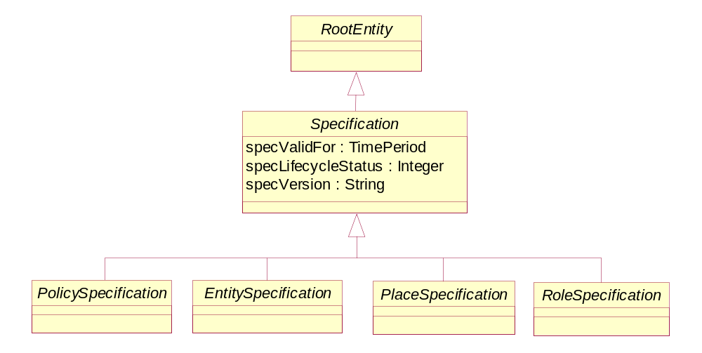
Figure 7. Business View of the Specification Class Hierarchy

EntitySpecification Overview
The EntitySpecification – Entity pattern, shown in Figure 8 below, enables all Entities to be abstracted such that their invariant attributes (in the business view) are captured in the EntitySpecification. This has a simple yet effective use: when different Entities are instantiated that are associated with the same EntitySpecification, then the presence of the EntitySpecification ensures that each different entity instance will always have the common attributes defined in their associated EntitySpecification. This enables each Entity to define its own distinguishing attributes in addition to the common attributes defined by the EntitySpecification.
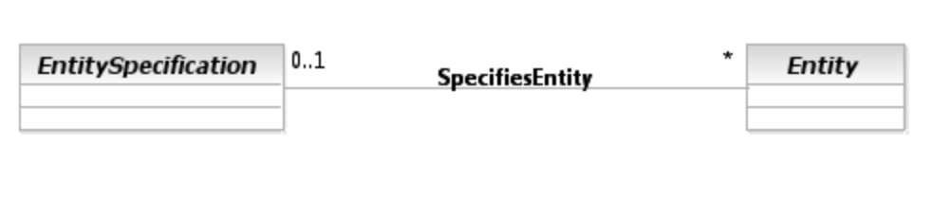
Figure 8. The EntitySpecification – Entity Pattern

In the system view, EntitySpecifications define the invariant characteristics (attributes, methods, constraints, and relationships) and behavior of an Entity. Note that EntitySpecifications can apply to ManagedEntities as well as UnManagedEntities.
The relationships between the subclasses of EntitySpecification and ManagedEntity are shown in Figure 9 below.
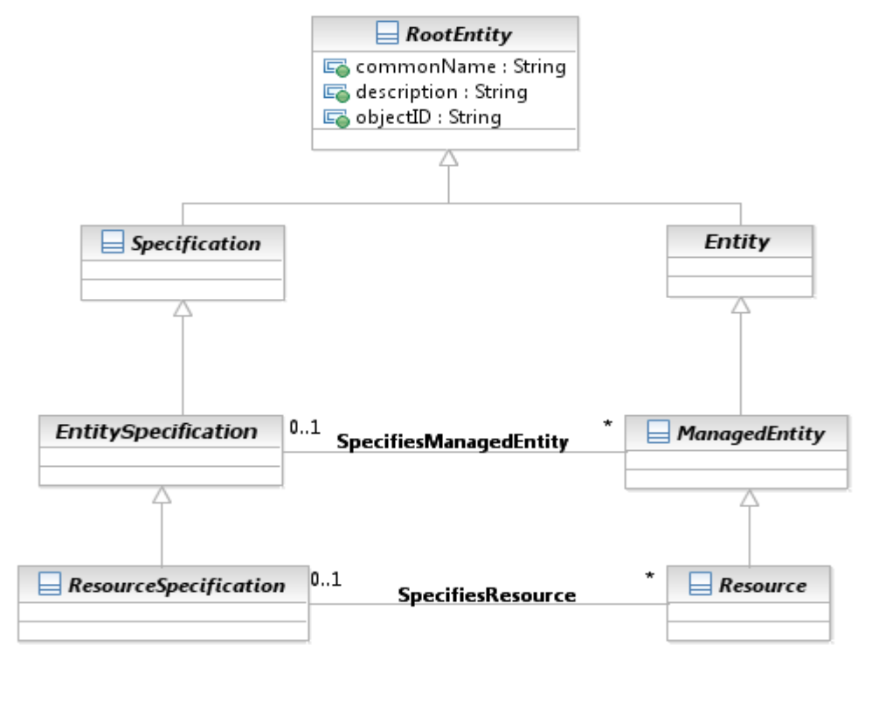
Figure 9. Interaction Between Specification and Entity Classes
More formally, an EntitySpecification is an abstract class that extends the RootEntity class in order to define the invariant attributes in the business view (and methods, constraints, relationships and behavior in the system view) of a ManagedEntity. An EntitySpecification can be used for ManagedEntities as well as for UnManagedEntities.

  - Identification
Business entities consist of two types – those that are simple values, such as a quantity of money or a period of time, and those that have identity. For these latter entities, the concept of an identity is used to distinguish different instances of the same object.
Identity is flexibly and extensibly defined using the group of objects defined in this chapter.

Identification Overview
Individual people, places, and things, such as customer orders, equipment, network elements and so forth, can be recognized (identified) by different attributes. The business will define (usually through a policy) what particular set of attributes or concepts is appropriate for a given entity. For example, an individual person may be identified using a passport number, a driver’s license number, or a national identification number. Similarly, a network location may be identified by a network node ID or a Location Entity Identification Code (as defined in American National Standard T1.253).
It should be noted that policy does not have to be used. However, the use of policy provides an elegant and extensible means to define the semantics of using an identity. This is done by modeling associations between PolicyRules and the identification entities that it relates to.

PartyIdentification Overview
Figure 10 below shows an excerpt for identifying different types of Parties (e.g., Individuals and Organizations). This was taken from GB922, Addendum 1P.

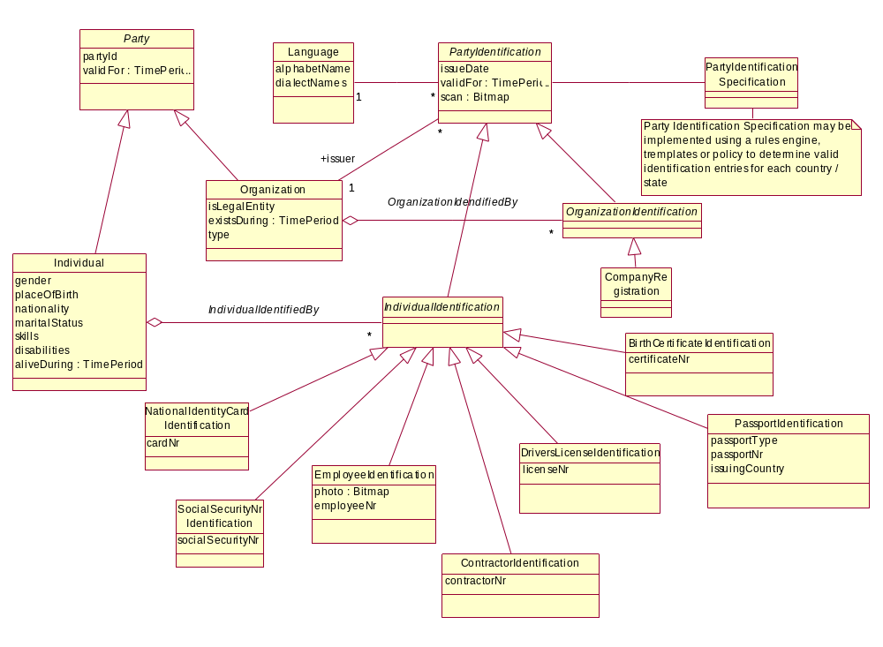
Figure 10. PartyIdentification Excerpt (taken from GB922, Addendum 1P)
The manner in which each key business entity in the SID model is identified could be modeled in a way similar to Party. However, each business entity can be identified in a number of ways, as shown in the example above for individuals. Modeling the identity in this way means that each key entity would have a set of classes similar to those used to model the identities of Party. This introduces redundancy into the SID model for every entity that requires identification. In addition, using explicit subclasses to model the different types of identification attributes for an entity results in a model that cannot be easily extended. This is because as new ways to identify an entity are defined or discovered, a new subclass must be introduced into the SID model. Having to introduce new subclasses implies that the parts of the SID model that represent entity identifications are not very stable. It also makes it difficult for other teams and fora to adopt the SID, since its baseline is always changing.

EntityIdentificationSpecification
To eliminate the redundancy and instability within the model caused by the repeated modeling of similar identification structures and by introducing subclasses for each way that an entity can be identified, the EntitySpecification - Entity pattern is used. Here, the “EntitySpecification” part of the pattern will take the form of a specification for identifying Entities, and the “Entity” part of the pattern will take the form of an object that can be used to identify entities.
Therefore, applying this pattern yields the beginning of a model for Entity identification, as shown in Figure 11 below.
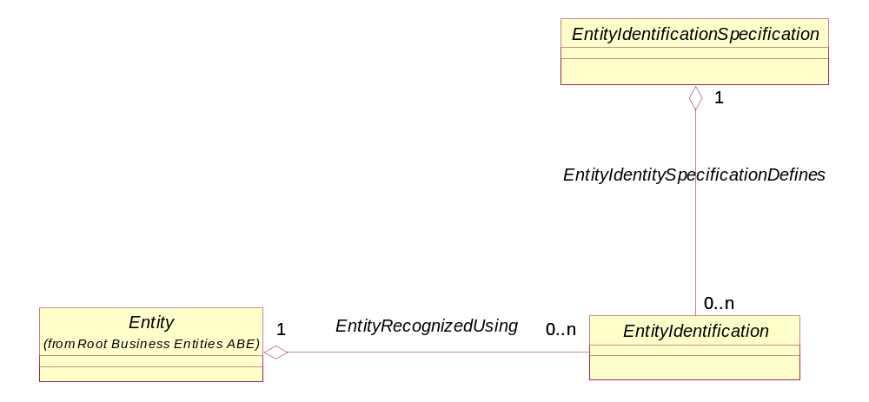
Figure 11. Beginning of the Entity Identification ABE Model
An EntityIdentificationSpec defines the invariant attributes in the business view (and methods, constraints, relationships and behavior in the system view) of an EntityIdentification object. Note that methods and constraints (as specified in OCL) are useful for specifying “static” behavior (e.g., functionality that can be defined at design time). Thus, “behavior” refers to dynamic functionality and runtime considerations that are not easy to represent in a class model. For example, the directive to instantiate an object only in response to a run-time exception is easy to conceptualize as a constraint, but is difficult to model in UML. Other examples include the specification of pre- and post-conditions and other contract related data.
As the identification model is further developed in this addendum, the EntityIdentificationSpecification will be expanded to include business entities that define the structure and format of Entity identifiers. The EntityIdentification entity will similarly be expanded to show the structure for values of Entity identifiers and the Entities they identify.
An Entity identifier could be a single attribute or a composite of two or more attributes. For example, a network node ID is a single attribute that identifies a network location; the 8-byte Network Site Format of ANS T1.253 used to identify a building is a composite of a Geographical Code, a Geopolitical Code, and a Network Site Code. Applying the composite pattern to Entity identification captures this concept, and provides the ability to extensibly define EntityIdentificationSpecifications. The composite pattern is shown in Figure 12 below.
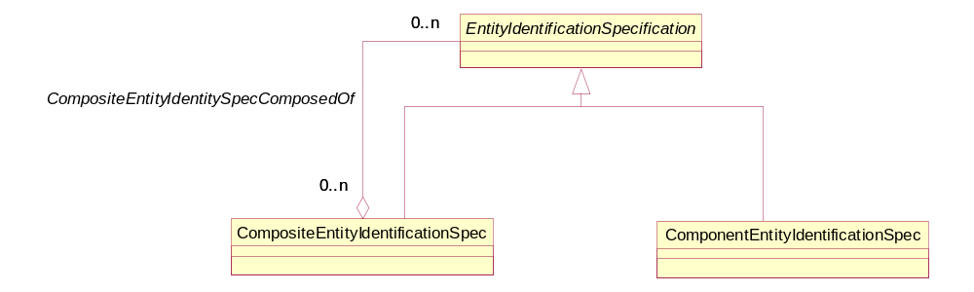
Figure 12. The Composite Pattern Applied to EntityIdentificationSpecification
An EntityIdentificationSpecification represents one or more attributes (not attribute values) used to recognize (identify) an instance of an Entity. Figure 13 below shows an 8-byte Network Site Format using ANS T1.253. Note that the various component specifications (Geographical Code, Geopolitical Code, and Network Site Code) that make up a complete Network Node ID, which is represented as an CompositeEntityIdentificationSpec object, are represented as instances of the ComponentEntityIdentificationSpec, and are aggregated by the CompositeEntityIdentificationSpec.
4 byte Geographical Code
2 byte Geopolitical Code
2 byte Network Site Code
8-byte Network Node ID Format
Geographical Code
Geopolitical Code Network Site Code
Figure 13. EntityIdentificationSpecification Examples
The component specification must be able to occur in a certain sequence to define the composite. And, they may be preceded and/or followed by certain characters. For example, the format of a phone number could contain dashes, such as 972-477-8401. Figure 14 below shows an association class added to hold the sequence in which the components appear in a composite object, along with its formatting attributes.
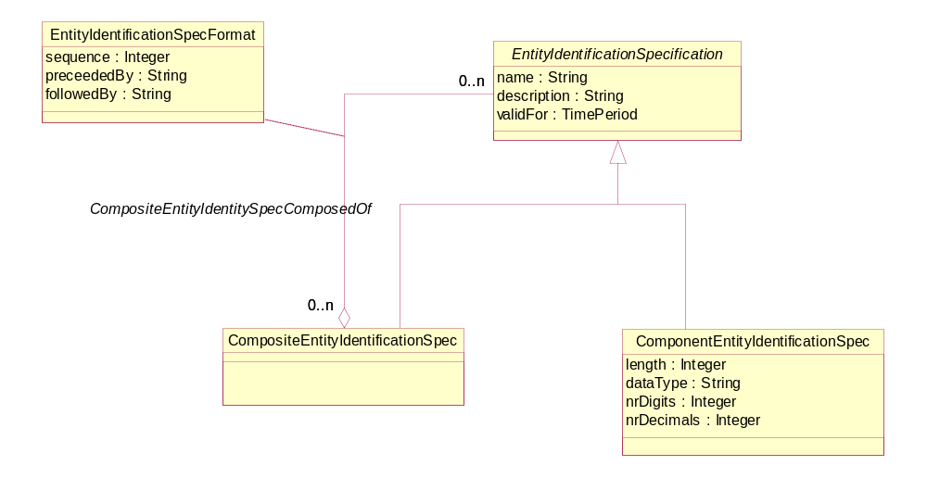
Figure 14. The EntityIdentificationSpecificationFormat Association Class

The next thing that must be known about an EntityIdentitySpecification is what type of business Entity the EntityIdentitySpecification applies to. There are two different means of doing this. The difference is whether the Entity being identified has an associated EntitySpecification or not. For example, a Market Entity has no associated Specification, whereas a Resource Entity or a Service Entity often do have an associated EntitySpecification.
The first option is shown in Figure 15. In this option, an EntitySpecification defines a Entity as well as a set of EntityIdentificationSpecs. Any of these EntityIdentitySpecs may be used to identify the EntityIdentification object that is used to identify the associated Entity. Looking at Figure 15 below, we see that the EntitySpecification that characterizes the Entity contains, in addition to its invariant attributes, zero or more EntityIdentificationSpecs. The EntityIdentitySpecification in turn specifies the set of EntityIdentification objects that can be used to identify the Entity that the EntitySpecification applies to. This enables the EntitySpecification to in effect direct the usage of a subordinate specification (the EntityIdentitySpecification) to indirectly define EntityIdentification objects that can be used to identify the Entity to which the EntitySpecification applies to, providing a great deal of inherent flexibility in determining how the Entity will be identified.
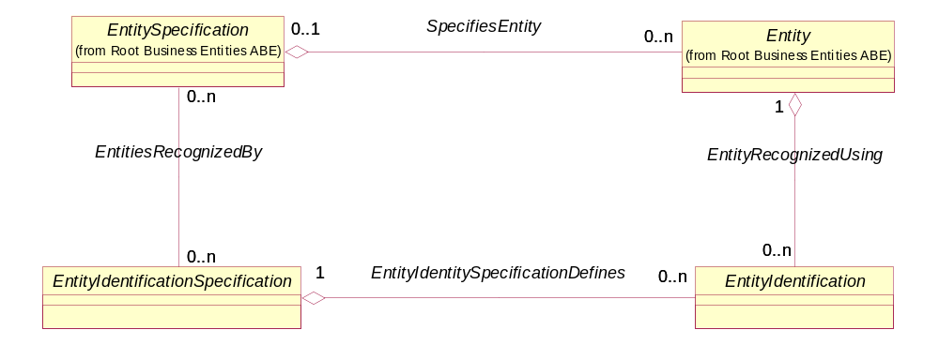
Figure 15. Identifying Entities Using an Associated EntitySpecification
The second option is shown in Figure 16 below. This option is used for Entities that don’t have an associated EntitySpecification, and can also be used in the first case if desired. This option introduces an entity (called RootEntityType) into the model whose instance is the business entity that is to be identified. Examples of business entities that use this approach include Location (identified by the 8-byte Network Site Format), Individual, Organization, Customer, Supplier, Market Segment and so forth.
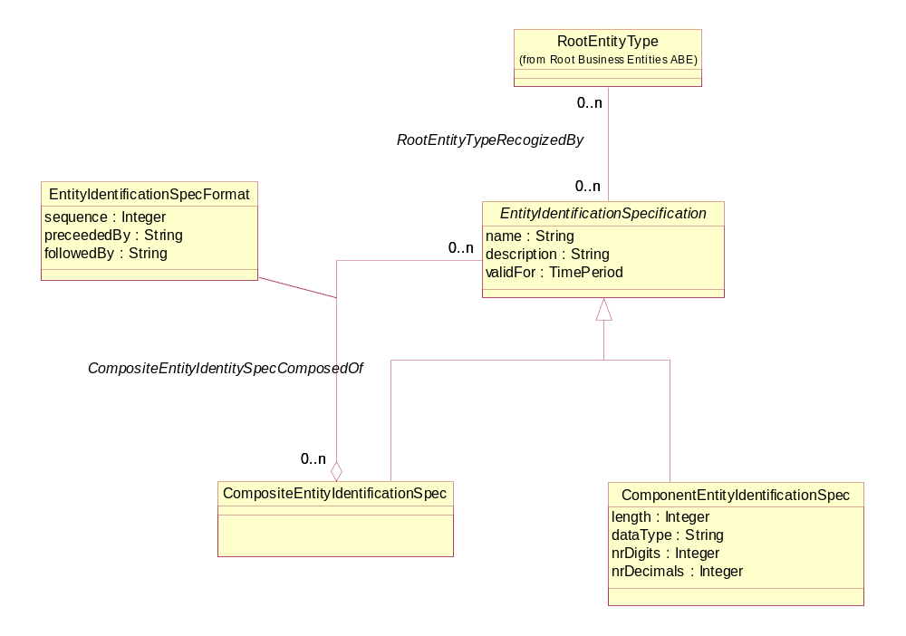
Figure 16. Identifying Entities Using the RootEntityType Entity
Although association classes are not normally shown in the business view of the SID model, two are introduced in the Entity identification model as shown in Figure 17 below. The EntityIdentificationSpecFormat association class, which was first shown in Figure 14 above, is used to define the formatting and sequencing of EntityIdentificationSpec objects that are aggregated by a particular EntityIdentificationSpecComposite object. The RootEntityTypeIdentificationSpec association class, shown in Figure 17 below, is used to indicate, via its use attribute, whether the entity identification specification is used as the primary or as a secondary identifier.
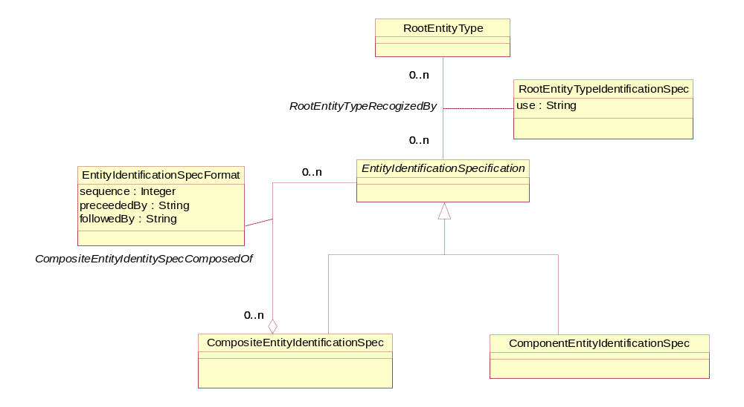
Figure 17. Use of an Entity Identification Specification
The following example shows where both approaches may be used. In some cases, for example if a manufacturer has a special identification scheme for a certain type of equipment, it may be necessary to associate an EntityIdentificationSpecification to a specific EntitySpecification. This type of association would specify that the EntityIdentificationSpecification is only applicable for equipment Entity instances related to the instance of the equipment EntitySpecification and not for equipment Entity instances related to other EquipmentSpecifications. Figure 18 below shows the association between an EntityIdentificationSpecification and an EntitySpecification.
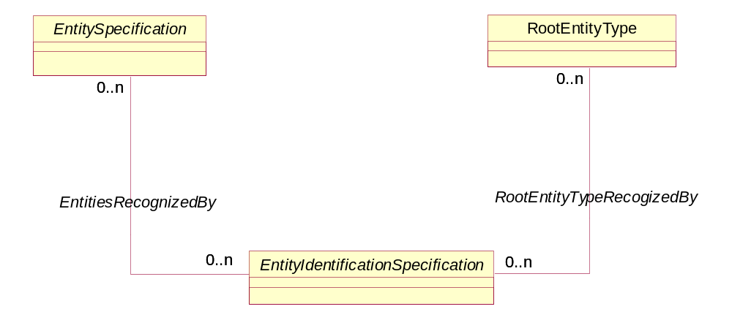
OR
OR
Figure 18. EntitySpecification Association With EntityIdentificationSpecification

EntityIdentification
Every instance of an entity has a unique identifier. Simple identifiers can be defined as attributes of an entity. In cases where one or more complex identifiers are required, an object is required. This is implemented using an entity identification specification and its associated entity identification objects. For example, ANS T1.253 specifies a complex identifier for a network location. Figure 19 below shows an example of the EntityIdentificationSpecification, the EntityIdentification, and the RootEntity instance identified using this specification. (Note that the multiplicity of the RootEntityRecognizedUsing association is 0..1 on the RootEntity side, and not 1, because our first option doesn’t use this approach; therefore, RootEntity and RootEntityType must be kept optional.)
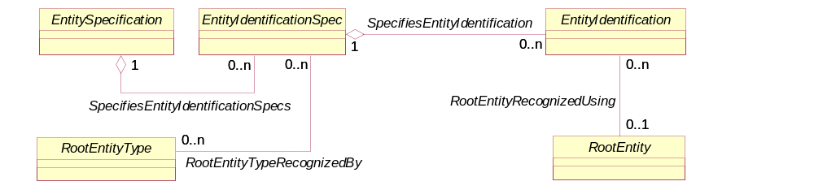
Network Node ID Spec
Network Location Denver Cell Site #102
Node ID Instance - DNVRCOC0
Figure 19. Entity and Entity Identification
  - Additional Entity Identification Examples
This section contains additional examples that depict the use of the Entity Identification Specification and Entity Identification. The examples are taken from the American National Standard T1.253-1999.

Customer Site Format
This is a standardized code that uniquely identifies a customer’s presence at a location at which network elements or network systems equipment exists.
Components

Geographical Code
The designation for a single geographical locality within a state, province, territory, country, or distinct region of the world (e.g., municipality). This data element shall consist of four alphabetic characters. New codes assigned shall contain exactly four characters and shall not contain spaces. For previously assigned codes of less than four characters, the unused character positions after the code shall be filled with spaces to make up four character positions.
Geopolitical Code
The designation of a state or territory of the United States, a province or territory of Canada, another country having a national federal government, or a unique designation (e.g., the oceans). This data element shall consist of two alphabetic characters.
Customer Site Code
The designation of a customer that utilizes telecommunications equipment at a specific location where there is a requirement to uniquely identify that customer’s presence for the purpose of inventory and facility management.
This data element shall consist of five characters having one numeric character in the first position followed by one alphabetic and three alphabetic or numeric characters in that sequence.
Customer Site Format Table
This format shall consist of a sequence of Geographical Code and Geopolitical Code data elements plus a Customer Site Code data element, resulting in a code that totals eleven characters in the format shown in the table below.

ELEMENTS/POSITIONS | 1 2 3 4 | 5 6 | 7 8 9 10 11
Geographical Code | A A A A
Geopolitical Code |  | A A
Customer Site Code |  |  | N A A/N A/N A/N
Table R.x – Customer Site Format
Figure 20 below shows this format overlaid on the EntityIdentitySpecification ABE previously discussed. First, we need to define some more components from ANS T1.253-1999.

Equipment Entity Identification Format
A standardized code that uniquely identifies a type of manufactured telecommunications network equipment or an assignable entity within a type of equipment. The Equipment Entity Identification Format shall consist of a sequence of Family Code, Sub-Family Code, Features Code, Reference Code and Complemental Code data elements, resulting in a code that totals ten characters in the following format:
Components

Family Code
A label to denote a functional category of manufactured telecommunications equipment. This data element shall consist of two characters, either of which may be alphabetic or numeric. An example is D4, representing a D4 channel bank.
Sub-Family Code
A label to denote a functional category of manufactured telecommunications equipment within a family. This data element shall consist of two characters, either of which may be alphabetic or numeric. An example is CE, representing an E&M signaling channel unit.
Features Code
A standardized code to denote a distinctive service-providing design capability available within a sub-family of manufactured telecommunication equipment when compared to other similar equipment of the same or other manufacturers. This data element shall consist of three characters, each of which may be alphabetic or numeric. Manufacturers’ examples are:
- 18B, where
- 1 signifies E&M signaling, 4 wire
- 8 signifies E with M lead applique, M lead resistor 510 ohm
- B signifies with busy switch and level adjust attenuator
- 424, where
- 4 signifies DX signaling, 4 wire with post equalization
- 2 signifies adjustable balance capacitance and resistance
- 4 signifies impedance 150/600/1200 ohm
- 363, where
- 3 signifies DX signaling, 2 wire with gain transfer
- 6 signifies eliminate signaling condition, fixed balance capacitance
- 3 signifies receive enable circuit

Reference Code
This is a label to denote the manufacturer’s information used to describe the design capability encoded in the equipment entity identification code. This data element shall consist of one character, which may be alphabetic or numeric. Examples are:
- 7, signifying NNTM
- 8, signifying LEAR
- P, signifying SD-7C026-02

Complemental Code

This is a standardized code to provide uniqueness to an equipment entity identification code. This data element shall consist of two characters, either of which may be alphabetic or numeric. (Examples of typical information are manufacturing vintage, version data, circuit wiring, or equipment data.) Examples are:
- AA, for Northern Telecom, signifying NNTM QPP357B
- AA, for LEAR, signifying LEAR D4DX-4010-11
- AB, for Lucent Technologies, signifying J98726SD-2

Composites

Basic Code

A Basic Code is comprised of the Family Code and Sub-Family Code data elements taken together, represented in the following format:
ELEMENTS/POSITIONS | 1 2 | 3 4
Family Code | A/N A/N
Sub/Family Code |  | A/N A/N

ELEMENTS/POSITIONS | 1 2 | 3 4 | 5 6 7 | 8 | 9 10
Family Code | A/N A/N
Sub/Family Code |  | A/N A/N
Features Code |  |  | A/N A/N A/N
Reference Code |  |  |  | A/N
Complemental Code |  |  |  |  | A/N A/N

The next two figures show examples of CustomerSiteFormat and EquipmentEntityIdentityFormat within the context of the EntityIdentificationSpecification and EntityIdentification entities.
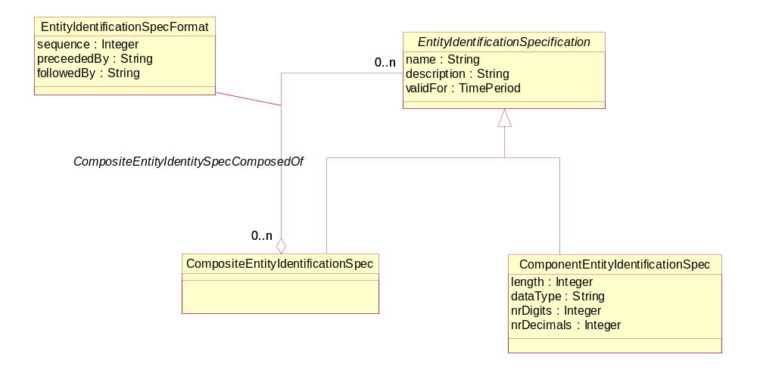
CUS GGC 1
CUS GPC 2
CUS CUC 3
EEI FAC 1
EEI SFC 2
EEI FEC 3
EEI REC 4
EEI COC 5
Customer Site (CUS)
Equipment Entity Identification (EEI)
Geographical Code (GGC)
Geopolitical Code (GPC)
Customer Site Code (CUC)
Family Code (FAC)
Sub/Family Code (SFC)
Features Code (FEC)
Reference Code (REC)
Complemental Code (COC)
Figure 20. EntityIdentificationSpec Example
Customer Site (CUS)
Equipment Entity Identification (EEI)
Geographical Code (GGC)
Geopolitical Code (GPC)
Customer Site Code (CUC)
Family Code (FAC)
Sub/Family Code (SFC)
Features Code (FEC)
Reference Code (REC)
Complemental Code (COC)

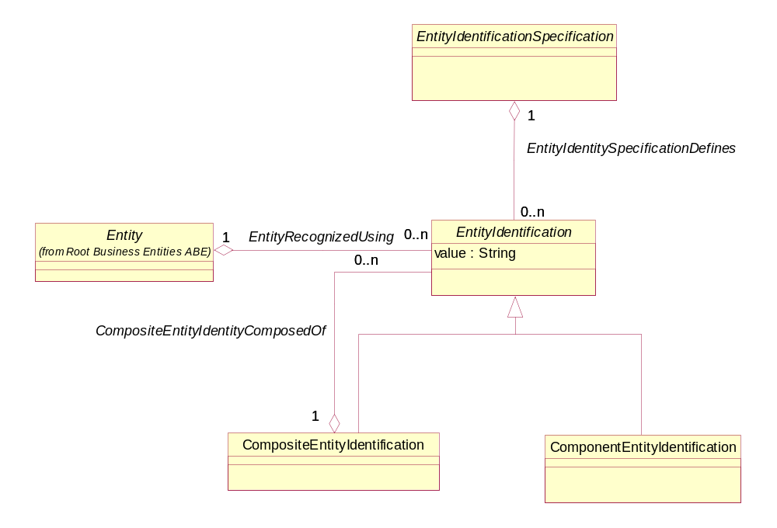
CUS #1 (PLANTX1APBX)
CUS #2 (DNVRCO1APBX)
EEI #1 (AABBCAC151)
EEI #2 (DDEEDID261)
CUS #1 GGC - PLAN
CUS #1 GPC – TX
CUS #1 CUC – 1APBX
CUS #2 GGC – DNVR
CUS #2 GPC – CO
CUS #2 CUC – 1APBX
EEI #1 FAC - AA
EEI #1 SFC - BB
EEI #1 FEC - CAC
EEI #1 REC - 1
EEI #1 COC - 51
EEI #2 FAC - DD
EEI #2 SFC - EE
EEI #2 FEC - DID
EEI #2 REC - 2
EEI #2 COC - 61
Figure 21. Additional EntityIdentification Examples

  - Role
Roles represent a fundamental way to provide extensibility in the model. The Role Object pattern [ROLEOBJ] is used to extend the use and application of an object by modeling the different functions that a device can play as a set of objects.

Role Overview
A role characterizes the function that a particular object plays. In the business view of the SID, the characterization may be to specify attributes and relationships. In the system view, this characterization is extended to include methods, constraints, and behavior.
Roles provide an extensible means of abstraction that enables the user to model the functions played by an entity as separate objects (instead of embedding that functionality in the entity itself). For example, suppose that you are modeling the business functions that your employees have. Basic organizational boundaries define some behavior (e.g., marketing vs. sales vs. engineering), but often employees play multiple roles (e.g., an engineer that has sales support functions). This phenomenon doesn’t just occur for people – other managed objects exhibit it as well. For example, in a VPN, some DeviceInterfaces talk to the Customer, while others never touch the Customer.
In general, managed objects don’t all have the same behavior, but different managed objects may have some common behavior. Worse, an object might exhibit more than one set of common behaviors, or may take on and remove different behaviors during its lifetime. Thus, we need a means to capture these and related cases. A set of role patterns provide an extensible and straightforward means of accomplishing this goal.
Before these different role patterns are discussed, it is important to differentiate between an instance or a type. Asking an object if it is an instance of a type is something different than asking it if it is an instance of a class, since the types (interfaces) and the classes (implementations) can be different. (Note that there are patterns to accomplish this function.)
The business view of the SID is concerned with types, not implementation.
There are five types of role patterns that are extensions of [ROLEOBJ], described as follows:
- Single Role Type. This pattern combines all of the features of different roles into a single type, and is most useful for modeling objects having a few variations on the same basic behavior.
- Separate Role Type. This pattern models each role as its own separate type, and is most useful for modeling objects that have little if any common behavior.
- Role Subtype. This pattern models each role that exhibits different behavior as a subtype. Note that this does NOT mean that subclassing is used, as this is an analysis pattern and is thus concerned with interfaces, not implementation. This pattern is all about maintaining the illusion that clients are dealing with a single object that has multiple, changeable types.
- Role Object. This pattern models each role that exhibits different behavior as a separate object. The separate role objects are then related to a single base object that ties the different behaviors together. This pattern is used when maintaining the illusions of a single object is too difficult, or doesn’t supply the correct semantics.
- Role Relationship. This pattern models each role as a relationship with an appropriate object.
Of these five patterns, the SID uses the fourth – Role Object – almost exclusively in the business view (others are used in other views). Single Role Type isn’t used because the behavior being modeled in the SID is significantly different. Similarly, Separate Role Type isn’t used because the SID tries to provide the flexibility to capture common as well as different behavior. In this pattern, all shared behavior must be duplicated. In addition, if an object has multiple different roles, this pattern becomes unwieldy.
This leaves Role Subtype and Role Relationship. The problem with the Role Subtype pattern (in the context of the SID) is that this pattern cannot be used if there are multiple and/or changing roles. In addition, while new roles can be added, each new role causes the interface of the supertype to change. This is undesirable from the system and implementation points-of-view.
The Role Relationship pattern is not used in the business view of the SID due to its complexity. This pattern is very well suited when the role itself embodies a relationship between a base object and some other object (usually a group). For example, consider an organization which requires new employees to spend an equal amount of time working for multiple departments. In this case, the role binds the person to the particular organization that he or she is currently working for. Thus, it is best modeled as a relationship between the person and the organization that the person is working for. The SID does not yet use this pattern, but most likely will in the near future.
Figure 22 below shows a simplified view of the concepts of using roles in this way.
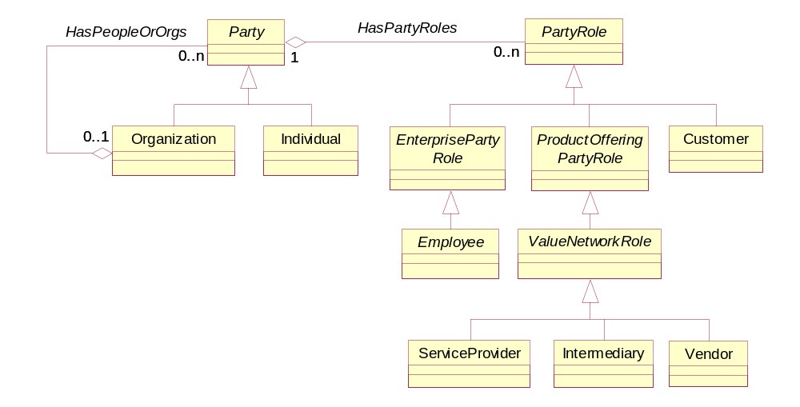
Figure 22. The Basics of Roles – An Example
Figure 22 shows that an Individual (or an Organization) can be assigned zero or more roles. Thus, an Employee can take on the roles of ServiceProvider and Customer.
A portion of the DEN-ng PartyRole model is shown in Figure 22. EnterprisePartyRole and ProductOfferingPartyRole are both abstract classes, and serve to enforce a formal classification approach to modeling different types of roles.
The idea is to define the functionality that a ManagedEntity can play as a set of subclasses of EntityRole, and then associate the specific functionality that is desired using the EntityHasRoles aggregation. This enables the functionality and behavior of the ManagedEntity to be easily customized. For example, consider two different people working in the same department – both interact with a customer, but Bob is a manager and Joe isn’t. Rather than add employee-specific attributes to the definition of a Person, a Person can be kept general, and employee-specific attributes can be added to an appropriate role.
More formally, roles recognize the fact that different entities may have different roles that it can play when it collaborates with other entities in the system. Separating this into different roles enables behavior to be defined that involves just the role, as opposed to all of the attributes of the entity. This enables the communication to become more specific and thus easier to generalize.

Different Types of Roles in the SID
The SID is unique, in that roles are used in the vast majority of its domains, to ensure that the above philosophy is applied wherever it makes sense. Three different examples that show the diversity of roles in the SID are as follows:
- Party and PartyRole (Addendum 1P). Party is a superclass for modeling people and organizations, and PartyRole is a superclass for modeling the different jobs that people can have. Note that the current addendum does not have the full role classification hierarchy of DEN-ng; this will be added as part of SID Phase VI.
- Resource and ResourceRole (Addendum 5PR, Addendum 5LR, Addendum 5RO). Resources are physical and logical entities that represent the definition, development, and operational aspects of the information computing and processing infrastructure of a system. There are PhysicalResourceRoles as well as LogicalResourceRoles, which enable functions associated with the physical and logical aspects, respectively, of an resource to be modeled independent of that resource. There are also CompoundResourceRoles, which enable roles to be assigned to CompoundResources (i.e., Resources that contain at least one PhysicalResource and at least one LogicalResource).
- Service and ServiceRole (Addendum 4SO, Addendum 4S-QoS). Services represent intangible functionality that is provided by the information computing and processing infrastructure of a system. CustomerFacingServiceRoles represent abstracted functionality that the Customer is specifically aware of, while ResourceFacingServiceRoles represent abstracted functionality that the Customer is not specifically aware of, but nevertheless are required in order for the CustomerFacingService to function correctly.
DEN-ng defines roles for Locations as well. This enables semantics for different types of locations to be modeled using Roles.
All of these (except the different types of LocationRoles) are currently defined in various GB922 Addenda except as noted above.
  - RoleSpecification
RoleSpecifications exist to help standardize the functionality and use of roles.

RoleSpecification Overview
A RoleSpecification is an abstract class that extends the Specification class in order to define the invariant attributes (in the business view, and methods, constraints, relationships and behavior in the system view) of Roles. In general, if a Role is used, it is also advisable to use a RoleSpecification, since RoleSpecifications enable a set of Roles:
- to be specified as a set of common abstractions which are used throughout an application
- to have their invariant characteristics and behavior defined in a standard way
- to indirectly specify the set of Roles that must be used to abstract the functionality that is to be modeled
The principal RoleSpecifications currently defined are:
- ResourceRoleSpecification, which will be defined in Addendum 5RO, is the superclass for PhysicalResourceRoleSpecs, LogicalResourceRoleSpecs, and CompoundResourceRoleSpecs. These three subclasses will be defined in future versions of Addenda 5PR and 5LR.
- ServiceRoleSpecification, which will be defined in a future version of Addendum 4SO, is the superclass for CustomerFacingServiceRoleSpec and ResourceFacingServiceRoleSpec. These will also be defined in future versions of Addenda 4SO and 4S-QoS.
There are several ways to extend this. For example, the DEN-ng model currently has two important extensions:
- PartyRoleSpecification (extends the SID Party model)
- PlaceRoleSpecification (extends the SID Location model)
All of these (except the different types of PartyRoles and PlaceRoles) will be defined in various GB922 Addenda as noted above.
  - EntityRole
An EntityRole is an abstract class that extends the Role class to define the concept of various types of roles for both ManagedEntities and UnManagedEntities. Figure 23 below shows the relationships between an Entity, an EntitySpecification, a RoleSpecification, and an EntityRole.
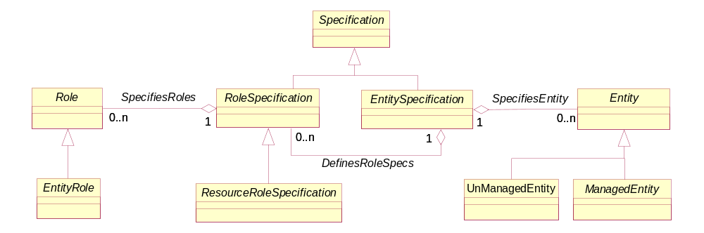
Figure 23. Associating EntityRoles with a ManagedEntity
If an EntitySpecification is used to define the invariant attributes (and methods, constraints, relationships and behavior in the system view) of an Entity, then that same EntitySpecification can be used to define a set of RoleSpecifications that can be used to assign different types of Roles to that Entity. These two assignments are done using the DefinesRoleSpecs and SpecifiesRoles aggregations, respectively. This indirection enables an extensible model that is independent of particular vendor devices to be built.
  - ManagementDomain
ManagementDomain represents a special grouping of ManagedEntities that has two important properties. First, it is used to partition managed objects into a meaningful logical grouping. One important use of such a grouping is to provide a means to define which EMS (as well as which NMS) manages, monitors, etc. which set of devices. Another important use of such a grouping is to provide a means to show how management functions are distributed and scaled.
Second, this grouping defines a common administrative domain that is used to administer the managed objects that it contains. This implies that all of the managed objects contained in this ManagementDomain are administered similarly - either by the same user, group of users or policy.
A ManagementDomain is the superclass of several important entities in the SID. One of the most important of these is the PolicyDomain class. A PolicyDomain is a collection of entities and services that are administered in a coordinated fashion using a set of policies. The policies are used to control the set of services and entities according to a common methodology, such as a finite state machine. This is defined in GB922, Addendum 1-POL.
The ManagementDomain class also enables relationships to be defined that convey various semantics, such as containment, scoping, administration, and more generic management functions.
  - ManagementInfo
ManagementInfo is an abstract class that is used to represent entities that represent management information obtained in a managed environment. Specifically, in the process of managing an entity, information of various forms is created. This class is the superclass for defining different types of management information. Its main subclasses are shown in Figure 24 below.
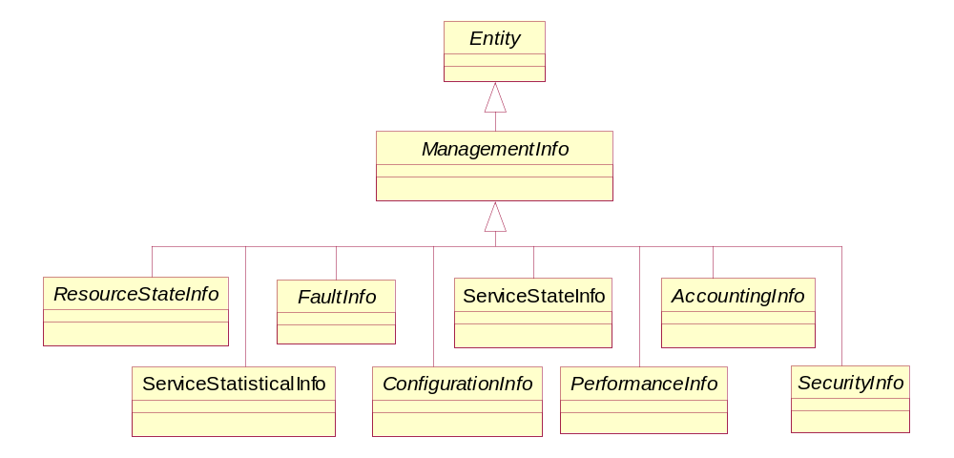
Figure 24. ManagementInfo Class Hierarchy
The design of how management information is obtained uses this class to gather specific types of information, and the ManagementMethodEntity class to obtain the desired data using an appropriate method. This combination of class hierarchies enables different management methods (e.g., CLI vs. SNMP) to be used to gather different types of management data, and is unique to the DEN-ng and SID information models.
  - ManagementMethodEntity
ManagementMethodEntity is an abstract class for representing the different types of management methods that can be used to gather a particular type of management information. For example, this enables configuration setting classes to be defined as using CLI, while configuration monitoring classes could be defined as using a different method, such as SNMP. Its main subclasses are shown in Figure 25 below.
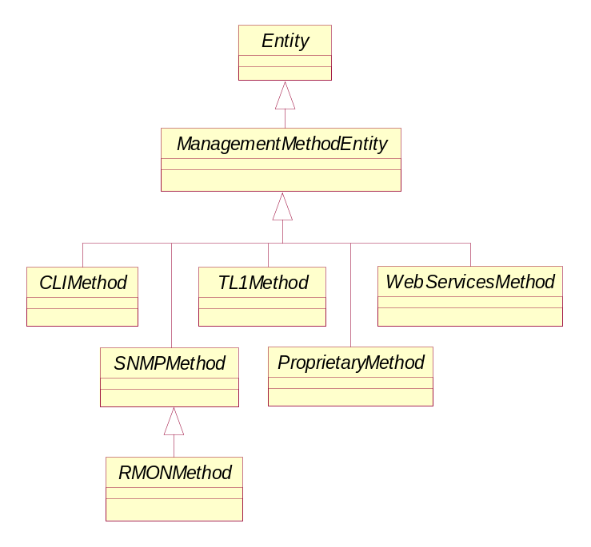
Figure 25. ManagementMethodEntity Class Hierarchy
The design of how management information is obtained uses this class to gather specific types of information, and the ManagementMethodEntity class to obtain the desired data using an appropriate method. This combination of class hierarchies enables different management methods (e.g., CLI vs. SNMP) to be used to gather different types of management data, and is unique to the DEN-ng and SID information models.
Figure 26 shows how ManagementInfo and ManagementMethodEntity work together to provide a single, scalable solution for gathering different types of management information that describe a management entity. This is especially important for some types of network devices, where different protocols and approaches are used to configure vs. monitor the device.
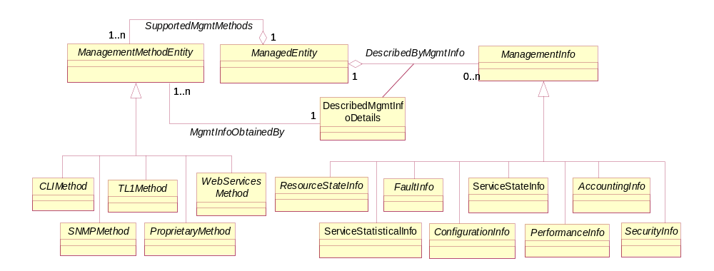
Figure 26. Gathering Management Information

Root Business Entities/Characteristic ABE
Figure 27 depicts the basic CharacteristicSpecification pattern. The pattern enables attributes unique to a type of entity to be created via its association to EntitySpecification and enables attributes unique to a certain entity to be created via its association to RootEntityType. A RootEntityType is an entity in the SID. For example, characteristics could be defined for entities (instances of RootEntityType) such as Product, Customer, and ProductSpecification that apply to all instances of those entities. Instance diagrams are shown in Figures 29 and 30. Definitions of entities and attributes are provided in the data dictionary at the end of this document.
An example of the use of the pattern will also be illustrated using the following figure.
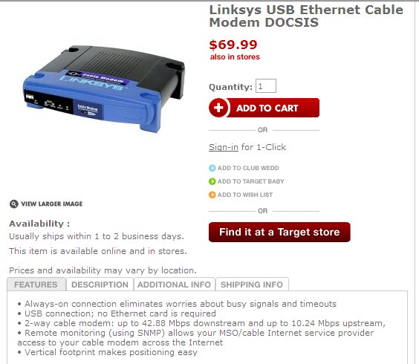
The EntitySpecification, which could be a ProductSpecification, instance is for a Linksys USB Ethernet Cable Modem DOCSIS. Each tab, Features, Description, Additional Info, and Shipping Info is an instance of CharacteristicSpecification. The Features CharacteristicSpec is a composite that is comprised of an instance of CharacteristicSpec for each feature line. Instances of the CharacteristicSpecRelationship are used to compose the Features of the instances of feature line. Instances of EntitySpecCharUse has the canBeOverriden attribute set to true, which means the characteristics cannot have a value specified for them.
In this example, the CharacteristicSpecValue and CharSpecValueRelationship entities are not used. An example of their use could be for a set of coordinated colors for the modem. For example, if a choice for a faceplate color (CharacteristicSpec) is blue (CharacteristicSpecValue), then the only color for the case color is black. This rule would be implemented by an instance of CharSpecValueRelationship that relates the color blue with the color black with a value for charValueRelationshipType of “inclusive”. The charRelSeq is used to sequence attributes that make up a composite CharacteristicSpecification. For example, a composite that represents an US telephone number is made up of an area code, a number plan area, and a number in this sequence. The charRelSeq is used to specify this sequence.

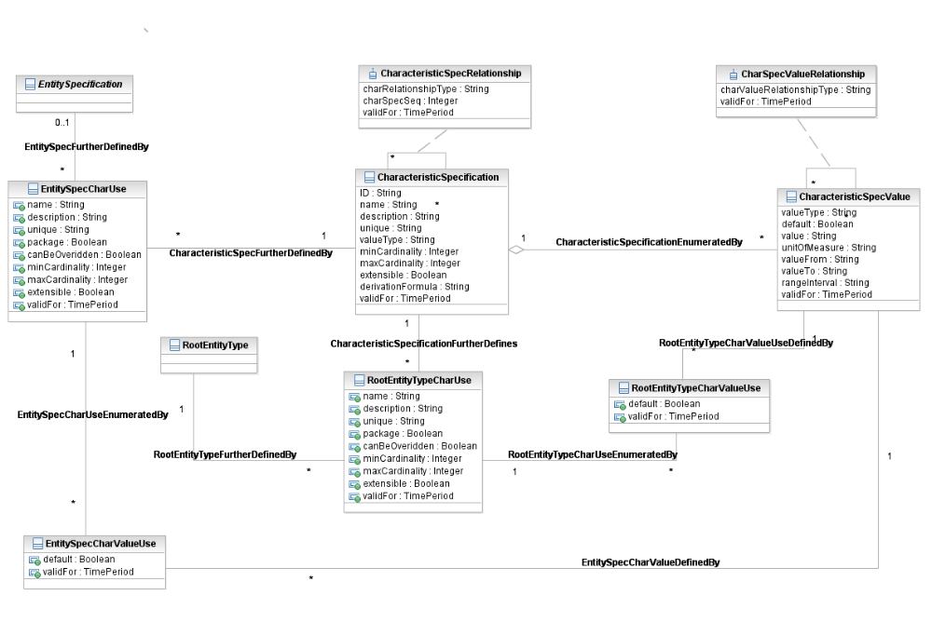
Figure 27. Characteristic Specification

The minCardinality and maxCardinality attributes are used to specify the number of values that can be associated with an instance of a RootEntity. In the example the faceplate color would have a minCardinality of 1 and a maxCardinality of 1. A minCardinality of 0 implies that a value does not have to be assigned to a characteristic.
A valueType attribute exists for both CharacteristicSpecifications and CharacteristicSpecValue in order to have a mixture of value types for values. For example, a CharacteristicSpecification may be enumerated by a combination of strings and integers. The valueType of the CharacteristicSpecification is used if the valueType is the same for all CharacteristicSpecValue instances.
An instance CharacteristicSpecValues can represent discrete value or a range of values. An example of a discrete value is the values that the CharacteristicSpecification “color” can take on. An example of a range of values is the range of operating temperatures under which the cable modem can operate. A rangeInterval attribute for CharacteristicSpecValue defines whether the valueFrom and valueTo attributes are inclusive or not. This is equivalent to adding an “operator” attribute for valueFrom and an “operator” attribute for valueTo, such as “<=” or “<”.
In some models the value attribute and the range attributes are contained within separate subclasses of the CharacteristicSpecValue entity. This was not done in the Characteristic model in order to simplify it. Also, some models may contain unit of measure as a separate entity with a recursive association and an association class that is used to define conversion factors between various units of measure. This was not done in the Characteristic model. However, both the subclasses and unit of measure entity and association class could be modeled as extensions to the SID if desired.
Some CharacteristicSpecifications are enumerated by a fixed value or set of values that remain constant for every instance of an Entity. For example, the operating temperature range for the cable modem remains constant. The attribute canBeOverriden is used to indicate this. Additionally, the set of CharacteristicSpecValues may be open to extension as values are assigned to instances of EntityCharacteristics. For example, their may be a desire to keep a list of userIDs as instances of CharacteristicSpecValues in addition to their existence as instances of CharacteristicValues. The extensible attribute is used to indicate that new instances of CharacteristicSpeValues can be added as instances of CharacteristicValues are created.
CharacteristicSpecifications can be shared by a number of EntitySpecification and RootEntityType instances. The “use” entity contains attributes that may be specific to a use of the CharacteristicSpecification by an instance of an EntitySpecification or a RootEntityType. For example, a CharacteristicSpec with “bandwidth” value for the name attribute, could be named “download speed” in one use and “upload speed” in another use. The values assigned to these attributes override the values assigned to an instance of a CharacteristicSpecification. For example, the minCardinality attribute assigned to an instance of CharacteristicSpecification may be zero, indicating that a value does not have to be assigned for an instance of a CharacteristicValue; however, for a particular use of the CharacteristicSpecificaiton, the attribute must be assigned a value. In this case the minCardinality attribute in the “use” entity would be assigned a value of one.
The package attribute, also a “use” entity attribute, indicates that the attribute represents a composite attribute, similar to the composite/atomic pattern without the explicit sub-classing. When this attributes value is set to “true” a number of attributes do not apply, such as min and maxCardinality, unique, canBeOverriden, and extensible,.
The use of an attribute by an EntitySpecification or a RootEntityType may also required a further restriction on the values that a Characteristic can be assigned. The associations between CharacteristicSpecValue and the “use” entities can be used to define the further restriction. For example, the instances of CharacteristicSpecValue for the instance of the “color” CharacteristicSpecification may contain the entire rainbow of colors, but only a subset of colors is available for the cable modem.
Similarly, the two “SpecValueUse” entities enable different default values to be specified for the use of values associated with the use of a CharacteristicSpecification by an EntitySpecification or a RootEntityType.
Note: CharacteristicSpecification can be related to specification entities in a number of ways. The relationship can be inherited if a specification entity is a subclass of EntitySpecification or via a direct association between the CharacteristicSpecification and the specification entity.
Figure 27 depicts CharacteristicValues and their association to Entities, in the figure a RootEntity. A CharacteristicValue is one chosen or entered for an Entity for a specific CharacteristicSpecification. In the example above the instances would be “blue” for the face plate and black for the case. The values would be related to the respective CharacteristicSpecValue.
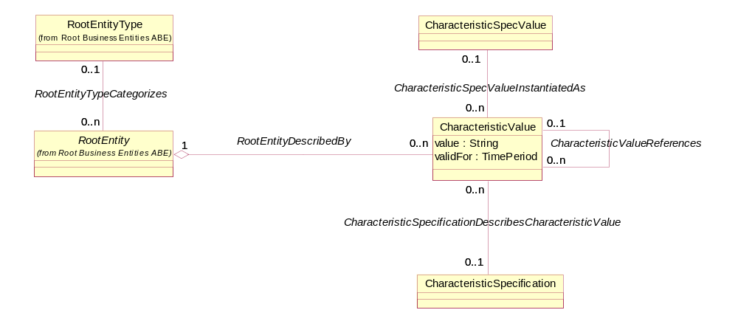
Figure 28. Characteristic Value
When values are not specified in CharacteristicSpecValue, but are entered for a CharacteristicSpecification, then CharacteristicValue is related to CharacteristicSpecification. For example, a startTime is a CharacteristicSpecification for a Video on Demand, an entered value of 6 Aug 2007 would be related to startTime. This one of the two cases when a CharacteristicValue would be related to a CharacteristicSpecification and when the value attribute of CharacteristicValue would have to be populated. The other case is when a value is chosen from a range of values defined by the CharacteristicSpecValue. When a CharacteristicSpecValue is chosen from a list of discrete values or it is unchangeable (via the canBeOverrided attribute set to “false”), there is no need to populate the value attribute, unless performance considerations required this from an implementation perspective. In these cases the instance of CharacteristicValue is related to the instance of CharacteristicSpecValue and not the instance of CharacteristicSpecification.
Note: CharacteristicValue can also be directly related to an entity, such as ServicePerformance or Customer if they do not inherit from the RootEntity.

Figure 29 shows an example of an IPTV EntitySpecification with three associated CharacteristicSpecifications.
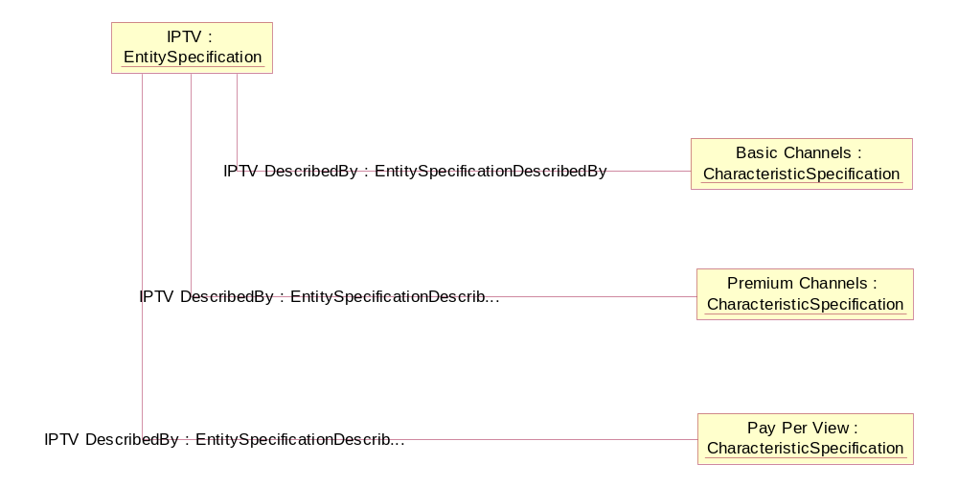
Figure 29. Characteristic Spec Instance – Example 1
Figure 30 shows how characteristics can be added for an entity whether the entity has an associated specification or not. In the figure two characteristics have been added to the Service Entity in general, independent of those that may be added to instances of ServiceSpecifications. The RootEntityType in the SID is populated with a list of all business entities contained in the SID. The Characteristic model shown in Figure 27 shows how CharactersticSpecifications are be associated with the RootEntityType.

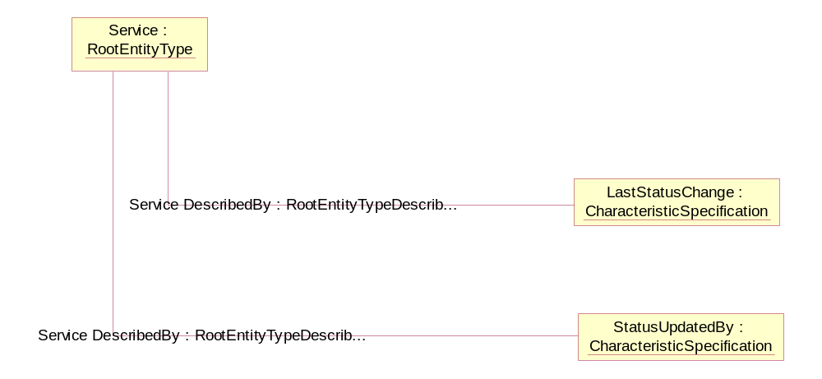
Figure 30. Characteristic Spec Instance – Example 2
Characteristic-Based Pricing and Charging
In the not-so-distant past factors influencing the price of a product were based on the usage of network resources and other resources, measured by such factors as amount of time, or some other unit, a resource was used or the amount of bandwidth consumed. But once the usage of other types of resources, such as content, is included, many other characteristics influence the price.
This model was originally envisioned to support content pricing and charging, but it can be used for any type of pricing and charging that is based on characteristics and their values. As will be seen it can also be used for usage-based pricing d charging also.
Policy versus Simplicity
When rules for pricing (and charging) were first being developed in the Information Framework (SID) many years ago, Reliance on the policy model was not total. An additional set of entities were under development to support simple rules, such as quantity-based pricing and tiered-based pricing. However, this additional set was not introduced in the released version of the SID. Rather, all rules relied on policy. Many members believe that using only policy is a bit extreme. A balance can be achieved between simplicity and complexity.
This balance was introduced into the SID in release 6.0 with the addition of an association between ProductSpecCharacteristicValue and ProductOfferingPrice. This provided a simple rule that enabled a price to be dependent on value(s) of one or more characteristics.
This balance continued in SID in release 9.0 with the arrival of a new Level 2 ABE (Aggregate Business Entity, a cohesive group of entities) named Pricing Logic Algorithm within the Product Offering Level 1 ABE. This ABE used Product Specification Characteristics to provide support for pricing that involves parameters which are multi dimensional matrices, in which each dimension is defined by the valid values for a specific characteristic. For example, a PLA which rates events based on customer type, there is one instantiation in which customer type is either residential or commercial (and in which case the size of the dimension of the matrix is 2) and in other instantiation the customer type can be student, normal and senior citizen (in this case the size of the dimension is 3).
And, the use of a simple approach is used here.
The Characteristic Model
The generalized application of the CharacteristicSpecification/CharacteristicValue pattern will be used to demonstrate this. Figure 31 shows a partial view of Characteristic model that will be used to support characteristic-based pricing and charging.

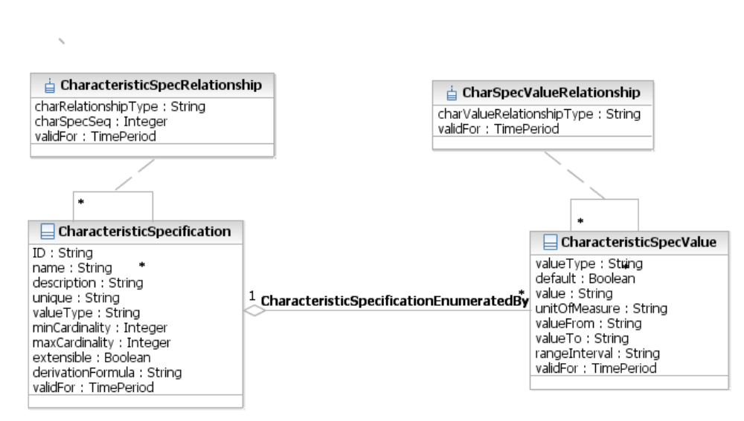
Figure 31.Partial View of Characteristic Model

The Pricing and Charging Scenario
A typical and simple scenario will be used to demonstrate the model. Pay per view Video on Demand (VoD) product depends on the format, standard (STD) or high definition (HD) with a special price given for certain movies viewed in HD during a Saturday and Sunday period.
Shown in Figure 32 is an Object Diagram that shows how the current model supports movies. There are other attributes associated with a movie, such as run time, director, and so forth that are not shown in this example.
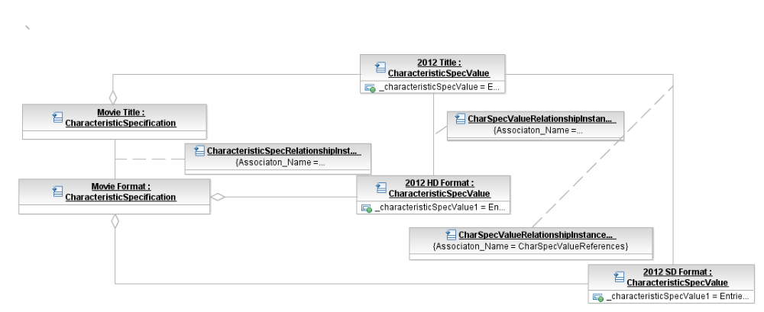
Figure 32 . Content Characteristic Specs
In this example, 2012 is available in both high definition (HD) and standard (STD) formats. This is specified by the relationship between the CharacteristicSPecValue instance 2012 and the two format instances. The Movie Title CharacteristicSpecification instance represents a composite of other specification instances that describe the Movie, such as Title shown in the figure.
The use of the EntitySpecification/Entity pattern was considered to support the requirements. However, this would proliferate the number of EntitySpecifications and Entities from an implementation perspective. In this example, there would have to be a separate instance of EntitySpecification for each movie and a separate instance of an Entity for each chosen movie. Using the generalized CharacteristicSpecification/Characteristic model eliminates this. In this example there could be a single instance of an EntitySpecification that represents Pay Per View and a single instance of and Entity that represents a Pay Per View subscription.
Enhancements to the Characteristic Model
- Add two new entities to the characteristic model
- Add associations to ProductOfferingPrice and ComponentProductPrice.
Also, catalogs of movies can be created by adding a composite CharacteristicSpecification named Video Catalog and associating the Movie Title composite with it. Since this is dependent on the “use” of the values, a recursive association on EntitySpecCharValueUse is required. A similar association and association class is also added to EntitySpecCharUse as shown in Figure 33.
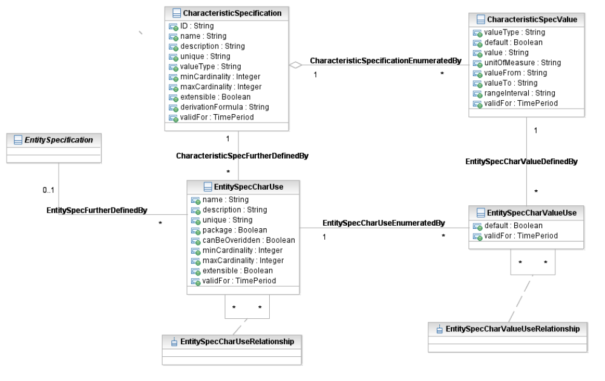
Figure 33. Updated Characteristic Use Entities
Shown in Figure 34 is one of the promoted “use” association classes and two new price dependency entities. These two entities enable a single or multiple attributes (assuming a simple “and” association between the attributes) to govern a price. In the figure the price is represented as ComponentProdOfferPrice, an existing entity in the Product Offering Price ABE.
More comprehensive requirements, such as and’s and or’s, are supported by by adding appropriate attributes to the member entity. An Object diagram follows to show an example.
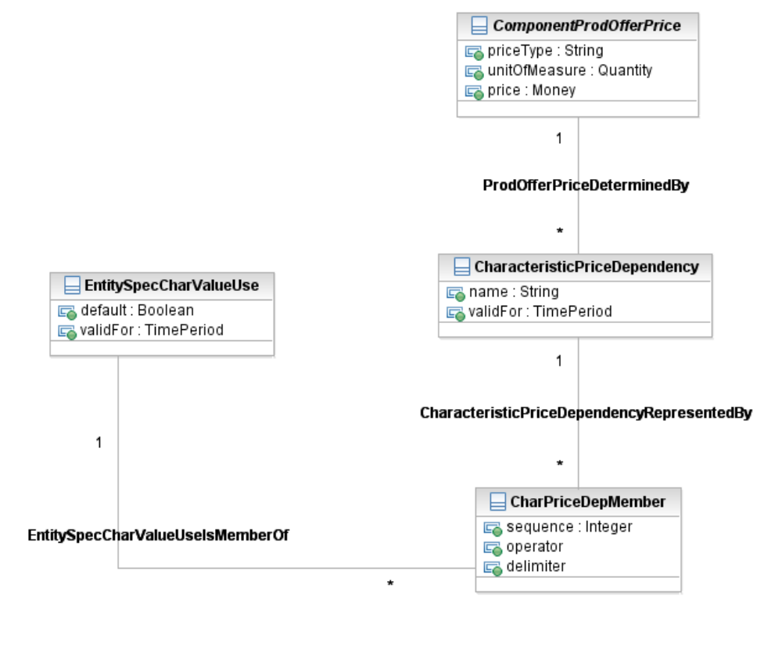
Figure 34. Characteristic Specs and Pricing
Shown in Figure 35 is an example where the high definition (HD) format for the movie 2012 has one price, while the same movie has a different price for standard (STD) format.
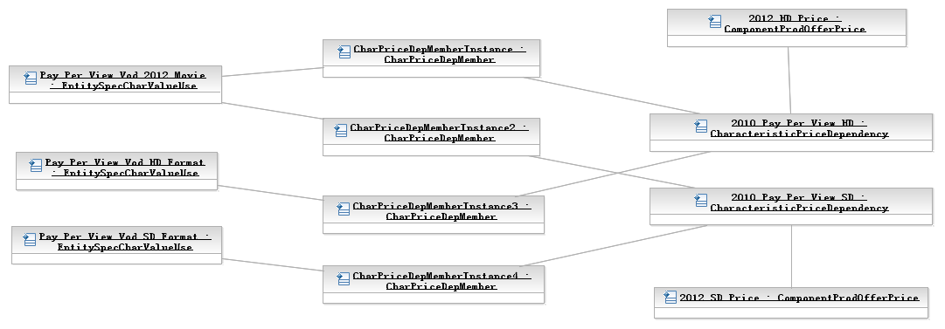
Figure 35. Content Charging Offer Price
The STD and HD values do not have to be repeated as instances of CharacteristicSpecValues. The Format instance of CharacteristicSpecification can be shared among all movie titles. The names of the objects in the diagram are illustrative only. If the price varied only by HD and STD and not by title then dependencies could be created that were only related to the format values.
If the pay per view price was the same for every movie, then there would be no need for this type of pricing. The current Product Offering to Product Offering Price association would be support this. Also, the ProductOfferingPrice name is illustrative only; the price can be shared by multiple CharacteristicPriceDependencies.
Note that an attribute may be required in Product Offering and/or Product Specification to indicate that choices can be made when accessing an associated Product.
By relating price dependencies to the “use” entities
- A VoD subscription offering with unlimited free viewing with a fixed subscription price can be created by not associating use attributes with price dependencies and associating a ProductOfferingPrice to the VoD subscription offering
- A VoD subscription offering with unlimited free viewing except for “special” movies can be created by associating only the specials uses with price dependencies and associating a ProductOfferingPrice to the VoD subscription offering
- A VoD pay per view offering can be created by associating appropriate use attributes, such as title and format, with price dependencies.
In the Product domain this could be done for Offering, Specs, or some combination.
Shown in Figure 36 is a more involved price dependency. The 2012 movie in high definition (HD) format is available for Saturday or Sunday night viewing at a special price. The dependency can be interpreted as “2012 and HD and (Saturday Viewing or Sunday Viewing)”.
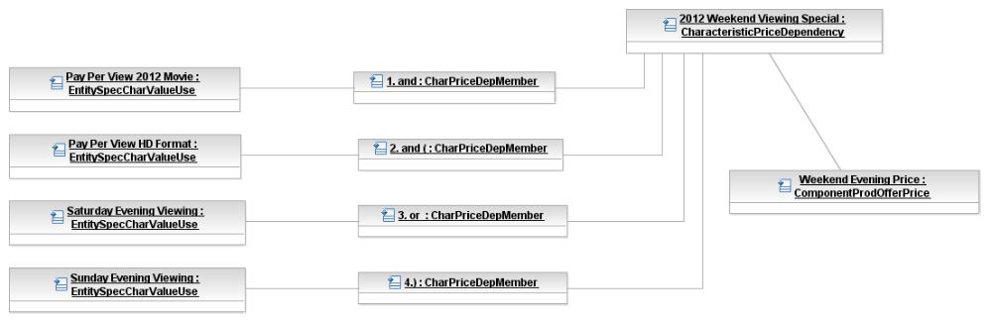
Figure 36. Complex Content Charging Offer Price
Shown in Figure 37 is an example of associating the characteristics with a Product Offering. There are no associated EntitySpecCharValueUses, which implies that all movie titles are available in all formats. The choices can be limited by associating values with the Pay Per View Offering.
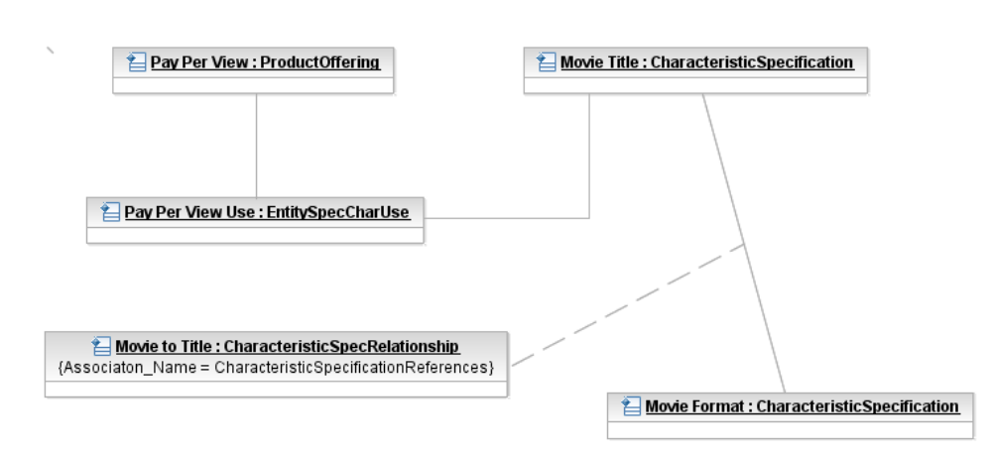
Figure 37. Content Charging Product Offer Example
By using the generalized characteristic pattern other variations, such as usage-based pricing that is dependent on values associated with usage characteristics or resource characteristics, is also supported. This will be discussed in section .
Support for charging is shown in Figure 38. A new association added to Component Product Price that indicates that the price was based on one or more characteristic values. The CharacteristicValue entity in the figure is shown describing RootEntity. But, any entity that does not inherit from RootEntity, such as Product, could be related to CharacteristicValue. An Object diagram follows to show an example.
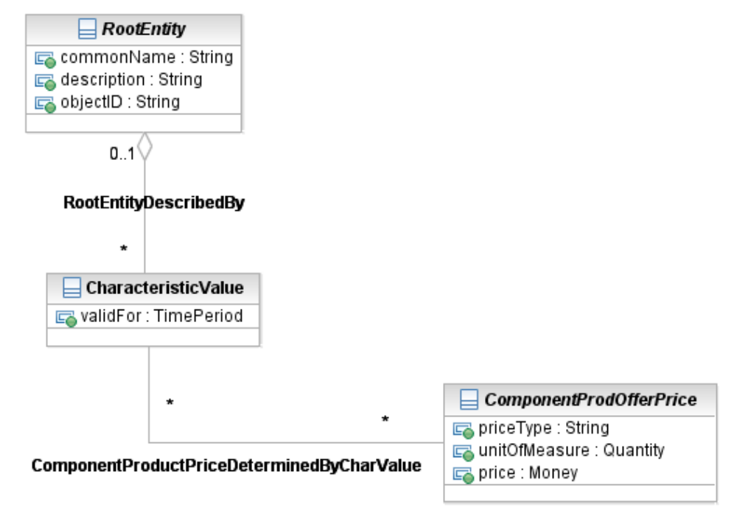
Figure 38. Characteristic Value and Pricing

Shown in Figure 39 is an example of viewing of the HD version of 2012, and the price that was determined based on the characteristic values that represent the chosen movie.
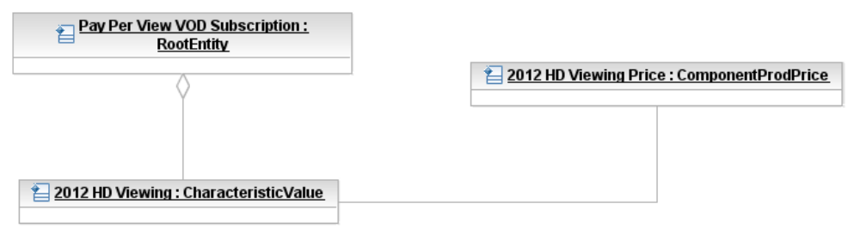
Figure 39. Content Charging Product Price

Domain Options – Product and/or Resource
The changes is only made to the Characteristic Spec ABE. All other ABEs where this pattern is duplicated are not updated. By promoting the use entities, any entity that does not inherit from the EntitySpecification, or is an entity (RootyEntityType) that does not have a specification, can be related to the use entities.
The choice using this model in the Product and/or Resource domain may be based upon a company’s business model. In the content example presented here, a company may treat each request for content as an order associated with a ProductOffering. Or, a company may treat each request as some form of usage. Or a company may use a hybrid model that combines the treatment of requests.
This model supports all three of these business models, because it can be used for
- Product Spec/Offer Pricing/Charging (as shown in the diagrams in this section)
- Usage Pricing/Charging
- Resource Spec Pricing/Charging.
One other factor needs to be considered when making the choice. The information may have to be duplicated because of application boundaries. A CRM application may need this information as well as Provisioning and Inventory applications.
There are also some application/database implementation considerations
- The use of one set of shared characteristic tables (if the applications are cooperative enough to do this!)
- If the data is only contained in one application then other applications have to request characteristic data from it.
Figure 40 shows an example of usage-based pricing/charging.
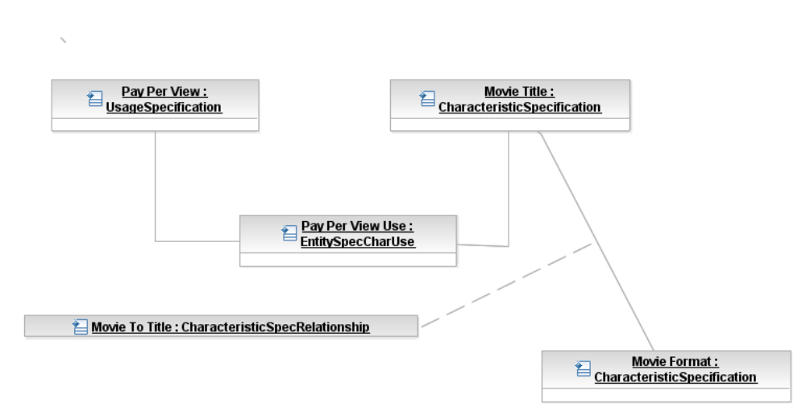
Figure 40. Content Charging Usage Specification Example
Notice that the only difference between this example and the Product Offering example in Figure 40 is that UsageSpecification is related to the Pay Per View Use instance of EntitySpecCharUse. To handle charging the Usage entity would be related to CharacteristicValue, just as Product was related to CharacteristicValue in the Product domain example in this section.

  - Policy
This is an abstract class, and is the root of the Policy model. It extends RootEntity to define common attributes, methods, constraints, relationships and behavior that all policy subclasses use and take part in.
The Policy model has two main purposes:
- To represent different types of policies,
- To represent how different constituencies use policy, and
- To represent how policy is used in a managed environment
There are many different types of policies. Policies can control what type of Product should be offered to a particular Market, what type of action should be taken when an SLA condition is violated, when a user’s hard drive should be backed up, or even who should construct and approve configuration changes to a network device.
In general, policy represents a set of goals to be realized when an event occurs. The event itself triggers the evaluation of a set of conditions. If the conditions are met, then a set of actions are directed to be executed.
Addendum 1-POL describes the above three uses in more detail.
- References
LIFE | NGOSS Lifecycle Team White Paper, to be published
LIFEPRES | NGOSS Lifecycle Team Dallas TMW 2003 Presentation
ANS T1.253-1999 | American National Standard T1.253, Information Interchange Code Description and Codes for the Identification of Location Entities for the North American Telecommunications System
GB922 Main | Shared Information/Data (SID) Model – Concepts, Principles and Domains
Addendum 1L | Shared Information/Data (SID) Model – Addendum 1L – Common Business Entity Definitions - Location
Addendum 1P | Shared Information/Data (SID) Model – Addendum 1P – Common Business Entity Definitions - Party
Addendum 1POL | Shared Information/Data (SID) Model – Addendum 1POL – Common Business Entity Definitions - Policy
Addendum 2 | Shared Information/Data (SID) Model – Addendum 2 – Common Business Entity Definitions - Customer
Addendum 3 | Shared Information/Data (SID) Model – Addendum 3 – Common Business Entity Definitions - Product
Addendum 4SO | Shared Information/Data (SID) Model – Addendum 4SO – Common Business Entity Definitions – Service Overview
Addendum 4S-QoS | Shared Information/Data (SID) Model – Addendum 4S-QoS – Common Business Entity Definitions – Quality of Service Definition
Addendum 5RO | Shared Information/Data (SID) Model – Addendum 5RO – Common Business Entity Definitions – Resource Overview
Addendum 5LR | Shared Information/Data (SID) Model – Addendum 5LR – Common Business Entity Definitions - LogicalResource
Addendum 5PR | Shared Information/Data (SID) Model – Addendum 5PR – Common Business Entity Definitions - PhysicalResource
[ROLEOBJ] | The Role Object (Design) Pattern. Download PDF from  http://www.riehle.org/computer-science-research/1997/plop-1997-role-object.pdf

- Data Dictionary
This section of this Addendum uses the SID Data Dictionary template to briefly define all of the classes, and their pertinent attributes, that were referred to in previous sections of this document.

Words

Business Definition – RootEntity

Business Entity Name | RootEntity
Description | This is the top of the SID class hierarchy. The purpose of the RootEntity is to define a set of attributes that are common to all SID entities that derive from it. These properties enable us to name and describe all objects (manageable and unmanageable) in the environment.
Sources | DEN-ng | Cross- References |  |  | Synonyms / Aliases | The root of M.3100 is the managedElement class. The root of the CIM hierarchy is called ManagedElement. Both of these classes have different properties and semantics.
Related Business Entities | Entity, Specification, Identity, Role, Characteristic, CharacteristicValue, Party, Place, ManagementDomain
Business Rules | To be determined

Business Attributes Definition – RootEntity
Business Entity Name | RootEntity
Attribute Name | Description | Data Type | Characteristics, Permitted  Values & Units | Required/  Optional | Notes (used to map to other models; blank is other models don’t have it)
objectID | Unambiguously distinguishes different object instances. It is the naming attribute of the object. | String |  | Required
commonName | Represents a user-friendly identifier of an object. It is a (possibly ambiguous) name by which the object is commonly known in some limited scope (such as an organization) and conforms to the naming conventions of the country or culture with which it is associated. It is NOT used as a naming attribute (i.e., to uniquely identify an instance of the object). | String |  | Required | The managedElementID attribute is defined in managedElement. This is similar to an objectID, which appears in the SID system view. It also embeds usageState, operationalState, and administrativeState in top (defined in X.721) which is inherited by managedElement. The SID and DEN-ng instead define rich state objects that are associated with a managed object. The CIM has in effect two attributes for this use: Name (but this is subclassed as a key) and ElementName.
description | This is a string, and defines a textual free-form description of the object. | String |  | Optional | This attribute doesn’t exist in M.3100. The CIM has two attributes for this purpose, Caption (a short description) and Description.

Business Model – RootEntity
The business entity model of RootEntity was shown in Figure 1.

Business Definition – Entity

Business Entity Name | Entity
Description | This is an abstract class that extends the RootEntity class in order to represent classes of objects that play a business function. Entities can be either managed or unmanaged. More formally, an Entity represents objects that have a separate and distinct existence. They are not just a collection of attributes or an abstraction of behavior.
Sources | DEN-ng | Cross- References |  |  | Synonyms / Aliases | No direct analog in M.3100 or in the CIM, as the latter doesn’t include the concept of an UnManagedEntity, and it has very different subclassing for Product, Service, and Resource.
Related Business Entities | RootEntity (superclass), ManagedEntity (subclass), UnManagedEntity (subclass), Specification, EntitySpecification, Identity, EntityIdentification, EntitySpecification, Role, EntityRole, Characteristic, EntityCharacteristic, CharacteristicValue, EntityCharacteristicValue, Party, Place, Policy, ManagementDomain
Business Rules | To be determined

Business Attributes Definition – Entity
Business Entity Name | Entity
Attribute Name | Description | Data Type | Characteristics, Permitted  Values & Units | Required/  Optional | Notes (used to map to other models; blank is other models don’t have it)
version | This is a string that identifies the version of the object. | String |  | Required | No analog in M.3100 or the CIM (version exists in some CIM subclasses, but these are relatively deep in the CIM hierarchy).

Business Model – Entity
The business entity model of Entity was shown in Figure 2.

Business Definition – RootEntityType
Business Entity Name | RootEntityType
Description | A SID entity, such as Customer, Product, Service, and so forth.
Sources | SID team | Cross- References |  |  | Synonyms / Aliases
Related Business Entities | CategizesRootEntity  FurtherDefinedByRootEntityTypeCharUse  FocusedOnByRevenueAssuranceParameter  IdentifiedByEntityIdenficationSpecification
Business Rules

Business Entity Name | RootEntityType
Attribute Name | Description | Data Type | Characteristics, Permitted  Values & Units | Required/  Optional | Notes (used to map to other models; blank is other models don’t have it)
name | A word, term, or phrase by which the RootEntityType is known and distinguished from other RootEntityTypes. | String | Any SID entity name. | Required

Business Definition – ManagedEntity

Business Entity Name | ManagedEntity
Description | This is an abstract class that extends the Entity class, and is used to represent Entities in a managed environment that have the following semantics in common: (1) a business entity owns or is otherwise responsible for them, (2) management of the entity is critical for providing a service and/or maintaining the environment, and (3) the entity is "important" from a management point-of-view. As such, it is a point at which semantically important relationships can be created.  A fundamental characteristic of a ManagedEntity is that it can perform management functions and/or collect management information. This distinguishes ManagedEntities from UnManagedEntities.  The three principal types of ManagedEntities are Product, Resource, and Service.
Sources | DEN-ng | Cross- References |  |  | Synonyms / Aliases | No direct analog in M.3100. The CIM has a similarly named class, but its position in the CIM class hierarchy is different than the position of this class in the DEN-ng class hierarchy. Therefore, the semantics are different.
Related Business Entities | Entity (superclass), UnManagedEntity (sibling), Product (subclass), Resource (subclass), Service (subclass), Specification, EntitySpecification, Identity, EntityIdentification, EntitySpecification, Role, EntityRole, Characteristic, EntityCharacteristic, CharacteristicValue, EntityCharacteristicValue, Party, Place, Policy, ManagementDomain
Business Rules | To be determined

Business Attributes Definition – ManagedEntity
Business Entity Name | ManagedEntity
Attribute Name | Description | Data Type | Characteristics, Permitted  Values & Units | Required/  Optional | Notes (used to map to other models; blank is other models don’t have it)
managementMethodCurrent | This is an enumerated integer that defines the particular type of management method that is currently being used. | Integer | 0: Unknown  1: None  2: CLI  3: SNMP  4: TL1  5: CMIP  6: Indirectly through  Web Services  7: Indirectly through  an API  8: Proprietary | Required | No analog in M.3100 or the DMTF CIM.
managementMethodSupported | This is an array of integers that define the different management methods that are supported by this object. | Integer Array | 0: Unknown  1: None  2: CLI  3: SNMP  4: TL1  5: CMIP  6: Indirectly through  Web Services  7: Indirectly through  an API  8: Proprietary | Required | No analog in M.3100 or the DMTF CIM.

Business Model – ManagedEntity
The business entity model of MangedEntity was shown in Figure 3.

Business Definition – Product
Please see GB922, Addendum 3, for a description of the Product ABE and its definition.

Business Definition – Resource
Please see GB922, Addendum 5RO (Resource Overview), Addendum 5PR (PhysicalResource) and Addendum 5LR (LogicalResource), for a description of the Resource ABE and its definition.

Business Definition – Service
Please see GB922, Addendum 4SO (Service Overview), for a description of the Service ABE and its definition.

Business Definition – UnManagedEntity

Business Entity Name | UnManagedEntity
Description | The UnManagedEntity class is a concrete class that extends the Entity class in order to represent Entities that are not manageable. Specifically, this means that an UnManagedEntity is one that has no management information associated with it, and cannot perform management functions.  A corollary of the above is that an UnManagedEntity is a type of Entity that can only be manually controlled.  Note that management information can be associated with components of an UnManagedEntity (e.g., antennae in a Tower), or indirectly with the UnManagedEntity (e.g., a temperature sensor for a Tower or Building).
Sources | DEN-ng | Cross- References |  |  | Synonyms / Aliases | No analog in M.3100 or the DMTF CIM.
Related Business Entities | Entity (superclass), ManagedEntity (sibling), Product, Resource, Service, Specification, EntitySpecification, Identity, EntityIdentification, EntitySpecification, Role, EntityRole, Characteristic, EntityCharacteristic, CharacteristicValue, EntityCharacteristicValue, Party, Place, Policy, ManagementDomain
Business Rules | To be determined

Business Attributes Definition – UnManagedEntity
Business Entity Name | UnManagedEntity
Attribute Name | Description | Data Type | Characteristics, Permitted  Values & Units | Required/  Optional | Notes (used to map to other models; blank is other models don’t have it)
TBD | TBD | TBD | TBD | TBD

Business Model – UnManagedEntity
The business entity model of UnManagedEntity was shown in Figure 2.

Business Definition – Specification

Business Entity Name | Specification
Description | A Specification is an abstract class that extends the RootEntity class in order to define the invariant characteristics (attributes in the business view, and methods, constraints, relationships, and behavior in the system view) of an object.
Sources | DEN-ng, MetaSolv, OSS/J | Cross- References |  |  | Synonyms / Aliases | No direct analog in M.3100 or the DMTF CIM. This is called a Template in OSS/J.
Related Business Entities | RootEntity (superclass), Entity, ManagedEntity, UnManagedEntity, Product, Resource, Service, EntitySpecification (subclass), ProductSpecification, ResourceSpecification, ServiceSpecification, Identity, Role, Characteristic, CharacteristicValue, Party, Place, Policy, ManagementDomain
Business Rules | To be determined

Business Attributes Definition – Specification
Business Entity Name | Specification
Attribute Name | Description | Data Type | Characteristics, Permitted  Values & Units | Required/  Optional | Notes (used to map to other models; blank is other models don’t have it)
specValidFor | This is a TimePeriod that defines the start and end times during which this Specification is valid for. | PolicyConditionTimePeriod |  | Optional | No analog in M.3100 or the DMTF CIM.
specLifecycleStatus | This is an enumerated integer that defines the current status of this Specification. | Integer | 0: active  1: inactive  2: obsolete  3: retired  4: planned | Optional | No analog in M.3100 or the DMTF CIM.
specVersion | This is a string that identifies the version of the Specification. | String |  | Optional | No analog in M.3100 or the DMTF CIM.

Business Model – Specification
The business entity model of Specification was shown in Figure 7.

Business Definition – EntitySpecification

Business Entity Name | EntitySpecification
Description | An EntitySpecification is an abstract class that extends the RootEntity class in order to define the invariant attributes in the business view (and methods, constraints, relationships and behavior in the system view) of a ManagedEntity. An EntitySpecification can be used for ManagedEntities as well as UnManagedEntities.  In the business view of the SID, the EntitySpecification class is used to define high-level business characteristics and relationships that apply to a Product and the Services and Resources that realize the Product. In the system view of the SID, the EntitySpecification class is also used to specify invariant behavior for instances of a Product and its Services and Resources.
Sources | DEN-ng, MetaSolv, OSS/J | Cross- References |  |  | Synonyms / Aliases | No direct analog in M.3100 or the DMTF CIM.
Related Business Entities | Entity, ManagedEntity, UnManagedEntity, Product, Resource, Service, Specification (superclass), ProductSpecification (subclass), ResourceSpecification (subclass), ServiceSpecification (subclass), Identity, Role, Characteristic, CharacteristicValue, Party, Place, Policy, ManagementDomain
Business Rules | To be determined

Business Attributes Definition – EntitySpecification
Business Entity Name | EntitySpecification
Attribute Name | Description | Data Type | Characteristics, Permitted  Values & Units | Required/  Optional | Notes (used to map to other models; blank is other models don’t have it)
TBD | TBD | TBD

Business Model – EntitySpecification
The business entity model of EntitySpecification was shown in Figure 8.

Business Definition – EntityIdentification

Business Entity Name | EntityIdentification
Description | Essential characteristics that uniquely identifies somebody or something.
Sources | MetaSolv, DEN-ng | Cross- References |  |  | Synonyms / Aliases | No direct analog in M.3100 or the DMTF CIM.
Related Business Entities | Entity, EntityIdentificationSpec, CompositeEntityIdentification
Business Rules

Business Attributes Definition – EntityIdentification
Business Entity Name | EntityIdentification
Attribute Name | Description | Data Type | Characteristics, Permitted  Values & Units | Required/  Optional | Notes (used to map to other models; blank is other models don’t have it)
value | A value used to identify an instance of an entity. | String |  | Required

Business Definition – CompositeEntityIdentification

Business Entity Name | CompositeEntityIdentification
Description | A type of EntityIdentification that is formed by aggregating other EntityIdentifications, which may be Composite or Atomic EntityIdentifications.
Sources | MetaSolv
Related Business Entities | EntityIdentification, subclass of EntityIdentification
Business Rules

Business Definition – ComponentEntityIdentification

Business Entity Name | ComponentEntityIdentification
Description | A type of EntityIdentification that does not have any subordinate EntityIdentifications, that is, an ComponentEntityIdentification is a leaf-level EntityIdentification.
Sources | MetaSolv
Related Business Entities | Subclass of EntityIdentification
Business Rules

Business Model – EntityIdentification
The business model of EntityIdentification was shown in Figure 11.

Business Definition – EntityIdentificationSpecification

Business Entity Name | EntityIdentificationSpecification
Description | One or more attributes (not attribute values) used to recognize (identify) an instance of an entity.
Sources | MetaSolv, DEN-ng | Cross- References |  |  | Synonyms / Aliases | No direct analog in M.3100 or the DMTF CIM.
Related Business Entities | RootEntityType, EntitySpecification, EntityIdentification, CompositeEntityIdentificationSpec
Business Rules

Business Attributes Definition – EntityIdentificationSpecification
Business Entity Name | EntityIdentificationSpecification
Attribute Name | Description | Data Type | Characteristics, Permitted  Values & Units | Required/  Optional | Notes (used to map to other models; blank is other models don’t have it)
name | A word, term, or phrase by which the EntityIdentificationSpecification is known and distinguished from other EntityIdentificationSpecifications. | String |  | Required
description | A narrative that explains what the EntityIdentificationSpecification is. | String |  | Optional
validFor | The period during which the entity is applicable. | Time Period |  | Optional

Business Definition – CompositeEntityIdentificationSpec

Business Entity Name | CompositeEntityIdentificationSpec
Description | A type of EntityIdentificationSpec that is formed by aggregating other EntityIdentificationsSpecs, which may be Composite or Atomic EntityIdentificationSpecs.
Sources | MetaSolv
Related Business Entities | EntityIdentificationSpecification
Business Rules

Business Definition – ComponentEntityIdentificationSpec

Business Entity Name | ComponentEntityIdentificationSpec
Description | A type of EntityIdentificationSpec that does not have any subordinate EntityIdentificationSpecs, that is, an ComponentEntityIdentificationSpec is a leaf-level EntityIdentificationSpec.
Sources | MetaSolv
Related Business Entities | Subclass of EntityIdentificationSpecfication
Business Rules

Business Attributes Definition – ComponentEntityIdentificationSpec
Business Entity Name | ComponentEntityIdentificationSpec
Attribute Name | Description | Data Type | Characteristics, Permitted  Values & Units | Required/  Optional | Notes (used to map to other models; blank is other models don’t have it)
length | The value that represents unit of measure for the ComponentEntityIdentificaitonSpec. | Integer |  | Required
dataType | A kind of value that the ComponentEntityIdentificationSpec can take on, such as numeric, text, and so forth. | String |  | Required
nrDigits | A value that represents the number of digits in the ComponentEntityIndentificationSpec. | Integer |  | Optional
nrDecimals | A value that represents the number of digits in the ComponentEntityIndentificationSpec. | Integer |  | Optional

Business Definition – EntityIdentficationSpecFormat

Business Entity Name | EntityIdentificationSpecFormat
Description | The sequence in which the EntityIdentificationSpecs that comprise a CompositeEntityIdentificationSpec appear in a CompositeEntityIdentificationSpec, along with its formatting attributes. For example, the format of a phone number contains dashes, such as 972-477-8401.
Sources | MetaSolv
Related Business Entities | Association class: EntityIdentificationSpecification, CompositeEntityIdentificationSpec
Business Rules

Business Attributes Definition – EntityIdentificationSpecFormat
Business Entity Name | EntityIdentificationSpecFormat
Attribute Name | Description | Data Type | Characteristics, Permitted  Values & Units | Required/  Optional | Notes (used to map to other models; blank is other models don’t have it)
sequence | A value that specifies the order in which EntityIdentificationSpecs appear in a CompositeEntityIdentificationSpec. | Integer |  | Required
precededBy | One or more characters that precede the EntityIdentification value. For example, the format of a phone number contains dashes, such as 972-477-8401. | String |  | Optional
followedBy | One or more characters that follow the EntityIdentification value. For example, the format of a phone number contains dashes, such as 972-477-8401. | String |  | Optional

Business Definition – RootyEntityTypeIdentificationSpec

Business Entity Name | RootEntityTypeIdentificationSpec
Description | A specification that indicates if the EntityIdentification described by the EntityIdentificationSpec is used as the primary or as a secondary identifier.
Sources
Related Business Entities | Association class: EntityIdentificationSpecification, RootEntityType
Business Rules

Business Attributes Definition – RootyEntityTypeIdentificationSpec
Business Entity Name | RootyEntityTypeIdentificationSpec
Attribute Name | Description | Data Type | Characteristics, Permitted  Values & Units | Required/  Optional | Notes (used to map to other models; blank is other models don’t have it)
use | A character that EntityIdentification based on the EntityIdentificationSpec is used as the primary or as a secondary identifier. | String |  | Required

Business Definition – Role

Business Entity Name | Role
Description | This is an abstract class that extends RootEntity to define the concept of various types of roles used in the SID models.  A role characterizes the function that a particular object plays. The characterization may be to specify attributes, methods, constraints, and/or relationships that the entity has. Roles provide an extensible means of abstraction that enables the user to model the functions played by an entity as separate objects (instead of embedding that functionality in the entity itself).
Sources | DEN-ng | Cross- References |  |  | Synonyms / Aliases | No direct analog in M.3100; the DMTF CIM limits the use of Roles to specifying sets of policies.
Related Business Entities | RootEntity (superclass), Entity, ManagedEntity, UnManagedEntity, Resource, Service, Specification, RoleSpecification, Policy, ManagementDomain
Business Rules | To be determined

Business Attributes Definition – Role
Business Entity Name | Role
Attribute Name | Description | Data Type | Characteristics, Permitted  Values & Units | Required/  Optional | Notes (used to map to other models; blank is other models don’t have it)
roleCombination | A roleCombination is an array of string attributes that are used to identify and potentially select one or more objects for a set of managed entities from among a much larger set of available objects. A second attribute, called roleSelectionMethod, is used to precisely define how the selection process is determined.  Values of this attribute should be entered in comma separated value format; white space should be ignored. | String array |  | Optional | Not present in M.3100. The IETF defined a restricted form of this in RFC3060. The DMTF CIM used this but changed its design, so that the PolicyRole attribute is used to name a Collection (which has different semantics).
roleSelectionMethod | This is an enumerated integer that defines the precise means used to select one or more entities which map to one or more roles contained in the roleCombination attribute of this object.  If the value of this attribute is 0, then all managed objects that have a Role matching any element in the roleCombination array will be retrieved. In contrast, if the value of this attribute is 1, then only those managed objects whose Roles are all contained in the roleCombination attribute (i.e., the intersection) will be retrieved. | Integer | 0: retrieve all  1: retrieve  intersection |  | Not present in the ITU, IETF, or DMTF specs.

Business Model – Role
The business entity model of Role is shown in Figure below. Note that this has been limited to a small excerpt of the many different subclasses of Role for simplicity. SID phase VI will incorporate the full DEN-ng role model, plus add contributions from other NGOSS teams.
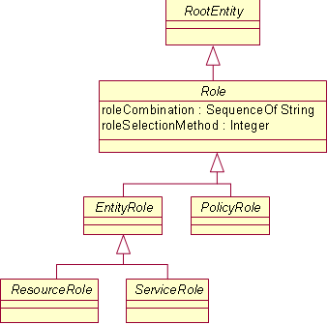
Figure 28. Business Model of a Role

Business Definition – RoleSpecification

Business Entity Name | RoleSpecification
Description | A RoleSpecification is an abstract class that extends the Specification class in order to define the invariant attributes (in the business view, and methods, constraints, relationships and behavior in the system view) of Roles.  In general, if a Role is used, it is also advisable to use a RoleSpecification, since RoleSpecifications enable a set of Roles (1) to be specified as a set of common abstractions which are used throughout an application, (2) to have their invariant characteristics and behavior defined in a standard way, and (3) to indirectly specify the set of Roles that must be used to abstract the functionality that is to be modeled.
Sources | DEN-ng | Cross- References |  |  | Synonyms / Aliases | Not present in M.3100 or the DMTF CIM.
Related Business Entities | Specification (superclass), Entity, ManagedEntity, UnManagedEntity, Resource, Service, Role, Policy, ManagementDomain
Business Rules | To be determined

Business Attributes Definition – RoleSpecification
Business Entity Name | RoleSpecification
Attribute Name | Description | Data Type | Characteristics, Permitted  Values & Units | Required/  Optional | Notes (used to map to other models; blank is other models don’t have it)
TBD | TBD | TBD |  | TBD

Business Model – RoleSpecification
The business entity model of RoleSpecification is shown in Figure below. Note that this has been limited to a small excerpt of the many different subclasses of Role for simplicity. SID phase VI will incorporate the full DEN-ng role model, plus add contributions from other NGOSS teams.
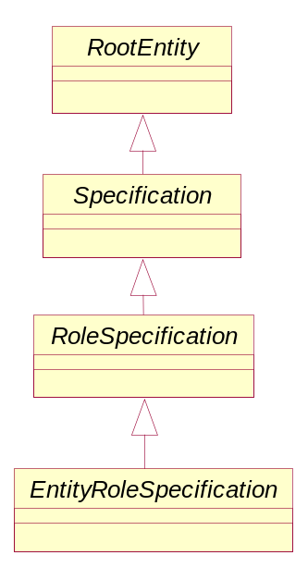
Figure 29. Business Model of a RoleSpecification

Business Definition – EntityRole

Business Entity Name | EntityRole
Description | This is an abstract class that defines the concept of various types of roles for entities that are used to describe ManagedEntities and UnManagedEntities.
Sources | DEN-ng | Cross- References |  |  | Synonyms / Aliases | Not present in the M.3100 or the DMTF CIM.
Related Business Entities | Role (superclass), Entity, ManagedEntity, UnManagedEntity, Resource, Service, Specification, RoleSpecification, Policy, ManagementDomain
Business Rules | To be determined

Business Attributes Definition – EntityRole
Business Entity Name | EntityRole
Attribute Name | Description | Data Type | Characteristics, Permitted  Values & Units | Required/  Optional | Notes (used to map to other models; blank is other models don’t have it)
TBD | TBD | TBD |  | TBD

Business Model – EntityRole
The business entity model of EntityRole is shown in Figure above.

Business Definition – Party
Please see GB922, Addendum, for a description of the Party ABE and its definition.

Business Definition – ManagementDomain

Business Entity Name | ManagementDomain
Description | A ManagementDomain extends RootEntity, and represents a special grouping of ManagedEntities that has two important properties. First, it is used to partition managed objects into a meaningful logical grouping. One important use of such a grouping is to provide a means to define which EMS (as well as which NMS) manages, monitors, etc. which set of devices. It also provides a means to show how management functions are distributed and scaled.  Second, it defines a common administrative domain that is used to administer the managed objects that it contains. This implies that all of the managed objects contained in this ManagementDomain are administered similarly - either by the same user, group of users or policy.
Sources | DEN-ng | Cross- References |  |  | Synonyms / Aliases | No direct analog in M.3100. The DMTF CIM defines an AdminDomain class that has a subset of these semantics.
Related Business Entities | RootEntity (superclass), Entity, ManagedEntity, UnManagedEntity, Resource, Service, Role, Specification, Policy
Business Rules | To be determined

Business Attributes Definition – ManagementDomain
Business Entity Name | ManagementDomain
Attribute Name | Description | Data Type | Characteristics, Permitted  Values & Units | Required/  Optional | Notes (used to map to other models; blank is other models don’t have it)
TBD | TBD | TBD |  | TBD

Business Model – ManagementDomain
The business entity model of ManagementDomain is shown in Figure 1.

Business Definition – ManagementInfo

Business Entity Name | ManagementInfo
Description | This is an abstract class that is used to represent entities that represent management information obtained in a managed environment . Specifically, in the process of managing an entity, information of various forms are created. This class is the superclass for defining different types of management information.  The design of how management information is obtained uses this class to gather specific type of information, and the ManagementMethodEntity class to obtain the desired data using an appropriate method. This combination of class hierarchies enables different management methods (e.g., CLI vs. SNMP) to be used to gather different types of management data, and is unique to the DEN-ng information model.  Note that unlike other information models, FCAPS, state and other management information is NOT embedded directly in the object. Instead, it is gathered into the subclasses of ManagementInfo. This makes for a more extensible and reusable design.
Sources | DEN-ng | Cross- References |  |  | Synonyms / Aliases | No present in the M.3100 or the DMTF CIM specs.
Related Business Entities | Entity (superclass), ManagementMethodEntity, ManagedEntity, UnManagedEntity, Resource, Service, Role, Specification, Policy, ManagementDomain
Business Rules | To be determined

Business Attributes Definition – ManagementInfo
Business Entity Name | ManagementInfo
Attribute Name | Description | Data Type | Characteristics, Permitted  Values & Units | Required/  Optional | Notes (used to map to other models; blank is other models don’t have it)
retrievalMethodCurrent | This is an enumerated integer that defines the particular type of method that is currently being used to retrieve the management information. | Integer | 0: Unknown  1: None  2: CLI  3: SNMP  4: TL1  5: CMIP  6: RMON  7: Indirectly through Web  Services  8: Indirectly through an API  9: Proprietary | Required | Not present in the ITU and DMTF CIM models.
retrievalMethodsSupported | This is an array of integers that define the different means of retrieving management methods that are supported by this object. | Integer array | 0: Unknown  1: None  2: CLI  3: SNMP  4: TL1  5: CMIP  6: RMON  7: Indirectly through Web  Services  8: Indirectly through an API  9: Proprietary | Required | Not present in the ITU and DMTF CIM models.

Business Model – ManagementInfo
The business entity model of ManagementInfo is shown in Figure 24.

Business Definition – ManagementMethodEntity

Business Entity Name | ManagementMethodEntity
Description | This is an abstract base class for representing the different types of management methods that can be used to gather a particular type of management information. For example, this enables configuration setting classes to be defined as using CLI, while configuration monitoring classes could be defined as using a different method, such as SNMP.  The design of how management information is obtained uses this class to gather specific type of information, and the ManagementMethodEntity class to obtain the desired data using an appropriate method. This combination of class hierarchies enables different management methods (e.g., CLI vs. SNMP) to be used to gather different types of management data, and is unique to the DEN-ng information model.  Note that unlike other information models, FCAPS, state and other management information is NOT embedded directly in the object. Instead, it is gathered into the subclasses of ManagementInfo. This makes for a more extensible and reusable design.
Sources | DEN-ng | Cross- References |  |  | Synonyms / Aliases | Not present in the M.3100 or the DMTF CIM specs.
Related Business Entities | Entity (superclass), ManagementMethodEntity, ManagedEntity, UnManagedEntity, Resource, Service, Role, Specification, Policy, ManagementDomain
Business Rules | To be determined

Business Attributes Definition – ManagementMethodEntity
Business Entity Name | ManagementMethodEntity
Attribute Name | Description | Data Type | Characteristics, Permitted  Values & Units | Required/  Optional | Notes (used to map to other models; blank is other models don’t have it)
TBD | TBD | TBD |  | TBD

Business Model – ManagementMethodEntity
The business entity model of ManagementMethodEntity is shown in Figure 25.

CharacteristicSpecification

Business Entity Definition
Business Entity Name | CharacteristicSpecification
Description | A quality or distinctive feature that defines an entity. The characteristic can be take on a discrete value, such as color, can take on a range of values, (for example, sensitivity of 100-240 mV), or can be derived from a formula (for example, usage time (hrs) = 30 - talk time *3).
Sources | Oracle (MetaSolv), Tektronix, T-Systems, Telecom Italia, mTOP-SM team, Amdocs, Telstra, IBM | Cross- References |  |  | Synonyms / Aliases | Attribute, Property, Feature are a synonyms for all uses of Characteristic.
Related Business Entities | DescribesEntitySpecification  DescribesRootEntityType  EnumeratedByCharacteristicSpecValue  ReferencesCharacteristicSpecification
Business Rules

Business Entity Attributes Definition
Business Entity Name | CharacteristicSpecification
Attribute Name | Description | Data Type | Characteristics, Permitted Values & Units | Required/  Optional | Notes
ID | A unique identifier for the CharacteristicSpecification. | String |  | Required
name | A word, term, or phrase by which a CharacteristicSpecification is known and distinguished from other CharacteristicSpecifications. | String |  | Required
description | A narrative that explains in detail what the CharacteristicSpecification is. | String |  | Optional
unique | An indicator that specifies if a value is unique for the specification.  Possible values are; "unique while value is in effect" and "unique whether value is in effect or not" | String |  | Optional
valueType | A kind of value that the characteristic can take on, such as numeric, text, and so forth. | String |  | Required, if the specification is not a composite
minCardinality | The minimum number of instances a CharacteristicValue can take on. For example, zero to five phone numbers in a group calling plan, where zero is the value for the minCardinality. | Integer |  | Optional
maxCardinality | The maximum number of instances a CharacteristicValue can take on. For example, zero to five phone numbers in a group calling plan, where five is the value for the maxCardinality. | Integer |  | Optional
extensible | An indicator that specifies that the values for the characteristic can be extended by adding new values when instantiating a characteristic for an Entity. | Boolean |  | Optional
derivationFormula | A rule or principle represented in symbols, numbers, or letters, often in the form of an equation used to derive the value of a characteristic value. | String |  | Optional
validFor | The period of time for which a CharacteristicSpecification is applicable. | Time Period |  | Optional

CharacteristicSpecValue

Business Entity Definition
Business Entity Name | CharacteristicSpecValue
Description | A number or text that can be assigned to a CharacteristicSpecification.
Sources | Oracle (MetaSolv), Tektronix, T-Systems, Telecom Italia, mTOP-SM team, Amdocs, Telstra, IBM | Cross- References |  |  | Synonyms / Aliases
Related Business Entities | EnumeratesCharacteristicSpecification  InstantiatedAsPerformanceCharacteristicValue  UsedByRootEntityTypeCharUse  UsedByEntitySpecCharUse
Business Rules

Business Entity Attributes Definition
Business Entity Name | CharacteristicSpecValue
Attribute Name | Description | Data Type | Characteristics, Permitted Values & Units | Required/  Optional | Notes
valueType | A kind of value that the characteristic can take on, such as numeric, text, and so forth. | String |  | Optional
default | Indicates if the value is the default value for a characteristic. | Boolean |  | Optional
value | A discrete value that the characteristic can take on. | String |  | Optional | Either value or valueFrom and/or valueTo are required
unitofMeasure | A length, surface, volume, dry measure, liquid measure, money, weight, time, and the like. Iin general, a determinate quantity or magnitude of the kind designated, taken as a standard of comparison for others of the same kind, in assigning to them numerical values, as 1 foot, 1 yard, 1 mile, 1 square foot. | Text |  | Optional
valueFrom | The low range value that a characteristic can take on. | String |  | Optional
valueTo | The upper range value that a characteristic can take on. | String |  | Optional
rangeInterval | An indicator that specifies the inclusion or exclusion of the valueFrom and valueTo attributes.  Possible values are "open", "closed", "closedBottom" and "closedTop". | String |  | Optional
validFor | The period of time for which a value is applicable. | Time Period |  | Optional

CharacteristicSpecRelationship

Business Entity Definition
Business Entity Name | CharacteristicSpecRelationship
Description | A aggregation, migration, substitution, dependency, or exclusivity relationship between/among CharacteristicSpecifications.
Sources | Oracle (MetaSolv), Tektronix, T-Systems, Telecom Italia, mTOP-SM team, Amdocs, Telstra, IBM | Cross- References |  |  | Synonyms / Aliases
Related Business Entities | An association class that describes the association CharacteristicSpecificationReferencesCharacteristicSpecification
Business Rules

Business Entity Attributes Definition
Business Entity Name | CharacteristicSpecRelationship
Attribute Name | Description | Data Type | Characteristics, Permitted Values & Units | Required/  Optional | Notes
charRelationshipType | A categorization of the relationship, such as aggregation, migration, substitution, dependency, exclusivity. | String |  | Required
validFor | The period for which the relationship is applicable. | Time Period |  | Optional
charSpecSeq | The order in which a CharacteristicSpecification appears within another CharacteristicSpecification that defines a grouping of CharacteristicSpecifications.  For example, a grouping may represent the name of an individual. The given name is first, the middle name is second, and the last name is third. | Integer |  | Optional

Business Entity Definition
Business Entity Name | CharSpecValueRelationship
Description | A aggregation, migration, substitution, dependency, or exclusivity relationship between/among CharacteristicSpecValues.
Sources | Oracle (MetaSolv), Tektronix, T-Systems, Telecom Italia, mTOP-SM team, Amdocs, Telstra, IBM | Cross- References |  |  | Synonyms / Aliases
Related Business Entities | An association class that describes the association CharacteristicSpecificationReferencesCharacteristicSpecification
Business Rules

Business Entity Attributes Definition
Business Entity Name | CharSpecvalueRelationship
Attribute Name | Description | Data Type | Characteristics, Permitted Values & Units | Required/  Optional | Notes
charRelationshipType | A categorization of the relationship, such as aggregation, migration, substitution, dependency, exclusivity. | String |  | Required
validFor | The period for which the relationship is applicable. | Time Period |  | Optional

EntitySpecCharUse

Business Entity Definition
Business Entity Name | EntitySpecCharUse
Description | A use of the CharacteristicSpecification by an EntitySpecification to which additional properties (attributes) apply or override the properties of similar properties contained in CharacteristicSpecification.
Sources | Oracle (MetaSolv), Tektronix, T-Systems, Telecom Italia, mTOP-SM team, Amdocs, Telstra, IBM | Cross- References |  |  | Synonyms / Aliases
Related Business Entities
Business Rules | An association class that describes the association EntitySpecificationDescribedByCharacteristicSpecification

Business Entity Attributes Definition
Business Entity Name | EntitySpecCharUse
Attribute Name | Description | Data Type | Characteristics, Permitted Values & Units | Required/  Optional | Notes
name | A word, term, or phrase by which the CharacteristicSpecification is known and distinguished from other CharacteristicSpecifications. | String |  | Optional
description | A narrative that explains the CharacteristicSpecification. | String |  | Optional
package | An indicator that specifies that the associated CharacteristicSpecification is a composite. | Boolean |  | Optional | If there is an instance of this entity, at least the name attribute should have a value.
unique | An indicator that specifies if a value is unique for the specification.  Possible values are; "unique while value is in effect" and "unique whether value is in effect or not" | String |  | Optional
canBeOverridden | An indicator that specifies that the CharacteristicSpecValues associated with the CharacteristicSpec cannot be changed when instantiating a CharacteristicValue. For example, a bandwidth of 64 MB cannot be changed. | Boolean |  | Optional
minCardinality | The minimum number of instances a CharacteristicValue can take on. For example, zero to five phone numbers in a group calling plan, where zero is the value for the minCardinality. | Integer |  | Optional
maxCardinality | The maximum number of instances a CharacteristicValue can take on. For example, zero to five phone numbers in a group calling plan, where five is the value for the maxCardinality. | Integer |  | Optional
extensible | An indicator that specifies that the values for the characteristic can be extended by adding new values when instantiating a characteristic for an Entity. | Boolean |  | Optional
validFor | The period of time for which the use of the CharacteristicSpecification is applicable. | TimePeriod |  | Optional

EntitySpecCharValueUse

Business Entity Definition
Business Entity Name | EntitySpecCharValueUse
Description | A use of the CharacteristicSpecificationValue by an EntitySpecification to which additional properties (attributes) apply or override the properties of similar properties contained in CharacteristicSpecificationValue.
Sources | Oracle (MetaSolv), Tektronix, T-Systems, Telecom Italia, mTOP-SM team, Amdocs, Telstra, IBM | Cross- References |  |  | Synonyms / Aliases
Related Business Entities | An association class that describes the association EntitySpecCharUseDescribedByCharacteristicSpecValue
Business Rules

Business Entity Attributes Definition
Business Entity Name | EntitySpecCharValueUse
Attribute Name | Description | Data Type | Characteristics, Permitted Values & Units | Required/  Optional | Notes
default | Indicates if the value is the default value for a characteristic. | String |  | Optional
validFor | The period of time for which the use of the CharacteristicSpecificationValue is applicable. | TimePeriod |  | Optional

RootEntityTypeCharUse

Business Entity Definition
Business Entity Name | RootEntityTypeCharUse
Description | A use of the CharacteristicSpecification by a RootEntityType to which additional properties (attributes) apply or override the properties of similar properties contained in CharacteristicSpecification.
Sources | Oracle (MetaSolv), Tektronix, T-Systems, Telecom Italia, mTOP-SM team, Amdocs, Telstra, IBM | Cross- References |  |  | Synonyms / Aliases
Related Business Entities | An association class that describes the association RootEntityTypeDescribedByCharacteristicSpecification
Business Rules

Business Entity Attributes Definition
Business Entity Name | RootEntityTypeCharUse
Attribute Name | Description | Data Type | Characteristics, Permitted Values & Units | Required/  Optional | Notes
name | A word, term, or phrase by which the CharacteristicSpecification is known and distinguished from other CharacteristicSpecifications. | String |  | Optional
description | A narrative that explains the CharacteristicSpecification. | String |  | Optional
unique | An indicator that specifies if a value is unique for the specification.  Possible values are; "unique while value is in effect" and "unique whether value is in effect or not" | String |  | Optional
package | An indicator that specifies that the associated CharacteristicSpecification is a composite. | Boolean |  | Optional | If there is an instance of this entity, at least the name attribute should have a value.
canBeOverriden | An indicator that specifies that the CharacteristicSpecValues associated with the CharacteristicSpec cannot be changed when instantiating a CharacteristicValue. For example, a bandwidth of 64 MB cannot be changed. | Boolean |  | Optional
minCardinality | The minimum number of instances a CharacteristicValue can take on. For example, zero to five phone numbers in a group calling plan, where zero is the value for the minCardinality. | Integer |  | Optional
maxCardinality | The maximum number of instances a CharacteristicValue can take on. For example, zero to five phone numbers in a group calling plan, where five is the value for the maxCardinality. | Integer |  | Optional
extensible | An indicator that specifies that the values for the characteristic can be extended by adding new values when instantiating a characteristic for an Entity. | Boolean |  | Optional
validFor | The period of time for which the use of the CharacteristicSpecification is applicable. | TimePeriod |  | Optional

RootEntityTypeCharValueUse

Business Entity Definition
Business Entity Name | RootEntityTypeCharValueUse
Description | A use of the CharacteristicSpecificationValue by a RootEntityType to which additional properties (attributes) apply or override the properties of similar properties contained in CharacteristicSpecificationValue.
Sources | Oracle (MetaSolv), Tektronix, T-Systems, Telecom Italia, mTOP-SM team, Amdocs, Telstra, IBM | Cross- References |  |  | Synonyms / Aliases
Related Business Entities | An association class that describes the association RootEntityTypeCharUseDescribedByCharSpecValue
Business Rules

Business Entity Attributes Definition
Business Entity Name | RootEntityTypeCharValueUse
Attribute Name | Description | Data Type | Characteristics, Permitted Values & Units | Required/  Optional | Notes
default | Indicates if the value is the default value for a characteristic. | String |  | Optional
validFor | The period of time for which the use of the CharacteristicSpecificationValue is applicable. | TimePeriod |  | Optional

Business Entity Definition
Business Entity Name | CharacteristicValue
Description | A value of a CharacteristicSpecifcation chosen or entered (if no values are specified) for a Entity that further defines what the Entity is.
Sources | Oracle (MetaSolv), Tektronix, T-Systems, Telecom Italia, mTOP-SM team, Amdocs, Telstra, IBM | Cross- References |  |  | Synonyms / Aliases
Related Business Entities | DescribesRootEntity  InstantiatesCharacteristicSpecValue  DescribedByCharacteristicSpecification
Business Rules

Business Entity Attributes Definition
Business Entity Name | CharacteristicValue
Attribute Name | Description | Data Type | Characteristics, Permitted Values & Units | Required/  Optional | Notes
value | A fact that describes a Entity. | String |  | Optional | Required if there are no CharacteristicSpecValue instances or the value is chosen from a range of values.
validFor | The period for which the characteristic value is applicable. | Time Period |  | Optional

CharacteristicPriceDependency

Business Entity Definition
Business Entity Name | CharacteristicPriceDependency
Description | A group of EntitySpecValueUse entities that are used to deterimine a ComponentProdOfferPrice.
Sources | Huawei | Cross- References |  |  | Synonyms / Aliases
Related Business Entities | RepresentedByCharPriceDepMember  DeterminesComponentProdOfferPrice
Business Rules

Business Entity Attributes Definition
Business Entity Name | CharacteristicPriceDependency
Attribute Name | Description | Data Type | Characteristics, Permitted Values & Units | Required/  Optional | Notes
name | A word, term, or phrase by which the entity is known and distinguished from other entities. | String |  | Required
validFor | The period of time for which the entity is valid. | TimePeriod |  | Optional

CharPriceDepMember

Business Entity Definition
Business Entity Name | CharPriceDepMember
Description | An element of a rule defined by a EntitySpecValueUse used to determine a ComponentProdOfferPrice.
Sources |  | Cross- References |  |  | Synonyms / Aliases
Related Business Entities | DefinesCharacteristicPriceDependency  DefinedInPartByEntitySpecValueUse
Business Rules

Business Entity Attributes Definition
Business Entity Name | CharPriceDepMember
Attribute Name | Description | Data Type | Characteristics, Permitted Values & Units | Required/  Optional | Notes
sequence | The order in which a member appears in an expression. | Integer | Defaults to 1 | Required
operator | A mathematical symbol, term, or other entity that describes an operation. |  | Defaults to and | Required
delimiter | A character used to specify the boundary between separate members. |  |  | Optional

Business Definition – Policy
Please see GB922 Addendum 1-POL, for a complete definition of the Policy ABE

Administrative Appendix
This Appendix provides additional background material about the TM Forum and this document. In general. sections may be included or omitted as desired, however a Document History must always be included..

About this document
This is a TM Forum Guidebook. The guidebook format is used when:
- The document lays out a ‘core’ part of TM Forum’s approach to automating business processes. Such guidebooks would include the Telecom Operations Map and the Technology Integration Map, but not the detailed specifications that are developed in support of the approach.
- Information about TM Forum policy, or goals or programs is provided, such as the Strategic Plan or Operating Plan.
- Information about the marketplace is provided, as in the report on the size of the OSS market.

Document History

Version History
<This section records the changes between this and the previous document version as it is edited by the team concerned. Note: this is an incremental number which does not have to match the release number>

Version | Date | Author | Purpose
0.1 | Sept 2003 | J. Reilly | First Draft
0.2 | Oct 2003 | J. Reilly | Updates based on comments from Paul Levine and John Strassner
0.3 | Oct 2003 | J. Strassner | Additional updates to reflect redesign of Entity Identification
0.4 | Oct 2003 | J. Strassner | Filled in skeleton of complete Addendum
0.5 | Nov 2003 | J. Strassner | Completed Addendum up thru Roles Overview for review
0.6 | Dec 2003 | J. Strassner | Incorporated detailed comments from Dave Raymer, along with additional comments from JohnR and Cliff
0.7 | Dec 2003 | J. Strassner | Finished rest of data dictionary section; one last try to explain UnManagedEntity; additional comments from Cliff
0.8 | Dec 2003 | J. Strassner | Incorporated comments from Dave; final clean-up
0.9 | Jan 2004 | J. Strassner | Final clean-up comments in response to Greg Fiddler
1.0 | Feb 2004 | TMF | Final formatting
1.1 | May 2004 | J. Strassner | Minor update
1.2 | June 2004 | J. Strassner | Included update from John Reilly and Paul Levine
1.3 | July 2004 | J. Strassner | Final revisions for NGOSS 4.5 release
1.4 | August 2004 | C. Faurer | Minor cleanup
1.5 | August 2004 | C. Faurer | Accepted comments from Paul Levine
1.6 | November 2004 | TMF | Minor updates prior to
1.7 |  | TMF | Updated notice statements & doc status
2.0 | March 2008 | John Reilly | Fully develop Characteristic ABE and provide definitions for Entity Identification ABE
2.1 | July 2008 | Tina O’Sullivan | Corrections prior to posting.
2.2 | May 2009 | Alicja Kawecki | Minor updates to reflect TM Forum Approved status
9.0 | January 2010 | John Reilly | Updated to reflect implemented change requests
9.1 | April 2010 | Alicja Kawecki | Minor cosmetic corrections for web posting and ME
9.2 | June 2010 | Alicja Kawecki | Updated Notice
9.3 | October 2010 | Alicja Kawecki | Updated to reflect TM Forum Approved status
9.5 | November  2010 | Sihao Li | Updated with characteristic based pricing model proposed by Huawei
9.6 | March 2011 | Alicja Kawecki | Minor formatting corrections prior to web posting and ME
9.7 | September 2011 | John Reilly | Corrected Figure 35

Release History
<This section records the changes between this and the previous Official document release>

Release Number | Date Modified | Modified by: | Description of changes
8.0 | 7/July/2008 | John Reilly | Fully develop Characteristic ABE and provide definitions for Entity Identification ABE
9.0 | January 2010 | John Reilly | Updated to reflect implemented change requests
9.5 | November  2010 | Sihao Li | Updated with characteristic based pricing model
9.5 | September 2011 | John Reilly / Josh Salomon | Corrected Figure 35

Company Contact Details
Company | Team Member Representative
Amdocs | Name: Josh Salomon  Title: Senior Billing architect,  Email: joshs@amdocs.com  Phone: +972 9 7764422  Fax
Progress Software | Name: John Wilmes  Title: Chief Technical Architect  Email: jwilmes@progress.com  Phone: +1 650 302 5198  Fax

Acknowledgments
This document was prepared by the members of the TeleManagement Forum SID team:
The Shared Information/Data Model is a genuinely collaborative effort. The TM Forum would like to thank the following people for contributing their time and expertise to the production of this document. It is just not possible to recognize all the organizations and individuals that have contributed or influenced the introduction. We apologize to any person or organization we inadvertently missed in these acknowledgments.
Key individuals that reviewed, provided input, managed, and determined how to utilize inputs coming from all over the world, and really made this document happen were:

Name | Affiliation
Cliff Faurer | TeleManagement Forum
Ed Grossman | Independent
Enrico Grosso | Telecom Italia
Chris Hartley | Telstra
Paul Levine | Telcordia
Dave Raymer | Motorola
John Reilly | MetaSolv Software
Wayne Sigley | Telstra
John Strassner | Intelliden (editor)
Fabrizio Bobbio | Telecom Italia
Francis Anderson | IBM
Lutz Bettge | T-Systems
Josh Salomon | Amdocs
John Giles | Telstra
mTOP-SM Team | TM Forum
Sihao Li | Huawei

An example of an UnManagedProduct is a phone card. It is sold (and therefore qualifies as a product) and offers a service (the ability to make phone calls) and exists as a Resource (the physical phone card).
Note that no example of an UnManagedService yet exists (though we don’t doubt that one will turn up soon!). The phone card example has a service, but the service itself is manageable (i.e., the phone calls can be administrated).
To be published in Phase V

