Shared Information/Data (SID) Model
Addendum 1T – Time Related Business Entity Definitions

GB922 Addendum 1T
Version 1.7


October, 2012

Notice
No recipient of this document and code shall in any way interpret this material as representing a position or agreement of TM Forum or its members. This material is draft working material of TM Forum and is provided solely for comments and evaluation. It is not “Forum Approved” and is solely circulated for the purposes of assisting TM Forum in the preparation of final material in furtherance of the aims and mission of TM Forum.
Although it is copyrighted material of TM Forum:
- Members of TM Forum are only granted the limited copyright waiver to distribute this material within their companies and may not make paper or electronic copies for distribution outside of their companies.
- Non-members of the TM Forum are not permitted to make copies (paper or electronic) of this draft material other than for their internal use for the sole purpose of making comments thereon directly to TM Forum.
- If this material forms part of a supply of information in support of an Industry Group Liaison relationship, the document may only be used as part of the work identified in the Liaison and may not be used or further distributed for any other purposes
Any use of this material by the recipient, other than as set forth specifically herein, is at its own risk, and under no circumstances will TM Forum be liable for direct or indirect damages or any costs or losses resulting from the use of this material by the recipient.
This material is governed, and all recipients shall be bound, by all of the terms and conditions of the Intellectual Property Rights Policy of the TM Forum (http://www.tmforum.org/Bylaws/1094/home.html) and may involve a claim of patent rights by one or more TM Forum members or by non-members of TM Forum.

Direct inquiries to the TM Forum office:

240 Headquarters Plaza,
East Tower – 10th Floor,
Morristown, NJ 07960 USA
Tel No. +1 973 944 5100
Fax No. +1 973 944 5110
TM Forum Web Page: www.tmforum.org

Acknowledgments
This document was prepared by the members of the TeleManagement Forum SID team:
The Shared Information/Data Model is a genuinely collaborative effort. The TM Forum would like to thank the following people for contributing their time and expertise to the production of this document. It is just not possible to recognize all the organizations and individuals that have contributed or influenced the introduction. We apologize to any person or organization we inadvertently missed in these acknowledgments.
Key individuals that reviewed, provided input, managed, and determined how to utilize inputs coming from all over the world, and really made this document happen were:

Name | Affiliation
Cliff Faurer | TeleManagement Forum
Chris Hartley | Telstra
Helen Hepburn | British Telecom
John Reilly | MetaSolv Software
Wayne Sigley | Telstra
John Strassner | Intelliden

About this document
This is a TM Forum Guidebook. The guidebook format is used when:
The document lays out a ‘core’ part of TM Forum’s approach to automating business processes. Such guidebooks would include the Telecom Operations Map and the Technology Integration Map, but not the detailed specifications that are developed in support of the approach.
Information about TM Forum policy, or goals or programs is provided, such as the Strategic Plan or Operating Plan.
Information about the marketplace is provided, as in the report on the size of the OSS market.

Document Life Cycle
This document is being issued for Member Evaluation. The purpose of an Evaluation Version is to encourage input based on experience of members and the public as they begin to use the document. Following the Evaluation Period, documents that are seen to deliver value are candidates for formal approval by the TM Forum. All documents approved by the TM Forum undergo a formal review and approval process.
This document will continue under formal change control. Supporting work will be issued as companions to this document. A document of this type is a “living document,” capturing and communicating current knowledge and practices. Further inputs will be made because of detailed work ongoing in the TM Forum and the industry.

Document History
Version | Date | Purpose
0.1 | Mar 2003 | Initial Version
1.0 | Apr 2003 | Formatted for Team review
1.1 | July 2003 | Formatted for Member Review with NGOSS R3.5
1.2 | Aug 2004 | To reflect TMF Approval status
1.3 | Dec 2010 | Updated Notice
1.4 | Mar 2011 | Minor formatting corrections prior to web posting and ME
1.5 | Sep 2011 | Updated to reflect TM Forum Approved status
1.6 | Sep 2012 | Adding Schedule Definition ABE
1.7 | Oct 2012 | Minor style/cosmetic corrections prior to web posting and Member Evaluation

Time Stamp
This version of this document can be considered valid until further notice.

How to obtain a copy
An electronic copy of this document can be downloaded at the TM Forum Web Site (www.tmforum.org) at Publications or through a link to Publications from a specific team’s public project area.
If the document version has only been released to members for review and comment, the document can only be downloaded from the TM Forum Web Site in the Members Only Area. Depending upon the document, it could be accessible from New Items, Evaluation Versions, or a team’s Members Only project area.
If you would like a paper version of this document, please order via the TM Forum Web Site or contact the TM Forum office. If you are not a member, please contact the TM Forum office on +1.973.292.1901.

How to comment on the document
Comments must be in written form and addressed to the TOM team leader and TMF staff sponsor for review with the project team. Please send your comments to the contacts shown below:

John Reilly | Jreilly@metasolv.com | +1 972-403-8408
John Strassner | John.Strassner@intelliden.com | +1 719-785-0648
Cliff Faurer | Cfaurer@tmforum.org | +1 303-367-1443

Team email: SID_team@tmforum.org

Table of Contents
Notice 2
Acknowledgments 3
About this document 4
Document Life Cycle 4
Document History 4
Time Stamp 5
How to obtain a copy 5
How to comment on the document 5
Table of Contents 6
Table of Figures 7
Business Entities 8
Time ABE 8
Introduction 8
Using this model for Process Analysis 24
Further Work Required in Later Releases 24
Notes: 24
References 27
Standard citation for this document 28
Examples 28
Calendar 28
CalendarEntry 30
Temporal Expression 32
SimpleTemporalExpression 33
RecurrenceTemporalExpression 34
CalendarEntryParticipation 35
CalendarActionEntry 37
CalendarJournalEntry 38
CalendarEvent 39
CalendarToDo 40
CalendarAlarm 41
AbsoluteCalendarAlarm 42
RelativeCalendarAlarm 43
CalendarEntryAssociation 44
CalendarEntryAttachment 45
ScheduleDefinition 46
RecurringScheduleDefinition 47
WeeklyScheduleDefinition 48
DateScheduleDefinition 49
MonthlyScheduleDaysofMonthDefinition 50
MonthlyScheduleDaysofWeekDefinition 51
ScheduleDefinitionExcludedDates 52
FixedScheduleDefinition 54
FixedScheduleItem 55
ScheduledDuration 56

Table of Figures
fig 0 – Showing how this document fits in 8
fig 1 – iCalendar UML interpretation 11
fig 2 – Basic Structure 12
fig 3 – Detailed Structure 14
fig 4 – Calendar Detail 15
fig 5 – Calendar Entry Relationships 16
fig 6a – Organizer & Attendee 17
fig 6b – Organizer & Attendee 18
fig 7 – Entry Types 20
fig 8 – Entry Characteristics 22
fig 9 – Linking to the rest of SID 23
fig 10 - Schedule Definition 25

Business Entities

Time ABE

Introduction
This document covers non base type entities that are time related (Entities like Time Period are covered by the Base Types SID document).
At the most fundamental level [Zachman], [Coad-Archetypes] the world can be thought of as comprising of entities that answer the 5 fundamental questions.
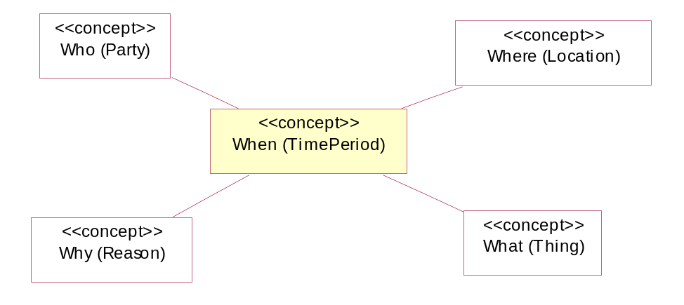
fig 0 – Showing how this document fits in
This facet of the SID deals with Time based entities, which answer the question “when”. In this initial version of the document, we will only cover entities related to Calendar functionality.

eTOM Requirements
The eTOM has direct references to Time Management in the following process definitions:
- CRM Operations Support & Process Management (CRM – OSR) – “employee schedules”
- RM&O Support & Process Management (RM&O - OSR) – “employee schedules”
- S/PRM Operations Support & Process Management (S/PRM - OSR) – “employee schedules”
- Marketing Communications & Promotion (M&OM - PLM) – “schedules press interviews, manages an editorial calendar to plan placements”
- RM&O People Support & Scheduling (RM&O – OSR) - “employee schedules”
- Resource Maintenance & Repair (RM&O – OSR) – “scheduled maintenance activities”

Since the eTOM doesn’t give detailed requirements for Time Management, this model will provide a level of functionality that could be reasonably be expected to be required by eTOM based use cases.

Calendar Introduction
One of the few publicly defined Calendar specifications is the iCalendar spec [iCalendar]. Unfortunately, the specification is implementation focused (not problem domain concept focused) and defines standard information interchange messages rather than entity definitions.
The iCalendar specification is significant enough, however, that it is worthwhile to try and interpret the document and convert it to a SID compatible format (refer figure 1).
One other issue with the iCalendar specification is that the main concept is called “Calendar”, which clashes with the Calendar Java class name (which is focused on implementing “calendrical systems” such as the Gregorian Calendar). We will use the term Calendar in this document, the other option would be to name the entities using “schedule”, which aligns with Fowler’s naming and would be more compatible with uses such as in the Project management area.
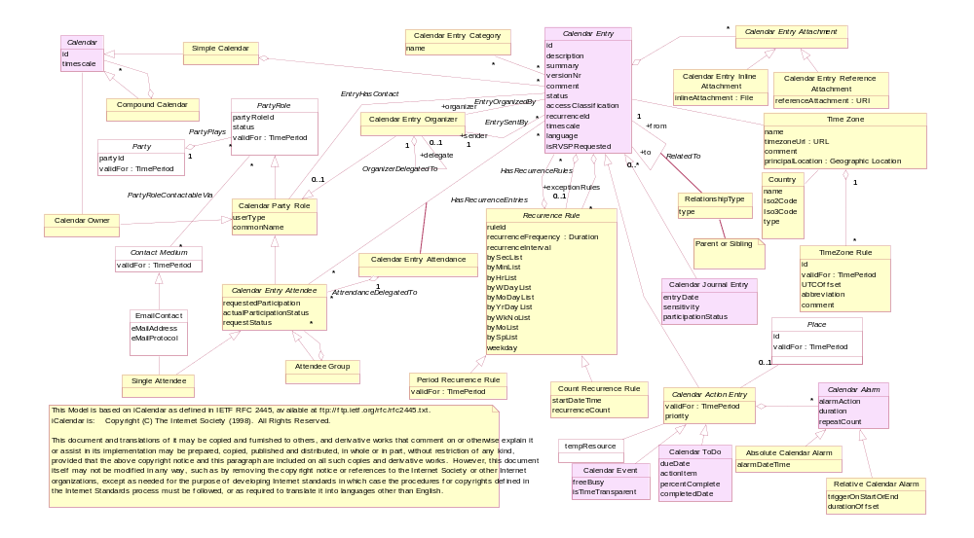
fig 1 – iCalendar UML interpretation

Calendar Structure
Fowler provides a good overview of the business problem that requires a calendar [Fowler-Calendar]. A good starting point for our discussion is shown in fig 1. Note that here we are using the term Calendar rather than Schedule.
A Calendar has an owner who can control updates to it. The Calendar could also be associated with Assets like a Site or a Workgroup.
A Calendar contains Calendar Entries. These entries are related to events and have a temporal expression that indicates the Time Periods for the entry. Note that an entry may have repeating Time Periods in the temporal expression.
In figure 2, the slashes on the associations denote that the association is derived. This is because the entities are logically associated, but the actual association is done via subclasses of the entities.

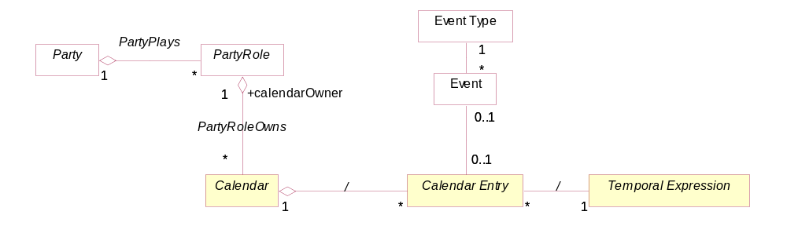
fig 2 – Basic Structure

Figure 3 shows the structure in more detail. Note that the Event and EventType entities should only be considered as placeholders until the SID has modeled this area in detail.
We will allow Calendars to be grouped, allowing for all of the Calendars for a workgroup to be combined into a workgroup overview Calendar. Note, however, that only simple Calendars can have CalendarEntries.
Note that CalendarEntries are specific to each calendar, they aren’t shared. This gives the CalendarOwner complete control over the entries in their Calendar.
We have defined three basic types of CalendarEntry; Journal Entries, Events and ToDos. The CalendarEntry entity is an abstract concept that we use to group common attributes and common associations to other entities.
Since both Event and ToDo entries can have Alarms attached, we have introduced an abstract entity “ActionEntry” to hold the common concepts.
A CalendarEntry has a related Temporal Expression, which contains the TimePeriod or collection of repeating TimePeriods. Note that when we create a recurring CalendarEntry that the Recurrence Rule will create a set of subsidiary Calendar Entries. We need to keep track of these as we may need to update or remove them if the recurrence rule is modified, or the recurring CalendarEntry is removed. Rather than have a main and subsidiary set of CalendarEntries, all the entries are made equal and there is a both-way reference between the Entries and the associated RecurrenceRule.
The recurrence rule could be specified using a frequency like weekly, monthly, yearly. This means that the duration between repetitions may vary (e.g. for a monthly frequency the duration will vary from 28 to 31 days)
Note that there may be many ways to implement the Recurrence Temporal Expression; these may include Templates, Rules or Policy Engines or hard coded algorithms.
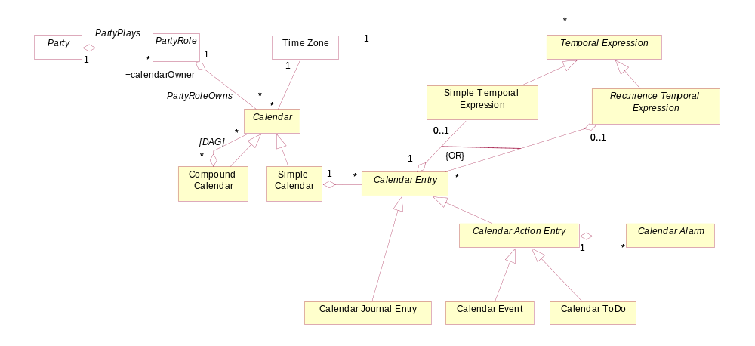
fig 3 – Detailed Structure

Calendar
The calendar entity has defaults to be applied when a user receives and views CalendarEntries. For example it has a time zone reference that allows it to convert entries from different time zones to a standard time zone.
It also has a calendrical System reference so that it knows the format to present the calendar in. For example the Gregorian calendar is used in “western” countries. Other calendrical systems in use today [calendrical systems] include the Islamic, Persian (Jalali) , Hebrew and Chinese calendrical systems.
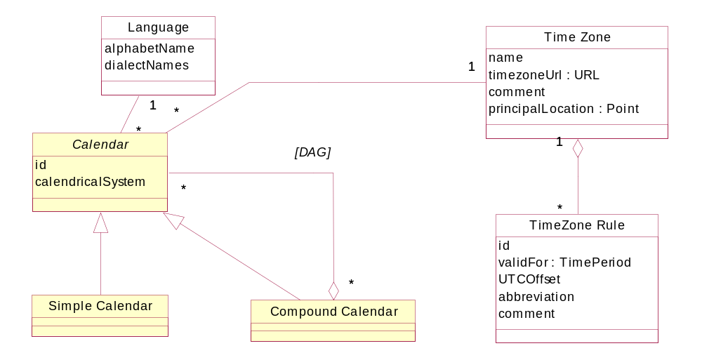

fig 4 – Calendar Detail

Calendar Entry Relationships
We allow Calendar Entries to be related to each other. The relationship can be parent-child or peer-peer.
With parent-child relationships, modifying or deleting the parent Entry may require action on the children.
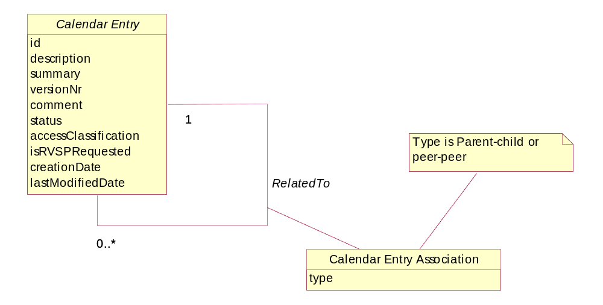
fig 5 – Calendar Entry Relationships

Organizer and Attendee
Calendar Entries have an Organizer. The Organizer may have delegated to someone else and hence we keep track of both the Sender and the Organizer.
When organizing meetings, requests are sent to a number of potential attendees. An attendee may be requested to participate or may be told their participation is optional. Each attendee may have read or not read the request, which is represented by the requestStatus. Each attendee may then accept or reject the request to define their actual participation.
In the same way that an organizer can delegate organizing a meeting, an attendee may delegate attendance.
In the SID Party document we defined that a PartyRole could be contacted in many ways via various contact media.
Figure 6a shows how this relates to a meeting attendee.
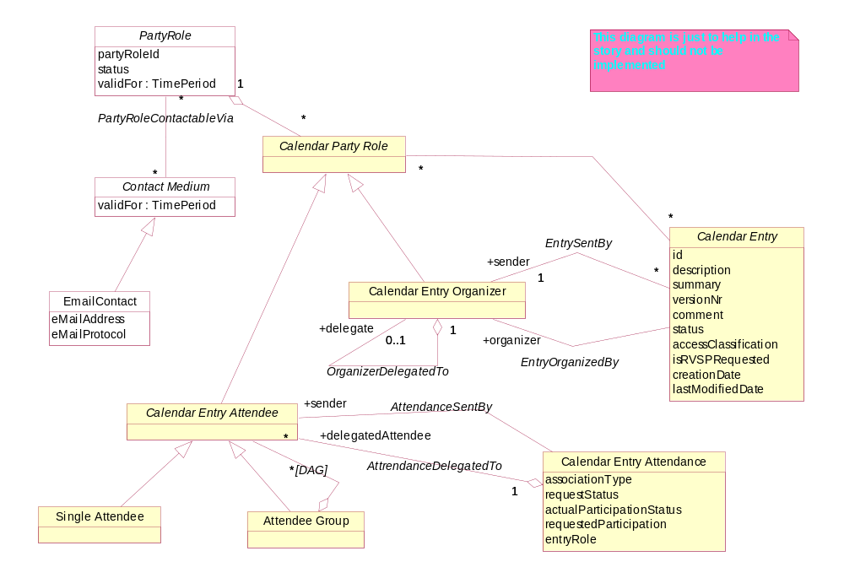
fig 6a – Organizer & Attendee
We will abstract the Organizer and Attendee associations into a common entity, making the model easier to understand and more flexible. This now provides the concept of “Participation” where for each CalendarEntry there are Customers, Suppliers … participating in various ways. The participation can be delegated to someone else. Also a secretary may reply on behalf of a manager, and this is recorded in the ParticipationSentBy association. In effect, CalendarEntryParticipation is an implementation of Roles using a simple attribute [Fowler-Roles] of participationType. Note that we deliberately have kept participationType separate from the PartyRole hierarchy, as they are independent.

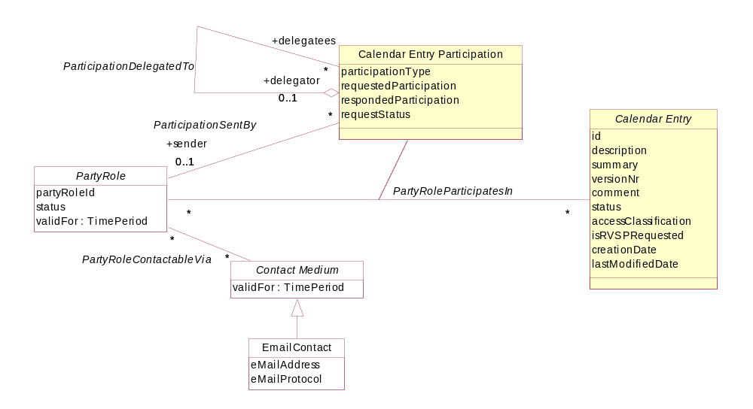
fig 6b – Organizer & Attendee

Calendar Entry Types
We will now look at the Calendar Entry Types in more detail.
CalendarEntry contains the common attributes for Journal, Event and ToDo entries.
AccessClassification refers to an entry being public or private and controls access to the entry by other than the CalendarOwner. IsRSVPRequested identifies if a return message is to be created when the entry is received.
Journal Entries allow notes to be added to the Calendar.
CalendarEvents relate to real world events. These may reserve Resources or Parties for a period of time in the calendar.
ToDo entries relate to reminders to check on progress for a task.
Events and ToDo entries can have associated Alarms. When the alarm conditions are satisfied, then the CalendarOwner can be notified in some way. The alarm trigger can be an absolute DateTimePoint and can be made relative to the start or end of the owning CalendarEntry, offset before or after the start/end by a given duration. The alarm can also be set to repeat, until the notification is responded to.
e.g. A meeting has been set for 9:00am on Tues 25 Mar 2003. An alarm is set to activate 5 minutes before the meeting starts and the alarm sound is to go for 10 seconds, repeating every minute for 10 minutes, or until a response is recorded.
Note that an Alarm activation is really a type of Event. The Event could send messages to initiate various actions.

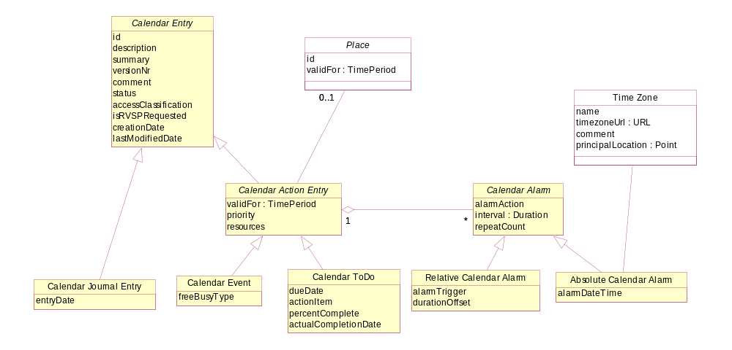
fig 7 – Entry Types

Calendar Entry Characteristics
This section explains the remaining entities that relate directly to CalendarEntry.
CalendarEntries can be categorized to allow for easier sorting and filtering.
We can also attach files to CalendarEntries, which could be items like a document sent out with a meeting request. The attachments may either be in-line or via a URI reference.
To allow for working across different time zones, we need to tag each Calendar Entry TemporalExpression with a time zone. An implementation may decide to make timezone issues invisible to the user by converting all entries on receipt, to the Calendar TimeZone.
Similarly, CalendarEntityTemporalExpressions may be translated from the calendricalSystem that they were created with to the Calendar default.
The CalendarEntry TemporalExpression could be a simple TimePoint or TimePeriod for a non-repeating Entry.
For a repeating Entry, we will need some sort of rule to enable us to specify how long it should repeat for (interval) and how often (frequency).
e.g. we may decide to go to the gym every Wednesday in Summer 2003/4.
So an entry could be created on 24 Dec 2003 at 5:00pm – 6:30pm. It could be set to repeat weekly, stopping on 17 Mar 2004. As noted before, depending on the complexity required, the RecurrenceRules entity could be implemented using rules or policy engines or simple templates.

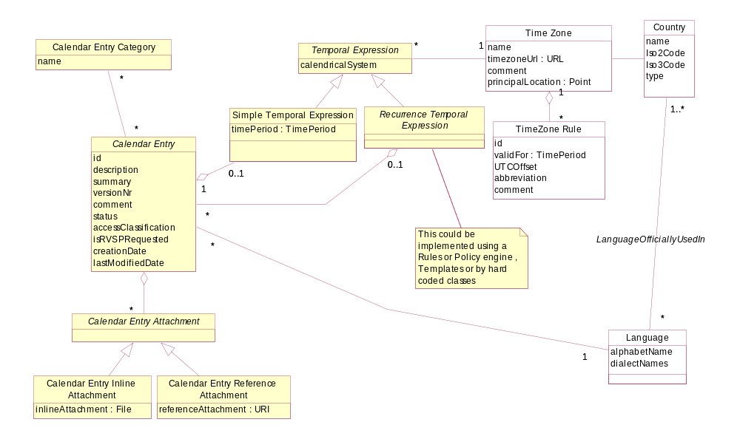
fig 8 – Entry Characteristics

Linking with the rest of the SID model
Usage of the Calendar model will be specific to the required usage.
There are two main points in the model at which linking could occur. For instance we may define a ProjectSchedule and create a Calendar for a Project. Each of the Project Activities can then have a CalendarEntry created showing the start and finish times of the event.
Similarly, a Network Site could have a Calendar defined for it. A battery bank at the site could require regular checking and checking of the water levels could be scheduled every 6 months using a recurring CalendarEvent also inserted into the work queue for the workgroup in charge of maintenance at the site.
The other way that this model can be used is by sub-classing the Calendar and CalendarEntry entities.
To see a more detailed example of the Calendar entities in use, refer to the SID Project model.

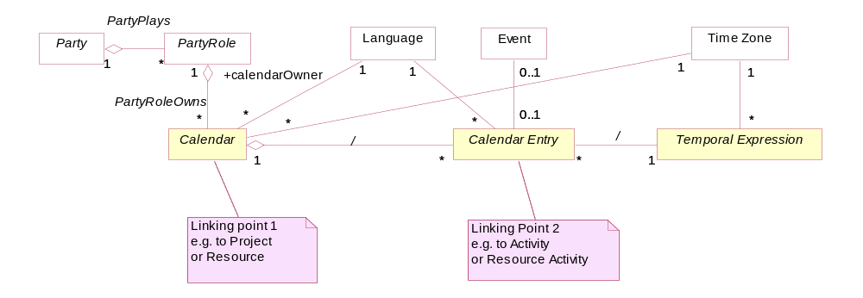
fig 9 – Linking to the rest of SID

Using this model for Process Analysis
The most useful entities will be the concrete ones Calendar, Event, ToDo, JournalEntry and Alarm.

Further Work Required in Later Releases
- Consider if we should use the term Schedule rather than Calendar
- Integrate with SID event model & the “Red Team” Event document
- provide for mail group/ list functionality (use PartyRoleAssociation ?)
- The current model is e-mail focused. Need to consider other calendar applications e.g. Internet chat meetings ?
- Need to integrate the TimeZone entities with the SID Location model

Notes:
- Note that these entities represent business concepts in a Service Provider that conforms to the eTOM process model [eTOM].
- Entities that are outside the scope of this model facet are shown with a white fill color.
- This is intended as a “minimalist” model. Subtypes and attributes should be added as required. The attributes shown should be considered as suggested, not required.
- Parent attributes are not repeated in the sub entities
- In most cases relationships are not documented as attributes
- Only significant entities are shown in the “related business entities” cells

Schedule Definition
The Schedule Definition model is targeted to answer the need of applications to schedule jobs either on a recurring basis or at specific dates and times. The base entity for Schedule Definition is the ScheduleDefinition entity. A ScheduleDefinition entity is associated with a management job entity when it is scheduled. ScheduleDefinition is an abstract entity as any schedule definition has specific parameters that need to be defined by using its sub-entities.
The following diagram shows the data model of the Schedule Definition.

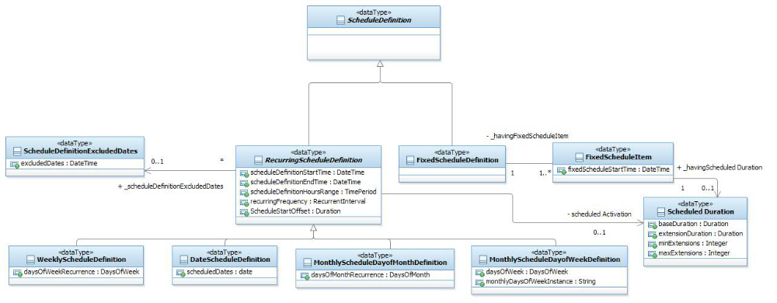
fig 10 - Schedule Definition

A Schedule Definition may be either Recurring or Fixed. A Recurring schedule definitions is composed of four parts:
- The base RecurringScheduleDefinition entity. This entity has the general attributes necessary for any definition of a recurring schedule. RecurringScheduleDefinition is an abstract entity as any schedule definition having a specific recurrence pattern needs to be defined by using its sub-entities. The general attributes of a base recurring schedule definition entity are:
• scheduleDefinitionStartTime -- The start time of a schedule definition.
• scheduleDefinitionEndTime -- The end time of a schedule definition.
• recurringFrequency -- An optional intra-day schedule recurrence, such as: every 5 minutes, 15 minutes, 30 minutes, 1 hour.
• scheduleDefinitionHoursRange -- A list of time ranges within a specific day when the schedule should be active, for example 08:00-12:00, 16:00-19:00.
• scheduleStartOffset -- An offset relating to the recurring interval. For example, if the recurring interval is 1 hour and the offset is 10 minutes, a job will be executed at 1:10, 2:10, 3:10, etc.
- The supported recurrence patterns are defined via the sub-entities of the RecurringScheduleDefinition:
• WeeklyScheduleDefinition -- A schedule definition based on days of the week, for example every Saturday and Sunday. For this schedule an additional dayOfWeekRecurrence is added to define the list of the requested days. If no day is defined the schedule will be executed every day.
• MonthlyScheduleDaysofMonthDefinition -- A schedule definition based on days of the month, such as: 1st, 20th, 30th. For this schedule an additional dayOfMonthRecurrence is added to define the list of days.
• MonthlyScheduleDaysofWeekDefinition -- A schedule definition based on instances of days of week in the month, for example: the 1st Monday in a month. Two attributes are added to support this schedule: recurringWeekSequence for selecting the requested week and daysOfWeekRecurrence to indicate the requested days(s).
• DateScheduleDefinition -- This schedule definition supports the selection of specific dates such as: January
1st 2012, July 4th 2015, etc. A scheduledDates attribute is used to define the list of the requested dates.
A recurring schedule may optionally define the exclusion of specific dates from the scheduling definition is defined by associating a ScheduleDefinitionExclusion with the RecurringScheduleDefinition entity.
- The scheduleDefinitionExcludedDates Entity is optimally used to define the list of dates that should be excluded from the schedule.
- Finally, a Schedule Duration may optionally be defined by associating a Scheduled Duration Entity to the Recurring Schedule. A duration of a schedule is defined by specifying a base duration, an expected duration for the execution of a job. Extensions to the base duration may be optionally specified. It is possible to define expected duration for the extensions, the mean number of expected extensions and the maximal number of the expected extensions.

Unlike the Recurring schedule definition; it is possible to define a schedule containing exact execution times. This is done by using the FixedScheduleDefinition entity. Each fixed schedule is composed of a list of fixed scheduleitems. A fixed schedule item provides the schedule for a specific execution, supplying the fixScheduleStartTime and Schedule duration (as explained above).

References

Hay | Data Model Patterns , Conventions of Thought  http://www.dorsethouse.com/books/dmp.html
Fowler-AP | Analysis Patterns – Reusable Object Models  by Martin Fowler ISBN 0-201-89542-0  http://martinfowler.com/articles.html
Fowler-Time | Patterns for things that change with time  http://martinfowler.com/ap2/timeNarrative.html
ACIA | Alliance Common Information Architecture (AT&T, BT & Concert) version 3.1, 15 Dec 2000
eTOM | GB921 version 2.5
Composite Pattern | Articles: Composite à la Java, Part I & II  http://www.research.ibm.com/designpatterns/publications.htm
ISO / DIS 19108.2 | Draft International Standard. 2. CD 19108, Geographic information – Temporal schema
Fowler-Calendar | Recurring Events for Calendars  http://martinfowler.com/apsupp/recurring.pdf
iCalendar | Internet Calendaring and Scheduling Core Object Specification (iCalendar), F. Dawson, D. Stenerson  http://www.ietf.org/rfc/rfc2445.txt
UBL | Universal Business Language (UBL) Date and Time Representation Position Paper 5, 26 March 2003, Stuhec & Adcock  http://www.oasis-open.org/committees/ubl/ndrsc/current/p-stuhec-datetime-05.doc
calendrical systems | Assorted calendrical systems  http://www.projectpluto.com/calendar.htm
Fowler-Role | Dealing with Roles, http://www.awl.com/cseng/titles/0-201-89542-0/apsupp/roles2-1.html

Standard citation for this document
TeleManagement Forum SID GB922 Addendum 1T (Time)
Chris Hartley, et al.
http://www.tmforum.org/

Examples
Examples will be added in a later version

Calendar

Business Entity Definition
Business Entity Name | Calendar
Description | A Calendar is “a collection of calendaring and scheduling information” [iCalendar]
Sources | [iCalendar], [Fowler-Calendar] | Cross- References |  |  | Synonyms / Aliases | Schedule
Related Business Entities
Business Rules

Business Entity Attributes Definition
Business Entity Name | Calendar
Attribute Name | Description | Data Type | Characteristics, Permitted Values & Units | Required/  Optional | Notes
id | unique identifier |  |  | Required
calendricalSystem | the default calendrical system for the Calendar |  | GREGORIAN, … | Required | CALSCALE [iCalendar]
language | the default language for the Calendar |  |  | Required | refer SID Party Addendum
timeZone | the default time zone for the Calendar | TimeZone |  | Required | refer SID Party Addendum
description | records the calendar purpose and any other comments | Text |  | Optional

CalendarEntry

Business Entity Definition
Business Entity Name | CalendarEntry
Description | An entry in a calendar. This is an abstract entity.
Sources | [iCalendar] , [Fowler-Calendar] | Cross- References |  |  | Synonyms / Aliases | Schedule Element
Related Business Entities
Business Rules

Business Entity Attributes Definition
Business Entity Name | CalendarEntry
Attribute Name | Description | Data Type | Characteristics, Permitted Values & Units | Required/  Optional | Notes
id | unique identifier |  |  | Required | UID [iCalendar]
description | a complete description of the entry | Text |  | Optional | DESCRIPTION [iCalendar]
summary | a summarized description or subject of the entry | Text |  | Optional
comment | comment text about the entry | Text |  | Optional | COMMENT [iCalendar]
status | the status of the Event, toDo or Journal entry | Text | refer [iCalendar] | Required | STATUS [iCalendar]
accessClassification | the access intended for this entry |  | PUBLIC, PRIVATE or CONFIDENTIAL | Required | CLASS [iCalendar]
language | the language used in this Entry | Language |  | Required | refer SID Party Addendum
isRSVPrequested | if an RSVP is expected | Boolean | True, False | Required | RVSP [iCalendar]
versionNr | a sequence number, showing the version of the entry. It is incremented whenever the entry is modified and saved. | Integer | >0 | Required | SEQUENCE [iCalendar]
creationDate | the DateTime (in UTC time) that the entry was created | DateTime |  | Required | CREATED [iCalendar]
lastModifiedDate | the DateTime (in UTC time) that the entry was lastModifier | DateTime |  | Required | LAST-MODIFIED [iCalendar]

Temporal Expression

Business Entity Definition
Business Entity Name | Temporal Expression
Description | An expression that defines one or more time periods, often periodic in nature. This is an abstract entity that abstracts simple and recurring time periods from the calendar entry. It may also allow reuse of temporal expressions in other parts of the SID model.
Sources | [Fowler-Calendar] | Cross- References |  |  | Synonyms / Aliases
Related Business Entities
Business Rules

Business Entity Attributes Definition
Business Entity Name | Temporal Expression
Attribute Name | Description | Data Type | Characteristics, Permitted Values & Units | Required/  Optional | Notes
calendricalSystem | the calendrical system used to define the dates in this expression |  |  | Required | CALSCALE [iCalendar]
timeZone | the time zone for the expression | TimeZone |  | Required | refer SID Party Addendum

SimpleTemporalExpression

Business Entity Definition
Business Entity Name | SimpleTemporalExpression
Description | This is used when a Calendar Entry has a simple single start and end DateTime.
Sources | [Fowler-Calendar] | Cross- References |  |  | Synonyms / Aliases
Related Business Entities
Business Rules

Business Entity Attributes Definition
Business Entity Name | SimpleTemporalExpression
Attribute Name | Description | Data Type | Characteristics, Permitted Values & Units | Required/  Optional | Notes
timePeriod | the TimePeriod that the related entry is for | TimePeriod |  | Required | refer to the SID Base Types addendum

RecurrenceTemporalExpression

Business Entity Definition
Business Entity Name | RecurrenceTemporalExpression
Description | This is a placeholder entity that would likely be implemented using a rule or policy engine. Refer to [iCalendar] for an example implementation via recurrence and exception Rules.
Sources | [Fowler-Calendar]  RECUR, EXDATE, EXRULE, RDATE, RRULE [iCalendar] | Cross- References |  |  | Synonyms / Aliases
Related Business Entities
Business Rules

Business Entity Attributes Definition
Business Entity Name | RecurrenceTemporalExpression
Attribute Name | Description | Data Type | Characteristics, Permitted Values & Units | Required/  Optional | Notes

CalendarEntryParticipation

Business Entity Definition
Business Entity Name | CalendarEntryParticipation
Description | Shows the participation for a CalendarEntry
Sources | ATTENDEE, ORGANIZER [iCalendar] | Cross- References |  |  | Synonyms / Aliases
Related Business Entities
Business Rules

Business Entity Attributes Definition
Business Entity Name | CalendarEntryParticipation
Attribute Name | Description | Data Type | Characteristics, Permitted Values & Units | Required/  Optional | Notes
participationType | the role that the participant is playing for the associated entry | Text | ATTENDEE, ORGANIZER, DELEGATED-ATTENDEE, DELEGATED-ORGANIZER | Required | ATTENDEE, ORGANIZER [iCalendar]
requestedParticipation | the requested participation status | Text | REQ-PARTICIPANT, OPT-PARTICIPANT, NON-PARTICIPANT | Required | ROLE [iCalendar]
respondedParticipation | the responded participation status | Text | refer [iCalendar] | Required | PARTSTAT [iCalendar]
delegatedFrom | the participant who delegated this participation | PartyRole |  | Optional | DELEGATED-FROM [iCalendar]
delegatedTo | who this participation has been delegated to | PartyRole |  | Optional | DELEGATED-TO [iCalendar]
sentBy | the PartyRole acting on behalf of the participant | PartyRole |  | Required | SENT-BY [iCalendar]
requestStatus | indicates if the request has been delivered to the participant and if it has been read (but not actioned) | Text | DELIVERED-UNREAD, READ, UNDELIVERED | Required

CalendarActionEntry

Business Entity Definition
Business Entity Name | CalendarActionEntry
Description | This is an abstract entity that contains common properties and associationsfor CalendarEvents & ToDos
Sources | [iCalendar] | Cross- References |  |  | Synonyms / Aliases
Related Business Entities
Business Rules

Business Entity Attributes Definition
Business Entity Name | CalendarActionEntry
Attribute Name | Description | Data Type | Characteristics, Permitted Values & Units | Required/  Optional | Notes
validFor | the date range that this entry can be considered valid within | TimePeriod |  | Required | refer to TimePeriod in the Base Types addendum
priority | allows for overlapping events to be prioritized |  |  | Optional | PRIORITY [Calendar]
resources | the equipment or resource requirements |  |  | Optional | RESOURCES [iCalendar]
location | the location of a CalendarEvent or ToDo | Place |  | Optional | Refer SID Location Addendum

CalendarJournalEntry

Business Entity Definition
Business Entity Name | CalendarJournalEntry
Description | Represents “one or more descriptive text notes associated with a particular calendar date” [iCalendar]
Sources | [iCalendar] | Cross- References |  |  | Synonyms / Aliases
Related Business Entities
Business Rules

Business Entity Attributes Definition
Business Entity Name | CalendarJournalEntry
Attribute Name | Description | Data Type | Characteristics, Permitted Values & Units | Required/  Optional | Notes
entryDate | the date that the JournalEntry is associated with |  |  | Required | DTSTART [iCalendar]

CalendarEvent

Business Entity Definition
Business Entity Name | CalendarEvent
Description | “represents a scheduled amount of time on a calendar. For example, it can be an activity; such as a one-hour long, department meeting from 8:00 AM to 9:00 AM, tomorrow. Generally, an event will take up time on an individual calendar.” [iCalendar]
Sources | [iCalendar] | Cross- References |  |  | Synonyms / Aliases
Related Business Entities
Business Rules

Business Entity Attributes Definition
Business Entity Name | CalendarEvent
Attribute Name | Description | Data Type | Characteristics, Permitted Values & Units | Required/  Optional | Notes
freeBusyType | determines the event resource reservation on the Calendar | Boolean | FREE, BUSY, BUSY-UNAVAILABLE, BUSY-TENTATIVE | Required | TRANSP, FREEBUSY, FBTYPE [iCalendar]

CalendarToDo

Business Entity Definition
Business Entity Name | CalendarToDo
Description | This represents ‘an action-item or assignment. For example, it can be used to represent an item of work assigned to an individual; such as "turn in travel expense today".’
Sources | [iCalendar] | Cross- References |  |  | Synonyms / Aliases
Related Business Entities
Business Rules | The percentComplete and completedDate attributes need to be kept consistent as 100% complete implies that a completedDate is required.

Business Entity Attributes Definition
Business Entity Name | CalendarToDo
Attribute Name | Description | Data Type | Characteristics, Permitted Values & Units | Required/  Optional | Notes
dueDate | the DateTime the toDo is expected to be completed | DateTime |  | Required | DUE [iCalendar]
percentComplete | shows progress from 0 (not started to 100 (complete) |  |  | Required | PERCENT-COMPLETE [iCalendar]
actualCompletionDate | the date the toDo was actually completed |  |  | Optional | COMPLETED [iCalendar]

CalendarAlarm

Business Entity Definition
Business Entity Name | CalendarAlarm
Description | Is “a reminder or alarm for an event or a to-do. For example, it may be used to define a reminder for a pending event or an overdue to-do.” [iCalendar]
Sources | [iCalendar] | Cross- References |  |  | Synonyms / Aliases
Related Business Entities
Business Rules | The alarm description & summary is the description / summary of the CalendarEntry that the Alarm is for.

Business Entity Attributes Definition
Business Entity Name | CalendarAlarm
Attribute Name | Description | Data Type | Characteristics, Permitted Values & Units | Required/  Optional | Notes
alarmAction | “the action to be invoked when an alarm is triggered” [iCalendar] | Event |  | Required | ACTION [iCalendar]
interval | the interval between alarm repetitions | Duration |  | Required
repeatCount | “the number of time the alarm should be repeated, after the initial trigger” [iCalendar] |  |  | Required | REPEAT [iCalendar]

AbsoluteCalendarAlarm

Business Entity Definition
Business Entity Name | AbsoluteCalendarAlarm
Description | A Calendar Alarm that is triggered at an absolute time.
Sources |  | Cross- References |  |  | Synonyms / Aliases
Related Business Entities
Business Rules

Business Entity Attributes Definition
Business Entity Name | AbsoluteCalendarAlarm
Attribute Name | Description | Data Type | Characteristics, Permitted Values & Units | Required/  Optional | Notes
alarmDateTime | an absolute date/ time for the alarm to activate | DateTime |  | Required
timeZone | the time zone for the alarm DateTime | TimeZone |  | Required | refer SID Party Addendum

RelativeCalendarAlarm

Business Entity Definition
Business Entity Name | RelativeCalendarAlarm
Description | A CalendarAlarm that is triggered relative to the start or end of a CalendarEntry
Sources |  | Cross- References |  |  | Synonyms / Aliases
Related Business Entities
Business Rules

Business Entity Attributes Definition
Business Entity Name | RelativeCalendarAlarm
Attribute Name | Description | Data Type | Characteristics, Permitted Values & Units | Required/  Optional | Notes
alarmTrigger | specifies if the alarm trigger durationOffset relates to the start or the end of the Entry | Text |  |  | TRIGGER, RELATED [iCalendar]
durationOffset | specifies the alarm offset. e.g. –5 mins is 5 minutes before and 10hr is 10 hours after | Duration |  |  | DURATION [iCalendar]  refer SID Base Types addendum

CalendarEntryAssociation

Business Entity Definition
Business Entity Name | CalendarEntryAssociation
Description | Allows us to associate Calendar Entries
Sources | RELATED-TO [iCalendar] | Cross- References |  |  | Synonyms / Aliases
Related Business Entities
Business Rules | The implementation should consider if CalendarEntry is best modeled using a composite pattern for the parent-child hierarchy

Business Entity Attributes Definition
Business Entity Name | CalendarEntryAssociation
Attribute Name | Description | Data Type | Characteristics, Permitted Values & Units | Required/  Optional | Notes
type | the type of entry relationship |  | PEER, PARENT-CHILD |  | RELTYPE [iCalendar]

CalendarEntryAttachment

Business Entity Definition
Business Entity Name | CalendarEntryAttachment
Description | Allows documents, spreadsheets etc. to be associated to a CalendarEntry. This is an abstract class that needs to be implemented with a concrete attachment type. (e.g. inline file(s) or a URL to open)
Sources | [iCalendar] | Cross- References |  |  | Synonyms / Aliases
Related Business Entities
Business Rules

Business Entity Attributes Definition
Business Entity Name | CalendarEntryAttachment
Attribute Name | Description | Data Type | Characteristics, Permitted Values & Units | Required/  Optional | Notes

ScheduleDefinition

Business Entity Definition
Business Entity Name | ScheduleDefinition
Description | The Schedule Definition base Entity holds the required parameters for the definition of a schedule that will be attached to jobs.
Sources |  | Cross- References |  |  | Synonyms / Aliases
Related Business Entities
Business Rules | An abstract entity, inherited by specific Schedule Definition entities, does not contain any attributes.

Business Entity Attributes Definition
Business Entity Name | ScheduleDefinition
Attribute Name | Description | Data Type | Characteristics, Permitted Values & Units | Required/  Optional | Notes

RecurringScheduleDefinition

Business Entity Definition
Business Entity Name | RecurringScheduleDefinition
Description | The RecurringScheduleDefinition entity holds the parameters related to a schedule that defines recurrent executions.
Sources |  | Cross- References |  |  | Synonyms / Aliases
Related Business Entities | Subclass of ScheduleDefinition  References ScheduledDefinitionExcludedDates  havingScheduledDuration
Business Rules

Business Entity Attributes Definition
Business Entity Name | RecurringScheduleDefinition
Attribute Name | Description | Data Type | Characteristics, Permitted Values & Units | Required/  Optional | Notes
scheduleDefinitionStartTime | The Start time of the Schedule Definition. If the attribute is empty the Schedule will be active immediately. | DateTime |  | Optional
scheduleDefinitionEndTime | The End time of the Schedule Definition. If the attribute is empty the Schedule run forever, not having a time constraint. | DateTime |  | Optional
scheduleDefinitionHoursRange | A list of time ranges within a specific day that the schedule will  be active on, for example 08:00-12:00, 16:00-19:00. | TimePeriod |  | Optional
recurringFrequency | A recurring frequency to run a job within day that is included in schedule definition, for example: every 5 minutes, 15 minuutes, 30 minutes, 1 hour. | RecurrentInterval |  | Optional
ScheduleStartOffset | This is an offeset relating to the recurring interval. For example, if the recurring interval is 1 hour and the offset is 10 minutes, a job will be executed at 1:10, 2:10, 3:10, etc. | Duration |  | Optional

WeeklyScheduleDefinition

Business Entity Definition
Business Entity Name | WeeklyScheduleDefinition
Description | The weekly schedule is used to define a schedule that is based on the days of the week, e.g. a schedule that will be active only on Monday, Tuesday.
Sources |  | Cross- References |  |  | Synonyms / Aliases
Related Business Entities | Subclass of RecurringScheduleDefinition
Business Rules

Business Entity Attributes Definition
Business Entity Name | WeeklyScheduleDefinition
Attribute Name | Description | Data Type | Characteristics, Permitted Values & Units | Required/  Optional | Notes
daysOfWeekRecurrence | The list of days of week when the weekly schedule definition is active on: e.g. Monday, Tuesday, Wednesday. | DaysOfWeek |  | Optional

DateScheduleDefinition

Business Entity Definition
Business Entity Name | DateScheduleDefinition
Description | The date schedule is used to define a schedule that is based on specific dates, such as December 31st 2015, February 28th 2013, etc.
Sources |  | Cross- References |  |  | Synonyms / Aliases
Related Business Entities | Subclass of RecurringScheduleDefinition
Business Rules

Business Entity Attributes Definition
Business Entity Name | DateScheduleDefinition
Attribute Name | Description | Data Type | Characteristics, Permitted Values & Units | Required/  Optional | Notes
scheduledDates | The list of dates when the date schedule definition is active on, e.g. November 1st 2022. | dateTime |  | Required

MonthlyScheduleDaysofMonthDefinition

Business Entity Definition
Business Entity Name | MonthlyScheduleDaysofMonthDefinition
Description | The monthly schedule by days of month is used to define a schedule that is based on specifying which days of month are requited, e.g. the10th, 20th, 30th of each month.
Sources |  | Cross- References |  |  | Synonyms / Aliases
Related Business Entities | Subclass of RecurringScheduleDefinition
Business Rules

Business Entity Attributes Definition
Business Entity Name | MonthlyScheduleDaysofMonthDefinition
Attribute Name | Description | Data Type | Characteristics, Permitted Values & Units | Required/  Optional | Notes
daysOfMonthRecurrence | The list of days of month when the monthly schedule definition is active on, e.g. 10th, 15th, 20th. | DaysOfMonths |  | Optional

MonthlyScheduleDaysofWeekDefinition

Business Entity Definition
Business Entity Name | MonthlyScheduleDaysofWeekDefinition
Description | The monthly schedule by days of week is used to define a monthly schedule based on the sequence of a day in the month, specifying its instance, e.g. the 1st Monday of the month.
Sources |  | Cross- References |  |  | Synonyms / Aliases
Related Business Entities | Subclass of RecurringScheduleDefinition
Business Rules

Business Entity Attributes Definition
Business Entity Name | MonthlyScheduleDaysofWeekDefinition
Attribute Name | Description | Data Type | Characteristics, Permitted Values & Units | Required/  Optional | Notes
daysOfWeek | The list of days of week when the monthly schedule definition is active on, e.g. Monday, Tuesday, etc. This works with the weekly instance (1-4, last) as specified in the monthlyDaysOfWeekInstance attribute. For example: the 2nd Monday in a month. | DaysOfWeek |  | Required
monthlyDaysOfWeekInstance | The instance of a selected day in the monthly schedule definition, 1-4 or "last" instance. For example: the 2nd Monday  in a month. This works in conjunction with the daysOfWeek attribute. | String | 1-4, last | Required

ScheduleDefinitionExcludedDates

Business Entity Definition
Business Entity Name | ScheduleDefinitionExcludedDates
Description | Excluded dates are dates that should be excluded from the Schedule definition, e.g. the schedule definition will not be active on May 1st 2014.
Sources |  | Cross- References |  |  | Synonyms / Aliases
Related Business Entities
Business Rules

Business Entity Attributes Definition
Business Entity Name | ScheduleDefinitionExcludedDates
Attribute Name | Description | Data Type | Characteristics, Permitted Values & Units | Required/  Optional | Notes
excludedDates | Dates that should be excluded from the Schedule definition. | dateTime |  | Required

FixedScheduleDefinition

Business Entity Definition
Business Entity Name | FixedScheduleDefinition
Description | The FixedScheduleDefinition entity holds ta list of fixed executions in the sense that each execution has specific time parameters (i.e. starts at a certain date and time).
Sources |  | Cross- References |  |  | Synonyms / Aliases
Related Business Entities | Subclass of ScheduleDefinition  havingFixedScheduleItem
Business Rules

Business Entity Attributes Definition
Business Entity Name | FixedScheduleDefinition
Attribute Name | Description | Data Type | Characteristics, Permitted Values & Units | Required/  Optional | Notes

FixedScheduleItem

Business Entity Definition
Business Entity Name | FixedScheduleItem
Description | The FixedScheduleItem entity holds a list of specific parameters (e.g. start date and time) related to a single execution.
Sources |  | Cross- References |  |  | Synonyms / Aliases
Related Business Entities | havingScheduledDuration
Business Rules

Business Entity Attributes Definition
Business Entity Name | FixedScheduleItem
Attribute Name | Description | Data Type | Characteristics, Permitted Values & Units | Required/  Optional | Notes
fixedScheduleStartTime | The date and time to start a job/activity. | dateTime |  | Optional

ScheduledDuration

Business Entity Definition
Business Entity Name | ScheduledDuration
Description | The Scheduled Duration entity defines a set of parameters related to the duration of a job/activity, such as the planned base duration and possible extensions.
Sources |  | Cross- References |  |  | Synonyms / Aliases
Related Business Entities
Business Rules

Business Entity Attributes Definition
Business Entity Name | ScheduledDuration
Attribute Name | Description | Data Type | Characteristics, Permitted Values & Units | Required/  Optional | Notes
baseDuration | The expected duration of a job (amount and units). | Duration |  | Optional
extensionDuration | The duration of the expected extensions. | Duration |  | Optional
meanExtensions | The mean number of expected extensions. | int |  | Optional
maxExtensions | The maximal number of expected extensions. | int |  | Optional

