Information Framework (SID)
Catalog Business Entities

GB922 Addendum 1 Catalog
Version 1.1


October, 2012
Notice
No recipient of this document and code shall in any way interpret this material as representing a position or agreement of TM Forum or its members. This material is draft working material of TM Forum and is provided solely for comments and evaluation. It is not “Forum Approved” and is solely circulated for the purposes of assisting TM Forum in the preparation of final material in furtherance of the aims and mission of TM Forum.
Although it is copyrighted material of TM Forum:
- Members of TM Forum are only granted the limited copyright waiver to distribute this material within their companies and may not make paper or electronic copies for distribution outside of their companies.
- Non-members of the TM Forum are not permitted to make copies (paper or electronic) of this draft material other than for their internal use for the sole purpose of making comments thereon directly to TM Forum.
- If this material forms part of a supply of information in support of an Industry Group Liaison relationship, the document may only be used as part of the work identified in the Liaison and may not be used or further distributed for any other purposes
Any use of this material by the recipient, other than as set forth specifically herein, is at its own risk, and under no circumstances will TM Forum be liable for direct or indirect damages or any costs or losses resulting from the use of this material by the recipient.
This material is governed, and all recipients shall be bound, by all of the terms and conditions of the Intellectual Property Rights Policy of the TM Forum (http://www.tmforum.org/Bylaws/1094/home.html) and may involve a claim of patent rights by one or more TM Forum members or by non-members of TM Forum.

Direct inquiries to the TM Forum office:

240 Headquarters Plaza,
East Tower – 10th Floor,
Morristown, NJ 07960 USA
Tel No. +1 973 944 5100
Fax No. +1 973 944 5110
TM Forum Web Page: www.tmforum.org

Table of Contents
Notice 2
Table of Contents 3
List of Figures 4
1 Catalog Business Entities 5
1.1 Catalog Business Entities 7
1.2 Product/Product Catalog 10
1.2.1 Product Catalog and Product Catalog Specification 10
1.3 Service Catalog 12
1.4 Resource Catalog 13
1.5 Related Entities 14
1.6 Business Entity Definitions – Catalog 16
1.6.1 CatalogSpecification 16
1.6.2 CatalogSpecRelationship 17
1.6.3 Catalog 18
1.6.4 ProductCatalog 19
1.6.5 ProductCatalogSpecification 19
1.6.6 ProdCatalogProdOffer 20
1.6.7 ServiceCatalog 20
1.6.8 ServiceCatalogSpecification 21
1.6.9 ResourceCatalog 21
1.6.10 ResourceCatalogSpecification 22
1.6.11 ServiceCandidate 22
1.6.12 ResourceCandidate 23
1.6.13 ServCatalogServCandidate 24
1.6.14 ResCatalogResCandidate 25
2 Administrative Appendix 27
2.1. Document Life Cycle 27
2.2. Document History 27
2.3. Company Contact Details 28
2.4. Acknowledgments 29

List of Figures

Figure Cat.00 – SID Framework Catalog Entities 6
Figure Cat.01 – Catalog Definition and Basic Associations 8
Figure Cat.02 – Catalog Entities and Associations 9
Figure Cat.03 – Product Catalog Definition and Basic Relationships 11
Figure Cat.04 – Service Catalog Entities and Associations 12
Figure Cat.05 – Resource Catalog Entities and Associations 13
Figure Cat.06 – Product Catalog Entities and Associations 15

1 Catalog Business Entities
This addendum describes the SID Catalog ABEs. This Catalog guide book also includes the current SID Product Catalog ABE. These ABEs were developed to support the SID principle of inherent extensibility by employing SID modeling patterns. Figure Cat.00 shows the SID Framework with catalog related ABEs.

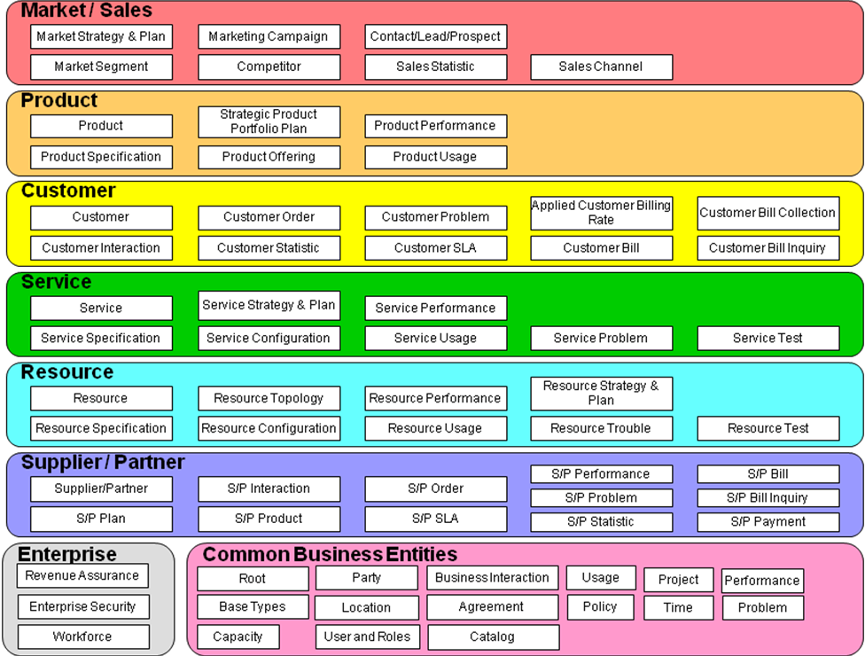
Figure Cat.00 – SID Framework Catalog Entities
The Catalog Management Guidebook describes the usage of “Catalogs” to to provide consistency of catalog model definitions across the Product, Service, and Resource domains.

Catalog Business Entities
This guidebook introduces a generic (abstract) catalog entity as a container for entity specs. All specific catalogs should be derived from that entity. This catalog entity defines the common attribute and generic associations applicable for any derived catalogs. The patterns proposed for new Catalog entity definition is EntitySpecification/Entity and CharacteristicSpecification/CharacteristicValue patterns and embraces the existing entity of ‘Product Catalog ABE’ definition present before this guidebook was developed.

Basic entities related to Catalog and their relationships and relationship with the existing entities are shown in the following figure Cat.01. A CatalogSpecification defines a Catalog, both defined as abstract entities. There are three business entities that inherit from catalog: ProductCatalog, ServiceCatalog and ResourceCatalog. It can be extended further to different situations like Supplier/Partner Catalog and so forth. The Characteristic entity can be used to define dynamic attributes for any Catalog.
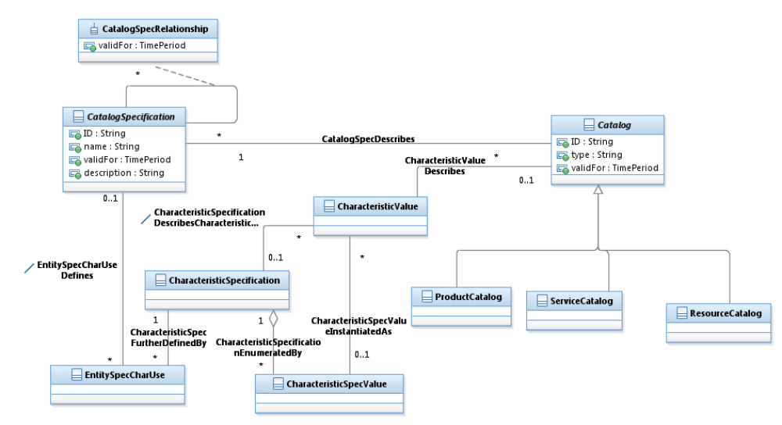
Figure Cat.01 – Catalog Definition and Basic Associations
Figure Cat.02 depicts the relationship of Catalog entities to the existing entities of information framework in the Product, Service and Resource domains. In this figure there are two more entities that are introduced through this guidebook. They are ServiceCandidate and ResourceCandidate. These two entities are defined to enable the respective specifications (ServiceSpecification and ResourceSpecification) to be available for defining respective catalogs.
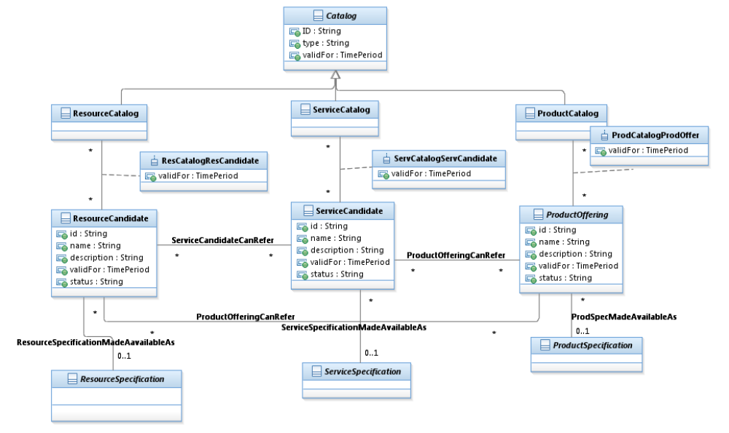

Figure Cat.02 – Catalog Entities and Associations

Product/Product Catalog
A ProductCatalog is a collection of ProductOfferings, intended for a specific DistributionChannel, enhanced with additional information such as SLA parameters, invoicing and shipping details. As described in the Products addendum document, each ProductOffering in a ProductCatalog combines pricing and availability information with ProductSpecifications that describe the relationships between Products, the Services used to realize the Products, and the Resources they require.
A service provider may choose to present its ProductOfferings to multiple audiences through multiple channels. Therefore, although the collection of all available ProductOfferings may be considered “the” ProductCatalog, the information model should support the definition and differentiation of multiple ProductCatalogs, containing possibly overlapping subsets of the ProductOffering universe. This support is provided by the use of the EntitySpecification/Entity pattern used elsewhere in the SID.

Product Catalog and Product Catalog Specification
A ProductOffering may be “published” – made visible – in any number of ProductCatalogs, or in none. The most important association in the Product Catalog ABE is the publication of a ProductOffering in a ProductCatalog. Attributes affecting that association, such as the time period during which a ProductOffering is valid in a particular ProductCatalog, are contained in the association class ProdCatalogProdOffer.
The ProductCatalog itself may have attributes that define its identity or existence, such as type (String) and validFor (TimePeriod). But most of the variant data related to a ProductCatalog is controlled by the ProductCatalogSpecification entity.
Key associations with entities developed earlier in this document include a ProductCatalog’s availability through a SalesChannel, and the publication of a ProductCatalog in a GeographicArea. The availability of a ProductCatalog through a specific SalesChannel implies that each ProductOfferingPrice that values a ProductOffering appearing in that ProductCatalog must also be made available through the same SalesChannel. In turn, each ProductOfferingPrice may be advertised in any number of ProdCatalogProdOffers.
The association class ProdCatalogProdOffer may contain additional information regarding, such as the location of an offering in a catalog.
These basic entities are shown in Figure Cat.03.

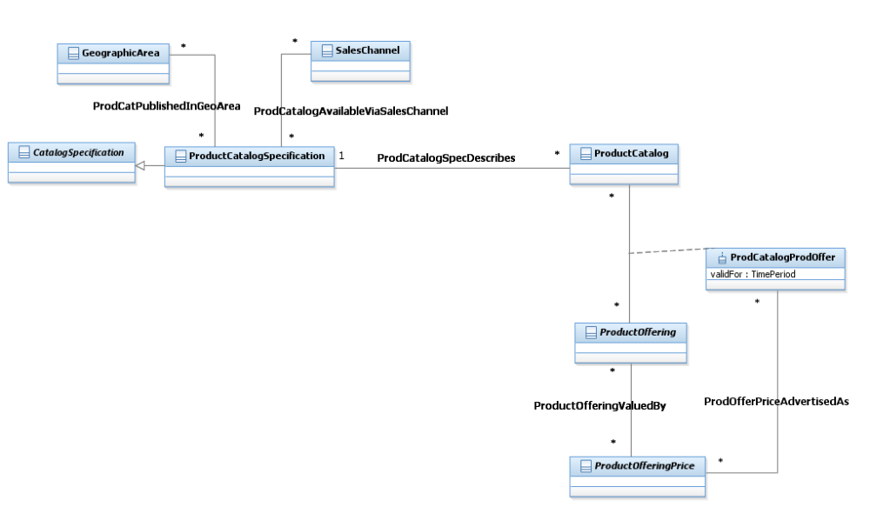
Figure Cat.03 – Product Catalog Definition and Basic Relationships

Service Catalog
A service catalog is a group of ServiceSpecifications made available through ServiceCandidates that an organization provides to the consumers (internal consumers like its employees or B2B customers or B2C customers). A service catalog typically includes name, description and time period that is valid for. It will have a list of ServiceCandidates. A ServiceCandidate is an entity that makes a ServiceSpecification available to a catalog. A ServiceCandidate and its associated ServiceSpecification may be “published” – made visible – in any number of ServiceCatalogs, or in none. One ServiceSpecification can be composed of other ServiceSpecifications. These ServiceSpecifications may also be published. Attributes affecting that association, such as the time period during which a ServiceCandidate is valid in a particular ServiceCatalog, are contained in the association class ServCatalogServCandidate. These basic entities are shown in Figure Cat.04.

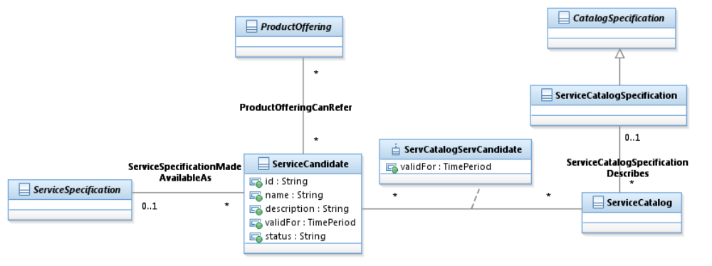

Figure Cat.04 – Service Catalog Entities and Associations

Resource Catalog

A ResourceCatalog is a list of ResourceSpecifications made available through ResourceCandidates that an organization will provide it to its consumers (internal or external). Not all ResourceCandidates are made available to a consumer. A ResourceCatalog typically includes name, description and time period that it is valid for. It will have a list of ResourceCandidates. A ResourceCandidate is an entity that enables the ResourceSpecifications to a catalog. A ResourceCandidate and its ResourceSpecification may be “published” – made visible – in any number of ResourceCatalogs, or in none. One ResourceSpecification can be composed of other ResourceSpecifications. These ResourceSpecifications may also be published. Attributes affecting that association, such as the time period during which a ResourceCandidate is valid in a particular ResourceCatalog, are contained in the association class ResCatalogResCandidate. These basic entities are shown in Figure Cat.05.

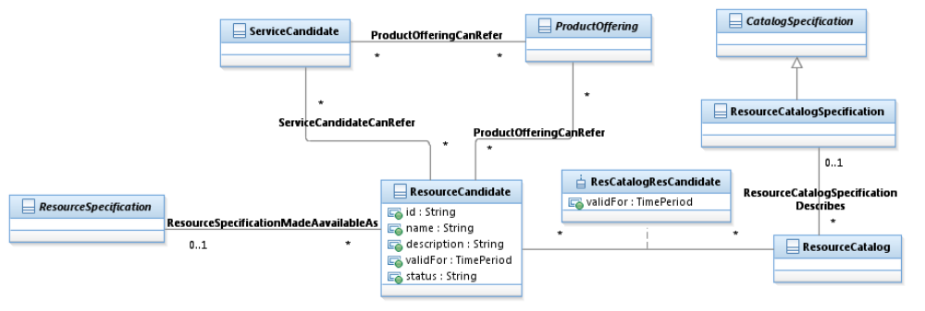
Figure Cat.05 – Resource Catalog Entities and Associations

Related Entities
Several additional entities complete the Product Catalog. A DistributionChannel is responsible for providing ProductOfferings in a specific GeographicArea. Each ProductOffering is managed under a ProductOfferingStrategy that supports any number of MarketingCampaigns. MarketingCampaigns are run through SalesChannels, and use ProductCatalogs selected by ProductCatalogSpecification. These entities are shown in Figure Cat.06.

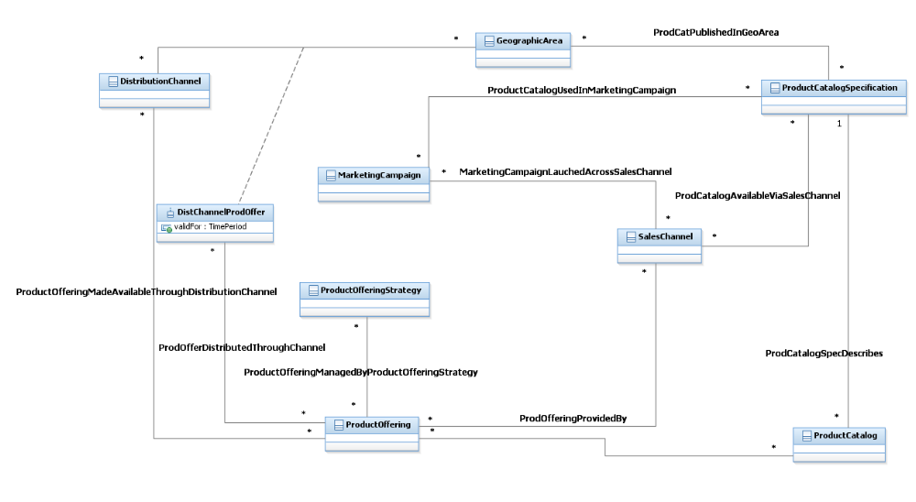
Figure Cat.06 – Product Catalog Entities and Associations

Business Entity Definitions – Catalog

CatalogSpecification

Business Entity Definition
Business Entity Name | CatalogSpecification
Description | A CatalogSpecification defines attributes shared by all instances of related Catalogs.
Sources |  | Cross- References |  |  | Synonyms / Aliases
Related Business Entities
Business Rules

Business Entity Attributes Definition
Business Entity Name | CatalogSpecification
Attribute Name | Description | Data Type | Characteristics, Permitted Values & Units | Required/  Optional | Notes
ID | A unique identifier for the CatalogSpecification. | String |  | Required
name | A word, term, or phrase by which the CatalogSpecification is known and distinguished from other CatalogSpecification. | String |  | Required
description | A narrative that explains the CatalogSpecification. | String |  | Optional
validFor | The period of time for which a CatalogSpecification is applicable. | Time Period |  | Optional

CatalogSpecRelationship

Business Entity Definition
Business Entity Name | CatalogSpecRelationship
Description | A CatalogSpecification can be associated or related to another CatalogSpecification. This relationship entity is defined for this purpose.
Sources |  | Cross- References |  |  | Synonyms / Aliases
Related Business Entities
Business Rules

Business Entity Attributes Definition
Business Entity Name | CatalogSpecRelationship
Attribute Name | Description | Data Type | Characteristics, Permitted Values & Units | Required/  Optional | Notes
validFor | The period of time for which a value is applicable. | Time Period |  | Optional

Catalog

Business Entity Definition
Business Entity Name | Catalog
Description | A catalog can be defined as a collation of items and arranging them in a particular manner based on the need. In the information framework point, it is as collection of entities.  This entity is proposed as an abstract entity. This is to have sub classes derived out of this entity to synch up with the real world examples of product catalog, service catalog etc. The catalog presentation can be in book form or web form.
Sources |  | Cross- References |  |  | Synonyms / Aliases
Related Business Entities
Business Rules

Business Entity Attributes Definition
Business Entity Name | Catalog
Attribute Name | Description | Data Type | Characteristics, Permitted Values & Units | Required/  Optional | Notes
ID | A unique identifier for the Catalog. | String |  | Required
name | A word, term, or phrase by which the Catalog is known and distinguished from other Catalogs. | String |  | Required
type | A categorization of an entry in the catalog, such as web, book | String |  | Optional
validFor | The period of time for which a Catalog is applicable. | Time Period |  | Required

ProductCatalog

Business Entity Definition
Business Entity Name | ProductCatalog
Description | A list of ProductOfferings for sale, with prices and illustrations, for example in book form or on the web. ProductCatalogs can be used by Customers during a self-care ordering process and may be used across one or more DistributionChannels.
Sources |  | Cross- References |  |  | Synonyms / Aliases
Related Business Entities | presents ProductOffering  offeredVia DistributionChannel
Business Rules

ProductCatalogSpecification

Business Entity Definition
Business Entity Name | ProductCatalogSpecification
Description | A ProductCatalogSpecification defines the invariant characteristics of a ProductCatalog.
Sources |  | Cross- References |  |  | Synonyms / Aliases
Related Business Entities | GeographicArea, MarketingCampaign, SalesChannel and ProductCatalog
Business Rules

ProdCatalogProdOffer

Business Entity Definition
Business Entity Name | ProdCatalogProdOffer
Description | The appearance of a ProductOffering in a ProductCatalog.
Sources |  | Cross- References |  |  | Synonyms / Aliases
Related Business Entities | ProdCatalogProdOffer:  PublicationOf ProductOffering in ProductCatalog
Business Rules

Business Entity Attributes Definition
Business Entity Name | ProductCatalogProdOffer
Attribute Name | Description | Data Type | Characteristics, Permitted Values & Units | Required/  Optional | Notes
validFor | The period of time for which a value is applicable. | Time Period |  | Optional

ServiceCatalog

Business Entity Definition
Business Entity Name | ServiceCatalog
Description | A ServiceCatalog is a collection of ServiceCandidates representing ServiceSpecifications. ServiceCandidates define the underlying services that support a ProductOffering. ServiceCandidates are exposed to one or more Product Catalogs to be utilized to configure one or more ProductOfferings. ServiceCandidates can be exposed to one or more Service Catalogs to be utilized or incorporated in one or more ServiceCandidates. A collection may consist of similar ServiceCandidates, such as a collection of broadband ServiceCatalogCandidates or a collection of wireless ServiceCatalogCandidates. A Service Catalog contents can expose a collection of ServiceCandidates to be utilized internal/external to an enterprise.
Sources |  | Cross- References |  |  | Synonyms / Aliases
Related Business Entities
Business Rules

ServiceCatalogSpecification

Business Entity Definition
Business Entity Name | ServiceCatalogSpecification
Description | A ServiceCatalogSpecification defines the invariant characteristics of a ServiceCatalog.
Sources |  | Cross- References |  |  | Synonyms / Aliases
Related Business Entities
Business Rules

ResourceCatalog

Business Entity Definition
Business Entity Name | ResourceCatalog
Description | A ResourceCatalog is a collection of ResourceCandidates representing ResourceSpecifications. ResourceCandidates define the underlying resources. ResourceCandidates can be exposed to one or more ResourceCatalogs to be utilized to configure or incorporated in one or more ServiceCandidates or ProductOfferings. A ResourceCatalog contents can expose a collection of ResourceCandidates to be utilized internal/external to an enterprise.
Sources |  | Cross- References |  |  | Synonyms / Aliases
Related Business Entities
Business Rules

ResourceCatalogSpecification

Business Entity Definition
Business Entity Name | ResourceCatalogSpecification
Description | A ResourceCatalogSpecification defines the invariant characteristics of a ResourceCatalog.
Sources |  | Cross- References |  |  | Synonyms / Aliases
Related Business Entities
Business Rules

ServiceCandidate

Business Entity Definition
Business Entity Name | ServiceCandidate
Description | A ServiceCandidate is an entity that makes a ServiceSpecification available to a catalog. A ServiceCandidate and its associated ServiceSpecification may be “published” – made visible – in any number of ServiceCatalogs, or in none. One ServiceSpecification can be composed of other ServiceSpecifications. These ServiceSpecifications may also be published.
Sources |  | Cross- References |  |  | Synonyms / Aliases
Related Business Entities
Business Rules

Business Entity Attributes Definition
Business Entity Name | ServiceCandidate
Attribute Name | Description | Data Type | Characteristics, Permitted Values & Units | Required/  Optional | Notes
ID | A unique identifier for the ServiceCandidate. | String |  | Required
name | A word, term, or phrase by which the ServiceCandidate is known and distinguished from other ServiceCandidate. | String |  | Required
description | A narrative that explains the ServiceCandidate. | String |  | Optional
validFor | The period of time for which a ServiceCandidate is applicable. | Time Period |  | Required
status | The condition in which the ResourceCandidate exists such as Planned, Active or Obsolete. | String |  | Required

ResourceCandidate

Business Entity Definition
Business Entity Name | ResourceCandidate
Description | A ResourceCandidate is an entity that enables the ResourceSpecifications to a catalog. A ResourceCandidate and its ResourceSpecification may be “published” – made visible – in any number of ResourceCatalogs, or in none. One ResourceSpecification can be composed of other ResourceSpecifications.
Sources |  | Cross- References |  |  | Synonyms / Aliases
Related Business Entities
Business Rules

Business Entity Attributes Definition
Business Entity Name | ResourceCandidate
Attribute Name | Description | Data Type | Characteristics, Permitted Values & Units | Required/  Optional | Notes
ID | A unique identifier for the ResourceCandidate. | String |  | Required
name | A word, term, or phrase by which the ResourceCandidate is known and distinguished from other ResourceCandidate. | String |  | Required
description | A narrative that explains the ResourceCandidate. | String |  | Optional
validFor | The period of time for which a ResourceCandidate is applicable. | Time Period |  | Required
Status | The condition in which the ServiceCandidate exists such as Planned, Active or Obsolete. | String |  | Required

ServCatalogServCandidate

Business Entity Definition
Business Entity Name | ServCatalogServCandidate
Description | The appearance of a ServiceCandidate in a ServiceCatalog.
Sources |  | Cross- References |  |  | Synonyms / Aliases
Related Business Entities
Business Rules

Business Entity Attributes Definition
Business Entity Name | ServCatalogServCandidate
Attribute Name | Description | Data Type | Characteristics, Permitted Values & Units | Required/  Optional | Notes
validFor | The period of time for which a value is applicable. | Time Period |  | Optional

ResCatalogResCandidate

Business Entity Definition
Business Entity Name | ResCatalogResCandidate
Description | The appearance of a ResourceCandidate in a ResourceCatalog.
Sources |  | Cross- References |  |  | Synonyms / Aliases
Related Business Entities
Business Rules

Business Entity Attributes Definition
Business Entity Name | ResCatalogResCandidate
Attribute Name | Description | Data Type | Characteristics, Permitted Values & Units | Required/  Optional | Notes
validFor | The period of time for which a value is applicable. | Time Period |  | Optional

2 Administrative Appendix
This Appendix provides additional background material about this document.

Document Life Cycle
The Catalog Business Entities is being issued as member contribution version 1.1.
This document will continue under formal change control. Supporting work will be issued as companions to this document. A document of this type is a “living document,” capturing and communicating current knowledge and practices.

Document History
Version Number | Date Modified | Modified by: | Description of changes
0.1 | 14/08/2012 | Raj Ravi | first issue of TM Forum contribution
0.2 | 28/09/2012 | Raj Ravi, John Reilly and Elaine Haher | Consolidation of the definitions and documentation
0.5 | 28/09/2012 | Catalog Management project team | Final edits of definitions
1.0 | 02/10/2012 | Raj Ravi | Added the generalization association between CatalogSpecification to ProductCatlaogSpecification (Cat 04), ResrouceCatalogSpecification (Cat05) & ServiceCatalogSpecification (Cat06).  Removed the ‘type’ attribute that was present in the earlier version in CatalogSpecRelationship  Added the entity definition for CatalogSpecRelationship(Section 1.6.2).  Removed the attribute list from the ProductCatalog definition in the entity definition (Section 1.6.3.2 in the previous version.)  Updated the ‘Company Contact Details’ section with the team list and also removed the email and phone contact details.  Added the ProductCatalogSpecification, ResourceCatalogSpecification and ServiceCatalogSpecification entities in the entity definitions section.
1.1 | 25/10/2012 | Alicja Kawecki | Minor formatting/cosmetic corrections prior to web posting and Member Evaluation

Company Contact Details
Company | Team Member Representative
Syntologica | Name: John Wilmes  Title: Subject Matter Expert
TM Forum | Name: John Reilly  Title: Subject Matter Expert
Ericsson | Name: Elaine Haher
Infosys | Name: Raja Sekhar Ravi
SquarHoop | Name: Mark Watson
Cisco | Name: Greg Scullard

Acknowledgments
This document was prepared by the members of the TM Forum Catalog Management team.

- Elaine Haher, Ericsson - Team Leader and Contributor
- Raja Sekhar Ravi, Infosys Ltd. – Editor and Contributor
- Mark Watson, SquareHoop - Contributor
- John Wilmes, Progress Software – Contributor and Reviewer
- John Reilly, TM Forum – Contributor and Reviewer
- Greg Scullard, Cisco - Contributor

