Information Framework (SID)
Usage Business Entity Definitions

GB922 Addendum 1 Usage
TM Forum Approved Version 9.4


September, 2011

Notice
This material, including documents, code and models, has been through review cycles; however, due to the inherent complexity in the design and implementation of software and systems, no liability is accepted for any errors or omissions or for consequences of any use made of this material.
Under no circumstances will the TM Forum be liable for direct or indirect damages or any costs or losses resulting from the use of this specification. The risk of designing and implementing products in accordance with this specification is borne solely by the user of this specification.
This material bears the copyright of TM Forum and its use by members and non-members of TM Forum is governed by all of the terms and conditions of the Intellectual Property Rights Policy of the TM Forum (http://www.tmforum.org/Bylaws/1094/home.html) and may involve a claim of patent rights by one or more TM Forum members or by non-members of TM Forum.

Direct inquiries to the TM Forum office:
240 Headquarters Plaza,
East Tower – 10th Floor,
Morristown, NJ 07960 USA
Tel No. +1 973 944 5100
Fax No. +1 973 944 5110
TM Forum Web Page: www.tmforum.org

Table of Contents
Notice 2
Table of Contents 3
List of Figures 5
1. Chapter Usage 6
1.1. Introduction 6
1.2. The Usage Information Model 6
1.2.1. Usage Modeling Alternatives 6
1.2.2. Resource and Service Usage 12
1.2.3. Product Usage 14
1.3. Implementing Resource, Service and Product Usage 17
1.4. Implementation option 19
2. Chapter 2- Internet Protocol Detail Record (IPDR) to SID Mapping 20
2.1. Introduction 20
2.1.1. Purpose and Scope 20
2.1.2. Out of scope 21
2.1.3. Terminology 21
2.1.4. Clarification 21
2.1.5. Other relevant documents 21
2.1.6. IPDR Base Model 22
2.1.7. IPDR/SP 22
2.2. First approach 22
2.2.1. IPDRDoc 22
2.2.2. Mapping IPDR base model to SID 25
2.2.3. Mapping IPDR/SP model to SID 28
2.3. Second approach 29
2.4. Summary 31
2.4.1. Modeling Approaches Advantages and Disadvantages 31
2.4.2. Conclusions 31
2.5. Business Entity Definitions – Product Usage 32
2.5.1. AtomicProductUsageSpec 32
2.5.2. CompositeProductUsageSpec 32
2.5.3. ProductBundleUsage 33
2.5.4. ProductComponentUsage 33
2.5.5. ProductUsage 34
2.5.6. ProductUsageSpec 34
2.6. Business Entity Definitions – Resource Usage 35
2.6.1. ResourceUsage 35
2.6.2. ResourceUsageSpec 35
2.7. Business Entity Definitions – Service Usage 36
2.7.1. ServiceUsage 36
2.7.2. ServiceUsageSpec 36
2.8. Business Entity Definitions – Usage 37
2.8.1. Usage 37
2.8.2. UsageCharacteristicValue 38
2.8.3. UsageCharacteristicCategory 39
2.8.4. UsageSpecCharacteristic 40
2.8.5. UsageSpecCharacteristicValue 42
2.8.6. UsageSpecification 44
2.8.7. UsageSpecVersion 45
3. Administrative Appendix 46
3.1. About this document 46
3.2. Document History 46
3.2.1. Version History 46
3.2.2. Release History 47
3.3. Company Contact Details 47
3.4. Acknowledgments 47

List of Figures
Figure U. 01 – Sub-class of Usage class 7
Figure U. 02 – Usage Specification 8
Figure U. 03 – Instance of Usage Specification 10
Figure U. 04 – Resource/Service Usage 13
Figure U. 05 – Product Usage, Part 1 15
Figure U. 06 – Product Usage, Part 2 16
Figure U. 07 – Resource/Service/Product Usage – as classes that inherited from Usage class. 17
Figure U. 08 – Resource/Service/Product Usage – as different states of the same Usage class. 19
Figure U. 09 – IPDR Base Model 24
Figure U. 10 – Mapping IPDR base model to SID 26
Figure U. 11 – Mapping between the IPDR/SP model and the SID. 28
Figure U. 12 – IPDR as a Subclass of Resource Usage 30

Chapter Usage

Introduction
Put simply, usage is how much product is used, by whom is it used, where and when is it used and circumstances under which it is used. Normally, when a usage event occurs, it is stored in a network element, for instance in a switch, router, gateway or in an application system. Resources (applications, network and computing capabilities) usually store usage data in proprietary formats that are not understood by external systems, such as billing systems. Depending on the polling strategy, a mediation engine connects to resources, collects usage data and formats them into a format that is understood by the billing system. Outputs of a mediation engine are Usage Detail Records (UDRs). Examples of UDRs are Call Detail Records (CDRs – used to describe usage details of voice call services) and Internet Protocol Detail Records (IPDRs – used to describe usage details of Internet Protocol based services). In this document we will use the Usage abstract business entity to describe any resource-, service- or product-based usage that the external system can read, update and process.

The Usage Information Model

Usage Modeling Alternatives

Alternative 1
Specific types of Usage can be either modeled as set of attributes in specific sub-class of Usage or as specific instance of UsageSpecification (including its specific set of UsageSpecCharacteristics)
For example: service usage such as voice call that is characterized by:
- originationAddress - An origination address (Who),
- destinationAddress - A destination address (Who),
- time - A time of a day the call was connected (When),
- duration - a duration of the call (When),
- callType - A call type (What),
- locations - Connection locations of the call (Where) and
- cause - A cause of event recording (Why).
This alternative can be modeled as sub-class of Usage class as shown in Figure U.01.
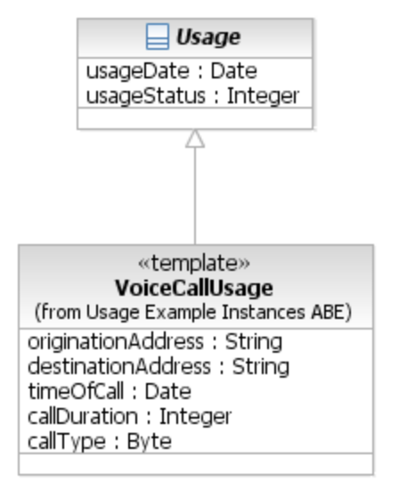
Figure U. 01 – Sub-class of Usage class

Alternative 2
Figure U.02 shows abstract business entities that are used to model usage. The model shown below is generic; 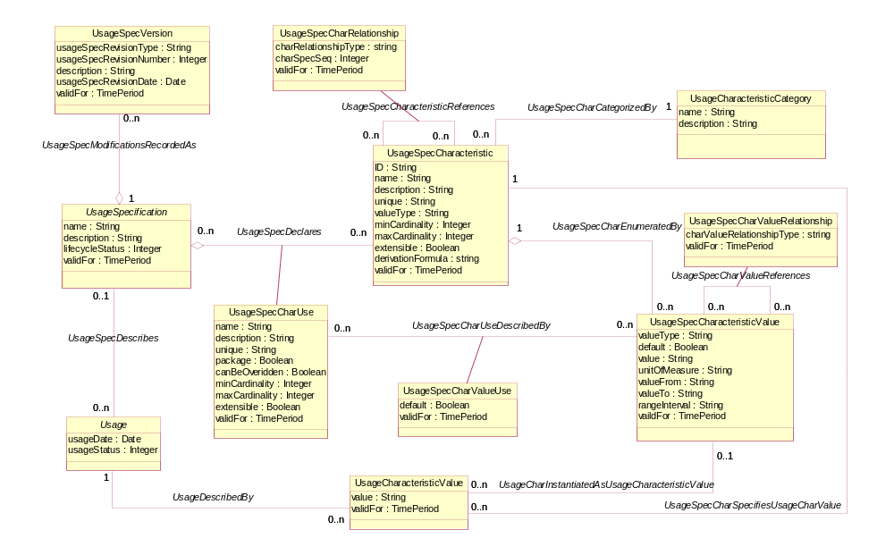
Figure U. 02 – Usage Specification
The UsageSpecification class describes a type of usage. In order to achieve a flexible structure of the UsageSpecification all its attributes are stored as characteristics. Alternatively, different types of usage could be modeled as sub-classes of the Usage entities (Usage, ProductUsage, ServiceUsage, ResourceUsage).
The UsageSpecification is comprised of UsageSpecCharacteristics that define all characteristics (attributes) known by a particular type of usage. Each characteristic is described by its name, category, presence and a set of allowed values.
- Name defines a unique name that identifies the characteristic.
- Category defines one of the high-level aspects of the usage information described by the characteristic. These categories are commonly referred to as: Who, When, What, Where, and Why.
- Min and Max cardinalities that defines whether the characteristic is required or optional.
Additional details about the Characteristic pattern can be found in GB922-1R Root Business Entities addendum.
The set of allowed values is modeled with UsageSpecCharacteristicValue. This class describes all allowed values or value ranges.
The Usage class represents a usage event. It is described by the UsageSpecification and comprised of UsageCharacteristicValues that hold data attributes of a usage specified by UsageSpecCharacteristics. The UsageCharacteristic can either store its value in the usageCharValue property or reference predefined UsageSpecCharacteristicValue.
As mentioned above there are two alternatives to model specific usage record structure:
- As sub-class of the Usage; in such case the UsageSpecification is irrelevant and the subclass definition well defines the set of required and optional characteristics including its constrains, default values, etc..
- As instance of UsageSpecification with specific set of UsageSpecCharacteristics.
A combination of the above might be used as well or as an instance of UsageSpecification as shown in Figure U.03.
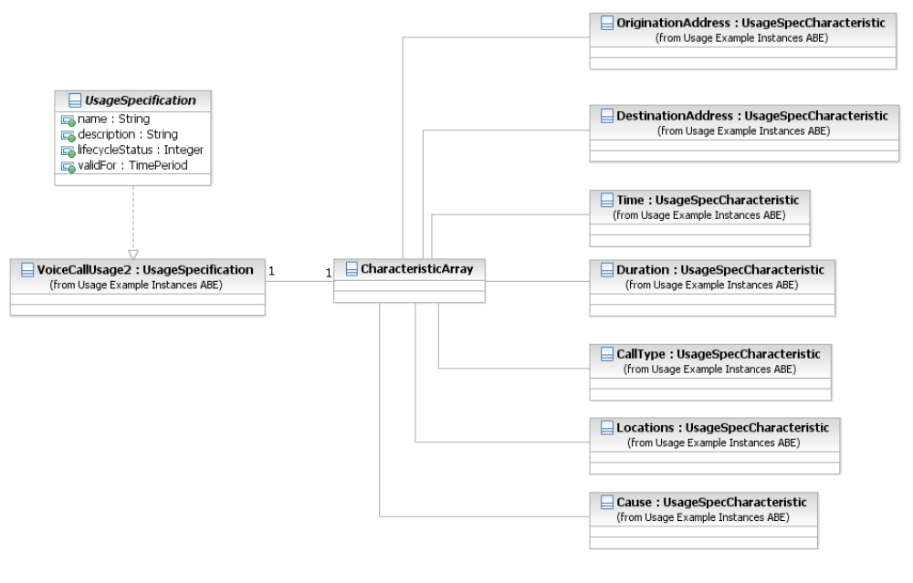
Figure U. 03 – Instance of Usage Specification
The sub-class modeling approach is considered to be strongly type approach. It enable the user/implementer to easily check and refer the Usage definition in modeling time but it is much less dynamic and each time new usage is defined or existing usage is modified the model and probably the underlying database changes. Usage definition cannot be defined in run time and parsing the Usage event becomes easy. This approach is suitable for events with fixed structure (such as standardized events) that are not likely to change in the future.
The Usage Specification approach is very dynamic and enables changing and adding Usage definition in run time. This approach is much more flexible but parsing the Usage event in run time becomes more complex. This approach is more suitable for events that change from time to time, since the change is modeled in meta data and not in classes.
Three classes were pre-identified in the SID:
- ResourceUsage
- ServiceUsage
- ProductUsage

Resource and Service Usage
A resource usage represents any usage of resources in its broadest meaning, for example a purchase or lease of a product realized by a resource. A service usage represents any usage of service in its broadest meaning, for example a purchase of a product realized/implemented by a service or a usage of a service that realizes a product. Classes that are used to model resource and service usages are subclasses of abstract usage classes as shown in the Figure U.04 The ResourceUsageSpec is a subclass of the UsageSpecification and represents a type of resource usage, while the ServiceUsageSpec represents a type of service usage. A typical source of resource or service usage is a mediation application. Other sources may be application servers and other applications (for example, an online shopping application) that are aware of the usage format and can generate usage directly without mediation.
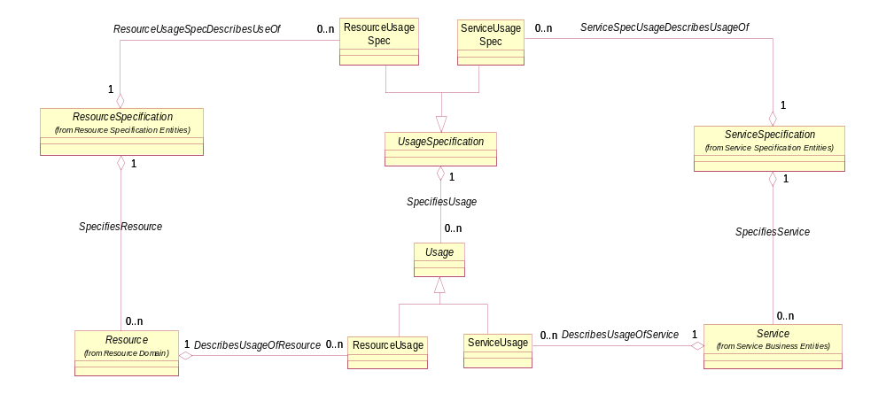
Figure U. 04 – Resource/Service Usage
An example of the ServiceUsage class is a voice call that is characterized by:
- An origination and a destination address (Who), typically complete information is available only for ProductUsage
- A time of a day the call was connected and a duration of the call (When),
- A call type and its details (What),
- Connection locations of the call (Where) and
- A cause of event recording (Why).

Product Usage
A Product is realized as one or more Service(s) and/or Resource(s). A Product is created by instantiating a ProductOffering and associating it to a specific customer and possibly a customer account, to which charges will be made. In order to charge a service (or a resource) usage, the service (or resource) has to be associated to a product.
Figure U.05 shows relationships among the ProductSpecification, the Product, the ProductUsageSpec and the ProductUsage ABEs. The ProductUsageSpec is defined for the certain ProductSpecification. As the ProductSpecification has 2 subclasses (the AtomicProductSpecification and the CompositeProductSpecification), the ProductUsageSpec needs 2 subclasses as well: the AtomicProductUsageSpec and the CompositeProductUsageSpec (associated with the AtomicProductSpecification and the CompositeProductSpecification entities respectively).
The ProductUsage describes the usage of an instantiated Product. The Product ABE is extended with the ProductComponent and the ProductBundle business entities. Consequently, the ProductUsage is extended with ProductComponentUsage and the ProductBundleUsage business entities (that are associated with the ProductComponent and the ProductBundle respectively).
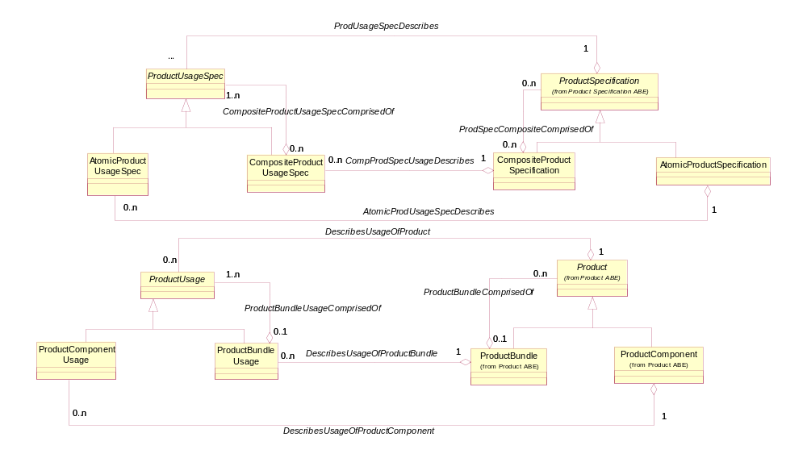
Figure U. 05 – Product Usage, Part 1
As mentioned above, a product is realized as one or more services and/or resources. Consequently, the ProductUsageSpec business entity has to be associated with the ResourceUsageSpec and the ServiceUsageSpec business entities. The ProductUsage, the ServiceUsage and the ResourceUsage business entities have to reflect these associations as well. The ProductComponentUsage can be associated with either ServiceUsage or ResourceUsage and included in a ProductBundleUsage. These entities and associations are shown on the Figure U.06.

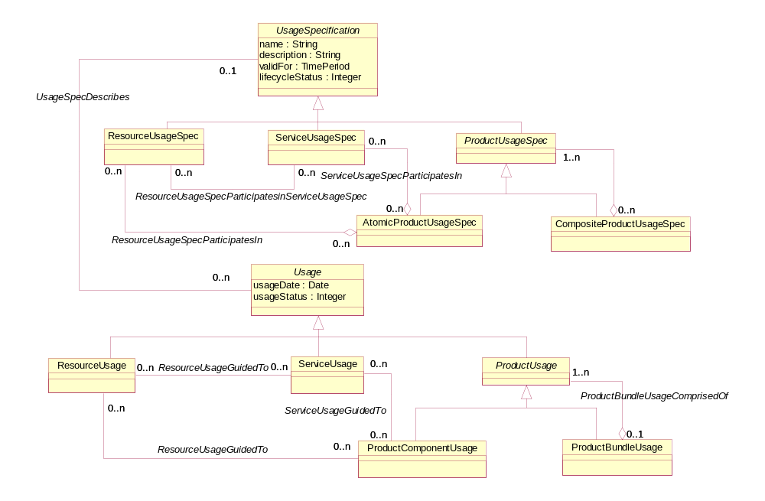
Figure U. 06 – Product Usage, Part 2

Implementing Resource, Service and Product Usage
A resource usage represents any usage of resources in its broadest meaning, for example a usage of a product realized by a resource.
A service usage represents any usage of service in its broadest meaning, for example or a usage of a service that realizes a product.
A Product is realized as one or more Service(s) and/or Resource(s). A Product is created by instantiating a ProductOffering and adding it to a specific customer account. In order to charge a service (or a resource) usage, the service (or resource) has to be associated to a product.
The product usage describes the usage of an instantiated Product.
Theoretically there are many different ways to model resource, service and product usage. For example:
- As classes that inherited from Usage class.
- As different states of the same Usage class.
Figure U.07 describes the first approach where ResourceUsage, ServiceUsage and ProductUsage usage abstract templates inherited from Usage class.
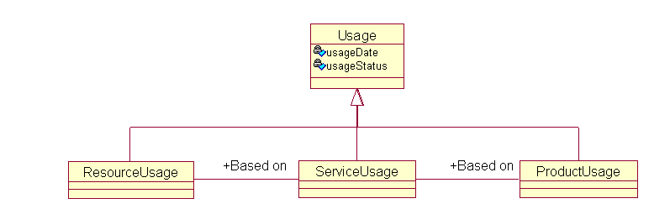
Figure U. 07 – Resource/Service/Product Usage – as classes that inherited from Usage class.
Figure U.08 describes the model that resource, service and product usage as state of the same ContextUsage class.

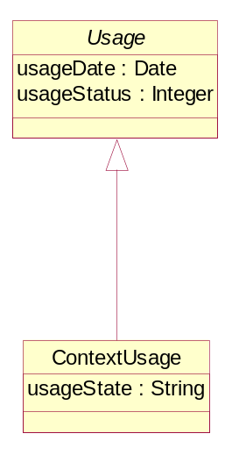
Figure U. 08 – Resource/Service/Product Usage – as different states of the same Usage class.
The usageState attribute can take on one of the values "resource usage", "service usage" or "product usage".
Usage could be still modeled in one of the two approaches described in the Modeling Alternatives subchapter that located inside the "The Usage Information Model" subchapter.

Implementation option
In practice there is one usage entity that changes its state according to its progress in the rating process (resource usage guided to service usage that eventually guided to product usage). Actually in most cases it starts its life as service usage (such as voice call CDR which already has the phone number in the record so there it is created in the state of service (phone line) usage) and moves to become in product usage state after guiding to customer and subscriber.
The Resource, Service and Product usage can be implemented in many ways. It could be implemented as-is (each of the entities inherit directly from Usage class and with no real association to the other entity) but this means quite a bit of extra data. But it also can be implemented in many other ways.
Most rating systems implement this usage state transition by simply adding new set of characteristics along the guiding process. For example a VoIP service usage (usage record in "service state") might contains the call initiator, the call target and the fact that the service is VoIP (as well as other service characteristics) The guiding process will change the usage record state to be "product state" and simply will add the user information characteristics to this usage record.

Chapter 2- Internet Protocol Detail Record (IPDR) to SID Mapping

Introduction
One of the main purposes of the SID is to act as the telecommunication world map and used as the universal language for developer and operators.
The SID describes the telecommunication information model. It includes the different components and the relation between them.
In the industry there are existing OSS and BSS implementations for the telecommunication as well as different standards that are based on different telecommunication data models.
The SID developed in order to improve the communication and enable better understanding of requirements in one hand and better understating of the different solutions on the other hand.
Mapping each of the existing data models to one agreed information model (i.e. the SID) will enable seamless integration between different OSS and BSS products and solutions and will save a lot of time and money.
The IPDR.org, now part of the TM Forum, is an open consortium of leading service providers, equipment vendors, system integrators, and billing and mediation vendors collaborating to facilitate the exchange of usage and control data between network and hosting elements and operations and business support systems by deployment of IPDR standards.
Among other things it defines the usage records or in other words the fields that should be present in Internet Protocol Detail Record (IPDR) document for each class of service (Service Specifications). The formal definition language for Service Specifications is XML Schema. Additional standards under development to address by IPDR.org are provisioning and settlement of next-generation data services.
Mapping the IP Detail Records to the SID will leverage the SID as the universal telecommunication map in one hand and will enable seamless adoption of the IPDR.org products and artifacts by the industry.

Purpose and Scope
The purpose of this chapter is to present mapping between the IPDR.org data model to the SID. The scope includes mapping of all the entities modeled by IPDR.org into the SID. It includes the way to map the IPDR Service Specifications, and mapping of the relevant IPDR Streaming Protocol (IPDR/SP) data model.

Out of scope
It was agreed that IPDR documents (IPDRDocs) are more of an implementation artifact, while the SID is focused on an information model (logical) therefore IPDRDocs is not modeled in the SID and out of the scope of this document.
It was also agreed that although Supplier/Partner Settlements (S/PS) supposed to be modeled in the SID, it will be out of the scope in the first stage and the mapping between the S/PS data model in the IPDR.org and the SID will be done later in one of the next versions of this document.

Terminology
- IPDR Service Specification – a document that is intended to specify the business use case and formal XML Schema for specific service such as VoIP, DOCSIS, etc. In this document the "IPDR Service Specification" can be treat to an xsd schema or even just to the relevant business record type definition in the xsd file (for example: IPDR-VoIP-Type, IPDR-SM-Type, etc.).
- SID UsageSpcification – a formal description to describe what is defining the Usage Meta Data. Instance of service specification is the Meta data for specific Usage record.

Clarification
There are at least two approaches that can be used to model IPDRs.
As we agreed in the IPDR-SID sub team, we are going to present two modeling approaches.

Other relevant documents
- Shared Information/Data (SID) Model; Addendum 2 Customer Business Entity Definitions (Release 7.0)
- IPDR Service Specification Design Guide Version 3.5.1
  - IPDRType.xsd
  - IPDRDoc3.5.1.xsd
- All the IPDR Service Specification files and the relevant xsd files.
  - Service Specification – Public WLAN Access Version 3.5-A.0.1
    - PublicWLANAccess3.5-A.0.1.xsd
- IPDR/SP Protocol Specification Version 2.1 (Future versions of this document will map to more advanced versions of IPDR and IPDR/SP)

IPDR Base Model
Note: The "IPDR base model" data model is derived from the IPDR Service Specification Design Guide Version 3.5.1 and the set of IPDR Service Specifications.

IPDR/SP
The IPDR/SP specification provides an advanced streaming protocol for detail records and especially accounting information exchange. It delivers a compelling solution to the technical and business challenges faced by the next-generation equipment and server vendors.
One of the key design requirements was achieving reliability while optimizing network element resources, network bandwidth, and collection system resources.
The protocol achieves these efficiencies by controlling or limiting the exported network data to only that which is requested by the collection system. Other characteristics of IPDR/SP include: interoperability across multiple vendors, versions and record structure through the use of protocol negotiation features; flexible record structures, supporting vendor specific extensions and a wide variety of services; support for a wide range of billing models; and back-end compatibility for a wide variety of OSS/BSS functions.
IPDR/SP leverage the IPDR base model and use IPDR Service Specification as reference in its Template definitions.
The IPDR/SP enable negotiate the usage records template. In order to do it, IPDR/SP modeled the usage Meta data (and not just the usage record itself).
Note: The IPDR/SP data model is derived from the IPDR/SP IDL message definitions.

First approach

IPDRDoc
The IPDRDoc is the detail records container. It includes reference to zero or more IPDRType instances (the reference name is IPDR) and reference to some conclude-record (IPDRDocEnd). We consider the IPDRDoc and its conclude-records as implementation artifacts. Figure U.09 presents the IPDR base model.
IPDRType is an abstract representation of usage record. The most basic abstract representation of usage record in IPDR model has optional reference to two attributes (creation time and sequence number that presented by IPDRCreationTim and seqNum classes accordingly).
The IPDR base model defines set of simple types in addition to the primitive types defined by the schema (dateTimeMsec, dateTimeUsec, ipV4Addr, ipV6Addr, UUID, macAddress).
Figure U.09 describes the IPDR base model.
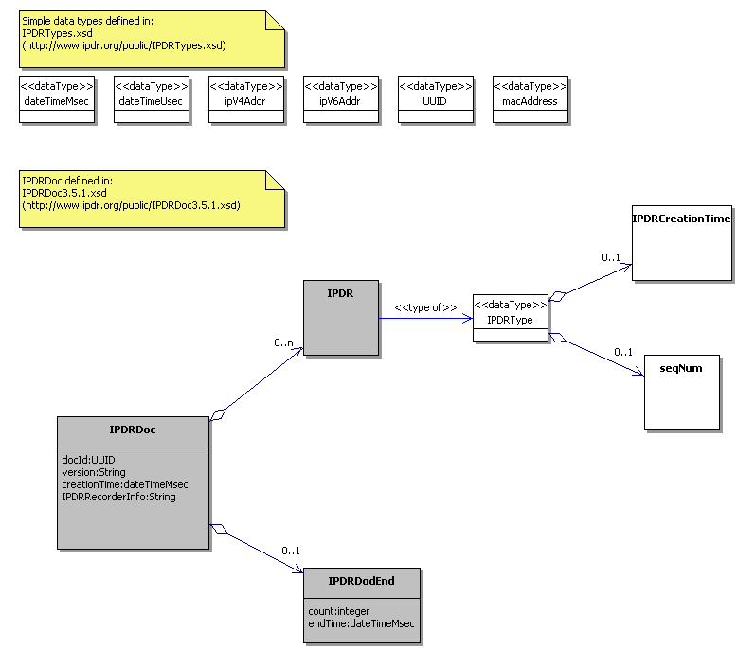
Legend
In scope
Out of scope

Figure U. 09 – IPDR Base Model
Items which are out of the scope of this document (such as IPDRDoc, IPDRDocEnd and IPDR) will be added to the SID as a special IPDR blade in another document.

Mapping IPDR base model to SID
Figure U.10 describes the mapping between the IPDR base model and the SID.
The anchor for all record definitions in the IPDR base model is the IPDRType. In other words, all records definitions must be extensions of the IPDRType and instance of IPDRType (or one of its derived classes) is usage record. Usage class has exactly the same role in the SID. So IPDRType in the IPDR maps to the Usage class in the SID.
In the SID there are three predefined Usage records (Resource Usage, Service Usage and Product Usage abstract records) but as information model it does not define any specific resource usage, service usage or product usage. The IPDR model does not define any layer between the IPDRType and each specific IPDR Service Specification.
The IPDR Service Specifications that are defined and standardized up to the time this document is written, can all be considered as Service Usage.
The instance of UsageSpecCharacteristic class in the SID presents a Usage's attribute. Exactly the same role holds by the elements referred by IPDRType definition or its inherited classes definitions. For example seqNum in the IPDRType or VoIP:callProgressState in the IPDR-VoIP-Type are attributes in the proper IPDR Service Specification.
As a rule: each element referred by IPDRType definition or its inherited classes definitions in the IPDR model is mapped to specific instance UsageSpecCharacteristic in the SID.
The UsageSpecCharacteristicValue in the SID is responsible for specifying constrains and default value for each specific UsageCharacteristicValue.
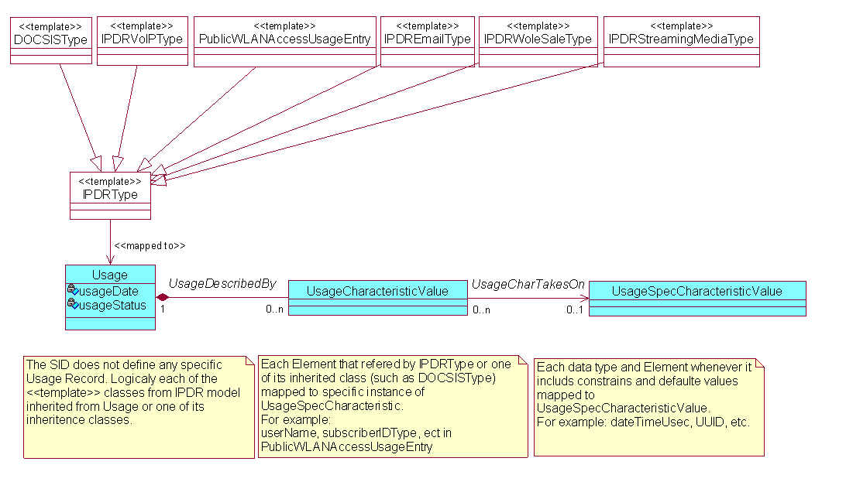
Figure U. 10 – Mapping IPDR base model to SID

In the IPDR model there is no clear separation between the attribute definition and its behavior definition (default values and constrains). An attribute in the IPDR model is first defined with its behavior definition values and then can be used by referring to it in specific IPDR Service Specification definition.
As a rule: each data type and Element whenever it includes constrains and default values mapped logically to UsageSpecCharacteristicValue.
Note: SID UsageSpecification and IPDR Service Specification cannot be mapped to each other. Instance of SID UsageSpecification and the IPDR Service Specification itself can be logically mapped to each other.
An instance of SID UsageSpecification defines the usage Meta data. Realization of usage Meta data is the usage record itself.
IPDR Service Specification itself is the usage metadata and instance of it is usage record.

Mapping IPDR/SP model to SID
Figure U.11 describes the mapping between the IPDR/SP model and the SID.
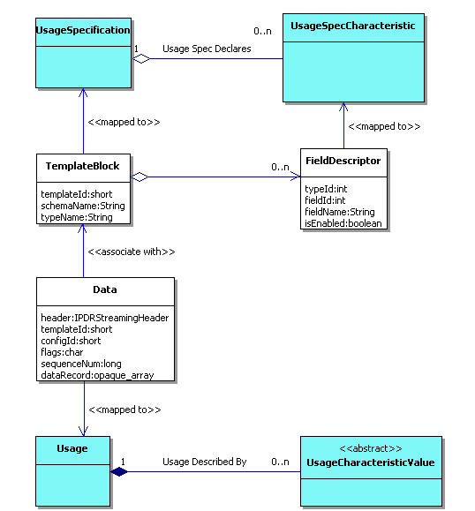
Figure U. 11 – Mapping between the IPDR/SP model and the SID.

The Template Block class in the IPDR/SP defines the usage Meta data, it has identification (templateId) and it associates with IPDR Service Specification (schemaName, typeName). The Meta data itself is defined by list of field descriptors (FieldDescriptor) that defines the name and the type of the field.
An instance of Template Block is the usage meta-data and the SID UsageSpecification has exactly the same role. It also appears that the FieldDescriptor has exactly the same role like the UsageSpecCharacteristic. The Template Block in the IPDR/SP is mapped to the SID UsageSpecification and The FieldDescriptor in the IPDR/SP is mapped to the UsageSpecCharacteristic in the SID. The Data entity in the IPDR/SP model is mainly consists of identification (seqNum), association with its template (templateId - instance of TemplateBlock has an id) and the Data entity. The data itself is just an opaque array. It can be decoded using the instance of TemplateBlock it associate with (its meta-data). The objective of the Data class is to hold the usage data. The Usage entity has the same role and Data attributes n the IPDR/SP which is shown mapped to the SID Usage entity..

Second approach
The second approach represents a modification of the current SID Usage model with the introduction of several relationships not currently modeled and explicit modeling of IPDR attributes not supported by the modified Usage model. The resultant model is shown in Figure U.12 using the IPDR WAN Usage detail record as an example. Each IPDR would be modeled explicitly as a subclass of the ResourceUsage entity.
Note: If this option is chosen then each new type of usage needs to be explicitly modeled, resulting in an unstable model. It is not the preferred option. The preferred option is shown figure U.10 and U.11.

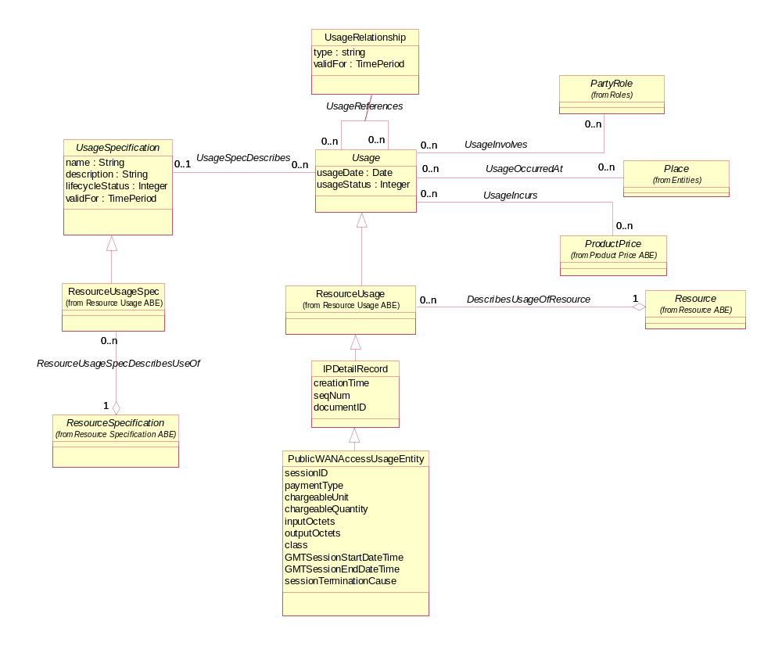
Figure U. 12 – IPDR as a Subclass of Resource Usage

Summary

Modeling Approaches Advantages and Disadvantages
Each modeling approach presented in this addendum has its own advantages and disadvantages as shown in the table below.
Modeling Approach | Advantage | Disadvantage
UsageCharacteristics | Dynamically extensible with no need to change model and possible database changes when introducing new types of usage | Hides attributes as instances of entities
 | May reduce the impact of other changes to an application, such as user interface changes | Represents a meta-modeling approach that is more complex than explicit sub-classing
Explicit Subclasses | Explicitly shows types of usage | Requires model and possible database changes when introducing new types of usage
 | Less complex than a characteristic-based model | May require other application changes resulting from the introduction of new usage subclasses

Conclusions
The choice of the appropriate modeling approach is at the discretion of the SID implementer. One approach would be to explicitly model existing IPDRs that are stable and least likely to change. As new IPDRs are added the characteristic specification approach can be used to reduce the implementation time. These could then be explicitly modeled once the IPDR matures and stabilizes.

Business Entity Definitions – Product Usage

AtomicProductUsageSpec

Business Entity Definition
Business Entity Name | AtomicProductUsageSpec
Description | A detailed description of the usage of a product, described by AtomicProductSpecification.
Sources |  | Cross- References |  |  | Synonyms / Aliases
Related Business Entities | ResourseUsageSpec, ServiceUsageSpec, AtomicProductSpecification
Business Rules

CompositeProductUsageSpec

Business Entity Definition
Business Entity Name | CompositeProductUsageSpec
Description | A detailed description of the usage of a Product, specified by CompositeProductSpecification. It is formed by aggregating other ProductUsageSpec(s), which may be either Composite or Atomic ProductUsageSpec(s).
Sources |  | Cross- References |  |  | Synonyms / Aliases
Related Business Entities | ProductUsageSpec, CompositeProductSpecification
Business Rules

ProductBundleUsage

Business Entity Definition
Business Entity Name | ProductBundleUsage
Description | A detailed product bundle usage event, It is comprised of other ProductUsage(s), that may be either ProductBundleUsage(s) or ProductComponentUsage(s).
Sources |  | Cross- References |  |  | Synonyms / Aliases
Related Business Entities | ProductUsage, ProductBundle
Business Rules

ProductComponentUsage

Business Entity Definition
Business Entity Name | ProductComponentUsage
Description | A detailed product component usage event.
Sources |  | Cross- References |  |  | Synonyms / Aliases
Related Business Entities | ResourceUsage, ServiceUsage, ProductComponent
Business Rules

ProductUsage

Business Entity Definition
Business Entity Name | ProductUsage
Description | An occurrence of employing a Product for its intended purpose.
Sources |  | Cross- References |  |  | Synonyms / Aliases
Related Business Entities | Product, ProductUsageSpec, ProductBundleUsage, AppliedCustomerBillingProductUsageRate
Business Rules

ProductUsageSpec

Business Entity Definition
Business Entity Name | ProductUsageSpec
Description | A detailed description of a product usage event. It represents customer's transaction as a whole or its autonomously billable part.
Sources |  | Cross- References |  |  | Synonyms / Aliases
Related Business Entities | ProductSpecification, ProductUsage, CompositeProductUsageSpec
Business Rules

Business Entity Definitions – Resource Usage

ResourceUsage

Business Entity Definition
Business Entity Name | ResourceUsage
Description | An occurrence of employing a Resource for its intended purpose.
Sources |  | Cross- References |  |  | Synonyms / Aliases
Related Business Entities | ResourceUsageSpec, Resource, ProductComponentUsage
Business Rules

ResourceUsageSpec

Business Entity Definition
Business Entity Name | ResourceUsageSpec
Description | A detailed description of a resource usage event (for example, a purchase or a lease of a resource).
Sources |  | Cross- References |  |  | Synonyms / Aliases
Related Business Entities | ResourceSpecification, ResourceUsage, AtomicProductUsageSpec
Business Rules

Business Entity Definitions – Service Usage

ServiceUsage

Business Entity Definition
Business Entity Name | ServiceUsage
Description | An occurrence of employing a Service for its intended purpose.
Sources |  | Cross- References |  |  | Synonyms / Aliases
Related Business Entities | ServiceUsageSpec, Service, ProductComponentUsage
Business Rules

ServiceUsageSpec

Business Entity Definition
Business Entity Name | ServiceUsageSpec
Description | A detailed description of a service usage event (for example, a purchase or a usage of a service).
Sources |  | Cross- References |  |  | Synonyms / Aliases
Related Business Entities | ServiceSpecification, ServiceUsage, AtomicProductUsageSpec
Business Rules

Business Entity Definitions – Usage

Usage

Business Entity Definition
Business Entity Name | Usage
Description | An occurrence of employing a Product, Service, or Resource for its intended purpose, which is of interest to the business and can have charges applied to it. It is comprised of characteristics, which represent attributes of usage.
Sources |  | Cross- References |  |  | Synonyms / Aliases
Related Business Entities | UsageSpecification, UsageCharacteristic
Business Rules

Business Entity Attributes Definition
Business Entity Name | Usage
Attribute Name | Description | Data Type | Characteristics, Permitted Values & Units | Required/  Optional | Notes
usageDate | The date the usage was created. | Date |  | Required
usageStatus | The condition of the usage, such as new, processed. | Integer |  | Required

UsageCharacteristicValue

Business Entity Definition
Business Entity Name | UsageCharacteristicValue
Description | A value of a UsageSpecCharacteristic that represents an attribute value for Usage.
Sources |  | Cross- References |  |  | Synonyms / Aliases
Related Business Entities | UsageSpecCharacteristic, UsageSpecCharacteristicValue, UsageSpecCharacteristicSum
Business Rules

Business Entity Attributes Definition
Business Entity Name | UsageCharacteristicValue
Attribute Name | Description | Data Type | Characteristics, Permitted Values & Units | Required/  Optional | Notes
value | A fact that describes a Usage. | String |  | Optional
validFor | The period for which the entity is valid. | TimePeriod |  | Optional

UsageCharacteristicCategory

Business Entity Definition
Business Entity Name | UsageCharacteristicCategory
Description | A category representing a high-level aspect of the usage information described by the characteristic. These categories are commonly referred to as: Who, When, What, Where or Why.
Sources |  | Cross- References |  |  | Synonyms / Aliases
Related Business Entities | UsageSpecCharacteristic
Business Rules

Business Entity Attributes Definition
Business Entity Name | UsageCharacteristicCategory
Attribute Name | Description | Data Type | Characteristics, Permitted Values & Units | Required/  Optional | Notes
name | The name of the usage characteristic category. | String |  | Required
description | A narrative that explains the usage characteristic category. | String |  | Optional

UsageSpecCharacteristic

Business Entity Definition
Business Entity Name | UsageSpecCharacteristic
Description | A detailed description of an attribute that defines a particular type of usage, described by its name, category, type, presence and a set of allowed values.
Sources |  | Cross- References |  |  | Synonyms / Aliases
Related Business Entities | UsageCharacteristicCategory, UsageSpecCharacteristicValue, UsageCharacteristic , UsageCharacteristicSumSpec
Business Rules

Business Entity Attributes Definition
Business Entity Name | UsageSpecCharacteristic
Attribute Name | Description | Data Type | Characteristics, Permitted Values & Units | Required/  Optional | Notes
ID | A unique identifier for the UsageSpecCharacteristic | String |  | Required
name | The name of the usage characteristic. | String |  | Required
description | A narrative that explains the usage characteristic. | String |  | Optional
unique | An indicator that specifies if a value is unique for the specification. | String | Possible values are; "unique while value is in effect" and "unique whether value is in effect or not" | Optional
valueType | A kind of value that the characteristic can take on, such as numeric, text, and so forth. | String |  | Required
minCardinality | The minimum number of instances a CharacteristicValue can take on. For example, zero to five phone numbers in a group calling plan, where zero is the value for the minCardinality. | Integer |  | Optional
maxCardinality | The maximum number of instances a CharacteristicValue can take on. For example, zero to five phone numbers in a group calling plan, where five is the value for the maxCardinality. | Integer |  | Optional
extensible | An indicator that specifies that the values for the characteristic can be extended by adding new values when instantiating a characteristic for an Entity. | Boolean |  | Optional
derivationFormula | A rule or principle represented in symbols, numbers, or letters, often in the form of an equation used to derive the value of a characteristic value. | String |  | Optional
validFor | The period for which the entity is valid. | TimePeriod |  | Optional

UsageSpecCharacteristicValue

Business Entity Definition
Business Entity Name | UsageSpecCharacteristicValue
Description | A value that can be assigned to a UsageSpecCharacteristic.
Sources |  | Cross- References |  |  | Synonyms / Aliases
Related Business Entities | UsageSpecCharacteristic, UsageCharacteristic
Business Rules

Business Entity Attributes Definition
Business Entity Name | UsageSpecCharacteristicValue
Attribute Name | Description | Data Type | Characteristics, Permitted Values & Units | Required/  Optional | Notes
valueType | A kind of value that the characteristic can take on, such as numeric, text, and so forth. | String |  | Required
defalut | Indicates if the value is the default value for a characteristic. | Boolean |  | Optional
value | A discrete value that the characteristic can take on. | String |  | Optional | Value or valueFrom/valueTo must be present
unitOfMeasure | A length, surface, volume, dry measure, liquid measure, money, weight, time, and the like. Iin general, a determinate quantity or magnitude of the kind designated, taken as a standard of comparison for others of the same kind, in assigning to them numerical values, as 1 foot, 1 yard, 1 mile, 1 square foot. | String |  | Optional
valueFrom | The low range value that a characteristic can take on. | String |  | Optional
valueTo | The upper range value that a characteristic can take on. | String |  | Optional
rangeIntervale | An indicator that specifies the inclusion or exclusion of the valueFrom and valueTo attributes. | String | Possible values are "open", "closed", "closedBottom" and "closedTop". | Optional
validFor | The period of time for which a value is applicable. | TimePeriod |  | Optional

UsageSpecification

Business Entity Definition
Business Entity Name | UsageSpecification
Description | A detailed description of a usage event that are of interest to the business and can have charges applied to it. It is comprised of characteristics, which define all attributes known for a particular type of usage.
Sources |  | Cross- References |  |  | Synonyms / Aliases
Related Business Entities | Usage, UsageSpecCharacteristic, UsageSpecVersion
Business Rules

Business Entity Attributes Definition
Business Entity Name | UsageSpecification
Attribute Name | Description | Data Type | Characteristics, Permitted Values & Units | Required/  Optional | Notes
name | The name of the usage specification. | String |  | Required
description | A narrative that explains in detail what the product specification is. | String |  | Optional
validFor | The period for which the usage specification is valid. | TimePeriod |  | Required
lifecycleStatus | The condition of the usage specification, such as active, inactive, planned. | Integer |  | Required

UsageSpecVersion

Business Entity Definition
Business Entity Name | UsageSpecVersion
Description | A particular form or variety of a UsageSpecification that is different from others or from the original. The form represents differences in properties that characterize a UsageSpecification, that are not enough to warrant creating a new UsageSpecification.
Sources |  | Cross- References |  |  | Synonyms / Aliases
Related Business Entities | UsageSpecification
Business Rules

Business Entity Attributes Definition
Business Entity Name | UsageSpecVersion
Attribute Name | Description | Data Type | Characteristics, Permitted Values & Units | Required/  Optional | Notes
usageSpecRevisionType | The significance of the revision. | String |  | Required
usageSpecRevisionNumber | A number that represents the occurrence of the version in the sequence of versions. | Integer |  | Required
description | A narrative that explains the reason for the version's creation. | String |  | Optional
usageSpecRevisionDate | The date the version was created. | Date |  | Required
validFor | The period during which the version is applicable. | TimePeriod |  | Required

Administrative Appendix
This Appendix provides additional background material about the TM Forum and this document. In general, sections may be included or omitted as desired, however a Document History must always be included..

About this document
This is a TM Forum Guidebook. The guidebook format is used when:
- The document lays out a ‘core’ part of TM Forum’s approach to automating business processes. Such guidebooks would include the Telecom Operations Map and the Technology Integration Map, but not the detailed specifications that are developed in support of the approach.
- Information about TM Forum policy, or goals or programs is provided, such as the Strategic Plan or Operating Plan.
- Information about the marketplace is provided, as in the report on the size of the OSS market.

Document History

Version History
<This section records the changes between this and the previous document version as it is edited by the team concerned. Note: this is an incremental number which does not have to match the release number>

Version Number | Date Modified | Modified by: | Description of changes
0.1 | July 2006 |  | First Draft
0.2 | Dec 2007 |  | Usage model added to the document
1.0 | Mar 2008 |  | Final Draft for approval
1.1 | July 2008 | Tina O’Sullivan | Corrections prior to posting.
1.2 | May 2009 | Alicja Kawecki | Minor updates to reflect TM Form Approved status
9.0 | Jan 2010 | Josh Salomon | Added Acknowledgements table
9.0a | Jan 2010 | Josh Salomon | Updated U.01 and U.03 because instance entities were moved
9.1 | Apr 2010 | Alicja Kawecki | Minor cosmetic corrections for web posting and ME
9.2 | Dec 2010 | John Reilly | Updated Notice
9.3 | Mar 2011 | Alicja Kawecki | Minor formatting corrections prior to web posting and ME
9.4 | Sep 2011 | Alicja Kawecki | Updated to reflect TM Forum Approved status

Release History

Release Number | Date Modified | Modified by: | Description of changes
Release 8.0 | 14/July/08 |  | First issue
Release 9.0 | 3/Jan/2010 | Josh Salomon | Updated to reflect change requests from release 9
Release 9.5 | 29/Dec/2010 | John Reilly | Updated Notice

Company Contact Details
Company | Team Member Representative
Amdocs | Name: Josh Salomon  Title: Senior Billing architect,  Email: joshs@amdocs.com  Phone: +972 9 7764422  Fax
Progress Software | Name: John Wilmes  Title: Chief Technical Architect  Email: jwilmes@progress.com  Phone: +1 650 302 5198  Fax

Acknowledgments
This document was prepared by the members of the TM Forum Information Framework (SID) team.
The Information Framework Model is a genuinely collaborative effort. The TM Forum would like to thank the following people for contributing their time and expertise to the production of this document. It is just not possible to recognize all the organizations and individuals that have contributed or influenced the introduction. We apologize to any person or organization we inadvertently missed in these acknowledgments.
Key individuals that reviewed, provided input, managed, and determined how to utilize inputs coming from all over the world, and really made this document happen were:
Name | Affiliation
Shai Gotlib | Amdocs
John Reilly | TM Forum
Josh Salomon | Amdocs

