Shared Information/Data (SID) Model

Customer Business Entity Definitions

GB922 Addendum 2
Version 10.1


October, 2012
Notice

No recipient of this document and code shall in any way interpret this material as representing a position or agreement of TM Forum or its members. This material is draft working material of TM Forum and is provided solely for comments and evaluation. It is not “Forum Approved” and is solely circulated for the purposes of assisting TM Forum in the preparation of final material in furtherance of the aims and mission of TM Forum.
Although it is copyrighted material of TM Forum:
- Members of TM Forum are only granted the limited copyright waiver to distribute this material within their companies and may not make paper or electronic copies for distribution outside of their companies.
- Non-members of the TM Forum are not permitted to make copies (paper or electronic) of this draft material other than for their internal use for the sole purpose of making comments thereon directly to TM Forum.
- If this material forms part of a supply of information in support of an Industry Group Liaison relationship, the document may only be used as part of the work identified in the Liaison and may not be used or further distributed for any other purposes
Any use of this material by the recipient, other than as set forth specifically herein, is at its own risk, and under no circumstances will TM Forum be liable for direct or indirect damages or any costs or losses resulting from the use of this material by the recipient.
This material is governed, and all recipients shall be bound, by all of the terms and conditions of the Intellectual Property Rights Policy of the TM Forum (http://www.tmforum.org/Bylaws/1094/home.html) and may involve a claim of patent rights by one or more TM Forum members or by non-members of TM Forum.

Direct inquiries to the TM Forum office:

240 Headquarters Plaza,
East Tower – 10th Floor,
Morristown, NJ 07960 USA
Tel No. +1 973 944 5100
Fax No. +1 973 944 5110
TM Forum Web Page: www.tmforum.org

Table of Contents
Notice 2
Table of Contents 3
List of Figures 7
1. Business Entities 8
1.1. Customer 8
1.1.1. Customer 8
1.2. Customer Order 11
1.2.1. Customer Order 11
1.3. Customer Service Level Agreement 13
1.3.1. Customer Service Level Agreement 13
1.4. Customer Interaction 15
1.4.1. References 17
1.4.2. CustomerDisputedAmount 17
1.5. Customer Billing 19
1.5.1. Introduction 19
1.6. Usage 22
1.6.1. Usage 22
1.6.2. Resource and Service Usage 24
1.6.3. Product Usage 26
1.7. Product Price 30
1.8. Customer Billing ABEs 32
1.8.1. Applied Customer Billing Rate 32
1.8.2. Customer Billing Credit 35
1.8.3. Customer Bill 36
1.8.4. Customer Billing Statistic 42
1.8.5. Customer Payment 46
1.8.6. Dunning 53
1.9. Business Entity Definitions - Customer 61
1.9.1. Customer 61
1.9.2. CustomerCreditProfile 63
1.9.3. CustomerCreditProfileReference 64
1.9.4. CustomerAccount 65
1.9.5. CustomerAccountContact 67
1.9.6. CustomerAccountRelationship 68
1.9.7. CustomerAccountTaxExemption 69
1.10. Business Entity Definitions - Customer Order 70
1.10.1. CustomerOrder 70
1.10.2. CustomerOrderItem 71
1.10.3. LocalServiceRequest 73
1.10.4. AccessServiceRequest 74
1.10.5. DirectoryServiceRequest 75
1.11. Business Entity Definitions – CustomerServiceLevelAgreement 76
1.11.1. CustomerServiceLevelAgreement 76
1.12. Business Entity Definitions – Customer Interaction 77
1.12.1. InquiryRequest 77
1.12.2. CustomerBillingInquiry 78
1.12.3. CustomerInquiry 79
1.12.4. CustomerInvoiceInquiry 79
1.12.5. CustomerDisputedAmount 80
1.12.6. InquiryResponse 80
1.12.7. CustomerQuote 81
1.13. Business Entity Definitions – Applied Customer Billing Rate 82
1.13.1. AppliedCustomerBillIingCharge 82
1.13.2. AppliedCustomerBillingAllowance 82
1.13.3. AppliedCustomerBillingCredit 83
1.13.4. AppliedCustomerBillingDiscount 83
1.13.5. AppliedCustomerBillingProductAlteration 84
1.13.6. AppliedCustomerBillingProductCharge 85
1.13.7. AppliedCustomerBillingProductUsageRate 85
1.13.8. AppliedCustomerBillingRate 86
1.13.9. AppliedCustomerBillingRateSpec 87
1.13.10. AppliedCustomerBillingRebate 87
1.13.11. AppliedCustomerBillingTaxRate 88
1.13.12. AppliedCustomerPenaltyCharge 89
1.13.13. AtomicAppliedCustomerBillingRate 89
1.13.14. CompositeAppliedCustomerBillingRate 90
1.13.15. FinancialCharge 90
1.14. Business Entity Definitions – Customer Bill/Customer Billing Credit 91
1.14.1. CustomerAllowanceBalance 91
1.14.2. CustomerAllowance 91
1.14.3. CustomerBillingCredit 92
1.14.4. CustomerBillingCreditBalance 93
1.14.5. CustomerDiscount 95
1.14.6. CustomerDiscountBalance 95
1.15. Business Entity Definitions – Customer Bill/Customer Bill 96
1.15.1. BillingPeriod 96
1.15.2. CustomerBill 97
1.15.3. CustomerBillFormat 99
1.15.4. CustomerBillingCycle 100
1.15.5. CustomerBillingCycleSpecification 101
1.15.6. CustomerBillPresentationMedia 103
1.15.7. CustomerBillSpec 104
1.16. Business Entity Definitions – Customer Bill/Customer Billing Statistic 105
1.16.1. CustomerAccountChargeSum 105
1.16.2. CustomerAccountChargeSumBalance 106
1.16.3. CustomerAccountChargeSumSpec 107
1.16.4. CustomerBillingProductChargeSum 108
1.16.5. CustomerBillingProductChargeSumBalance 108
1.16.6. CustomerBillingProductChargeSumSpec 109
1.16.7. CustomerBillingStatistic 110
1.16.8. CustomerBillingStatisticBalance 111
1.16.9. CustomerBillingStatisticSpec 112
1.16.10. UsageCharacteristicSum 113
1.16.11. UsageCharacteristicSumBalance 113
1.16.12. UsageCharacteristicSumSpec 114
1.17. Business Entity Definitions – Customer Bill Collection/Customer payment 115
1.17.1. CustomerPayment 115
1.17.2. PaymentMethod 116
1.17.3. CashPM 117
1.17.4. CreditCardPM 117
1.17.5. ThirdPartyCollectionPM 118
1.17.6. PaymentPlan 119
1.17.7. PaymentItem 120
1.18. Business Entity Definitions – Customer Bill Collection/Dunning 121
1.18.1. DunningScenario 121
1.18.2. DunningRule 122
1.18.3. DunningCase 123
1.18.4. DunningCaseRule 124
1.18.5. SoftDunning 125
1.18.6. HardDunning 126
1.18.7. DunningWriteOff 126
1.18.8. DunningNotification 127
1.19. Business Entity Definitions – Product/Product Price 129
1.19.1. AllowanceProdPriceAlteration 129
1.19.2. ComponentProdPrice 129
1.19.3. CompositeProdPrice 130
1.19.4. DiscountProdPriceAlteration 131
1.19.5. ProdPriceAlteration 132
1.19.6. ProdPriceCharge 132
1.19.7. ProductPrice 133
1.20. Business Entity Definitions – Product Usage 134
1.20.1. AtomicProductUsageSpec 134
1.20.2. CompositeProductUsageSpec 135
1.20.3. ProductBundleUsage 135
1.20.4. ProductComponentUsage 136
1.20.5. ProductUsage 136
1.20.6. ProductUsageSpec 137
1.21. Business Entity Definitions – Resource Usage 137
1.21.1. ResourceUsage 137
1.21.2. ResourceUsageSpec 138
1.22. Business Entity Definitions – Service Usage 139
1.22.1. ServiceUsage 139
1.22.2. ServiceUsageSpec 139
1.23. Business Entity Definitions – Usage 140
1.23.1. Usage 140
1.23.2. UsageCharacteristicValue 141
1.23.3. UsageCharacteristicCategory 142
1.23.4. UsageSpecCharacteristic 143
1.23.5. UsageSpecCharacteristicValue 144
1.23.6. UsageSpecification 146
1.23.7. UsageSpecVersion 147
2. Administrative Appendix 149
2.1 About this document 149
2.2 Document Life Cycle 149
2.3 Document History 150
2.3.1 Version History 150
2.3.2 Release History 151
2.4 Acknowledgments 151

List of Figures

Figure C. 1 - Customer as a Type of Party Role 9
Figure C. 2 - Customer Business Entities 10
Figure C. 3 – Customer Order Business Entities 12
Figure C. 4 – Service Level Agreement 14
Figure C. 5 - Customer Interaction: Types of Requests 16
Figure C. 6 – Customer Interaction: Types of Responses 17
Figure C. 6a – CustomerDisputedAmount Associations to Other Business Entities 19
Figure C. 7 – Billing Entities Overview 21
Figure C. 8 – Usage 23
Figure C. 9 – Resource/Service Usage 25
Figure C. 10 – Product Usage, Part 1 27
Figure C. 11 – Product Usage, Part 2 29
Figure C. 12 – Product Price 31
Figure C. 13 – Applied Customer Billing Rate 34
Figure C. 14 –Customer Billing Credit 36
Figure C. 14a – Issues with Using Composite/Atomic Charges to Model Financial Reporting 37
Figure C. 15 – Customer Bill 38
Figure C. 15a – FinancialCharge Accumulates AtomicAppliedCustomerBillingRate 41
Figure C. 16 – Customer Billing Statistic, Part 1 43
Figure C. 17 – Customer Billing Statistic, Part 2 45
Figure C. 18 – Customer Payment Scope 47
Figure C. 19 – Payment’s Associations with Roles 49
Figure C. 20 – Payment Method and Plan 50
Figure C. 21 – Applying Payment 52
Figure C. 22 - Dunning Scenario and Case 54
Figure C. 23 - Dunning Result 58

1. Business Entities

Customer

Customer
Customers are at the center of any enterprise. Without customers at some point in its like, an enterprise cannot exist. Within the SID model, quite a bit of what is normally thought of as customer data resides within the Party business entity. This data includes attributes that describe individuals and organizations, such as name, address, phone, fax, email, and other contact information. More specifically, the role object model is used to abstract the notion of a “customer” into a specific subclass of PartyRole, which is documented in GB922, Addendum 1P. This is shown in Figure C. 1 below.

Figure C. 1 - Customer as a Type of Party Role
This makes the Customer model inherently extensible. Customers can be conceptualized as an Individual, a group of people, or an organization. By making Customer a subclass of PartyRole, the SID avoids “hard-wiring” specific people or organizations as “customers”. Rather, the SID enables Customer to be one of possibly many roles played.
The primary business entities in the Customer Data model are Customer and Customer Account. The other business entities are shown for illustrative purposes and may be used as desired. Additional business entities, unique to a given enterprise, can be added to extend this model.
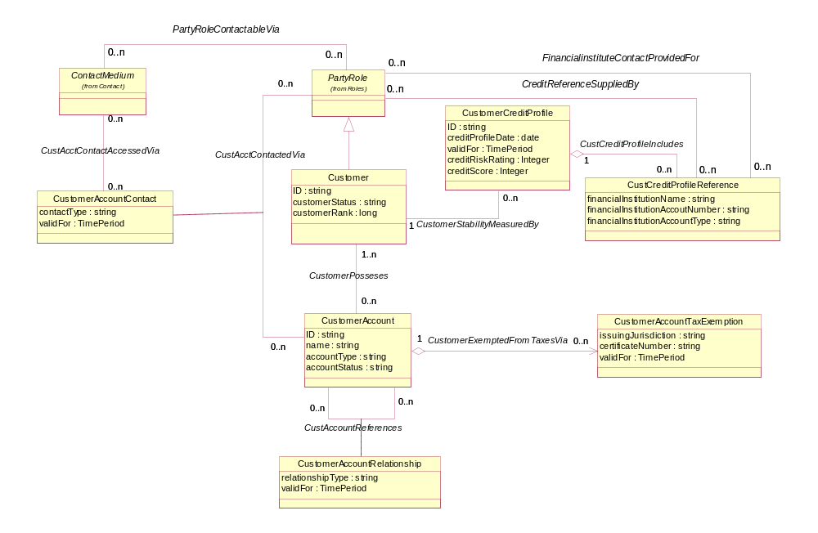
Figure C. 2 - Customer Business Entities

Customer Order

Customer Order
Note: Some but not all enterprises consider a Customer Order to be a type of an Agreement. In the SID model, a Customer Order is considered to be a type of Request (which is a type of BusinessInteraction – see Addendum 1-BI Business Interaction) without the legal formalisms that characterize an Agreement. From a SID model perspective, a Customer Order can be formalized by an Agreement and the Agreements relationship between the Agreement and the Customer Order. This philosophy has the advantage of clearly separating two different concepts: a request (that is, the actual Customer Order) from the legal formalisms associated with the request.
The Customer Order model is shown in Figure C. 3 below.
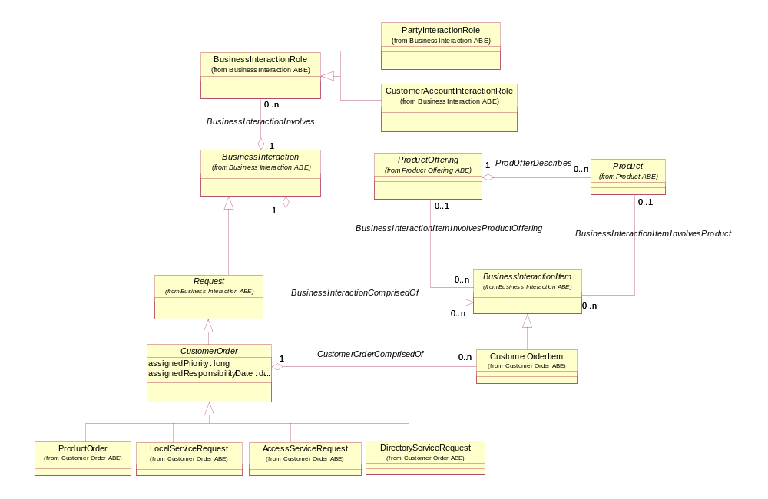
Figure C. 3 – Customer Order Business Entities

Customer Service Level Agreement

Customer Service Level Agreement
A Customer Service Level Agreement differs from other types of Service Level Agreements due to the fact that a Customer is one of the PartyRoles involved in the Service Level Agreement, while other roles are involved in other types of agreements. For example, a Supplier is involved in a Supplier Service Level Agreement. See GB922 Addendum 1A for details of Agreements and Service Level Agreements. See GB922 Addendum 4SO for details of Service Level Specifications and Service Level Objectives.
The figure below provides an overview of a Service Level Agreement. It does not show all of the relevant associations to reduce the complexity of the figure. In particular, associations that BusinessInteraction or BusinessInteractionItems have with other entities are suppressed. Two examples of this are the suppression of the association between a BusinessInteractionItem and a ProductOffering as well as the association between a BusinessInteraction and a Customer playing a PartyRole.

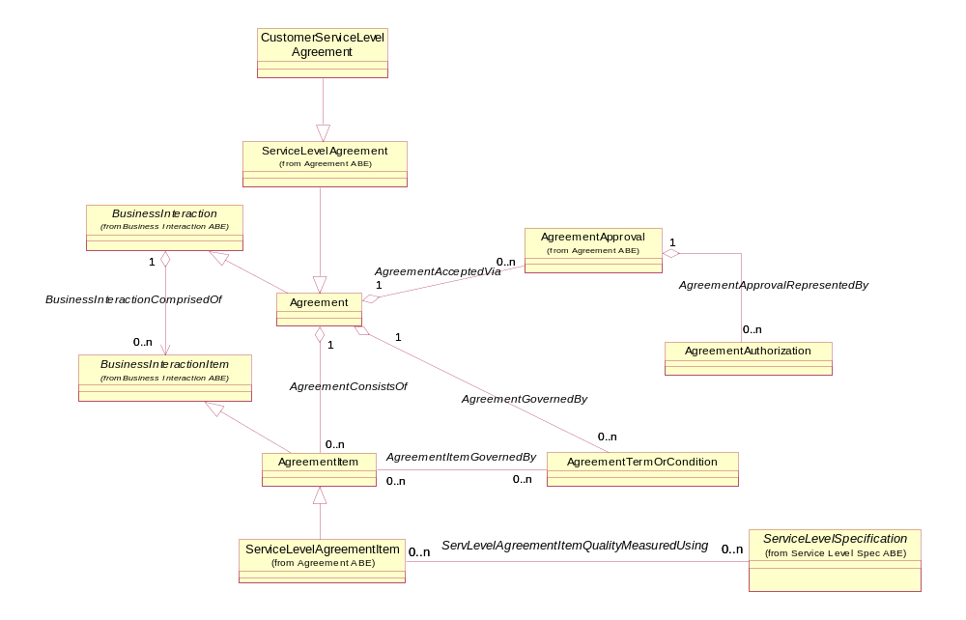
Figure C. 4 – Service Level Agreement

Customer Interaction
The Customer Interaction Aggregate Business Entity has not been fully detailed at the time of this writing. Currently, there are six business entities in the model as shown in the figure below. Customer interactions take the form of requests (CustomerInquiry, CustomerBillInquiry, and CustomerInvocieInquiry) and responses (CustomerQuoteOrOffer).

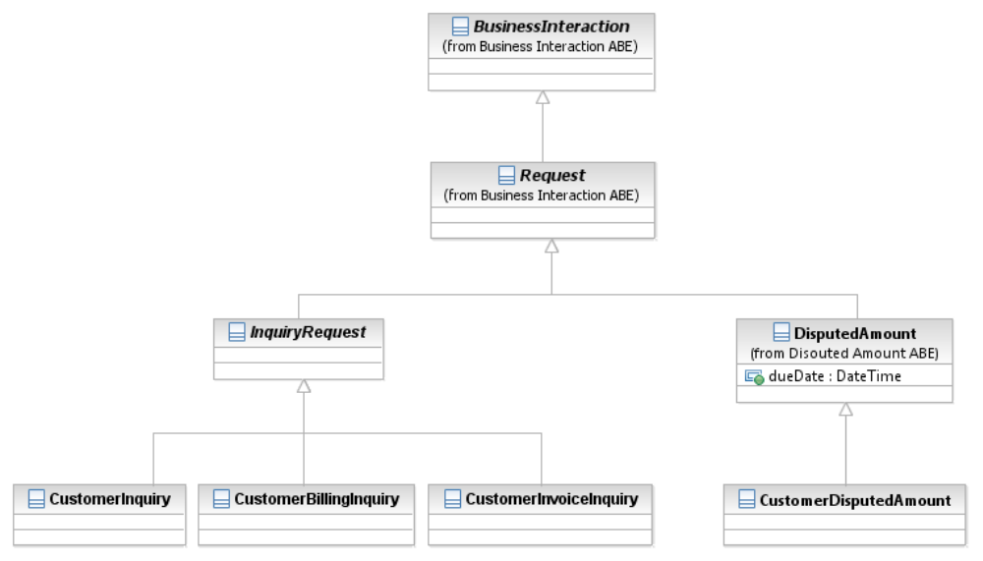
Figure C. 5 - Customer Interaction: Types of Requests

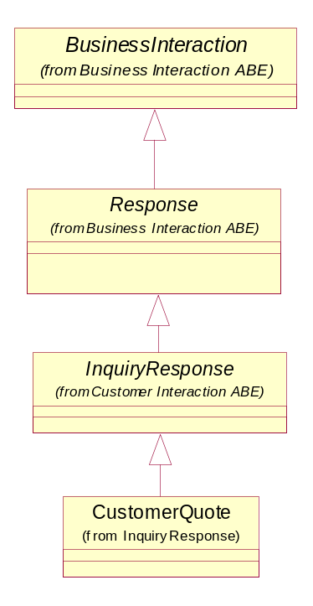
Figure C. 6 – Customer Interaction: Types of Responses

References
IPDR | Service Specification Design Guide, Version 3.5.1
Jane M. Hunter | Telecommunications Billing Systems, ISBN 0-07-140857-6

CustomerDisputedAmount

CustomerDisputedAmount is a subclass of DisputedAmount which models amount in dispute between the enterprise and a customer (amount can be in dispute between the enterprise and other entities such as supplier or partner). The Customer can request a refund for a specific Charge (for example, because the service was not available in a specific time), for a bill (for example when a bill is too high because of unexpected charges such as data roaming) or by generic complaint (for example when the customer waited at home for a technician which did not arrive on time). Each such a request generates a CustomerDisputedAmount request which is associates optionally to the entity which is in dispute. The generic dispute is associated with the CustomerAccount.
In addition justified dispute generates AppliedCustomerBillingCredit for the justified amount. The association DisputeAppliesTo is required for accessing all CustomerDisputedAmounts which relate for specific CustomerAccount (for example when evaluating if the CustomerAccount should be moved to Collection handling)
All this is modeled in the following figure

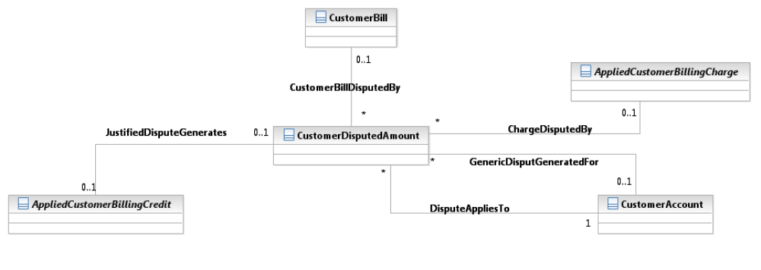
Figure C. 6a – CustomerDisputedAmount Associations to Other Business Entities

Customer Billing

Introduction
This document is intended to specify an entity model used in mediation, rating and billing processes.
-----------------------------------------------------------
Scope and Limitations
Hence the model:
- Has no distinction between prepaid and postpaid
- Has no distinction between an Invoice and a Bill
- Some financial entities that represent the integration with other ABEs such as Accounts Receivable and General Ledger are missing.
These issues will be addressed in following versions of the SID.
-------------------------------------------------------------
A typical billing process involves collecting business transaction details from network equipment, application servers and various other sources, correlating and formatting collected transaction details into billable events that a billing system can understand, guiding (associating usage to customer products), assigning charges to each billable event, applying other fees and discounts, applying taxes, and aggregating everything into customer bills (invoices) and receiving and recording payments from customers.
This model is not focused on any specific business domain but rather tries to build a model framework into which models for different billing domains would fit (for example, telecom billing, utilities billing). It also supports all three basic billing types: postpaid periodical billing, postpaid real-time billing and prepaid real-time billing. The model, by no means, represents the complete set of bill elements that can be incurred. The model provides a framework into which other types of bill elements can easily fit.
The overview figure below shows a simplified overview of the main billing domain business entities. The text following the figure provides an explanation of each of the figure’s entities.

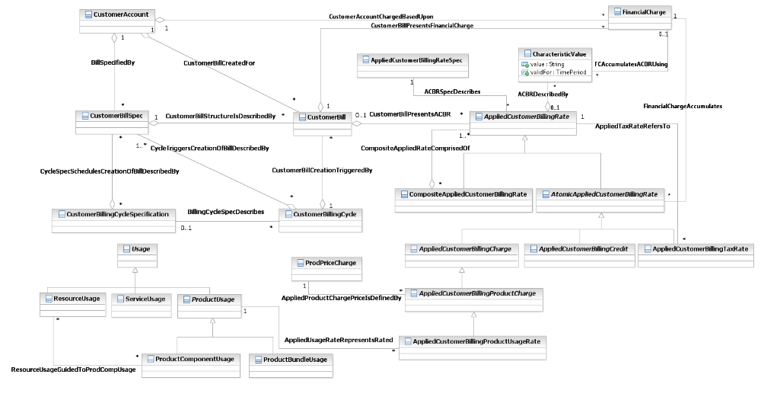
Figure C. 7 – Billing Entities Overview

Usage
Put simply, usage is how much service is used, by whom is it used, where and when is it used and circumstances under which it is used. Normally, when a usage event occurs, it is stored in a network element, for instance in a switch, router, gateway or in an application system. Resources (applications, network and computing capabilities) usually store usage data in proprietary formats that are not understood by the billing system. Depending on the polling strategy, a mediation engine connects to resources, collects usage data and formats them into a format that is understood by the billing system. Output of a mediation engine are Usage Detail Records (UDRs). Examples of UDRs are Call Detail Records (CDRs – used to describe usage details of voice call services) and Internet Protocol Detail Records (IPDRs – used to describe usage details of Internet Protocol based services). In this document we will use the Usage abstract business entity to describe any resource-, service- or product-based usage that the billing system can read, update and process.

Usage
Figure C. 8 shows abstract business entities that are used to model usage. The model shown below is generic; particular usage models should define their own usage business entities by extending the Usage entity.
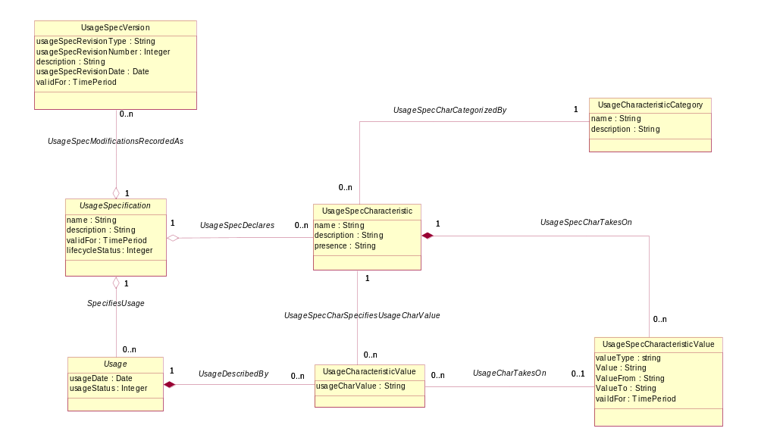
Figure C. 8 – Usage
The UsageSpecification class describes a type of usage. In order to achieve a flexible structure of the UsageSpecification all its attributes are stored as characteristics. Alternatively, different types of usage could be modeled as sub-classes of the Usage entities (Usage, ProductUsage, ServiceUsage, ResourceUsage).
The UsageSpecification is comprised of UsageSpecCharacteristics that define all characteristics (attributes) known by a particular type of usage. Each characteristic is described by its name, category, presence and a set of allowed values.
Name defines a unique name that identifies the characteristic.
Category defines one of the high-level aspects of the usage information described by the characteristic. These categories are commonly referred to as: Who, When, What, Where, and Why.
Presence defines whether the characteristic is required or optional.
The set of allowed values is modeled with UsageSpecCharacteristicValue. This class describes all allowed values or value ranges.
The Usage class represents a usage event. It is described by the UsageSpecification and comprised of UsageCharacteristicValues that hold data attributes of a usage specified by UsageSpecCharacteristics. The UsageCharacteristic can either store its value in the usageCharValue property or reference predefined UsageSpecCharacteristicValue.
The UsageSpecification entity has the following subclasses:
ServiceUsageSpec (that represents a service usage);
ResourceUsageSpec (that represents a resource usage);
ProductUsageSpec (that represents a product usage).

Resource and Service Usage
A resource usage represents any usage of resources in its broadest meaning, for example a purchase or lease of a product realized by a resource. A service usage represents any usage of service in its broadest meaning, for example a purchase of a product realized/implemented by a service or a usage of a service that realizes a product. Classes that are used to model resource and service usages are subclasses of abstract usage classes as shown in the Figure C. 9. The ResourceUsageSpec is a subclass of the UsageSpecification and represents a type of resource usage, while the ServiceUsageSpec represents a type of service usage. A typical source of resource or service usage is a mediation application. Other sources may be application servers and other applications (for example, an online shopping application) that are aware of the usage format and can generate usage directly without mediation.
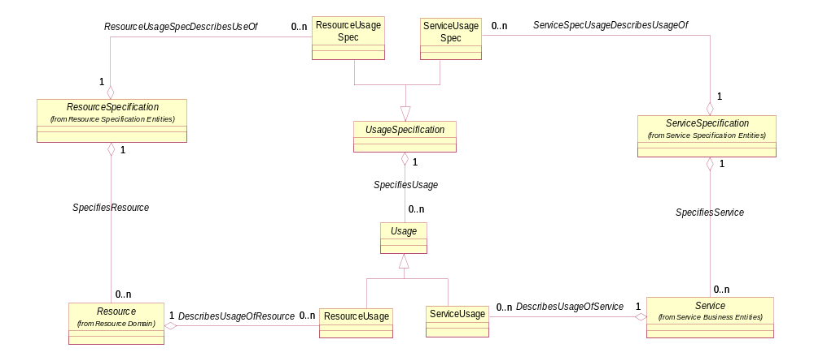
Figure C. 9 – Resource/Service Usage
An example of the ServiceUsage class is a voice call that is characterized by:
An origination and a destination address (Who),
A time of a day the call was connected and a duration of the call (When),
A call type and its details (What),
Connection locations of the call (Where) and
A cause of event recording (Why).

Product Usage
A Product is realized as one or more Service(s) and/or Resource(s). A Product is created by instantiating a ProductOffering and adding it to a specific customer account. In order to charge a service (or a resource) usage, the service (or resource) has to be associated to a product.
Figure C. 10 shows relationships among the ProductSpecification, the Product, the ProductUsageSpec and the ProductUsage ABEs. The ProductUsageSpec is defined for the certain ProductSpecification. As the ProductSpecification has 2 subclasses (the AtomicProductSpecification and the CompositeProductSpecification), the ProductUsageSpec needs 2 subclasses as well: the AtomicProductUsageSpec and the CompositeProductUsageSpec (associated with the AtomicProductSpecification and the CompositeProductSpecification entities respectively).
The ProductUsage describes the usage of an instantiated Product. The Product ABE is extended with the ProductComponent and the ProductBundle business entities. Consequently, the ProductUsage is extended with ProductComponentUsage and the ProductBundleUsage business entities (that are associated with the ProductComponent and the ProductBundle respectively).
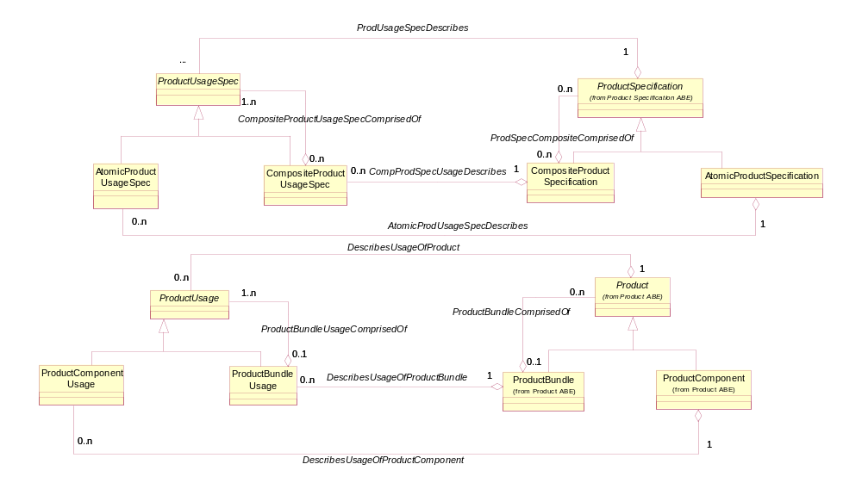
Figure C. 10 – Product Usage, Part 1
As mentioned above, a product is realized as one or more services and/or resources. Consequently, the ProductUsageSpec business entity has to be associated with the ResourceUsageSpec and the ServiceUsageSpec business entities. The ProductUsage, the ServiceUsage and the ResourceUsage business entities have to reflect these associations as well. The ProductComponentUsage can be associated with either ServiceUsage or ResourceUsage and included in a ProductBundleUsage. These entities and associations are shown on the Figure C. 11.
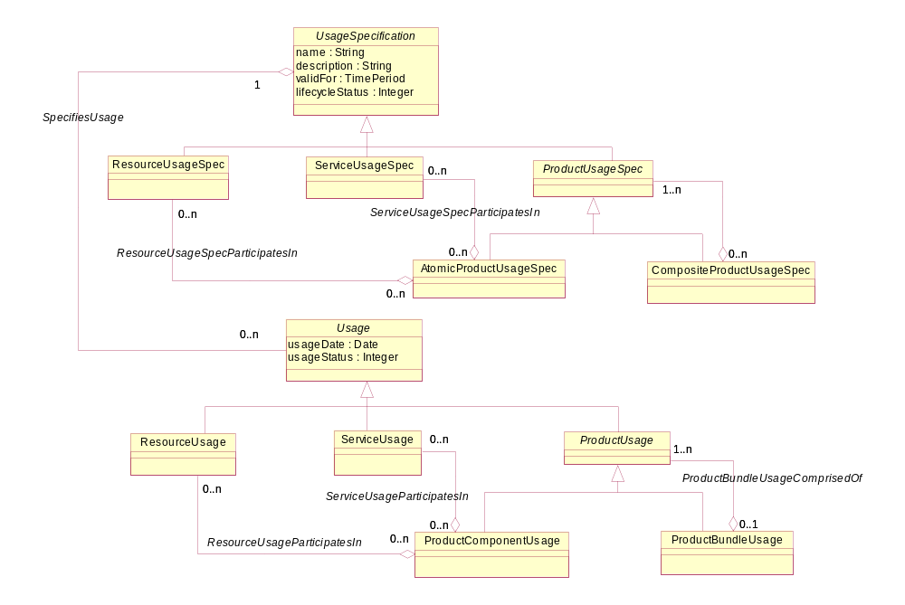
Figure C. 11 – Product Usage, Part 2

Product Price
When an enterprise agrees to deliver a product to a customer, a price is associated with the Product that has to be recorded. The figure below presents the set of entities that are used to hold this information. The ProductPrice represents an amount, usually of money, that represents the actual price paid by a customer for a purchase, a rent or a lease of a Product. The ProductPrice is associated with the Product entity and the ProductOfferingPrice entity. The structure of ProductPrice subclasses resembles the structure of ProductOfferingPrice subclasses.
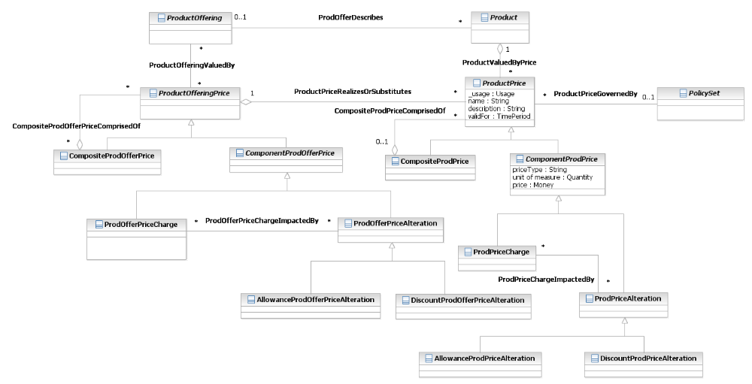
Figure C. 12 – Product Price

Customer Billing ABEs
Customer Billing covers business entities utilized by rating and billing processes. These entities form the Applied Customer Billing Rate ABE and the Customer Bill ABE. Products are rated at different prices depending on ProductOfferingPrices, ProductOfferingPriceRules and additional terms & conditions that are determined by the CustomerAccount. Rating process takes ProductUsages on input and applies rates to them. The Billing process applies additional charges (for example, one time charges, recurring charges), allowances, discounts and taxes, to Products, then aggregates applied rates into bills and sends them to customers. With the emergence of real-time billing the boundary between rating and billing has become blurry.

Applied Customer Billing Rate
The AppliedCustomerBillingRate business entity represents an applied billing rate assigned to the CustomerAccount. AppliedCustomerBillingRates are created before or during the billing cycle. The billing process aggregates applied rates into FinancialCharges which in turn are aggregated into one or more bills. Each applied billing rate is either atomic or composed of other applied rates. This is very useful for displaying AppliedCustomerBillingRates in the CustomerBill. For Financial purposes, however, the composite/atomic pattern is inappropriate since the AppliedCustomerBillingRate may be aggregated more than once (see example in Figure C. 14a ) and therefore FinancialCharge is presented which aggregates each AtomicAppliedCustomerBillingRate exactly once for reporting to the financial systems.
AppliedCustomerBillingRate is described by AppliedCustomerBillingRateSpec, and it is associated with dynamic Characteristics. This is due to the fact that each type of AppliedCustomerBillingRate may carry different Characteristics based on service type, line of business or other parameters.
The AtomicAppliedCustomerBillingRate class has four subclasses:
AppliedCustomerBillingCharge, that represents any kind of charge (except taxation charges);
AppliedCustomerBillingCredit, that represents any kind of credit;
AppliedCustomerBillingTaxRate, that represents a taxation charge.
AppliedCustomerPenaltyCharge that represents penalty charges such as late fees, payment rejection fees…
The AppliedCustomerBillingProductCharge is a subclass of the AppliedCustomerBillingCharge and represents a charge applied to a product, while its subclass AppliedCustomerBillingProductUsageRate represents the rate for a rated product usage event typically produced by a rating engine.
Examples of the AppliedCustomerBillingProductCharge are:
A recurring monthly fee charged for the voice service product.
A one time installation fee charged when the customer subscribes for a voice service product.
Examples of the AppliedCustomerBillingProductUsageRate are:
When a customer makes a voice call a ServiceUsage instance representing call details is created. Afterwards the guiding process creates a ProductUsage instance that represents the ServiceUsage associated with the proper Product. Then the rating process applies a usage price to the ProductUsage instance and creates an AppliedCustomerBillingProductUsageRate instance representing the price of the rated Product Usage.
Similarly when a mobile service customer send an SMS, an AppliedCustomerBillingProductUsageRate representing charge for SMS transportation is created.
The AppliedCustomerBillingCredit business entity is an abstraction of an applied billing credit. The applied billing credit is usually created by the rating or billing process. Its creation can be governed by ProductPriceRules.
The AppliedCustomerBillingRebate is a subclass of AppliedCustomerBillingCredit and represents a rebate given to the customer account.
The AppliedCustomerBillingProductAlteration is a subclass of AppliedCustomerBillingCredit that represents a modification of the referred applied billing charge (either atomic or composite).
The AppliedCustomerBillingTaxRate represents taxes applied to billing charges. The entity may be linked to another applied rate (either atomic charge or composite rate) to indicate which applied rate it refers to. It is calculated during a billing process.
The CompositeAppliedCustomerBillingRate represents a sum of one or more other applied rates. It is formed by aggregating other AppliedCustomerBillingRates that may be either Composite or Atomic AppliedCustomerBillingRates. The main purpose of the CompositeAppliedCustomerBillingRate is to represent an aggregated view of comprising AppliedCustomerBillingRates that can be referenced by other AppliedCustomerBillingRates, for example, by AppliedCustomerBillingTaxRate.
The presented model by no means represents the complete set of applied billing rates that can be incurred. The model provides a framework into which other types of applied billing rates can easily fit.
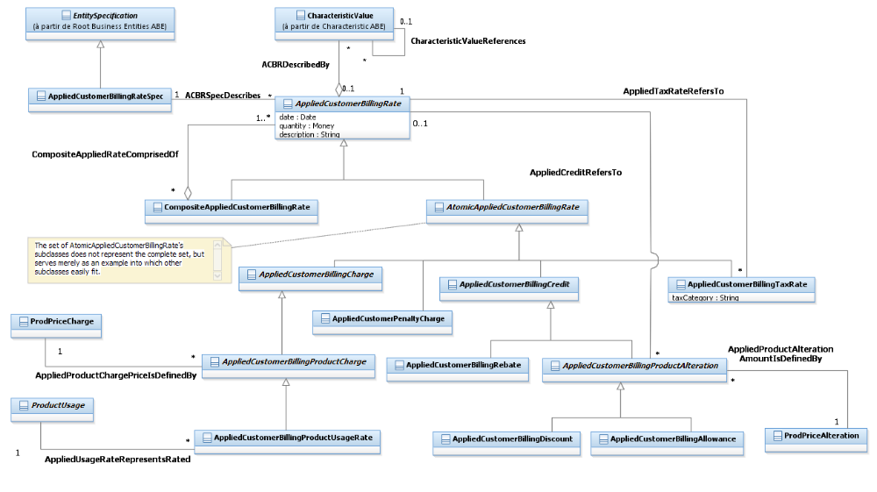
Figure C. 13 – Applied Customer Billing Rate

Customer Billing Credit
The creation of CustomerBillingCredit instances is usually governed by ProductOfferingPriceRules. The ProductOfferingPriceRule or some other business logic can grant a certain credit to a customer account. When a part of the credit is applied during the billing process, the available credit is reduced. The CustomerBillingCredit and related business entities keep track of the credit. Because the balance of the CustomerBillingCredit changes over the time, the CustomerBillingCreditBalance entity represents the balance valid for a certain time period.
The CustomerDiscount business entity is a type of the CustomerBillingCredit. It keeps track of the available discount quantity for the associated DiscountProductPriceAlteration. For example, the DiscountProductPriceAlteration grants $100 discount on the Product charge. As the customer uses the service, the billing process is creating AppliedCustomerBillingCharge instances during each billing cycle, and the available discount amount is reduced. The billing process utilizes the CustomerDiscountBalance to keep track of the available discount (that has not been used yet).
The CustomerAllowanceBalance business entity similarly keeps track of the available allowance (that has not been used yet).
The figure below serves merely as an example of possible types of the CustomerBillingCredit that can be easily extended to keep track of other credits.
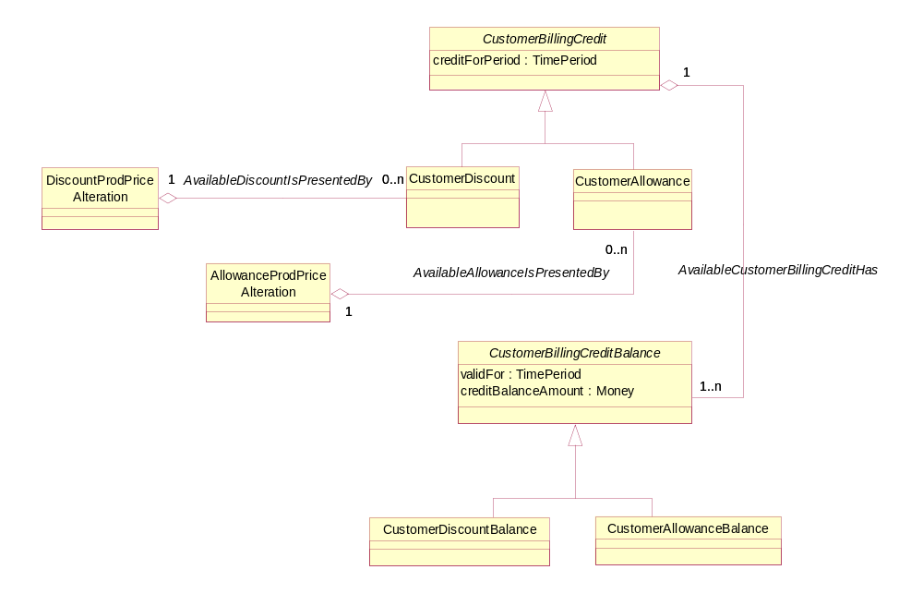
Figure C. 14 –Customer Billing Credit

Customer Bill
The ultimate goal of any billing process is creation of a bill (an invoice). The bill is created during a customer account billing cycle and associated with a customer account.
For financial reasons it is critical that each AtomicAppliedCustomerBillingRate amount appears exactly once on each CustomerBill. This is not well supported by the atomic/Composite pattern as explained in the Figure below:
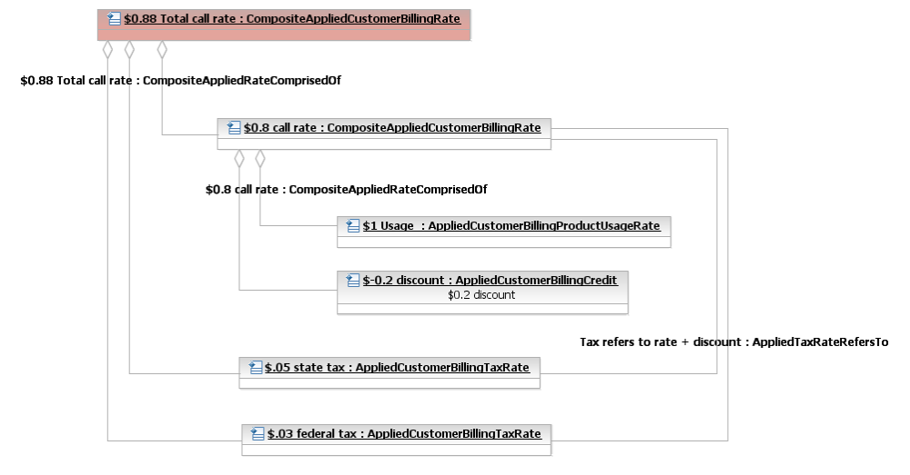
Figure C. 14a – Issues with Using Composite/Atomic Charges to Model Financial Reporting
For financial reasons we must report $0.88, however summing all these instances together gives us $2.56. If we sum, however, only the leaves of the tree (the AtomicAppliedCustomerBillingRates) we get exactly $0.88 ($1 - $0.2 + $.05 + $.03). Therefore the FinancialCharge business entity aggregates only AtomicAppliedCustomerBillingRate

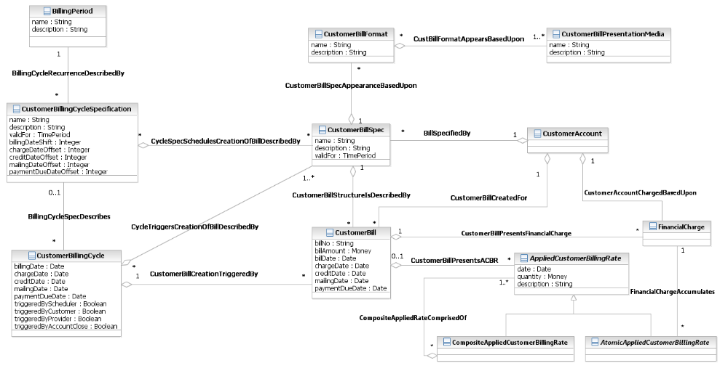
Figure C. 15 – Customer Bill
The CustomerBillSpec describes the detailed structure of the customer’s bill. It describes which AppliedCustomerBillingRates should be included into the bill, when to initiate the bill creation and bill presentation formats. The presentation format of the bill and its aggregated AppliedCustomerBillingRates are described by the CustomerBillFormat. The bill may be presented via various presentation media (for example, email, post mail, web page).
The CustomerBillingCycleSpecification, as shown in the figure above, identifies when to initiate a billing cycle and various sub steps of a billing cycle. It defines a date to be shown on the bill, the date through which charges and credits previously received by the billing system will appear on the bill, the mailing date and the payment due date.
The CustomerBillingCycle entity represents a particular occurrence of a billing cycle. Besides significant dates, it records who (or what) triggered the cycle. The CustomerBillingCycle aggregates all CustomerBillSpecs and in this way defines, which bills are to be created during the represented billing cycle. The association between the CustomerBillingCycle and CustomerBillingCycleSpecification is optional.
- The initiation of a new billing cycle may be triggered by the CustomerBillingCy cleSpecification. In this case the CustomerBillingCycle must have an association with the corresponding CustomerBillingCycleSpecification.
- The initiation of billing cycle may be triggered by an event, not described by the CustomerBillingCycleSpecification. This includes creation of a bill on a customer request, a provider request or by account close. In this case the created CustomerBillingCycle doesn’t have a corresponding CustomerBillingCycleSpecification.
The CustomerBill entity is used to model a bill (an invoice). It represents a total amount due for all products during the billing period and all significant dates (i.e. billDate, chargeDate, creditDate, mailingDate and paymentDueDate). The structure of the bill and its presentation formats are described by the CustomerBillSpec. The bill is generated during the CustomerBillingCycle and is associated with a customer account. The CustomerBill aggregates AppliedCustomerBillingRates. It is the responsibility of the bill creator to assure that each applied rate is aggregated only once into total bill amount.
Let’s imagine the AtomicAppliedCustomerBillingRate and CompositeAppliedCustomerBillingRate, the latter containing the former. While both applied rates may be included into the bill, only one of both may be summarized into the bill amount. The typical reason to include CompositeAppliedCustomerBillingRate into the bill is to present a partial sum, either for customer information or because some other applied rates refer to it. FinancialCharge, on the other hand, is the entity that accumulates AtomicAppliedCustomerBillingRate into the bill amount, and therefore the entity which is influences the customer account’s balance. The accumulation is based on characteristic values of AppliedCustomerBillingRate as described in the figure below:

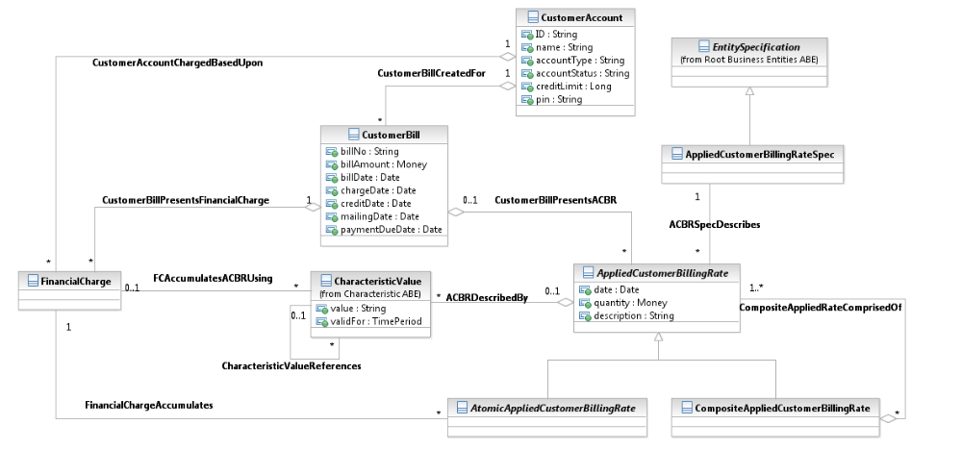
Figure C. 15a – FinancialCharge Accumulates AtomicAppliedCustomerBillingRate

In this figure we see that the CustomerBill presents both AppliedCustomerBillingRates and FinancialCharges – this depends on the business requirements, configuration and regulations – one or both options are possible pending the CSP business.
The important thing (and change from Information Framework versions prior to version 12) is that the CustomerAccount now is based upon the FinacialCharges and not upon the AppliedCustomerBillingRate, for reasons which are explained above. FinancialCharge can accumulate AppliedCustomerBillingRates based on its characteristic values, so that it can accumulate based on ACBR type, line of business, service type or any other ACBR characteristic.
The presented model by no means represents the complete set of bill elements that can be incurred. The model provides a framework into which other types of bill elements can easily fit.

Customer Billing Statistic
The CustomerBillingStatistic and related business entities are used to model various totals and other statistical data associated with a customer account and its products that are of billing process interest over a certain period of time. For example, they can represent customer account total annual revenue or total volume of product usage per quarter. Application of various billing credits (e.g. discount, credit) can be triggered by billing statistic data meeting (for example, exceeding) a certain value.
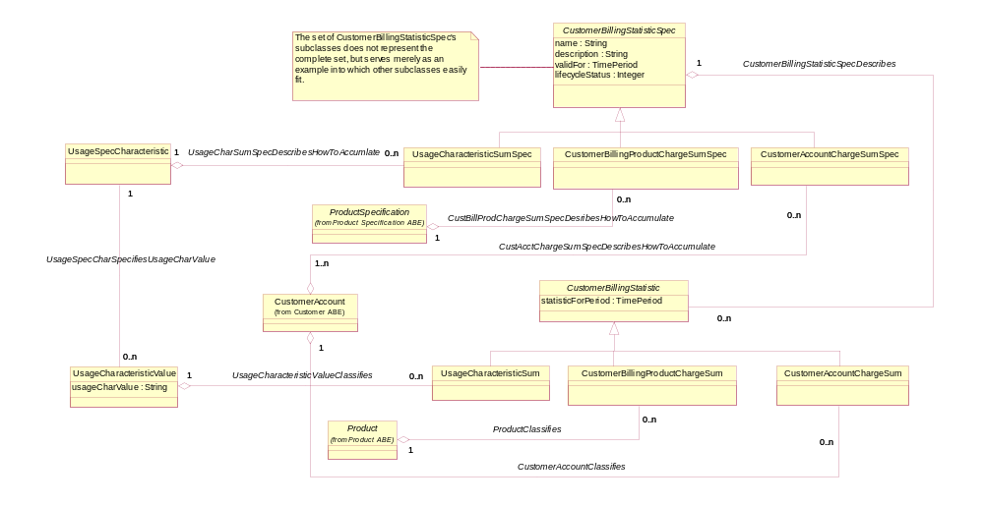
Figure C. 16 – Customer Billing Statistic, Part 1
The CustomerBillingStatisticSpec is used to describe the statistic that needs to be collected. The UsageCharacteristicSumSpec describes the collection of usage characteristic statistic (for example, the total sum of the duration of voice calls in a month). Policy rules can be used to define, which statistic data are of the billing process interest, when they should be created and expired, how they should be calculated, and what actions should be triggered when statistic data meet certain conditions.
CustomerBillingStatistic entity instances are typically created and updated during rating and billing process. Since a quantity represented by CustomerBillingStatistic changes over time corresponding Balance entities are used to track its history as shown in the figure below.
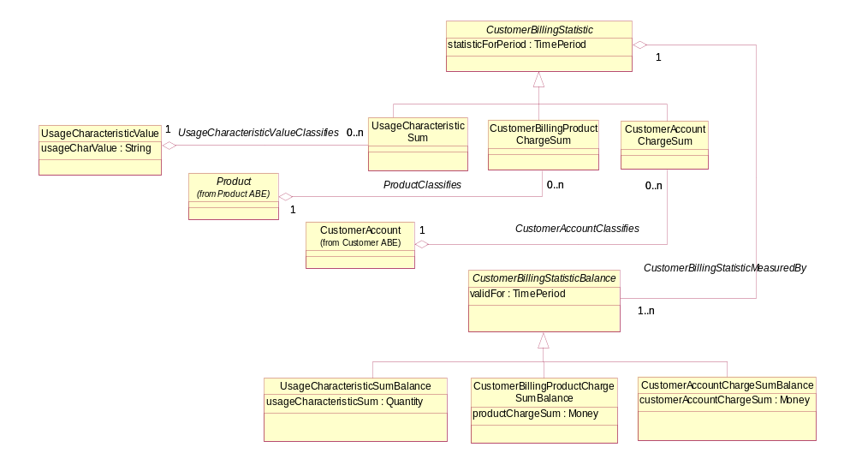
Figure C. 17 – Customer Billing Statistic, Part 2
For example, for a certain product a billing system may track total number of kilobytes transferred over GPRS connection per quarter. The total sum is recorded by a billing system and stored in an instance of UsageCharacteristicSum entity. When a certain volume is exceeded a DiscountProductPriceAlteration instance may be generated entitling customer to a certain discount.

Customer Payment
This section is intended to define the scope of payment from the following perspectives.

- Why (the reason for payment)
From the view of customer, a payment is usually applied to a bill or an invoice, maybe through a customer account, and applied to product, and product usage in postpaid scenario. The payment may represent a prepayment. The payment amount may be a credit or debit amount. The payment is eventually applied to a bill or AppliedCustomerBillingRate.
- How (the methods and plan for payment)
Payment is implemented through different means, such as cash, bank transfer, and so forth. A payment is applied to several bills or AppliedCustomerBillingRate according to the priority defined by payment plan.
- When
In case of auto pay or receipt of customer payment
- Who
Payee and Payer, the third party as an agency
- What (customer payment scope)
Involve all the above info, which is described in Figure C. 18 Customer Payment Scope below.
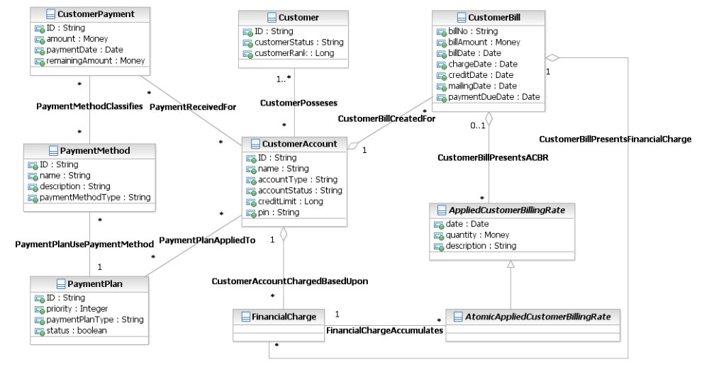
Figure C. 18 – Customer Payment Scope

The payment model presented here is intended to support a converged payment model for both prepaid and postpaid condition. Other requirements include:
- Handling prepaid customers in cases where there is no bill. So Payment could be related to AppliedCustomerBillingRate and not to a CustomerBill.
- Handling a payment that is applied to multiple bills
- Handling underpayments and overpayments

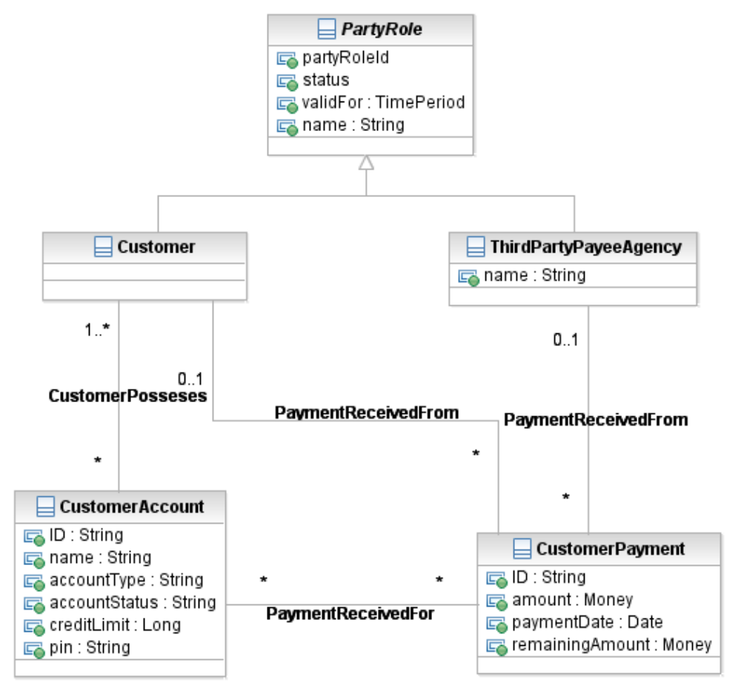
Figure C. 19 – Payment’s Associations with Roles

Customer and ThirdPartyAgency play a role as payee. Payment is received for one or more CustomerAccounts.

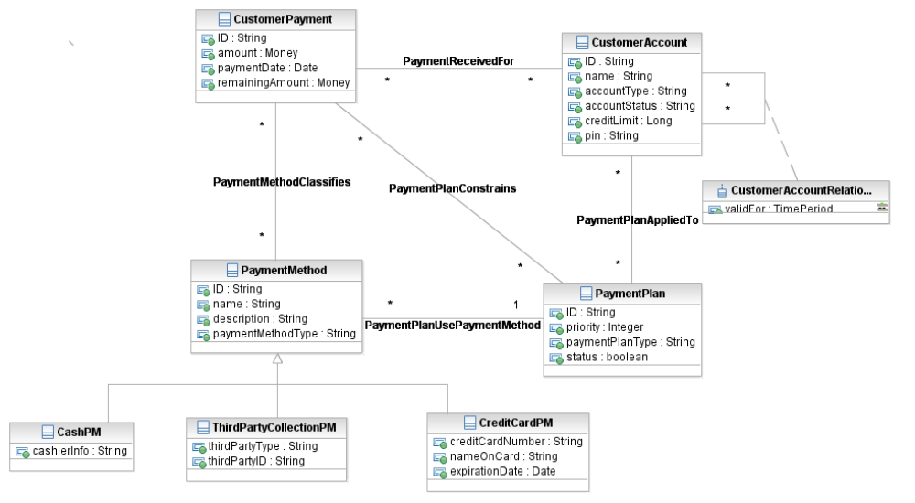
Figure C. 20 – Payment Method and Plan

The means of payment is classified by PaymentMethod. For example, payment by cash, bank transfer, or credit card. PaymentMethod is a generalization of the subclasses shown in Figure C.20 Payment Method and Plan, which could be used by PaymentPlan .
In case of auto payment, PaymentPlan will use PaymentMethod and the information from CustomerAccount to obtain the money from the applicable resource(s) and then apply them based on prearrangement, such as priority of bills based on payment due date.

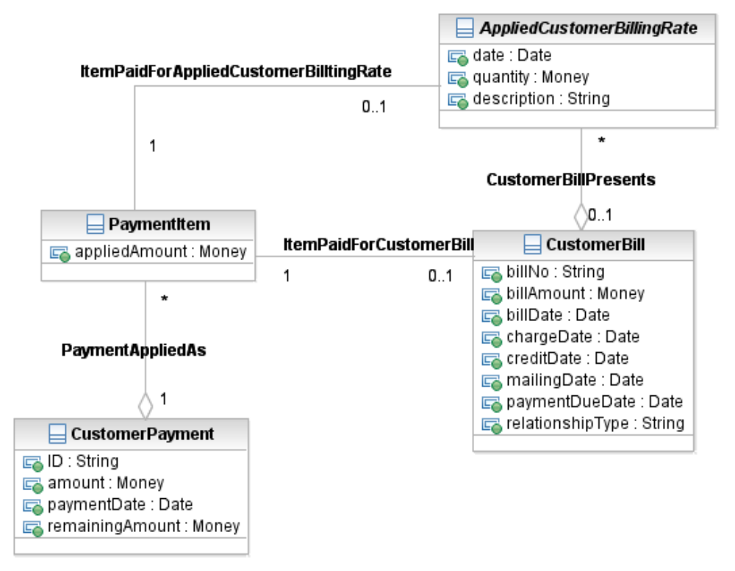
Figure C. 21 – Applying Payment

As shown in Figure C. 21 Applying Payment, Payments can be applied to the CustomerBill and AppliedCustomerBillingRate.

Dunning
The Dunning ABE is part of the Customer Bill Collection ABE.
This section is intended to define the scope of information used by the dunning process.
More precisely, this section describes information produced and consumed by the level 3 business processes from eTOM
- 1.1.1.11.3 Manage Customer Debt Collection
- and 1.1.1.1.14 Support Bill Payments & Receivable Management

Figure C. 22 - Dunning Scenario and Case presents the dunning scenario and the corresponding cases.
Each provider/operator has to define its dunning strategy. This strategy is described by DunningScenario. Each DunningScenario contains the dunning rules to apply to a case, the order in which applying them, the events that trigger dunning rules evaluation, the actions that must be done, and so forth.
The DunningCaseRules are specified by DunningRule that is a type of PolicyRule.
This allows specifying for each dunning rule:
- the events that trigger the evaluation of the rule (Ex: due debt not paid after 8 days
- conditions that have to be evaluated (Ex: no bill dispute in progress)
- and actions that have to be done (Ex: send a dunning letter).
A DunningScenario is assigned to a CustomerAccount, depending on the Holder quality (Ex: a more tolerant DunningScenario is assigned to VIPs).
If no specific DunningScenario is assigned to a CustomerAccount, a default scenario is applied.
As soon as an event triggering a DunningRule occurs on a CustomerAccount, a DunningCase is created according to the DunningScenario assigned to the CustomerAccount.
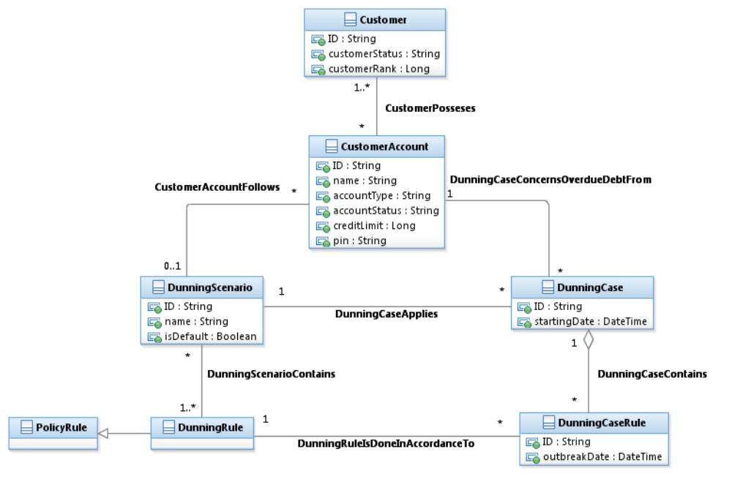
Figure C. 23 - Dunning Scenario and Case

The following example illustrates the use of the dunning model and, more specifically, the inheritance from PolicyRule.
In this example, the provider/operator has defined a default Dunning scenario for Mass Market.
The Rules 1 and 1b use the same PolicyEvent and the same PolicyAction but their conditions are different. Only one of these two rules may be applied in a specific context.
In the Rules 2 and 2b
- the PolicyEvents and the PolicyAction are the same
- but the PolicyConditions are different : the amount of the due debt conditioning the action is only 20€ for a bad debtor and 100€ for a good payer
The Rules 13 and 13b trigger two PolicyActions if the condition is true.

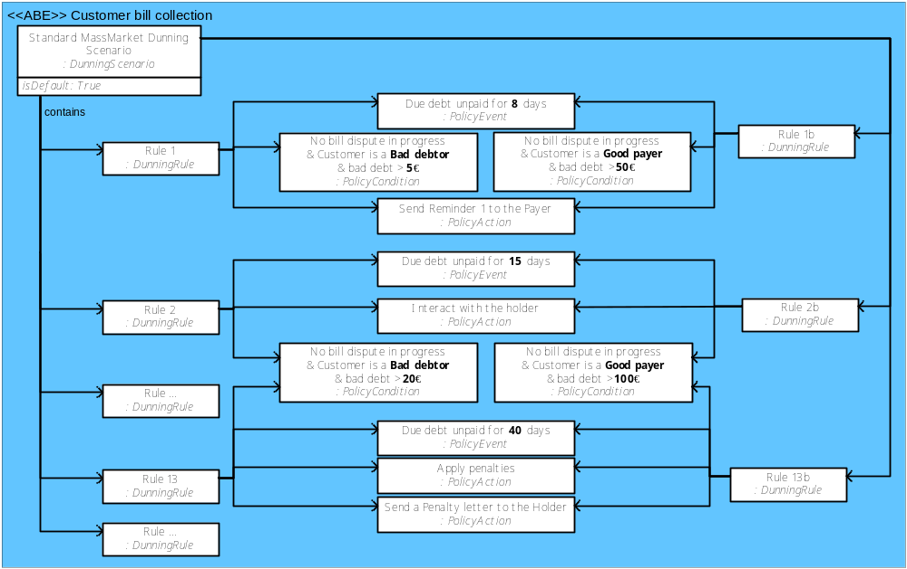
Figure C. 3 - Dunning Result presents the different type of actions resulting from a dunning process.
When a dunning process is triggered, it will first create a SoftDunning. At this stage the provider/operator starts to get in touch with the payer. And without result, we get in touch with the holder.
Finally, after restriction measures, the entire holder’s contracts are removed and a closing invoice is produced.
Once the closing invoice is produced, a HardDunning starts.
According to the law, several interactions will be done with the holder and finally a DunningWriteOff is credited.

Each time DunningRule events occur, a DunningCaseRule is triggered to apply it.
If the condition specified by the DunningRule is true, then one or several actions are done.
The different types of dunning actions are the following:
- One type of dunning action may be to interact with the customer to ask for a CustomerPayment or negotiate a PaymentPlan
- Another type of dunning action may be to apply penalty for overdue debt (AppliedCustomerPenaltyCharge that is a type of Charge)
- Another type of dunning action may be to create a CustomerOrder that will apply a limitation Product on the customer’s existing Products (Ex: limit to national calls) and even a CustomerOrder that will remove all the Customer’s Products
- When all the Customer’s Products are removed a closing CustomerBill is produced, including the rented material goods price
- The last action done by the Dunning process is to produce a DunningWriteOff.
- 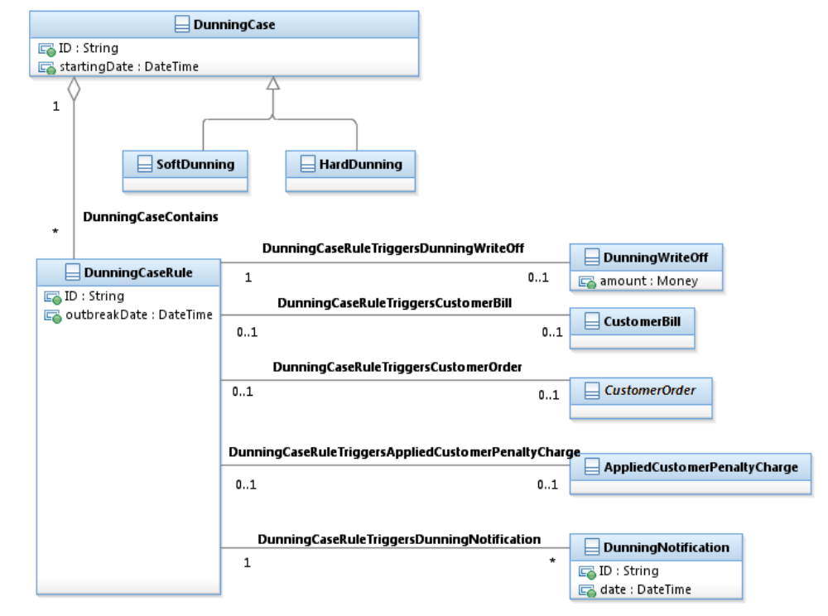
Figure C. 23 - Dunning Result
The following example illustrates the application of a dunning scenario for a specific customer.

In this example, John Smith has a contract with the provider/operator. Therefore, he is liable for eventual debt that could be incurred on his CustomerAccount
Mary Smith plays the role of Payer and pays the debt of John Smith’ CustomerAccount

As no specific dunning scenario has been assigned to John Smith’ CustomerAccount, it follows the Standard MassMarket Dunning Scenario.
As Mary Smith didn’t pay the due debt of the CustomerBill for 8 days, a DunningCase is created starting by the first step.
In accordance with the DunningRule, a reminder letter is sent to Mary Smith (the Payer).
As no payment has been received from Mary Smith, the second step of the Dunning Scenario is triggered. The CSR (Customer Service Representative) calls Mary Smith.
And hopefully, the interaction with Mary Smith led to a Payment covering the complete debt.
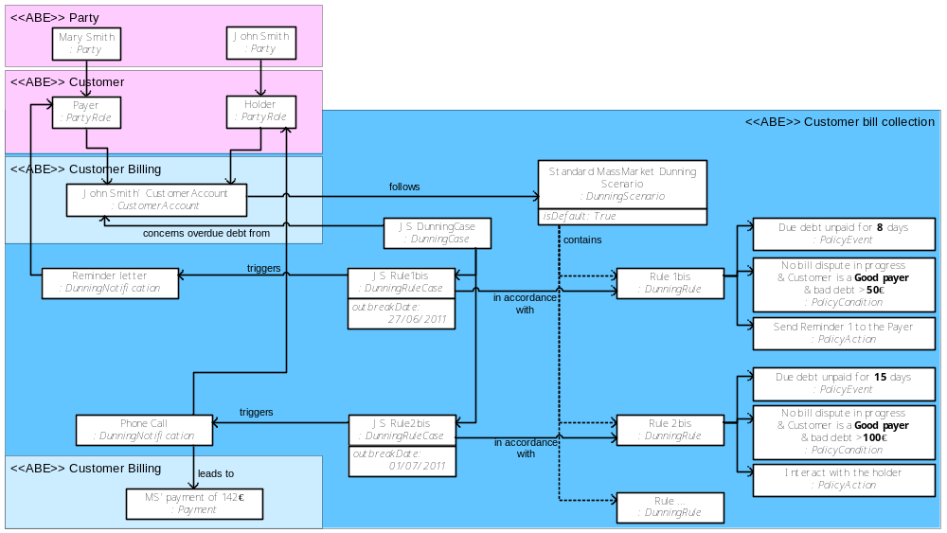

Business Entity Definitions - Customer

Customer

Business Entity Definition
Business Entity Name | Customer
Description | A person or organization that buys or has bought or otherwise obtained Products, Resources and/or Services from the enterprise or receives free offers for Products, Resources, and/or Services. This is modeled as a Party playing the role of Customer.  Customers do not have to be end-users. For example, a Customer can also be another Service Provider (i.e., one who resells the enterprise's Products, Services and/or Resources), or a Service Providers that leases the enterprise's Products, Services and/or Resources.
Sources | eTOM | Cross- References |  | PartyRole | Synonyms / Aliases
Related Business Entities | possess CustomerAccount  requests Customer Quote/Offer  entersInto CustomerAgreement  stabilityMeasuredBy CustomerCreditProfile
Business Rules

Business Entity Attributes Definition
Business Entity Name | Customer
Attribute Name | Description | Data Type | Characteristics, Permitted Values & Units | Required/  Optional | Notes
customerID | A unique identifier that enables different instances of a Customer to be distinguished from each other. | String |  | Required
customerStatus | The current condition of a customer such as  - unknown  - active  - inactive  - terminated  - pending | Enumerated Sting |  | Required | Application-specific extensions should be appended to this list:
customerRank | The relative importance of this Customer compared to other Customers. | Integer |  | Optional

Customer Business Entity Model
See Figure_C2

CustomerCreditProfile

Business Entity Definition

Business Entity Name | CustomerCreditProfile
Description | An outline of a Customer’s credit worthiness.
Sources | MetaSolv Customer Contribution, Bell Canada Enterprise Model Contribution | Cross- References |  |  | Synonyms / Aliases | CustomerCreditApplication
Related Business Entities | measureTheStabilityOf Customer  include CustomerCreditProfileReference
Business Rules

Business Entity Attributes Definition
Business Entity Name | CustomerCreditProfile
Attribute Name | Description | Data Type | Characteristics, Permitted Values & Units | Required/  Optional | Notes
creditProfileID | A unique identifier that enables different instances of a CustomerCreditProfile to be distinguished from each other. | String |  | Required
creditProfileDate | The date the profile was established. | Date |  | Required
validFor | The period for which the profile is valid. | Time Period |  | Required | See TimePeriod class
creditRiskRating | This is an integer whose value is used to rate the risk of this Customer paying late or defaulting versus paying on time. | Integer |  | Optional
creditScore | a measure of a person’s or organization’s creditworthiness calculated on the basis of a combination of factors such as their income and credit history | Integer |  | Optional

CustomerCreditProfile Business Entity Model
See Figure C. 2 - Customer Business Entities.

CustomerCreditProfileReference

Business Entity Definition
Business Entity Name | CustomerCreditProfileReference
Description | A source of information that helps define a Customer’s credit worthiness.
Sources | MetaSolv Customer Contribution, Bell Canada Enterprise Model | Cross- References |  |  | Synonyms / Aliases | CustomerCreditApplicationReference
Related Business Entities | includedIn CustomerCreditProfile
Business Rules

Business Entity Attributes Definition
Business Entity Name | CustomerCreditProfileReference
Attribute Name | Description | Data Type | Characteristics, Permitted Values & Units | Required/  Optional | Notes
financialInstitutionName | The name of the financial institution that holds the referenced account. | String |  | Required
financialInstitutionAccountNumber | The financial institution account number that identifies the customer account at the financial institution. | String |  | Required
financialInstitutionAccountType | The type of financial institution account. | String |  | Required | Examples are savings, checking, mutual fund, stock, and so forth.

Business Entity Model
See Figure C. 2.

CustomerAccount

Business Entity Definition
Business Entity Name | CustomerAccount
Description | An arrangement that a Customer has with an enterprise that provides Products to the Customer.
Sources | TMF SID team, MetaSolv Customer contribution | Cross- References |  | Business Interaction  Request | Synonyms / Aliases
Related Business Entities | ownedBy Customer  referenceOther CustomerAccount  exemptedFromTaxesVia CustomerAccountTaxExemption  receivesABillDuring CustomerAccountBIllingCycle  impactedBY CustomerAgreement
Business Rules

Business Entity Attributes Definition
Business Entity Name | CustomerAccount
Attribute Name | Description | Data Type | Characteristics, Permitted Values & Units | Required/  Optional | Notes
accountID | A unique identifier that enables different instances of a CustomerAccount to be distinguished from each other. | String |  | Required
accountName | The name of the account. | String |  | Required | The account name can be different than the party name.
accountType | A categorization of an account, such as individual, joint, and so forth, whose instances share some of the same characteristics. | String |  | Optional
accountStatus | The condition of the account, such as due, paid, or in arrears. | String |  | Required

CustomerAccount Business Entity Model
See Figure C. 2.

CustomerAccountContact

Business Entity Definition
Business Entity Name | CustomerAccountContact
Description | An individual or organization used as a contact point for a CustomerAccount and accessed via some contact medium. The contact may be a member of the customer’s organization or a member of some other enterprise, such as the provider who services the customer account.
Sources | MetaSolv Customer contribution | Cross- References |  |  | Synonyms / Aliases
Related Business Entities | definedBy a PartyRole  accessedVia ContactMedium
Business Rules

Business Entity Attributes Definition
Business Entity Name | CustomerAccountContact
Attribute Name | Description | Data Type | Characteristics, Permitted Values & Units | Required/  Optional | Notes
contactType | Identifies the relationship of the contact to the account, such as primary, secondary, and emergency contact. | String |  | Required
customerAccount  ContactValidFor | The period for which the contact is applicable. | TimePeriod |  | Required | See TimePeriod class.

CustomerAccountContactDetails Business Entity Model
See Figure C. 2.

CustomerAccountRelationship

Business Entity Definition
Business Entity Name | CustomerAccountRelationship
Description | A significant connection between two CustomerAccounts.
Sources | MetaSolv Customer contribution | Cross- References |  |  | Synonyms / Aliases
Related Business Entities | CustomerAccountRelationship(s):  references CustomerAccount
Business Rules

Business Entity Attributes Definition
Business Entity Name | CustomerAccountRelationship
Attribute Name | Description | Data Type |  | Characteristics, Permitted Values & Units | Required/  Optional | Notes
customerAccountRelationshipType | This attribute defines the type of relationship between two Customer Accounts (for example, primary-secondary, linked, and so forth) | String |  |  | Required
validFor | The period for which the relationship is valid. | Time Period |  |  | Required | See TimePeriod class.

CustomerAccountReferencesDetail Business Entity Model
See Figure C. 2.

CustomerAccountTaxExemption

Business Entity Definition
Business Entity Name | CustomerAccountTaxExemption
Description | Justification that a particular CustomerAccount is not required to pay taxes imposed by a taxing jurisdiction.
Sources | MetaSolv Customer Contribution | Cross- References |  |  | Synonyms / Aliases
Related Business Entities | CustomerAccountTaxExemption(s):  defineTaxExemptionsFor CustomerAccount
Business Rules

Business Entity Attributes Definition
Business Entity Name | CustomerAccountTaxExemption
Attribute Name | Description | Data Type | Characteristics, Permitted Values & Units | Required/  Optional | Notes
issuingJurisdiction | The name of the taxing jurisdiction for which taxes are exempt. | String |  | Required
certificateNumber | The identifier of a document that shows proof of exemption from taxes for the taxing jurisdiction. | String |  | Optional
validFor | The period for which the exemption is valid. | Time Period |  | Required | See TimePeriod class.

CustomerAccountTaxExemption Business Entity Model
See Figure C. 2.

Business Entity Definitions - Customer Order

CustomerOrder

Business Entity Definition
Business Entity Name | CustomerOrder
Description | A CustomerOrder is a communication used to procure a Product. There are different types of CustomerOrders, such as AccessServiceRequests (ASRs), LocalServiceRequests (LSRs), DirectoryServiceRequests (DSRs), ProductOrders (PSRs).
Sources | Unified Ordering Model (T1M1, OBF, TFCI joint project), MetaSolv TMF Contribution. | Cross- References |  | Business Interaction  Agreement | Synonyms / Aliases | Service Request
Related Business Entities
Business Rules | A CustomerOrder must reference one or more Products Offerings and/or one or more Products  A CustomerOrder may reference one or more customers.

Business Entity Attributes Definition
Business Entity Name | CustomerOrder
Attribute Name | Description | Data Type | Characteristics, Permitted Values & Units | Required/  Optional | Notes
assignedPriority | The order’s assigned priority after review, relative to other orders in the system.. | Integer
assignedResponseDate | The target response date assigned after review. | Date

CustomerOrder Business Entity Model
See Figure C. 3.

CustomerOrderItem

Business Entity Definition
Business Entity Name | CustomerOrderItem
Description | The purpose for the Customer Order expressed in terms of a Product Offering or a Product inherited from BusinessInteractionItem.
Sources | MetaSolv TMF Contribution | Cross- References |  |  | Synonyms / Aliases
Related Business Entities
Business Rules

LocalServiceRequest

Business Entity Definition
Business Entity Name | LocalServiceRequest
Description | A Local Service Request (LSR) contains information pertaining to the administrative, billing, service and contact details for a local service order as mandated in Ordering and Billing Forum(OBF) guidelines.
Sources | OBF Guidelines, MetaSolv TMF Contribution | Cross- References |  |  | Synonyms / Aliases | LSR
Related Business Entities
Business Rules

Business Entity Attributes Definition
The Ordering and Billing Forum (OBF) provides guidelines that govern many aspects of a Local Service Request. The OBF is a forum of the Carrier Liaison Committee (CLC). The OBF provides a forum for customers and providers in the telecommunications industry to identify, discuss and resolve national issues which affect ordering, billing, provisioning and exchange of information about access services, other connectivity and related matters. OBF member companies can find attribute details at the following location. Non-members may access this site, but must pay for the documents containing attribute descriptions.
http://www.atis.org/atis/clc/obf/LSOP/Lsophome.htm

LocalServiceRequest Business Entity Model
See Figure C. 3.

AccessServiceRequest

Business Entity Definition
Business Entity Name | AccessServiceRequest
Description | Access Service Requests are industry template requests to initiate or change access services submitted by an Access Customer to an Access Provider. Access services include service and facilities provided for the origination or termination of InterLATA or foreign telecommunications. The Access Service Request provides a uniform means of requesting service. Each request contains entries required for ordering of the particular service and for the establishment of billing of the appropriate customer account. The request is either for special access or switched access services as specified in the various Access Service Tariffs. The Access Service Request is also the mechanism for ordering local interconnection trunks. The Ordering and Billing Forum (OBF) defines and publishes access ordering guidelines.
Sources | OBF Guidelines, MetaSolv TMF contribution | Cross- References |  |  | Synonyms / Aliases | ASR
Related Business Entities
Business Rules

AccessServiceRequest Business Entity Attributes Definition
The Ordering and Billing Forum (OBF) provides guidelines that govern many aspects of an Access Service Request. The OBF is a forum of the Carrier Liaison Committee (CLC). The OBF provides a forum for customers and providers in the telecommunications industry to identify, discuss and resolve national issues which affect ordering, billing, provisioning and exchange of information about access services, other connectivity and related matters. OBF member companies can find attribute details at the following location. Non-members may access this site, but must pay for the documents containing attribute descriptions.
http://www.atis.org/atis/clc/obf/ISOP/isophome.htm

AccessServiceRequest Business Entity Model
See Figure C. 3.

DirectoryServiceRequest

Business Entity Definition
Business Entity Name | DirectoryServiceRequest
Description | A Directory Service Requests contains the administrative, billing, contact details and listing or directory delivery information for a directory service. The Ordering and Billing Forum (OBF) defines and publishes directory service ordering guidelines.
Sources | OBF Guidelines, MetaSolv TMF contribution | Cross- References |  |  | Synonyms / Aliases | DSR
Related Business Entities
Business Rules

Business Entity Attributes Definition
The Ordering and Billing Forum (OBF) provides guidelines that govern many aspects of a Directory Service Request. The OBF is a forum of the Carrier Liaison Committee (CLC). The OBF provides a forum for customers and providers in the telecommunications industry to identify, discuss and resolve national issues which affect ordering, billing, provisioning and exchange of information about access services, other connectivity and related matters. OBF member companies can find attribute details at the following location. Non-members may access this site, but must pay for the documents containing attribute descriptions.
http://www.atis.org/atis/clc/obf/dc/dchom.htm

DirectoryServiceRequest Business Entity Model
See Figure C. 3.

Business Entity Definitions – CustomerServiceLevelAgreement

CustomerServiceLevelAgreement

Business Entity Definition
Business Entity Name | CustomerServiceLevelAgreement
Description | A service level agreement (SLA) is a type of agreement that represents a formal negotiated agreement between two parties designed to create a common understanding about products, services, priorities, responsibilities, and so forth. The SLA is a set of appropriate procedures and targets formally or informally agreed between parties in order to achieve and maintain specified Quality of Service. See GB922, Addendum 1A for more information.  This type of SLA is between a Customer and an organization offering Products, such as a Service Provider. The Customer is directly aware of this SLA.
Sources | WSM Handbook (GB923) | Cross- References |  |  | Synonyms / Aliases | Service Level Guarantee
Related Business Entities | Inherited from the Agreement business entity.
Business Rules

Business Entity Attributes Definition
Business Entity Name | CustomerServiceLevelAgreement
Attribute Name | Description | Data Type | Characteristics, Permitted Values & Units | Required/  Optional | Notes
Tbd

CustomerServiceLevelAgreement Business Entity Model
See Figure C. 4.

Business Entity Definitions – Customer Interaction

InquiryRequest

Business Entity Definition
Business Entity Name | InquiryRequest
Description | A Request for information.
Sources | SID model | Cross- References |  |  | Synonyms / Aliases
Related Business Entities | A type of Request
Business Rules

Inquiry Request Business Entity Model
See Figure C. 5.

CustomerBillingInquiry

Business Entity Definition
Business Entity Name | CustomerBillingInquiry
Description | A request for information about a statement of money owed by a customer.
Sources | SID model | Cross- References |  |  | Synonyms / Aliases
Related Business Entities | A type of InquiryRequest
Business Rules

CustomerRequest Business Entity Model
See Figure C. 5.

CustomerInquiry

Business Entity Definition
Business Entity Name | CustomerInquiry
Description | A request for information from a Customer.
Sources | SID model | Cross- References |  |  | Synonyms / Aliases
Related Business Entities | A type of InquiryRequest
Business Rules

CustomerInvoiceInquiry

Business Entity Definition
Business Entity Name | CustomerInvoiceInquiry
Description | A request for information about a written record of goods or services provided and the amount charged for them, sent to a Customer as a request for payment.
Sources | SID model | Cross- References |  |  | Synonyms / Aliases
Related Business Entities | A type of InquiryRequest
Business Rules

CustomerInvoiceInquiry Business Entity Model
See Figure C. 5.

CustomerDisputedAmount

Business Entity Definition
Business Entity Name | CustomerDisputedAmount
Description | CustomerDisputedAmount is a type of DisputedAmount which represents an amount of money in dispute between the enterprise and one of its customers
Sources | SID model | Cross- References |  |  | Synonyms / Aliases
Related Business Entities | A type of DisputedAmount  References CustomerBill, AppliedCustomerBillingCharge, AppliedCustomerBillingCredit, CustomerAccount
Business Rules

CustomerDisputedAmount Business Entity Model
See Figure C. 5 and Figure C. 6a.

InquiryResponse

Business Entity Definition
Business Entity Name | InquiryResponse
Description | A reply to an InquiryRequest.
Sources | SID model | Cross- References |  |  | Synonyms / Aliases
Related Business Entities | A type of Response
Business Rules

CustomerResponse Business Entity Model
See Figure C. 6.

CustomerQuote

Business Entity Definition
Business Entity Name | CustomerQuote
Description | A price estimate (quote) or a presentation for sale (offer) of product offerings to a party playing a role.
Sources | SID model | Cross- References |  |  | Synonyms / Aliases
Related Business Entities | A type of InquiryResponse
Business Rules

CustomerQuote Business Entity Model
See Figure C. 6.

Business Entity Definitions – Applied Customer Billing Rate

AppliedCustomerBillIingCharge

Business Entity Definition
Business Entity Name | AppliedCustomerBillIingCharge
Description | An amount, usually of money, for which a person or organization is financially liable.
Sources |  | Cross- References |  |  | Synonyms / Aliases
Related Business Entities
Business Rules

AppliedCustomerBillingAllowance

Business Entity Definition
Business Entity Name | AppliedCustomerBillingAllowance
Description | An applied amount, usually of money, deducted from the charge for a Product as a discount or in exchange for something. The applied amount could also be a number of free units, such as minutes, applied to usage.
Sources |  | Cross- References |  |  | Synonyms / Aliases
Related Business Entities
Business Rules

AppliedCustomerBillingCredit

Business Entity Definition
Business Entity Name | AppliedCustomerBillingCredit
Description | A credit assigned to the customer's account in the course or for the purpose of the billing process.
Sources |  | Cross- References |  |  | Synonyms / Aliases
Related Business Entities
Business Rules

AppliedCustomerBillingDiscount

Business Entity Definition
Business Entity Name | AppliedCustomerBillingDiscount
Description | A reduction in the price of a Product that is applied to reduce the associated charge.
Sources |  | Cross- References |  |  | Synonyms / Aliases
Related Business Entities
Business Rules

AppliedCustomerBillingProductAlteration

Business Entity Definition
Business Entity Name | AppliedCustomerBillingProductAlteration
Description | A credit, that is applied in order to reduce the associated charge.
Sources |  | Cross- References |  |  | Synonyms / Aliases
Related Business Entities | ProdPriceAlteration, AppliedCustomerBillingRate
Business Rules

AppliedCustomerBillingProductCharge

Business Entity Definition
Business Entity Name | AppliedCustomerBillingProductCharge
Description | An amount, usually of money, for which a person or organization is financially liable when a Product is bought, rented, leased, or used in some manner.
Sources |  | Cross- References |  |  | Synonyms / Aliases
Related Business Entities | ProdPriceCharge
Business Rules

AppliedCustomerBillingProductUsageRate

Business Entity Definition
Business Entity Name | AppliedCustomerBillingProductUsageRate
Description | A rated usage event typically produced by a rating engine.
Sources |  | Cross- References |  |  | Synonyms / Aliases
Related Business Entities | ProductUsage
Business Rules

AppliedCustomerBillingRate

Business Entity Definition
Business Entity Name | AppliedCustomerBillingRate
Description | A charge or a credit assigned to the customer's account in the course or for the purpose of the billing process. Subclasses further define these elements.
Sources |  | Cross- References |  |  | Synonyms / Aliases
Related Business Entities | CustomerBill, CompositeAppliedCustomerBillingRate, CustomerAccount, AppliedCustomerBillingTaxRate, AppliedCustomerBillingProductAlteration
Business Rules

Business Entity Attributes Definition
Business Entity Name | AppliedCustomerBillingRate
Attribute Name | Description | Data Type | Characteristics, Permitted Values & Units | Required/  Optional | Notes
date | A date of creation. | Date |  | Required
quantity | A unit (for example US Dollars) and number of the applied rate. | Money |  | Required
description | A textual description. | String |  | Optional

AppliedCustomerBillingRateSpec

Business Entity Definition
Business Entity Name | AppliedCustomerBillingRateSpec
Description | A detailed description of AppliedCustomerBillingRate entity. This business entity holds the definition of all the characteristics (variant attributes) of AppliedCustomerBillingRate
Sources |  | Cross- References |  |  | Synonyms / Aliases
Related Business Entities | derivedFrom EntitySpecification  AppliedCustomerBillingRate
Business Rules

AppliedCustomerBillingRebate

Business Entity Definition
Business Entity Name | AppliedCustomerBillingRebate
Description | An amount, usually of money, which is paid back to a customer's account, for example, because a customer is entitled to a refund.
Sources |  | Cross- References |  |  | Synonyms / Aliases
Related Business Entities
Business Rules

AppliedCustomerBillingTaxRate

Business Entity Definition
Business Entity Name | AppliedCustomerBillingTaxRate
Description | An amount of money levied on the price of a Product by a legislative body.
Sources |  | Cross- References |  |  | Synonyms / Aliases
Related Business Entities | AppliedCustomerBillingRate
Business Rules

Business Entity Attributes Definition
Business Entity Name | AppliedCustomerBillingTaxRate
Attribute Name | Description | Data Type | Characteristics, Permitted Values & Units | Required/  Optional | Notes
taxCategory | A categorization of the tax rate. | String |  | Optional

AppliedCustomerPenaltyCharge

Business Entity Definition
Business Entity Name | AppliedCustomerPenaltyCharge
Description | The AppliedCustomerPenaltyCharge is a type of AppliedCustomerBillingCharge.  It represents penalty charges such as late fees, payment rejection fees, interests, that could be applied, linked to dunning of a due amount, in order to bill the customer according to contractual terms and conditions.
Sources | Orange | Cross- References |  |  | Synonyms / Aliases
Related Business Entities | May be triggered by a DunningCaseRule
Business Rules

AtomicAppliedCustomerBillingRate

Business Entity Definition
Business Entity Name | AtomicAppliedCustomerBillingRate
Description | A single charge or a credit.
Sources |  | Cross- References |  |  | Synonyms / Aliases
Related Business Entities
Business Rules

CompositeAppliedCustomerBillingRate

Business Entity Definition
Business Entity Name | CompositeAppliedCustomerBillingRate
Description | A sum of one or more other AppliedCustomerBillingRates formed by aggregating other AppliedCustomerBillingRates, which may be either Composite or Atomic AppliedCustomerBillingRates.
Sources |  | Cross- References |  |  | Synonyms / Aliases
Related Business Entities | AppliedCustomerBillingRate
Business Rules

FinancialCharge

Business Entity Definition
Business Entity Name | FinancialCharge
Description | FinancialCharge represent a normalized aggregation of AtomicAppliedCustomerBillingRate so every AtomicAppliedCustomerBillingRate appears in exactly one FinancialCharge. This is critical for financial reporting.
Sources |  | Cross- References |  |  | Synonyms / Aliases
Related Business Entities | AtomicAppliedCustomerBillingRate, CustomerBill, CustomerAccount, CharacteristicValue
Business Rules

Business Entity Definitions – Customer Bill/Customer Billing Credit

CustomerAllowanceBalance

Business Entity Definition
Business Entity Name | CustomerAllowanceBalance
Description | A balance of available customer allowance, that is typically money deducted from the selling price of a Product a service provider as a discount or in exchange for something.
Sources |  | Cross- References |  |  | Synonyms / Aliases
Related Business Entities
Business Rules

CustomerAllowance

Business Entity Definition
Business Entity Name | CustomerAllowance
Description | Money (typically) deducted from the selling price of a Product a service provider as a discount or in exchange for something. An example of allowance is 500 free minutes of domestic calls granted to new customers by AllowanceProdPriceAlteration. While a customer uses the service the available allowance is gradually reduced.
Sources |  | Cross- References |  |  | Synonyms / Aliases
Related Business Entities | AllowanceProdPriceAlteration
Business Rules

CustomerBillingCredit

Business Entity Definition
Business Entity Name | CustomerBillingCredit
Description | A deduction that can be applied against a CustomerBill. Billing credits are typically governed by ProductPriceRule(s) and ProductPriceAlteration(s).
Sources |  | Cross- References |  |  | Synonyms / Aliases
Related Business Entities | CustomerBillingCreditBalance
Business Rules

Business Entity Attributes Definition
Business Entity Name | CustomerBillingCredit
Attribute Name | Description | Data Type | Characteristics, Permitted Values & Units | Required/  Optional | Notes
creditForPeriod | The period for which the credit is valid. | TimePeriod |  | Required

CustomerBillingCreditBalance

Business Entity Definition
Business Entity Name | CustomerBillingCreditBalance
Description | A remaining or outstanding credit for a CustomerAccount.
Sources |  | Cross- References |  |  | Synonyms / Aliases
Related Business Entities | CustomerBillingCredit
Business Rules

Business Entity Attributes Definition
Business Entity Name | CustomerBillingCreditBalance
Attribute Name | Description | Data Type | Characteristics, Permitted Values & Units | Required/  Optional | Notes
validFor | The period for which the balance is valid. | TimePeriod |  | Required
availableCreditAmount | The amount of the credit and the currency in which the amount is expressed. | Money |  | Required | Units (currency) and amount, for example $12

CustomerDiscount

Business Entity Definition
Business Entity Name | CustomerDiscount
Description | A reduction to a CustomerBill that can be used by a CustomerAccount. An example of discount is $100 off granted by DiscountProdPriceAlteration. While customer is using the service the available discount is gradually reduced.
Sources |  | Cross- References |  |  | Synonyms / Aliases
Related Business Entities | DiscountProdPriceAlteration
Business Rules

CustomerDiscountBalance

Business Entity Definition
Business Entity Name | CustomerDiscountBalance
Description | A remaining or outstanding customer discount.
Sources |  | Cross- References |  |  | Synonyms / Aliases
Related Business Entities
Business Rules

Business Entity Definitions – Customer Bill/Customer Bill

BillingPeriod

Business Entity Definition
Business Entity Name | BillingPeriod
Description | A billing time period. It can be recurring (for example, a week, a month, a quarter of year, a year) or custom (in this case additional business entities to describe custom dates would be needed).
Sources |  | Cross- References |  |  | Synonyms / Aliases
Related Business Entities | CustomerBillingCycleSpecification
Business Rules

Business Entity Attributes Definition
Business Entity Name | BillingPeriod
Attribute Name | Description | Data Type | Characteristics, Permitted Values & Units | Required/  Optional | Notes
name | A short descriptive name such as "week", "month" and "quarter of a year". | String |  | Required
description | A narrative that explains in detail the semantics of this component. | String |  | Optional

CustomerBill

Business Entity Definition
Business Entity Name | CustomerBill
Description | A total amount due from a CustomerAccount for all products during the billing period.
Sources |  | Cross- References |  |  | Synonyms / Aliases
Related Business Entities | CustomerBillingCycle, AppliedCustomerBillingRate, CustomerAccount, CustomerBillSpec
Business Rules

Business Entity Attributes Definition
Business Entity Name | CustomerBill
Attribute Name | Description | Data Type | Characteristics, Permitted Values & Units | Required/  Optional | Notes
billNo | A unique identification number of a bill. | String |  | Required
billAmount | A total customer bill amount due. | Money |  | Required
billDate |  | Date |  | Required
chargeDate | A date through which charges previously received by the billing system appear on the bill. | Date |  | Optional
creditDate | A date through which credits previously received by the billing system appear on the bill. | Date |  | Optional
mailingDate | A customer bill mailing date. | Date |  | Optional
paymentDueDate | A customer bill payment due date. | Date |  | Optional

CustomerBillFormat

Business Entity Definition
Business Entity Name | CustomerBillFormat
Description | A detailed description of the way in which a customer's bill is presented. The current version of this entity serves as a placeholder. It will be further developed in a future version of this document.
Sources |  | Cross- References |  |  | Synonyms / Aliases
Related Business Entities | CustomerBillSpec, CustomerBillPresentationMedia
Business Rules

Business Entity Attributes Definition
Business Entity Name | CustomerBillFormat
Attribute Name | Description | Data Type | Characteristics, Permitted Values & Units | Required/  Optional | Notes
name | A short descriptive name. | String |  | Required
description | A description of the bill format. | String |  | Optional

CustomerBillingCycle

Business Entity Definition
Business Entity Name | CustomerBillingCycle
Description | An occurrence of a billing cycle. Besides significant dates, it records who triggered the cycle.
Sources |  | Cross- References |  |  | Synonyms / Aliases
Related Business Entities | CustomerBillingCycleSpecification, CustomerBill, CustomerBillSpec
Business Rules

Business Entity Attributes Definition
Business Entity Name | CustomerBillingCycle
Attribute Name | Description | Data Type | Characteristics, Permitted Values & Units | Required/  Optional | Notes
billingDate | A billing date. | Date |  | Required
chargeDate | A date through which charges previously received by the billing system appear on the bill. | Date |  | Required
creditDate | A date through which credits previously received by the billing system appear on the bill. | Date |  | Required
mailingDate | A customer bill mailing date. | Date |  | Optional
paymentDueDate | A customer bill payment due date. | Date |  | Optional
triggeredByScheduler | Indicates that billing system scheduler triggered the billing cycle. | Boolean |  | Optional
triggeredByCustomer | Indicates that customer request triggered the billing cycle | Boolean |  | Optional
triggeredByProvider | Indicates that provider request triggered the billing cycle | Boolean |  | Optional
triggeredByAccountClose | Indicates that billing cycle has been triggered by customer account closing. | Boolean |  | Optional

CustomerBillingCycleSpecification

Business Entity Definition
Business Entity Name | CustomerBillingCycleSpecification
Description | A detailed description of when to initiate a billing cycle and the various sub steps of a billing cycle.
Sources |  | Cross- References |  |  | Synonyms / Aliases
Related Business Entities | BillingPeriod, CustomerBillingCycle, CustomerBillSpec
Business Rules

Business Entity Attributes Definition
Business Entity Name | CustomerBillingCycleSpecification
Attribute Name | Description | Data Type |  | Characteristics, Permitted Values & Units | Required/  Optional | Notes
name | A short descriptive name. | String |  |  | Required
description | A narrative that explains in detail the semantics of this component. | String |  |  | Optional
validFor | The period for which the CustomerBillingCycleSpecification is valid. | TimePeriod |  |  | Required
billingDateShift | An offset of a billing date. The offset is expressed as number of days with regard to the start of the BillingPeriod. | Integer |  |  | Required
chargeDateOffset | An offset of a date through which charges previously received by the billing system will appear on the bill. The offset is expressed as number of days with regard to the start of the BillingPeriod. | Integer |  |  | Required
creditDateOffset | An offset of a date through which credits previously received by the billing system will appear on the bill. The offset is expressed as number of days with regard to the start of the BillingPeriod. | Integer |  |  | Required
mailingDateOffset | An offset of a customer bill mailing date. The offset is expressed as number of days with regard to the start of the BillingPeriod. | Integer |  |  | Optional
paymentDueDateOffset | An offset of a payment due date. The offset is expressed as number of days with regard to the start of the BillingPeriod. | Integer |  |  | Optional

CustomerBillPresentationMedia

Business Entity Definition
Business Entity Name | CustomerBillPresentationMedia
Description | A means of communicating a CustomerBill, supported by the associated bill format. For example, post mail, email, web page.
Sources |  | Cross- References |  |  | Synonyms / Aliases
Related Business Entities | CustomerBillFormat
Business Rules

Business Entity Attributes Definition
Business Entity Name | CustomerBillPresentationMedia
Attribute Name | Description | Data Type | Characteristics, Permitted Values & Units | Required/  Optional | Notes
name | A short descriptive name. | String |  | Required
description | A description of the presentation media. | String |  | Optional

CustomerBillSpec

Business Entity Definition
Business Entity Name | CustomerBillSpec
Description | A detailed description of a customer's bill structure. The current version of this entity serves as a placeholder. It will be further developed in a future version of this document..
Sources |  | Cross- References |  |  | Synonyms / Aliases
Related Business Entities | CustomerBillFormat, CustomerBill, CustomerAccount, CustomerBillingCycleSpecification, CustomerBillingCycle
Business Rules

Business Entity Attributes Definition
Business Entity Name | CustomerBillSpec
Attribute Name | Description | Data Type | Characteristics, Permitted Values & Units | Required/  Optional | Notes
name | A short descriptive name. | String |  | Required
description | A narrative that explains in detail the specification. | String |  | Optional
validFor | The period for which the CustomerBillSpec is valid. | TimePeriod |  | Required

Business Entity Definitions – Customer Bill/Customer Billing Statistic

CustomerAccountChargeSum

Business Entity Definition
Business Entity Name | CustomerAccountChargeSum
Description | An aggregation of all charges applied to a CustomerAccount.
Sources |  | Cross- References |  |  | Synonyms / Aliases
Related Business Entities | CustomerAccount
Business Rules

CustomerAccountChargeSumBalance

Business Entity Definition
Business Entity Name | CustomerAccountChargeSumBalance
Description | A balance of the aggregation of all charges applied to a CustomerAccount.
Sources |  | Cross- References |  |  | Synonyms / Aliases
Related Business Entities
Business Rules

Business Entity Attributes Definition
Business Entity Name | CustomerAccountChargeSumBalance
Attribute Name | Description | Data Type | Characteristics, Permitted Values & Units | Required/  Optional | Notes
customerAccountChargeSum | The charges applied to the CustomerAccount sum. | Money |  | Required

CustomerAccountChargeSumSpec

Business Entity Definition
Business Entity Name | CustomerAccountChargeSumSpec
Description | A detailed description of the aggregation of all charges applied to a CustomerAccount.
Sources |  | Cross- References |  |  | Synonyms / Aliases
Related Business Entities | CustomerAccount
Business Rules

CustomerBillingProductChargeSum

Business Entity Definition
Business Entity Name | CustomerBillingProductChargeSum
Description | An aggregation of all CustomerAccount charges applied to a Product.
Sources |  | Cross- References |  |  | Synonyms / Aliases
Related Business Entities | Product
Business Rules

CustomerBillingProductChargeSumBalance

Business Entity Definition
Business Entity Name | CustomerBillingProductChargeSumBalance
Description | A balance of all CustomerAccount charges applied to a Product.
Sources |  | Cross- References |  |  | Synonyms / Aliases
Related Business Entities
Business Rules

Business Entity Attributes Definition
Business Entity Name | CustomerBillingProductChargeSumBalance
Attribute Name | Description | Data Type | Characteristics, Permitted Values & Units | Required/  Optional | Notes
productChargeSum | The customer account charges applied to the Product sum. | Money |  | Required

CustomerBillingProductChargeSumSpec

Business Entity Definition
Business Entity Name | CustomerBillingProductChargeSumSpec
Description | A detailed description of the aggregation of all CustomerAccount charges applied to a Product.
Sources |  | Cross- References |  |  | Synonyms / Aliases
Related Business Entities | ProductSpecification
Business Rules

CustomerBillingStatistic

Business Entity Definition
Business Entity Name | CustomerBillingStatistic
Description | Collected data derived from CustomerBills. It is defined by CustomerBillingStatisticSpecification.
Sources |  | Cross- References |  |  | Synonyms / Aliases
Related Business Entities | CustomerBillingStatisticBalance, CustomerBillingStatisticSpec
Business Rules

Business Entity Attributes Definition
Business Entity Name | CustomerBillingStatistic
Attribute Name | Description | Data Type | Characteristics, Permitted Values & Units | Required/  Optional | Notes
statisticForPeriod | The period for which the statistic is calculated. | TimePeriod |  | Required

CustomerBillingStatisticBalance

Business Entity Definition
Business Entity Name | CustomerBillingStatisticBalance
Description | The balance of collected statistical data.
Sources |  | Cross- References |  |  | Synonyms / Aliases
Related Business Entities | CustomerBillingStatistic
Business Rules

Business Entity Attributes Definition
Business Entity Name | CustomerBillingStatisticBalance
Attribute Name | Description | Data Type | Characteristics, Permitted Values & Units | Required/  Optional | Notes
validFor | The period for which the balance is valid. | TimePeriod |  | Required

CustomerBillingStatisticSpec

Business Entity Definition
Business Entity Name | CustomerBillingStatisticSpec
Description | A detailed description of a collection of statistical data derived from CustomerBills (for example, customer account charge sum over a certain period of time). Statistical data are typically collected during rating and billing processes. A specification may be implemented using a rules engine or a policy to determine collection rules.
Sources |  | Cross- References |  |  | Synonyms / Aliases
Related Business Entities | CustomerBillingStatistic
Business Rules

Business Entity Attributes Definition
Business Entity Name | CustomerBillingStatisticSpec
Attribute Name | Description | Data Type | Characteristics, Permitted Values & Units | Required/  Optional | Notes
name | The name of the specification. | String |  | Required
description | A narrative that explains in detail what the specification is. | String |  | Optional
validFor | The period for which the specification is valid. | TimePeriod |  | Required
lifecycleStatus | The condition of the specification, such as active, inactive, planned. | Integer |  | Required

UsageCharacteristicSum

Business Entity Definition
Business Entity Name | UsageCharacteristicSum
Description | An aggregation of UsageCharacteristicValues.
Sources |  | Cross- References |  |  | Synonyms / Aliases
Related Business Entities | UsageCharacteristic
Business Rules

UsageCharacteristicSumBalance

Business Entity Definition
Business Entity Name | UsageCharacteristicSumBalance
Description | A balance of the aggregation of UsageCharacteristic'Values.
Sources |  | Cross- References |  |  | Synonyms / Aliases
Related Business Entities
Business Rules

Business Entity Attributes Definition
Business Entity Name | UsageCharacteristicSumBalance
Attribute Name | Description | Data Type | Characteristics, Permitted Values & Units | Required/  Optional | Notes
usageCharacteristicSum | The UsageCharacteristic's values sum. | Quantity |  | Required

UsageCharacteristicSumSpec

Business Entity Definition
Business Entity Name | UsageCharacteristicSumSpec
Description | A detailed description of the aggregation of UsageCharacteristicValues.
Sources |  | Cross- References |  |  | Synonyms / Aliases
Related Business Entities | UsageSpecCharacteristic
Business Rules

Business Entity Definitions – Customer Bill Collection/Customer payment

CustomerPayment

Business Entity Definition
Business Entity Name | CustomerPayment
Description | CustomerPayment represents the transfer of wealth from a customer for a product or usage of product.
Sources | Huawei | Cross- References |  |  | Synonyms / Aliases
Related Business Entities | Classified By PaymentMethod  Applied As PaymentItem  Constrainted By PaymentPlan  Received for CustomerAccount
Business Rules

Business Entity Attributes Definition
Business Entity Name | CustomerPayment
Attribute Name | Description | Data Type | Characteristics, Permitted  Values & Units | Required/  Optional | Notes (used to map to other models; blank is other models don’t have it)
ID | A unique identifier for the CustomerPayment | String |  | Required
amount | The monetary form of the CustomerPayment. | Money |  | Required
paymentDate | The date the CustomerPayment was made | Date |  | Required
remainingAmount | The payment amount that has not been applied as payment item. | Money |  | Required

PaymentMethod

Business Entity Definition
Business Entity Name | PaymentMethod
Description | PaymentMethod is the way in which customer provides payment, for example cash ,credit,transfer.
Sources | Huawei | Cross- References |  |  | Synonyms / Aliases
Related Business Entities | Classifies CustomerPayment  Used by PaymentPlan  Generalizes CashPM,CreditPM,ThirdPartyCollectionPM
Business Rules

Business Entity Attributes Definition
Business Entity Name | PaymentMethod
Attribute Name | Description | Data Type | Characteristics, Permitted  Values & Units | Required/  Optional | Notes (used to map to other models; blank is other models don’t have it)
ID | A unique identifier for the PaymentMethod | String |  | Required
name | A word, term, or phrase by which a PaymentMethod is known and distinguished from other PaymentMethods | String |  | Required
description | An explanation of the PaymentMethod. | String |  | Optional
paymentMethodType | The means by which the CustomerPayment is made. | String |  | Required | cash, bank transfer, and so forth

CashPM

Business Entity Definition

Business Entity Name | CashPM
Description | CashPM is an example of payment method, through which payment can be made by cash.
Sources | Huawei | Cross- References |  |  | Synonyms / Aliases
Related Business Entities | CashPM is the subclass of PaymentMethod
Business Rules

Business Entity Attributes Definition

Business Entity Name | CashPM
Attribute Name | Description | Data Type | Characteristics, Permitted  Values & Units | Required/  Optional | Notes (used to map to other models; blank is other models don’t have it)
cashierInfo | A description of the employee who received the cash for payment | String |  | Optional

CreditCardPM

Business Entity Definition
Business Entity Name | CreditCardPM
Description | CreditCardPM is an example of payment method, using which payment can be made by credit card.
Sources | Huawei | Cross- References |  |  | Synonyms / Aliases
Related Business Entities | CreditCardPM is the subclass of PaymentMethod
Business Rules

Business Entity Attributes Definition
Business Entity Name | CreditCardPM
Attribute Name | Description | Data Type | Characteristics, Permitted  Values & Units | Required/  Optional | Notes (used to map to other models; blank is other models don’t have it)
creditCardNumber | The number of credit card | String |  | Required
nameOnCard | The name of the person who owns the card | String |  | Optional
expirationDate | The date of card expiration | Date |  | Optional

ThirdPartyCollectionPM

Business Entity Definition
Business Entity Name | ThirdPartyCollectionPM
Description | ThirdPartyCollectionPM is an example of payment method, using which payment can be made through the third party,such as bank.
Sources | Huawei | Cross- References |  |  | Synonyms / Aliases
Related Business Entities | ThirdPartyCollectionPM is the subclass of PaymentMethod
Business Rules

Business Entity Attributes Definition
Business Entity Name | ThirdPartyCollectionPM
Attribute Name | Description | Data Type | Characteristics, Permitted  Values & Units | Required/  Optional | Notes (used to map to other models; blank is other models don’t have it)
thirdPartyType | A classification of the third party which collects the money for service provider | String |  | Optional
thirdPartyID | The unique identifier for the third party which collects the money for service provider | String |  | Required

PaymentPlan

Business Entity Definition
Business Entity Name | PaymentPlan
Description | PaymentPlan defines the plan for payment via its associations to the PaymentMethod and PaymentItem priorities
Sources | Huawei | Cross- References |  |  | Synonyms / Aliases
Related Business Entities | Applied to CustomerAccount  Constrains CustomerPayment  Use PaymentMethod
Business Rules

Business Entity Attributes Definition
Business Entity Name | PaymentPlan
Attribute Name | Description | Data Type | Characteristics, Permitted  Values & Units | Required/  Optional | Notes (used to map to other models; blank is other models don’t have it)
ID | A unique identifier for the Payment Plan | String |  | Required
priority | The relative rank of the PaymentPlan compared to other PaymentPlans. | Integer |  | Required
paymentPlanType | A grouping of PaymentPlans that have strongly marked and readily defined similarities | String |  | Required
status | A condition of the PaymentPlan that is subject to change | Boolean |  | Required | effective or ineffective

PaymentItem

Business Entity Definition
Business Entity Name | PaymentItem
Description | PaymentItem is the application of CustomerPayment. PaymentItem is applied to CustomerBillInvoice, AppliedCustomerBillingRate.
Sources | Huawei | Cross- References |  |  | Synonyms / Aliases
Related Business Entities | Application of CustomerPayment  Applies to CustomerBill,AppliedCustomerBillingRate etc
Business Rules

Business Entity Attributes Definition
Business Entity Name | PaymentItem
Attribute Name | Description | Data Type | Characteristics, Permitted  Values & Units | Required/  Optional | Notes (used to map to other models; blank is other models don’t have it)
appliedAmount | The amount of money that has been applied to specific entity, such as CustomerBill. | Money |  | Required

Business Entity Definitions – Customer Bill Collection/Dunning

DunningScenario

Business Entity Definition
Business Entity Name | DunningScenario
Description | A dunning scenario describes the company’s dunning strategy. It must be easily configurable to describe the dunning rules to apply to a case, the order in which applying them, the events that trigger dunning rules evaluation, the actions that must be done…  If a DunningScenario is assigned to a CustomerAcount, the DunningCase will follow this DunningScenario in case of debt; else it will follow a default DunningScenario.  DunningScenario is assigned to a CustomerAccount, depending on the Holder quality.
Sources | Orange | Cross- References |  |  | Synonyms / Aliases | Recovery scenario
Related Business Entities | Is followed by CustomerAccount  Is applied by DunningCase  Contains DunningRuleSpec
Business Rules | A DunningScenario contains at least one DunningRuleSpec

Business Entity Attributes Definition
Business Entity Name | DunningScenario
Attribute Name | Description | Data Type | Characteristics, Permitted  Values & Units | Required/  Optional | Notes (used to map to other models; blank is other models don’t have it)
ID |  | String |  | Required
name |  | String |  | Optional
isDefault | If true, indicates that the DunningScenario is the one to use by default if no specific DunningScenario is specified for the CustomerAccount | Boolean |  | Required

DunningRule

Business Entity Definition
Business Entity Name | DunningRule
Description | A DunningRule is a type of PolicyRule.  It represents rules to apply to a dunning case: the events that trigger dunning rules evaluation, the conditions to evaluate and the actions that must be done (Ex: SMS, letters, outbound calls, barring/unbarring actions, late fees, penalties…)
Sources | Orange | Cross- References |  |  | Synonyms / Aliases | Recovery rule
Related Business Entities | Is contained in one or several DunningScenarios  Is applied by one or several DunningCaseRule
Business Rules

DunningCase

Business Entity Definition
Business Entity Name | DunningCase
Description | The DunningCase represents a type of cases open for a customer. Whenever a customer enters the dunning process, a dunning case is linked to his customer account debt and it contains all details pertaining to the debt, such as dunning case rules, interactions… The status of a dunning case evolves according to internal or external events (payments made by the customer, payment schedule granted…).
Sources | Orange | Cross- References |  |  | Synonyms / Aliases | Recovery File
Related Business Entities | Concerns overdue debt from a CustomerAccount  Applies a DunningScenario  May Contain several DunningCaseRule
Business Rules

Business Entity Attributes Definition
Business Entity Name | DunningCase
Attribute Name | Description | Data Type | Characteristics, Permitted  Values & Units | Required/  Optional | Notes (used to map to other models; blank is other models don’t have it)
ID |  | String |  | Required
startingDate | As soon as an event triggering a DunningRule occurs on a CustomerAccount, a DunningCase is created according to the DunningScenario assigned to the CustomerAccount. This date corresponds to the startingDate | DateTime |  | Required

DunningCaseRule

Business Entity Definition
Business Entity Name | DunningCaseRule
Description | The DunningCaseRule represents an action performed by the company (or on its behalf) to recover a debt.
Sources | Orange | Cross- References |  |  | Synonyms / Aliases
Related Business Entities | Is done in accordance to a DunningRule  Triggers a DunningNotification, and/or an AppliedPenaltyCharge, and/or a CustomerOrder, and/or a CustomerBill and/or a WriteOff
Business Rules

Business Entity Attributes Definition
Business Entity Name | DunningCaseRule
Attribute Name | Description | Data Type | Characteristics, Permitted  Values & Units | Required/  Optional | Notes (used to map to other models; blank is other models don’t have it)
ID |  | String |  | Required
outbreakDate | The outbreakDate represents the date at which the condition of the DunningRule has been verified, triggering the outbreak of the DunningCaseRule. | DateTime |  | Required

SoftDunning

Business Entity Definition
Business Entity Name | SoftDunning
Description | The SoftDunning is a type of DunningCase. It represents all actions performed to recover the customers’ debt from the due date until the contract termination.  At some point attributes and/or associations should be added to this entity in order to highlight the differences with HardDunning.
Sources | Orange | Cross- References |  |  | Synonyms / Aliases
Related Business Entities
Business Rules

HardDunning

Business Entity Definition
Business Entity Name | HardDunning
Description | The HardDuning is a type of DunningCase.  Hard dunning means all actions performed to recover the customer’s debt after the contract termination by the company.  At some point attributes and/or associations should be added to this entity in order to highlight the differences with SoftDunning.
Sources | Orange | Cross- References |  |  | Synonyms / Aliases
Related Business Entities
Business Rules

DunningWriteOff

Business Entity Definition
Business Entity Name | DunningWriteOff
Description | A CustomerAccount may be written off for two main reasons:  • When the dunning procedures failed to recover the debt, the bad debt must be written off and reported as such to the General Ledger  • When a contract terminates with a “minimal” credit or debit balance (smaller than a threshold reflecting the cost of the collection process).  The DunningWriteOff corresponds, in a dunning context, to a credit to definitively balance the CustomerAccount before being able to close it.
Sources | Orange | Cross- References |  |  | Synonyms / Aliases
Related Business Entities | May be triggered by a DunningCaseRule
Business Rules

Business Entity Attributes Definition
Business Entity Name | DunningWriteOff
Attribute Name | Description | Data Type | Characteristics, Permitted Values & Units | Required/  Optional | Notes
amount | The amount written-off. | Money |  | Required

DunningNotification

Business Entity Definition
Business Entity Name | DunningNotification
Description | A DunningNotification is a communication or joint activity from the Telecommunication Operator to the customer to ask for a CustomerPayment or negotiate a PaymentPlan.  The relation resulting from a DunningCaseRule might be  • either only from the telecommunication operator to the customer (Ex: send a SMS)  • or in both ways (Ex: a CSR call the customer to negotiate a PaymentPlan).
Sources | Orange | Cross- References |  |  | Synonyms / Aliases
Related Business Entities | is triggered by a DunningCaseRule
Business Rules

Business Entity Attributes Definition
Business Entity Name | DunningNotification
Attribute Name | Description | Data Type | Characteristics, Permitted Values & Units | Required/  Optional | Notes
ID | Unique Identifier | String |  | Required
date | The date represents the date at which the notification is done. | DateTime |  | Required

Business Entity Definitions – Product/Product Price

AllowanceProdPriceAlteration

Business Entity Definition
Business Entity Name | AllowanceProdPriceAlteration
Description | An allowance (a number of something allowed before charging begins) for a Product.
Sources |  | Cross- References |  |  | Synonyms / Aliases
Related Business Entities | CustomerAllowance
Business Rules

ComponentProdPrice

Business Entity Definition
Business Entity Name | ComponentProdPrice
Description | Part of a ProductPrice representing a single element of the price.
Sources |  | Cross- References |  |  | Synonyms / Aliases
Related Business Entities
Business Rules

Business Entity Attributes Definition
Business Entity Name | ComponentProdPrice
Attribute Name | Description | Data Type | Characteristics, Permitted Values & Units | Required/  Optional | Notes
priceType | A category that describes the price, such as recurring, discount, allowance, penalty, and so forth. | String |  | Required
unitOfMeasure | A number representing the value of this component and units (such as each) of the price. Its meaning depends on the priceType. It could be a price, a rate, or a discount. | Quantity |  | Required
price | The amount of money that characterizes the price. | Money |  | Required

CompositeProdPrice

Business Entity Definition
Business Entity Name | CompositeProdPrice
Description | A ProductPrice that is made up of parts. The parts may be other CompositeProdPrices or ComponentProdPrices.
Sources |  | Cross- References |  |  | Synonyms / Aliases
Related Business Entities | ProductPrice
Business Rules

DiscountProdPriceAlteration

Business Entity Definition
Business Entity Name | DiscountProdPriceAlteration
Description | A discount (a reduction of price) for a Product.
Sources |  | Cross- References |  |  | Synonyms / Aliases
Related Business Entities | CustomerDiscount
Business Rules

ProdPriceAlteration

Business Entity Definition
Business Entity Name | AllowanceProdPriceAlteration
Description | An amount, usually of money, that modifies the price charged for a Product.
Sources |  | Cross- References |  |  | Synonyms / Aliases
Related Business Entities | ProdPriceCharge, AppliedCustomerBillingProductAlteration
Business Rules

ProdPriceCharge

Business Entity Definition
Business Entity Name | ProdPriceCharge
Description | An amount, usually of money, that is asked for when a Product is bought, rented, or leased.
Sources |  | Cross- References |  |  | Synonyms / Aliases
Related Business Entities | ProdPriceAlteration, AppliedCustomerBillingProductCharge
Business Rules

ProductPrice

Business Entity Definition
Business Entity Name | ProductPrice
Description | An amount, usually of money, that represents the actual price paid by a Customer for a purchase, a rent or a lease of a Product. The price is valid for a defined period of time.
Sources |  | Cross- References |  |  | Synonyms / Aliases
Related Business Entities | ProductOfferingPrice, Product, CompositeProdPrice
Business Rules

Business Entity Attributes Definition
Business Entity Name | ProductPrice
Attribute Name | Description | Data Type | Characteristics, Permitted Values & Units | Required/  Optional | Notes
name | A short descriptive name such as "affinity discount". | String |  | Required
description | A narrative that explains in detail the semantics of this component. | String |  | Optional
validfor | The period for which the price is valid. | TimePeriod |  | Required

Business Entity Definitions – Product Usage

AtomicProductUsageSpec

Business Entity Definition
Business Entity Name | AtomicProductUsageSpec
Description | A detailed description of the usage of a product, described by AtomicProductSpecification.
Sources |  | Cross- References |  |  | Synonyms / Aliases
Related Business Entities | ResourseUsageSpec, ServiceUsageSpec, AtomicProductSpecification
Business Rules

CompositeProductUsageSpec

Business Entity Definition
Business Entity Name | CompositeProductUsageSpec
Description | A detailed description of the usage of a Product, specified by CompositeProductSpecification. It is formed by aggregating other ProductUsageSpec(s), which may be either Composite or Atomic ProductUsageSpec(s).
Sources |  | Cross- References |  |  | Synonyms / Aliases
Related Business Entities | ProductUsageSpec, CompositeProductSpecification
Business Rules

ProductBundleUsage

Business Entity Definition
Business Entity Name | ProductBundleUsage
Description | A detailed product bundle usage event, It is comprised of other ProductUsage(s), that may be either ProductBundleUsage(s) or ProductComponentUsage(s).
Sources |  | Cross- References |  |  | Synonyms / Aliases
Related Business Entities | ProductUsage, ProductBundle
Business Rules

ProductComponentUsage

Business Entity Definition
Business Entity Name | ProductComponentUsage
Description | A detailed product component usage event.
Sources |  | Cross- References |  |  | Synonyms / Aliases
Related Business Entities | ResourceUsage, ServiceUsage, ProductComponent
Business Rules

ProductUsage

Business Entity Definition
Business Entity Name | ProductUsage
Description | An occurrence of employing a Product for its intended purpose.
Sources |  | Cross- References |  |  | Synonyms / Aliases
Related Business Entities | Product, ProductUsageSpec, ProductBundleUsage, ApplaiedCustomerBillingProductUsageRate
Business Rules

ProductUsageSpec

Business Entity Definition
Business Entity Name | ProductUsageSpec
Description | A detailed description of a product usage event. It represents customer's transaction as a whole or its autonomously billable part.
Sources |  | Cross- References |  |  | Synonyms / Aliases
Related Business Entities | ProductSpecification, ProductUsage, CompositeProductUsageSpec
Business Rules

Business Entity Definitions – Resource Usage

ResourceUsage

Business Entity Definition
Business Entity Name | ResourceUsage
Description | An occurrence of employing a Resource for its intended purpose.
Sources |  | Cross- References |  |  | Synonyms / Aliases
Related Business Entities | ResourceUsageSpec, Resource, ProductComponentUsage
Business Rules

ResourceUsageSpec

Business Entity Definition
Business Entity Name | ResourceUsageSpec
Description | A detailed description of a resource usage event (for example, a purchase or a lease of a resource).
Sources |  | Cross- References |  |  | Synonyms / Aliases
Related Business Entities | ResourceSpecification, ResourceUsage, AtomicProductUsageSpec
Business Rules

Business Entity Definitions – Service Usage

ServiceUsage

Business Entity Definition
Business Entity Name | ServiceUsage
Description | An occurrence of employing a Service for its intended purpose.
Sources |  | Cross- References |  |  | Synonyms / Aliases
Related Business Entities | ServiceUsageSpec, Service, ProductComponentUsage
Business Rules

ServiceUsageSpec

Business Entity Definition
Business Entity Name | ServiceUsageSpec
Description | A detailed description of a service usage event (for example, a purchase or a usage of a service).
Sources |  | Cross- References |  |  | Synonyms / Aliases
Related Business Entities | ServiceSpecification, ServiceUsage, AtomicProductUsageSpec
Business Rules

Business Entity Definitions – Usage

Usage

Business Entity Definition
Business Entity Name | Usage
Description | An occurrence of employing a Product, Service, or Resource for its intended purpose, which is of a billing system's interest and can have charges applied to it. It is comprised of characteristics, which represent attributes of usage.
Sources |  | Cross- References |  |  | Synonyms / Aliases
Related Business Entities | UsageSpecification, UsageCharacteristic
Business Rules

Business Entity Attributes Definition
Business Entity Name | Usage
Attribute Name | Description | Data Type | Characteristics, Permitted Values & Units | Required/  Optional | Notes
usageDate | The date the usage was created. | Date |  | Required
usageStatus | The condition of the usage, such as new, processed. | Integer |  | Required

UsageCharacteristicValue

Business Entity Definition
Business Entity Name | UsageCharacteristicValue
Description | A value of a UsageSpecCharacteristic that represents an attribute value for Usage.
Sources |  | Cross- References |  |  | Synonyms / Aliases
Related Business Entities | UsageSpecCharacteristic, UsageSpecCharacteristicValue, UsageSpecCharacteristicSum
Business Rules

Business Entity Attributes Definition
Business Entity Name | UsageCharacteristicValue
Attribute Name | Description | Data Type | Characteristics, Permitted Values & Units | Required/  Optional | Notes
usageCharValue | A fact that describes a Usage. |  |  | Optional

UsageCharacteristicCategory

Business Entity Definition
Business Entity Name | UsageCharacteristicCategory
Description | A category representing a high-level aspect of the usage information described by the characteristic. These categories are commonly referred to as: Who, When, What, Where or Why.
Sources |  | Cross- References |  |  | Synonyms / Aliases
Related Business Entities | UsageSpecCharacteristic
Business Rules

Business Entity Attributes Definition
Business Entity Name | UsageCharacteristicCategory
Attribute Name | Description | Data Type | Characteristics, Permitted Values & Units | Required/  Optional | Notes
name | The name of the usage characteristic category. | String |  | Required
description | A narrative that explains the usage characteristic category. | String |  | Optional

UsageSpecCharacteristic

Business Entity Definition
Business Entity Name | UsageSpecCharacteristic
Description | A detailed description of an attribute that defines a particular type of usage, described by its name, category, type, presence and a set of allowed values.
Sources |  | Cross- References |  |  | Synonyms / Aliases
Related Business Entities | UsageCharacteristicCategory, UsageCharacteristicType, UsageSpecCharacteristicValue, UsageCharacteristic , UsageCharacteristicSumSpec
Business Rules

Business Entity Attributes Definition
Business Entity Name | UsageSpecCharacteristic
Attribute Name | Description | Data Type | Characteristics, Permitted Values & Units | Required/  Optional | Notes
ID | A unique identifier for the UsageSpecCharacteristic | String |  | Required
name | The name of the usage characteristic. | String |  | Required
description | A narrative that explains the usage characteristic. | String |  | Optional
derivationFormula | A rule or principle represented in symbols, numbers, or letters, often in the form of an equation used to derive the value of a characteristic value. | String |  | Optional
presence | The presence of usage characteristic, which defines whether attribute is required or optional. | String |  | Required

UsageSpecCharacteristicValue

Business Entity Definition
Business Entity Name | UsageSpecCharacteristicValue
Description | A value that can be assigned to a UsageSpecCharacteristic.
Sources |  | Cross- References |  |  | Synonyms / Aliases
Related Business Entities | UsageSpecCharacteristic, UsageCharacteristic
Business Rules

Business Entity Attributes Definition
Business Entity Name | UsageSpecCharacteristicValue
Attribute Name | Description | Data Type | Characteristics, Permitted Values & Units | Required/  Optional | Notes
valueType | A kind of value that the characteristic can take on, such as numeric, text, and so forth. | String |  | Required
value | A discrete value that the characteristic can take on. | String |  | Optional | Value or valueFrom/valueTo must be present
valueFrom | The low range value that a characteristic can take on. | String |  | Optional
valueTo | The upper range value that a characteristic can take on. | String |  | Optional
validFor | The period of time for which a value is applicable. | TimePeriod |  | Optional

UsageSpecification

Business Entity Definition
Business Entity Name | UsageSpecification
Description | A detailed description of a usage event that are of billing system's interest and can have charges applied to it. It is comprised of characteristics, which define all attributes known for a particular type of usage.
Sources |  | Cross- References |  |  | Synonyms / Aliases
Related Business Entities | Usage, UsageSpecCharacteristic, UsageSpecVersion
Business Rules

Business Entity Attributes Definition
Business Entity Name | UsageSpecification
Attribute Name | Description | Data Type | Characteristics, Permitted Values & Units | Required/  Optional | Notes
name | The name of the usage specification. | String |  | Required
description | A narrative that explains in detail what the product specification is. | String |  | Optional
validFor | The period for which the usage specification is valid. | TimePeriod |  | Required
lifecycleStatus | The condition of the usage specification, such as active, inactive, planned. | Integer |  | Required

UsageSpecVersion

Business Entity Definition
Business Entity Name | UsageSpecVersion
Description | A particular form or variety of a UsageSpecification that is different from others or from the original. The form represents differences in properties that characterize a UsageSpecification, that are not enough to warrant creating a new UsageSpecification.
Sources |  | Cross- References |  |  | Synonyms / Aliases
Related Business Entities | UsageSpecification
Business Rules

Business Entity Attributes Definition
Business Entity Name | UsageSpecVersion
Attribute Name | Description | Data Type | Characteristics, Permitted Values & Units | Required/  Optional | Notes
usageSpecRevisionType | The significance of the revision. | String |  | Required
usageSpecRevisionNumber | A number that represents the occurrence of the version in the sequence of versions. | Integer |  | Required
description | A narrative that explains the reason for the version's creation. | String |  | Optional
usageSpecRevisionDate | The date the version was created. | Date |  | Required
validFor | The period during which the version is applicable. | TimePeriod |  | Required

2. Administrative Appendix
This Appendix provides additional background material about the TeleManagement Forum and this document. In general. sections may be included or omitted as desired, however a Document History must always be included..

2.1 About this document
This is a TM Forum Guidebook. The guidebook format is used when:
The document lays out a ‘core’ part of TM Forum’s approach to automating business processes. Such guidebooks would include the Telecom Operations Map and the Technology Integration Map, but not the detailed specifications that are developed in support of the approach.
Information about TM Forum policy, or goals or programs is provided, such as the Strategic Plan or Operating Plan.
Information about the marketplace is provided, as in the report on the size of the OSS market.

2.2 Document Life Cycle
This document is being issued for Member Evaluation. The purpose of an Evaluation Version is to encourage input based on experience of members and the public as they begin to use the document. Following the Evaluation Period, documents that are seen to deliver value are candidates for formal approval by the TM Forum. All documents approved by the TM Forum undergo a formal review and approval process.
This document will continue under formal change control. Supporting work will be issued as companions to this document. A document of this type is a “living document,” capturing and communicating current knowledge and practices. Further inputs will be made because of detailed work ongoing in the TM Forum and the industry.

2.3 Document History

2.3.1 Version History
<This section records the changes between this and the previous document version as it is edited by the team concerned. Note: this is an incremental number which does not have to match the release number>

Version | Date |  | Purpose
0.1 | Jan 2002 |  | GB922 Addendum Template created from TMF407 v1.1 Guidebook template
0.5 | May 2002 |  | Initial member review version
1.0 | June 2002 |  | Formatted for Member Evaluation
1.1 | Oct 2002 |  | Phase II updates
3.0 | May 2003 |  | Phase III updates, including updated association and attribute names.
5.0 | June 2004 |  | Updates based on member feedback.
5.1 | August 2004 |  | Synchronized with other Addenda
5.2 | February 2005 |  | Update based on member feedback
6.0a | April 2005 |  | Update based on member feedback
6.0b | July 2005 | John Reilly | Updated with Marand’s Billing model
6.1 | November 2005 | Tina O’Sullivan | Converted to new template and corrected various administrative items.
6.2 | November 2005 | Tina O'Sullivan | Figure label
6.3 | November 2005 | Tina O'Sullivan | realigned a number of Figures
6.4 |  | Tina O'Sullivan | Updated notice statement & document status
6.5 | May 2009 | Alicja Kawecki | Minor updates to reflect TM Forum Approved status
9.0 | Jan 2010 | Josh Salomon | Applied CR artf1869 - needed to change diagram C.12 to reflect entity name change
9.1 | Apr 2010 | Alicja Kawecki | Minor corrections for web posting and ME
9.2 | Jun 2010 | Alicja Kawecki | Updated Notice
9.3 | Oct 2010 | Alicja Kawecki | Updated to reflect TM Forum Approved status
9.5 | Nov 2010 | Sihao Li | Updated with customer payment model proposed by Huawei
9.6 | Mar 2011 | Alicja Kawecki | Minor formatting corrections prior to web posting and ME
9.7 | Sep 2011 | Alicja Kawecki | Updated to reflect TM Forum Approved status
9.8 | Jan 2012 | Josh Salomon | Updated with FinancialCharge and DisputedAmount contributions (artf2441 and artf2647)
9.9 | Mar 2012 | Alicja Kawecki | Minor cosmetic corrections prior to web posting and ME
9.10 | Oct 2012 | Alicja Kawecki | Updated to reflect TM Forum Approved status of R12.0
10.0 | July 2012 | Cécile Ludwichowski | Updated with the Dunning ABE located in the Customer Bill Collection ABE
10.1 | Oct 2012 | Alicja Kawecki | Minor style/cosmetic corrections prior to web posting and Member Evaluation

2.3.2 Release History
<This section records the changes between this and the previous Official document release>

Release Number | Date Modified | Modified by: | Description of changes
Release 6.0 | 31-Oct-2005 | J. Reilly
Release 9.0 | 3-Jan-2010 | J. Salomon | Changed diagram C.12
Release 9.5 | 20-Nov-2010 | Sihao Li | Updated with customer payment model proposed
Release 12.0 | 30-Jan-2012 | Josh Salomon | Updated with FinancialCharge and DisputedAmount contributions
Release 12.5 | 5 Oct 2012 | Cécile Ludwichowski | Updated with the Dunning ABE located in the Customer Bill Collection ABE

2.4 Acknowledgments
This document was prepared by the members of the TeleManagement Forum SID team:
The Shared Information/Data Model is a genuinely collaborative effort. The TM Forum would like to thank the following people for contributing their time and expertise to the production of this document. It is just not possible to recognize all the organizations and individuals that have contributed or influenced the introduction. We apologize to any person or organization we inadvertently missed in these acknowledgments.
Key individuals that reviewed, provided input, managed, and determined how to utilize inputs coming from all over the world, and really made this document happen were:

Name | Affiliation
Ian Best | TeleManagement Forum
Chris Hartley | Telstra
Helen Hepburn | BT
John Reilly | MetaSolv Software
Wayne Sigley | Telstra
John Strassner | IMotorola
Dominik Roblek | Marand
Boris Cimperman | Marand
Tomaz Gornik | Marand
Bostjan Keber | Marand
Wayne Tackabury | Intelliden
Josh Salomon | Amdocs
Sihao Li | Huawei
Cécile Ludwichowski | France Telecom - Orange

