Information Framework (SID)

Product Business Entity Definitions

GB922 Addendum 3
Version 9.11


October, 2012

Notice
No recipient of this document and code shall in any way interpret this material as representing a position or agreement of TM Forum or its members. This material is draft working material of TM Forum and is provided solely for comments and evaluation. It is not “Forum Approved” and is solely circulated for the purposes of assisting TM Forum in the preparation of final material in furtherance of the aims and mission of TM Forum.
Although it is copyrighted material of TM Forum:
- Members of TM Forum are only granted the limited copyright waiver to distribute this material within their companies and may not make paper or electronic copies for distribution outside of their companies.
- Non-members of the TM Forum are not permitted to make copies (paper or electronic) of this draft material other than for their internal use for the sole purpose of making comments thereon directly to TM Forum.
- If this material forms part of a supply of information in support of an Industry Group Liaison relationship, the document may only be used as part of the work identified in the Liaison and may not be used or further distributed for any other purposes
Any use of this material by the recipient, other than as set forth specifically herein, is at its own risk, and under no circumstances will TM Forum be liable for direct or indirect damages or any costs or losses resulting from the use of this material by the recipient.
This material is governed, and all recipients shall be bound, by all of the terms and conditions of the Intellectual Property Rights Policy of the TM Forum (http://www.tmforum.org/Bylaws/1094/home.html) and may involve a claim of patent rights by one or more TM Forum members or by non-members of TM Forum.

Direct inquiries to the TM Forum office:

240 Headquarters Plaza,
East Tower – 10th Floor,
Morristown, NJ 07960 USA
Tel No. +1 973 944 5100
Fax No. +1 973 944 5110
TM Forum Web Page: www.tmforum.org

Table of Contents
Notice 2
Table of Contents 3
List of Figures 5
1. Business Entities 7
1.1. Product Domain 7
1.1.1. Introduction 7
1.1.2. Overview of ‘Product’ 7
1.2. Product/Product Specification 11
1.3. Product/Product Offering 19
1.4. Product/Product 26
1.5. Product/Product Offering/Product Offering Price 29
1.6. Product/Product Offering/Product Offering Price Rule 40
1.7. Product/Product Offering/Pricing Logic Algorithm 59
1.7.1. Modeling Matrices 65
1.8. Product/Product/Product Price 70
1.9. Product/Product Usage 72
1.9.1. Usage 72
1.9.2. Product Usage 75
1.10. Product/Product Catalog 78
1.11. References 78
1.12. Business Entity Definitions – Product Specification 80
1.12.1. ProductSpecification 80
1.12.2. CompositeProductSpecification 81
1.12.3. AtomicProductSpecification 82
1.12.4. ProductSpecificationRelationship 82
1.12.5. ProductSpecificationCost 83
1.12.6. ProductSpecificationType 84
1.12.7. ProductCategory 85
1.12.8. ProductLine 86
1.12.9. ProductSpecificationVersion 86
1.12.10. ProductSpecCharacteristic 87
1.12.11. ConfigurableProductSpecCharacteristic 89
1.12.12. ProductSpecCharRelationship 90
1.12.13. ProductSpecCharacteristicValue 91
1.13. Business Entity Definitions – Product Offering 93
1.13.1. ProductOffering 93
1.13.2. BundledProductOffering 94
1.13.3. SimpleProductOffering 95
1.13.4. BundledProdOfferOption 95
1.13.5. ProductOfferingTerm 96
1.13.6. DistributionChannel 97
1.13.7. DistChannelProdOffer 98
1.14. Business Entity Defintions - Product 98
1.14.1. Product 98
1.14.2. ProductBundle 100
1.14.3. ProductComponent 100
1.14.4. ProductCharacteristicValue 101
1.14.5. ProductInvolvementRole 102
1.15. Business Entity Definitions – Product Offering Price 103
1.15.1. ProductOfferingPrice 103
1.15.2. CompositeProdOfferPrice 104
1.15.3. ComponentProdOfferPrice 105
1.15.4. ProdOfferPriceCharge 106
1.15.5. ProdOfferPriceAlteration 106
1.16. Business Entity Definitions – Product Offering Price Rule 107
1.16.1. ProdOfferPriceCondition 107
1.16.2. ProdOfferPriceAction 108
1.16.3. ProdOfferPricePolicyValue 108
1.16.4. ProdOfferPricePolicyVariable 109
1.17. Business Entity Definitions – Product Offering/Pricing Logic Algorithm 110
1.17.1. PricingLogicAlgorithm 110
1.17.2. OneTimeRatingPLA 111
1.17.3. RecurringRatingPLA 111
1.17.4. UsageRatingPLA 111
1.17.5. MatrixCharValue 112
1.17.6. MatrixCellCharValue 112
1.17.7. MatrixCharValueIndex 113
1.18. Business Entity Definitions – Product Offering/Pricing Logic Algorithm/PLA Spec 114
1.18.1. PricingLogicAlgorithmSpec 114
1.18.2. OneTimePLASpec 115
1.18.3. RecurringPLASpec 115
1.18.4. UsagePLASpec 115
1.18.5. MatrixCharacteristicSpec 116
1.18.6. MatrixSpecDimension 116
1.19. Business Entity Definitions – Product/Product Price 117
1.19.1. AllowanceProdPriceAlteration 117
1.19.2. ComponentProdPrice 118
1.19.3. CompositeProdPrice 119
1.19.4. DiscountProdPriceAlteration 119
1.19.5. ProdPriceAlteration 120
1.19.6. ProdPriceCharge 120
1.19.7. ProductPrice 121
1.20. Business Entity Definitions – Product Usage 122
1.20.1. AtomicProductUsageSpec 122
1.20.2. CompositeProductUsageSpec 122
1.20.3. ProductBundleUsage 123
1.20.4. ProductComponentUsage 123
1.20.5. ProductUsage 124
1.20.6. ProductUsageSpec 124
2. Administrative Appendix 126
2.1 About this document 126
2.2 Document History 126
Version History 126
Release History 128
2.3 Company Contact Details 128
2.4 Acknowledgments 129

List of Figures
Figure Pr.1 - Primary Product Domain Business Entities 8
Figure Pr.2 - Product, Service, Resource Domain Relationships 10
Figure Pr.3 - Product Specification – Basic Entities 12
Figure Pr.4 - Product Specification - Characteristics and Versions 14
Figure Pr.4a - Product and Service Characteristic Associations 16
Figure Pr.4b - Product and Resource Characteristic Associations 17
Figure Pr.4c – ProductSpecCharUse ProductOffering Associations 18
Figure Pr.5 - Product Offering - Basic Entities 20
Figure Pr.5a – Product Spec – Product Offering Relationship – Alternative 1 21
Figure Pr.5b – Product Spec – Product Offering Relationship – Alternative 2 22
Figure Pr.5c – Bundled Product Offering Option 23
Figure Pr.6 – Product Offering Terms 25
Figure Pr.7 – Product Entities 27
Figure Pr.8 – Product Offering Price 30
Figure Pr.9 – Product Offering Price’s Associations With Other Business Entities 32
Figure Pr.10 – Product Offering Price Components 33
Figure Pr.11 – Types of Product Offering Price Charges 35
Figure Pr.12 – Types of Product Offering Price Adjustments 37
Figure Pr.13 – Complete Product Offer Price Model 39
Figure Pr.14 – Product Offering Price Governed By Policy 41
Figure Pr.15 Policy Rule Components 42
Figure Pr.16 – Product Offering Price Condition 43
Figure Pr.17 –Product Price Condition and Policy Statement 44
Figure Pr.18 – Product Offer Price Action and Policy Statement 46
Figure Pr.19 – Product Offer Price Action and Product Offering Price 47
Figure Pr.20 – Subscribe for a Year with Free Accessories 48
Figure Pr.21 – Product Offer Price Policy Value 51
Figure Pr.22 – WLAN Subscription with Discounts 52
Figure Pr.23 – DSL Service and Router Rebate 54
Figure Pr.24 – Price Rules for Like Products 56
Figure Pr.25 – Product Offering Prices Associations With Business Interactions 58
Figure Pr.26 – Pricing Logic Algorithm basic entities 62
Figure Pr.27 – Types of PLA Spec and associations to different Spec Characteristics 63
Figure Pr.28 – Types of Pricing Logic Algorithms and associations to different characteristic values 64
Figure Pr.29 – Pricing Logic Algorithm full picture 65
Figure Pr.30 – Modeling a matrix with dimensions based on PLASpec and ProductSpec Characteristics 67
Figure Pr.31 – Modeling matrix values 69
Figure Pr.32 – Product Price 71
Figure Pr.33 – Usage Specification 73
Figure Pr.34 - Usage 74
Figure Pr.35 – Product Usage, Part 1 76
Figure Pr.36 – Product Usage, Part 2 78

Business Entities

Product Domain

Introduction
In looking at ‘Product’ for the SID model, the modelers looked at Product concepts in the eTOM and member company offerings and implementations. The key concepts that were looked at were the detailed specification of products (ProductSpecifications); the way in which they are offered into the market (ProductOfferings); and the way in which they are maintained and perform while in use (Products). The SID model reflects Product entities from a business-oriented point-of-view and uses the best of standard modeling patterns for this area.

Overview of ‘Product’
An overview of how the main Product domain business entities are related is shown in the figure below. This model is developed as we work through this document.

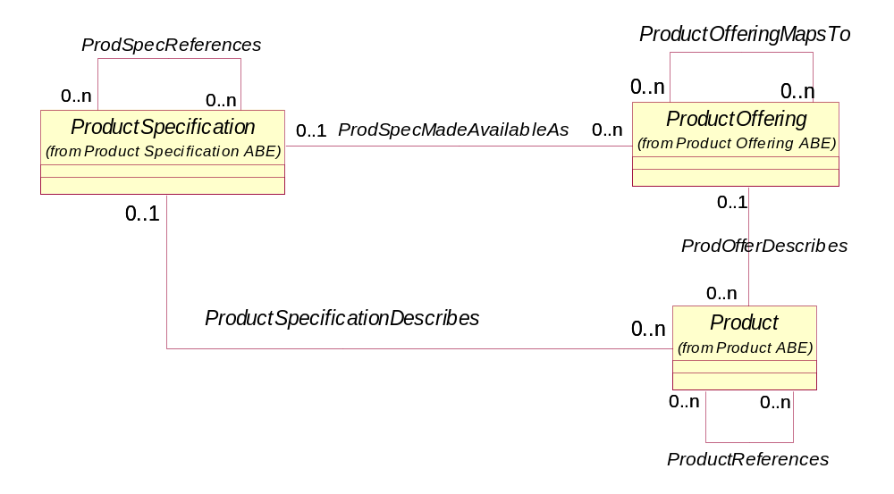
Figure Pr.1 - Primary Product Domain Business Entities

The Product domain is essential to the overall SID model. Customers need to be able to express their needs in plain English in order to determine which ProductOfferings can support their requirements and Service Providers need to be able to match these requirements to technical specifications to realize the ProductOffering. A ProductOffering represents what is externally presented to the market for the market’s use. A ProductOffering can be assembled from a reusable ProductSpecification (sometimes referred to as a product spec). For example, an email specification may be used in a number of different ProductOfferings. For example, on offering may be bundled with a Broadband Internet offering, while another may be offering may represent stand-alone email. A single ProductOffering (called a BundledProductOffering), such as home-based internet service, may represent the aggregation of internet connection, email service, and web hosting ProductOfferings. In the case of the home-base internet service, the ProductOffering may not be related to a ProductSpecification, since it merely represents a grouping of other offerings. A Product represents the subscription of a ProductOffering by a Party playing a PartyRole, such as a Customer. For example, Helen has subscribed to company ABC’s internet ProductOffering.
The association between ProductSpecification and Product allows ProductSpecifications, particularly specifications that are part of a CompositeProductSpecification, which are not marketed as a ProductOffering to be instantiated as Products and related to customers or other involved parties. If this association did not exist, then these specifications would have to be instantiated as offerings. This enables a customer or other party to report problems about a product which was not marketed as an offering or for a product to appear on a bill, and so forth. For example, a composite high speed internet specification may include email and personal web pages atomic specifications which are not instantiated as separate offerings, but must be instantiated as Products. This is also necessary if a ProductSpecification not instantiated as a ProductOffering has configurable characteristics or prices associated with one or more characteristics.
Business entities in the Product domain have a close relationship with business entities in the Service and Resource domains. While Product business entities represent what the market sees of a provider’s offerings, Service and Resource business entities represent the realization of the offerings from a provider’s perspective. For example, a Broadband Internet ProductOffering is realized by two CustomerFacingServices, one is a bandwidth connectivity service to the provider’s network; the second is a virtual connectivity service to the Internet Service Provider. The figure below depicts the relationship among Product, Service, and Resource domain business entities.
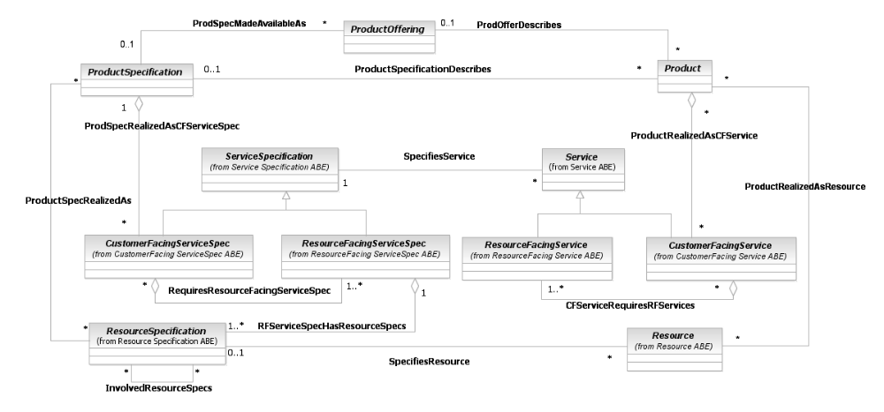
Figure Pr.2 - Product, Service, Resource Domain Relationships

Product/Product Specification
Products are things (tangible or intangible) which enterprises, such as service providers, market, sell or lease to customers to create profit. In a changing world, monopoly telcos with a custom-built portfolio have been replaced by a value network [eTOM] of Suppliers and Service Providers offering complex communications-based Products. The way in which those Products have to be specified is not as simple as it used to be.
A ProductSpecification may be simple (atomic) or a composition of other ProductSpecifications [Fowler-Specification]. A ProductSpecification may represent a tangible object or something intangible provided to customers, realized as a ‘service’ but not to be confused with a network service here. The SID modeling of a CompositeProductSpecification covers both the physical build of more than one ProductSpecification and one or more ProductSpecifications supplied together in a collection. In addition, a CompositeProductSpecification may consist of other ProductSpecifications that give rise to separate ProductOfferings, or of AtomicProductSpecifications that are only for sale as part of a single ProductOffering. ProductSpecifications may also exist within groupings, such as product categories or product lines or product types.
Enterprises may assemble products themselves or they may buy them in from other suppliers (through contractual agreements where the enterprise takes the role of customer - see SID Agreement addendum 1A); or they may do a combination of these things.

Product Specification Example - The "3G Mobile super saver pack"
This is sold via intermediaries ("Dog-n-Bones-R-Us" phone shops) as a "BigTelephone" branded product. Nokia supply the phones and provides a 2-year guarantee. The "BigTelephone" network is used for voice and they supply a phone number and a SIM card. The SMS function is provided by "Best Messaging”, as "BigTelephone" doesn't have an SMS function. The customer signs the contract with "Dog-n-Bones-R-Us" for 2 years with minimum monthly calls and Dog-n-Bones-R-Us bills the customer directly. Dog-n-Bones-R-Us has a separate contract with “Best Messaging” to cover the use of their SMS function. In looking at the detail of ProductSpecification, the following concepts are modeled by the figure below:
- Relationships between different ProductSpecifications for bundling or composite specifications;
- Different attributes for different types of ProductSpecification; for example, some Products the customer can take home with them, others they experience as a Service; for example, one delivered across a network;
- Atomic ProductSpecifications which cannot be broken down further.
- CompositeProductSpecifications which comprise a number of other ProductSpecifications, any of which may provide more than one instance per CompositeProductSpecification.
Note: A ProductSpecification cannot contain itself, but it can reference other ProductSpecifications.
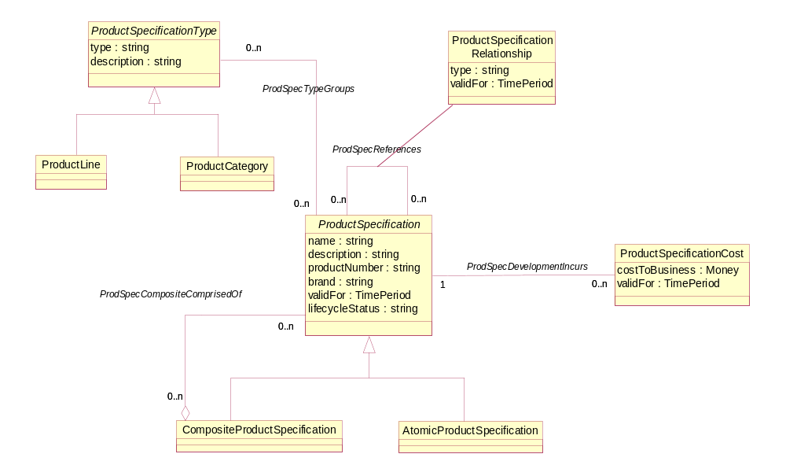
Figure Pr.3 - Product Specification – Basic Entities
In all combinations of products, there must be clearly defined relationships between the products in order to ensure consistency of service to the customer. Some examples of such ProductSpecificationRelationships would be migration, exclusivity, dependency and substitution, as indicated in Figure Pr.3 above.
ProductSpecifications can be grouped based on common characteristics or how the specs are marketed. Groupings are supported by ProductSpecificationType entity and its two subclasses, ProductLine and ProductCategory. For example, a ProductCategory could group all wire-line ProductSpecifications; a ProductLine could group all routers sold to a home-based consumer.
There are also costs associated with creating, developing and maintaining a ProductSpecification; the enterprise records these against the ProductSpecification. There is an implied link between the ProductSpecificationCost entity and business information but this has not been explored in this area of the SID model.

Product Characteristics
ProductSpecifications also have a variety of characteristics, such as a printer’s dimensions, paper capacity, print speed, color, and so forth, and possible values associated with the characteristics. The SID uses ProductSpecification Characteristic and ProductSpecCharacteristicValue to represent the properties for a ProductSpecification [Fowler-Properties] as shown in Figure Pr.4 on the following page. Additional information regarding this pattern can be found in Gb922 Addendum 1R – Root Business Entities.
Characteristics can be grouped into three different types:
- If a characteristic has a discrete value (e.g. color or business coding), it may be derived from a range of allowable values;
- If a characteristic describes the product within a parameter range (e.g. dimension), it may be defined with a ‘high value’ and a ‘low value’ [Fowler-Range] ;
- If a characteristic value is ‘derived’, it will use other parameters in a formula. N.B. There are business rules implied here that require more work in a future phase of the SID Product definition.
Characteristics can also be bundled together into packages by using the ProductSpecCharRelationship. For example, a number of electrical characteristics can be grouped together using an “electrical properties” characteristic that represents a composite of the detailed properties, such as power requirements, plug requirements, and so forth. This entity can also be used for a number of other relationships between characteristics, such as mutually exclusive, inclusive, and so forth.
CharacteristicValues can reference other CharacteristicValues.
As ProductSpecifications are upgraded, and as the market and technology move on, they are subject to version control. If there is a significant change of capabilities, a new ProductSpecification is created; if the existing characteristics are revised in a way that doesn’t affect the ProductOffering, then a new version of the existing ProductSpecification can be created. A ProductSpecification may have a number of different versions that represent minor revisions relating to its characteristics, cost and so forth. A description of these revisions is captured as attributes of the appropriate ProductSpecificationVersion.
When a product is created based on a ProductSpecification (see Product Offering below), the party may also have the option to choose from a set of properties values, such as color, or may be able to choose one from a number of product properties. Where a ProductSpecificationCharacteristic is interchangeable with others in this way, it is modeled as a ConfigurableProductSpecificationCharacteristic.
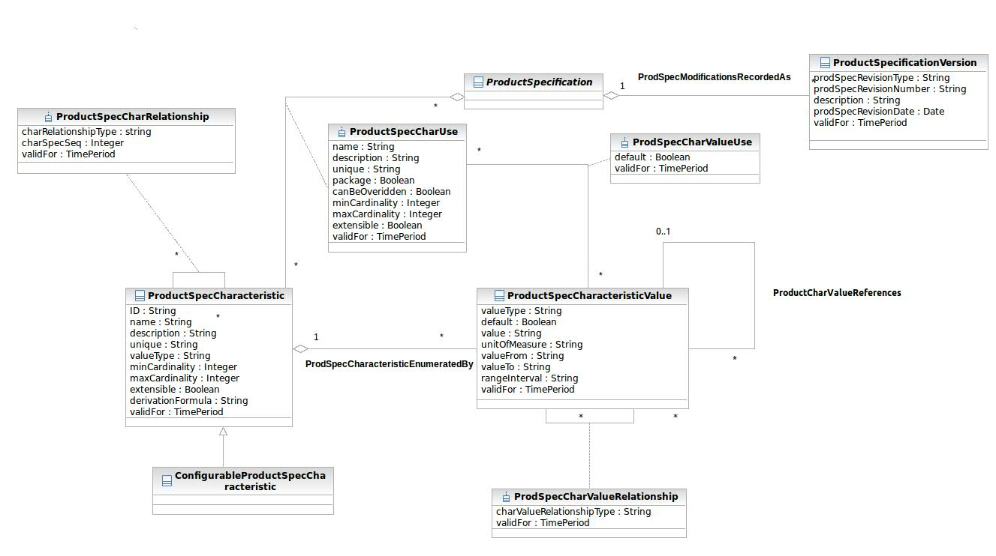
Figure Pr.4 - Product Specification - Characteristics and Versions

Product Characteristic Example – Email ProductSpecification
ProductSpecCharacteristics and their related ProductSpecCharacteristicValues can be used to support features provided by ProductSpecifications. For example, an Email may have a number of features, such as Spam protection, storage, message size, virus scanning and cleaning, mail forwarding, archiving, and so forth.
One way this type of product can be introduced into a model is by sub-classing the Product entity and including each feature as an attribute of a EmailProduct subclass. But this means that each time a new type of product is introduced the information architecture and most likely the application that supports the Product ABE would have to be changed. This is sometimes viewed as a static extension to an information architecture.
A more dynamic approach is to consider these features as instances of a ProductSpecCharacteristic. In this example each feature has a value associated with it. The value associate with Spam protection is “SpamBlock”; the value associated with storage is “1GB”; the value associated with message size is “10BM”; the value associated with virus scanning and cleaning is “included”; the value associated with mail forwarding is “included”; the value associated with archiving is “included. Note that all features or characteristics do not have to have values. For example, user ID and password are features, but the values are assigned when an instance of a Product is created.
The example will be continued in the Product section of this addendum.
There are cases when an instance of a ProductSpecCharacteristic and/or a ProductSpecCharacteristicValue must be translated to a corresponding ServiceSpecCharacteristic and/or a ServiceSpecCharacteristicValue. For example, there may be a ProductSpecCharacteristic that represents the level of service provided as defined by associated Platinum, Gold, and Sliver instances of ProductSpecCharacteristicValues. Each of these values may be translated into specific upload and download bit rates as defined by ServiceSpecCharacteristicValues.
Figure Pr.4a shows the associations between characteristics in the Product and Service domains that enable this translation. Similar translations can be made between characteristics in the Product, Service, and Resource domains as shown in Figure Pr.4b.
Figure Pr.4c shows the association between characteristic use and ProductOffering. This association can be applied, if the ProductOffering determines the applicable characteristic values – e.g. the ProductOffering “silver plan” only allows bandwidths 2000 Mbit and 5000 Mbit out of the values 1000Mbit, 2000Mbit, 5000Mbit and 8000Mbit that are possible for the ProductSpecCharacteristic “bandwidth” in general.

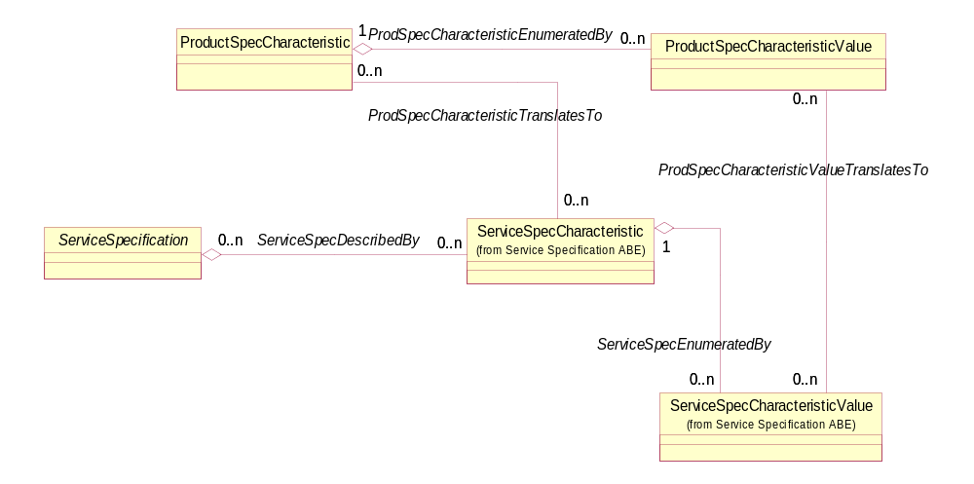
Figure Pr.4a - Product and Service Characteristic Associations

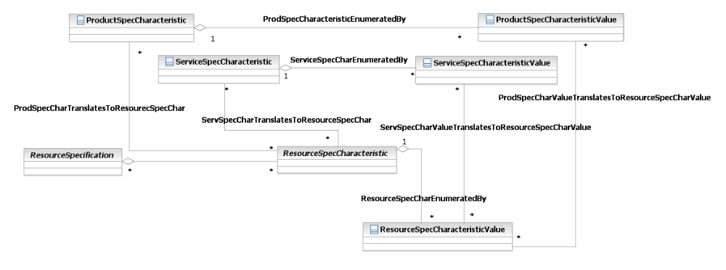
Figure Pr.4b - Product and Resource Characteristic Associations
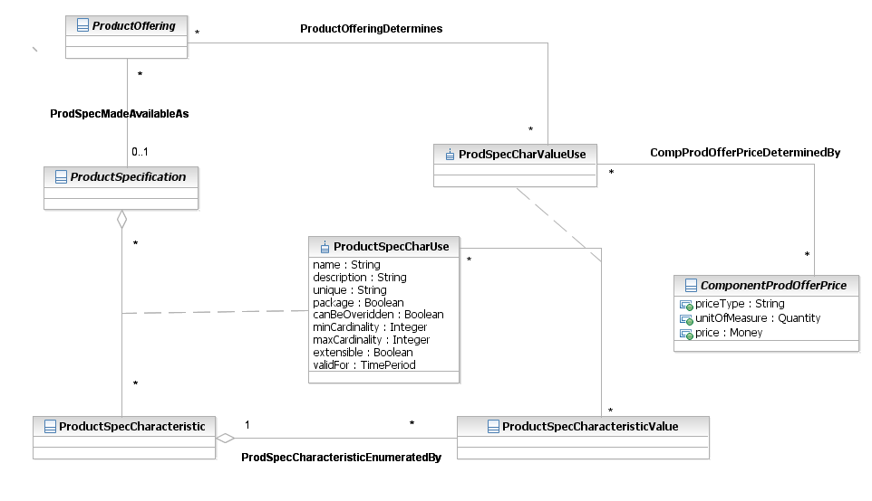
Figure Pr.4c – ProductSpecCharUse ProductOffering Associations

Product/Product Offering
ProductOfferings are targeted at one or more MarketSegments based on the appropriate MarketStrategy. Enterprises create ProductOfferings from ProductSpecifications that have additional market led details applied over a particular period of time. The ProductOffering may also be defined by the Location(s) at which it is available. Locations in the SID model are represented by the Location business entity. Customers do not need to know anything about the detailed ProductSpecification, as the enterprise tailors the ProductOffering to their needs.
Where a business market strategy dictates, ProductOfferings may be bundled together and re-priced as necessary. In addition, the time period for a BundledProductOffering will depend upon those for its component offerings.
An enterprise puts ProducOfferings into the marketplace by developing and maintaining a catalog of ProductOfferings across one or more (market) DistributionChannels, for example a catalog on a website and a glossy brochure have different attributes and may also contain different sets of ProductOfferings. The ProductOfferings set out in the ProductCatalog are ProductSpecifications with additional details that enable a contract to be struck for their sale/purchase. This includes not only the ProductCharacteristics but also other product-dependent details, such as SLA parameters, invoicing and shipping details.
There are typically a number of ProductOfferings associated with a single ProductSpecification, for example to reflect offers to the market for different time periods. In cases where a ProductSpecification’s value to the business is solely as a component part of a CompositeProductSpecification, it does not have a ProductOffering associated with it as it is not be sold on its own. Cases where these items are supplied to the Customer separately as ‘spares’, e.g. under warranty, are covered under Product below.
When Customers select Products from the ProductCatalog, it is the ProductOffering details that they are looking at and which are reflected in what they agree to contractually.
The main ProductOffering entities are shown in Figure Pr.5 below.
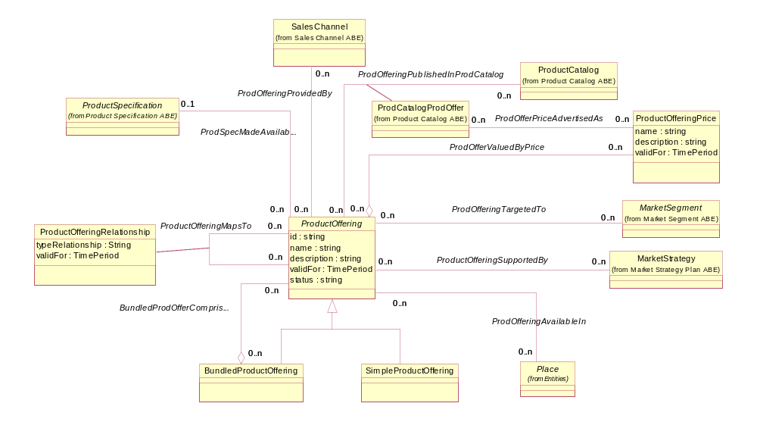
Figure Pr.5 - Product Offering - Basic Entities

Product Offering Example
Smooth Telco normally markets a range of mobile phones as individual items. For a limited period around February 14th, it decides to market, a BundledProductOffering called the Valentine Special, one model with a special red cover, boxed in pairs and accompanied by two champagne glasses. As an added attraction, the deal includes a discount for calls made between the telephone numbers allocated to each pair for a set period. It is a huge success and likely to be repeated the following year when a new ProductOffering with the new valid time period will be created. These ProductOfferings exist side by side with the standard ProductOffering for the mobile phone model when the phones are sold individually.
A question arises with this example. Should the Valentine Special or any BundledProductOffering have an associated ProductSpecification? The current model, shown in Figure Pr.5a, allows for this by representing the association between ProductOffering and ProductSpecification as 0, 1. But this association could lead to a SimpleProductOffering not having a related ProductSpecification.

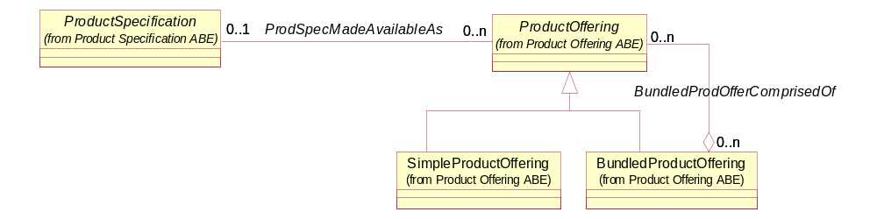
Figure Pr.5a – Product Spec – Product Offering Relationship – Alternative 1
A better representation of this association would be to only relate a SimpleProductOffering to a ProductSpecification as shown in Figure Pr.5b. This association allows a BundledProductOffering to not have a related ProductSpecification while requiring that a SimpleProductOffering has one.

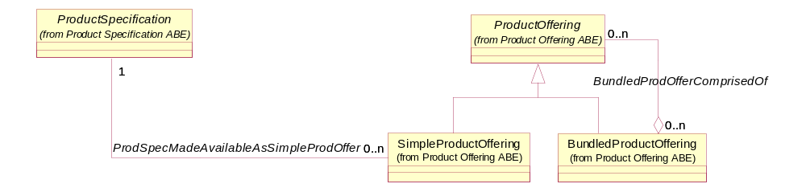
Figure Pr.5b – Product Spec – Product Offering Relationship – Alternative 2

In some cases there are limits to the number of ProductOfferings that can be procured as part of a BundledProductOffering. For example, when subscribing to a mobile telephone service up to five phones can be procured at a special price. The BundledProdOfferOption handle these cases by allowing lower and upper limits to be set for ProductOfferings that comprise a BundledProductOffering as shown in Figure Pr.5c.
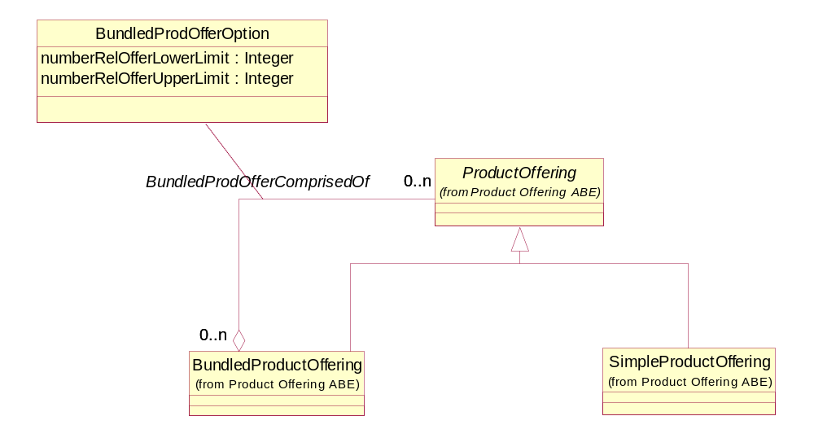
Figure Pr.5c – Bundled Product Offering Option
ProductOfferings that are part of a BundledProductOffering should not be individually procurable. For example, a free SMS offering cannot be procured by itself. A separate SimpleProductOffering would be created to allow for add-on SMS service. From an implementation perspective a rule can be established that does not allow a ProductOffering that is part of a BundledProductOffering to be procured. This rule would check to see if the offering is part of a bundle. Another implementation option would add an attribute to ProductOffering that indicates whether the offering was part of a bundle. The choice of these two options is up to the implementer.

Product Offering Terms
The ProductOffering is primarily the way to position products in the marketplace to create profit; the amount of profit depends upon both the original pricing of the product and the eventual terms of the sales agreements struck for that product offering.
The ProductOfferingPrice is based on both the basic cost to develop and produce products (see Product Specification) and the enterprise’s policy on revenue targets. The pricing policy mechanism is represented in this model by ‘term’. Terms are the conditions under which the ProductOffering is made available to Customers. For example, product finance term is only one of many which may come into play. In addition to a definition of the list price, financial terms may also include acceptable methods of payment for this type of product. As examples of other types of ProductOfferingTerm, the SID model could also include product service term and product shipment term.
When a price has been created, it will appear as the list price for ProductOffering in the ProductCatalog. For a SimpleProductOffering, this may also be the effective list price but, if ProductOfferings are bundled together, the overall price will not necessarily be the combination of component list prices and pricing policy will be required. The Customer will refer to the list price in selecting a Product but, depending upon their relationship with the enterprise making the ProductOffering available, this price may be further revised through discounting, such as for bulk buying, loyalty and so forth. This is modeled through the AgreementTermOrCondition class, shown in Figure Pr.6.
The price, applied for a ProductOffering may also be influenced by the ProductOfferingTerm, the customer selected – e.g. a ProductOffering can be offered with multiple terms, like commitment periods for the contact. A 12 month contract may be cheaper than a contract with a 24 month commitment period.
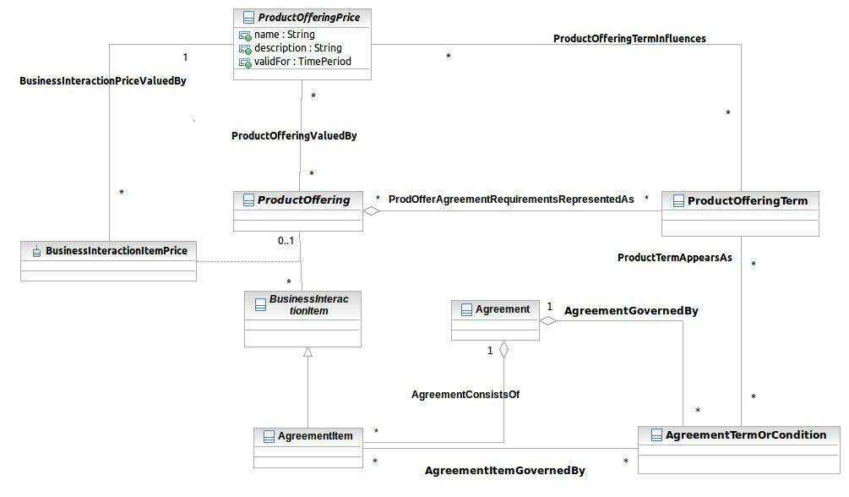
Figure Pr.6 – Product Offering Terms

Product/Product
When A Customer makes a selection, they may also have a number of options to select from. These are associated with the ProductOffering via its association to a ProductSpecification and modeled in ProductCharacteristicValue (see Figure Pr.7 below), which defines the Product delivered to the Customer. The ProductCharacteristicValue comprises the detail of the ProductSpecCharacteristics, such as color, selected by the Customer.
When an enterprise agrees to deliver a Product to a Customer, there is a significant amount of information that needs to be recorded to implement that Product on the provider’s infrastructure or Resources and to activate the Service via with the Product is realized. This is modeled in Product and associated entities below.
A Product bundle in an instantiation of the BundledProductOffering that was used when the customer purchased a product or products from the provider. The ProductBundle holds the information (usually business information) that relates to the specific product offering (such as special prices or commitment terms) in case the customer changes its products and is no more eligible to the special business terms that are attached to the ProductOffering.
If the customer, purchased, as example a triple play bundle (VoIP, High speed internet and Cable TV) and as a result is eligible for a 10$ monthly discount on the Cable TV charges, then this information should be kept so when the customer cancels the VoIP product the TV discount is removed. In the same way the bundle can also have changes on commitment terms and other business terms. The information which BundledProductOffering was used for the purchase is kept in the ProductBundle entity and when a product is cancelled, possibly the ProductBundle may change (to reflect the fact that now the product business terms are derived form a different ProductOffering
A Product component in an instantiation of the SimpleProductOffering that was used when the customer purchased a product or products from the provider. The ProductComponent holds the information (usually business information) that relates to the specific product offering (such as special prices or commitment terms) in case the customer changes its products and is no more eligible to the special business terms that are attached to the ProductOffering.
If the customer, purchased, as example a VoIP line and as a result is eligible for a low recurring charge because of a special promotion in order to penetrate a new city, then this information should be kept so when the customer changes her address the special rate is replaced with a normal monthly rate. In the same way the product component can also have changes on commitment terms and other business terms. The information which SimpleProductOffering was used for the purchase is kept in the ProductComponent entity and when a product is cancelled, possibly the ProductComponent may change (to reflect the fact that now the product business terms are derived from a different ProductOffering
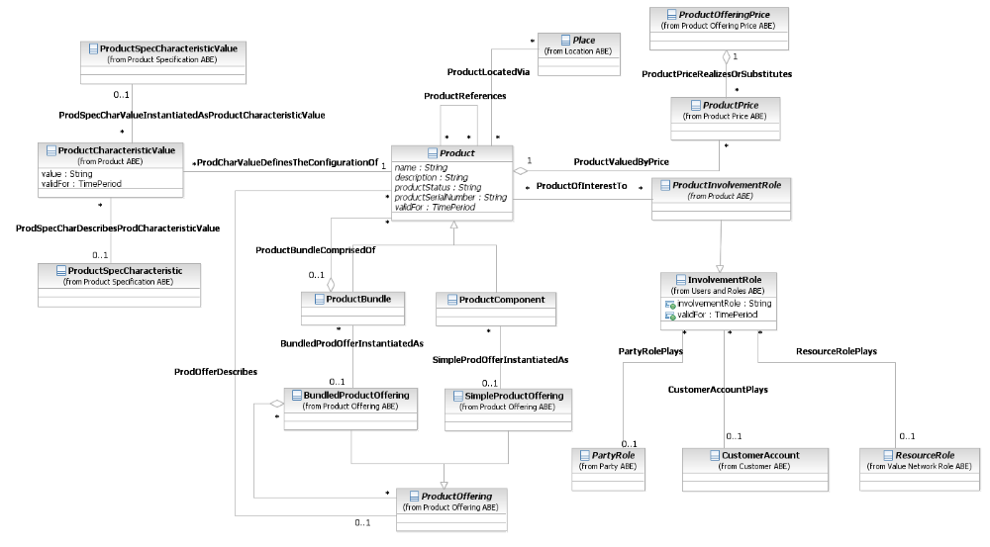
Figure Pr.7 – Product Entities
ProductOfferings may be obtained by the Customer in a number of ways. Two different examples are Products are equipment obtained directly by the Customer, compared to Products that are realized by Services provided across the provider’s Resources and which the Customer accesses and uses, rather than owns. In some cases, a provider may give the Customer access to a Product resident on a third party’s resources. Where a third-party Product is involved, it may be branded/labeled as coming from another provider or it may be re-branded/labeled as the first provider’s Product. Whichever of these is applicable, once the customer is using the Product, we are talking about a realization of the Product Offering that is based on a standard Product Specification.
The price someone pays, the rate charged for usage of a Product, discounts and allowances related to a Product are represented by the ProductPrice entity. ProductPrice is a separate SID ABE that is further detailed in a later section of this addendum.
We are also talking about the user/recipient that is entitled to use the Product. This is represented by a PartyRole, which is in turn related to the Product using the Product Involvement Role business entity and it’s involvementRole derived attribute.
The Product that the Customer has obtained is not truly realized until it is in use. The user may be the signatory to an agreement, particularly if the Customer is an Individual, but they may also be an agent or Employee of the Customer where that Customer is a large Organization.
Finally, a CustomerAccount may also be involved with a Product. For example, the role could be the CustomerAccount that pays for a Product; the CustomerAccount to which a Product was charged; the CustomerAccount associated with ordering a Product. This is represented by the CustomerAccountProductInvolvement business entity.

ProductCharacteristicValue Example – Email Product
The features of a Product to which a Customer subscribes are represented by ProductCharacteristicValues. In the email example, the features Spam protection, storage, message size, virus scanning and cleaning, mail forwarding, and archiving all have fixed values. These values are sometimes referred to as invariant characteristics. User name and password are variant characteristics in that the values are specified for each Product. The values may come from a list of permitted values specified in ProductSpecCharacteristicValues or may be simply be entered Product by Product. User name and password are examples of the latter. In the example, user name may take on a value of “GSmith” and password may take on a value of “mom001”.

Product/Product Offering/Product Offering Price
The price of a ProductOffering or a bundle may be simple or quite complex. A simple price could be the charge associated with the monthly rental of a cable modem. Or, a price could encompass many different components. A typical introductory wireless offering, for example, will have an activation cost, a monthly cost, a number of free minutes, a cost for extra minutes, and some sort of promotional component. It might also include a corporate discount for business users. Each of these elements must be described in order to paint an accurate picture of the overall price charged for any ProductOffering.
This part of the SID model presents a set of components that can be combined to offer a complete and accurate description of the price charged for an offering. A secondary consideration is to define those components in such a way that they can be readily implemented in a typical billing system.
A ProductOffering may have any number of prices, each of which is made up of a single component or a composite of a number of components. The Product Offering Price model employs the composite/component modeling pattern used throughout the SID to represent simple and complex prices, as illustrated in the figure below.
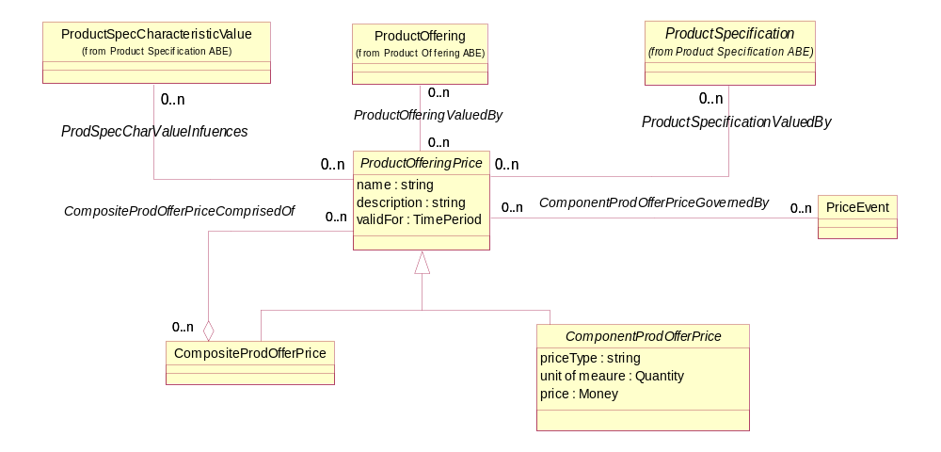
Figure Pr.8 – Product Offering Price
ProductOfferingPrices can be dependent upon a ProductSpecCharacteristicValue as shown in the figure above. For example, a provider may offer a photo printing service for mobile phone pictures. The price may depend on the size of the photo or the type of finish of the photo; $.20 for a 3 by 5, plain finish, $.25 for a 5 by 7, plain finish, and so forth. The values associated with the size (3 by 5, 5 by 7, and so forth) and finish (plain, glossy, matte, and so forth) can be stored as ProductSpecCharacteristicValues.
ProductOfferingPrice, which may have a complex structure (composition) and involve complex billing / rating capabilities, could be defined in a ”pricing catalog” as a reusable component pre-defined for given ProductSpecs and then selected for use by the ProductOffering to be published in the ProductCatalog.
The ProductSpecification to ProductOfferingPrice association allows the use of the ProductOfferingPrice entity as a “pricing specification component” defined for ProductSpecifications. For a given ProductSpecification, the “pricing catalog” may contain several pricing component candidates for use. When defining the ProductOffering, pre-defined pricing components (ProductOfferingPrices) for ProductSpecs, can be selected to value the ProductOffering. Existing pricing components may also be individually altered or new ones defined for a given ProductOffering.
Figure Pr.8 also shows an association between ProductOfferingPrice and PriceEvent. The PriceEvent business entity represents an occurrence (happening) or schedule that triggers the creation of a billing charge for a ProductOffering. For example, a PriceEvent instance may represent the end of a month when monthly recurring billing charges are created. In some cases, the creation of a charge associated with a ProductOfferingPrice may be triggered by multiple events. For example, a penalty (ProductOfferingPrice) may be triggered by over- or under-usage of a service. Under- and over-usage are represented as two separate PriceEvent entity instances.

The price paid for a ProductOffering may appear in ProductCatalogs, may be offered via certain DistributionChannels, or in certain GeographicAreas. The figure below depicts the associations a ProductOfferingPrice has with these business entities.
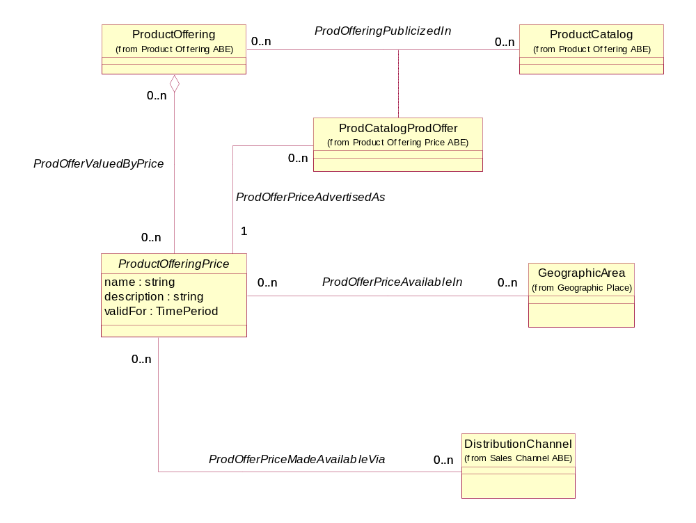
Figure Pr.9 – Product Offering Price’s Associations With Other Business Entities
Each component of a ProductOfferingPrice can take on one of two forms. A component may represent the amount charged to a party playing a role. For example, a monthly internet connection fee. Or, a component may represent an adjustment that will be made to the amount charged. For example, an installation allowance of $49.95 to the first month’s bill, which offsets an installation charge. The figure below depicts the two types of ComponentProdOfferPrices.
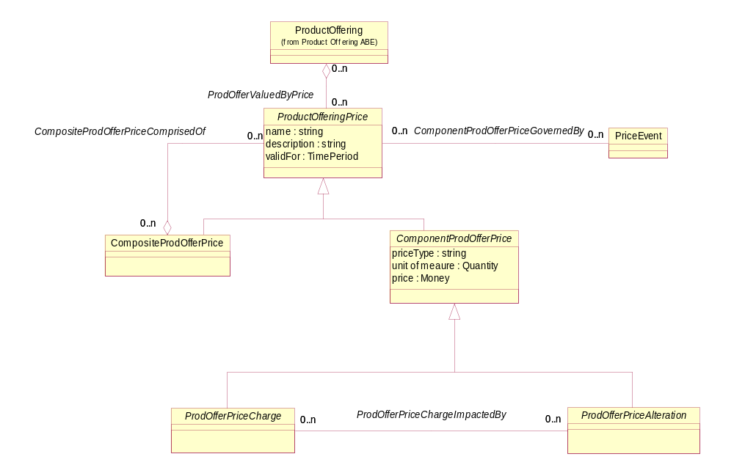
Figure Pr.10 – Product Offering Price Components
Charges incurred for a ProductOffering can take many different forms, such as
- Recurring Charge – A recurring charge is levied repeatedly. It has a period, such as monthly, quarterly, or yearly. An example would be a monthly charge for long distance.
- One Time Charge – A one time charge is levied once. An example is the cost of a cell phone handset.
- Fee – A particular type of one time charge, such as an activation fee or installation fee.
- Usage – A charge levied for usage, based on measuring events. This model distinguishes between simple usage and usage where the charge is described by a tariff.
- Simple Usage – Simple usage describes a rate where the charge is the same for all events. A 10 cents a minute for long distance plan is one example.
- Tariff Usage – Tariff usage describes a rate where there are different charges for different types of events. This could include plans, which have different prices for evening minutes and anytime minutes. This usage aggregates a number of simple usages.
- Alternate Price Charge – A price charged in lieu of another price. For example, purchasing two of a single product offering may result in a discounted price for both.
A representative set of these types of charges is shown in the figure below. The set by no means represents the complete set of charges that can be incurred for a product offering. The Product Price Model provides a framework into which other types of charges can easily fit.
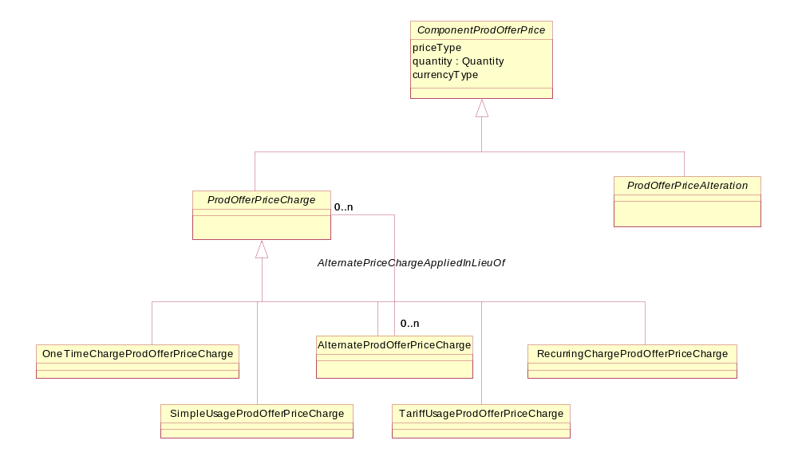
Figure Pr.11 – Types of Product Offering Price Charges
Similarly, alterations made to charge(s) incurred for a ProductOffering can take many different forms, such as
- Discount – A discount is a reduction in price. It could be a flat fee such as 10 dollars or a percentage, such as 50% off. A discount always applies to, and thus is associated with, one or more other ProdOfferPriceComponents. So a discount would be 10 dollars off the installation fee or 50% off the per-minute rate.
- Allowance – An allowance is a number of something allowed before charging begins. 300 free minutes per month is an example of an allowance. Another example would be a minimum monthly charge, where a ten dollar per month recurring charge would be combined with a ten dollar allowance. The ProductOfferingPrice contains attributes that describe what the allowed unit is (i.e. minutes, dollars), the number of units as well as the period (per month, per call). Note: the unit and number are represented by the composite attribute quantity.
A representative set of these types of allowances is shown in the figure below. The set by no means represents the complete set of allowances for a product offering. The Product Price Model provides a framework into which other types of allowances can, like charges, easily fit.
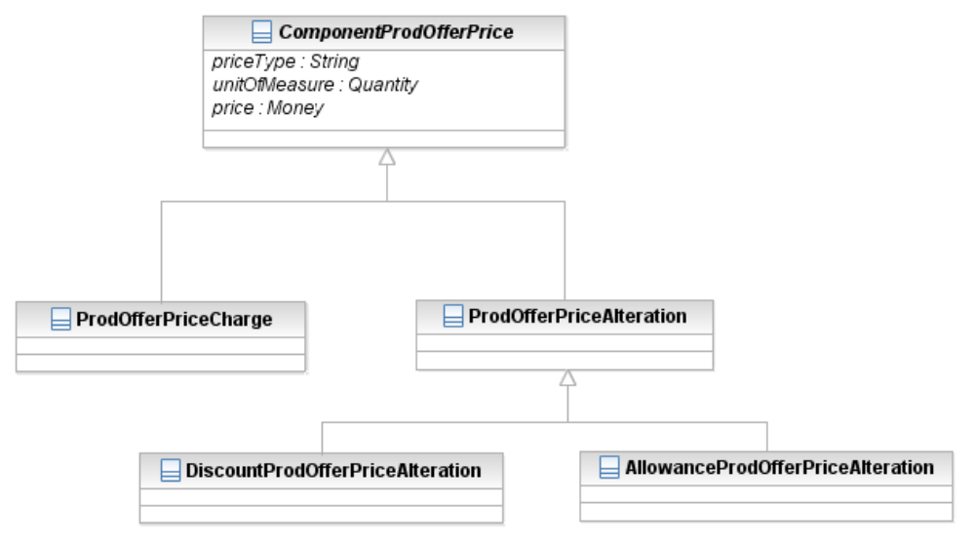
Figure Pr.12 – Types of Product Offering Price Adjustments
Putting charges and allowances in a single example provides a complete view of a ProductOfferingPrice. A simple wireless plan includes a 75 dollar phone, a 50 dollar activation fee, a 20 dollar monthly charge, 250 free local minutes per month, 10 cents a minute for additional minutes, and 25 cents a minute long distance. The components are
- A 75 dollar One Time Charge (charge)
- A 50 dollar Fee (charge)
- A 20 dollar Recurring Charge per month (charge)
- A Tariff Usage comprising a 10 cent per minute Simple Usage and a 25 cent per minute Simple Usage (charge)
- An Allowance of 250 minutes (adjustment)
Adding on to the example, suppose Sue is an employee of a company, that has a volume discount agreement with the service provider. The agreement is to waive the installation fee and provide a 20 percent discount on local minutes. This would manifest itself as:
- A composite price that associated the 50 dollar Discount with the 50 dollar Fee
- A composite price that associated the 20 percent Discount with the 10 cent per minute Simple Usage

The complete ProductOfferingPrice model is shown in the figure below.
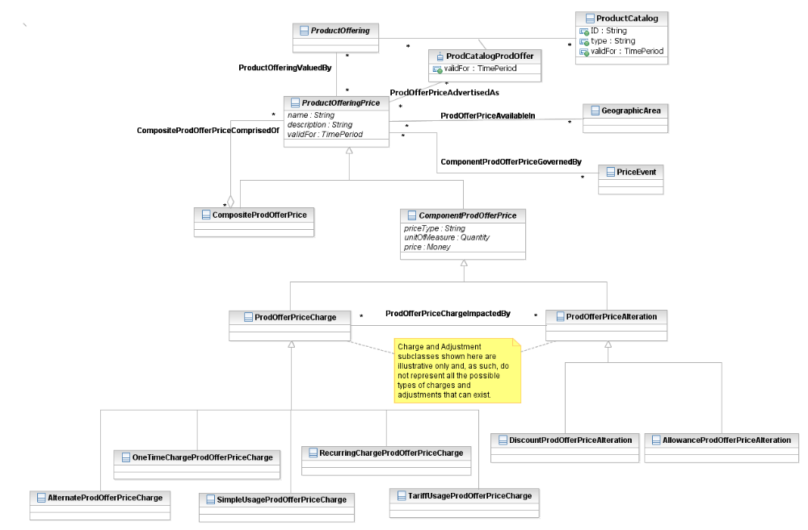
Figure Pr.13 – Complete Product Offer Price Model

Product/Product Offering/Product Offering Price Rule
The price of a Product is often dependent upon the procurement of another Product for a particular price, another ProductOffering, or another ProductOffering of the same type. For example, a Family Plan mobile phone service includes two free phones. Within this offer, the cell phones are associated with a zero value price. In another offering, there may be a choice of some number of phone accessories that are offered at no or greatly reduced cost.
Both of these offers require the employment of a policy rule that governs the price of the accessories. In the first case, the PolicyRule is used to ensure that two of the phones are provided at zero cost, as long as the terms of a particular ProductOffering are met. In the second case, the PolicyRule defines which accessories can be purchased at what price.
Price rules such as these require another set of business entities in addition to the more basic rules set forth in Product Offering Price and its components.
The intent of this part of the SID model is to present a model that can be used to define simple cross-product price policy rules. This will be done by extending the SID Policy model, as documented in [1-POL]. As such, the model presented here is not intended to provide for elaborate pricing schemes. In these cases, it may be necessary to employ business entities as yet to be defined within the policy model or that may require the development of code specific to the rule. Still, it is significant that the existing SID Policy model, whose primary use case was to support the definition of networking policies, can be easily extended to meet the needs of a very different domain.
The figure below shows the relationship that a price rule has with ProductOfferings and with Policy.

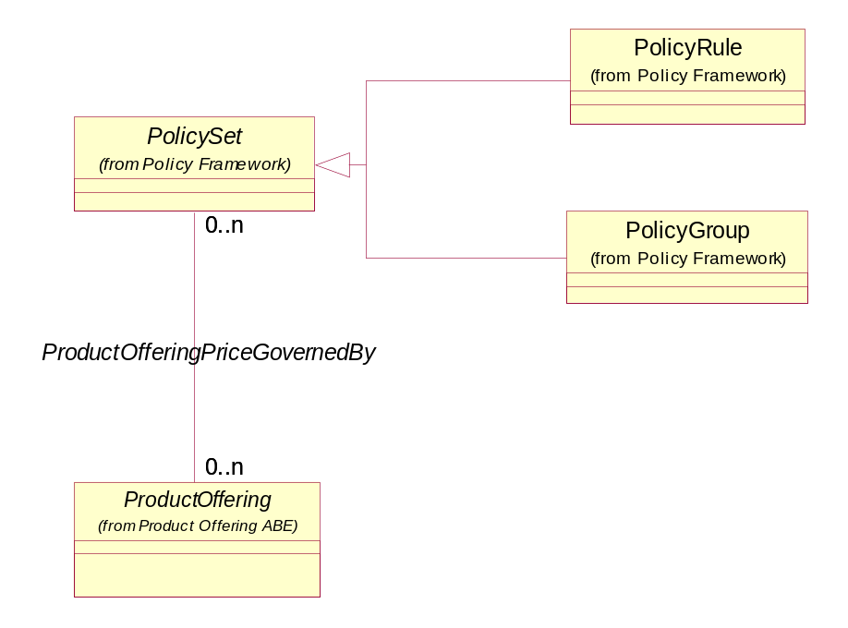
Figure Pr.14 – Product Offering Price Governed By Policy

The price of a ProductOffering is governed by a PolicySet. The PolicySet may be a single PolicyRule or a PolicyGroup which ties together a number of PolicyRules. The use of both single rules and grouped rules will be explained via examples.
For example, suppose there is a ProductOffering called “Subscribe for a Year, Get Two Accessories Free”. The free accessories can be selected from list of available accessories. In this example, the accessories are a cell phone re-charger, hands-free holder, cell phone wallet, or earphone and microphone. Included in the offering are the cell phone service and the accessories. There is an instance of PolicySet rule related to this offering.
All PolicyRules consist of three types of components, which define the semantics of the rule. (Please see [1-POL] for more information.) This is shown in the figure below.
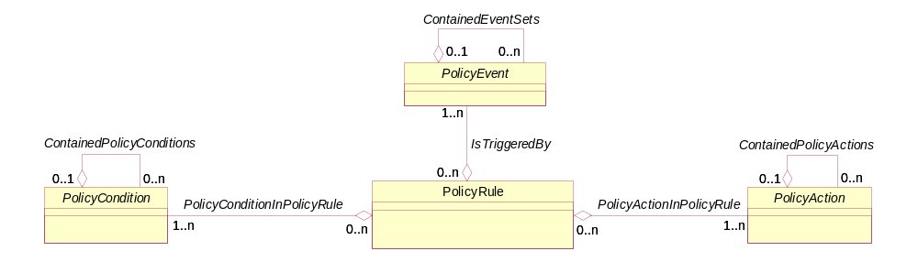
Figure Pr.15 Policy Rule Components
The semantics of a rule that governs the price of a ProductOffering builds upon this generic structure. The first component is a PolicyEvent, which triggers the evaluation of the PolicyRule. The second defines the PolicyCondition(s) of the PolicyRule being evaluated. The third defines the PolicyAction(s) that are taken if the PolicyCondition(s) of the rule are met. In the “Subscribe for a Year” offering:
The PolicyEvent is the time of purchase
The PolicyCondition is the particular type of cell phone service offering being purchased (since different pricing rules could be attached to different types of cell phone offerings)
The PolicyAction taken as a result of this particular condition being true is that two of the accessories are free.
Note that a PolicyRule aggregates at least one or more PolicyConditions and at least one or more PolicyActions. (Addendum 1-POL defines a general set of semantics that specify how a PolicyRule is evaluated, including the concepts of rule priority and a decision strategy for combining different PolicyConditions.) In addition, there are other constructs, such as a Policy Group, that can aggregate multiple PolicyRules. This enables more complex pricing rules to be developed by defining appropriate subclasses of PolicyRule, PolicyCondition and PolicyAction. Note that PolicyCondition and PolicyAction both use the composite pattern; please see Addendum 1-POL for more information.
Next, a subclass of PolicyConditionAtomic, called ProdOfferPriceCondition will be defined. Its purpose is to add semantics that determine if one or more PolicyAction(s) should be taken.
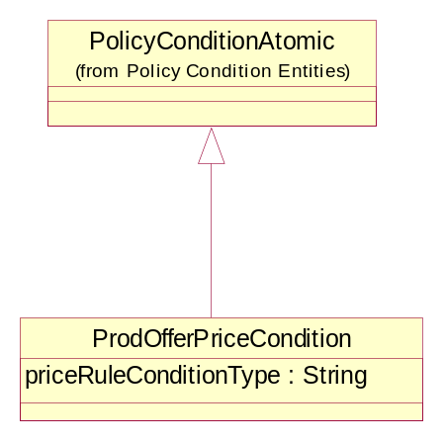
Figure Pr.16 – Product Offering Price Condition

The attributes of the above policy subclasses do not completely define the semantics of the condition governing the price of a ProductOffering. To complete the definition of the condition, associations to other business entities specify what must be procured or what must have been procured. The related business entity may be a ProductOffering, a similar type of product, or a product at a particular price. In the “Subscriber for a Year” offering example, the ProdOfferPriceCondition instance is associated to the cell phone service instance of ProductOffering.
In the example, the condition type (which is represented by the priceRuleConditionType attribute) is “buy”. Other values for the type will be described in later examples.
The condition is fully defined using the PolicyStatement entities in the Policy model, as shown in the figure below.
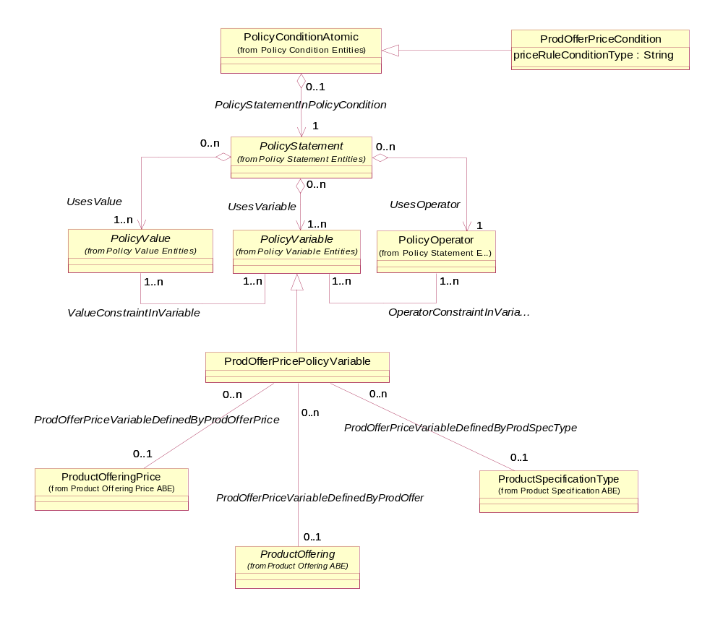
Figure Pr.17 –Product Price Condition and Policy Statement
The complete PolicyStatement for this condition is: The ProdOfferPolicyVariable is the quantity ordered for the cell phone instance of ProductOffering. The PolicyOperator is “equals”. The PolicyValue is 1. The condition is interpreted as “if one instance of the cell phone is ordered” then some action will be taken. The power of representing a PolicyStatement in this way is that each part of the PolicyCondition is object-oriented and reusable. This sets the stage for representing more complex pricing rule conditions.
Satisfying a condition may govern the entire price of an offering or one or more of the components of the offering. In this example, it governs the entire price of the offering for the accessories. That is, two can be chosen for free.
The action to take is defined by ProdOfferPriceAction, which is a subclass of PolicyAction. These entities are shown in the figure below, along with the association between PolicyAction and PolicyStatement.
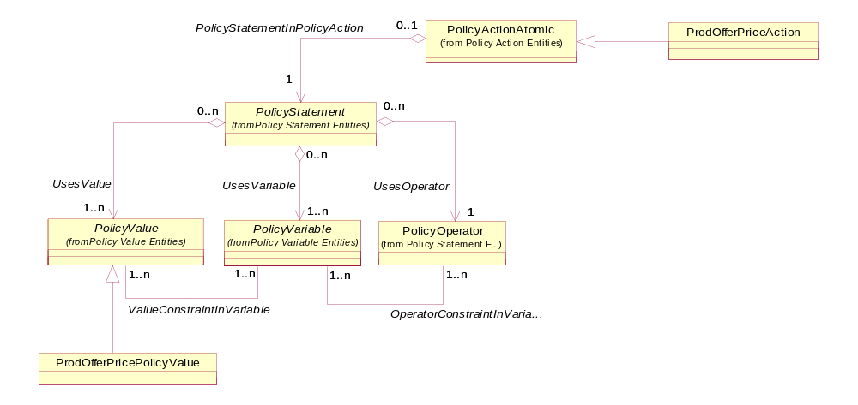
Figure Pr.18 – Product Offer Price Action and Policy Statement
The complete PolicyStatement for this action is: The Prod Offer Policy Variable is the quantity for the accessories. The Policy Operator is “equal to or less than”. The PolicyValue is “2”. The action is interpreted as “set the quantity allowed for free accessories to no more than 2”.
There is one missing variable in this action. The missing variable is the price (0) to be paid for the accessories and what accessories are free. This variable is expressed using an association between ProdOfferPriceAction and ProductOfferingPrice. Instances of this association specify the ProductOffering and the Price associated with the action. In this example, the instance of the action would be associated with instances of zero value prices for cell phone re-charger, hands-free holder, cell phone wallet, and earphone/microphone. The figure below shows this association.

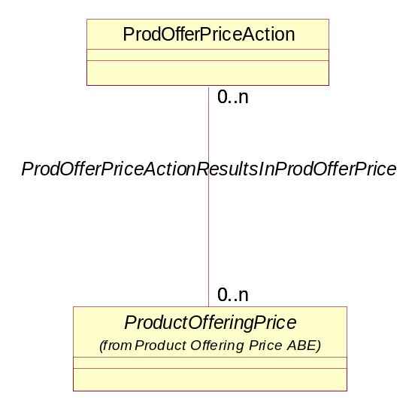
Figure Pr.19 – Product Offer Price Action and Product Offering Price

The figure below shows the instances of all business entities that define product price rules within the context of the model for the Subscribe for a year with Free Accessories example.

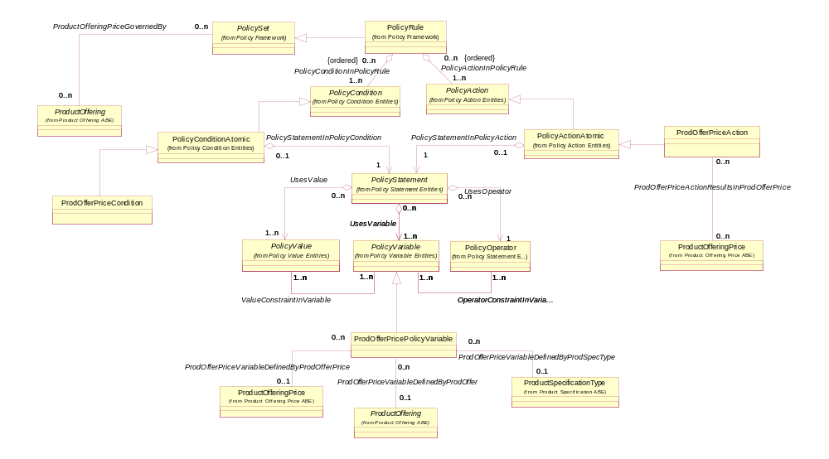
Subscribe for a Year
Cellular service
Re-charger
Hands-free holder
Cell phone wallet
Earphone and microphone
Subscribe for a Year Rule
Subscribe for a Year Condition
Buy:
1 Cellular service (PolicyVariable related to Subscribe for a Year Prod Offer)
Subscribe for a Year Action
Get:
1 to 2 accessories free (related to each accessory Prod Offer Price)
Re-charger zero price
Hands-free holder zero price
Cell phone wallet zero price
Earphone and microphone zero price
Figure Pr.20 – Subscribe for a Year with Free Accessories
It is not always necessary to relate an instance of ProductOffering to a price rule. In some cases, obtaining a product offering at a specific price may enable the procurement of other product(s) for a particular price. This price may be represented by an instance of an entire ProductOfferingPrice or may be represented by an instance of a ProductOfferingPriceComponent.
For example, suppose that if a customer subscribes to wireless Local Area Network (WLAN) access at the regular price, the customer is entitled to a discount on their DSL internet access or a discount on their cellular phone service.
Handling this rule requires the use of a PolicyGroup. The PolicyGroup subclass of PolicySet brings together multiple PolicyRules and applies them as an atomic set of rules. This enables different PolicyRules to be defined to serve stand-alone needs, yet be reused in other applications. The first rule checks to see if the price of the ordered WLAN access is equal to or greater than the regular price. If this condition is true, then an event is generated that triggers an option that allows the user to select one of the two items offered at a discount. The second rule, also triggered by this event, determines which choice of options has been made and sets the price to the discounted price.

Expressed as a PolicySet, the rules’ conditions and actions are:
User chooses WLAN access in GUI screen #1. This selection triggers an event, which fires the following rule:
PolicyRule 1: WLAN_Access_Sale
ON EVENT customer_choice DO
IF (order >= min_price) THEN
SET Event_WLAN_Access_Options to TRUE
ENDIF
ENDEVENT
Setting the Event to TRUE initiates the display of GUI screen #2. The user chooses an option, which is recorded in a choice variable, which initiates the following nested PolicyRule (remember, a PolicyRule can contain a PolicyRule):
PolicyRule 2: Determine_Option_Choice
ON EVENT WLAN_Access_Options DO
IF (choice == DSL) THEN
SET Business_Interaction_Item_Price = Discounted_DSL_Price
ENDIF
IF (choice == Cell) THEN
SET Business_Interaction_Item_Price = Discounted_Cell_Price
ENDIF
ENDEVENT

To support the action associated to this complex rule, another extension is added to the Policy model. The value of the discounted price is not a fixed value, but one associated with a specific Product Offering Price. This can be modeled by first creating a subclass of PolicyValues, called ProdOfferPricePolicyValue, and then creating an association between ProdOfferPricePolicyValue and ProductOfferingPrice, as shown in the figure below.
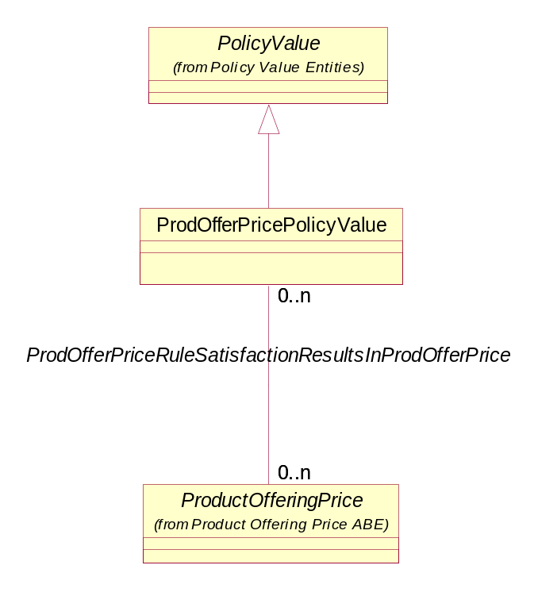
Figure Pr.21 – Product Offer Price Policy Value
Note: In all the pricing rule examples, if a condition is not TRUE, then nothing happens.
The figure below shows the instances of these business entities for the WLAN example within the context of the model.

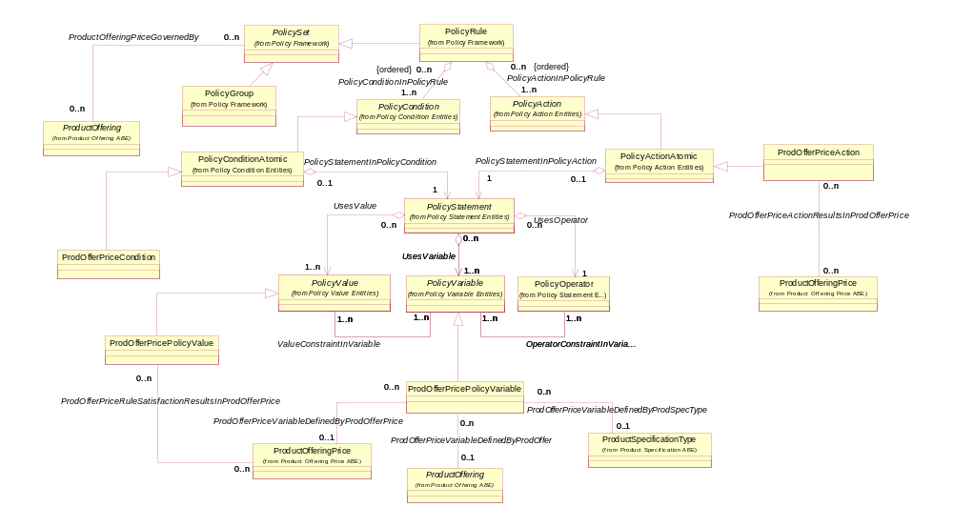
WLAN Discount Rule
WLAN Discount Condition – Rule 1
Buy:
1 WLAN access – regular price PolicyVariable related to WLAN access regular price)

WLAN Discount Condition – Rule 2
Choice = DSL – Condition 1
Choice = Cell – Condition 2
WLAN Discount Action Rule 1
Set Access Options to TRUE

WLAN Discount Action Rule 2
Get:
1 DSL internet access discount (related to DSL internet discount) - Action 1
1 Cellular phone service discount (related to Cell phone service discount) - Action 2
WLAN access regular price
DSL internet discount
Cellular phone service discount

Rule 1 – Checks to see if price of WLAN qualifies for discount
Rule 2 – Checks to see which discounted item is selected
Figure Pr.22 – WLAN Subscription with Discounts
The next example is a ProductOffering that combines ordering DSL service with one of several types of routers that offer varying functionality. If both the DSL service and either of the routers are purchased, a subscriber (customer) gets a fifty-dollar rebate on the router of choice (we’ll keep it simple and assume that there are only two types of routers to choose from in this example). In this case the ProductOffering instance, “Buy DSL Service and Router, Get $50 Back!”, has as its product offering components, the DSL service and one of two different routers.
Since the price rule involves purchasing two products, a composite PolicyCondition is employed. The model for representing a composite PolicyCondition follows the Composite/Component pattern used throughout the SID model and in the Product domain, so the PolicyConditionComposite class is not shown here.
The price rule has six condition instances, three atomic condition instances and three composite condition instances (the composite instances aggregate two or more atomic instances). The first atomic condition’s ProdOfferPolicyVariable is related to the quantity for the DSL service. The PolicyOperator is “equals”. The PolicyValue is “1”. The second atomic condition’s ProdOfferPolicyVariable is related to the quantity for one type of router. The PolicyOperator is “equals”. The PolicyValue is “1”. The third atomic condition’s ProdOfferPolicyVariable is related to the quantity for the other type of router. The Policy Operator is “equals”. The Policy Value is “1”.
In order to represent the completed composite PolicyCondition, two of the composite conditions join the DSL service with the routers using an “and” Boolean operator. The third composite joins these two composites using an “or” Boolean operator. This entire condition is: (DSL service “and” router #1) or (DSL service “and” router #2).
The ProdOfferPriceAction is related to the $50 rebate for the DSL service. The action is: “Set allowed quantity for the DSL service rebate equal to 1”. The description of the price indicates it is a rebate on the purchased router. The figure below shows the instances of these business entities within the context of the model.
Buy DSL Service!
DSL Service
Wired Router
Wireless Router
DSL Rebate Rule
DSL Rebate Rule Conditions
Buy:
1 DSL service (PolicyVariable related to DSL Service Prod Offer) and
1 wired router (PolicyVariable related to Wired Router Prod Offer) or
1DSL service (PolicyVariable related to DLS Service Prod Offer) and
1 wireless router (PolicyVariable related to Wireless Router Prod Offer)
DSL service $50 rebate on router

DSL Rebate Rule Action
Get:
1 DSL service router rebate (rel to DSL service rebate)

Figure Pr.23 – DSL Service and Router Rebate
The next example shows a price rule that allows a discount on like products. Suppose that for any mobile phone accessory purchased at the regular price, one whose price is equal to or less than the accessory purchased at the regular price may be purchased at a 50% discount. In this case the ProductOfferingPrices represent regular and discounted prices. In this example, rule condition types of “buy” and “price” are used. The “buy” condition specifies that two accessories must be obtained. The “price” condition specifies the relationship between the prices of the two accessories; the price of the discounted accessory must be less than or equal to the price of the accessory obtained at the regular price.
Of course, the policy model can’t represent all of the behavior implied in this example; application code would have to be written to interpret a rule such as this. For example, when a customer purchases a cell phone wallet (an accessory), the application would have to check to see if there are price rules associated with compatible accessories. It would find the “buy one get one at 50%” rule. The customer could be queried to see if a purchase of a second accessory is of interest. The figure below shows the instances of these business entities within the context of the model.
Mobile Phone Accessory
Accessory Regular Price
Accessory Discount Price
Buy One Accessory, Get Another at 50% Off
50% off Conditions:
Buy: 2 accessories (PolicyVariable related to Mobile Phone Accessory) and
Price of 1 discounted accessory PolicyVariable (related tot Accessory Discount Price) <=
Price of 1 regular priced accessory (PolicyVariable related to Accessory Regular Price)
50% off Rule Action:
Get:
1 accessory at discount price (related to Accessory Discount Price
Figure Pr.24 – Price Rules for Like Products

The ProductOffering price rules described here can also be used to represent many other types of pricing rules. Some additional examples include:
- Defining conditions based on the prior procurement of a product offering possibly within a certain time period
- Defining quantity based discounts
- Defining quantity-tier based discounts
As can be seen by the examples provided here, this simple model provides a variety of pricing options that can be used by a provider.
Prices are often associated with ProductOfferings involved in BusinessInteractions, such as CustomerOrders, Agreements, RequestsForQuotes, and so forth. Additionally, these prices are sometimes influenced by rules that govern ProductOfferingPrices. Figure Pr.25, below, shows these associations.

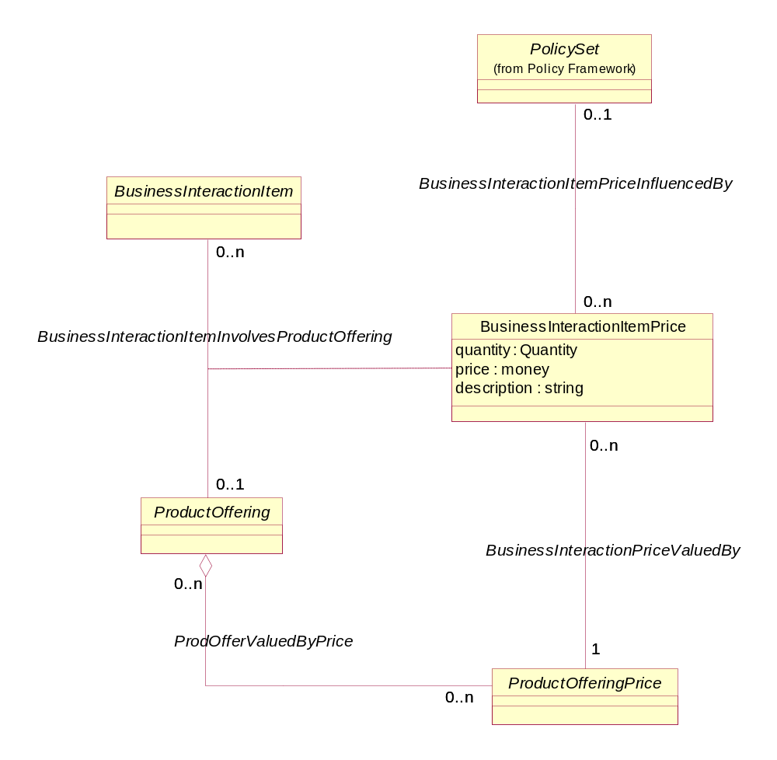
Figure Pr.25 – Product Offering Prices Associations With Business Interactions

Product/Product Offering/Pricing Logic Algorithm
The PricingLogicAlgorithm (PLA) entity is designed to support the link to a “black box” that is used for rating events. This is the common case for usage rating but this scenario exists also for rating recurring and one-time charges. In such cases the price is not kept in the catalog nor the rules used to determine the price, only the interface to the black box algorithm is modeled and prices are determined by sending the relevant information using the interface, and getting the rate for the event from this black box algorithm. The PricingLogicAlgorithm and its related entities (especially PricingLogicAlgorithmSpec) are designed to model flexible interface definition in order to provide maximal reuse for existing rating algorithms.

Use Case 1: Linear Call Rating
This use case describes one of the simplest possible rating algorithms for call usage events – a linear rating according to call duration. Such an algorithm may require two parameters in order to be instantiated (just an example):
Rate for a minute
Interval for calculating the rate
This algorithm is charging the call based on call duration in intervals according to the second parameter, so if the interval is 5 seconds, a call between 1 and 5 seconds would be charged for 5 seconds, between 6 and 10 seconds would be charged for 10 seconds and so on. In any case the charge will be for a whole number multiplication of 5 seconds.
The following table illustrates such an algorithm – in all cases the rate is $0.30/minute
Call Duration (secs) | Interval (secs) | Call charged for (secs) | Call cost ($)
20 | 5 | 20 | 0.10
20 | 6 | 24 | 0.12
32 | 6 | 36 | 0.18
32 | 10 | 40 | 0.20
32 | 16 | 32 | 0.16
32 | 20 | 40 | 0.20

Using such an algorithm, instantiation of $.12/minute and interval of 5 seconds will always yield a whole number (in cents) and so $.10/minute and 6 seconds interval. On the other hand a rate of $.07/minute and 1 second interval will almost always yield charges with fractions of cents.
Note that in order to calculate the rate you need to set the rate and interval (which is something that is communicated to the customer and typically done during the customer order), and also pass the Usage event details (Usage class in SID) to the rating algorithm (in order to get event relates data, in our use case only the call duration is important).

Use case2: Time and Customer Information Sensitive Algorithm
This use case describes a more complex algorithm in which there are more parameters which are also more complex. Let’s assume we have an algorithm which charges differently for peak and off-peak calls (and can also split the charge of a call that starts peak and ends off-peak or vice versa). Let’s also assume that the rate per minute is different according to customer type (student, normal, VIP)
In order to instantiate such an algorithm we need to set the following parameters:
- Define which time is peak and which is off-peak (we can have one instantiation in which peak is 10-15 Mon-Thu and another one which is 8-18 Mon-Thu)
- Define the rate per combination of customer type and peak/off-peak. Such a matrix could look like

 | Peak | Off-Peak
Student | $.15/min | $.10/min
Normal | $.20/min | $.12/min
VIP | $.10/min | $0/min (free)
Note – this matrix is not necessarily two dimensional in some cases it has more dimensions (the rate depends on time (peak/off-peal), customer type and local/long distance rates)
More complex usage rating algorithm may include tiers ($.12/minute for first minute, $.10/minute for minutes 2-5 and $.08/minutes for more than 5 minutes) in which case the parameters become more complex.
What we try to model in the SID is the interface to these algorithms. The algorithms can be implemented in many different ways by different systems but we need to model the interface to them with all the parameters in order to be able to use these algorithms in our systems
PricingLogicAlgorithm is a classic case of the EntitySpec/Entity pattern as described in the above use cases. This is described in the following diagram
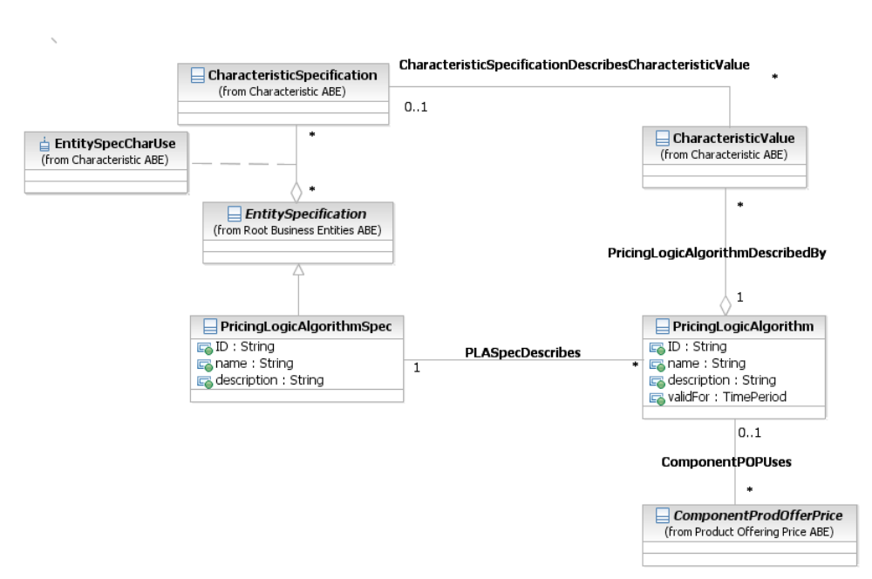
Figure Pr.26 – Pricing Logic Algorithm basic entities
This diagram uses the generic EntitySpec/Entity pattern so that PricingLogicAlgorithmSpec automatically gets the characteristics that are associated with EntitySpecification. The PricingLogicAlgorithm is an instantiation of PricingLogicAlgorithmSpec after the parameters were set, so in the case of the simple use case above it represents linear usage rating, $0.10/minute with 6 seconds interval. The parameters ($0.10 and 6) are characteristic values
The next diagram shows the association of the PricingLogicAlgorithmSpec to the other sources of parameters to the algorithm (not only PLA characteristics, but also ProductSpecCharacteritics and UsageSpecCharacteristics)
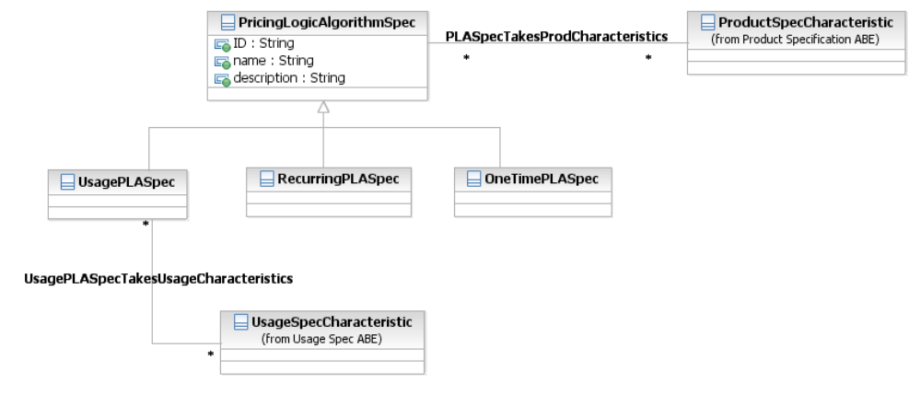
Figure Pr.27 – Types of PLA Spec and associations to different Spec Characteristics
This diagram completes the definition of PricingLogicAlgorithmSpec and together with Figure Pr.26 it shows all the sources of parameters which are needed to be defined and associated with the PLA spec in order to create an instance (PricingLogicAlgorithm) which has enough information (with Product and Usage information) in order to rate an event.
The next diagram shows how the PricingLogicAlgorithm uses the ProductCharacteristicValue and the Usage record information and associated UsageCharacteristicValue in order to generate a charge out of an event:
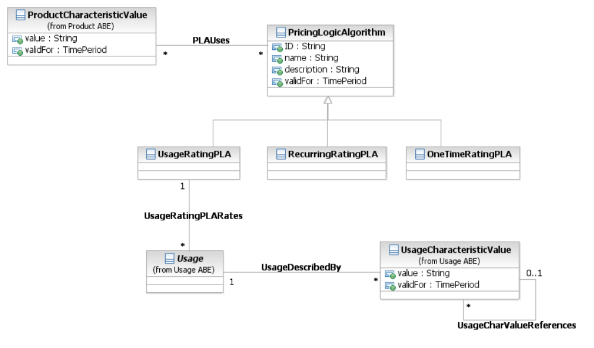
Figure Pr.28 – Types of Pricing Logic Algorithms and associations to different characteristic values
The following diagram shows the entire picture – how PLA Spec is defined, how PLA is instantiated, and the association to the possible event related characteristic values.
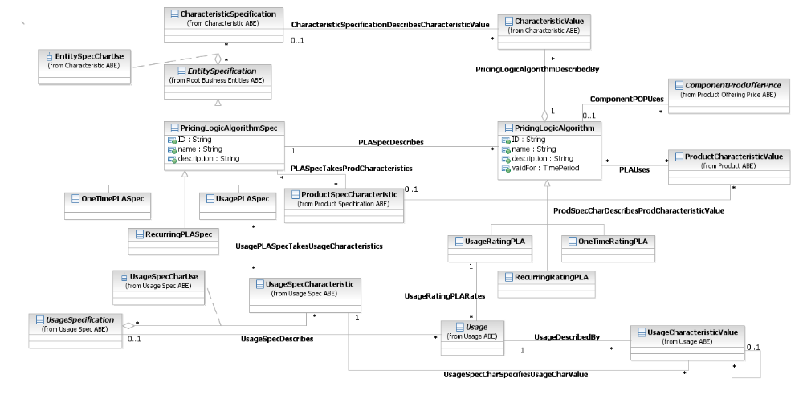
Figure Pr.29 – Pricing Logic Algorithm full picture

Modeling Matrices
As described in the use cases, a typical implementation of ProcingLogicAlgorithm requires parameters which are multi-dimensional matrices, in which each dimension is defined by the valid values for a specific characteristic. For example, if we have PLA which rates events based on customer type, we can have one instantiation in which customer type is either residential or commercial (and in which case the size of the dimension of the matrix is 2) and in other instantiation the customer type can be student, normal and senior citizen (in this case the size of the dimension is 3).

Modeling the matrix
As described above, the matrices are defined by the possible valid values of characteristics (from ProductSpec or PLASpec), so we can define the matrix itself using the self association CharacteristicSpecificationReferences. This was correct if CharacteristicValue and ProductCharacteristicValue were the same entity. Since currently these entities do not share a common base class there is a need to create some more complex modeling in order to create a matrix.
Note: MatrixSpecDimention is associated to a single entity either ProductSpecCharacteristic or CharacteristicSpecification – but it is always associated to one (association to none or both entities is not allowed, so this class (MatrixSpecDimention) is a specification for a single dimension of the matrix.
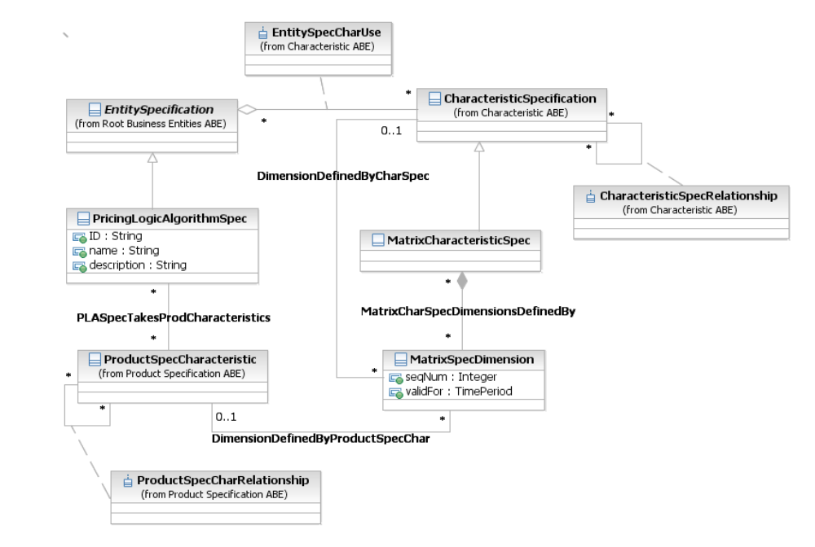
Figure Pr.30 – Modeling a matrix with dimensions based on PLASpec and ProductSpec Characteristics

Modeling the Matrix Values
We can look at each value (cell) of n dimensional matrix as n+1-tupple of Characteristic Values, one describes the cell value and the other n are the indices of the dimensions (not numeric indices, but the values are themselves indices). Since each index can be either CharacteristicValue or ProductCharacteristicValue we cannot use the self association for the CharacteristcValue class. Instead we define the class MatrixCharValueIndex which associate either CharacteristcValue or ProductCharacteristicValue. In addition we define a class which is derived from CharacteristicValue which represent a matrix value and includes associations to the matrix dimensions (defined by either CharacteristicValue or ProductCharacteristicValue) and aggregates the matrix cell values which are derived from CharValue (to include the value) and associated with the MatrixCharValueIndex for the indices of this cell value.
This is the matrix value diagram
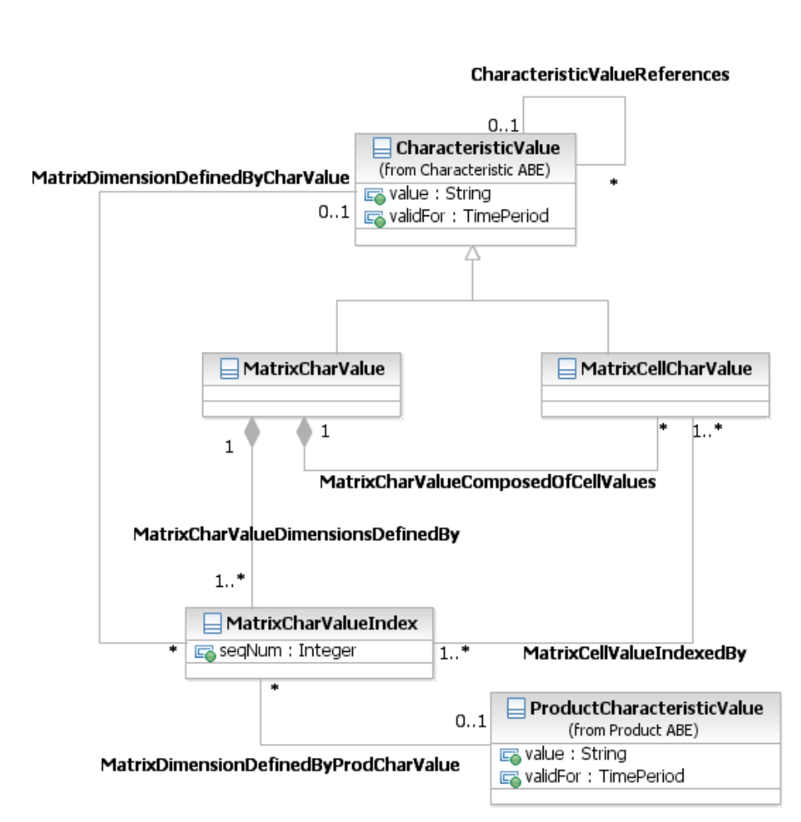
Figure Pr.31 – Modeling matrix values

Product/Product/Product Price
When an enterprise agrees to deliver a product to a customer, a price is associated with the Product that has to be recorded. The figure below presents the set of entities that are used to hold this information. The ProductPrice represents an amount, usually of money, that represents the actual price paid by a customer for a purchase, a rent or a lease of a Product. The ProductPrice is associated with the Product entity and the ProductOfferingPrice entity. The structure of ProductPrice subclasses resembles the structure of ProductOfferingPrice subclasses.

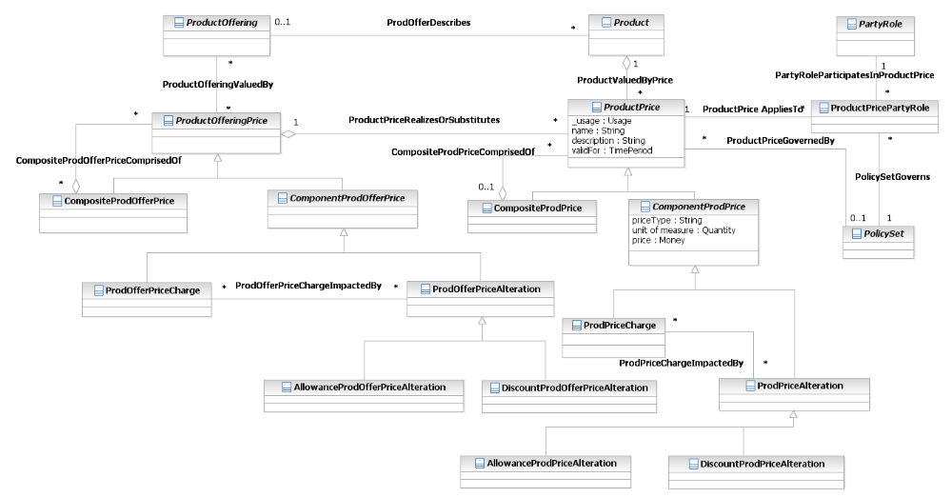
Figure Pr.32 – Product Price

Product/Product Usage
Put simply, usage is how much service is used, by whom is it used, where and when is it used and circumstances under which it is used. Normally, when a usage event occurs, it is stored in a network element, for instance in a switch, router, gateway or in an application system. Resources (applications, network and computing capabilities) usually store usage data in proprietary formats that are not understood by the billing system. Depending on the polling strategy, a mediation engine connects to resources, collects usage data and formats them into a format that is understood by the billing system. Output of a mediation engine are Usage Detail Records (UDRs). Examples of UDRs are Call Detail Records (CDRs – used to describe usage details of voice call services) and Internet Protocol Detail Records (IPDRs – used to describe usage details of Internet Protocol based services). In this document we will use the Usage abstract business entity to describe any resource-, service- or product-based usage that the billing system can read, update and process.

Usage
Figures Pr.27 and Pr.27a show business entities that are used to model usage. The model shown below is generic; particular usage models should define their own usage business entities by extending the Usage entity.
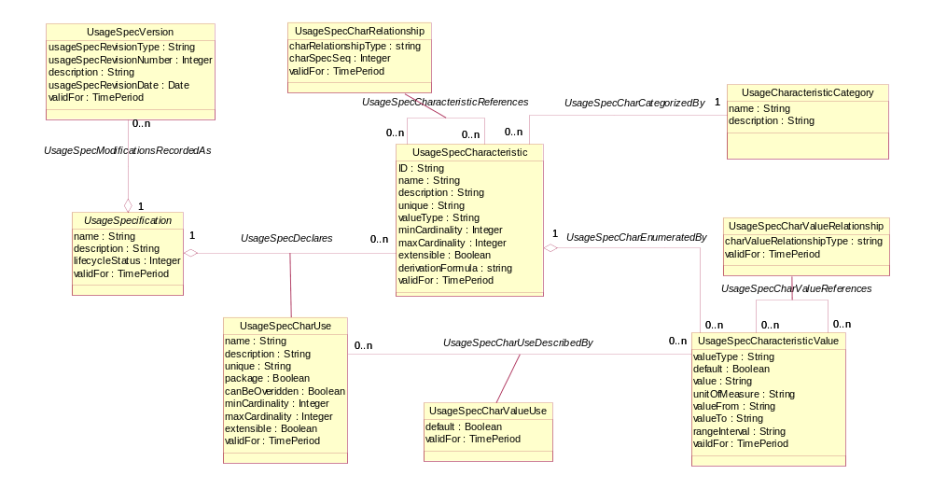
Figure Pr.33 – Usage Specification
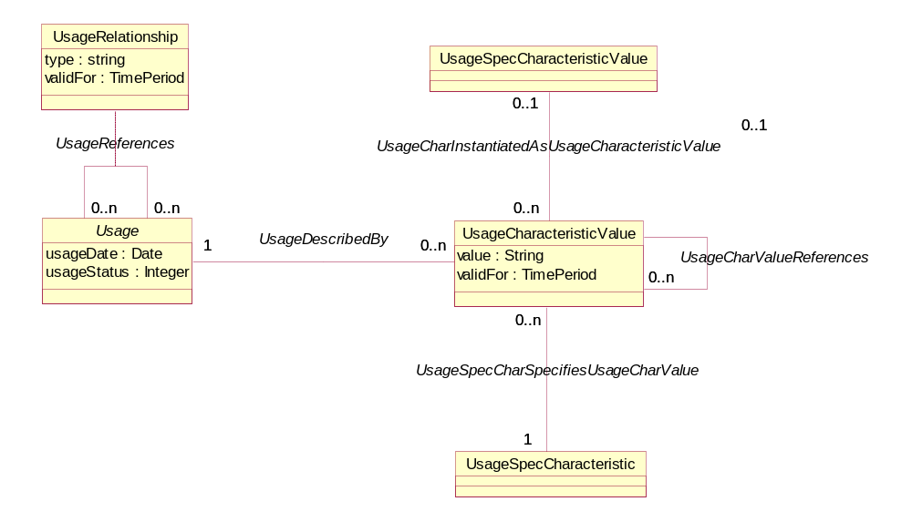
Figure Pr.34 - Usage
The UsageSpecification class describes a type of usage. In order to achieve a flexible structure of the UsageSpecification all its attributes are stored as characteristics. Alternatively, different types of usage could be modeled as sub-classes of the Usage entities (Usage, ProductUsage, ServiceUsage, ResourceUsage).
The UsageSpecification is comprised of UsageSpecCharacteristics that define all characteristics (attributes) known by a particular type of usage. Each characteristic is described by its name, category, presence and a set of allowed values.
Name defines a unique name that identifies the characteristic.
Category defines one of the high-level aspects of the usage information described by the characteristic. These categories are commonly referred to as: Who, When, What, Where, and Why.
Presence defines whether the characteristic is required or optional.
The set of allowed values is modeled with UsageSpecCharacteristicValue. This class describes all allowed values or value ranges.
Additional information regarding the CharacteristicSpecification/CharactersticValue pattern can be found in GB922 Addendum 1R – Root Business Entities.
The Usage class represents a usage event. It is described by the UsageSpecification and comprised of UsageCharacteristicValues that hold data attributes of a usage specified by UsageSpecCharacteristics. The UsageCharacteristic can either store its value in the usageCharValue property or reference predefined UsageSpecCharacteristicValue.
The UsageSpecification entity has the following subclasses:
- ServiceUsageSpec (that represents a service usage);
- ResourceUsageSpec (that represents a resource usage);
- ProductUsageSpec (that represents a product usage).

Product Usage
A Product is realized as one or more Service(s) and/or Resource(s). A Product is created by instantiating a ProductOffering and adding it to a specific customer account. In order to charge a service (or a resource) usage, the service (or resource) has to be associated to a product.
Figure Pr.28 shows relationships among the ProductSpecification, the Product, the ProductUsageSpec and the ProductUsage ABEs. The ProductUsageSpec is defined for the certain ProductSpecification. As the ProductSpecification has 2 subclasses (the AtomicProductSpecification and the CompositeProductSpecification), the ProductUsageSpec needs 2 subclasses as well: the AtomicProductUsageSpec and the CompositeProductUsageSpec (associated with the AtomicProductSpecification and the CompositeProductSpecification entities respectively).
The ProductUsage describes the usage of an instantiated Product. The Product ABE is extended with the ProductComponent and the ProductBundle business entities. Consequently, the ProductUsage is extended with ProductComponentUsage and the ProductBundleUsage business entities (that are associated with the ProductComponent and the ProductBundle respectively).
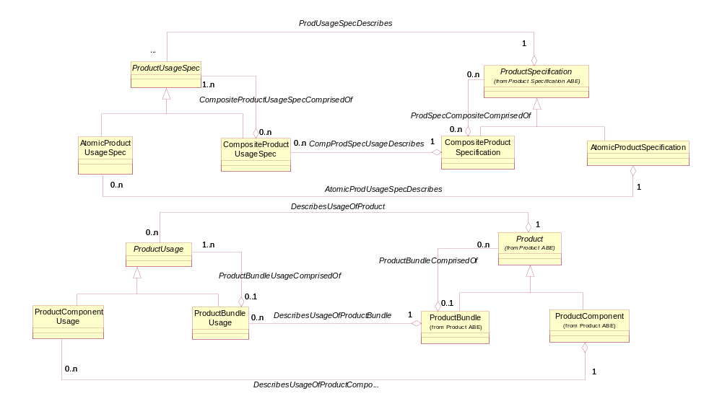
Figure Pr.35 – Product Usage, Part 1
As mentioned above, a product is realized as one or more services and/or resources. Consequently, the ProductUsageSpec business entity has to be associated with the ResourceUsageSpec and the ServiceUsageSpec business entities. The ProductUsage, the ServiceUsage and the ResourceUsage business entities have to reflect these associations as well. The ProductComponentUsage can be associated with either ServiceUsage or ResourceUsage and included in a ProductBundleUsage. These entities and associations are shown on the figure Pr.29.
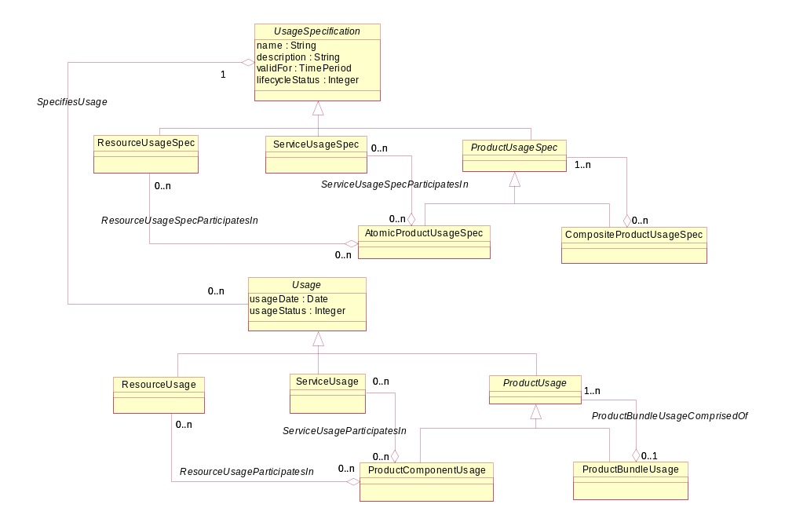
Figure Pr.36 – Product Usage, Part 2

Product/Product Catalog
From SID v12.5 release onwards, the ProductCatalog documentation and respective entity definition (data dictionary) is available in the SID Catalog guide book.

References
Normative References
UML 1.5 | OMG UML Resource Page http://www.uml.org/
Non Normative References
Fowler-AP | Analysis Patterns – Reusable Object Models  by Martin Fowler ISBN 0-201-89542-0  http://martinfowler.com/articles.html
Fowler-Time | Patterns for things that change with time  http://martinfowler.com/ap2/timeNarrative.html
Fowler-Properties | Dealing with Properties by Martin Fowler  http://www.martinfowler.com/apsupp/properties.pdf
Fowler-Range | Range http://martinfowler.com/ap2/range.html
Fowler-Specification
ACIA | Alliance Common Information Architecture (AT&T, BT & Concert) version 3.1, 15 Dec 2000
eTOM | GB921 version 7.0
Metasolv | Sales & Marketing Business Objects Document for TMF
Larman | Applying UML and Patterns, Second Edition  ISBN 0-13-095004-1  http://www.craiglarman.com/book_applying_2nd/Applying_2nd.htm
Arsanjani | Service Provider: A Domain Pattern and its Business Framework Implementation  http://st-www.cs.uiuc.edu/~plop/plop99/proceedings/Arsanjani/provider3.pdf
Hay | Advanced Data Model Patterns by David Hay
OMG | ftp://ftp.omg.org/pub/docs/formal/00-11-11.pdf
SID | GB922 Addendum 1-POL Policy Business Entity Definitions
SID | GB922 Addendum 1A – Agreement Business Entity Definitions

Business Entity Definitions – Product Specification

ProductSpecification

Business Entity Definition
Business Entity Name | ProductSpecification
Description | A detailed description of a tangible or intangible object made available externally in the form of a ProductOffering to Customers or other Parties playing a PartyRole. A ProductSpecification may consist of other ProductSpecifications supplied together as a collection. Members of the collection may be offered in their own right. ProductSpecifications may also exist within groupings, such as ProductCategories, ProductLines, and ProductTypes.
Sources | ACIA, MetaSolv, Fowler | Cross- References |  |  | Synonyms / Aliases | ProductTemplate, ProductSpec
Related Business Entities | groupedBy ProductCategory  bundledInto CompositeProductSpecification  involvedWith ProductSpecification  incurs ProductSpecCost  madeAvailableToTheMarketAs ProductOffering
Business Rules

Business Entity Attributes Definition
Business Entity Name | ProductSpecification
Attribute Name | Description | Data Type | Characteristics, Permitted Values & Units | Required/  Optional | Notes
name | The name of the product specification. | String |  | Required
description | A narrative that explains in detail what the product spec is. | String |  | Required
productNumber | An identification number assigned to uniquely identify the specification. | String |  | Required
brand/Badge | The manufacturer or trademark of the specification. | String |  | Optional
validFor | The period for which the product specification is valid. | Time Period |  | Required
lifeCycleStatus | The condition of the product specification, such as active, inactive, planned. | String |  | Required

CompositeProductSpecification

Business Entity Definition
Business Entity Name | CompositeProductSpecification
Description | A type of ProductSpecification that is formed by aggregating other ProductSpecifications, which may be Composite or Atomic ProductSpecifications.
Sources |  | Cross- References |  |  | Synonyms / Aliases
Related Business Entities | Subclass of ProductSpecification
Business Rules

AtomicProductSpecification

Business Entity Definition
Business Entity Name | AtomicProduct Specification
Description | A type of ProductSpecification that does not have any subordinate ProductSpecifications, that is, an AtomicProductSpecification is a leaf-level ProductSpecification.
Sources | SID team | Cross- References |  |  | Synonyms / Aliases
Related Business Entities | Subclass of ProductSpecification
Business Rules

ProductSpecificationRelationship

Business Entity Definition
Business Entity Name | ProductSpecificationRelationship
Description | A migration, substitution, dependency, or exclusivity relationship between/among ProductSpecifications.
Sources | ACIA, MetaSolv | Cross- References |  |  | Synonyms / Aliases
Related Business Entities | definesAssociationsBetween ProductSpecification  governedBy ProductSpecificationRelationshipPolicy
Business Rules

Business Entity Attributes Definition
Business Entity Name | ProductSpecificationRelationship
Attribute Name | Description | Data Type | Characteristics, Permitted Values & Units | Required/  Optional | Notes
type | A categorization of the relationship, such as migration, substitution, dependency, exclusivity. | String |  | Required
validFor | The period for which the relationship is applicable. | Time Period |  | Required

ProductSpecificationCost

Business Entity Definition
Business Entity Name | ProductSpecificationCost
Description | A monetary amount assigned to a ProductSpecification that represents the cost to the business to plan, develop, market, and implement the ProductSpecification.
Sources |  | Cross- References |  |  | Synonyms / Aliases
Related Business Entities | assignsCostValueTo ProductSpecification
Business Rules

Business Entity Attributes Definition
Business Entity Name | ProductSpecificationCost
Attribute Name | Description | Data Type | Characteristics, Permitted Values & Units | Required/  Optional | Notes
costToBusiness | The monetary amount that represents the cost. | Money |  | Required
validFor | The period during which the cost is applicable. | Time Period |  | Required

ProductSpecificationType

Business Entity Definition
Business Entity Name | ProductSpecificationType
Description | A classification that groups ProductSpecifications that share common characteristics.
Sources |  | Cross- References |  |  | Synonyms / Aliases
Related Business Entities | categorizes ProductSpecification
Business Rules

Business Entity Attributes Definition
Business Entity Name | ProductSpecificationType
Attribute Name | Description | Data Type | Characteristics, Permitted Values & Units | Required/  Optional | Notes
type | The name of the product specification type. | String |  | Required
description | A narrative that explains in detail what the product spec is. | String |  | Required

ProductCategory

Business Entity Definition
Business Entity Name | ProductCategory
Description | A method used to group a set of ProductSpecifications that are classified together because of common characteristics.
Sources |  | Cross- References |  |  | Synonyms / Aliases | Product Type
Related Business Entities | ProductCategory:  Is a subclass of ProductSpecificationType
Business Rules

ProductLine

Business Entity Definition
Business Entity Name | ProductLine
Description | A method used to group related ProductSpecifications marketed by the same company that differ only in size or style.
Sources |  | Cross- References |  |  | Synonyms / Aliases
Related Business Entities | ProductLine:  Is a subclass of ProductSpecificationType
Business Rules

ProductSpecificationVersion

Business Entity Definition
Business Entity Name | ProductSpecificationVersion
Description | A particular form or variety of a ProductSpecification that is different from others or from the original. The form represents differences in properties that characterize a ProductSpecification, that are not enough to warrant creating a new ProductSpecification.
Sources | ACIA, Fowler | Cross- References |  |  | Synonyms / Aliases
Related Business Entities | refinesTheDefintionOf ProductSpecification  definedBy ProductSpecProperty
Business Rules

Business Entity Attributes Definition
Business Entity Name | ProductSpecificationVersion
Attribute Name | Description | Data Type | Characteristics, Permitted Values & Units | Required/  Optional | Notes
prodSpecRevisionType | The significance of the revision. | String | Major, Minor | Required
prodSpecRevisionNumber | A number that represents the occurrence of the version in the sequence of versions. | String |  | Required
description | A narrative that explains the reason for the version’s creation. | String |  | Optional
prodSpecRevisionDate | The date the version was created. | Date |  | Required
validFor | The period during which the version is applicable. | Time Period |  | Optional

ProductSpecCharacteristic

Business Entity Definition
Business Entity Name | ProductSpecCharacteristic
Description | A characteristic quality or distinctive feature of a ProductSpecification. The characteristic can be take on a discrete value, such as color, can take on a range of values, (for example, sensitivity of 100-240 mV), or can be derived from a formula (for example, usage time (hrs) = 30 – talk time *3). Certain characteristics, such as color, may be configured during the ordering or some other process.
Sources | MetaSolv, Fowler | Cross- References |  |  | Synonyms / Aliases | ProductSpecificationProperty
Related Business Entities | takesOn ProductSpecCharacteristicValue  references ProductSpecificationCharacteristic
Business Rules

Business Entity Attributes Definition
Business Entity Name | ProductSpecCharacteristic
Attribute Name | Description | Data Type | Characteristics, Permitted Values & Units | Required/  Optional | Notes
ID | A unique identifier for the ProductSpecCharacteristic. | String |  | Required
name | A word, term, or phrase by which the characteristic is known and distinguished from characteristics. | String |  | Required
description | A narrative that explains the characteristic. | String |  | Optional
unique | An indicator that specifies if a value is unique for the specification.  Possible values are; "unique while value is in effect" and "unique whether value is in effect or not" | String |  | Optional
valueType | A kind of value that the characteristic can take on, such as numeric, text, and so forth. | String |  | Required, if the specification is not a composite
minCardinality | The minimum number of instances a CharacteristicValue can take on. For example, zero to five phone numbers in a group calling plan, where zero is the value for the minCardinality. | Integer |  | Optional
maxCardinality | The maximum number of instances a CharacteristicValue can take on. For example, zero to five phone numbers in a group calling plan, where five is the value for the maxCardinality. | Integer |  | Optional
extensible | An indicator that specifies that the values for the characteristic can be extended by adding new values when instantiating a characteristic for an Entity. | Boolean |  | Optional
derivationFormula | A rule or principle represented in symbols, numbers, or letters, often in the form of an equation used to derive the value of a characteristic value. | String |  | Optional
validFor | The period of time for which a characteristic is applicable. | Time Period |  | Optional

ConfigurableProductSpecCharacteristic

Business Entity Definition
Business Entity Name | ConfigurableProductSpecCharacteristic
Description | A type of ProductSpecCharacteristic, such as color, whose may be assigned during the ordering or some other process.
Sources | SID Team | Cross- References |  | Synonyms / Aliases | ConfigurableProductSpecProperty
Related Business Entities | subclass of ProductSpecCharacteristic
Business Rules

ProductSpecCharRelationship

Business Entity Definition
Business Entity Name | ProductSpecCharRelationship
Description | An aggregation, migration, substitution, dependency, or exclusivity relationship between/among ServiceSpecCharacteristics.
Sources | MetaSolv Software | Cross- References |  |  | Synonyms / Aliases
Related Business Entities
Business Rules

Business Entity Attributes Definition
Business Entity Name | ProductSpecCharRelationship
Attribute Name | Description | Data Type | Characteristics, Permitted Values & Units | Required/  Optional | Notes
charRelationshipType | A categorization of the relationship, such as aggregation, migration, substitution, dependency, exclusivity. | String |  | Required
charSpecSeq | The order in which a CharacteristicSpecification appears within another CharacteristicSpecification that defines a grouping of CharacteristicSpecifications.  For example, a grouping may represent the name of an individual. The given name is first, the middle name is second, and the last name is third. | Integer |  | Optional
validFor | The period for which the relationship is applicable. | Time Period |  | Optional

ProductSpecCharacteristicValue

Business Entity Definition
Business Entity Name | ProductSpecCharacteristicValue
Description | A number or text that can be assigned to a ProductSpecCharacteristic.
Sources | SID Team | Cross- References |  |  | Synonyms / Aliases | ProductSpecPropertyValue
Related Business Entities | takenOn by ProductSpecCharacteristic  describes ProductSpecification  assignedTo Product  determines ProductOfferingPrice
Business Rules

Business Entity Attributes Definition
Business Entity Name | ProductSpecCharacterisiticValue
Attribute Name | Description | Data Type | Characteristics, Permitted Values & Units | Required/  Optional | Notes
valueType | A kind of value that the characteristic can take on, such as numeric, text, and so forth. | String |  | Optional
default | Indicates if the value is the default value for a characteristic. | Boolean |  | Optional
value | A discrete value that the characteristic can take on. | String |  | Optional | Either value or valueFrom and/or valueTo are required
unitofMeasure | A length, surface, volume, dry measure, liquid measure, money, weight, time, and the like. In general, a determinate quantity or magnitude of the kind designated, taken as a standard of comparison for others of the same kind, in assigning to them numerical values, as 1 foot, 1 yard, 1 mile, 1 square foot. | Text |  | Optional
valueFrom | The low range value that a characteristic can take on. | String |  | Optional
valueTo | The upper range value that a characteristic can take on. | String |  | Optional
rangeInterval | An indicator that specifies the inclusion or exclusion of the valueFrom and valueTo attributes.  Possible values are "open", "closed", "closedBottom" and "closedTop". | String |  | Optional
validFor | The period of time for which a value is applicable. | Time Period |  | Optional

Business Entity Definitions – Product Offering

ProductOffering

Business Entity Definition
Business Entity Name | ProductOffering
Description | The presentation of one or more ProductSpecifications to the marketplace for sale, rental, or lease for a ProductOfferingPrice. A ProductOffering may target one or more MarketSegments, be included in one or more ProductCatalog, presented in support of one or more ProductStrategies, and made available in one or more Places. ProductOffering may represent a simple offering of a single ProductSpecification or could represent a bundling of one or more other ProductOffering.
Sources | ACIA, MetaSolv, | Cross- References |  |  | Synonyms / Aliases
Related Business Entities | makesAvailable ProductSpecification  references ProductOffering  bundleInto BundledProductOffering  soldAt ProductOfferingPrice  targets MarketSegment  appearsIn ProductCatalog  supports marketStrategy  availableIn Place  offeredVia DistributionChannel
Business Rules

Business Entity Attributes Definition
Business Entity Name | ProductOffering
Attribute Name | Description | Data Type | Characteristics, Permitted Values & Units | Required/  Optional | Notes
id | A unique identifier for the ProductOffering. | String |  | Required
name | The name of the offering. | String |  | Required
description | A narrative that explains what the offering is. | String |  | Optional
validFor | The period during which the offering is applicable. | Time Period |  | Required
status | The condition in which the offering exists, such as planned, obsolete, active. | String |  | Required

BundledProductOffering

Business Entity Definition
Business Entity Name | BundledProductOffering
Description | A type of ProductOffering that represents a grouping of ProductOfferings made available to the market. The grouping may consist of other BundledProductOffering(s) or SimpleProductOffering(s).
Sources |  | Cross- References |  |  | Synonyms / Aliases
Related Business Entities | comprised of ProductOffering  Instantiated As ProductBundle
Business Rules

SimpleProductOffering

Business Entity Definition
Business Entity Name | SimpleProductOffering
Description | A type of ProductOffering that does not have any subordinate ProductOfferings, that is, an SimpleProductOffering is a leaf-level ProductOffering.
Sources |  | Cross- References |  |  | Synonyms / Aliases
Related Business Entities | Instantiated As ProductComponent
Business Rules

BundledProdOfferOption

Business Entity Definition
Business Entity Name | BundledProdOfferOption
Description | A set of numbers that specifies the lower and upper limits for a ProductOffering that can be procured as part of the related BundledProductOffering.  Values can range from 0 to unbounded.
Sources | CGI Group Inc. | Cross- References |  |  | Synonyms / Aliases
Related Business Entities
Business Rules

Business Entity Attributes Definition
Business Entity Name | BundledProdOfferOption
Attribute Name | Description | Data Type | Characteristics, Permitted Values & Units | Required/  Optional | Notes
numberRelOfferLowerLimit | The lower limit of related ProductOfferings that can be procured as part of the BundledProductOffering. | Integer | 0 to unbounded | Required
numberRelOfferUpperLimit | The upper limit of related ProductOfferings that can be procured as part of the BundledProductOffering. | Integer | 0 to unbounded | Required

ProductOfferingTerm

Business Entity Definition
Business Entity Name | ProductOfferingTerm
Description | A condition under which a ProductOffering is made available to Customers. ProductOfferingTerm include ProductOfferingFinancialTerm, which includes such things as acceptable methods of payment, ShipmentTerm, and ServiceTerm.
Sources |  | Cross- References |  |  | Synonyms / Aliases
Related Business Entities | specifiesConditionsGoverning ProductOffering  appearsAs AgreementTermOrCondition
Business Rules

DistributionChannel

Business Entity Definition
Business Entity Name | DistributionChannel
Description | A distribution channel is the organization or entity by which a product catalog is presented to a customer.
Sources |  | Cross- References |  |  | Synonyms / Aliases
Related Business Entities | ProductOffering, GeographicArea
Business Rules

Business Entity Attributes Definition
Business Entity Name | DistributionChannel
Attribute Name | Description | Data Type | Characteristics, Permitted Values & Units | Required/  Optional | Notes
ID | A unique identifier for the DistributionChannel. | String |  | Required
Name | The name of the DistributionChannel. | String |  | Required

DistChannelProdOffer

Business Entity Definition
Business Entity Name | DistChannelProdOffer
Description | The ability of a distribution channel to distribute a product that has been ordered (as a product offering).
Sources |  | Cross- References |  |  | Synonyms / Aliases
Related Business Entities | ProductOffering:  DistributionOf ProductOffering in GeographicArea
Business Rules

Business Entity Attributes Definition
Business Entity Name | DistChannelProdOffer
Attribute Name | Description | Data Type | Characteristics, Permitted Values & Units | Required/  Optional | Notes
validFor | The period of time for which a value is applicable. | Time Period |  | Optional

Business Entity Definitions - Product

Product

Business Entity Definition
Business Entity Name | Product
Description | A ProductOffering procured by a Customer, or other interested Party playing a PartyRole, appearing as a BusinessInteractionItem, which could take the form of an Agreement. ProductSpecificationCharacteristic(s) in part define the Product. A Product is realized as one or more Service(s) and/or Resource(s).
Sources |  | Cross- References |  |  | Synonyms / Aliases
Related Business Entities | createdUsing ProductOffering  involves BusinessParticipant  appearsAs BusinessInteractionItem  definedBy ProductCharacteristic  realizedAs Service  realizedAs Resource
Business Rules

Business Entity Attributes Definition
Business Entity Name | Product
Attribute Name | Description | Data Type | Characteristics, Permitted Values & Units | Required/  Optional | Notes
Name | A word, term, or phrase by which the product is known and distinguished from other products. | String |  | Optional
Description | An explanation of what the product is. | String |  | Optional
productSerialNumber | A set of identifying characters and/or numbers assigned to, and usually marked on, each of a series of identical products. | String |  | Optional
productStatus | The condition of the product, such as planned, designed, activated, disconnected. | String |  | Required
validFor | The period during which the product is applicable. | Time Period |  | Required

ProductBundle

Business Entity Definition
Business Entity Name | ProductBundle
Description | A ProductBundle is an instantiation of BundledProductOffering which keeps the business terms under which the customer purchased the product bundle (using a BundledProductOffering).
Sources |  | Cross- References |  |  | Synonyms / Aliases
Related Business Entities | comprisedOf Product
Business Rules

ProductComponent

Business Entity Definition
Business Entity Name | ProductComponent
Description | A ProductComponent is an instantiation of SimpleProductOffering which keeps the business terms under which the customer purchased the product (using a SimpleProductOffering).
Sources |  | Cross- References |  |  | Synonyms / Aliases
Related Business Entities
Business Rules

ProductCharacteristicValue

Business Entity Definition
Business Entity Name | ProductCharacteristicValue
Description | A value of a ProductSpecCharacteristic chosen for a Product that further defines what the Product is.
Sources |  | Cross- References |  |  | Synonyms / Aliases
Related Business Entities | chosenFor Product  describedBy ProductSpecCharacteristic  instantiationOf ProductSpecCharacteristicValue
Business Rules

Business Entity Attributes Definition
Business Entity Name | ProductCharacteristicValue
Attribute Name | Description | Data Type | Characteristics, Permitted Values & Units | Required/  Optional | Notes
Value | A fact that describes a Product. | String |  | Optional | Required if the association there is an association with ProductSpecCharacteristic only.
validFor | The period for which the characteristic value is applicable. | Time Period

ProductInvolvementRole

Business Entity Definition
Business Entity Name | ProductInvolvementRole
Description | A role a business entity (such as PartyRole, ResourceRole or CustomerAccount) plays in the relationship for a Product. For example: user, owner, payer and so forth.
Sources | SID team | Cross- References |  |  | Synonyms / Aliases
Related Business Entities | representsTheInvolvementOf BusinessParticipant  involves Product
Business Rules

Business Entity Attributes Definition
Business Entity Name | ProductInvolvementRole
Attribute Name | Description | Data Type | Characteristics, Permitted Values & Units | Required/  Optional | Notes
productInvolvementRole | A part a Party or Resource plays in its involvement with a product. | String |  | Required
validFor | The period of time during with the business participant is involved with the product. | Time Period |  | Optional

Business Entity Definitions – Product Offering Price

ProductOfferingPrice

Business Entity Definition
Business Entity Name | ProductOfferingPrice
Description | An amount, usually of money, that is asked for or allowed when a ProductOffering is bought, rented, or leased. The price is valid for a defined period of time and may not represent the actual price paid by a customer.
Sources | Joule Software model  MetaSolv Software model | Cross-References |  | Synonyms / Aliases
Related Business Entities | ProductOfferingPrice:  AppliesTo ProductOffering  Advertise As ProdCatalogProdOffer  Governed By PriceEvent  GovernedBy Policy  Made Available Via DistributionChannel  Available In Geographic Area
Business Rules

Business Entity Attributes Definition
Business Entity Name | ProductOfferingPrice
Attribute Name | Description | Data Type | Characteristics, Permitted Values & Units | Required/  Optional | Notes
name | A short descriptive name such as “affinity discount”. | String |  | Required
description | A narrative that explains in detail the semantics of this component. | String |  | Optional
validFor | The period for which the price is valid. | Time Period |  | Required

CompositeProdOfferPrice

Business Entity Definition
Business Entity Name | CompositeProdOfferPrice
Description | A ProductOfferingPrice that is made up of parts. The parts may be other CompositeProdOfferPrices or ComponentProdOfferPrices.
Sources | Joule Software model  MetaSolv model | Cross- References |  |  | Synonyms / Aliases
Related Business Entities | CompositeProdOfferPrice:  Composed Of ProductOfferingPrice
Business Rules

ComponentProdOfferPrice

Business Entity Definition
Business Entity Name | ComponentProdOfferPrice
Description | Part of a ProductOfferingPrice representing a single element of the price. Subclasses further define these elements.
Sources | Joule Software model | Cross- References |  |  | Synonyms / Aliases
Related Business Entities | ComponentProdOfferPrice:  Defines ProductOfferingPrice
Business Rules

Business Entity Attributes Definition
Business Entity Name | ComponentProdOfferPrice
Attribute Name | Description | Data Type | Characteristics, Permitted Values & Units | Required/  Optional | Notes
priceType | A category that describes the price, such as recurring, discount, allowance, penalty, and so forth. | String |  | Required
quantity | A number representing the value of this component and units (such as each) of the price. Its meaning depends on the priceType. It could be a price, a rate, or a discount. | Quantity |  | Required
price | The amount of money and currency in which this price is defined. | Money |  | Required

ProdOfferPriceCharge

Business Entity Definition
Business Entity Name | ProdOfferPriceCharge
Description | An amount, usually of money, that is asked for when a ProductOffering is bought, rented, or leased.
Sources | Joule Software model  MetaSolv Software model | Cross- References |  |  | Synonyms / Aliases
Related Business Entities | ProdOfferPriceCharge:  Impacted By ProdOfferAlteration  Replaced By AlternateProdOfferCharge
Business Rules

ProdOfferPriceAlteration

Business Entity Definition
Business Entity Name | ProdOfferPriceAlteration
Description | An amount, usually of money, that modifies a price charged for a ProductOffering.
Sources | Joule Software model  MetaSolv Software model | Cross- References |  |  | Synonyms / Aliases
Related Business Entities | ProdOfferPriceAlteration:  Impacts ProdOfferPriceCharge
Business Rules

Business Entity Definitions – Product Offering Price Rule

ProdOfferPriceCondition

Business Entity Definition
Business Entity Name | ProdOfferPriceCondition
Description | Part of a PolicyStatement representing a single constraint that defines the assessment of the rule. The constraint is specified in terms of one or more ProductOffering, ProductSpecificationType, ProductOfferingPrice, and/or ProductOfferingPriceComponent. ProdOfferPriceRuleCondition is a type of PolicyCondition.
Sources | MetaSolv model, Joule Software model, DEN-ng model | Cross- References |  |  | Synonyms / Aliases
Related Business Entities
Business Rules

Business Entity Attributes Definition
Business Entity Name | ProductOfferPriceCondition
Attribute Name | Description | Data Type | Characteristics, Permitted Values & Units | Required/  Optional | Notes
priceRuleComponentType | A character string that specifies how to interpret the component. A value of “Buy” means that the component specifies how many of an entity must be procured to satisfy the rule. A value of “Price” means that the component specifies that there is a relationship between prices of two entities that must exist for the rule to be satisfied. The value “ObtainedWithin” specifies dates within which a Product Offering must be procured to satisfy the Policy Condition. |  | Buy, Price, ObtainedWithin | Required

ProdOfferPriceAction

Business Entity Definition
Business Entity Name | ProdOfferPriceAction
Description | The outcome of the successful evaluation of a PolicyCondition (that is, one that has met its condition(s)). The outcome is expressed in terms of the price of a ProductOffering. A ProdOfferPriceAction is a type of PolicyAction.
Sources | MetaSolv model, Joule Software model, DEN-ng | Cross – References |  |  | Synonyms / Aliases
Related Business Entities | ProdOfferPriceAction:  ResultsIn ProductOfferingPrice
Business Rules

ProdOfferPricePolicyValue

Business Entity Definition
Business Entity Name | ProdOfferPricePolicyValue
Description | An amount expressed in money or another medium of exchange that is thought to be a fair exchange for a ProductOffering as the result of the evaluation of a ProdOfferPriceRule.
Sources | MetaSolv model, Joule Software model, DEN-ng | Cross – References |  |  | Synonyms / Aliases
Related Business Entities | ProdOfferPricePolicyValue:  ResultsIn ProductOfferingPrice
Business Rules

ProdOfferPricePolicyVariable

Business Entity Definition
Business Entity Name | ProdOfferPricePolicyVariable
Description | A type of PolicyVariable that represents a ProductOffering, ProductOfferingPrice, or ProductSpecificationType.
Sources | MetaSolv model, Joule Software model, DEN-ng | Cross – References |  |  | Synonyms / Aliases
Related Business Entities | ProdOfferPricePolicyVariable:  DefinedBy ProductOfferingPrice  DefinedBy ProductOffering  DefinedBy ProductSpecificationType
Business Rules

Business Entity Definitions – Product Offering/Pricing Logic Algorithm

PricingLogicAlgorithm

Business Entity Definition
Business Entity Name | PricingLogicAlgorithm
Description | The PricingLogicAlgorithm entity represents an instantiation of an interface specification to external rating function (without a modeled behavior in SID). Some of the parameters of the interface definition may be already set (such as price per unit) and some may be gathered during the rating process from the event (such as call duration) or from ProductCharacteristicValues (such as assigned bandwidth)
Sources |  | Cross – References |  |  | Synonyms / Aliases
Related Business Entities | PricingLogicAlgorithmSpec  CharacteristicValue  ProductCharacteristicValue  ComponentProdOfferPrice
Business Rules

Business Entity Attributes Definition
Business Entity Name | PricingLogicAlgorithm
Attribute Name | Description | Data Type | Characteristics, Permitted Values & Units | Required/  Optional | Notes
ID | Unique ID of this PricingLogicAlgorithm |  |  | Required
name | Meaningful name for this PricingLogicAlgorithm (such as "usage rating at $0.20/minute") |  |  | Required
description | Description of this PricingLogicAlgorithm |  |  | Optional
validFor | The period during which the PricingLogicAlgorithm is applicable. |  |  | Required

OneTimeRatingPLA

Business Entity Definition
Business Entity Name | OneTimeRatingPLA
Description | PLA that rates One Time events and generates type of AppliedCustomerBillingProductCharge
Sources |  | Cross – References |  |  | Synonyms / Aliases
Related Business Entities
Business Rules

RecurringRatingPLA

Business Entity Definition
Business Entity Name | RecurringRatingPLA
Description | PLA that rates Recurring events and generates type of AppliedCustomerBillingProductCharge
Sources |  | Cross – References |  |  | Synonyms / Aliases
Related Business Entities
Business Rules

UsageRatingPLA

Business Entity Definition
Business Entity Name | UsageRatingPLA
Description | PLA that rates ProductUsage events and generates type of AppliedCustomerBillingProductUsageRate
Sources |  | Cross – References |  |  | Synonyms / Aliases
Related Business Entities | Usage
Business Rules

MatrixCharValue

Business Entity Definition
Business Entity Name | MatrixCharValue
Description | Holds the list of scalar values of MatrixCharacteristic. In addition it includes the indices of the dimensions of the matrix.
Sources |  | Cross – References |  |  | Synonyms / Aliases
Related Business Entities | MatrixCellCharValue  MatrixCharValueIndex
Business Rules

MatrixCellCharValue

Business Entity Definition
Business Entity Name | MatrixCellCharValue
Description | Holds the value of a single cell of MarixCharacteristic and associations to the indices of this value in the matrix
Sources |  | Cross – References |  |  | Synonyms / Aliases
Related Business Entities | MatrixCharValue  MatrixCharValueIndex
Business Rules

MatrixCharValueIndex

Business Entity Definition
Business Entity Name | MatrixCharValueIndex
Description | Holds the value of a single index into a dimension of MatrixCharValue.
Sources |  | Cross – References |  |  | Synonyms / Aliases
Related Business Entities | MatrixCharValue  MatrixCellCharValue
Business Rules

Business Entity Attributes Definition
Business Entity Name | MatrixCharValueIndex
Attribute Name | Description | Data Type | Characteristics, Permitted Values & Units | Required/  Optional | Notes
seqNum | Holds the sequential number of the dimension that this index applies to |  |  | Required

Business Entity Definitions – Product Offering/Pricing Logic Algorithm/PLA Spec

PricingLogicAlgorithmSpec

Business Entity Definition
Business Entity Name | PricingLogicAlgorithmSpec
Description | The PricingLogicAlgorithmSpec entity specifies an interface to (potentially external) rating function that can rate billing events (usage, recurring or on time). This entity lists all the parameters that should be passed to the rating function in order to rate the events correctly. Parameters can be determined when instantiating this entity as PricingLogicAlgorithm (e.g. price per unit) or come from the rated event (e.g. call duration) or the ProductCharacteristicValue
Sources |  | Cross – References |  |  | Synonyms / Aliases
Related Business Entities | ProductSpecCharacterisrtic  PricingLogicAlgorithm
Business Rules

Business Entity Attributes Definition
Business Entity Name | PricingLogicAlgorithmSpec
Attribute Name | Description |  | Data Type | Characteristics, Permitted Values & Units | Required/  Optional | Notes
ID | Unique ID of this PricingLogicAlgorithmSpec |  |  |  | Required
name | Meaningful name for this PricingLogicAlgorithmSpec (such as "linear usage rating") |  |  |  | Required
description | Description of this  PricingLogicAlgorithmSpec |  |  |  | Optional

OneTimePLASpec

Business Entity Definition
Business Entity Name | OneTimePLASpec
Description | Interface specification for a function that rates one time events.
Sources |  | Cross – References |  |  | Synonyms / Aliases
Related Business Entities
Business Rules

RecurringPLASpec

Business Entity Definition
Business Entity Name | RecurringPLASpec
Description | Interface specification for a function that rates recurring events.
Sources |  | Cross – References |  |  | Synonyms / Aliases
Related Business Entities
Business Rules

UsagePLASpec

Business Entity Definition
Business Entity Name | UsagePLASpec
Description | Interface specification for a function that rates usage events.
Sources |  | Cross – References |  |  | Synonyms / Aliases
Related Business Entities | UsageSpecCharacteristic
Business Rules

MatrixCharacteristicSpec

Business Entity Definition
Business Entity Name | MatrixCharacteristicSpec
Description | This entity specifies a characteristic which is not a scalar value but rather n-dimensional matrix.
Sources |  | Cross – References |  |  | Synonyms / Aliases
Related Business Entities | MatrixSpecDimension
Business Rules

MatrixSpecDimension

Business Entity Definition
Business Entity Name | MatrixSpecDimension
Description | A specification of a single dimension of MatrixCharacteristic. Each dimension is defined by a single CharacteristicSpecification or ProductSpecCharacteristic which specifies the legal values for this dimension
Sources |  | Cross – References |  |  | Synonyms / Aliases
Related Business Entities | CharacteristicSpecification  MartixCharacteristicSpec  ProductSpecCharacteristic
Business Rules

Business Entity Attributes Definition
Business Entity Name | MatrixSpecDimension
Attribute Name | Description |  | Data Type | Characteristics, Permitted Values & Units | Required/  Optional | Notes
seqNum | The sequential (ordered) number of this  Dimension |  |  |  | Required
validFor | The period during which the MatrixSpecDimension is applicable. |  |  |  | Required

Business Entity Definitions – Product/Product Price

AllowanceProdPriceAlteration

Business Entity Definition
Business Entity Name | AllowanceProdPriceAlteration
Description | An allowance (a number of something allowed before charging begins) for a Product.
Sources |  | Cross- References |  |  | Synonyms / Aliases
Related Business Entities | AvailableCustomerAllowance
Business Rules

ComponentProdPrice

Business Entity Definition
Business Entity Name | ComponentProdPrice
Description | Part of a ProductPrice representing a single element of the price.
Sources |  | Cross- References |  |  | Synonyms / Aliases
Related Business Entities
Business Rules

Business Entity Attributes Definition
Business Entity Name | ComponentProdPrice
Attribute Name | Description | Data Type | Characteristics, Permitted Values & Units | Required/  Optional | Notes
priceType | A category that describes the price, such as recurring, discount, allowance, penalty, and so forth. | String |  | Required
unitOfMeasure | A number representing the value of this component and units (such as each) of the price. Its meaning depends on the priceType. It could be a price, a rate, or a discount. | Quantity |  | Required
price | The amount of money that characterizes the price. | Money |  | Required

CompositeProdPrice

Business Entity Definition
Business Entity Name | CompositeProdPrice
Description | A ProductPrice that is made up of parts. The parts may be other CompositeProdPrices or ComponentProdPrices.
Sources |  | Cross- References |  |  | Synonyms / Aliases
Related Business Entities | ProductPrice
Business Rules

DiscountProdPriceAlteration

Business Entity Definition
Business Entity Name | DiscountProdPriceAlteration
Description | A discount (a reduction of price) for a Product.
Sources |  | Cross- References |  |  | Synonyms / Aliases
Related Business Entities | AvailableCustomerDiscount
Business Rules

ProdPriceAlteration

Business Entity Definition
Business Entity Name | AllowanceProdPriceAlteration
Description | An amount, usually of money, that modifies the price charged for a Product.
Sources |  | Cross- References |  |  | Synonyms / Aliases
Related Business Entities | ProdPriceCharge, AppliedCustomerBillingProductAlteration
Business Rules

ProdPriceCharge

Business Entity Definition
Business Entity Name | ProdPriceCharge
Description | An amount, usually of money, that is asked for when a Product is bought, rented, or leased.
Sources |  | Cross- References |  |  | Synonyms / Aliases
Related Business Entities | ProdPriceAlteration, AppliedCustomerBillingProductCharge
Business Rules

ProductPrice

Business Entity Definition
Business Entity Name | ProductPrice
Description | An amount, usually of money, that represents the actual price paid by a Customer for a purchase, a rent or a lease of a Product. The price is valid for a defined period of time.
Sources |  | Cross- References |  |  | Synonyms / Aliases
Related Business Entities | ProductOfferingPrice, Product, CompositeProdPrice
Business Rules

Business Entity Attributes Definition
Business Entity Name | ProductPrice
Attribute Name | Description | Data Type | Characteristics, Permitted Values & Units | Required/  Optional | Notes
name | A short descriptive name such as "affinity discount". | String |  | Required
description | A narrative that explains in detail the semantics of this component. | String |  | Optional
validfor | The period for which the price is valid. | TimePeriod |  | Required

Business Entity Definitions – Product Usage

AtomicProductUsageSpec

Business Entity Definition
Business Entity Name | AtomicProductUsageSpec
Description | A detailed description of the usage of a product, described by AtomicProductSpecification.
Sources |  | Cross- References |  |  | Synonyms / Aliases
Related Business Entities | ResourseUsageSpec, ServiceUsageSpec, AtomicProductSpecification
Business Rules

CompositeProductUsageSpec

Business Entity Definition
Business Entity Name | CompositeProductUsageSpec
Description | A detailed description of the usage of a Product, specified by CompositeProductSpecification. It is formed by aggregating other ProductUsageSpec(s), which may be either Composite or Atomic ProductUsageSpec(s).
Sources |  | Cross- References |  |  | Synonyms / Aliases
Related Business Entities | ProductUsageSpec, CompositeProductSpecification
Business Rules

ProductBundleUsage

Business Entity Definition
Business Entity Name | ProductBundleUsage
Description | A detailed product bundle usage event, It is comprised of other ProductUsage(s), that may be either ProductBundleUsage(s) or ProductComponentUsage(s).
Sources |  | Cross- References |  |  | Synonyms / Aliases
Related Business Entities | ProductUsage, ProductBundle
Business Rules

ProductComponentUsage

Business Entity Definition
Business Entity Name | ProductComponentUsage
Description | A detailed product component usage event.
Sources |  | Cross- References |  |  | Synonyms / Aliases
Related Business Entities | ResourceUsage, ServiceUsage, ProductComponent
Business Rules

ProductUsage

Business Entity Definition
Business Entity Name | ProductUsage
Description | An occurrence of employing a Product for its intended purpose.
Sources |  | Cross- References |  |  | Synonyms / Aliases
Related Business Entities | Product, ProductUsageSpec, ProductBundleUsage, ApplaiedCustomerBillingProductUsageRate
Business Rules

ProductUsageSpec

Business Entity Definition
Business Entity Name | ProductUsageSpec
Description | A detailed description of a product usage event. It represents customer's transaction as a whole or its autonomously billable part.
Sources |  | Cross- References |  |  | Synonyms / Aliases
Related Business Entities | ProductSpecification, ProductUsage, CompositeProductUsageSpec
Business Rules

Administrative Appendix
This Appendix provides additional background material about the TeleManagement Forum and this document. In general, sections may be included or omitted as desired; however a Document History must always be included.

2.1 About this document
This is a TM Forum Guidebook. The guidebook format is used when:
- The document lays out a ‘core’ part of TM Forum’s approach to automating business processes. Such guidebooks would include the Telecom Operations Map and the Technology Integration Map, but not the detailed specifications that are developed in support of the approach.
- Information about TM Forum policy, or goals or programs is provided, such as the Strategic Plan or Operating Plan.
- Information about the marketplace is provided, as in the report on the size of the OSS market.

2.2 Document History

Version History
<This section records the changes between this and the previous document version as it is edited by the team concerned. Note: this is an incremental number which does not have to match the release number>

Document Version | Date | Modified By | Purpose
0.1 | Jan 2002 | John Reilly | GB915 Addendum Template created from TMF407 v1.1 Guidebook template
 | Feb 2002 | John Reilly | TAW - updated diagrams & minor changes
0.5 | May 2002 | John Reilly | Change to Product Offering and Product (Instance) agreed on team calls. General changes resulting from Telstra comments including Version.
1.0 | June 2002 | John Reilly | Formatted for Member Evaluation release
1.1 | Sept 2002 | John Reilly | Phase II updates.
1.2 | Sept 2002 | John Reilly | Updates based on team review.
3.0 | May 2003 | John Reilly | Added Product Pricing, updated association and attribute names.
5.0 | May 2004 | John Reilly | Added Product Pricing rules, added data types to figures, added subclasses to ProductSpecificationType.
5.1 | August 2004 | John Reilly | Synchronized with other Addenda.
6.0 | July 2005 | John Reilly | Update based on review comments
6.5 | November 2006 | John Reilly | Included more product offering and characteristic examples; added Product Catalog ABE within Product Offering ABE; minor edits.
6.6 | January, 2007 | John Reilly | Minor & cosmetic Updates.
7.0 | March 2007 | John Reilly | Updates to Product Offering, Product Specification, Product, Product Spec Characteristics
7.5 | January 2008 | John Reilly | Updated for ITU-T submission
7.6 | May 2008 | Tina O’Sullivan | Converted to correct template and other corrections prior to posting.
7.7 | July 2008 | John Reilly | Updates to Product Offering, Product Specification, Product, Product Spec Characteristics
7.9 | May 2009 | Alicja Kawecki | Minor updates to reflect TM Forum Approved status
9.0 | Jan 2010 | Josh Salomon | Updates to reflect change requests from V9.0
9.0 | Feb 2010 | Josh Salomon | Added PricingLogicAlgorithm contribution.
9.1 | Apr 2010 | Alicja Kawecki | Minor cosmetic corrections for web posting and ME
9.2 | Jun 2010 | Alicja Kawecki | Updated Notice
9.3 | Oct 2010 | Alicja Kawecki | Updated to reflect TM Forum Approved status
9.4 | Jan 2011 | Dirk Rejahl | Incorporation of CRs:  artf1364, artf2012, artf2079, artf2087
9.5 | Mar 2011 | Alicja Kawecki | Minor formatting corrections prior to web posting and ME
9.6 | Sep 2011 | John Reilly | Updated multiplicity on Figure Pr.04c.
9.7 | Jan 2012 | Josh Salomon | Updates Figure Pr.07 and InvolvementRole modeling
9.8 | Mar 2012 | Alicja Kawecki | Minor cosmetic corrections prior to web posting and ME
9.9 | Oct 2012 | Alicja Kawecki | Updated to reflect TM Forum Approved status of R12.0
9.10 | Oct 2012 | Raj Ravi | Removed the ProductCatalog definitions and respective documentation as it is moved to the Catalog guidebook which is introduced as a part of SID12.5 release.
9.11 | Oct 2012 | Alicja Kawecki | Minor style/cosmetic corrections prior to web posting and Member Evaluation

Release History

<This section records the changes between this and the previous Official document release>

SID Release Number | Date Modified | Modified by: | Description of changes
7.0 | January 2007 | SID Team
8.0 | March 2008 | SID Team | Updates to Product Offering, Product Specification, Product, Product Spec Characteristics
9.0 | January 2010 | SID team | Various updates to diagrams and fix discrepancies in existing model. Added Pricing Logic Algorithm ABE description into this addendum
9.5 | January 2011 | SID team | Incorporation of CRs:  artf1364, artf2012, artf2079, artf2087
9.5 | September 2011 | SID team | Corrected multiplicity on Figure Pr.04c
12 | January 2012 | SID Team | Corrected Figure PR.07 based on changes in InvolvementRole modeling as described in addendum 1 Users and Roles
12.5 | October 2012 | Catalog Team | Removed the ProductCatalog definitions and respective text as it is moved to the Catalog guidebook which is as a part of SID12.5 release.

2.3 Company Contact Details
Company | Team Member Representative
Amdocs | Name: Josh Salomon  Title: Senior Billing architect,  Email: joshs@amdocs.com  Phone: +972 9 7764422  Fax
Progress Software | Name: John Wilmes  Title: Chief Technical Architect  Email: jwilmes@progress.com  Phone: +1 650 302 5198  Fax

2.4 Acknowledgments
This document was prepared by the members of the TeleManagement Forum SID team:
The Shared Information/Data Model is a genuinely collaborative effort. The TM Forum would like to thank the following people for contributing their time and expertise to the production of this document. It is just not possible to recognize all the organizations and individuals that have contributed or influenced the introduction. We apologize to any person or organization we inadvertently missed in these acknowledgments.
Key individuals that reviewed, provided input, managed, and determined how to utilize inputs coming from all over the world, and really made this document happen were:

Name | Affiliation
Cliff Faurer | TeleManagement Forum
Chris Hartley | Telstra
Helen Hepburn | British Telecom
Vilho Räisänen | Nokia
John Reilly | MetaSolv Software
Wayne Sigley | Telstra
John Strassner | Motorola
Johan Lindblahd | Ki Consulting
John Wilmes | Ceon Corporation
Shai Gotlib | Amdocs
Josh Salomon | Amdocs
Xin Shi | HUAWEI Technologies
Oliver Kamps | CGI Group Inc.
Francis Anderson | IBM
Iwan Gramatikoff | Edelweiss Service Consulting
RajaSekhar Ravi | Infosys

