Shared Information/Data (SID) Model
Addendum 4S-QoS
Quality of Service Business Entity Definitions

GB922 Addendum – 4S-QoS
TM Forum Approved Version 1.4


September, 2011

Notice
This material, including documents, code and models, has been through review cycles; however, due to the inherent complexity in the design and implementation of software and systems, no liability is accepted for any errors or omissions or for consequences of any use made of this material.
Under no circumstances will the TM Forum be liable for direct or indirect damages or any costs or losses resulting from the use of this specification. The risk of designing and implementing products in accordance with this specification is borne solely by the user of this specification.
This material bears the copyright of TM Forum and its use by members and non-members of TM Forum is governed by all of the terms and conditions of the Intellectual Property Rights Policy of the TM Forum (http://www.tmforum.org/Bylaws/1094/home.html) and may involve a claim of patent rights by one or more TM Forum members or by non-members of TM Forum.

Direct inquiries to the TM Forum office:
240 Headquarters Plaza,
East Tower – 10th Floor,
Morristown, NJ 07960 USA
Tel No. +1 973 944 5100
Fax No. +1 973 944 5110
TM Forum Web Page: www.tmforum.org

Acknowledgments
This document was prepared by the members of the TeleManagement Forum SID team:
The Shared Information/Data Model is a genuinely collaborative effort. The TM Forum would like to thank the following people for contributing their time and expertise to the production of this document. It is just not possible to recognize all the organizations and individuals that have contributed or influenced the introduction. We apologize to any person or organization we inadvertently missed in these acknowledgments.
Key individuals that reviewed, provided input, managed, and determined how to utilize inputs coming from all over the world, and really made this document happen were:

Name | Affiliation
Cliff Faurer  Ram Garg | TeleManagement Forum  MetaSolv Software
Chris Hartley | Telstra
Helen Hepburn | British Telecom
Matt Izzo | Agilent Technologies
Mike McLoughlin | British Telecom
Dave Raymer | Motorola
John Reilly | MetaSolv Software
Josh Salomon | Amdocs
Wayne Sigley | Telstra
John Strassner | Intelliden (editor)

About this document
This is a TM Forum Guidebook. The guidebook format is used when:
- The document lays out a ‘core’ part of TM Forum’s approach to automating business processes. Such guidebooks would include the Telecom Operations Map and the Technology Integration Map, but not the detailed specifications that are developed in support of the approach.
- Information about TM Forum policy, or goals or programs is provided, such as the Strategic Plan or Operating Plan.
- Information about the marketplace is provided, as in the report on the size of the OSS market.

Document Life Cycle
This document is being issued for Member Evaluation. The purpose of an Evaluation Version is to encourage input based on experience of members and the public as they begin to use the document. Following the Evaluation Period, documents that are seen to deliver value are candidates for formal approval by the TM Forum. All documents approved by the TM Forum undergo a formal review and approval process.
This document will continue under formal change control. Supporting work will be issued as companions to this document. A document of this type is a “living document,” capturing and communicating current knowledge and practices. Further inputs will be made because of detailed work ongoing in the TM Forum and the industry.

Document History
Version | Author | Date | Purpose
0.1 | J. Strassner | April 2003 | First rough draft
0.2 | J. Strassner | May 2003 | Released to Service sub-team
0.3 | J. Strassner | May 2003 | Incorporated review comments by SID core team
0.4 | J. Strassner | June 2003 | Final clean up and completion of data dictionary
1.0 | TMF | July 2003 | Formatted for Member Review with NGOSS R3.5
1.1 | TMF | Aug 2004 | To reflect TMF Approved Status.
1.2 | John Reilly | December 2010 | Update Notice
1.3 | Alicja Kawecki | Mar 2011 | Minor formatting corrections prior to web posting and ME
1.4 | Alicja Kawecki | Sep 2011 | Updated to reflect TM Forum Approved status

Time Stamp
This version of this document can be considered valid until further notice.

How to obtain a copy
An electronic copy of this document can be downloaded at the TM Forum Web Site (www.tmforum.org) at Publications or through a link to Publications from a specific team’s public project area.
If the document version has only been released to members for review and comment, the document can only be downloaded from the TM Forum Web Site in the Members Only Area. Depending upon the document, it could be accessible from New Items, Evaluation Versions, or a team’s Members Only project area.
If you would like a paper version of this document, please order via the TM Forum Web Site or contact the TM Forum office. If you are not a member, please contact the TM Forum office on +1.973.292.1901.

How to comment on the document
Comments must be in written form and addressed to the SIM team leaders and TMF staff sponsor for review with the project team. Please send your comments to the contacts shown below:

John Reilly | Jreilly@metasolv.com | +1 972-403-8408
John Strassner | John.Strassner@intelliden.com | +1 719-785-0648
Cliff Faurer | Cfaurer@tmforum.org | +1 303-367-1443

Team email: SID_team@tmforum.org

Table of Contents
Notice 2
Acknowledgments 3
About this document 4
Document Life Cycle 4
Document History 5
Time Stamp 6
How to obtain a copy 6
How to comment on the document 6
Table of Contents 7
Table of Figures 11
Business Entities 13
Service Domain – Quality of Service Sub-Domain 13
Introduction 13
Approach 17
Use Cases 18
Scope 18
Background – Linkage to Product 22
More Background – Services and Resources 26
ServicePackageSpec and ServiceBundleSpec 30
Final Backgrounder – Connecting the Resource and Service Models 43
A Brief Introduction to QoS 50
Traffic Service Models 51
Differentiating Traffic 52
Prioritizing Traffic 53
Controlling TCP-Based Applications 54
Ensuring Traffic Doesn’t Exceed Its Quota 54
Putting It All Together 55
Practical Aspects of QoS 57
The DEN-ng QoS Model 58
QoSService 59
ToSService 61
802Service 61
DiffServService 61
NetworkForwardingService 63
TrafficIdentificationService 64
ClassifierService 65
MarkerService 66
TrafficConditioningService 67
DropperService 69
MeterService 69
QueueService 70
SchedulerService 71
CompoundConditioningElement 71
PolicerService 72
ShaperService 73
Interaction With Other SID Business Entities 74
Introduction 74
Policy 74
BusinessInteraction 76
PartyRole 76
Product 79
Services 79
Resources 79
Location 80
References 81
Business Entity Definitions 82
QoSService Business Entity Definition 83
QoSService Business Entity Attributes Definition 84
Business Entity Model – QoSService 85
ToSService Business Entity Definition 86
ToSService Business Entity Attributes Definition 87
Business Entity Model – ToSService 87
802Service Business Entity Definition 88
802Service Business Entity Attributes Definition 89
Business Entity Model – 802Service 89
DiffServService Business Entity Definition 90
DiffServService Business Entity Attributes Definition 91
Business Entity Model – DiffServService 93
AFService Business Entity Definition 94
AFService Business Entity Attributes Definition 95
Business Entity Model – AFService 95
EFService Business Entity Definition 96
EFService Business Entity Attributes Definition 97
Business Entity Model – EFService 97
NetworkForwardingService Business Entity Definition 98
NetworkForwardingService Business Entity Attributes Definition 99
Business Entity Model – NetworkForwardingService 99
TrafficIdentificationService Business Entity Definition 100
TrafficIdentificationService Business Entity Attributes Definition 101
Business Entity Model – TrafficIdentificationService 101
ClassifierService Business Entity Definition 102
ClassifierService Business Entity Attributes Definition 103
Business Entity Model – ClassifierService 105
MarkerService Business Entity Definition 106
MarkerService Business Entity Attributes Definition 107
Business Entity Model – MarkerService 108
StandardMarkerService Business Entity Definition 109
StandardMarkerService Business Entity Attributes Definition 110
Business Entity Model – StandardMarkerService 110
PreambleMarkerService Business Entity Definition 111
PreambleMarkerService Business Entity Attributes Definition 112
Business Entity Model – PreambleMarkerService 112
MarkerPool Business Entity Definition 113
MarkerService Business Entity Attributes Definition 114
Business Entity Model – MarkerPool 115
TrafficConditioningService Business Entity Definition 116
TrafficConditioningService Business Entity Attributes Definition 117
Business Entity Model – TrafficConditioningService 118
MeterService Business Entity Definition 119
MeterService Business Entity Attributes Definition 120
Business Entity Model – MeterService 121
MeterProfile Business Entity Definition 122
MeterProfile Business Entity Attributes Definition 123
Business Entity Model – MeterProfile 123
DropperService Business Entity Definition 124
DropperService Business Entity Attributes Definition 125
Business Entity Model – DropperService 127
HeadTailDropperService Business Entity Definition 128
HeadTailDropperService Business Entity Attributes Definition 129
Business Entity Model – HeadTailDropperService 129
REDDropperService Business Entity Definition 130
REDDropperService Business Entity Attributes Definition 131
Business Entity Model – REDDropperService 132
REDServiceElement Business Entity Definition 134
REDServiceElement Business Entity Attributes Definition 135
Business Entity Model – REDServiceElement 139
QueueService Business Entity Definition 140
QueueService Business Entity Attributes Definition 141
Business Entity Model – QueueService 143
PriorityQueuingService Business Entity Definition 144
PriorityQueuingService Business Entity Attributes Definition 145
Business Entity Model – PriorityQueuingService 146
CustomQueuingService Business Entity Definition 147
CustomQueuingService Business Entity Attributes Definition 148
Business Entity Model – CustomQueuingService 149
FairQueuingService Business Entity Definition 150
FairQueuingService Business Entity Attributes Definition 151
Business Entity Model – FairQueuingService 152
WeightedFairQueuingService Business Entity Definition 153
WeightedFairQueuingService Business Entity Attributes Definition 154
Business Entity Model – WeightedFairQueuingService 155
ClassBasedWeightedFairQueuingService Business Entity Definition 156
ClassBasedWeightedFairQueuingService Business Entity Attributes Definition 157
Business Entity Model – ClassBasedWeightedFairQueuingService 157
SchedulingService Business Entity Definition 158
SchedulingService Business Entity Attributes Definition 159
Business Entity Model – SchedulingService 160
SchedulingServiceAtomic Business Entity Definition 161
SchedulingServiceAtomic Business Entity Attributes Definition 162
Business Entity Model – SchedulingServiceAtomic 162
SchedulingServiceComposite Business Entity Definition 163
SchedulingServiceComposite Business Entity Attributes Definition 164
Business Entity Model – SchedulingServiceComposite 164
RoundRobinSchedulingService Business Entity Definition 165
RoundRobinSchedulingService Business Entity Attributes Definition 166
Business Entity Model – RoundRobinSchedulingService 167
DeficitRoundRobinSchedulingService Business Entity Definition 168
DeficitRoundRobinSchedulingService Business Entity Attributes Definition 169
Business Entity Model – DeficitRoundRobinSchedulingService 169
WeightedRoundRobinSchedulingService Business Entity Definition 170
WeightedRoundRobinSchedulingService Business Entity Attributes Definition 171
Business Entity Model – WeightedRoundRobinSchedulingService 171
StrictSchedulingService Business Entity Definition 172
StrictSchedulingService Business Entity Attributes Definition 173
Business Entity Model – StrictSchedulingService 173
CompoundConditioningElement Business Entity Definition 174
CompoundConditioningElement Business Entity Attributes Definition 175
Business Entity Model – CompoundConditioningElement 176
PolicerService Business Entity Definition 177
PolicerService Business Entity Attributes Definition 178
Business Entity Model – PolicerService 178
ShaperService Business Entity Definition 179
ShaperService Business Entity Attributes Definition 180
Business Entity Model – ShaperService 180

Table of Figures
Figure 4Q- 1. eTOM Level 0 Concepts 2
Figure 4Q- 2. Level One of the Service Domain of the SID Framework 3
Figure 4Q- 3. Level Two of the Service Domain of the SID Framework 4
Figure 4Q- 4. Summary of the Product Model 8
Figure 4Q- 5. Products Are Realized As Services and Resources 9
Figure 4Q- 6. The Concept of a CompoundResource 12
Figure 4Q- 7. Various Types of ServiceSpecifications 14
Figure 4Q- 8. High-Level Link between Service and QoS Models 16
Figure 4Q- 9. The Concept of a ServicePackageSpec 17
Figure 4Q- 10. Grouping Together CustomerFacingServiceSpecifications into a ServicePackage 18
Figure 4Q- 11. ServicePackageSpecs and ServicePackages 19
Figure 4Q- 12. Relationship Between ServiceBundleSpec and ServicePackageSpec 21
Figure 4Q- 13. ServiceBundles and ServiceBundleSpecifications 22
Figure 4Q- 14. Mapping of ServicePackages and ServiceBundles 23
Figure 4Q- 15. Simplified Summary of the PhysicalResource Model 28
Figure 4Q- 16. Simplified View of the DEN-ng LogicalResource Model 29
Figure 4Q- 17. DeviceInterface Relationships 31
Figure 4Q- 18. Different Traffic Requires Different Network Treatment 32
Figure 4Q- 19. An Example of Using Different Traffic Conditioning Mechanisms 36
Figure 4Q- 20. Business Definition of a QoSService 40
Figure 4Q- 21. Business Definition of DiffServService 42
Figure 4Q- 22. Business Definition of a TrafficIdentificationService 44
Figure 4Q- 23. Business Defnition of a TrafficConditioningService 48
Figure 4Q- 24. The Effect of Policing on a Variable Traffic Stream 52
Figure 4Q- 25. The Effect of Shaping on a Variable Traffic Stream 53
Figure 4Q- 26. Interaction Between PartyRole and Service 56
Figure 4Q- 27. Business Entity Model of a QoSService 64
Figure 4Q- 28. Business Entity Model for a DiffServService 72
Figure 4Q- 29. Business Entity Model of a ClassifierService 84
Figure 4Q- 30. Business Entity Model of a Marker Service 87
Figure 4Q- 31. Business Entity Model of a MarkerPool 94
Figure 4Q- 32. Business Entity Model of a TrafficConditioningService 97
Figure 4Q- 33. Business Entity Model of a MeterService 100
Figure 4Q- 34. Business Entity Model of a DropperService 106
Figure 4Q- 35. Business Entity Model of a REDDropperService 111
Figure 4Q- 36. Business Entity Model of a QueueService 120
Figure 4Q- 37. Business Entity Diagram of a PriorityQueue 123
Figure 4Q- 38. Business Entity Model of a CustomQueuingService 126
Figure 4Q- 39. Business Entity Model of a FairQueuingService 129
Figure 4Q- 40. Business Entity Model of WFQ and CBWFQ 132
Figure 4Q- 41. Business Entity Model of a SchedulingService 137
Figure 4Q- 42. Business Entity Model of SchedulingService Subclasses 144
Figure 4Q- 43. Business Entity Model of a CompoundConditioningElement 153

Business Entities

Service Domain – Quality of Service Sub-Domain

Introduction
One of the goals of the SID model is to enable a seamless transition from business concepts and definitions to other domains, such as networking. This becomes critical in order for business people to be able to properly leverage highly technical concepts, like Quality of Service (QoS). This addendum covers the business definition of QoS entities.
QoS is a very misunderstood concept. QoS is not just the usage of bandwidth! There are a host of applications, such as voice and SNA traffic, that are relatively unaffected by the application of “more” bandwidth. Instead, a better definition is:
QoS is a collection of technologies, which allows applications and/or users to request and receive predictable service levels in terms of data throughput capacity (bandwidth), latency variations (jitter) and delay.
More specifically, the application of QoS mechanisms to affect how traffic is treated in a network is a function of hardware and software. An end-to-end service is not achieved simply by stringing boxes together. It involves programming the devices so that they each do their own relative part in delivering a service. The software is used to treat traffic from different applications and/or users differently. The hardware provides the basic physical features that are manipulated by the software in order to deliver the service.
The SID solves this problem by abstracting QoS into a set of concepts that are appropriate for use by business people. This set of abstractions, which are defined by the DEN-ng QoS model, are then used to mask the differences in hardware and software.
In the SID, the business modeling of these features is defined by the following Addenda:
- Addendum 5PR – the modeling of the physical aspects of a device
- Addendum 5LR – the modeling of the logical aspects of a device
- Addendum 4SO – the modeling of high-level services, including a link between these services and QoS
- Addendum 3 – the modeling of products that deliver services
- Addendum 1POL – the modeling of policies to control devices, services, how each is managed, etc.
Note that other business entities from other Addenda are also involved in minor ways.
Thus, it is important for the reader of this document to be familiar with the first four Addenda listed above. Familiarity with the Policy Addendum is helpful but not required, as this will be more fully explored in SID Phase IV.
The SID brings these four Addenda together using a set of simple concepts that are based on the eTOM [eTOM]. The first, and most important, is that Products can contain Services and Resources. That is, a Customer doesn’t buy, use, or obtain a Service or a Resource without it being part of a Product. This separation is clearly shown in the eTOM in its Level 0 Domain map in Figure 4Q- below.
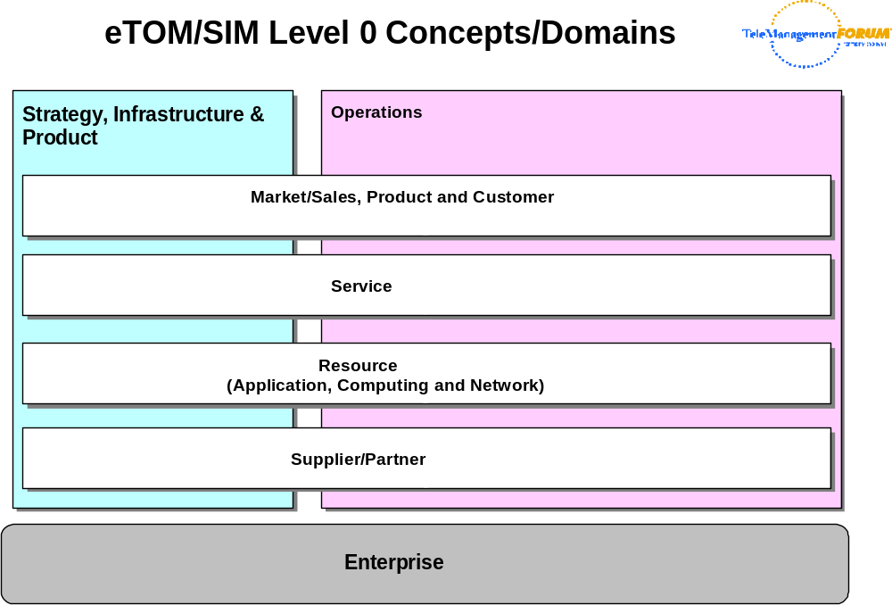
Figure 4Q- . eTOM Level 0 Concepts
The reader is encouraged to refer to [eTOM] for an explanation of the various business processes that are defined to support the concepts in the above domains.
The SID Framework [GB922] is used by the SID team to define a formal mapping between the eTOM domains and the SID domains. The SID Framework is also used to define and organize collections of business entities, called Aggregate Business Entities (ABEs) that are further defined in the SID Addenda. Level 1 of the Service Domain of the SID Framework is shown in Figure 4Q- below. Please note that this is subject to change over time.
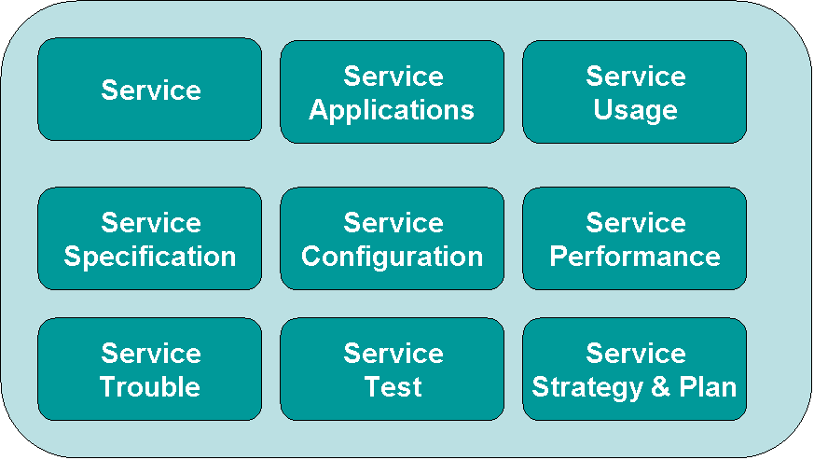
Figure 4Q- . Level One of the Service Domain of the SID Framework
This Addendum explores the simplest aspect of the Service Applications Aggregated Business Entity (ABE). This is defined in Level Two of the Service Domain of the SID Framework, shown in Figure 4Q- .
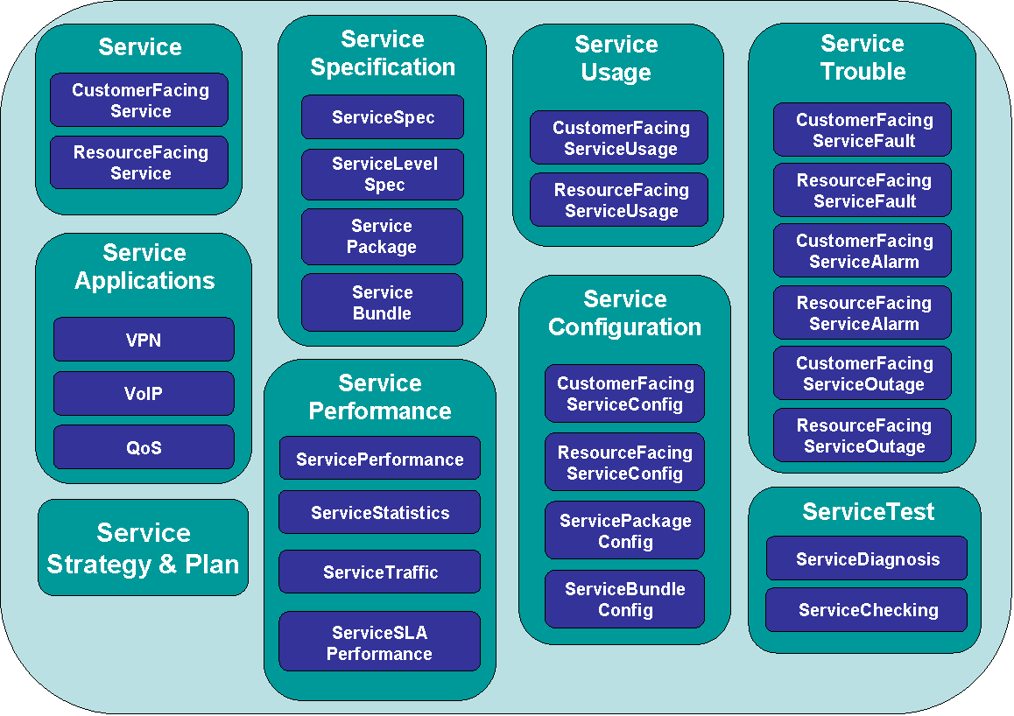
Figure 4Q- . Level Two of the Service Domain of the SID Framework

Approach
As can be seen in Figure 4Q- and Figure 4Q- , the first and second levels of the Service Domain are large and complex. The nature of this complexity lies both in the nature of each of the Aggregate Business Entities (ABEs) that are in the Service Domain in these figures as well as in the interaction between entities of different ABEs in the Service domain. A third area of complexity is the interaction between entities in the Service Domain and entities in other Domains.
The QoS ABE is unique in the Service Applications sub-domain, in that it forms a “core” part of the lower-level functionality that can be used by other ABEs. For simplicity, Figure 4Q- shows two other ABEs in this sub-domain, called VPN and VoIP. QoS is needed by many different applications. However, the confusing aspect is that different types of applications need different types of QoS behavior, which in turn means that different types of QoS mechanisms must be used. This Addendum provides a generic description of QoS that can be used by all applications. Service views will provide more application-specific, lower-level views of QoS.
Conceptually, the Service Domain as described in [Add 4SO] defined a framework for providing the different entities in the SID Level One Framework. QoS is a level two ABE within the level one Service Applications ABE. Thus, there are two goals that this Addendum must achieve:
- Demonstrate that the managed entities that it defines can be seamlessly fit into the set of managed entities defined in the Service Overview Addendum [Add 4SO], and
- Demonstrate that the QoS managed entities fit into the existing relationships with other managed entities
The approach is to base this model on the DEN-ng QoS model, which is in turn based on DEN, ITU, and IETF concepts.
This model reflects service entities from a business-oriented point-of-view, and uses the best of standard modeling patterns for this area to build in extensibility. For example, patterns are used to capture common relationships and occurrences of services as they relate to other services, and also Products, Resources, and other entities in other Domains. This helps make the model inherently extensible. Three important patterns utilized in this document are:
- Composite pattern, which provides a common structure for stand-alone and aggregate objects of a given type
- Entity-EntitySpecification pattern, which separates the common and invariant characteristics and behavior of an object from its individual characteristics and behavior
- Role Object pattern, which uses the notion of roles to dynamically extend the behavior of an object by delegation
Phase IV of the SID will further develop all aspects of this model, and specify more completely the interaction between this model and other business entities.

Use Cases
The primary use case that drove the design of this model is to support Service creation and activation, as referenced in the above level 2 processes and defined in the eTOM. A very important related use case is to set the groundwork for defining how devices can be configured in a standard way to support service creation, activation, measurement, and other processes defined by the eTOM. Finally, the third primary use case is to provide a set of abstractions that can be used in all four of the NGOSS viewpoints [053 Main] to represent the appropriate aspects of QoS in each of these viewpoints. For example, the NGOSS computational viewpoint focuses on functional decomposition of the system into a set of managed objects, which interact at interfaces. This Addendum helps fulfill this requirement by abstracting QoS as a set of interfaces at the business level.
As another example, the NGOSS engineering viewpoint focuses on the mechanisms and functions required to support distributed interaction between objects in the system. This Addendum defines managed objects that represent how QoS mechanisms interact with other managed entities in the system.
There are countless examples of dependent use cases that come into play when considering the above use case. For example, one important use case is to be able to understand how QoS mechanisms present in a system support each other, as well as how they support various other CustomerFacingServices and ResourceFacingServices [Add 4SO]. Another example is to define the dependence that these mechanisms have on physical entities.

Scope
This Addendum will focus on defining a framework for representing QoS mechanisms, and the interaction between those mechanisms, higher-level Services, Resources, and Products. Specifically, the set of classes defined in this Addendum will be able to be used as a foundation for three important activities:
- First, to define QoS mechanisms, and show how CustomerFacingServices and ResourceFacingServices interact with and use those mechanisms
- Second, to define how QoS mechanisms interact with and use managed entities in the PhysicalResource as well as the LogicalResource domains
- Third, to show how these QoS mechanisms, and their relationships with other Service, Resource and Product entities, can satisfy the needs of different customers. Since the needs of different customers can vary widely, a normalization layer must be established to accommodate these different needs and usages
An important goal of the SID effort is to reuse standards (as opposed to reinventing the same concepts) wherever possible. There are several important sources of information for these concepts used in this Addendum. The most important of these are concepts and entities defined in [DEN-ng], [MetaSolv], [DEN], and contributions from BT and Telstra. These information sources form the basis of the Product, Service and Resource models, and also define other SID entities that are related to these models. The QoS model is derived almost entirely from the DEN-ng specification. Since this model is a federated model that draws from different standards, we need a starting point for resolving the naming conflicts that will inevitably arise. We have elected to start with [DEN-ng]. The rationale for this decision is as follows:
- DEN-ng was built to be integrated with other SID models as a starting point
- Important concepts from the MetaSolv model were integrated into the DEN-ng model
- Considerable implementation experienced was provided by BT
- The DEN model was already taken into account and enhanced with the building of DEN-ng
- Experience with version 1 of this model has helped improve and enhance it
One may wonder about the existence of the IETF QoS models and the CIM mappings of them, and how these two pieces of work fit into this Addendum. The IETF QoS models, in their original form, represent good models of these concepts. However, these are system-oriented models, and not business-oriented models. The CIM mappings are problematical, not just because of the open defects against the CIM [CIMPROB], but also because of modeling inconsistencies and errors found in the 2.7 release of CIM (specifically, the Core, Service, and Network models). These will be discussed in a separate document to be issued by the TMF. Furthermore, the IETF models lack any of the associated framework that DEN-ng provides, and the DMTF models suffer from an inconsistent and incorrect framework.
Consistent terminology in a federated model is critical. This terminology, as the model itself, will be introduced in stages. This enables more complex ideas to build on simpler concepts, thereby enabling both an easier as well as a more thorough understanding of the QoS Domain and its relationship to other Domains as defined in the SID Framework [GB922].
Regarding terminology, it is important to be able to relate this view (i.e., the “business” view) of the Service model to other views (e.g., the “system” and the “implementation” views) of these same concepts. By doing this, we achieve the important goal of being able to connect the business requirements to the system representation to how the system is implemented.
Thus, the next section (up to theReferences Section) discusses the existing SID framework that the QoS model fits into, provides a (very) brief introduction to QoS, and then leads the reader step by step through the design of the DEN-ng QoS model. The final section of this document contains a detailed data dictionary that defines from where classes, attributes, relationships (e.g., associations, aggregations and compositions) presented in this model were derived. Note that this section has a special “synonyms / aliases” section to provide easy correlation to these external documents. This section also presents the results of mining information from other models into the baseline provided by the DEN-ng model.

Background – Linkage to Product
Previous Addenda ([Add 3], [Add 4SO], [Add 5PR], and [Add 5LR]) have collectively built a model wherein a Product can be realized by a set of Resources and Services. This section will briefly describe this relationship, because of its critical nature and because new examples of it will be provided as an aid to understanding the QoS model. Readers familiar with the Product model can skip to the next section.
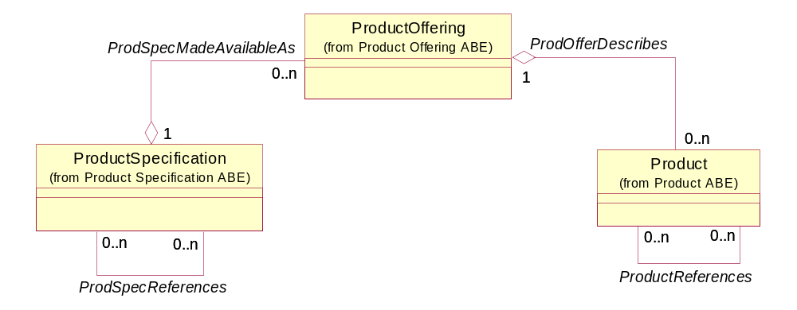
Figure 4Q- . Summary of the Product Model
A ProductSpecification contains a detailed description of a set of tangible (e.g., a PhysicalResource, such as a router) or intangible (e.g., a CustomerFacingService, such as a VPN) objects made available externally in the form of a ProductOffering to Customers or other Parties playing one or more PartyRoles. A ProductSpecification may consist of other ProductSpecifications supplied together as a collection. The purpose of a ProductSpecification is to define a set of invariant characteristics and behavior that will be manifested in the form of a ProductOffering.
A ProductOffering is a presentation of one or more ProductSpecifications to the marketplace for sale, rental, or lease. A ProductOffering may target one or more MarketSegments.
A Product is derived from a ProductOffering, and is procured by a Customer, or other interested Parties playing one or more PartyRoles. A Product is realized as one or more Service(s) and/or Resource(s).
Products are realized as a set of Service(s) and/or Resource(s), as shown in Figure 4Q- below.
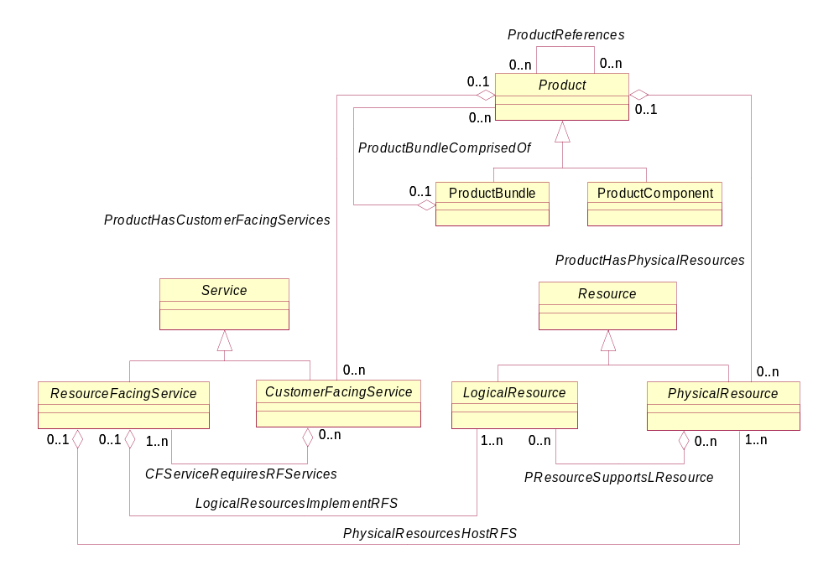
Figure 4Q- . Products Are Realized As Services and Resources
The ProductHasCustomerFacingServices aggregation defines the set of CustomerFacingServices that a PartyRole using this Product is directly cognizant of. Similarly, the ProductHasPhysicalResources aggregation defines the set of PhysicalResources that a PartyRole is directly aware of and uses as a part of this Product.
Note that the ProductHasCustomerFacingServices aggregation is not between Product and Service. Similarly, the ProductHasPhysicalResources aggregation is not between Product and Resource. This is because relationships to the Service and Resource class are too generic, and more importantly, they destroy the simple, yet effective, abstraction of the structure of Product, and its relationship with (subclasses of) Service and Resource. This abstraction can be stated as:
Products are realized as Entities that the PartyRole is directly aware of.
LogicalResources, as well as ResourceFacingServices, represent entities that the PartyRole should not be directly aware of. For example, the Customer is aware of a VPN, but not of the Protocols used to make that VPN function. That is why a VPN is a CustomerFacingService, whereas the Protocols that the VPN uses are ResourceFacingServices.
It is important to understand that the QoS mechanisms detailed in this Addendum are not customer-facing entities. The user should have NO IDEA how traffic is classified and marked, or which algorithms are used to condition different types of traffic. In fact, business users DO NOT CARE about such details. The appropriate entities to use for these abstractions are the ServicePackage and ServiceBundle entities described in [Add 4SO], which are briefly described in the section titled More Background – Services and Resources.
This Addendum was built in order to link the business and system viewpoints together. The idea is to provide a gradual transition between “pure” business concepts (as implemented in ServicePackage and ServiceBundle) and “quasi” business concepts that bridge the business needs to implementation. The business analyst must know what the network is capable of – the QoS concepts of this are defined in this Addendum.

More Background – Services and Resources
This section provides a brief summary of the key concepts in the Service and Resource domain that are required to understand the QoS model. Readers familiar with [Add 4SO], [Add 5PR], and [Add 5LR] can skip to the next section.
The Resource domain has two types of abstractions. The simplest example is again shown in Figure 4Q- , where the distinction between PhysicalResource and LogicalResource is made. A PhysicalResource is an abstract superclass for defining different types of hardware that constitute a Product. It has two main purposes: (1) to collect common attributes and relationships for all hardware, and (2) to provide a convenient, single point where relationships with other managed objects can be defined. Examples of PhysicalResources range from the complete physical manifestation of a device (such as a router) to the components that make up a device, such as PhysicalPorts, Cards, and Connectors. The business aspects of PhysicalResource, and its many subclasses, are defined in [Add 5PR].
A LogicalResource is an abstract base class for describing different logical aspects of devices (e.g., DeviceInterfaces) that constitute a Product. It has two main purposes: (1) to collect common attributes and relationships for all logical entities, and (2) to provide a convenient, single point where relationships with other managed objects can be defined. The business aspects of LogicalResource, and its many subclasses, are defined in [Add 5LR].
A third abstraction of Resource exists, which is also defined in [Add 5LR]. This is the notion of a CompoundResource, and is shown in Figure 4Q- below. A CompoundResource is an abstract base class for all composite entities that are inherently manageable and make up a Product. The key difference between Resource and CompoundResource is that the Resource describes either a Physical or a Logical entity (through its PhysicalResource and LogicalResource hierarchies). In contrast, CompoundResource is used to describe managed entities that are collections of other managed entities. A key point is that each managed entity that is part of a CompoundResource can be individually managed as a PhysicalResource or a LogicalResource.
This abstraction is useful because it enables the user to use one object to represent physical as well as logical capabilities. However, this version of this Addendum will not use this object in order to explicitly define the appropriate relationships between the QoS entities and entities in the PhysicalResource and LogicalResource domains.
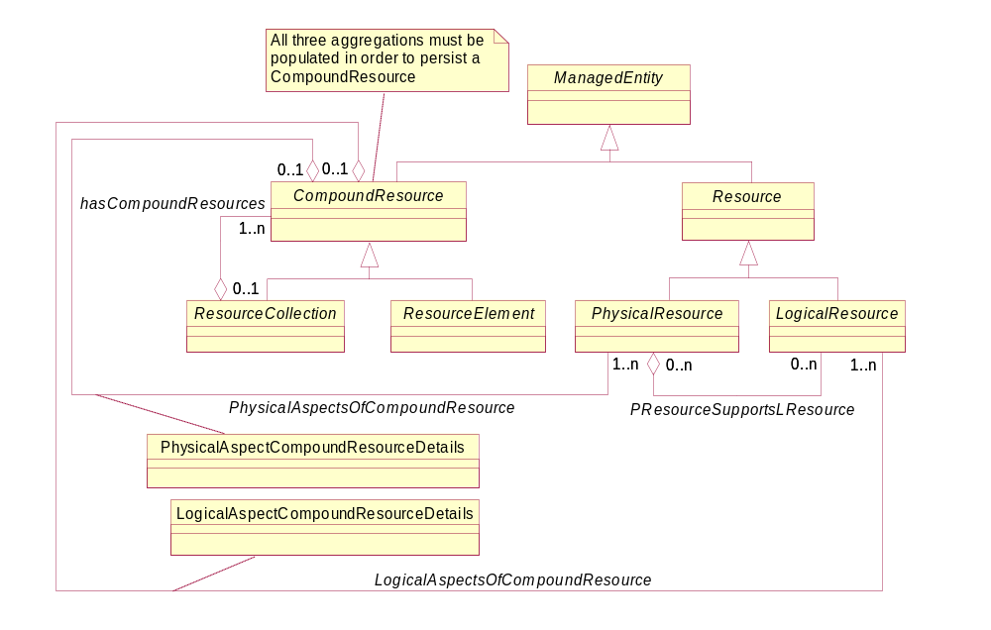
Figure 4Q- . The Concept of a CompoundResource
In [Add 4SO], Services are split into CustomerFacingServices and ResourceFacingServices. This is shown in Figure 4Q- . A CustomerFacingService is an abstraction that defines the characteristics and behavior of a particular Service as seen by the Customer or other appropriate PartyRole. This means that this PartyRole purchases, leases, uses and/or is otherwise directly aware of this type of Service. This is in direct contrast to ResourceFacingServices, which support CustomerFacingServices but are NOT seen or purchased directly by the Customer. For example, a VPN is an example of a CustomerFacingService, while the sub-services that perform different types of routing between network devices making up the VPN are examples of ResourceFacingServices.
A ResourceFacingService is an abstraction that defines the characteristics and behavior of a particular Service that is not directly seen or purchased by the Customer. ResourceFacingServices are "internal" Services that are required to support a CustomerFacingService. The Customer purchases CustomerFacingServices, and is not aware of the ResourceFacingServices which support the CustomerFacingService(s) that is being purchased directly by the Customer.
This abstraction is very important in being able to build scalable, reusable Services. For example, many different types of VPNs can use QoS. Without this abstraction, the binding of QoS to these different VPNs will be needlessly repeated. Note that this is independent of any abstractions used to define QoS itself. However, by using the CustomerFacingService vs. ResourceFacingService abstraction, the designer is able to design a managed environment by linking together abstractions.
All Services, regardless of whether they are CustomerFacingServices or ResourceFacingServices, are made up of changeable as well as invariant attributes, methods, relationships and constraints. A ServiceSpecification defines the invariant characteristics and behavior of a Service. It can be conceptually thought of as a template that different Service instances can be instantiated from. Each of these Service instances will have the same invariant characteristics. However, the other characteristics of the instantiated Service will be specific to each instance.
A ServiceSpecification may consist of other ServiceSpecifications supplied together as a collection. Members of the collection may be offered individually or collectively. ServiceSpecifications may also exist within groupings, such as within a Product.
A simplified view of different types of ServiceSpecifications is shown in Figure 4Q- below.
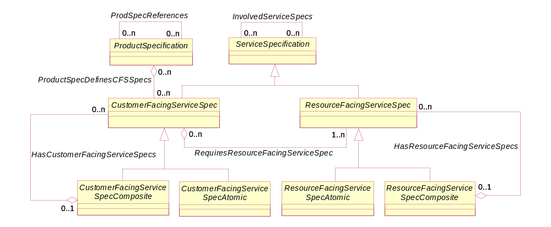
Figure 4Q- . Various Types of ServiceSpecifications
ServicePackageSpec and ServiceBundleSpec
The following material was covered briefly in [Add 4SO]. Since this forms the main link to the QoS model, the reader is encouraged to not skip this section, as it is expanded compared to the material in [Add 4SO].
The Entity-EntitySpecification concept is critical to the development of the link between the Service model and the QoS model. This link consists of two important subclasses of CustomerFacingServiceSpec and ResourceFacingServiceSpec, called ServicePackageSpec and ServiceBundleSpec, respectively. Since this is a generic implementation of the more specific Entity-EntitySpecification pattern, there are of course instance-specific partners to ServicePackageSpec and ServiceBundleSpec.
A ServicePackage defines the concept of bundling a set of different CustomerFacingServiceSpecs to meet the functionality specified by one or more ProductSpecifications. This definition is at the template level, which enables the invariant behavior and characteristics of each of these CustomerFacingServiceSpecs to be reflected in the invariant behavior and characteristics of their containing ProductSpecification.
This in turn enables multiple CustomerFacingServices to be derived from this set of related CustomerFacingServiceSpecs. Each CustomerFacingService so derived is free to add its own behavior, but the important thing is that each CustomerFacingService so derived MUST INHERIT the behavior of its associated CustomerFacingServiceSpec. This enables multiple Products to be built from their associated ProductSpecification to address different application-specific needs that share common behavior.
Treating this set of CustomerFacingServiceSpecifications as a single object is very important for building complex Services, such as a VPN. This enables a single Product (derived ultimately from a ProductSpecification) to be offered to the Customer, even though in reality the Product consists of a set of different CustomerFacingServices that must work together to provide the functionality that the Customer needs.
For example, consider a router that is going to be used at the edge of the network. The CustomerFacingServiceSpecs for this edge router will define the various types of CustomerFacingServices that it will support, such as a VPN. The ServicePackageSpec is used to define the set of CustomerFacingServiceSpecs for this edge router as well as link to a ServiceBundleSpec. The ServiceBundleSpec, which will be discussed later in this section, defines the set of ResourceFacingServiceSpecs that are required to support and implement the CustomerFacingServiceSpecs defined by the ServicePackageSpec. Thus, the ServicePackageSpec is the link between CustomerFacingServiceSpecs and ResourceFacingServiceSpecs. Since a ServicePackageSpec is also linked (indirectly) to a ProductSpecification, it serves the function of binding CustomerFacingServices and ResourceFacingServices to a set of Products that are derived from this ProductSpecification.
A ServicePackageSpec defines the concept of bundling a set of different CustomerFacingServiceSpecs to meet the functionality specified by one or more ProductSpecifications. This enables the invariant characteristics and behavior of these CustomerFacingServices to be specified, so that multiple Products can be built from their associated ProductSpecification.
A ServiceBundleSpec is analogous to a ServicePackageSpec. A ServiceBundleSpec defines the concept of bundling a set of different ResourceFacingServiceSpecs to meet the functionality specified by one or more CustomerFacingServiceSpecs that are grouped together in a ServicePackageSpec. Conceptually, we have the following simplified model:
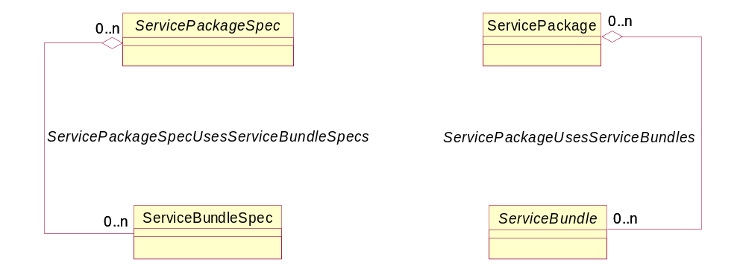
“derives ServicePackages”
“derives ServiceBundles”
Figure 4Q- . High-Level Link between Service and QoS Models
The actual UML model to represent this is more complicated. The above is a conceptual model, and depicts ServicePackageSpecs and ServiceBundleSpecs being used to derive multiple ServicePackage and ServiceBundle instances, respectively.
The composite pattern is used to make the ServicePackageSpec and ServiceBundleSpec objects extensible. It is not used for the corresponding instance objects (ServicePackage and ServiceBundle) because the objective is to define the flexibility on the template (i.e., Specification) side, and use instances to implement the results.
The ServicePackageSpec Hierarchy in shown in Figure 4Q- below.
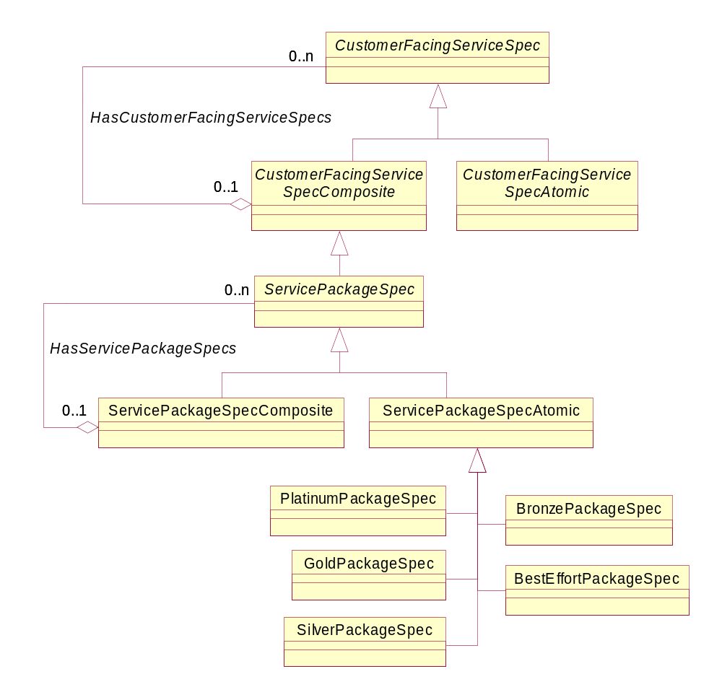
Figure 4Q- . The Concept of a ServicePackageSpec
For example, GoldPackageSpec is an individual packaging of services, and is therefore an instance of the ServicePackageSpecAtomic class. If there was a service offering that combined the services defined by the GoldPackageSpec with those defined by the PlatinumPackageSpec, then that would be an instance of the ServicePackageSpecComposite class.
Figure 4Q- below shows four exemplary subclasses of the ServicePackageSpecAtomic class – PlatinumPackageSpec, GoldPackageSpec, SilverPackageSpec, and BronzePackageSpec. Each of these classes represents a collection of CustomerFacingServiceSpecs that work together to collectively offer a set of Services. This enables these Services to be compared as a group to (for example) a ServiceLevelAgreement.
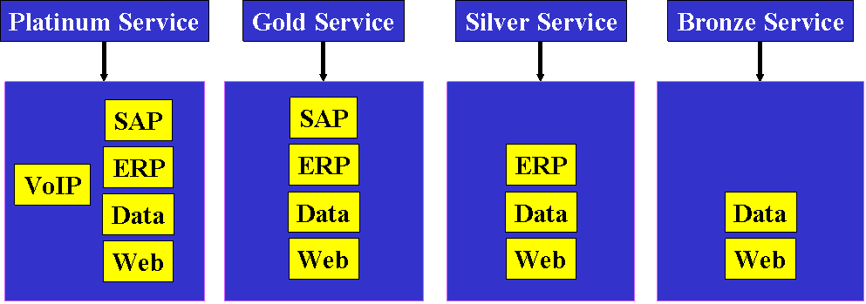
Service
Quality
Lowest
Highest
Service Level
Figure 4Q- . Grouping Together CustomerFacingServiceSpecifications into a ServicePackage
There are two important differences between Platinum, Gold, Silver, and Bronze Service. The first is obvious from Figure 4Q- above – the higher the Service Level, the more CustomerFacingServices that a user has access to. The second is more subtle, and involves the quality of CustomerFacingService. For example, all four ServicePackages shown in Figure 4Q- above provide Web and Data access. The difference between these applications is that the quality of Web and Data access for PlatinumService is better from an end-user’s point-of-view (i.e., faster downloads, less waiting, etc.) than for GoldService, and so forth.
The link between a ServicePackageSpec and a ServicePackage is shown in Figure 4Q- below.
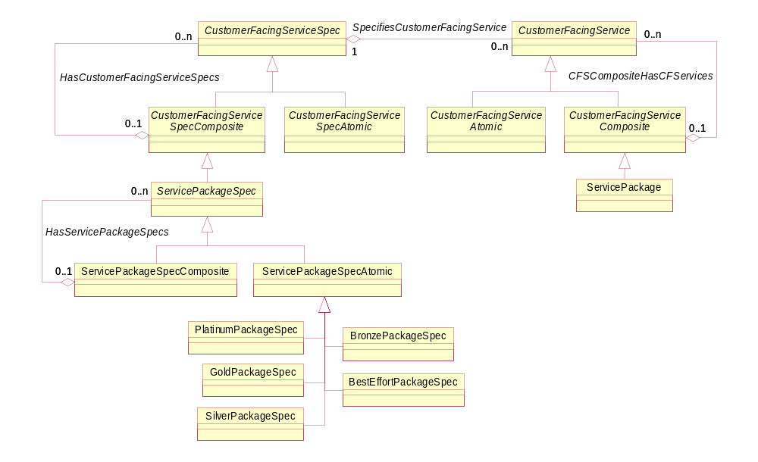
Figure 4Q- . ServicePackageSpecs and ServicePackages
A ServicePackage is derived from an associated ServicePackageSpec. The ServicePackageSpec defines the invariant attributes, methods, relationships, and constraints for all ServicePackage instances that are derived from it. This enables each individual ServicePackage to add its own application-specific changeable characteristics and behavior.
Note that there is no specific aggregation used to relate a particular ServicePackage to the ServicePackageSpec that it is derived from. This is because the ServicePackageSpec and ServicePackage both inherit the SpecifiesService aggregation, and at this (the business level) view, there are no new semantics that are required to represent this relationship.
Thus, we see that a ServicePackageSpecification is a way to define the set of CustomerFacingServiceSpecifications that are to be used by a particular ProductSpecification. The next concept to introduce is that of ServiceBundles and ServiceBundleSpecs.
Just as ServicePackageSpecs and ServicePackages define the templates and instances of a set of CustomerFacingServices, ServiceBundleSpecs and ServiceBundles define the templates and instances of a set of ResourceFacingServices. Note the symmetry – this is once again indicative of an extensible, robust information model. The extensibility is, of course, in the use of the ServicePackageSpec and ServiceBundleSpec entities. Once the desired behavior and functionality have been translated into templates, it is relatively easy to instantiate those templates (thereby producing ServicePackage and ServiceBundle entities). Furthermore, this enables different instances to be easily differentiated while ensuring that their important characteristics and behavior remain constant. This also greatly simplifies their definition and management.
Figure 4Q- shows the relationship between a ServicePackageSpec and a ServiceBundleSpec. Note that a new aggregation, called ServicePackageSpecUsesServiceBundleSpecs, is used to define the set of ServiceBundleSpecs that are used in this particular ServicePackageSpec. This is because the RequiresResourceFacingServiceSpecs aggregation defines the set of ResourceFacingServiceSpecs that are used to implement the functionality specified in this particular CustomerFacingServiceSpec. While a ServicePackageSpec is a type of CustomerFacingServiceSpec, and a ServiceBundleSpec is a type of ResourceFacingServiceSpec, the RequiresResourceFacingServiceSpecs aggregation is too generic. There are additional semantics to this relationship that define which particular set of ServiceBundleSpecs are used to select which bundle of ResourceFacingServiceSpecs (i.e., a ServiceBundleSpec) will be used to implement the functionality required by this particular set of CustomerFacingServiceSpecs (i.e., a ServicePackageSpec). Not only is the notion of “set of specifications” introduced; there are other important semantics of this relationship that need to be defined. Thus, in the system view, the ServicePackageSpecUsesServiceBundleSpecs aggregation is in reality implemented as a class, whereas the RequiresResourceFacingServiceSpecs aggregation is not. An additional detail is that in the DEN-ng system view, there is a ServiceBundlingPolicy object that defines a policy for determining which ServiceBundleSpecs can be used to implement this particular ServicePackageSpec. That, however, is beyond the scope of this Addendum.

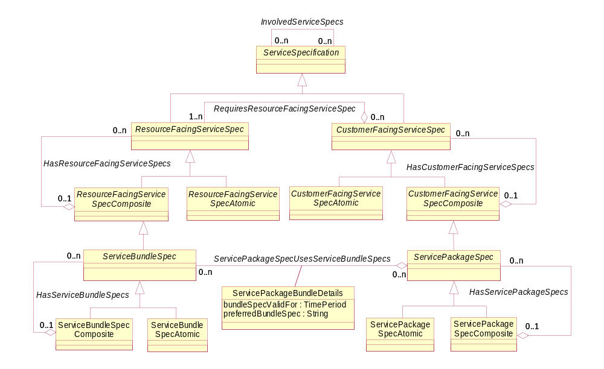
Figure 4Q- . Relationship Between ServiceBundleSpec and ServicePackageSpec
Specific ResourceFacingServices are related to a ServiceBundleSpecification as shown in Figure 4Q- below:
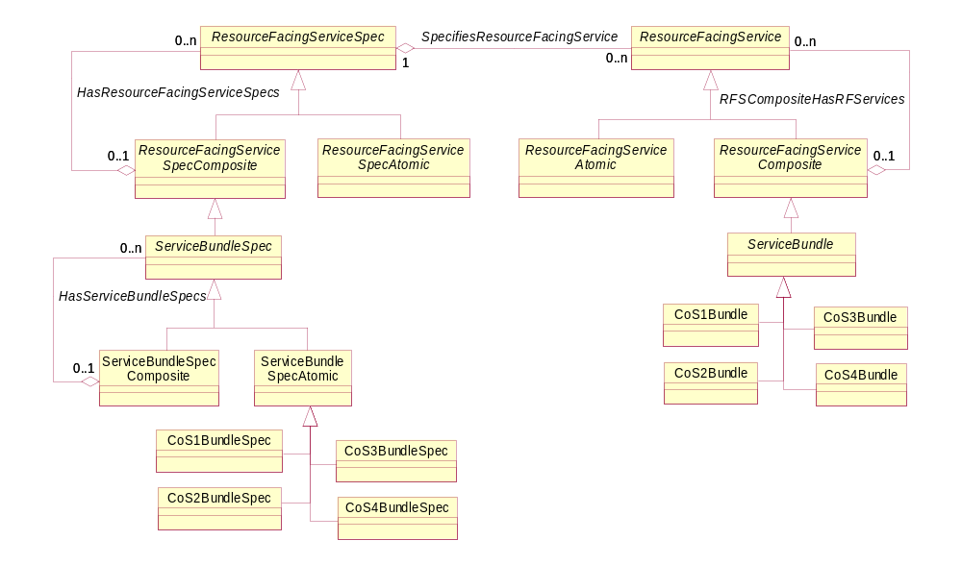
Figure 4Q- . ServiceBundles and ServiceBundleSpecifications
Conceptually, a ServiceBundle is thought of as a collection to enable the needs of different sets of ResourceFacingServices to be grouped together. The "bundle" conveys the concept of grouped Services that are related. Referring back to Figure 4Q- , the different service instances (e.g., PlatinumService) are subclasses of ServicePackage, and the different types of conditioning that each application in a ServicePackage receives are instances of a CoSService, which is a subclass of ServiceBundle. This is explicitly shown in Figure 4Q- below.
ServicePackageSpecAtomic Instance
ServicePackage
Instance
Service
Quality
ServiceBundle Instances
Lowest
Highest
Figure 4Q- . Mapping of ServicePackages and ServiceBundles
Figure 4Q- defines four different subclasses of ServicePackageSpecAtomic, called PlatinumService, GoldService, SilverService, and BronzeService. Each of these ServicePackageSpecs aggregate a different number of ServiceBundles. That is, different ServiceBundles are used to provide the appropriate traffic conditioning for each of the applications contained in the ServicePackageSpec, and that a ServicePackageSpec is free to group together different applications that require different types of QoS as it sees fit. A ServiceBundleSpec exists for each ServiceBundle (though it isn’t shown in Figure 4Q- above) to ensure that these vital services are templatized.
Note that this is a simplistic example, but sufficient to show how the infrastructure works. A real Service Provider would have many more applications, and could have many different applications assigned to the same Class of Service (CoS). To show how this model supports this use case, we will assume that Data and Web services are assigned the same CoS.
A CoS is a bundle of ResourceFacingServices, and reflects how traffic should be treated relative to other traffic in the network. Here, “bundle” refers specifically to the fact that different types of QoS mechanisms will need to be used to achieve a particular CoS. Thus, we have the following abstractions:
- ServicePackage: an object representing the relative priority of service and/or the set of services accessible by a particular Customer (or other appropriate PartyRole) compared to other PartyRoles using the network
- ServiceBundle: an object representing a bundling of different CoS assignments, one CoS for at least one application defined in the associated ServicePackage
- CoSBundle: an object representing a bundling of cooperating traffic conditioning mechanisms in order to implement a particular CoS
We will assign the following mappings in this example for the PlatinumService shown in Figure 4Q- :
- CoS1Bundle: VoIP
- CoS2Bundle: SAP
- CoS3Bundle: other mission critical applications, including ERP
- CoS4Bundle: Web and Data services
It is the definition of these different CoS Bundles that defines how traffic that is associated with a particular CoS is to be treated in the network. This enables different qualities of service to be associated with different applications.
The combination of ServicePackage, ServiceBundle, and CoSBundle objects enables the designer to abstract the notion of different service offerings that are sold to subscribers. Each service offering can be differentiated on the basis of quality of applications and the set of applications that can be used. Each application can be assigned a specific CoS that is used to differentiate its treatment by the network compared to other application traffic that have different CoSs.
For example, ServicePackageSpecs can be defined for each basic service offering that will be offered to a set of Customers. These are simply intelligent containers, and don’t care what specific services are put in each. Thus, a ServiceProvider might want to standardize on the notion of five types of QoS – Platinum, Gold, Silver, Bronze, and Best Effort – but vary the contents of each to suit the demographics of the market segment that they are being sold to. This can be easily done with this model, since the contents of each ServicePackageSpec are defined independently of the contents of each ServiceBundleSpec.
ServicePackageSpecs are CustomerFacingServiceSpecs. Every CustomerFacingServiceSpec, no matter what its intent, must be supported by one or more ResourceFacingServiceSpecs. In the case of QoS, ServiceBundleSpecs can be defined for each CoS that will be offered to the Customer. This ensures that any service offering will always use the same implementation of its core services. This greatly simplifies service and resource provisioning and management.
Note that no dependence on technology or vendor has yet been defined. This is because the purpose of the ServicePackage and ServiceBundle classes is to serve as a technology- and vendor-independent framework in which to link network services to business needs. The QoS model defines mechanisms that are technology-dependent (but still vendor-independent) that define how QoS is implemented. Thus, the ServicePackage and ServiceBundle classes serve as a bridge between business needs and implementation in the network.
As another example, the troublesome use case of provisioning a Customer’s request to upgrade to a higher-level Service (or downgrade to a lower-level Service) can now be much more easily and efficiently handled. In addition, the above abstractions enable the designer to ask more complicated questions (e.g., does the network have the capacity to handle an additional user of this service class?). More importantly, this enables a single link to be defined between the low-level DEN-ng QoS model (which controls the mechanisms used in the devices to condition traffic appropriately) and this higher-level, business-oriented model.
The last remaining bit of background information that is needed before we examine the QoS model in detail is the notion of a DeviceInterface. This is covered in the next section: Final Backgrounder – Connecting the Resource and Service Models.
Final Backgrounder – Connecting the Resource and Service Models
Services don’t just exist in the ether – they need one or more Resources to support them. This can be modeled a number of different ways. The most straightforward of these is to use appropriate subclasses of PhysicalResource and LogicalResource to represent the physical and logical aspects of a Resource.
We’ll first examine PhysicalResource, since it is conceptually simpler to understand. Figure 4Q- shows a simplified summary of the PhysicalResource model. The interested reader is encouraged to read [Add 5PR] for more detailed information.
PhysicalResource is, of course, a subclass of Resource, and is used to describe different types of hardware that constitute a Product. The test for whether a managed object is indeed a PhysicalResource (compared to some other type of managed entity) is indeed a simple one, and is as follows:
If the entity in question can be picked up and held, it is a PhysicalResource.
PhysicalResource has two main subclasses, PhysicalDevice and Hardware. A PhysicalDevice represents hardware devices that can be managed. This class represents a convenient aggregation point for combining different aspects of a device (e.g., the cables, connectors, cards, power supplies, and other objects that together make up the device). Thus, it enables the device itself to have a physical manifestation (e.g., the “Internet Gateway Router” can be identified as a PhysicalDevice). Examples of this class include routers and switches, computers, and other end-devices that are managed.
Hardware represents any type of physical entity that has a distinct physical identity and exists as an atomic unit. Hardware doesn’t include PhysicalLinks or PhysicalConnectors. ManagedHardware adds additional semantics to the Hardware base class that provides management information on the hardware (e.g., whether the hardware is enabled, or whether it is removable while power is applied). PhysicalContainer is used to add additional semantics to the ManagedHardware class. For example, attributes defined by this class can provide the administrative and operational state of the entity, and tell whether it has any alarms. PhysicalContainer adds further semantics to the ManagedHardware class. Its attributes define whether a ManagedHardware object can be removed and/or replaced, and whether this action requires power to be removed or not when the action is performed.
A PhysicalPort represents an actual or potential end point of a topological (physical) link, and corresponds directly to a physical port on a topology map. PhysicalPorts are always contained by another physical object - they can't exist by themselves. The two most common examples are PhysicalPorts contained by a Card and on a Chassis.
Auxiliary Components are managed objects, such as power supplies, fans and cables, that are required for proper operation of the Device but have a function that is different than the primary end-user function(s) of the Device.
EquipmentHolders represents physical objects that are both manageable as well as able to host, hold, or contain other physical objects. Examples of physical objects that can be represented by instances of this object class are Racks, Chassis, Shelfs (yes, it looks funny, but most network vendors call these Shelfs and not Shelves), and Slots.
Equipment represents physical components of a managed device, including replaceable components. An instance of this object class must be present in only a single geographic location. An Equipment object may be nested within another Equipment object, thereby creating a containment relationship. The Equipment type shall be identified by sub-classing this object class. Either the name of the sub-class or an attribute may be used for identifying the equipment type. The most obvious example of an Equipment object is a Card. The DEN-ng model differentiates between different types of Cards, such as Line Cards, Memory Cards, and System Cards.
Finally, a PhysicalComponent is a type of managed entity that can reside either in an Equipment or an EquipmentHolder object. It cannot be used as a stand-alone object. From a management point-of-view, this object either cannot or does not need to be split into its constituent parts. For example, an ASIC (or Chip) cannot be further divided into component parts. Any piece of hardware that is not a PhysicalLink, PhysicalConnector, Equipment, or EquipmentHolder, is a subclass of this class. Its main use in the DEN-ng model is to model special types of Chips that are field replaceable. This is because cards are often built with the ability to be upgraded to a faster unit, or a unit that has more capacity of some type.
Looking at this model, two PhysicalResource entities in particular are required for this Addendum. These are the PhysicalDevice and PhysicalPort entities. We can easily make the model more detailed, and therefore more accurate, by adding additional entities (such as the Card that contains the PhysicalResource), but this will not be done in this Addendum in order to keep it of reasonable length. For our purposes, a PhysicalDevice will be used to represent the device as a whole, such as a router. The PhysicalPort is what enables the device to communicate with other devices. As we will see, protocols and other types of logical entities will use one or more logical managed entities, called a DeviceInterface, to communicate. The physical layer of communication is represented by the PhysicalPort object.

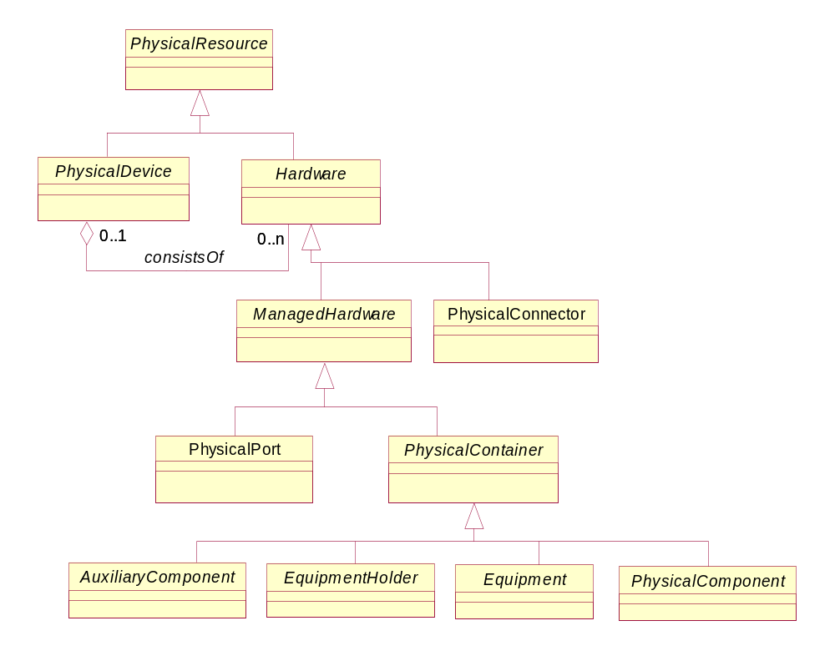
Figure 4Q- . Simplified Summary of the PhysicalResource Model

The LogicalResource model (which is described in [Add 5LR]) is used to model resources that aren’t physical in nature. For example, a Protocol isn’t a physical object because it can’t be seen or held. Similarly, a DeviceInterface represents the logical layers of communication, and while it is contained within a PhysicalPort, it also can’t be seen or held. A simplified high-level overview of the LogicalResource model is provided in Figure 4Q- below.
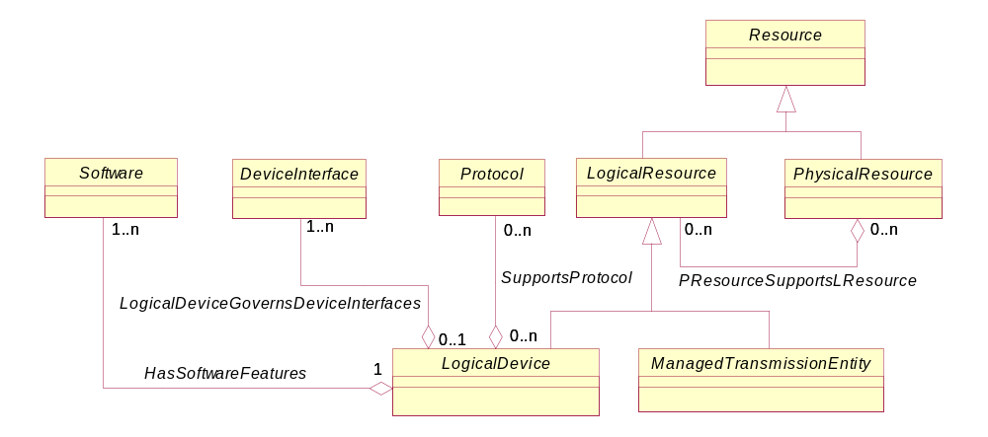
Figure 4Q- . Simplified View of the DEN-ng LogicalResource Model
LogicalDevice is used to represent logical concepts and services that can be managed that are associated with the device as a whole. This class represents a convenient aggregation point for combining different aspects of a device (e.g., software contained in the device, protocols that the devices runs, the set of services that it offers, and so forth). It also enables the device itself to have a single logical manifestation. Conceptually, this represents the “brains” of the LogicalDevice. For example, it represents the set of entities required for a router to know how to route packets.
Software represents the set of user visible functions and processes that are contained in a device. The HasSoftwareFeatures association is used to define software that is associated in some way with a LogicalDevice, such as programs and operating systems. Since this software can be associated with devices and/or device components, this association is defined between the roots of the two classes. Currently, the subclasses of this class reflect user-facing features (e.g., features that are manageable, configurable, and executable by users and applications). Software may be nested within other software, thereby creating a containment relationship.
A DeviceInterface represents the (logical) interface or sub-interface of a device. This is used to represent a logical connection from a device to a network medium. Thus, there are different types of DeviceInterfaces for the different types of network media (e.g., IP vs. ATM) that are used in a network. The combination of a LogicalDevice and a DeviceInterface is what a developer programs to define Services that run on the device.
A Protocol is a formal set of rules and conventions that governs how two entities exchange information (usually over one or more types of network media). The Protocol class, shown in Figure 4Q- , represents different protocols that can be managed and/or used to accomplish a management task (e.g., configuration of the device).
A ManagedTransmissionEntity is the base class for describing different types of logical entities that are or help to form connections that transmit and/or receive information. The interested reader is encouraged to read [Add 5LR] for more information.
Given this introduction, we can now start putting the pieces together. The first is shown in Figure 4Q- below. The PPortHasInterfaces aggregation defines the set of DeviceInterfaces that have been established on this particular PhysicalPort. The LogicalDeviceGovernsDeviceInterfaces aggregation defines the set of (logical) DeviceInterfaces that are managed by a particular LogicalDevice. Note the difference between these two aggregations – the former represents physical containment, whereas the latter represents administrative management. This flexibility enables complex devices that have multiple LogicalDevices to be modeled, where a particular LogicalDevice can be assigned to manage a given DeviceInterface. The cardinalities are also different, reflecting the fact that a DeviceInterface cannot exist on its own – it must be contained within a PhysicalPort (hence the “1” on the PPortHasInterfaces aggregation). However, a DeviceInterface must be explicitly managed through a LogicalDevice, so the cardinality of the LogicalDeviceGovernsDeviceInterfaces is 0 (to represent the unmanaged state) or 1 (to represent the managed state) of the DeviceInterface.
The DeviceInterfaceTakesOn aggregation defines the specific set of DeviceInterfaceRole objects that are associated with a particular DeviceInterface object. This will be discussed later in this Addendum.
Finally, the InterfaceContainsNetworkAddress defines the particular type of NetworkAddress that is contained in this specific type of Interface. The semantics of this containment are defined in the InterfaceNetworkAddressDetails class in the system view.
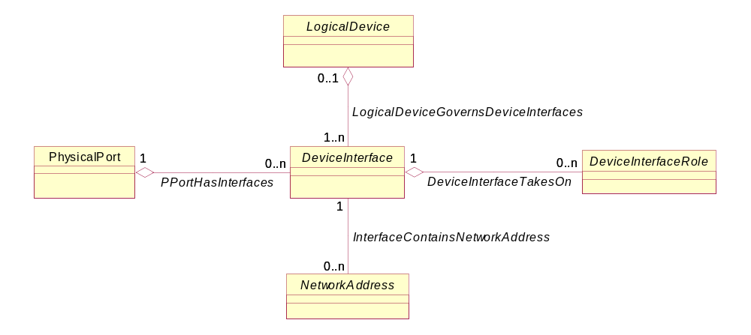
Figure 4Q- . DeviceInterface Relationships
Summarizing then, a DeviceInterface is how different devices communicate. It is contained in a PhysicalPort, and managed by a LogicalDevice. Roles can be assigned to a DeviceInterface, so that groups of them can be better programmed and managed. Finally, a DeviceInterface will contain one or more addresses, where the technology of the network medium matches the type of DeviceInterface that is defined.
In general, a device has an ingress and an egress interface for a given traffic flow. However, the types of QoS mechanisms used may differ. Ingress or egress can be represented as a role to simplify management of sets of DeviceInterfaces that are configured the same way.
The QoS mechanisms defined in this Addendum will be used to program the device resources to meet the specifications of a ServiceBundle (or ServiceBundleSpec). This is the subject of the next section.

A Brief Introduction to QoS
Fundamentally, different types of traffic have different needs of the network. This is shown in Figure 4Q- below.

Requirement | Type of Application
Requirement | Voice | Mission-Critical | FTP
Needs Bandwidth | Low to Moderate | Low | Moderate to High
Sensitive to Dropped Packets | Low | Moderate to High | High
Sensitive to Delay | High | Low to Moderate | Low
Sensitive to Jitter | High | Moderate | Low
Figure 4Q- . Different Traffic Requires Different Network Treatment
Figure 4Q- shows four different requirements that three different types of applications require of the network. As can be seen, these three applications have little in common with respect to what they need from the network.
More importantly, an organization cannot rely on best-effort delivery of traffic, nor can it rely on splitting its resources fairly among all applications competing for shared resources. This is because different applications have different business priorities. Simply put, QoS is a set of mechanisms that can be used to distinguish between, separate, and provide different treatment for applications, based on their business priority.
Conceptually, QoS provides the following services:
- Traffic from different applications must be distinguished from each other
- Traffic from more important applications should get prioritized use of network resources, which means that traffic from less important applications can get delayed
- Traffic from TCP applications can be controlled by dropping packets
- Traffic can also be dropped to signal an application that it is exceeding its quota, or it can be buffered to ensure that it doesn’t exceed its allotted resources
How are these features provided? Let’s start by providing a more technical definition of QoS:
QoS is a collection of technologies, which allows better service (in terms of bandwidth, latency, and delay) to be provided for selected network traffic. QoS can also be used to enable applications to request and receive predictable service levels in terms of data throughput capacity (bandwidth), latency variations (jitter), improved loss characteristics, and delay.
QoS is usually defined in terms of flows or sub-flows of traffic. The simplest way to define a flow is:
A flow is a combination of source and destination addresses, source and destination port numbers, and additional optional information (e.g., a session identifier, or a tag in the header of the traffic).
The following subsections will relate the more technical definition of QoS to the four basic services that QoS performs.
Traffic Service Models
Fundamentally, there are three types of service models – best effort, integrated service, and differentiated service. These service models define the different levels of service that can be offered in the network. These service models can be combined to provide richer mechanisms for the network designer.
Best Effort Service is the simplest service model. Here, the network simply delivers data if it can, when it can, without any assurances or guarantees of service level. Conceptually, this models the network as a “dumb” pipe of finite bandwidth, and traffic that first enters the network is first to leave it. As bad as this may seem, best effort is in fact suitable for a wide variety of applications, such as email or FTP. However, its most obvious drawback is that there is no concept of business priority. Therefore, best effort traffic, if not properly managed, can swamp other critical traffic. This model supports both the definition of best effort delivery as well as the proper management of best effort services with both integrated and differentiated services.
Integrated Service uses explicit signaling to define the service that an application needs of the network. Unlike best effort service, integrated Service is a multiple service model – different applications can request different needs of the network. An application uses a traffic profile to describe its bandwidth, jitter, and delay requirements. The network will signal back to the network if it can or cannot support this traffic profile, and the application will send traffic only after the network says that it can support its traffic profile. This process is referred to as admission control. Traffic is admitted only if the network can guarantee that it has the resources necessary to support the traffic profile of the application. (Of course, if the application violates its traffic profile (for example, by sending too much traffic), then the network is not guaranteed to support that extra traffic. Minor variations, called bursting, are tolerated, and are supported in the DEN-ng QoS model.) The disadvantage of this service is that per-flow state must be maintained. This service requires classification, marking, policing and intelligent queuing (which are defined starting in the next section).
Differentiated Service is also a multiple service model. In contrast to Integrated Services, Differentiated Services does not use explicit signaling to communicate its needs. Rather, Differentiated Services relies on pre-provisioning the network into a set of classes. Each CoS is mapped to a particular packet marking. The advantage of this model is that multiple flows that have the same requirements can be aggregated together into a single class. Hence, it is inherently more scalable than Integrated Services. However, it is harder to achieve the guaranteed levels of service that Integrated Service offers. This service requires classification, marking, policing, shaping, and intelligent queuing.
There are many ways that these services can be combined. One method is to tunnel (i.e., encapsulate) an Integrated Services request across a Differentiated Services network. This enables the Integrated Services request to be enforced only where necessary, and doesn’t require per-state information to be kept in the Differentiated Services network. Issues such as this are beyond the scope of this document, but are covered in the system view of the DEN-ng QoS model.
Differentiating Traffic
QoS is based on being able to provide better service to certain flows. The model in this Addendum divides this into two functions, called classification and marking. Classification identifies each flow and assigns it to a particular CoS, and is discussed in the Section titled ClassifierService. It then marks the flow using a specific technology, such as the ToS (Type of Service) field [RFC1349] or the DSCP (Differentiated Services Code Point) in the IP header [RFC2474]. This is explained in the Section titled MarkerService.
The DEN-ng QoS model provides a generic method to map the capabilities of different technologies to a set of normalized classification and marking services. This provides a framework for the DEN-ng system view to model vendor-specific commands.
Prioritizing Traffic
Once traffic has been identified and marked, it can be assigned to a specific CoS. Different traffic conditioning mechanisms, as defined in the Section titled TrafficConditioningService, can then be used to map the business priority of the traffic to the service models used in the network. This enables different applications having different CoS levels prioritized usage of shared network resources. Congestion management techniques, such as different types of queuing, are used to enable higher-priority traffic to be sent before lower priority traffic.
Controlling TCP-Based Applications
Dropping packets can be used to signal TCP-based applications to slow their transmission rate. This is a simple example of congestion avoidance, which is used to anticipate and avoid congestion as much as possible. Other, more advanced, techniques are available for non-TCP-based applications. However, these methods are very technical and, so far, vendor-specific, and so will not be described in this Addendum. Please see the DEN-ng system view (to be published) for more information.
Ensuring Traffic Doesn’t Exceed Its Quota
There are a finite number of network resources. Therefore, most traffic is assigned a limit to the resources that it can use. The two most popular methods of enforcing this quota are called policing and shaping.
Policing is defined in the Section titled PolicerService. Policing, often called rate-limiting, enforces a strict limit on the amount of traffic that can be sent or received. If that limit is exceeded, the traffic is dropped.
Shaping is defined in the Section titled ShaperService. Shaping is a mechanism to delay, or buffer, traffic that exceeds its quota. By delaying the traffic, it is often possible to still transmit the data, albeit over a longer period of time.
Clearly, policing and shaping can be combined to ensure that misbehaving applications (i.e., applications that violate their associated traffic profiles) are controlled in the network. This is very important, because otherwise a misbehaving application could consume more than its allocated share of network resources. This could prevent a higher priority application from receiving the traffic conditioning that it is supposed to, which in turn may violate SLAs.

Putting It All Together
Figure 4Q- below shows an example of how different traffic conditioning mechanisms can be used together to provide a complex set of traffic conditioning services. This figure is taken from [N+I2002].
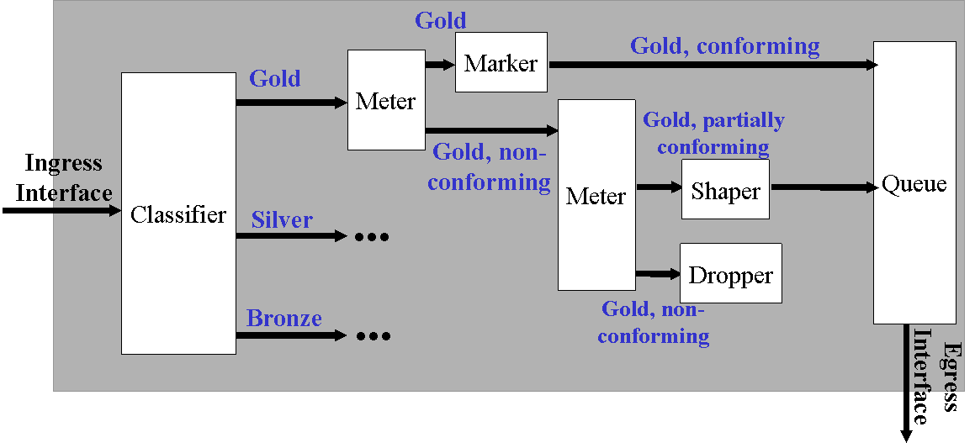
Figure 4Q- . An Example of Using Different Traffic Conditioning Mechanisms
The classifier takes traffic from its ingress DeviceInterface and splits it into three basic service levels, Gold, Silver, and Bronze. For Gold, traffic is further split between conforming (to its traffic profile), partially conforming (i.e., it bursts above its traffic profile, but the size of the burst is within limits) and non-conforming. All of the traffic streams enter a set of Queues, which then delivers traffic in (business) priority order.

Practical Aspects of QoS
There are two factors that make QoS difficult to program. First, QoS is only relevant unless it is applied end-to-end. However, different Customers (or other types of PartyRoles) can have very different needs. Even different departments of the same company can have different needs. Thus, it is of paramount importance that QoS mechanisms be able to be related back to the Customers (or other appropriate PartyRoles). This is accomplished by relating QoS mechanisms to ServiceBundles (or ServiceBundleSpecs), and then relating ServiceBundles (or ServiceBundleSpecs) to ServicePackages (or ServicePackageSpecs).
The second factor is that hardware as well as software must be used. QoS is not achieved simply by connecting boxes together. Rather, QoS involves networking devices, and the software that is run on the devices is a function of the hardware capabilities of the network devices.
Clearly, most organizations run a large number of applications, each generating at least one type of traffic. Note that some applications, such as multimedia, generate a large number of different type of applications. Thus, network developers design schemes to aggregate different types of traffic that require similar characteristics into the same “class”. This is where the term “Class of Service”, or CoS, comes from – it is the assignment of a particular way to treat a class of application traffic.
Example policies that specify different types of QoS are:
- Make Sure my Platinum Class get a priority treatment and Gold Class gets a minimum bandwidth Guarantee
- Make Sure my Bronze Traffic does not get more than x kbps of bandwidth at any time
QoS, if used properly, provides a number of benefits. The most obvious is granular control over network resources, especially resources within the devices that are performing QoS. The ability of QoS to provide different value-added treatment of different traffic flows enables different applications in a network to conform to the business rules of the organization using the network. But most importantly, the modeling of QoS enables multiple applications to peacefully coexist in the network, even though these applications require different resources from the network.

The DEN-ng QoS Model
This section of this document will define the business view of the DEN-ng QoS model. Much of the detail present in the classes mentioned in this section is hidden, as they represent concepts that are not appropriate for a business viewpoint. However, all of the top-level classes of the QoS model have been described, so as to enable business analysts to have a better working understanding of QoS.

QoSService
QoSService represents a generic specification for defining the different types of Sub-Services that are required to implement a specific type of QoS. A QoSService can be thought of as an aggregation of sub-services needed to realize the functionality specified by, for example, a ServiceBundle object (via the RFSComposite has RFServices aggregation). This enables the network administrator to map business rules (as specified in a more abstract object or set of objects) to the network, and the network designer to engineer the network such that it can provide different functions for different types of applications.
A QoSService is modeled as shown in Figure 4Q- below.
QoSService has three exemplary subclasses shown in Figure 4Q- . These three subclasses define technology-specific mechanisms for providing QoS, and will be discussed in the next subsection.
The HasQoSSubServices aggregation defines the set of QoSServices that make up a particular QoSService. This enables a single high-level QoSService to be defined in terms of multiple lower-level QoSServices. For example, a network that consists of DiffServ-aware and non-DiffServ-aware devices can have a single QoSService defined to govern how QoS is provided by the network, even though some devices use ToSService and other devices use DiffServService. The higher-level QoSService network-wide QoSService in effect controls the definition of the lower-level ToSServices and DiffServServices, and more importantly coordinates their management, application and usage.
The ForwardingDefinedBy aggregation defines the set of NetworkForwardingServices that make up a particular QoSService. Since NetworkForwardingServices can be used for purposes other than QoS, the cardinality of this aggregation on the QoSService side is defined to be 0..1. However, a QoSService cannot exist without defining at least one NetworkForwardingService - hence, the cardinality of this aggregation is 1..n.
The ConditionsQoSService aggregation defines the set of TrafficConditioningServices that make up this particular QoSService. This, as well as the IdentifiesQoSService aggregation, exists in addition to the more generic ForwardingDefinedBy aggregation because they each have their own special semantics. In the DEN-ng system view, this aggregation and the IdentifiesQoSService aggregation are implemented by different classes, whereas the ForwardingDefinedBy aggregation is implemented without a class.
Finally, the IdentifiesQoSService aggregation defines the set of TrafficIdentificationServices that make up this particular QoSService. It is analogous to the ConditionsQoSService aggregation, except that it aggregates TrafficIdentificationServices.
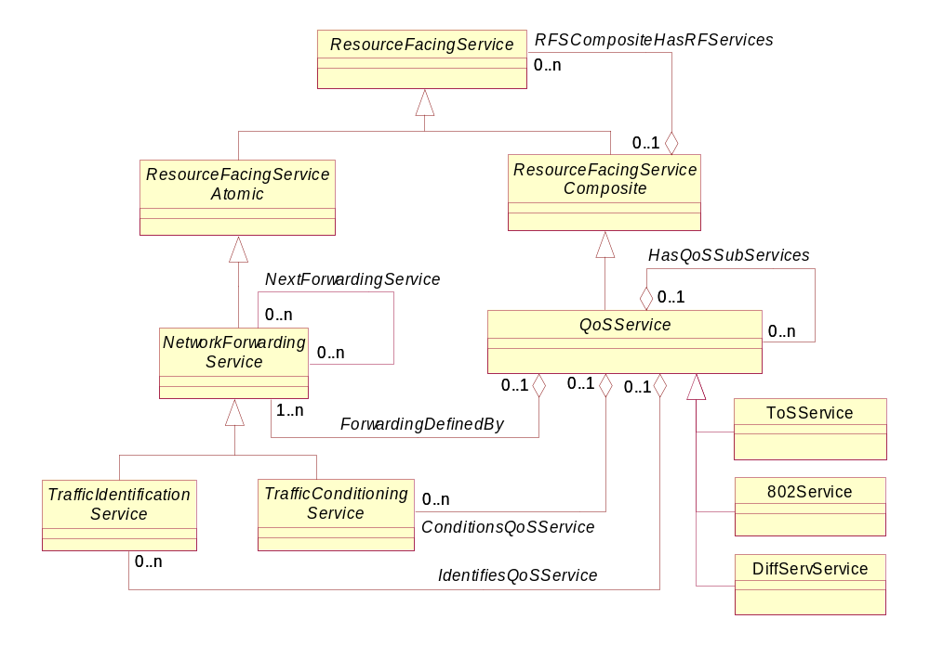
Figure 4Q- . Business Definition of a QoSService
ToSService
ToSService contains semantics that define how traffic is forwarded based on the value of the ToS byte of a packet. This class is used to enable different types of QoSServices, such as 802Service and DiffServService, to exchange traffic with each other. Each of these different types of QoSServices has its own means of indicating that one type of traffic should be treated in a different manner from other types of traffic. Thus, without the ability to define mappings between these different marking methods, interoperability is not possible.
802Service
802Service contains semantics that define how traffic is forwarded based on the value of the priority field in the 802.1P header. This class is used to enable different types of QoSServices, such as 802Service and DiffServService, to exchange traffic with each other. Each of these different types of QoSServices has its own means of indicating that one type of traffic should be treated in a different manner from other types of traffic. Thus, without the ability to define mappings between these different marking methods, interoperability is not possible.
DiffServService
DiffServService contains semantics that define how traffic is forwarded based on the value of the DSCP (DiffServ Code Point) of a packet. This class is used to enable different types of QoSServices, such as 802Service and DiffServService, to exchange traffic with each other. Each of these different types of QoSServices has its own means of indicating that one type of traffic should be treated in a different manner from other types of traffic. Thus, without the ability to define mappings between these different marking methods, interoperability is not possible.
DiffServService is more complicated, as it has two important subclasses that are required to realize its semantics. This is shown in Figure 4Q- below.
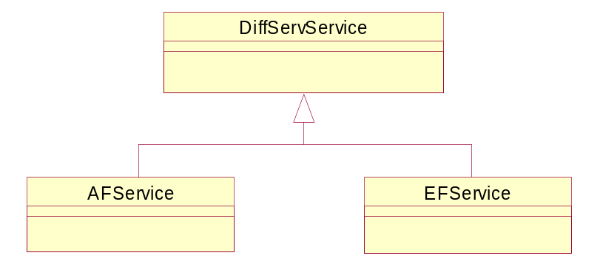
Figure 4Q- . Business Definition of DiffServService
EFService is the simpler of the two subclasses of DiffServService. This class defines how to forward network traffic by adding specific semantics that characterize the operation of the Expedited Forwarding (EF) Service, as defined in [RFC3246] and [RFC3247]. EF can be used to build a low loss, low latency, low jitter, assured bandwidth, end-to-end service through DiffServ-compliant domains. Such a service appears to the endpoints like a point-to-point connection or a "virtual leased line".
AFService defines how to forward network traffic by adding specific semantics that characterize the operation of the Assured Forwarding (AF) Service, as defined in [RFC2597]. This RFC defines four different AF classes to represent four different treatments of traffic (e.g., a different amount of forwarding resources, such as buffer space and bandwidth, are allocated). This RFC defines three different drop probabilities for each AF class, though clearly additional drop probabilities can be defined.
The idea of AFService is to mark IP packets with one of three possible drop precedence values. The drop precedence of a packet determines the relative importance of that packet compared to other packets within the same AF class if congestion occurs. A congested interface will try to avoid dropping packets with a lower drop precedence value by instead discarding packets with a higher drop precedence value. Of course, if there is no congestion on the DeviceInterface, then nothing will happen.

NetworkForwardingService
The Business Definition of NetworkForwardingService was shown in Figure 4Q- .
The programming of a QoSService is represented in DEN-ng as a set of NetworkForwardingServices. This is because when traffic is forwarded, it can be differentiated from other traffic. During the forwarding process, packets can be (for example) queued or dropped. These are two examples of different types of QoS that are grouped into what are called TrafficConditioningServices in DEN-ng.
In order to packets to be identified, they need to be classified and marked. This is, in DEN-ng, termed a TrafficIdentificationService.
Both TrafficIdentificationService and TrafficConditioningService are subclassed from NetworkForwardingService. A TrafficIdentificationService is used to classify and mark packets to separate one traffic flow from another traffic flow. Once this is done, different means of defining how packets are forwarded can be defined, such as queuing and dropping, which are different types of TrafficConditioningServices.
Thus, we see that a given QoSService technology can be programmed using a particular set of NetworkForwardingServices, which is represented in generic fashion by the forwardingDefinedBy relationship.
The NextForwardingService association defines a dependency, in the form of a defined sequencing between two NetworkForwardingService objects, where one NetworkForwardingService must follow the other NetworkForwardingService. This is used to model complex forwarding mechanisms that can be decomposed into two or more simpler forwarding mechanisms. An example of this was shown in Figure 4Q- , in which conforming Gold Traffic passed through first a Classifier, then a Meter, and finally a Marker before it entered the Queue. (Note that all of these functions are within a Router.) The example in Figure 4Q- thus used three instances of the NextForwardingService association (one each to connect the Classifier to a Meter, the Meter to a Marker, and the Marker to a Queue) to implement the conditioning required by GoldService for traffic that conformed to the SLA for GoldService.

TrafficIdentificationService
A TrafficIdentificationService is a fundamental QoS building block. The Business Definition of a TrafficIdentificationService is shown in Figure 4Q- below.
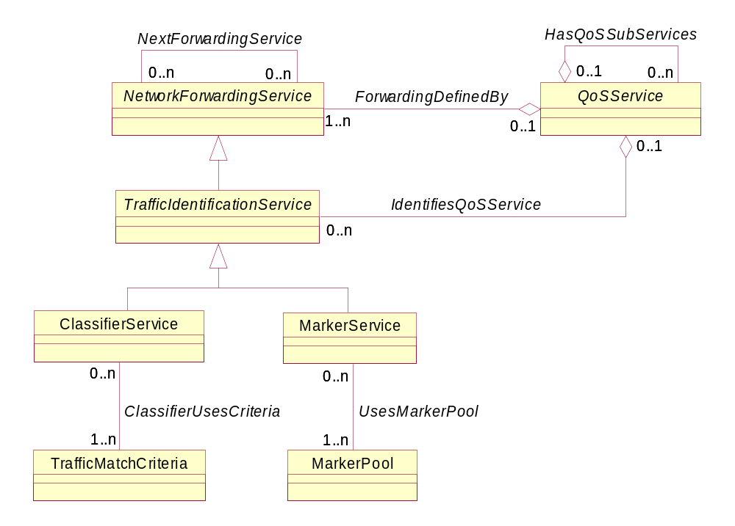
Figure 4Q- . Business Definition of a TrafficIdentificationService
A TrafficIdentificationService is an abstract base class that is the parent for different types of traffic identification services defined in the DEN-ng Service model. TrafficIdentificationServices are one example of a ResourceFacingService, in that the Customer is not able to control them. In fact, the Customer doesn't even have to be aware that they exist! However, they must be implemented in order for different CoSs to be differentiated from each other, and hence for different Customers to receive different CoSs.
TrafficIdentificationServices control how packets and flows are identified and distinguished from other packets and flows in the system. Without these services, TrafficConditioningServices cannot work.
TrafficIdentificationService has two main subclasses, ClassifierService and MarkerService. These classes are described below.

ClassifierService
A Classifier is an internal component of the forwarding path. It is used to recognize and distinguish among different packet streams or flows. Without classification, all packets will be treated the same.
The function of the ClassifierService is to model the identification of traffic accepted at the ingress interface of the device, and to separate traffic into different flows. This enables flows from different applications that can be treated the same way to be aggregated together, making the network design much more scalable.
For almost all situations, the ClassifierService will be followed by a MarkerService (or one of its subclasses) so that separate traffic can be assigned a unique mark in the packet header. This will enable subsequent mechanisms to simply examine the mark in the header and perform operations based on that marking. This dependency is modeled using an instance of the NextForwardingService association.
The definition of which flows can be separated by the ClassifierService into which aggregates is defined using the TrafficMatchCriteria class. The purpose of this class is to formally define selection criteria for the ClassifierService to use so that the ClassifierService can separate ingress traffic into sets of flows. This class contains data, metadata, and links to PolicyRules to govern the selection criteria. However, these are beyond the scope of this Addendum. (They are described in the DEN-ng system view).
The ClassifierUsesCriteria association binds a specific ClassifierService to one or more TrafficMatchCriteria classes. Every ClassifierService must use at least one TrafficMatchCriteria object, hence the cardinality for this end of the relationship is 1..n. However, a TrafficMatchCriteria object can be designed before it is associated with a particular ClassifierService, and can in fact be used with more than one ClassifierService. Hence, the cardinality for this end of the relationship is 0..n.

MarkerService
The function of a MarkerService is to mark packets in a flow so that different devices in the network know how to treat the traffic that these packets belong to. This is done by “coloring” a packet so that it can be identified and distinguished among other packets that are receiving traffic conditioning. In effect, this partitions a network into multiple priority levels or classes. Marking packets is done using a technology-specific mechanism, such as the ToS byte, the DSCP, or other methods for other media.
In DEN-ng, this function is modeled by the MarkerService. This service will mark a selected field in a network packet with a specified value. Packets are marked in order to indicate to downstream components what types of TrafficConditioningServices they will subsequently receive. The definition of how to mark a particular packet is defined using the MarkerPool class.
The MarkerPool class models technology-specific marking mechanisms. For example, if simple IP Precedence is used, then 3 bits (but only 6 legal values) are available for marking. In contrast, if Differentiated Services is used, then 6 bits (32 values defined as standard, and 32 values defined as experimental) are available for marking. In the DEN-ng system view, the MarkerPool class is related to specific subclasses of QoSService to model these limits. PolicyRules are also defined that govern which set of Marks can be used for which application, Customer, etc. The UsesMarkerPool association binds a specific MarkerService to one or more MarkerPool classes. (For example, different MarkerPools could be defined for different Customers as well as for different technologies). Every MarkerService must use at least one MarkerPool object, hence the cardinality for this end of the relationship is 1..n. However, a MarkerPool object can be designed before it is associated with any particular MarkerService, and can in fact be used with many different MarkerServices. Hence, the cardinality for this end of the relationship is 0..n.
Note that there are several subclasses of MarkerService, but these represent lower-level system variations of how the Marking is done. Thus, they are not suitable for this Addendum. They will be described in the system view DEN-ng QoS Addendum.

TrafficConditioningService
A TrafficConditioningService is a fundamental QoS building block. A TrafficConditioningService is an abstract base class that is the parent for different types of traffic conditioning services defined in the DEN-ng Service model. TrafficConditioningServices are one example of a ResourceFacingService, n that the Customer is not able to control them. In fact, the Customer doesn't even have to be aware that they exist! However, they must be implemented in order for different CoSs to be differentiated from each other, and hence for different Customers to receive different CoSs.
TrafficConditioningServices control how packets and flows are treated compared to other packets and flows in the system. The simplest building blocks are DropperService, MeterService, QueueService, and SchedulerService. DEN-ng also defines a CompoundConditioningElement, which combines two or more of these more basic functions together so that they can be modeled (and therefore programmed) as an atomic entity. All of these will be described in the following subsections.
Note that the following subsections define the most basic of building blocks. For example, many devices have additional mechanisms, such as improving the link efficiency by controlling fragmentation and interleaving of different packets. However, this is a very complex task, and is not described in this Addendum. Please see the DEN-ng system view for other advanced TrafficConditioningServices.
A Business Definition of a TrafficConditioningService is shown in Figure 4Q- below.

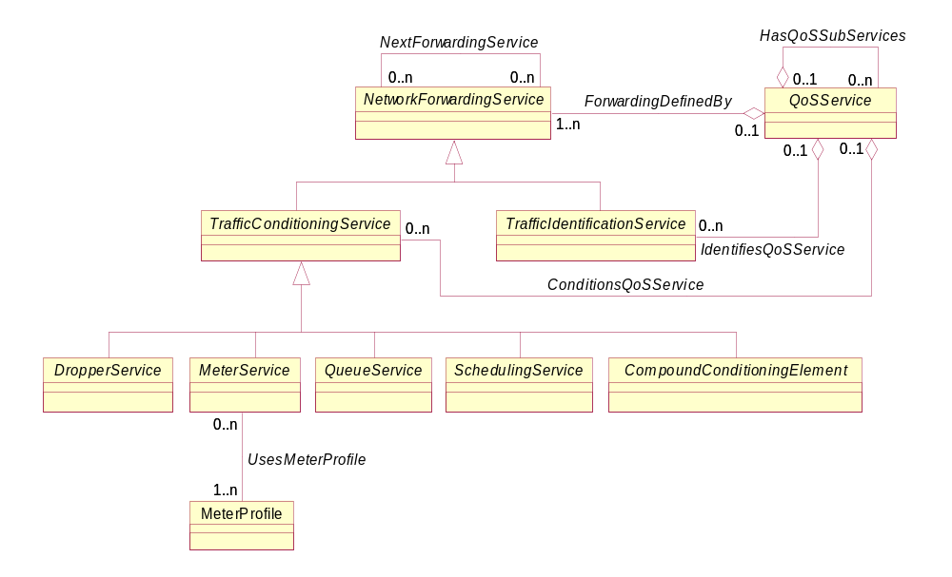
Figure 4Q- . Business Defnition of a TrafficConditioningService

DropperService
A DropperService is a basic traffic conditioning building block. A DropperService represents the ability to selectively drop network packets or even flows. This is NOT the same as denying the forwarding of a packet or flow; rather, this represents the conscious act to discard a packet (or possibly even a flow). Compound traffic conditioning elements, such as Policers and Shapers, will implicitly use DropperServices.
Droppers are distinguished by the algorithm that they use to drop traffic. The semantics of these algorithms are different enough to warrant their modeling by using subclasses. However, these subclasses are low-level, and not appropriate for this Addendum. Please see the system view of the DEN-ng QoS model for their definition.

MeterService
A meter is a basic traffic conditioning building block. A meter determines the level of conformance of each packet or flow with respect to a pre-established traffic profile. A meter has the ability to invoke different TrafficConditioningServices for conforming vs. other (e.g., partially - and non-conforming) traffic, as illustrated in Figure 4Q- .
The definition of which metric(s) are monitored to serve as input for the metering decision is defined by attributes in this class. However, the definition of the traffic profile that is used to make the metering decision is defined using the MeterProfile class.
The MeterProfile class defines a traffic profile that the MeterService can use to compare traffic against. The MeterProfile will define what levels of traffic pass through the MeterService unaltered, what levels get delayed, what levels get dropped, and what levels get further analyzed.
The purpose of the MeterProfile class is to formally define these four different traffic levels. This requires data and metadata. Furthermore, the application of a particular MeterProfile is governed by PolicyRules. These are advanced, low-level features, and as such are beyond the scope of this Addendum. Please see the system view of the DEN-ng QoS model for their definition.
The UsesMeterProfile association binds a specific MeterService to one or more MeterProfile classes. (For example, different MeterProfiles could be defined for different Customers as well as for different technologies, or for conforming vs. partially conforming vs. non-conforming traffic). Every MeterService must use at least one MeterProfile object, hence the cardinality for this end of the relationship is 1..n. However, a MeterProfile object can be designed before it is associated with any particular MeterService, and can in fact be used with many different MeterServices. Hence, the cardinality for this end of the relationship is 0..n.

QueueService
Queuing can be thought of as the act of delaying of packets inside a device before they are transmitted to the next device. This is often called congestion management in the literature. There are many different algorithms to do this task, each having different purposes, different implementation (and therefore programming) complexities, and different uses. Since the semantics of these algorithms are very different, DEN-ng models each algorithm as a subclass of QueueService.
Queues are not infinite in size, and therefore can fill to capacity. So, what happens when a new packet arrives if the queue is filled? Either the new packet is inserted into the queue, and the existing contents of the queue are dropped, or the new packet is inserted and a packet is removed from the queue to make room for the new packet. The details of how a packet is inserted and removed are examples of the differences in queuing algorithms.
Queuing is designed to accommodate temporary congestion on a network device's interface by storing excess packets in buffers until bandwidth becomes available. This can be used in order to meet the varying bandwidth, jitter, and delay requirements of different applications.
DEN-ng models many different types of queuing algorithms, the most popular of which are:
- First In First Out (FIFO), the default mechanism on most DeviceInterfaces.
- Priority Queuing, in which multiple queues (each with their own priority) are used. Note that lower-priority queues may not get serviced at all if higher-priority queues have too much traffic to process.
- Fair Queuing, a round-robin approach designed to service all queues in a “fair” way. While this prevents any one source from overusing its allotted share of network capacity, but its problems stem from being too fair. ☺
- Weighted Fair Queuing (WFQ), which is a cross between priority queuing and fair queuing. All queues are serviced so that none are starved, but some queues are serviced more than others. A portion of the bandwidth of a DeviceInterface is allocated to each active flow, with a weight applied to each queue to give some queues higher priority than other queues. WFQ weights traffic so that low-bandwidth traffic gets a fair level of priority. A unique feature is that it moves real-time interactive traffic to the front of queues and fairly shares the remaining bandwidth among other flows.
There are other, more advanced, queuing mechanisms that combine multiple types of NetworkForwardingServices in their programming (e.g., Class-Based WFQ). However, their technical details are beyond the scope of this Addendum.
Queuing typically happens on egress interfaces only, though some advanced routers have the ability to shape (e.g., queue) inbound traffic. However, this is a system design issue, and hence is covered in the DEN-ng system view QoS Addendum.

SchedulerService
The SchedulerService is one or more processes that determine whether a queued packet should be removed from a queue and sent to an appropriate DeviceInterface. This is almost always an egress DeviceInterface. A SchedulingService can support one or more queues. There are two generic types of SchedulingServices, called work-conserving and non-work-conserving.
All SchedulerServices work by making decisions. Some types of schedulers can “pass” on their opportunity to make a scheduling decision – these are called non-work conserving scheduler. In contrast, work-conserving schedulers will always take advantage of an opportunity to make a scheduling decision.
DEN-ng defines many different types of SchedulerServices. However, these are beyond the scope of this Addendum.

CompoundConditioningElement
This is an abstract base class that defines "compound" traffic conditioning elements. Such elements are made up of two or more TrafficConditioningServices. For example, a Policer can be modeled as a Dropper and a Marker that feeds a Queue.
The advantage of this class is that objects and relationships can be defined once with it that its subclasses inherit. For example, both a Policer and a Shaper can use a TokenBucket to define the traffic profile that they will police or shape against. Without this class, two different associations would have to be defined.
There are many different types of CompoundConditioningElements. Subclasses of this class reflect two decisions by network device manufacturers – to build generic functions, such as policing and shaping, and to build unique, value-added functions that combine many different TrafficConditioningServices (and often TrafficIdentificationServices as well) that are programmed using vendor-specific means. The utility of this class is that it serves as a parent to both of these mechanisms.
To give the reader a better feel for the utility of this class, two of its many subclasses will be described at a very high level. These are the PolicerService and ShaperService subclasses.

PolicerService
A PolicerService is a CompoundConditioningElement. Its purpose is to limit traffic flow to a configured bit rate with limited bursting capability. This is shown in Figure 4Q- below.
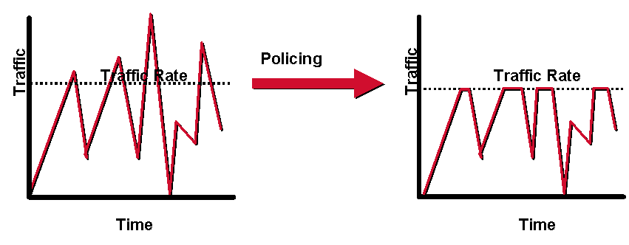
Figure 4Q- . The Effect of Policing on a Variable Traffic Stream
A standard PolicerService has no buffering, meaning that packets that cannot be transmitted are simply dropped. As can be seen in Figure 4Q- above, a Policer limits traffic flow to a configured bit rate. Policers can be configured with limiting bursting (i.e., the ability to exceed their contracted limit) capability, and they can also have various policies attached that provide configurable actions (i.e., transmit, drop, go to the next action in the list, remark and transmit, and so forth). These are modeled as PolicyRules in the DEN-ng system model, but their complexity and network knowledge prevent them from being further described in this Addendum.

ShaperService
A ShaperService is a CompoundConditioningElement. Its purpose is to regulate traffic flow to an average bit rate, taking into account any bursting capability that is desired.
Normally, a ShaperService includes buffering. This means that any packets that cannot be transmitted are queued. A ShaperService is shown in Figure 4Q-25 below.
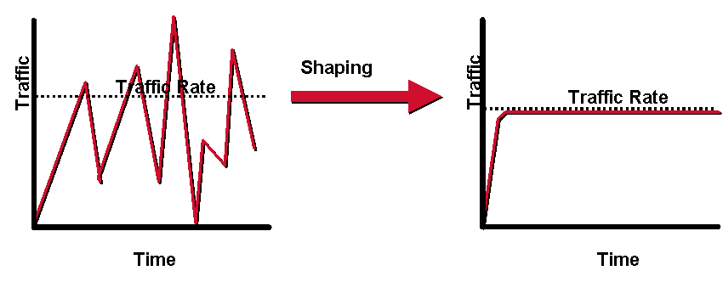
Figure 4Q- . The Effect of Shaping on a Variable Traffic Stream
Any packets that cannot be transmitted are instead queued. As in Policing, Shaping limits traffic, but has a very different impact on traffic. Shaping strives not to drop traffic (which can cause a retransmission of traffic), whereas policing drops any traffic that exceeds its contracted rate. However, by buffering traffic, Shaping adds a variable delay to the transmission of traffic.

Interaction With Other SID Business Entities

Introduction
This part of this Addendum will briefly describe the other SID business entities that have been identified that can interact with classes and relationships in the QoS Domain. The principal types of entities that can interact with a QoS entity are:
- Policy
- BusinessInteraction
- PartyRole
- Product (only indirectly!)
- Service
- Resource
- Location

Policy
Policy is used to define the semantics of how a Service is managed and controlled. Some of the tasks that Policy governs include the following:
- define what Services are needed for a particular task
- define how to manage, provision, activate, and monitor a set of Services
- define when a set of Services need to be reconfigured, and any additional semantics (e.g., order of changes)
- define which PartyRoles can manage a particular Service
- define which set of Services a particular PartyRole is authorized to use
- define where a Service can be installed or used
QoS is a type of Service, and therefore all of the above interactions apply to QoS as well. In addition, there are new interactions, such as using policy to determine when different types of QoS mechanisms should be enabled or disabled. For example, if traffic exceeds a certain rate, the probability of it being dropped should be increased. This decision can be made on different types of information, from the number of users of a particular service that are currently logged on to many other factors. As can be seen, the interactions between Policy and Service are varied and complex. This will be one of the areas that will be explored in detail in SID Phase IV. The Policy model is defined in [Add 1Pol].

BusinessInteraction
A BusinessInteraction describes how different entities interact with each other. Business interactions take the form of requests, responses, notifications, and agreements. This set of relationships will be explored in detail in SID Phase IV after more of the Policy interactions for Service and LogicalResource have been defined.

PartyRole
A PartyRole defines the function that a Party takes on. PartyRoles can represent the ability to manage, configure, use, and perform other types of interactions with Services. A simple starting model is shown in Figure 4Q- below.
One can see that the Service and Resource management methods are symmetrical. Therefore, this section will only discuss the Service ownership and administration classes.
The OwnsService association defines the set of Services (CustomerFacing and/or ResourceFacing) that a particular PartyRole owns. Note that this is a very different relationship than the AdministersService association. The OwnsService association defines the PartyRole that is the owner of the Service. Here, “owner” is the person or group that is responsible (e.g., organizational, financial, and so forth) for the Service. Note that the cardinality of the OwnsService association on the PartyRole side is 1 - this means that a Service MUST have at least one PartyRole to manage it. Furthermore, the cardinality of this association on the Service side is 0..n, which ensures that a PartyRole doesn’t have to own a Service.
The AdministersService association defines the set of Services (CustomerFacing and/or ResourceFacing) that a particular Party, playing the role of ValueNetworkRole, administers. From a business perspective, the Owner has to either appoint or give permission to the Administrator to administer the Service that is owned. This is done using the GrantsServiceAdminRights association. Note that a ValueNetworkRole, not just a PartyRole, is required to administer the Service. This is because a ValueNetworkRole possesses additional skills that a PartyRole doesn’t necessarily have.
The GrantsServiceAdminRights association defines which ValueNetworkRoles are allowed to administer a particular owned Service. Different ValueNetworkRoles will in general have different administration rights for the same Service. For example, different types of Administrators will in general each have the ability to make more changes than different types of Technicians.
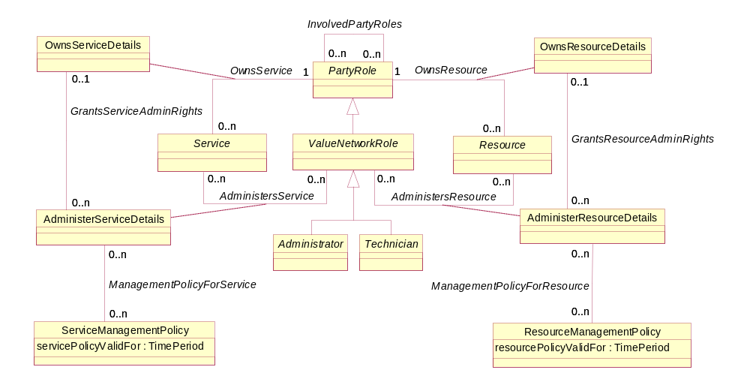
Figure 4Q- . Interaction Between PartyRole and Service
Policies can be defined for controlling the specific rights of administering a Service. This is the function of the ServiceManagementPolicy class. Since this is the business view of this relationship, only a simple single attribute is shown.
The ServiceManagementPolicy class defines the particular policies that are used to define how different aspects of the Service are managed and maintained. For example, assume that a Service is made up of several sub-Services. One of these sub-Services might require multiple PartyRoles to approve changes to its configuration, whereas another sub-Service might not require any approvals to change its configuration. Since Policy also uses the composite pattern, if a set of Policies are needed, these can be aggregated into a single Policy).
Note the power of this pattern - the ManagementPolicyForService association, along with its ServiceManagementPolicy class, provide a generic template for defining which set of PartyRoles can perform which type of management function for which type of Service. Figure 4Q-26 shows that Services and Resources can be managed using the same pattern, even though the contents of the classes will be different.
There is a lot more to the model, but this will be developed further in Phase IV of the SID.

Product
For now, the basic relationship between Product and Service (as defined in Figure 4Q- ) are deemed sufficient. Note that the basic Service model has been designed to deliberately separate CustomerFacingServices from ResourceFacingServices. Fundamentally, QoS is a special type of ResourceFacingService. Therefore, it doesn’t seem likely that a Product can directly interact with a QoS entity. However, this will be continuously re-evaluated as the above areas are more fully defined in SID Phase IV.

Services
The primary interaction between the Service and QoS domains are provided by the ResourceFacingServiceAtomic and ResourceFacingServiceComposite classes, along with the ServicePackageSpec, ServicePackage, ServiceBundleSpec, and ServiceBundle classes. In fact, as of Phase 3, these are the only Service classes that interact with QoS classes.
ResourceFacingServiceAtomic is the superclass for NetworkForwardingService, which in turn is the superclass for TrafficIdentificationService and TrafficConditioningService. These classes represent mechanisms in a device that can be used to identify and condition traffic. They represent how QoS is provided by particular devices.
ResourceFacingServiceComposite is the superclass for QoSService, which serves to bind NetworkForwardingServices to ServiceBundles.
The ServicePackageSpec, ServicePackage, ServiceBundleSpec, and ServiceBundle classes are used to link business concepts and requirements to networking capabilities.
These will be re-evaluated for completeness as part of the SID Phase IV effort.

Resources
Various diagrams throughout this Addendum have described different types of interactions between the Service and Resource Domains. Additional detail will be provided in the business view of the QoS Addendum, and in the system views of the Service and Resource Addenda. However, many of these are very low-level and not appropriate for the business view. While these will be continued to be examined as part of the SID Phase IV effort, they will most likely show up in the system view of the SID.

Location
In the SID, different types of Locations have different types of semantics associated with them. For example, a Wireless Access Point has an associated coverage area. Only applications within that coverage area can use the services associated with the Wireless Access Point. As another example, subscribers will access different POPs (Points of Presence, the Service Provider term for an access network) as they travel nationally and internationally. Services may vary, and additional peering relationships may come into effect. A simple starting model relating Service to Location is shown in Figure SO.32 of [Add 4SO].
SID Phase IV may address building specific relationships between the QoS and Location domains. However, it is likely that these will be relegated to the system, not the business, view.

References
The following table provides a list of references used in this Addendum.

[053Main] | TMF053, “The NGOSS Technology Neutral Architecture”, TMF
[DEN-ng] | Directory Enabled Networks New Generation by John Strassner, et. al., to be published
[eTOM] | GB921 version 2.5
[Add 3] | SID Product Model, GB922, Addendum 3
[Add 4SO] | SID Service Overview Model, GB922, Addendum 4SO
[Add 5LR] | SID LogicalResource Model, GB922, Addendum 5LR
[Add 5PR] | SID PhysicalResource Model, GB922, Addendum 5PR
[GB922] | SID Concepts and Principles, GB922 (main document)
[Fowler-AP] | Analysis Patterns – Reusable Object Models by Martin Fowler ISBN 0-201-89542-0  http://martinfowler.com/articles.html
[Fowler-Role] | Dealing with Roles  http://www.awl.com/cseng/titles/0-201-89542-0/apsupp/roles2-1.html
[DEN] | Directory Enabled Networks by John Strassner ISBN 1-57870-140-6
[CIM] | Common Information Model, DMTF  http://www.dmtf.org/standards/standard_cim.php
[CIMPROB] | Mining Information from the DMTF CIM into the TMF SID, ed by John Strassner (This was a deliverable from the TMF-DMTF liaison)
[RFC1349] | P. Almquist, “Type of Service in the Internet Protocol Suite”, RFC1349
[RFC2474] | K. Nichols, S. Blake, F. Baker, D. Black, “Definition of the Differentiated Services Field (DS Field) in the IPv4 and IPv6 Headers”, RFC2474
[N+I2002] | J. Strassner, J. Wheeler, “Policy, DEN, and QoS Workshop”, a two-day tutorial for the  Network World + Interop conference, 2002
[RFC3246] | B. Davie, A. Charny, J.C.R. Bennett, K. Benson, J.Y. Le Boudec, W. Courtney, S. Davari, V. Firoiu,  D. Stiliadis, “An Expedited Forwarding PHB (Per-Hop Behavior)”, RFC3246, March 2002
[RFC3247] | A. Charny, J.C.R. Bennett, K. Benson, J.Y. Le Boudec, A. Chiu, W. Courtney, S. Davari, V. Firoiu,  C. Kalmanek, K.K. Ramakrishnan, “Supplemental Information for the New Definition of the EF PHB”, RFC3247, March 2002
[RFC2597] | J. Heinanen, F. Baker, W. Weiss, J. Wroclawski, “Assured Forwarding PHB Group“, June 1999

Business Entity Definitions
The following sections will define the business entities referred to in the preceding portion of this Addendum. This section will consist of a business entity definition, definition of any attributes appropriate for the business level, and finally provide a business model in UML of that entity and its main relationships.

QoSService Business Entity Definition

Business Entity Name | QoSService
Description | This class represents a generic specification for defining the different types of Sub-Services that are required to implement a specific type of QoS. This enables business rules to be mapped to the network, and define services that the network provides.  A QoSService can be thought of as an aggregation of sub-services needed to realize the functionality specified by, for example, a ServiceBundle object. This enables the network administrator to map business rules (as specified in a more abstract object or set of objects) to the network, and the network designer to engineer the network such that it can provide different functions for different types of applications.  QoSServices are a type of ResourceFacingService, and are bundled together using ServiceBundles. They can be templatized using ServiceBundleSpecs.  The QoSService itself is a means to coordinate different technology-specific approaches to implementing QoS, such as DiffServ, ToS, and IEEE 802.x. As such, it is an abstract class.
Sources | DEN-ng | Cross- References |  |  | Synonyms / Aliases | No concept of this categorization in the ITU specs. The DMTF CIM defines QoSService as a concrete class directly below Service, and has deprecated PrecedenceService and 802.1P Service. Thus, the semantics between the DMTF and the TMF are completely different, since the subclasses and superclasses are different.
Related Business Entities | ManagedEntity, Product, ProductBundle, ProductComponent, Resource, PhysicalResource, LogicalResource, Service, CustomerFacingService, ResourceFacingService, CustomerFacingServiceAtomic, CustomerFacingServiceComposite, ResourceFacingServiceAtomic, ResourceFacingServiceComposite (superclass), TOSService (subclass), DiffServService (subclass), 802Service (subclass), ServiceRole, ServiceCharacteristic, ServiceSpecification (template), CustomerFacingServiceSpec, ResourceFacingServiceSpec, ServicePackageSpec, ServicePackage, ServiceBundleSpec, ServiceBundle, ServiceSpecVersion, ProductSpecification, Location, BusinessInteraction, PartyRole
Business Rules | To be determined

QoSService Business Entity Attributes Definition
The purpose of this class is to aggregate different QoS technologies. As such, it most likely will not have any attributes (leaving specific attributes to its subclasses). However, it does have a set of important relationships that its subclasses participate in.
This will be investigated more in Phase IV of the SID.

Business Entity Name | QoSService
Attribute Name | Description | Data Type | Characteristics, Permitted  Values & Units | Required/  Optional | Notes (used to map to other models; blank is other models don’t have it)
Tbd

Business Entity Model – QoSService
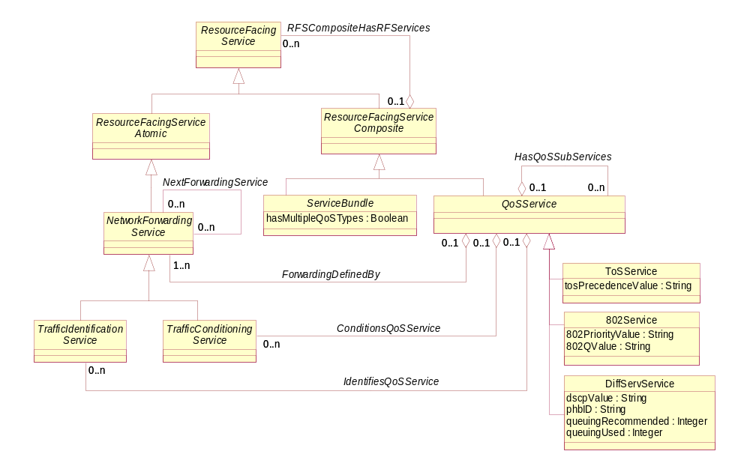
Figure 4Q- . Business Entity Model of a QoSService

ToSService Business Entity Definition

Business Entity Name | ToSService
Description | ToSService contains semantics that define how traffic is forwarded based on the value of the ToS byte of a packet.  This class is used to enable different types of QoSServices, such as 802Service and DiffServService, to exchange traffic with each other. Each of these different types of QoSServices has its own means of indicating that one type of traffic should be treated in a different manner from other types of traffic. Thus, without the ability to define mappings between these different marking methods, interoperability is not possible.
Sources | DEN-ng | Cross- References |  |  | Synonyms / Aliases | No concept of this categorization in the ITU specs. The DMTF CIM has deprecated PrecedenceService (which is their equivalent to this class). Thus, the semantics between the DMTF and the TMF are completely different, since the superclasses are different and this class no longer exists in the CIM.
Related Business Entities | ManagedEntity, Product, ProductBundle, ProductComponent, Resource, PhysicalResource, LogicalResource, Service, CustomerFacingService, ResourceFacingService, CustomerFacingServiceAtomic, CustomerFacingServiceComposite, ResourceFacingServiceAtomic, ResourceFacingServiceComposite, QoSService(superclass), DiffServService (sibling), 802Service (sibling), ServiceRole, ServiceCharacteristic, ServiceSpecification (template), CustomerFacingServiceSpec, ResourceFacingServiceSpec, ServicePackageSpec, ServicePackage, ServiceBundleSpec, ServiceBundle, ServiceSpecVersion, ProductSpecification, Location, BusinessInteraction, PartyRole
Business Rules | To be determined

ToSService Business Entity Attributes Definition

Business Entity Name | ToSService
Attribute Name | Description | Data Type | Characteristics, Permitted  Values & Units | Required/  Optional | Notes (used to map to other models; blank is other models don’t have it)
tosPrecedenceValue | This attribute is a string that contains the 3-bit marking in the ToS byte. | String |  | Required | The CIM has deprecated this class.

Business Entity Model – ToSService
The business entity model of the ToSService is the same as that for the QoSService, which was shown in Figure 4Q- above.

802Service Business Entity Definition

Business Entity Name | 802Service
Description | 802Service contains semantics that define how traffic is forwarded based on the value of the priority field in the 802.1P header.  This class is used to enable different types of QoSServices, such as 802Service and DiffServService, to exchange traffic with each other. Each of these different types of QoSServices has its own means of indicating that one type of traffic should be treated in a different manner from other types of traffic. Thus, without the ability to define mappings between these different marking methods, interoperability is not possible.
Sources | DEN-ng | Cross- References |  |  | Synonyms / Aliases | No concept of this categorization in the ITU specs. The DMTF CIM has deprecated 802.1P Service (which is the equivalent of this class). Thus, the semantics between the DMTF and the TMF are completely different, since the subclasses and superclasses are different.
Related Business Entities | ManagedEntity, Product, ProductBundle, ProductComponent, Resource, PhysicalResource, LogicalResource, Service, CustomerFacingService, ResourceFacingService, CustomerFacingServiceAtomic, CustomerFacingServiceComposite, ResourceFacingServiceAtomic, ResourceFacingServiceComposite, QoSService(superclass), DiffServService (sibling), ToSService (sibling), ServiceRole, ServiceCharacteristic, ServiceSpecification (template), CustomerFacingServiceSpec, ResourceFacingServiceSpec, ServicePackageSpec, ServicePackage, ServiceBundleSpec, ServiceBundle, ServiceSpecVersion, ProductSpecification, Location, BusinessInteraction, PartyRole
Business Rules | To be determined

802Service Business Entity Attributes Definition
The purpose of this class is to aggregate different QoS technologies. As such, it most likely will not have any attributes (leaving specific attributes to its subclasses). However, it does have a set of important relationships that its subclasses participate in.
This will be investigated more in Phase IV of the SID.

Business Entity Name | 802Service
Attribute Name | Description | Data Type | Characteristics, Permitted  Values & Units | Required/  Optional | Notes (used to map to other models; blank is other models don’t have it)
802PriorityValue | This attribute is a string that defines the priority of this packet according to an 802.1P specification. | String |  | Required | The CIM has deprecated this class.
802QValue | This is a String that can be used to identify a VLAN.  The IEEE 802.1Q standard defines the operation of VLAN Bridges that permit the definition, operation and administration of Virtual LAN topologies within a Bridged LAN infrastructure.  The standard also helps provide a higher level of security between segments of internal networks. The 802.1Q specification establishes a standard method for inserting VLAN membership information into Ethernet frames. | String |  | Required | The CIM never defined this value.

Business Entity Model – 802Service
The business entity model of the 802Service is the same as that for the QoSService, which was shown in Figure 4Q- above.

DiffServService Business Entity Definition

Business Entity Name | DiffServService
Description | This class represents a generic specification for defining the different types of Sub-Services that are required to implement a specific type of QoS. This enables business rules to be mapped to the network, and define services that the network provides.  A QoSService can be thought of as an aggregation of sub-services needed to realize the functionality specified by, for example, a ServiceBundle object. This enables the network administrator to map business rules (as specified in a more abstract object or set of objects) to the network, and the network designer to engineer the network such that it can provide different functions for different types of applications.  QoSServices are a type of ResourceFacingService, and are bundled together using ServiceBundles. They can be templatized using ServiceBundleSpecs.  The QoSService itself is a means to coordinate different technology-specific approaches to implementing QoS, such as DiffServ, ToS, and IEEE 802.x. As such, it is an abstract class.
Sources | DEN-ng | Cross- References |  |  | Synonyms / Aliases | No concept of this categorization in the ITU specs. The DMTF CIM defines DiffServService, but has deprecated the DSCP attribute and the EFService class. Thus, the semantics between the DMTF and the TMF are completely different, since the subclasses and superclasses are different.
Related Business Entities | ManagedEntity, Product, ProductBundle, ProductComponent, Resource, PhysicalResource, LogicalResource, Service, CustomerFacingService, ResourceFacingService, CustomerFacingServiceAtomic, CustomerFacingServiceComposite, ResourceFacingServiceAtomic, ResourceFacingServiceComposite, QoSService(superclass), ToSService (sibling), 802Service (sibling), ServiceRole, ServiceCharacteristic, ServiceSpecification (template), CustomerFacingServiceSpec, ResourceFacingServiceSpec, ServicePackageSpec, ServicePackage, ServiceBundleSpec, ServiceBundle, ServiceSpecVersion, ProductSpecification, Location, BusinessInteraction, PartyRole
Business Rules | To be determined

DiffServService Business Entity Attributes Definition

Business Entity Name | DiffServService
Attribute Name | Description | Data Type | Characteristics, Permitted  Values & Units | Required/  Optional | Notes (used to map to other models; blank is other models don’t have it)
dscpValue | This attribute is a string that defines the Differentiated Services Code Point (DSCP) that this interface uses to represent various types of differentiated services through device-specific configuration commands. | String |  | Required | Not present in the ITU specs. The CIM has deprecated this attribute.
queuingRecommended | This is an enumerated integer that defines the type of queuing that is recommended for this particular PHB. |  | 0: not specified  1: PQ (priority queuing)  2: WFQ (weighted fair queuing)  3: CBWFQ (class-based WFQ)  4: PQ-CBWFQ (2 and 3 together)  5: other | Optional | Not present in the ITU or CIM specs.
queuingUsed | This is an enumerated integer that defines the type of queuing that is actually used in this instance for this particular PHB. |  | 0: not specified  1: PQ (priority queuing)  2: WFQ (weighted fair queuing)  3: CBWFQ (class-based WFQ)  4: PQ-CBWFQ (2 and 3 together)  5: other | Optional | Not present in the ITU or CIM specs.

Business Entity Name | DiffServService (continued)
Attribute Name | Description | Data Type | Characteristics, Permitted  Values & Units | Required/  Optional | Notes (used to map to other models; blank is other models don’t have it)
phbID | This attribute is a string that identifies a particular Per Hop Behavior (PHB). The value of this string is the Per Hop Behavior Identification Code, as defined in RFC3140.  PHB identification codes define how traffic belonging to a particular behavior aggregate is treated at an individual network node. In IP packet headers, PHBs are not indicated as such; instead DSCP values are used. There are only 64 possible DSCP values, but there is no such limit on the number of PHBs.  In a given network domain, there is a locally defined mapping between DSCP values and PHBs. Standardized PHBs recommend a DSCP mapping, but network operators may choose alternative mappings. | String |  | Required | No concept of this attribute in the ITU specs. The CIM defines this attribute (with not as complete semantics) but its data type is an integer.

Business Entity Model – DiffServService
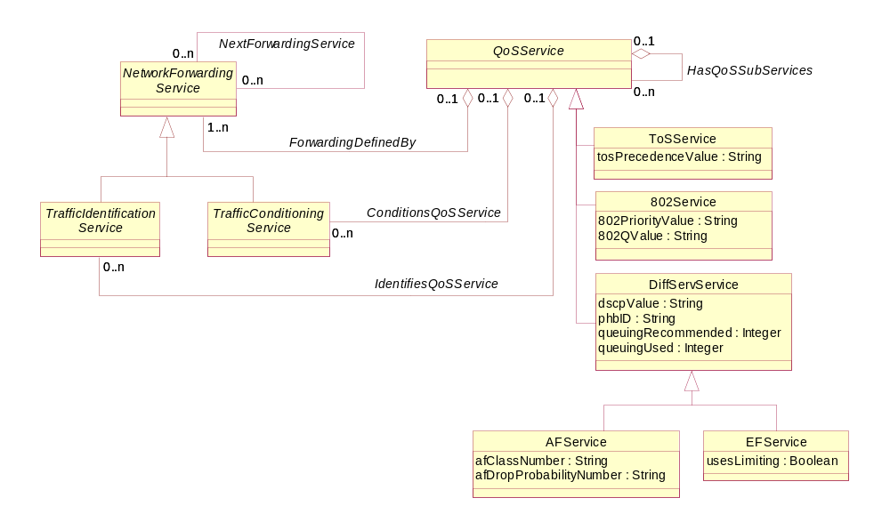
Figure 4Q- . Business Entity Model for a DiffServService

AFService Business Entity Definition

Business Entity Name | AFService
Description | This class defines how to forward network traffic by adding specific semantics that characterize the operation of the Assured Forwarding (AF) Service (RFC2597).  This RFC defines four different AF classes to represent four different treatments of traffic (e.g., a different amount of forwarding resources, such as buffer space and bandwidth, are allocated). This RFC defines three different drop probabilities for each AF class, though clearly additional drop probabilities can be defined.  The idea of AFService is to mark IP packets with one of three possible drop precedence values. The drop precedence of a packet determines the relative importance of that packet compared to other packets within the same AF class if congestion occurs. A congested interface will try to avoid dropping packets with a lower drop precedence value by instead discarding packets with a higher drop precedence value. Of course, if there is no congestion on the DeviceInterface, then nothing will happen.
Sources | DEN-ng | Cross- References |  |  | Synonyms / Aliases | No concept of this categorization in the ITU specs. The DMTF CIM defines DiffServService, but has deprecated the DSCP attribute and the EFService class. In addition, the CIM defines a recursive association (AFServices) which is redundant. Thus, the semantics between the DMTF and the TMF are completely different, since the subclasses and superclasses are different.
Related Business Entities | ManagedEntity, Product, ProductBundle, ProductComponent, Resource, PhysicalResource, LogicalResource, Service, CustomerFacingService, ResourceFacingService, CustomerFacingServiceAtomic, CustomerFacingServiceComposite, ResourceFacingServiceAtomic, ResourceFacingServiceComposite, QoSServic, ToSService, 802Service, DiffServService (superclass), EFService (sibling), ServiceRole, ServiceCharacteristic, ServiceSpecification (template), CustomerFacingServiceSpec, ResourceFacingServiceSpec, ServicePackageSpec, ServicePackage, ServiceBundleSpec, ServiceBundle, ServiceSpecVersion, ProductSpecification, Location, BusinessInteraction, PartyRole
Business Rules | To be determined

AFService Business Entity Attributes Definition

Business Entity Name | AFService
Attribute Name | Description | Data Type | Characteristics, Permitted  Values & Units | Required/  Optional | Notes (used to map to other models; blank is other models don’t have it)
afClassNumber | This attribute is a string that defines the number of AF classes that this AF implementation uses. | String |  | Required | Not present in the ITU specs. The CIM has defined this attribute as an integer.
afDropProbabilityNumber | This attribute is a string that defines the number of drop precedence values that this AF implementation uses. Each AF class has exactly this number of drop precedence values - no more, no less. | String |  | Required | Not present in the ITU specs. The CIM has defined this attribute as an integer.

Business Entity Model – AFService
The business entity model of AFService is the same as that for DiffServServices, and was shown in Figure 4Q- above.

EFService Business Entity Definition

Business Entity Name | EFService
Description | This class defines how to forward network traffic by adding specific semantics that characterize the operation of the Expedited Forwarding (EF) Service (RFC3246 and RFC3247).  The recommended DSCP for defining EF is 101110. called expedited forwarding (EF). The EF PHB can be used to build a low loss, low latency, low jitter, assured bandwidth, end-to-end service through DiffServ-compliant domains. Such a service appears to the endpoints like a point-to-point connection or a "virtual leased line".  The PHB for this class and its DSCP value come from DiffServService. However, this class defines attributes that can be used as "implementation hints" to the rest of the network to ensure that interoperability is achieved even if heterogeneous devices are being used.
Sources | DEN-ng | Cross- References |  |  | Synonyms / Aliases | No concept of this categorization in the ITU specs. The DMTF CIM has deprecated this class. In addition, its old IETF references were outdated. Thus, the semantics between the DMTF and the TMF are completely different, since the subclasses and superclasses are different.
Related Business Entities | ManagedEntity, Product, ProductBundle, ProductComponent, Resource, PhysicalResource, LogicalResource, Service, CustomerFacingService, ResourceFacingService, CustomerFacingServiceAtomic, CustomerFacingServiceComposite, ResourceFacingServiceAtomic, ResourceFacingServiceComposite, QoSServic, ToSService, 802Service, DiffServService (superclass), AFService (sibling), ServiceRole, ServiceCharacteristic, ServiceSpecification (template), CustomerFacingServiceSpec, ResourceFacingServiceSpec, ServicePackageSpec, ServicePackage, ServiceBundleSpec, ServiceBundle, ServiceSpecVersion, ProductSpecification, Location, BusinessInteraction, PartyRole
Business Rules | To be determined

EFService Business Entity Attributes Definition

Business Entity Name | EFService
Attribute Name | Description | Data Type | Characteristics, Permitted  Values & Units | Required/  Optional | Notes (used to map to other models; blank is other models don’t have it)
usesLimiting | This is a Boolean attribute that, if TRUE, indicates that this particular EF PHB implementation has a limiting mechanism to protect the rest of the network from the effects of EF traffic.  Various mechanisms can be used to implement the EF PHB. If the particular mechanism chosen allows unlimited preemption of other traffic (e.g., a priority queue), this implementation must include some means to limit the damage EF traffic could inflict on other traffic (e.g., a token bucket rate limiter).  Traffic that exceeds this limit must be discarded. | String |  | Required | Not present in the ITU or CIM specs. In addition, the CIM has deprecated this class.

Business Entity Model – EFService
The business entity model of EFService is the same as that for DiffServServices, and was shown in Figure 4Q- above.

NetworkForwardingService Business Entity Definition

Business Entity Name | NetworkForwardingService
Description | The programming of a QoSService is represented in DEN-ng as a set of NetworkForwardingServices. This is because when traffic is forwarded, it can be differentiated from other traffic. During the forwarding process, packets can be (for example) queued or dropped. These are two examples of different types of QoS that are grouped into what are called TrafficConditioningServices in DEN-ng. In order to packets to be identified, they need to be classified and marked. This is, in DEN-ng, termed a TrafficIdentificationService.  Both TrafficIdentificationService and TrafficConditioningService are subclassed from NetworkForwardingService. A TrafficIdentificationService is used to classify and mark packets to separate one traffic flow from another traffic flow. Once this is done, different means of defining how packets are forwarded can be defined, such as queuing and dropping, which are different types of TrafficConditioningServices.  Thus, we see that a given QoSService technology can be programmed using a particular set of NetworkForwardingServices, which is represented in generic fashion by the ForwardingDefinedBy relationship.
Sources | DEN-ng | Cross- References |  |  | Synonyms / Aliases | No concept of this categorization in the ITU specs. The DMTF CIM doesn’t have any separation between a TrafficIdentificationService and a TrafficConditioningService. Thus, the semantics between the DMTF and the TMF are completely different, since the subclasses and superclasses are different.
Related Business Entities | ManagedEntity, Product, ProductBundle, ProductComponent, Resource, PhysicalResource, LogicalResource, Service, CustomerFacingService, ResourceFacingService, CustomerFacingServiceAtomic, CustomerFacingServiceComposite, ResourceFacingServiceAtomic (superclass), ResourceFacingServiceComposite, QoSServic, ToSService, 802Service, DiffServService, TrafficIdentificationService (subclass), TrafficConditioningService (subclass), ServiceRole, ServiceCharacteristic, ServiceSpecification (template), CustomerFacingServiceSpec, ResourceFacingServiceSpec, ServicePackageSpec, ServicePackage, ServiceBundleSpec, ServiceBundle, ServiceSpecVersion, ProductSpecification, Location, BusinessInteraction, PartyRole
Business Rules | To be determined

NetworkForwardingService Business Entity Attributes Definition
The primary purpose of this class is to serve as a common place to define attributes and relationships for traffic identification and forwarding. These are two principle characteristics of any QoS service, and are bound to a QoSService via the ForwardingDefinedBy aggregation.
Thus, this class currently has no common attributes at the business level, since traffic identification and forwarding are different in nature. This will be further examined as part of SID Phase IV.

Business Entity Name | NetworkForwardingService
Attribute Name | Description | Data Type | Characteristics, Permitted  Values & Units | Required/  Optional | Notes (used to map to other models; blank is other models don’t have it)
tbd

Business Entity Model – NetworkForwardingService
The business entity model of NetworkForwardingService is the same as that for QoSServices, and was shown in Figure 4Q- above.

TrafficIdentificationService Business Entity Definition

Business Entity Name | TrafficIdentificationService
Description | A TrafficIdentificationService is a fundamental QoS building block.  A TrafficIdentificationService is an abstract base class that is the parent for different types of traffic identification services defined in the DEN-ng Service model. TrafficIdentificationServices are one example of a ResourceFacingService, in that the Customer is not able to control them. In fact, the Customer doesn't even have to be aware that they exist! However, they must be implemented in order for different CoSs to be differentiated from each other, and hence for different Customers to receive different CoSs.  TrafficIdentificationServices control how packets and flows are identified and distinguished from other packets and flows in the system. Without these services, traffic conditioning cannot work.
Sources | DEN-ng | Cross- References |  |  | Synonyms / Aliases | No concept of this categorization in the ITU specs. The DMTF CIM doesn’t have any separation between a TrafficIdentificationService and a TrafficConditioningService. Thus, the semantics between the DMTF and the TMF are completely different, since the subclasses and superclasses are different.
Related Business Entities | ManagedEntity, Product, ProductBundle, ProductComponent, Resource, PhysicalResource, LogicalResource, Service, CustomerFacingService, ResourceFacingService, CustomerFacingServiceAtomic, CustomerFacingServiceComposite, ResourceFacingServiceAtomic, ResourceFacingServiceComposite, QoSServic, ToSService, 802Service, DiffServService, NetworkForwardingService (superclass), ClassifierService (subclass), MarkerService (subclass), TrafficConditioningService (sibling), ServiceRole, ServiceCharacteristic, ServiceSpecification (template), CustomerFacingServiceSpec, ResourceFacingServiceSpec, ServicePackageSpec, ServicePackage, ServiceBundleSpec, ServiceBundle, ServiceSpecVersion, ProductSpecification, Location, BusinessInteraction, PartyRole
Business Rules | To be determined

TrafficIdentificationService Business Entity Attributes Definition
The primary purpose of this class is to serve as a common place to define attributes and relationships for traffic identification.
Thus, this class currently has no common attributes at the business level, since traffic identification and marking are different in nature. This will be further examined as part of SID Phase IV.

Business Entity Name | TrafficIdentificationService
Attribute Name | Description | Data Type | Characteristics, Permitted  Values & Units | Required/  Optional | Notes (used to map to other models; blank is other models don’t have it)
tbd

Business Entity Model – TrafficIdentificationService
The business entity model of TrafficIdentificationService is the same as that for QoSServices, and was shown in Figure 4Q- above.

ClassifierService Business Entity Definition

Business Entity Name | ClassifierService
Description | A Classifier is an internal component of the forwarding path. It is used to recognize and distinguish among different packet streams or flows. Without classification, all packets will be treated the same.  The function of the ClassifierService is to model the identification of traffic accepted at the ingress interface of the device, and to separate traffic into different flows. This enables flows from different applications that can be treated the same way to be aggregated together, making the network design much more scalable.  For almost all situations, the ClassifierService will be followed by a MarkerService (or one of its subclasses) so that separate traffic can be assigned a unique mark in the packet header. This will enable subsequent mechanisms to simply examine the mark in the header and perform operations based on that marking. This dependency is modeled using an instance of the NextForwardingService association.  The definition of which flows can be separated into which aggregates is defined using the TrafficMatchCriteria class. This can be formalized using the PolicyStatement construct from the Policy Model if desired. PolicyVariable and PolicyValue can either be predefined in a TrafficMatchCriteria class, or defined dynamically using the four attributes defined in this class.
Sources | DEN-ng | Cross- References |  |  | Synonyms / Aliases | No concept of this categorization in the ITU specs. The DMTF CIM has a similarly named class, but it has different semantics.
Related Business Entities | ManagedEntity, Product, ProductBundle, ProductComponent, Resource, PhysicalResource, LogicalResource, Service, CustomerFacingService, ResourceFacingService, CustomerFacingServiceAtomic, CustomerFacingServiceComposite, ResourceFacingServiceAtomic, ResourceFacingServiceComposite, QoSServic, ToSService, 802Service, DiffServService, NetworkForwardingService, TrafficIdentificationService (superclass), MarkerService (sibling), TrafficConditioningService, ServiceRole, ServiceCharacteristic, ServiceSpecification (template), CustomerFacingServiceSpec, ResourceFacingServiceSpec, ServicePackageSpec, ServicePackage, ServiceBundleSpec, ServiceBundle, ServiceSpecVersion, ProductSpecification, Location, BusinessInteraction, PartyRole
Business Rules | To be determined

ClassifierService Business Entity Attributes Definition
In addition to the attributes listed below, this object serves as a source for generating important traffic classification statistics in the DEN-ng system model. This will be further examined as part of SID Phase IV.

Business Entity Name | ClassifierService
Attribute Name | Description | Data Type | Characteristics, Permitted  Values & Units | Required/  Optional | Notes (used to map to other models; blank is other models don’t have it)
dynamicClassVariableName | This is a string attribute, whose value contains the name of a class to be used to form all or part of the traffic match criteria. For example, if it is desired to match on a dynamically negotiated port number, then the value of this attribute would be used to identify the appropriate class (e.g., PortVariable) that would be used. | String |  | Required | Not present in the DMTF CIM or ITU specs.
dynamicAttributeVariableName | This is a string attribute, whose value contains the name of an attribute to be used to form all or part of the traffic match criteria. For example, if it is desired to match on a dynamically negotiated port number, then the value of this attribute would be used to identify the appropriate attribute (e.g., PortNumber ) in the appropriate class (e.g., PortVariable) that would be used. | String |  | Required | Not present in the DMTF CIM or ITU specs.

Business Entity Name | ClassifierService (continued)
Attribute Name | Description | Data Type | Characteristics, Permitted  Values & Units | Required/  Optional | Notes (used to map to other models; blank is other models don’t have it)
dynamicClassValueName | This is a string attribute, whose value contains the name of a class to be used to supply the value to be matched against. For example, if it is desired to match on a dynamically negotiated port number, then the value of the dynamicClassVariableName attribute would be PortVariable. The value of this attribute could then be StringValue. | String |  | Required | Not present in the DMTF CIM or ITU specs.
dynamicAttributeValueName | This is a string attribute, whose value contains the name of an attribute to be used to supply the value to be matched against.  For example, if it is desired to match on a dynamically negotiated port number, then the value of the dynamicClassVariableName attribute would be PortVariable, and the attribute to match against in PortVariable might be PortNumber. The value of the dynamicClassValueName attribute to compare the SourcePort against could be StringValue | String |  | Required | Not present in the DMTF CIM or ITU specs.

Business Entity Model – ClassifierService
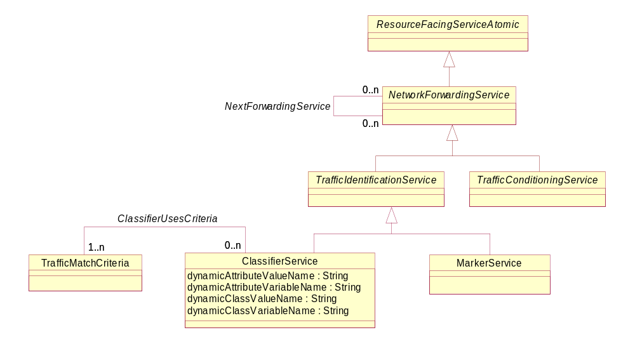
Figure 4Q- . Business Entity Model of a ClassifierService

MarkerService Business Entity Definition

Business Entity Name | MarkerService
Description | The function of a MarkerService is to mark packets in a flow so that different devices in the network know how to treat the traffic that these packets belong to. This is done by "coloring" a packet so that it can be identified and distinguished among other packets that are receiving traffic conditioning. In effect, this partitions a network into multiple priority levels or classes. Marking packets is done using a technology-specific mechanism, such as the ToS byte, the DSCP, or other methods for other media.  In DEN-ng, this function is modeled by the MarkerService. This service will mark a selected field in a network packet with a specified value. Packets are marked in order to indicate to downstream components what types of TrafficConditioningServices they will subsequently receive.  The definition of how to mark a particular packet is defined using the MarkerPool class.  Note that there is a fundamental difference between its two subclasses. StandardMarkerService enables different types of technology-specific marking, which directly affect subsequent operations, to be defined. Examples of this include the difference between DiffServ marking and IEEE 802 marking. The PreambleMarkingService is used to capture the result of traffic conditioning operations and store them in a preamble. The two types of marking can be combined in some implementations.
Sources | DEN-ng | Cross- References |  |  | Synonyms / Aliases | No concept of this categorization in the ITU specs. The DMTF CIM has a set of subclasses, each with a single attribute for controlling that type of marker. This approach is more generic and more scalable.
Related Business Entities | ManagedEntity, Product, ProductBundle, ProductComponent, Resource, PhysicalResource, LogicalResource, Service, CustomerFacingService, ResourceFacingService, CustomerFacingServiceAtomic, CustomerFacingServiceComposite, ResourceFacingServiceAtomic, ResourceFacingServiceComposite, QoSServic, ToSService, 802Service, DiffServService, NetworkForwardingService, TrafficIdentificationService (superclass), ClassifierService (sibling), StandardMarkerService (subclass), PreambleMarkerService (subclass), TrafficConditioningService, ServiceRole, ServiceCharacteristic, ServiceSpecification (template), CustomerFacingServiceSpec, ResourceFacingServiceSpec, ServicePackageSpec, ServicePackage, ServiceBundleSpec, ServiceBundle, ServiceSpecVersion, ProductSpecification, Location, BusinessInteraction, PartyRole
Business Rules | To be determined

MarkerService Business Entity Attributes Definition
The primary purpose of this class is to serve as a common place to define attributes and relationships for traffic marking. Thus, this class currently has no common business attributes defined, since its two subclasses are implemented very differently. This will be further examined as part of SID Phase IV.

Business Entity Name | MarkerService
Attribute Name | Description | Data Type | Characteristics, Permitted  Values & Units | Required/  Optional | Notes (used to map to other models; blank is other models don’t have it)
tbd

Business Entity Model – MarkerService
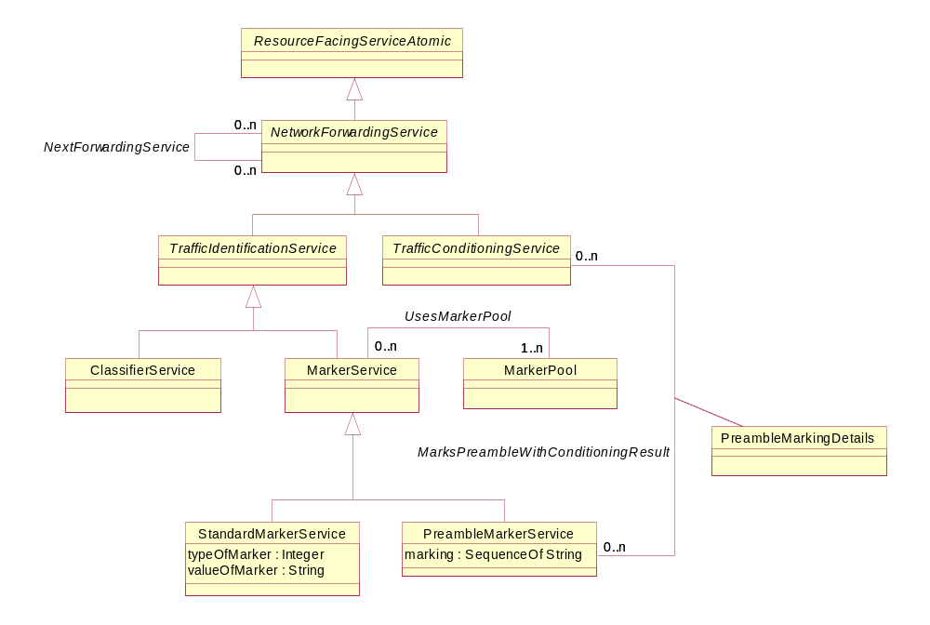
Figure 4Q- . Business Entity Model of a Marker Service

StandardMarkerService Business Entity Definition

Business Entity Name | StandardMarkerService
Description | This subclass defines the most common type of marker, which sets existing bits in specific fields of a packet or frame. The marking is done via the two attributes of this class. The first value is used to define the type of marker (e.g., ToS vs. DSCP), while the second attribute contains the actual value to be marked.
Sources | DEN-ng | Cross- References |  |  | Synonyms / Aliases | No concept of this categorization in the ITU specs. The DMTF CIM has a set of subclasses, each with a single attribute for controlling that type of marker. This approach is more generic and more scalable.
Related Business Entities | ManagedEntity, Product, ProductBundle, ProductComponent, Resource, PhysicalResource, LogicalResource, Service, CustomerFacingService, ResourceFacingService, CustomerFacingServiceAtomic, CustomerFacingServiceComposite, ResourceFacingServiceAtomic, ResourceFacingServiceComposite, QoSServic, ToSService, 802Service, DiffServService, NetworkForwardingService, TrafficIdentificationService, MarkerService (superclass), ClassifierService, PreambleMarkerService (sibling), TrafficConditioningService, ServiceRole, ServiceCharacteristic, ServiceSpecification (template), CustomerFacingServiceSpec, ResourceFacingServiceSpec, ServicePackageSpec, ServicePackage, ServiceBundleSpec, ServiceBundle, ServiceSpecVersion, ProductSpecification, Location, BusinessInteraction, PartyRole
Business Rules | To be determined

StandardMarkerService Business Entity Attributes Definition

Business Entity Name | StandardMarkerService
Attribute Name | Description | Data Type | Characteristics, Permitted  Values & Units | Required/  Optional | Notes (used to map to other models; blank is other models don’t have it)
typeOfMarker | This is an enumerated integer that defines the type of marker that this instance is. | Integer | 0: ToS  1: DSCP  2: 802-priority field  3: 802-vlan id  4: ISL class of service field (3 bits)  5: Class of Service (other field)  6: MPLS Label  7: VC ID  8: VC Bundle (set of VC IDs) | Required | No concept of this in the ITU specs. The CIM has specific subclasses for a few of these fields.
valueOfMarker | This is a string attribute that contains the value of the marker. This attribute is not used if a general preamble marking is desired. | String |  | Required | No concept of this in the ITU specs. The CIM has specific subclasses that contain the attribute definition and value.

Business Entity Model – StandardMarkerService
The business entity model for the StandardMarkerService is the same as that for the MarkerService, and is shown in Figure 4Q- above.

PreambleMarkerService Business Entity Definition

Business Entity Name | PreambleMarkerService
Description | This type of MarkerService is used to model the storing of traffic-conditioning results in a packet preamble. The results are stored as an array of <type>,<value> pairs.
Sources | DEN-ng | Cross- References |  |  | Synonyms / Aliases | No concept of this in the ITU specs. The DMTF CIM has this function, but the implementation is significantly different.
Related Business Entities | ManagedEntity, Product, ProductBundle, ProductComponent, Resource, PhysicalResource, LogicalResource, Service, CustomerFacingService, ResourceFacingService, CustomerFacingServiceAtomic, CustomerFacingServiceComposite, ResourceFacingServiceAtomic, ResourceFacingServiceComposite, QoSServic, ToSService, 802Service, DiffServService, NetworkForwardingService, TrafficIdentificationService, MarkerService (superclass), ClassifierService, StandardMarkerService (sibling), TrafficConditioningService, ServiceRole, ServiceCharacteristic, ServiceSpecification (template), CustomerFacingServiceSpec, ResourceFacingServiceSpec, ServicePackageSpec, ServicePackage, ServiceBundleSpec, ServiceBundle, ServiceSpecVersion, ProductSpecification, Location, BusinessInteraction, PartyRole
Business Rules | To be determined

PreambleMarkerService Business Entity Attributes Definition

Business Entity Name | PreambleMarkerService
Attribute Name | Description | Data Type | Characteristics, Permitted  Values & Units | Required/  Optional | Notes (used to map to other models; blank is other models don’t have it)
marking | This is an array of strings of the form  <type>, <value>  Each string represents the result of a specific traffic conditioning action. This enables "memory" of the traffic conditioning process to be passed along from conditioning element to conditioning element. | String Array |  | Required | No concept of this in the ITU specs. The CIM has a similar concept, but the implementation is significantly different.

Business Entity Model – PreambleMarkerService
The business entity model for the PreambleMarkerService is the same as that for the MarkerService, and is shown in Figure 4Q- above.

MarkerPool Business Entity Definition

Business Entity Name | MarkerPool
Description | A MarkerPool object represents a set of markings that can be used by one or more MarkerServices. For example, different MarkerPools could be defined for different Customers as well as for different technologies. Since MarkerPool objects can be designed independently of MarkerServices, the cardinality of the UsesMarkerPool association is 0..n on the MarkerService side. However, since a MarkerService must have at least one or more MarkerPool objects to function correctly, the cardinality of the UsesMarkerPool association is 1..n on the MarkerPool side.
Sources | DEN-ng | Cross- References |  |  | Synonyms / Aliases | No concept of this in the ITU or DMTF CIM specs.
Related Business Entities | ManagedEntity, Product, ProductBundle, ProductComponent, Resource, PhysicalResource, LogicalResource, Service, CustomerFacingService, ResourceFacingService, CustomerFacingServiceAtomic, CustomerFacingServiceComposite, ResourceFacingServiceAtomic, ResourceFacingServiceComposite, QoSServic, ToSService, 802Service, DiffServService, NetworkForwardingService, TrafficIdentificationService, ClassifierService, MarkerService, StandardMarkerService, PreambleMarkerService, TrafficConditioningService, ServiceRole, ServiceCharacteristic, ServiceSpecification (template), CustomerFacingServiceSpec, ResourceFacingServiceSpec, ServicePackageSpec, ServicePackage, ServiceBundleSpec, ServiceBundle, ServiceSpecVersion, ProductSpecification, Location, BusinessInteraction, PartyRole
Business Rules | To be determined

MarkerService Business Entity Attributes Definition
The primary purpose of this class is to serve as a common place to define attributes and relationships for traffic marking. Thus, this class currently has no common business attributes defined, since its two subclasses are implemented very differently. This will be further examined as part of SID Phase IV.

Business Entity Name | MarkerService
Attribute Name | Description | Data Type | Characteristics, Permitted  Values & Units | Required/  Optional | Notes (used to map to other models; blank is other models don’t have it)
tbd

Business Entity Model – MarkerPool
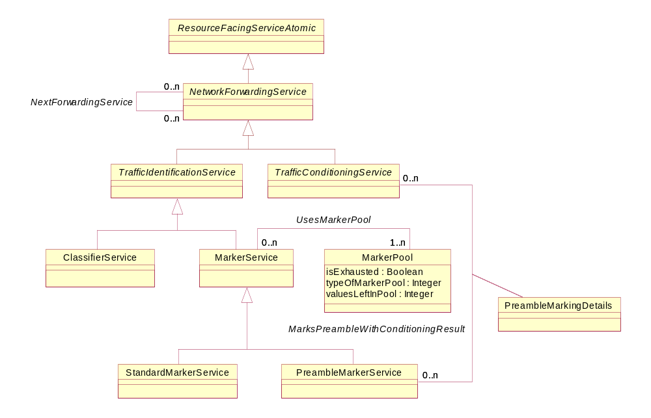
Figure 4Q- . Business Entity Model of a MarkerPool

TrafficConditioningService Business Entity Definition

Business Entity Name | TrafficConditioningService
Description | A TrafficConditioningService is a fundamental QoS building block.  A TrafficConditioningService is an abstract base class that is the parent for different types of traffic conditioning services defined in the DEN-ng Service model. TrafficConditioningServices are one example of a ResourceFacingService, n that the Customer is not able to control them. In fact, the Customer doesn't even have to be aware that they exist! However, they must be implemented in order for different CoSs to be differentiated from each other, and hence for different Customers to receive different CoSs.  TrafficConditioningServices control how packets and flows are treated compared to other packets and flows in the system.
Sources | DEN-ng | Cross- References |  |  | Synonyms / Aliases | No concept of this categorization in the ITU specs. The DMTF CIM doesn’t have any separation between a TrafficIdentificationService and a TrafficConditioningService. Thus, the semantics between the DMTF and the TMF are completely different, since the subclasses and superclasses are different.
Related Business Entities | ManagedEntity, Product, ProductBundle, ProductComponent, Resource, PhysicalResource, LogicalResource, Service, CustomerFacingService, ResourceFacingService, CustomerFacingServiceAtomic, CustomerFacingServiceComposite, ResourceFacingServiceAtomic, ResourceFacingServiceComposite, QoSServic, ToSService, 802Service, DiffServService, NetworkForwardingService (superclass), TrafficIdentificationService (sibling), MeterService (subclass), DropperService (subclass), QueueService (subclass), SchedulingService (subclass), CompoundConditioningElement (subclass), ServiceRole, ServiceCharacteristic, ServiceSpecification (template), CustomerFacingServiceSpec, ResourceFacingServiceSpec, ServicePackageSpec, ServicePackage, ServiceBundleSpec, ServiceBundle, ServiceSpecVersion, ProductSpecification, Location, BusinessInteraction, PartyRole
Business Rules | To be determined

TrafficConditioningService Business Entity Attributes Definition
The primary purpose of this class is to serve as a common place to define relationships and services for traffic conditioning and forwarding. These are two principle characteristics of any QoS service, and are bound to a QoSService via the ConditionsQoSService aggregation.
Thus, this class currently has no common attributes at the business level, since traffic identification and forwarding are different in nature. This will be further examined as part of SID Phase IV.

Business Entity Name | TrafficConditioningService
Attribute Name | Description | Data Type | Characteristics, Permitted  Values & Units | Required/  Optional | Notes (used to map to other models; blank is other models don’t have it)
tbd

Business Entity Model – TrafficConditioningService
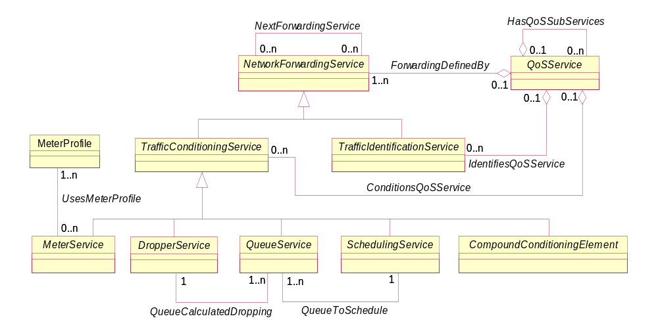
Figure 4Q- . Business Entity Model of a TrafficConditioningService

MeterService Business Entity Definition

Business Entity Name | MeterService
Description | A meter is a basic traffic conditioning building block. A meter determines the level of conformance of each packet or flow with respect to a pre-established traffic profile by monitoring a metric of a packet or flow (e.g., its arrival time). A meter has the ability to invoke different TrafficConditioningServices for conforming vs. other (e.g., partially - and non-conforming) traffic.  The definition of which metric(s) are monitored to serve as input for the metering decision is defined by attributes in this class. However, the definition of the traffic profile that is used to make the metering decision is defined using the MeterProfile class.
Sources | DEN-ng | Cross- References |  |  | Synonyms / Aliases | No concept of this categorization in the ITU specs. The DMTF CIM has a meter class, but defines the semantics of metering as based on “...monitoring the arrival times of packets of a traffic stream”.
Related Business Entities | ManagedEntity, Product, ProductBundle, ProductComponent, Resource, PhysicalResource, LogicalResource, Service, CustomerFacingService, ResourceFacingService, CustomerFacingServiceAtomic, CustomerFacingServiceComposite, ResourceFacingServiceAtomic, ResourceFacingServiceComposite, QoSServic, ToSService, 802Service, DiffServService, NetworkForwardingService, TrafficConditioningService (superclass), DropperService (subclass), QueueService (subclass), SchedulingService (subclass), CompoundConditioningElement (subclass), TrafficIdentificationService, ServiceRole, ServiceCharacteristic, ServiceSpecification (template), CustomerFacingServiceSpec, ResourceFacingServiceSpec, ServicePackageSpec, ServicePackage, ServiceBundleSpec, ServiceBundle, ServiceSpecVersion, ProductSpecification, Location, BusinessInteraction, PartyRole
Business Rules | To be determined

MeterService Business Entity Attributes Definition

Business Entity Name | MeterService
Attribute Name | Description | Data Type | Characteristics, Permitted  Values & Units | Required/  Optional | Notes (used to map to other models; blank is other models don’t have it)
typeOfMeter | This attribute is an enumerated integer that is used to specify the particular type of meter. | Integer | 0: Other  1: Average Rate Meter  2: Exponentially Weighted Moving  Average Meter  3: Token Bucket Meter | Required | No concept of this in the ITU specs; very similar to the DMTF CIM.
otherTypeOfMeter | This is a string attribute that is used to define the name of this meter instance when the value of the typeOfMeter attribute is 0. | String |  | Optional | No concept of this in the ITU specs; very similar to the DMTF CIM.

Business Entity Model – MeterService
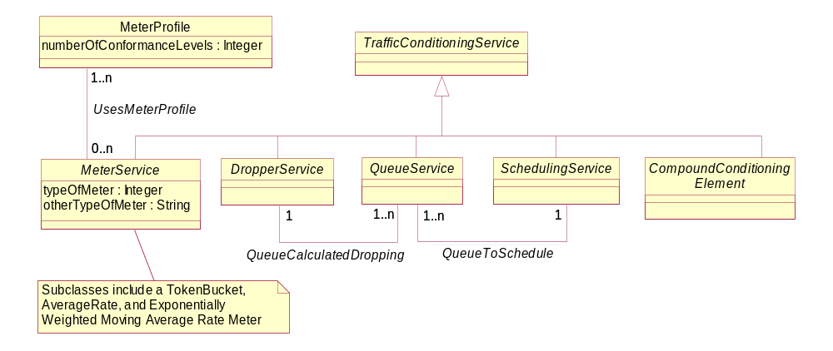
Figure 4Q- . Business Entity Model of a MeterService

MeterProfile Business Entity Definition

Business Entity Name | MeterProfile
Description | The MeterProfile class defines a traffic profile that the MeterService can use to compare traffic against. The MeterProfile will define what levels of traffic pass through the MeterService unaltered, what levels get delayed, what levels get dropped, and what levels get further analyzed.  The purpose of the MeterProfile class is to formally define these four different traffic levels. This requires data and metadata. Furthermore, the application of a particular MeterProfile is goverened by PolicyRules. This is described in the DEN-ng system view.  The UsesMeterProfile association binds a specific MeterService to one or more MeterProfile classes.
Sources | DEN-ng | Cross- References |  |  | Synonyms / Aliases | No concept of this categorization in the ITU specs. The DMTF CIM doesn’t have a separate MeterProfile class – rather, it defines the number of conformance levels as an attribute within the Meter itself. This makes it difficult to attach policies to control the actions associated with each conformance level enforced by the Meter.
Related Business Entities | ManagedEntity, Product, ProductBundle, ProductComponent, Resource, PhysicalResource, LogicalResource, Service, CustomerFacingService, ResourceFacingService, CustomerFacingServiceAtomic, CustomerFacingServiceComposite, ResourceFacingServiceAtomic, ResourceFacingServiceComposite, QoSServic, ToSService, 802Service, DiffServService, NetworkForwardingService, TrafficIdentificationService, MeterService, DropperService, QueueService, SchedulingService, CompoundConditioningElement, ServiceRole, ServiceCharacteristic, ServiceSpecification (template), CustomerFacingServiceSpec, ResourceFacingServiceSpec, ServicePackageSpec, ServicePackage, ServiceBundleSpec, ServiceBundle, ServiceSpecVersion, ProductSpecification, Location, BusinessInteraction, PartyRole
Business Rules | To be determined

MeterProfile Business Entity Attributes Definition

Business Entity Name | MeterProfile
Attribute Name | Description | Data Type | Characteristics, Permitted  Values & Units | Required/  Optional | Notes (used to map to other models; blank is other models don’t have it)
numberOfConformanceLevels | This attributes defines the number of conformance levels supported by this particular Meter. The simplest Meter has two conformance levels, called "'in-profile" and "out of profile". | Integer |  | Required | Not present in the ITU specs; the DMTF CIM embeds this in the Meter itself, which makes it difficult to use policy to control the actions associated with each conformance level.

Business Entity Model – MeterProfile
The business entity model of a MeterProfile is the same as that for a MeterService, which was shown in Figure 4Q- above.

DropperService Business Entity Definition

Business Entity Name | DropperService
Description | A DropperService is a basic traffic conditioning building block. A DropperService represents the ability to selectively drop network packets or even flows. This is NOT the same as denying the forwarding of a packet or flow; rather, this represents the conscious act to discard a packet (or possibly even a flow). Compound traffic conditioning elements, such as Policers and Shapers, will implicitly use DropperServices.  Droppers are distinguished by the algorithm that they use to drop traffic. The semantics of these algorithms are different enough to warrant their modeling by using subclasses. However, most of these subclasses are low-level, and not appropriate for this Addendum. Please see the system view of the DEN-ng QoS model for their definition.
Sources | DEN-ng | Cross- References |  |  | Synonyms / Aliases | No concept of this categorization in the ITU specs. The DMTF CIM has a similarly named class, but the semantics between it and this class are very different.
Related Business Entities | ManagedEntity, Product, ProductBundle, ProductComponent, Resource, PhysicalResource, LogicalResource, Service, CustomerFacingService, ResourceFacingService, CustomerFacingServiceAtomic, CustomerFacingServiceComposite, ResourceFacingServiceAtomic, ResourceFacingServiceComposite, QoSServic, ToSService, 802Service, DiffServService, NetworkForwardingService, TrafficConditioningService (superclass), MeterService (subclass), QueueService (subclass), SchedulingService (subclass), CompoundConditioningElement (subclass), TrafficIdentificationService, ServiceRole, ServiceCharacteristic, ServiceSpecification (template), CustomerFacingServiceSpec, ResourceFacingServiceSpec, ServicePackageSpec, ServicePackage, ServiceBundleSpec, ServiceBundle, ServiceSpecVersion, ProductSpecification, Location, BusinessInteraction, PartyRole
Business Rules | To be determined

DropperService Business Entity Attributes Definition

Business Entity Name | DropperService
Attribute Name | Description | Data Type | Characteristics, Permitted  Values & Units | Required/  Optional | Notes (used to map to other models; blank is other models don’t have it)
typeOfDropper | This is an enumerated integer that defines the type of DropperService that this instance is. | Integer | 0: Custom Vendor Algorithm  1: Random Algorithm  2: Drop from the Head of the Queue  3: Drop from the Tail of the Queue  4: Absolute Dropper (i.e., always drop) | Required | No concept in the ITU specs. The CIM has a subset of these values defined.
customDropAlgorithmInfo | This is a string attribute that is used to describe the type of dropping algorithm that is being used. It should ONLY be used if the value of the typeOfDropper attribute is "0". | String |  | Optional | No concept of this in the ITU specs. The CIM has an attribute called OtherDropperType that is similar to this attribute.
startMetric | This attribute is an enumerated integer that defines the metric used to trigger the start of dropping packets. This does NOT mean that all packets entering the interface will be dropped. However, it does mean that SOME packets will start to be dropped. The number and type of packets dropped is a function of the type of algorithm used by this Dropper. | Integer | 0: Custom  1: Queue Threshold  2: Arrival Rate  Note: for a value of 0 (Custom), the metric used is defined in the otherStartMetric attribute of this class. | Required | No concept of this in the ITU specs. The CIM has an attribute called DropStartMetric that is similar to this attribute. However, it doesn’t define an attribute to be used for the “Other” (equivalent to “Custom”) value.

Business Entity Name | DropperService (continued)
Attribute Name | Description | Data Type | Characteristics, Permitted  Values & Units | Required/  Optional | Notes (used to map to other models; blank is other models don’t have it)
dropAllMetric | This attribute is an enumerated integer that defines the metric used to trigger when ALL packets are dropped regardless of the type of algorithm used by this dropper. | Integer | 0: Custom  1: Queue Threshold  2: Arrival Rate  Note: The type of metric to be used when the value of this attribute is 0 (i.e., Custom) is defined in the otherDropAllMetric attribute. | Required | No concept in the ITU specs. The CIM has a similar attribute named DropMaintainMetric.
otherStartMetric | This attribute is a string that defines the name of the attribute used when the startMetric is neither queueThreshold or arrivalRate. Thus, this attribute MUST be NULL unless the value of the startMetric is 0 (denoting "Custom"). | String |  | Optional | No concept of this in the ITU specs. The CIM doesn’t define this attribute.
otherDropAllMetric | This attribute is a string that defines the name of the attribute used when the dropAllMetric is neither queueThreshold or arrivalRate. Thus, this attribute MUST be NULL unless the value of the dropAllMetric is 0 (denoting "Custom"). | String |  | Required | No concept of this in the ITU specs. The CIM doesn’t define this attribute.

Business Entity Model – DropperService
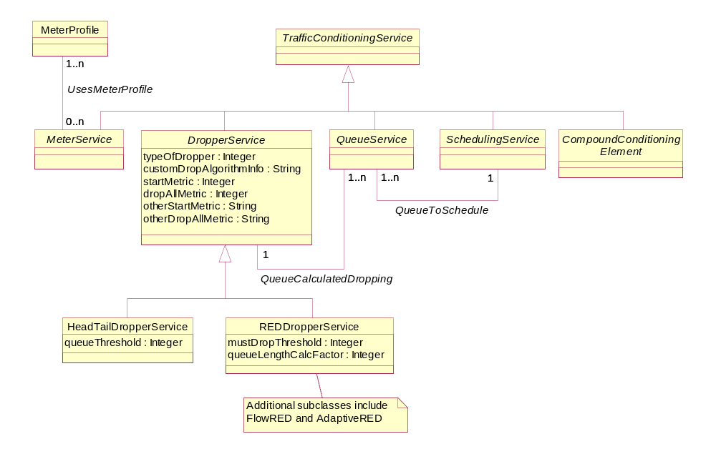
Figure 4Q- . Business Entity Model of a DropperService

HeadTailDropperService Business Entity Definition

Business Entity Name | TrafficConditioningService
Description | The HeadTailDropper class models the behavior of either a head or tail dropper (e.g., a dropper which drops from the head or tail of its queue, respectively). The inherited attribute typeOfDropper indicates whether a particular instance of this class is a head dropper or a tail dropper.  If this instance is a "HeadDropper", then all newly arriving traffic (which arrives at the head of the queue) will be dropped. In contrast, if this instance is a "TailDropper", then newly arriving traffic will be enqueued, and old traffic at the end of the queue will be dropped to make room for it.
Sources | DEN-ng | Cross- References |  |  | Synonyms / Aliases | No concept of this categorization in the ITU specs. The DMTF CIM has a similarly named class, but the semantics between the DMTF and the TMF are completely different, since the subclasses and superclasses are different. Note also that the documentation for the CIM class is wrong.
Related Business Entities | ManagedEntity, Product, ProductBundle, ProductComponent, Resource, PhysicalResource, LogicalResource, Service, CustomerFacingService, ResourceFacingService, CustomerFacingServiceAtomic, CustomerFacingServiceComposite, ResourceFacingServiceAtomic, ResourceFacingServiceComposite, QoSServic, ToSService, 802Service, DiffServService, NetworkForwardingService, TrafficConditioningService, MeterService, DropperService (superclass), REDDropperService (sibling), QueueService, SchedulingService, CompoundConditioningElement, TrafficIdentificationService, ServiceRole, ServiceCharacteristic, ServiceSpecification (template), CustomerFacingServiceSpec, ResourceFacingServiceSpec, ServicePackageSpec, ServicePackage, ServiceBundleSpec, ServiceBundle, ServiceSpecVersion, ProductSpecification, Location, BusinessInteraction, PartyRole
Business Rules | To be determined

HeadTailDropperService Business Entity Attributes Definition

Business Entity Name | HeadTailDropperService
Attribute Name | Description | Data Type | Characteristics, Permitted  Values & Units | Required/  Optional | Notes (used to map to other models; blank is other models don’t have it)
queueThreshold | This is an integer attribute that indicates the queue depth (in bytes) at which traffic is dropped.  If this instance is a "HeadDropper", then all newly arriving traffic (which arrives at the head of the queue) will be dropped. In contrast, if this instance is a "TailDropper", then newly arriving traffic will be enqueued, and old traffic at the end of the queue will be dropped to make room for it. | Integer |  | Required | No concept of this in the ITU specs. The CIM defines a similar attribute, but its definition is wrong.

Business Entity Model – HeadTailDropperService
The business entity model for a HeadTailDropperService is the same as that for the DropperService, and is shown in Figure 4Q- above.

REDDropperService Business Entity Definition

Business Entity Name | REDDropperService
Description | The REDDropperService represents the ability to drop network traffic using a Random Early Detection (RED) type of algorithm. The purpose of a RED algorithm is to avoid congestion (as opposed to managing congestion). Without RED, when the queue fills up, all packets that arrive are dropped. With RED, as opposed to dropping traffic from a fixed location (e.g., from the head or the tail of the queue), the device monitors the average queue size and uses a random algorithm to drop traffic from a random location. These discards cause TCP-based applications to slow its transmission rate for those connections that experienced the packet discards. Note that UDP-based applicatons aren't affected; this is why the FlowREDDropper subclass was built.  WRED adds a weighting factor to the RED algorithm to enable traffic with different priorities to have different performance characteristics. This is dictated by associating different drop probabilities with different traffic. A weighted algorithm is identified by having its isWeighted attribute to be TRUE. For example, traffic with different ToS or DSCP values can have different probabilities of being dropped. The same is true for different types of protocols (e.g., trtaffic using RSVP could be given a smaller drop probability). This means that WRED provides separate thresholds and weights for different traffic, instead of a single threshold and weight like RED does.
Sources | DEN-ng | Cross- References |  |  | Synonyms / Aliases | No concept of this categorization in the ITU specs. The DMTF CIM has a similarly named class, but the attributes, superclasses, and subclasses are completely different. Thus, the semantics are different.
Related Business Entities | ManagedEntity, Product, ProductBundle, ProductComponent, Resource, PhysicalResource, LogicalResource, Service, CustomerFacingService, ResourceFacingService, CustomerFacingServiceAtomic, CustomerFacingServiceComposite, ResourceFacingServiceAtomic, ResourceFacingServiceComposite, QoSServic, ToSService, 802Service, DiffServService, NetworkForwardingService, TrafficIdentificationService, ClassifierService, MarkerService, TrafficConditioningService, DropperService (superclass), AdaptiveREDDropperService (subclass), FlowREDDropperService (subclass), REDServiceElement, MeterService, QueueService, SchedulingService, CompoundConditioningElement, ServiceRole, ServiceCharacteristic, ServiceSpecification (template), CustomerFacingServiceSpec, ResourceFacingServiceSpec, ServicePackageSpec, ServicePackage, ServiceBundleSpec, ServiceBundle, ServiceSpecVersion, ProductSpecification, Location, BusinessInteraction, PartyRole
Business Rules | To be determined

REDDropperService Business Entity Attributes Definition

Business Entity Name | REDDropperService
Attribute Name | Description | Data Type | Characteristics, Permitted  Values & Units | Required/  Optional | Notes (used to map to other models; blank is other models don’t have it)
isWeighted | This is a Boolean attribute that, if TRUE, defines this algorithm as having the ability to weight the probability of dropping different traffic types differently. | Boolean |  | Required | Not present in the ITU specs. The CIM deprecated its WRED class.
hasDifferentDropProbabilities | This is a Boolean attribute that, if TRUE, defines this algorithm as having the ability to assign different drop probabilities to different types of traffic. | Boolean |  | Required | Not present in the ITU or CIM specs.

Business Entity Model – REDDropperService
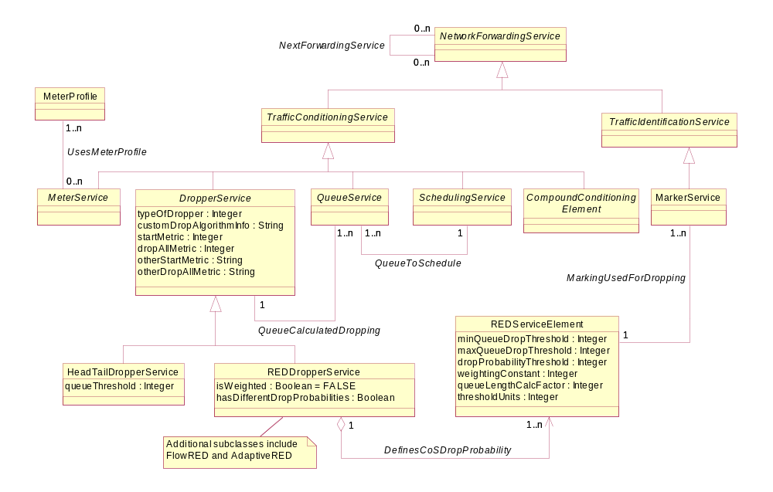
Figure 4Q- . Business Entity Model of a REDDropperService

REDServiceElement Business Entity Definition

Business Entity Name | REDServiceElement
Description | This class defines the drop probability, weighting, and other important parameters for distinguishing one traffic type from another traffic type for applying different dropping behavior. This is usually tied to supporting different classes of service. The class identifies traffic using a set mechanism, such as its DSCP or ToS value, through the MarkingUsedForDropping association.  The REDDropper class (and its subclasses) associate one or more REDServiceElements (for each different type of traffic) using the DefinesCoSDropProbability association. If the algorithm used is RED, then by definition there is only one instance of this (the REDServiceElement) class.
Sources | DEN-ng | Cross- References |  |  | Synonyms / Aliases | No concept of this categorization in the ITU specs. The DMTF CIM doesn’t define this as a separate managed entity – instead, it defines some of the characteristics of this class in the REDDropper itself. Thus, the semantics are different.
Related Business Entities | ManagedEntity, Product, ProductBundle, ProductComponent, Resource, PhysicalResource, LogicalResource, Service, CustomerFacingService, ResourceFacingService, CustomerFacingServiceAtomic, CustomerFacingServiceComposite, ResourceFacingServiceAtomic, ResourceFacingServiceComposite, QoSServic, ToSService, 802Service, DiffServService, NetworkForwardingService, TrafficIdentificationService, ClassifierService, MarkerService, TrafficConditioningService, DropperService, AdaptiveREDDropperService, FlowREDDropperService, MeterService, QueueService, SchedulingService, CompoundConditioningElement, ServiceRole, ServiceCharacteristic, ServiceSpecification (template), CustomerFacingServiceSpec, ResourceFacingServiceSpec, ServicePackageSpec, ServicePackage, ServiceBundleSpec, ServiceBundle, ServiceSpecVersion, ProductSpecification, Location, BusinessInteraction, PartyRole
Business Rules | To be determined

REDServiceElement Business Entity Attributes Definition

Business Entity Name | REDServiceElement
Attribute Name | Description | Data Type | Characteristics, Permitted  Values & Units | Required/  Optional | Notes (used to map to other models; blank is other models don’t have it)
minQueueDropThreshold | This is an integer attribute that defines the minimum queue threshold for dropping traffic. If the average queue length is less than this value, then the arriving traffic is enqueued. | Integer |  | Required | Not present in the ITU specs. The CIM defines a similar attribute, but embeds it in the REDDropper itself. Thus, the semantics are different.
maxQueueDropThreshold | This is an integer attribute that defines the maximum queue threshold for dropping traffic. If the average queue length is less than this value but greater than the minQueueDropThreshold, then the arriving traffic is subject to being randomly dropped. Whether the traffic actually is dropped or not is a function of the dro probability for that particular type of traffic.  If the average queue length is equal to or greater than this value, then arriviing traffic will always be dropped, regardless of the specifics of the probability algorithm. | Integer |  | Required | Not present in the ITU specs. The CIM defines a similar attribute, but embeds it in the REDDropper itself. Thus, the semantics are different.

Business Entity Name | REDServiceElement (continued)
Attribute Name | Description | Data Type | Characteristics, Permitted  Values & Units | Required/  Optional | Notes (used to map to other models; blank is other models don’t have it)
queueLengthCalcFactor | This attribute is a non-negative integer that is used to determine the average queue size.  For high values of n, the previous average becomes more important. A large factor smooths out the peaks and lows in queue length. The average queue size is unlikely to change very quickly, avoiding drastic swings in size. The WRED process will be slow to start dropping packets, but it may continue dropping packets for a time after the actual queue size has fallen below the minimum threshold. The slow-moving average will accommodate temporary bursts in traffic. If the value of n gets too high, WRED will not react to congestion. Packets will be transmitted or dropped as if WRED were not in effect.  For low values of n, the average queue size closely tracks the current queue size. The resulting average may fluctuate with changes in the traffic levels. In this case, the WRED process responds quickly to long queues. Once the queue falls below the minimum threshold, the process will stop dropping packets. If the value of n gets too low, WRED will overreact to temporary traffic bursts and drop traffic unnecessarily. | Integer |  | Optional | Not present in the ITU or CIM specs.

Business Entity Name | REDServiceElement (continued)
Attribute Name | Description | Data Type | Characteristics, Permitted  Values & Units | Required/  Optional | Notes (used to map to other models; blank is other models don’t have it)
dropProbabilityThreshold | This is a non-negative integer that represents the fraction of packets dropped when the average queue depth is at the maximum threshold.  When the average queue depth is above the value of the minQueueDropThreshold attribute, traffic will start being dropped. As long as the average queue depth is between the value of the minQueueDropThreshold and the maxQueueDropThreshold attributes, traffic will be dropped. The probability of this dropping increases linearly between the values of the minQueueDropThreshold and the maxQueueDropThreshold attributes, and is determined by the value of this attribute.  For example, if the value of this attribute is 512, one out of every 512 packets is dropped when the average queue is at the maximum threshold.  When the average queue size is above the maximum threshold, all packets are dropped. | Integer |  | Required | Not present in the ITU specs. The CIM defines a different way of computing this.

Business Entity Name | REDServiceElement (continued)
Attribute Name | Description | Data Type | Characteristics, Permitted  Values & Units | Required/  Optional | Notes (used to map to other models; blank is other models don’t have it)
weightingConstant | This is an integer attribute, and is used to configure the weighting factor used in calculating the average queue length for a specific traffic type. | Integer |  | Required | Not present in the ITU specs. The CIM deprecated the WRED class.
thresholdUnits | This is an enumerated integer that defines the units for the threshold measurement. | Integer | 0: custom  implementation  1: bytes  2: packets  3: cells  4: frames  5: flows | Required | Not present in the ITU specs. CIM defines an attribute that has a subset of this information.

Business Entity Model – REDServiceElement
The business entity model of a REDServiceElement is the same as that for a REDDropper, and is shown in Figure 4Q- above.

QueueService Business Entity Definition

Business Entity Name | QueueService
Description | Queuing can be thought of as the act of delaying of packets inside a device before they are transmitted to the next device. This is often called congestion management in the literature. There are many different algorithms to do this task, each having different purposes, different implementation (and therefore programming) complexities, and different uses. Since the semantics of these algorithms are very different, DEN-ng models each algorithm as a subclass of QueueService.  Queues are not infinite in size, and therefore can fill to capacity. So, what happens when a new packet arrives if the queue is filled? Either the new packet is inserted into the queue, and the existing contents of the queue are dropped, or the new packet is inserted and a packet is removed from the queue to make room for the new packet. The details of how a packet is inserted and removed are examples of the differences in queuing algorithms.  Queuing is designed to accommodate temporary congestion on a network device's interface by storing excess packets in buffers until bandwidth becomes available. This can be used in order to meet the varying bandwidth, jitter, and delay requirements of different applications.
Sources | DEN-ng | Cross- References |  |  | Synonyms / Aliases | No concept of this categorization in the ITU specs. The DMTF CIM has a similarly named class, but its semantics are much simpler.
Related Business Entities | ManagedEntity, Product, ProductBundle, ProductComponent, Resource, PhysicalResource, LogicalResource, Service, CustomerFacingService, ResourceFacingService, CustomerFacingServiceAtomic, CustomerFacingServiceComposite, ResourceFacingServiceAtomic, ResourceFacingServiceComposite, QoSServic, ToSService, 802Service, DiffServService, NetworkForwardingService, TrafficConditioningService (superclass), MeterService (sibling), PriorityQueuingService (subclass), CustomQueuing (subclass), FairQueuingService (subclass), WeightedFairQueuingService (subclass), ClassBasedWeightedFairQueuingService (subclass), SchedulingService (sibling), CompoundConditioningElement (sibling), TrafficIdentificationService, ClassifierService, MarkerService, ServiceRole, ServiceCharacteristic, ServiceSpecification (template), CustomerFacingServiceSpec, ResourceFacingServiceSpec, ServicePackageSpec, ServicePackage, ServiceBundleSpec, ServiceBundle, ServiceSpecVersion, ProductSpecification, Location, BusinessInteraction, PartyRole
Business Rules | To be determined

QueueService Business Entity Attributes Definition

Business Entity Name | QueueService
Attribute Name | Description | Data Type | Characteristics, Permitted  Values & Units | Required/  Optional | Notes (used to map to other models; blank is other models don’t have it)
isIngressQueue | This is a Boolean attribute that, if TRUE, defines this to be a queue on the ingress side of the device. Otherwise, it is an egress queue.  The default value of this attribute is set to FALSE, because many devices and line cards support non-blocking inputs (i.e., there is no input queuing present). | Boolean |  | Required | No concept in the ITU or CIM specs.
isTransmitQueue | This is a Boolean attribute that, if TRUE, defines this queue as a transmit queue (i.e., this queue is used to transmit traffic from the device to the external world). If the value of this attribute is FALSE, then this queue doesn't transmit traffic to the outside world and is instead used for buffering only. | Boolean |  | Optional | No concept of this in the ITU specs. The CIM has an attribute called OtherDropperType that is similar to this attribute.
currentQueueDepth | This is a non-negative integer that defines the current depth of this queue. Units are specified by the queueDepthUnits attribute of this class. | Integer |  | Optional | No concept in the ITU specs. The CIM has a similarly named attribute.
queueDepthUnits | This is an enumerated integer that defines the units for the currentQueueDepth attribute. | Integer | 0: custom  implementation  1: bytes  2: packets  3: cells  4: frames  5: flows | Optional | No concept in the ITU specs. The CIM has a similarly named attribute.

Business Entity Name | QueueService (continued)
Attribute Name | Description | Data Type | Characteristics, Permitted  Values & Units | Required/  Optional | Notes (used to map to other models; blank is other models don’t have it)
isFIFOqueuing | This is a Boolean attribute that, if TRUE, defines this queue to be a FIFO queue.  This is the simplest of all queuing mechanisms, and represents a basic first-in, first-out queuing technique in which the first packet in the queue is the first packet that is processed. When queues become full, congestion occurs and incoming packets are dropped. FIFO relies on end systems to control congestion via congestion control mechanisms.  Even with its limitations, FIFO queuing is often the default queuing mechanism installed on a DeviceInterface. | Boolean |  | Required | No concept in the ITU or CIM specs.
queueID | This is a string attribute that uniquely identifies this Queue. This enables a device having multiple instances of the same type of Queue to identify each Queue instance. | String |  | Required | No concept in the ITU or CIM specs.

Business Entity Model – QueueService
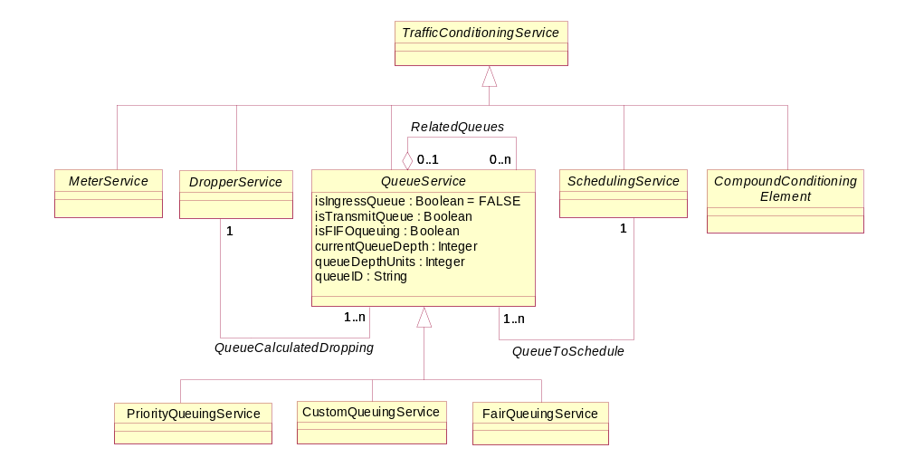
Figure 4Q- . Business Entity Model of a QueueService

PriorityQueuingService Business Entity Definition

Business Entity Name | PriorityQueuingService
Description | This technique uses multiple queues, but queues are serviced with different levels of priority, with the highest priority queues being serviced first. Packets are classified and placed into queues according to information in the packets. When congestion occurs, packets are dropped from lower-priority queues in order to service higher-priority queues.  The main problem with this method is that lower-priority queues may not get serviced at all if high-priority traffic is excessive. Therefore, the use of Admission Control mechanisms to monitor PriorityQueues and ensure that they are used properly is recommended by the DEN-ng QoS model.
Sources | DEN-ng | Cross- References |  |  | Synonyms / Aliases | No concept of this categorization in the ITU or CIM specs.
Related Business Entities | ManagedEntity, Product, ProductBundle, ProductComponent, Resource, PhysicalResource, LogicalResource, Service, CustomerFacingService, ResourceFacingService, CustomerFacingServiceAtomic, CustomerFacingServiceComposite, ResourceFacingServiceAtomic, ResourceFacingServiceComposite, QoSServic, ToSService, 802Service, DiffServService, NetworkForwardingService, TrafficConditioningService, MeterService, QueueService (superclass), CustomQueuingService (sibling), FairQueuingService (sibling), WeightedFairQueuingService (sibling), ClassBasedWeightedFairQueuingService (sibling), SchedulingService, CompoundConditioningElement, TrafficIdentificationService, ClassifierService, MarkerService, ServiceRole, ServiceCharacteristic, ServiceSpecification (template), CustomerFacingServiceSpec, ResourceFacingServiceSpec, ServicePackageSpec, ServicePackage, ServiceBundleSpec, ServiceBundle, ServiceSpecVersion, ProductSpecification, Location, BusinessInteraction, PartyRole
Business Rules | To be determined

PriorityQueuingService Business Entity Attributes Definition

Business Entity Name | PriorityQueuingService
Attribute Name | Description | Data Type | Characteristics, Permitted  Values & Units | Required/  Optional | Notes (used to map to other models; blank is other models don’t have it)
relativePriorityValue | This is a non-negative integer that defines the priority of this Queue instance compared to all other Queue instances that are of the same type.  Note that some QueuingServices can mix Queues of different types (e.g., PriorityQueues with ClassBasedWeightedFairQueues). The priority between heterogeneous Queue instances is defined by the RelatedQueueDetails class, which implements the RelatedQueues aggregation. | Integer |  | Required | No concept in the ITU or CIM specs.

Business Entity Model – PriorityQueuingService
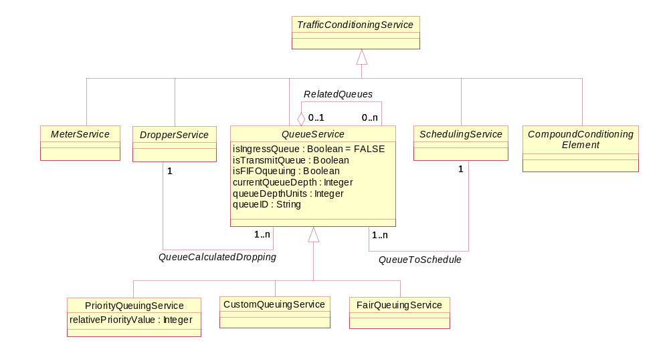
Figure 4Q- . Business Entity Diagram of a PriorityQueue

CustomQueuingService Business Entity Definition

Business Entity Name | CustomQueuingService
Description | Custom Queueing enables the designer to specify a particular number of bytes, packets, or flows to forward from a specific Queue each time the Queue is serviced. This is most often used to enable network resources (e.g., bandwidth) to be shared among applications with specific minimum requirements for that metric (or set of metrics).
Sources | DEN-ng | Cross- References |  |  | Synonyms / Aliases | No concept of this categorization in the ITU or CIM specs.
Related Business Entities | ManagedEntity, Product, ProductBundle, ProductComponent, Resource, PhysicalResource, LogicalResource, Service, CustomerFacingService, ResourceFacingService, CustomerFacingServiceAtomic, CustomerFacingServiceComposite, ResourceFacingServiceAtomic, ResourceFacingServiceComposite, QoSServic, ToSService, 802Service, DiffServService, NetworkForwardingService, TrafficConditioningService, MeterService, QueueService (superclass), PriorityQueuingService (sibling), FairQueuingService (sibling), WeightedFairQueuingService (sibling), ClassBasedWeightedFairQueuingService (sibling), SchedulingService, CompoundConditioningElement, TrafficIdentificationService, ClassifierService, MarkerService, ServiceRole, ServiceCharacteristic, ServiceSpecification (template), CustomerFacingServiceSpec, ResourceFacingServiceSpec, ServicePackageSpec, ServicePackage, ServiceBundleSpec, ServiceBundle, ServiceSpecVersion, ProductSpecification, Location, BusinessInteraction, PartyRole
Business Rules | To be determined

CustomQueuingService Business Entity Attributes Definition

Business Entity Name | CustomQueuingService
Attribute Name | Description | Data Type | Characteristics, Permitted  Values & Units | Required/  Optional | Notes (used to map to other models; blank is other models don’t have it)
queueServiceMetric | This attribute is an enumerated integer, and specifies the metric used for servicing a queue. | Integer | 0: custom  implementation  1: bytes  2: packets  3: cells  4: frames  5: flows | Required | No concept in the ITU or CIM specs.
queueServiceValue | This is a non-negative integer that defines the number of units that are forwarded from a CustomQueue instance each time it is serviced. The units are defined by the countMetric attribute.  Note that if it is desired to evenly split the bandwidth among three Protocols which have different packet sizes, this attribute enables each Queue instance to forward a different number of bytes each time it is serviced. This can be used to provide even bandwidth for each Protocol, even though the Protocols use different sized packets. | Integer |  | Required | No concept in the ITU or CIM specs.

Business Entity Model – CustomQueuingService
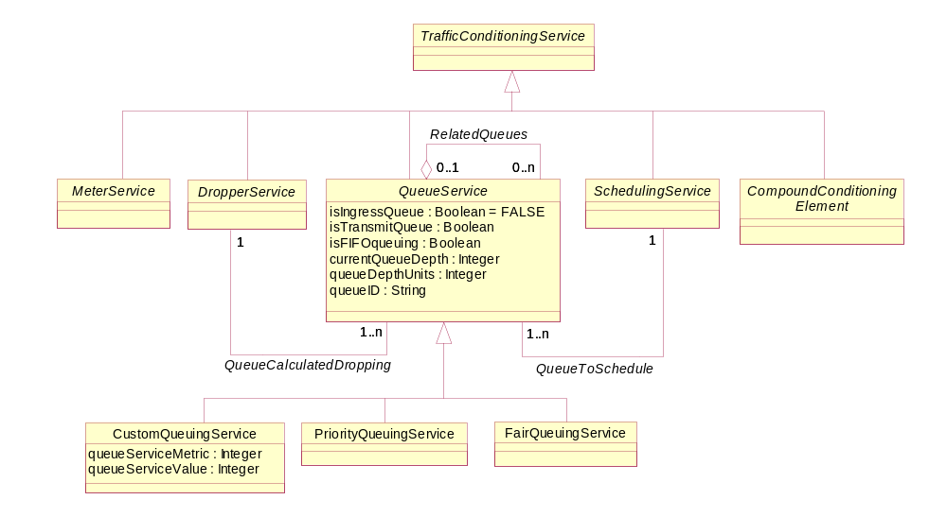
Figure 4Q- . Business Entity Model of a CustomQueuingService

FairQueuingService Business Entity Definition

Business Entity Name | FairQueuingService
Description | This method helps solve the problem where some Queues may not get serviced because high-priority Queues are being serviced. A round-robin approach is used to service all Queues in a fair way. This prevents any one source from overusing its share of network capacity. Ultimately, the goal of this algorithm is to ensure that each Queue receives a fair share of the set of applicable metrics (e.g., bandwidth) that are divided among the different Queue instances.  Problems can occur when packets are variable in length and each Queue is allowed to release one packet at a time. Some Queues will take more time. A byte-oriented scheme may be used to equalize the Queues. In addition, some Queues may be fuller than others and naturally need more service, but a strict, fair Queuing scheme will service each queue equally.  A better alternative is most likely one of its derivative algorithms, such as weighted fair queuing or possibly class-based weighted fair queuing.
Sources | DEN-ng | Cross- References |  |  | Synonyms / Aliases | No concept of this categorization in the ITU or CIM specs.
Related Business Entities | ManagedEntity, Product, ProductBundle, ProductComponent, Resource, PhysicalResource, LogicalResource, Service, CustomerFacingService, ResourceFacingService, CustomerFacingServiceAtomic, CustomerFacingServiceComposite, ResourceFacingServiceAtomic, ResourceFacingServiceComposite, QoSServic, ToSService, 802Service, DiffServService, NetworkForwardingService, TrafficConditioningService, MeterService, QueueService (superclass), PriorityQueuingService (sibling), FairQueuingService (sibling), WeightedFairQueuingService (subclass), ClassBasedWeightedFairQueuingService (subclass), SchedulingService, CompoundConditioningElement, TrafficIdentificationService, ClassifierService, MarkerService, ServiceRole, ServiceCharacteristic, ServiceSpecification (template), CustomerFacingServiceSpec, ResourceFacingServiceSpec, ServicePackageSpec, ServicePackage, ServiceBundleSpec, ServiceBundle, ServiceSpecVersion, ProductSpecification, Location, BusinessInteraction, PartyRole
Business Rules | To be determined

FairQueuingService Business Entity Attributes Definition

Business Entity Name | FairQueuingService
Attribute Name | Description | Data Type | Characteristics, Permitted  Values & Units | Required/  Optional | Notes (used to map to other models; blank is other models don’t have it)
queueServiceMetric | This is an enumerated integer that defines the sorting mechanism used by this QueuingService. | Integer | 0: custom  implementation  1: by flows  2: by traffic classes | Required | No concept in the ITU or CIM specs.
messagesPerQueue | This is a non-negative integer that defines the maximum number of conversations that are allowed in this particular Queue instance. | Integer |  | Required | No concept in the ITU or CIM specs.

Business Entity Model – FairQueuingService
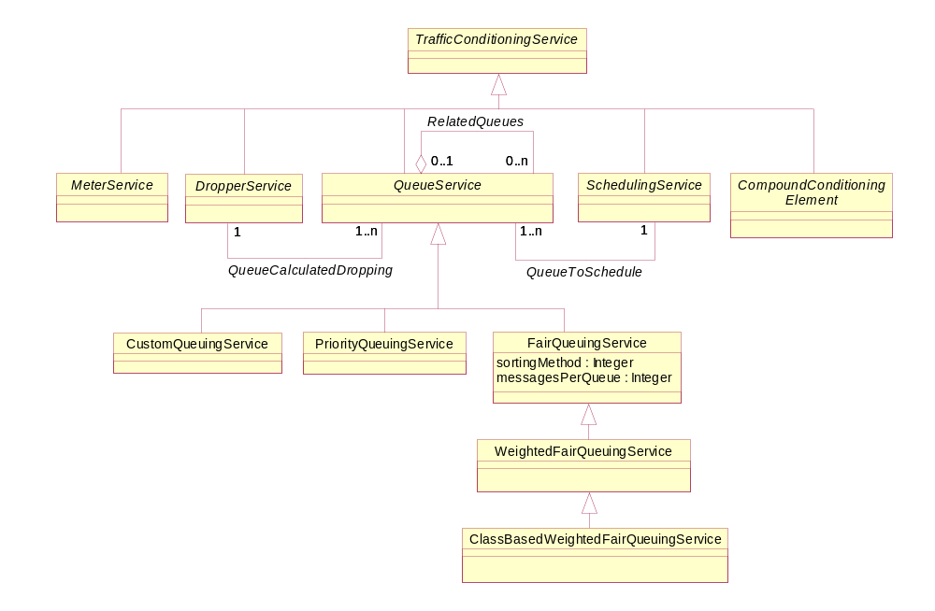
Figure 4Q- . Business Entity Model of a FairQueuingService

WeightedFairQueuingService Business Entity Definition

Business Entity Name | WeightedFairQueuingService
Description | This is a cross between priority queuing and fair queuing, seeking to garner the best from both algorithms. All queues are serviced so that none are starved, but some queues are serviced more than others. A portion of the bandwidth of a DeviceInterface is allocated to each active flow.  A weight is applied to each queue to give some queues higher priority than other queues. For example, one queue may get half the available bandwidth and other queues will get a varying percentage of the remaining bandwidth. Traffic may be prioritized according to many different mechanisms, such as packet markings, source and destination IP address fields, source and destination port numbers, and so forth.  WFQ weights traffic so that low-bandwidth traffic gets a fair level of priority. If high-priority queues are not in use, lower-priority traffic uses its queues. This prevents high-bandwidth traffic from grabbing an unfair share of resources. A unique feature is that it moves real-time interactive traffic to the front of queues and fairly shares the remaining bandwidth among other flows.
Sources | DEN-ng | Cross- References |  |  | Synonyms / Aliases | No concept of this categorization in the ITU or CIM specs.
Related Business Entities | ManagedEntity, Product, ProductBundle, ProductComponent, Resource, PhysicalResource, LogicalResource, Service, CustomerFacingService, ResourceFacingService, CustomerFacingServiceAtomic, CustomerFacingServiceComposite, ResourceFacingServiceAtomic, ResourceFacingServiceComposite, QoSServic, ToSService, 802Service, DiffServService, NetworkForwardingService, TrafficConditioningService, MeterService, QueueService, PriorityQueuingService (sibling), FairQueuingService (superclass), ClassBasedWeightedFairQueuingService (subclass), SchedulingService, CompoundConditioningElement, TrafficIdentificationService, ClassifierService, MarkerService, ServiceRole, ServiceCharacteristic, ServiceSpecification (template), CustomerFacingServiceSpec, ResourceFacingServiceSpec, ServicePackageSpec, ServicePackage, ServiceBundleSpec, ServiceBundle, ServiceSpecVersion, ProductSpecification, Location, BusinessInteraction, PartyRole
Business Rules | To be determined

WeightedFairQueuingService Business Entity Attributes Definition

Business Entity Name | WeightedFairQueuingService
Attribute Name | Description | Data Type | Characteristics, Permitted  Values & Units | Required/  Optional | Notes (used to map to other models; blank is other models don’t have it)
numberFlowCategories | This is a non-negative integer that defines the number of different types of conversation categories that traffic flows are grouped into. Typically, this is 2 (low-bandwidth vs. high-bandwidth), enabling control messages to always be serviced while applications are serviced according to a service policy. | Integer |  | Required | No concept in the ITU or CIM specs.
queueWeight | This is a non-negative integer that defines the weight that this flow gets relative to all other flows. The sum of all weights must add up to 99. | Integer |  | Required | No concept in the ITU or CIM specs.
numberQueuesPerFlow | This is a non-negative integer that defines the number of Queues that support a particular flow. | Integer |  | Required | No concept in the ITU or CIM specs.
numberReservedQueues | This defines the number of Queues that can be used for special, or reserved, traffic. If any Queue can be used for any traffic, then the value of this attribute should be set to 0. | Integer |  | Optional | No concept in the ITU or CIM specs.

Business Entity Model – WeightedFairQueuingService
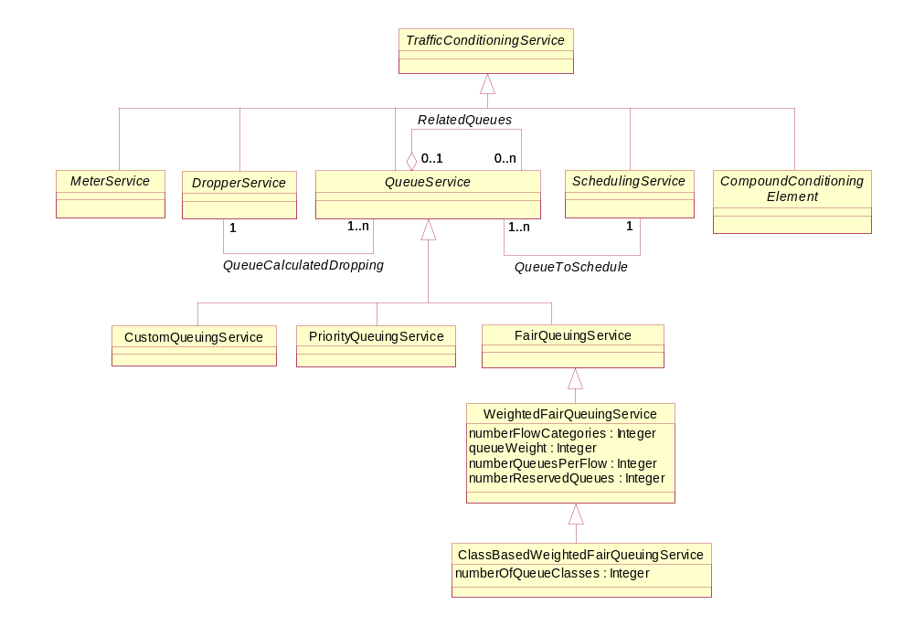
Figure 4Q- . Business Entity Model of WFQ and CBWFQ

ClassBasedWeightedFairQueuingService Business Entity Definition

Business Entity Name | ClassBasedWeightedFairQueuingService
Description | CBWFQ is a class-based algorithm that schedules packets in queues and guarantees a certain transmission rate. If a queue is not in use, the bandwidth is made available to other queues.  CBWFQ sorts traffic into flows, or classes, and then allocates bandwidth to those flows or classes via sophisticated packet scheduling. The weight assignments drive the bandwidth allocation. Each class can have its own dropping, policing and/or shaping mechanisms, which in effect enables each class to be tied to a particular SLA.  Thus, CBWFQ is more than a queuing scheme. It is also a QoS scheme that identifies different types of traffic and queues the traffic according to predefined parameters.
Sources | DEN-ng | Cross- References |  |  | Synonyms / Aliases | No concept of this categorization in the ITU or CIM specs.
Related Business Entities | ManagedEntity, Product, ProductBundle, ProductComponent, Resource, PhysicalResource, LogicalResource, Service, CustomerFacingService, ResourceFacingService, CustomerFacingServiceAtomic, CustomerFacingServiceComposite, ResourceFacingServiceAtomic, ResourceFacingServiceComposite, QoSServic, ToSService, 802Service, DiffServService, NetworkForwardingService, TrafficConditioningService, MeterService, QueueService, PriorityQueuingService (sibling), FairQueuingService, WeightedFairQueuingService (superclass), SchedulingService, CompoundConditioningElement, TrafficIdentificationService, ClassifierService, MarkerService, ServiceRole, ServiceCharacteristic, ServiceSpecification (template), CustomerFacingServiceSpec, ResourceFacingServiceSpec, ServicePackageSpec, ServicePackage, ServiceBundleSpec, ServiceBundle, ServiceSpecVersion, ProductSpecification, Location, BusinessInteraction, PartyRole
Business Rules | To be determined

ClassBasedWeightedFairQueuingService Business Entity Attributes Definition

Business Entity Name | ClassBasedWeightedFairQueuingService
Attribute Name | Description | Data Type | Characteristics, Permitted  Values & Units | Required/  Optional | Notes (used to map to other models; blank is other models don’t have it)
numberOfQueueClasses | This is a non-negative integer that defines the number of classes that can be defined. | Integer |  | Required | No concept in the ITU or CIM specs.

Business Entity Model – ClassBasedWeightedFairQueuingService
The business entity model of a ClassBasedWeightedFairQueuingService is the same as that for a WeightedFairQueuingService, and is shown in Figure 4Q- above.

SchedulingService Business Entity Definition

Business Entity Name | SchedulingService
Description | A Scheduler is used in the network forwarding path to determine how output queues are serviced. The SchedulingService can be used to dequeue traffic from internal Queues and send the traffic to DeviceInterfaces as well as dequeue traffic from an internal component, such as a backplane. This service uses the QueuingService to store packets and then services these queues according to a pre-defined algorithm.  Note that when there is no congestion, the net effect is simply FIFO. However, when there is congestion, scheduling is the primary QoS action component that provides control over traffic behavior.
Sources | DEN-ng | Cross- References |  |  | Synonyms / Aliases | No concept of this categorization in the ITU specs. The CIM has a similarly named class, but its structure and superclasses are very different. In addition, DEN-ng uses the composite pattern, which the CIM doesn’t. Hence, the semantics between this class and the CIM class are different.
Related Business Entities | ManagedEntity, Product, ProductBundle, ProductComponent, Resource, PhysicalResource, LogicalResource, Service, CustomerFacingService, ResourceFacingService, CustomerFacingServiceAtomic, CustomerFacingServiceComposite, ResourceFacingServiceAtomic, ResourceFacingServiceComposite, QoSServic, ToSService, 802Service, DiffServService, NetworkForwardingService, TrafficConditioningService (superclass), MeterService (sibling), DropperService (sibling), QueueService (sibling), PriorityQueuingService, FairQueuingService, WeightedFairQueuingService, CompoundConditioningElement (sibling), TrafficIdentificationService, ClassifierService, MarkerService, ServiceRole, ServiceCharacteristic, ServiceSpecification (template), CustomerFacingServiceSpec, ResourceFacingServiceSpec, ServicePackageSpec, ServicePackage, ServiceBundleSpec, ServiceBundle, ServiceSpecVersion, ProductSpecification, Location, BusinessInteraction, PartyRole
Business Rules | To be determined

SchedulingService Business Entity Attributes Definition

Business Entity Name | SchedulingService
Attribute Name | Description | Data Type | Characteristics, Permitted  Values & Units | Required/  Optional | Notes (used to map to other models; blank is other models don’t have it)
isWorkConserving | This is a Boolean attribute that, if TRUE, defines this Scheduler to be a work-conserving scheduler.  A work-conserving scheduler will always transmit one packet provided that there is at least one packet inside the router buffers. A non-work-conserving scheduler may defer the transmission of packets on the output link even if some packets are waiting inside the device to be dequeued. | Boolean |  | Required | No concept in the ITU specs. The CIM defines this, but in a much different class structure.
schedulingFrequency | This is a non-negative integer that defines how frequently the SchedulingService visits each Queue. This attribute is important for SchedulingServices that don't handle variable-length packets well, such as the RoundRobin Scheduler. | Integer |  | Optional | No concept in the ITU or CIM specs.

Business Entity Model – SchedulingService
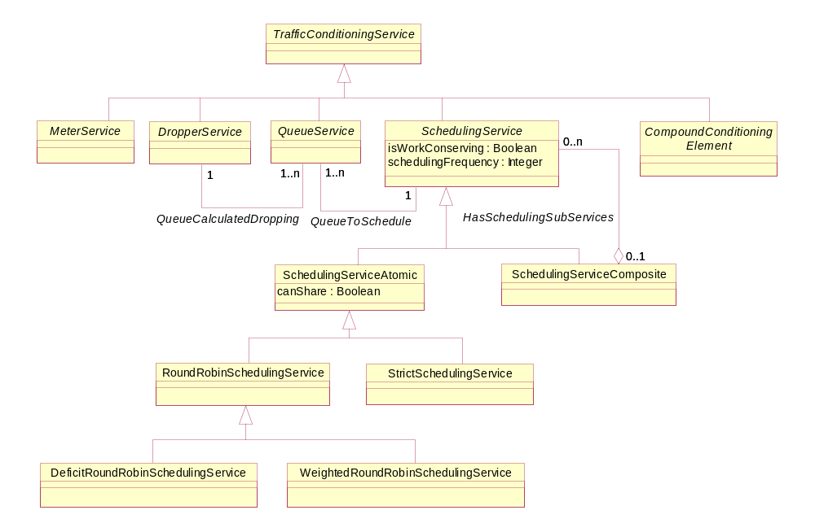
Figure 4Q- . Business Entity Model of a SchedulingService

SchedulingServiceAtomic Business Entity Definition

Business Entity Name | SchedulingServiceAtomic
Description | A SchedulingServiceAtomic object models a SchedulingService as an independent (i.e., stand-alone) TrafficConditioningService. This is fundamentally different than the SchedulingServiceComposite object, which is used to model a SchedulingService as the combination of other existing SchedulingServices (as well as providing its own extensions).
Sources | DEN-ng | Cross- References |  |  | Synonyms / Aliases | No concept of this categorization in the ITU or CIM specs.
Related Business Entities | ManagedEntity, Product, ProductBundle, ProductComponent, Resource, PhysicalResource, LogicalResource, Service, CustomerFacingService, ResourceFacingService, CustomerFacingServiceAtomic, CustomerFacingServiceComposite, ResourceFacingServiceAtomic, ResourceFacingServiceComposite, QoSServic, ToSService, 802Service, DiffServService, NetworkForwardingService, TrafficConditioningService, SchedulingService (superclass), SchedulingServiceComposite (sibling), RoundRobinSchedulingService (subclass), StrictSchedulingService (subclass), MeterService, DropperService, QueueService, PriorityQueuingService, FairQueuingService, WeightedFairQueuingService, CompoundConditioningElement, TrafficIdentificationService, ClassifierService, MarkerService, ServiceRole, ServiceCharacteristic, ServiceSpecification (template), CustomerFacingServiceSpec, ResourceFacingServiceSpec, ServicePackageSpec, ServicePackage, ServiceBundleSpec, ServiceBundle, ServiceSpecVersion, ProductSpecification, Location, BusinessInteraction, PartyRole
Business Rules | To be determined

SchedulingServiceAtomic Business Entity Attributes Definition

Business Entity Name | SchedulingServiceAtomic
Attribute Name | Description | Data Type | Characteristics, Permitted  Values & Units | Required/  Optional | Notes (used to map to other models; blank is other models don’t have it)
canShare | This is a Boolean attribute that, if TRUE, means that resources (e.g., bandwidth) can be shared across different Queue instances. | Boolean |  | Required | No concept in the ITU specs. The CIM defines this, but in a much different class structure.

Business Entity Model – SchedulingServiceAtomic
The business entity model of a SchedulingServiceAtomic is the same as that for a SchedulingService, and is shown in Figure 4Q- above.

SchedulingServiceComposite Business Entity Definition

Business Entity Name | SchedulingServiceComposite
Description | A SchedulingServiceComposite object models a SchedulingService as a set of coordinated SchedulingServices. This is fundamentally different than the SchedulingServiceAtomic object, which is used to model a SchedulingService as a stand-alone TrafficConditioningService.
Sources | DEN-ng | Cross- References |  |  | Synonyms / Aliases | No concept of this categorization in the ITU or CIM specs.
Related Business Entities | ManagedEntity, Product, ProductBundle, ProductComponent, Resource, PhysicalResource, LogicalResource, Service, CustomerFacingService, ResourceFacingService, CustomerFacingServiceAtomic, CustomerFacingServiceComposite, ResourceFacingServiceAtomic, ResourceFacingServiceComposite, QoSServic, ToSService, 802Service, DiffServService, NetworkForwardingService, TrafficConditioningService, SchedulingService (superclass), SchedulingServiceAtomic (sibling), RoundRobinSchedulingService (subclass), StrictSchedulingService (subclass), MeterService, DropperService, QueueService, PriorityQueuingService, FairQueuingService, WeightedFairQueuingService, CompoundConditioningElement, TrafficIdentificationService, ClassifierService, MarkerService, ServiceRole, ServiceCharacteristic, ServiceSpecification (template), CustomerFacingServiceSpec, ResourceFacingServiceSpec, ServicePackageSpec, ServicePackage, ServiceBundleSpec, ServiceBundle, ServiceSpecVersion, ProductSpecification, Location, BusinessInteraction, PartyRole
Business Rules | To be determined

SchedulingServiceComposite Business Entity Attributes Definition
The primary purpose of this entity is to serve as a convenient aggregation point to model complex SchedulingServices that are made up of different SchedulingServiceAtomic instances. There are no obvious business attributes for this entity, though that will be examined again in Phase IV of the SID.

Business Entity Name | SchedulingServiceComposite
Attribute Name | Description | Data Type | Characteristics, Permitted  Values & Units | Required/  Optional | Notes (used to map to other models; blank is other models don’t have it)
Tbd

Business Entity Model – SchedulingServiceComposite
The business entity model of a SchedulingServiceComposite is the same as that for a SchedulingService, and is shown in Figure 4Q- above.

RoundRobinSchedulingService Business Entity Definition

Business Entity Name | RoundRobinSchedulingService
Description | This is a popular type of Scheduler, mainly because it is relatively easy to implement in hardware. Basically, it serves each active Queue, one after another. A Queue is defined to be active if it has any packets that are enqueued.  This scheduler provides fair distribution for packets that are fixed-size. However, it doesn't provide fair behavior if there are variable-size packets.
Sources | DEN-ng | Cross- References |  |  | Synonyms / Aliases | No concept of this categorization in the ITU or CIM specs.
Related Business Entities | ManagedEntity, Product, ProductBundle, ProductComponent, Resource, PhysicalResource, LogicalResource, Service, CustomerFacingService, ResourceFacingService, CustomerFacingServiceAtomic, CustomerFacingServiceComposite, ResourceFacingServiceAtomic, ResourceFacingServiceComposite, QoSServic, ToSService, 802Service, DiffServService, NetworkForwardingService, TrafficConditioningService, SchedulingService, SchedulingServiceAtomic (superclass), StrictSchedulingService (sibling), SchedulingServiceComposite, MeterService, DropperService, QueueService, PriorityQueuingService, FairQueuingService, WeightedFairQueuingService, CompoundConditioningElement, TrafficIdentificationService, ClassifierService, MarkerService, ServiceRole, ServiceCharacteristic, ServiceSpecification (template), CustomerFacingServiceSpec, ResourceFacingServiceSpec, ServicePackageSpec, ServicePackage, ServiceBundleSpec, ServiceBundle, ServiceSpecVersion, ProductSpecification, Location, BusinessInteraction, PartyRole
Business Rules | To be determined

RoundRobinSchedulingService Business Entity Attributes Definition

Business Entity Name | RoundRobinSchedulingService
Attribute Name | Description | Data Type | Characteristics, Permitted  Values & Units | Required/  Optional | Notes (used to map to other models; blank is other models don’t have it)
isFlowBased | This is a Boolean that, if TRUE, defines this instance as a flow-based scheduler. If it is false, it is a class-based scheduler. | Boolean |  | Required | No concept of this in the ITU specs. This is not explicitly identified as an attribute in the CIM spec.
schedulingMetric | This is an enumerated integer that defines the metric used to schedule flows in the RoundRobinScehduler. | Integer | 0: custom  implementation  1: packets  2: bytes  3: cells  4: frames  5: flows | Required | No concept of this in the ITU specs. The CIM doesn’t have a RoundRobin Scheduler.
metricValue | This is a non-negative integer that defines the number of metric units to allocate per Queue vist. The metric is defined in the schedulingMetric attribute. | Integer |  | Required | No concept of this in the ITU or CIM specs.

Business Entity Model – RoundRobinSchedulingService
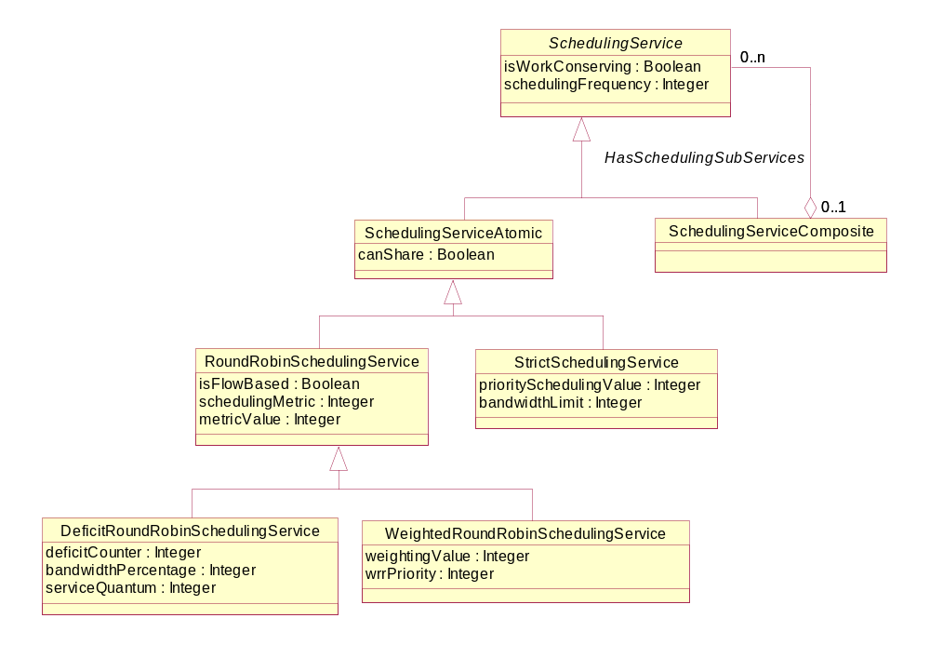
Figure 4Q- . Business Entity Model of SchedulingService Subclasses

DeficitRoundRobinSchedulingService Business Entity Definition

Business Entity Name | DeficitRoundRobinSchedulingService
Description | This scheduling algorithm is designed to address the limitations of WRR and WFQ. Its main goal is to provide weighted fair distribution of bandwidth for multiple Queues that contain variable-length packets.
Sources | DEN-ng | Cross- References |  |  | Synonyms / Aliases | No concept of this categorization in the ITU or CIM specs.
Related Business Entities | ManagedEntity, Product, ProductBundle, ProductComponent, Resource, PhysicalResource, LogicalResource, Service, CustomerFacingService, ResourceFacingService, CustomerFacingServiceAtomic, CustomerFacingServiceComposite, ResourceFacingServiceAtomic, ResourceFacingServiceComposite, QoSServic, ToSService, 802Service, DiffServService, NetworkForwardingService, TrafficConditioningService, SchedulingService, SchedulingServiceAtomic, RoundRobinSchedulingService (superclass), WeightedRoundRobinSchedulingService (sibling), StrictSchedulingService, SchedulingServiceComposite, MeterService, DropperService, QueueService, PriorityQueuingService, FairQueuingService, WeightedFairQueuingService, CompoundConditioningElement, TrafficIdentificationService, ClassifierService, MarkerService, ServiceRole, ServiceCharacteristic, ServiceSpecification (template), CustomerFacingServiceSpec, ResourceFacingServiceSpec, ServicePackageSpec, ServicePackage, ServiceBundleSpec, ServiceBundle, ServiceSpecVersion, ProductSpecification, Location, BusinessInteraction, PartyRole
Business Rules | To be determined

DeficitRoundRobinSchedulingService Business Entity Attributes Definition

Business Entity Name | DeficitRoundRobinSchedulingService
Attribute Name | Description | Data Type | Characteristics, Permitted  Values & Units | Required/  Optional | Notes (used to map to other models; blank is other models don’t have it)
deficitCounter | This specifies the total number of units that this particular Queue is allowed to transmit each time the Scheduler visits it. Units are most often bytes, but could conceivably be other metrics as well. | Integer |  | Required | No concept of this in the ITU or CIM specs.
bandwidthPercentage | This is a non-negative integer that defines the percentage of bandwidth that is allocated to a particular Queue. | Integer |  | Required | No concept of this in the ITU or CIM specs.
serviceQuantum | This is an amount that is added to the deficitCounter to determine if the Queue is allowed to transmit. If the value of the deficitCounter is greater than the size of the unit (e.g., packet, cell, etc.) waiting in the Queue, then the Scheduler moves to the next Queue. If the value of the deficitCounter is less than or equal to the size of the unit waiting in the Queue, then the deficitCounter is reduced by the size of the transmitted unit, and the unit is transmitted. | Integer |  | Required | No concept of this in the ITU or CIM specs.

Business Entity Model – DeficitRoundRobinSchedulingService
The business entity model of a DeficitRoundRobinSchedulingService is the same as that for a RoundRobinSchedulingService, and is shown in Figure 4Q- above.

WeightedRoundRobinSchedulingService Business Entity Definition

Business Entity Name | WeightedRoundRobinSchedulingService
Description | This algorithm uses weighting to make up for the inability of a RoundRobinScheduler to accommodate variable packet sizes. Most WeightedRoundRobinSchedulers also have the ability to prioritize their treatment of certain special Queues. For example, an instance of this Scheduler may control multiple Queues, where some are dedicated for serving real-time traffic and others are to be used for all other types of traffic. The simplest way to accommodate this is to use a priority and a weight.
Sources | DEN-ng | Cross- References |  |  | Synonyms / Aliases | No concept of this categorization in the ITU specs. The CIM defines a similarly named class, but the CIM class structure is so different as to make its semantics very different than those of this class.
Related Business Entities | ManagedEntity, Product, ProductBundle, ProductComponent, Resource, PhysicalResource, LogicalResource, Service, CustomerFacingService, ResourceFacingService, CustomerFacingServiceAtomic, CustomerFacingServiceComposite, ResourceFacingServiceAtomic, ResourceFacingServiceComposite, QoSServic, ToSService, 802Service, DiffServService, NetworkForwardingService, TrafficConditioningService, SchedulingService, SchedulingServiceAtomic, RoundRobinSchedulingService (superclass), DeficitRoundRobinSchedulingService (sibling), StrictSchedulingService, SchedulingServiceComposite, MeterService, DropperService, QueueService, PriorityQueuingService, FairQueuingService, WeightedFairQueuingService, CompoundConditioningElement, TrafficIdentificationService, ClassifierService, MarkerService, ServiceRole, ServiceCharacteristic, ServiceSpecification (template), CustomerFacingServiceSpec, ResourceFacingServiceSpec, ServicePackageSpec, ServicePackage, ServiceBundleSpec, ServiceBundle, ServiceSpecVersion, ProductSpecification, Location, BusinessInteraction, PartyRole
Business Rules | To be determined

WeightedRoundRobinSchedulingService Business Entity Attributes Definition

Business Entity Name | WeightedRoundRobinSchedulingService
Attribute Name | Description | Data Type | Characteristics, Permitted  Values & Units | Required/  Optional | Notes (used to map to other models; blank is other models don’t have it)
weightingValue | This is a non-negative integer that defines the actual value of the weight used for a particular Queue. | Integer |  | Required | No concept of this in the ITU specs. The CIM defines a similarly named attribute, but has different semantics.
wrrPriority | This is a non-negative integer that defines the absolute priority of a particular Queue. This ensures that this Queue will always be able to be serviced, and hence can be used to provide a guaranteed service. | Integer |  | Required | No concept of this in the ITU specs. The CIM definition of this attribute is wrong.

Business Entity Model – WeightedRoundRobinSchedulingService
The business entity model of a WeightedRoundRobinSchedulingService is the same as that for a RoundRobinSchedulingService, and is shown in Figure 4Q- above.

StrictSchedulingService Business Entity Definition

Business Entity Name | StrictSchedulingService
Description | The simplest type of Scheduler is a Priority scheduler. This type of Scheduler assigns each Queue a priority, and then visits each Queue in priority order. However, as long as a Queue of a higher priority has traffic enqueued, Queues of lower priority are starved.  Still, there are advantages to this type of Scheduler, especially when dealing with voice traffic.  Other types of Schedulers that provide strict rules about Queue servicing can be derived from this class.
Sources | DEN-ng | Cross- References |  |  | Synonyms / Aliases | No concept of this categorization in the ITU specs. The CIM defines a similarly named class, but the CIM class structure is so different as to make its semantics very different than those of this class.
Related Business Entities | ManagedEntity, Product, ProductBundle, ProductComponent, Resource, PhysicalResource, LogicalResource, Service, CustomerFacingService, ResourceFacingService, CustomerFacingServiceAtomic, CustomerFacingServiceComposite, ResourceFacingServiceAtomic, ResourceFacingServiceComposite, QoSServic, ToSService, 802Service, DiffServService, NetworkForwardingService, TrafficConditioningService, SchedulingService, SchedulingServiceAtomic (superclass), RoundRobinSchedulingService (sibling), SchedulingServiceComposite, MeterService, DropperService, QueueService, PriorityQueuingService, FairQueuingService, WeightedFairQueuingService, CompoundConditioningElement, TrafficIdentificationService, ClassifierService, MarkerService, ServiceRole, ServiceCharacteristic, ServiceSpecification (template), CustomerFacingServiceSpec, ResourceFacingServiceSpec, ServicePackageSpec, ServicePackage, ServiceBundleSpec, ServiceBundle, ServiceSpecVersion, ProductSpecification, Location, BusinessInteraction, PartyRole
Business Rules | To be determined

StrictSchedulingService Business Entity Attributes Definition

Business Entity Name | StrictSchedulingService
Attribute Name | Description | Data Type | Characteristics, Permitted  Values & Units | Required/  Optional | Notes (used to map to other models; blank is other models don’t have it)
prioritySchedulingValue | This is a non-negative integer that defines the priority of the associated Queue. | Integer |  | Required | No concept of this in the ITU specs. The CIM defines a similarly named attribute, but has different semantics.
bandwidthLimit | This is a non-negative integer that defines the upper limit on the amount of traffic that can be handled by the associated Queue instance. | Integer |  | Required | No concept of this in the ITU specs. The CIM defines a similarly named attribute.

Business Entity Model – StrictSchedulingService
The business entity model of a StrictSchedulingService is the same as that for a RoundRobinSchedulingService, and is shown in Figure 4Q- above.

CompoundConditioningElement Business Entity Definition

Business Entity Name | CompoundConditioningElement
Description | This is an abstract base class that defines "compound" traffic conditioning elements. Such elements are made up of two or more TrafficConditioningServices. For example, a Policer can be modeled as a Dropper and a Marker that feeds a Queue.  The advantage of this class is that objects and relationships can be defined once with it that its subclasses inherit. For example, both a policer and a shaper can use a TokenBucket to define the traffic profile that they will police or shape against. Without this class, two different associations would have to be defined.  A second advantage of this class is that it mirrors user-programmable features of modern network devices, and hence enables the DEN-ng model to better and more closely represent what the user programs.
Sources | DEN-ng | Cross- References |  |  | Synonyms / Aliases | No concept of this categorization in the ITU or CIM specs.
Related Business Entities | ManagedEntity, Product, ProductBundle, ProductComponent, Resource, PhysicalResource, LogicalResource, Service, CustomerFacingService, ResourceFacingService, CustomerFacingServiceAtomic, CustomerFacingServiceComposite, ResourceFacingServiceAtomic, ResourceFacingServiceComposite, QoSServic, ToSService, 802Service, DiffServService, NetworkForwardingService, TrafficConditioningService (superclass), SchedulingService (sibling), MeterService (sibling), DropperService (sibling), QueueService (sibling), TrafficIdentificationService, ClassifierService, MarkerService, ServiceRole, ServiceCharacteristic, ServiceSpecification (template), CustomerFacingServiceSpec, ResourceFacingServiceSpec, ServicePackageSpec, ServicePackage, ServiceBundleSpec, ServiceBundle, ServiceSpecVersion, ProductSpecification, Location, BusinessInteraction, PartyRole
Business Rules | To be determined

CompoundConditioningElement Business Entity Attributes Definition

Business Entity Name | CompoundConditioningElement
Attribute Name | Description | Data Type | Characteristics, Permitted  Values & Units | Required/  Optional | Notes (used to map to other models; blank is other models don’t have it)
conditioningDirection | This is an enumerated integer that defines the direction of the policing. | Integer | 0: BOTH ingress  and egress  1: ingress only  2: egress only | Required | No concept of this in the ITU or CIM specs.
hasBuffering | This is a Boolean attribute that, if TRUE, means that this CompoundConditioningElement DOES have buffering. The default is to NOT have buffering. | Boolean |  | Required | No concept of this in the ITU or CIM specs.

Business Entity Model – CompoundConditioningElement
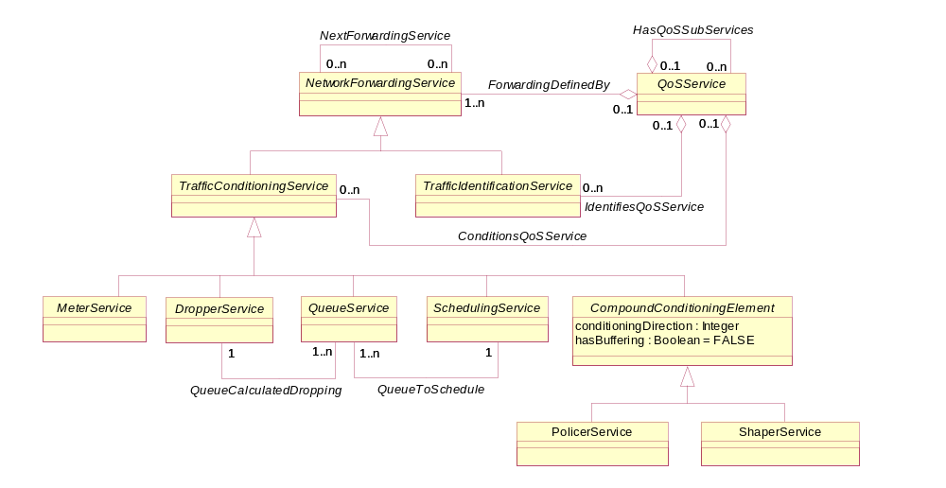
Figure 4Q- . Business Entity Model of a CompoundConditioningElement

PolicerService Business Entity Definition

Business Entity Name | PolicerService
Description | A PolicierService is a CompoundConditioningElement. Its purpose is to limit traffic flow to a configured bit rate with limited bursting capability.  A standard PolicerService has no buffering, meaning that packets that cannot be transmitted are simply dropped.
Sources | DEN-ng | Cross- References |  |  | Synonyms / Aliases | No concept of this categorization in the ITU or CIM specs.
Related Business Entities | ManagedEntity, Product, ProductBundle, ProductComponent, Resource, PhysicalResource, LogicalResource, Service, CustomerFacingService, ResourceFacingService, CustomerFacingServiceAtomic, CustomerFacingServiceComposite, ResourceFacingServiceAtomic, ResourceFacingServiceComposite, QoSServic, ToSService, 802Service, DiffServService, NetworkForwardingService, TrafficConditioningService, SchedulingService, MeterService, DropperService, QueueService, CompoundConditioningElement (superclass), ShaperService (sibling), TrafficIdentificationService, ClassifierService, MarkerService, ServiceRole, ServiceCharacteristic, ServiceSpecification (template), CustomerFacingServiceSpec, ResourceFacingServiceSpec, ServicePackageSpec, ServicePackage, ServiceBundleSpec, ServiceBundle, ServiceSpecVersion, ProductSpecification, Location, BusinessInteraction, PartyRole
Business Rules | To be determined

PolicerService Business Entity Attributes Definition
Business attributes for this class will be filled in as part of SID Phase IV.

Business Entity Name | PolicerService
Attribute Name | Description | Data Type | Characteristics, Permitted  Values & Units | Required/  Optional | Notes (used to map to other models; blank is other models don’t have it)
Tbd

Business Entity Model – PolicerService
The business entity model of a PolicerService is the same as that of a CompoundConditioningElement, which is shown in Figure 4Q- above.

ShaperService Business Entity Definition

Business Entity Name | ShaperService
Description | A ShaperService is a CompoundConditioningElement. Its purpose is to regulate traffic flow to an average bit rate, taking into account any bursting capability that is desired.  Normally, a ShaperService includes buffering. This means that any packets that cannot be transmitted are queued.
Sources | DEN-ng | Cross- References |  |  | Synonyms / Aliases | No concept of this categorization in the ITU or CIM specs.
Related Business Entities | ManagedEntity, Product, ProductBundle, ProductComponent, Resource, PhysicalResource, LogicalResource, Service, CustomerFacingService, ResourceFacingService, CustomerFacingServiceAtomic, CustomerFacingServiceComposite, ResourceFacingServiceAtomic, ResourceFacingServiceComposite, QoSServic, ToSService, 802Service, DiffServService, NetworkForwardingService, TrafficConditioningService, SchedulingService, MeterService, DropperService, QueueService, CompoundConditioningElement (superclass), PolicerService (sibling), TrafficIdentificationService, ClassifierService, MarkerService, ServiceRole, ServiceCharacteristic, ServiceSpecification (template), CustomerFacingServiceSpec, ResourceFacingServiceSpec, ServicePackageSpec, ServicePackage, ServiceBundleSpec, ServiceBundle, ServiceSpecVersion, ProductSpecification, Location, BusinessInteraction, PartyRole
Business Rules | To be determined

ShaperService Business Entity Attributes Definition
Business attributes for this class will be filled in as part of SID Phase IV.

Business Entity Name | ShaperService
Attribute Name | Description | Data Type | Characteristics, Permitted  Values & Units | Required/  Optional | Notes (used to map to other models; blank is other models don’t have it)
Tbd

Business Entity Model – ShaperService
The business entity model of a ShaperService is the same as that of a CompoundConditioningElement, which is shown in Figure 4Q- above.

