Information Framework (SID)
Market/Sales Business Entity Definitions

GB922 Addendum 6
TM Forum Approved Version 2.5


September, 2011

Notice

This material, including documents, code and models, has been through review cycles; however, due to the inherent complexity in the design and implementation of software and systems, no liability is accepted for any errors or omissions or for consequences of any use made of this material.
Under no circumstances will the TM Forum be liable for direct or indirect damages or any costs or losses resulting from the use of this specification. The risk of designing and implementing products in accordance with this specification is borne solely by the user of this specification.
This material bears the copyright of TM Forum and its use by members and non-members of TM Forum is governed by all of the terms and conditions of the Intellectual Property Rights Policy of the TM Forum (http://www.tmforum.org/Bylaws/1094/home.html) and may involve a claim of patent rights by one or more TM Forum members or by non-members of TM Forum.

Direct inquiries to the TM Forum office:
240 Headquarters Plaza,
East Tower – 10th Floor,
Morristown, NJ 07960 USA
Tel No. +1 973 944 5100
Fax No. +1 973 944 5110
TM Forum Web Page: www.tmforum.org

Table of Contents
Notice 2
Table of Contents 3
List of Figures 5
1. Business Entities 6
1.1. Market and Sales Domain 6
1.2. Market and Sales/Market Segment 7
1.2.1. Party Demographic 7
1.2.2. Party Profile Type 8
1.2.3. Market Segment 8
1.2.4. Market Statistics 16
1.3. Market and Sales/Marketing Campaign 18
1.3.1. MarketingCampaign 18
1.3.2. Media 23
1.4. Market and Sales/Competitor 24
1.4.1. Competitor 24
1.4.2. Competitor Intelligence 27
1.4.3. Product Domain Competitor ABEs 31
1.4.4. Competitor Product Correlation 33
1.5. Business Entity Definitions – Market Segment/Market Segment 37
1.5.1. AtomicMarketSegement 37
1.5.2. AtomicMarketSegmentCharacteristic 37
1.5.3. CompositeMarketSegment 38
1.5.4. CompositeMarketSegmentCharacteristic 38
1.5.5. MarketSegment 39
1.5.6. MarketSegmentCharacteristic 41
1.5.7. MarketSegmentCharacteristicValue 43
1.6. Business Entity Definitions – Market Segment/Party Demographic 46
1.7. Business Entity Definitions – Market Segment/Party Profile 46
1.8. Business Entity Definitions – Market Segment/Market Statistic 46
1.8.1. AtomicMarketStatistic 46
1.8.2. CompositeMarketStatistic 47
1.8.3. MarketStatistic 47
1.9. Business Entity Definitions – Marketing Campaign/Marketing Campaign 49
1.9.1. AtomicMarketingCampaignCharacteristic 49
1.9.2. CompositeMarketingCampaignCharacteristic 50
1.9.3. MarketingCampaign 50
1.9.4. MarketingCampaignCharacteristic 52
1.9.5. MarketingCampaignCharacteristicValue 54
1.10. Business Entity Definitions – Marketing Campaign/Media 56
1.10.1. Media 56
1.11. Business Entity Definitions – Competitor/Competitor 57
1.11.1. CompetitiveTier 57
1.11.2. Competitor 58
1.11.3. CompetitorMarketSegment 59
1.11.4. CompetitorMarketSegmentSWOT 60
1.11.5. CompetitorSWOT 61
1.11.6. CompetitorTier 62
1.11.7. SWOT 63
1.12. Business Entity Definitions – Competitor/Competitor Intelligence 64
1.12.1. AtomicCompIntelCharacteristic 64
1.12.2. CompetitorIntelCharacteristic 65
1.12.3. CompetitorIntelCharactertisticValue 67
1.12.4. CompetitorIntelligence 69
1.12.5. CompetitorIntelligenceMarketSegment 70
1.12.6. CompetitorIntelligencePartyRole 71
1.12.7. CompositeCompIntelCharacteristic 73
1.13. Business Entity Definitions – Competitor/Competitor Product Correlation 73
1.13.1. AtomicCompProdCorrelationCharacteristic 73
1.13.2. CompetitorProductCorrelation 74
1.13.3. CompositeCompProdCorrelationCharacteristic 75
1.13.4. CompProdCorCharacteristicValue 76
1.13.5. CompProdCorrelationCharacteristic 78
1.13.6. <Business Entity> 80
2. Administrative Appendix 82
2.1. About this document 82
2.2. Document History 82
2.2.1. Version History 82
2.2.2. Release History 83
2.3. Company Contact Details 83
2.4. Acknowledgments 83

List of Figures
Figure MS. 1 - Market/Sales Domain Aggregate Business Entities 6
Figure MS. 7 – Basic Market Segment Entities 9
Figure MS. 8 - Composite and Atomic Market Segments 10
Figure MS. 9 – Market Segment Characteristics 11
Figure MS. 10 – Market Segment Characteristics Example 12
Figure MS. 11 – Composite and Atomic Market Segment Characteristics 14
Figure MS. 12 – Market Segment’s Associations With Other Business Entities 15
Figure MS. 13 – Market Statistics and Related Entities 16
Figure MS. 14 – Marketing Campaign’s Association With Media 18
Figure MS. 15 - Marketing Campaign Characteristics 19
Figure MS. 16 – Marketing Campaign Associations, Part 1 21
Figure MS. 17 – Marketing Campaign Associations, Part 2 22
Figure MS. 18 – Media Association With Other Business Entities 23
Figure MS. 19 – Basic Competitor Business Entities 26
Figure MS. 20 – Competitor Intelligence Basic Entities 28
Figure MS. 21 – Competitor Intelligence Characteristics 30
Figure MS. 22 - Product Domain Entities Support of Competitor Product Information 32
Figure MS. 23 – Competitor Product Correlation Basic Entities 34
Figure MS. 24 – Competitor Product Correlation Characteristics 36

Business Entities

Market and Sales Domain
This addendum describes the Aggregate Business Entities (ABEs) that comprise the Market/Sales domain of the SID model. The ABEs contained within this domain are shown in the figure below.
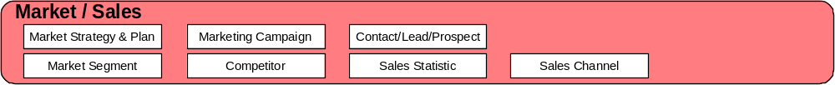
Figure MS. 1 - Market/Sales Domain Aggregate Business Entities
Note: The Market Strategy and Plan ABE is not included in the current release of this addendum.
Market-oriented ABEs presented here focus on gathering and evaluation of competitor and demographic information and the formulation of marketing campaign strategies based on the analysis of this information. Results of this analysis are used to determine the most effective approach for marketing new, as well as existing, product offerings.
Market-oriented domains will be covered first in the following order
- Market Segment – Supports market segments, market statistics, and forecasts (Note: Forecasts are not yet covered in this addendum.)
- Marketing Campaign – supports marketing new or existing product offerings to identified target markets segments. For example, the launch of a pre-paid product offering with multiple promotions across sales channels, market segments, and so forth; a new campaign for an existing product offering; a re-launch of a campaign for an existing product offering.
- Competitor – Identifies other providers who compete in the same market segments, accumulates intelligence about the competitors, including product offerings (price, key performance indicators, and so forth).
Sales-oriented domains will be covered second in the following order
- Sales Channel – Keeps track of sales channels (also known as distribution channels) and sales activities, sales quotas, sales contests, commission/bonus plans, commissions/bonuses, and maintains groups of individuals that make up the sales force.
- Contact/Lead/Prospect – Provides the ability to track sales leads through their life cycle up until the time the leads become customers, including lead and contact information, sales prospects, proposals made to potential customers, and the amount of potential revenue the leads represent in the form of a sales pipeline.
- Sales Statistics – Maintains sales forecasts, new service requirements, customer needs, and customer education, as well as calculating key performance indicators about Sales & Marketing revenue and sales channel performance.

Market and Sales/Market Segment
MarketSegments and other marketing ABEs and business entities rely heavily on their associations with demographics and profiles of parties, whether the party is a customer or a competitor. Therefore, before presenting the MarketSegment business entity, Demographics and PartyProfiles will be described.

Party Demographic
This ABE used to be part of the Market Sales domain but was moved to the Party model. For documentation of the Party Demographic ABE see GB922 addendum 1P (Party)

Party Profile Type
This ABE used to be part of the Market Sales domain but was moved to the Party model. For documentation of the Party Profile ABE see GB922 addendum 1P (Party)

Market Segment
A MarketSegment is key to market analysis and many other business processes. Market analysis uses the results of competitive analysis and demographic analysis to identify what constitutes a market, or MarketSegment. There are a number of ways to group entities, such as parties and sales channels) into MarketSegments for targeting by MarketingCampaigns, ProductPromotions, and so forth, from internal and Competitor perspectives. MarketSegments can be simple or complex. For example, one MarketSegment may be consumer customers, one may be all states west of the Mississippi, and another may be all consumer customers who live in California, have a family income over $50,000 a year, and use the Internet regularly.
Typically MarketSegments encompass one or more GeographicAreas, target one or more PartyProfileTypes, and are serviced by one or more SalesChannels as shown in the figure below.
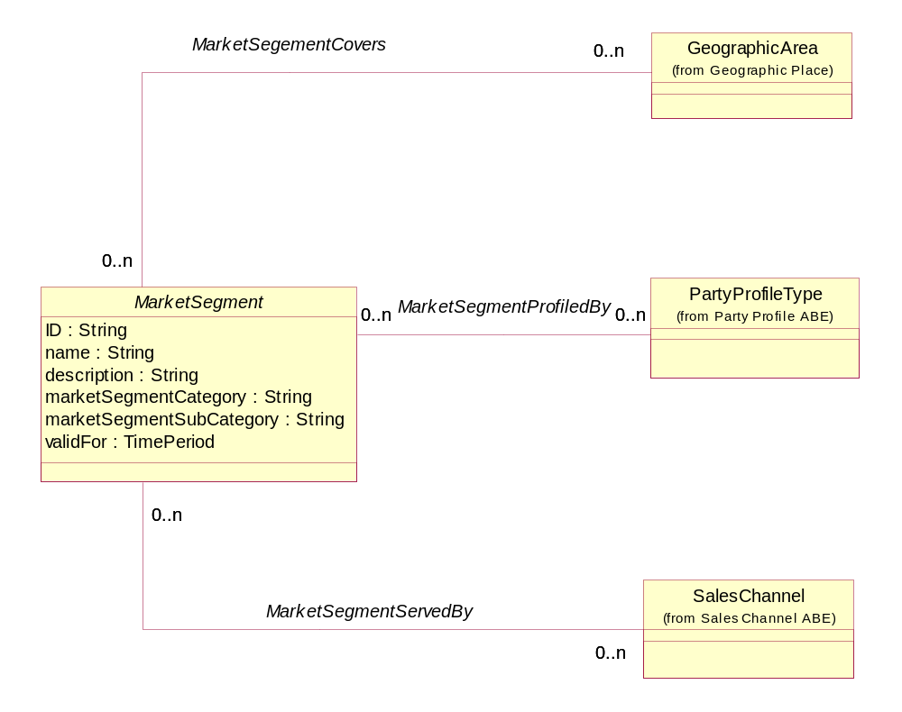
Figure MS. 2 – Basic Market Segment Entities
MarketSegments may be comprised of other MarketSegments. For example, the state of California may represent a composite MarketSegment made up of Northern and Southern California Market Segments. The SID Composite/Atomic pattern is employed (yet again) to accommodate this structuring of MarketSegments. The figure below depicts CompositeMarketSegment and AtomicMarketSegment.
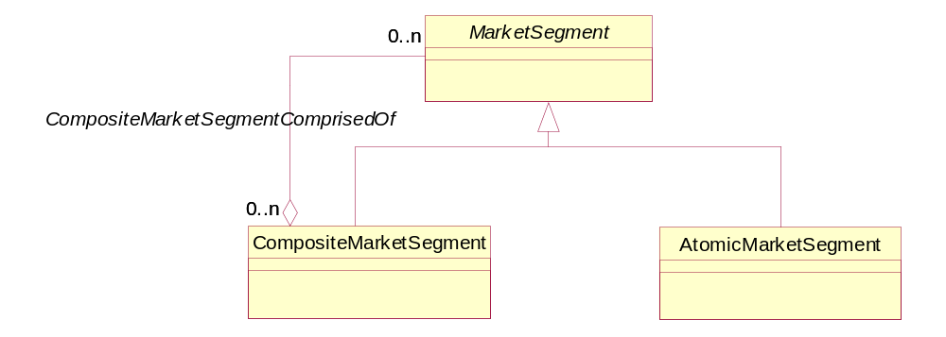
Figure MS. 3 - Composite and Atomic Market Segments
Some simple MarketSegments, such as a segment that covers all states west of the Mississippi, can be handled by employing the association to GeographicAreas shown in figure MS.02. Other more complex MarketSegments, such as all consumer customers who live in California, have a family income over $50,000 a year, and use the Internet regularly, require the addition of characteristic entities to the MarketSegment ABE. The CharacteristicSpec/Characteristic is another of the SID modeling patterns that is applied here. These entities are shown in the figure below; the figure following this one shows which entities are used to hold the details of the example complex segment.
Notice that MarketSegmentCharacteristic and MarketSegmentCharacteristicValue entities can be shared by one or more MarketSegments. This follows the same pattern that was described for PartyProfileTypeCharacteristics.
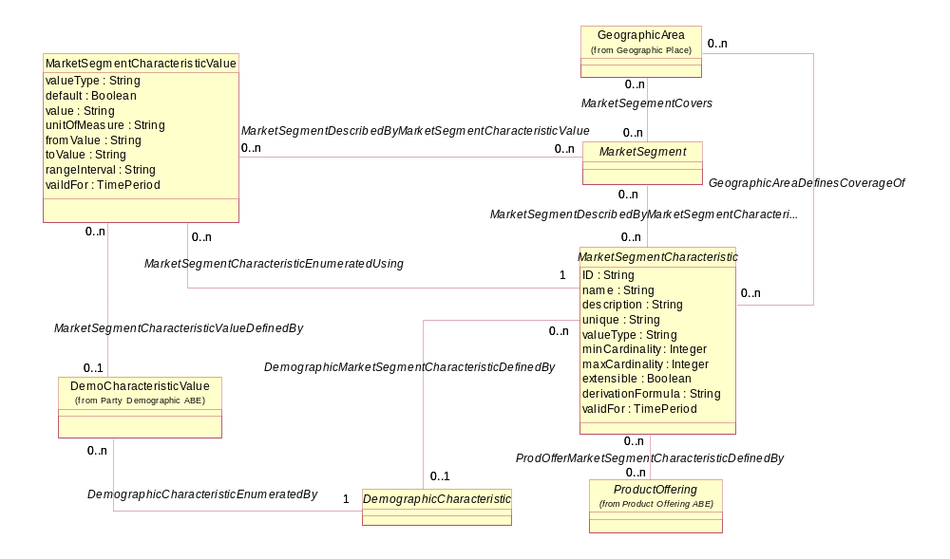
Figure MS. 4 – Market Segment Characteristics
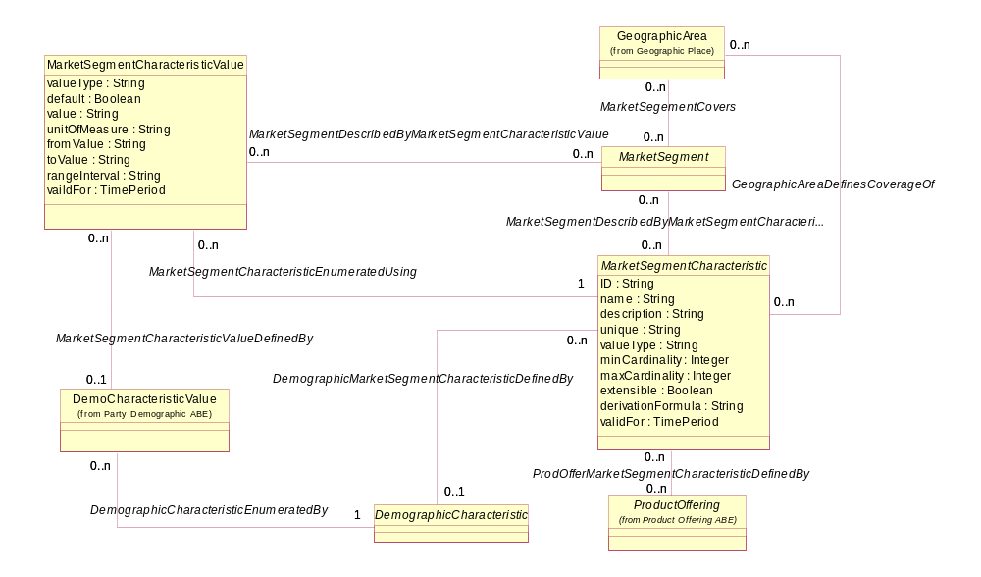
State of Residence
Internet Use
Family Income Level
Customer Type
(via association to Demo Characteristic)
California (State of Residence)
Internet Use – None, Infrequently, regularly
Family Income Level - <20,000; 20-50,000; over 50,000
Customer Type – business, consumer, carrier
Internet Use – Regular
Family Income Level – over 50,000
Customer type - consumer
Middle Income California Internet Consumer Customer
State of Residence
Internet Use
Family Income Level
Customer Type
Number of Households
Population
Figure MS. 5 – Market Segment Characteristics Example
There are some additional details of the model not shown in the example figure above.
The first is the use of the Characteristic/Characteristic Value pattern. The association from MarketSegmentCharacteristic to DemographicCharacteristic is optional. This member of the association is optional so that non-demographic characteristics can be used to define the MarketSegment. For example, the full complement of video conferencing offerings may define a MarketSegment. Similarly, the association from MarketSegmentCharacteristicValue back to DemoCharacteristicValidValue is optional. This member of the association is optional for two reasons. One is so that values not associated with demographics can be entered. The second is so that values can be entered for MarketSegmentCharacteristicValue that do not exist as a DemoCharacteristicValidValue. For example, one characteristic is the exact count of subscribers using a product; it doesn’t make sense to put an extensive list of valid values together that ranges from one to some very large number.
The second is the association between MarketSegmentCharacteristic and ProductOffering. This association exists to enable tracking of the sales, inquiries made, and so forth of one or more ProductOfferings. If a MarketSegment’s characteristics include the individual use of a number of ProductOfferings, then one instance of MarketSegmentCharacteristic is created for each ProductOffering; If a MarketSegment’s characteristic includes the total use of a number of ProductOfferings, then a single MarketSegmentCharacteristic is created and associated with each of the ProductOfferings.
The third is that, as with all SID ABEs, this model provides a framework for a MarketSegment information model that is meant to be extended. For example, one extension could be the association of a MarketSegmentCharacteristic to the Product entity. This could be used to track the actual use of a product by a subscriber.
The MarketSegmentCharacteristic also employs the Composite/Atomic pattern used by other Market/Sales domain ABEs. The figure below shows the application of this pattern.
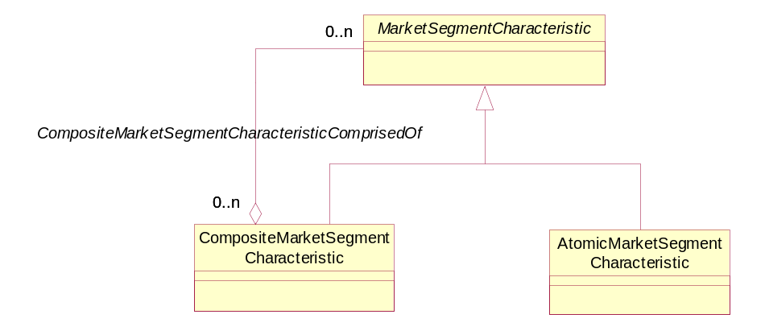
Figure MS. 6 – Composite and Atomic Market Segment Characteristics
The associations shown in the MarketSegment figures up to this point are only a fraction of the associations that MarketSegment, as a key entity within the Market/Sales domain, has. The figure below depicts some of the associations that MarketSegment has with other business entities. These associations are also described in the addenda containing the related entities.
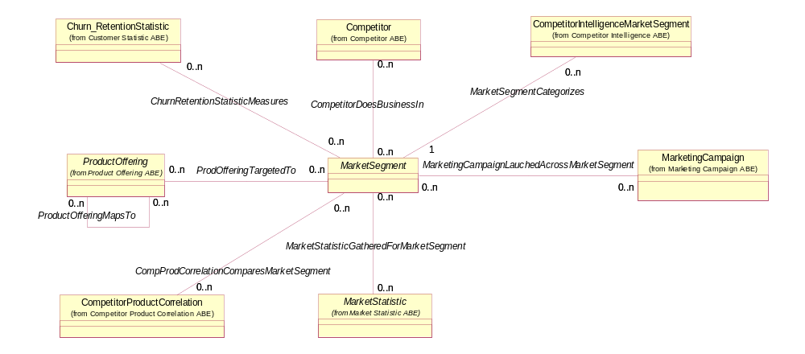
Figure MS. 7 – Market Segment’s Associations With Other Business Entities

Market Statistics
A MarketStatistic tracks performance measurements (some of which represent Key Marketing Performance Indicators, or KPIs) for both a service provider and a service provider’s Competitors via an association to PartyRole. Performance measurements include churn and retention, usage patterns, take rates (procurement of a ProductOffering by the market), and market penetration. Any mix of ProductOfferings and ProductPromotions, MarketSegments, SalesChannels, and GeographicAreas can categorize the statistics over any time period. The figure below shows MarketStatistic and its related entities.
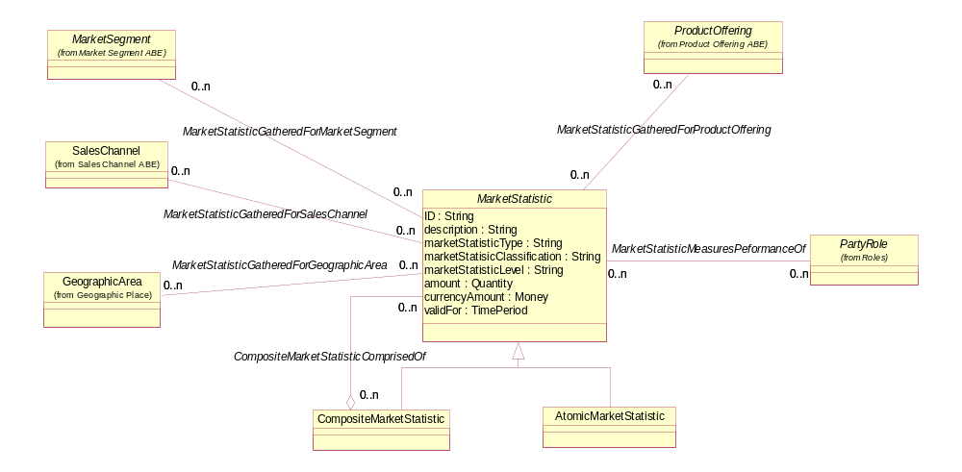
Figure MS. 8 – Market Statistics and Related Entities
When a MarketStatistic represents a KPI, the CompositeMarketStatistic can be used to represent a roll-up of statistics. For example, manager level statistics can roll up to director level statistics, which in turn can roll up to enterprise officer level statistics.

Market and Sales/Marketing Campaign
The Marketing Campaign ABE represents the strategy, or approach, for marketing new or existing ProductOfferings to identified target markets. The campaign could be for one of the following.
- The launch of a pre-paid ProductOffering with multiple promotions across SalesChannels, MarketSegments, and so forth
- A new campaign for an existing ProductOffering; the ProductOffering is not new, but the relationships, collateral, and so forth could be new
- A re-launch of a campaign for an existing ProductOffering

MarketingCampaign
Inter-department teams typically put MarketingCampaigns together for the purposes described above. Some form of Media is typically used to communicate details about the campaign to the market. The section following this one describes the Media ABE. The figure below depicts the MarketingCampaign business entity, its key attributes, and its association with Media.
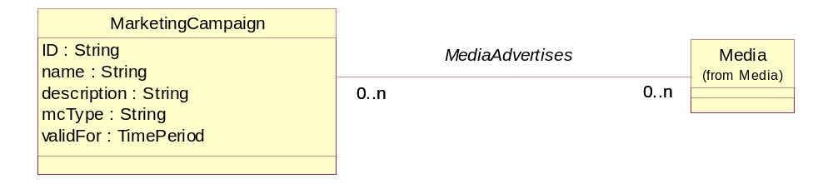
Figure MS. 9 – Marketing Campaign’s Association With Media
As with other business entities contained within the Market/Sales domain there may be a number of other attributes that are important in characterizing a MarketingCampaign. For example, the brokerage houses that have picked up a campaign, the number of press releases associated with a campaign, or the number of prospects intended to be reached by a campaign may be of interest. The CharacteristicSpec/Characteristic and Composite/Atomic patterns used through the Market/Sales domain are also applied here to accommodate this need. These entities as they relate to a MarketingCampaign are shown in the figure below.
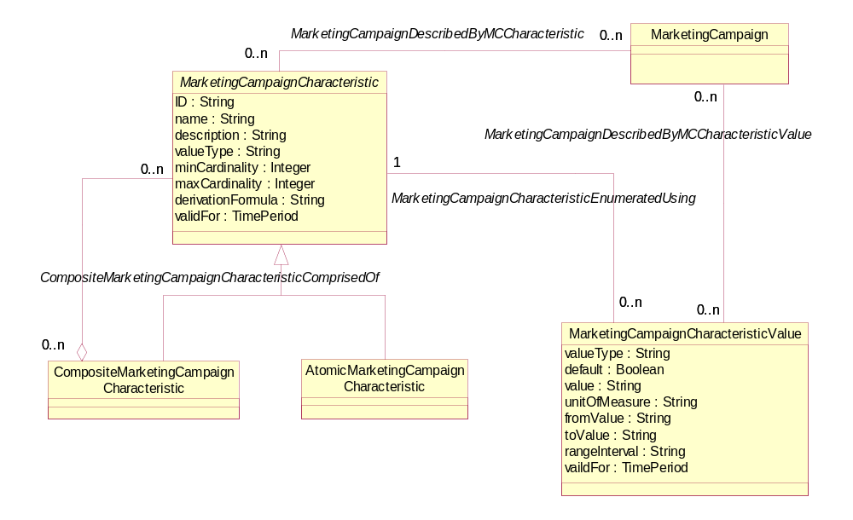
Figure MS. 10 - Marketing Campaign Characteristics
An example of the use of the composite characteristic is the definition of a characteristic that consolidates all brokerage house attributes. This composite would be comprised of atomic characteristic instances representing brokerage house names associated with a MarketingCampaign, as well as an instance representing the total number of brokerage houses that took up the MarketingCampaign.
Notice that MarketingCampaignCharacteristic and MarketingCampaignCharacteristicValue entities can be shared by one or more MarketingCampaigns. This follows the same pattern is used through the Market/Sales domain.
A MarketingCampaign may target certain PartyRoleTypes, PartyProfileTypes, such as ones based on usage charges and usage patterns. The campaign can be launched across SalesChannels and/or MarketSegments. The figure below depicts these associations.
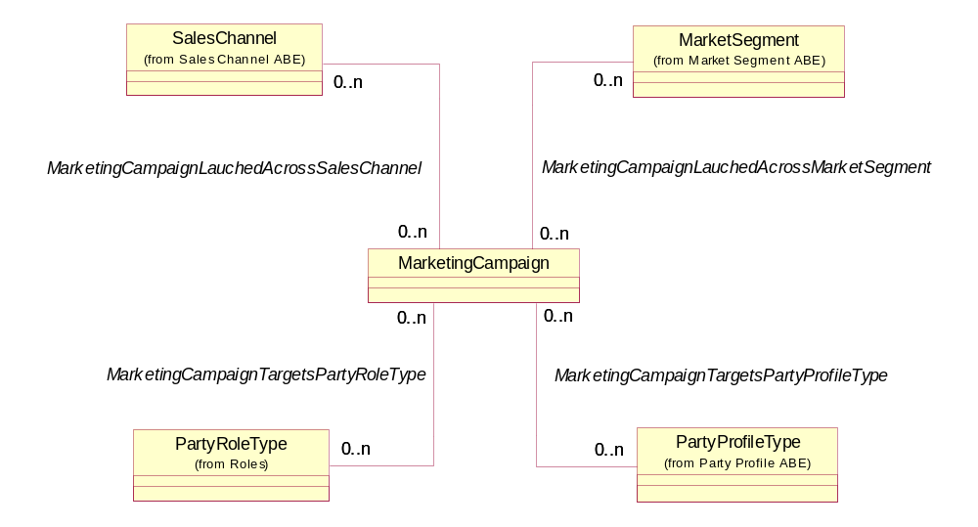
Figure MS. 11 – Marketing Campaign Associations, Part 1
MarketingCampaigns support a ProductOffering or a specific ProductPromotion that offers incentives to procure a ProductOffering. MarketingCampaigns represent the implementation of ProductOfferingStrategies, which can be correlated to ProductOfferingStrategies of other providers, such as Competitors. Later in this addendum, the business entities within the Product domain will be reused to include domain details for Competitor and other provider products. The ChurnAndRetentionStatistics measure the effectiveness of MarketingCampaigns. The figure below shows the associations that MarketingCampaign has with these other business entities.
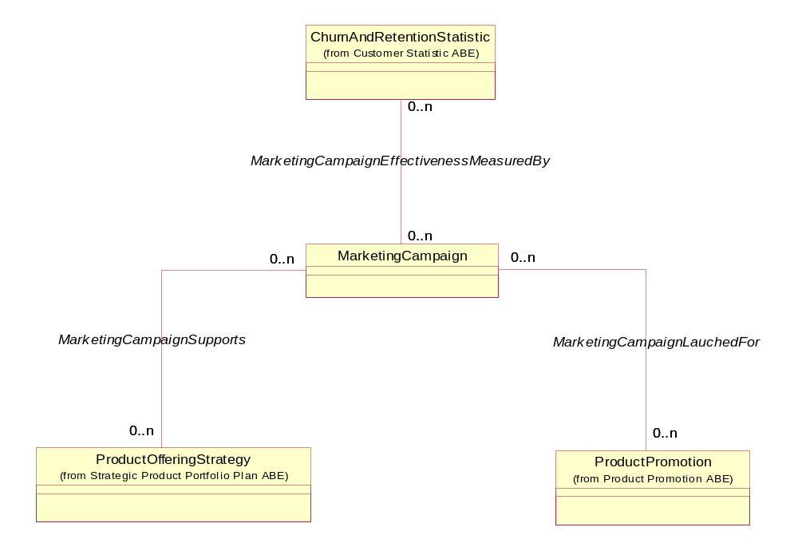
Figure MS. 12 – Marketing Campaign Associations, Part 2

Media
Media represents the various ways in which MarketingCampaigns, ProductPromotions, and ProductPlacements can be launched into the marketplace. It describes the mechanisms, such as press, radio, internet, TV, trade shows, and so forth that are employed. The figure below shows a basic model for Media and its relationships to other business entities. It is expected that Media will be developed further in future NGOSS releases.

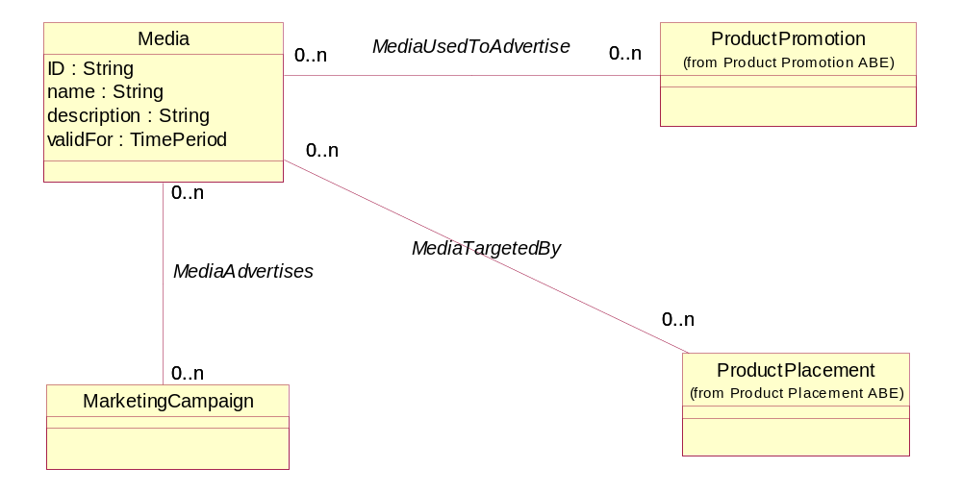
Figure MS. 13 – Media Association With Other Business Entities

Market and Sales/Competitor
The Competitor ABE provides information relative to the analysis of intelligence pertaining to an enterprise’s competitors. It is crucial to understand who the competitors are, what their products are, what the target markets for their products are, and how successful their products are.
The Competitor ABE and Competitor entities also comprise the following level-two ABEs
- Competitor Intelligence
- A variety of Product domain ABEs relative to Competitors

Competitor
Before any competitive analysis can be done, it is critical to identify and understand who the Competitors are. Competitors are any Party playing a PartyRole that offers ProductOfferings similar to the enterprise’s ProductOfferings in a MarketSegment. Once a Competitor is identified and targeted, an “owner” PartyRole is established. The owner maintains information about a Competitor. The owner is notified whenever additional information about the owner’s Competitor is obtained.
Competitors are also placed into “tiers”. This placement varies depending on the MarketSegment. Examples of Competitor tiers include
- Private line versus switched
- Small, medium, large
- Vertical (consumer, business, carrier)
- Horizontal (size, usage, customer)
An enterprise may wish to perform Strength, Weakness, Opportunity, Threat (SWOT) analysis on a Competitor. SWOT analysis is a formal framework of identifying and framing organizational growth opportunities. Additional information about SWOT Analysis can be found via an Internet search.
The figure below shows the model for basic Competitor business entities.
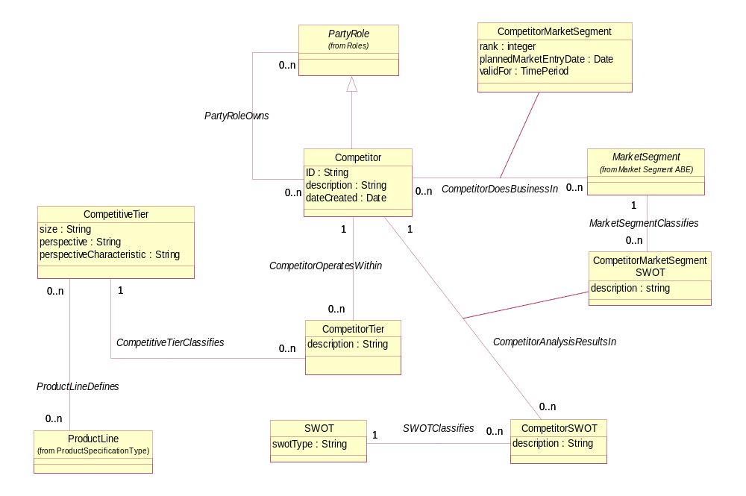
Figure MS. 14 – Basic Competitor Business Entities

Competitor Intelligence
CompetitorIntelligence are facts gathered about a Competitor's plans and activities that contributes to building a profile for a Competitor. This type of information may also be kept about internal organizations by treating them as Competitors. Many of the facts overlap with those gathered for the enterprise itself in the form of MarketStatistics. There are several sources from which to gather this information, including trade shows, networks, and the public domain (such as press releases).
CompetitorIntelligence can encompass, but is not limited to, the following
- Revenue (by geographic area, by product and so forth)
- Public financial information
- Press releases for information, such as personnel changes, product introductions, exits from MarketSegments, earnings, new agreements
- Product brochures
- Strategic alliances
- Market entry
- Person profiles of a Competitor’s executives
- Prospects
- Rank within a MarketSegment
These facts can be used to perform Competitor SWOT analysis in order to better understand a Competitor.
The figure below depicts the basic entities that make up the CompetitorIntelligence ABE.
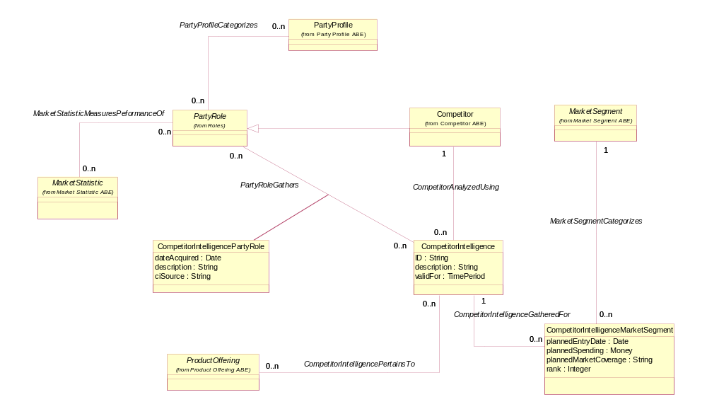
Figure MS. 15 – Competitor Intelligence Basic Entities
CompetitorIntelligenceMarketSegment tracks the entry or planned entry of a Competitor into a MarketSegment. The association with ProductOffering may pertain to an enterprise’s ProductOffering or to a Competitor’s ProductOffering (use of Product domain ABEs and entities to model Competitor Product domain entities will be explained in the next section of this addendum). The association means that the intelligence pertains to a particular ProductOffering or group of ProductOfferings. CompetitorIntelligencePartyRole captures the Party playing a PartyRole that gathered the intelligence. The association between PartyRole and MarketStatistics can be used to track Key Performance Indicators (KPIs) for a Competitor. KPIs measure such things as churn and retention, usage patterns, take rates, market penetration, market share changes, and so forth. The association with PartyRole also provides via PartyRole a means to create PartyProfiles for a Competitor.
As has been seen with other business entities contained within the Market/Sales domain there may be a number of other attributes that are important in characterizing CompetitorIntelligence. For example, the strategic alliances that have been formed by a Competitor, the coverage of a Competitor’s network, the number of potential customers reached by a Competitor’s network may be of interest. The CharacteristicSpec/Characteristic and Composite/Atomic patterns used through the Market/Sales domain are also applied here to accommodate this need. These entities as they relate to CompetitorIntelligence are shown in the figure below.
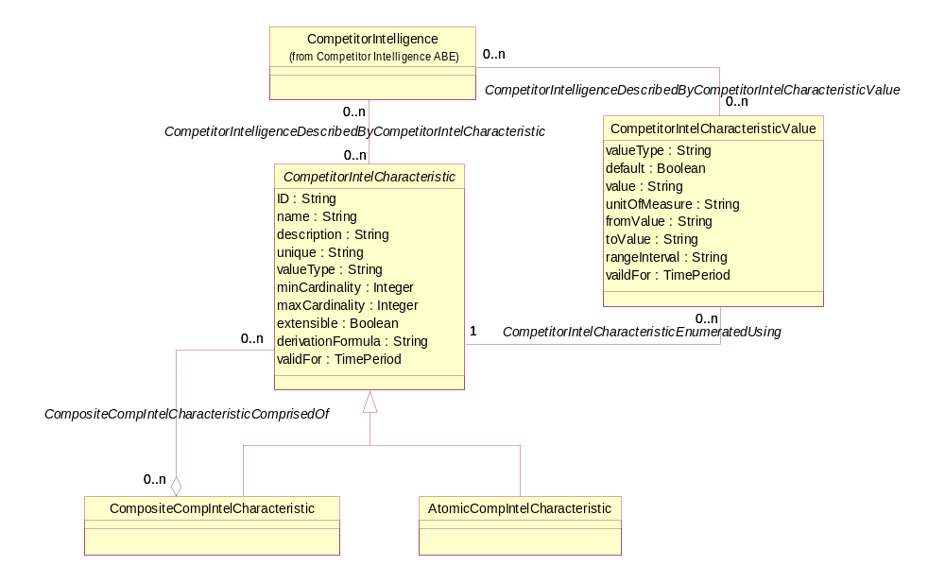
Figure MS. 16 – Competitor Intelligence Characteristics
An example of the use of the composite characteristic is the definition of a characteristic that consolidates all network-related attributes. This composite would be comprised of atomic characteristic instances representing name or location of the network associated with a MarketingCampaign, as well as instances representing the total number of potential customers that the networks support.
Notice that CompetitorIntelCharacteristic and CompetitorIntelCharacteristicValue entities can be shared by one or more instances of CompetitorIntelligence. This follows the same pattern that is used throughout the Market/Sales domain.

Product Domain Competitor ABEs
Gathering Competitor intelligence includes information about the ProductOfferings a Competitor markets, the ProductPrices for which payment is expected, ProductPromotions offered by Competitors, and so forth. Therefore, it would be expected that the SID model would contain these Product domain entities for Competitors. And, some modelers would expect to find entities such as CompetitorProductOffering, CompetitorProductPrice, and so forth. SID team members working in the Product and Marketing domains have in the past constructed a separate information model of these Competitor-related entities. And, when complete, have found striking similarities to Product domain entities.
It’s really all a matter of perspective. Suppose a Competitor used the SID as the basis for an information model. The Competitor Product domain model would the same model as used by a competing enterprise. The perspective is provided by introducing the PartyRole entity into the Product domain as shown in the figure below.
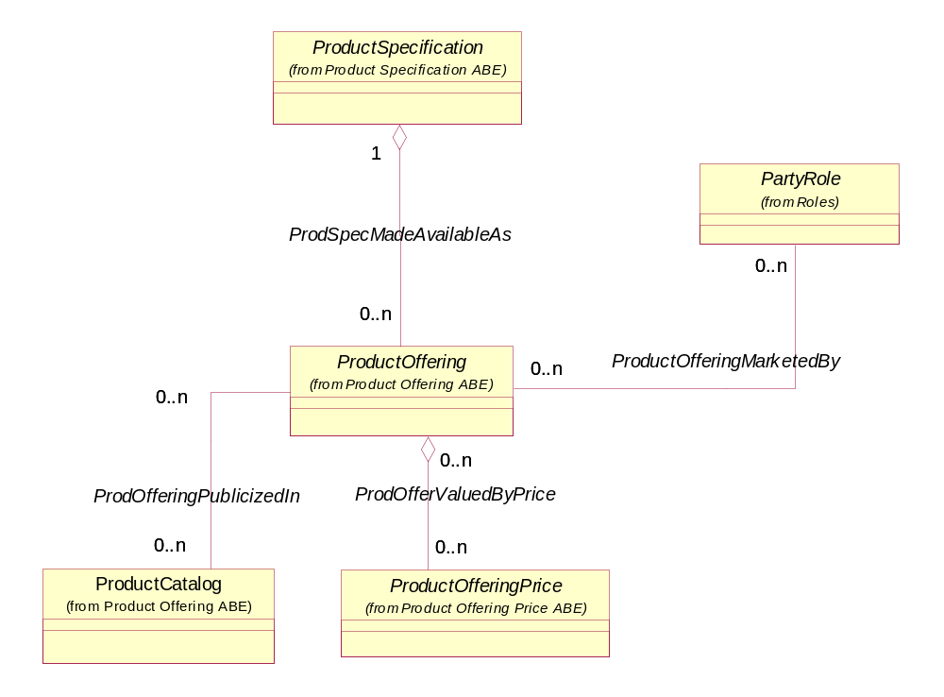
Figure MS. 17 - Product Domain Entities Support of Competitor Product Information
When a Competitor is associated with an instance of ProductOffering, all related Product domains “inherit” the association to Competitor via their associations with ProductOffering. An enterprise can decide how much detail, in the form of instances of entities related to are necessary. For example, an enterprise may not be interested in keeping ProductPriceRules associated with a Competitor’s ProductOfferings. Using PartyRole also provides a means for an enterprise to segregate ProductOfferings made available by different organizations within the enterprise.
Note: From an implementation view, an enterprise may chose to develop a database that only contains the enterprise’s Product domain entities, and a separate one that contains the enterprise’s Competitors’ Product domain entities. Both data bases are based on the same information model.
There is one new Market-domain-oriented Competitor product ABE. The Competitor Product Correlation ABE compares an enterprise’s ProductOfferings with its Competitors’ ProductOfferings. The next section describes this ABE.

Competitor Product Correlation
CompetitorProductCorrelations represent a comparison of an enterprise’s ProductOfferings and a ProductOffering’s related entities, such as ProductPromotions, ProductOfferingPrices, and ProductPlacements. Within the SID model, a CompetitorProductCorrelation is represented as information about the association between two ProductOfferings. This is possible since the same model is used to represent an enterprise’s ProductOfferings and those of its Competitors as was previously explained in this addendum. The correlation may be based on Jurisdiction (an area over which authority extends) and/or MarketSegment.
The figure below depicts the associations the basic associations that a CompetitorProductCorrelation has with other business entities.
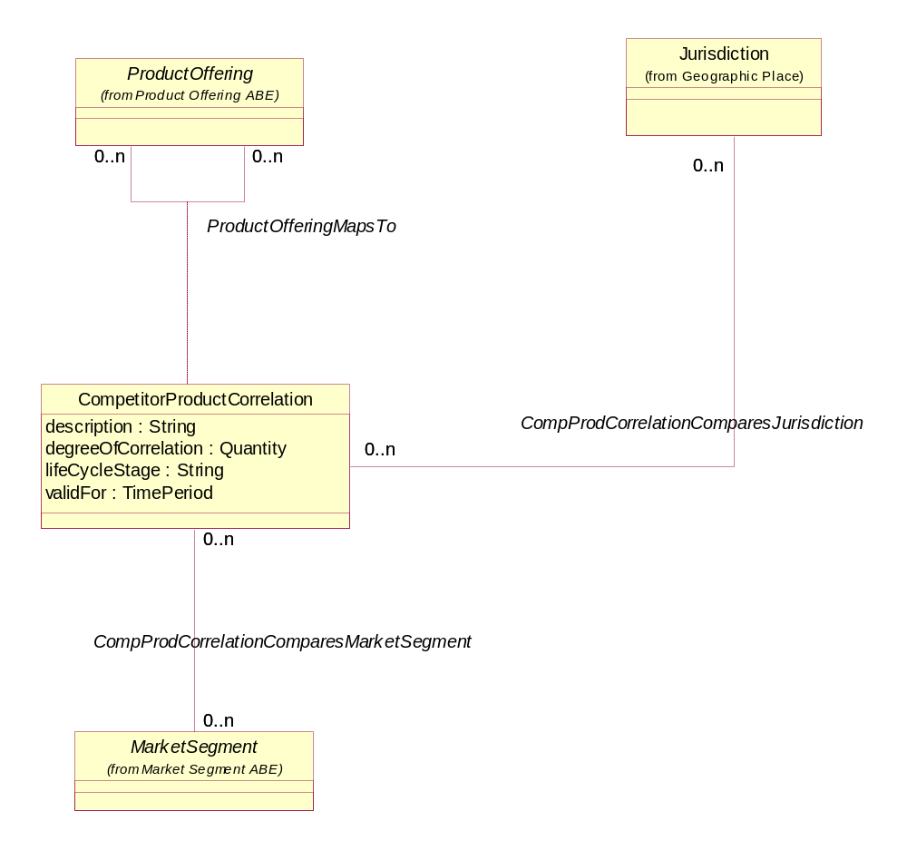
Figure MS. 18 – Competitor Product Correlation Basic Entities
As has been seen with other business entities contained within the Market/Sales domain there may be a number of other attributes that are important in characterizing CompetitorProductCorrelations. For example, the characteristic can be take on a discrete value, such as geographic disbursement (central, national, cascading), can take on a range of values, (for example, Competitor ProductOffering revenue of $500,000 - $1,000,000), or can be derived from a formula (for example, number of MarketSegments in correlation = number of MarketSegments related to this correlation). The CharacteristicSpec/Characteristic and Composite/Atomic patterns used through the Market/Sales domain are also applied here to accommodate this need. These entities as they relate to CompetitorProductCorrelation are shown in the figure below.
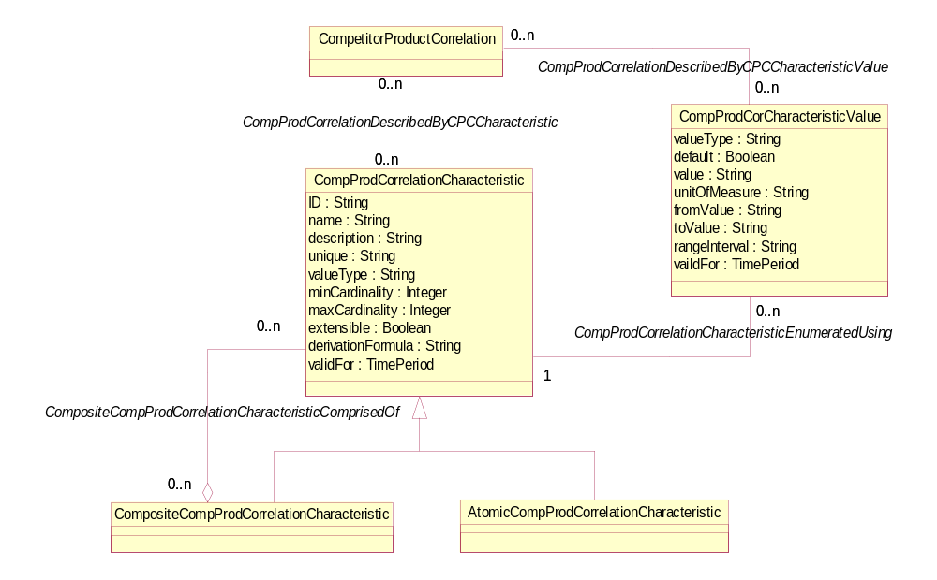
Figure MS. 19 – Competitor Product Correlation Characteristics

Business Entity Definitions – Market Segment/Market Segment
Entity and attribute definitions can be found in all available Information Framework (SID) model formats. The next release of the SID will move all entity and attribute definitions from domain/ABE addenda to a single addendum containing all definitions. The definitions will be generated from the SID UML model. All model formats will continue to contain definitions.

AtomicMarketSegement

Business Entity Definition
Business Entity Name | AtomicMarketSegement
Description | A type of MarketSegment that does not have any subordinate MarketSegments, that is, an AtomicMarketSegment is a leaf-level MarketSegment.
Sources | MetaSolv Software | Cross- References |  |  | Synonyms / Aliases
Related Business Entities | Subclass of MarketSegment
Business Rules

AtomicMarketSegmentCharacteristic

Business Entity Definition
Business Entity Name | AtomicMarketSegmentCharacteristic
Description | A type of MarketSegmentCharacteristic that does not have any subordinate MarketSegmentCharacteristics, that is, an AtomicMarketSegmentCharacteristic is a leaf-level MarketSegmentCharacteristic.
Sources | MetaSolv Software | Cross- References |  |  | Synonyms / Aliases
Related Business Entities | Sublcass of MarketSegmentCharacteristic
Business Rules

CompositeMarketSegment

Business Entity Definition
Business Entity Name | CompositeMarketSegment
Description | A type of MarketSegment that is formed by aggregating other MarketSegments, which may be Composite or Atomic MarketSegments.
Sources | MetaSolv Software | Cross- References |  |  | Synonyms / Aliases
Related Business Entities | Subclass of MarketSegment  ComprisedOf MarketSegment
Business Rules

CompositeMarketSegmentCharacteristic

Business Entity Definition
Business Entity Name | CompositeMarketSegmentCharacteristic
Description | A type of MarketSegmentCharacteristic that is formed by aggregating other MarketSegmentCharacteristic, which may be Composite or Atomic MarketSegmentCharacteristic.
Sources | MetaSolv Software | Cross- References |  |  | Synonyms / Aliases
Related Business Entities | Subclass of MarketSegmentCharacteristic  ComprisedOf MarketSegmentCharacteristic
Business Rules

MarketSegment

Business Entity Definition
Business Entity Name | MarketSegment
Description | A grouping of Parties, GeographicAreas, SalesChannels, and so forth. MarketSegments are the target of MarketingCampaigns, ProductOfferings, ProductPromotions, ProductPlacements, and ProductPrograms from both internal and external (Competitors, and other Providers) perspective.
Sources | MetaSolv Software | Cross- References |  |  | Synonyms / Aliases
Related Business Entities | Covers GeographicArea  ProfiledBy PartyProfileType  ServedBy SalesChannel  DescribedBy MarketSegmentCharacteristic  Comprises CompositeMarketSegment  DescribedBy MarketSegmentCharacteristicValue  ProfiledBy PartyDemographic  QuantifiedBy MarketStatistic  ServedBy Competitor  Classifies CompetitorMarketSegmentSWOT  Categorizes CompetitorIntelligenceMarketSegment  ComparedBy CompetitorProductCorrelation  CoveredBy MarketingCampaign  MeasuredBy ChurnAndRetentionStatistic  TargetedBy ProductOffering
Business Rules

Business Entity Attributes Definition
Business Entity Name | MarketSegment
Attribute Name | Description | Data Type | Characteristics, Permitted Values & Units | Required/  Optional | Notes
ID | A unique identifier for the MarketSegment. | String |  | Required
name | A word, term, or phrase by which the MarketSegment is known and distinguished from other MarketSegments. | String |  | Required
description | A narrative that explains what the PartyProfileType is. | String |  | Optional
marketSegmentCategory | A classification of MarketSegments because they share common characteristics. For example a vertical or horizontal MarketSegment. Vertical MarketSegments put a PartyRole in a single segment, while a PartyRole can exist in multiple horizontal MarketSegments | String |  | Optional
marketSegmentSubCategory | A further classification of MarketSegments because they share common characteristics. For example, a vertical category MarketSegment may be further categorized as consumer, business, or carrier. | String |  | Optional
validFor | The period during which the MarketSegment is applicable. | Time Period |  | Optional

MarketSegmentCharacteristic

Business Entity Definition
Business Entity Name | MarketSegmentCharacteristic
Description | A characteristic quality or distinctive feature of a MarketSegment. The characteristic can be take on a discrete value, such as sex, can take on a range of values, (for example, household income of $50,000 - $100,000), or can be derived from a formula (for example, number of households = number of customer party roles).
Sources | MetaSolv Software | Cross- References |  |  | Synonyms / Aliases
Related Business Entities | CoverageDefinedBy GeographicArea  DefinedBy DemographicCharacteristic  Describes MarketSegment  DefinedBy ProductOffering  EnumeratedBy MarketSegmentCharacteristicValue  Comprises CompositeMarketSegmentCharacteristic
Business Rules

Business Entity Attributes Definition
Business Entity Name | MarketSegmentCharacteristic
Attribute Name | Description | Data Type | Characteristics, Permitted Values & Units | Required/  Optional | Notes
ID | A unique identifier for the MarketSegmentCharacteristic. | String |  | Required
name | A word, term, or phrase by which the characteristic is known and distinguished from characteristics. | String |  | Required
description | A narrative that explains what the characteristic is. | String |  | Optional
unique | An indicator that specifies if a value is unique for the specification.  Possible values are; "unique while value is in effect" and "unique whether value is in effect or not" | String |  | Optional
valueType | A kind of value that the characteristic can take on, such as numeric, text, and so forth. | String |  | Required, if the specification is not a composite
minCardinality | The minimum number of instances a CharacteristicValue can take on. For example, zero to five phone numbers in a group calling plan, where zero is the value for the minCardinality. | Integer |  | Optional
maxCardinality | The maximum number of instances a CharacteristicValue can take on. For example, zero to five phone numbers in a group calling plan, where five is the value for the maxCardinality. | Integer |  | Optional
extensible | An indicator that specifies that the values for the characteristic can be extended by adding new values when instantiating a characteristic for an Entity. | Boolean |  | Optional
derivationFormula | A rule or principle represented in symbols, numbers, or letters, often in the form of an equation used to derive the value of a characteristic value. | String |  | Optional
validFor | The period of time for which a characteristic is applicable. | Time Period |  | Optional

MarketSegmentCharacteristicValue

Business Entity Definition
Business Entity Name | MarketSegmentCharacteristicValue
Description | A number or text that can be assigned to a MarketSegmentCharacteristic.
Sources | MetaSolv Software | Cross- References |  |  | Synonyms / Aliases
Related Business Entities | DefinedBy DemoCharacteristicValue  Enumerates MarketSegmentCharacteristic  Describes MarketSegment
Business Rules

Business Entity Attributes Definition
Business Entity Name | MarketSegmentCharacteristicValue
Attribute Name | Description | Data Type | Characteristics, Permitted Values & Units | Required/  Optional | Notes
valueType | A kind of value that the characteristic can take on, such as numeric, text, and so forth. | String |  | Optional
default | Indicates if the value is the default value for a characteristic. | Boolean |  | Optional
value | A discrete value that the characteristic can take on. | String |  | Optional | Either value or valueFrom and/or valueTo are required
unitofMeasure | A length, surface, volume, dry measure, liquid measure, money, weight, time, and the like. Iin general, a determinate quantity or magnitude of the kind designated, taken as a standard of comparison for others of the same kind, in assigning to them numerical values, as 1 foot, 1 yard, 1 mile, 1 square foot. | Text |  | Optional
valueFrom | The low range value that a characteristic can take on. | String |  | Optional
valueTo | The upper range value that a characteristic can take on. | String |  | Optional
rangeInterval | An indicator that specifies the inclusion or exclusion of the valueFrom and valueTo attributes.  Possible values are "open", "closed", "closedBottom" and "closedTop". | String |  | Optional
validFor | The period of time for which a value is applicable. | Time Period |  | Optional

Business Entity Definitions – Market Segment/Party Demographic
The Party Demographic ABE used to be part of the Market Sales domain but was moved to the Party model. For documentation of the Party Demographic ABE see GB922 addendum 1P (Party)

Business Entity Definitions – Market Segment/Party Profile
The Party Profile ABE used to be part of the Market Sales domain but was moved to the Party model. For documentation of the Party Profile ABE see GB922 addendum 1P (Party)

Business Entity Definitions – Market Segment/Market Statistic

AtomicMarketStatistic

Business Entity Definition
Business Entity Name | AtomicMarketStatistic
Description | A type of MarketStatistic that does not have any subordinate MarketStatistics, that is, an AtomicMarketStatistic is a leaf-level MarketStatistic.
Sources | MetaSolv Software | Cross- References |  |  | Synonyms / Aliases
Related Business Entities | Subclass of MarketStatistic
Business Rules

CompositeMarketStatistic

Business Entity Definition
Business Entity Name | CompositeMarketStatistic
Description | A type of MarketStatistic that is formed by aggregating other MarketStatistics, which may be Composite or Atomic MarketStatistics.
Sources | MetaSolv Software | Cross- References |  |  | Synonyms / Aliases
Related Business Entities | Subclass of MarketStatistic
Business Rules

MarketStatistic

Business Entity Definition
Business Entity Name | MarketStatistic
Description | A categorization of performance measures by MarketSegment. Performance is measured for the ServiceProvider and a ServiceProvider's Competitors in the market place.
Sources | MetaSolv Software | Cross- References |  |  | Synonyms / Aliases
Related Business Entities | Comprises CompositeMarketStatistic  GatheredFor GeographicArea  GatheredFor SalesChannel  GatheredFor MarketSegment  GatheredFor ProductOffering  MeasuresPerformanceOf PartyRole
Business Rules

Business Entity Attributes Definition
Business Entity Name | MarketStatistic
Attribute Name | Description | Data Type | Characteristics, Permitted Values & Units | Required/  Optional | Notes
ID | A unique identifier for the MarketStatistic. | String |  | Required
description | A narrative that explains what the MarketStatistic is. | String |  | Optional
marketStatisticType | A division of MarketStatistic into groups because they exhibit common characteristics. For example, market penetration, churn, retention, market share, and so forth. | String |  | Optional
marketStatistic Classification | A specification of what the MarketStatistic represents, for example a ProductProgram, ProductPromotion, ProductOffering, Branch, and so forth. | String |  | Optional
marketStatistic Level | Describes the place the MarketStatistic holds in a hierarchy of MarketStatistics. For example, director, executive, external, and so forth. | String |  | Optional
amount | An number use to value the MarketStatistic, such as a percent. | Quantity |  | See Note | Mutually exclusive with the currencyAmount attribute.
currencyAmount | A current amount used to value the MarketStatistic. | Money |  | See Note | Mutually exclusive with the amount attribute.
validFor | The period during which the MarketStatistic is applicable. | TimePeriod |  | Optional

Business Entity Definitions – Marketing Campaign/Marketing Campaign

AtomicMarketingCampaignCharacteristic

Business Entity Definition
Business Entity Name | AtomicMarketingCampaignCharacteristic
Description | A type of MarketingCampaignCharacteristic that does not have any subordinate MarketingCampaignCharacteristics, that is, an AtomicMarketingCampaignCharacteristic is a leaf-level MarketingCampaignCharacteristic.
Sources | MetaSolv Software | Cross- References |  |  | Synonyms / Aliases
Related Business Entities | Subclass of MarketingCampaignCharacteristic
Business Rules

CompositeMarketingCampaignCharacteristic

Business Entity Definition
Business Entity Name | CompositeMarketingCampaignCharacteristic
Description | A type of MarketingCampaignCharacteristic that is formed by aggregating other MarketingCampaignCharacteristic, which may be Composite or Atomic MarketingCampaignCharacteristic.
Sources | MetaSolv Software | Cross- References |  |  | Synonyms / Aliases
Related Business Entities | Subclass of MarketingCampaignCharacteristic  ComprisedOf MarketingCampaignCharacteristic
Business Rules

MarketingCampaign

Business Entity Definition
Business Entity Name | MarketingCampaign
Description | A depiction of how the launch or re-launch of a ProductOffering is or will be undertaken.
Sources | MetaSolv Software | Cross- References |  |  | Synonyms / Aliases
Related Business Entities | AdvertisedIn Media  DescribedBy MarketingCampaignCharacteristic  DescribedBy MarketingCampaignCharacteristicValue  LaunchedAcross MarketSegment  LaunchedAcross SalesChannel  Targets PartyProfileType  Targets PartyRoleType  EffectivenessMeasuredBy ChurnAndRetentionStatistic  Supports ProductOfferingStrategy  LaunchedFor Product Promotion
Business Rules

Business Entity Attributes Definition
Business Entity Name | MarketingCampaign
Attribute Name | Description | Data Type | Characteristics, Permitted Values & Units | Required/  Optional | Notes
ID | A unique identifier for the MarketingCampaignt. | String |  | Required
name | A word, term, or phrase by which the MarketingCampaign is known and distinguished from other MarketingCampaigns. | String |  | Required
description | A narrative that explains what the PartyProfileType is. | String |  | Optional
mcType | A categorization of a MarketingCampaign, such as new or re-launch. | String |  | Optional
validFor | The period during which the MarketingCampaign is applicable. | Time Period |  | Optional

MarketingCampaignCharacteristic

Business Entity Definition
Business Entity Name | MarketingCampaignCharacteristic
Description | A characteristic quality or distinctive feature of a MarketingCampaign. The characteristic can be take on a discrete value, such as number of press releases, can take on a range of values, (for example, number of prospects reached 50,000 - 100,000), or can be derived from a formula (for example, number of brokerage house pickups = sum of all brokerage house instance characteristics).
Sources | MetaSolv Software | Cross- References |  |  | Synonyms / Aliases
Related Business Entities | Describes MarketingCampaign  EnumeratedUsing MarketingCampaignCharacteristicValue  Comprises CompositeMarketingCampaignCharacteristic
Business Rules

Business Entity Attributes Definition
Business Entity Name | MarketingCampaignCharacteristic
Attribute Name | Description | Data Type | Characteristics, Permitted Values & Units | Required/  Optional | Notes
ID | A unique identifier for the MarketingCampaignCharacteristic | String |  | Required
name | A word, term, or phrase by which the characteristic is known and distinguished from characteristics. | String |  | Required
description | A narrative that explains the characteristic. | String |  | Optional
unique | An indicator that specifies if a value is unique for the specification.  Possible values are; "unique while value is in effect" and "unique whether value is in effect or not" | String |  | Optional
valueType | A kind of value that the characteristic can take on, such as numeric, text, and so forth. | String |  | Required, if the specification is not a composite
minCardinality | The minimum number of instances a CharacteristicValue can take on. For example, zero to five phone numbers in a group calling plan, where zero is the value for the minCardinality. | Integer |  | Optional
maxCardinality | The maximum number of instances a CharacteristicValue can take on. For example, zero to five phone numbers in a group calling plan, where five is the value for the maxCardinality. | Integer |  | Optional
extensible | An indicator that specifies that the values for the characteristic can be extended by adding new values when instantiating a characteristic for an Entity. | Boolean |  | Optional
derivationFormula | A rule or principle represented in symbols, numbers, or letters, often in the form of an equation used to derive the value of a characteristic value. | String |  | Optional
validFor | The period of time for which a characteristic is applicable. | Time Period |  | Optional

MarketingCampaignCharacteristicValue

Business Entity Definition
Business Entity Name | MarketingCampaignCharacteristicValue
Description | A number or text that can be assigned to a MarketingCampaignCharacteristic.
Sources | MetaSolv Software | Cross- References |  |  | Synonyms / Aliases
Related Business Entities | Enumerates MarketingCampaignCharacteristic  Describes MarketingCampaign
Business Rules

Business Entity Attributes Definition
Business Entity Name | MarketingCampaignCharacteristicValue
Attribute Name | Description | Data Type | Characteristics, Permitted Values & Units | Required/  Optional | Notes
valueType | A kind of value that the characteristic can take on, such as numeric, text, and so forth. | String |  | Optional
default | Indicates if the value is the default value for a characteristic. | Boolean |  | Optional
value | A discrete value that the characteristic can take on. | String |  | Optional | Either value or valueFrom and/or valueTo are required
unitofMeasure | A length, surface, volume, dry measure, liquid measure, money, weight, time, and the like. Iin general, a determinate quantity or magnitude of the kind designated, taken as a standard of comparison for others of the same kind, in assigning to them numerical values, as 1 foot, 1 yard, 1 mile, 1 square foot. | Text |  | Optional
valueFrom | The low range value that a characteristic can take on. | String |  | Optional
valueTo | The upper range value that a characteristic can take on. | String |  | Optional
rangeInterval | An indicator that specifies the inclusion or exclusion of the valueFrom and valueTo attributes.  Possible values are "open", "closed", "closedBottom" and "closedTop". | String |  | Optional
validFor | The period of time for which a value is applicable. | Time Period |  | Optional

Business Entity Definitions – Marketing Campaign/Media

Media

Business Entity Definition
Business Entity Name | Media
Description | A mechanism by which MarketingCampaigns, ProductPromotions, and ProductPlacements can be launched into the marketplace. It describes such mechanisms as the press, radio, trade shows, internet, and so forth. It is also used to advertise other provider ProductPromotions and ProductPlacements.
Sources | MetaSolv Software | Cross- References |  |  | Synonyms / Aliases
Related Business Entities | Advertises MarketingCampaign  TargetedBy ProductPlacement  Advertises ProductPromotion
Business Rules

Business Entity Attributes Definition
Business Entity Name | Media
Attribute Name | Description | Data Type | Characteristics, Permitted Values & Units | Required/  Optional | Notes
ID | A unique identifier for the Media. | String |  | Required | ID
name | A word, term, or phrase by which the Media is known and distinguished from other Media. |  |  |  | name
description | A narrative that explains what the Media is. | String |  | Optional | description
validFor | The period during which the Media is applicable. | Time Period |  | Optional | validFor

Business Entity Definitions – Competitor/Competitor

CompetitiveTier

Business Entity Definition
Business Entity Name | CompetitiveTier
Description | A classification of a Competitor, such as by size, product lines offered, and so forth.
Sources | MetaSolv Software | Cross- References |  |  | Synonyms / Aliases
Related Business Entities | Classifies CompetitiveTier  DefinedBy ProductLine
Business Rules

Business Entity Attributes Definition
Business Entity Name | CompetitiveTier
Attribute Name | Description | Data Type | Characteristics, Permitted Values & Units | Required/  Optional | Notes
size | How big the Competitor is, such as small, medium, large, compared to other Competitors. | String |  | Optional | At least one of these attribute must be present.
perspective | How the CompetitiveTier is viewed, such as vertical or horizontal. | String |  | Optional
perspectiveCharacteristic | A feature or quality that further describes the perspective recognizable, such as consumer, business, carrier, size, usage, customer, and so forth. For example, a consumer vertical market | String |  | Optional

Competitor

Business Entity Definition
Business Entity Name | Competitor
Description | A Party playing a PartyRole that offers ProductOfferings similar to the enterprise's ProductOfferings in a MarketSegment.
Sources | MetaSolv Software | Cross- References |  |  | Synonyms / Aliases
Related Business Entities | DoesBusinessIn MarketSegment  OperatesWithin CompetitorTier  AnalysisResultsIn CompetitorSWOT  OwnedBy PartyRole  AnalyzedUsing CompetitorIntelligence
Business Rules

Business Entity Attributes Definition
Business Entity Name | Competitor
Attribute Name | Description | Data Type | Characteristics, Permitted Values & Units | Required/  Optional | Notes
ID | A unique identifier for the Competitor. | String |  | Required
description | A narrative that explains what the Competitor is. | String |  | Optional
dateCreated | The date on which the Competitor was created. | Date |  | Optional

CompetitorMarketSegment

Business Entity Definition
Business Entity Name | CompetitorMarketSegment
Description | A MarketSegment served by a Competitor.
Sources | MetaSolv Software | Cross- References |  |  | Synonyms / Aliases
Related Business Entities | Association Class for Competitor and MarketSegment association
Business Rules

Business Entity Attributes Definition
Business Entity Name | CompetitorMarketSegment
Attribute Name | Description | Data Type | Characteristics, Permitted Values & Units | Required/  Optional | Notes
rank | The degree of importance or excellence of a Competitor in a MarketSegment relative to other Competitors in the MarketSegment. | Integer |  | Optional
plannedMarketEntryDate | The date on which a Competitor plans to offer ProductOfferings in a MarketSegment. | String |  | Optional
validFor | The period during which the CompetitorMarketSegment information is applicable. | TimePeriod |  | Optional

CompetitorMarketSegmentSWOT

Business Entity Definition
Business Entity Name | CompetitorMarketSegmentSWOT
Description | Strength, Weakness, Opportunity, or Threat in a MarketSegment served by a Competitor.
Sources | MetaSolv Software | Cross- References |  |  | Synonyms / Aliases
Related Business Entities | Association class for Competitor and CompetitorSWOT association  ClassifiedBy MarketSegment
Business Rules

Business Entity Attributes Definition
Business Entity Name | CompetitorMarketSegmentSWOT
Attribute Name | Description | Data Type | Characteristics, Permitted Values & Units | Required/  Optional | Notes
description | A narrative that further details the strength, weakness, opportunity, or threat for a Competitor in a MarketSegment. |  |  | Optional

CompetitorSWOT

Business Entity Definition
Business Entity Name | CompetitorSWOT
Description | General (non-MarketSegment specific) Strength, Weakness, Opportunity, or Threat when compared to a Competitor.
Sources | MetaSolv Software | Cross- References |  |  | Synonyms / Aliases
Related Business Entities | ResultsFrom CompetitorAnalysis  ClassifiedBy SWOT
Business Rules

Business Entity Attributes Definition
Business Entity Name | CompetitorSWOT
Attribute Name | Description | Data Type | Characteristics, Permitted Values & Units | Required/  Optional | Notes
description | A narrative that further details the strength, weakness, opportunity, or threat. | String |  | Optional

CompetitorTier

Business Entity Definition
Business Entity Name | CompetitorTier
Description | A hierarchical level into which a Competitor is placed.
Sources | MetaSolv Software | Cross- References |  |  | Synonyms / Aliases
Related Business Entities | OperatedInBy Competitor  Classifies CompetitiveTier
Business Rules

Business Entity Attributes Definition
Business Entity Name | CompetiveTier
Attribute Name | Description | Data Type | Characteristics, Permitted Values & Units | Required/  Optional | Notes
description | A narrative that further details the Competitor's placement in a CompetitiveTier. | String |  | Optional

SWOT

Business Entity Definition
Business Entity Name | SWOT
Description | A Strength, Weakness, Opportunity, Threat (SWOT) that an enterprise has when compared to a Competitor. SWOT analysis is a formal framework of identifying and framing organizational growth opportunities.
Sources | MetaSolv Software | Cross- References |  |  | Synonyms / Aliases
Related Business Entities | Classifies CompetitorSWOT
Business Rules

Business Entity Attributes Definition
Business Entity Name | SWOT
Attribute Name | Description | Data Type | Characteristics, Permitted Values & Units | Required/  Optional | Notes
swotType | A category of organizational analysis, such as strength (S), weakness (W), opportunity (O), threat (T). | String |  | Required

Business Entity Definitions – Competitor/Competitor Intelligence

AtomicCompIntelCharacteristic

Business Entity Definition
Business Entity Name | AtomicCompIntelCharacteristic
Description | A type of CompIntelCharacteristic that does not have any subordinate CompIntelCharacteristics, that is, an AtomicCompIntelCharacteristic is a leaf-level CompIntelCharacteristic.
Sources | MetaSolv Software | Cross- References |  |  | Synonyms / Aliases
Related Business Entities | Subclass of CompetitorIntelCharacteristic
Business Rules

CompetitorIntelCharacteristic

Business Entity Definition
Business Entity Name | CompetitorIntelCharacteristic
Description | A characteristic quality or distinctive feature of a CompetitorIntelligence. The characteristic can be take on a discrete value, such as number of press releases, can take on a range of values, (for example, number customers within a MarketSegment (50,000 - 100,000), or can be derived from a formula (for example, number of products offered in a MaketSegment = the number of the Competitor's ProductOfferrng instances associated to the MarketSegment).
Sources | MetaSolv Software | Cross- References |  |  | Synonyms / Aliases
Related Business Entities | EnumeratedUsing CompetitorIntelCharacteristicValue  Describes CompetitorIntelligence  Comprises CompositeCompetitorIntelCharacteristic
Business Rules

Business Entity Attributes Definition
Business Entity Name | CompetitorIntelCharacteristic
Attribute Name | Description | Data Type |  | Characteristics, Permitted Values & Units | Required/  Optional | Notes
ID | A unique identifier for the CompetitorIntelCharacteristic. | String |  |  | Required
name | A word, term, or phrase by which the characteristic is known and distinguished from characteristics. | String |  |  | Required
description | A narrative that explains the characteristic. | String |  |  | Optional
unique | An indicator that specifies if a value is unique for the specification.  Possible values are; "unique while value is in effect" and "unique whether value is in effect or not" | String |  |  | Optional
valueType | A kind of value that the characteristic can take on, such as numeric, text, and so forth. | String |  |  | Required, if the specification is not a composite
minCardinality | The minimum number of instances a CharacteristicValue can take on. For example, zero to five phone numbers in a group calling plan, where zero is the value for the minCardinality. | Integer |  |  | Optional
maxCardinality | The maximum number of instances a CharacteristicValue can take on. For example, zero to five phone numbers in a group calling plan, where five is the value for the maxCardinality. | Integer |  |  | Optional
extensible | An indicator that specifies that the values for the characteristic can be extended by adding new values when instantiating a characteristic for an Entity. | Boolean |  |  | Optional
derivationFormula | A rule or principle represented in symbols, numbers, or letters, often in the form of an equation used to derive the value of a characteristic value. | String |  |  | Optional
validFor | The period of time for which a characteristic is applicable. | Time Period |  |  | Optional

CompetitorIntelCharactertisticValue

Business Entity Definition
Business Entity Name | CompetitorIntelCharactertisticValue
Description | A number or text that can be assigned to a CompIntelCharacteristic.
Sources | MetaSolv Software | Cross- References |  |  | Synonyms / Aliases
Related Business Entities | Enumerates CompetitorIntelCharacteristic  Describes CompetitorIntelligence
Business Rules

Business Entity Attributes Definition
Business Entity Name | CompetitorIntelCharactertisticValue
Attribute Name | Description | Data Type | Characteristics, Permitted Values & Units | Required/  Optional | Notes
valueType | A kind of value that the characteristic can take on, such as numeric, text, and so forth. | String |  | Optional
default | Indicates if the value is the default value for a characteristic. | Boolean |  | Optional
value | A discrete value that the characteristic can take on. | String |  | Optional | Either value or valueFrom and/or valueTo are required
unitofMeasure | A length, surface, volume, dry measure, liquid measure, money, weight, time, and the like. Iin general, a determinate quantity or magnitude of the kind designated, taken as a standard of comparison for others of the same kind, in assigning to them numerical values, as 1 foot, 1 yard, 1 mile, 1 square foot. | Text |  | Optional
valueFrom | The low range value that a characteristic can take on. | String |  | Optional
valueTo | The upper range value that a characteristic can take on. | String |  | Optional
rangeInterval | An indicator that specifies the inclusion or exclusion of the valueFrom and valueTo attributes.  Possible values are "open", "closed", "closedBottom" and "closedTop". | String |  | Optional
validFor | The period of time for which a value is applicable. | Time Period |  | Optional

CompetitorIntelligence

Business Entity Definition
Business Entity Name | CompetitorIntelligence
Description | Facts gathered about a Competitor's plans and activities. These facts can be used to perform Competitor SWOT analysis in order to better understand a Competitor.
Sources | MetaSolv Software | Cross- References |  |  | Synonyms / Aliases
Related Business Entities | GatheredFor MarketSegment  GatheredBy PartyRole  Analyzes Competitor  Pertains to ProductOffering  DescribedBy CompetitorIntelCharacteristic  DescribedBy CompetitorIntelCharacteristicValue
Business Rules

Business Entity Attributes Definition
Business Entity Name | CompetitorIntelligence
Attribute Name | Description | Data Type | Characteristics, Permitted Values & Units | Required/  Optional | Notes
ID | A unique identifier for the CompetitorIntelligence. | String |  | Required
description | A narrative that describes the CompetitorIntelligence. | String |  | Optional
validFor | The period during which the CompetitorIntelligence is applicable. | TimePeriod |  | Optional

CompetitorIntelligenceMarketSegment

Business Entity Definition
Business Entity Name | CompetitorIntelligenceMarketSegment
Description | A MarketSegment in which a Competitor makes ProductOfferings available.
Sources | MetaSolv Software | Cross- References |  |  | Synonyms / Aliases
Related Business Entities | CategorizedBy MarketSegment  GatheredFor CompetitorIntelligence
Business Rules

Business Entity Attributes Definition
Business Entity Name | CompetitorIntelligenceMarketSegment
Attribute Name | Description | Data Type | Characteristics, Permitted Values & Units | Required/  Optional | Notes
plannedEntryDate | The date on which the Competitor intends to begin making ProductOfferings available to a MarketSegment. | Date |  | Optional
plannedSpending | The amount of money that a Competitor intends on spending make ProductOfferings available in a MarketSegment. | Money |  | Optional
plannedMarketCoverage | A percent or description that describes the degree to which a Competitor will/does/has extend into a MarketSegment. | Date |  | Optional
rank | The degree of importance or excellence of a Competitor in a MarketSegment relative to other Competitors in the MarketSegment. | Integer |  | Optional

CompetitorIntelligencePartyRole

Business Entity Definition
Business Entity Name | CompetitorIntelligencePartyRole
Description | The PartyRole who developed the CompetitiveIntelligence.
Sources | MetaSolv Software | Cross- References |  |  | Synonyms / Aliases
Related Business Entities | Association Class for MarketIntelligence and PartyRole association
Business Rules

Business Entity Attributes Definition
Business Entity Name | CompetitorIntelligencePartyRole
Attribute Name | Description | Data Type | Characteristics, Permitted Values & Units | Required/  Optional | Notes
dateAcquired | The date on which the CompetitorIntelligence was gathered by a Party playing a PartyRole. | Date |  | Optional
description | A narrative that explains such things as how the intelligence was gathered. | String |  | Optional
ciSource | The origin of the CompetitorIntelligence, such as a financial report, press release, or product brochure, gathered by a PartyRole. | String |  | Optional

CompositeCompIntelCharacteristic

Business Entity Definition
Business Entity Name | CompositeCompIntelCharacteristic
Description | A type of CompIntelCharacteristic that is formed by aggregating other CompIntelCharacteristic, which may be Composite or Atomic CompIntelCharacteristic.
Sources | MetaSolv Software | Cross- References |  |  | Synonyms / Aliases
Related Business Entities | Subclass of CompetitorIntelCharacteristic  ComprisedOf CompetitorIntelCharacteristic
Business Rules

Business Entity Definitions – Competitor/Competitor Product Correlation

AtomicCompProdCorrelationCharacteristic

Business Entity Definition
Business Entity Name | AtomicCompProdCorrelationCharacteristic
Description | A type of CompetitorProducutCharacteristic that does not have any subordinate CompetitorProductCharacteristics, that is, an AtomicCompProdCorrelationCharacteristic is a leaf-level CompProdCorrelationCharacteristic.
Sources | MetaSolv Software | Cross- References |  |  | Synonyms / Aliases
Related Business Entities | Subclass of CompProdCorrelationCharacteristic
Business Rules

CompetitorProductCorrelation

Business Entity Definition
Business Entity Name | CompetitorProductCorrelation
Description | A comparison or relationship between an enterprise's ProductOffering with a Competitors' ProductOfferings. Information about the correlation may include MarketSegments,
Sources | MetaSolv Software | Cross- References |  |  | Synonyms / Aliases
Related Business Entities | Compares MarketSegment  Compares Jurisdiction  DescribedBy CompetitorProductCorrelationCharacteristic  DescribedBy CompProdCorCharacteristicValue
Business Rules

Business Entity Attributes Definition
Business Entity Name | CompetitorProductCorrelation
Attribute Name | Description | Data Type | Characteristics, Permitted Values & Units | Required/  Optional | Notes
description | A narrative that explains what the CompetitorProductCorrelation is. | String |  | Optional
degreeOfCorrelation | A percentage that measures how closely an enterprise's ProductOffering compares to a CompetitorProductOffering. | Quantity |  | Optional
lifeCycleStage | The stage in the life cycle of the ProductOfferings being correlated. Examples are acquisition, retention, win back, and so forth. | String |  | Optional
validFor | The period during which the CompetitorProductCorrelation is applicable. | TimePeriod |  | Optional

CompositeCompProdCorrelationCharacteristic

Business Entity Definition
Business Entity Name | CompositeCompProdCorrelationCharacteristic
Description | A type of CompetitorProductCorrelation that is formed by aggregating other CompetitorProductCorrelations, which may be Composite or Atomic CompetitorProductCorrelations.
Sources | MetaSolv Software | Cross- References |  |  | Synonyms / Aliases
Related Business Entities | Subclass of CompProdCorrelationCharacteristic  ComprisedOf CompProdCorrelationCharacteristic
Business Rules

CompProdCorCharacteristicValue

Business Entity Definition
Business Entity Name | CompProdCorCharacteristicValue
Description | A number or text that can be assigned to a CompProdCorrelationCharacteristic.
Sources | MetaSolv Software | Cross- References |  |  | Synonyms / Aliases
Related Business Entities | Enumerates CompetitorProductCorrelationCharacteristic  Describes CompetitorProductCorrelation
Business Rules

Business Entity Attributes Definition
Business Entity Name | CompProdCorCharacteristicValue
Attribute Name | Description | Data Type | Characteristics, Permitted Values & Units | Required/  Optional | Notes
valueType | A kind of value that the characteristic can take on, such as numeric, text, and so forth. | String |  | Optional
default | Indicates if the value is the default value for a characteristic. | Boolean |  | Optional
value | A discrete value that the characteristic can take on. | String |  | Optional | Either value or valueFrom and/or valueTo are required
unitofMeasure | A length, surface, volume, dry measure, liquid measure, money, weight, time, and the like. Iin general, a determinate quantity or magnitude of the kind designated, taken as a standard of comparison for others of the same kind, in assigning to them numerical values, as 1 foot, 1 yard, 1 mile, 1 square foot. | Text |  | Optional
valueFrom | The low range value that a characteristic can take on. | String |  | Optional
valueTo | The upper range value that a characteristic can take on. | String |  | Optional
rangeInterval | An indicator that specifies the inclusion or exclusion of the valueFrom and valueTo attributes.  Possible values are "open", "closed", "closedBottom" and "closedTop". | String |  | Optional
validFor | The period of time for which a value is applicable. | Time Period |  | Optional

CompProdCorrelationCharacteristic

Business Entity Definition
Business Entity Name | CompProdCorrelationCharacteristic
Description | A characteristic quality or distinctive feature of a CompetitorProductCorrelation. The characteristic can be take on a discrete value, such as geographic disbursement (central, national, cascading), can take on a range of values, (for example, Competitor ProductOffering revenue of $500,000 - $1,000,000), or can be derived from a formula (for example, number of MarketSegments in correlation = number of MarketSegments related to this correlation).
Sources | MetaSolv Software | Cross- References |  |  | Synonyms / Aliases
Related Business Entities | Comprises CompositeCompProdCorrelationCharacteristic  EnumeratedUsing CompProdCorCharacteristicValue  Describes CompetitorProductCorrelation
Business Rules

Business Entity Attributes Definition
Business Entity Name | CompProdCorrelationCharacteristic
Attribute Name | Description | Data Type | Characteristics, Permitted Values & Units | Required/  Optional | Notes
ID | A unique identifier for the CompProdCorrelationCharacteristic. | String |  | Required
name | A word, term, or phrase by which the characteristic is known and distinguished from characteristics. | String |  | Required
description | A narrative that explains the characteristic. | String |  | Optional
unique | An indicator that specifies if a value is unique for the specification.  Possible values are; "unique while value is in effect" and "unique whether value is in effect or not" | String |  | Optional
valueType | A kind of value that the characteristic can take on, such as numeric, text, and so forth. | String |  | Required, if the specification is not a composite
minCardinality | The minimum number of instances a CharacteristicValue can take on. For example, zero to five phone numbers in a group calling plan, where zero is the value for the minCardinality. | Integer |  | Optional
maxCardinality | The maximum number of instances a CharacteristicValue can take on. For example, zero to five phone numbers in a group calling plan, where five is the value for the maxCardinality. | Integer |  | Optional
extensible | An indicator that specifies that the values for the characteristic can be extended by adding new values when instantiating a characteristic for an Entity. | Boolean |  | Optional
derivationFormula | A rule or principle represented in symbols, numbers, or letters, often in the form of an equation used to derive the value of a characteristic value. | String |  | Optional
validFor | The period of time for which a characteristic is applicable. | Time Period |  | Optional

<Business Entity>

Business Entity Definition
Business Entity Name
Description
Sources |  | Cross- References |  |  | Synonyms / Aliases
Related Business Entities
Business Rules

Business Entity Attributes Definition
Business Entity Name
Attribute Name | Description | Data Type | Characteristics, Permitted Values & Units | Required/  Optional | Notes

Administrative Appendix
This Appendix provides additional background material about the TM Forum and this document. In general. sections may be included or omitted as desired, however a Document History must always be included..

About this document
This is a TM Forum Guidebook. The guidebook format is used when:
- The document lays out a ‘core’ part of TM Forum’s approach to automating business processes. Such guidebooks would include the Telecom Operations Map and the Technology Integration Map, but not the detailed specifications that are developed in support of the approach.
- Information about TM Forum policy, or goals or programs is provided, such as the Strategic Plan or Operating Plan.
- Information about the marketplace is provided, as in the report on the size of the OSS market.

Document History

Version History

Version Number | Date Modified | Modified by: | Description of changes
1.0a | Aug 2004 |  | First Draft
1.0b | Oct 2004 |  | Completed draft Market domain entities and model
1.0c | Jul 2005 | John Reilly | Updated based on team member feedback
1.1 | November 2005 | Tina O'Sullivan | Converted template and other minor changes.
1.2 | November 2005 | Tina O'Sullivan | Figure labels
1.3 | November 2005 | Tina O'Sullivan | Modified some figures to handle A4 or Letter.
1.4 |  | Tina O'Sullivan | Updated notice statement & document status
2.0 | March 2008 | John Reilly | Updates to characteristics
2.1 | July 2008 | Tina O’Sullivan | Minor corrections.
2.2 | May 2009 | Alicja Kawecki | Minor updates to reflect TM Forum Approved status
2.3 | January 2011 | Josh Salomon | Update based on approved change requests
2.4 | March 2011 | Alicja Kawecki | Updated Notice, minor formatting corrections prior to web posting and ME
2.5 | September 2011 | Alicja Kawecki | Updated to reflect TM Forum Approved status

Release History
<This section records the changes between this and the previous Official document release>

Release Number | Date Modified | Modified by: | Description of changes
8.0 | 19/july/2008 | John Reilly | Updates to characteristics
9.5 | 9/Feb/2011 | Josh Salomon | Update based on approved change requests

Company Contact Details
Company | Team Member Representative
Amdocs | Name: Josh Salomon  Title: Senior Billing architect,  Email: joshs@amdocs.com  Phone: +972 9 7764422  Fax
Progress Software | Name: John Wilmes  Title: Chief Technical Architect  Email: jwilmes@progress.com  Phone: +1 650 302 5198  Fax

Acknowledgments
This document was prepared by the members of the TeleManagement Forum SID team:
The Shared Information/Data Model is a genuinely collaborative effort. The TM Forum would like to thank the following people for contributing their time and expertise to the production of this document. It is just not possible to recognize all the organizations and individuals that have contributed or influenced the introduction. We apologize to any person or organization we inadvertently missed in these acknowledgments.
Key individuals that reviewed, provided input, managed, and determined how to utilize inputs coming from all over the world, and really made this document happen were:
Name | Affiliation
Chris Hartley | Telstra
John Reilly | TM Forum
John Strassner | Motorola
Paul Levine | Telcordia

