Information Framework (SID)
Common Business Entity Definitions – Capacity

GB922 - 1CAP
TM Forum Approved Version 1.2


October, 2012

Notice

This material, including documents, code and models, has been through review cycles; however, due to the inherent complexity in the design and implementation of software and systems, no liability is accepted for any errors or omissions or for consequences of any use made of this material.
Under no circumstances will the TM Forum be liable for direct or indirect damages or any costs or losses resulting from the use of this specification. The risk of designing and implementing products in accordance with this specification is borne solely by the user of this specification.
This material bears the copyright of TM Forum and its use by members and non-members of TM Forum is governed by all of the terms and conditions of the Intellectual Property Rights Policy of the TM Forum (http://www.tmforum.org/Bylaws/1094/home.html) and may involve a claim of patent rights by one or more TM Forum members or by non-members of TM Forum.

Direct inquiries to the TM Forum office:
240 Headquarters Plaza,
East Tower – 10th Floor,
Morristown, NJ 07960 USA
Tel No. +1 973 944 5100
Fax No. +1 973 944 5110
TM Forum Web Page: www.tmforum.org

Table of Contents
Notice 2
Table of Contents 2
List of Figures 4
List of Tables 5
Executive Summary 6
1. The Capacity Model 7
1.1. Capacity and the Business Process Framework (eTOM) 7
1.2. Capacity and Capacity Demand 7
1.3. Types of Capacity and Demand Details 10
1.4. Business Entity Definitions – Performance Specification 16
1.4.1. Capacity 16
1.4.2. ProductCapacity 17
1.4.3. ServiceCapacity 17
1.4.4. ResourceCapacity 18
1.4.5. CapacityRelatioinship 19
1.4.6. CapacityAmount 20
1.4.7. ApplicableTimePeriod 21
1.4.8. CapacityDemand 22
1.4.9. ResourceCapacityDemand 24
1.4.10. ProductCapacityDemand 24
1.4.11. ServiceCapacityDemand 25
1.4.12. CapacityDemandRelationship 26
2. Administrative Appendix 28
2.1. About this document 28
2.2. Document History 28
2.2.1. Version History 28
2.2.2. Release History 29
2.3. Company Contact Details 29
2.4. Acknowledgments 29

List of Figures
Figure CM.01 – Types of Capacity 7
Figure CM.02 – Basic Capacity Entities 8
Figure CM.03 – Types of Capacity Demand 9
Figure CM.04 – Basic Resource Capacity Entities 10
Figure CM.05 – Basic Product Capacity Entities 11
Figure CM.06 – Basic Service Capacity Entities 11
Figure CM.07 – Basic Resource Capacity Demand Entities 12
Figure CM.08 – Basic Product Demand Entities 13
Figure CM.09 – Basic Service Demand Entities 13
Figure CM.10 – Capacity Dependencies Example 14
Figure CM.11 – Dynamic Load Balancing and Capacity Example 15

List of Tables
Insert if applicable

Executive Summary
Capacity is the ability to provide some capability. For example, one measure of network capacity is the ability of a network to provide a certain amount of bandwidth during the month of May. This document provides an initial Information Framework (SID) model for discussion and review that supports various types of capacity, such as Product, Service, and Resource capacity, based on a generalized capacity model.

The Capacity Model
The model presented here shows both capacity and demand on capacity. Beginning with a description of a generalized model, specializations to support various types of capacity and demand are shown.

Capacity and the Business Process Framework (eTOM)
A number of eTOM Level 3 process elements were used as the basis for some of the requirements satisfied by this model. They include the L3 processes, Produce Product Portfolio Business Plans. Produce Service Business Plans, and Produce Resource Business Plans, with L1 Strategy & Commit processes. Additionally included are the L3 processes, Map & Analyze Service Requirements and Map & Analyze Resource Requirements, within the L1 Infrastructure Lifecycle Management processes. And, the L3 processes, Enable Service Configuration & Activation and Enable Resource Provisioning, within the L1 Operations Support & Readiness processes.

Capacity and Capacity Demand
There are several types (subclasses) of capacity as shown in Figure CM.01 – Types of Capacity. For example, the requirement exists to be capable of delivering 10000 Products during the first week of June in the Northeast geographic area. This would be represented as an instance of ProductCapacity as shown in the figure. Capacity can be expressed in terms of planned or actual Capacity using the plannedOrActualCapacity attribute.
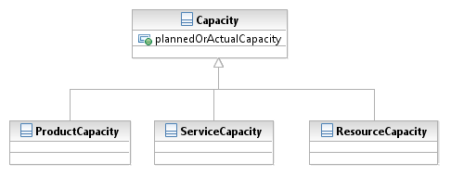
Figure CM.01 – Types of Capacity
A generalized capacity and capacity demand model is shown in Figure CM.02 – Basic Capacity Entities. Explanation of the figure follows.
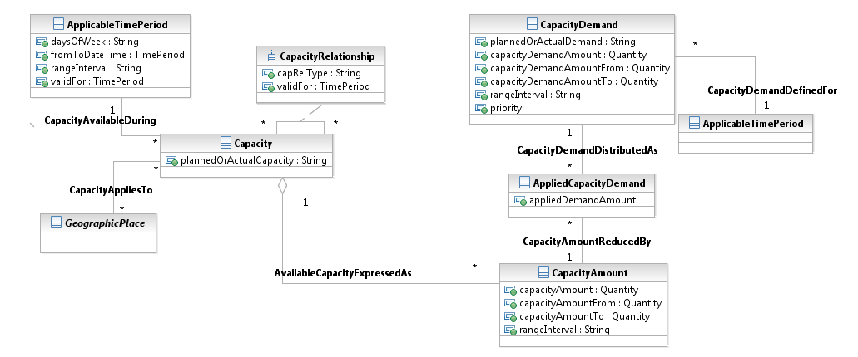
Figure CM.02 – Basic Capacity Entities
The need to satisfy the capacity requirement during the first week in June is expressed using the fromToDateTime attribute, which is a composite of from and to dates/times, and the rangeInterval attribute of ApplicableTimePeriod. Refinements to the schedule can include days of the week as shown by the daysOfWeek attribute in the ApplicableTimePeriod entity. The rangeInterval attribute is used to handle some combination of >, <, >=, <=. It is assumed this is a planned Capacity, which would be indicated using the plannedOrActutalCapacity attribute. The CapacityRelationship entity enables a planned Capacity to be associated with an actual Capacity or for Capacities to be aggregated.
The requirement for this capacity to be available in the Northeast geographic area is expressed using the relationship to GeographicPlace. Other entities that further define/refine capacity requirements could be added as needed by extending the SID.
The ability to deliver 10000 units of Product described in the previous example is expressed via the CapacityAmount, whose datatype is Quantity. Quantity is a composite of an amount attribute and a units (unit of measure) attribute. For this instance of Capacity, the capacityAmount attribute contains the amount “10000”, and the unit of measure “units”. Other examples of units of measure could be transaction volumes, storage requirements, traffic volumes, port availabilities, and so forth. The capacityAmountFrom, capacityAmountTo, and rangeInterval enable ranges of capacity to be specified.
Demands are placed on the capacity as defined by the CapacityDemand entity. The related ApplicableTimePeriod is used to here to express the timeframe over which the demand exists. It may or may not be the same instance of the ApplicableTimePeriod associated with the Capacity. Therefore, it may be a demand placed on more than one CapacityAmount. Similarly, the CapacityAmount may have many demands placed against it.
The attributes are similar to those in CapacityAmount with the addition of a priority attribute that defines the relative importance of this demand.
The AppliedCapacityDemand entity represents the amount of the CapacityDemand that has been applied against a CapacityAmount.
Similar to types (subclasses) of Capacity, there are types of CapacityDemand as shown in Figure CM.03 – Types of Capacity Demand. An example of each, Capacity and CapacityDemand will be described further in the next section.
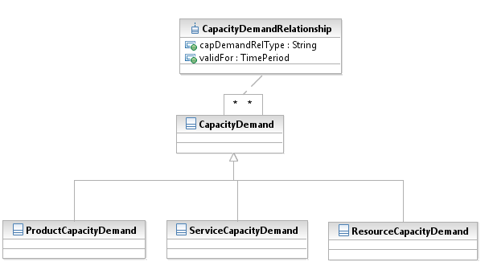
Figure CM.03 – Types of Capacity Demand
The different types (subclasses) of CapacityDemand can be related to one another. For example, ServiceCapacityDemand may be used to calculate ResourceCapacityDemand. Or, demand could be aggregated. The CapacityDemandRelationship entity provides support for these and other inter-demand relationships.

Types of Capacity and Demand Details
This section describes ResourceCapacity and ResourceCapacityDemand entities.
A similar set of entities, not yet included in the model until some agreement is reached on the basic model and the ResourceCapacity and ResourceCapacityDemand, would support similar Product and Service capacity concepts.
Figure CM.04 – Basic Resource Capacity Entities shows that ResourceCapacity can be expressed in terms of types of Resources (ResourceSpecifications) or instances of Resources.
There is often a need to express capacity (planned and unplanned) in a general way for all instances of a Resource, possibly within a specific Geographic Area. This is where ResourceCapacity would be related to ResourceSpecification For example, the need for fiber access networks in the southwest quadrant of a city to connect up to 100 households.
Similarly, there is often a need to express capacity for a specific instance of a Resource. For example the western distribution network must support XXX Terabytes of bandwidth. This would be handled by the association between ResourceCapacity and Resource in the figure.
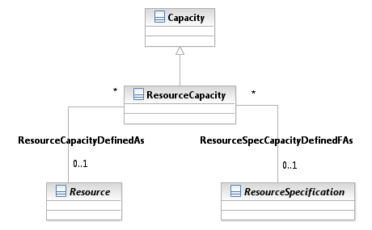
Figure CM.04 – Basic Resource Capacity Entities
The next two figures show ProductCapacity and ServiceCapacity entities.
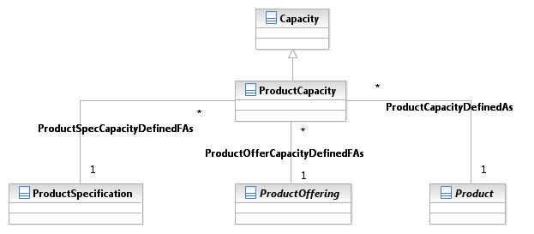
Figure CM.05 – Basic Product Capacity Entities

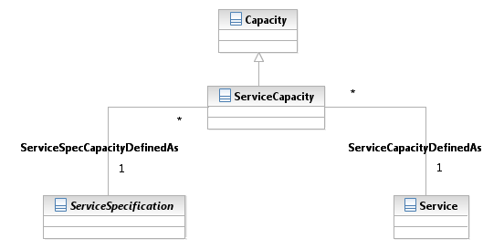
Figure CM.06 – Basic Service Capacity Entities
CapacityDemand, in this case Resource CapacityDemand, can be reflected by / based upon associations to a number of other entities. In Figure CM.07 – Basic Resource Capacity Demand Entities, the entities shown represent these (there may be more than could be added to the model as needed by the Information Framework implementer using published extension guidelines) and related to ResourceCapacityDemand).
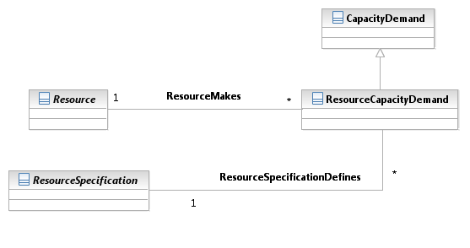
Figure CM.07 – Basic Resource Capacity Demand Entities
In the figure, one Resource may place (make) a demand on another. For example, a Scheduler may demand that a network support one million queries a day.
ServiceForecasts may also influence the capacity demands for Resources as described in various eTOM process elements. So can ResourceForecasts. While this is acknowledged here, these two entities, which are most likely ABEs, have not been modeled as part of the Capacity Model that was contributed to the Information Framework.
And, a single Service may also make a demand of ResourceCapacity. An important point to note is that care must be taken when determining demand so that none of the various sources of demand overlap with one another.
The next two figures show ProductCapacityDemand and ServiceCapacityDemand entities.
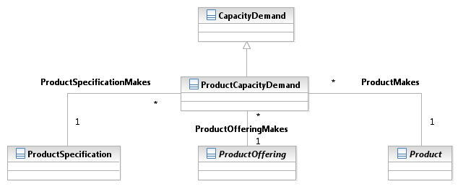
Figure CM.08 – Basic Product Demand Entities
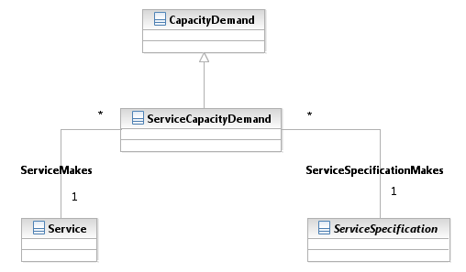
Figure CM.09 – Basic Service Demand Entities

An example of dependencies is show in Figure CM.10 – Capacity Dependencies Example. The capacity/demand relationships between resources would be used to determine the demand placed on the virtual resources by the three instances of Application A. And the relationships would then be used determine the demand placed on the physical resources by the virtual resources. This information is what could be used in part to support the policy-based load balancing described in the first example of this section.
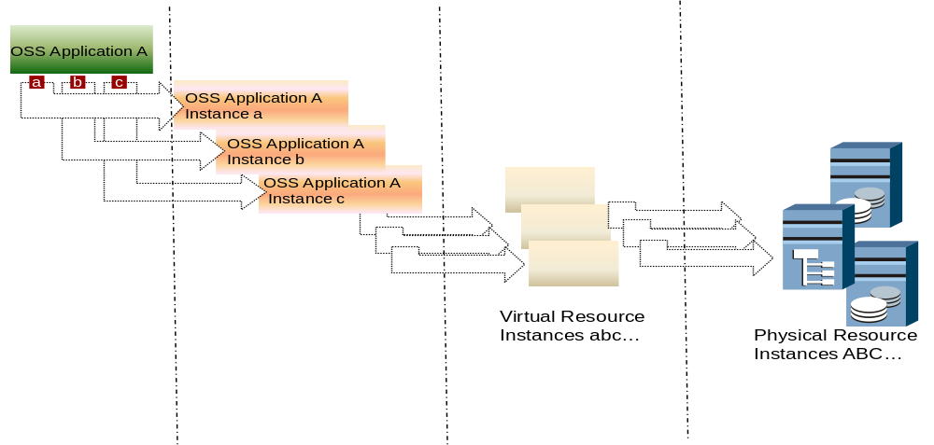
Figure CM.10 – Capacity Dependencies Example
There is most likely a need to provide the ability to calculate the demand placed on a Resource, or other demand entity, based on the source of the demand, such as a Service or other Resource. To support this requirement the current Characteristic model could be considered for use or additional entities that support the calculation could be identified and added to the Capacity model.
One example use of the model is shown in Figure CM.11 – Dynamic Load Balancing and Capacity Example. Available capacity of the machines and an associated SID load balancing Policy would be used to identify that an application (APP1) should be dynamically moved to the machine with a large amount of available capacity. As a result the demand placed on the first machine by APP1 would be removed from the first machine and transferred to represent demand on the second machine.
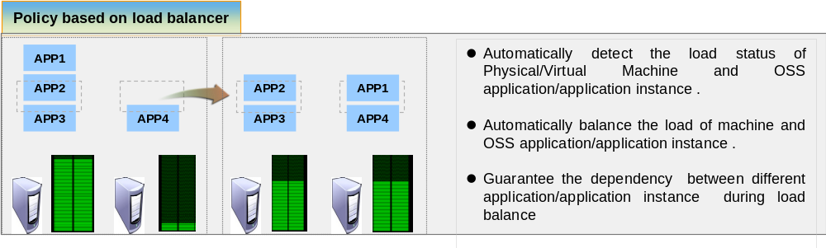
Figure CM.11 – Dynamic Load Balancing and Capacity Example

Business Entity Definitions – Performance Specification

Capacity

Business Entity Definition
Business Entity Name | Capacity
Description | Specific ability of an entity measured in quantity and units of quantity over an extended period.
Sources |  | Cross- References |  |  | Synonyms / Aliases
Related Business Entities
Business Rules

Business Entity Attributes Definition
Business Entity Name | Capacity
Attribute Name | Description | Data Type | Characteristics, Permitted Values & Units | Required/  Optional | Notes
plannedOrActualCapacity | An indicator that specifies whether the capacity is planned or actual | String |  | Required

ProductCapacity

Business Entity Definition
Business Entity Name | ProductCapacity
Description | Specific ability of Product domain entities measured in quantity and units of quantity over an extended period.
Sources |  | Cross- References |  |  | Synonyms / Aliases
Related Business Entities | Subclass of Capacity
Business Rules

Business Entity Attributes Definition
Business Entity Name | ProductCapacity
Attribute Name | Description | Data Type | Characteristics, Permitted Values & Units | Required/  Optional | Notes

ServiceCapacity

Business Entity Definition
Business Entity Name | ServiceCapacity
Description | Specific ability of Service domain entities measured in quantity and units of quantity over an extended period.
Sources |  | Cross- References |  |  | Synonyms / Aliases
Related Business Entities | Subclass of Capacity
Business Rules

Business Entity Attributes Definition
Business Entity Name | ServiceCapacity
Attribute Name | Description | Data Type | Characteristics, Permitted Values & Units | Required/  Optional | Notes

ResourceCapacity

Business Entity Definition
Business Entity Name | ResourceCapacity
Description | Specific ability of Resource domain entities measured in quantity and units of quantity over an extended period.
Sources |  | Cross- References |  |  | Synonyms / Aliases
Related Business Entities | Subclass of Capacity
Business Rules

Business Entity Attributes Definition
Business Entity Name
Attribute Name | Description | Data Type | Characteristics, Permitted Values & Units | Required/  Optional | Notes

CapacityRelationship

Business Entity Definition
Business Entity Name | CapacityRelationship
Description | A relationship between/among Capacities.
Sources |  | Cross- References |  |  | Synonyms / Aliases
Related Business Entities | Recursive association class for Capacity.
Business Rules

Business Entity Attributes Definition
Business Entity Name | CapacityRelationship
Attribute Name | Description | Data Type | Characteristics, Permitted Values & Units | Required/  Optional | Notes
capRelType | A categorization of the relationship, such as aggregation, dependency. | String |  | Required
validFor | The period of time during which the relationship applies. | TImePeriod |  | Optional

CapacityAmount

Business Entity Definition
Business Entity Name | CapacityAmount
Description | A quantity that define the Capacity.
Sources |  | Cross- References |  |  | Synonyms / Aliases
Related Business Entities
Business Rules

Business Entity Attributes Definition
Business Entity Name | CapacityAmount
Attribute Name | Description | Data Type | Characteristics, Permitted Values & Units | Required/  Optional | Notes
capacityAmount | A value and units that define the CapacityAmount, such as 10000 ea, 10B Mb. | Quantity |  | Required | Instance values are mutually exclusive with From and To capacityAmounts and range interval
capacityAmountFrom | The low range value that a CapacityAmount can take on. | Quantity |  | Required
capacityAmountTo | The upper range value that a CapacityAmount can take on. | Quantity |  | Required
rangeInterval | An indicator that specifies the inclusion or exclusion of the capacityAmountFrom and capacityAmountTo attributes.  Possible values are "open", "closed", "closedBottom" and "closedTop". | String |  | Required

ApplicableTimePeriod

Business Entity Definition
Business Entity Name | ApplicableTimePeriod
Description | The period of time for which Capacity or CapacityDemand applies.
Sources |  | Cross- References |  |  | Synonyms / Aliases
Related Business Entities
Business Rules

Business Entity Attributes Definition
Business Entity Name | ApplicableTimePeriod
Attribute Name | Description | Data Type | Characteristics, Permitted Values & Units | Required/  Optional | Notes
daysofWeek | A day or days representing hen the schedule is applicable. For example 2, 3 represent Monday and Tuesday. | String |  | Optional
fromToDateTime | The period of time for which the schedule is applicable. | TimePeriod |  | Required | Instance values are mutually exclusive with daysOfWeek values.
rangeinterval | An indicator that specifies the inclusion or exclusion of the from and to DateTime attributes.  Possible values are "open", "closed", "closedBottom" and "closedTop". | String |  | Required
validFor | The period of time during which the schedule is considered of interest to the business. | TimePeriod |  | Optional

CapacityDemand

Business Entity Definition
Business Entity Name | CapacityDemand
Description | The amount of capacity that is planned to be consumed or has been consumed.
Sources |  | Cross- References |  |  | Synonyms / Aliases
Related Business Entities
Business Rules

Business Entity Attributes Definition
Business Entity Name | CapacityDemand
Attribute Name | Description | Data Type | Characteristics, Permitted Values & Units | Required/  Optional | Notes
plannedOrActualDemand | An indicator that specifies whether the capacity demand is planned or actual | String |  | Required
capacityDemandAmount | A value and units that define the CapacityDemand, such as 10000 ea, 10B Mb. | Quantity |  | Required | Instance values are mutually exclusive with From and To capacityDemandAmounts and range interval
capacityDemandAmountFrom | The low range value that a CapacityDemand can take on. | Quantity |  | Required
capacityDemandAmountTo | The upper range value that a CapacityDemand can take on. | Quantity |  | Required
rangeInterval | An indicator that specifies the inclusion or exclusion of the capacityDemandAmountFrom and capacityDemandAmountTo attributes.  Possible values are "open", "closed", "closedBottom" and "closedTop". | String |  | Required
Priority | The relative importance of the CapacityDemand. | String |  | Optional

ResourceCapacityDemand

Business Entity Definition
Business Entity Name | ResourceCapacityDemand
Description | The amount of ResourceCapacity that is planned to be consumed or has been consumed.
Sources |  | Cross- References |  |  | Synonyms / Aliases
Related Business Entities | Subclass of CapacityDemand
Business Rules

Business Entity Attributes Definition
Business Entity Name | ResourceCapacityDemand
Attribute Name | Description | Data Type | Characteristics, Permitted Values & Units | Required/  Optional | Notes

ProductCapacityDemand

Business Entity Definition
Business Entity Name | ProductCapacityDemand
Description | The amount of ProductCapacity that is planned to be consumed or has been consumed.
Sources |  | Cross- References |  |  | Synonyms / Aliases
Related Business Entities | Subclass of CapacityDemand
Business Rules

Business Entity Attributes Definition
Business Entity Name | ProductCapacityDemand
Attribute Name | Description | Data Type | Characteristics, Permitted Values & Units | Required/  Optional | Notes

ServiceCapacityDemand

Business Entity Definition
Business Entity Name | ServiceCapacityDemand
Description | The amount of ServiceCapacity that is planned to be consumed or has been consumed.
Sources |  | Cross- References |  |  | Synonyms / Aliases
Related Business Entities | Subclass of CapacityDemand
Business Rules

Business Entity Attributes Definition
Business Entity Name | ServiceCapacityDemand
Attribute Name | Description | Data Type | Characteristics, Permitted Values & Units | Required/  Optional | Notes

CapacityDemandRelationship

Business Entity Definition
Business Entity Name | CapacityDemandRelationship
Description | A relationship between/among CapacityDemands.
Sources |  | Cross- References |  |  | Synonyms / Aliases
Related Business Entities
Business Rules

Business Entity Attributes Definition
Business Entity Name | CapacityDemandRelationship
Attribute Name | Description | Data Type | Characteristics, Permitted Values & Units | Required/  Optional | Notes
capDemandRelType | A categorization of the relationship, such as aggregation, used to calculate. | String |  | Required
validFor | The period of time during which the relationship applies. | TImePeriod |  | Optional

Administrative Appendix
This Appendix provides additional background material about the TM Forum and this document. In general, sections may be included or omitted as desired; however a Document History must always be included.

About this document
This is a TM Forum Guidebook. The guidebook format is used when:
The document lays out a ‘core’ part of TM Forum’s approach to automating business processes. Such guidebooks would include the Telecom Operations Map and the Technology Integration Map, but not the detailed specifications that are developed in support of the approach.
Information about TM Forum policy, or goals or programs is provided, such as the Strategic Plan or Operating Plan.
Information about the marketplace is provided, as in the report on the size of the OSS market.

Document History

Version History
<This section records the changes between this and the previous document version as it is edited by the team concerned. Note: this is an incremental number which does not have to match the release number>

Version Number | Date Modified | Modified by: | Description of changes
0.1 | 01May2011 | Scott Li | First draft of document
0.2 | 23Jun2011 | Scott Li | Updated flow of document.
0.3 | 31Aug 2011 | Scott Li | Added more detail, such as attributes and definitions
1.0 | 05Jan 2012 | Scott Li | Words edit
1.1 | 13Mar 2012 | Alicja Kawecki | Minor cosmetic and formatting corrections prior to posting and ME
1.2 | 26 October 2012 | Alicja Kawecki | Updated to reflect TM Forum Approved status

Release History
<This section records the changes between this and the previous Official document release>

Release Number | Date Modified | Modified by: | Description of changes
1.0 | 01May2011 | Scott Li | First draft of document
12.0 | 05Jan 2012 | Scott Li | Words edit

Company Contact Details
Company | Team Member Representative
Huawei Software | Scott Li  Title : Senior System Engineer  Email : lisihao@huawei.com  Phone  Fax
Name
Title
Email
Phone
Fax

Acknowledgments
This document was prepared by the members of the TM Forum Information Framework (SID) program:
Scott Li, Huawei Software, Editor

