Information Framework (SID)
Information Framework Primer

GB922 0-P
TM Forum Approved Version 1.6


September, 2011

Notice
This material, including documents, code and models, has been through review cycles; however, due to the inherent complexity in the design and implementation of software and systems, no liability is accepted for any errors or omissions or for consequences of any use made of this material.
Under no circumstances will the TM Forum be liable for direct or indirect damages or any costs or losses resulting from the use of this specification. The risk of designing and implementing products in accordance with this specification is borne solely by the user of this specification.
This material bears the copyright of TM Forum and its use by members and non-members of TM Forum is governed by all of the terms and conditions of the Intellectual Property Rights Policy of the TM Forum (http://www.tmforum.org/Bylaws/1094/home.html) and may involve a claim of patent rights by one or more TM Forum members or by non-members of TM Forum.

Direct inquiries to the TM Forum office:
240 Headquarters Plaza,
East Tower – 10th Floor,
Morristown, NJ 07960 USA
Tel No. +1 973 944 5100
Fax No. +1 973 944 5110
TM Forum Web Page: www.tmforum.org

Table of Contents
Notice 2
Table of Contents 3
List of Figures 5
List of Tables 6
Executive Summary 7
1. Primer 8
1.1. Document Scope and Objectives 8
1.2. Target Audience 9
2. The Information Framework 10
2.1. Information Framework Scope and Objectives 10
2.2. High Level Concepts 10
2.3. Why have an Information Model? 11
2.4. What is it? 12
2.5. What does it do for me ? 13
2.6. When to apply it ? 13
2.7. Where does it apply ? 14
2.8. Who applies it ? 14
2.9. What an Information Framework Is Not 15
2.10. Impacts / Implications 16
2.11. Constraints & Challenges 16
2.12. Lessons learned 17
3. Business Concepts 19
3.1. Things of interest to the Business 19
3.2. Context & Role 20
3.3. State and Lifecycle 20
3.4. Relationships 21
4. Conceptual Model 22
4.1. Identity / Party (who) 23
4.2. Time & Time Period (when) 23
4.3. Places / Location (where) 23
4.4. Motivation (why) 24
4.5. Work (how) 24
4.6. Policy (how) 25
4.7. The Business (what) 25
4.8. Event (when) 26
4.9. Financials (what) 26
5. How the Information Framework relates to the Business Process Framework 27
6. How the Information Framework relates to Other Industry Frameworks 28
7. Information Framework Documentation 29
8. Definitions 30
9. References 31
10. Appendices 32
10.1. Appendix 1 - Introduction to UML Notation 32
10.1.1. Entities 32
10.1.2. Associations 33
10.1.3. Aggregation Association ^{[11]} 34
10.1.4. Inheritance / Specialization 35
10.2. Appendix 2 - Analysis Patterns Used in Information Framework 37
10.2.1. Specification ^{[2]} 37
10.2.2. Abstract Superclass ^{[14]} 38
10.2.3. Composite ^{[9]} 40
10.2.4. Role Entity^{[17]} 41
10.2.5. Temporal State Entity ^{[9]} 42
10.2.6. Self Relationship ^{[8]} 43
11. Administrative Appendix 45
11.1. Document History 45
11.1.1. Version History 45
11.1.2. Release History 45
11.2. Acknowledgments 45

List of Figures
Figure 4-1 - Concept Block Diagram 22
Figure 10-1 UN1-Entities 33
Figure 10-2 UN2 - Associations 34
Figure 10-3 UN3 – Aggregation Association 35
Figure 10-4 UN4 – Inheritance / Specialization 36
Figure 10-5 AP1 – Specification Pattern 38
Figure 10-6 AP2a – Abstract Superclass Pattern 39
Figure 10-7 AP2b – Abstract Superclass Pattern Example 40
Figure 10-8 AP3 – Composite Pattern 41
Figure 10-9 AP6 – Self Relationship Pattern 44

List of Tables
Table 2-1 – Information Model comparison to other artifacts 11
Table 3-1 – Zachman framework columns 19
Table 10-1 AP1 – Self Relationship Types 44

Executive Summary
In today’s tough environment, businesses are looking for that additional competitive edge. True competitive advantage comes from understanding the business fundamentals; your processes & assets, your customers, and the other businesses forming your supply and delivery network.
The Information Framework is part of the TeleManagement Forum Frameworx (formerly known as NGOSS) initiative. Complementing the Business Process Framework(also known as eTOM), the Information Framework focuses on the things that are involved in business processes; people, assets, products & services.
The Information Framework is an enabler to success, not a guarantee of success. It should be applied to business issues and opportunities in conjunction with sound management techniques, as part of an enterprise information architecture.
Use of the TM Forum Frameworx to provide terminology and interface specifications throughout a businesses supply and delivery network, means that customers and suppliers can interact more efficiently and effectively. Competitive advantage over other companies adopting Frameworx will come from the quality of the business implementation and its level of integration with the business processes.
The Information Framework has ‘mined’ existing industry models and standards for Service Provider business knowledge, and then standardized and extended it to produce a single model, consistent with the Business Process Framework terminology.
Since Frameworx and the Information Framework are open industry standards, businesses won’t become tied to proprietary standards, controlled by companies who require expensive ongoing payments. TM Forum members can participate in the definition of the Information Framework or just provide feedback to the Information Framework team.

Primer

Document Scope and Objectives
This document is an introduction to the TM Forum Information Framework. To keep it brief, the concepts and examples have been simplified. This document should not be used for implementation work; refer to the detailed Information Framework addenda for that. In standards terms, this document is informative, not normative.
This document includes examples that are deliberately not Telco specific. This is to show that the concepts / patterns are generic and also to provide examples that can be understood by a wider audience. Advanced readers may wish to think of more specific examples that relate to their own areas of expertise.
There are currently one Information models; the Information Framework analysis model in GB922 which analyses the Service Provider business environment.
This document will focus solely on the Information Framework analysis model. All future references to ‘the Information Framework’ within this document, should be assumed to refer to the Information Framework analysis model.
This Primer has a companion slide pack which can be used to promote the use of the Information Framework in your organization and to promote team discussion. Both this document and the slide pack can be downloaded from the TM Forum web site.
We suggest reading this document straight through once, without getting sidetracked. Then read it again, using the links to the Information Framework documents and other references to work through the concepts of interest to you.
To avoid interrupting the flow of thought, references use a more compact format than that used in the rest of the Information Framework. References, such as one to Fowler’s book ^{[1]},are shown using a number in square brackets, as a superscript .

Target Audience
This document is aimed at:
- Subject matter experts
- process experts
- Executive and Senior Technical Managers
- technical managers
- business & system analysts
and anyone else interested in a deeper understanding of communications, information and entertain businesses.

The Information Framework

Information Framework Scope and Objectives
The Information Framework analysis model scope covers all of the information required to implement use cases based on the Business Process Framework processes ^{[5]}; in effect this means that the Information Framework covers a large proportion of the information needs for a Service Provider. However, the Information Framework is still being developed and while the documents available today cover a substantial part of a Service Provider’s core information needs, they do not cover of them.
The initial Information Framework releases have focused on higher level conceptual modeling. Later releases are expected to expand to more solution focused design and implementation artifacts.
The Information Framework makes an effort to document not only the result, but also the reasoning and decisions that led to the result. This allows organizations to understand how the Information Framework works and how to extend it to fit their own specific needs.
The Information Framework is based on earlier work done on the TM Forum SIM, the TM Forum Business Process Framework, contributions by the companies on the Information Framework team and from public industry models and more general models in books and articles.
The Information Framework has been built using an iterative approach, so that the results are available to TMF members in a timely manner. We are also aiming for continuous improvement, so feedback on this primer and the other documents in the GB922 series will be appreciated.

High Level Concepts
For this introductory document, we will define an information model as follows:
An information model is a representation of business concepts, their characteristics and relationships, described in an implementation independent manner.
This means that in an information model, some detail is ignored, and the level of detail may vary, depending on the business needs. The Information Framework uses the Business Process Framework process definitions to define its scope and determine what is important to a Service Provider.
The use of analysis techniques can aid in understanding non-obvious business fundamentals, and this insight can be used in all areas of the business.
The Information Framework analysis model is implementation independent, focusing on what the information is and what its relationships are, not on how these are to be implemented.
In the next sections we will look at information models in general and then the Information Framework specifically.

Why have an Information Model?

Information Model
A common information model will streamline the processes associated with information exchange, both within an Enterprise and between the Enterprise and its external stakeholders.
Having a standard information model provides the following benefits:
- it allows for simplification of information management, by providing a common terminology and reducing unnecessary variation
- it allows for unification of information both within an enterprise and between enterprises
- it provides a bridge between the business and Information Technology groups by providing definitions that are understandable by the business, but are rigorous enough to be used for software development
These benefits then enable business benefits relating to cost, quality, timeliness and adaptability of enterprise operations, allowing an enterprise to focus on value creation for their customers.

The Information Framework
The TM Forum Frameworx initiative needs an information model as part of defining the Frameworx Components and Contracts.
There are no comprehensive information models publicly available for a Service Provider’s business that could have been used, so it was necessary to produce a model specifically for Frameworx.

What is it?

Information Model
An information model (as opposed to a data model) is an abstraction and only provides a high level view of things of interest to the business. It aids understanding the scope and breadth of the business, rather than the depth.

An Information Model is a way of representing and structuring information that has advantages over other common artifacts, as described in the table below.

Artefact | Artefact Limitations | Information Model advantage
Glossary | Hard to understand how the concepts relate | An information Model links concepts together and provides a visual overview.
Descriptive document | Often rambling & inconsistent with overlapping terminologies used | An information model is more precise, using the power of UML to ensure that the information is represented in a consistent manner
Database model or source code | Too detailed to get a feel of the big picture. Hard to match to business requirements. Hard to convert from a particular language / platform / environment. | A database model is a solution, but it may not map to your problem. A business is likely to have many database models and these need to be understood against a common view of the business (e.g. for EAI integration, Business Intelligence etc.). The Information Framework documents a unifying view: the basis for decisions, not just the results.
Table 2-1 – Information Model comparison to other artifacts

The Information Framework
There are many views as to what an Information Model is and does. For the Information Framework, the initial work has focused on creating a conceptual or analysis model, (also known as a domain model ^{[1], [2]} or a semantic model ^{[15]}). The model is a representation of real world objects in which there is interest from the business.

An analysis model includes:
- things in which the business is interested (domain entities)
- how they are related to one another (associations)
- key details about those things which help to define them unambiguously (domain-level attributes)

What does it do for me ?

Information Framework
If your understanding of your business consists of “large documents of rambling text and spreadsheets”^{[4]}, then you need an information model to structure your information.
A good information model provides a rigorous understanding of the subject area being modeled.
“A ‘deep’ model provides a lucid expression of the primary concerns of the domain experts and their most relevant knowledge, while it sloughs off the superficial aspects of the domain”^{[5]}.

The Information Framework
The Information Framework Addenda use a mixture of descriptive text, UML diagrams and tables which formally define the entities and attributes. This provides concise & precise definitions with background reasoning and explanations.
The Information Framework documents knowledge of Service Providers businesses in a format that provides a bridge between the business and information technology worlds.

When to apply it ?

Information Framework
An information model is useful:
- as a starting point for internal modeling work, applications and messages between software components or database schemas
- to help in defining a common business terminology, e.g. for integration activities
- to help in business transformation programs
- to help in understanding business concepts and their relationships
- as a source of inspiration - for a new view on traditional practices

The Information Framework
The Information Framework will be useful for all of the above, and in addition, it is useful as a formal specification for building Frameworx compliant components.

Where does it apply ?

Information Framework
An Information Framework represents the things involved in the processes that were included in the model scope.
Any business that executes these processes or is a supplier to these processes will find the model useful.

The Information Framework
The Information Framework applies primarily to Service Providers’ businesses and engaged stakeholders: System Integrators (SI), Independent Software Vendors (ISV) and Network Equipment Providers (NEP).
Parts of the Information Framework may also apply directly to, or be adaptable to, other non-Telco Service Provider enterprise businesses.

Who applies it ?

Information Framework
An information model will be directly used by:
- Process experts for process redesign
- Business & System analysts for application design
- System Integrators where it can be a starting point for defining generic APIs, message formats etc between software components.
- Enterprise Architects to analyze inter- and intra-Enterprise business activities
- Business Intelligence/Data Warehousing experts for a business-wide view and common terminology
- Independent Software Vendors to build COTS-like solutions

The Information Framework
In addition to the above, the Information Framework model will be directly used by:
- Network Equipment Providers to build network equipment with industry standard interface definitions. This will make it easier for Service Providers to manage a network composed of Network Elements from many NEPs.

What an Information Framework Is Not

Information Framework
An analysis model is not:
- a database model
- a definition of how software will be written
- an implementation of software classes
- a software API (Application Programming Interface)
- a set of component messaging definitions

The analysis model will, however, provide business definitions that should be a major input to the definition of the above items.

The Information Framework
The Information Framework analysis model is not:
- a definition of Frameworx software classes
- enough to do an implementation on its own
- a definition of platforms, protocols, software languages or software products to be used for developing Frameworx components

Impacts / Implications
The Information Framework is not a “magic bullet” but should be seen as a key component of an integrated information architecture (model framework + methodology) within an overall enterprise architecture (i.e. Frameworx).
Other parts of an Information Architecture are typically:
- Information Policy – directs information management within a business
- Communication Policy – information maintenance and publishing standards (model downloads, data glossary/dictionary definitions, interface definitions, data translations etc)
- Governance Processes – managing separate component models within the overarching framework principles including interface design; managing data definitions within process design; managing data definition within applications design.

To achieve maximum business benefits, businesses need to consider how to integrate use of the Information Framework into their existing processes and procedures, especially those relating to IT definition & development.

Constraints & Challenges
An information model should model fundamental concepts and not be affected by minor business environment changes like organization restructures.
The information model should be an enabler of change (new Products, Processes and ways of doing business), not a blocker to progress.
A challenge for our team has been to determine the right level of detail for the Information Framework: should the model be more conceptual and focused on analysis or should it include enough detail to support design. Business people want to link data concepts to the Business Process Framework activities whereas vendors have a need to focus more on implementation.
Hence, the early Information Framework work focused on building conceptual models and is now beginning to create the Information Framework design model.

Lessons learned
Our original intention was to “mine” “best of breed” models in each subject area but the availability of suitable public models was less than expected. There are many detailed models for specific business areas but few at the conceptual level, particularly for the telecommunications industry, which has a complexity all of its own.
Modeling projects like this require an iterative approach due to their size, complexity, and the interaction between the deliverables. There is always a temptation to try and do everything at once. We started by modeling simpler subject areas that we were familiar with. By the time we tackled the harder subject areas we had our processes and standards well defined.
A major issue was we had to choose and merge terminologies from existing models and different subject areas. We learned that having a terminology map is essential to provide a way forward, as each person will start by being sure that their terminology is already common – or should be.

Business Concepts
In this section we will be introducing some basic concepts. If we refer to existing Information Framework Entities, Information Framework Addenda etc. then these will be shown in italics in the text and suitably qualified. e.g. Person is a concept which is modeled in the Party Addendum by the Party Entity and Party Role Entity.
In this section we will look at some fundamental “laws of nature” that have guided the Information Framework modeling efforts.

Things of interest to the Business

Identities
We can think of there being two types of things, those that are identifiable and those that only have a value.
“Many objects are not fundamentally defined by their attributes, but by a thread of continuity and identity”^{[5]}.
A person can change their name, hair color & style, gender; their nationality, address and phone number … but still be the same person.
The concept of identity may not be absolute, but a pragmatic business decision. For example, what defines the identity of a personal computer? Over time, if all of the parts of a PC have been replaced or upgraded, would the business want to treat this as a new PC or not? Would this be influenced by taxation rules?

Values
“Many objects have no conceptual identity. These objects describe some characteristic of a thing.”^{[5]}
Things without an identity are called ‘Value Entities’ in the Information Framework. An example of a value entity is a color like “dark red” or a quantity of money like 27 CHF.
The Information Framework defines a number of value entities (in the Base Types Addendum), such as the Time Period Entity and Money Entity.

Categorizing Things
We can think about information by categorizing it with the six primitive questions^{[15]}: ’what?’, ‘where?’, ‘how?’, ‘who?’, ‘when?’ and ‘why?’. These interrogative primitives are used to define the columns in the Zachman framework^{[15]}, commonly used to categorize items in an enterprise architecture.

Zachman Framework columns^{[15]} | An example of what we may be interested in
What | Any item that is required to conduct business
Where | Properties, countries, localities (suburbs), cable routes, street centrelines, coastal boundaries
How | Processes, tasks, plans and strategies
Who | Customers, suppliers and employees
When | A time point or time period
Why | Business investment drivers, goals and objectives
Table 3-2 – Zachman framework columns

Context & Role
Often we may think of things and concepts as ‘absolutes’; e.g. “a rock is a rock”. We are often interested, however, in concepts in a context.
A Role represents behavior in a context.
So in the context of a legal trial, a rock may be an exhibit or a murder weapon (but it is still just a rock!).
The Information Framework allows for the representation of both a thing and the roles that it plays in various business contexts (we separate the intrinsic characteristics from the contextual characteristics). So in a Sale, a Person may play the role of Customer. In the context of a completed phone call there will be a calling party and a called party.

State and Lifecycle
Things rarely exist forever. They are formed or created, exist for some time and then wear out, are discarded, destroyed or recycled. During its useful life, a thing’s characteristics may change many times. We can think of the state of a thing as its characteristics at a point in time.
Depending on the business requirements, we may be interested in the current state only, or in the complete lifecycle of past and future planned / expected states. Note that in many cases, we may be interested in tracking only the changes in one or two characteristics.
As an example, consider a rental car. We may wish to track its usability state (in-service, out of service) now and in the past and its booking state (free, booked) now and in the future.
The Information Framework allows for the representation of states and lifecycle by separating characteristics that we need to track over time from those that we only keep the current value.

Relationships
The things that we are interested in rarely exist in isolation. We are interested in how things relate to each other. Asking which Customers haven’t paid their bill for their service this month means that we need to relate the Customer, Service, Bill and Payment concepts.
As well as things that relate to each other as peers, we will have other types of relationships. One common type is that denoting whole-part relationships. Examples of this type of relationship includes things like Order and Order-Line-Item, Party and PartyRole.

Conceptual Model
In this section we will provide some simple definitions to help in understanding the concepts covered by the Information Framework. If we refer to existing Information Framework Entities, Information Framework Addenda etc. then these will be shown in italics and suitably qualified. For example, a Person is a concept which is modeled in the Party Addendum by the Party Entity and Party Role Entity.
Figure 1 shows an abstract view of business ‘things’ across an entire business or end-to-end Value Chain. This represents data modeled to ensure completeness and the integrity of relationships at the high level (cf. a semantic model ^{[15]}).
As a result, the diagram contains concepts not yet modeled in Information Framework, particularly in the Enterprise domain. – this is detailed in the text in this section. However, it does provide a roadmap of concepts that the Information Framework will model in the near future.

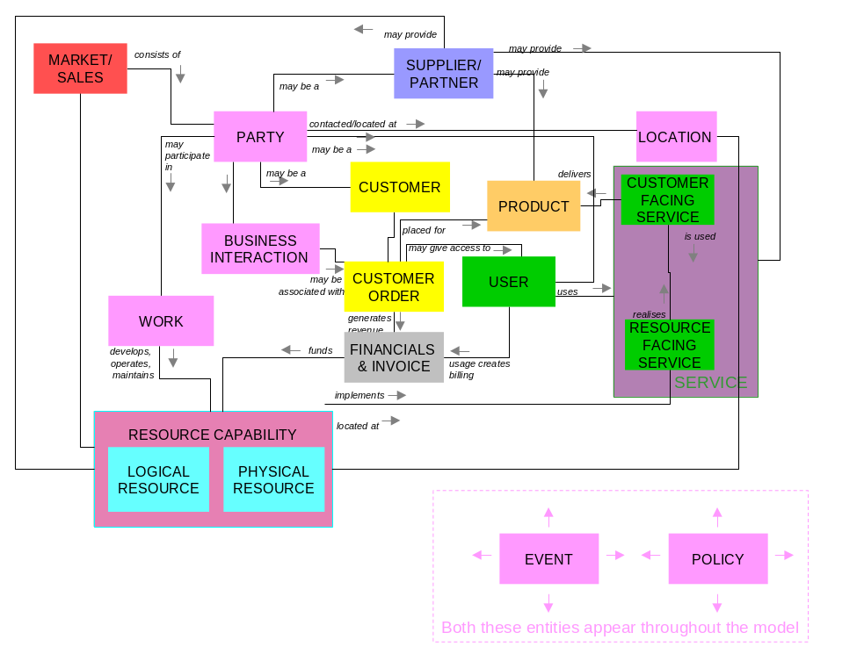
Figure 4-1 - Concept Block Diagram
The colors in the above diagram relate to the Information Framework structure (See GB9222: Information Framework Concepts, Principles & Domains)

Identity / Party (who)
This represents the information about an individual or organization and the many roles that they can play or be assigned.

Individuals & Organizations
A Party may be either an Individual or an Organization. Individual and Organization can be related to each other (e.g. an Organization consists of Individuals) and an Organization may be related to itself in an organizational hierarchy (e.g. an Organization may consist of other Organizations).

When a Party acts in relation to a business, that Party takes on a Party Role. The following are key types of Party Roles:

Customer (actual or potential)
A Customer is associated with a target Market and may purchase Product Offerings from a Supplier via an Agreement.

Supplier
A Supplier markets and sells Product Offerings to Customers.

User
A User (not yet detailed in the Information Framework Addenda) is a Party that uses Services and requires access rights and responses to Business Interactions but who does not play a role at the commercial level, e.g. as the Customer.

Time & Time Period (when)

Calendar
Information relating to dates, e.g. with regard to project scheduling, and to dates within different calendars.

Places / Location (where)
This represents any place, area or position of interest.

Locations & Sites
A Location is an absolute location, e.g. of a piece of equipment.

Addresses
An Address is a way of describing a Location and therefore a means of locating/contacting a Party or a business ‘thing’ (e.g. Product/Service availability, Physical Resource/piece of equipment etc.)

Motivation (why)

Business Planning
Represents plans, strategies and policies that direct a business in its creation, management and withdrawal of the things that matter to it (e.g. Agreements, Products, Services, Resources etc).
These plans & strategies provide the ‘why’ in that there will be objectives behind the plans, e.g. to reduce costs, to grow revenues, to introduce a new product, etc.

Work (how)
The ‘How’ needs to be carefully defined in information terms, i.e. in relation to the given process framework and modeling.

Plan & Project
These are common units of work that are planned over a period of time (e.g. as parts of funded programs), usually to bring about business change, improvement or a specific implementation (e.g. of a new product).
A business needs to record how it assigns work and resource against budget:
- the activities it is interested in, both the common project structures and the instances
- how you string together those elements to meet the specific objectives that drive a project.

Process
Processes represent the dynamic aspects of the business – the business at work. A business supports its processes with systems/applications and these systems implement the processes, e.g. in workflow engines. The TMF process framework is the Business Process Framework.
An information model holds the static information about these processes in relation to the ‘things’ that they manage and the way the process is implemented: what the business processes are, the things that they control, sequencing, rules etc.
Process information:
- differs from Plan and Project which are assigned to a finite time period;
- is similar to Plan & Project in that both include ‘Activity’ as a concept.

Policy (how)
Put simply, ‘Policy’ comprises the rules needed to direct the business or the systems and networks that run the business.
Policy has many different meanings. For example:
- Policy is a set of business rules and is meant for use by business people
- Policy is a means to control Quality of Service (QoS), and is meant for use by networking people
- Policy is a means to scale the system, and is meant for use by systems architects
Policy is therefore of interest to both the business and technical communities – a rules structure used in diverse contexts. Policy is a key concept where the business needs to automate its decisions and processes.
The Information Framework Policy model brings together the diverse views of what ‘policy’ means to a business in the Policy Continuum.

The Business (what)
This covers products and the offerings made to the marketplace. Products are defined to include associated services as well.
An Enterprise’s resources provide the ability to offer products & services to customers.
The main things to consider are:

Agreement & Contract
This represents written and verbal understandings between parties.

Product
Represents what is sold, leased or rented to Customers.

Service
Services are tightly bound to Products. A Product may be implemented through one or more Services which utilize Resources.

Resource
Resource is the ‘infrastructure’ that supports the provision of Services and therefore the delivery of Products to Customers.
Resources are both physical and logical: they may be managed by a Telecommunication Management Network; or managed manually as part of the operations of the Network or Service Provider.
These ‘things’ may not just be viewed as things that the business ‘has’. In modern commerce, there is more than one way of creating business assets. They may be:
- Sold or leased to others
- Bought or leased from others
- Made or Assembled

Event (when)
Represents an occurrence of interest to the enterprise, at a point in time.
An event may trigger an action or response by the Enterprise.

Financials (what)
Represents the way in which the business (products, services, resource etc) are funded and accounted for.

How the Information Framework relates to the Business Process Framework
The Information Framework and Business Process Framework model the same subject matter from different points of view. The Business Process Framework focuses on the business processes; the dynamic aspects of the business.
The Information Framework analysis model focuses on the static aspects of the business; the things that the business processes act on, their characteristics and relationships.
The Information Framework analysis model is organized using the Information Framework. The Information Framework domain-based structure is derived from the earlier TM Forum SIM work, and allows us to group the Information Framework analysis model entities in a way that aligns with major areas of interest to the business.
The top level of grouping, called a Information Framework domain, aligns with the Business Process Framework level 0 definitions of :
- Market / Sales
- Product
- Customer
- Service
- Resource
- Supplier / Partner
The framework also represents Common Business Entities (e.g. Party, Location, Policy) and has a placeholder domain for Enterprise entities which have not yet been fully defined (e.g. Financials).
The Information Framework structure is extensively documented in the main GB922 document^{[13]} and hence is not repeated in this primer.

How the Information Framework relates to Other Industry Frameworks
The Information Framework utilizes existing public industry models wherever possible. Proprietary models are not used, so that the Information Framework can be used without requiring intellectual payments.
Major inputs to the Information Framework include the DEN models and ITU-T recommendations, as well as input from sources such as Martin Fowler’s “Analysis Patterns” book.
A model like the Information Framework can’t just be patched together with bits and pieces of existing models. To produce a result consistent with the Business Process Framework, the source model concepts have been amalgamated into a single coherent model.

Information Framework Documentation
This document has two appendices:
- The first appendix explains enough about UML notation to get started in reading the diagrams in the other Information Framework documents.
- The second appendix explains some of the modeling patterns used throughout the Information Framework, to aid in understanding some of these more advanced modeling concepts.

If you are now ready for more detail, you can visit the Information Framework documentation direct:
- Information Framework Concepts, Principles & Domains (GB922)
- Information Framework Addenda, organized by domains
  - Information Framework Primer (this document)
  - Common Business Entities (8 addenda)
  - Customer
  - Product
  - Service (2 addenda)
  - Resource (2 addenda)
- Using and Extending the Information Framework
- Information Framework models (Rational Software Modeler model file, web version, and other formats of the model)

Definitions
The following words, acronyms and abbreviations are referred to in this document and are considered important or confusing enough to warrant being formally defined.
Term | Definition
Asset | Something of value to a business. Usually physical things such as buildings, stock, equipment.
Analysis Pattern | A pattern that represents the subject matter under investigation.
Association | “A description of a related set of links between objects of two classes” ^{[2]}
Attribute | A named characteristic or property of an Entity
Cohesion | A measure of how well an entity or a group of entities represents a single business concept A good model will have high cohesion. ^{[19]}
Contextual Characteristic | A characteristic of a thing that represents how a thing interacts with other things. It is also known as an extrinsic characteristic.
Coupling | A measure of how much interdependency there is between entities. A good model will have low coupling, that is the model will keep the numbers of associations from each entity to entities in other subject areas low. ^{[19]}
Design Pattern | A pattern that represents how to implement requirements using object oriented techniques.
Enterprise | “Enterprise is used to refer to the overall business, corporation or firm, which is using Business Process Framework for modelling its business processes. The enterprise is responsible for delivering products and services to the Customer. It is assumed that the enterprise is an Information or Communications Service Provider.” ^{[6]}
Entity | An information modeling construct used to represent a real-world thing.
Intrinsic Characteristic | A characteristic that defines what a thing is, independent of how it reacts with other things in the environment.
ISV | Independent Software Vendor
NEP | Network Equipment Provider. A business that sells network equipment.
Process | “A Process describes a systematic, sequenced set of functional activities that deliver a specified result. In other words, a Process is a sequence of related activities or tasks required to deliver results or outputs.” ^{[6]}
Semantic Framework | A model that focuses on the meaning of things (what they signify).
Service Provider | An Enterprise that sells Information and/or Communications Services to other parties.
SI | System Integrator. A business that composes systems from components at the request of a Service Provider.
UML | Unified Frameworkling Language
Use Case | “A description of a set of sequences of actions, including variants, that a system performs that yields an observable result of value to an actor” ^{[11]}

References
1 | Analysis Patterns – Reusable Object Frameworks by Martin Fowler ISBN 0-201-89542-0  http://martinfowler.com/articles.html
2 | Applying UML and Patterns, Second Edition by Craig Larman, ISBN 0-13-095004-1  http://www.craiglarman.com/book_applying_2nd/Applying_2nd.htm
3 | US Government Federal Enterprise Architecture  http://www.feapmo.gov/
4 | The Grammar of Business Rules (3 parts), by Terry Moriarty  http://www.tdan.com/
5 | Domain-Driven Design: Tackling Complexity in the Heart of Software, Eric Evans  ISBN: 0321125215 (Aug 2003 release)
6 | enhanced Telecom Operations Map (eTOM), The Business Process Framework GB921 version 3  http://www.tmforum.org/
7 | Alliance Common Information Architecture (AT&T, BT & Concert) version 3.1, 15 Dec 2000
8 | ISO / DIS 19108.2  Draft International Standard. 2. CD 19108, Geographic information – Temporal schema
9 | E. Gamma, R. Helm, R. Johnson, and J. Vlissides, Design Patterns: Elements of Reusable Object-Oriented Software, Addison Wesley, Reading, MA, Oct. 1994
10 | Fowler, M. UML Distilled: A Brief Guide to the Standard Object Modeling Language
11 | Booch, Rumbaugh & Jacobson. The Unified Frameworking Language User Guide
12 | IBM Research Design Patterns Web Pages  http://www.research.ibm.com/designpatterns/publications.htm
13 | Information Framework GB922 Concepts, Principles, and Domains
14 | The Abstract Class Pattern by Bobby Woolf  http://jerry.cs.uiuc.edu/~plop/plop97/Proceedings/woolf.pdf
15 | Zachman Framework http://www.zifa.com/framework.html  Various Articles by John A Zachman http://www.brcommunity.com/
16 | Peter Coad, Eric Lefebvre, Jeff De Luca, Java Frameworking in Color with UML, Prentice Hall PTR, 1999
17 | Dealing with Roles, by Martin Fowler http://www.martinfowler.com/apsupp/roles.pdf
18 | A Pattern Language: Towns, Buildings, Construction by Christopher Alexander, Sara Ishikawa, Murray Silverstein
19 | Structured Design  WP Stevens, GJ Myers & LL Constantine, IBM Systems Journal, vol 13, nr2 1974
20 | Directory Enabled Networks (DEN)  J. Strassner, “Directory Enabled Networks”, Macmillan Technical Publishing, ISBN 1-57870-140-6

Note that you are not expected to read all of these references. Craig Larman’s book[2], is a good introductory text on UML, software development processes and patterns.
This document uses a heading structure which is derived from a US Government Enterprise Architecture Paper “Service Component Reference Framework (SRM) Version 1.0 Release Document”, page 31 ^{[3]} and a Business Rules paper by Terry Moriarty^{[4].}.

Appendices

Appendix 1 - Introduction to UML Notation
This section provides a short overview of the UML notation used in the Information Framework analysis model. Note that this section covers only modeling the static parts of a business. Frameworking dynamic behavior is not covered here as it is not used in the Information Framework analysis model (but will be used in the Information Framework design model).
There are a number of excellent introductory^{[10]} and more advanced books^{[11]} on this subject that should be consulted by those wishing to learn more.

Entities
An Entity represents a collection of instances of the same type (i.e. a chair entity represents the concept of chairs, not just a single chair). An entity name is usually a noun in the singular, such as Animal, Cable Section, Customer Request ….
Entities represent both physical (e.g. mobile phone) and conceptual (e.g. ownership) things.
Entities in the Information Framework are shown using a box with 3 segments, as shown in fig UN1. In some Information Framework diagrams, a simplified representation of a single box has been used.
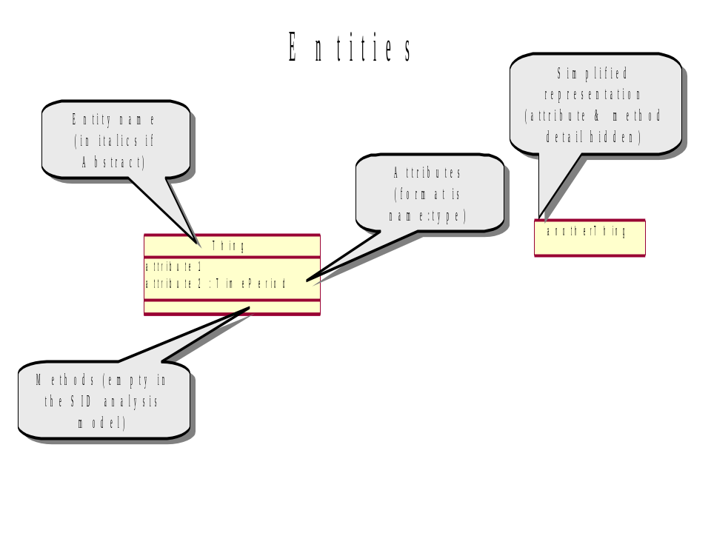
Figure 10-2 UN1-Entities
Abstract entities are discussed in the “Abstract Superclass” pattern in Appendix 2.
Note that the Information Framework analysis models will not show methods.
An attribute represents a characteristic of an Entity (e.g. a chair may have attributes of weight & manufacture date). An attribute may optionally have its type specified, as shown in figure UN1.
Complex attributes may be split into a separate Entity using the Composite Pattern (e.g. Person Entity and PersonName Entity) in Appendix 2.

Associations
An Association is shown as a solid line joining two entities, allowing us to show the relationships between entities. This relates to business information such as “Customers purchase Products”.
When an Association has its own separate properties, it is shown as an Association Entity, with a dashed line joining it to the association that it is representing.
Association names help us to understand what the association represents. The name will usually be a verbal phrase, like “Person has Name” or “Customer orders a Product”.
Associations are also assigned a cardinality at each end, indicating the number of instances participating in the relationship.
In some cases, an association may have an association role defined. An association role is used when an entity at one end plays a role in the association and is often used in self joins. e.g. an association between two individuals in a family to model the business rule “a parent has one or more children; each child has two parents”.
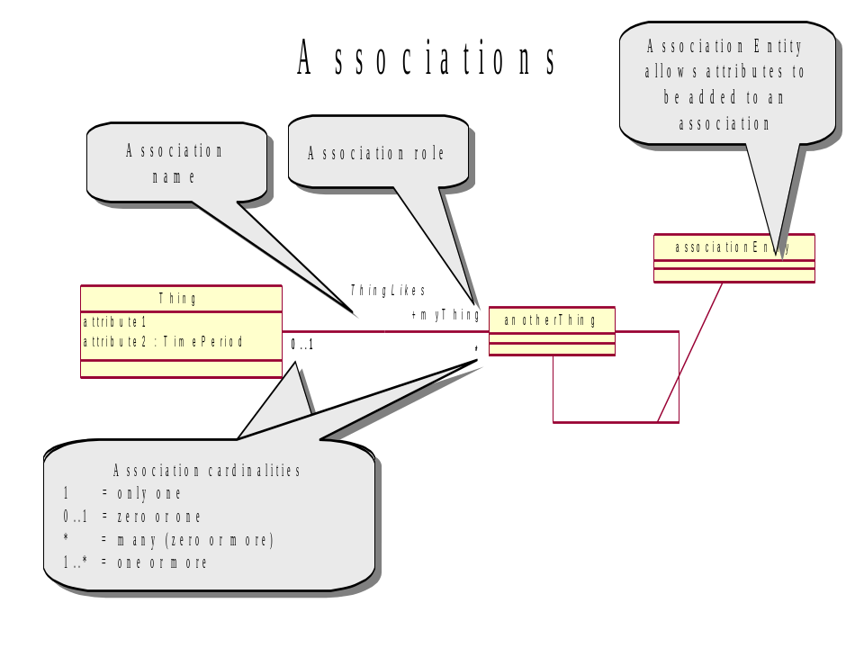
Figure 10-3 UN2 - Associations

Aggregation Association ^{[11]}
The aggregation association is an association that indicates that there is a closer relationship than with a normal association, such as a whole / part relationship. The aggregation association is shown with a ‘hollow diamond’ at the Entity that groups the parts.
Aggregation often relates to a business rule like “X has one or more Y, each Y is part of an X”.
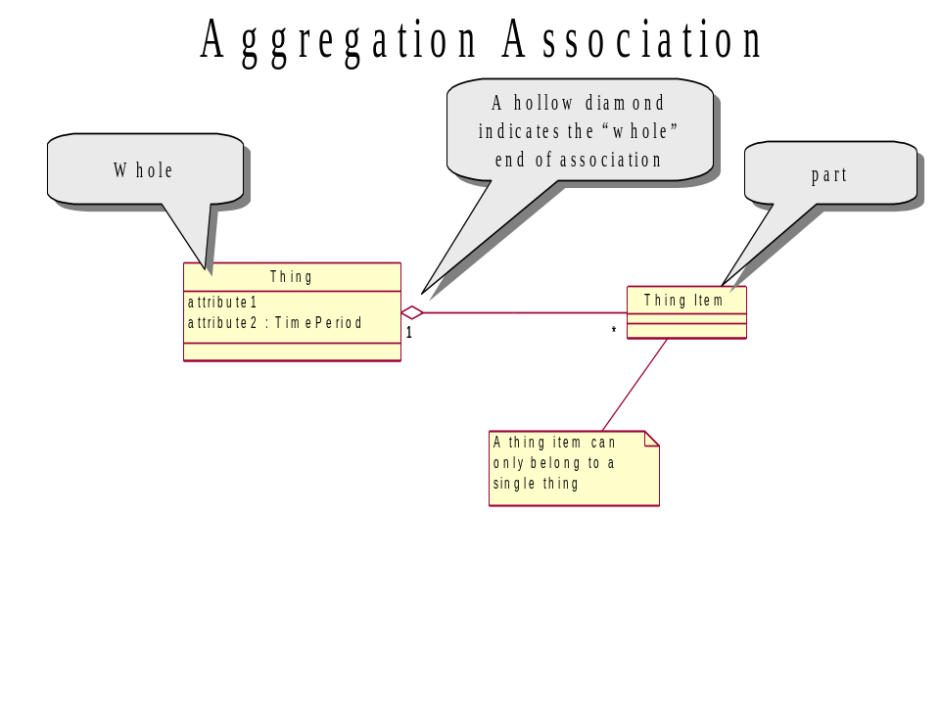
Figure 10-4 UN3 – Aggregation Association

Inheritance / Specialization
Inheritance relates generic entities to more specific variants.
This means that we can say that “A mobile phone is a type of phone”.
Overuse of inheritance can produce poor models and so simple “X is a type of Y” concepts are not always modeled in the Information Framework using inheritance.
In the Information Framework, parent entities are often shown as being abstract (the name is shown in italics). Abstract entities are discussed in the “Abstract Superclass” pattern.
Note that attributes in the parent entity are present in the child entity but are not repeated on UML diagrams.
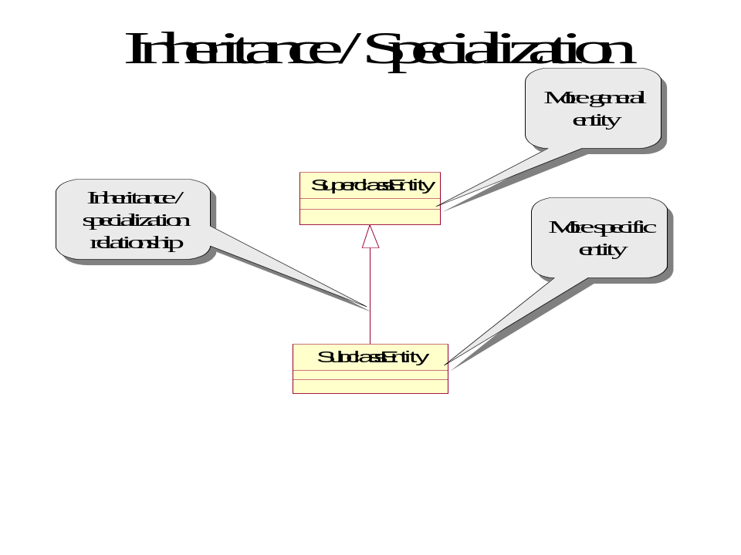
Figure 10-5 UN4 – Inheritance / Specialization

Appendix 2 - Analysis Patterns Used in Information Framework
This appendix introduces patterns that have emerged as we modeled the Business Process Framework processes in the Information Framework analysis model. We use these patterns to improve the quality of the Information Framework model, in particular the coupling & cohesion ^{[19]}.
Since the primary focus of this primer is not on patterns, only a brief overview will be given and a reference given to more detailed definitions.
A pattern can be described as follows:
”Each pattern describes a problem which occurs over and over again in our environment, and then describes the core of the solution to that problem, in such a way that you can use this solution a million times over, without ever doing it the same way twice”^{[18]}

Specification ^{[2]}
The Specification pattern is used in the Information Framework when:
“There needs to be a description about an item or service, independent of the current existence of any examples of those items or services”^{[2]}.
The Specification Entity doesn’t represent a concept or thing, but information about a concept or thing. Specification Entities are found in business concepts such as catalogs, manufacturing specifications, recipes and other documentation that relates to types of things rather than individual instances.
This pattern is used in the Information Framework Product Addendum (Product & ProductSpecification Entities) and most other Information Framework addenda.

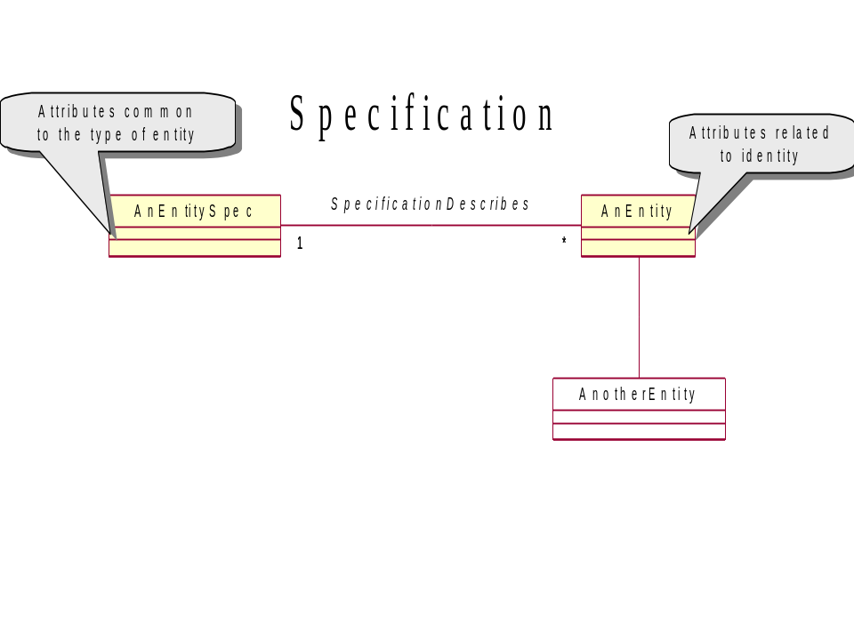
Figure 10-6 AP1 – Specification Pattern

Abstract Superclass ^{[14]}
We use the Abstract Superclass pattern to add superclass Entities to allow us to group similar Entities together. We make the parent Entity abstract, to show that it will not occur in the real world, but is a modeling construct.
The Abstract Superclass pattern helps make the Information Framework more general and easier to extend. This pattern helps us improve the modularity (coupling & cohesion ^{[19]}) of the Information Framework model.
This pattern is used extensively in the Information Framework (e.g. the Party Entity is an Abstract Superclass of the Individual Entity and the Organization Entity).
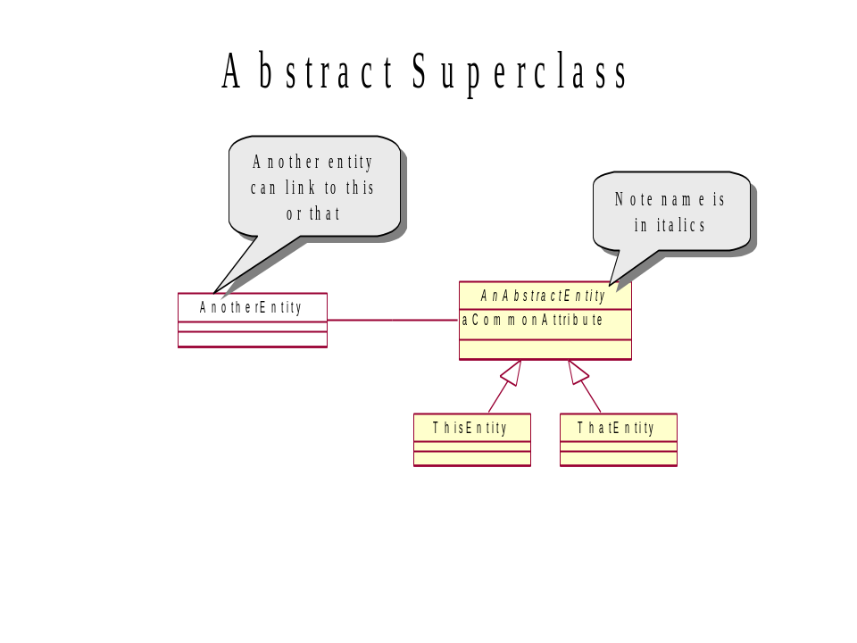
Figure 10-7 AP2a – Abstract Superclass Pattern
We will now go through a simple example of how the abstract entity pattern can be used to improve a model.
We may be asked to model a piece of business information “We sell bookshelves, chairs and desks to charities, individuals, companies and government departments”. If we just model this directly then we will produce a model that will be complex and hard to extend.
If we add two new abstract entities, we can now say “We sell furniture to BusinessParties”. The new concepts show a more fundamental understanding of the business. Note that Furniture is a placeholder for the “Concrete Entities” Chair, Desk & Bookshelf. Furniture is abstract because when we sell something to a particular customer we don’t say “I just sold a furniture to John Brown”, instead we use one of the specific (concrete) entities.
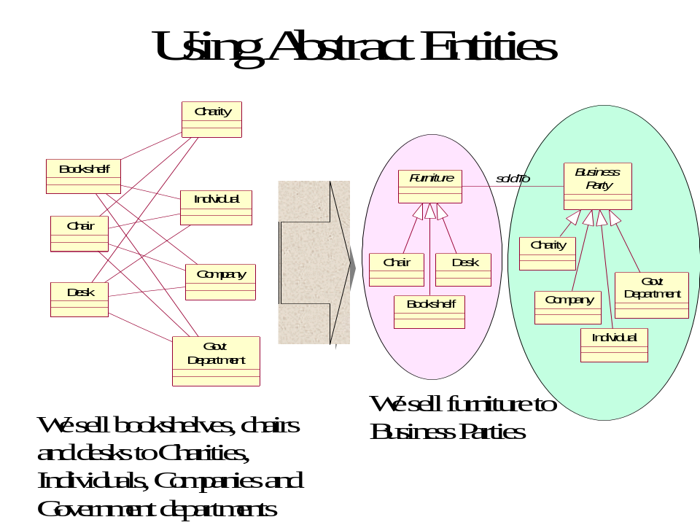
Figure 10-8 AP2b – Abstract Superclass Pattern Example

Composite ^{[9]}
The Composite pattern is usually thought of as a design pattern^{[12]}.
“Assemble objects into tree structures. COMPOSITE simplifies clients by
letting them treat individual objects and assemblies of objects uniformly.”

In the Information Framework, we use the Composite pattern when there is a business concept where a single thing or a collection of those things can be used interchangeably. For example, in a warehouse the concept of a “stock item” may include parts, sub-assemblies and complete items.
This pattern is used extensively in the Information Framework (e.g. Party, Individual & Organization Entities).

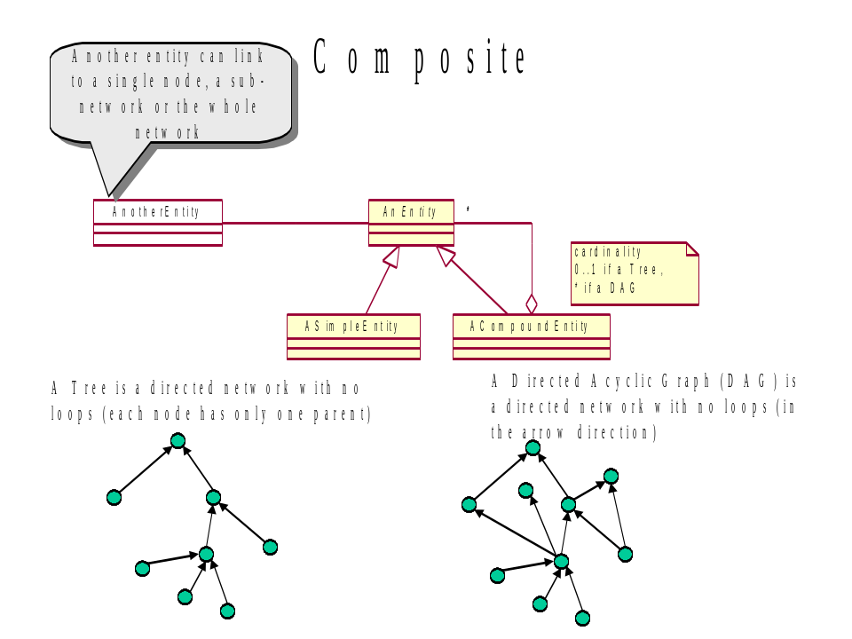
Figure 10-9 AP3 – Composite Pattern

Note that when we form composites of physical things, these often form tree structures. Composites of logical things and composites of specifications often form directed acyclic graphs. In effect this is just common sense. If I have a specific hard drive, it can only be plugged into a single computer at a time. A type of hard drive, however, may be able to be plugged into many different types of computers (PCs, Macintoshes, Sun Workstations etc.).

Role Entity^{[17]}
The Role Entity pattern allows us to represent behavior with respect to a given context. For instance, “A person who is a witness in the context of a legal trial”.

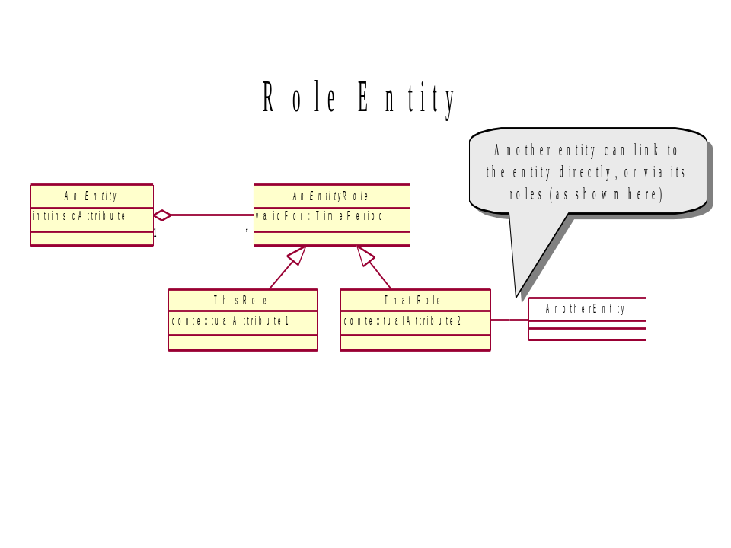
Figure AP4 – Role Entity Pattern

Use of roles is a fundamental pattern that helps us simplify a model, and make it more closely represent the real world.
Intrinsic attributes are those that a thing always has. Contextual attributes are those that relate to a thing in certain situations.
When modeling a thing, ask yourself if it has different behaviors in different circumstances i.e how it is being used, not just what it is. If so, the role pattern may be useful.
Representing the concept and its roles using two Entities makes the Information Framework model more robust to change and reduces duplication.

Temporal State Entity ^{[9]}
We use this pattern when we wish to be able to show the states of an entity, the attributes for each state and the temporal or lifecycle aspects of an Entity. An Entity’s state will change over time and we may wish to keep only the current state or a complete history, depending on the business requirements.
Separating the characteristics that we need to monitor over time into a separate entity allows us to show this more clearly than if it was shown as attributes in the entity.
Note that this pattern looks similar to the “Role Entity” pattern but represents a different concept.
The articles “Patterns for things that change with time” on Martin Fowler’s ^{[1]} web site give a good understanding of time related issues and are well worth reading.
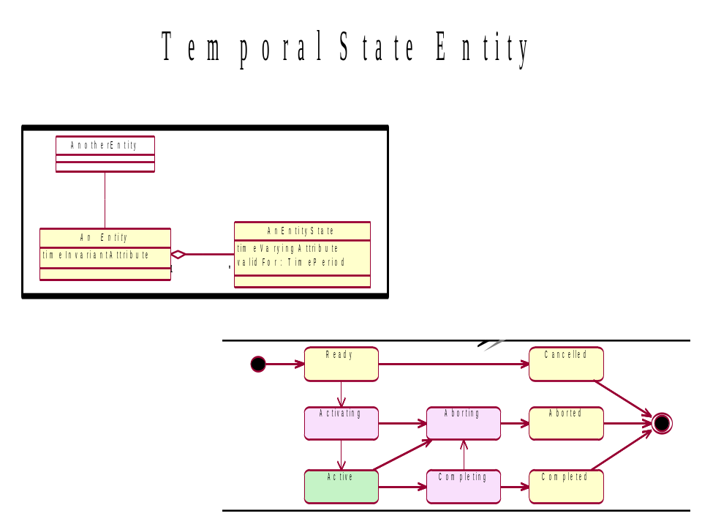
Figure AP5 – Temporal State Entity Pattern

Self Relationship ^{[8]}
The Self Relationship pattern is used when an instance of an entity may have a relationship to other instances of the same entity. For instance, a family tree could be formed by linking individuals to their parents.
This pattern is used in the Information Framework Project analysis model (e.g. Project Element Entity).

Relationship Type | Description
Dependency | This is where the two Entities have some starting or finishing dependency,. E.g. Activity 2 cannot start until Activity 1 is complete
Succession | This is where one or more Entities are replaced by one or more other Entities. This is an abstract relationship and one of the concrete types listed below must be used.
Substitution | This is a one for one replacement. e.g. Activity 1 is no longer valid and has been replaced by Activity 1A
Division | This is a one for many replacement. e.g. Activity 1 is no longer valid and has been replaced by Activities 1A, 1B and 1C
Fusion | This is a many for one replacement. e.g. Activities 1A, 1B and 1C are no longer valid and have been replaced by Activity 1Z
Table 10-3 AP1 – Self Relationship Types
Note how the model uses an association entity, allowing us to define attributes for the association.

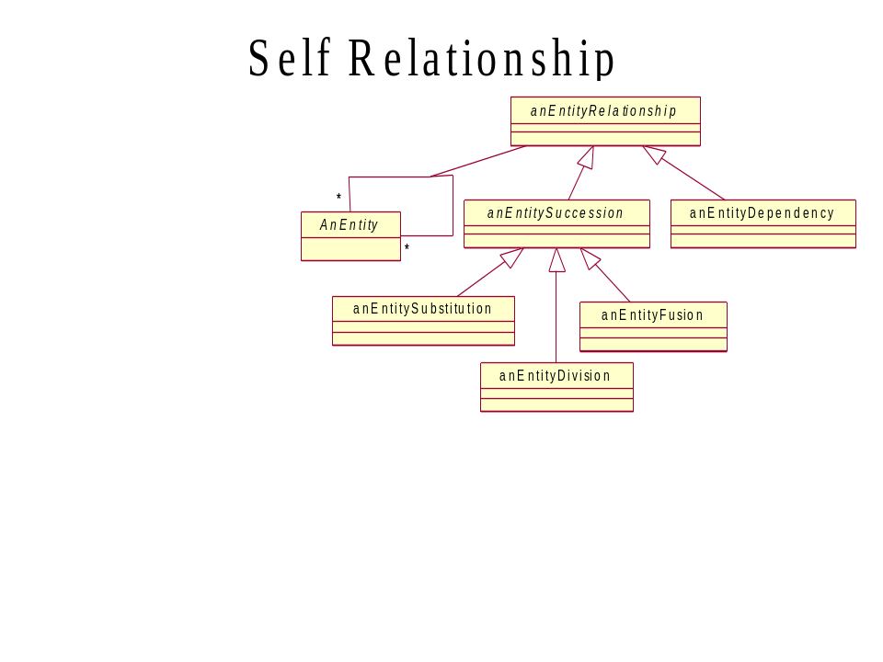
Figure 10-10 AP6 – Self Relationship Pattern

Administrative Appendix

Document History

Version History

Version Number | Date Modified | Modified by: | Description of changes
.9 | Dec 2003 | <<name>> | Initial Release
1.0 | Jan 2004 |  | Updated with SMT Feedback
1.1 | Aug 2004 |  | Updated to reflect TMF Approval Status
1.2 | March 2010 | Alicja Kawecki | Minor cosmetic corrections for web posting
1.3 | June 2010 | Alicja Kawecki | Updated Notice
1.4 | December 2010 | John Reilly | Corrected use of “Framework” to “Model” where appropriate
1.5 | March 2011 | Alicja Kawecki | Minor formatting corrections prior to web posting and ME
1.6 | September 2011 | Alicja Kawecki | Updated to reflect TM Forum Approved Status

Release History

Release Number | Date Modified | Modified by: | Description of changes
8.1 | March 2010 | Ken Dilbeck | Change SID to Information Framework and is part of Frameworx
9.5 | December 2010 | John Reilly | Updated to version 1.4.

Acknowledgments
This document was prepared by the members of the TeleManagement Forum Information Framework team:
The Shared Information/Data model (SID or Information Framework) is a genuinely collaborative effort. The TM Forum would like to thank the following people for contributing their time and expertise to the production of this document. It is just not possible to recognize all the organizations and individuals that have contributed or influenced the introduction. We apologize to any person or organization we inadvertently missed in these acknowledgments.
Key individuals that reviewed, provided input, managed, and determined how to utilize inputs coming from all over the world, and really made this document happen were:

Name | Affiliation
Cliff Faurer | TeleManagement Forum
Chris Hartley | Telstra
Helen Hepburn | British Telecom
John Reilly | MetaSolv Software
Wayne Sigley | Telstra
John Strassner | Intelliden
Amr Elkady | Alcatel
Josh Salomon | Amdocs
Enrico Grosso | Telecom Italia Lab
Muli Koppel | Partner Communications Company Ltd
Roger Cutts | Vodafone
Matt Izzo | Agilent

