Shared Information/Data (SID) Model
Common Business Entity Definitions – Agreement (including Service Level Agreement)

GB922 Addendum 1A
TM Forum Approved Version 6.7


September, 2011

Notice
This material, including documents, code and models, has been through review cycles; however, due to the inherent complexity in the design and implementation of software and systems, no liability is accepted for any errors or omissions or for consequences of any use made of this material.
Under no circumstances will the TM Forum be liable for direct or indirect damages or any costs or losses resulting from the use of this specification. The risk of designing and implementing products in accordance with this specification is borne solely by the user of this specification.
This material bears the copyright of TM Forum and its use by members and non-members of TM Forum is governed by all of the terms and conditions of the Intellectual Property Rights Policy of the TM Forum (http://www.tmforum.org/Bylaws/1094/home.html) and may involve a claim of patent rights by one or more TM Forum members or by non-members of TM Forum.

Direct inquiries to the TM Forum office:
240 Headquarters Plaza,
East Tower – 10th Floor,
Morristown, NJ 07960 USA
Tel No. +1 973 944 5100
Fax No. +1 973 944 5110
TM Forum Web Page: www.tmforum.org

Table of Contents

Notice 2
Table of Contents 3
List of Figures 5
1. Business Entities 6
1.1. Common Business Entities/Agreement 6
1.1.1. Agreement Overview 6
1.2. Common Business Entities/Service Level Agreement 16
1.2.1. Service Level Agreement Overview 16
1.2.2. References 19
1.3. Agreement Business Entity Definitions 20
1.3.1. Agreement Business Entity Definition 20
1.3.2. AgreementApproval Business Entity Definition 23
1.3.3. AgreementAuthorization Business Entity Definition 23
1.3.4. AgreementTermOrCondition Business Entity Definition 24
1.3.5. AgreementItem Business Entity Definition 25
1.3.6. ServiceLevelAgreement Business Entity Definition 25
1.3.7. ServiceLevelAgreementItem Business Entity Definition 26
2. Administrative Appendix 27
2.1 About this document 27
2.2 Document Life Cycle 27
2.3 Document History 28
2.3.1 Version History 28
2.3.2 Release History 28
2.4 Acknowledgments 29

List of Figures
Figure A. 1 - Agreement Business Entity and Its Inherited Associations 7
Figure A. 2 - Business Interaction Roles 8
Figure A. 3 - Agreement Approval Business Entities 10
Figure A. 4 - Agreement Terms and Conditions 11
Figure A. 5 - Agreement Item and Its Related Business Entities 12
Figure A. 6 - Agreement Item Inherited Associations with Product, Service, and Resource 13
Figure A. 7 - Service Level Agreement’s Inherited Associations 15
Figure A. 8 . Service Level Agreement Item’s Association to Service Level Specification 16
Figure A. 9 - Agreement Business Entity Model 19

1. Business Entities

Common Business Entities/Agreement

Agreement Overview
One form of business interaction in which Parties (for example, Service Providers or Customers) engage is an agreement. An agreement is a contract or arrangement, either written or verbal and sometimes enforceable by law, such as a service level agreement or a customer price agreement. An agreement involves a number of other business entities, such as Products, Services, and/or Resources. This can also extend to Product, Resource, and/or Service specifications. In the SID model an agreement is a subclass (type) of BusinessInteraction. A resulting benefit is that an agreement inherits a number of informational characteristics from business interaction in the model.
The inherited business characteristics of an Agreement (class) include:
- Associations with Products, Service, and/or Resources (as well as with their specifications) involved in agreement items (not shown in the figure below)
- Association with business participants (Parties, Roles and Resources) that engage in Agreements
- Associations with locations (Locations)
- Associations with other BusinessInteractions, such as Requests, Responses, and Notifications
Details about BusinessInteractions can be found in GB922 Addendum 1BI – Business Interaction. This addendum, GB922 1A, focuses on the informational characteristics that are unique to an Agreement.
An Agreement possesses a number of attributes and relationships that are unique to it. The figure below shows the attributes unique to an Agreement. The remainder of this overview provides a glimpse of the relationships and other business entities that make up the aggregate business entity Agreement.

Figure A. 1 - Agreement Business Entity and Its Inherited Associations

Entities participating in an Agreement take on a number of Roles. These Roles include:
- Agreement owners; those entities who have entered into an agreement, such as a Customer and a Service Provider
- Agreement contacts; those entities who help with the administration of the agreement, such as emergency contacts, help desk contacts, and so forth
- Agreement authorizers; those entities who are responsible for the approval of the agreement
Agreement owner and Agreement contact information are inherited from the BusinessInteractionRole business entity; agreement authorizers are a specific type of PartyRole. The BusinessInteractionRole business entity is shown within the context of a BusinessInteraction in the figure below.

Figure A. 2 - Business Interaction Roles

The three roles and their derivatives become enumerated values for the biInteractionRole attribute that characterizes the Business Interaction Role business entity. For example, role values could include owner, emergency contact, authorizer, and so forth.
Authorizations of an Agreement indicate approval of the agreement. This involves more than just capturing who is the authorizer. For example, an Agreement and its versions may go through many different levels of approval. Two business entities, AgreementApproval and AgreementAuthorization, are used to model approvals in the SID model. These business entities are shown in the figure below.

Figure A. 3 - Agreement Approval Business Entities

AgreementApproval represents the acceptance of the agreement by the owners of the Agreement. During the negotiation of the Agreement, there could be several iterations of approvals. Approval may require the involvement of a number of business Parties. Each authorized signature may be recorded electronically or by the more traditional signature. The agreementSignatureRepresentation attribute is a record of the means by which the signature was obtained, for example electronically or by hand.
Agreements are bound by terms and conditions. In addition, individual items that make up an agreement may be bound by their own set of terms and conditions. Terms and conditions can include such things as exclusions, legal issues, and contract termination clauses. The figure below depicts the relationships that agreements have with terms and conditions.

Figure A. 4 - Agreement Terms and Conditions

Agreements can involve a number of Products, Services, and/or Resources, as well as their specifications. For example, an order from a new customer may specify a number of desired ProductOfferings; a ServiceLevelAgreement may specify the Services covered by the Agreement. Items on an Agreement may also be characterized by a price. The price may be a one-off price or a price associated to a ProductOffering (in the case of an order for a Product). The figure below shows how terms and conditions of an Agreement, along with a price, can be related to an AgreementItem and an Agreement.
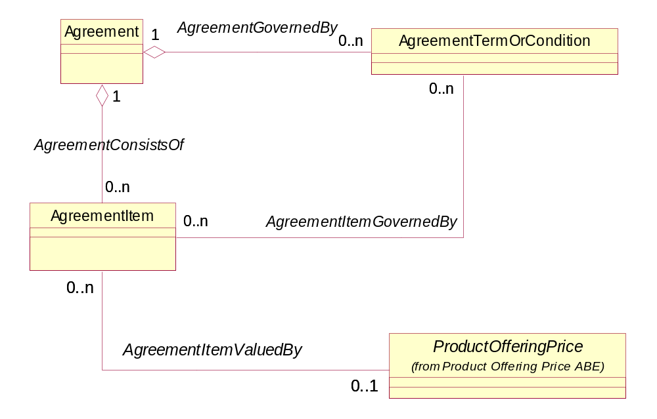
Figure A. 5 - Agreement Item and Its Related Business Entities

The associations to Product, Service, and/or Resource, along with their associated specifications, are inherited from the BusinessInteractionItem business entity, which is shown in the figure below.

Figure A. 6 - Agreement Item Inherited Associations with Product, Service, and Resource

Common Business Entities/Service Level Agreement

Service Level Agreement Overview
"A Service Level Agreement (SLA) (also know as a Service Level Guarantee) is a type of Agreement that represents a formal negotiated Agreement between two Parties designed to create a common understanding about Products, Services, priorities, responsibilities, and so forth. The SLA is a set of appropriate procedures and targets formally or informally agreed between parties in order to achieve and maintain specified Quality of Service".
“There are three distinct types of SLAs:
- Customer SLAs
  - These are aimed at the ProductOffering between the customer and the Service Provider, and are usually subject to a formal contract between the Customer and the Service Provider. They are written in terms that the customer understands and based on the end-to-end delivery of the product components defined in the ProductOffering.
- Supplier/Partner SLAs
  - These are aimed at Suppliers and/or Partners, and are meant to ensure that the performance objectives are met for service components that are provided by a Supplier or Partner. They are derived from or form part of the contractual agreement between the Supplier/Partner and the Service Provider.
- Internal SLAs
These are primarily Service- and/or Resource-focused. They are aimed at service elements (components of a service) or groups of service elements, and are subject to agreements between organizational functions within the operators business”
As a type of Agreement, ServiceLevelAgreements inherit all the informational characteristics of agreements previously describe in this addendum. Their inheritance is shown in the figure below.

Figure A. 7 - Service Level Agreement’s Inherited Associations

ServiceLevelAgreements do possess one unique characteristic. An AgreementItem is related to a ServiceLevelSpecification (see GB922 Addendum 4 – Service). A ServiceLevelSpecification is a group of ServiceLevelObjectives, such as thresholds, metrics, and tolerances, along with consequences that result from not meeting the objectives. ServiceLevelSpecifications are also characterized by exclusions associated to the Specification. These concepts are shown in the figure below.

Figure A. 8 . Service Level Agreement Item’s Association to Service Level Specification

References
ACIA | Alliance Common Information Architecture (AT&T, BT & Concert) version 3.1, 15 Dec 2000
Business Interaction Addendum | GB922 version 5.0 (draft)
eTOM | GB921 version 3.5
SLA Handbook | GB917 version 1.5
Service Addendum | GB922 version 1.1 (draft)
Wireless Services Measurement Handbook | GB923 version 1.0 (member evaluation)
XML Specification of SLAs for Telecom Services | Stephen Cross, University of Oxford, Masters Thesis, Feb 2002.

Agreement Business Entity Definitions

Agreement Business Entity Definition
Business Entity Name | Agreement
Description | A type of BusinessInteraction that represents a contract or arrangement, either written or verbal and sometimes enforceable by law.
Sources | All references noted in this addendum | Cross- References |  |  | Synonyms / Aliases | Business Agreement
Related Business Entities | AcceptedVia AggrementApproval  ModifiedBy AgreementVersion  GovernedBy AgreementTermOrCondition  ConsistsOf AgrementItem
Business Rules

Business Entity Attributes Definition
Business Entity Name | Agreement
Attribute Name | Description | Data Type | Characteristics, Permitted Values & Units | Required/  Optional | Notes
agreementDocumentNumber | A reference number assigned to an Agreement that follows a prescribed numbering system. | String |  | Optional
AgreementStatementOfIntent | An overview and goals of the Agreement. | String |  | Optional
agreementPeriod | The time period during which the Agreement is in effect. | PolicyConditionTimePeriod |  | Required

Business Entity Model

Figure A. 9 - Agreement Business Entity Model

AgreementApproval Business Entity Definition
Business Entity Name | AgreementApproval
Description | A group of AgreementAuthorizations required from the BusinessParticipants involved in the Agreement.
Sources | XML Specification of SLAs for Telecom Services | Cross- References |  |  | Synonyms / Aliases
Related Business Entities | DocumentsApprovalOf Agreement  RepresentedBy AgreementAuthorization
Business Rules

AgreementAuthorization Business Entity Definition
Business Entity Name | AgreementAuthorization
Description | BusinessParticpant responsible for approving an Agreement.
Sources | XML Specification of SLAs for Telecom Services | Cross- References |  |  | Synonyms / Aliases
Related Business Entities | represents AgreementApproval  authorizedBy BusinessInteractionRole
Business Rules

Business Entity Attributes Definition
Business Entity Name | AgreementAuthorization
Attribute Name | Description | Data Type | Characteristics, Permitted Values & Units | Required/  Optional | Notes
agreementAuthorizationState | Current status of the authorization, for example in process, approved, rejected. | Integer |  | Required
agreementAuthorizationDate | The date associated with the status. | Date |  | Required
agreementSignatureRepresentation | Indication that represents whether the signature is a physical paper signature or a digital signature. | Integer |  | Optional

AgreementTermOrCondition Business Entity Definition
Business Entity Name | AgreementTermOrCondition
Description | Aspects of the Agreement not formally specified elsewhere in the Agreement and that cannot be captured elsewhere in a formal notation, or automatically monitored and require a more human level of management.
Sources | XML Specification of SLAs for Telecom Services  ACIA | Cross- References |  |  | Synonyms / Aliases
Related Business Entities | Govern Agreement  Govern AgreementItem
Business Rules

Business Entity Attributes Definition
Business Entity Name | AgreementTermOrCondition
Attribute Name | Description | Data Type | Characteristics, Permitted Values & Units | Required/  Optional | Notes
term/conditionNumber | Unique number assigned for reference. | Number |  | Required
description | Text that explains the AgreementTermOrCondition. | String |  | Required
validFor | The period of time during which the AgreementTermOrCondition applies. | Time Period

AgreementItem Business Entity Definition
Business Entity Name | AgreementItem
Description | The purpose for an Agreement expressed in terms of a Product, Service, Resource, and/or their respective specifications, inherited from BusinessInteractionItem.
Sources | ACIA | Cross- References |  |  | Synonyms / Aliases
Related Business Entities | SpecifiedBy Agreement  GovernedBy AgreementTermOrCondition
Business Rules

ServiceLevelAgreement Business Entity Definition
Business Entity Name | ServiceLevelAgreement
Description | A ServiceLevelAgreement (SLA) is a type of Agreement that represents a formal negotiated agreement between two parties designed to create a common understanding about Products, Services, priorities, responsibilities, and so forth. The SLA is a set of appropriate procedures and targets formally or informally agreed between parties in order to achieve and maintain specified Quality of Service.
Sources | WSM Handbook (GB923) | Cross- References |  |  | Synonyms / Aliases | Service Level Guarantee
Related Business Entities | Inherited from BusinessInteraction and Agreement business entities
Business Rules

ServiceLevelAgreementItem Business Entity Definition
Business Entity Name | ServiceLevelAgreementItem
Description | The purpose for a ServiceLevelAgreement expressed in terms of a Product, Service, Resource, and/or their respective specifications, inherited from BusinessInteractionItem and in terms of ServiceLevelSpecification(s).
Sources | SID team | Cross- References |  |  | Synonyms / Aliases
Related Business Entities | QualityMeasuredUsing ServiceLevelSpecification
Business Rules

2. Administrative Appendix
This Appendix provides additional background material about the TeleManagement Forum and this document. In general, sections may be included or omitted as desired, however a Document History must always be included..

2.1 About this document
This is a TM Forum Guidebook. The guidebook format is used when:
- The document lays out a ‘core’ part of TM Forum’s approach to automating business processes. Such guidebooks would include the Telecom Operations Map and the Technology Integration Map, but not the detailed specifications that are developed in support of the approach.
- Information about TM Forum policy, or goals or programs is provided, such as the Strategic Plan or Operating Plan.
- Information about the marketplace is provided, as in the report on the size of the OSS market.

2.2 Document Life Cycle
This document is being issued for Member Evaluation. The purpose of an Evaluation Version is to encourage input based on experience of members and the public as they begin to use the document. Following the Evaluation Period, documents that are seen to deliver value are candidates for formal approval by the TM Forum. All documents approved by the TM Forum undergo a formal review and approval process.
This document will continue under formal change control. Supporting work will be issued as companions to this document. A document of this type is a “living document,” capturing and communicating current knowledge and practices. Further inputs will be made because of detailed work ongoing in the TM Forum and the industry.

2.3 Document History

2.3.1 Version History
<This section records the changes between this and the previous document version as it is edited by the team concerned. Note: this is an incremental number which does not have to match the release number>

Version Number | Date Modified | Modified by: | Description of changes
1.1 | Aug 2002 |  | First Draft
1.2 | Sept 2002 |  | Updated based on team comments
3.0a | Apr 2003 |  | Updated business entity definitions, attribute definitions, association names, and figures.
5.0 | Jun 2004 |  | Updated business entity definitions, attribute definitions, association names, and figures based on member feedback.
5.1 | July 2004 |  | Minor updates to synchronize with contract spec
5.2 | August 2004 | John Reilly | Final comments prior to release
6.0 | July 2005 | John Reilly | Integrate member comments
6.1 | November 2005 | Tina O'Sullivan | Converted to new template and corrected various administrative items.
6.2 | November 2005 | Tina O'Sullivan | Figure labels.
6.3 |  | Tina O'Sullivan | Updated notices & document status
6.5 | December 2010 | John Reilly | Updated Notice
6.6 | March 2011 | Alicja Kawecki | Minor formatting corrections prior to web posting and ME
6.7 | September 2011 | Alicja Kawecki | Updated to reflect TM Forum Approved status

2.3.2 Release History
<This section records the changes between this and the previous Official document release>

Release Number | Date Modified | Modified by: | Description of changes
Release 6.0 | 31-Oct-2005 | J. Reilly
Release 9.5 | 28Dec2010 | John Reilly | Updated Notice

2.4 Acknowledgments
This document was prepared by the members of the TeleManagement Forum SID team:
The Shared Information/Data Model is a genuinely collaborative effort. The TM Forum would like to thank the following people for contributing their time and expertise to the production of this document. It is just not possible to recognize all the organizations and individuals that have contributed or influenced the introduction. We apologize to any person or organization we inadvertently missed in these acknowledgments.
Key individuals that reviewed, provided input, managed, and determined how to utilize inputs coming from all over the world, and really made this document happen were:
Name | Affiliation
Ian Best | TeleManagement Forum
Chris Hartley | Telstra
John Reilly | MetaSolv Software
Wayne Sigley | Telstra
John Strassner | Motorola
Johan Lindblahd | Ki Consulting

Excerpt from Wireless Service Measurements Handbook (GB923), TeleManagement Forum, 2002, page 14.
Ibid., page 38-39.

