Shared Information/Data (SID) Model
Common Business Entity Definitions – Business Interaction

GB922 Addendum 1BI
TM Forum Approved Version 6.11


October, 2012

Notice
This material, including documents, code and models, has been through review cycles; however, due to the inherent complexity in the design and implementation of software and systems, no liability is accepted for any errors or omissions or for consequences of any use made of this material.

Under no circumstances will the TM Forum be liable for direct or indirect damages or any costs or losses resulting from the use of this specification. The risk of designing and implementing products in accordance with this specification is borne solely by the user of this specification.

This material bears the copyright of TM Forum and its use by members and non-members of TM Forum is governed by all of the terms and conditions of the Intellectual Property Rights Policy of the TM Forum (http://www.tmforum.org/Bylaws/1094/home.html) and may involve a claim of patent rights by one or more TM Forum members or by non-members of TM Forum.

Direct inquiries to the TM Forum office:
240 Headquarters Plaza,
East Tower – 10th Floor,
Morristown, NJ 07960 USA
Tel No. +1 973 944 5100
Fax No. +1 973 944 5110
TM Forum Web Page: www.tmforum.org

Table of Contents
Notice 2
Table of Contents 3
List of Figures 4
1. Business Entities 5
1.1. Business Interaction Entities 5
1.1.1. Business Interaction 5
1.1.2. Disputed Amount 13
1.2. Business Interaction Data Dictionary 16
1.2.1. BusinessInteractionSpec 16
1.2.2. BusinessInteraction 17
1.2.3. BusinessInteractionItem 20
1.2.4. BusinessInteractionItemPrice 22
1.2.5. BusinessInteractionVersion 23
1.2.6. BusinessInteractionRole 24
1.2.7. BusinessInteractionLocation 26
1.2.8. BusinessInteractionRelationship 26
1.2.9. AtomicBusinessInteraction 27
1.2.10. CompositeBusinessInteraction 28
1.2.11. BusinessInteractionType 28
1.2.12. Agreement 29
1.2.13. Notification 30
1.2.14. Request 31
1.2.15. Response 33
1.2.16. Command 34
1.2.17. InquiryRequest 35
1.2.18. DisputedAmount 36
1.2.19. DisputedAmountActivity 37
1.2.20. DAACreated 38
1.2.21. DAARejected 39
1.2.22. DAACancelled 40
1.2.23. DAAAccepted 41
1.2.24. DAACompleted 42
2. Administrative Appendix 43
2.1 About this document 43
2.2 Document Life Cycle 43
2.3 Document History 44
2.3.1 Version History 44
2.3.2 Release History 45
2.4 Acknowledgments 46

List of Figures
Figure BI. 1 - Types of Business Interactions 5
Figure BI. 2 – Relationship Between Business Interactions 6
Figure BI. 3 – Business Interaction Specification 7
Figure BI. 4 – Business Interaction Version 7
Figure BI. 5 - Business Interaction Relationships with Party Roles, Resource Roles, and Customer Accounts 8
Figure BI. 6 - Relationship Between Business Interaction and Product Offering 9
Figure BI. 7 – Product Offering Price and Business Interaction 10
Figure BI. 8 - Relationship Between Business Interaction and Product Domain Entities 11
Figure BI. 9 – Business Interaction Item Association with Product, Service, and Resource Domain Entities 12
Figure BI. 10 - Relationship Between Business Interaction and Location 13
Figure BI. 11 – DisputedAmount Lifecycle 14
Figure BI. 12 - DisputedAmount Main Business Entities 15
Figure BI. 13 - DisputedAmountActivity Entities Representing the DisputedAmount Life Cycle 16
Figure BI. 14 – Business Interaction Model (BusinessInteractionVersion not shown) 19
Figure BI. 15old – Request Business Entities 32
Figure BI. 15 – Request Business Entities 33

1. Business Entities

Business Interaction Entities

Business Interaction
In the course of doing business a service provider interacts with other entities such as individuals and organizations (or parts of organizations). Individuals and organizations are known as parties. Parties can play a number of different roles from a service provider’s perspective. A party could play the role of customer, employee, supplier, partner, and so forth. Business interactions can also involve such things as applications, intelligent devices, and other types of resources. Interactions can also involve customer accounts.
Business interactions take the form of requests, responses, notifications, and agreements. The figure below depicts a business interaction and its various types.
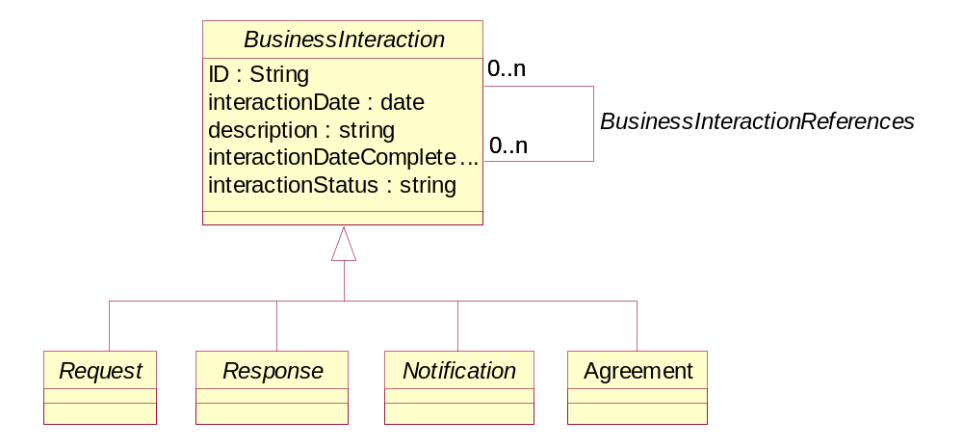
Figure BI. 1 - Types of Business Interactions
Figure BI. 1 also shows that business interactions can be related to each other. For example, a request for information from an individual is followed by a response from a service provider back to the individual. The request and the response are associated with each other so that the string of related business interactions is maintained. The figure below shows this type of relationship between business interactions.
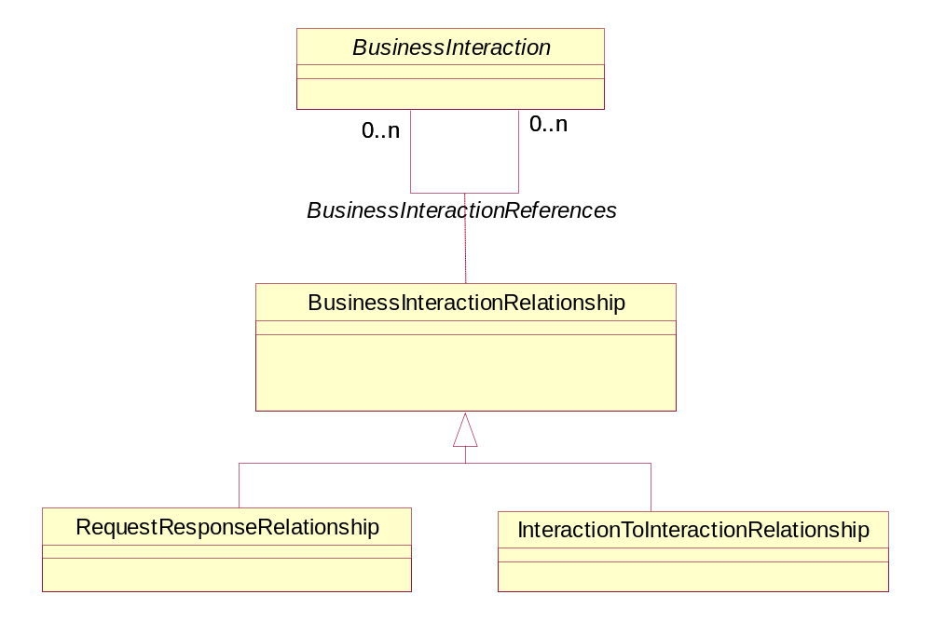
Figure BI. 2 – Relationship Between Business Interactions
Other types of associations can exist between business interactions. For example, a Product may be realized by configuring a number of services. A provisioning (or service) order is created for the product and associated to a number of orders that configure each of the services.
The Business Interaction ABE model employs the commonly used SID EntitySpecification/Entity pattern. Conceptually, a BusinessInteractionSpec defines the invariant attributes and relationships (and in the system view, methods and constraints as well) for defining a set of BusinessInteractions. A BusinessInteraction uses these invariant characteristics and behavior and adds instance-specific characteristics and behavior to them such that, by building from a base of standard capabilities, it becomes possible to create unique BusinessInteractions that are specifically targeted at different users, market segments, and so forth. The figure below shows the relationship between a BusinessInteractionSpec and a BusinessInteraction.

Figure BI. 3 – Business Interaction Specification
More than one version of a business interaction may exist during the interaction’s life. This is an important facet of an interaction. The figure below depicts a minimalist approach for handling interaction versions. The different versions can be linked together using the BusinessInteractionRelationship entity. Much more elaborate versioning models can be developed as needed by a user of the SID model. The figure below shows the minimalist approach to business interaction versions.
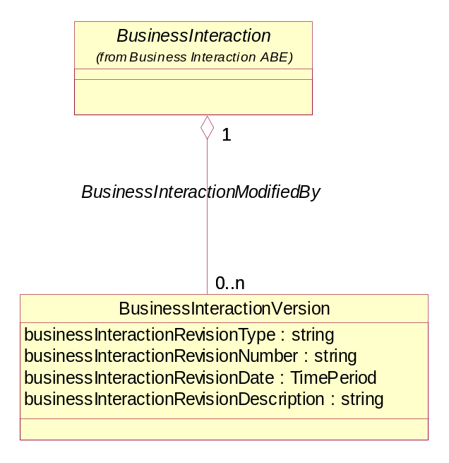
Figure BI. 4 – Business Interaction Version
More than one business entity can be involved in an interaction. For example, Bob Smith, a business entity playing the party role of a customer, requests information about cable modem service from Joe Jones, a business entity playing the party role of a customer service representative.
As stated earlier, business entities involved in an interaction can also be resources. For example,
a) A soft drink machine receives an inquiry from a third party servicing agent (or an automatic timed status report transmission from the machine) to gather data on the stock level, fault or performance data or even a cash transaction report.
b) Activation instructions could be delivered to your home heating/cooling system ready for your arrival. A burglar alarm could send a video image of an intruder to a monitoring office.
c) A car could have a mobile radio device to communicate with the engine management system as well as the vehicle user. This could be an extension of a personal communicator using a ‘Blue Tooth’ radio access system.
Business entities involved in an interaction can also be customer accounts. For example, different products offerings involved as interaction items could be charged to one or more customer accounts.
The figure below depicts the relationship that business entities have with business interactions and how the business entities party role, resource role, and customer account, are involved in business interactions.
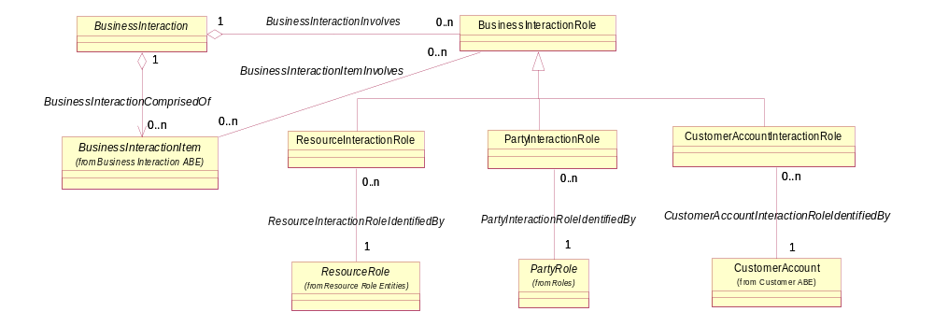
Figure BI. 5 - Business Interaction Relationships with Party Roles, Resource Roles, and Customer Accounts
As described in the example above, the inquiry request type of business interaction from Bob Smith involves a product offering that is made available by a service provider. The figure below depicts the involvement that product offerings have with all types of business interactions.
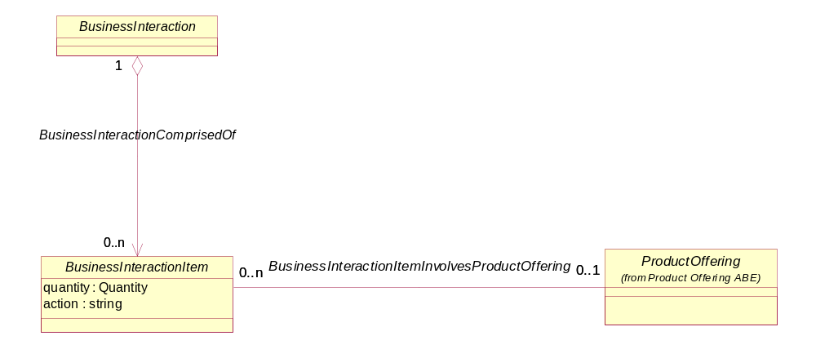
Figure BI. 6 - Relationship Between Business Interaction and Product Offering
A number of product offerings can be involved in a business interaction. The business interaction business entity in Figure BI.3 allows for multiple items, such as product offerings, to be handled by a single instance of a business interaction.
Prices are often associated with product offerings involved in business interaction, such as customer orders, agreements, requests for quotes, and so forth. Additionally, these prices are sometimes influenced by rules (in the form of policies) that govern product offering prices. Figure BI. 4, below, shows these associations.
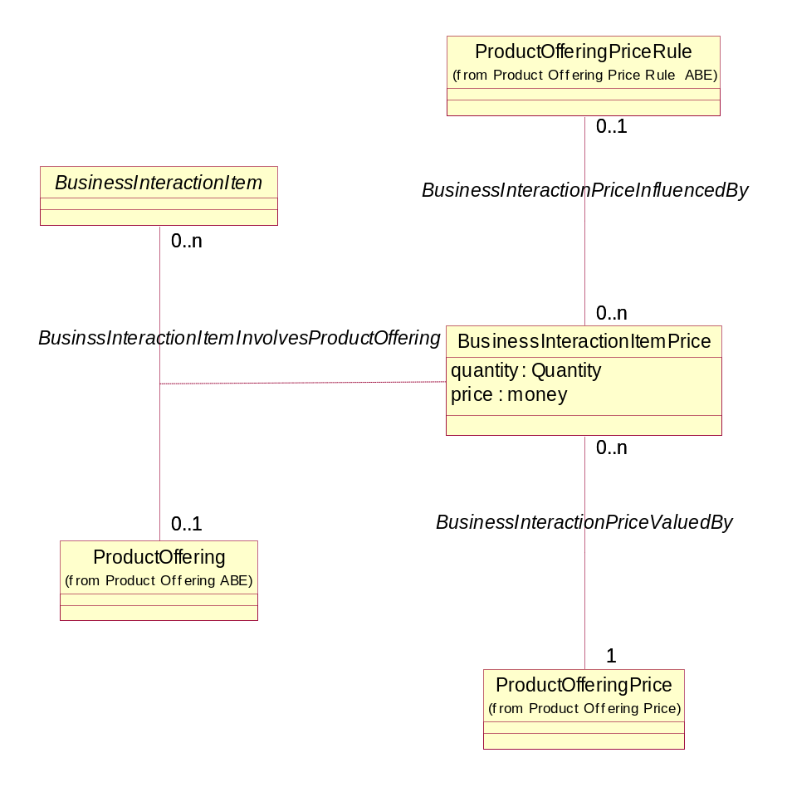
Figure BI. 7 – Product Offering Price and Business Interaction
Similarly, if Bob Smith already has cable modem, the request may be for a change to the product provided to Bob. Product offerings obtained by a customer are called products. The figure below depicts the involvement that products have with all types of business interactions.
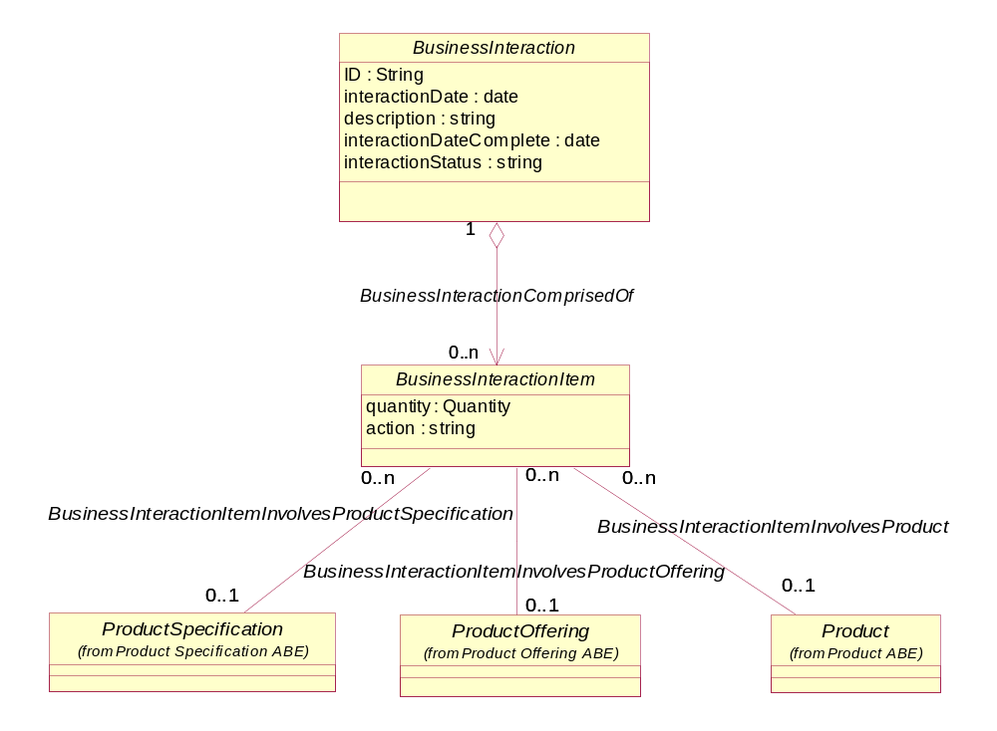
Figure BI. 8 - Relationship Between Business Interaction and Product Domain Entities
In addition to product offerings and products, services and resources are also the focus of in business interactions. For example, one service provider may enter into a lease agreement to use a connection belonging to another service provider; the failure of a network device may precipitate the need to send a notification communicating the need to repair the device to a technician, while another notification must be sent to the service subscribes offering an alternative product offering for use by the subscribers. The relationship that product, service, and resource business entities have with business interaction is shown in the figure below.
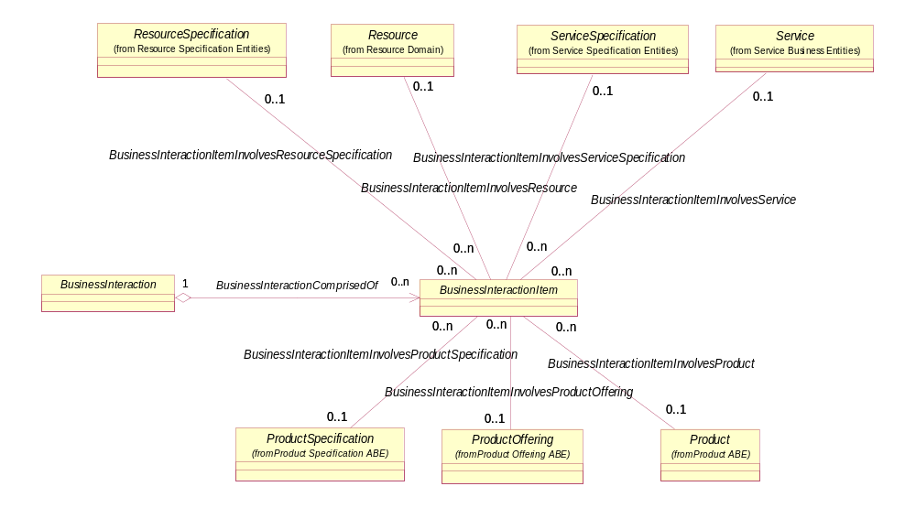
Figure BI. 9 – Business Interaction Item Association with Product, Service, and Resource Domain Entities
During the interaction, Bob Smith may also provide information about the location (referred to as a Location or Place in the SID Model) of his cable modem. Therefore, as shown in the figure below, a business interaction also can involve one or more Locations. In the SID model, locations, such as addresses, geographic areas, and geographic coordinates are collectively called Locations.
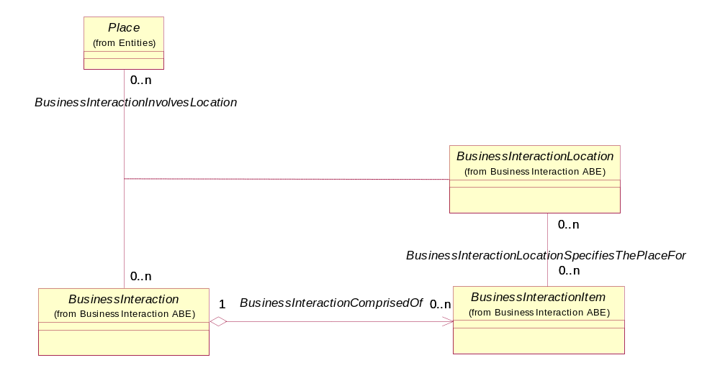
Figure BI. 10 - Relationship Between Business Interaction and Location
In summary, a business interaction involves a number of other business entities, including product offerings, products, Locations, and business participants.
By using the concept of a business interaction, each of its various types, such as agreement and notification, can inherit the business interaction’s relationships, attributes and behaviors without having to explicitly show these for each type. For example, it would be quite redundant and unstable to show an agreement and a notification, and a request, and a response, and a command each participating in relationships to business participants, locations, products, services, and resources. What would happen if this was done and another type of business interaction was discovered?

Disputed Amount
DisputedAmount represents a business interaction in which a party (Customer or Supplier/Partner) complains about an amount it is charged for by the enterprise, and this complaint is under investigation. From financial perspective this amount is handled differently than other charges as it may not be included in Collections (dunning) calculations and in late payment fee calculations. The base class is defined here, and is further refined in the appropriate domains (Customer and Supplier/Partner).
The lifecycle of disputed amount is described in the following diagram:
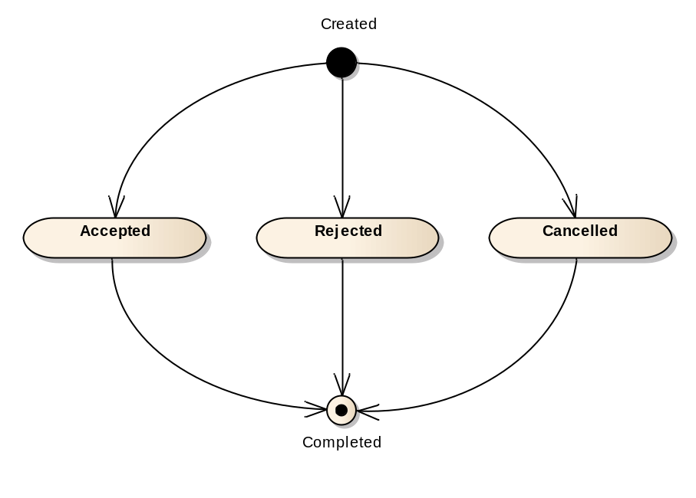
Figure BI. 11 – DisputedAmount Lifecycle

DisputedAmount is modeled as type of request since it is a state in the lifecycle of a request for credit from the Customer or Supplier/Partner.
Following is the model of DisputedAmount main business entities.
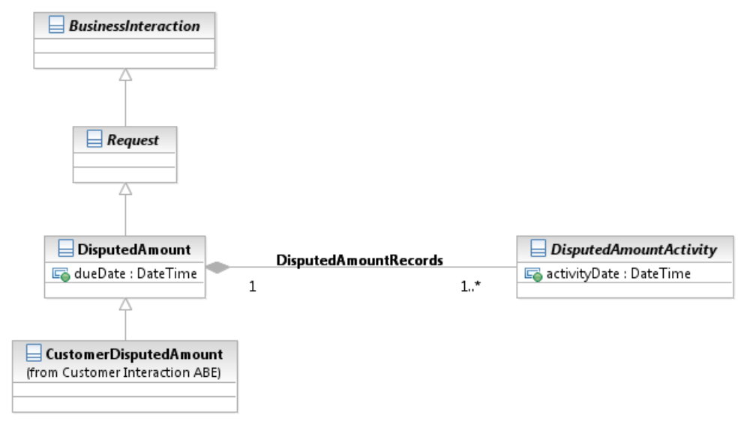
Figure BI. 12 - DisputedAmount Main Business Entities
Note: Suppier/Partner dispute is not included here since it is not modeled in the Information Framework yet. This is a candidate for future improvement of this model.
The modeling of the DisputedAmount state is depicted in the following diagram. Since UML does not support lifecycle modeling directly the states are modeled as subclasses of DisputedAmountActivity, which are contained by DisputedAmount.
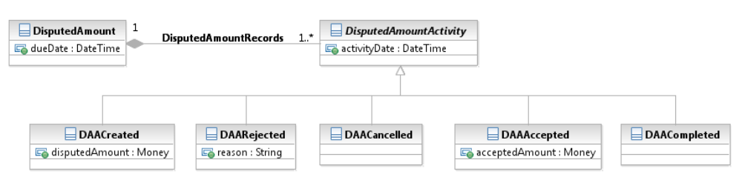
Figure BI. 13 - DisputedAmountActivity Entities Representing the DisputedAmount Life Cycle
DisputedAmountActivity is not a subclass of BusinssInteractionItem since it does not need all association from BusinessInteractionItem to other business entities
DAARejected represents rejection by the enterprise, while DAACancelled represents cancellation of the request by the Customer.
Further refinement of this model can be found in the Customer and Supplier/Partner domains.

Business Interaction Data Dictionary

BusinessInteractionSpec

Business Entity Definition
Business Entity Name | BusinessInteractionSpec
Description | The invariant characteristics (attributes in the business view, and methods, constraints, relationships, and behavior in the system view) and behavior of a BusinessInteraction. This is done by optionally defining a set of BusinessInteractionSpecItems, each of which aggregates one or more other types of Specifications. This helps to ensure that different BusinessInteractions have the same basic characteristics and behavior by deriving them from the same BusinessInteractionSpec.
Sources | Motorola | Cross- References |  |  | Synonyms / Aliases
Related Business Entities | Characterizes BusinessInteraction
Business Rules

BusinessInteraction

Business Entity Definition
Business Entity Name | BusinessInteraction
Description | A BusinessInteraction is an arrangement, contract, or communication between one or more Business Participants. A BusinessInteraction may consist of one or more BusinessInteractionItems. A BusinessInteractionItem may refer to a Product, Service, Resource, or one of their specifications. A BusinessInteraction is further defined by one or more Locations. One BusinessInteraction may reference another BusinessInteraction and one BusinessInteractionItem may reference another BusinessInteractionItem on the same or different BusinessInteraction. There are types of BusinessInteractions are: Requests, Responses, Notifications, and Agreements.
Sources | Unified Ordering Model (T1M1, OBF, TCIF joint project), British Telecom TMF contribution, MetaSolv TMF contribution | Cross- References |  |  | Synonyms / Aliases | Communication, Message
Related Business Entities | ParticipantsAreDefined by BusinessInteractionRole  References BusinessInteraction  LocatedVia Location  CategorizedBy BusinessInteractionType  ComposedOf BusinessInteractionItem
Business Rules

Business Entity Attributes Definition
Business Entity Name | BusinessInteraction
Attribute Name | Description | Data Type | Characteristics, Permitted Values & Units | Required/  Optional | Notes
ID | Unique identifier for Interaction. | String |  | Required
interactionDate | Date interaction initiated | Date |  | Required
description | Narrative that explains the interaction and details about an interaction, such as why an interaction is taking place. | String |  | Required
interactionStatus | The current condition of an interaction, such as open, in research, closed, and so forth. | String |  | Required
interactionDateClosed | The date on which an interaction is closed or completed. | Date |  | Optional

Business Entity Model
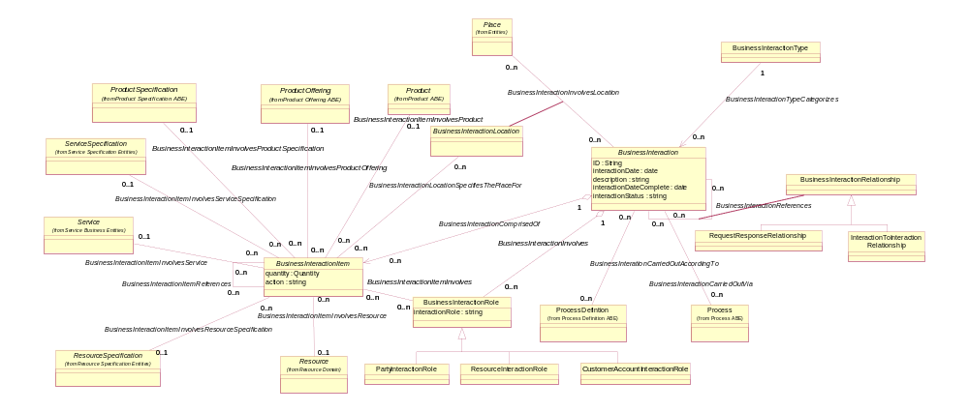
Figure BI. 14 – Business Interaction Model (BusinessInteractionVersion not shown)

Note on Business Interaction Subclasses
There are attributes (a few) and associations (quite a few) for business interactions. None can be found for the intermediate subclasses…only for the leaf level classes. The intermediate subclasses are useful for categorization and organization reasons, but from an implementation view, only Interaction and the leaf level subclasses are needed.
Business Interaction Examples
Example 1
Dan M., a business participant playing the customer party role, communicates a request for information about cable internet access to John S., a business participant playing the customer service representative party role for Global Cable. The business interaction is an inquiry request for the product cable internet access.
John S. responds back to Dan M. with a quotation price for the cable internet access. The business participants do not change. The business interaction is a customer quote/offer request response.
Example 2
Wayne S., a business participant playing the party role of interested third party, communicates via the Web that he cut a cable while digging a water hazard for his backyard golf course. The business interaction is a trouble report not specifying a product, service, resource or specification. Wayne’s address is referenced as a business interaction Location.

BusinessInteractionItem

Business Entity Definition
Business Entity Name | BusinessInteractionItem
Description | The purpose for the BusinessInteraction expressed in terms of a ProductSpecification, ProductOffering, ServiceSpecification or ResourceSpecification or may refer to a Product, Service, or Resource.
Sources | SID Team | Cross- References |  |  | Synonyms / Aliases
Related Business Entities | Comprise BusinessInteraction  References BusinessInteractionItem  LocatedVia BusinessInteractionLocation  Specifies ProductSpecification  Specifies ProdutOffering  Specifies Product  Specifies ServiceSpecification  Specifies Service  Specifies ResourceSpecification  Specifies Resource
Business Rules

Business Entity Attributes Definition
Business Entity Name | BusinessInteractionItem
Attribute Name | Description | Data Type | Characteristics, Permitted Values & Units | Required/  Optional | Notes
quantity | Quantity of a Specification or Entity involved in a business interaction. | Quantity |  | Optional
action | The action to take for a BusinessInteractionItem, such as add, change, remove. | String |  | Required

Business Entity Model
See Business Interaction Business Entity Model

BusinessInteractionItemPrice

Business Entity Definition
Business Entity Name | BusinessInteractionPrice
Description | An amount associated with a BusinessInteractionItem that is valued by the associated ProductOfferingPrice.
Sources | MetaSolv model | Cross- References |  | Synonyms / Aliases
Related Business Entities | ValuesBusinessInteractionItem  InfluencedByPolicy  ValuedByProductOfferingPrice
Business Rules

Business Entity Attributes Definition
Business Entity Name | BusinessInteractionItemPrice
Attribute Name | Description | Data Type | Characteristics, Permitted Values & Units | Required/  Optional | Notes
quantity | The portion of the Business Interaction Item quantity that is valued by a price. | Quantity |  | Optional
price | A one-time price, not included as an available product offering price, associated with a business interaction item. | Money |  | Optional

BusinessInteractionVersion

Business Entity Definition
Business Entity Name | BusinessInteractionVersion
Description | A record of changes made to a BusinessInteraction.
Sources | XML Specification of SLAs for Telecom Services | Cross- References |  |  | Synonyms / Aliases
Related Business Entities | RepresentsModificationMadeTo BusinessInteraction  RecordedBy PartyRole
Business Rules

Business Entity Attributes Definition
Business Entity Name | BusinessInteractionVersion
Attribute Name | Description | Data Type | Characteristics, Permitted Values & Units | Required/  Optional | Notes
businessInteractionRevisionType | The significance of the revision. | String | Major, Minor | Required
businesInteractionRevisionNumber | A unique number that identifies the revision. | Number |  | Required
businessInteractionRevisionDate | The date of the revision. | Time Period |  | Required
businessInteractionRevisionDescription | Text that explains the revision, including why the revision was made. | String |  | Required

Business Entity Model
See BusinessInteraction Business Entity Model

BusinessInteractionRole

Business Entity Definition
Business Entity Name | BusinessInteractionRole
Description | An entity involved in a BusinessInteraction. The entity may be a Party playing a PartyRole or a Resource playing a ResourceRole, such as a system.
Sources | TMF SID team | Cross- References |  | Synonyms / Aliases
Related Business Entities | InvolvedInBusinessInteraction
Business Rules

Business Entity Model
See Business Interaction Business Entity Model

Business Entity Attributes Definition
Business Entity Name | BusinessInteractionRole
Attribute Name | Description | Data Type | Characteristics, Permitted Values & Units | Required/  Optional | Notes
interactionRole | The part a business entity plays in a business interaction, such as requester, responder, recipient, and so forth. | String |  | Required

Business Entity Model
See Business Interaction Business Entity Model

BusinessInteractionLocation

Business Entity Definition
Business Entity Name | BusinessInteractionLocation
Description | A Location involved in a BusinessInteraction. For example, John R’s home address is the Location where an ordered Product will be installed.
Sources | TMF SID team | Cross- References |  |  | Synonyms / Aliases
Related Business Entities | SpecifiesTheLocationfor BusinessInteraction  SpecifiesTheLocationfor BusinessInteractionItem
Business Rules

Business Entity Model
See Business Interaction Business Entity Model

BusinessInteractionRelationship

Business Entity Definition
Business Entity Name | BusinessInteractionRelationship
Description | An association between two BusinessInteractions. For example, a Notification sent to customers affected by a problem contained on a Trouble Report; a response to a request, an agreement and the interactions that led up to the agreement.
Sources | TMF SID team | Cross- References |  | Synonyms / Aliases
Related Business Entities | DefinesAssociationsBetween BusinessInteraction
Business Rules | BusinessInteractionType specifies the types of Interactions that can be related.

Business Entity Model
See Business Interaction Business Entity Model

AtomicBusinessInteraction

Business Entity Definition
Business Entity Name | AtomicBusinessInteraction
Description
Sources |  | Cross- References |  |  | Synonyms / Aliases
Related Business Entities
Business Rules

CompositeBusinessInteraction

Business Entity Definition
Business Entity Name | CompositeBusinessInteraction
Description
Sources |  | Cross- References |  |  | Synonyms / Aliases
Related Business Entities
Business Rules

BusinessInteractionType

Business Entity Definition
Business Entity Name | BusinessInteractionType
Description | The possible types of BusinessInteractions that can occur.
Sources | SID Team | Cross- References |  | Business Interaction | Synonyms / Aliases
Related Business Entities | Reference BusinessInteractionType
Business Rules

Business Entity Attributes Definition
Business Entity Name | BusinessInteractionType
Attribute Name | Description | Data Type | Characteristics, Permitted Values & Units | Required/  Optional | Notes
name | The name of a Business Interaction Type, such as Customer Inquiry, Customer Quote/Offer, Trouble Report. | String |  | Required
description | A brief narrative that describes a Business Interaction Type. | String |  | Optional

Agreement

Business Entity Definition
Business Entity Name | Agreement
Description | A contract or arrangement, either written or verbal and sometimes enforceable by law.
Sources | TMF SID team, British Telecom TMF Contribution | Cross- References |  |  | Synonyms / Aliases | Contract
Related Business Entities | ComprisedOf AgreementItem
Business Rules
Further details about the Agreement business entity can be found in Addendum 1A.

Business Entity Model
See Agreement Business Entity Model in Addendum 1A

Notification

Business Entity Definition
Business Entity Name | Notification
Description | A communication that informs about something that has or will happen. A Notification is typically one-sided, in that no Response is expected. A Notification can be created as the result of a Request; for example, a Trouble Report may result in Notifications being sent to affected Parties. A Notification is a type of Business Interaction.
Sources | Unified Ordering Model (T1M1, OBF, TCIF joint project). | Cross- References |  | Business Interaction | Synonyms / Aliases
Related Business Entities
Business Rules

Business Entity Model
See Business Interaction Business Entity Model
Notification Example
Based on Wayne S’s trouble report, those customers (Jane F. and Cliff F.) affected by the split cable are notified that their cable modem service will be out for the next several hours. Jane F. and Cliff F., the business participants are parties playing a customer party role. A Notification is created for both Jane and Cliff referencing their cable modem product instance.

Request

Business Entity Definition
Business Entity Name | Request
Description | The act of asking that something be done that typically involves a Response. Request is a type of Business Interaction.
Sources | Unified Ordering Model (T1M1, OBF, TCIF joint project). | Cross- References |  | Business Interaction | Synonyms / Aliases
Related Business Entities
Business Rules | Request(s):  result in Response

Business Entity Model
See Business Interaction Business Entity Model
See Customer Order Business Entity Model
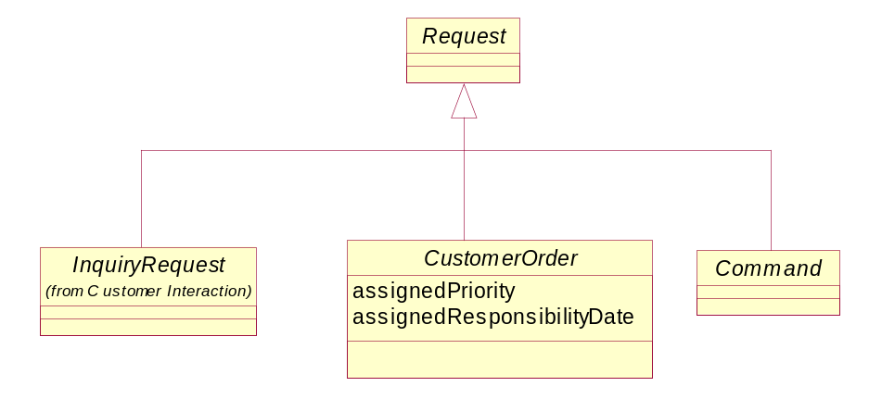
Figure BI. 15old – Request Business Entities
Editorial Note:
At the closing of SID version 12, we discovered that the Command entity disappeared from the SID model. We do not have the time to approve a CR to add it to the model before the closing of the version. Hence the following figure shows the type of requests as currently exist in the model, but a CR was issued to add Command back to the model in a near future version

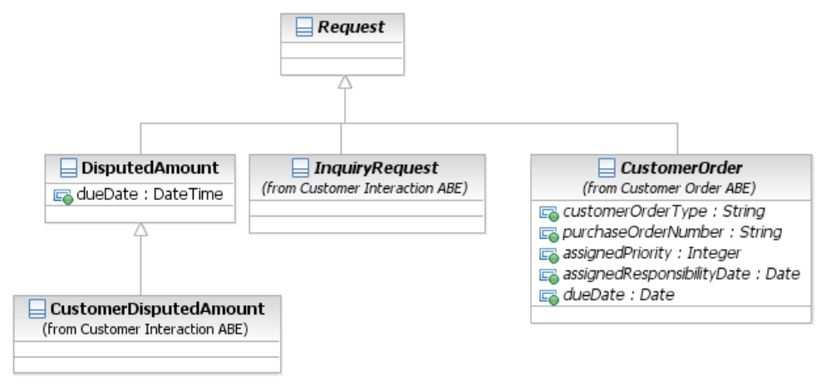
Figure BI. 16 – Request Business Entities
Request Example
Jane F., a business participant playing the party role of a customer, requests information about a VPN for her growing consulting practice.

Response

Business Entity Definition
Business Entity Name | Response
Description | A reply to a Request.
Sources | Unified Ordering Model (T1M1, OBF, TCIF joint project). | Cross- References |  | Business Interaction | Synonyms / Aliases
Related Business Entities | IssuedAs the result of Request
Business Rules | A Response must be related to at least one Request

Business Entity Model
See Business Interaction Business Entity Model
Response Example
Cliff F., a business participant playing the party role of service engineer, responds back to Jane F.’s information request for a VPN in an attempt to schedule a site visit at Jane’s offices.

Command

Business Entity Definition
Business Entity Name | Command
Description | A Request that cannot be refused. Any failure to service the Command as expected is treated as an exception, meaning something is wrong and needs to be fixed.
Sources | SID Team | Cross- References |  | Business Interaction | Synonyms / Aliases
Related Business Entities
Business Rules

Editorial Note:
At the closing of SID version 12, we discovered that the Command entity disappeared from the SID model. We do not have the time to approve a CR to add it back to the model before the closing of the version. We leave the data dictionary entry as is since a CR was added to add this entry back into the Information Framework

Business Entity Model
See Interaction Business Entity Model

InquiryRequest

Business Entity Definition
Business Entity Name | InquiryRequest
Description | A Request for information
Sources | Unified Ordering Model (T1M1, OBF, TCIF joint project) | Cross- References |  | Business Interaction | Synonyms / Aliases
Related Business Entities
Business Rules

Business Entity Model
See Business Interaction Business Entity Model

DisputedAmount

Business Entity Definition
Business Entity Name | DisputedAmount
Description | This entity represents a request by an external party (Customer or Supplier/Partner) to change the amount it is required to pay the enterprise. The amount in disagreement is being in dispute, and may be handled differently from financial aspects (for example, an amount in dispute may not be target to late payment fees calculations or being considered as part of collection calculations)
Sources |  | Cross- References |  | Business Interaction | Synonyms / Aliases
Related Business Entities | isTypeOf BusinessInteraction  records DisputedAmountActivity (represents DisputedAmount lifecycle)
Business Rules

Business Entity Attributes Definition
Business Entity Name | DisputedAmount
Attribute Name | Description | Data Type | Characteristics, Permitted Values & Units | Required/  Optional | Notes
dueDate | dueDate is the latest date in which the DisputedAmount should be closed. | DateTime |  | Required

Business Entity Model
See Figure BI. 13

DisputedAmountActivity

Business Entity Definition
Business Entity Name | DisputedAmountActivity
Description | This is an abstract base class for the different states in the DisputedAmount lifecycle
Sources |  | Cross- References |  |  | Synonyms / Aliases
Related Business Entities | recordedBy DisputedAmount  represents a state in the lifecycle of DisputedAmount
Business Rules

Business Entity Attributes Definition
Business Entity Name | DisputedAmountActivity
Attribute Name | Description | Data Type | Characteristics, Permitted Values & Units | Required/  Optional | Notes
activityDate | activityDate is the date in which this activity was performed | DateTime |  | Required

Business Entity Model
See Figure BI. 13

DAACreated

Business Entity Definition
Business Entity Name | DAACreated
Description | This entity represents the creation of DisputedAmount
Sources |  | Cross- References |  | Business Interaction | Synonyms / Aliases
Related Business Entities | isTypeOf DisputedAmountActivity
Business Rules

Business Entity Attributes Definition
Business Entity Name | DAACreated
Attribute Name | Description | Data Type | Characteristics, Permitted Values & Units | Required/  Optional | Notes
disputedAmount | disputedAmount holds the amount which the customer wants a refund for. | Money |  | Required

Business Entity Model
See Figure BI. 13

DAARejected

Business Entity Definition
Business Entity Name | DAARejected
Description | This entity represents the state of rejection of the DisputedAmount by the enterprise.
Sources |  | Cross- References |  | Business Interaction | Synonyms / Aliases
Related Business Entities | isTypeOf DisputedAmountActivity
Business Rules

Business Entity Attributes Definition
Business Entity Name | DAARejected
Attribute Name | Description | Data Type | Characteristics, Permitted Values & Units | Required/  Optional | Notes
Reason | the reason for the rejection | String |  | Required

Business Entity Model
See Figure BI. 13

DAACancelled

Business Entity Definition
Business Entity Name | DAACancelled
Description | This entity represents the state of cancelation of the DisputedAmount by the Customer
Sources |  | Cross- References |  | Business Interaction | Synonyms / Aliases
Related Business Entities | isTypeOf DisputedAmountActivity
Business Rules

Business Entity Model
See Figure BI. 13

DAAAccepted

Business Entity Definition
Business Entity Name | DAAAccepted
Description | This entity represents the state of acceptance (completely or partially) of the DisputedAmount by the enterprise.
Sources |  | Cross- References |  | Business Interaction | Synonyms / Aliases
Related Business Entities | isTypeOf DisputedAmountActivity
Business Rules

Business Entity Attributes Definition
Business Entity Name | DAAAccepted
Attribute Name | Description | Data Type | Characteristics, Permitted Values & Units | Required/  Optional | Notes
acceptedAmount | acceptedAmount holds the amount which the enterprise agreed to refund the Customer as a result of this DisputedAmount. This amount is less or equal the disputedAmount (in DAACreated entity), pending of the DisputedAmount was partially or completely accepted respectively | Money |  | Required

Business Entity Model
See Figure BI. 13

DAACompleted

Business Entity Definition
Business Entity Name | DAACompleted
Description | This entity represents the completion of the DisputedAmount lifecycle.
Sources |  | Cross- References |  | Business Interaction | Synonyms / Aliases
Related Business Entities | isTypeOf DisputedAmountActivity
Business Rules

Business Entity Model
See Figure BI. 13

2. Administrative Appendix
This Appendix provides additional background material about the TeleManagement Forum and this document. In general, sections may be included or omitted as desired, however a Document History must always be included.

2.1 About this document
This is a TM Forum Guidebook. The guidebook format is used when:
The document lays out a ‘core’ part of TM Forum’s approach to automating business processes. Such guidebooks would include the Telecom Operations Map and the Technology Integration Map, but not the detailed specifications that are developed in support of the approach.
Information about TM Forum policy, or goals or programs is provided, such as the Strategic Plan or Operating Plan.
Information about the marketplace is provided, as in the report on the size of the OSS market.

2.2 Document Life Cycle
This document is being issued for Member Evaluation. The purpose of an Evaluation Version is to encourage input based on experience of members and the public as they begin to use the document. Following the Evaluation Period, documents that are seen to deliver value are candidates for formal approval by the TM Forum. All documents approved by the TM Forum undergo a formal review and approval process.
This document will continue under formal change control. Supporting work will be issued as companions to this document. A document of this type is a “living document,” capturing and communicating current knowledge and practices. Further inputs will be made because of detailed work ongoing in the TM Forum and the industry.

2.3 Document History

2.3.1 Version History
<This section records the changes between this and the previous document version as it is edited by the team concerned. Note: this is an incremental number which does not have to match the release number>

Version Number | Date Modified | Modified by: | Description of changes
0.1 | Jan 2002 |  | Document created. Party copied from old template.
0.2 | Feb 2002 |  | Updates from Team review, Identity added, Matrix Organization example added
.31 | Apr 2002 |  | Updates from Team review, separated Interaction, Party, Location into separate addenda
.5 | May 2002 |  | First member review version
1.1 | July 2002 |  | Changed addendum number from 1I to 1PI; updated figures to represent UML diagrams; added relationships from Interaction to generic Entity Specification and Entity to replace associations with Product Spec and Product; added more detail to the overview, updated descriptions based on changes.
1.3 | August 2002 | John Reilly | Changed Party Interaction to Business Interaction and introduced the concept of a Business Actor business entity.
1.4 | Sept 2002 |  | Updates based on team review.
3.0a | Apr 2003 |  | Updated figures, association names, business entity definitions, and attribute definitions.
5.0 | June 2004 |  | Updated figures, attribute definitions, and other content based on member feedback
6.0 | July 2005 | John Reilly | Updated figures, attribute definitions, and other content based on member feedback.
6.1 | November 2005 | Tina O'Sullivan | Converted to new template and corrected various administrative items.
6.2 | November 2005 | Tina O'Sullivan | Figure labels
6.3 | November 205 | Tina O'Sullivan | Tidied up TOC
6.4 |  | Tina O'Sullivan | Updated notice statement & document status
6.5 | May 2009 | Alicja Kawecki | Minor updates to reflect TM Forum Approved status
6.6 | December 2010 | John Reilly | Updated Notice
6.7 | March 2011 | Alicja Kawecki | Minor formatting corrections prior to web posting and ME
6.8 | September 2011 | Alicja Kawecki | Updated to reflect TM Forum Approved status
6.9 | January 2012 | Josh Salomon | Added DisputedAmount entities
6.10 | March 2012 | Alicja Kawecki | Minor formatting corrections prior to web posting and ME
6.11 | October 2012 | Alicja Kawecki | Updated to reflect TM Forum Approved status

2.3.2 Release History
<This section records the changes between this and the previous Official document release>

Release Number | Date Modified | Modified by: | Description of changes
Release 6.0 | 31-Oct-2005 | J. Reilly
Release 9.5 | 28Dec2010 | John Reilly | Updated Notice
Release 12 | 29-Jan-2012 | Josh Salomon | Added DisputedAmount entities

2.4 Acknowledgments
This document was prepared by the members of the TeleManagement Forum SID team:
The Shared Information/Data Model is a genuinely collaborative effort. The TM Forum would like to thank the following people for contributing their time and expertise to the production of this document. It is just not possible to recognize all the organizations and individuals that have contributed or influenced the introduction. We apologize to any person or organization we inadvertently missed in these acknowledgments.

Key individuals that reviewed, provided input, managed, and determined how to utilize inputs coming from all over the world, and really made this document happen were:

Name | Affiliation
Ian Best | TeleManagement Forum
Chris Hartley | Telstra
John Reilly | MetaSolv Software
Wayne Sigley | Telstra
John Strassner | Motorola
Josh Salomon | Amdocs

