Information Framework
(SID)

CSSU Addendum
GB922 Addendum 1UR
TM Forum Approved Version 1.3


October, 2012

Notice

This material, including documents, code and models, has been through review cycles; however, due to the inherent complexity in the design and implementation of software and systems, no liability is accepted for any errors or omissions or for consequences of any use made of this material.
Under no circumstances will the TM Forum be liable for direct or indirect damages or any costs or losses resulting from the use of this specification. The risk of designing and implementing products in accordance with this specification is borne solely by the user of this specification.
This material bears the copyright of TM Forum and its use by members and non-members of TM Forum is governed by all of the terms and conditions of the Intellectual Property Rights Policy of the TM Forum (http://www.tmforum.org/Bylaws/1094/home.html) and may involve a claim of patent rights by one or more TM Forum members or by non-members of TM Forum.

Direct inquiries to the TM Forum office:
240 Headquarters Plaza,
East Tower – 10th Floor,
Morristown, NJ 07960 USA
Tel No. +1 973 944 5100
Fax No. +1 973 944 5110
TM Forum Web Page: www.tmforum.org
Table of Contents

Notice 2
Table of Contents 3
List of Figures 5
Executive Summary 6
1 Introduction 7
2 Use Cases Analysis 8
2.1 Use Cases 8
2.1.1 Scenario 1 8
2.1.2 Scenario 2 14
2.1.3 Scenario 3 17
2.2 Discussion 18
3 Entities 21
3.1 Preliminary Comments 21
3.2 New Artifacts 22
3.2.1 InvolvementRole 26
3.2.2 ServiceInvolvementRole 26
3.2.3 ResourceInvolvementRole 27
3.2.4 InvolvementIdentification 27
3.2.5 InvolvementIdentificationRole 28
3.2.6 PartyUser 28
3.2.7 ResourceUser 29
3.3 Existing Artifacts (Being Amended) 30
3.3.1 Customer 30
4 Harmonization 32
4.1 Note about Subscriber and Subscription 32
4.2 Mapping of the Terms to other Standard Bodies 32
5 References 39
6 Business Entity Definitions _Users and Roles 41
6.1.1 InvolvementRole Business Entity Definition 41
InvolvementRole 41
Business Entity Attributes Definition 41
InvolvementRole 41
6.1.2 InvolvementIdentification Business Entity Definition 42
InvolInvolvementIdentification 42
Business Entity Attributes Definition 43
InvolvementIdentification 43
6.1.3 InvolvementIdentificationRole Business Entity Definition 43
InvolvementIdentificationRole 43
Business Entity Attributes Definition 44
InvolvementIdentificationRole 44
6.1.4 PartyUser Business Entity Definition 44
PartyUser 44
Business Entity Attributes Definition 44
PartyUser 44
6.1.5 ResourceUser Business Entity Definition 45
ResourceUser 45
Business Entity Attributes Definition 45
Resource 45
7 Appendix: Object Instances Example 47
8 Administrative Appendix 49
8.1 About this document 49
8.2 Version History 49
8.3 Release History 50
8.4 Acknowledgments 50
List of Figures

Figure USR. 1 24
Figure USR. 2 25

Executive Summary
This document depicts various entities and the actions they take while using a system. Its main focus is users and the roles they perform.
Through the use of Use-cases, a number of scenarios are explored. Existing Information Framework entities are revised and new ones are created, the work then models the entities. Finally, harmonization to other fora is offered through mapping.
In particular this document is augmenting the current definition of Customer by elongating the duration of interaction with the enterprise ( see section 3.1.1)
The work examines the User be it a party or a resource and looks at what does he uses. By modeling InvolvementIdentification the identity of the entity that is using the system is represented. (See section 3.2.4)
Roles are also discussed:
As part of this work InvolvemntRole-s were introduced to Services and Resources (up to SID V9.5 only Products had involvement role classes). Therefore a refactoring of the ProductInvolvementRole class was introduced so it can be easily extended to support Services and Resources (see section 3.2.) Please note that this model, models how User uses things in the CSP space. It does not model things like permissions, authorization, and rights. These entities are defined by the Enterprise Identity Management (EIM) team and are connected (through association to class InvolvementIdentificationRole) with the described user model.

Introduction
This Information Framework (SID) Addendum was initially motivated by questions around customers, users and administrators of products, their relationships, and how TM Forum terms and concepts relate to those used in 3GPP and ETSI TISPAN.
  - Later on the group focused the work on modeling the User and the relations between the User and the thing being used. This is the scope of phase I of the work as described in this addendum. The User can be human or a machine, while she can use a Product, Service or a Resource. This addendum focuses on the modeling of the user and the associations to the things being used.
  - Future work will model the way a User can impact the configuration of the thing being used.
This addendum also includes an attempt to map between TM Forum terms and the related 3GPP and ETSI TISPAN terms.

Use Cases Analysis
In order to better try to capture the essential aspects of the problem space we present in this section few use cases and comments which should help the reader understand the decision which drive to the identification of the new entities presented in the rest of this document.
The intention is not to be exhaustive but more to illustrate the diversity of view points and to suggest an organization of concepts that will help supporting them. For this reason, only the most important aspects of each use case are presented: mainly the actors and the roles they play (the “who”), the description (the “what”). Sometimes, in addition, in order to trigger thoughts for the next section, a suggestion of involved entities is informally sketched (the “how”).
The TMF Information Framework identifies several important domains, such as Product, Customer, Service, and Resource. While this separation of the related concepts into different domains can be very powerful, it may sometimes create confusion. In particular, the distinction between concepts of the Product and Service domains and how they relate to Customer and Resource domains is not always clear. As a result some real life concept can be modeled in more than one way using the information model and none of the options is more “correct” than the other. The “correct” model depends on business considerations of the CSP and on choices taken during the modeling work. We will see some of this duality later in this document.

Use Cases

Scenario 1
Bob, the family’s father, has subscribed to a triple play offering (VoIP, HSI, and IPTV) over an ADSL connection proposed by the BestSP service provider.
The other members of the family are Alice, the mother, and two children, Marie (16) and John (14).
Bob works in the IT domain and as a consequence has a reasonable knowledge of some technical issues.
The IPTV allows accessing many channels with no extra charges and contains a VoD service, where each video download is automatically charged to the account. This VoD service is password protected.
The VoIP allows configuring 3 phone numbers, and contains a certain number of supplementary voice services, e.g. individual voice mail, call forwarding. The Service Provider supplies a range of 3 phone numbers, but leaves the customer to personalise the VoIP services between the family members. The family choice is to allocate one number for the father Bob, one for the mother Alice, and the last one for the two children, Marie and John (they share the same number).
Call forwarding will not be given to the children (so to avoid expensive call forwarding to the children mobile).
The different users can configure the telephone services they have.
All configuration settings must be done through the SP portal which is password protected: one password for the administrator and one password per user, identified with his/her phone number.
When it is necessary to contact the SP support services, the contract number will have to be mentioned to the SP. We assume that only the administrator (Bob) knows this number while normal users don’t.

Use Case # | 1
Name | Modify the network parameters of a set top box.
Actors/Roles  (who) | - Customer side (Family):  - Actor: Bob  - Involvement Role:  Resource Administrator  - SP side:  - Actor: Technical Support  - Involvement Role:  Resource Administrator (read/modify capability)
Description  (what) | The family has computers and the TV set.  Bob wants to interconnect all those devices through a LAN.  - he activates the router function of the set top box  - he configures the DHCP range (the desktop has a fixed IP address,  the laptop have a dynamic IP address)  - He redirects tcp ports to access video streaming on the desktop.
How  (suggested entities / comments) | The Resource Administrator can execute the configuration changes through the SP portal.  There is no change to the Service Profile
Discussion | The set top box is the resource.  This use case relates to the Resource view.  Bob acts as an (external) Resource Administrator.  The access control is checked with a password.  The services are not directly affected by the changes (they can be affected indirectly however).  In case of trouble, Bob will contact (phone call, email or chat) the technical support of the SP who will act as an (internal) Resource Administrator.

Use Case # | 2
Name | Modify the billing options
Actors/Roles  (who) | - Customer side (Family):  - Actor: Bob  - Involvement Role:  Product Administrator  - SP side:  - Actor: Customer Care / Commercial Support  - Involvement Role:  Product Administrator (read/modify capability)
Description  (what) | Bob can request to receive only electronic bill and not any more paper bill;  he can also change the bank account to debit.
How  (suggested entities / comments) | The access control is checked with a password.  The rights to access/modify the appropriate information are controlled by the SP’s system by checking the relevant profile (external Product Administrator).
Discussion | This use case relates to the Product view.  In case of trouble, Bob will contact (phone call, email or chat) the commercial support of the SP, who will act as an internal Product Administrator.

Use Case # | 3
Name | Access the current bill,  Access current consumption
Actors/Roles  (who) | - Customer side (Family):  - Actor: any user; Alice, Marie and John (for their own number), Bob (for any number in the family)  - Involvement Role:  Product Administrator (Bob),  Product User (Alice, Marie, John)  - SP side:  - Actor: Customer Care / Commercial Support  - Involvement Role:  Product Administrator (read/modify capability)
Description  (what) | Bob can access the global bill under construction and can also check the consumption during the current month for all users and all services.  This bill shows the data presented per service or per user (all services and all users are displayed).  Alice, Marie and John can access only the current consumption and the current bill for the services related to their own account (e.g. the number of minutes left for the current month)
How  (suggested entities / comments) | The access control is checked with a password.  The rights to access the appropriate information are controlled by the SP’s system by checking the relevant profiles (external Product Administrator or external Product User).
Discussion | This use case relates to the Product view (see the next case for discussion).  In case of trouble, Bob will contact (phone call, email or chat) the commercial support of the SP, who will act as an internal Product Administrator.

Use Case # | 4
Name | Set telephone options
Actors/Roles  (who) | - Customer side (Family):  - Actor: any user; Alice, Marie and John (for their own number), Bob (for any number in the family)  - Involvement Role:  Product Administrator (Bob),  Product User (Alice, Marie, John)  - SP side:  - Actor: Technical Support  - Involvement Role:  Service Administrator (read/modify capability),  Product Administrator (read/modify capability)
Description  (what) | Bob, Alice, Marie can configure the different options authorized with their own number, such as:  - activate/deactivate a call forwarding, with associated conditions (only Bob and Alice)  - Define/modify the number to which calls will be forwarded. (only Bob and Alice)  - activate/deactivate the DnD function (do not disturb) (All)  - Activate/deactivate the rejection of anonymous incoming calls. (All)  Bob can configure the authorized options for any user.
How  (suggested entities / comments) | The access control is checked with security credentials (e.g. password).  The rights to access/modify the appropriate configuration are controlled by the SP’s system by checking the relevant profiles (external Product User).
Discussion | - While the changes describe in this use case are eventually reflected in the service layer, there are (at least) two ways to look at such changes(add reference )  - Bob, Alice and Marie change the Product configuration and this configuration is reflected to the Service domain. This approach is taken for CSP which think that the Customers are exposed directly only to Products and do not know their services at all. In this view Bob acts as a ProductAdministrator, and Alice and Marie act as ProductUsers  - Bob, Alice and Marie change the Service configuration directly without changing the Products, In order to take such a view CSP must expose parts of the Service layer to the customers, and keep in the Product layer commercial information only (and not technical configuration). In this view Bob acts as ServiceAdministrator, and Alice and Marie act as ServiceUsers  - In case of trouble, Bob, as the Product/Service Administrator, will contact (phone call, email or chat) the technical support of the SP.  - Compared to the previous use case, the difference sits on the SP roles. Here, it is the SP Technical Support actor who is involved with either (pending on the modeling decisions described in section 1 above):  - With full read/modify capabilities in his Product Administrator and Service Administrator roles.  - With full read/modify capabilities in his Service Administrator role and only read capabilities in his Product Administrator role.  - Also compared to the use cases 2 and 3, the involvement roles associated to the Customer / Users remain the same: Product Administrator or Product User.  Although the parameters to be set are technical, as opposed to the use case 2 where they relate to the bill.  (However, see the discussion in 2.2).

Scenario 2
A small business company (50 employees) has bought a Business Communications Product from a Service Provider that offers a range of mobile phone services.
In the company,
    - the IT system administrator, Matthew, is in charge of creating/closing users accounts and of configuring the authorized services;
he acts as an external technical Party Product Administrator (A PartyRole which is responsible for the technical aspects; note that the creation/closure of users accounts is seen as a task that relates to the administration of the Product)
    - the accountant, Sandra, is responsible for receiving and paying the bill; in addition, she is responsible for the contractual aspects and their modifications in agreement with her manager (e.g. negotiating a rebate when the number of accounts exceeds a certain range);
she acts as an external business Party Product Administrator (responsible for non technical aspects, such as billing and contract management); note that whether Matthew and Sandra roles are modelled as a single administrator role or as two separate roles in the system is an implementation decision. The writers of this document recommend on having two separate roles for such a case

Use Case # | 5
Name | Create a new user account
Actors/Roles  (who) | - Customer side (Company):  - Actor: Matthew  - Involvement Role:  Product Administrator  - SP side:  - Actor: Technical Support  - Involvement Role:  Service Administrator (read/modify capability),  Product Administrator (read/modify capability)
Description  (what) | The (external) Product Administrator creates a new user account by filling a form on the SP portal.  Depending on the responsibilities of this new user in the company he selects the corresponding services;  examples:  - international calls allowed only for sales staff and VPs  - calls redirection only for VPs  The phone number allocated to this new user is returned by the SP.
How  (suggested entities / comments) | A new PartyUser is created associated with an appropriate ProductInvolvementRole as a user.  The (external) Product Administrator will select the services allocated to the new user among a list of possible services as negotiated in the contract and available in the agreement between the CSP and the Customer or in the ProductOfferings available to the Customer
Discussion | In case of trouble, Matthew, as an external Product Administrator will contact (phone call, email or chat) the technical support of the SP, who will act as either:  - With full read/modify capabilities in his Product Administrator and Service Administrator roles.  - With full read/modify capabilities in his Service Administrator role and only read capabilities in his Product Administrator role.

Use Case # | 6
Name | Add a new service
Actors/Roles  (who) | - Customer side (Company):  - Actor: Sandra, Matthew, Head of Sales  - Involvement Roles:  Business Product Administrator (Sandra, for the non technical aspects)  Technical Product Administrator (Matthew, for the technical aspects)  Product User (Head of Sales and Sales staff)  - SP side:  - Actor: Customer Care / Commercial Support  - Involvement Role:  Product Administrator (read/modify/create capability)
Description  (what) | The head of the sales department wants to be able to track his crew during business hours.  For this purpose, he asks Sandra as Party Business Product Administrator (responsible for the contract) to negotiate the possibility to add the geo-positioning service to the contract.  Once agreed, Matthew as Party Technical Product Administrator adds this new service to all the sales users and installs special software for the head of sales to track his crew.  The head of sales has access to a specific application (rich client and web client) which allows him to track his team; this application offers complementary services to ease communication with the sales staff.
How  (suggested entities / comments) | The Agreement between the customer and the CSP is modified, as well as Product and Service inventories (as a result of an order to purchase the geo-positioning features).  The concerned ProductInvolvementRole roles are modified.
Discussion | The writers of this document recommend separating the respective responsibilities of Matthew and Sandra in their Product Administrator roles into two different roles.

Scenario 3
An enterprise has a network of devices which send heartbeat signals over a secured network to which they should log-in. The users in this use case are the devices.

Use Case # | 7
Name | Send heartbeat signal from a device
Actors/Roles  (who) | - An air conditioner with a communication device (wireless) sending status heartbeat every 30 minutes  - Actor: “smart” air conditioner  - Involvement Role:  Resource Product User  (the resource - the communication module in the air conditioner - is the user of the network)  - SP side:  - Actor: technical support technician  - Involvement Role:  Resource Product Administrator (read/modify/create capability – monitor communications problems with the device, possibly remotely configuring the device)
Description  (what) | The device sends status information to a support center every 30 minutes. It has to login to a secured network before sending the information.  In case of communications failure a secondary channel (unsecured) is available for communications device maintenance.
How
(suggested entities / comments)
Discussion | This use case is introduced to emphasis the importance of resources (non humans) as users of the CSP communications network.

Discussion
As illustrated by the use cases of the previous section, it is sometimes difficult to clearly identify if a concept (a “noun”) or an action (a “verb”) belongs entirely to the Product layer or to the Service layer or to both. Different points of view can sometimes be considered for the same use case and be equally valid.
Use Cases which relate to commercial contract seem to clearly belong to the Product layer, as the TMF Information Framework clearly states (ref [5]):
“Products are things which enterprises, such as service providers, market, sell or lease to customers to create profit”.
“When Customers select Products from the ProductCatalog, it is the ProductOffering details that they are looking at and which are reflected in what they agree to contractually.”
However, when it comes to modifying parameter options, it is less clear. The use case “Set telephone setting options” above illustrates this issue.
Ref [3] presents a simple use case (email) and addresses its model representation in large details.
In a first release of this document, the view point was that a User does not directly interact with a Product (Product layer) but with its associated Services (Service layer).
Further to the publication of the first release of this document, a chain of discussions engaged, suggesting that there is another valid view point as well, through which Users interact only with Products and does not need to know about the Service layer, since this layer is more internal to the SP.
A summary of this discussion is available in [7] and the main points are extracted below:
- Viewpoint 1 (case study)
  - a product serves as a packaging of services by a provider that can be purchased, leased or rented by a customer
  - customers and providers commercially agree on the basis of products
  - products cannot be used because they are only packaging, e.g. you can't make a phone call with a product, but only with the service that realizes the product
  - a user uses a customer-facing service to obtain the value promise of the product, e.g. to make a phone call
  - the user experience of using a customer-facing service is created at an interface realized by an application in an end-user device
  - the application on the end-user device invokes resource-facing services by communicating over protocols with device interfaces (service access point) that constitute the boundary of the provider infrastructure
  - a user may administrate aspects that influence the behavior of the customer-facing service (like call-forwarding) but not the commercial agreement through characteristics on the customer-facing service or by using another customer-facing service
- Viewpoint 2
  - A product serves as a window for customers and users into the world of the services and resources used to realize the product. Customer/user always deal with products, unless the individual/organization they represent is playing the role of a service technician or some similar role
  - customers and providers commercially agree on the basis of products
  - a user uses a product to obtain its value promise, e.g. to make a phone call
  - the user experience of using a product is created at an interface realized by an application in an end-user device*
  - the application on the end-user device invokes resource-facing services by communicating over protocols with device interfaces (service access point) that constitute the boundary of the provider infrastructure
  - a customer-facing service represents a functionality at the boundary of the service provider infrastructure in a protocol-agnostic way, it groups a set of resource-facing services that together provide the necessary technical functionality
  - a user may administrate aspects that influence the behavior of the product (like call-forwarding), this changes characteristics of the product
Ref [3] was revisited to illustrate the two viewpoints.

While the authors of the present document recommend the usage of the second view point (where customers interact only with Products and do not need to know about the Service layer.) they also recognize the validity of the first one and have agreed to create the appropriate artifacts to support both.

Entities

Preliminary Comments
Before presenting in details the new proposed entities, it is essential to highlight some important concepts of the TMF Information Framework:
- Roles, and Involvement Roles
  - Role is an ABE which has several specializations such as PartyRole, ResourceRole (among others)
[6] defines the abstract artifact PartyRole as “the role played by a Party in a given context”.
This definition is deliberately vague; it must be interpreted as a way to characterize the behavior of a Party. The default interpretation of this definition as represented in the model is “the role played by a party relative to enterprise in a given context”.
Here are some existing concrete specializations of PartyRole:
      - ServiceProviderEmployee (but not a CustomerEmployee – this requires minor extension to the model)
      - Vendor, Intermediary, (partner) ServiceProvider…

Note that a PartyRole can be defined independently of any possible involvement with a Product, a Service or a Resource (same remark applies as well to ResourceRole).

  - InvolvementRole:
Involvement Role classes represent the association between two classes. These are association classes that were ‘promoted’ to become normal classes. ProductInvolvementRole, for example, describes the association between Product and other entities.
Up to release 9.5, the TMF Information Framework Model captures the concept of InvolvementRole for a given Product through the ProductInvolvementRole abstract artifact (up to release 9.5, there is no equivalent for ServiceInvolvementRole and ResourceInvolvementRole; these entities are proposed to be added in the present document – see below);
[5] defines a ProductInvolvementRole as “a role a Party or Resource plays in the relationship with a Product (such as user, subscriber…), the model implementation also includes CustomerAccount which is missing from the definition”.
In other words, it characterizes the involvement of a Party, CustomerAccount or Resource w.r.t. a Product.

  - The concepts of PartyRole (or ResourceRole) and InvolvementRole must be considered as orthogonal to each other and complementary.
    - The characteristics of a PartyRole (e.g. Customer, Vendor) can be modeled independently from any product at all and remains valid and relevant for all products involved presently and in the future.
    - The characteristics of a ProductInvolvementRole can be modeled independently from the nature of the Party or Resource for which this ProductInvolvementRole will apply; however, up to version 9.5 of the Information Framework it must be associated with a PartyRole, a ResourceRole or a CustomerAccount.
It means that the characteristics of the involvement itself can be modeled on its own, but it must always be associated with the actor involved.
- Separation of Party versus Resource:

A Party represents an individual or an organization unit. Although not explicitly stated, it is hinted that a Party is an entity that can be considered responsible with regard to the law.
Individuals or organizations can be internal or external to the Service Provider:
employees, company department are examples of internal individuals and organizations;
Individual customers, suppliers’ organizations are examples of external individuals and organizations.

By definition, a Party cannot be a Resource.

Both Parties and Resources can be the subject (i.e. actor) of InvolvementRoles.

New Artifacts
This document proposes the introduction of new artifacts; they are represented in green and orange in the picture below:
First of all we create a new example class UserNameResourceRole for clarifying the following diagrams.
UserNameResourceRole represents the role of a user name in the system. It is a LogicalResourceRole because from life cycle management perspective a user name behaves just like any other LogicalResource (such as phone number or email address) and therefore it must be managed like any other LogicalResource (to prevent duplication, etc.). This is a LogicalResourceRole because the same logical resource (phone number or email address) can play in multiple roles, for example, the email address can play the roles of user name, and email contact address.
In real world implementations the base class (ResourceRole) can be used directly instead of the example class. This is because the same logical resource (e.g. email address) can play many roles including the role of a user name.

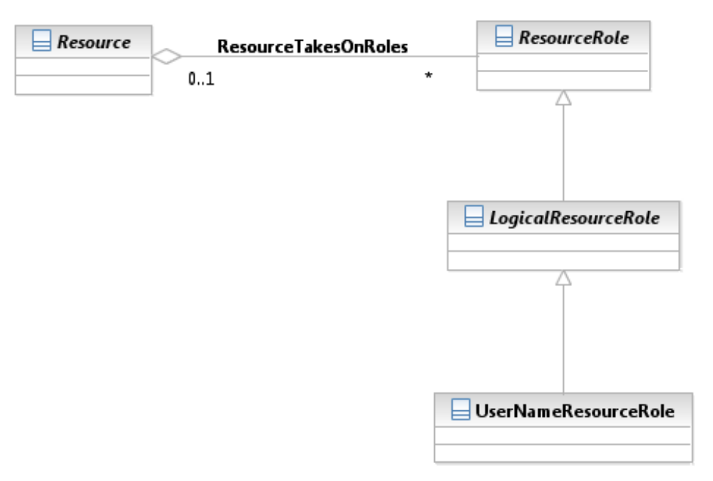
Figure USR. 1

The full model that represents the contribution in this document is listed below:
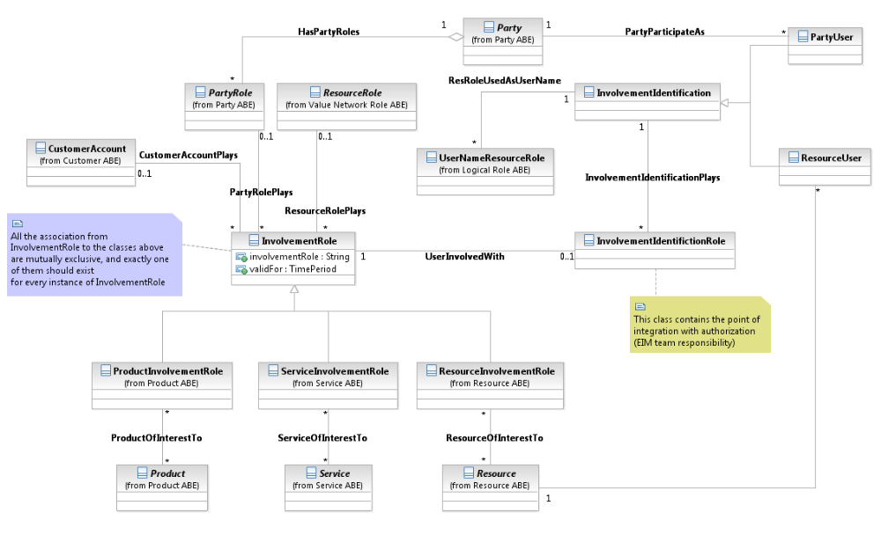
Figure USR. 2
Note – This model represents refactoring of the ProductInvolvementRole class and subclasses in previous versions of SID. The specific involvement roles which were subclasses of ProductInvolvementRole are now represented by associations to the InvolvementRole base class while the subclasses represent now a second dimension – the involvement with Product, Service and Resource.

InvolvementRole
  - Definition

An abstract base class for all more specific classes representing associations of involvement type.
  - Modeling Notes
This class represents the involvement between involved classes (e.g. PartyRole or CustomerAcount) and Product, Service or Resource. It is an association class that was promoted to real class due to UML limitations of association classes.
This base class is abstract.
It contains attributes which are common to all possible specific InvolvementRole subclasses (e.g. validFor);
in particular a specific attribute (enumeration type) with a list of proposed values for roles (e.g.: normal user, administrator, supervisor, controller, etc). This attribute can make different values in each implementation and represents the various involvement types supported but the CSP.

ServiceInvolvementRole
  - Definition

A role played by an actor in relationship with a Service.
The role would typically be represented by an attribute or a characteristic in such a way that specific extensions may be easily added to the proposed values; possible examples are: administrator, supervisor, normal user, etc.

Notes:
There is no assumption on the kind of actor that may be associated with this role: the actor may be a PartyUser, a ResourceUser or any other class associated to InvolvementRole.

ResourceInvolvementRole
  - Definition

A role played by an actor in relationship with a Resource.
The role would typically be represented by an attribute or a characteristic in such a way that specific extensions may be easily added to the proposed values; possible examples are: controller, installer, normal user, etc.
The actor may be a PartyUser, a ResourceUser or any other class associated to InvolvementRole.

InvolvementIdentification
  - Definition
A (concrete) base class for the PartyUser and ResourceUser actors entities representing the identity of an actor involved in a role.

  - Modeling Notes

While the use cases in this document reflect a known InvolvementIdentification (PartyUser or ResouceUser) there are cases when the identification is not known (e.g. normal phone call) in which InvolvementIdentifcation instance is used and not one of the subclasses.

  - Discussion notes:

From implementation perspective, Information Framework implementers can use the bottom up technique to consolidate this class and its subclasses into a single class with 2 optional mutually exclusive, associations to a Party and to a Resource.
The team considered an alternative proposal: this class will still be created as a concrete class with no specialization at all and associations will be added with ResourceRole and PartyRole. ResouceUser and PartyUser will also be added but as specialization of ResourceRole and PartyRole respectively.
Indeed, this alternative proposal would not enforce the mutual exclusion through which an InvolvementIdentification instance may be associated with either a ResourRole or a PartyRole, but not both. Moreover, the attributes of a user (username, password) will not be handled in the User classes (PartyUser, ResourceUser) but in a class associated to them. This is an instance of the aspect pattern which is not used in the core SID but is recommended for SID extensions in some cases.

Another difference between the approach retained and the alternative one is that in the former case an InvolvementIdentification instance is ultimately associated with either a Party (e.g. a representation of Bob as an individual Party) or a Resource while in the alternative proposal an InvolvementIdentification instance is associated with a PartyRole (e.g. a representation of Bob as a Customer PartyRole) or a ResourceRole.

This alternative proposal was not retained. The approach taken (as depicted in the diagram above) is better aligned with current SID model practices and patterns and does not present new a pattern in to the framework.

InvolvementIdentificationRole
  - Definition
The InvolvementIdentificationRole entity is used to represent the specific information (e.g. rights and restrictions) related to a point of integration of a given InvolvementIdentification instance in its specific InvolvementRole.

PartyUser
  - Definition

A specialization of the InvolvementIdentification entity used to indicate that he actor identified is a party (an individual or an organization).

  - Modeling Notes
    - Modeled as a specialization of InvolvementIdentification
    - This entity associates with the Party entity through an exactly-one multiplicity.

Note:
The associated Party may itself play one or several PartyRoles.
Depending on the nature of the PartyRoles played (e.g. Customer, ServiceProviderEmployee), the PartyUser identified can be:
      - internal to the SP organization (representing a SP perspective),
      - External to the SP organization (representing a Customer/Partner perspective).

The associated InvolvementIdentificationRole will further qualify the rights and restrictions granted to this PartyUser in its InvolvementRoles.

ResourceUser
  - Definition

A specialization of the InvolvementIdentification entity used to indicate that he actor identified is a resource.

  - Modeling Notes
    - Modeled as a specialization of InvolvementIdentification
    - This entity associates with the Resource entity through an exactly-one multiplicity

Note:
The associated Resource may itself play one or several ResourceRoles.
The ResourceUser identified can be:
      - internal to the SP organization (e.g. a switch, a router, a DSLAM),
      - external to the SP organization (e.g. a set top box, a telephone handset, a TV set, an intelligent air conditioning system etc.).

The associated InvolvementIdentificationRole will further qualify the rights and restrictions granted to this ResourceUser in its InvolvementRoles.

Existing Artifacts (Being Amended)

Customer
  - Current Definition
A person or organization that buys products and services from the enterprise or receives free offers or services. This is modeled as a Party playing the role of Customer. A Customer is a type of PartyRole. Customers can also be other service providers who resell the enterprises products, other service providers that lease the enterprise's resources for utilization by the other service provider's products and services, and so forth.
Amended Definition
A person or an organization that intends to obtain or has obtained products. This is modeled as a Party playing the role of a Customer.

Notes:
      - A party which pays for products received for its usage or for products consumed by other parties is also a customer.
      - A Customer is the liable entity in regards to the enterprise. It is entitled to accept the product, can decide to terminate use of the product, and is the responsible party for paying for use of the product where such payment is involved.
      - Customers can also be other service providers who resell the enterprises products, other service providers that lease the enterprise's resources for utilization by the other service provider's products and services, and so forth.
  - Modeling Notes
    - Modeled as a specialization of PartyRole
    - In some cases, can be modeled as a ValuenetworkRole (not in all cases)
    - Given a Customer instance it must be possible to find/navigate to all the associated PartyUser instances;
example: in scenario 1, Bob will be represented as an individual Party with a Customer role; it must be possible to find, from this Customer role, the four Individual parties characterized as corresponding PartyUsers in the case there are represented in the model: Alice, Marie, John and Bob (as a PartyUser).

Harmonization
This section includes an attempt to map between TM Forum terms and the related 3GPP and ETSI TISPAN terms.

Note about Subscriber and Subscription
The terms Subscriber and Subscription are widely used in the industry, but there is no single accepted definition of what each means. In TM Forum parlance it could commonly mean in whole or in part Customer, Product User, Product Administrator, Agreement or some combination of those. Thus it would only be confusing to use those terms in our model, and as a consequence, a choice was made to deliberately not use those terms.

Mapping of the Terms to other Standard Bodies
Term | 3GPP  ([10][11],[13],[14],[15]) | TISPAN  ([8],[9]) | TMF SID
Agreement | N.A.  (see Subscription) | N.A  (See Subscription). | A type of BusinessInteraction that represents a contract or arrangement, either written or verbal and sometimes enforceable by law.
Customer | N.A.  (see Subscriber) | N.A.  (see Subscriber) | A person or organization that obtains or has obtained products. This is modeled as a Party playing the role of Customer.
InvolvementIdentification |  |  | A (concrete) base class for the PartyUser and ResourceUser actors entities representing the identity of an actor involved in a role.
Party | N.A. | N.A. | Represents an individual, organization or organization unit.  Party is an abstract concept that should be used in places where the business says something can be an organization, organization unit or an individual.
PartyRole | N.A. | N.A. | The role played by a Party in a given context with any characteristics, such as expected pattern and behavior, attributes, and/or associations that it entails.  PartyRole is an abstract concept that should be used in places where the business refers to a Party playing a Role.
PartyUser | See User | See User | A specialization of the InvolvementIdentification entity used to indicate that the actor identified for the involvement is a party (an individual or an organization).
Resource |  |  | A Resource contains characteristics that are used to represent the  Physical and logical aspects of a Resource.
ResourceUser | See User | See User | A specialization of the InvolvementIdentification entity used to indicate that he actor identified for the involvement is a resource.
ProductInvolvementRole |  |  | This entity represents a role played by another entity in relationship with a Product.  Examples are: user, administrator, owner, etc.
ServiceInvolvementRole |  |  | This entity represents a role played by another entity in relationship with a Service.  Examples are: administrator, supervisor, normal user, etc.
ResourceInvolvementRole |  |  | This entity represents a role played by another entity in relationship with a Resource.  Examples are: controller, installer, normal user, etc.
Service Profile  (IMS) Service Profile | Service Profile:  A service specific subscription profile component. | An IMS Service Profile is a collection of service and user related data as defined in TS 129 228 [i.1].  The IMS Service Profile is identified by the attributes detailed in a table available in section C1.15 of [9] | To be studied in the next phase
Service provider | A Service Provider is either a network operator or another entity that provides services to a subscriber (e.g. a MVNO) | entity that offers services to subscribers  NOTE: The exact terms, their definition and use within the present document may be modified as a result of the  Development of the SuM information model and SuM functional architecture.
Subscriber | Same as TISPAN | entity (associated with one or more users) that is engaged in a subscription with a service provider  NOTE: The subscriber is allowed to subscribe and unsubscribe services, to register a user or a list of users authorized to use these services, and also to set the limits relative to the use that associated users make of these services. | See Customer and Product/Service Administrator role
Subscriber Profile | The set of data managed and stored by Subscription Management (SuM) for a subscriber for the management of associated users and subscribed services and the limits relative to their use. | N.A. | To be studied in the next phase
Subscription | Same as TISPAN | describes the commercial relationship between the subscriber and the service provider | N.A.  (see Agreement)
Subscription Profile | Subscription Profile:  The set of data managed and stored by network domains and subsystems for the operation and execution of the services provided to a specific user associated with a subscriber.  Subscription profile component:  Discrete subset of the subscription profile that may be stored or managed separately from other subsets e.g. components that may be stored in different domains, subsystems or replicated using different synchronization rules. | N.A. | To be studied in the next phase
User | An entity, not part of the 3GPP System, which uses 3GPP System services. Example: a person using a 3GPP System mobile station as a portable telephone. | Entity that consumes the services subscribed by the subscriber.  A user is described by its characteristics/attributes, possibly including various identifiers. A user must be immutable and, therefore, independent of any information that may change during the lifecycle of the user. In particular, it must not depend on any service, any device, network access, credential, etc. A user may be associated with zero or more devices, network accesses, credentials, contracts, etc. In addition, the change of/in devices, network accesses, credentials, contracts, etc. must not lead to a change of identities. A user is defined to be long lasting. Life cycle of a user identity is  independent of several aspects:   A user is not strictly bound to a particular contract subscription.   A user is independent from any device.   A user is independent from any network access. | See the InvolvementIdentification hierarchy, including PartyUser and ResourceUser.
User NGN Network Access Profile | N.A. | The User NGN Network Access Profile is a collection of parameters describing a specific profile of a user for network access. A User NGN Network Access Profile is possibly linked to multiple sub profiles.
User Service Profile | User Services Profiles:  Contains identification of subscriber services, their status and reference to service preferences. | User NGN Service Profile:  A User NGN Service Profile is a collection of service and user related data. A User NGN Service Profile is possibly linked to a list of NGN Services depending on the service subscription. This list may change in the following cases:   The associated subscription account has requested new services or resigned services.   The service operator has decided to add new services (e.g. for marketing reasons).   The service operator has decided to restrict some services for any reason.  A User NGN Service Profile can contain either an IMS Service Profile or another type of Service Profile.

References
- R. Sandhu, D.F. Ferraiolo, D, R. Kuhn (2000), "The NIST Model for Role Based Access Control: Toward a Unified Standard," Proceedings, 5th ACM Workshop on Role Based Access Control, July 26-27, 2000, Berlin, pp.47-63 - first public draft of the NIST RBAC model and proposal for an RBAC standard.
- TR142, Lifecycle Management Process Specification, Version 1.2, August 2009
- TR153, Product-Service-Resource Information Model E-Mail, a PLM Case Study, Version 1.0, June 2009
It can be found at: http://www.tmforum.org/Documents/TR153ProductServiceResource/39077/article.html
- SD2-19, VoIP service Definition, Version 1.0,
A VoIP example that was produced by the MTOSI-Service Management team
Delivered with the MTOSI 2.0 Release, in the Service Basic DDP.
It can be found at http://www.tmforum.org/MTOSIRelease20/35252/article.html?linkid=35252

- GB 922 – Addendum 3,
SID Release 8.0, Addendum 3: Product Business Entity definitions

- GB 922 – Addendum 1P,
SID, Common Business Entity Definition, Party

- Product/Service Nugget
John Reilly and Martin Gutzi
It can be found at: http://www.tmforum.org/community/groups/information_framework_sid/wiki/product-service-nugget.aspx

- ETSI TS 188 002-2, NGN Subscription Management; Part 1: Requirements
Version 3.1.1, 2009-12
It can be found at : http://www.etsi.org/deliver/etsi_ts/188000_188099/18800201/03.01.01_60/ts_18800201v030101p.pdf

- ETSI TS 188 002-2, NGN Subscription Management; Part 2: Information Model
Version 3.1.1, 2009-12
It can be found at : http://www.etsi.org/deliver/etsi_ts/188000_188099/18800202/03.01.01_60/ts_18800202v030101p.pdf
- 3GPP, 21905-a20
Vocabulary of 3GPP Specifications (Release 10)
Version 10.2.0, 2010-03
- 3GPP, 32140,
Telecommunication management; Subscription Management (SuM) requirements
Version 10.0.0, 2011-03

- 3GPP, 32141,
Telecommunication management; Subscription Management (SuM) architecture
Version 10.0.0, 2011-03

- 3GPP, 32171,
Telecommunication management; Subscription Management (SuM) Network Resource Model (NRM) Integration Reference Point (IRP); Requirements
Version 10.0.0, 2011-03

- 3GPP, 32172,
Telecommunication management; Subscription Management (SuM) Network Resource Model (NRM) Integration Reference Point (IRP); Information Service
Version 10.2.0, 2011-03

Business Entity Definitions _Users and Roles
All the entities are in “Users and Roles ABE” under Common Business Entities domain.

InvolvementRole Business Entity Definition
Business Entity Name | InvolvementRole
Description | An abstract base class for all more specific classes representing associations of involvement type such as ProductInvolvemenRole. ServiceInvolvementRole and ProductInvolvementRole
Sources |  | Cross- References |  |  | Synonyms / Aliases
Related Business Entities | CustomerAccount  PartyRole  ResourceRole  InvolvementIdentificationRole
Business Rules

Business Entity Attributes Definition
Business Entity Name | InvolvementRole
Attribute Name | Description | Data Type | Characteristics, Permitted Values & Units | Required/  Optional | Notes
involvementRole | A part a business entity plays in its involvement with a product, service or resource | String |  | Required
validFor | The period of time during with the business participant is involved with the product. | Time Period |  | Optional

InvolvementIdentification Business Entity Definition
Business Entity Name | InvolInvolvementIdentification
Description | A (concrete) base class for the PartyUser and ResourceUser actors entities representing the identity of an actor involved in a role, this class can also represent a user which its type (party or resource) is unknown.
Sources |  | Cross- References |  |  | Synonyms / Aliases
Related Business Entities | UserNameResourceRole  InvolvementIdentificationRole
Business Rules

Business Entity Attributes Definition
Business Entity Name | InvolvementIdentification
Attribute Name | Description | Data Type | Characteristics, Permitted Values & Units | Required/  Optional | Notes

InvolvementIdentificationRole Business Entity Definition
Business Entity Name | InvolvementIdentificationRole
Description | The InvolvementIdentificationRole entity is used to represent the specific information (e.g. rights and restrictions) related to a point of integration of a given InvolvementIdentification instance in its specific InvolvementRole
Sources |  | Cross- References |  |  | Synonyms / Aliases
Related Business Entities | InvolvementRole  InvolvementIdentification
Business Rules

Business Entity Attributes Definition
Business Entity Name | InvolvementIdentificationRole
Attribute Name | Description | Data Type | Characteristics, Permitted Values & Units | Required/  Optional | Notes

PartyUser Business Entity Definition
Business Entity Name | PartyUser
Description | A specialization of the InvolvementIdentification entity used to indicate that he actor identified is a party (an individual or an organization).
Sources |  | Cross- References |  |  | Synonyms / Aliases
Related Business Entities | Party
Business Rules

Business Entity Attributes Definition
Business Entity Name | PartyUser
Attribute Name | Description | Data Type | Characteristics, Permitted Values & Units | Required/  Optional | Notes

ResourceUser Business Entity Definition
Business Entity Name | ResourceUser
Description | A specialization of the InvolvementIdentification entity used to indicate that he actor identified is a resource
Sources |  | Cross- References |  |  | Synonyms / Aliases
Related Business Entities | Resource
Business Rules

Business Entity Attributes Definition
Business Entity Name | Resource
Attribute Name | Description | Data Type | Characteristics, Permitted Values & Units | Required/  Optional | Notes

Appendix: Object Instances Example

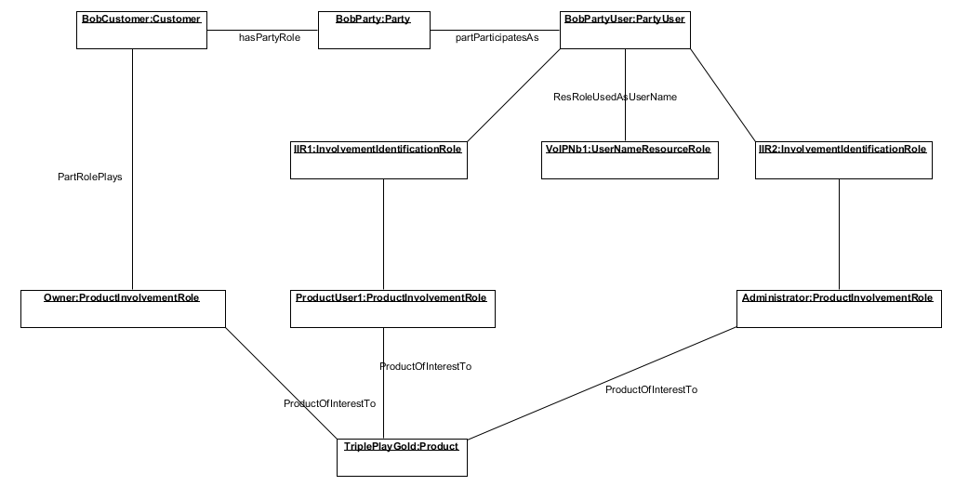
The Object diagram above illustrates some of the classes from the proposed information model based on the scenario 1.
TriplePlayGold: Product
Represents the product instance created after it has been purchased.
BobParty:Party
Represents Bob as a party. As such, this instance associates with BobCustomer: Customer which represents a party role and with BobPartyUser: PartyUser which is a representation of Bob as a user.
BobCustomer: Customer
Owner: ProductInvolvementRole
Represents a role played by Bob.
This instance associates with Owner: ProductInvolvementRole which represents the role played by the customer Bob w.r.t. the TriplePlayGold: Product instance.
BobPartyUser: PartyUser
Administrator: ProductInvolvementRole
ProductUser1: ProductInvolvementRole
IIR1: InvolvementIdentificationRole
IIR2: InvolvementIdentificationRole
Represents Bob as a user.
This instance is uniquely identified through the VoIPNb1: UserNameResourceRole logical resource.
It associates (indirectly) to two ProductInvolvementRole instances, one as a user (ProductUser1: ProductInvolvementRole) and the other one as the administrator of the product (Administrator: ProductInvolvementRole). These associations are indirect through specific InvolvementIdentificationRole instances, which will typically specify the credentials and access rights of the two roles respectively.
VoIPNb1: UserNameResourceRole
Is a logical resource used as user name to represent BobPartyUser?

Administrative Appendix
This Appendix provides additional background material about the TM Forum and this document.

About this document
This is a TM Forum Guidebook. The guidebook format is used when:
- The document lays out a ‘core’ part of TM Forum’s approach to automating business processes. Such guidebooks would include the Telecom Operations Map and the Technology Integration Map, but not the detailed specifications that are developed in support of the approach.
- Information about TM Forum policy, or goals or programs is provided, such as the Strategic Plan or Operating Plan.
- Information about the marketplace is provided, as in the report on the size of the OSS market.

Version History

Version Number | Date Modified | Modified by: | Description of changes
1.0 | July 2011 | CSSU Team | Initial release
1.0 | October 2011 | CSSU Team | Change working title CSSU to Users and Roles and Submited as a CR
1.1 | January 2012 | CSSU Team | Clean up and editorial changes to the document
1.2 | March 2012 | Alicja Kawecki | Minor formatting and cosmetic corrections prior to web posting and ME
1.3 | October 2012 | Alicja Kawecki | Updated to reflect TM Forum Approved status

Release History
<This section records the changes between this and the previous Official document release>

Release Number | Date Modified | Modified by: | Description of changes
Release 12.0 | 30/1/2012 | Avi Talmor | Initial version

Acknowledgments
This document was prepared by the members of the TeleManagement Forum SID team:
The Shared Information/Data Model is a genuinely collaborative effort. The TM Forum would like to thank the following people for contributing their time and expertise to the production of this document. It is just not possible to recognize all the organizations and individuals that have contributed or influenced the introduction. We apologize to any person or organization we inadvertently missed in these acknowledgments.
Key individuals that reviewed, provided input, managed, and determined how to utilize inputs coming from all over the world, and really made this document happen were:

Name | Affiliation
Michel Besson  Garry Munson  Josh Salomon  Johan Silvander  Avi Talmor | Amdocs  AT&T  Amdocs  Ericsson  Amdocs

