Shared Information/Data (SID) Model
Addendum 1J - PROJECT Business Entity Definitions

GB922 – 1J
TM Forum Approved Version 2.2


September, 2011

Notice

This material, including documents, code and models, has been through review cycles; however, due to the inherent complexity in the design and implementation of software and systems, no liability is accepted for any errors or omissions or for consequences of any use made of this material.
Under no circumstances will the TM Forum be liable for direct or indirect damages or any costs or losses resulting from the use of this specification. The risk of designing and implementing products in accordance with this specification is borne solely by the user of this specification.
This material bears the copyright of TM Forum and its use by members and non-members of TM Forum is governed by all of the terms and conditions of the Intellectual Property Rights Policy of the TM Forum (http://www.tmforum.org/Bylaws/1094/home.html) and may involve a claim of patent rights by one or more TM Forum members or by non-members of TM Forum.

Direct inquiries to the TM Forum office:
240 Headquarters Plaza,
East Tower – 10th Floor,
Morristown, NJ 07960 USA
Tel No. +1 973 944 5100
Fax No. +1 973 944 5110
TM Forum Web Page: www.tmforum.org

Table of Contents
Notice 2
Table of Contents 3
List of Figures 5
List of Tables 6
Executive Summary 7
1. Project ABE 8
1.1. Enterprise Business Objectives, Vision and Project Deliverables 8
1.2. Structure 10
1.3. ProjectElement Relationships 14
1.4. Activities and ProjectResource Status 22
1.5. Project Roles 23
1.6. Project Calendar 25
1.7. Project Triggers 27
1.8. Resourcing 29
1.9. Work Orders 32
1.10. Costing 33
1.11. Project ABE - SCRUM extension blade 37
1.11.1. Workflow 39
1.12. Using this model for Process Analysis 39
1.13. Further Work Required in Later Releases 39
1.14. Notes 40
1.15. References 41
1.16. Standard citation for this document 42
2. Business Entity Definitions 44
2.1.1. ProjectElement 44
2.1.2. Project 46
2.1.3. Vision 47
2.1.4. Atomic Vision 48
2.1.5. CompositeVision 49
2.1.6. ProjectScope 50
2.1.7. Project Deliverable 51
2.1.8. AtomicProjectDeliverable 52
2.1.9. CompositeProjectDeliverable 53
2.1.10. ProjectDeliverableVersion 54
2.1.11. WBS Element 55
2.1.12. Activity 56
2.1.13. SimpleActivity 57
2.1.14. ActivityStatus 58
2.1.15. ProjectElementRelationship 59
2.1.16. ProjectElementSuccession 60
2.1.17. ProjectElementSubstitution 61
2.1.18. ProjectElementDivision 62
2.1.19. ProjectElementFusion 63
2.1.20. ProjectElementDependency 64
2.1.21. ProjectElementSpecification 65
2.1.22. ActivitySpecification 66
2.1.23. WBSElementSpecification 67
2.1.24. ProjectSpecification 68
2.1.25. SCRUM_ProductOwner 69
2.1.26. SCRUM_Team 70
2.1.27. SCRUM_ScrumMaster 71
2.1.28. SCRUM_WorkingIncrement 72
2.1.29. SCRUM_Sprint 73
2.1.30. SCRUM_BacklogItem 74
2.1.31. SCRUM_Task 75
2.1.32. SCRUM_Impediment 76
3. Administrative Appendix 77
3.1. About this document 77
3.2. Document History 77
3.2.1. Version History 77
3.2.2. Release History 78
3.3. Acknowledgments 78

List of Figures
fig 1 – Basic Structure 4
fig 2 – Detailed Structure 6
fig 3 – ProjectElement DependencyTypes 8
fig 4 – ProjectElement Relationships 10
fig 5 – Specification 13
fig 6 – Activity Status (UML Statechart diagram) 14
fig 7 – Project Roles 17
fig 8 – Project Calendar 19
fig 9 – Project Triggers 21
fig 10 – Intrinsic & Contextual ProjectResource Characteristics 23
fig 11 – Work Orders (& Reservations) 26
fig 12 – ABC Costing Concepts 27
fig 13 – Costing Overview 29

List of Tables
Table 1 – Relationship Types 7
Table 2 - DependencyTypes (from [PSL]) 7
Table 3 - Constraint Types 9
Table 4 - Allowable Project Relationships 11
Table 5 – ProjectResource & Activity Status Example 1 15
Table 6 – ProjectResource & Activity Status Example 2 15
Table 7 – Costing Model Example 28

Executive Summary
The intention of this document is not to try and define a radically different model of a project, but to provide a generic model, based on current industry best practice that can be used to link parts of the SID model together.
Unfortunately there is no industry standard project model that we can adopt, so the approach of this document is to provide a generic project management model and to extend that model by SID blades (sub-classing), reflecting specific project management techniques.
Accordingly this document models a generic Project ABE that is independent from specific project management methodologies provides the ability to plug in extension blades, specific for project management methodologies.
The first blade, provided by the C2M Best Practices team is documented at the end of this document. Blades describing other project management techniques may provided in future releases of the SID.

Project ABE

Enterprise Business Objectives, Vision and Project Deliverables
Projects are executed to generate business value for the enterprise. This business value is specified by the Vision which addresses distinct BusinessObjectives of the enterprise.
The Vision is the common understanding of all parties involved in a project (either directly or as a stakeholder) about the goals of a project, the key success criteria, timeline and impact of not doing the project.
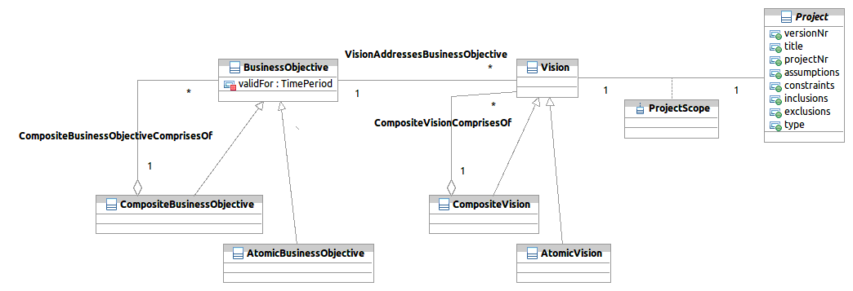
fig 0 – BusinessObjectives drive Projects

The ProjectScope defines the "functional area" impacted by a project that can be expressed by eTOM process elements, SID entities and/or TAM application which might be affected by the project. In a multi-project environment (or a program) the scopes of those projects might be structured in a (composite) hierarchy.
Aligned with the strategical goals of the organization projects provide value by enabling Service-, Ressource- and ProductSpecifications and/ or ProductOfferings, as shown in figure 0b.
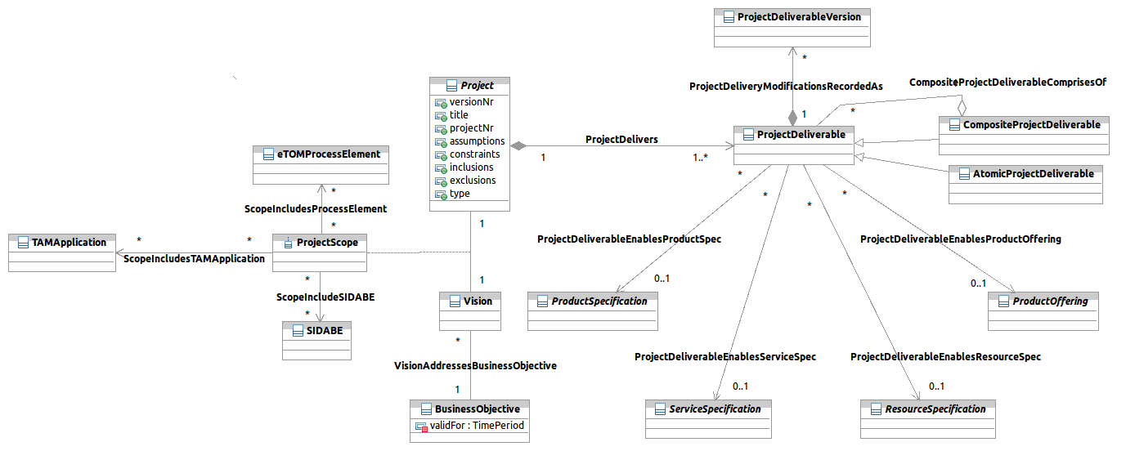
fig 0.b – Project Scope and Project Deliverable

Structure
Projects are made up of Sub-Projects, Work Breakdown Structure (WBS) Elements and Activities, as shown in figure 1.
Projects can be established for many reasons in an Enterprise and Activities can cover any task in the Enterprise, from Strategic work, Product Development through to Repair and Maintenance. A Project can be thought of as a grouping of Activities to achieve one or more business goals.
We will define an abstract entity “ProjectElement” that contains the common attributes and associations of Project, WBS Element and Activity. This will help in making the model simpler, more robust and more flexible.
Note that in the model, many of the relationships have been generalized to link to ProjectElement. This allows the relationships to be defined at a high level (e.g. per Project) or at the lowest level (e.g. per Activity). To reduce data entry and data maintenance, the linkages should be made at the highest practical level. For example, if a Project is all at a certain Location then this linkage should be done at the Project level. If the Project is at 3 locations then link to the Locations at the highest level practical (e.g. a t the WBS or Activity level).
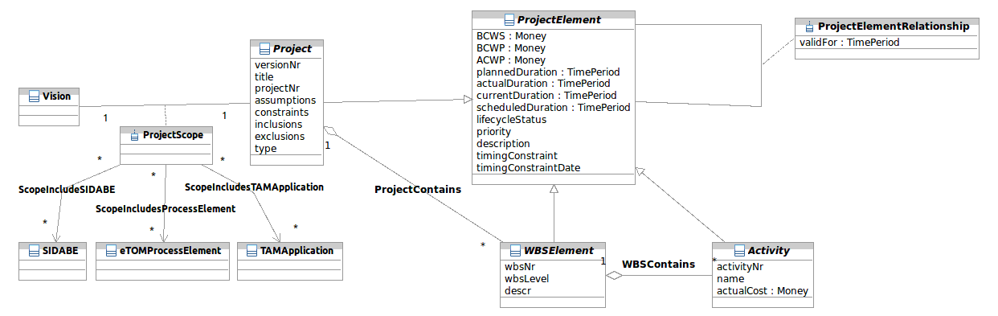
fig 1 – Basic Structure
Figure 2 shows the ProjectElement structure in more detail.
Projects can be decomposed into smaller parts (sub-projects) forming a hierarchy.
Similarly, WBS Elements are broken down using a strict hierarchy.
Activities can also be formed into a hierarchy, allowing us to deal with them at both a summary and a detailed level.
Note that Project, WBS Element & Activity are linked at the abstract level, allowing for greater flexibility.
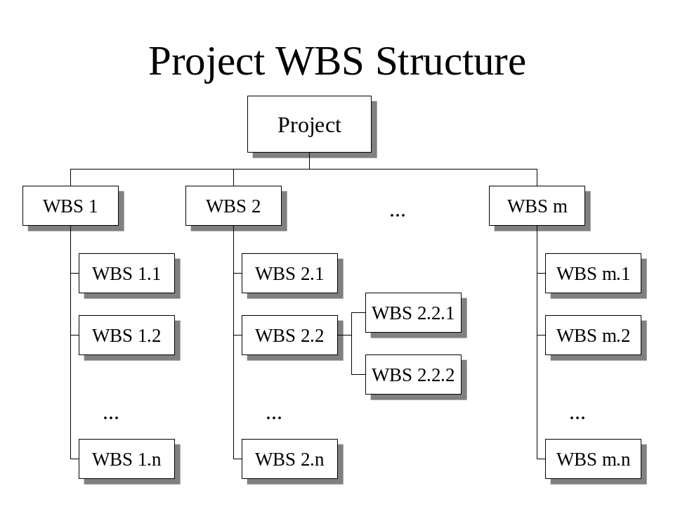
fig 1.b – WBS Structure Example

Notice that the model in figure 2 shows the composite pattern and associations individually, rather than at the ProjectElement level. This has been done to help the understanding of the business rules. In the design model it may be worthwhile moving these associations to ProjectElement and implementing the business rules using a rules or policy engine.
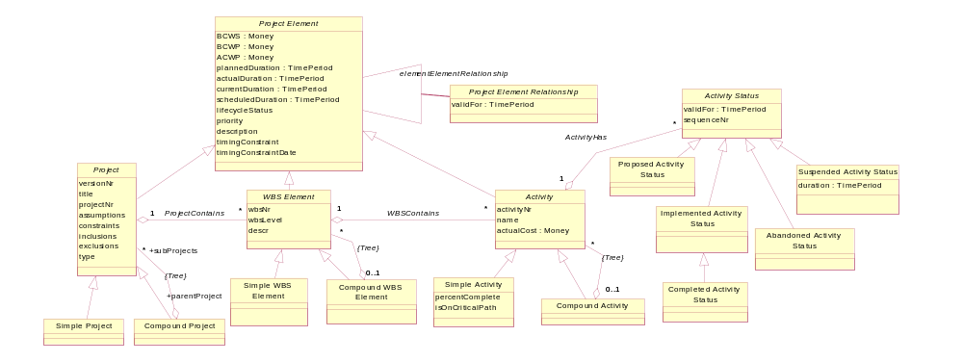
fig 2 – Detailed Structure

ProjectElements can be related to each other, for instance an Activity can have predecessor and successor Activities. This will be explored in more detail in the next section.
ProjectElements of the same type can be arranged into trees. This is shown using the Composite pattern [GoF], with the restriction [DAG] denoting that the composite forms a directed acyclic graph (no loops allowed) or [Tree] denotes that it is a strict hierarchy (an element can have only one parent at a given point in time). Note that the WBS Element hierarchy is restricted to the same Project and the Activity hierarchy is restricted to the same Project/WBS Element.

ProjectElement Relationships
As well as the ProjectElement hierarchies, ProjectElements of different types can be related. We will define four different ways that ProjectElements can be related. The Relationship Types are based on the definitions in [ISO / DIS 19108.2].

Relationship Type | Description
Dependency | This is where the two Project Elements have some starting or finishing dependency. E.g. Activity 2 cannot start until Activity 1 is complete. See table 2 for a complete list of dependencyTypes.
Succession | This is where one or more ProjectElements are replaced by one or more other ProjectElements. This is an abstract relationship and one of the concrete types listed below must be used.
Substitution | This is a one for one replacement. E.g. Activity 1 is no longer valid and has been replaced by Activity 1A
Division | This is a one for many replacement. E.g. Activity 1 is no longer valid and has been replaced by Activities 1A, 1B and 1C
Fusion | This is a many for one replacement. E.g. Activities 1A, 1B and 1C are no longer valid and have been replaced by Activity 1Z
Table 1 – Relationship Types

dependencyType | Definition
before-start-delay | Activity2 starts at least “lag” timepoints after Activity1 starts
before-finish-delay | Activity2 starts at least “lag” timepoints after Activity1 finishes
after-start-delay | Activity2 finishes at least “lag” timepoints after Activity1 starts
after-finish-delay | Activity2 finishes at least “lag” timepoints after Activity1 finishes
start-equal-start | Activity2 starts exactly “lag” timepoints after Activity1 starts
start-equal-finish | Activity2 starts exactly “lag” timepoints after Activity1 finishes
finish-equal-start | Activity2 finishes exactly “lag” timepoints after Activity1 starts
finish-equal-finish | Activity2 finishes exactly “lag” timepoints after Activity1 finishes
Table 2 - DependencyTypes (from [PSL])

Note that a similar set of dependencyTypes can be defined using Leading rather than lagging relationships, as shown in figure 3.

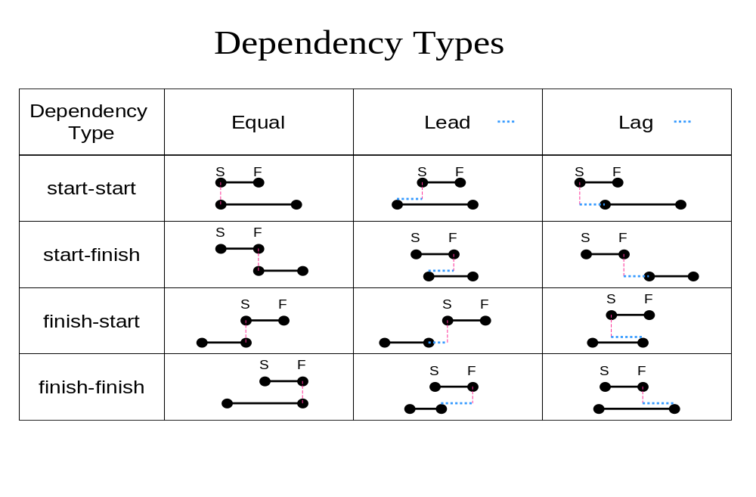
fig 3 – ProjectElement DependencyTypes

Table 3 shows ProjectElement timing constraints. These are used to determine the scheduled times when there is enough slack to allow the timing to vary. Note that timing conflicts may occur between the relationships and constraints and this will need to be addressed by an application implementing this model.

Timing Constraint Type | Definition
ASAP | As Soon As Possible
ALAP | As Late As Possible
FNET | Finish No Earlier Than
SNET | Start No Earlier Than
FNLT | Finish No Later Then
SNLT | Start No Later Than
MFO | Must Finish On
MSO | Must Start On
Table 3 - Constraint Types
Figure 4 shows how these relationship types are incorporated into the Project model.
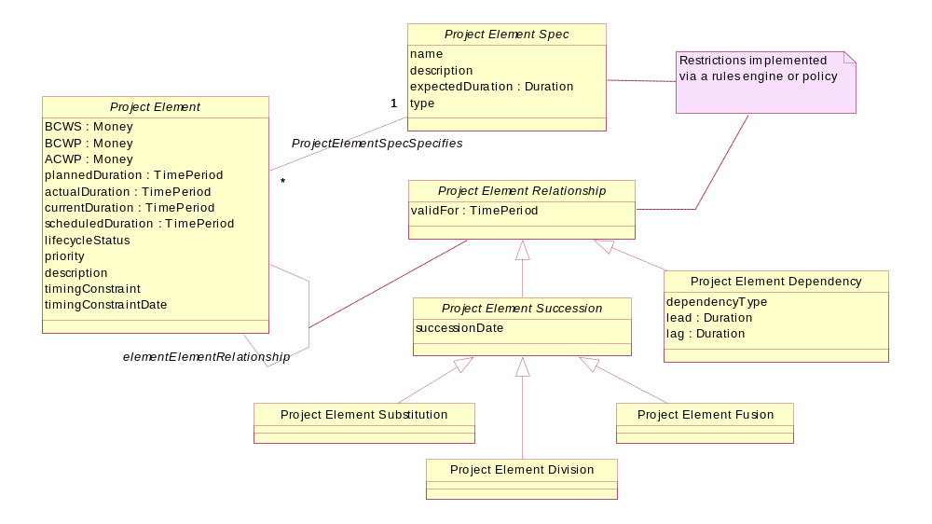
fig 4 – ProjectElement Relationships

Table 4 shows the allowable relationship type combinations for different ProjectElement types. These restrictions would probably be implemented with a rules or policy engine.

From ProjectElement
To ProjectElement | Project | WBS Element | Activity |  | Milestone (Activity)
Project | Dependency, Substitution, Division & Fusion | Dependency | Dependency
WBS Element | Dependency | Dependency on any WBS,.  Substitution, Division & Fusion in same Project only | Dependency in same Project only
Activity |  | Dependency in same Project only | Dependency, Substitution, Division & Fusion in same Project only
Milestone (Activity) | Dependency | Dependency | Dependency
Table 4 - Allowable Project Relationships
Note that table 4 only gives suggested linking rules. In general, projects should be globally visible but the visibility of WBS elements and Activities should be more restricted. Allowing individual Activities to be linked across Projects means that the detailed structure is then available to other Projects. Changes in the detail can then cause the relationships to become invalid. We need to balance unstructured relationships (which will be come a mess) against being too structured (which doesn’t allow us to implement valid requirements).
Figure 5 shows the specification or knowledge layer. The specification entities have been highlighted in green to make the distinction easier to see. Note that the composite pattern for the specifications will often not match that for the instance entities. Also the instance layer or specification layer may not have a corresponding composite pattern in the other layer. This is deliberate and not an error.
The specification layer would probably relate to providing templates for standard situations. ProjectSpecification could provide for common project types to be stored as templates (e.g. ‘Software Project’, ‘Install Remote Switch’, ‘Product Launch’). The Project template could contain standard WBS structures, activities and resourcing that could reduce the effort in creating projects.
Figure 5 also shows a new Entity, ProjectResource. For now we will use a simple definition for ProjectResource, as being an input to an Activity that can be consumed, modified or utilized by the Activity.
e.g. If we have an Activity “Weld Chair” then we may have ProjectResources such as chair parts, welding rod, a welder tradesman, a welding machine and electricity.
e.g. If we have an Activity “Upgrade Router” then we may have ProjectResources of firmware CD, technician, upgraded IO card, Laptop PC.
Note that in reality we don’t constrain ProjectResources only to Activity inputs but also allow other things that add to the ProjectCost to be included (maybe the cost of capital, if a Project involves borrowing money!).

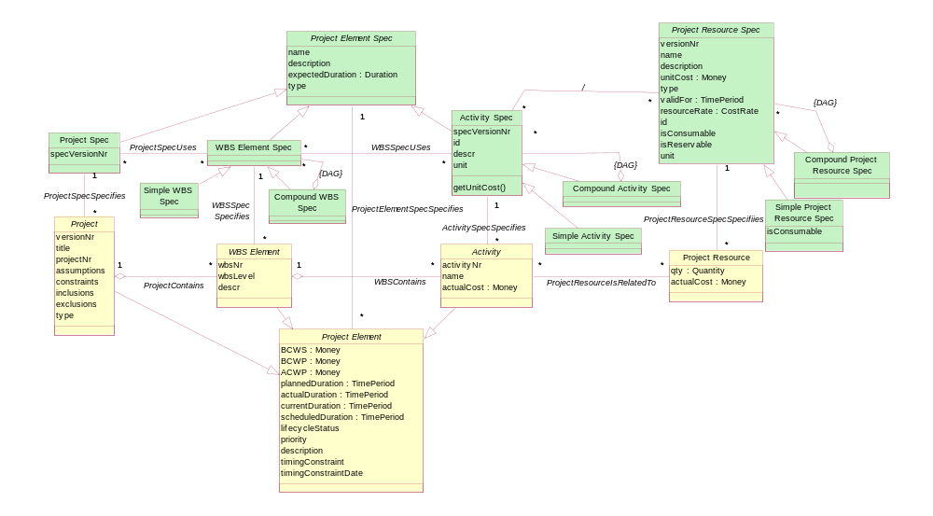
fig 5 – Specification

Activities have statuses. One possible set of statuses is shown in figure 6, based on those used in BPML [BPML]
The arrows show the allowable state transitions. Note that the Activating, Aborting and Completing statuses will be short lived and in effect are notifications of a transition, which will be useful in implementing an event model.
Ready
Cancelled
Active
Completed
Aborted
Aborting
Completing
Activating
fig 6 – Activity Status (UML Statechart diagram)

Activities and ProjectResource Status
When an Activity acts on a ProjectResource then the Activity is likely to change the status of the ProjectResource. The ProjectResource is likely to have status changes that occur in line with the Activity Status changes.
For example we may have an Activity ready to install a Router. The Router status may change in line with the Activity status, as shown in the table below.
Activity Status “”Install Router”” | ProjectResource Status
Ready | Planned
Activating | Planned
Active | Planned
Completing | Planned
Completed | Existing
Table 5 – ProjectResource & Activity Status Example 1
Similarly if we have an existing Router that we have an Activity to decommission, the Router status may change in line with the Activity status, as shown in the table below.
Activity Status “”Remove Router” | ProjectResource Status
Ready | Existing
Activating | Decommissioned
Active | Decommissioned
Completing | Decommissioned
Completed | Removed
Table 6 – ProjectResource & Activity Status Example 2
We can see that the status interaction is dependant on the ProjectResource status before the Activity starts and the type of Activity (install, modify, recover) being performed on the ProjectResource.
It is expected that the SID Resource addenda will define how ProjectResource statuses change.

Project Roles
Parties (Organizations and Individuals) can play various Roles in a Project. This could be at the Project, WBS or Activity level and so this has been abstracted to the ProjectElement level in this model.
We will define an abstract role that all ProjectRoles will be derived from. A few concrete roles are shown as examples. Other roles may also be appropriate.
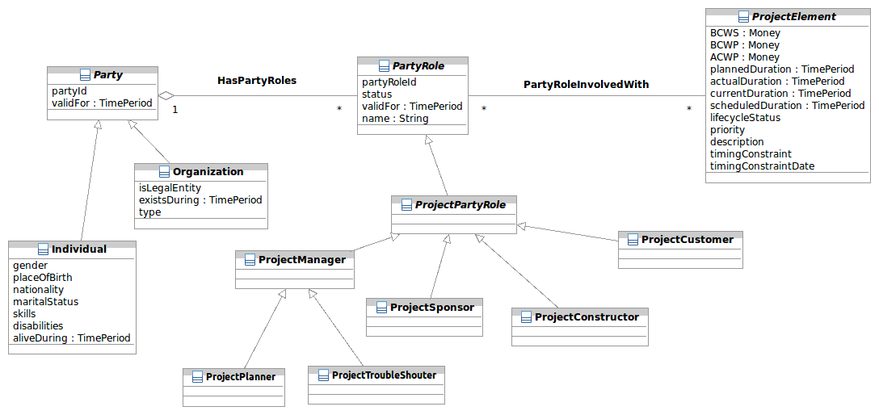
fig 7 – Project Roles
Note that for implementation, PartyRole is most likely to be an Interface with ProjectPartyRole a root abstract class implementing the PartyRole interface.
There will be other Role sets that may also be important for a Project. Only a few Project specific ones are shown here.

Project Calendar
A Project has two different Calendar related requirements.
The first is to have a Calendar that shows the working time periods, used to convert between working hours and elapsed days. For example if we have a 10 hour Activity, that is due to start at noon on a Friday, and if working hours are 9:00am –12:00am and 1:00pm ‘till 5:00pm Monday to Friday, then the Activity will not be completed until 4:00pm on Monday.
A Project also needs to keep track of working days and holidays. Each Project may wish to have its own working time Calendar (e.g. for projects in different countries with different hours of work), but it will be most effective for a Project to utilize or modify a standard calendar.
The second requirement is to be able to show Activities on a Gantt chart. To do this, we can store the Activity start and end dates in a Calendar Entry
For more details of the Calendar core model, refer to the SID Time Addendum.
Figure 8 shows Project linking to Calendar. A Project links to a single ProjectCalendar, which is a type of CompoundCalendar. The CompoundCalendar would normally be made up of a Standard Work Calendar storing all of the public holidays for a Country or a State (refer SID Location model). In addition, changes to the standard calendar can be made in a ProjectSpecificWorkCalendar. The intention is to reduce work calendar maintenance by allowing for the sharing of standard work times.
For Projects that span multiple Countries, then a Project may need to use more than one StandardWorkCalendar. In that case then the project will need to associate Activities with Countries and use the correct StandardWorkCalendar for scheduling.

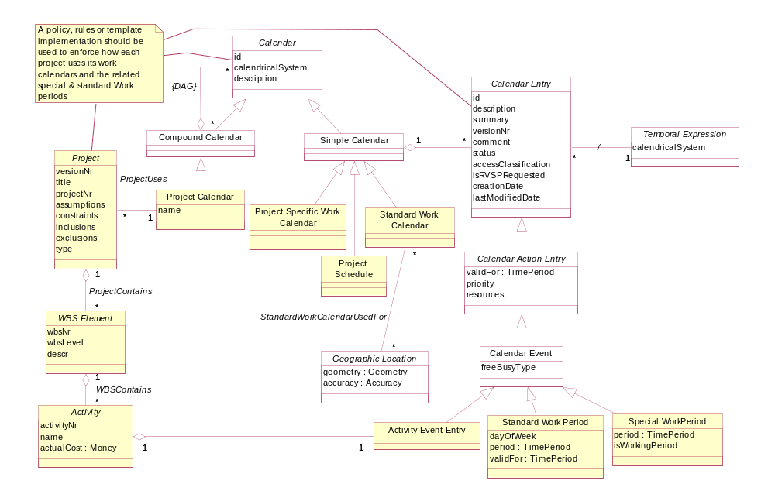
fig 8 – Project Calendar

Project Triggers
Here we will define an Event as a “happening at a point in time”. We will define a Trigger as an event that requires a response, even if the response may end up being “no action required”. Since the definition of a trigger may be contextual (the same event may require responses from some groups only) then it may be best to model this as a role (Event plays role of Trigger).
A ProjectMilestone is modeled as an Activity rather than as an Event, so that it is a type of ProjectElement and can form part of a Project.
There will be Triggers that may cause the generation of an Activity. For example, a network fault, Customer complaint or network infrastructure run-out. Also completion of a ProjectMilestone may generate events e.g. payment to a Contractor.
Note: This part of the model may change when the SID Event model is defined..
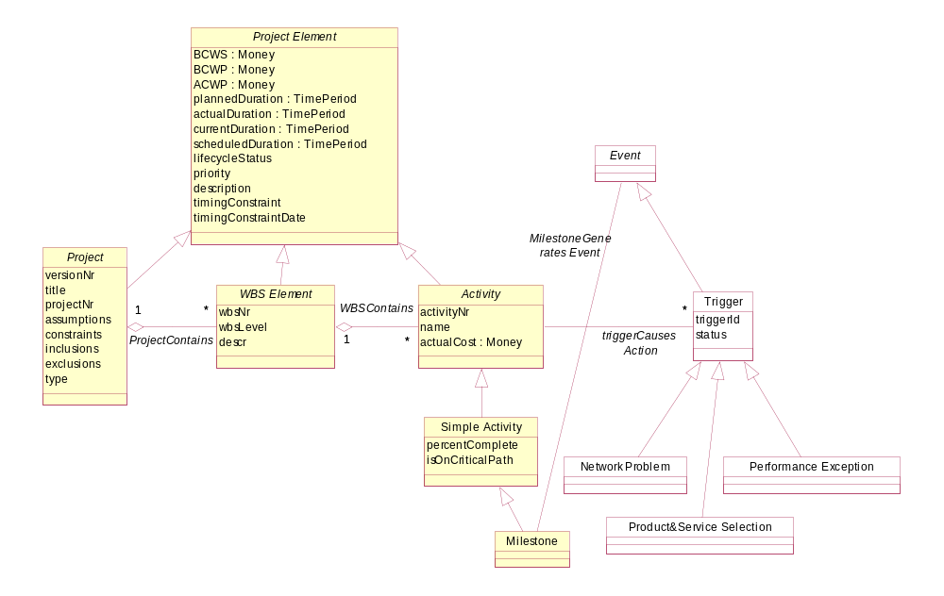
fig 9 – Project Triggers

Resourcing
In this section we will look at how ProjectResources are allocated to ProjectElements.
As explained by Martin Fowler [Fowler-AP], there are two types of ProjectResource usage; consumption, and reservation for a period of time. This may also be dependant on the type of ProjectResource, for instance some types of ProjectResource can only be used once.
Also there are two types of ProjectResource allocation; generic (based on ProjectResourceSpecifications) or specific (based on ProjectResource instances). The allocation may change over time, early on a ProjectResource may be generically allocated and then later on this may be changed to a particular instance.
ProjectResources may be able to be individually identified (e.g. via a serial number) or may be identified in bulk (e.g. by lot or batch). This will affect the way that we model ProjectResources. Expensive items like an expensive machine or tool will be tracked through its lifetime, while tins of paint and piles of gravel will be tracked at a more aggregate level.
We will define Intrinsic and Contextual characteristics of an Asset as:
- Intrinsic characteristics are those that are independent of how an asset is used (e.g. weight, color, size)
- Contextual characteristics relate to how an Asset is used by an Activity
  - consumption of the asset by the Activity
  - reservation of the asset by the Activity for a period of time
  - production of the asset by the Activity

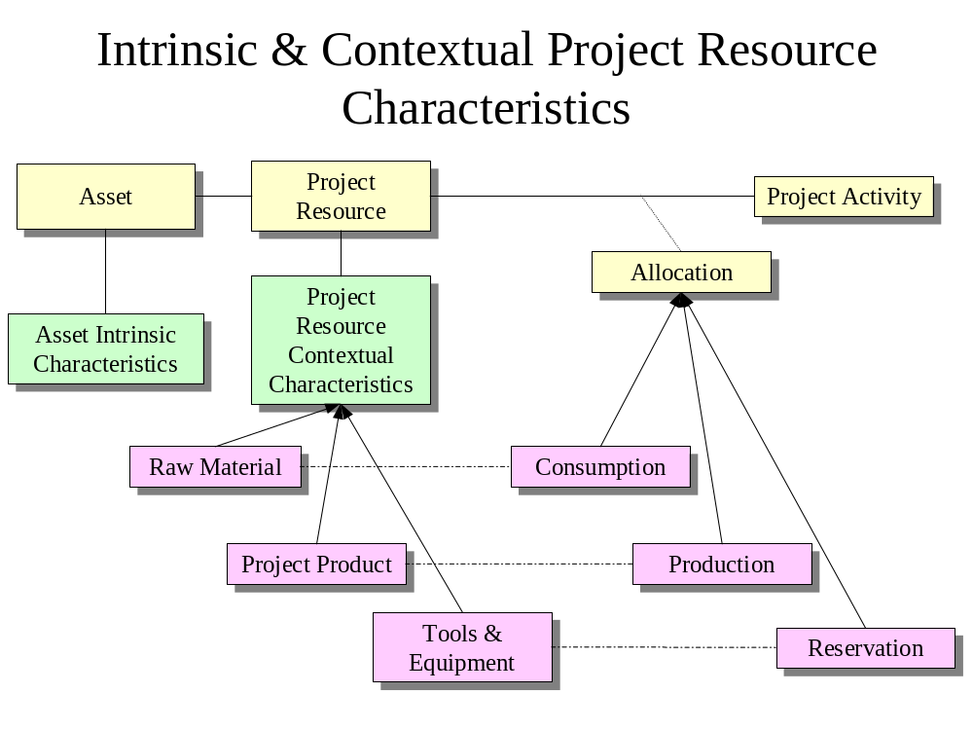
fig 10 – Intrinsic & Contextual ProjectResource Characteristics
An Activity consumes a ProjectResource if, after use by an Activity, the ProjectResource is destroyed or unable to be recovered and used by another Activity.
An Activity produces a Project Resource if, when the Activity is complete, a ProjectResource is available for sale to a customer or as an input to another Activity.
An Activity permanently reserves a ProjectResource if, when the Activity is complete, the ProjectResource is not free for reuse. Another Activity may be required to recover the ProjectResource.
An Activity temporally reserves a ProjectResource if, on completion of the Activity, the ProjectResource is available to be used (by another Activity).
For temporal usage resources, we will define ProjectResource pools. This will allow us to show available ProjectResources at a Location.
For example: for car sales, a new car dealer may sell a car to a Customer and either allocate a model type (color & accessories ordered from the factory) or a particular car (based on engine nr if chosen by the Customer from the car lot).
A car rental company will have pools of cars at various Locations. These are allocated to Customers. It would be likely that Customers book generic car types e.g. a particular model. Actual cars could then be allocated as Customers arrive. In this way late Customers can be matched to cars available at the time.

Work Orders
To actually use resources, most organizations will require a formal signed document to authorize the usage. We will call this document a Work Order.
This model uses the Order Pattern by Riehle [Order Pattern]. Figure 3 shows that a WorkOrder may have many WorkOrderItems associated with it. These items would relate to lines on the order.
Each WorkOrderItem may then have zero or more Fulfillments associated with it.
Note that the WorkOrderItem may not equal the WorkOrderFulfillment as there may have been a substitution.
e.g. 3 buckets of red sand on the Order, but 3 buckets of orange sand (an allowable alternative ) actually sent

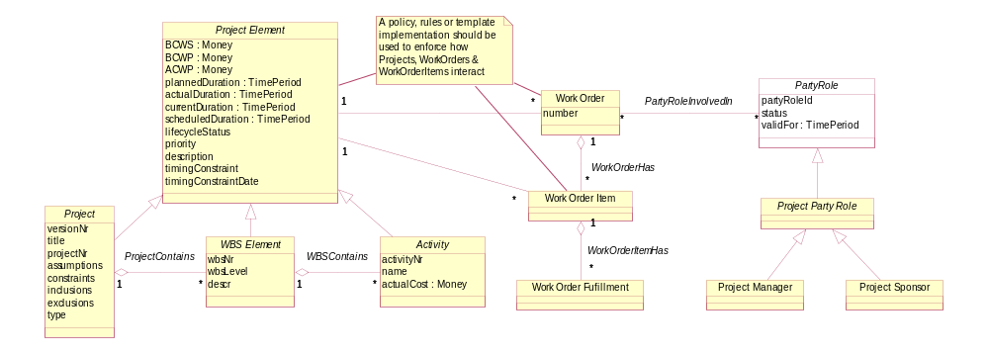
fig 11 – Work Orders (& Reservations)

Costing
An Activity uses ProjectResources to directly or indirectly produce value for the Customer. This may involve production of Products, expansion of infrastructure etc.
One important requirement is that we need to be able to determine the cost of a ProjectElement (Project, Project Activity, WBS Element) and also of Project Resources.
This model adopts a parameterized cost model based on Activity Based Costing (ABC) definitions.
Note that determination of the Activity & ProjectResource parameters is not covered by this model. The parameters should be chosen to give the best indication of cost and other deliverables (e.g. labor requirements). Refer to the [PEI handbook] for details on how to determine these parameters.
Figure 12 shows the basic ABC concepts and how they relate. The book [Common Cents] provides a good introduction to Activity Based Costing.
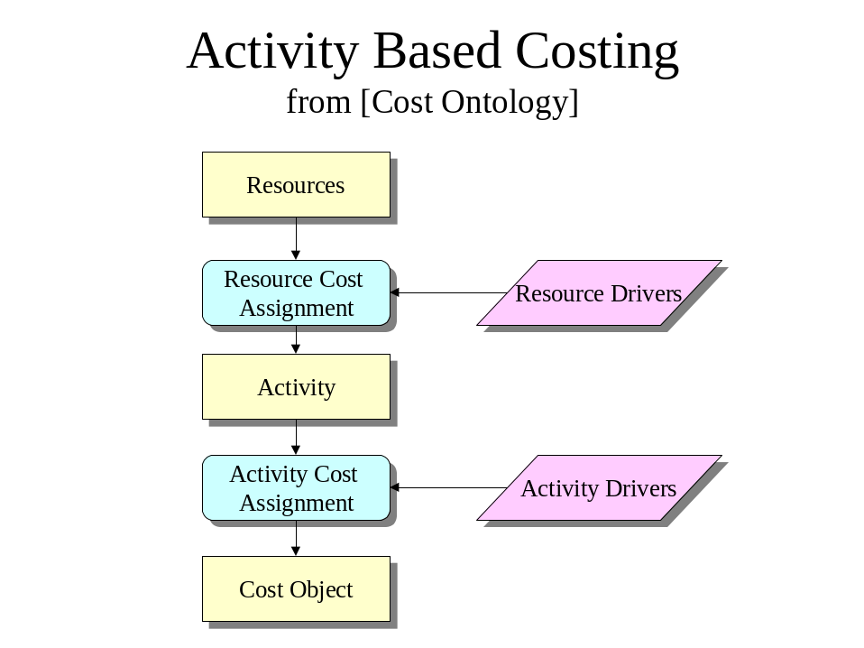
fig 12 – ABC Costing Concepts

Table 7 shows how we can use parameters to calculate costs.

Cost Model | Example of Usage | Costing Calculation Example
Block | 7 bricks | Price = 7 * 2.5
Linear parameterized | 5 brickbats(size=1, nr_ports=7) | Price = 3 * size + 2 * ports + 11
Non-linear parameterized | 5 nl_brickbats (size=1, nr_ports=7) | Price = 3 * size + sqrt(2 * ports) + 11
Table 7 – Costing Model Example
Note again that in the following figure, the specification entities have been shaded green to make the diagrams easier to read.
In figure 13 we can see that Project Resources are linked to Activities of a Project.

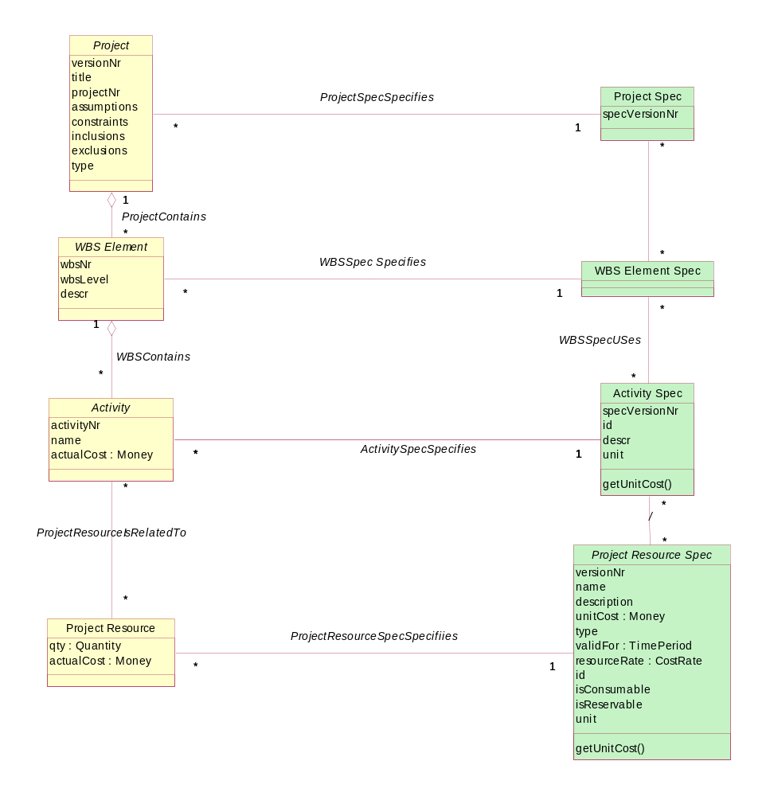
fig 13 – Costing Overview

Project ABE - SCRUM extension blade
Figure 14 depicts the utilization of the generic project model presented in the special context of SCRUM by plugging in an extension blade. SCRUM is an iterative incremental process of delivery commonly used with agile software development. The SCRUM specific business entities were added specializing and concretizing business entities of the project ABE without changing or modifying the logical structure.
The SCUM blade specializes most of the generic project entities:
In SCRUM ProjectElements are BacklogItems and Tasks (derived from acitivity); ProjectPartyRoles are the ProductOwner as the representative of the customer, ProjectContructor and the ScrumMaster. The deliverables of a SCRUM like project are WorkingIncrements; the project schedule consists of multiple Sprints.
Specific to SCRUM is the Impediment that has no corresponding entity in the generic project model.
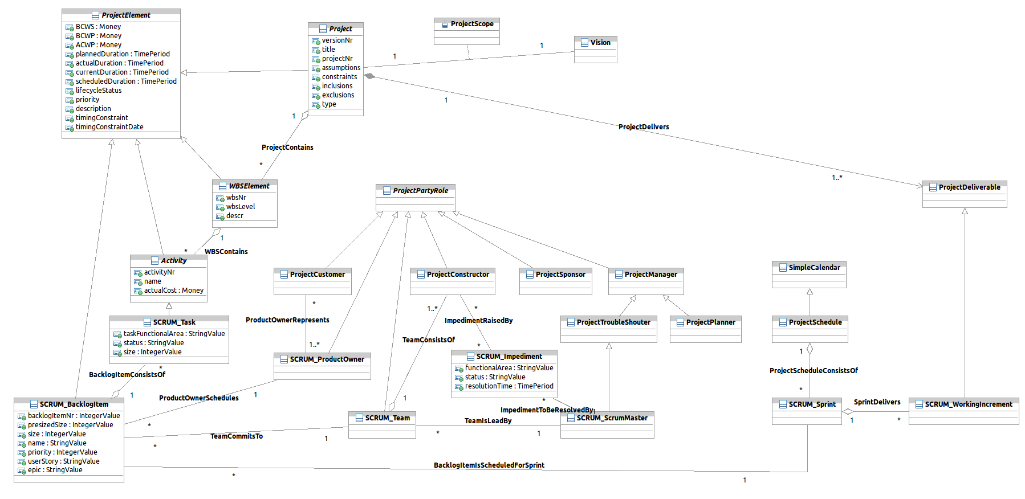
fig 14 – project blade SCRUM

Workflow
Note that this is not a complete workflow model. If required, workflow should be covered in a separate SID addendum.
A Workflow document would focus on Processes, the Activities that make up the Processes and their dependencies. The Process and Activity definitions could then be used as templates for Project definition.
The Activity composite pattern in this document will allow Project and Workflow to be linked, but be defined at different levels of granularity if required.
The interdependencies between the two ABEs will need to be carefully thought out so that a clean separation can be made.

Using this model for Process Analysis
This will be added in a later release

Further Work Required in Later Releases
- complete the parametric costing model
- need to consider if Activity Structure is in the Specifications only or we should allow an instance hierarchy similar to MS project ?
- additional blades for further project methodologies

Notes
- Note that these entities represent business concepts in a Service Provider that conforms to the eTOM process model [eTOM].
- This is intended as a “minimalist” model. Subtypes and attributes should be added as required. The attributes shown should be considered as suggested, not required.
- Parent attributes are not repeated in the sub entities
- In most cases relationships are not documented as attributes
- Only significant entities are shown in the “related business entities” cells
- Some of the Entity names are generic and if this is likely to cause confusion they have been prefixed by “Project”. E.g. “ProjectResource” is not the same as the eTOM “Resource”
- Some of the diagrams in this document show association roles. The association roles are denoted by a plus sign and then the association role name (starting with lower case). For example, in figure 2, the association between Project & CompoundProject has a role on the Project end of “subprojects”

References

Hay | Data Model Patterns , Conventions of Thought  http://www.dorsethouse.com/books/dmp.html
Fowler-AP | Analysis Patterns – Reusable Object Models  by Martin Fowler ISBN 0-201-89542-0  http://martinfowler.com/articles.html
Fowler-Time | Patterns for things that change with time  http://martinfowler.com/ap2/timeNarrative.html
ACIA | Alliance Common Information Architecture (AT&T, BT & Concert) version 3.1, 15 Dec 2000
eTOM | GB921 version 2.5
Composite Pattern | Articles: Composite à la Java, Part I & II  http://www.research.ibm.com/designpatterns/publications.htm
PEI Handbook | Parametric Estimating Initiative (PEI) Parametric Estimating Handbook  http://www.ispa-cost.org/PEIWeb/newbook.htm
ABC | Key Features of Activity Based Costing
----- | Journal of Cost Management, Ron Bleeker, vol 15, nr 4, 2001
ABC Review | Activity-based Costing: A Review with Case Studies, J Innes and F Mitchell, ISBN 0948036729
Common Cents | Common Cents: The ABC Performance Breakthrough, Peter B.B. Turney
Order Pattern | Three-Level Order Pattern  http://www.riehle.org/practical-matters/patterns/business/association-objects/three-level-order.html
GoF | Design Patterns - Gamma, Helm, Johnson & Vlissides
Entity Reservation | An Analysis Pattern for Reservation and Use of Reusable Entities  Eduardo B. Fernandez and Xiaohong Yuan  http://jerry.cs.uiuc.edu/~plop/plop99/proceedings/Fernandez2/reservAnalysisPattern3.PDF
WBS | MIL-HDBK-881 - DEPARTMENT OF DEFENSE HANDBOOK : WORK BREAKDOWN STRUCTURE  http://www.acq.osd.mil/pm/newpolicy/wbs/wbs.html
BPML | Business Process Modeling Language  http://xml.coverpages.org/BPML-2002.pdf
ISO / DIS 19108.2 | Draft International Standard. 2. CD 19108, Geographic information – Temporal schema
Resource Ontology | A GENERIC ENTERPRISE RESOURCE ONTOLOGY  Fadi George Fadel, Mark S. Fox, Michael Gruninger  http://www.eil.utoronto.ca/enterprise-modelling/papers/fadel-wetice94.pdf
Cost Ontology | A COST ONTOLOGY FOR ENTERPRISE MODELLING  K. D.(Donald) Tham, Mark S. Fox, Michael Gruninger  http://www.eil.utoronto.ca/enterprise-modelling/papers/cost-WETICE94.pdf
Activity Ontology | An Activity Ontology for Enterprise Modeling  Michael Gruninger and Mark S. Fox  http://www.eil.utoronto.ca/enterprise-modelling/papers/gruninger-wetice94-act.pdf
PSL | The Process Specification Language (PSL) Overview and Version 1.0 Specification  Craig Schlenoff, Michael Gruninger, Florence Tissot, John Valois, Josh Lubell, Jintae Lee  http://www.nist.gov/msidlibrary/doc/nistir6459.pdf
SCRUM Alliance | http://www.scrumalliance.org

Standard citation for this document
TM Forum SID GB922 Addendum 1J (Project)
Chris Hartley, Helen Hepburn et al.
http://www.tmforum.org/

Business Entity Definitions

ProjectElement

Business Entity Definition
Business Entity Name | ProjectElement
Description | This is an abstract entity used to hold the attributes and associations common to Project, WBS Element and Activity.
Sources |  | Cross- References |  |  | Synonyms / Aliases
Related Business Entities
Business Rules

Business Entity Attributes Definition
Business Entity Name | ProjectElement
Attribute Name | Description | Data Type | Characteristics, Permitted Values & Units | Required/  Optional | Notes
BCWS | budgeted cost of work scheduled | Cost |  | Optional
BCWP | budgeted cost of work performed | Cost |  | Optional
ACWP | actual cost of work scheduled | Cost |  | Optional
plannedDuration | the duration expected during the planning process | Duration |  | Optional
scheduledDuration | the duration expected during the detailed scheduling process | Duration |  | Optional
currentDuration | the latest expected duration before the actual occurrence | Duration |  | Optional
actualDuration | the duration that actually occurred | Duration |  | Optional
lifecycleStatus | the current status | Text |  | Required
priority |  | Text |  | Optional
description | descriptive text about the ProjectElement | Text |  | Optional

Project

Business Entity Definition
Business Entity Name | Project
Description | A Project achieves a business goal and is a discrete unit of work
Sources |  | Cross- References |  |  | Synonyms / Aliases
Related Business Entities
Business Rules

Business Entity Attributes Definition
Business Entity Name | Project
Attribute Name | Description | Data Type | Characteristics, Permitted Values & Units | Required/  Optional | Notes
projectNr | a unique identifier for the Project | Number |  | Required
versionNr | allows us to keep track of updates to the Project | Number |  | Required
title | a short description of the Project | Text |  | Required
type |  | Text |  | Required
assumptions | assumptions made when defining the Project (especially assumptions for success) | Text |  | Optional
constraints | constraints that may affect Project success | Text |  | Optional
inclusions | items that the Project covers that are not obvious | Text |  | Optional
exclusions | specific exclusions that may have been reasonably expected to be included in the Project | Text |  | Optional

Vision

Business Entity Definition
Business Entity Name | Vision
Description | The Vision is the common understanding of all parties involved in a project (either directly or as a stakeholder) about the goals of a project, the key success criteria, timeline and impact of not doing the project. The Vision is associated to a business objective.
Sources | C2M Best Practices (C2MBP) team | Cross- References |  | Business Objective | Synonyms / Aliases
Related Business Entities | Defines ProjectScope of a Project  Addresses BusinessObjective
Business Rules

Business Entity Attributes Definition
Business Entity Name | Vision
Attribute Name | Description | Data Type | Characteristics, Permitted Values & Units | Required/  Optional | Notes

Atomic Vision

Business Entity Definition
Business Entity Name | Atomic Vision
Description | A type of Vision that does not have any subordinate Vision, that is, an Atomic Vision is a leaf-level Vision.
Sources | C2M Best Practices (C2MBP) team | Cross- References |  |  | Synonyms / Aliases
Related Business Entities | Subclass of Vision
Business Rules

Business Entity Attributes Definition
Business Entity Name | Atomic Vision
Attribute Name | Description | Data Type | Characteristics, Permitted Values & Units | Required/  Optional | Notes

CompositeVision

Business Entity Definition
Business Entity Name | CompositeVision
Description | A type of Vision that is formed by aggregating other Visions, which may be composite or atomic Visions.
Sources | C2M Best Practices (C2MBP) team | Cross- References |  |  | Synonyms / Aliases
Related Business Entities | SubclassOf Vision  ComprisedOf Vision
Business Rules

Business Entity Attributes Definition
Business Entity Name | CompositeVision
Attribute Name | Description | Data Type | Characteristics, Permitted Values & Units | Required/  Optional | Notes

ProjectScope

Business Entity Definition
Business Entity Name | Project Scope
Description | The ProjectScope defines the "functional area" impacted by a project that can be expressed by eTOM process elements, SID entities and/or TAM application which might be effected by the project. In a multi-project environment (or a program) the scopes of those projects might be structured in a (composite) hierarchy.
Sources | C2M Best Practices (C2MBP) team | Cross- References |  | SID ABEs, eTOM process elements, TAM application | Synonyms / Aliases
Related Business Entities | Is derived of the vision for a special project  Includes eTOMProcessElement  Includes SIDABE  Includes TAMApplication
Business Rules

Business Entity Attributes Definition
Business Entity Name | ProjectScope
Attribute Name | Description | Data Type | Characteristics, Permitted Values & Units | Required/  Optional | Notes

Project Deliverable

Business Entity Definition
Business Entity Name | ProjectDeliverable
Description | A ProjectDeliverable is the agreed output of a project. A ProjectDeliverable enables Service-, Ressource- and ProductSpecifications or ProductOfferings.
Sources | C2M Best Practices (C2MBP) team | Cross- References |  | Product Offering, Product, Service, Ressource | Synonyms / Aliases
Related Business Entities | Enables ServiceSpecification  Enables ProductSpecification  Enables RessourceSpecification  Enables ProductOffering
Business Rules

Business Entity Attributes Definition
Business Entity Name | ProjectDeliverable
Attribute Name | Description | Data Type | Characteristics, Permitted Values & Units | Required/  Optional | Notes

AtomicProjectDeliverable

Business Entity Definition
Business Entity Name | AtomicProjectDeliverable
Description | A type of ProjectDeliverable that does not have any subordinate ProjectDeliverables, that is, an Atomic ProjectDeliverable is a leaf-level ProjectDeliverable.
Sources | C2M Best Practices (C2MBP) team | Cross- References |  |  | Synonyms / Aliases
Related Business Entities | Subclass of ProjectDeliverable
Business Rules

Business Entity Attributes Definition
Business Entity Name | AtomicProjectDeliverable
Attribute Name | Description | Data Type | Characteristics, Permitted Values & Units | Required/  Optional | Notes

CompositeProjectDeliverable

Business Entity Definition
Business Entity Name | CompositeProjectDeliverable
Description | A type of ProjectDeliverable that is formed by aggregating other ProjectDeliverables, which may be composite or atomic ProjectDeliverables.
Sources | C2M Best Practices (C2MBP) team | Cross- References |  |  | Synonyms / Aliases
Related Business Entities | Subclass of ProjectDeliverable  ComprisedOf ProjectDeliverables
Business Rules

Business Entity Attributes Definition
Business Entity Name | CompositeProjectDeliverable
Attribute Name | Description | Data Type | Characteristics, Permitted Values & Units | Required/  Optional | Notes

ProjectDeliverableVersion

Business Entity Definition
Business Entity Name | ProjectDeliverableVersion
Description | A ProjectDeliverableVersion is the recorded version of a ProjectDeliverable
Sources | C2M Best Practices (C2MBP) team | Cross- References |  |  | Synonyms / Aliases
Related Business Entities
Business Rules

Business Entity Attributes Definition
Business Entity Name | ProjectDeliverableVersion
Attribute Name | Description | Data Type | Characteristics, Permitted Values & Units | Required/  Optional | Notes

WBS Element

Business Entity Definition
Business Entity Name | WBS Element
Description
Sources |  | Cross- References |  |  | Synonyms / Aliases
Related Business Entities
Business Rules

Business Entity Attributes Definition
Business Entity Name | WBS Element
Attribute Name | Description | Data Type | Characteristics, Permitted Values & Units | Required/  Optional | Notes
wbsNr | a unique identifier for the WBS, usually defined as a structured set of numbers e.g. 1003.8842.36 may identify a level 3 WBS withing a Project. | Text |  | Required
wbsLevel | the level that this WBS is in the Project’s WBS hierarchy | Number |  | Required

Activity

Business Entity Definition
Business Entity Name | Activity
Description | A small item of work, that aligns to a task in a process
Sources |  | Cross- References |  |  | Synonyms / Aliases
Related Business Entities
Business Rules

Business Entity Attributes Definition
Business Entity Name | Activity
Attribute Name | Description | Data Type | Characteristics, Permitted Values & Units | Required/  Optional | Notes
activityNr | a unique identifier for the Activity | Number |  | Required
name |  | Text |  | Optional
actualCost | the cost actually booked to the activity | Cost |  | Optional

SimpleActivity

Business Entity Definition
Business Entity Name | SimpleActivity
Description | An indivisible item of work, that aligns to a task in a process.
Sources |  | Cross- References |  |  | Synonyms / Aliases
Related Business Entities
Business Rules

Business Entity Attributes Definition
Business Entity Name | SimpleActivity
Attribute Name | Description | Data Type | Characteristics, Permitted Values & Units | Required/  Optional | Notes
percentComplete | indicates how much work has been completed for the Activity | Integer | 0-100 | Required
isOnCriticalPath | indicates if the Activity is on the Project critical path | Boolean |  | Required

ActivityStatus

Business Entity Definition
Business Entity Name | ActivityStatus
Description | The lifecycle flag for the Activity Possible statuses are Proposed, Implemented, Completed, Abandoned and Suspended.
Sources | [BPML] | Cross- References |  |  | Synonyms / Aliases
Related Business Entities
Business Rules

Business Entity Attributes Definition
Business Entity Name | ActivityStatus
Attribute Name | Description | Data Type | Characteristics, Permitted Values & Units | Required/  Optional | Notes

ProjectElementRelationship

Business Entity Definition
Business Entity Name | ProjectElementRelationship
Description | Allows us to relate ProjectElements. This is an abstract entity used to hold common attributes and associations for the concrete relationship types Substitution, Division, Fusion & Dependency
Sources |  | Cross- References |  |  | Synonyms / Aliases
Related Business Entities
Business Rules

Business Entity Attributes Definition
Business Entity Name | ProjectElementRelationship
Attribute Name | Description | Data Type | Characteristics, Permitted Values & Units | Required/  Optional | Notes
validFor | the TimePeriod that the relationship is valid for. | TimePeriod |  | Required

ProjectElementSuccession

Business Entity Definition
Business Entity Name | ProjectElementSuccession
Description | Is a type of ProjectElement relationship where one or more ProjectElements are succeeded by one or more ProjectElements. This is an abstract entity used to hold common attributes and associations for the concrete relationship types Substitution, Division & Fusion
Sources |  | Cross- References |  |  | Synonyms / Aliases
Related Business Entities
Business Rules

Business Entity Attributes Definition
Business Entity Name | ProjectElementSuccession
Attribute Name | Description | Data Type | Characteristics, Permitted Values & Units | Required/  Optional | Notes
successionDate | the date that the substitution, division or fusion takes effect | DateTime |  | Required

ProjectElementSubstitution

Business Entity Definition
Business Entity Name | ProjectElementSubstitution
Description | Is a type of ProjectElement relationship where one ProjectElement is succeeded by another ProjectElement.
Sources |  | Cross- References |  |  | Synonyms / Aliases
Related Business Entities
Business Rules

Business Entity Attributes Definition
Business Entity Name | ProjectElementSubstitution
Attribute Name | Description | Data Type | Characteristics, Permitted Values & Units | Required/  Optional | Notes

ProjectElementDivision

Business Entity Definition
Business Entity Name | ProjectElementDivision
Description | Is a type of ProjectElement relationship where one ProjectElement is succeeded by more than one ProjectElement. (i.e. the Element is split into many new Elements)
Sources |  | Cross- References |  |  | Synonyms / Aliases
Related Business Entities
Business Rules

Business Entity Attributes Definition
Business Entity Name | ProjectElementDivision
Attribute Name | Description | Data Type | Characteristics, Permitted Values & Units | Required/  Optional | Notes

ProjectElementFusion

Business Entity Definition
Business Entity Name | ProjectElementFusion
Description | Is a type of ProjectElement relationship where more than one ProjectElement is succeeded by one ProjectElement. (i.e. a number of Elements are combined into a single new Element)
Sources |  | Cross- References |  |  | Synonyms / Aliases
Related Business Entities
Business Rules

Business Entity Attributes Definition
Business Entity Name | ProjectElementFusion
Attribute Name | Description | Data Type | Characteristics, Permitted Values & Units | Required/  Optional | Notes

ProjectElementDependency

Business Entity Definition
Business Entity Name | ProjectElementDependency
Description | This allows us to show dependencies, that typically relate to a ProjectElement not being able to commence until another Element has been completed.
Sources | [PSL] | Cross- References |  |  | Synonyms / Aliases
Related Business Entities
Business Rules

Business Entity Attributes Definition
Business Entity Name | ProjectElementDependency
Attribute Name | Description | Data Type | Characteristics, Permitted Values & Units | Required/  Optional | Notes
dependencyType | the relationship to be applied between the start or end points of the project elements (refer table 2) | Text |  | Required | see [PSL]
lead | the time lead to be applied to the dependency | Duration |  | Optional | may be zero
lag | the time lag to be applied to the dependency | Duration |  | Optional | may be zero

ProjectElementSpecification

Business Entity Definition
Business Entity Name | ProjectElementSpecification
Description | Specifies characteristics that apply to types of ProjectElements. This is an abstract entity used to hold the attributes and associations common to ProjectSpecification, WBS ElementSpecification and ActivitySpecification.  These entities can be used to build standard project templates to aid in Project creation.
Sources |  | Cross- References |  |  | Synonyms / Aliases
Related Business Entities
Business Rules

Business Entity Attributes Definition
Business Entity Name | ProjectElementSpecification
Attribute Name | Description | Data Type | Characteristics, Permitted Values & Units | Required/  Optional | Notes
name | short text allowing for easy identification of the element specification | Text |  | Required
type |  | Text |  | Required
specVersionNr | allows us to keep track of changes in the specification | Number | positive integer | Required
description | descriptive text about the specification | Text |  | Optional
expectedDuration | the normal duration of this standard element | TimePeriod |  | Optional

ActivitySpecification

Business Entity Definition
Business Entity Name | ActivitySpecification
Description | Specifies characteristics that apply to types of Activities
Sources |  | Cross- References |  |  | Synonyms / Aliases
Related Business Entities
Business Rules

Business Entity Attributes Definition
Business Entity Name | ActivitySpecification
Attribute Name | Description | Data Type | Characteristics, Permitted Values & Units | Required/  Optional | Notes
id |  |  |  | Required
unit |  |  |  | Required

WBSElementSpecification

Business Entity Definition
Business Entity Name | WBSElementSpecification
Description | Specifies characteristics that apply to types of WBS Elements
Sources |  | Cross- References |  |  | Synonyms / Aliases
Related Business Entities
Business Rules

Business Entity Attributes Definition
Business Entity Name | WBSElementSpecification
Attribute Name | Description | Data Type | Characteristics, Permitted Values & Units | Required/  Optional | Notes

ProjectSpecification

Business Entity Definition
Business Entity Name | ProjectSpecification
Description | Specifies characteristics that apply to types of Projects
Sources |  | Cross- References |  |  | Synonyms / Aliases
Related Business Entities
Business Rules

Business Entity Attributes Definition
Business Entity Name | ProjectSpecification
Attribute Name | Description | Data Type | Characteristics, Permitted Values & Units | Required/  Optional | Notes

SCRUM_ProductOwner

Business Entity Definition
Business Entity Name | SCRUM_ProductOwner
Description | SCRUM_ProductOwner is a party role representing the ProjectCustomer in a SCRUM project. SCRUM_ProductOwners take on some traditional ProjectManager tasks. SCRUM_BacklogItems are presized and prioritized by the SCRUM_ProductOwner. Furthermore user stories and project epic are defined or agreed on by the SCRUM_ProductOwner. The sprint commitment by the SCRUM_Teams to process a certain number of SCRUM_BacklogItems during a sprint is given to the SCRUM_ProductOwner. The SCRUM_ProductOwner oversees the work progress during a SCRUM_sprint via task boards and backlogitem burndown of the SCRUM_Teams.
Sources | C2M Best Practices (C2MBP) team  SCRUM alliance | Cross- References |  | PartyRole | Synonyms / Aliases
Related Business Entities | Subclass of ProjectPartyRole  Represents ProjectCustomer  Schedules SCRUM_BacklogItem
Business Rules

Business Entity Attributes Definition
Business Entity Name | SCRUM_ProductOwner
Attribute Name | Description | Data Type | Characteristics, Permitted Values & Units | Required/  Optional | Notes

SCRUM_Team

Business Entity Definition
Business Entity Name | SCRUM_Team
Description | SCRUM_Team is a party role consisting of a number of ProjectConstructors and lead by a SCRUM_ScrumMaster. The SCRUM_Team sizes and commits to SCRUM_BacklogItems to be processed in a SCRUM_Sprint at the sprint planning meeting and presents the outcome a SCRUM_WorkingIncrement to the ProjectCustomer at the sprint review meeting. A SCRUM_Team is internally self organizing in breaking down SCRUM_BacklogItems into SCRUM_Tasks and allocating them to ProjectConstructors while being led by a SCRUM_ScrumMaster for external issues such as inter-SCRUM_Team communication or resolving of SCRUM_Impediments. The SCRUM_ScrumMaster is controlled by the SCRUM_Team. Dosumentation of the progress of work is the duty of the SCRUM_Team. Therefore the SCRUM_Team tracks its SCRUM_Tasks and backlog item burndown visible to the SCRUM_ProductOwner.
Sources | C2M Best Practices (C2MBP) team  SCRUM alliance | Cross- References |  | PartyRole | Synonyms / Aliases
Related Business Entities | Subclass of ProjectPartyRole  ConsistsOf ProjectConstructers  CommitsTo SCRUM_BacklogItem  IsLedBy SCRUM_ScrumMaster
Business Rules

Business Entity Attributes Definition
Business Entity Name | SCRUM_Team
Attribute Name | Description | Data Type | Characteristics, Permitted Values & Units | Required/  Optional | Notes

SCRUM_ScrumMaster

Business Entity Definition
Business Entity Name | SCRUM_ScrumMaster
Description | SCRUM_ScrumMaster is a party role specialization of ProjectTroubleShooter. The SCRUM_ScrumMaster  leads a number of SCRUM_Teams and resolves SCRUM_Impediments raised by ProjectConstructors in the daily SCRUM meeting. SCRUM_ScrumMaster explicitely does not fulfil an universal ProjectManagement role. In SCRUM duties of the ProjectManager role are shared between SCRUM_ScrumMaster (problem handling, organization), SCRUM_ProductOwner (vision, mission and long term planning) and SCRUM_Team (short term planning, responsibility for delivery).
Sources | C2M Best Practices (C2MBP) team  SCRUM alliance | Cross- References |  | PartyRole | Synonyms / Aliases
Related Business Entities | Subclass of ProjectTroubleShooter  IsToResolve SCRUM_Impediment  Leads SCRUM_Team
Business Rules

Business Entity Attributes Definition
Business Entity Name | SCRUM_ScrumMaster
Attribute Name | Description | Data Type | Characteristics, Permitted Values & Units | Required/  Optional | Notes

SCRUM_WorkingIncrement

Business Entity Definition
Business Entity Name | SCRUM_WorkingIncrement
Description | SCRUM_WorkingIncrement is a special type of ProjectDeliverable in SCRUM projects. It is delivered by SCRUM_Team(s) as the outcome of the processing of SCRUM_BacklogItems in a SCRUM_Sprint. SCRUM_WorkingIncrements do not depend on future ProjectDeliverables. Therefore they are either usable stand-alone providing a new service/ product/ ressource or enhancing an existing one. The SCRUM_WorkingIncrement is presented to the ProjectCustomer at the sprint review meeting held at the end of a SCRUM_Sprint.
Sources | C2M Best Practices (C2MBP) team  SCRUM alliance | Cross- References |  |  | Synonyms / Aliases
Related Business Entities | Subclass of ProjectDeliverable  IsDeliveredBy SCRUM_Sprint
Business Rules

Business Entity Attributes Definition
Business Entity Name | SCRUM_WorkingIncrement
Attribute Name | Description | Data Type | Characteristics, Permitted Values & Units | Required/  Optional | Notes

SCRUM_Sprint

Business Entity Definition
Business Entity Name | SCRUM_Sprint
Description | SCRUM_Sprint is an element of the ProjectSchedule reflecting a time periode defining a project iteration. The SCRUM_Team commits to the processing of scheduled SCRUM_BacklogItems for a SCRUM_Sprint at the sprint planning meeting. The outcome of every SCRUM_Sprint is a SCRUM_WorkingIncrement presented by the SCRUM_Team to the ProjectCustomer at the sprint review meeting.
Sources | C2M Best Practices (C2MBP) team  SCRUM alliance | Cross- References |  |  | Synonyms / Aliases
Related Business Entities | Delivers SCRUM_WorkingIncrement  ProjectSchedule ConsistsOf  SCRUM_BacklogItem ScheduledFor
Business Rules

Business Entity Attributes Definition
Business Entity Name | SCRUM_Sprint
Attribute Name | Description | Data Type | Characteristics, Permitted Values & Units | Required/  Optional | Notes

SCRUM_BacklogItem

Business Entity Definition
Business Entity Name | SCRUM_BacklogItem
Description | A SCRUM_BacklogItem is a type of ProjectElement which is scheduled (prioritized and presized) by the SCRUM_ProductOwner for a SCRUM_Sprint and sized by, assigned to and commited to by a SCRUM_Team at the sprint planning meeting. The SCRUM_BacklogItem is broken down into individual SCRUM_Tasks to be  assigned to a ProjectConstructor in a SCRUM_Sprint. The SCRUM_BacklogItem reflects the requirements,  expectations and desires of a ProjectCustomer. Those are verbalized in user stories. The SCRUM_BacklogItems collectively define the project backlog reflecting the project overall goal verbalized in an epic.
Sources | C2M Best Practices (C2MBP) team  SCRUM alliance | Cross- References |  |  | Synonyms / Aliases
Related Business Entities | Subclass of Project Element  ScheduledFor SCRUM_Sprint  CommitedToBy SCRUM_Team  ScheduledBy SCRUM_ProductOwner  ConsistingOf SCRUM_Task
Business Rules

Business Entity Attributes Definition
Business Entity Name | SCRUM_BacklogItem
Attribute Name | Description | Data Type | Characteristics, Permitted Values & Units | Required/  Optional | Notes

SCRUM_Task

Business Entity Definition
Business Entity Name | SCRUM_Task
Description | A SCRUM_Task is a type of Activity which is part of a SCRUM_BacklogItem. The SCRUM_BacklogItem is  decomposed into SCRUM_Tasks by the SCRUM_Team. The size of a SCRUM_Task should be such that it can be processed by the ProjectConstructor it is assigned to in less than a day. The status of a SCRUM_Task is tracked on the task board of a SCRUM_Team.
Sources | C2M Best Practices (C2MBP) team  SCRUM alliance | Cross- References |  |  | Synonyms / Aliases
Related Business Entities | Subclass of Activity  SCRUM_BacklogItem ConsistsOf
Business Rules

Business Entity Attributes Definition
Business Entity Name | SCRUM_Task
Attribute Name | Description | Data Type | Characteristics, Permitted Values & Units | Required/  Optional | Notes

SCRUM_Impediment

Business Entity Definition
Business Entity Name | SCRUM_Impediment
Description | A SCRUM_Impediment is an obstacle encountered by a ProjectConstructor during the work on a SCRUM_Task  preventing the task from getting done. The SCRUM_Impediment is raised to the SCRUM_ScrumMaster at the daily scrum meeting. The status of the SCRUM_Impediment has to be tracked and to be resolved in due time by the SCRUM_ScrumMaster. SCRUM_Impediments jeopardize the sprint commitment and therefore the sprint delivery.
Sources | C2M Best Practices (C2MBP) team  SCRUM alliance | Cross- References |  |  | Synonyms / Aliases
Related Business Entities | RaisedBy ProjectConstructor  ToBeResolvedBy SCRUM_ScrumMaster
Business Rules

Business Entity Attributes Definition
Business Entity Name | SCRUM_Impediment
Attribute Name | Description | Data Type | Characteristics, Permitted Values & Units | Required/  Optional | Notes

Administrative Appendix
This Appendix provides additional background material about the TM Forum and this document. In general, sections may be included or omitted as desired, however a Document History must always be included.

About this document
This is a TM Forum Guidebook. The guidebook format is used when:
- The document lays out a ‘core’ part of TM Forum’s approach to automating business processes. Such guidebooks would include the Telecom Operations Map and the Technology Integration Map, but not the detailed specifications that are developed in support of the approach.
- Information about TM Forum policy, or goals or programs is provided, such as the Strategic Plan or Operating Plan.
- Information about the marketplace is provided, as in the report on the size of the OSS market.

Document History

Version History
This section records the changes between this and the previous document version as it is edited by the team concerned. Note: this is an incremental number which does not have to match the release number

Version Number | Date Modified | Modified by: | Description of changes
0.1 | Aug 2002 |  | Initial Version
1.0 | Apr 2003 |  | Formatted for Team Review
1.1 | July 2003 |  | Formatted for Member Review with NGOSS R3.5
1.2 | Aug 2004 |  | To reflect TMF Approved Status
2.0 | Nov 2010 | Christian Kaemmerer  John Reilly | Review version NGOSS R9.5
2.1 | Mar 2011 | Alicja Kawecki | Updated Notice, minor formatting corrections prior to web posting and ME
2.2 | Sep 2011 | Alicja Kawecki | Updated to reflect TM Forum Approved status

Release History
This section records the changes between this and the previous Official document release

Release Number | Date Modified | Modified by: | Description of changes
9.5 | 22/Dec/10 | Christian Kaemmerer  John Reilly | First issue of document using updated template

Acknowledgments
This document was prepared by the members of the TM Forum SID team:
The Shared Information/Data Model is a genuinely collaborative effort. The TM Forum would like to thank the following people for contributing their time and expertise to the production of this document. It is just not possible to recognize all the organizations and individuals that have contributed or influenced the introduction. We apologize to any person or organization we inadvertently missed in these acknowledgments.
Key individuals that reviewed, provided input, managed, and determined how to utilize inputs coming from all over the world, and really made this document happen were:
Company | Team Member Representative
TM Forum | Cliff Faurer
Telstra | Chris Hartley
British Telecom | Helen Hepburn
CGI Group Inc. | Christian Kaemmerer
TM Forum | John Reilly
Mediaan abs | Dirk Rejahl
Oracle Corporation | Elmar Rode
Telstra | Wayne Sigley
Singer TC | Jan Singer
Intelliden | John Strassner

