Information Framework (SID)

Common Business Entity Definitions - Party

GB922 – Addendum 1P
TM Forum Approved Version 9.7


September, 2011

Notice
This material, including documents, code and models, has been through review cycles; however, due to the inherent complexity in the design and implementation of software and systems, no liability is accepted for any errors or omissions or for consequences of any use made of this material.
Under no circumstances will the TM Forum be liable for direct or indirect damages or any costs or losses resulting from the use of this specification. The risk of designing and implementing products in accordance with this specification is borne solely by the user of this specification.
This material bears the copyright of TM Forum and its use by members and non-members of TM Forum is governed by all of the terms and conditions of the Intellectual Property Rights Policy of the TM Forum (http://www.tmforum.org/Bylaws/1094/home.html) and may involve a claim of patent rights by one or more TM Forum members or by non-members of TM Forum.

Direct inquiries to the TM Forum office:
240 Headquarters Plaza,
East Tower – 10th Floor,
Morristown, NJ 07960 USA
Tel No. +1 973 944 5100
Fax No. +1 973 944 5110
TM Forum Web Page: www.tmforum.org

Table of Contents
Notice 2
Table of Contents 3
Table of Figures 5
1 Business Entities 6
1.1 Party Domain 6
1.1.1 Introduction 6
1.1.2 Party Demographic 21
1.1.3 Party Profile Type 26
1.1.4 Using this model for Process Analysis 28
1.1.5 Further Work Required in Later Releases 29
1.1.6 Notes: 30
1.1.7 References 31
1.1.8 Standard citation for this document 32
1.2 Business Entity Model 33
1.2.1 Examples 33
1.3 Business Entity Definitions 43
1.3.1 Party 43
1.3.2 Individual 44
1.3.3 Organization 46
1.3.4 Party Name 47
1.3.5 Individual Name 48
1.3.6 Organization Name 50
1.3.7 Party Role 51
1.3.8 Party RoleType 52
1.3.9 Value Network Role 53
1.3.10 Party Role Category 54
1.3.11 Service Provider Employee 55
1.3.12 OrganizationPost 56
1.3.13 Party Role Association 57
1.3.14 Language 58
1.3.15 Language Ability 59
1.3.16 Contact Medium 60
1.3.17 eMail Contact 61
1.3.18 Party Identification 62
1.3.19 Organization Identification 63
1.3.20 Individual Identification 64
1.3.21 Passport Identification 65
1.3.22 AtomicDemographicCharacteristic 65
1.3.23 AtomicPartyDemographic 66
1.3.24 CompositeDemographicCharacteristic 67
1.3.25 CompositePartyDemographic 67
1.3.26 DemoCharacteristicValue 68
1.3.27 DemographicCharacteristic 69
1.3.28 PartyDemographic 71
1.3.29 PartyDemographicValue 73
1.3.30 AtomicPartyProfileTypeCharacteristic 74
1.3.31 CompositePartyProfileTypeCharacteristic 74
1.3.32 PartyProfile 75
1.3.33 PartyProfileType 76
1.3.34 PartyProfileTypeCharacteristic 77
1.3.35 PartyProfileTypeCharacteristicValue 79
2 Administrative Appendix 81
2.1 About this document 81
2.2 Document History 81
2.2.1 Version History 81
2.2.2 Release History 82
2.3 Company Contact Details 82
2.4 Acknowledgments 83

Table of Figures

fig 0 – Showing how Party fits in 6
fig 1 – basic Party model 7
fig2 – naming for Parties 9
fig 3 – Identifying Parties 11
fig 4 – party and the main eTOM roles 13
fig 5a – modeling Interactions directly to Party – appealing, but NOT suitable for our purpose 15
fig 5b –Parties interact via their roles 16
fig 6 – Parties can be associated via their roles 17
fig 7 – Contacting a Party 19
fig 8 – showing possible links to other parts of the SID model 20
fig 9 – Demographic Characteristic Business Entities 23
fig 10 – Party Demographics Business Entities 25
fig 11 – Party Profile Type Entities 26
fig 12 – Composite and Atomic Party Profile Type Characteristics 27
fig 13 – Party Role and Party Profile Type 28
fig E1 – simplified class diagram used for examples 34
fig E2 – example 1 – Organization Hierarchy & Name Change 36
fig E3 – example 2 – Value Network , Supplier, Customer 38
fig E4 – example 3, Prospective Party Roles, Contact Medium & Language Ability 40
fig E5 – example 4 43

Business Entities

Party Domain
This SID domain defines information about companies and people. Implementations of this model are responsible for ensuring that the relevant privacy legislation standards are adhered to in the countries that will use the implementation.

Introduction

Background
At the most fundamental level [Zachman], [Coad-Archetypes] the world can be thought of as comprising of entities that answer the 5 fundamental questions.
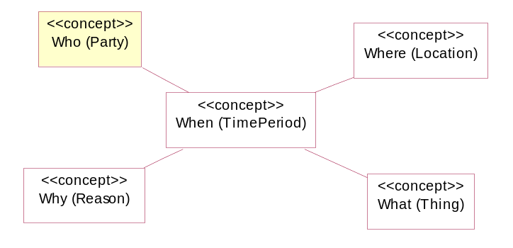
fig 0 – Showing how Party fits in
This section of the SID answers the question “who ?” and deals with people and organizations in the context of the eTOM, which looks at processes from a Service Provider’s point of view.
“The eTOM is a business process model or framework that provides the enterprise processes required for a service provider.” [eTOM]
Organizations can be internal (department, subsidiary) or external to the Service Provider (suppliers, customers).
Individuals can be internal (employees, board members) or external to the Service Provider (customers, organization contacts, shareholders).

Party Fundamentals
Fig 1a shows our starting point for the model, based on [Fowler-AP] fig 2.2, and shows a Party representing an Individual or Organization.
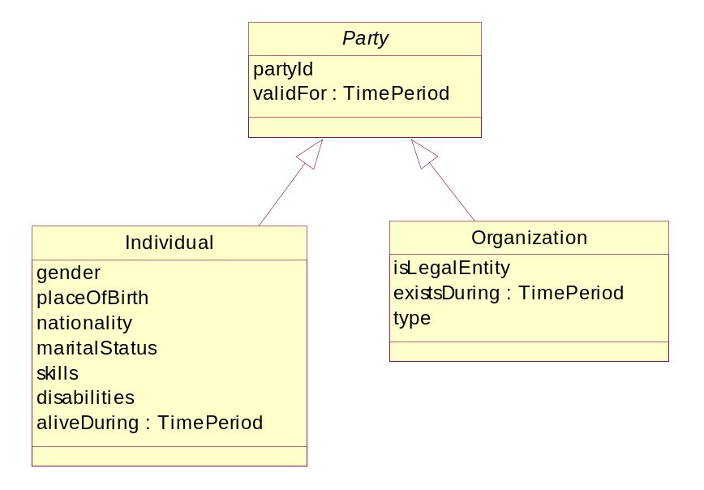
fig 1 – basic Party model
In this model, both organization and organization unit (e.g. consortium, parent company, subsidiary, division, department, branch or team) are represented by the Organization entity, which should be subclassed as required.
Organization can also represent government agencies, clubs, societies, charities and educational & religious organizations.
Whilst Party is not a term often used in the business, the concept of “a person or a company” is often heard, and the Party abstraction makes the domain model easier to understand.
Stephen Palmer [Coad Letter] uses the definition that “A party is a legal entity, something or someone that can be sued in a court of law”.

Party Names
An individual is referred to by their name. This name can change over time (e.g. After marriage, by deed poll) and to allow for this we will model an individual’s name as a separate entity. Similarly, organizations can change their names (e.g. from Telecom to Telstra) and we will also model organization names as a separate entity. Note that this model does not provide support for individual name or organization name aliases. If aliases are required, they will be added to a later version of this model.
“A name is an informal way of identifying an entity” [Fowler-AP]

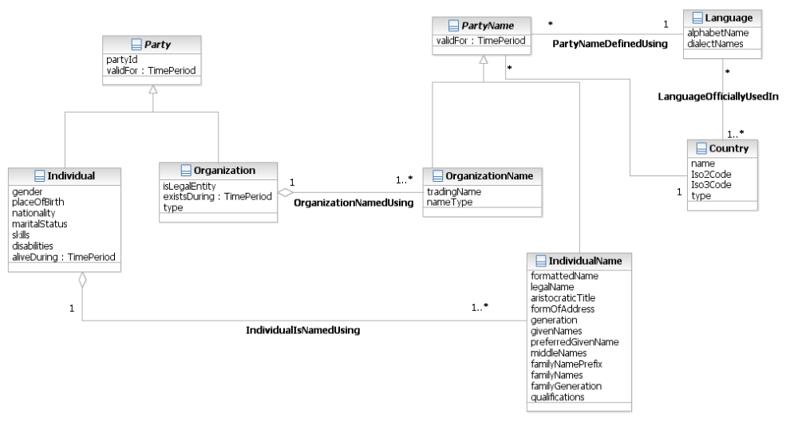
fig2 – naming for Parties

Party Identification
As well as being having names for Parties, we also need more formal ways of identification [Coad Letter]. When a customer applies for a service, for instance, they may need to provide some proof of identity. The Party Identification entities allow for this information to be stored and accessed as required.
Note that the Party Identification structure has been defined in a similar manner to Party Name.
Concrete subclasses to Individual Identification and Organization Identification should be created as required. Figure 3 shows some common example concrete entities.
The Party Identification Specification entity may be implemented as a Policy, using a Rules Engine or via a set of Templates that detail a valid set of Identification entries sufficient for a given purpose.

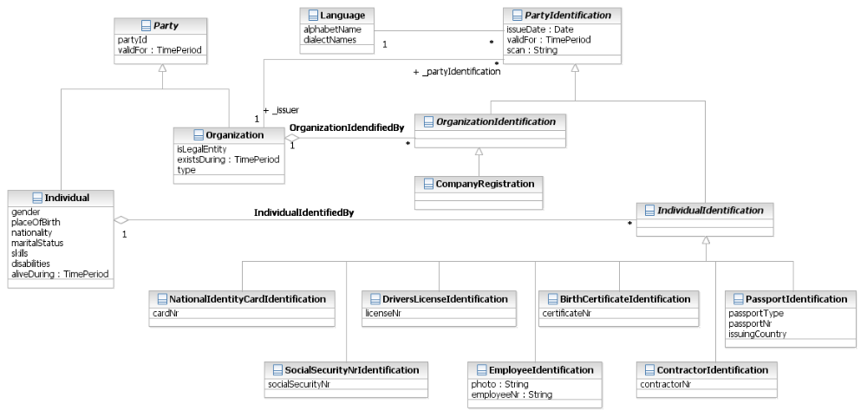
fig 3 – Identifying Parties

Party Roles
People and Organizations exhibit complex behavior. A lot of the behavior can be grouped, based on a particular context, or participation in a certain interaction.
For instance, a child at school will behave as a student and an adult may behave as a teacher. A person playing cricket may behave as a bowler, a batsman or as a fielder or wicket-keeper.
These behavior groups will change over time and will cause problems if we model them using inheritance / specialization. Also we need to allow for the fact that a Party may play more than one role at any given point in time (an employee may also be a customer, a graduate student may also be a tutor).
By modeling PartyRole as a separate concept from Party, we allow for proper representation of these complex sets of behaviors.
When looking at the eTOM, we see that in the Value Network, Parties play roles in the context of an interaction to provide Customer value.
This interaction may be per service or per event (e.g. a phone call).
“Note that these are roles and that individual enterprises can adopt different roles in different value networks. Roles represent activities that businesses can engage in and, for example, a service provider may be the customer-facing service provider in one value network and a third party (e.g. wholesale) service provider in another. Relationships are established between the roles, hence the business relationship context model. In today’s fast-moving marketplace, relationships can be very short-lived compared with the more static relationships of the traditional telecommunications market. By focusing on roles rather than organizations, a more flexible business relationship context model can be achieved. Enterprises can adopt and shed roles dynamically, but the relationships between the roles are established, so the adoption of a particular role will also define the relationship of the enterprise playing that role towards another role player..” [eTOM]
The Value Network roles defined in the eTOM are shown as subclasses of PartyRole in fig 4
Note that even though we are modeling from the point of view of the service provider, we need to model all of the value chain.
“In today’s marketplace, companies must implement an end-to-end value stream and have an integrated and customer-centric technology foundation. It is also necessary to be a part of and to manage ebusiness communities (EBCs), which are networks of relationships linking businesses, customers and suppliers to create a unique business entity that is re-configurable, to meet customer needs. In order to develop customer relationship solutions, companies must extend beyond their own boundaries to encompass the entire extended enterprise and make this transparent to the customer.” [eTOM]
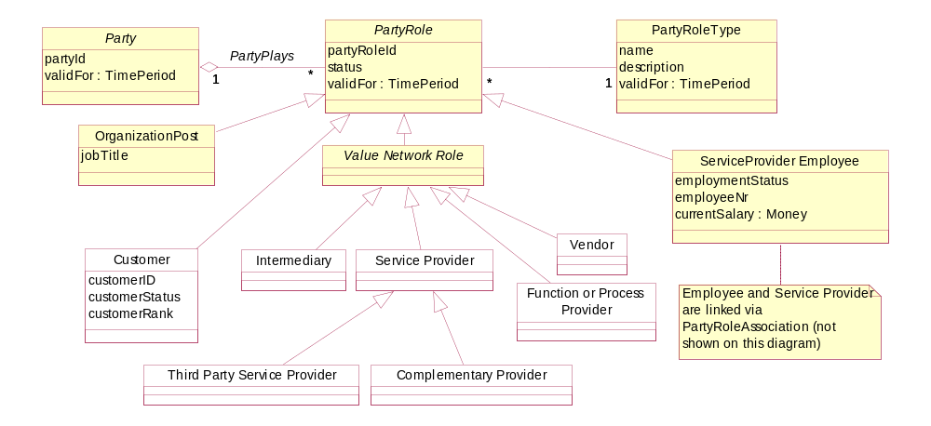
fig 4 – party and the main eTOM roles
Note:
- Prospective customers can be entered by creating an Individual or Organization entity (and associated name etc entities) and creating a Customer role for that party with a roleStatus of ‘prospective”
- To support these roles, we will use the “Role Object” pattern [Fowler-Role] [Larman].
- The PartyRole entity represents the common behavior by a Party when acting in the role.
- This model explicitly separates the information held about individuals and organizations from the roles that they perform and the relationships between the roles.
- PartyRole is shown with an id attribute. Existing data may have different id formats for different role types, e.g. “customer number”, “supplier id”, “employee nr” … PartyRoleId should be seen as a new key that may allow replacement of some of the other ids in the future.
- In the value network, roles may not be exclusive, e.g. a customer may also be a supplier
- In a number of cases we are interested in parties playing a combination of roles, e.g. staff who use our services get staff discount, suppliers who use or products are “preferred suppliers”
- If the number of roles becomes very large, then it may be necessary to create “sub-roles” so that the inheritance tree dos not become unmanageable.
Parties & PartyRoles may be recorded, even if there is no interaction with the Service Provider.
e.g. a Service Provider may wish to keep a list of Phone Dealers (including competitors) to help in determining shop placements. The Organizations are stored, with a role of “Phone Dealer” , but there may never be any “Interaction” between the dealers and the Service Provider.
An Employment Position or Post is represented by creating an Organization Role of type “POST” for the relevant organization unit.
e.g. the Organization unit “Western Region” has a Post of “Western Region Data Quality Coordinator”. A Party Role linked to “Western Region” is created for this Post and employees can be assigned to the Post using interactions. Typically there would only be one person assigned to a Post at any point in time (using TimePeriods).

Business Interactions between Parties
We need to be able to model relationships in the eTOM Value Network.
If we use a model like the diagram shown in fig 2, which is based on [Fowler-AP] fig.2.8, then the model will only support Party-to-Party interactions (here we are using the term Interaction instead of Fowler’s term Accountability).
Note that this model limits us to a binary directed interaction (an interaction is from a single Party to a single Party) and doesn’t allow us to show PartyRole interactions.
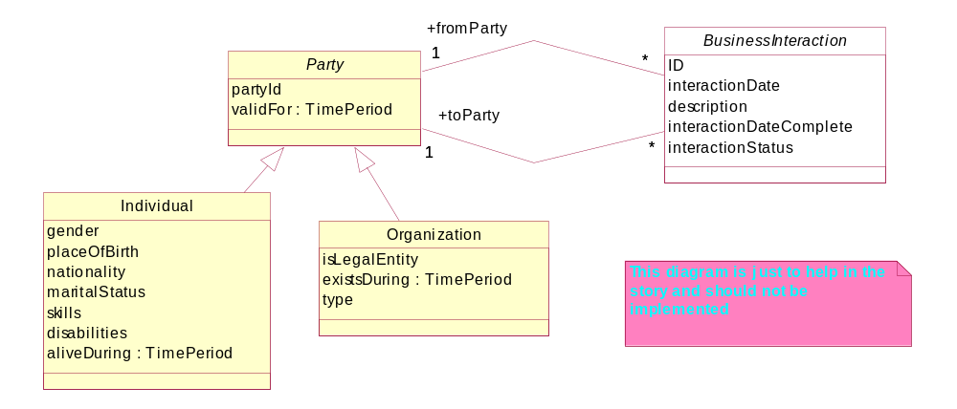
fig 5a – modeling Interactions directly to Party – appealing, but NOT suitable for our purpose
Combining figures 2 and 4 gives us the model shown in fig 5a.
PartyRoleCategory allows for PartyRoles to be categorized (e.g. into Customer Demographics)
A BusinessInteraction will involve one or more Parties playing roles participating in the value network to provide Customer value.
A BusinessInteraction may also have links to Product & Location.
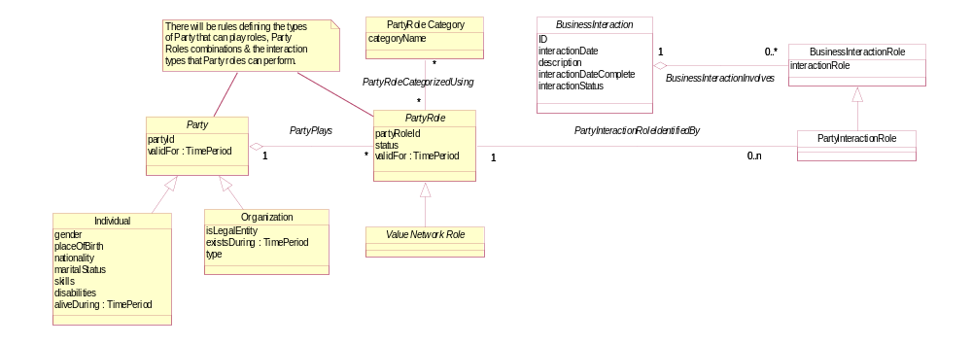
fig 5b –Parties interact via their roles
For more information on Business Interaction refer to GB922 Addendum 1BI.

Associations between Party Roles
We need to be able to show associations between Parties playing roles that are not directly involved in the value network.
Examples of these associations include
- Organizational associations in the service provider’s own business (organization unit – employee, organization unit – organization unit)
- Associations in other Organizations participating in the value network (organization unit – employee, organization unit – organization unit)
- Associations allowing us to determine the make-up of a household (household member – household member)
- Associations showing family make-up (parent-child)
PartyRoleAssociation and its subclasses must not be linked to Location, Product or Agreement.

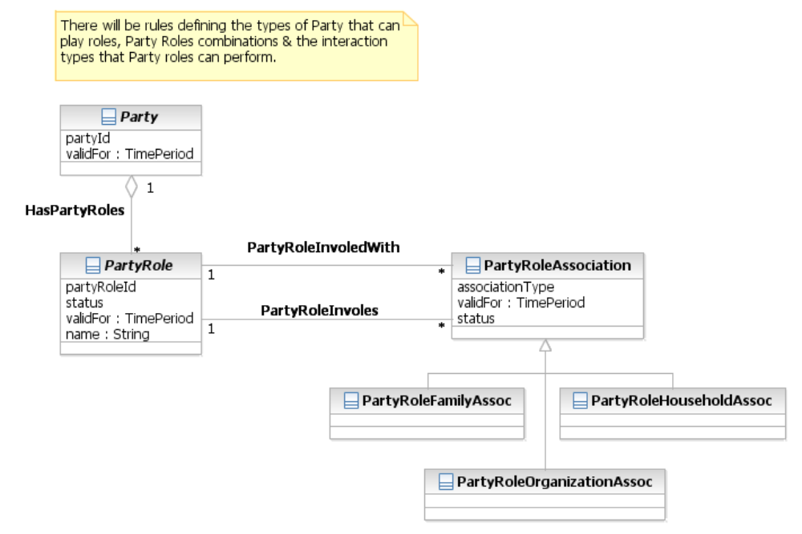
fig 6 – Parties can be associated via their roles

Contact Medium
An PartyRole can be contacted using a contact medium [ACIA], which is an abstraction of the commonly used contact types: email, Postal Address, telephone, fax, etc. We model a PartyRole to having contact mediums rather than a Party. This allows us to cater for role based e-mail addresses and work queues and Contact Details for a POST.
To allow for international usage, we also model the languages and dialects that Parties are able to use. Language Ability tells us which languages a party can converse in.
The Language entity links to Party, not Individual, as it also allows us to represent languages that an Organization supports. For instance, a Service Provider may provide interpreters in certain languages for Customer inquiries.

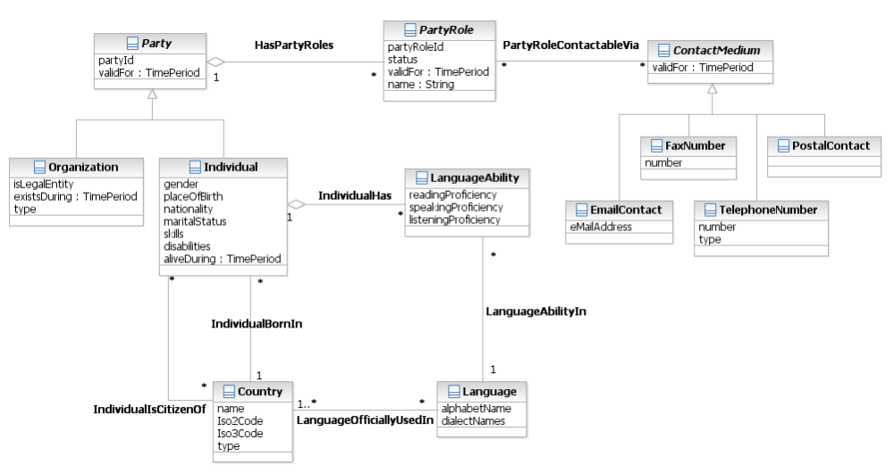
fig 7 – Contacting a Party

Interworking with the rest of the SID model
Fig 8 shows the main Party classes and the expected connections to other parts of the SID model.
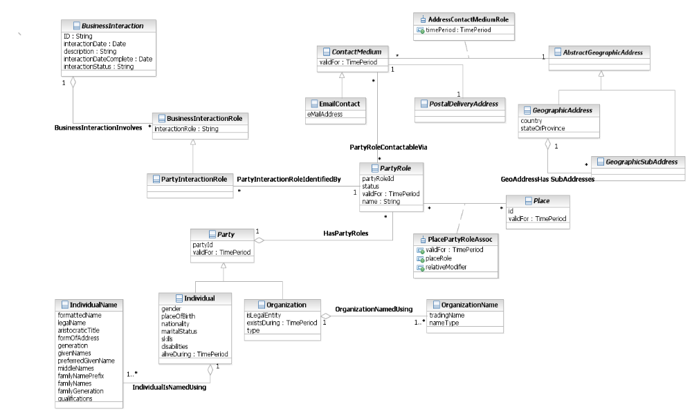
fig 8 – showing possible links to other parts of the SID model

Party Demographic
Demographics deal with the study of individuals and organizations (Parties), including their size, growth, density, and distribution, as well as statistics regarding birth, marriage, disease, and death. Demographic data is information about parties that allows decisions to be made such as the make-up and size of a market segment, classification and ranking of customers, and so forth. Demographics provide the key “what” information and can be broken down into two categories: individual demographics and organization demographics.
Individual demographic data provides information pertaining to the consumer market. Examples of this type of demographic are:
- Age, income, education, vehicle registration, gender, ethnicity, and the source of the information
- Geography, or sizing, demographics
- Number of households
- Number of telephone lines (single vs. multiple, switched vs. dedicated)
- Population
- Telecom spending by segment related back to another demographic (wireless, calling features, calling card, etc.)
Organization demographic data provides information pertaining to the non-consumer market. Examples of business demographic data are:
- Standard industry (SIC) code (for vertical industries)
- Geographic dispersal
- Headquarters location, number and location of offices (domestic vs. international, regions/triads); each have different access requirements
- By hierarchy (headquarters vs. regions vs. sales offices)
- Existing networks
- Private vs. frame relay
- WAN/LAN (in every office vs. stand-alone)
- By SIC code (partially)
- Network equipment
- Centralized vs. distributed processing
- Applications (Human Resources, Payroll, FTP, Intranet, and so forth)
- Voice mail, audio/video
- Infrastructure setup (type of computer) by geography
- Usage (switched vs. dedicated, intra-company vs. intercompany)
- Features (large sales force could indicate use of calling cards); related to number and type of employees
- Number of employees by type (for example, sales force)
- Number of customers and prospects
- Geographies covered
- Target markets
- Sales channels
- Current telecom spending by product (inbound vs. outbound vs. calling card)
- Date acquired, current provider, provider products
- Percent of existing telecom bill spent with the service provider by product
- Public information (revenue, profit, employees, and so forth)
The business entities that support PartyDemographic (and also support PartyProfileType and MarketSegment as described later) should be generic enough to allow new demographic characteristics and other types of characteristics to be defined as needed. To accomplish this, the Demographic entity employs the Characteristic Spec/Characteristic pattern used throughout the SID. PartyDemographic also employs the Composite/Atomic pattern to represent collections of related DemographicCharacteristics.
Note: This pattern is used throughout the Market/Sales domain. Additional information about the Characteristic pattern can be found in GB922 Addendum 1R Root Business Entities. The application of the pattern in the Market/Sales domain does not use all the association classes defined by the pattern; if needed, they can be added by a SID implementer.
The figure below depicts Demographic business entities.
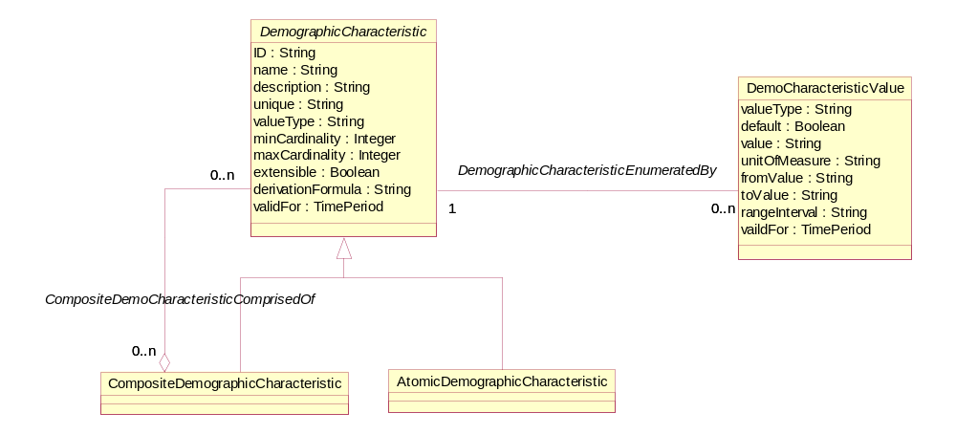
Employee type and number
Type employee
Number of employees
Type employee – engineer, salesperson, administrator
Number of employees – 0-50, 51-100, 101-500, 500+
fig 9 – Demographic Characteristic Business Entities
An example of the use of the Composite/Atomic pattern from the list of example demographics above is a CompositeDemographicCharacteristic called “employee type and number” that aggregates the AtomicDemographicCharacteristics “type employee” and “number of employees”. These examples are shown in the figure above.
A PartyDemographic is a feature or quality used to make recognizable or to define a Party playing a PartyRole, such as age, income, education, revenue, and so forth. The figure below shows the entities that make up the PartyDemographic ABE. Notice that PartyDemographic also uses the Composite/Atomic pattern for defining PartyDemographics that are aggregates of other PartyDemographics. For example, a standard of living composite may be the aggregation of income level, value of investments, and home value (assuming a home is not an investment!).
Note that one of the members of the associations from PartyDemographicValue to DemographicCharacteristic and DemographciCharacteristicValue are of cardinalty of 0,1. This is because not all DemographicCharacteristics have a set of defined values. For example, a characteristic of children’s names does not have set of “valid” values, but is entered as text for an instance of PartyDemographicValue; in this example there is not an instance of the association between PartyDemographicValue and DemographicCharacteristicValue. Similarly, if there is a set of DemographicCharacteristic values (1, 2, 3 or more) for number of children living at home, there is an instance of the association between PartyDemographicValue and DemographicCharacteristicValue, but not one between PartyDemographicValue and DemogrpahicCharacteristic. This second association is derived via the first association.
PartyDemographics characterize a single PartyRole. There was thought given to describing both PartyDemographics and PartyRoleDemographics. However, as was done with PartyRoleContacts (see addendum GB922 1P – Party), having demographics at both the Party and PartyRole seemed to be a bit of over-modeling. Therefore, if the same demographic characterizes two or more PartyRoles played by the same Party, the demographic is repeated for each role.
PartyDemographics can also be defined in part by a ProductOffering that a Party has obtained and/or used. For example, the number of minutes of long distance used within a Calling Plan offering.
PartyDemographics can also be grouped by GeographicArea and MarketSegment.
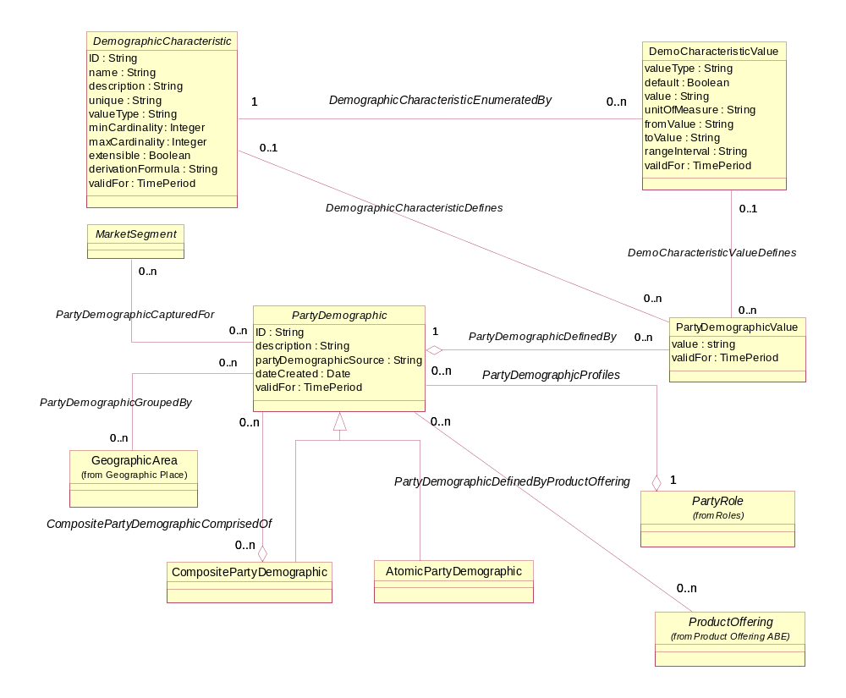
fig 10 – Party Demographics Business Entities

Party Profile Type
A PartyProfileType defines the characteristics used to group Parties that typify MarketSegments and for the formulation and targeting of MarketingCampaigns. A PartyProfileType is used to categorize one or more PartyRoleTypes. A PartyProflieType can be defined for one or more GeographicAreas. The profile type can target one or more ProductOfferings and one or more MarketSegments. PartyProfileTypes can be based on (or defined by) DemographicCharacteristics.
The figure below shows the entities that make up a PartyProflleType.
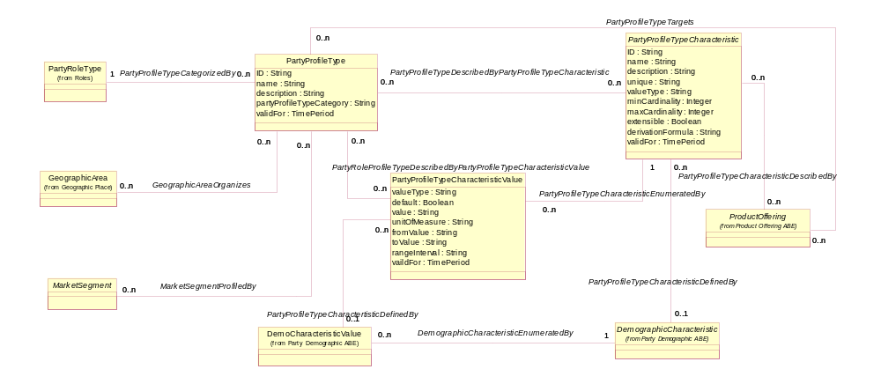
fig 11 – Party Profile Type Entities
The PartyProfileTypeCharacteristic may be based on a DemographicCharacteristic or may represent another data point that is not a demographic. For example, the number of Parties in the profile may be of interest. For this reason, PartyProfileTypeCharacteristic and PartyProfileTypeCharacteristicValue have fully optional associations with DemographicCharacteristic and DemographicCharacteristicValue.
Note the n-n associations between PartyProfileType and the two entities PartyProfileTypeCharacteristic and PartyProfileTypeCharacteristicValue. This allows the same characteristic, such as age range, income range, and so forth to be shared by many types of profiles. The two associations are also mutually exclusive. If a PartyProfileType includes all the values for a characteristic, then the profile is associated to the characteristic and not the values. If a PartyProflieType includes a subset of the values for a characteristic, then the profile is associated to the values that define the profile. For example, if the possible age ranges are under 18, 18-35, 36-54, 55-65, over 65 and a profile is looking for baby boomers in the age ranges of 55 and above, the profile would be associated with the two ranges 55-65, and over 65. No association would be made to the characteristic. If this is done then the profile would appear to include all age ranges, which is not correct.
PartyProfileTypeCharacteristic also employs the Composite/Atomic pattern to represent collections of related characteristics. The figure below shows the continued use of this pattern within the Market/Sales domain.
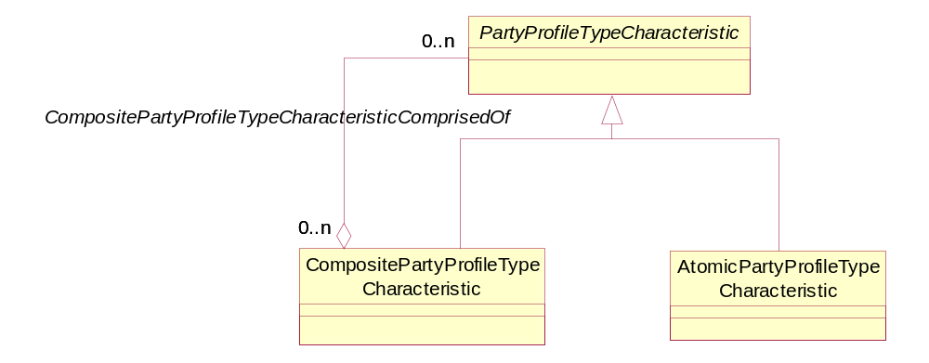
fig 12 – Composite and Atomic Party Profile Type Characteristics

The next step is to match PartyProfileType Characteristics with PartyRoles. A PartyProfile forms the bridge between a PartyRole and a PartyProfileType. The PartyProfile provides a means to keep a record of what PartyProfileTypes were a match at a particular point in time. The PartyRoles that match a profile type help identify the potential market size for a MarketingCampaign, can be the targets of a MarketingCampaign and SalesChannels, and so forth. The figure below shows the association that PartyRoles have with PartyProfileTypes.

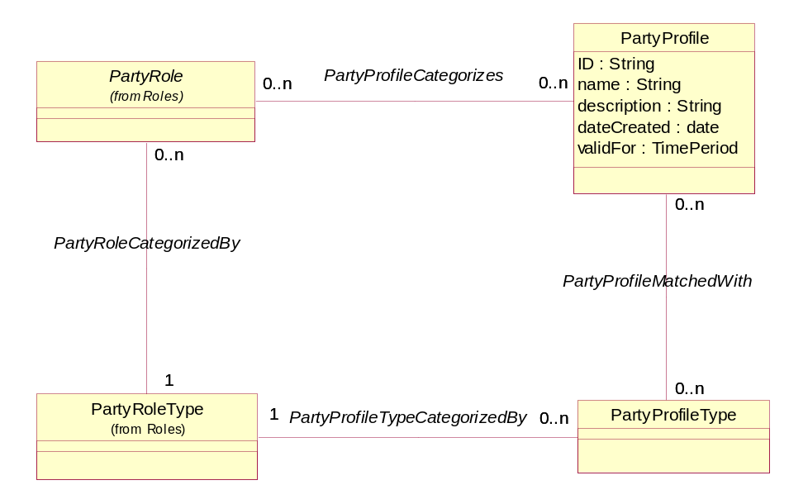
fig 13 – Party Role and Party Profile Type

Using this model for Process Analysis
When using these entity definitions in process or use case analysis, the most useful entities will be the concrete entities
- Individual
- Organization (and Organization Unit)
- Customer, Supplier, Service Provider … roles
In some cases, where a lot of references are made to “Individual or Organization”, the use of the Party entity may be worthwhile.
In some cases it may be useful to refer to the concrete roles as “Customer role”, Supplier Role” …
If more detailed entities are referenced, then they should be defined and related back to the entities in this model. E.g. “Section is a type of Organization unit that …”

Further Work Required in Later Releases
This section documents some issues that have not been able to be resolved in this version.

Notes:
- Note that these entities represent business concepts in a Service Provider that conforms to the eTOM process model [eTOM].
- Entities that are outside the scope of this model facet are shown with a white fill color.
- This is intended as a “minimalist” model. Subtypes and attributes should be added as required. The attributes shown should be considered as suggested, not required.
- Parent attributes are not repeated in the sub entities
- In most cases relationships are not documented as attributes
- Only significant entities are shown in the “related business entities” cells
When there is a need to show that a Business Entity is only valid for a certain time, this will be shown by an attribute called validFor, of type TimePeriod. In the design model, temporal support may be implemented in other ways, [Fowler-time] but this approach has been chosen for the analysis model as it shows the requirement without cluttering up the model.
Note that the Time Period entity is documented in [BaseTypes].
Also, when there is a need to show that a set of complex business rules exists, a comment is shown on the diagram. In the design model, this may be implemented using a set of policy rule classes or using a rules engine.

References
BaseTypes | GB922 Addendum 1BT , SID Base Types
Fowler-AP | Analysis Patterns – Reusable Object Models by Martin Fowler ISBN 0-201-89542-0  http://martinfowler.com/articles.html
Fowler-Role | Dealing with Roles, http://www.awl.com/cseng/titles/0-201-89542-0/apsupp/roles2-1.html
Fowler-Time | Patterns for things that change with time http://martinfowler.com/ap2/timeNarrative.html  Effectivity http://martinfowler.com/ap2/effectivity.html
Fowler-Range | Range http://martinfowler.com/ap2/range.html
ACIA | Alliance Common Information Architecture (AT&T, BT & Concert) version 3.1, 15 Dec 2000
eTOM | GB921 version 3.0
HR-XML | HR-XML Person Name Schema/DTD V1.2  http://www.hr-xml.org/
Zachman | Zachman Framework  http://www.zifa.com/frmwork2.htm
Coad-Roles | Coad Letter 76 – January 2001  http://www.togethercommunity.com/coad-letter/Coad-Letter-0076.html
Coad-Archetypes | Modeling with Color  http://www.togethersoft.com/services/tutorials/jmcu/index.html
Bus-Patterns | Business Modeling with UML, Business Patterns at Work  Hans-Erik Eriksson, Magnus Penker ISBN 0-471-29551-5
Metasolv | Sales & Marketing Business Objects Document
Larman | Applying UML and Patterns, Second Edition, ISBN 0-13-095004-1  http://www.craiglarman.com/book_applying_2nd/Applying_2nd.htm
Sesera | A Recurring Fulfilments Analysis Pattern, Lubor Sesera  http://jerry.cs.uiuc.edu/~plop/plop2k/proceedings/Sesera/Sesera.pdf
Baumer | The Role Object (Design) Pattern. Download PDF from  http://www.riehle.org/computer-science-research/1997/plop-1997-role-object.html
OMG | Party Management Facility Specification 1.0 Feb 2001  http://www.omg.org/
AP ADDR STDS | Australia Post – Presentation Standards Booklet.  http://www.auspost.com.au/futurepost/index.asp?link_id=9.1575
ISO 4217 | ISO 4217:2001 Codes for the representation of currencies and funds
Composite Pattern | Articles: Composite à la Java, Part I & II  http://www.research.ibm.com/designpatterns/publications.htm
Coad Letter | The Coad Letter: Issue 103 - Party Time  The Coad Letter: Issue 107 - Party Time, Part 2: Modeling Party Id's  http://www.thecoadletter.com/
JOT- Mossé | Francis G. Mossé: Modeling Roles – A Practical Series of Analysis Patterns , in Journal of Object Technology, vol. 1, no. 4, September-October 2002, pages 27-37.  http://www.jot.fm/issues/issue_2002_09/column2
JOT-Odell | James Odell et al.: The Role of Roles, in Journal of Object Technology, vol. 2, no. 1, January-February 2003, pages 39-51.  http://www.jot.fm/issues/issue_2003_01/column5

Standard citation for this document
TeleManagement Forum SID GB922 Addendum 1P (Party)
Chris Hartley et al.
URL: http://www.tmforum.org/

Business Entity Model

Examples
A few simplified examples have been included to help understand the model (so this model is not completely consistent with the main model).
Note that Visio cannot display association class objects, so these are missing from the examples.
Note that these examples are designed to be instructive. They are not designed to be complete and are simplified to show the main points of the model.
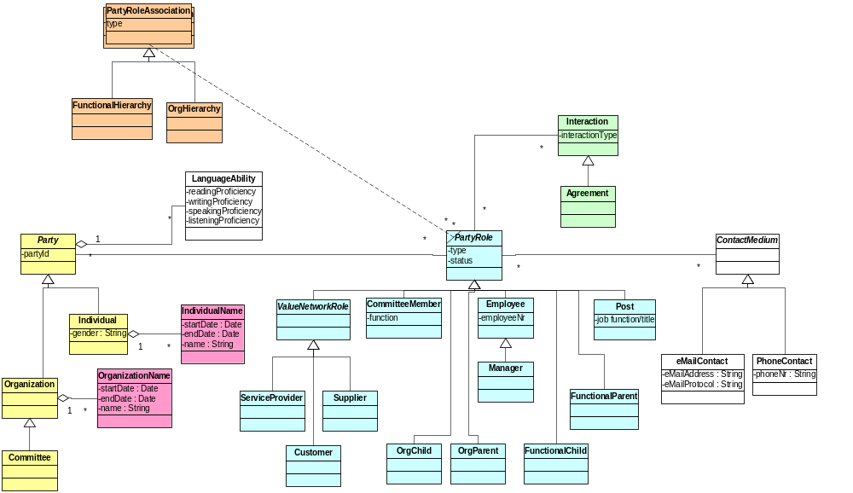
fig E1 – simplified class diagram used for examples

Example 1
Telco is a Service Provider that has two departments, Engineering and Operations.
Chris works for Telco, in the Internal plant section of the engineering department.
Jane is the head of the Engineering department.
Jane got married on 23/11/01 and her name changed from Jane Smith to Jane Lamborgizzia
Chris was assigned to the post of “Engineering Department Fire Warden” from 22/8/1988 to 25/12/2001.
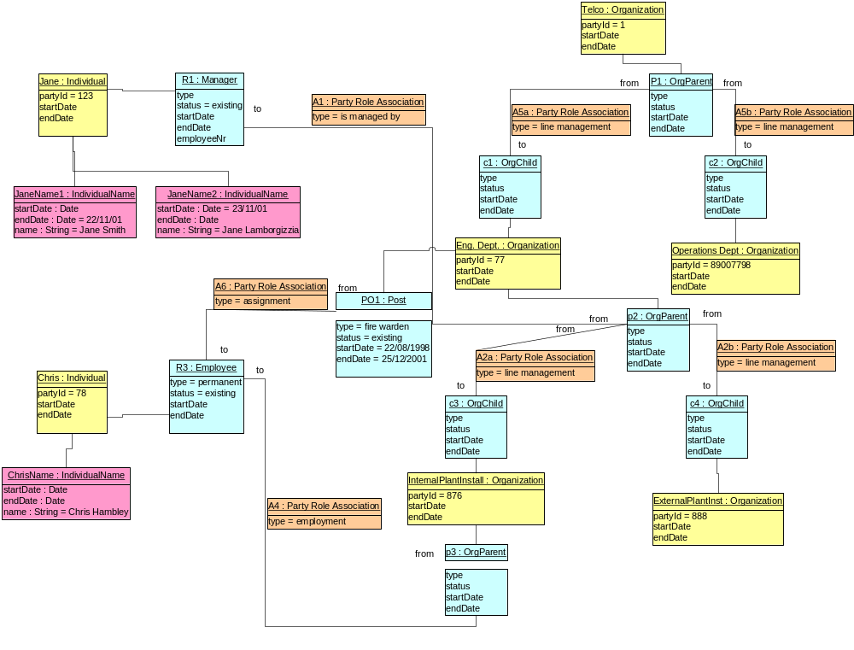
fig E2 – example 1 – Organization Hierarchy & Name Change

Example 2
Telco has a business customer EveDotCom.
EveDotCom is also a supplier to Telco.
Adam is the managing director of EveDotCom and he is also a customer of Telco.
Telco has an Internal Communications section to manage its own communication needs
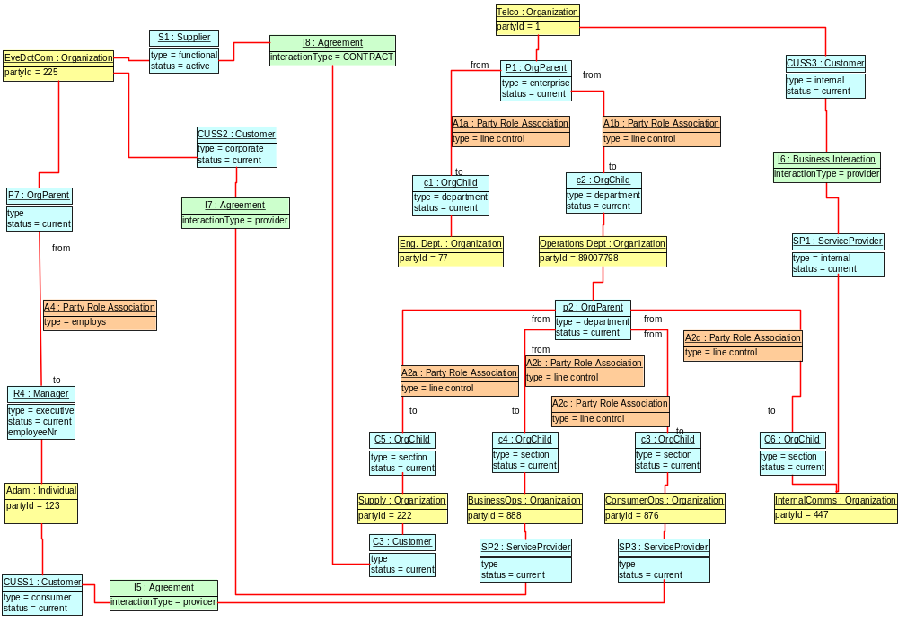
fig E3 – example 2 – Value Network , Supplier, Customer

Example 3
Telco is looking at expanding by opening an international section in Germany.
It is building a list of prospective employees, clients and suppliers.
Hans is a possible customer. His language abilities are unknown. (He may be from Eastern Europe so we won’t assume he speaks German)
BayernElectronik are a possible design and construct company (supplier)
Gretel is a possible employee. She can speak German and good English.
Telco bought a mailing list containing Hans’s name and has had no contact with him yet.
Telco has signed a Memorandum of Understanding (MOU) with BayernElectronik
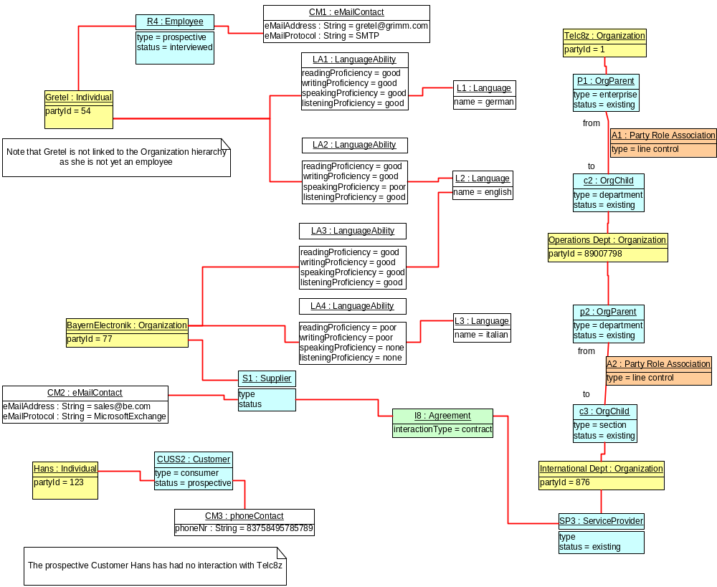
fig E4 – example 3, Prospective Party Roles, Contact Medium & Language Ability

Example 4
This is a simple example, showing how the SID Party model can be used to represent an matrix organization.
The matrix is formed by considering both line control & functional control as separate axes of the matrix.

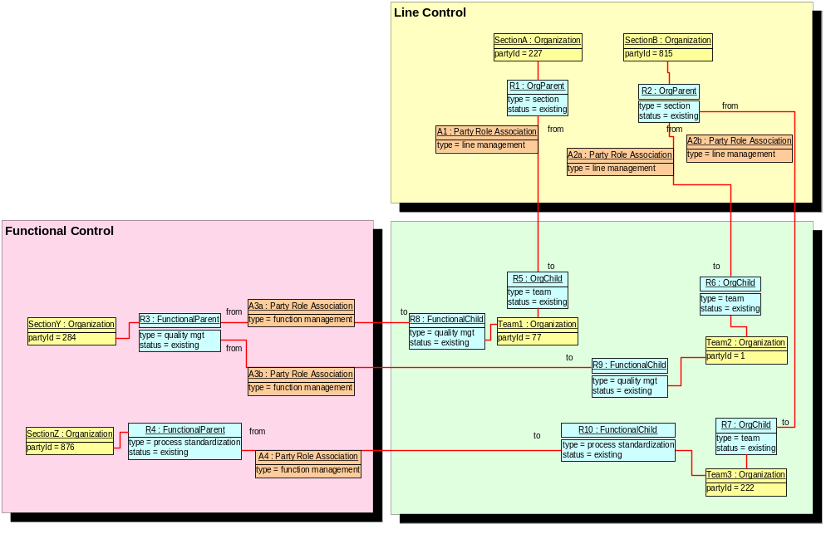
fig E5 – example 4

Business Entity Definitions
Entity and attribute definitions can be found in all available Information Framework (SID) model formats. The next release of the SID will move all entity and attribute definitions from domain/ABE addenda to a single addendum containing all definitions. The definitions will be generated from the SID UML model. All model formats will continue to contain definitions.

Party

Business Entity Definition
Business Entity Name | Party
Description | Represents an individual, organization or organization unit.  Party is an abstract concept that should be used in places where the business says something can be an organization , organization unit or an individual
Sources | [Fowler-AP]  [ACIA] | Cross- References |  |  | Synonyms / Aliases | Involved Party  Business Party
Related Business Entities | Individual  Organization
Business Rules

Business Entity Attributes Definition
Business Entity Name | Party
Attribute Name | Description | Data Type | Characteristics, Permitted Values & Units | Required/  Optional | Notes
validFor | the time period that the Party is valid for | TimePeriod | Refer Time Period class | Required
partyId | Unique identifier for Party |  |  | Required

Individual

Business Entity Definition
Business Entity Name | Individual
Description | Represents a single human being ( a man, woman or child).  The individual could be a customer, an employee or any other person that the organization needs to store information about. An Individual is a type of Party.
Sources | [Fowler-AP]  [ACIA] | Cross- References |  |  | Synonyms / Aliases | person
Related Business Entities | Party
Business Rules

Business Entity Attributes Definition
Business Entity Name | Individual
Attribute Name | Description | Data Type | Characteristics, Permitted Values & Units | Required/  Optional | Notes
gender |  |  | MALE or FEMALE | required
placeOfBirth |  | Location |  | Optional | Pointer to a Location object  City, town name etc.
countryOfBirth |  | Country |  | required | Pointer to a country object
nationality |  | Country |  | required | Pointer to a country object
maritalStatus |  |  | married, never married, divorced, widowed | required
disabilities |  | Disability |  | Optional | Used for legal requirements (special billing, special products, special contact media – Braille)  This should be modeled as a separate entity but is shown as an attribute for brevity
skills |  | Skill |  | Optional | Probably only used for employees, but is really role independent  This should be modeled as a separate entity but is shown as an attribute for brevity
aliveDuring | birth date and death date | TimePeriod |  | required

Organization

Business Entity Definition
Business Entity Name | Organization
Description | A group of people identified by shared interests or purpose.  Examples include business, department, enterprise.  Because of the complex nature of many businesses, both organizations and organization units are represented by the same business entity in this model. An Organization is a type of Party.
Sources | [Fowler-AP]  [ACIA] | Cross- References |  |  | Synonyms / Aliases | Organization unit  Business, Enterprise,  Consortium, subsidiary, division, department, branch, section, government agency, club, charity, school, church, society
Related Business Entities | Party
Business Rules

Business Entity Attributes Definition
Business Entity Name | Organization
Attribute Name | Description | Data Type | Characteristics, Permitted Values & Units | Required/  Optional | Notes
isLegalEntity |  | boolean | TRUE or FALSE | required
existsDuring | incorporation date to disincorporation date | Time Period |  | required
type | The type of organization | Text |  |  | Club, Society, …

Party Name

Business Entity Definition
Business Entity Name | PartyName
Description | A word, term, or phrase by which a party (individual or organization) is known and distinguished from other parties.  A name is an informal way of identifying an object [Fowler].  PartyName is an abstract concept that should be used in places where the business refers to an organization name, organization unit name or individual name
Sources |  | Cross- References |  |  | Synonyms / Aliases
Related Business Entities | Party
Business Rules

Business Entity Attributes Definition
Business Entity Name | PartyName
Attribute Name | Description | Data Type | Characteristics, Permitted Values & Units | Required/  Optional | Notes
validFor | the time period that the Party Name is valid for | TimePeriod | Refer Time Period class | required
nameRuleCountry | The name of the country to use for the name rules. | Use the ISO country 3(2?) character code ? |  | required | Pointer to a rule on how to format the name based on the country the person associates with

Individual Name

Business Entity Definition
Business Entity Name | IndividualName
Description | A word, term, or phrase by which an individual is known and distinguished from other individuals.  A name is an informal way of identifying an object [Fowler]  This entity allows for international naming variations. An IndividualName is a type of PartyName.
Sources | [HR-XML]  [AP ADDR STDS] | Cross- References |  |  | Synonyms / Aliases | Person Name
Related Business Entities | PartyName  Individual
Business Rules

Note that the individual name attributes are based on, and designed to be compatible with, the HR-XML Person Name schema [HR-XML]
Attribute descriptions in quotes are copied from the HR-XML document.

Business Entity Attributes Definition
Business Entity Name | IndividualName
Attribute Name | Description | Data Type | Characteristics, Permitted Values & Units | Required/  Optional | Notes
formattedName | “Contains, in one string, a fully formatted name with all of its pieces in their proper place. This includes all of the necessary punctuation. This de-normalized form of the name cannot be easily parsed.” | Text |  | optional | if NULL, then derive from the other fields using name policy
legalName | “Contains, in one string, a fully formatted name with all of its pieces in their proper place. This includes all of the necessary punctuation.” |  |  | optional | if NULL, then derive from the other fields using name policy
aristocraticTitle | ” e.g. Baron, Graf, Earl, etc.” | Text |  | optional
formOfAddress | “Contains the Salutation,  e.g. Mr., Mrs., Hon., Dr.,  Major, etc.” | Text |  | optional | Also known as person title  Also includes. Miss, Ms,
generation | “e.g. Sr., Jr., III (the third), etc.” |  |  | optional
givenNames |  | Text |  | required | Also known as Christian name, chosen name, first name  Multiple fields may be entered with a delimiter in-between or stored in a collection
preferredGivenName | “Contains the chosen name by which the person prefers to be addressed. Note: This name may be a name other than a given name, such as a nickname" | Text |  | optional
middleNames | Middle name(s) or initial(s) | Text |  | optional | Multiple fields may be entered with a delimiter in-between or stored in a collection
familyNamePrefix |  | Text |  | optional | e.g. Van den, Von etc.
familyNames | Contains the non-chosen or inherited name. Also known as a person’s last name in the Western context. | Text |  | required | Also known as surname  Multiple fields may be entered with a delimiter in-between
familyGeneration | i.e. Sr, Jr | Text |  | optional
qualifications | “Contains the letters used to describe academic or other type qualifications held by a person and/or the distinctions conferred upon them. e.g. PhD, MD, CPA, MCSD, etc.” | Text |  | optional | also known as orders, decorations, honors, awards and distinctions

Organization Name

Business Entity Definition
Business Entity Name | OrganizationName
Description | A word, term, or phrase by which an organization is known and distinguished from other organizations.  A name is an informal way of identifying an object [Fowler]  An OrganizationName is a type of PartyName.
Sources |  | Cross- References |  |  | Synonyms / Aliases
Related Business Entities | PartyName  Organization
Business Rules

Business Entity Attributes Definition
Business Entity Name | OrganizationName
Attribute Name | Description | Data Type | Characteristics, Permitted Values & Units | Required/  Optional | Notes
tradingName | The name that the organization (unit) trades under | Text |  | required
nameType | Co., Inc., Ltd., Pty Ltd. , Plc., Gmbh … | text |  | optional

Party Role

Business Entity Definition
Business Entity Name | PartyRole
Description | The part played by a party in a given context with any characteristics, such as expected pattern of behavior, attributes, and/or associations that it entails.  PartyRole is an abstract concept that should be used in places where the business refers to a Party playing a Role
Sources | [Coad-Role]  [Fowler-Role] | Cross- References |  |  | Synonyms / Aliases
Related Business Entities | Party
Business Rules

Business Entity Attributes Definition
Business Entity Name | Party Role
Attribute Name | Description | Data Type | Characteristics, Permitted Values & Units | Required/  Optional | Notes
partyRoleId | Unique identifier for PartyRoles |  |  | Required
validFor | the time period that the PartyRole is valid for | TimePeriod | Refer Time Period class | Required
status | used to track the lifecycle status, e.g. existing, prospective or former customers. |  | dependant on the Party Role Type | required

Party RoleType

Business Entity Definition
Business Entity Name | PartyRoleType
Description | An entity that captures the common information about PartyRoles. It may be used by rules or policy engines to implemtn Business Rules when allocating Roles to a Party
Sources | [Coad-Role]  [Fowler-Role] | Cross- References |  |  | Synonyms / Aliases
Related Business Entities | PartyRole
Business Rules

Business Entity Attributes Definition
Business Entity Name | Party RoleType
Attribute Name | Description | Data Type | Characteristics, Permitted Values & Units | Required/  Optional | Notes
name | The name of the PartyRoleType | Text |  | Required
description | A narrative explains the PartyRoleType. | Text |  | Required
validFor | the time period that the PartyRoleType is valid for | TimePeriod | Refer Time Period class | Required

Value Network Role

Business Entity Definition
Business Entity Name | ValueNetworkRole
Description | This is an abstract class with no attributes. Used to group roles that pertain to the eTOM value network [eTOM].
Sources | [Coad-Role]  [Fowler-Role] | Cross- References |  |  | Synonyms / Aliases
Related Business Entities | PartyRole
Business Rules

Business Entity Attributes Definition
Business Entity Name | Value Network Role
Attribute Name | Description | Data Type | Characteristics, Permitted Values & Units | Required/  Optional | Notes

Party Role Category

Business Entity Definition
Business Entity Name | PartyRoleCategory
Description | This is an entity that can be used to provide simple grouping or categorization of PartyRoles. In some cases this is done in a more specific manner (e.g. Customer demographics).
Sources |  | Cross- References |  |  | Synonyms / Aliases
Related Business Entities | PartyRole
Business Rules

Business Entity Attributes Definition
Business Entity Name | Party RoleCategory
Attribute Name | Description | Data Type | Characteristics, Permitted Values & Units | Required/  Optional | Notes
categoryName | The name of the category | Text |  | Required

Service Provider Employee
This entity is included as a concrete example of the PartyRole business entity

Business Entity Definition
Business Entity Name | ServiceProviderEmployee
Description | A Service ProviderEmployee is an Individual who is employed by the Service Provider  This is modeled as an Individual playing the role of ServiceProviderEmployee . A ServiceProviderEmployee is a type of PartyRole.
Sources |  | Cross- References |  |  | Synonyms / Aliases
Related Business Entities | PartyRole  Individual
Business Rules

Business Entity Attributes Definition
Business Entity Name | ServiceProviderEmployee
Attribute Name | Description | Data Type | Characteristics, Permitted Values & Units | Required/  Optional | Notes
employmentStatus |  | Text | employed, suspended, resource-rebalanced | required
employeeNr | some firms give employees a unique identification number | Text |  | optional
currentSalary |  | Money |  | optional

OrganizationPost
This entity is included as a concrete example of the PartyRole business entity

Business Entity Definition
Business Entity Name | OrganizationPost
Description | An OrganizationPost is a PartyRole that is used to model where a one or more employees share a function.
Sources | [Fowler-AP] | Cross- References |  |  | Synonyms / Aliases
Related Business Entities | PartyRole  Individual
Business Rules | An Individual can fill zero, one or more than one OrganizationPost.  An OrganizationPost can be filled by zero, one or more than one Individual.

Business Entity Attributes Definition
Business Entity Name | OrganizationPost
Attribute Name | Description | Data Type | Characteristics, Permitted Values & Units | Required/  Optional | Notes
jobTitle |  | Text |  | Required

Party Role Association

Business Entity Definition
Business Entity Name | Party RoleAssociation
Description | Allows PartyRoles to be associated  Note that Interaction must be used for associations that are a direct part of the value network
Sources | [MetaSolv] | Cross- References |  |  | Synonyms / Aliases
Related Business Entities | PartyRole
Business Rules | PartyRoleAssociation and any subclasses must not be linked to Location, Product or Agreement.

Business Entity Attributes Definition
Business Entity Name | PartyRoleAssociation
Attribute Name | Description | Data Type | Characteristics, Permitted Values & Units | Required/  Optional | Notes
validFor | the time period that the PartyRoleAssociation is valid for | TimePeriod | Refer Time Period class
status
associationType

Language

Business Entity Definition
Business Entity Name | Language
Description | Represents a spoken and/or written language.
Sources |  | Cross- References |  |  | Synonyms / Aliases
Related Business Entities
Business Rules

Business Entity Attributes Definition
Business Entity Name | Language
Attribute Name | Description | Data Type | Characteristics, Permitted Values & Units | Required/  Optional | Notes
alphabetName | The alphabet name use for the language | Text |  |  | ISO standard ?
dialectNames | A list of the dialects of the language | Text[] |  |  | ISO standard ?

Language Ability

Business Entity Definition
Business Entity Name | LanguageAbility
Description | Represents the ability of a Party to understand or converse in a Language
Sources | [ACIA] | Cross- References |  |  | Synonyms / Aliases
Related Business Entities | Party  Language
Business Rules

Business Entity Attributes Definition
Business Entity Name | LanguageAbility
Attribute Name | Description | Data Type | Characteristics, Permitted Values & Units | Required/  Optional | Notes
readingProficiency
writingProficiency
speakingProficiency
listeningProficiency

Contact Medium

Business Entity Definition
Business Entity Name | ContactMedium
Description | A means by which communication may be established with a party (individual or organization).  Contact Medium is an abstract concept that should be subclassed as required.
Sources | [ACIA] | Cross- References |  |  | Synonyms / Aliases | Contact Mechanism
Related Business Entities | Party
Business Rules

Business Entity Attributes Definition
Business Entity Name | ContactMedium
Attribute Name | Description | Data Type | Characteristics, Permitted Values & Units | Required/  Optional | Notes
ValidFor | the time period that the Contact Medium is valid for | TimePeriod | Refer Time Period class | required

eMail Contact
This entity is included as a concrete example of the ContactMedium business entity

Business Entity Definition
Business Entity Name | eMailContact
Description | The eMail address to use when contacting a given PartyRole. An eMailContact is a type of ContactMedium.
Sources | [ACIA] | Cross- References |  |  | Synonyms / Aliases
Related Business Entities | ContactMedium  Party
Business Rules

Business Entity Attributes Definition
Business Entity Name | eMailContact
Attribute Name | Description | Data Type | Characteristics, Permitted Values & Units | Required/  Optional | Notes
eMailAddress | full e-mail address in standard format | Text |  |  | e.g. fred.bloggs@thing.com
eMailProtocol | protocol name | Text |  |  | e.g. SMTP, Microsoft Exchange

Party Identification

Business Entity Definition
Business Entity Name | Party Identification
Description | Party Identification represents our registration of information used as proof of identity by a Party
Sources | [Coad Letter] | Cross- References |  |  | Synonyms / Aliases | LegalId
Related Business Entities | Party
Business Rules

Business Entity Attributes Definition
Business Entity Name | Party Identification
Attribute Name | Description | Data Type | Characteristics, Permitted Values & Units | Required/  Optional | Notes
issuer | The Party that has ussued the identification | Text |  | required | e.g. a Government
issueDate | the date that the identification was produced / printed | Date |  | required
validFor | the time period that the Party Identification is valid for | TimePeriod | Refer Time Period class | required | Note that the validitity start date may not necessarily equal the issue date (e.g. credit cards are only valid some time after thay are issued)
scan | a scan of the identification paper | Bitmap |  | optional | may be used to get a copy of the photo to help in identification

Organization Identification

Business Entity Definition
Business Entity Name | Organization Identification
Description | Organization Identification represents our registration of information used as proof of identity by an Organization
Sources | [Coad Letter] | Cross- References |  |  | Synonyms / Aliases
Related Business Entities | Organization
Business Rules

Business Entity Attributes Definition
Business Entity Name | Organization Identification
Attribute Name | Description | Data Type | Characteristics, Permitted Values & Units | Required/  Optional | Notes

Individual Identification

Business Entity Definition
Business Entity Name | Individual Identification
Description | Individual Identification represents our registration of information used as proof of identity by an Individual
Sources | [Coad Letter] | Cross- References |  |  | Synonyms / Aliases
Related Business Entities | Individual
Business Rules

Business Entity Attributes Definition
Business Entity Name | Individual Identification
Attribute Name | Description | Data Type | Characteristics, Permitted Values & Units | Required/  Optional | Notes

Passport Identification
This entity is included as a concrete example of the IndividualIdentification business entity

Business Entity Definition
Business Entity Name | Passport Identification
Description | Passport information used to Identify an Individual
Sources | [Coad Letter] | Cross- References |  |  | Synonyms / Aliases
Related Business Entities | Individual Identification
Business Rules

Business Entity Attributes Definition
Business Entity Name | Passport Identification
Attribute Name | Description | Data Type | Characteristics, Permitted Values & Units | Required/  Optional | Notes
passportType | the type of Passport. e.g. Personal, Consular …
passportNr | the unique identifier per passport issuer
issuing Country | the country issuing the passport

AtomicDemographicCharacteristic

Business Entity Definition
Business Entity Name | AtomicDemographicCharacteristic
Description | A type of DemographicCharacteristic that does not have any subordinate DemographicCharacteristics, that is, an AtomicDemographicCharacteristic is a leaf-level DemographicCharacteristic.
Sources | MetaSolv Software | Cross- References |  |  | Synonyms / Aliases
Related Business Entities | Subclass of DemographicCharacteristic
Business Rules

AtomicPartyDemographic

Business Entity Definition
Business Entity Name | AtomicPartyDemographic
Description | A type of PartyDemographic that does not have any subordinate PartyDemographics, that is, an AtomicPartyDemographic is a leaf-level PartyDemographic.
Sources | MetaSolv Software | Cross- References |  |  | Synonyms / Aliases
Related Business Entities | Suclass of PartyDemographic
Business Rules

CompositeDemographicCharacteristic

Business Entity Definition
Business Entity Name | CompositeDemographicCharacteristic
Description | A type of DemographicCharacteristic that is formed by aggregating other DemographicCharacteristics, which may be Composite or Atomic DemographicCharacteristics.
Sources | MetaSolv Software | Cross- References |  |  | Synonyms / Aliases
Related Business Entities | Subclass of DemographicCharacteristic  ComprisedOf DemographicCharacteristics
Business Rules

CompositePartyDemographic

Business Entity Definition
Business Entity Name | CompositePartyDemographic
Description | A type of PartyDemographic that is formed by aggregating other PartyDemographics, which may be Composite or Atomic PartyDemographics.
Sources | MetaSolv Software | Cross- References |  |  | Synonyms / Aliases
Related Business Entities | Subclass of PartyDemographic  ComprisedOf PartyDemographic
Business Rules

DemoCharacteristicValue

Business Entity Definition
Business Entity Name | DemoCharacteristicValue
Description | A single value or range of values that can be used to define a DemographicCharacteristic.
Sources | MetaSolv Software | Cross- References |  |  | Synonyms / Aliases
Related Business Entities | Defines PartyDemographicValue  Enumerates DemographicCharacteristic  Defines PartyProfileTypeCharacteristicValue  Defines MarketSegmentCharacteristicValue
Business Rules

Business Entity Attributes Definition
Business Entity Name | DemoCharacteristicValue
Attribute Name | Description | Data Type | Characteristics, Permitted Values & Units | Required/  Optional | Notes
valueType | A kind of value that the characteristic can take on, such as numeric, text, and so forth. | String |  | Optional
default | Indicates if the value is the default value for a characteristic. | Boolean |  | Optional
value | A discrete value that the characteristic can take on. | String |  | Optional | Either value or valueFrom and/or valueTo are required
unitofMeasure | A length, surface, volume, dry measure, liquid measure, money, weight, time, and the like. Iin general, a determinate quantity or magnitude of the kind designated, taken as a standard of comparison for others of the same kind, in assigning to them numerical values, as 1 foot, 1 yard, 1 mile, 1 square foot. | Text |  | Optional
valueFrom | The low range value that a characteristic can take on. | String |  | Optional
valueTo | The upper range value that a characteristic can take on. | String |  | Optional
rangeInterval | An indicator that specifies the inclusion or exclusion of the valueFrom and valueTo attributes.  Possible values are "open", "closed", "closedBottom" and "closedTop". | String |  | Optional
validFor | The period of time for which a value is applicable. | Time Period |  | Optional

DemographicCharacteristic

Business Entity Definition
Business Entity Name | DemographicCharacteristic
Description | A feature or quality used to make recognizable or to define somebody or something, such as age, income, education, revenue, and so forth.
Sources | MetaSolv Software | Cross- References |  |  | Synonyms / Aliases
Related Business Entities | Defines PartyDemographicValue  Comprises CompositeDemographicCharacteristic  EnumeratedBy DemoCharacteristicValue  Defines PartyProfileTypeCharacteristic  Defines MarketSegmentCharacteristic
Business Rules

Business Entity Attributes Definition
Business Entity Name | DemographicCharacteristic
Attribute Name | Description | Data Type | Characteristics, Permitted Values & Units | Required/  Optional | Notes
ID | A unique identifier for the DemographicCharacteristic. | String |  | Required
name | A word, term, or phrase by which the characteristic is known and distinguished from characteristics. | String |  | Required
description | A narrative that explains the characteristic. | String |  | Optional
unique | An indicator that specifies if a value is unique for the specification.  Possible values are; "unique while value is in effect" and "unique whether value is in effect or not" | String |  | Optional
valueType | A kind of value that the characteristic can take on, such as numeric, text, and so forth. | String |  | Required, if the specification is not a composite
minCardinality | The minimum number of instances a CharacteristicValue can take on. For example, zero to five phone numbers in a group calling plan, where zero is the value for the minCardinality. | Integer |  | Optional
maxCardinality | The maximum number of instances a CharacteristicValue can take on. For example, zero to five phone numbers in a group calling plan, where five is the value for the maxCardinality. | Integer |  | Optional
extensible | An indicator that specifies that the values for the characteristic can be extended by adding new values when instantiating a characteristic for an Entity. | Boolean |  | Optional
derivationFormula | A rule or principle represented in symbols, numbers, or letters, often in the form of an equation used to derive the value of a characteristic value. | String |  | Optional
validFor | The period of time for which a characteristic is applicable.. | Time Period |  | Optional

PartyDemographic

Business Entity Definition
Business Entity Name | PartyDemographic
Description | A feature or quality used to make recognizable or to define a Party playing a PartyRole, such as age, income, education, revenue, and so forth.
Sources | MetaSolv Software | Cross- References |  |  | Synonyms / Aliases
Related Business Entities | CapturedFor MarketSegment  DefinedBy PartyDemographicValue  GroupedBy GeographicArea  Profiles PartyRole  Comprises CompositePartyDemographic  DefinedBy ProductOffering
Business Rules

Business Entity Attributes Definition
Business Entity Name | PartyDemographic
Attribute Name | Description | Data Type | Characteristics, Permitted Values & Units | Required/  Optional | Notes
ID | A unique identifier for the PartyDemographic. | String |  | Required
description | A narrative that explains what the PartyDemographic is. | String |  | Optional
partyDemographicSource | The origin of the PartyDemographic. | String |  | Optional
dateCreated | The date on which the PartyDemographic was created. | Date |  | Optional
validFor | The period during which the PartyDemographic is applicable. | Time Period |  | Optional

PartyDemographicValue

Business Entity Definition
Business Entity Name | PartyDemographicValue
Description | A value or text that further defines a Party Demographic, for example household income value of $100,000.
Sources | MetaSolv Software | Cross- References |  |  | Synonyms / Aliases
Related Business Entities | Defines PartyDemographic  DefinedBy DemographicCharacteristic  DefinedBy DemoCharacteristicValue
Business Rules

Business Entity Attributes Definition
Business Entity Name | PartyDemographicValue
Attribute Name | Description | Data Type | Characteristics, Permitted Values & Units | Required/  Optional | Notes
value | A fact that describes a Product. | String |  | Optional | Required if the association there is an association with DemographicCharacteristic only.
validFor | The period for which the characteristic value is applicable. | Time Period |  | Optional

AtomicPartyProfileTypeCharacteristic

Business Entity Definition
Business Entity Name | AtomicPartyProfileTypeCharacteristic
Description | A type of PartyProfileTypeCharacteristic that does not have any subordinate PartyProfileTypeCharacteristics, that is, an AtomicPartyProfileTypeCharacteristic is a leaf-level PartyProfileTypeCharacteristic.
Sources | MetaSolv Software | Cross- References |  |  | Synonyms / Aliases
Related Business Entities | Subclass of PartyProfileTypeCharacteristic
Business Rules

CompositePartyProfileTypeCharacteristic

Business Entity Definition
Business Entity Name | CompositePartyProfileTypeCharacteristic
Description | A type of PartyProfileTypeCharacteristic that is formed by aggregating other PartyProfileTypeCharacteristic, which may be Composite or Atomic PartyProfileTypeCharacteristic.
Sources | MetaSolv Software | Cross- References |  |  | Synonyms / Aliases
Related Business Entities | Subclass of PartyProfileTypeCharacteristic  ComprisedOf PartyProfileTypeCharacteristic
Business Rules

PartyProfile

Business Entity Definition
Business Entity Name | PartyProfile
Description | A match between a Party and a PartyProfileType. It is based on matching PartyDemographics and other Party characteristics, such as use of a product, with the characteristics of a PartyProfileType.
Sources | MetaSolv Software | Cross- References |  |  | Synonyms / Aliases
Related Business Entities | MatchedWith PartyProfileType  Categorizes PartyRole
Business Rules

Business Entity Attributes Definition
Business Entity Name | PartyProfile
Attribute Name | Description | Data Type | Characteristics, Permitted Values & Units | Required/  Optional | Notes
ID | A unique identifier for the PartyProfile. | String |  | Required
name | A word, term, or phrase by which the PartyProfile is known and distinguished from other PartyProfiles.
description | A narrative that explains what the PartyProfile is. | String |  | Optional
dateCreated | The date on which the PartyProfile was created. | Date |  | Optional
validFor | The period during which the PartyProfile is applicable. | Time Period |  | Optional

PartyProfileType

Business Entity Definition
Business Entity Name | PartyProfileType
Description | Characteristics used to group Parties for the formulation and targeting of MarketingCampaigns. ProfileTypes can be based on PartyDemographics, GeographicAreas, ProductOfferings, and MarketSegments. User-defined DataPoints can also be specified.
Sources | MetaSolv Software | Cross- References |  |  | Synonyms / Aliases
Related Business Entities | OrganizedBy GeographicArea  CategorizedBy PartyRoleType  DescribedBy PartyProfileTypeCharacteristic  MatchedWith PartyProfile  Targets ProductOffering  DescribedBy PartyProfileTypeCharacteristicValue  TargetedBy MarketingCampaign  Profiles MarketSegment
Business Rules

Business Entity Attributes Definition
Business Entity Name | PartyProfileType
Attribute Name | Description | Data Type | Characteristics, Permitted Values & Units | Required/  Optional | Notes
ID | A unique identifier for the PartyProfileType. | String |  | Required
name | A word, term, or phrase by which the PartyProfileType is known and distinguished from other PartyProfileTypes. | String |  | Required
description | A narrative that explains what the PartyProfileType is. | String |  | Optional
partyProfileCategory | A classification that groups PartyProfileTypes together because of common characteristics. | String |  | Optional
validFor | The period during which the PartyProfile is applicable. | Time Period |  | Optional

PartyProfileTypeCharacteristic

Business Entity Definition
Business Entity Name | PartyProfileTypeCharacteristic
Description | A characteristic quality or distinctive feature of a PartyProfileType. The characteristic can be take on a discrete value, such as age, can take on a range of values, (for example, investment portfolio value of $50,000 - $100,000), or can be derived from a formula (for example, number of households = number of customer party roles).
Sources | MetaSolv Software | Cross- References |  |  | Synonyms / Aliases
Related Business Entities | Describes PartyProfileType  DefinedBy DemographicCharacteristic  EnumeratedBy PartyProfileTypeCharacteristicValue  DescribedBy ProductOffering  Comprises CompositePartyProfileTypeCharacteristic
Business Rules

Business Entity Attributes Definition
Business Entity Name | PartyProfileTypeCharacteristic
Attribute Name | Description | Data Type | Characteristics, Permitted Values & Units | Required/  Optional | Notes
ID | A unique identifier for the PartyProfileTypeCharacteristic | String |  | Required
name | A word, term, or phrase by which the characteristic is known and distinguished from characteristics. | String |  | Required
description | A narrative that explains the characteristic. | String |  | Optional
unique | An indicator that specifies if a value is unique for the specification.  Possible values are; "unique while value is in effect" and "unique whether value is in effect or not" | String |  | Optional
valueType | A kind of value that the characteristic can take on, such as numeric, text, and so forth. | String |  | Required, if the specification is not a composite
minCardinality | The minimum number of instances a CharacteristicValue can take on. For example, zero to five phone numbers in a group calling plan, where zero is the value for the minCardinality. | Integer |  | Optional
maxCardinality | The maximum number of instances a CharacteristicValue can take on. For example, zero to five phone numbers in a group calling plan, where five is the value for the maxCardinality. | Integer |  | Optional
extensible | An indicator that specifies that the values for the characteristic can be extended by adding new values when instantiating a characteristic for an Entity. | Boolean |  | Optional
derivationFormula | A rule or principle represented in symbols, numbers, or letters, often in the form of an equation used to derive the value of a characteristic value. | String |  | Optional
validFor | The period of time for which a characteristic is applicable. | Time Period |  | Optional

PartyProfileTypeCharacteristicValue

Business Entity Definition
Business Entity Name | PartyProfileTypeCharacteristicValue
Description | A single value or range of values that can be used to define a PartyProfileTypeCharacteristic.
Sources | MetaSolv Software | Cross- References |  |  | Synonyms / Aliases
Related Business Entities | DefinedBy DemoCharacteristicValue  Enumerates PartyProfileTypeCharacteristic  Describes PartyProfileType
Business Rules

Business Entity Attributes Definition
Business Entity Name | PartyProfileTypeCharacteristicValue
Attribute Name | Description | Data Type | Characteristics, Permitted Values & Units | Required/  Optional | Notes
valueType | A kind of value that the characteristic can take on, such as numeric, text, and so forth. | String |  | Optional
default | Indicates if the value is the default value for a characteristic. | Boolean |  | Optional
value | A discrete value that the characteristic can take on. | String |  | Optional | Either value or valueFrom and/or valueTo are required
unitofMeasure | A length, surface, volume, dry measure, liquid measure, money, weight, time, and the like. Iin general, a determinate quantity or magnitude of the kind designated, taken as a standard of comparison for others of the same kind, in assigning to them numerical values, as 1 foot, 1 yard, 1 mile, 1 square foot. | Text |  | Optional
valueFrom | The low range value that a characteristic can take on. | String |  | Optional
valueTo | The upper range value that a characteristic can take on. | String |  | Optional
rangeInterval | An indicator that specifies the inclusion or exclusion of the valueFrom and valueTo attributes.  Possible values are "open", "closed", "closedBottom" and "closedTop". | String |  | Optional
validFor | The period of time for which a value is applicable. | Time Period |  | Optional

Administrative Appendix
This Appendix provides additional background material about the TM Forum and this document. In general, sections may be included or omitted as desired, however a Document History must always be included.

About this document
This is a TM Forum Guidebook. The guidebook format is used when:
- The document lays out a ‘core’ part of TM Forum’s approach to automating business processes. Such guidebooks would include the Telecom Operations Map and the Technology Integration Map, but not the detailed specifications that are developed in support of the approach.
- Information about TM Forum policy, or goals or programs is provided, such as the Strategic Plan or Operating Plan.
- Information about the marketplace is provided, as in the report on the size of the OSS market.

Document History

Version History
<This section records the changes between this and the previous document version as it is edited by the team concerned. Note: this is an incremental number which does not have to match the release number>

Version | Date | Purpose
0.1 | April 2002 | Document created. Party copied from old template.
0.2 | Feb 2002 | Updates from Team review, Identity added, Matrix Organization example added
0.3 | April 2002 | Minor updates for TMW Nice
0.5 | April 2002 | Final Version for Nice
1.0 | June 2002 | Formatted for Member Evaluation release
1.1c | Sep 2002 | Various updates from team feedback. Identity removed. Base types moved to new document Addendum 1BT.
1.5 | Dec 2002 | Formatted for Member Evaluation Release
1.6 | March 2003 | Addition of Party Identification. Some attributes moved from Individual to Party Identification
3.0 | May 2003 | Final Release for TMW Nice, numbering aligned with NGOSS release
3.1 | July 2003 | Formatted for Member Review with NGOSS R3.5
3.2 | Aug 2004 | To reflect TMF Approval Status
9.0 | Jan 2010 | Updates to reflect SID Phase IX Change Requests
9.1 | Apr 2010 | Minor cosmetic corrections for web posting and ME
9.2 | Jun 2010 | Updated Notice
9.3 | Oct 2010 | Updated to reflect TM Forum Approved status
9.5 | Jan 2011 | Update based on approved change requests
9.6 | Mar 2011 | Notice updated, minor formatting corrections prior to web posting and ME
9.7 | Sep 2011 | Updated to reflect TM Forum Approved status

Release History
<This section records the changes between this and the previous Official document release>

Release Number | Date Modified | Modified by: | Description of changes
9.0 | January 2010 | John Reilly | Updates to reflect SID Phase IX Change Requests
9.5 | January 2011 | Josh Salomon | Update based on approved change requests

Company Contact Details
Company | Team Member Representative
Amdocs | Name: Josh Salomon  Title: Senior Billing architect,  Email: joshs@amdocs.com  Phone: +972 9 7764422  Fax
Progress Software | Name: John Wilmes  Title: Chief Technical Architect  Email: jwilmes@progress.com  Phone: +1 650 302 5198  Fax

Acknowledgments
This document was prepared by the members of the TM Forum SID team:
The Shared Information/Data Model is a genuinely collaborative effort. The TM Forum would like to thank the following people for contributing their time and expertise to the production of this document. It is just not possible to recognize all the organizations and individuals that have contributed or influenced the introduction. We apologize to any person or organization we inadvertently missed in these acknowledgments.
Key individuals that reviewed, provided input, managed, and determined how to utilize inputs coming from all over the world, and really made this document happen were:

Name | Affiliation
Rick Cobb | Dorado Software
Cliff Faurer | TeleManagement Forum
Jane Fox | Convergineering
Chris Hartley | Telstra
Helen Hepburn | British Telecom
Dan Matheson | Hewlett-Packard
John Reilly | MetaSolv Software
Wayne Sigley | Telstra
John Strassner | Intelliden
Johan Vandenberghe | Lucent Technologies
Al Vincent | IGS

