Information Framework (SID)
Performance Business Entities

GB922 Addendum 1 Performance
Version 1.10


October, 2012
Notice
No recipient of this document and code shall in any way interpret this material as representing a position or agreement of TM Forum or its members. This material is draft working material of TM Forum and is provided solely for comments and evaluation. It is not “Forum Approved” and is solely circulated for the purposes of assisting TM Forum in the preparation of final material in furtherance of the aims and mission of TM Forum.
Although it is copyrighted material of TM Forum:
- Members of TM Forum are only granted the limited copyright waiver to distribute this material within their companies and may not make paper or electronic copies for distribution outside of their companies.
- Non-members of the TM Forum are not permitted to make copies (paper or electronic) of this draft material other than for their internal use for the sole purpose of making comments thereon directly to TM Forum.
- If this material forms part of a supply of information in support of an Industry Group Liaison relationship, the document may only be used as part of the work identified in the Liaison and may not be used or further distributed for any other purposes
Any use of this material by the recipient, other than as set forth specifically herein, is at its own risk, and under no circumstances will TM Forum be liable for direct or indirect damages or any costs or losses resulting from the use of this material by the recipient.
This material is governed, and all recipients shall be bound, by all of the terms and conditions of the Intellectual Property Rights Policy of the TM Forum (http://www.tmforum.org/Bylaws/1094/home.html) and may involve a claim of patent rights by one or more TM Forum members or by non-members of TM Forum.

Direct inquiries to the TM Forum office:

240 Headquarters Plaza,
East Tower – 10th Floor,
Morristown, NJ 07960 USA
Tel No. +1 973 944 5100
Fax No. +1 973 944 5110
TM Forum Web Page: www.tmforum.org

Table of Contents
Notice 2
Table of Contents 3
List of Figures 5
1. Performance Business Entities 6
1.1 Performance Specification and Performance Business Entities 8
1.2 Business Entity Definitions – Performance Specification 32
1.2.1 PerformanceSpecification 32
1.2.2 ServicePerformanceSpec 33
1.2.3 ResourcePerformanceSpec 34
1.2.4 Performance 34
1.2.5 ServicePerformance 36
1.2.6 ResourcePerformance 36
1.2.7 PerformanceIndicatorSpecification 37
1.2.8 PerformanceIndicator 39
1.2.9 PerformanceCategorySpecification 40
1.2.10 PerformanceCategory 41
1.2.11 PerformanceNetworkAddressSpecification 42
1.2.12 PerformanceNetworkAddress 43
1.2.13 CharacterisitcSpecification 44
1.2.14 PerformanceCharacteristicValue 46
1.2.15 PerformanceSpecificationInterval 47
1.2.16 PerformanceSpecIntervalConversion 48
1.2.17 PerformanceObjective 50
1.2.18 PerformanceConsequence 52
1.2.19 PerformanceNotificationSpecification 53
1.2.20 ConsequencePerformanceNotificationSpec 54
1.2.21 PerformanceNotification 55
1.2.22 ConsequencePerformanceNotification 55
1.2.23 PerformanceIndicatorSpecRelationship 56
1.2.24 PerformanceIndicatorRelationship 57
1.2.25 PerformanceApplicability 58
1.2.26 PerformanceObjectiveApplicability 60
1.2.27 PerformanceObjectiveApplicabilityConsequence 61
1.2.28 PerformanceCatSpecRelationship 62
1.2.29 CharacteristicSpecValue 63
1.2.30 PerformanceCatSpecRelationship 64
1.2.31 ProtocolSpecification 66
1.2.32 ResourceSpecificationPerfRole 67
1.2.33 ResourcePerformanceRole 68
1.2.34 NetworkAddressSpecification 69
1.2.35 NetworkAddress 70
1.2.36 PointCode 71
1.2.37 PerformancePointCode 72
1.2.38 PerformanceIPAddress 73
1.2.39 PerformanceMobileAddress 74
1.2.40 MeasurementJob 75
1.2.41 MeasurementCollectionJob 76
1.2.42 MonitoredObjectsCriteria 77
1.2.43 MonitoredInstancesCriteria 77
1.2.44 MonitoredClassCriteria 78
1.2.45 Adhoc Collection 79
1.2.46 MeasurementProductionJob 80
2. Model Alignment Opportunities 82
2.1 Key SID Performance Entities 82
2.2. TM Forum Interfaces 85
2.2.1. Resource and Service Assurance 85
2.3. Revenue Assurance Alignment 92
2.4. SID Alignment 95
2.5. Business Process Framework (eTOM) Alignment 95
3. Administrative Appendix 96
3.1. Document Life Cycle 96
3.2. Document History 96
3.3. Company Contact Details 97
3.4. Acknowledgments 98

List of Figures
Figure PF.00 – SID Framework Performance Entities 7
Figure PF.01 – Basic Performance Entities 9
Figure PF.02 – Service, Resource, and Performance 10
Figure PF.03 – Performance Specification 12
Figure PF.04 – Performance Specification Interval 14
Figure PF.05 – Performance Interval 16
Figure PF.06 – Performance Indicator – Objective, Consequence, Notification 18
Figure PF.07 – Performance - Applicability 20
Figure PF.08 – Performance Category (Dimension) Specification 21
Figure PF.09 – Performance Category (Dimension) 22
Figure PF.10 – Resource, Performance Category and Performance Network Address 23
Figure PF.11 – Performance Network Address (Mobile, IP Address and Point Code) 24
Figure PF.12 – Performance Characteristic 25
Figure PF.13 – Performance Indicator Derivation Parameter 26
Figure PF.14 – Performance Indicator Group 27
Figure PF.15 – Measurement Job 29
Figure PF.16 – Performance Monitoring, Measurement Production &Collection Jobs 30
Figure PF.17 – Ad-hoc Collection 31

Performance Business Entities
This addendum describes the SID Service and Resource Performance ABEs. This performance model could be extended to also support the SID Product Performance ABE. These ABEs were developed to support the SID principle of inherent extensibility by employing SID modeling patterns. Figure PF.00 shows the SID Framework with performance related ABEs highlighted.

Note: This model needs to be aligned with similar models within the SID, TM Forum Interface Program APIs, such as SQM and Performance Management, as well as the Revenue Assurance guide book and the Business Process Framework (eTOM). An appendix is included at the end of this addendum that summarizes the opportunities for alignment.

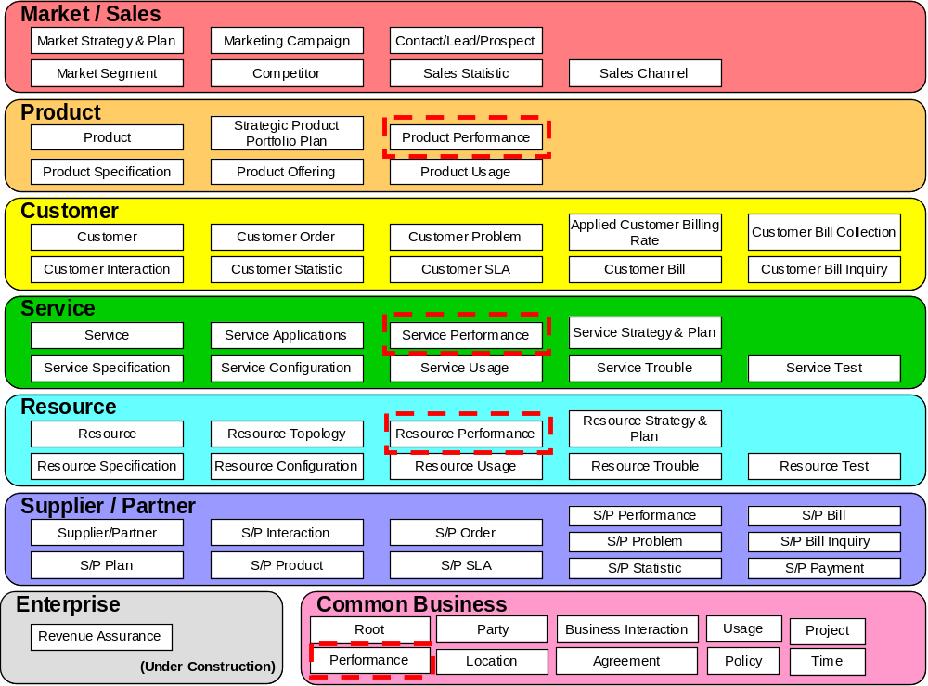
Figure PF.00 – SID Framework Performance Entities
The Service Performance ABE collects, correlates, consolidates, and validates various performance statistics and other operational characteristics of customer and resource facing service entities. It provides a set of entities that can monitor and report on performance. Each of these entities also conducts network performance assessment against planned goals, performs various aspects of trend analysis, including error rate and cause analysis and Service degradation. Entities in this ABE also manage the traffic generated by a Service, as well as traffic trend analysis. This is important for newer technologies that separate data, control and management functions for a given Service.
The Resource Performance ABE collects, correlates, consolidates, and validates various performance statistics and other operational characteristics of Resource entities. It provides a set of entities that can monitor and report on performance. The entities in this ABE provide physical, logical, and performance information. Each of these entities also conducts network performance assessment against planned goals, performs various aspects of trend analysis, including error rate and cause analysis and Resource degradation. Entities in this ABE also manage traffic in a Resource. This includes statistics defining Resource loading, and traffic trend analysis.

Performance Specification and Performance Business Entities
The Performance ABE is an addition to the SID model’s Common Business Entities domain. It represents a generalization of attributes and relationships that are common to both the SID Service Performance and Resource Performance ABEs’ entities, such as performance indicators, objectives, and consequences. Resource performance entities is collected hop by hop (between two network elements), while service performance is an aggregation of multiple resource performance instances that constitute the path a service takes through a network.
Two key entities that comprise the Performance ABE are PerformanceSpecification and Performance. They represent an application of the SID EntitySpecification/Entity pattern. A PerformanceSpecification and its related specification entities provide the definition of the performance attributes, such as KPIs, dimensions, and performance objectives. The Performance entity and its related entities provide the values associated with the manner in which a service or resource is performing or has performed, such as the loss of 5K packets between two network elements.
Figure PF.01 depicts the PerformanceSpecification and Performance entities along with the two types, or subclasses, of performance-related entities relevant to the model, ServicePerformanceSpec and ResourcePeformanceSpec, along with their related instance entities, ServicePerformance and ResourcePerformance.

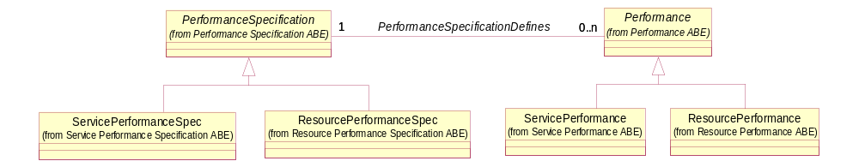
Figure PF.01 – Basic Performance Entities
Figure PF.02 shows the associations that performance entities have with existing service and resource entities, as well as the association that the Performance entity has with the Customer entity. Note that the dark-shaded entities, CustomerFacingServiceSpecification and CustomerFacingService are not within the scope of the model as they related the Service domain with the Product domain, which is out of scope at this point in time. Also note that the ResouceSpecification is related directly to the PerformanceSpecification entity and Resource is related to the Performance entity, since both Service and Resource performance deal with Resources.
The associations with the specification entities provide part of the definition of the performance specification entities. For example, the specification of a GGSN and SGSN define the types of network elements whose performance is measured.
The cardinality of the association between ResourceSpecification and PerformanceSpecification is 0,2 because at most two types of resources’ performance is defined by a PerformanceSpecification. Similarly, the association between Resource and Performance also has a cardinality of 0,2. These Resource domain entities are directly related to the respective Performance ABE entities and not to ResourcePerformanceSpec and ResourcePerformance. The reason is that Resources are used to measure both Service-related and Resource-related performance.
For the ServiceSpecification entity the cardinality is 1 because a given instance of a ServicePerformanceSpec entity measures the performance of a single ServiceSpecification entity, such as a mobile voice call. Similarly, the cardinality of the association between a Service and a Service performance is 1.
The cardinality between a Customer and Performance is 0,1 because an instance of Performance may or may not be a measure of performance for an instance of Customer.
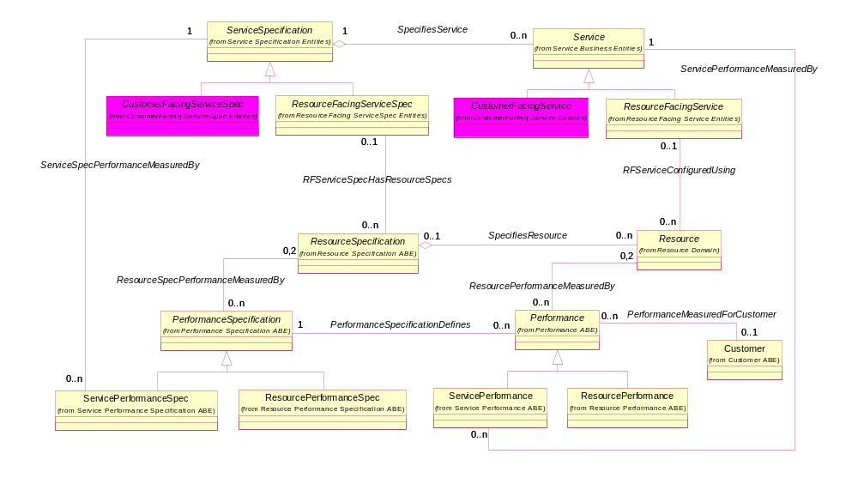
Figure PF.02 – Service, Resource, and Performance
The definition of performance specification and performance entities is based on four other key types of entities
- Performance Indicator (KPI) entities
- Performance Category entities
- Performance Network Address (IP and Point Code) entities
- Performance Characteristic (dynamic attribute) entities
Each of these types of entities is detailed in separate sections of this document. Figure PF.03 shows the core entities for each type and their relationship with PerformanceSpecification and Performance. These types of entities also employ the EntitySpecification/Entity pattern. For example, the PeformanceIndicatorSpecification entity defines a KPI with a name of pealPacketJitter, its description, how it is derived, and so forth; the PerformanceIndicator for peakPacketJitter contains the value for the KPI and the time at which it was calculated and so forth.
Note that all the performance specification related entities have an n-n association with PerformanceSpecification. This enables instances of these entities, such as PerformanceIndicatorSpecification, to be shared by many PerformanceSpecifications. For example, peakPacketDelay can be a KPI for a PerformanceSpecification that measures the performance of a GGSN to a SGSN and a SGSN and a BSS. From a PerformanceIndicator perspective, it does not make sense that all the instances of these entities be shared by instances of Performance. Entities that classify or further define the Performance, such as PeformanceCategory and PerformanceNetworkAddress, are shared. For example, a Codec with a value of GSM can classify many instances of Performance. Entities, such as PerformanceIndicator and PerformanceCharacteristicValue, define a single instance of Performance and are not shared. For example, the 1000 sent packets defines a single instance of the Performance between the north Dallas BSS and the Dallas SGSN.
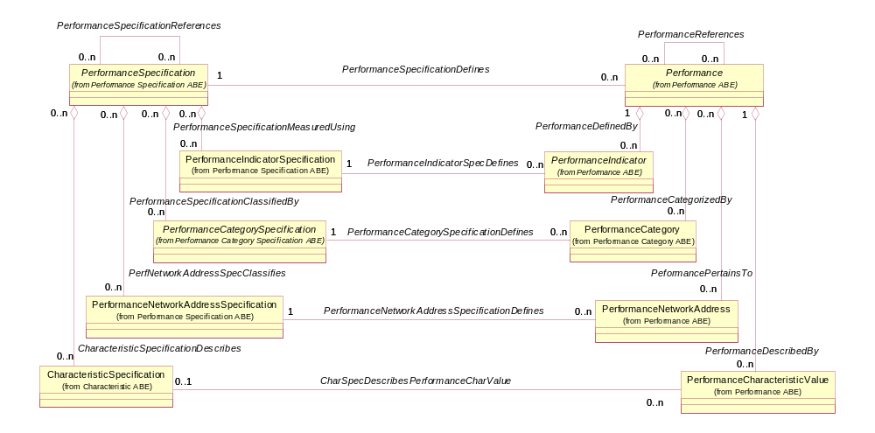
Figure PF.03 – Performance Specification
One entity not included in Figure PF.03, PerformanceSpecificationInterval, specifies the frequency at which Performance is calculated is shown in Figure PF.04. The figure includes the PerformanceSpecIntervalConversion entity which specifies how one conversion interval, such as hourly interval, is calculated from a five minute interval. Also shown in the figure is an association that enables customer-specific PerformanceSpecification to be created. These and the other entities in the figure depict the complete definition of a PerformanceSpecification.
The PefromanceIntervalSpecification and its related PerformanceSpecIntervalConversion entity also provide for an extensible model by allowing any type of interval to be defined in addition to those that currently exist.
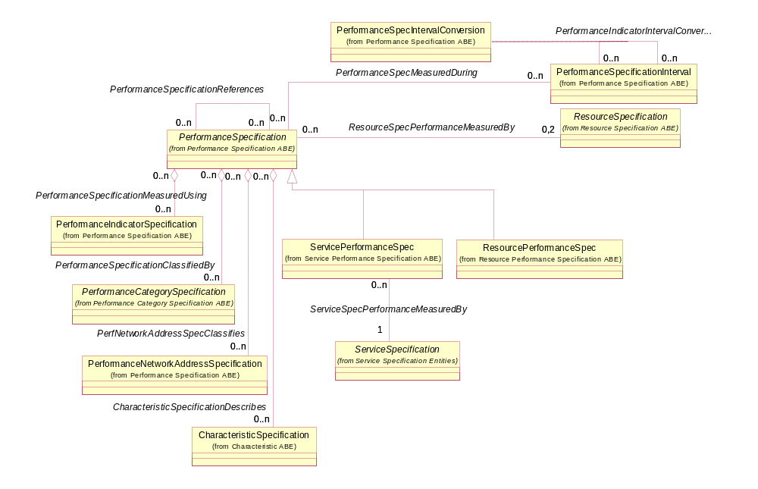
Figure PF.04 – Performance Specification Interval
PerformanceIntervals also apply to Performance entities as shown in Figure PF.05. It would be incorrect to assume that, since the PerformanceSpecification entity is associated to the Performance entity and PerformanceSpecification is associated to PerformanceSpecificationInterval, the interval association to Performance could be derived using this association. This assumption is not correct because a PerformanceSpecification can be associated to one or more PerofrmanceSpecifictionIntervals. From a Performance perspective, the PerformanceSpecificationInterval defines the time period over which the Performance is computed.
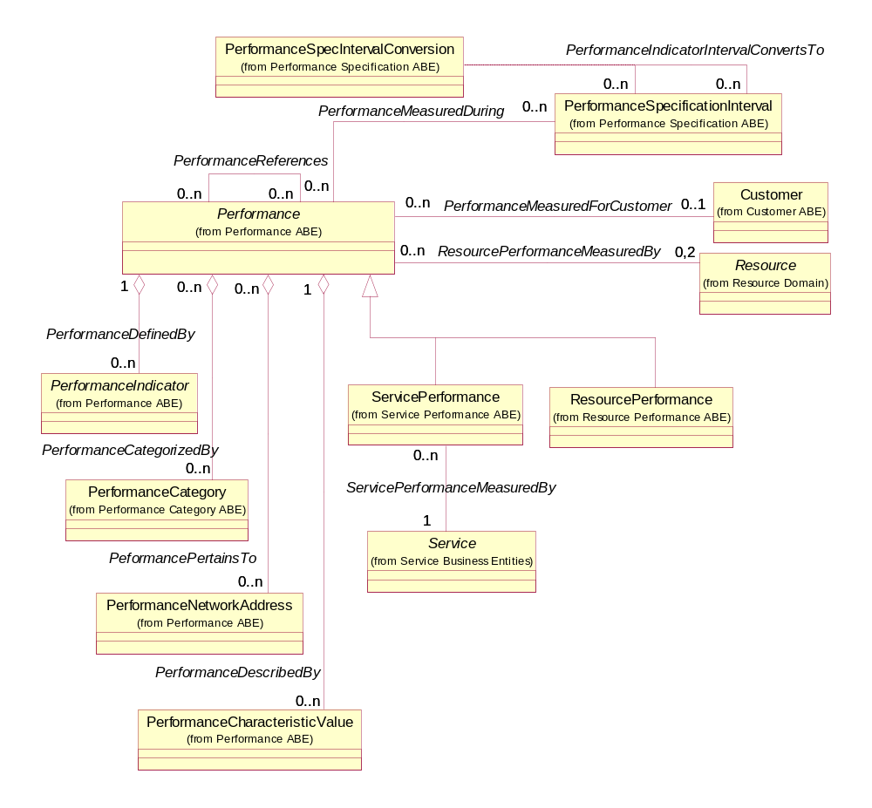
Figure PF.05 – Performance Interval

As stated earlier the PerformanceIndicatorSpecification and PerformanceIndicator entities provide the definition and values that are used to measure a specific aspect of the performance of an entity, such as number of lost packets and out of sequence packets. The indicator is measured by one or more instances of the PerformanceObjective entity. The PerformanceObjective entity, shown in Figure PF.06, defines a goal for a PerformanceIndicatorSpecification in terms of the threshold values, tolerances, grace periods, and a comparator. The comparator is operator that specifies whether PerformanceObjective threshold is violated when it is above or below a conformance target. For example, an objective may specify that when average lost packets indicator exceeds a value of 2000, then the objective is violated. A relationship between the objective and a PerformanceIndicator specifies which objective or objectives were applied to an instance of an indicator. For example, the lost packets indicator with a value of 2500 would be associated with the objective of no more than 2000 lost packets.
A PerformanceConsequence represents the action taken when a PerformanceObjective is violated. If a violation is triggered by a PerformanceIndicator an association is created between the instance of PerformanceIndicator and one or more PerformanceConsequences. The consequence prescribes that action to take via a prescribed action or may be related to a ConsequencePerformanceNotificationSpec, which is a type of PerformanceNotificationSpecification. For example, the prescribed action may be to monitor the PerformanceIndicator more closely. The notification specification overrides the prescribed of the PerformanceConsequence and indicates what type of notification should be raised, such as an alert or an alarm. If a notification specification is associated with a consequence and an instance of PerformanceIndicator triggers a consequence, an instance of ConsequencePerformanceNotification is created and associated to the instance of PerformanceIndicator. A ConsequencePerformanceNotification is a type of PerformanceNotification, which in turn is a type of Notification. This is also shown in Figure PF.06.
This part of the Performance model enables the creation of any type of PerformanceIndicatorSpecification along with its objectives, consequences, and notifications, without the need to make changes to the information model. This satisfies the requirement for the model to be adaptable to change.
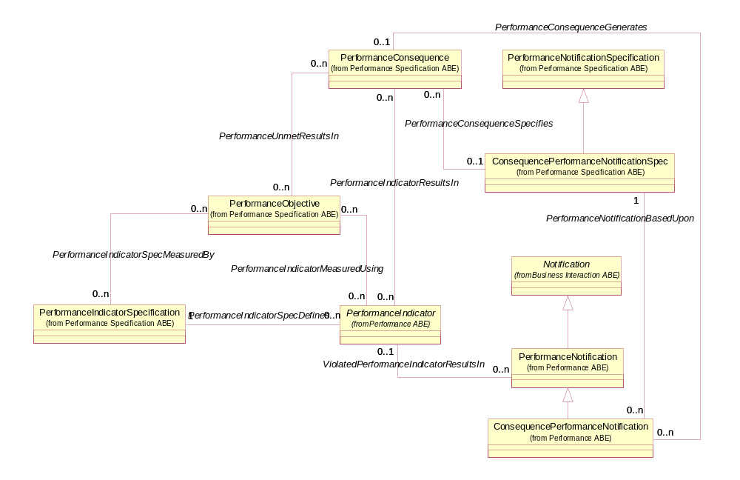
Figure PF.06 – Performance Indicator – Objective, Consequence, Notification
Performance in general, indicators, objectives, and consequences may apply a certain times or not apply during certain times. A set of performance entities, PerformanceApplicability, PerformanceObjectiveApplicability, PerformanceObjectiveApplicablityConsequence, controls applicability as shown in Figure PF.06. For example, an instance of a PerformanceObjective may apply to only to peak usage ours of 8AM – 5PM; or a PerformanceConsequence for an instance of PerformanceObjective may only apply on the weekends.

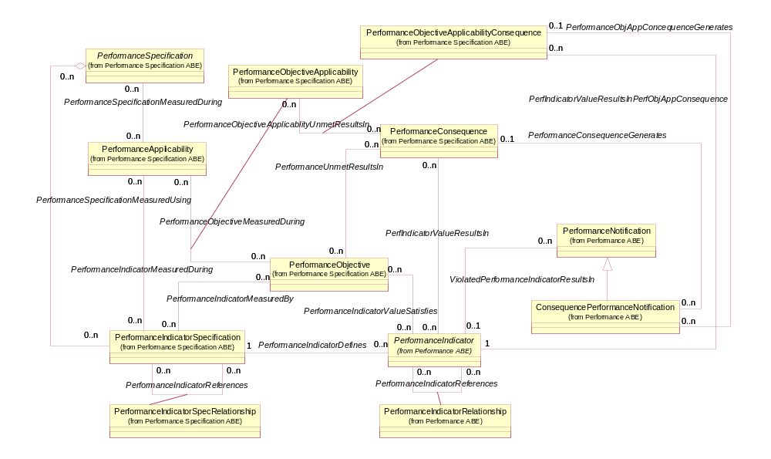
Figure PF.07 – Performance - Applicability

The specification of categories that add to the definition of PerformanceSpecifications and Performance are included in the model as shown in Figure PF.08. Categories are used to classify PerformanceSpecifications and Performance. Categories can be added as needed by defining new instances of the PerformanceCategorySpecification entity. This further demonstrates the inherent extensibility of the Performance model.
The association that exists between a PerformanceCategorySpecification and itself and the association class PerformanceCatSpecRelationship provides the ability to specify that one instance of a PerformanceCategory can be related to one or more other PerformanceCategories. For example, Codec instance can be related to a MediaType instance and a BearerType instance.
Figure PF.08 also introduces the concept of a characteristic in the form of CharacteristicSpecification. A characteristic is an additional attribute that defines a PerformanceCategorySpecification, such as successFlag, abnormalFlag, and so forth. The CharacteristicSpecification also allows a set of constraints to be placed on values of the associated CharacteristicSpecification. For example, successFlag can take on values of “Yes” or “No”. These two entities also demonstrate the ability to dynamically extend the Performance model, in this case PerformanceCategories with additional attributes that define a specific category.

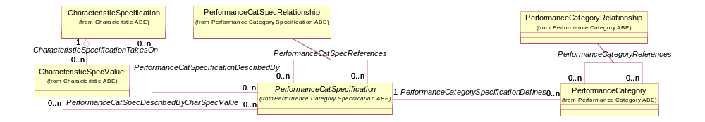
Figure PF.08 – Performance Category (Dimension) Specification
The next figure PF.09 depicts instances of PerformanceCategories that are based on a PerformanceCategorySpecification. For example, a Codec specification has category instances of 243-PCMU, 230-GSM, and so forth. Any number of category instances can be associated to a specification.
Also shown in the figure is an association between a PerformanceCategory and itself and the association class PerformanceCategoryRelationship. The relationship is governed by the association between a PerformanceCategorySpecification and itself. It defines associations that exist between categories. For example, the Codec instance 243-GSM is related to the BearerType instance 999 and the MediaType instance 546. These relationships further define the Codec instance in the example.

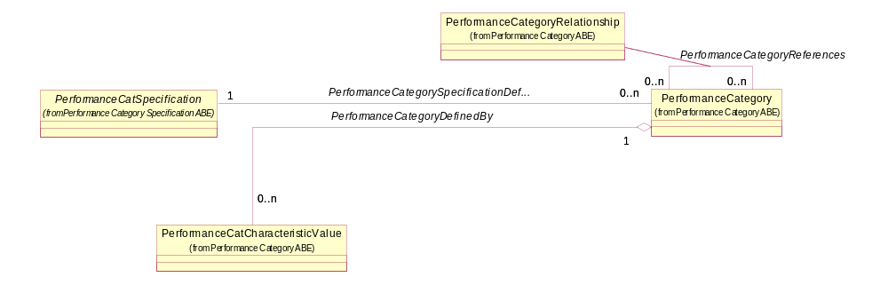
Figure PF.09 – Performance Category (Dimension)
The network addresses associated to elements whose performance is being measured are also important to the definition of a PerformanceSpecification. For example, an IP address associated with a GGSN. The PerformanceNetworkAddress entity, shown in Figure PF.10, supports the identification of associated network resources. It extends the definition of the existing SID NetworkAddress entity and identifies the source and destination resources which are critical for hop-by-hop measurements. Currently, a PerformanceNetworkAddress can be an IP address or a point code, but additional types of addresses can be added by adding a new instance of a NetworkAddressSpecification as shown in the figure. NetworkAddresses can also be associated with PerformanceCategories as defined by the association between NetworkAddressSpecification and PeformanceSpecification.
Figure PF.10 also shows the role a Resource can play in Performance via the association class PerfResourceSpecificationRole and PerformanceResourceRole entities. For example one network element may be the source of a message and another network element may be the destination.
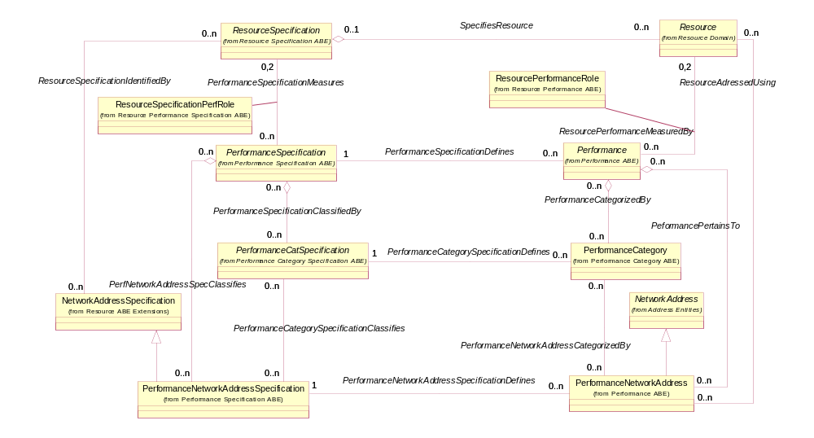
Figure PF.10 – Resource, Performance Category and Performance Network Address
The next figure, Figure PF.11, depicts the three types of PerformanceNetworkAddresses, MobilePerformanceAddress, PerformanceIPAddress and PerformancePointCode, which currently exist in the model. Additional network addresses can be added with minimal impact to the model.
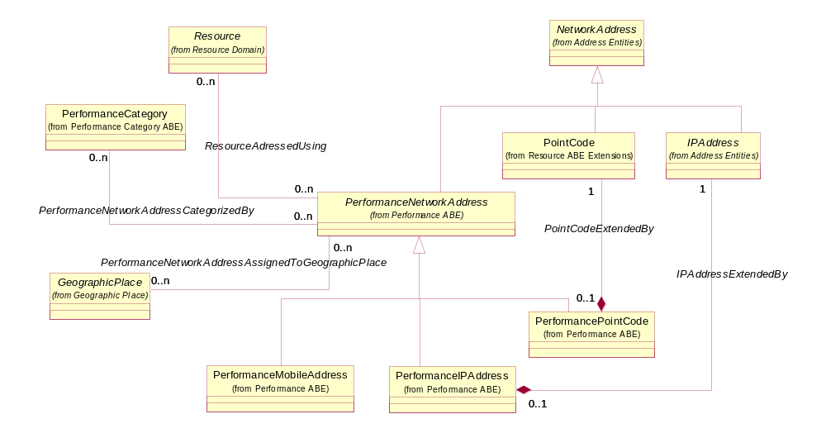
Figure PF.11 – Performance Network Address (Mobile, IP Address and Point Code)
The concept of a characteristic was introduced with performance categories. Characteristics can be associated with any entity specification and corresponding entity in the Performance model. Figure PF.12 shows how characteristics can be applied to the PerformanceSpecification and Performance entities. In this case a CharacteristicSpecification, such as sent packets, can be associated with an instance of PerformanceSpecification. The associated Performance entity may have a value, such as 75K, associated to the sent packets CharacteristicSpecification.
One important note is that CharacteristicSpecifications can be shared among one or more instances of PerformanceSpecifications. For example, sent packets, could be associated with an instance of a PerformanceSpecification for a GGSN to SGSN and an instance of a PerformanceSpecification for a BSC to a Cell Site.
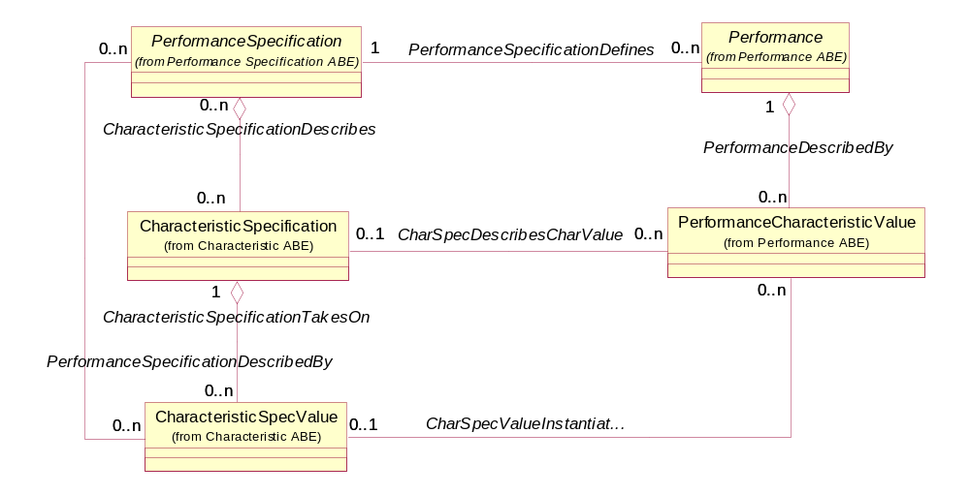
Figure PF.12 – Performance Characteristic

One area of the model that was preliminarily investigated was how characteristics and other performance indicators can be used in the calculation of a value for a PerformanceIndicator. Figure PF.13 shows that a PerformanceIndicator can many derivation parameters. One parameter may be defined by a CharacteristicSpecification; another may be defined by a PerformanceIndicatorSpecification. Additional analysis is needed to fully define this part of the model.
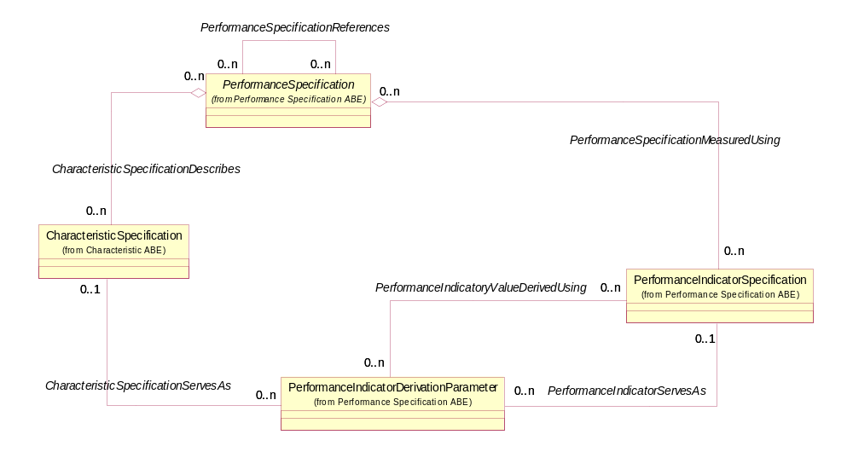
Figure PF.13 – Performance Indicator Derivation Parameter

Performance Indicators are often reported at the Resource Management layer in groups. A Performance Indicator Group is a set of performance indicators that are reported as a group by an Element Manager or a Network Element. Other common terms in the industry are Counter Set or Counter Group.

A Performance Indicator Group Specification is the logical group of the Performance Indicator Specification objects that compose a Performance Indicator Group. The Performance Indicator Group Specification has a name (string) and it can (optionally) hold the individual performance indicator specification objects.

The Performance Indicator Group and Performance Indicator Group Specification are shown in figure PF.14 below.
:
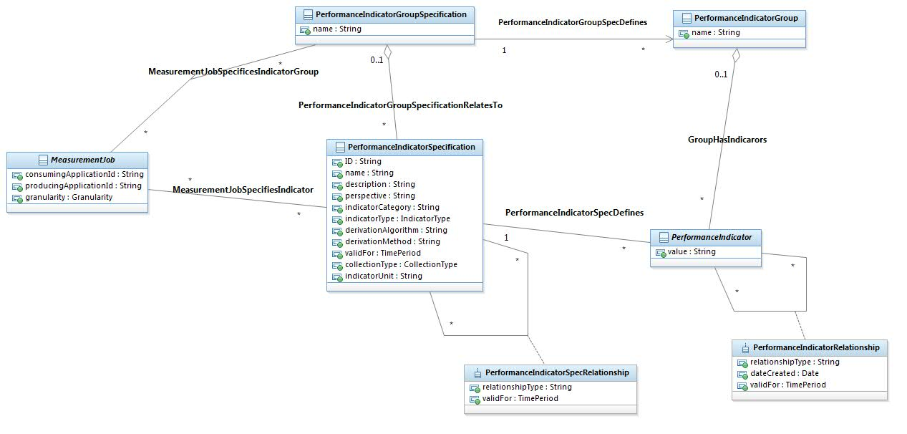
Figure PF.14 – Performance Indicator Group
A PM measurement job is the administrative entity defined by a client application to perform a periodic activity related to PM data. The PM activities may be production of measurements, collection of measurements or PM objective monitoring (scheduled evaluation of thresholds). The PM Measurement Job is a sub class of the PM Management Job (Management Job ABE under TIP Common ABE). The Management Job defines the attributes that may apply to any kind of a job while the Measurement Job adds the attributes that are specific to the Performance Management context.
The PM measurement job includes the following:
- A set of requested performance indicators
- A network/service scope defining a subset of the network or a subset of the service catalog
- Scheduling parameters
- Specific activity parameters, related to collection, production or objective monitoring
A measurement job must define a scope of monitored objects using the monitored objects criteria. The monitored objects criteria support two kinds of monitored objects specification, represented as two sub-entities:
- Monitored Instances criteria - Specifies a list of individual monitored instances (typed as object names).
- Monitored Class criteria - Specifies a monitored object class (a string) in conjunction with a filter object. The filter is composed of name value pairs that can be used to focus the PM collection.
The Measurement Job is shown in figure PF.15 below.

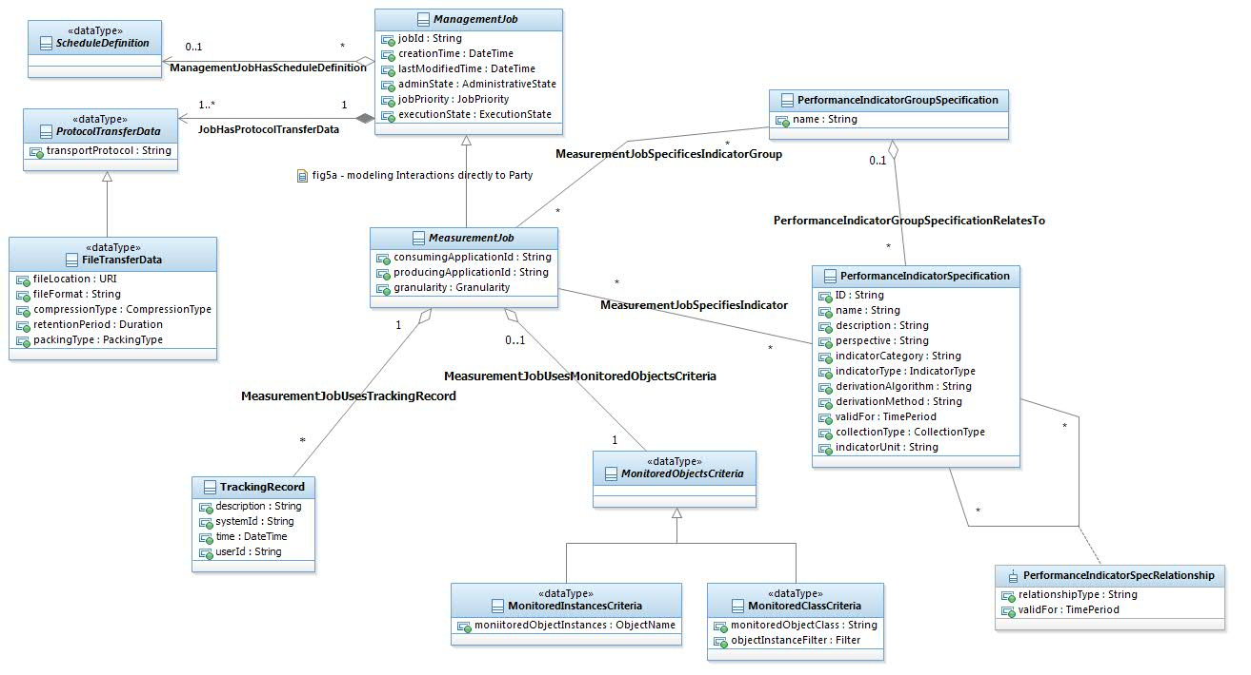
Figure PF.15 – Measurement Job

A Measurement Collection Job is used to control the periodic collection of performance indicators, implemented as a sub-entity of the PM Measurement Job. As the Measurement Collection Job inherits from the Measurement Job, it includes all attributes and associations defined for the base measurement job entity. The Measurement Collection Job and its attributes are shown in figure PF.16 below.
Similarly, a Measurement Production Job is defined as a sub-entity of the Measurement Job. It is used to define a job for generating indicators. A Production Job may have a Collection Job associated to it. The Production Job is described is also shown in PF.16 below.
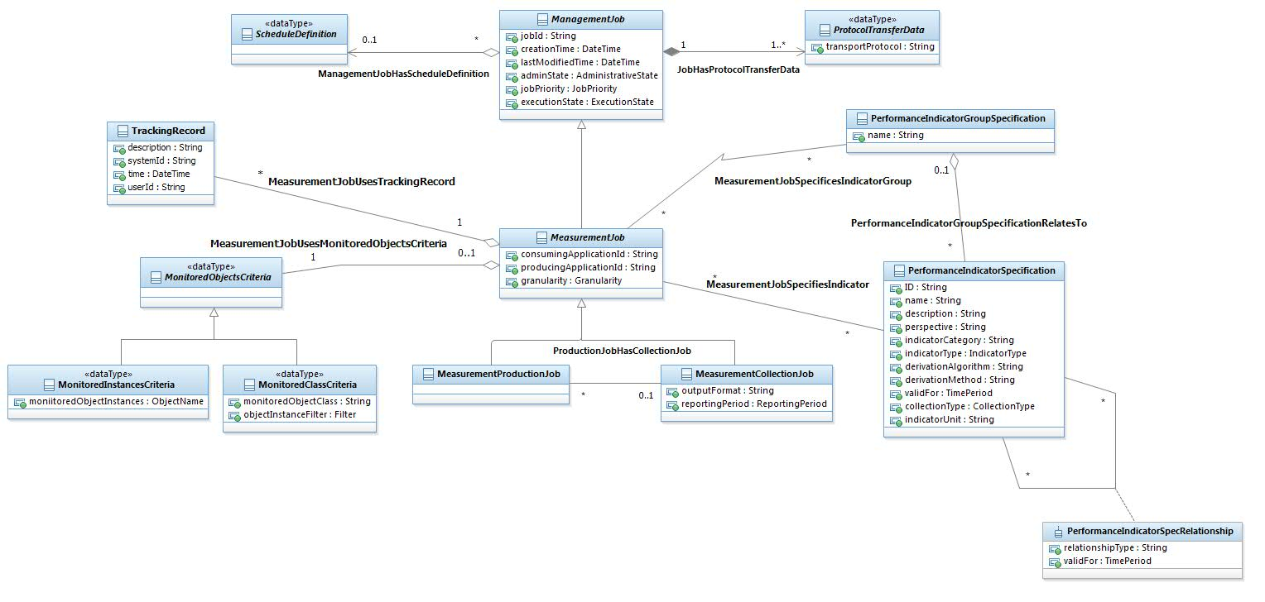
Figure PF.16 – Performance Monitoring, Measurement Production &Collection Jobs

Ad-hoc collection is an on-demand collection method of Performance measurements results from a consuming application, requesting spontaneously a set of data for a set of network or service testing resources for a given temporal context. As the ad-hoc query is a single isolated request, its lifecycle is much simpler and isolated, having a request-response nature.
The parameters of the PM data request are very similar to the parameters of the measurement job; the main difference is related to the administration of the request. Ad-hoc collection is shown in figure PF.17.
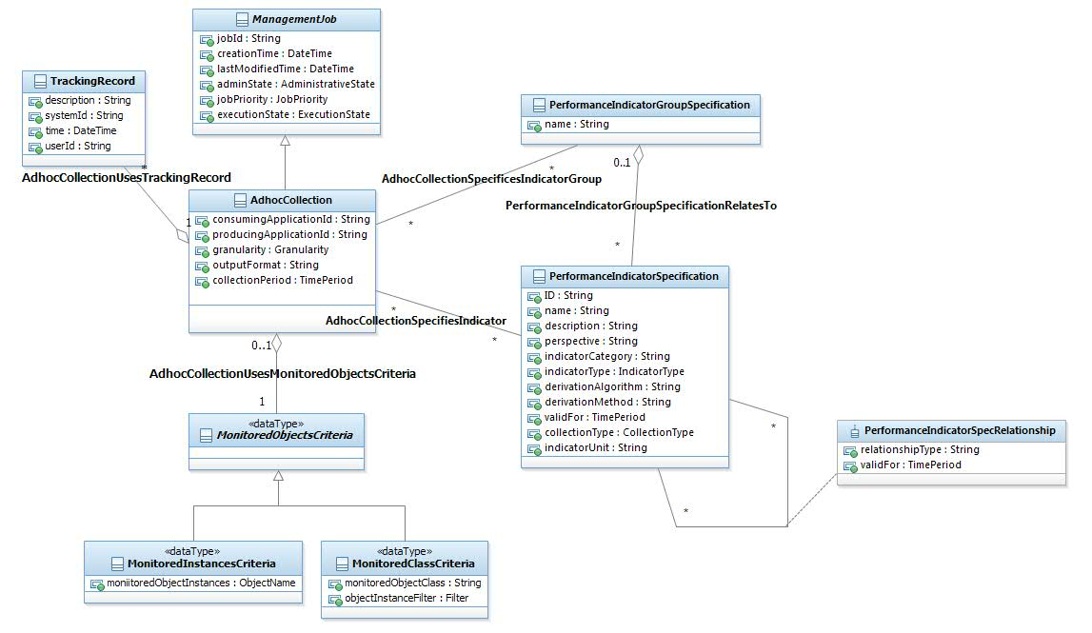
Figure PF.17 – Ad-hoc Collection

Business Entity Definitions – Performance Specification

PerformanceSpecification

Business Entity Definition
Business Entity Name | PerformanceSpecification
Description | The invariant characteristics of a measure of the manner in which a Service and/or Resource is functioning. Each related Performance instance will have the same invariant characteristics. However, the values associated with other characteristics of the instantiated Performance entity are specific to each instance.
Sources | Tektronix | Cross- References |  |  | Synonyms / Aliases
Related Business Entities | DefinesPerformance  MeasuredDuringPeformanceSpecificationInterval  MeasuresResourceSpecification  MeasureUsingPerformanceIndicatorSpecification  ClassifiedByPerformanceCategorySpecification  ClassifiedByPerformanceNetworkAddressSpecification  DescribedByCharacteristicSpecification  ReferencesPerformanceSpecification  DescribedByCharacteristicSpecification  MeasureDuringPerformanceApplicability
Business Rules

Business Entity Attributes Definition
Business Entity Name | PerformanceSpecification
Attribute Name | Description | Data Type | Characteristics, Permitted Values & Units | Required/  Optional | Notes
ID | A unique identifier for the PerformanceSpecification. | String |  | Required
Name | A word, term, or phrase by which the PerformanceSpecification is known and distinguished from other PerformanceSpecifications. | String |  | Required
Description | A narrative that explains the PerformanceSpecification. | String |  | Optional
validFor | The period of time for which a PerformanceSpecification is applicable. | Time Period |  | Optional

ServicePerformanceSpec

Business Entity Definition
Business Entity Name | ServicePerformanceSpec
Description | The invariant characteristics of a measure of the manner in which a Service is functioning. Each related Performance instance will have the same invariant characteristics. However, the values associated with other characteristics of the instantiated Performance entity are specific to each instance.
Sources | Tektronix | Cross- References |  |  | Synonyms / Aliases
Related Business Entities | ServiceSpecMeasuredBy
Business Rules

ResourcePerformanceSpec

Business Entity Definition
Business Entity Name | ResourcePerformanceSpec
Description | The invariant characteristics of a measure of the manner in which a Resource is functioning. Each related Performance instance will have the same invariant characteristics. However, the values associated with other characteristics of the instantiated Performance entity are specific to each instance.
Sources | Tektronix | Cross- References |  |  | Synonyms / Aliases
Related Business Entities
Business Rules

Performance

Business Entity Definition
Business Entity Name | Performance
Description | A measure of the manner in which a Service and/or Resource is functioning.
Sources | Tektronix | Cross- References |  |  | Synonyms / Aliases
Related Business Entities | DescribedByPerformanceSpecification  DefinedByPerformanceIndicator  MeasuredForCustomer  DescribedByPerformanceCharacteristicValue  PertainsToPerformanceNetworkAddress  ReferencesPerformance  CategorizedByPerformanceCategory  MeasuresResource  MeasuredDuringPerformanceSpecificationInterval
Business Rules

Business Entity Attributes Definition
Business Entity Name | Performance
Attribute Name | Description | Data Type | Characteristics, Permitted Values & Units | Required/  Optional | Notes
intervalTime | The increment of time (including date) for which the associated PerformanceIndicators were calculated/determined. | Date |  | Required

ServicePerformance

Business Entity Definition
Business Entity Name | ServicePerformance
Description | A measure of the manner in which a Service is functioning.
Sources | Tektronix | Cross- References |  |  | Synonyms / Aliases
Related Business Entities | MeasuresService
Business Rules

ResourcePerformance

Business Entity Definition
Business Entity Name | ResourcePerformance
Description | A measure of the manner in which a Resource is functioning.
Sources | Tektronix | Cross- References |  |  | Synonyms / Aliases
Related Business Entities
Business Rules

PerformanceIndicatorSpecification

Business Entity Definition
Business Entity Name | PerformanceIndicatorSpecification
Description | A measure of a specific aspect of the performance of an entity, such as a lost packets or average jitter, defined for a PeformanceSpecification that may trigger the creation of a PerformanceConsequence.
Sources | Tektronix | Cross- References |  | Synonyms / Aliases
Related Business Entities | UsedAsMeasureForPerformanceSpecification  ReferencesPerformanceIndicatorSpecification  DefinesPerformanceIndicator  ServesAsPerformanceIndicatorDerivationParameter  MeasuredByPerformanceObjective  MeasuredDuringPerformanceApplicability
Business Rules

Business Entity Attributes Definition
Business Entity Name | PerformanceIndicatorSpecification
Attribute Name | Description | Data Type | Characteristics, Permitted Values & Units | Required/  Optional | Notes
ID | A unique identifier for the PerformanceIndicatorSpecification. | String |  | Required
name | A word, term, or phrase by which a PerformanceIndicatorSpecification is known and distinguished from other PerformanceIndicatorSpecifications. | String |  | Required
description | A narrative that explains in detail what the PerformanceIndicatorSpecification is. | String |  | Optional
perspective | The point of view for the PerformanceIndicatorSpecification, such as a single user instance or an aggregation. | String |  | Optional
indicatoryCategory | A grouping or set of PerformanceIndicatorSpecifications that are classified together because of common characteristics, such as technology specific, service specific, or technology/service independent. | String |  | Optional
indicatorType | A kind of value that the PerformanceIndicator can take on, such as numeric, text, and so forth. | Indicator Type |  | Required
derivationAlgorithm | A step-by-step procedure used to calculate the value of the PerformanceIndicator. | String |  | Optional
derivationMethod | For simple calculations, the method used to calculate the value of a PerformanceIndicator, such as average, minimum, maximum, sum, and so forth. | String |  | Optional
validFor | The period of time during which the PerformanceIndicatorSpecification is applicable. | Time Period |  | Optional
collectionType | The type of the collection: gauge, cumulative, status inspection. Indicators can be produced using these methods. | Collection Type |  | Required
indicatorUnit | The unit by which the indicator is measured. For example: seconds, KBs,  rate per second, etc. | String |  | Optional

PerformanceIndicator

Business Entity Definition
Business Entity Name | PerformanceIndicator
Description | A numerical value or text determined for a PerformanceIndicatorSpecification. For example, a value of .005 ms that represents average packet delay.
Sources | Tektronix | Cross- References |  |  | Synonyms / Aliases
Related Business Entities | DefinedByPerformanceIndicatorSpecificationP  DefinesPerformance  SatisfiesPerformanceObjective  ResultsInPerformanceConsequence  ResultsInPerfObjAppConsequence  WhenViolatedResultsInPerformanceNotification  ReferencesPerformanceIndicator
Business Rules

Business Entity Attributes Definition
Business Entity Name | PerformanceIndicator
Attribute Name | Description | Data Type | Characteristics, Permitted Values & Units | Required/  Optional | Notes
value | A discrete value determined for the PerformanceIndicator. | String |  | Required

PerformanceCategorySpecification

Business Entity Definition
Business Entity Name | PerformanceCategorySpecification
Description | The invariant characteristics that define a group or set of performance qualities that are classified together because of common characteristics.
Sources | Tektronix | Cross- References |  | Synonyms / Aliases
Related Business Entities | ClassifiesPerformanceNetworkAddressSpecification  ReferencesPerformanceCategorySpecification  DescribedByCharacteristicSpecification  DescribedByCharSpecValue  ClassifiesPerformanceSpecification  DefinesPerformanceCategory
Business Rules

Business Entity Attributes Definition
Business Entity Name | PerformanceCategorySpecification
Attribute Name | Description | Data Type | Characteristics, Permitted Values & Units | Required/  Optional | Notes
ID | A unique identifier for the PerformanceCategorySpecification. | String |  | Required
name | A word, term, or phrase by which the PerformanceCategorySpecification is known and distinguished from other PerformanceCategorySpecifications. | String |  | Required
description | A narrative that explains the PerformanceCategorySpecification. | String |  | Optional
validFor | The period of time for which a PerformanceCategorySpecification is applicable. | Time Period |  | Optional

PerformanceCategory

Business Entity Definition
Business Entity Name | PerformanceCategory
Description | A group or set of performance qualities that are classified together because of common characteristics.
Sources | Tektronix | Cross- References |  |  | Synonyms / Aliases
Related Business Entities | DefinedByPerformanceCategorySpecification  ReferencesPerformanceCategory  DefinedByPerformanceCatCharacteristicValue  CategorizesPerformanceNetworkAddress  CategorizesPerformance
Business Rules

Business Entity Attributes Definition
Business Entity Name | PerformanceCategory
Attribute Name | Description | Data Type | Characteristics, Permitted Values & Units | Required/  Optional | Notes
ID | A unique identifier for the PerformanceCategory. | String |  | Required
name | A word, term, or phrase by which the PerformanceCategory is known and distinguished from other PerformanceCategory. | String |  | Required
description | A narrative that explains the PerformanceCategory. | String |  | Optional
validFor | The period of time for which a PerformanceCategory is applicable. | Time Period |  | Optional

PerformanceNetworkAddressSpecification

Business Entity Definition
Business Entity Name | PerformanceNetworkAddressSpecification
Description | The invariant characteristics that define Performance-related extensions to NetworkAddressSpecification. NetworkAddressSpecifications define different types of addresses of different technologies, such as an IPAddress vs. an IPXAddress. Each related PerformanceNetworkAddress instance will have the same invariant characteristics. However, the values associated with other characteristics of the instantiated PerformanceNetworkAddress entity are specific to each instance.
Sources | Tektronix | Cross- References |  |  | Synonyms / Aliases
Related Business Entities | Subclass of NetworkAddressSpecification  ClassifiesPerformanceSpecification  DefinesPerformanceNetworkAddress  ClassfiedByPerformanceCategorySpecification
Business Rules

PerformanceNetworkAddress

Business Entity Definition
Business Entity Name | PerformanceNetworkAddress
Description | A Performance-related extension to a NetworkAddress. A NetworkAddress define different ways to identify where a Resource is, such as an IPAddress vs. an IPXAddress vs. a PointCode.
Sources | Tektronix | Cross- References |  |  | Synonyms / Aliases
Related Business Entities | Subclass of NetworkAddress  DefinedByPerformanceNetworkAddressSpecification  UsedToAddressResource  CategorizedByPerformanceCategory  AssignedToGeographicPlace  AssignedToNetworkElement  IdentifiesPerformance  ClassifiedByNetworkElementSpecification
Business Rules

Business Entity Attributes Definition
Business Entity Name | PerformanceNetworkAddress
Attribute Name | Description | Data Type |  | Characteristics, Permitted Values & Units | Required/  Optional | Notes
validFor | The period of time during which the PerformanceNetworkAddress is applicable. | Time Period |  |  | Optional

CharacteristicSpecification

Business Entity Definition
Business Entity Name | CharacteristicSpecification
Description | A quality or distinctive feature that defines an entity. The characteristic can be take on a discrete value, such as color, can take on a range of values, (for example, sensitivity of 100-240 mV), or can be derived from a formula (for example, usage time (hrs) = 30 - talk time *3).
Sources | MetaSolv, Tektronix | Cross- References |  |  | Synonyms / Aliases
Related Business Entities | DescribesPerformanceSpecification  TakesOnCharacteristicSpecValue  ReferencesCharacteristicSpecification  DescribesPerformanceCharacteristicValue  DescribesPerformanceCategoryCharacteristicValue  DescribesPerformanceCategorySpecification  ServesAsPerformanceIndicatorDerivationParameter
Business Rules

Business Entity Attributes Definition
Business Entity Name | CharacteristicSpecification
Attribute Name | Description | Data Type | Characteristics, Permitted Values & Units | Required/  Optional | Notes
ID | A unique identifier for the CharacteristicSpecification. | String |  | Required
name | A word, term, or phrase by which a CharacteristicSpecification is known and distinguished from other CharacteristicSpecifications. | String |  | Required
description | A narrative that explains in detail what the CharacteristicSpecification is. | String |  | Optional
valueType | A kind of value that the characteristic can take on, such as numeric, text, and so forth. | String |  | Required
derivationFormula | A rule or principle represented in symbols, numbers, or letters, often in the form of an equation used to derive the value of a characteristic value. | String |  | Optional
presence | The presence of characteristic, which defines whether the CharacteristicSpecification is required or optional. | String |  | Optional
validFor | The period of time for which a CharacteristicSpecification is applicable. | Time Period |  | Optional

PerformanceCharacteristicValue

Business Entity Definition
Business Entity Name | PerformanceCharacteristicValue
Description | A value of a CharacteristicSpecification provided for Performance that further defines what the Performance is.
Sources | Tekronix | Cross- References |  |  | Synonyms / Aliases
Related Business Entities | DescribedByCharacteristicSpecification  InstantiatesCharacteristicSpecificationValue  DescribesPerformance
Business Rules

Business Entity Attributes Definition
Business Entity Name | PerformanceCharacteristicValue
Attribute Name | Description | Data Type | Characteristics, Permitted Values & Units | Required/  Optional | Notes
value | A fact that describes a PerformanceCharacteristicValue. | String |  | Required
validFor | The period for which the PerformanceCharacteristicValue is applicable. | Time Period |  | Optional

PerformanceSpecificationInterval

Business Entity Definition
Business Entity Name | PerformanceSpecificationInterval
Description | The interval of time for represented by the PerformanceSpecification.
Sources | Tektronix | Cross- References |  |  | Synonyms / Aliases
Related Business Entities | PerformanceSpecificationMeasuredDuring  PerformanceMeasuredDuring  ReferencesPerformanceSpecificationInterval
Business Rules

Business Entity Attributes Definition
Business Entity Name | PerformanceSpecificationInterval
Attribute Name | Description | Data Type | Characteristics, Permitted Values & Units | Required/  Optional | Notes
ID | A unique identifier for the PerformanceSpecificationInterval. | String |  | Required
name | A word, term, or phrase by which the PerformanceSpecificationInterval is known and distinguished from other PerformanceSpecificationIntervals. | String |  | Required
description | A narrative that explains the PerformanceSpecificationInterval. | String |  | Optional
interval | A value that represents the period of time over which the PerformanceSpecification is collected. | String |  | Required
validFor | The period of time for which a PerformanceSpecificationInterrval is applicable. | Time Period |  | Optional

PerformanceSpecIntervalConversion

Business Entity Definition
Business Entity Name | PerformanceSpecIntervalConversion
Description | The conversion factor that defines how many instances of one PerformanceSpecificationIntervals are contained in the related PerformanceSpecificationInterval.
Sources | Tektronix | Cross- References |  |  | Synonyms / Aliases
Related Business Entities | Defines the association between PerformanceSpecificationInterval and itself.
Business Rules

Business Entity Attributes Definition
Business Entity Name | PerformanceSpecIntervalConversion
Attribute Name | Description | Data Type | Characteristics, Permitted Values & Units | Required/  Optional | Notes
conversionFactor | A value used to convert one time interval to another time interval. For example a value of 12 converts a five minute interval into an hour interval. | Long |  | Required
validFor | The period of time for which a PerformanceSpecIntervalConversion is applicable. | Time Period |  | Optional

PerformanceObjective

Business Entity Definition
Business Entity Name | PerformanceObjective
Description | A goal for a PerformanceIndicator defined in terms of metrics, thresholds, and tolerances.
Sources | Tektronix | Cross- References |  |  | Synonyms / Aliases
Related Business Entities | MeasuresPerformanceIndicatorSpecification  MeasuresPerformanceIndicator  MeasuredDuring  UnmetResultsInPerformanceConsequence
Business Rules

Business Entity Attributes Definition
Business Entity Name | PerformanceObjective
Attribute Name | Description | Data Type | Characteristics, Permitted Values & Units | Required/  Optional | Notes
ID | A unique identifier for the PerformanceObjective. | String |  | Required
name | A word, term, or phrase by which a PerformanceObjective is known and distinguished from other PerformanceObjectives. | String |  | Required
description | A narrative that explains in detail what the PerformanceObjective is. | String |  | Optional
conformanceTarget | A value used to determine if the PerformanceObjective is met. | Long |  | Required
conformanceComparator | An operator that specifies whether a PerformanceObjective is violated above or below the conformanceTarget. | String |  | Required
conformancePeriod | An interval of time during which the conformanceTarget must be measured. | Duration |  | Required
thresholdTarget | A percent that is used to specify when a warning should be used that indicates a PerformanceObjective is in danger of not being met. | Long |  | Required
toleranceTarget | A percent that specifies the allowable variation of a conformanceTarget. | Long |  | Optional
tolerancePeriod | An interval of time over which the toleranceTarget is acceptable before a PerformanceObjectiveConsequence is initiated. | Duration |  | Optional
gracePeriods | The number of times an objective can remain un-updated in reference to the conformancePeriod without a PerformanceObjectiveConsequence being initiated. | Integer |  | Optional
validFor | The period of time during which the PerformanceObjective is applicable. | Time Period |  | Optional

PerformanceConsequence

Business Entity Definition
Business Entity Name | PerformanceConsequence
Description | An action taken if a PerformanceObjective is not met.
Sources | Tektronix | Cross- References |  |  | Synonyms / Aliases
Related Business Entities | ResultsFromUnmetPerformanceObjective  ResultsFromPerformanceIndicator  ResultsFromUnmetPerformanceObjectiveApplicability  SpecifiesPerformanceConsequenceNotificationSpecification  GeneratesPerformanceConsequenceNotification
Business Rules

Business Entity Attributes Definition
Business Entity Name | PerformanceConsequence
Attribute Name | Description | Data Type | Characteristics, Permitted Values & Units | Required/  Optional | Notes
ID | A unique identifier for the PerformanceConsequence. | String |  | Required
name | A word, term, or phrase by which a PerformanceConsequence is known and distinguished from other PerformanceConsequences. | String |  | Required
descripton | A narrative that explains in detail what the PerforrmanceConsequence is. | String |  | Optional
prescribedAction | Recommended remedy for a violated PeformanceIndicator. | String |  | Required
validFor | The period for which a PerformanceConsequence applies. | Time Period |  | Optional

PerformanceNotificationSpecification

Business Entity Definition
Business Entity Name | PerformanceNotificationSpecification
Description | The invariant characteristics that define a communication (notification) that occurs as part of performance measurement. A Notification is typically one-sided, in that no Response is expected.
Sources | Tektronix | Cross- References |  |  | Synonyms / Aliases
Related Business Entities
Business Rules

Business Entity Attributes Definition
Business Entity Name | PerformanceNotificationSpecification
Attribute Name | Description | Data Type | Characteristics, Permitted Values & Units | Required/  Optional | Notes
ID | A unique identifier for the PerformanceNotificationSpecification. | String |  | Required
name | A word, term, or phrase by which the PerformanceNotificationSpecification is known and distinguished from other PerformanceNotificationSpecifications. | String |  | Required
description | A narrative that explains the PerformanceNotificationSpecification. | String |  | Optional
validFor | The period of time for which a PerformanceNotificationSpecification is applicable. | Time Period |  | Optional

ConsequencePerformanceNotificationSpec

Business Entity Definition
Business Entity Name | ConsequencePerformanceNotificationSpec
Description | The invariant characteristics that define a communication (notification) that occurs as part of a PerformanceConsquence. A Notification is typically one-sided, in that no Response is expected. For example, an alarm may be raised as the result of a PerformanceObjective being violated.
Sources | Tektronix | Cross- References |  |  | Synonyms / Aliases
Related Business Entities | Subclass of PerformanceNotificationSpecification  PerformanceConsequenceSpecifies  FormsTheBasisOfPerformanceConsequenceNotification  GeneratedByPerformanceObjectiveApplicabilityConsequence
Business Rules

PerformanceNotification

Business Entity Definition
Business Entity Name | PerformanceNotification
Description | A communication that occurs as part of measuring performance. A Notification is typically one-sided, in that no Response is expected.
Sources | Tektronix | Cross- References |  |  | Synonyms / Aliases
Related Business Entities | Subclass of Notification  ResultsFromPerformanceIndicator
Business Rules

ConsequencePerformanceNotification

Business Entity Definition
Business Entity Name | ConsequencePerformanceNotification
Description | A communication that occurs as part of a PerformanceConsquence. A Notification is typically one-sided, in that no Response is expected. For example, an alert be raised as the result of a PerformanceObjective being violated.
Sources | Tektronix | Cross- References |  |  | Synonyms / Aliases
Related Business Entities | Subclass of PerformanceNotification  BasedUponConsequencePerformanceNotificationSpec  GeneratedByPerformanceConsequence  GeneratedByPerformanceObjectiveApplicabilityConsequence
Business Rules

PerformanceIndicatorSpecRelationship

Business Entity Definition
Business Entity Name | PerformanceIndicatorSpecRelationship
Description | An association between two PerformanceIndicatorSpecifications, such as one indicator derived from another.
Sources | Tektronix | Cross- References |  |  | Synonyms / Aliases
Related Business Entities | Association class for relationship between PerformanceIndicatorSpecification and itself
Business Rules

Business Entity Attributes Definition
Business Entity Name | PerformanceIndicatorSpecRelationship
Attribute Name | Description | Data Type | Characteristics, Permitted Values & Units | Required/  Optional | Notes
relationshipType | A categorization of the relationship, such as derived from, composite/atomic, and so forth. | String |  | Required
validFor | The period of time for which a PerformanceIndicatorSpecRelationship applies. | Time Period |  | Optional

PerformanceIndicatorRelationship

Business Entity Definition
Business Entity Name | PerformanceIndicatorRelationship
Description | An association between two PerformanceIndicators, such as one indicator derived from another.
Sources | Tektronix | Cross- References |  |  | Synonyms / Aliases
Related Business Entities | Association class for relationship between PerformanceIndicatorRelationship and itself.
Business Rules

Business Entity Attributes Definition
Business Entity Name | PerformanceIndicatorRelationship
Attribute Name | Description | Data Type |  | Characteristics, Permitted Values & Units | Required/  Optional | Notes
relationshipType | A categorization of the relationship, such as derived from, composite/atomic, and so forth. | String |  |  | Required
dateCreated | The date the relationship was established. | Date |  |  | Optional
validFor | The period for which a PerformanceIndicatorRelationship applies. | Time Period |  |  | Optional

PerformanceApplicability

Business Entity Definition
Business Entity Name | PerformanceApplicability
Description | The time of day or days during which a PerformanceSpecification is measured or not measured.
Sources | Tektronix | Cross- References |  |  | Synonyms / Aliases
Related Business Entities | DefinesMeasurementPeriodForPeformanceSpecification  DefinesMeasurementPeriodForPeformanceIndicatorSpecification  DefinesMeasurementPeriodforPerformanceObjective
Business Rules

Business Entity Attributes Definition
Business Entity Name | PerformanceApplicability
Attribute Name | Description | Data Type | Characteristics, Permitted Values & Units | Required/  Optional | Notes
ID | A unique identifier for the PerformanceApplicability. | String |  | Required
name | A word, term, or phrase by which an applicability is known and distinguished from other PerformanceApplicabilities. | String |  | Required
description | A narrative that explains in detail what the applicability is. | String |  | Optional
(un)applicableCode | Indicator that specifies whether an instance represents applicability or un-applicability. | String |  | Optional | One of the (un)applicable attributes is required
(un)applicableDuring | A period of time representing applicability or un-applicability. For example, from 8AM to 12PM. | Time Period |  | Optional
(un)applicableDays | A day or days representing applicability or un-applicability. For example 2, 3 represent Monday and Tuesday. | String |  | Optional
validFor | The period of time during which the applicability is in force. | Time Period |  | Optional

PerformanceObjectiveApplicability

Business Entity Definition
Business Entity Name | PerformanceObjectiveApplicability
Description | The time of day or days during which a PerformanceObjective is evaluated or not evaluated.
Sources | Tektronix | Cross- References |  | Synonyms / Aliases
Related Business Entities | Association class for the relationship between PerformanceApplicablity and PerformanceObjective  UnmetResultsInPerformanceConsequence
Business Rules

Business Entity Attributes Definition
Business Entity Name | PerformanceObjectiveApplicability
Attribute Name | Description | Data Type |  | Characteristics, Permitted Values & Units | Required/  Optional | Notes
validFor | The period of time during which the PerformanceObjectiveApplicability is valid. | Time Period |  |  | Optional

PerformanceObjectiveApplicabilityConsequence

Business Entity Definition
Business Entity Name | PerformanceObjectiveApplicabilityConsequence
Description | The time of day or days during which a PerformanceObjectiveConsequence applies or not to the violation of a PerformanceObjective.
Sources | Tektronix | Cross- References |  |  | Synonyms / Aliases
Related Business Entities | Association class for relationship between PerformanceObjectiveApplicability and PerformanceConsequence  ResultsFromUnmetPerformanceIndicator  GeneratesConsequencePerformanceNotificationSpec  GeneratesConsequencePerformanceNotification
Business Rules

Business Entity Attributes Definition
Business Entity Name | PerformanceObjectiveApplicabilityConsequence
Attribute Name | Description | Data Type |  | Characteristics, Permitted Values & Units | Required/  Optional | Notes
validFor | The period of time during which the PerformanceObjectiveApplicablity Consequence is valid. | Time Period |  |  | Optional

PerformanceCatSpecRelationship

Business Entity Definition
Business Entity Name | PerformanceCatSpecRelationship
Description | A specification for an association that can be established between two instances of PerformanceCategories. For example, a relationship can be established between a Codec instance and BearerType instance.
Sources | Tektronix | Cross- References |  |  | Synonyms / Aliases
Related Business Entities | Association class for the relationship between PerformanceCategoryRelationship and itself
Business Rules

Business Entity Attributes Definition
Business Entity Name | PerformanceCatSpecRelationship
Attribute Name | Description | Data Type |  | Characteristics, Permitted Values & Units | Required/  Optional | Notes
relationshipType | An indicator that specifies a relationship can be established between PerformanceCategories associated to the related PerformanceCategorySpecifications. | String |  |  | Required
validFor | The period of time for which a PerformanceCatSpecRelationship is applicable. | Time Period |  |  | Optional
numberRelCatLowerLimit | The lower limit of the number of PerformanceCategories that can be related.  Values can range from 0 to unbounded. | Integer |  |  | Optional
numberRelCatUpperLimit | The upper limit of the number of PerformanceCategories that can be related.  Values can range from 0 to unbounded. | Integer |  |  | Optional

CharacteristicSpecValue

Business Entity Definition
Business Entity Name | CharacteristicSpecValue
Description | A number or text that can be assigned to a CharacteristicSpecification.
Sources | MetaSolv, Tektronix | Cross- References |  |  | Synonyms / Aliases
Related Business Entities | TakenOnByCharacteristicSpecification  InstantiatedAsPerformanceCharacteristicValue  DescribesPerformanceCategorySpecification  DescribesPerformanceSpecification
Business Rules

Business Entity Attributes Definition
Business Entity Name | CharacteristicSpecValue
Attribute Name | Description | Data Type | Characteristics, Permitted Values & Units | Required/  Optional | Notes
valueType | A kind of value that the characteristic can take on, such as numeric, text, and so forth. | String |  | Optional
default | Indicates if the value is the default value for a characteristic. | Boolean |  | Optional
value | A discrete value that the characteristic can take on. | String |  | Optional | Either value or valueFrom and/or valueTo are required
valueFrom | The low range value that a characteristic can take on. | String |  | Optional
valueTo | The upper range value that a characteristic can take on. | String |  | Optional
validFor | The period of time for which a value is applicable. | Time Period |  | Optional

PerformanceCatSpecRelationship

Business Entity Definition
Business Entity Name | PerformanceCatSpecRelationship
Description | A specification for an association that can be established between two instances of PerformanceCategories. For example, a relationship can be established between a Codec instance and BearerType instance.
Sources | Tektronix | Cross- References |  | Synonyms / Aliases
Related Business Entities | Association class for the relationship between PerformanceCategorySpecification and itself.
Business Rules

Business Entity Attributes Definition
Business Entity Name | PerformanceCatSpecRelationship
Attribute Name | Description | Data Type |  | Characteristics, Permitted Values & Units | Required/  Optional | Notes
relationshipType | An indicator that specifies the type of relationship that can be established between PerformanceCategories associated to the related PerformanceCategorySpecifications. | String |  |  | Required
validFor | The period of time for which a PerformanceCategorySpecRelationship is applicable. | Time Period |  |  | Optional

ProtocolSpecification

Business Entity Definition
Business Entity Name | ProtocolSpecification
Description | The invariant characteristics that define a Protocol. A Protocol is a formal set of rules and conventions that governs how two entities exchange information (usually over one or more types of network media). Each related Protocol instance will have the same invariant characteristics. However, the values associated with other characteristics of the instantiated Protocol entity are specific to each instance.
Sources | Tektronix | Cross- References |  |  | Synonyms / Aliases
Related Business Entities | ServesAsProtocolCatSpecification
Business Rules

Business Entity Attributes Definition
Business Entity Name | ProtocolSpecification
Attribute Name | Description | Data Type | Characteristics, Permitted Values & Units | Required/  Optional | Notes
ID | A unique identifier for the ProtocolSpecification. | String |  | Required
name | A word, term, or phrase by which a ProtocolSpecification is known and distinguished from other ProtocolSpecifications. | String |  | Required
description | A narrative that explains in detail what the ProtocolSpecification is. | String |  | Optional
validFor | The period for which a ProtocolSpecification applies. | Time Period |  | Optional

ResourceSpecificationPerfRole

Business Entity Definition
Business Entity Name | ResourceSpecificationPerfRole
Description | A role that a ResourceSpecification plays in defining a PerformanceSpecification.
Sources | Tektronix | Cross- References |  |  | Synonyms / Aliases
Related Business Entities | Association class for relationship between ResourceSpecification and PerformanceSpecification
Business Rules

Business Entity Attributes Definition
Business Entity Name | ResourceSpecificationPerfRole
Attribute Name | Description | Data Type | Characteristics, Permitted Values & Units | Required/  Optional | Notes
roleType | A function that a ResourceSpecification plays in defining a PerformanceSpecification, such as source, destination, related, and so forth. | String |  | Required
validFor | The period of time during which the PerformanceSpecificationPerfRole is applicable. | Time Period |  | Optional

ResourcePerformanceRole

Business Entity Definition
Business Entity Name | ResourcePerformanceRole
Description | A role that a Resource plays in measuring Performance.
Sources | Tektronix | Cross- References |  |  | Synonyms / Aliases
Related Business Entities | Association class for relationship between Resource and Performance
Business Rules

Business Entity Attributes Definition
Business Entity Name | ResourcePerformanceRole
Attribute Name | Description | Data Type | Characteristics, Permitted Values & Units | Required/  Optional | Notes
role | A function that a Resource plays in measuring Performance, such as source, destination, related, and so forth. | String |  | Required

NetworkAddressSpecification

Business Entity Definition
Business Entity Name | NetworkAddressSpecification
Description | The invariant characteristics that define a NetworkAddress. NetworkAddressSpecifications define different types of addresses of different technologies, such as an IPAddress vs. an IPXAddress. Each related NetworkAddress instance will have the same invariant characteristics. However, the values associated with other characteristics of the instantiated NetworkAddress entity are specific to each instance.
Sources | Tektronix | Cross- References |  |  | Synonyms / Aliases
Related Business Entities | IdentifiesResourceSpecification
Business Rules

Business Entity Attributes Definition
Business Entity Name | NetworkAddressSpecification
Attribute Name | Description | Data Type |  | Characteristics, Permitted Values & Units | Required/  Optional | Notes
ID | A unique identifier for the NetworkAddressSpecification. | String |  |  | Required
name | A word, term, or phrase by which a NetworkAddressSpecification is known and distinguished from other NetworkAddressSpecifications. | String |  |  | Required
description | A narrative that explains in detail what the NetworkAddressSpecification is. | String |  |  | Optional
validFor | The period for which a NetworkAddressSpecification applies. | Time Period |  |  | Optional

NetworkAddress

Business Entity Definition
Business Entity Name | NetworkAddress
Description | This class represents the generic concept of a network address. Its subclasses define different types of addresses of different technologies, such as an IPAddress vs. an IPXAddress. Its utility lies in its ability to serve as a convenient point for sourcing and terminating relationships. This eliminates undue duplication of relationships that interact with the subclasses of NetworkAddress.
Sources | SID model | Cross- References |  |  | Synonyms / Aliases
Related Business Entities | Subclass of LogicalResource  ReferencesNetworkAddress  ContainedByDeviceInterface
Business Rules

PointCode

Business Entity Definition
Business Entity Name | PointCode
Description | ISUP Signaling OPC and DPC attributes that map to Region, Subregion, Node Type, and Node Name.
Sources | Tektronix | Cross- References |  |  | Synonyms / Aliases
Related Business Entities | Subclass of NetworkAddress  ExtendedByPerformancePointCode
Business Rules

Business Entity Attributes Definition
Business Entity Name | PointCode
Attribute Name | Description | Data Type | Characteristics, Permitted Values & Units | Required/  Optional | Notes
pointCode | A unique identifier for the PointCode. | String |  | Required
validFor | The period for which a PointCode applies. | Time Period |  | Optional

PerformancePointCode

Business Entity Definition
Business Entity Name | PerformancePointCode
Description | A Performance-related extension to a Point Code, which represents ISUP Signaling OPC and DPC attributes that map to Region, Subregion, Node Type, and Node Name.
Sources | Tektronix | Cross- References |  |  | Synonyms / Aliases
Related Business Entities | Subclass of PerformanceNetworkAddress  ExtendsPointCode
Business Rules

Business Entity Attributes Definition
Business Entity Name | PerformancePointCode
Attribute Name | Description | Data Type | Characteristics, Permitted Values & Units | Required/  Optional | Notes
networkInd |  | String |  | Optional

PerformanceIPAddress

Business Entity Definition
Business Entity Name | PerformanceIPAddress
Description | A Performance-related extension to an IP address.
Sources | Tektronix | Cross- References |  |  | Synonyms / Aliases
Related Business Entities | Subclass of PerformanceNetworkAddress  ExtendsIPAddress
Business Rules

Business Entity Attributes Definition
Business Entity Name | PerformanceIPAddress
Attribute Name | Description | Data Type | Characteristics, Permitted Values & Units | Required/  Optional | Notes
ipAddress | A single IP address or a range of IP addresses. | String |  | Required
numberOfIPs | A number that represents the number of IP addresses specified by a range of IP Addresses in the ipAddress attribute. | Integer |  | Optional

PerformanceMobileAddress

Business Entity Definition
Business Entity Name | PerformanceMobileAddress
Description | A network address that identifies mobile Resource Elements, such as cell sites and base station controllers.
Sources |  | Cross- References |  |  | Synonyms / Aliases
Related Business Entities | Sublcass of PerformanceNetworkAddress
Business Rules

Business Entity Attributes Definition
Business Entity Name | PerformanceMobileAddress
Attribute Name | Description | Data Type | Characteristics, Permitted Values & Units | Required/  Optional | Notes
ID | A unique identifier for a Resource Element, such as a Network Element. | String |  | Required

MeasurementJob

Business Entity Definition
Business Entity Name | MeasurementJob
Description | A job for scheduling PM related activities: the collection of performance indicators or the production of performance indicators.
Sources |  | Cross- References |  |  | Synonyms / Aliases
Related Business Entities | Subclass of ManagementJob (Management Job ABE under TIP Common ABE)  References PerformanceIndicatorGroupSpecification  References PerformanceIndicatorSpecification  References TrackingRecord  References MonitoredObjectsCriteria
Business Rules

Business Entity Attributes Definition
Business Entity Name | MeasurementJob
Attribute Name | Description | Data Type | Characteristics, Permitted Values & Units | Required/  Optional | Notes
consumingApplicationId | The identifier of the application that produces performance indicators. | String |  | Required
producingApplicationId | The identifier of the application that consumes performance indicators. | String |  | Required
granularity | The sampling rate of Performance Indicators as determined when they are produced. | Granularity |  | Required | In many cases a different granularity of an indicator will be reflected in a different indicator value (e.g. a gauge)

MeasurementCollectionJob

Business Entity Definition
Business Entity Name | MeasurementCollectionJob
Description | A job for collecting performance indicators.
Sources |  | Cross- References |  |  | Synonyms / Aliases
Related Business Entities | Subclass of MeasurementJob
Business Rules

Business Entity Attributes Definition
Business Entity Name | MeasurementCollectionJob
Attribute Name | Description | Data Type | Characteristics, Permitted Values & Units | Required/  Optional | Notes
outputFormat | The file format that is used for transferring the performance data between applications. | String |  | Required
reportingPeriod | The rate of collecting Performance Indicators reports. | ReportingPeriod |  | Required

MonitoredObjectsCriteria

Business Entity Definition
Business Entity Name | MonitoredObjectsCriteria
Description | Criteria for specifying what monitored objects are referenced by a PM query, both scheduled or ad-hoc.
Sources |  | Cross- References |  |  | Synonyms / Aliases
Related Business Entities
Business Rules | A virtual class, inherited by specific Criteria methods, does not contain any attributes.

MonitoredInstancesCriteria

Business Entity Definition
Business Entity Name | MonitoredInstancesCriteria
Description | Criteria for specifying what monitored objects are referenced by a PM query, specifying a list of monitored object instances.
Sources |  | Cross- References |  |  | Synonyms / Aliases
Related Business Entities | Subclass of MonitoredObjectsCriteria
Business Rules

Business Entity Attributes Definition
Business Entity Name | MonitoredInstancesCriteria
Attribute Name | Description | Data Type | Characteristics, Permitted Values & Units | Required/  Optional | Notes
monitoredObjectsInstances | A list of object identifiers for specifying what monitored objects need to be referenced by a PM query. | objectName |  | Optional

MonitoredClassCriteria

Business Entity Definition
Business Entity Name | MonitoredClassCriteria
Description | Criteria for specifying what monitored objects are referenced by a PM query, specifying a monitored object class in conjunction with a filter.
Sources |  | Cross- References |  |  | Synonyms / Aliases
Related Business Entities | Subclass of MonitoredObjectsCriteria
Business Rules

Business Entity Attributes Definition
Business Entity Name | MonitoredClassCriteria
Attribute Name | Description | Data Type | Characteristics, Permitted Values & Units | Required/  Optional | Notes
monitoredObjectsClass | A monitored object class for specifying the set of instances that are referenced by a PM query. | String |  | Optional
objectInstanceFilter | A filter that can be used in conjunction with the monitored object class for specifying the set of instances that are referenced by a PM query. | Filter |  | Optional

Adhoc Collection

Business Entity Definition
Business Entity Name | AdhocCollection
Description | A PM query for collecting performance indicators of a certain time range.
Sources |  | Cross- References |  |  | Synonyms / Aliases
Related Business Entities | Subclass of ManagementJob (Management Job ABE under TIP Common ABE)  References PerformanceIndicatorGroupSpecification  References PerformanceIndicatorSpecification  References TrackingRecord  References MonitoredObjectsCriteria
Business Rules

Business Entity Attributes Definition
Business Entity Name | AdhocCollection
Attribute Name | Description | Data Type | Characteristics, Permitted Values & Units | Required/  Optional | Notes
consumingApplicationId | The identifier of the application that produces performance indicators. | String |  | Required
producingApplicationId | The identifier of the application that consumes performance indicators. | String |  | Required
granularity | The sampling rate of Performance Indicators as determined when they are produced. | Granularity |  | Required
outputFormat | The file format that is used for transferring the performance data between applications. | String |  | Required
collectionPeriod | The time range of the requested Performance Indicators. | TimePeriod |  | Required

MeasurementProductionJob

Business Entity Definition
Business Entity Name | MeasurementProductionJob
Description | A job for producing performance indicators.
Sources |  | Cross- References |  |  | Synonyms / Aliases
Related Business Entities | Subclass of MeasurementJob  References MeasurementCollectionJob
Business Rules

Business Entity Attributes Definition
Business Entity Name | MeasurementProductionJob
Attribute Name | Description | Data Type | Characteristics, Permitted Values & Units | Required/  Optional | Notes

Model Alignment Opportunities
This appendix summarizes alignment of the SID Phase VIII Performance model with other TM Forum work, including TM Forum Interfaces, Revenue Assurance, Business Process Framework, and other SID model components.

Key SID Performance Entities
The figures below depict key entities within the SID Performance model that require alignment with the deliverables of other TM Forum programs. Alignment may result in future changes to the SID Performance model as well as changes to deliverables of other TM Forum programs. The content of the figures will be used to explain alignment opportunities.

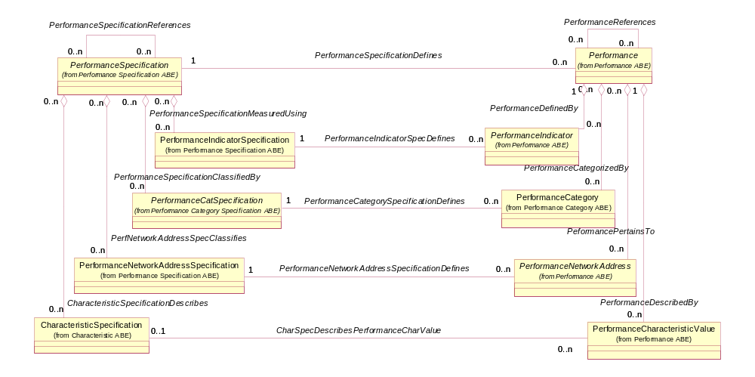

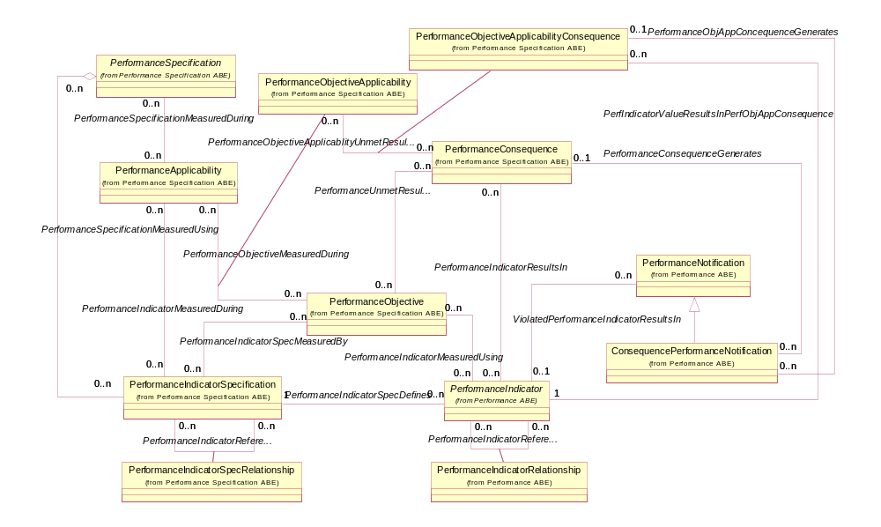

TM Forum Interfaces

Resource and Service Assurance

Resource-Level Performance Management
The figures below depict key Performance Management entities from TMF608, the UML model used to develop current mTOP APIs.

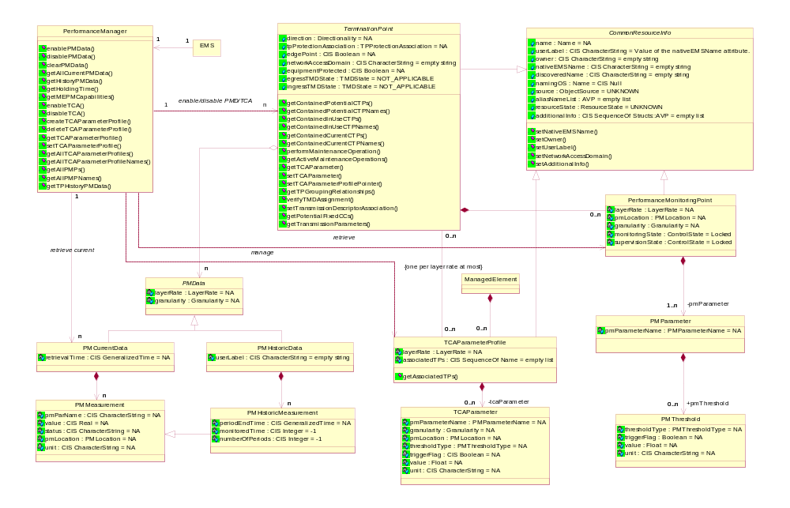

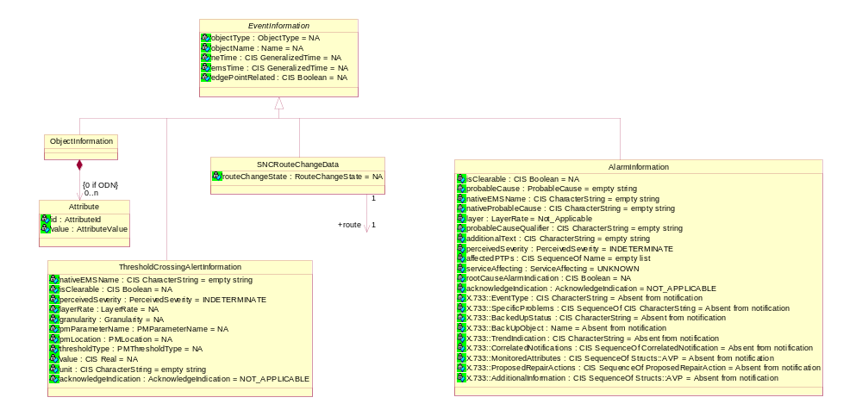

Alignment Opportunities
A number of alignment opportunities and their possible resolution are included in this section.
Opportunity 1: The SID Performance model only accommodates three thresholds that are contained within the PerformanceObjective entity, while the TMF608 PM model is not constrained to three thresholds.
Resolution 1: Create a separate entity within the SID Performance model that allows for any number of thresholds to be defined.
Opportunity 2: The entity PMData in TMF608 is only associated to TerminationPoint.
Resolution 2: Allow the PMData entity to be related to any type of Resource, or any type of Product, Service, or Resource.
Opportunity 3: Reconciling names used for common concepts.
Resolution 3: Choose appropriate names using existing entity names or new names. Existing names and sample mapping between the two models is shown in the table below.
Note: Not all potential mappings are shown in the table.
TMF608 Entity Name | SID Entity Name
PMParameter | PerformanceIndicatorSpecification
PMThreshold | PerformanceObjective
TCAParameterProfile and TCAParameter | PerformanceSpecification
PMMeasurement | PerformacneIndicator
ThresholdCrosssingAlertInformation | ConsequencePerformanceNotificationSpec, ConsequencePerformanceNotification
PerformanceMonitoringPoint - A PMP represents an access point identified by the triple of layer rate, PM location and granularity at which performance monitoring and threshold supervision are provided for a set of PM parameters. It is contained in a Termination Point. The set of Performance Monitoring Points contained in a Termination Point constitute the PM capabilities of the Termination Point. | Resource (closest match in the SID)

Opportunity 4: Employ SID modeling patterns within the TMF608 PM model.
Resolution 4: Introduce SID patterns used in the SID Performance and other areas into the TMF608 PM model.

Service-Level Performance Management
The figure below depicts key Service Level Specification entities from the SID model and the use of the UML model used to develop current OSS/J SQM API. The figure shows the similarity with the SID Performance model. An example of the generated SQM XML schema is included.
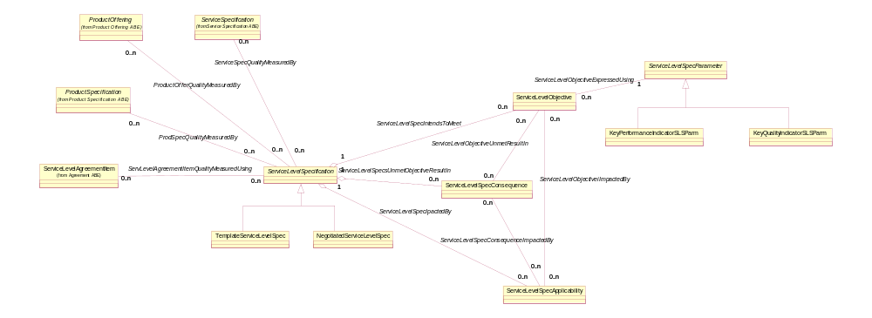

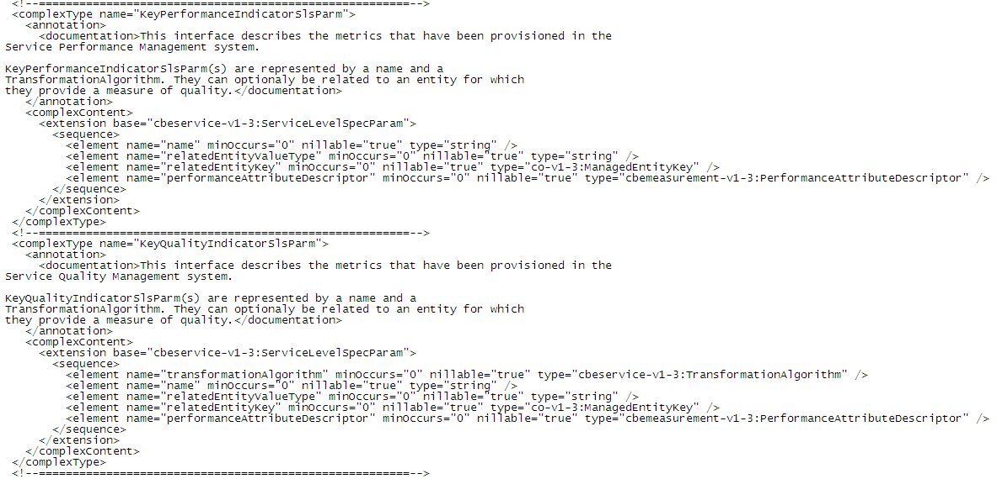

Alignment Opportunities
An alignment opportunity and its possible resolution is included in this section. The Service Level Specification figure included above shows the similarity to the models developed to support Performance and Service Level Specifications.
Opportunity 1: Use a consistent model for modeling Service Level Specifications and Performance.
Resolution 1: Align the models to use a consistent modeling approach or use the generalized Performance model. This may result in changes to the SID Performance model. This would result in a change to the SQM API to employ the generalized Performance model and a change to the Performance model to accommodate the two subclasses of ServiceLevelParameters.
Opportunity 2: Attach the ServiceLevelSpecification entity to the generalized PerformanceSpecification entity in the Performance model.
Resolution 2: This would result in a change to the SQM API to employ the generalized Performance model and a change to the Performance ABE to accommodate the two subclasses of ServiceLevelParameters.

Revenue Assurance Alignment
An opportunity for internal SID alignment and its possible resolution is included in this section. The Revenue Assurance figures included here show the similarity to the models developed to support Performance and Service Level Specifications.

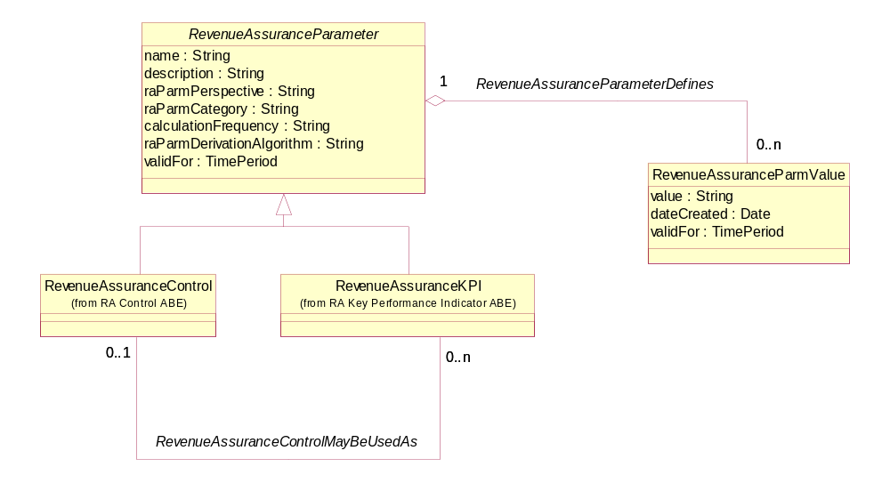

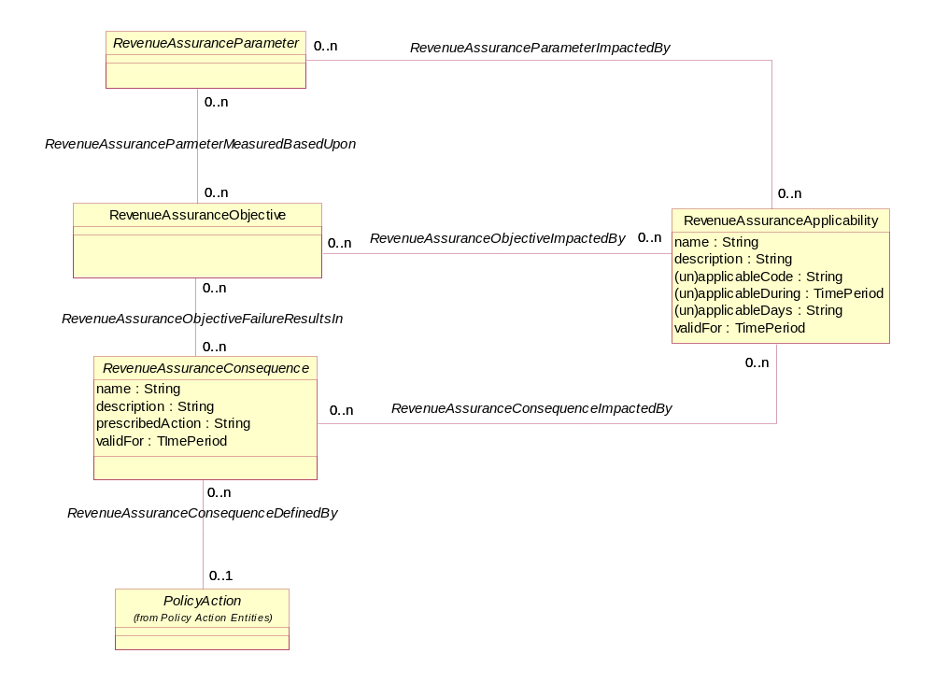

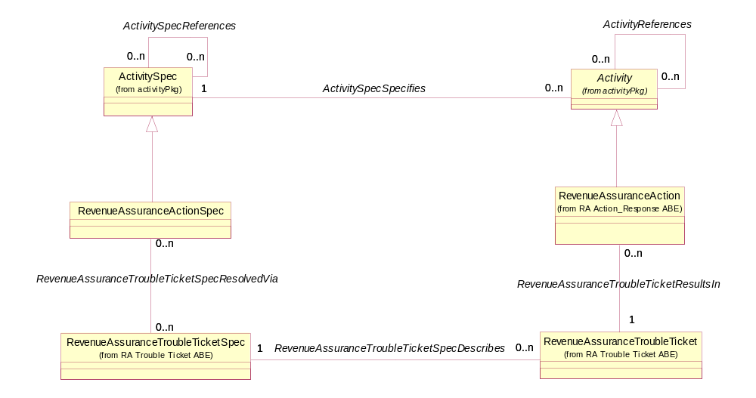
Opportunity 1: Use a consistent model for modeling Revenue Assurance and Performance.
Resolution 1: Align the models to use a consistent modeling approach or use the generalized Performance model. This may result in changes to the SID Performance model. This may result in a change the Performance model to accommodate requirements specific to Revenue Assurance as well as changes to the Revenue Assurance model.
Opportunity 2: Attach appropriate points in the Revenue Assurance model to the generalized PerformanceSpecification entities in the Performance model.
Resolution 2: This may result in changes to both models.

SID Alignment
An opportunity for internal SID alignment and its possible resolution is included in this section.
Opportunity 1: As the SID has been developed different areas, such as Revenue Assurance, Service Level Specifications, and Performance have modeled performance related entities in a number of ways. Each round of modeling has introduced “lessons learned” from prior modeling efforts.
Resolution 1: Either consistently model performance related entities or develop a set of generalized performance entities that can be reused within each area.

Business Process Framework (eTOM) Alignment
An opportunity for alignment between eTOM terminology and SID entity names is included in this section.
Opportunity 1: Align eTOM Service related and Resource related process terminology with the SID.
Resolution 1: Conduct a study to determine and then enact alignment between the two Frameworks.
Opportunity 2: A similar alignment opportunity exists within the eTOM Revenue Assurance processes that would be based on changes to the Revenue Assurance model. Note: The eTOM Revenue Assurance processes and the SID entity names are currently aligned.
Resolution 2: Conduct a study similar to Resolution 1 above.

Administrative Appendix
This Appendix provides additional background material about this document.

Document Life Cycle
The Performance Business Entities is being issued as member contribution version 1.1
This document will continue under formal change control. Supporting work will be issued as companions to this document. A document of this type is a “living document,” capturing and communicating current knowledge and practices.

Document History
Version Number | Date Modified | Modified by: | Description of changes
1.1 | 01/07/2008 | John Reilly | first issue of TM Forum contribution
1.2 | 22 Jul 2008 | Tina O’Sullivan | Minor corrections.
1.3 | 27 May 2009 | Alicja Kawecki | Minor updates to reflect TM Form Approved status
1.4 | 28 Dec 2010 | John Reilly | Update Notice
1.5 | 22 March 2011 | Alicja Kawecki | Minor formatting corrections prior to web posting and ME
1.6 | 23 Sep 2011 | Alicja Kawecki | Updated to reflect TM Forum Approved status
1.7 | 24 Jan 2012 | Yuval Stein | Changes to meet PM interface requirements
1.8 | 26 Sep 2012 | Alicja Kawecki | Corrected notice, minor cosmetic corrections prior to posting
1.9 | 25 October 2012 | Alicja Kawecki | Updated to reflect TM Forum Approved status of R12.0
1.10 | 26 October 2012 | Alicja Kawecki | Corrected Notice, minor style/cosmetic corrections prior to web posting and Member Evaluation for 12.5

Release Number | Date Modified | Modified by: | Description of changes
8.0 | 01/07/2008 | John Reilly | first issue of TM Forum contribution
9.5 | 12/28/2010 | John Reilly | Update Notice
12.0 | 1/24/2012 | Yuval Stein | Update Notice
12.5 | 9/26/2012 | Yuval Stein | Update Notice

Company Contact Details
Company | Team Member Representative
Amdocs | Name: Josh Salomon  Title: Senior Billing architect,  Email: joshs@amdocs.com  Phone: +972 9 7764422  Fax
Progress Software | Name: John Wilmes  Title: Chief Technical Architect  Email: jwilmes@progress.com  Phone: +1 650 302 5198  Fax

Acknowledgments
This document was prepared by the members of the TM Forum SID team.

