Information Framework (SID)
LogicalResource and CompoundResource Business Entity Definitions

GB922 Addendum 5LR
TM Forum Approved Version 9.10


October, 2012

Notice
This material, including documents, code and models, has been through review cycles; however, due to the inherent complexity in the design and implementation of software and systems, no liability is accepted for any errors or omissions or for consequences of any use made of this material.
Under no circumstances will the TM Forum be liable for direct or indirect damages or any costs or losses resulting from the use of this specification. The risk of designing and implementing products in accordance with this specification is borne solely by the user of this specification.
This material bears the copyright of TM Forum and its use by members and non-members of TM Forum is governed by all of the terms and conditions of the Intellectual Property Rights Policy of the TM Forum (http://www.tmforum.org/Bylaws/1094/home.html) and may involve a claim of patent rights by one or more TM Forum members or by non-members of TM Forum.

Direct inquiries to the TM Forum office:
240 Headquarters Plaza,
East Tower – 10th Floor,
Morristown, NJ 07960 USA
Tel No. +1 973 944 5100
Fax No. +1 973 944 5110
TM Forum Web Page: www.tmforum.org

Table of Contents
Notice 2
Table of Contents 3
Table of Figures 5
1. Business Entities 7
1.1 LogicalResource Framework 7
Notes 7
Introduction 7
Overview of “Resource” 14
Use Cases 15
Scope 15
A Starting Point – What IS a Resource? 16
Supporting a Link to Products 19
LogicalResource in More Detail 24
ResourceSpecifications 29
Atomic and Composite ResourceSpecifications 32
ResourceSpecVersion 34
ResourceSpecificationTypes 36
LogicalResourceRoles 37
ResourceCharacteristics and ResourceSpecCharacteristics 42
ResourceCharacteristicValues and ResourceSpecCharacteristicValues 45
Example Use of Resource Spec Characteristic 47
1.2 LogicalResource Detail Classes 51
Introduction 51
Software 52
OperatingSystem 55
DeviceInterface 59
Protocol 66
CompoundResource, ResourceCollection, and ResourceElement 70
TIP ABE 75
Integrating the SID and MTNM/MTOSI Models 87
ManagedTransmissionEntities 89
Network 93
Network Subclasses and a Refined Network Model 96
Roles in More Detail 103
Gathering Management Information 111
1.3 Interaction with Other SID Business Entities 115
Introduction 115
Policy 115
BusinessInteraction 115
PartyRole 116
Product 117
Service 120
Place 120
1.4 References 121
1.5 Business Entity Data Dictionary Definitions 122
1.6 Classes that are part of the LogicalResourceABE 123
1.7 Classes that are part of the Resource Domain, not part of the Logicalresource ABE 266
1.8 Additional classes added for MTOSI harmonization 303
2. Administrative Appendix 348
3.1 About this document 348
3.2 Document History 348
3.2.1. Version History 348
3.2.2. Release History 349
3.3 Company Contact Details 349
3.4 Acknowledgments 350

Table of Figures
Figure LR.01 - Level One of the Resource Domain 9
Figure LR.02 - Relevant Parts of Levels 2 and 3 of the Resource Domain 12
Figure LR.03 - Overview of the Resource Framework 13
Figure LR.04 - Resource specialization and inheritance 17
Figure LR.05 - Relationship between Resource and Product 19
Figure LR.06 - Concept of CustomerFacingServices vs. ResourceFacingServices 20
Figure LR.07 - Relationship between Product, Service and Resource 21
Figure LR.08 - Principal Subclasses of LogicalResource 25
Figure LR.09 - LogicalDevice in More Detail 27
Figure LR.10 - Resources and ResourceSpecifications 29
Figure LR.11 - Concept of Atomic and Composite ResourceSpecifications 32
Figure LR.12 - Concept of ResourceSpecVersions 34
Figure LR.13 - Concept of ResourceSpecificationTypes 36
Figure LR.14 - A Simple (but Bad) Approach to Modeling Types of Devices 37
Figure LR.15 - Using Roles to Represent Device Functionality 38
Figure LR.16 - LogicalResourceRole – A Starting Point 39
Figure LR.17 - Managing ResourceRoles Using PartyRoles 40
Figure LR.18 - ResourceCharacteristics and ResourceSpecCharacteristics 43
Figure LR.19 - ResourceCharacteristicValues and ResourceSpecCharacteristicValues 46
Figure LR.20 - Inheritance Diagram for Entities in Example 48
Figure LR.21 - TerminationPoint Profiles example (I) 49
Figure LR.22 - TerminationPoint Profile example (II) 50
Figure LR.23 - Relationship between LogicalDevice and Software 52
Figure LR.24 - VendorNetworkOS and SoftwareCommand Classes 54
Figure LR.25 - High-Level View of an OperatingSystem 57
Figure LR.26 - How DeviceInterfaces Interact With Other LogicalResource Entities 60
Figure LR.27 - Some Subclasses of DeviceInterface 62
Figure LR.28 - Relationship between DeviceInterface and ResourceFacingService 64
Figure LR.29 - Overview of the Top-Level Protocol Classes 66
Figure LR.30 - Protocol Interactions 69
Figure LR.31 - CompoundResource, ResourceCollection, and ResourceElement 71
Figure LR.32 - Example Instance Implementation of a CompoundResource 74
Figure LR.33 - MTOSI/MTNM Inheritance Class Diagram 76
Figure LR.34 - MTOSI/MTNM Inheritance Class Diagram with Attributes 77
Figure LR.35 - MTOSI/MTNM Containment 79
Figure LR.36 - MTOSI/MTNM Termination Point Model 81
Figure LR.37 - MTOSI/MTNM AlarmSeverityAssignmentProfile 82
Figure LR.38 - MTOSI/MTNM Connection-oriented Class Diagram 83
Figure LR.39 - MTOSI/MTNM Connectionless Class Diagram 85
Figure LR.40 - MTOSI/MTNM Transmission Parameters, Profiles and Descriptors 86
Figure LR.41 - Classes related to the PTP 88
Figure LR.42 - Top-Level ManagedTransmissionEntity Class Hierarchy 90
Figure LR.43 - TerminationPoint in context 92
Figure LR.44 - Defining the High-Level Concept of a Network 93
Figure LR.45 - ResourcePort Details 97
Figure LR.46 - Definition Using the Composite Pattern 98
Figure LR.47 - Additional Subclasses of the Network Class 100
Figure LR.48 - Policy Management of Network Entities 101
Figure LR.49 - A Simple 2547bis MPLS VPN 103
Figure LR.50 - Different Types of ResourceRoles 105
Figure LR.51 - Different Types of LogicalResourceRoles 107
Figure LR.52 - Extending Specifications to Include CompoundResources 109
Figure LR.53 - Extending Roles to Include CompoundResourceRoles 110
Figure LR.54 - Concepts of ManagementInfo and ManagementMethodEntity 111
Figure LR.55 - Interaction between PartyRole and LogicalResource 116
Figure LR.56 - Interaction between ProductSpecification and ResourceSpecification 119
Figure LR.57 - Interaction between LogicalResource and Place 120

Business Entities

LogicalResource Framework

Notes
Please note that in all cases, the SID UML model is the authoritative version for all model element (e.g., class, attribute, etc.) definitions for all SID views. In this document, a number of different classes will be mentioned that are documented in detail in other addendums. Such classes are shown in this Addendum in order to provide a better understanding for readers.
The SID UML model is an evolving model. Some elements of the model are recognized to be likely to change. Stereotypes are being added to the model to help identify these elements. At the time of release of this document this work has not been completed for the entire SID. Areas highlighted for change in the UML model (using stereotypes from the Lifecycle Profile such as <<likelyToChange>>) are also highlighted in the text of this document and should be treated with caution by the user. It should also be noted that as this is work in progress in some areas of the SID there are alternative approaches to solving the same problem. At this point where there are alternative approaches there is not particular preference as to which should be used.
MTNM/MTOSI additions include a number of classes and attributes marked not to be implemented. These attributes/classes will be addressed in a subsequent release.

Introduction
This part of this Addendum will discuss the LogicalResource Framework. It should be read in conjunction with Addendum 5PR which is devoted to modeling the physical aspects of a Resource. In conjunction the two addendums provide definitions for Resource in general and describe the Resource model in detail. (See Overview of “Resource” on page 14).
It should be noted that the approach of separation of Logical Resource considerations, i.e. the functionality, from the Physical Resource considerations emerged in the context of telecommunication equipments and network some while ago. It has proven to be a major advancement in the management of such equipments clarifying the problem and bringing coherence and consistency to the model and hence simplifying the model. It enables the consistent representation of functionality independent of the form of assembly of piece parts that provides the functionality. Hence the Logical Resource model is generally applicable regardless of the physical assembly. The same essential separation of concerns and consideration of viewpoint is applied throughout the SID. Under some circumstances it is necessary to view Resources as assemblies of both Physical and Logical elements. This will be discussed in the section CompoundResource, ResourceCollection, and ResourceElement.
The LogicalResource Framework provides specialized models for management of communications networks and for management of more general processing functions. The models representing communications network functionality are applicable to any telecommunications problem were signals are being generated, transmitted, received and processed.
The LogicalResource Framework has been extended in this release to include the MTNM/MTOSI model covering communications network functions and to provide guidance on how to use this model and appropriate linkages to support its use. The model should be read in conjunction with the formal MTNM and/or MTOSI documentation. The LogicalResource Framework is an extensible set of classes and relationships that enable new lower-level LogicalResource concepts to be plugged into it. Where the SID is being used in conjunction with the MTOSI/MTNM interfaces specific rules provided in the MTNM/MTOSI solution set must be adhered to when considering extension. For example extension of existing MTNM/MTOSI classes by specialization/inheritance is not allowed, however extension by addition of attributes is allowed. The mechanism for extension depends upon the type of extension considered. This is covered by the MTNM/MTOSI documentation. As the model evolves in future release the reflection of the extension rules in the UML model will be enhanced.
The eTOM defines functional processes to plan, control and manage, the network including mechanisms to measure performance, notify alarms / events and cater for routine administration. It is recommended that the reader also refer to the [eTOM] for an explanation of the various business processes that are defined to support the concepts in the Resource domain and other domains
The Logical Resource model relates to entities in many other domains. For example the model is related to the business entities in the Product domain represent what is offered to the market. This domain deals with such things as the development, promotion, pricing, and retirement of product offerings, as well as instances of offerings procured by customers and others. A Resource is part of an enterprise’s infrastructure utilized directly or indirectly by a Service or a good procured by the market in the form of a Product. Business entities in the Resource domain represent (among other concepts) how products offered to the market are implemented. Resources are used to support Services offered by the Product, both physically as well as logically. For example, a VPN needs a physical port to communicate on as well as one or more particular protocols. The port is a physical entity – one can see it, touch it, and hold it. In contrast, protocols are logical entities – one cannot see a packet being communicated between two entities! However, both of these are needed in order to configure the VPN.
This relationship between PhysicalResource and LogicalResource leads to the creation of a third form of resource, one that contains both physical and logical elements. There are several ways to handle this need, based on the particular semantics desired. This will be discussed in the section CompoundResource, ResourceCollection, and ResourceElement.
The SID uses the SID Framework, as defined in [GB922], to link the eTOM to the SID.
Level 1 of the Resource Domain of the SID Framework is shown in Figure LR.01 below. Please note that this is subject to change over time.
Figure LR.01 - Level One of the Resource Domain
The Resource Domain consists of a structured set of ABEs that are used to manage the definition, development, and operational aspects of the information computing and processing infrastructure of a system. It supports the eTOM processes that deal with the definition, development and management of the infrastructure of an enterprise. This includes the components of the infrastructure as well as Products and Services that use this infrastructure.
The Resource Domain has three important objectives.
- To associate Resources to Products and Services, and provide a detailed enough set of Resource entities (organized as ABEs) to facilitate this association.
- To ensure that Resources can support and deliver Services offered by the enterprise. Management of resources involves planning, configuration, and monitoring to capture performance, usage, and security information. This also includes the ability to reconfigure Resources in order to fine tune performance, respond to faults, and correct operational deficiencies in the infrastructure. Resources also provide usage information which is subsequently aggregated to the customer level for billing purposes.
- To enable strategy and planning processes to be defined. Entities in the Resource domain may be associated with processes that involve planning new and/or enhanced Services, or even the retirement of Services, offered by the Enterprise.
The following are brief descriptions of each of these ABEs.
The Resource ABE contains entities that are used to represent the various aspects of a Resource. This includes four sets of entities that represent: the physical and logical aspects of a Resource; show how to aggregate such resources into aggregate entities that have physical and logical characteristics and behavior; and show how to represent networks, sub-networks, network components, and other related aspects of a network.
The Resource Specification ABE contains entities that define the invariant characteristics and behavior of each type of Resource entities. This enables multiple instances to be derived from a single specification entity. In this derivation, each instance will use the invariant characteristics and behavior defined in its associated template.Resource Strategy & Plan
The Resource Management ABE contains entities that define how physical, logical, and compound resources are administered and managed. This includes delegation of management responsibility to human and non-human (e.g., application) entities, as well as the definition and usage of policies to control management functions.
The Resource Configuration ABE contains entities that are used to represent and manage configurations of PhysicalResource, LogicalResource, and CompoundResource entities. It should be noted that configurations themselves are managed entities. This set of entities also provides details on how the configuration of each of these types of resources is changed in order to meet product, service, and resource requirements, including activation, deactivation, and testing. Areas covered include verifying resource availability, reservation and allocation of resource instances, configuring and activating physical and logical resource instances, testing and updating of the resource inventory database.
The Resource Performance ABE collects, correlates, consolidates, and validates various performance statistics and other operational characteristics of Resource entities. It provides a set of entities that can monitor and report on performance. The entities in this ABE provide physical, logical, and performance information. Each of these entities also conducts network performance assessment against planned goals, performs various aspects of trend analysis, including error rate and cause analysis and Resource degradation. Entities in this ABE also manage traffic in a Resource. This includes statistics defining Resource loading, and traffic trend analysis.
The Resource Usage ABE collects Resource consumption data, and generates Resource usage records, for use by other business entities. The entities in this ABE provide physical, logical, and network usage information.
The Resource Strategy and Plan ABE is used to plan networks and resource elements both initially and for growth. It will coordinate both logical and physical resource growth. Inputs are budgets from business sources, service forecasts, current and projected network utilization, new technologies, and retiring technologies. It handles the lifecycle (installation, modification, removal, and retirement) for both logical and physical resources.
The Resource Trouble ABE manages problems found in allocated resource instances, regardless of whether the problem is physical or logical. Entities in this ABE detect these problems, act to determine their root cause, resolve these problems and maintain a history of the activities involved in diagnosing and solving the problem. Detecting problems can be done via software (e.g. responding to an alarm) and/or by hardware (e.g. a measurement or probe) and/or manually (e.g. visual inspection). This includes tracking, reporting, assigning people to fix the problem, testing and verification, and overall administration of repair activities.
The Resource Test ABE contains entities that are used to test PhysicalResources, LogicalResources, CompoundResources, and Networks. These entities are usually invoked during installation, as a part of trouble diagnosis, or after trouble repair has been completed.
The focus of this Addendum is on those ABEs that are logical in nature. This version of this Addendum will concentrate on two of these Level One ABEs, the Resource ABE and the Resource Specification ABE. Figure LR.02 - below shows the eight applicable Level Three ABEs that are covered in this Addendum.
Figure LR.02 - Relevant Parts of Levels 2 and 3 of the Resource Domain
In addition to the Framework ABEs there are also two new ABEs TIP Resource ABE and TIP Logical Resource ABE (in the Logical Resource ABE) which will be covered in this addendum. The TIP Logical Resource ABE contains entities that are used for the MTNM/MTOSI interface. This ABE provides a view of Logical Resources that is appropriate for communication over an OS-OS interface. Some of the entities identified are closely related to other entities in other ABEs within Logical Resource. The TIP Resource ABE includes some classes that terminate associations to TIP classes that have not yet been imported into the SID. The classes in the TIP Resource ABE are temporary for this release. The model will be rationalized in following releases. The classes that are expected to change as a result of this rationalization are marked in the model with the Lifecycle stereotype <<likelyToChange>>.
The model has been developed to support inventory and capacity management functions, as well planning equipment installation and maintenance. There are ties to related processes and activities, such as FAB (as defined in the eTOM), as well as relation to other major SID entities (e.g., Product, Party, and Services)..
This model represents logical resource entities from a business operations perspective and uses best practice patterns for this area to build in extensibility.
Three important examples of patterns that will be developed in this document are:
- Composite pattern, which provides a common structure for stand-alone and aggregate objects of a given type
- Entity-EntitySpecification pattern, which separates the invariant characteristics and behavior of an object from its changeable characteristics and behavior
- Role Object pattern, which uses the notion of roles to extend the use and application of an object
This Addendum provides a view of the logical resource portion of the information model, which includes mined information from other information models. The SID draws from the work of ITU-T, IETF and DMTF. In this release, the MTNM/MTOSI model has been incorporated in the SID..
This model is built with the express purpose of serving as a foundation for other LogicalResource (sub-) models to fit into. The model provides a framework upon which solutions for various network technologies and protocols can be built. This is shown in Figure LR.03 - below.
Core Framework
Resource Framework
PhysicalResource Domain
LogicalResource Domain
Resource Operations Domain
Resource
Management Domain
Figure LR.03 - Overview of the Resource Framework

Overview of “Resource”
This section provides an overview of the Resource model focusing on Logical Resource. The approach taken in this document is to build up pieces of the model gradually due to the complexity of the model. The final section of this document contains a detailed data dictionary that defines the classes, attributes, relationships (e.g., associations, aggregations and compositions) presented in this model and highlights their derivation. Note also that the final section has a special “synonyms / aliases” section to provide easy correlation to these external documents..
Consistent terminology in a federated model is critical. This terminology, as the model itself, will be introduced in stages. This enables more complex ideas to build on simpler concepts, thereby enabling both an easier as well as a more thorough understanding of the Resource domain as well as its relationship to entities in other domains as defined by the SID Framework [GB922].
The eTOM [eTOM] refers to the term “Resource” in different ways, depending on what level of the eTOM is being used. Specifically:
Level 0 defines the concept of a “Resource” as “processes include those dealing with development and management of the enterprise's infrastructure, whether related to products and services, or to supporting the enterprise itself”, but doesn’t explain these processes in detail.
Level 1 defines two different uses of Resource:
- Resource Management & Operations (RM&O): this process grouping maintains knowledge of resources and is responsible for managing resources for delivering and supporting services required by or proposed to customers. RM&O also has the basic function to assemble information about the resources, and then integrate, correlate, and in many cases, summarize that data to pass on the relevant information to Service Management systems, or to take action in the appropriate resource.
- Resource Development & Management: this process grouping focuses on planning, developing and delivering the resources needed to support services and products to the Operations domain. It includes functionalities necessary for defining the strategies for development of the network and other physical and non-physical resources, introduction of new technologies and interworking with existing ones, managing and assessing the performance of existing resources and ensuring that capabilities are in place to meet future service needs.

Level 2 defines additional detail for both of the Level 1 process groupings. However, the main focus of this Addendum is related to the Resource Provisioning and Service Configuration and Activation process. These processes encompass the configuration of resources, and logical resource provisioning for individual customer instances. This involves updating of the Resource Inventory Database to reflect the resource being used for a specific customer.

It should be noted that the eTOM describes many different types of Resources. The SID will be expanded over time to cover all types of resource referenced in the eTOM..
The Resource Domain has been constructed such that Resources are offered as Products or ProductComponents ([Add 3]). Note that the Service Domain has been similarly constructed ([Add 4SO]). This enables a strong relationship to be defined between Resource and Service entities.

Use Cases
There are two primary use cases that drove the design of this model. The first is the ability to create and maintain an Inventory of Logical entities, capabilities and functions. The second is to support Service creation and activation, as referenced in the above level 2 processes and defined in the eTOM. An important use case that is derived from the second is to support the modeling of the logical configuration of the functions of a device. This, of course, is how Resource entities support different types of Service entities. Another very important related use case is to set the groundwork for defining how devices can be configured in a standard way to support service creation, activation, measurement, and other processes defined by the eTOM. An important “sub use case” is the representation and management of resource configuration.
There are countless examples of dependent use cases that come into play when considering the above use case. For example, one important use case is to be able to understand how different Resources present in a system support each other. Another example is to relate the physical infrastructure and topology to the logical functions and topology of the system.

Scope
This Addendum will focus on constructing a framework for defining Resources. Specifically, the set of classes defined in this Addendum will provide a foundation for a number of important activities:
- to define Resources, ResourceSpecifications, ResourceRoles, and ResourceCharacteristics that can interact with other SID entities defined in other Addenda of GB922
- to define a framework which supports Products and Services
- to define a framework in which Resource configuration can be modeled in detail

A Starting Point – What IS a Resource?
Resources are physical or non-physical components (or some combination of these) within an enterprise's infrastructure or inventory. They are typically consumed or used by Services (for example a physical port assigned to a service) or contribute to the realization of a Product (for example, a SIM card). They can be drawn from the Application, Computing and Network domains, and include, for example, Network Elements, software, IT systems, content and information, and technology components.
One of the principal mechanisms of object-oriented analysis and design is the principle of abstraction. Network entities, like a Router, are very complex. Abstraction lets us focus on one or more aspects of a complex entity and (temporarily) ignore its other aspects. This enables us to divide a single complex entity into multiple simpler entities. In this case, we can clearly divide the Router into its physical and logical aspects. The separation is simple to determine: if you can touch the entity, then it is a physical entity; if not, it is a logical entity. Thus, the chassis, cards, and cables of a Router (among other things) are all physical entities, whereas the services and protocols that a router is running, or the number of processes that it has defined, are logical entities.
A simple starting pattern for Resources is shown in Figure LR.04 - below:
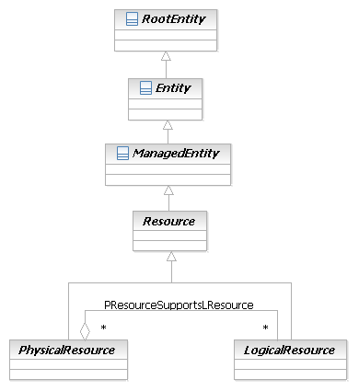
Figure LR.04 - Resource specialization and inheritance
This enables the concept of a Resource to be partitioned into its physical and logical aspects. This has a number of benefits:
- There are various different viewpoints taken in the operations process and this split reflects some of those critical viewpoints
  - The physical model view deal with such considerations as the shipping of cards and spares holdings. A physical resource may have many functional viewpoints but at many stages of the lifecycle the functions are not be relevant.
  - The logical model view (functional model) deals with the operations purpose in a consistent fashion regardless of the physical construction. A logical function may have many potential implementations but the specific implementation may not have yet been chosen (e.g. during the planning phase).
- By concentrating only on logical aspects, we are better able to produce models that can be applied to non-networking domains of interest.
  - Policy can be applied to govern physical, logical, or both aspects of the resource operation and functionality
  - PartyRoles can be defined to better link business and system goals with the implementation
- Through continued abstraction, we can apply this principle to enable (for example)
  - Software people to work on the software portion of the logical resource model
  - Network people to work on the networking portion of the logical resource model
  - Protocol people to work on the protocol portion of the logical resource model
  - And so forth
- The portioning of the model better enables different people to work on different parts in parallel
This basic model will be refined over the course of this Addendum. It should be noted that the PResourceSupportsLResource relationship should not be implemented for the MTNM/MTOSI interface model. The MTNM/MTOSI implementation form will be covered later in this Addendum.

Supporting a Link to Products
Before we develop too much of the LogicalResource structure, let’s link this concept to two other important SID entities: Product and Service. This linking must support the following two basic premises:
- A PhysicalResource may be a part of a Product, that is bought by a Customer
- A Resource can support one or more Services
The first relationship is modeled as shown in Figure LR.05 - below:
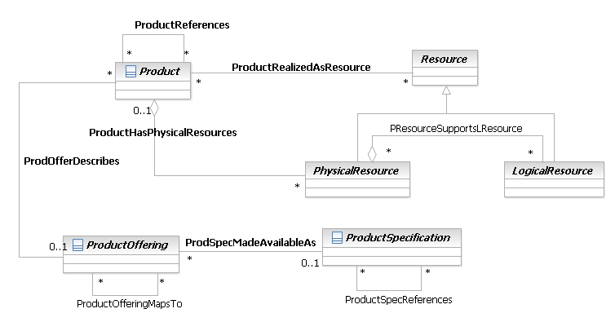
Figure LR.05 - Relationship between Resource and Product
The cardinality of the ProductHasPhysicalResources relationship is 0..1 on the Product side and 0..n on the PhysicalResource side. This means that PhysicalResources can be instantiated independent of a Product, but may also be bound to a Product. It also means that a Product can have zero or more PhysicalResources. ([Add 4SO] also explains how a Product may be realized as a Service.)
The reason that PhysicalResources are associated to Products is that the definition and use of a Product is essential to the business view of the overall SID model. Customers buy Products, not Resources. Similarly, Enterprise users utilize Products that contain Resources (here, the Enterprise has purchased or manufactured the Product). Both types of users use Services that are supported by Resources. This implies that Resources can’t exist “in the ether” – rather, they must be bound to a particular Product.
More specifically, a PhysicalResource is an instance of a Resource, just like a Product represents the instance of a Product that a PartyRole (such as a Customer) can buy. Consider two PhysicalResources – one is part of a Product that will be shipped to a Customer, and the second is a spare. BOTH of these are indeed PhysicalResources. The difference is that a PhysicalResource can be associated with a Product (the “1” in the “0..1” part of the ProductHasPhysicalResources aggregation) or not (the “0” in the “0..1” part of this same aggregation). Thus, we can distinguish between the PhysicalResource that is a spare and the PhysicalResource that is part of a Product, because the former will not have an association to any Product, and the latter will.
To understand the relationship between Service and Resource, we must first understand the relationship between Service and Product, since it is Product that contains both Service and Resource. Addendum 4SO describes the Service Framework Overview, in which a Service is represented as follows in Figure LR.06 - .
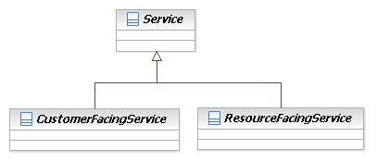
Figure LR.06 - Concept of CustomerFacingServices vs. ResourceFacingServices

For more information about Services, please see [Add 4SO] for an overview and [Add 4SQoS] for detailed examples of how Quality of Service is represented.
This leads to an important conclusion: a ProductComponent is directly related to a CustomerFacingService, since the CustomerFacingService is directly visible as a part of the Product. However, a ResourceFacingService is hidden from the Product, since it represents the logic that implements the CustomerFacingService. This understanding now enables us to connect ResourceFacingService to PhysicalResource and LogicalResource, as shown in Figure LR.07 - below, and are called PhysicalResourcesHostRFS and LogicalResourcesImplementRFS, respectively.
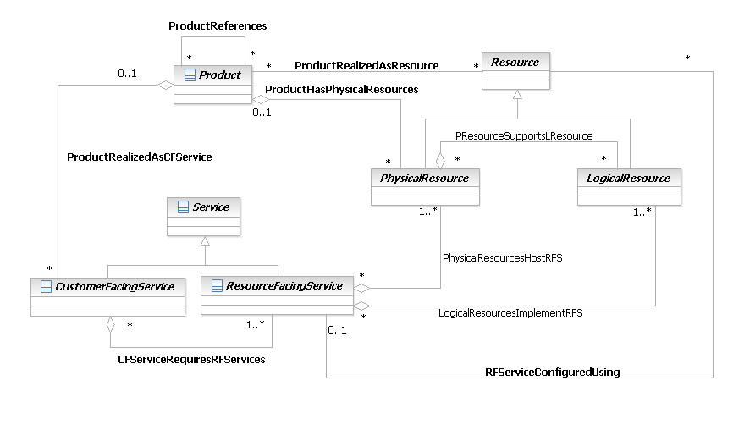
Figure LR.07 - Relationship between Product, Service and Resource
The model in Figure LR.07 - shows that a CustomerFacingService can aggregate multiple ResourceFacingServices. Each ResourceFacingService can aggregate a set of LogicalResources as well as a set of PhysicalResources. This follows our original logic, in that a Product defines a set of CustomerFacingServices, and each CustomerFacingService requires a set of ResourceFacingServices to support it. Note that the cardinality of the CFServiceRequiresRFServices is 0..n on the CustomerFacingService (aggregate) side and 1..n on the ResourceFacingService (component) side. This is because a ResourceFacingService can exist without being bound into a CustomerFacingService (e.g., in testing the network), but a CustomerFacingService requires at least one ResourceFacingService to function.
The ResourceFacingServices are hosted by one or more PhysicalResources (via the PhysicalResourcesHostRFS aggregation) and are implemented by one or more LogicalResources (via the LogicalResourcesImplementRFS aggregation). The cardinality of the LogicalResourcesImplementRFS and PhysicalResourcesHostRFS aggregations are both 0..n on the aggregate side, because PhysicalResources can be installed which use LogicalResources before a ResourceFacingService is actually implemented. Furthermore, a ResourceFacingService can have zero or more PhysicalResources and LogicalResources for it to be instantiated. Hence, both of the aggregations have a 1..n cardinality on their component ends. Note that the PhysicalResourcesHostRFS aggregation has different semantics than the LogicalResourcesImplementRFS aggregation. The former describes a hosting relationship, which is essentially passive in nature – the PhysicalResource exists so that the LogicalResource can be hosted on it. The LogicalResourcesImplementRFS aggregation is active in nature – it signifies an active whole-part relationship between a set of LogicalResources and a ResourceFacingService. Put another way, this latter aggregation is used to identify the LogicalResources that are used so that a ResourceFacingService can function.
Since a PhysicalResource aggregates LogicalResources (via the PResourceSupportsLResource aggregation), we can identify the specific PhysicalResource(s) that are required to support a particular LogicalResource.
Hence, the definition of a Product drives the definition of its (customer-facing) Services. The definition of a (customer-facing) Service requires a set of sub-services (implemented as ResourceFacingServices), each of which can be linked to PhysicalResources as well as LogicalResources. Thus, we have adhered to the intention for Resources to be both customer- and product-focused.
Here is an example to illustrate these relationships, based on Figure LR.07 - . Consider a Customer (a type of PartyRole) that wants to buy broadband Internet service from a Service Provider. The Customer needs to buy a new cable modem to connect to the Service Provider. In this example:
- The Cable Modem is a Product that the Customer buys; the Cable Modem is also a PhysicalResource. This is represented by the ProductHasPhysicalResources aggregation.
- Broadband Internet is a Product that the Customer buys; Broadband Internet is also a CustomerFacingService. This is represented by the ProductRealizedAsCFS aggregation.
- Both of these could be sold as separate Products or a parts of a larger Product. This is modeled in the Product Addendum.
- Note that the Boradband Internet Service depends on the Cable Modem. If the Cable Modem was not present, then the Broadband Internet Service could not be accessed. This is represented by the following set of relationships:
  - The Broadband Internet CustomerFacingService requires a set of ResourceFacingServices to connect to the Cable Modem. These could include, for example, one or more functions performed by one or more Protocols. These are represented by the CFServiceRequiresRFServices aggregation.
  - Each ResourceFacingService needs to connect to the Cable Modem. The physical connection will terminate on a physical port of the Cable Modem – this is represented by the PhysicalResourceHostsRFS aggregation.
  - The PhysicalPort of the Cable Modem hosts logical functions (e.g., a DeviceInterface). This is represented by the PResourceSupportsLResource aggregation.
  - Similarly, the Cable Modem functions are configured to work with the Broadband Internet CustomerFacingService. Different LogicalResources (e.g., Protocol, LogicalDevice, DeviceInterface, Software) are required to communicate with and feed the Broadband Internet CustomerFacingService through the Cable Modem to the Customer. These are modeled by the LogicalResourcesImplementRFS aggregation.
It should be noted that the LogcalResourceImplementsRFS relationship should not be implemented for the MTNM/MTOSI interface model. The MTNM/MTOSI implementation form will be covered later in this Addendum.

LogicalResource in More Detail
The next step is to explore the characteristics and behavior of a LogicalResource. Conceptually, a LogicalDevice represents the intelligence embedded in a particular Resource. This intelligence governs how a particular Resource (or even a set of Resources) behaves. The PhysicalResource Addendum [Add 5PR] used the concept of a PhysicalDevice to represent the “complete” physical device, and the concept of a Hardware entity to represent the superclass of different entities that could be contained in the PhysicalResource. This pattern works well for logical behavior as well, especially since complex devices can have many entities that collectively provide this intelligence. Therefore, a LogicalDevice entity is used to contain the different entities that collectively provide intelligence to a Resource.
A high-level view of the principal subclasses of LogicalResource is shown in Figure LR.08 - below.
The diagram can be divided into two sections by considering the LogicalResource Generalisation relationship split:
- The lefthand Generalisation tree shows the MTNM/MTOSI inheritance hierarchy (see TIP ABE on page 75)
- The righthand Generalisation tree shows the traditional SID classes (these classes will be described below).

It should be noted that in this diagram several of the SID classes are marked with the Lifecycle stereotype <<likelyToChange>>. The classes highlighted in this way and other classes that are specializations of these classes are subject to study at the time of publication of this document. The specific changes to be made to the highlighted classes are as yet to be determined. The intention is to minimize the impact of change on any users of these classes. In the remainder of this document the stereotypes are omitted to avoid clutter.
The MTNM/MTOSI classes are derived from LogicalResource but do not inherit any of its attributes. To convey this the attributes of LogicalResource are marked with the TIPProfile stereotype <<doNotImplement>>. The application of the stereotypes from the TIPProfile is described and explained in a later section.
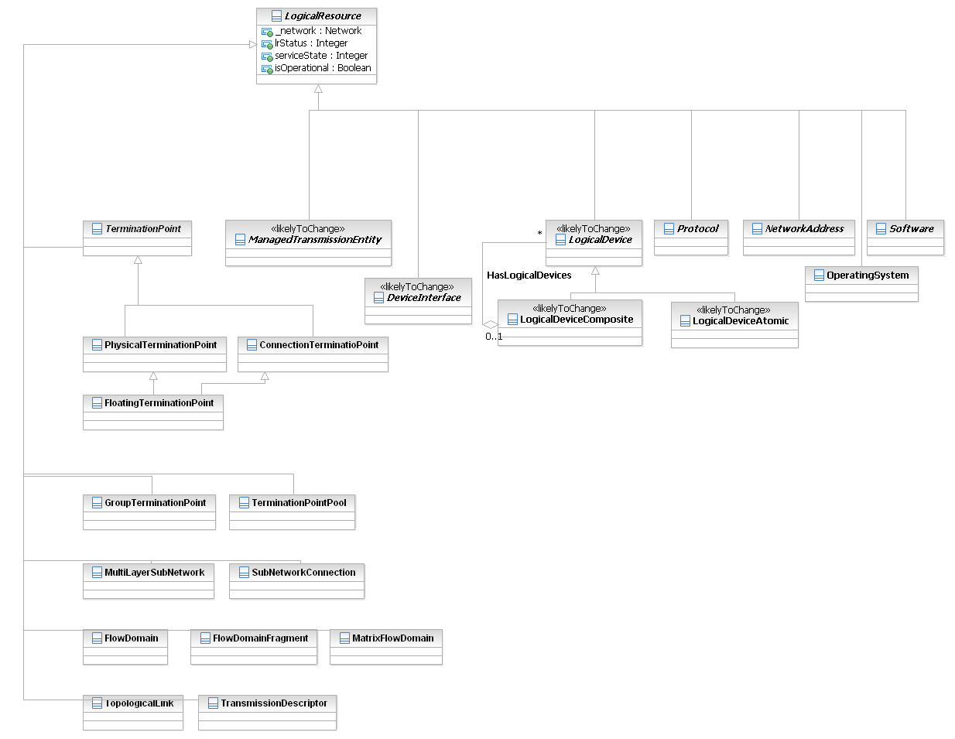
Figure LR.08 - Principal Subclasses of LogicalResource
The three attributes shown in LogicalResource are, of course, common to all of its subclasses. The lrStatus and serviceState attributes together define the current state that the LogicalResource is in. The isOperational attribute is a simple Boolean attribute – if its value is set to TRUE, then the LogicalResource is currently in operation.
Note: since the noun “status” is so common, we have chosen to disambiguate this attribute by prepending “lr” to it. .
A LogicalDevice is an abstract base class that describes different logical aspects of devices (e.g., services that are running, or processes that are instantiated) that constitute a Product. It has two main purposes: (1) to collect common attributes and relationships for all logical entities, and (2) to provide a convenient, single point where relationships with other managed objects can be defined. The standard Composite pattern [CompPtn] is used to ensure that LogicalDevice is inherently extensible.
In Figure LR.08 - above, a LogicalDevice is the center for defining the intelligence of the Resource as a whole. Two additional subclasses of LogicalResource, ManagedTransmissionEntity and OperatingSystem, are shown as examples of different types of LogicalResources, so that the reader can get a more intuitive feel of what a LogicalResource is.
An OperatingSystem is a concrete entity that represents either software and/or firmware that runs the LogicalResource. This entity implements and/or manages the resources, tasks, file systems, security, and data available on the LogicalResource.
Note that an OperatingSystem is distinct from software applications that are run on the Resource. All applications and software must communicate with the OperatingSystem for all operations that they need. This entity will be described in more detail later in this Addendum.
A ManagedTransmissionEntity is an abstract base class for describing different types of logical entities that are or help to form connections that transmit and/or receive information. These entities are often called transmission entities or path entities. This entity is an abstraction of connectivity as defined in the IETF and the ITU. Its value is that it enables the best networking concepts of both the IETF and the ITU to peacefully coexist. This entity will be described in more detail later in this Addendum. ManagedTransmissionEntities are built by the LogicalDevice, using the Software (this set of classes has not been shown yet) installed on the LogicalResource. Here, the term “built” connotes the ability of the LogicalDevice to create, manage, and tear down connections, paths, and trails. The LogicalDevice also is responsible for orchestrating the various functions required by the device (e.g., tell the appropriate Software to instantiate a routing process). The Software uses the OperatingSystem of the LogicalResource to carry out its functions.
The business view of the LogicalDevice is centered on its current configuration. This configuration defines the Capabilities of that particular LogicalResource, and is responsible for supporting the Roles associated with a particular LogicalResource. Capabilities define, in a normalized fashion independent of the vendor-specific characteristics of a particular Resource, what functions this LogicalResource has available for use. Capabilities and Roles will both be described in more detail later in this Addendum. A more granular view of a LogicalDevice is shown in Figure LR.09 - below. (Note that its associations with other classes are not shown below; they will be introduced as the other classes are introduced later in this section.)
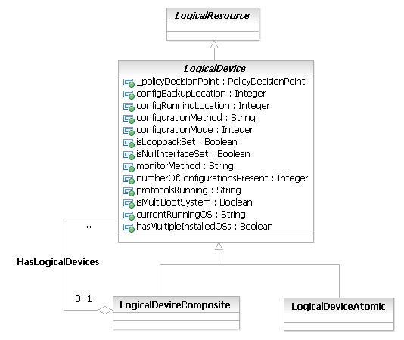
Figure LR.09 - LogicalDevice in More Detail
The attributes of the classes are defined in detail in the last section of this Addendum – the Data Dictionary. The following are brief descriptions of them for the sake of continuity.
The configurationMethod attribute defines the type of method used to configure this Resource (examples include CLI, SNMP and TL1).
The monitorMethod attribute defines the type of method used to monitor this Resource (examples include CLI, SNMP and RMON). This attribute is simply for query efficiency, and was put in the model at the request of several Service Providers.
Not shown in this simple Figure LR.09 - are relationships between LogicalDevice and other entities – these will be explained throughout this Addendum, starting with the next Section, as more detail is added to this model in this Addendum.
The detail shown in the LogicalDevice class is required to meet one of our main goals: modeling the configuration of a device. Since this means modeling at a level to enable different SNMP, CLI, and other commands and their effects to be represented, we need the 10 attributes shown in Figure LR.09 - above to represent “device-level” concepts.

ResourceSpecifications
A ResourceSpecification is an abstract base class for representing a generic means for implementing a particular type of Resource. In essence, a ResourceSpecification defines the common attributes and relationships of a set of related Resources, while Resource defines a specific instance that is based on a particular ResourceSpecification. This is represented in Figure LR.10 - below.
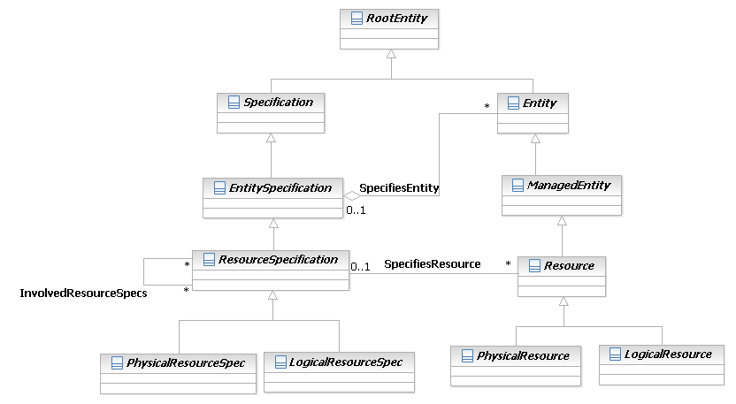
Figure LR.10 - Resources and ResourceSpecifications
The SpecifiesEntity association defines the set of Entities, including both ManagedEntities and UnManagedEntiites, whose invariant attributes, methods, relationships, constraints and behavior are specified by this particular EntitySpecification. This relationship is inherited by the Resource and ResourceSpecification classes, so a new relationship for these classes is not required. For more information on this hierarchy, please see the Root Entities Addendum.
ResourceSpecifications are generic in nature, just as Resources are. The SpecifiesEntity aggregation uses the generic Entity-EntitySpec pattern described in [Add 3]. This particular aggregation defines the ResourceSpecification that is used to provide the invariant characteristics and relationships (and methods and constraints in the system view) of a given Resource. This enables multiple Resources that each use a common set of attributes and/or relationships (and methods and constraints in the system view) to be related to a single invariant specification of those characteristics and behavior. The cardinality of the SpecifiesEntity aggregation is 1 on the ResourceSpecification side and 0..n on the Resource side. This means that a ResourceSpecification can be written that isn’t related to any specific Resources, but if a Resource is built, it must be derived from a ResourceSpecification. Furthermore, this is an aggregation because this is a whole-part relationship: the ResourceSpecification defines the invariant attributes and behavior of zero or more Resources, and each Resource derived from the ResourceSpecification uses all of the invariant attributes and behavior (and presumably adds its own instance-specific attributes and behavior).
PhysicalResourceSpec and LogicalResourceSpec are subclasses of ResourceSpecification, and are both abstract base classes that are used to define the invariant characteristics and behavior (attributes, methods, constraints, and relationships) of a PhysicalResource and a LogicalResource, respectively. PhysicalResourceSpec is described in more detail in [Add 5PR]. LogicalResourceSpecs are, of course, defined more in this Addendum.
There is at present no need to define a new aggregation for relating “LogicalResourceSpecifications” to LogicalResources. This is for two reasons. First, instead of creating a “LogicalResourceSpecification”, the composite pattern is used to create subclasses of ResourceSpecification, called LogicalResourceSpecAtomic and LogicalResourceSpecComposite. This is shown in Figure LR.11 - in the next section. Second, there are no additional semantics (at this time) needed to relate a LogicalResource object to either a LogicalResourceSpecAtomic or a LogicalResourceSpecComposite object. Note, however, that applications are free to add to the generic pattern represented in Figure LR.10 - if it will help them better define any necessary semantics for its use.
The InvolvedResourceSpecs association defines the set of ResourceSpecifications that are involved with, or related to, each other in order to build a particular type of ResourceSpecification.
One final note: the 0..1 cardinality on the two relationships in Figure LR.10 - means that the use of ResourceSpecifications are not mandatory. The SID team strongly recommends the use of ResourceSpecifications, because their use helps ensure a consistent, repeatable design. If ResourceSpecifications aren’t used, then it will be impossible to realize the full benefit of the SID. In some of the subclasses of this pattern, the ResourceSpecification contains critical information (e.g., modelNumber and partNumber are two of four critical attributes defined in a PhysicalResourceSpecificationAtomic, as documented in [Add 5PR]). Thus, the SpecifiesEntity and SpecifiesResource aggregations, along with their subclasses, are defined with this cardinality for consistency. More importantly, the Specification pattern enables different organizations, as well as different groups of the same organization, to define a set of invariant characteristics and behavior that are defined in the Specification; this enables each separate group or organization to define application-specific classes while ensuring that interoperability is maintained through the invariant characteristics and behavior defined in the Specification class(es).
PhysicalResources and LogicalResources both require their own ResourceSpecifications. Rather than build separate hierarchies for PhysicalResources and LogicalResources, this design takes advantages of their similarities. Therefore, the composite pattern is applied to the two subclasses of ResourceSpecification – PhysicalResourceSpec and LogicalResourceSpec. This ensures that both types of specifications inherit the same behavior. Thus, both the PhysicalResourceSpec and the LogicalResourceSpec have Atomic and Composite subclasses, as dictated by the composite pattern. This is shown in Figure LR.11 - below.
It should be noted that the SpecifiesResource and the SpecifiesEntity relationships should not be implemented for the MTNM/MTOSI interface model. The MTNM/MTOSI implementation form will be covered later in this Addendum.

Atomic and Composite ResourceSpecifications
The composite pattern can be applied to a LogicalResourceSpec, yielding the structure shown in Figure LR.11 - below:
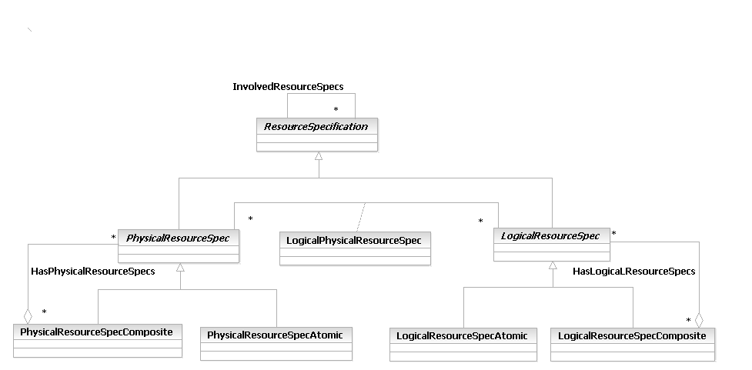
Figure LR.11 - Concept of Atomic and Composite ResourceSpecifications
A LogicalResourceSpecAtomic is an abstract base class for defining LogicalResourceSpecs that do not have any subordinate LogicalResourceSpecs. In other words, a LogicalResourceSpecAtomic is a stand-alone LogicalResourceSpec, and doesn't require any supporting LogicalResourceSpecs to define the invariant characteristics and behavior of Resources for which it serves as a template. (Note that the SID team has decided as of this writing to relegate behavioral definitions to the system and other views.)
A LogicalResourceSpecComposite is an abstract base class for defining LogicalResourceSpecs that are formed by aggregating other LogicalResourceSpecs. The types of LogicalResourceSpecs that are aggregated may be LogicalResourceSpecAtomic and/or LogicalResourceSpecComposite instances (but at least one LogicalResourceSpecAtomic must be present in the LogicalResourceSpecComposite). A LogicalResourceSpecComposite collectively defines all of the invariant characteristics and behavior of Resources that it serves as a template for. An analogy is as follows:
- LogicalResourceSpecAtomic is a file
- LogicalResourceSpecComposite is a folder
- Characteristics and behavior are specified as metadata on a file and/or folder basis
The InvolvedResourceSpecs association defines the set of ResourceSpecifications that are involved with, or related to, each other in order to build a particular type of ResourceSpecification. In particular, no distinction is made between physical and logical specifications.
The LResSpecBindsToPResSpec association represents the binding between a set of LogicalResourceSpecifications and a set of PhysicalResourceSpecifications. The semantics of this binding are represented by the LogicalPhysicalResourceSpec association class. Put another way, this association defines the set of LogicalResourceSpecs that are required by this PhysicalResourceSpec.
The HasLogicalResourceSpecs aggregation defines the set of LogicalResourceSpecAtomic and/or LogicalResourceSpecComposite objects that are contained in a particular LogicalResourceSpecComposite object.
The LogicalPhysicalResourceSpec is an association class that represents a Specification for defining the invariant attributes, methods, constraints, and relationships that exist between a particular LogicalResourceSpec and the PhysicalResourceSpec that it depends on.
These classes have been made abstract in order to set up a generic framework that can be used by many different applications. As such, the goal of this framework is to provide a basis for applications to create their own modifications to it. In other words, applications will subclass the LogicalResourceSpecAtomic and LogicalResourceSpecComposite classes to define specifications with the appropriate semantics for that particular application. This means that a consistent framework is established in this specification; applications can add to it and one application can find another application’s additions by simply searching for all subclasses of these classes.

ResourceSpecVersion
Applications often require the ability to distinguish between different versions of objects in general. This Addendum applies this principal to ResourceSpecifications. The ResourceSpecVersion class represents a particular form or variety of a ResourceSpecification that is different from others or from the original. The form represents differences in attributes and relationships (as well as methods and/or constraints in the system view) that characterize this particular ResourceSpecification, but which are not enough to warrant creating a new ResourceSpecification. This is shown in Figure LR.12 - below:
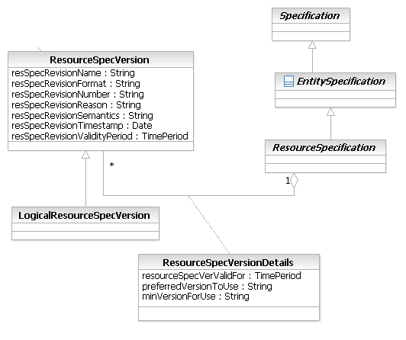
Figure LR.12 - Concept of ResourceSpecVersions
Notice that a LogicalResourceSpecVersion doesn’t define any new (business) attributes of its own. This is because the purpose of this class is to be able to track LogicalResourceSpecAtomic as well as LogicalResourceSpecComposite objects separately from other types of ResourceSpecifications. Note that this class defines the ModifiesResourceSpec aggregation, which can be used with all subclasses of LogicalResourceSpecVersion and ResourceSpecification. Therefore, the LogicalResourceSpecVersion can be used to track LogicalResourceSpecAtomic as well as LogicalResourceSpecComposite classes.
Brief definitions of the attributes of this class are as follows:
The resSpecRevisionName attribute defines the name of this revision for easy storage, retrieval, and querying
The resSpecRevisionFormat attribute defines the specific format of this revision (e.g., 2.5.3a)
The resSpecRevisionNumber attribute contains the actual value of this instance of this revision
The resSpecRevisionReason attribute contains the reason for creating this revision
The resSpecRevisionSemantics defines the particular semantics of this version, such as a minimum a description of the format of the revisionNumber
The resSpecRevisionTimestamp contains the date and time that this revision was created
The resSpecRevisionValidityPeriod defines the period of time for which this revision is valid
The ResourceSpecVersionDetails class defines the semantics of the ModifiesResourceSpec aggregation. Specifically, it enables an application to define which set of versions of the ResourceSpecification are appropriate for a given task.
The ModifiesResourceSpec aggregation represents the set of versions of this ResourceSpecification. The semantics of this aggregation are implemented with the ResourceSpecVersionDetails class. However, this class is not appropriate for this business view, and hence is not described in this Addendum.

ResourceSpecificationTypes
The preceding discussion has shown that multiple ResourceSpecifications can share common characteristics. This can be more efficiently represented using the concept of a ResourceSpecType, as shown in Figure LR.13 - below:
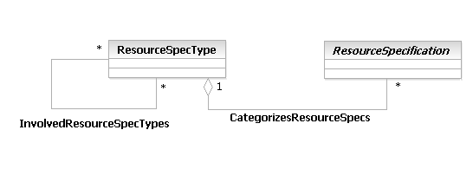
Figure LR.13 - Concept of ResourceSpecificationTypes
The CategorizesResourceSpecs aggregation defines the ResourceSpecificationType that is used to classify and catalog different ResourceSpecifications. The InvolvedResourceSpecTypes association defines the set of ResourceSpecifications that are involved with, or related to, each other in order to build a particular type of ResourceSpecification.
Note that in principle, ResourceSpecType could be subclassed, so that the subclasses of ResourceSpecType could be used to categorize different subclasses of ResourceSpecification. This is not recommended, as the ResourceSpecType object is used solely to help categorize objects. The only reason a ResourceSpecType object should be subclassed is if that subclass adds additional semantics (in the form of attributes, methods, relationships, and/or constraints).

LogicalResourceRoles
Previously issued Addenda, such as the PhysicalResource Addendum and the Party Addendum, have made extensive use of roles (see [Bäumer] and [Fowler-Roles] for more information on this powerful abstraction mechanism). Roles can once again be used to simplify the modeling of different types of Resources and to make the model inherently more extensible. This is especially true in the modeling of network devices, since any given modern network device (such as a router) can take on multiple roles and perform different functions. If roles aren’t used, then the model becomes ponderous and unmanageable.
To see the value of the role pattern, consider a modern day router. Assume that we want to model a (layer 2) Switch and a Router as types of LogicalDevices. The basic difference between a Switch and a Router is that the former forwards traffic, while the latter routes and forwards traffic. This could be simplistically modeled as shown in Figure LR.14 - below:
Figure LR.14 - A Simple (but Bad) Approach to Modeling Types of Devices
But what about the so-called “Layer 3” switches, which are switches that have routing capability? The method shown above encourages subclassing. For example, this could be done by creating a subclass of Switch, called Layer3Switch, which adds routing capabilities to the Switch. This is a poor solution, because now every time routing changes, we have to update the Router class as well as the Layer3Switch class. Besides, this implies that a Layer3Switch can do everything that a full-blown Router can do, which is almost never the case. There are other problems with this approach too, but this is enough for now.
One may also be tempted to use multiple inheritance. If we ignore the fact that multiple inheritance is not always supported when the system is implemented, the problem then becomes one of extensibility. What if there is a “Layer4Switch” (unfortunately, some vendors do label their products like this!)? What if we want to differentiate between the type of routing done in a Router vs. the type of routing done in the Layer3Switch vs. the type of routing done in the Layer4Switch? What if there is a Router that has firewalling capabilities, how is that modeled? There are simply too many permutations to account for using this approach.
Instead, a much more elegant and extensible solution is available – we can use the notion of roles. This simplifies our approach tremendously. Instead of trying to either define many subclasses or introduce multiple inheritance, we can instead define a set of roles that the device is meant to play. (Note that if LogicalDevice had not been split out, there would have been nothing to attach the roles to; since LogicalDevice has the conceptualization of being the “brains” of the Resource, attaching roles to LogicalDevice has the connotation of abstracting certain functions that the LogicalDevice controls using one or more roles).
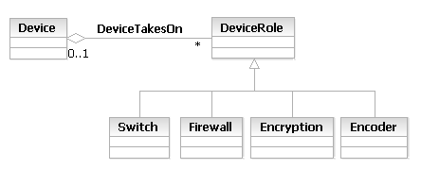
Figure LR.15 - Using Roles to Represent Device Functionality
Thus, by modeling DeviceRole as a separate concept from Device, we can build subclasses of DeviceRole to model different functions. Then, it’s a simple matter of aggregating the appropriate DeviceRoles to represent the different functions and roles that a particular device can play. We specifically avoid having to subclass Device to do this!
This concept is extensible to related interactions between Resources and other business entities, such as PartyRoles. For example, Figure LR.17 - (on the next page) associates specific PartyRoles, which are defined in [Add 1P], with specific DeviceRoles. This is an example of a real-world business case: since the core of a Provider network in general uses different devices than the (edge) devices used to access the core, and since the role of the core is different than that of the edge, different management personnel having different skill sets are often assigned to manage devices in the core versus devices in the edge.
Figure LR.16 - below shows the top of the LogicalResourceRole hierarchy. This hierarchy will be developed in more detail later in this Addendum.
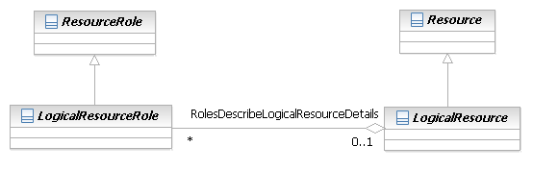
Figure LR.16 - LogicalResourceRole – A Starting Point
The RolesDescribeLogicalResource aggregation defines the set of logical roles that are used to describe an instance of a particular LogicalResource. It is a generic relationship that enables different types of roles to be aggregated by a particular LogicalResource.
The LogicalResourceRole class exists in order to separate LogicalResourceRoles from other types of ResourceRoles. Especially in the system view, there are many different types of PhysicalResourceRoles, LogicalResourceRoles, and other types of ResourceRoles. Thus, the LogicalResourceRole class helps classify roles and makes them easier to maintain. It also enables relationships to be developed that apply to many different types of LogicalResourceRoles while ensuring that other types of roles are not affected. This ensures that needless separate relationships between multiple types of LogicalResourceRoles don’t have to be created, as well as semantics that are specific to LogicalResources are defined just for LogicalResources.
We can take this concept one step further, and associate PartyRoles to ResourceRoles, as shown in Figure LR.17 - below:
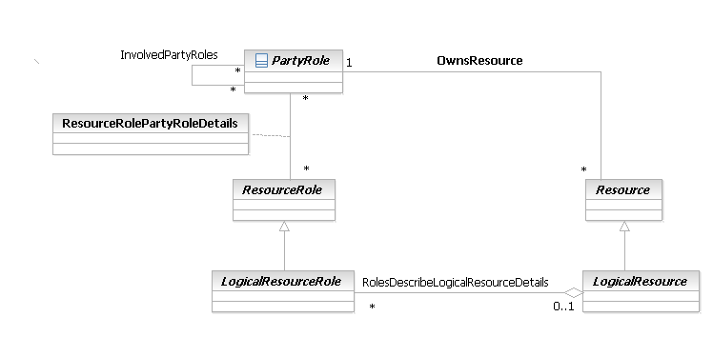
Figure LR.17 - Managing ResourceRoles Using PartyRoles

The ResourceRolesManagedByPartyRole association defines the set of ResourceRoles that are managed by a particular PartyRole. Oftentimes, there are important functional differences between different types of Resources that require very different skill sets, methods, and so forth to be used by the PartyRole that is managing that Resource. For example, different management personnel may be assigned to manage core routers compared to edge routers. This applies not just to the router as a whole, but to its physical (e.g., line cards) and logical (e.g., DeviceInterfaces) components as well.
This association enables these relationships to be captured. The semantics of this association are implemented by the ResourceRolePartyRoleDetails association class.
We will apply this concept to our MPLS VPN Example in the Section titled Roles in More Detail once more entities of the Resource and LogicalResource hierarchies have been described.
It should be noted that the RoleDescribesLogicalResourceDetails relationship should not be implemented for the MTNM/MTOSI interface model. The MTNM/MTOSI implementation form will be covered later in this Addendum.

ResourceCharacteristics and ResourceSpecCharacteristics
A major focus of marketing programs is to represent the key features of a Product. This was documented in Addendum 3 of GB922 as ProductCharacteristics (to denote instances) and ProductSpecCharacteristics (to denote features of a template). Since a Resource may be a realization of a Product, it makes sense to reuse this concept and define the notion of a ResourceCharacteristic.
There are cases when an instance of a ServiceSpecCharacteristic and/or a ServiceSpecCharacteristicValue must be translated to a corresponding ResourceSpecCharacteristic and/or a ResourceSpecCharacteristicValue. For example, there may be a ServiceSpecCharactertistic that represents the size of an email box as defined by associated 10MB instance of SerivceSpecCharacteristicValue. This value may be translated into the actual size of 10.5MB as defined by the ResourceSpecCharacteristicValue associated to an email box size ResourceSpecCharacteristic. Similar associations can be made between characteristics in the Product domain and those in the Resource domain.
The Resource Characteristic model is shown in Figure LR.18 - below. Additional information about the CharacteristicSpecification/CharacteristicValue pattern can be found in GB922 Addendum 1R Root Business Entities.

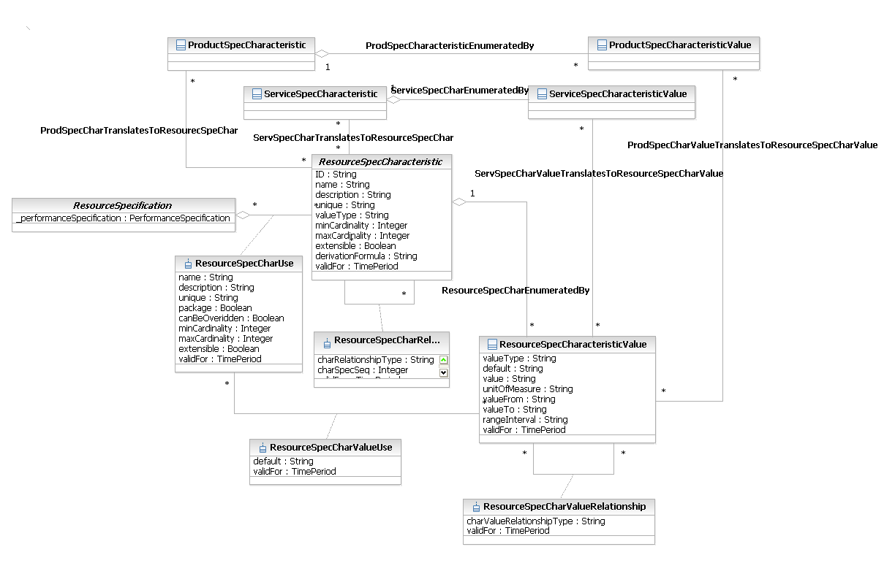
Figure LR.18 - ResourceCharacteristics and ResourceSpecCharacteristics
There are two different uses for CharacteristicValues and CharacteristicSpecs. The simplest use is to define the significant features and behavior of a ManagedEntity. The second is as a general-purpose extension mechanism. This Addendum will only discuss the former feature; the latter is discussed in the Root Business Entities Addendum.
A ResourceSpecCharacteristic is defines the characteristic features of a ResourceSpecification. Every ResourceSpecification has a variety of important attributes, methods, constraints, and relationships, which distinguish that ResourceSpecification from other ResourceSpecifications. These are called ResourceSpecCharacteristics. Each of these characteristics is used at the business level to characterize a ResourceSpecification.
ResourceSpecCharacteristics are related to ResourceSpecifications by ResourceSpecDescribedBy aggregation. ResourceSpecCharacteristics and ResourceSpecCharacteristicValues are used to define ResourceCharacteristicValues.
A ResourceCharacteristicValue defines the characteristic features of a Resource. Every Resource has a variety of important attributes and relationships, which distinguish that Resource from other Resources.
ResourceCharacteristicValues are related to Resources by the ResourceDescribedBy association.

ResourceCharacteristicValues and ResourceSpecCharacteristicValues
The purpose of the ResourceCharacteristicValue and ResourceSpecCharacteristicValue objects is to define how instances of these objects can be populated. This is shown in Figure LR.19 - below on the next page.
A ResourceSpecCharacteristicValue object is used to define a set of attributes, each of which can be assigned to a corresponding ResourceCharacteristicValue object. The values of the attributes in the ResourceSpecCharacteristicValue object describe the values of the attributes that a corresponding ResourceSpecCharacteristic object can take on.
The ResourceDescribedBy association defines the allowed set of values that a specific Resource can have when that Resource object is instantiated. The value associated with a ResourceCharacteristicValue may be association to a ResourceSpecCharacteristicValue if the ResourceSpecCharacteristic is constrained by a set of values or directly to a ResourceSpecCharacteristic if there are no value constraints.
Also shown in the figure are the possible translations made between ProductCharacteristicValues and/or ServiceCharacteristicValues and ResourceCharacteristicValues.
It should be noted that the ResourceDescribedBy relationship should not be implemented for the MTNM/MTOSI interface model. The MTNM/MTOSI implementation form will be covered later in this Addendum.
Figure LR.19 - ResourceCharacteristicValues and ResourceSpecCharacteristicValues

Example Use of Resource Spec Characteristic
In an information model of network elements it is usual practice to adopt the concept of “profile” to quickly configure a specific resource with a set of values. Each profile is a predefined invariant group of parameters, characteristic of every resource types, and each profiles instance is a set of values for each of these parameters.
OSS systems must know and manage profiles in order to correct interworking with network elements to carry out activates like resource configuration and service activation.
In SID model, resources specification and characteristics portray these resource profiles concept.
Resource profiles concept can be model through resource characteristic concept, as described in Figure LR.20. The entities in the model are useful to express profiles concepts, profiles composition, theirs association with resources and the values that each profiles can hold (theirs names and parameters values). It also includes a relationship that expresses the link between a specific profile and the group of its parameters values, which is an essential association to completely modeling resource profiles and more general, to model resource characteristic.
For example, the IP DSLAM network equipment use spectrum profiles to configure the maximum noise margin, upstream and downstream, within which xDSL lines can work. So, a specific xDSL port can be associated to spectrum profiles named “sp1”, with two specific parameters values like TargetNoiseMarginUp=6 and TargetNoiseMarginDown=6.
Profiles can be model with ResourceSpecification, ResourceSpecCharacteristic and ResourceSpecCharRelationship entities (for example, “spectrum profile” composed of two parameters, “TargetNoiseMarginUp” and “TargetNoiseMarginDown”), their specific instances as well as profiles parameters values can be model with the ResourceCharacteristicValue entity (for example, profile name “sp1” and two values “6” for parameters). To add a new profile, it is necessary to create new instances for profile name (e.g. “sp2”) and for parameters values (e.g. “3” for both TargetNoiseMarginUp and TargetNoiseMarginDown). The model also provides a relationship to discriminate what parameters values are associated with correct profile name. This is supported by the recursive relationship on ResourceCharacteristicValue entity which allows correlation between profiles names and theirs parameters values.
In IP DSLAM context, a network element defines some profiles and how to employ them for fulfillment process:
To configure service on user ports, network element needs a spectrum profile and a line profile
Spectrum profile has four parameters: TargetNoiseMarginUp, TargetNoiseMarginDown, PlannedBitRateUp, PlannedBitRateDown.
Line profile has one parameter: OPMODEV2
Fulfillment OSS system know port configuration only through generic and vendor - independent composite profile concept, as “Profile for TV” service. This profile corresponds to spectrum profile plus line profile when applied in IP DSLAM context.
To show how a port configuration scenario of this context can be model with SID Resource Characteristic ABE, it is fundamental to define the involved entities. Figure LR.20 - Inheritance Diagram for Entities in Example depicts an inheritance diagram from generic SID entities to specific entities, necessary for this example.
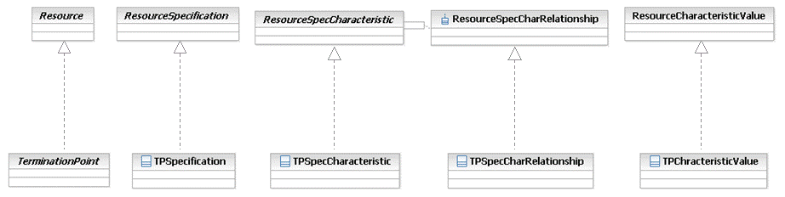

Figure LR.20 - Inheritance Diagram for Entities in Example
Figure LR.21 and Figure LR.22 depict entities and instances to illustrate the example. Large boxes represent instances entities in table format: the name in top of the box is the related entity name, columns represent entity properties and each row represents entity instances. Lines between boxes represent relationship instances.
Figure LR.21 - TerminationPoint Profiles example (I)
Figure LR.21exemplifies profiles specification and their composition.

Figure LR.22 - TerminationPoint Profile example (II)
Figure LR.22 exemplifies profiles values, relationships between profiles specification and profiles instances, association between specific resource and specific profile (through ConnectionTerminatioPoint-TPCharacteristicValue relationship).

LogicalResource Detail Classes

Introduction
This part of this Addendum will discuss the main classes that are currently plugged into the LogicalResource Framework. This extensible set of classes and relationships enable new lower-level LogicalResource concepts to be modeled. The principal classes that will be discussed include:
Software
DeviceInterface
Protocol
CompoundResource
Network
ManagementInfo, and its subclasses (which are targeted at FCAPS functionality)

Software
LogicalDevice and Software are related as follows:
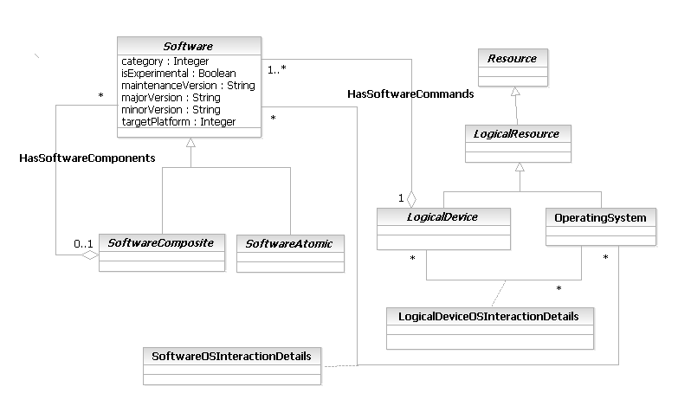
Figure LR.23 - Relationship between LogicalDevice and Software
Please note that the two association classes can be safely ignored for the business view. However, the programming of Software is complex, and since that is an important use case, it was felt that showing these association classes would help bridge between the business and system views. The same is true for some of the attributes shown (though this also helps readers familiar with the previous version of the SID understand where these attributes went).
Software can, in general, be associated with many different types of LogicalDevices. The features of a particular Software entity are not associated with the OperatingSystem of the LogicalResource – rather, Software uses the OperatingSystem to accomplish its tasks based on external commands given to it. This is represented by the SoftwareInteractsWithOS association. This is in reality a complex association class; other than the two simple attributes shown in the SoftwareOSInteractionDetails association class for the reader to better understand its purpose, this detail is suppressed from this Addendum, as that detail describes system features, not business features.
The SoftwareOSInteractionDetails class is an association class, and defines the semantics of the SoftwareInteractsWithOS association. This is a complex class, and consequently only a few simple attributes are shown in this viewpoint in order for the reader to get a flavor of the types of parameters defined in this class. This class is expanded into further detail in the system view to show how different Software interacts with different types of OperatingSystems.
This last point cannot be over-emphasized. A complex problem in today’s computing environments is how different versions of Software interact with different versions of an OS. Often, different features will be added and will require different support (e.g., more memory) in order to function correctly. The system view of this model was built to model this problem. However, this is quite complex, and is not suitable for this Addendum, because this Addendum focuses on the business view.
The standard composite pattern is applied to Software. This yields a robust infrastructure to represent the commands available in a vendor-specific network device, Other subclasses of Software are beyond the scope of this Addendum, but exist to model concepts such as the software installed on a device and, more importantly, how to program that device. Taking as an example a Cisco router running IOS, a subclass of SoftwareComposite would be used to model the functionality of IOS, while subclasses of SoftwareAtomic would be used to model individual Commands and groups of Commands. These subclasses are called SoftwareFeatureSets and SoftwareCommand, respectively. SoftwareCommands represent atomic commands that can be programmed (e.g., CLI, TL1, and SNMP commands). Since such commands are often organized by user-visible and user-programmable feature sets, the SoftwareFeatureSets class is used to represent collections of SoftwareCommands (see Figure LR.24 - ).
Software features are controlled by the LogicalResource. Since we have established the LogicalDevice as the “brains” of the LogicalResource, the HasSoftwareCommands aggregation is used to represent those software features that are being used by the LogicalDevice.
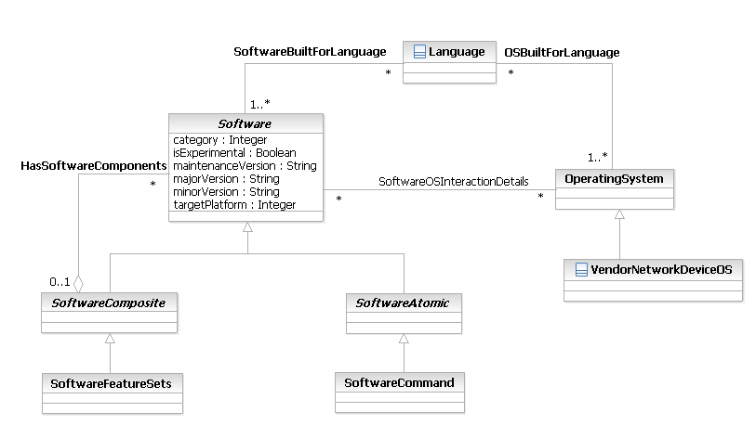
Figure LR.24 - VendorNetworkOS and SoftwareCommand Classes

SoftwareCommands are different than the notion of Characteristics. Characteristics have two uses: (1) to describe the salient features of a Resource, and (2) as an extensibility mechanism to define new attributes. Both of these are high-level concepts, and do not cover the lower-level detail of command syntax and semantics that the SoftwareCommand class covers..
SoftwareCommands are also different than the notion of Capabilities – Capabilities define what features and functions are available at a given moment for the Resource, while SoftwareCommands describe the sets of features that are programmable by a particular PartyRole. Thus, SoftwareCommands represent the specific commands that are available in a device that can be programmed, whereas Capabilities represent higher-level generic functions available in a Resource. Thus, the ability to perform BGP routing is a Capability, whereas the actual commands used to implement BGP routing are SoftwareCommands. Another important use of Capabilities with SoftwareCommands is to define specifically what types of functions should be available for different PartyRoles without having to define the exact commands. This abstraction is crucial when programming devices with different OperatingSystems and commands.
The attributes of the Software class are used to describe the details of this instance of Software. Note that for this release of the SID, the following three attributes were moved from the business view to the system view.
- The buildNumber attribute defines the internal identifier that identifies how to construct this unit of software.
- Category is an enumerated integer that is used to simplify searching for related types of SoftwareElements. For example, a QoSSoftwareElement may have many different subclasses (e.g., classification, queuing, dropping, etc.). Each of these would have a similar Category that would facilitate their identification and distinction from other types (i.e., Categories) of SoftwareElements.
- The otherDesignator attribute is a string attribute, and enables the manufacturer to label this software as having some set of special restrictions (e.g., early or limited deployment, end of life, or targeted at a specific type of market).
The following attributes are the business attributes defined for this release of the SID for the Software class:
- The isExperimental attribute is a Boolean attribute that is used to define if this instance represents a special build (perhaps as a trial to suit specific customer needs).
- The maintenanceVersion, majorVersion, minorVersion, and otherDesignator attributes are used to define the specific version of this Software instance.
- Finally, the targetPlatform attribute is an enumerated integer that defines the target platform that this Software will be deployed on. This helps define the specific feature capabilities that can be built in this Software instance.
There are additional system attributes that are hidden in Figure LR.24 - , which are used in the System view.
Note also that Software is part of a set of classes (Firmware and DataContent are the other two major branches) that are a part of a ResourceLogic class. This class is used to abstract different ways to program devices and their content. It is a relatively new class in the LogicalResource Addendum, and so is not discussed further in this document. It will be worked on in the next phase of the SID.

OperatingSystem
An OperatingSystem is a concrete entity that represents either software and/or firmware that runs the LogicalResource. This entity implements and/or manages the resources, tasks, file systems, security, and data available on the LogicalResource.
Note that an OperatingSystem is distinct from software applications that are run on the Resource. All applications and software must communicate with the OperatingSystem for all operations that they need. This abstraction is critical in order to be able to properly program devices, as one must be able to differentiate from standard operating system facilities available to all software versions from the content and functionality of the software itself.
The OperatingSystem class interacts with many other classes. The LogicalDeviceUsesOS association defines the semantics of how a particular LogicalDevice entity interacts with its OperatingSystem. The semantics of this association are defined in the LogicalDeviceOSInteractionDetails association class. Note that it is common for many types of network devices to have multiple OperatingSystem versions installed. Thus, we define the LogicalDeviceOSInteractionDetails class to define the specific semantics of the LogicalDeviceUsesOS association(s), which in turn defines the OperatingSystem(s) stored on a given LogicalDevice.
PatryRoles, such as Developer, NetworkOperator, and others, interact in a variety of ways with an OperatingSystem. Two exemplary interactions are shown in Figure LR.25 - below. The first, PartyRoleUsesProcesses, defines the particular Processes that a specific PartyRole is using. Often, privileged users can have access to more Processes than other types of users. The semantics of this association are implemented in the PartyRoleUsesProcessesDetails class.
The second, PartyRoleLicensesOS, defines the set of PartyRoles that can license a particular OperatingSystem. This can be used in a number of ways – one common example is to support computation of whether license restrictions for an individual or group of users has been violated or not. The semantics of this association are defined in the PartyRoleLicenseOSDetails class.
OperatingSystems, like Software, can be built to support a specific set of Languages. This is related to licensing details; however, this is somewhat complex to represent and is a systems issue. This is represented in the OSBuiltForLanguage association.
Software uses services of the OperatingSystem. This is represented in the SoftwareInteractsWithOS association. The semantics of this association are defined in the SoftwareOSInteractionDetails class. Note that by defining this association, we can model specific interaction semantics of different versions of Software and different versions of an Operating System. This is especially important when global issues such as upgrading an OperatingSystem or Software are addressed.
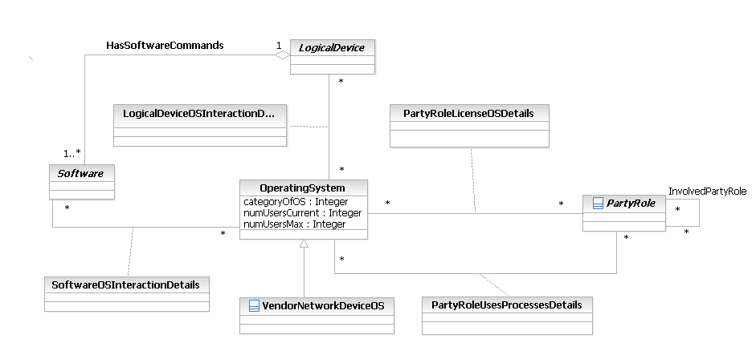
Figure LR.25 - High-Level View of an OperatingSystem

Finally, the VendorNetworkDeviceOS class is an abstract base class that is used to represent the network operating systems of different vendors. Each of these is in general different for different vendors, even for the same type of device, since it is common for vendors to change syntax and semantics for different versions of a network device’s OperatingSystem. Hence, this class represents common semantics and relationships that all vendor network operating systems have; the specific functionality of each network vendor operating system is contained in the subclasses of this class. For example, the primary use case is concerned with programming network devices to realize business needs. Since there is no common “router operating system”, the VendorNetworkDeviceOS class serves as the basis for representing unique semantics of each operating system that each network device vendor manufactures.
The attributes shown for the OperatingSystem class are a good representative to get the feel of its functionality, but are only some of the attributes that are defined for this class. The Data Dictionary contains all of the business attributes defined for this class.
The attributes shown fall into several categories. The categoryOfOS attribute is used to facilitate querying, storage and retrieval of OperatingSystem instances by identifying the type of OperatingSystem (e.g., network device, server, etc.) that this instance is.
The isDistributable attribute is used to show if this OperatingSystem instance is distributed across multiple physical instances or not. The isDistributedCurrent attribute is used to tell if this particular OperatingSystem instance is currently distributed or not.
The following attributes were moved to the System View for this release of the SID:
- OperatingSystems have a notion of time. This is critical for synchronizing operations done to the Resources that contain the OperatingSystem. The dateValue, timeValue, and isUTCTime attributes are used for this purpose. The first two attributes contain the actual values of the current date and time from the point-of-view of this OperatingSystem instance. The latter attribute is a Boolean that, if TRUE, means that this OperatingSystem uses UTC (or absolute) time.
- The lastBootTime attribute contains the date and time when this OperatingSystem instance was last (re)booted.
- The physicalMemoryTotal attribute and the physicalMemoryAvailableCurrent attributes represent the total and currently free (i.e., not used) physical memory that are available for this OperatingSystem instance to use. Similarly, the virtualMemorySpaceTotal and the virtualMemorySpaceUsedCurrent attributes represent the total and currently free virtual memory, which is available for this OperatingSystem instance to use. There are many more pairs of attributes defined in the system view (e.g., to represent paging space), but they have been suppressed from Figure LR.25 - above.
The releaseStatus attribute of the VendorNetworkDeviceOS is an enumerated integer that defines the particular release status of this software. Values include first customer ship, alpha, beta, end of life, and others.

DeviceInterface
It should be noted that some of the MTNM/MTOSI classes now included in the SID have roles similar to the DeviceInterface. In future releases on the SID there will be further consolidation and refinement of the model.
A DeviceInterface is a concrete class that represents the (logical) interface or sub-interface of a device. This is not a transmission entity; rather, DeviceInterfaces are used to program Services and LogicalResources on a Device; this will be discussed in more detail later in this section. Note that a LogicalDevice is used to orchestrate the behavior of a set of DeviceInterfaces. The DeviceInterface is shown in the context of some other key classes below in Figure LR.26 -.The programming of DeviceInterfaces is complex, and is an important use case.
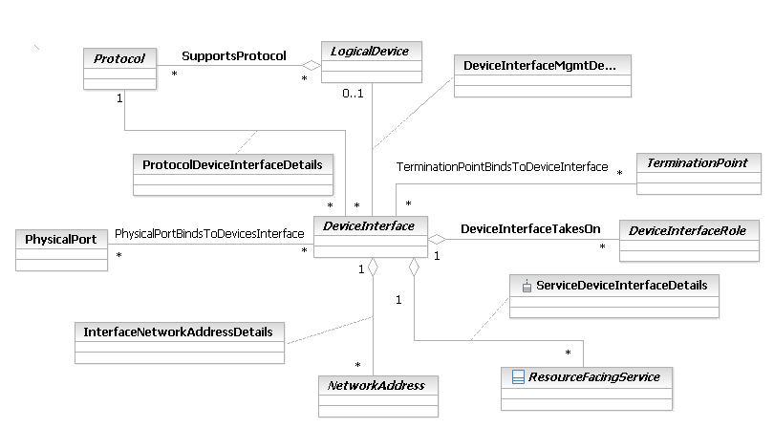

Figure LR.26 - How DeviceInterfaces Interact With Other LogicalResource Entities
The LogicalDevice at the top of Figure LR.26 - is the entity that is responsible for creating a DeviceInterface. This is an important point – a DeviceInterface must first be created. It is not a naturally occurring managed entity, like a PhysicalPort. Furthermore, since a DeviceInterface is a logical concept, it must be hosted by a physical entity, otherwise, there is nothing for the DeviceInterface to be anchored from. The hosting is done by the PPortBindsToDeviceInterfaces association. This reinforces the fundamental distinction between physical and logical entities, which is why PhysicalResource and LogicalResource both exist.
Note that it is important to avoid confusing CompoundResource with either PhysicalResource or LogicalResource. CompoundResource exists as an abstraction to simplify referring to concepts, such as a “port” or a “device”, that contain physical and logical concepts. For example, in most topology applications, the concept of a “port” is used that refers both to a physical port as well as logical aspects of that physical port. As we will see, the ResourcePort class, which is a subclass of CompoundResource, was created to model this common occurrence. Furthermore, the only real programming characteristics and behavior of a CompoundResource are those that apply to the CompoundResource as a whole. In contrast, the DeviceInterface class is used to program the functionality of an interface on a command-by-command basis.
The physical entity that hosts DeviceInterfaces is a PhysicalPort, which was defined in [Add 5PR]. A PhysicalPort can host multiple DeviceInterfaces, though as we will soon see, there are some limitations. For example, multiple virtual interfaces (e.g., sub-interfaces) can be created on a single PhysicalPort; examples include the representation of different types of Virtual Connections for ATM, VPNs for Ethernet, and others. The fact that a DeviceInterface is related to the source of its physical medium enables a rich taxonomy of DeviceInterfaces to be defined. For example, one can immediately separate Serial and PPP DeviceInterfaces from an Ethernet DeviceInterface, since the physical medium (represented by PhysicalPort) is fundamentally different.
A single DeviceInterface may take on multiple DeviceInterfaceRoles. This helps abstract the purpose and functionality of this particular DeviceInterace compared to other DeviceInterfaces in the Network. For example, an Ethernet DeviceInterface may have the roles EdgeInterface and Firewall assigned to it. This means that this particular DeviceInterface has two functions – one is to connect the outside world to the edge of its network, and the other is to perform firewall functions. The reason that this is so important is due to the very nature of the DeviceInterface – it is a programming medium. Hence, defining multiple roles for a DeviceInterface enables different “configuration snippets” to be written and installed on the DeviceInterface. This promotes reusability, since logical functionality can now be abstracted as a configuration object and reused across multiple managed elements, as long as the role is satisfied.
In addition, PhysicalResources can have PhysicalDevices, which in turn can have PhysicalDeviceRoles. Hence, it is possible to associate a set of LogicalDeviceRoles and/or DeviceInterfaceRoles with different types of PhysicalDeviceRoles. For example, the autonomation of programming different functionality for a set of devices can be managed using roles. A PhysicalDeviceRole defines aspects of the physical medium that is involved; a set of DeviceInterfaceRoles is then used to program media-specific functionality. This high-level set of abstractions is one of the novel features of the SID, and enables it to be used by a variety of constituencies.
The TPBindsToDeviceInterfaces association defines the set of TerminationPoints that are "programmed" using this particular DeviceInterface. The programming results in a binding relationship between the DeviceInterface and a TerminationPoint. This enables a direct mapping to the device’s language used to create, maintain, and destroy the TerminationPoints, such as CLI, SNMP, or TL1.
Finally, a DeviceInterface can contain a NetworkAddress (note that this is not just an IPAddress!). This process is more complex than it first appears, and will be described more fully later in this section. The InterfaceContainsNetworkAddress aggregation defines the particular type of NetworkAddress that is contained in this specific type of Interface. The semantics of this containment are defined in the InterfaceNetworkAddressDetails class.
The LogicalDeviceGovernsDeviceInterfaces association defines the set of DeviceInterfaces that are managed by a particular LogicalDevice. Note the difference between this association and the PPortBindsToDeviceInterfaces association - the LogicalDeviceGovernsDeviceInterfaces association represents administrative management, whereas the PPortBindsToDeviceInterfaces association represents the binding of logical domain managed entities to physical domain managed entities. This flexibility enables complex devices that have multiple types of DeviceInterfaces, or even a network device that consists of multiple LogicalDevices, to be modeled, where a particular LogicalDevice can be assigned to manage a given DeviceInterface. The model distinguishes between configuration and operational (e.g., monitoring and troubleshooting commands) management of a DeviceInterface. Thus, the DeviceInterfaceMgmtDetails class is used to help capture the semantics of these two different types of management operations. The details of this governance are more fully covered in the system view.
The ProtocolRunsOn association defines the set of Protocols that are currently running on this DeviceInterface. This can be very complicated, depending on the layering of Protocols and media involved, and is more fully covered in the system view. The semantics of any particular Layer are realized by the ProtocolDeviceInterfaceDetails association class.
The DeviceInterfaceTakesOn aggregation defines the specific set of DeviceInterfaceRole objects that are associated with a particular DeviceInterface object. Multiple specific DeviceInterfaceRoles can be defined as subclasses to the DeviceInterfaceRole class. Since they are subclasses, they will all inherit the DeviceInterfaceTakesOn aggregation. This enables developers to customize the SID according to their application-specific needs, but still use the rest of the high-level SID framework.
The DeviceInterfaceHasRFServices aggregation defines the particular set of ResourceFacingServices that a DeviceInterface is currently supporting. This is a very important aggregation, as it links the Services provided by a LogicalDevice to the programming of those Services. Note that these are ResourceFacingServices, not CustomerFacingServices – this is because CustomerFacingServices should not have to be aware of the specific type of DeviceInterface that is being used. For more information on the difference between CustomerFacingServices and ResourceFacingServices, please see Addendum 4SO. The semantics of supporting a particular ResourceFacingService are captured by the ServiceDeviceInterfaceDetails aggregation class.
Finally, the InterfaceContainsNetworkAddress association defines the particular type of NetworkAddress that is contained in this specific type of Interface. This simplifies changing the type of NetworkAddress that is associated with a particular DeviceInterface. The semantics of this containment are defined in the InterfaceNetworkAddressDetails class.
As previously noted, the DeviceInterface class covers a conceptual model with an implementation consideration, as its purpose is to administer the creation and configuration of other entities (in fact, the Device Interface enables a direct mapping to the device’s language used to create, maintain, and destroy various entities, such as TerminationPoints, using CLI, SNMP, TL1, or other methods). As such, it is a focus for the SID-MTNM/MTOSI harmonization activities (see TIP ABE on page 75). Note that this necessarily means that it will be the subject of future harmonization activities.
The attributes of DeviceInterface are defined in the Data Dictionary portion of this Addendum. Some of the subclasses of DeviceInterface are defined in Figure LR.27 - below.
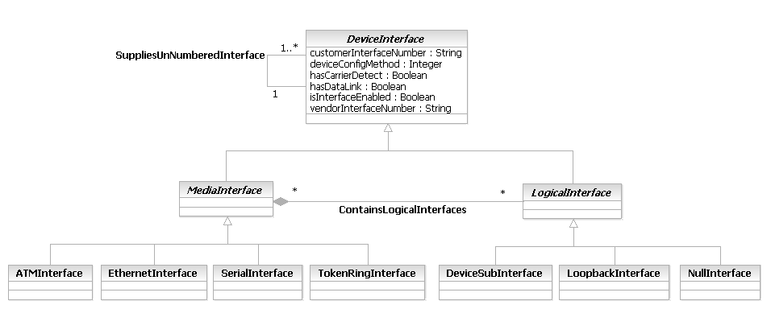
Figure LR.27 - Some Subclasses of DeviceInterface
The customerInterfaceNumber and vendorInterfaceNumber attributes provide customer-defined and vendor-defined names for this DeviceInterface. The former facilitates representing DeviceInterfaces in an enterprise, and the latter is required in order to model how to configure this DeviceInterface instance using the specific OperatingSystem version supported by a vendor for this device. Experience has shown that having these two attributes dramatically simplified the often difficult job of correlating naming strategies for network devices and the Services that they host.
The deviceConfigMethod attribute is an enumerated integer that defines how this interface is to be configured. Values include using the console or auxiliary ports (which usually means accessing the CCLI, or Command Line Interface, of the Device), using an EMS, or using other means (e.g., a proprietary protocol).
The hasCarrierDetect and hasDataLink attributes are used to verify that this DeviceInterface instance is working correctly.
The isInterfaceEnabled attribute defines whether this DeviceInterface instance has been administratively shut down or not.
A DeviceInterface has two subclasses – MediaInterface and LogicalInterface – that represent media-dependent interfaces and purely logical (i.e., virtual) interfaces.
MediaInterface is an abstract class that serves as the superclass for all interfaces that are directly hosted by a specific type of physical medium. It serves as a convenient aggregation point for defining different relationships that affect its subclasses, thereby avoiding having to instantiate multiple relationships that use different physical media but are otherwise essentially the same.
LogicalInterface is an abstract class that serves as the superclass for all purely virtual interfaces. This type of interface doesn’t have a corresponding physical implementation – it is instead a software construct.
The four subclasses of MediaInterface (as well as the three subclasses of LogicalInterface) that are shown in Figure LR.27 - are used for illustration, and are shown to help the reader understand the fundamental difference between a MediaInterface versus a LogicalInterface. As can be seen, ATM, Ethernet, Serial lines, and TokenRing are all forms of media that have a physical realization. In contrast, DeviceSubInterfaces, LoopbackInterfaces, and NullInterfaces are virtual, or logical, interfaces that have no physical realization – they represent software emulations of an interface, and greatly simplify the programming of a device.
A DeviceSubInterface represents sub-interfaces. These are virtual interfaces that are bound to a single physical interface. This enables different traffic to be assigned to different logical interfaces that are contained within a single physical interface. The traffic on the sub-interfaces are multiplexed into their containing interface.
A LoopbackInterface is a virtual interface that has a special property: traffic sent to the LoopbackInterface is forwarded to the Device itself for further processing. A LoopbackInterface is commonly used to guarantee reachability in networks with multiple paths. It is also used to test IP software without worrying about broken or corrupted drivers or hardware.
Finally, a NullInterface is another special type of virtual interface. Traffic sent to the NullInterface is discarded automatically.
All of these classes are defined more fully in the Data Dictionary section of this Addendum and in the system view.
DeviceInterface is related to a ResourceFacingService, as shown in Figure LR.28 - below:
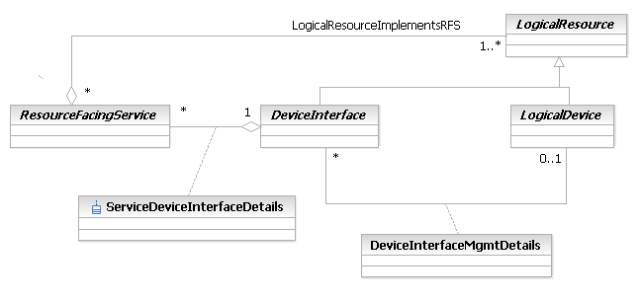
Figure LR.28 - Relationship between DeviceInterface and ResourceFacingService
Recall the relationship between Product, Resource and Service, as previously documented in Figure LR.07 - . The LogicalResourcesImplementRFS aggregation defines the set of LogicalResources required to implement a ResourceFacingService. The DeviceInterfaceHasRFServices aggregation shown above defines the particular set of ResourceFacingServices that a DeviceInterface is currently supporting. Hence, these two relationships work together – the first links different types of LogicalResources (not just DeviceInterfaces, but also Protocols, NetworkAddresses, LogicalDevices, and so forth) to a ResourceFacingService, while the second defines programming constructs (in the form of DeviceInterfaces) that are used to program all (or parts) of a ResourceFacingService.
The semantics of supporting a particular ResourceFacingService are captured by the ServiceDeviceInterfaceDetails aggregation class. Thus, the LogicalResourcesImplementRFS and DeviceInterfaceHasRFServices aggregations work together to help define how a particular ResourceFacingService is implemented. The LogicalResourcesImplementRFS aggregation defines at a high-level the set of LogicalResources required; the DeviceInterfaceHasRFServices aggregation defines one of the types of LogicalResources that are required to implement this ResourceFacingService.
The LogicalDeviceGovernsDeviceinterfaces association is used for two different purposes. First, it defines the set of DeviceInterfaces that are managed by a particular LogicalDevice. This association represents the administrative management of a specific DeviceInterface from its operational and configuration points-of-view. Its semantics are defined by the DeviceInterfaceMgmtDetails class. This flexibility enables complex devices that have multiple LogicalDevices to be modeled, where a particular LogicalDevice can be assigned to manage a given DeviceInterface. (Note that the system view provides much more additional information about this, such as how PartyRoles manage specific types of DeviceInterfaces and ResourceFacingServices.)
The second use is to enable different commands generated by the DeviceInterface to be orchestrated by the LogicalDevice. This is covered more fully in Figure LR.41 - Classes related to the PTP.
Please note that the use of DeviceInterface is optional. In particular, future versions of this Addendum will investigate not just DeviceInterface, but other methods, to program Services and LogicalResources. This is especially important for GMPLS and ASON work.

Protocol
A protocol is a formal set of rules and conventions that governs how two entities exchange information (usually over one or more types of network media). This is an abstract base class for representing protocols that can be managed. This class represents a convenient aggregation point for defining how protocols are managed and used. Figure LR.29 - shows the structure of the Protocol class hierarchy.
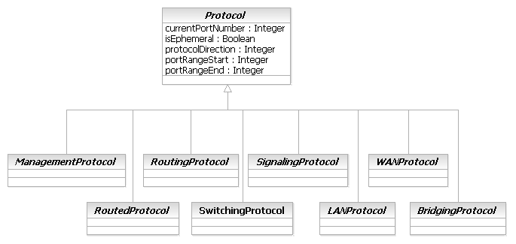
Figure LR.29 - Overview of the Top-Level Protocol Classes
The purpose of the above taxonomy is to form an extensible classification structure to enable contributions from other TMF programs and other industry standards to be added. Note that there is a large amount of disagreement in the network management space over how to model protocols. By building a taxonomy to normalize how different protocols are used, some of this confusion will be cleared up. Note also that this taxonomy specifically avoids any use of “layers”, since multiple protocol families (e.g., ATM and MPLS) do not fit neatly into a “layered” classification scheme.
A ManagementProtocol is an abstract superclass for protocols that are dedicated to exchanging management information between network devices. This type of protocol is an application layer protocol, and is used for configuring, monitoring, and gathering information about devices. An example of this type of protocol is SNMP.
RoutingProtocols is an abstract base class for representing different types of routing protocols that can be managed. Routing protocols are used to determine how information is routed (e.g., how it traverses an intermediate system). Examples of this type of protocol include OSPF, IS-IS, and BGP.
RoutedProtocols is an abstract base class for representing different types of routed protocols that can be managed. Routed protocols are those protocols that can be routed by a router. Specifically, the router must be able to interpret the logical internetwork as specified by that routed protocol. This class represents a convenient aggregation point for defining how routed protocols are managed and used. Examples of this type of protocol include IP and IPX.
In a network that uses standard routing, frames pass from a source to a destination in a hop-by-hop basis. Transit routers look at each frame's Layer 3 header and perform a route table lookup to determine the next hop toward the destination. This means that layer 2 information is effectively ignored. A SwitchingProtocol replaces the above hop-by-hop method with a method to specify a path in the network. This path may be based on any number of different attributes, such as cost of the path and QoS. The most popular implementation of this approach is MPLS.
LANProtocols operate at the lowest two levels of the OSI model (i.e., physical and data link) and are used to define communications over different types of local area media. Bridging Protocols operate at the data link layer of the OSI model, and are used to define communications over different types of homogeneous and heterogeneous local area networks. Examples of this type of protocol include Ethernet andToken Ring.
WANProtocols operate at the lowest three levels of the OSI model (i.e., physical, data link, and network) and are used to define communications over different types of wide-area media. Examples of this type of protocol include ATM, Frame Relay, and PPP.
SignalingProtocols is an abstract base class for representing different types of signaling protocols that can be managed. Signaling protocols are used to convey information along a specific path. This class represents a convenient aggregation point for defining how signaling protocols are managed and used. Examples of this type of protocol include RSVP and COPS.
Protocols interact with LogicalDevices as well as with ResourceFacingServices, as shown in Figure LR.30 - below. The RFServiceUsesProtocol aggregation defines the set of Protocols that are required by a particular ResourceFacingService. The semantics associated with how a given Protocol is used by a particular ResourceFacingService is defined by the ProtocolServiceDetails aggregation class (which is a system view class, and therefore its details are not shown in this model).
Each of the Protocol subclasses described in Figure LR.29 - has multiple subclasses, but these are system-oriented and beyond the scope of this (business-oriented) document.
The SupportsProtocol aggregation defines the particular set of Protocols that are supported by this LogicalDevice, independent of whether the protocol applies to the device as a whole or to an interface of the device. This aggregation enables the LogicalDevice to control the Protocols that are run on its various DeviceInterfaces.
The ProtocolRunsOn association defines the set of Protocols that are currently running on this DeviceInterface. This can be very complicated, depending on the layering of Protocols and media involved. In general, an instance of this association will be created for each layered Protocol that is represented. Also, the semantics of any particular Layer are realized by the ProtocolDeviceInterfaceDetails association class, as necessary.
The RFServiceUsesProtocol aggregation defines the set of Protocols that are required by a particular ResourceFacingService. The semantics associated with how a given Protocol is used by a particular ResourceFacingService is defined by the ProtocolServiceDetails aggregation class.

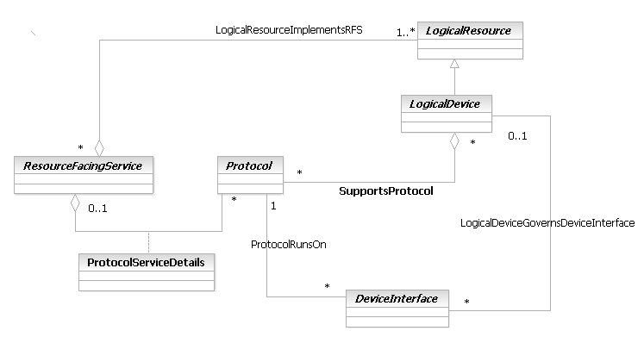
Figure LR.30 - Protocol Interactions

CompoundResource, ResourceCollection, and ResourceElement
PhysicalResource and its subclasses are designed to model the physical aspects of a managed Resource in as much detail as is necessary. Similarly, LogicalResource and its subclasses are designed to model the logical aspects of a managed Resource in as much detail as is necessary. Sometimes, however, it is easier to think of device components using a slightly higher level of abstraction. Note, for example, that it is common to think of a “device” – this has the connotation of aggregating the physical and logical aspects of the device together into a single managed entity.
The purpose of the CompoundResource hierarchy is to provide this abstraction. Conceptually, the CompoundResource class hierarchy provides a framework in which the PhysicalResource and LogicalResource class hierarchies can be aggregated into. This enables the application to construct application-specific views of the Resource or set of Resources that are being managed.
The reason that the ability to construct views is deemed so important is because different applications have different purposes, and need to focus on different parts of the network and/or different aspects of devices. The CompoundResource framework enables an application-specific view to be constructed from a standard template.
The semantics of the CompoundResource class dictate the following:
- At least one or more PhysicalResources must be present
- At least one or more LogicalResources must be present
- Optionally, CompoundResources can be aggregated as well
It is very important to realize that a CompoundResource MUST have at least one PhysicalResource and at least one LogicalResource present. Otherwise, one could simply have separate PhysicalResources and LogicalResources, which are related by appropriate associations. In effect, the CompoundResource is “shorthand” for referring to a managed entity that has both physical and logical aspects to it. For example, a Router could be modeled as a CompoundResource, since it has physical (e.g., Cards) and logical (e.g., route processing) aspects to it.
Note that CompoundResource is a subclass of Resource. This enables a CompoundResource to inherit all of the characteristics and behavior of a Resource. Even more importantly, ResourceSpecification can be subclassed to templatize the creation of CompoundResources. This also applies to Characteristics, CharacteristicValues, Versions, and other entities. If CompoundResource wasn’t a subclass of Resource, all of this work would have to be repeated. This would make it very difficult to synchronize these characteristics of CompoundResource with the same characteristics of PhysicalResource and LogicalResource.

The CompoundResource class hierarchy is shown in Figure LR.31 - below.
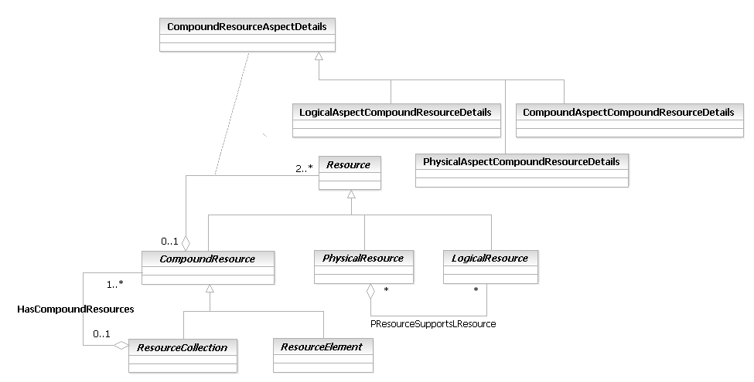
Figure LR.31 - CompoundResource, ResourceCollection, and ResourceElement
A key point is that each managed entity that is part of a CompoundResource can be individually managed. The CompoundResource is an abstraction that enables the physical and logical aspects of a complex entity, such as a Router, to be looked at using one (instead of multiple) objects. As such, it (and its subclasses) facilitate the coordination of configuration, monitoring, troubleshooting commands to be applied to different aspects of the CompoundResource. It also enables policies to be written that coordinate the physical and logical aspects of the CompoundResource..
The formal definition of how the physical and logical aspects of a CompoundResource is represented is very powerful, and is described as follows. Referring to Figure LR.31 - above, the HasCompoundResourceAspects aggregation is used to aggregate PhysicalResources, LogicalResources, and optionally CompoundResources into a specific CompoundResource. The 0..1 cardinality of this aggregation defines this relationship to be optional. In other words, CompoundResources are not required in an implementation. If a CompoundResource is needed (the “1” of the 0..1 cardinality), then two or more Resources must be present in order to instantiate a CompoundResource. These two Resources are, of course, one PhysicalResource and one LogicalResource. The “n” part of the 2..n cardinality enables additional PhysicalResources, LogicalResources, and optionally CompoundResources to be aggregated into this specific CompoundResource.
(Note that this representation is technically insufficient to implement the semantics described above. The system view of the model shows OCL (Object Constraint Language) statements that implement these semantics. However, OCL is not considered appropriate for business readers. Therefore, the OCL has been removed from Figure LR.31 - above.)
The HasCompoundResourceAspects aggregation defines the set of PhysicalResources and LogicalResources (and optionally, CompoundResources) that are necessary to create a particular CompoundResource. In order to show the PhysicalResources and LogicalResources that make up a particular CompoundResource, the HasCompoundResourceAspects aggregation is instantiated at least twice – once to show the physical aspects of the CompoundResource, and once to show its logical aspects.
The semantics of the CompoundResourceAspects aggregation are represented as an association class, called CompoundResourceAspectDetails. This is an abstract class and cannot be instantiated. Its purpose is to serve as the parent class for defining three subclasses of this class, which are used to represent the aggregation of PhysicalResources, LogicalResources, and CompoundResources into this particular CompoundResource. This enables a single relationship with a single association class to be defined, instead of having to define three different relationships. Besides requiring less model elements, this approach emphasizes the inherent synergy between the different aspects of a CompoundResource by defining three different association classes that are derived from one common one.
CompoundResourceAspectDetails has three subclasses. These are called PhysicalAspectCompoundResourceDetails, LogicalAspectCompoundResourceDetails, and CompoundAspectCompoundResourceDetails, and represent the physical, logical, and (optionally) CompoundResourceAspects of a particular CompoundResource. Note that if a CompoundResource is defined, then at least two HasCompoundResourceAspects aggregations will be instantiated (one will have a PhysicalAspectCompoundResourceDetails class to define its physical semantics, and the other will have a LogicalAspectCompoundResourceDetails class to define its logical semantics). Additional HasCompoundResourceAspects aggregations for relating additional subclasses of CompoundResourceAspectDetails are NOT required, since these new subclasses all inherit the HasCompoundResourceAspects aggregation. This is shown in Figure LR.32 - below.
This figure shows a Router modeled as a type of ResourceElement. This means that the Router must aggregate at least one PhysicalResource entity and at least one LogicalResource entity. The PhysicalResource entities and LogicalResource entities are identified in different colors on Figure LR.32 - to help show their different instances.
Starting at the bottom of Figure LR.32 - , there is a dashed line between the Router entity and the PhysicalDeviceAtomic entity. This depicts the physical part of the router – the enclosure and all of its Cards, PhysicalPorts, PowerSupplies, and so forth – as an assembled, atomic unit. This is because a PhysicalDeviceAtomic aggregates Hardware, and each of its components (Cards, etc.) are subclasses of Hardware. This is explained in more detail in [Add 5PR].
We also see three dashed lines connecting LogicalDevice, OperatingSystem, and ManagedTransmissionEntity to the Router entity. These are exemplary logical aspects of the Router – additional detail, such as DeviceInterfaces, Protocols, Software, and Addresses, would also exist. They have been omitted from Figure LR.32 - to keep the figure simple. The particular set of LogicalResource subclasses that are instantiated depend on the desired semantics that are required to be represented.
Each of the physical and logical aspects that are depicted with the dashed lines at the bottom of Figure LR.32 - are in reality instances of the HasCompoundResourceAspects aggregation, which is at the top of the Figure. Note that there are two aggregations shown (there should really be four, but only two are shown for simplicity. Each aggregation is implemented using a class.
Thus, we see that our Router is a shorthand notation for a set of PhysicalResources, LogicalResources, and optionally CompoundResources that collectively represent the physical and logical aspects of the Router. The concept of a CompoundResource helps simplify representing complex devices, and ensures that commands and policies that affect the physical and logical aspects of a device are sent to both the physical and logical components of the device.
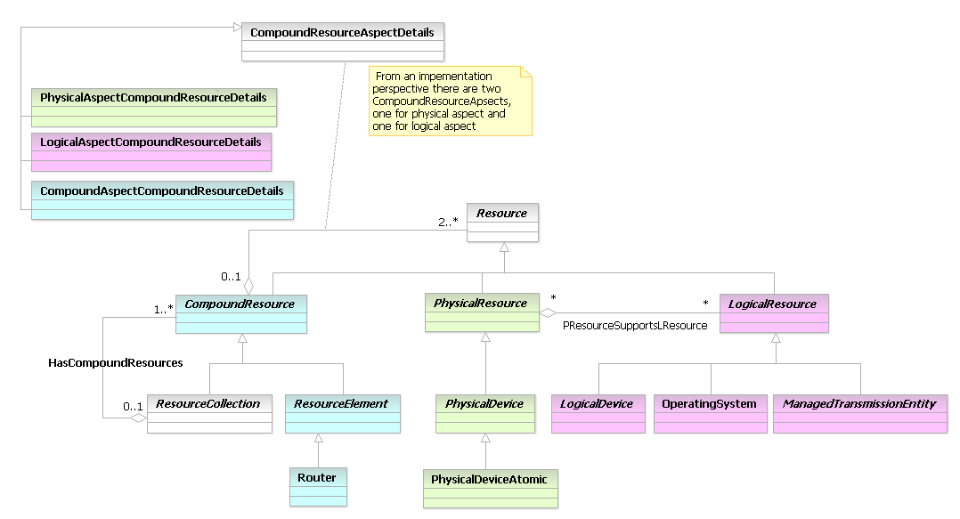
Figure LR.32 - Example Instance Implementation of a CompoundResource
CompoundResource has two subclasses, called ResourceElement and ResourceCollection. Both of these subclasses represent managed entities that have physical and logical aspects.
It should be noted that this is in reality another use of the composite pattern.
A ResourceElement is an entity that is individually manageable. For example, a Router can be modeled as a ResourceElement. Different PhysicalResource objects can model the physical aspects of the Router in detail, and different LogicalResource objects can model the logical aspects of the Router in detail. If the Router was a modular Router that was made up of different PhysicalDevices having different logical capabilities, then each of these “sub-devices” could be represented as a CompoundResource. ResourceElement aggregates an appropriate set of PhysicalResource, LogicalResource, and CompoundResource objects, enabling a high-level view of all of the aspects of the Resource to be provided.
A ResourceCollection is an entity that is also individually manageable. If we “look inside” a ResourceCollection object, we find an aggregate entity consisting of at least one ResourceElement and zero or more ResourceCollection entities. This is represented by the HasCompoundResources aggregation. For example, a Network can be modeled as a subclass of ResourceCollection. A Network can be made up of other Networks and/or SubNetworks. Each Network or SubNetwork can, be made up of physical and logical components. Each node in the network can be represented by a ResourceElement. Thus, the ResourceCollection enables a single entity to represent a set of ResourceElements. This is very convenient for many different types of applications. One important example are topology applications, that support the ‘drill-down” of elements. That is, imagine a network appearing as a single icon in a topology map. This would be a ResourceCollection. Now, imagine the user double-clicks on that icon, bringing up the next level of detail. This would show the different components of the Network, such as SubNetworks and individual network devices. These would be examples of ResourceElements. The process can continue for as many levels as desired because the HasCompoundResources cardinality on the component side is 1..n.

TIP ABE
The SID incorporates the LogicalResource model used for the MTNM/MTOSI interface. This model fragment is called the “TIP model”. This section provides a brief description of the model. To facilitate addition of these classes two profiles, the TIP Profile and the Lifecycle Profile, have been developed. The TIP Profile provides stereotypes that indicate how attributes, classes and relationships should be used in the TIP implementation and the Lifecycle profile provides stereotypes that indicate the maturity of a specific element of the model. It is intended that these profiles be generally applicable to the SID model and that the TIP Profile be used in the longer term to drive interface generation tooling.
The relationship between the TIP model ABEs and the other model elements in the SID (described in this document and in other documents) is discussed in the next section.
The TIP model has been built into the existing hierarchy under LogicalResource as shown in Figure LR.33. This figure shows the key classes of the TIP model and these will be described in more detail in the context of their inter-relationships later in this section. The Logical Resource ABE has been augmented with these key TIP classes which can be found in the Tip Logical Resource ABE.

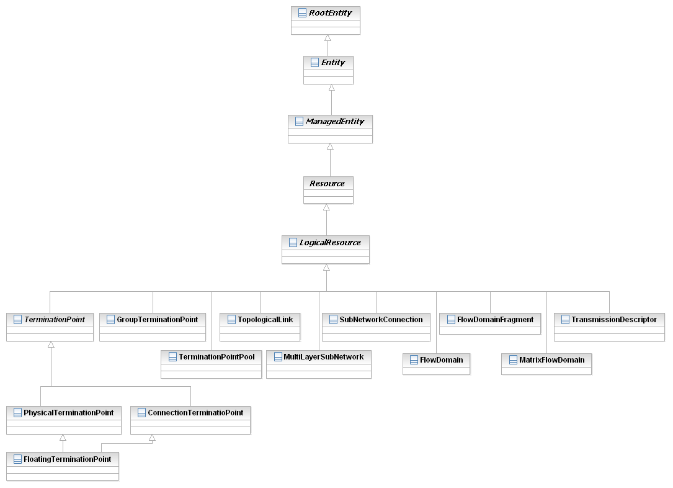
Figure LR.33 - MTOSI/MTNM Inheritance Class Diagram
To ensure compatibility with the existing MTNM/MTOSI interface implementations some attributes from the common classes in the TIP model have been introduced into the RootEntity (found in the Root Business Entity ABE). The attributes that have been introduced have been marked with appropriate stereotypes from the TIP profile, <<tipAttribute>> and <<tipProduct>>, and the attributes from SID 8 in the RootEntity have been marked with the <<doNotImplement>> sterotypes from the TIP profile to indicate that they should not be used for TIP conformant interface implementation. The Entity and ManagedEntity classes does not have any TIP attributes but as they are directly in the inheritance path to Resource the attributes are all marked with the <<doNotImplement>> sterotypes from the TIP profile.
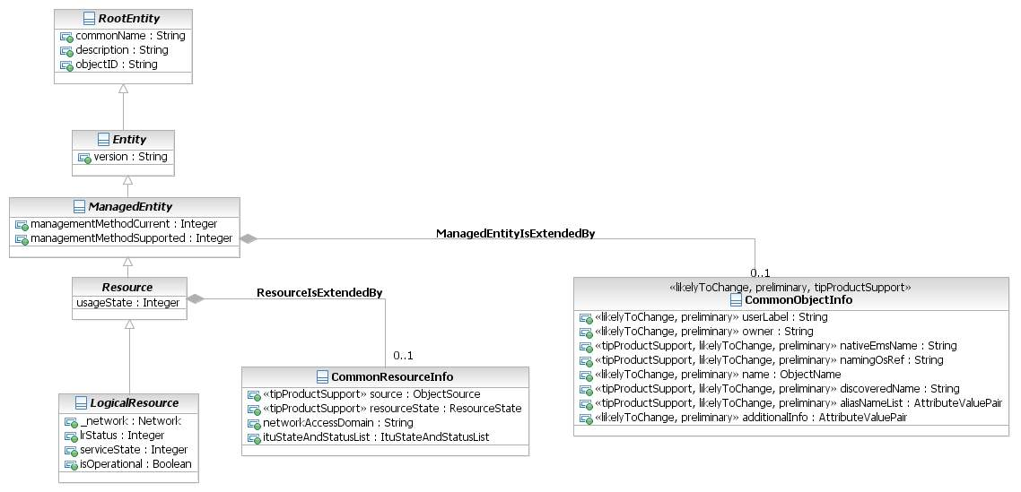
Figure LR.34 - MTOSI/MTNM Inheritance Class Diagram with Attributes
The attributes for the RootEntity, Entity and ManagedEntity are shown in figure x. It should be noted that the stereotype display has been suppressed in RSM displays but the details can be seen in the stereotype pane of the properties tab. For clarity the attributes that have been added for TIP, all of which are in RootEntity, are listed here (each of the remaining attributes in RootEntity, Entity and ManagedEntity is marked <<doNotImplement>>):
- additionalInfo
- owner
- userLabel
- name
- aliasNameList (mtosi)
- discoveredName (mtosi)
- namingOSRef (mtosi)
- nativeEmsName (mtnm)
The Resource class in the Resource ABE has been augmented with a number of attributes that are drawn from the TIP model. For clarity the attributes that have been added for TIP are listed here (each of the remaining attributes is marked <<doNotImplement>>):
- ituStateAndStatusList
- networkAccessDomain
- resourceState (mtosi)
- source (mtosi)
All attributes of LogicalResource are marked <<doNotImplement>>.
The classes RootEntity, Entity, ManagedEntity, Resource and LogicalResources have associations to other parts of the SID. It should be emphasized that the attributes that represent these associations are all marked <<doNotImplement>>. This intentionally detaches the Tip Logical Resource classes from the remainder of the SID. These associations will be explored and some may be enabled for future releases of the SID.
The classes in the Tip Logical Resource ABE have been introduced in conjunction with a number of other classes from the TIP model that have had their attributes removed. These “empty” classes have been added to the model solely to terminate associations from classes in the Tip Logical Resource ABE where in the existing MTNM/MTOSI the associations go outside the LogicalResource space. It is the intention that in a later release these association terminating classes will be removed and replaced with a more complete model elements. As a consequence the association terminating classes have been marked with the stereotypes <<likelyToChange>> and <<preliminary>> from the Lifecycle Profile and <<doNotImplement>> from the TIP Profile (as the actual classes are still present in the traditional TIP interface documentation (reference)).
Two of these “empty” classes, managedElememt (in the Resource ABE) and managementDomain (in Tip Common ABE which is in the Root Business Entity ABE), are shown in Figure LR.35 that depicts the containment view of the model. Both managedElement and managementDomain are provided solely to terminate relationships and as a consequence there are marked <<likelyToChange>>, <<preliminary>> and <<doNotImplement>>. These classes will be further harmonized in a future release of the SID. The figure emphasizes that all of the core TIP classes are contained in ManagementDomain.
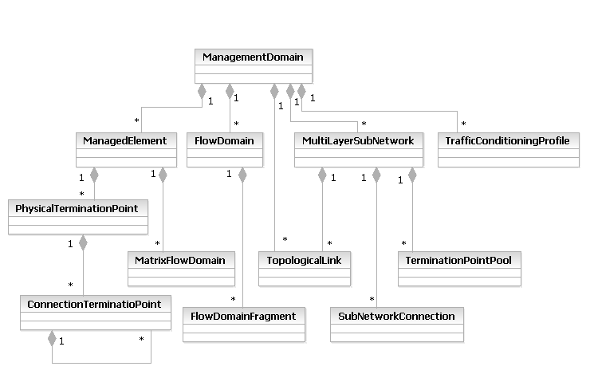
Figure LR.35 - MTOSI/MTNM Containment
The Tip Model classes in the Network Fulfilment ABE can be grouped into three distinct fragments:
- Termination model fragment
- Connection oriented model fragment
- Connectionless model fragment
Prior to embarking on the details of the specific fragment it is important to recognize that all classes in these three fragments are provided for the purpose of management of transport entities in the network. Each class is named to reflect the key aspects and/or familiar names of the transport entities for which it provides management. Where the name happens to coincide with that of a transport entity in a network protocol model this does not mean that the construction reflects exactly that of the transport entity in the network protocol model. Some of the classes have names that are the same as other classes in the SID. A specific example of this is the ConnectionTerminationPoint (where the other class with the same name is in the Managed Transmission ABE). It should be noted at this point that the classes in the Managed Transmission ABE are likely to change in a future release and are no longer recommended for use. This is highlighted in the SID using the <<likelyToChange>> and <<likelyToBeDeprecated>> stereotypes of the Lifecycle profile. The classes in the Managed Transmission ABE are likely to be replaced with classes more closely related to those in the three fragments highlighted above and at that point the name duplications will be removed. The ConnectionTerminationPoint in the Network Fulfilment ABE is recommended for use. The capabilities of the Connection Termination Point can be considered in the context of the Terminiation model fragment of the TIP model.
The Termination model fragment highlights the generalized class TerminationPoint and the specializations of PhysicalTerminationPoint, ConnectionTerminationPoint and FloatingTerminationPoint as shown in Figure LR.36. These are the core classes of the Termination Point model fragment of the TIP model and are described in more detail in supporting documents of the TIP interfaces (for example [SD1-18] of TMF 814). In addition to these core TerminationPoint classes there is also a TerminationPointPool and GroupTerminationPoint that both represent collections of TerminationPoints that may be used together and configured as one. The figure emphasizes that the core TerminationPoint model is strongly bound to the ManagedElement such that they relate to a “nodal” view where as the model of collections of termination points is bounded by the MultiLayerSubNetwork. The MultiLayerSubnetwork represents a fragment of the network that may incorporate the capabilities of many ManagedElements and hence can be considered where it does incorporate more than one ManagedElement as a “multi-modal” view. The MultiLayerSubnetwork will be describes in more detail with respect to the Connection Oriented model fragment below.
As indicated by the name the MultiLayerSubnetwork may represent many transport layers. In general TIP model is a layered model. The model specifically follows the layering principles of ITU-T G.805 (as opposed to any other layering approach) and supports the various transport technologies (Ethernet, SDH, WDM, DSL etc.) by qualification of layers using the TransmissionParameterList which offers a list of parameters per layerRate. The TerminationPoint classes should not be extended by generalization/inheritance. This principle of extension by qualification via flexible attributes as opposed to extension via generalization/specialization applied to the whole of the TIP model fragment. The approach to use of the TerminationPoint model to support specific technologies is shown via example in the documents of the TIP interfaces (for example [SD1-18]).
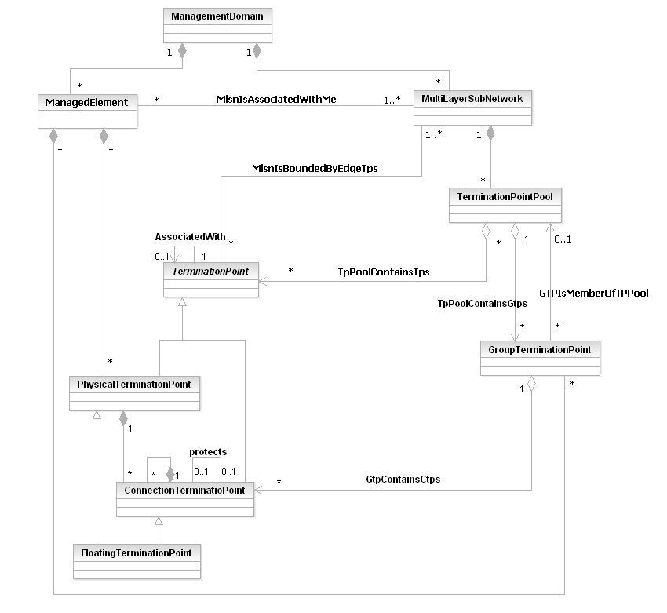
Figure LR.36 - MTOSI/MTNM Termination Point Model
The MTNM/MTOSI model also include the AlarmSeverityAssignmentProfile class (ASAP) that has the <<preliminary>> and <<likelyToChange>> stereotypes applied. This class supports the assignment of alarm severities for various entities. This class of the MTNM/MTOSI model has not been fully incorporated in the SID at this stage. As noted above this class is included in the model to represent the ends of associations from the other fragment of the model.
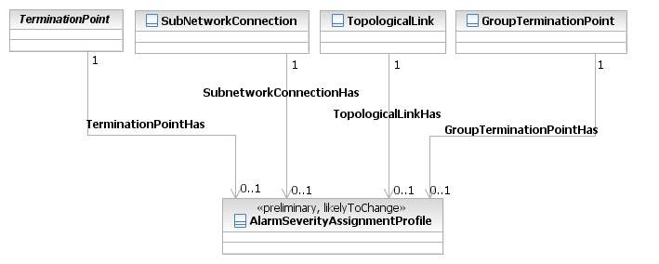
Figure LR.37 - MTOSI/MTNM AlarmSeverityAssignmentProfile
Clearly in addition to termination there is a need to represent the flow of a signal and this can be described in terms of the Connection Oriented model fragment. This fragment provides the key class SubnetworkConnection (introduced in the ASAP figure above). This represents the flow and/or potential flow of signal for a connection oriented technology between TerminationPoints or between GroupTerminationPoints. The SubnetworkConnection supports various types of connectivity (unprotected, protected etc.) and is always contained in a MultiLayerSubNetwork which represents the potential for creation of connectivity. The SubnetworkConnection can either represent the signal flow within a single ManagedElement where the MultiLayerSubnetwork that it is contained in is a “nodal” form or represent the signal flow across a portion of network, and hence potentially many ManagedElements, where the MultiLayerSubnetwork is “multi-nodal”. In a “multi-nodal” case the Route of the traffic within a SubnetworkConnection is described by a structure of Crossconnect data elements. Although not explicit in the model a Crossconnect can only interconnect ConnectionTerminationPoints that are within a single ManagedElement (where ConnectionTerminationPoint includes the FloatingTerminationPoint as indicated in Figure LR.33) .
The figure also shows the ToplogicalLink that interconnects TPs and essentially represents the interconnection between ManagedElements either within a MultiLayerSubNetwork (shown as contained in that subnetwork in Figure LR.38) or between MultiLayerSubNetworks (shown as contained in ManagementDomain in Figure LR.38). A ToplogicalLink is present in a specific layer and it represents the capacity provided by specific flow of connection oriented traffic in that layer to its client layer(s).

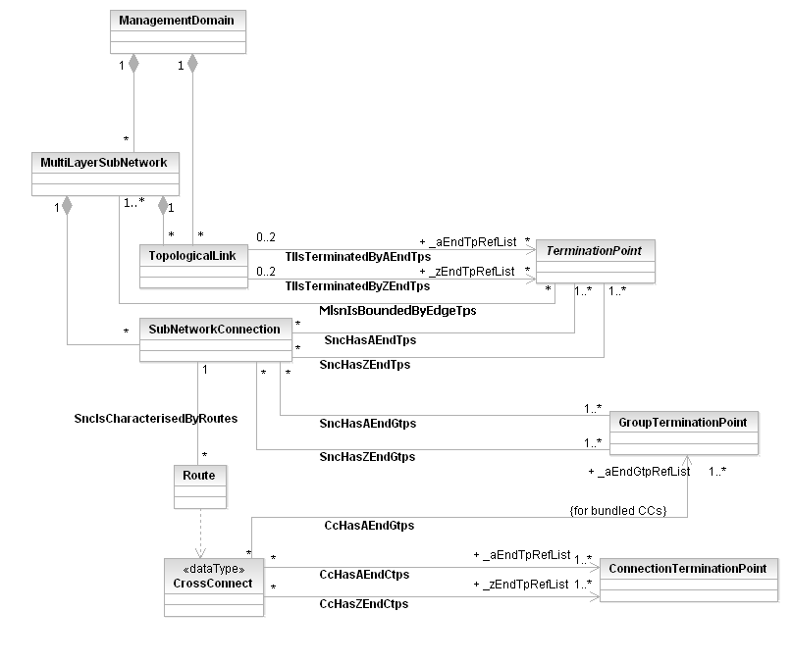
Figure LR.38 - MTOSI/MTNM Connection-oriented Class Diagram
The Topological Link also appears in the connectionless model fragment as shown in Figure LR.39. In this case it represents the capacity provided to a connectionless layer by its connection oriented server. The connectionless model is very similar to the connection oriented model. The FlowDomainFragment is essentially the connectionless equivalent to the SubnetworkConnection. It represents the flow of a connectionless protocol between TerminationPoints that are at the bounds of the FlowDomain (the connectionless equivalent of the MultiLayerSubNetwork). Just like the MultiLayerSubnetwork the FlowDomain can take a multi-nodal of a single nodal form. Similar to the connection oriented model the FlowDomainFragmentRoute (essentially the route of the potential flow of traffic and hence directly equivalent to the Route of the SubnetworkConnection) may be represented by the matrixFlowDomainFragment which is essentially equivalent to the CrossConnect. It should be noted however that unlike the connection oriented model a routing fabric within a single ManagedElement that participates in a multi-nodal subnetwork is actually represented by an object, the MatrixFlowDomain. It should be noted here that a ManagedElement may have associated more than one MatrixFlowDomain for the same layer. The MatrixFlowDomain models the grouping of a subset of the TerminationPoints of the ManagedElement. The MatrixFlowDomainFragment as its name implies can only interconnect TerminationPoints that are members of the same MatrixFlowDomain and hence are also within the bounds of a single ManagedElement.

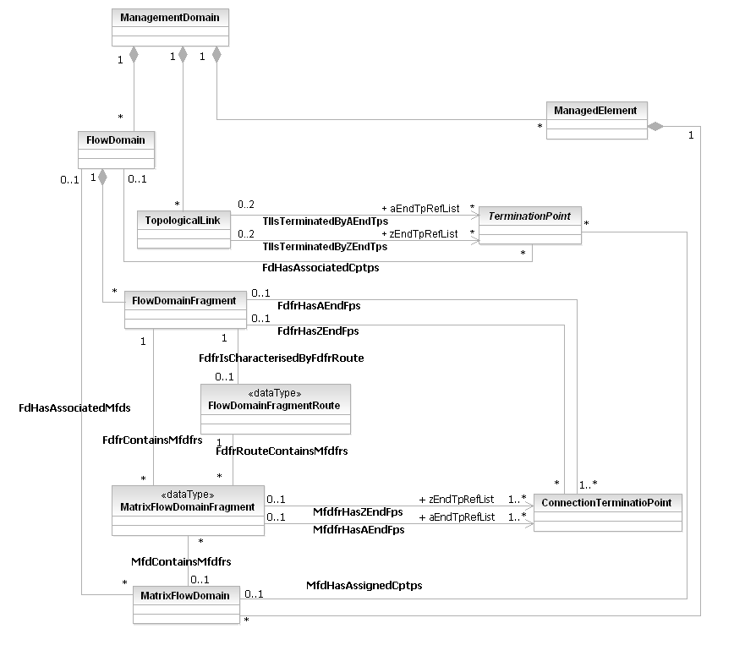
Figure LR.39 - MTOSI/MTNM Connectionless Class Diagram
Finally the TIP interface model provides a mechanism to convey generalized attributes. This mechanism uses the TransmissionParameterList datatype which is an extensible list structure that is applied on a per layer basis and is available to all key layered classes as shown in Figure LR.40. This enables vendor additions and model growth.
Also shown in Figure LR.40 are theTransmissionDescriptor and TrafficConditioningProfile. These two classes offer mechanisms to control attributes related to specific Termination Points.
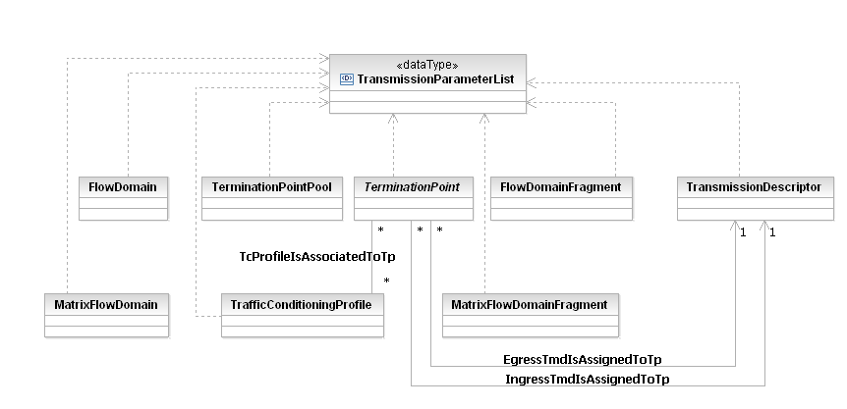
Figure LR.40 - MTOSI/MTNM Transmission Parameters, Profiles and Descriptors

Integrating the SID and MTNM/MTOSI Models
This version of the SID includes the MTNN/MTOSI Logical Resource model as discussed in the previous section. It is intended that in future releases the models in the SID will be further harmonized. For example the PTP and DeviceInterface entities have many properties in common and have a related purpose. The DeviceInterface represents a factory for creating some entities in the model and also can be considered as a proxy for configuration. The PTP provides potential CTPs and this approach can also be viewed as similar to a factory, as an actual CTP appears as a result of the creation of a connection using a name provided by a potential CTP of the PTP.
More detailed work needs to be carried out to find the true synergy between the essence of these two classes and the other related classes and subsequently to rationalize the model. This work will build from the understanding that the MTNM/MTOSI model has three main goals related to reducing cost of integration:
- remove unnecessary variety in interfacing through the use of a single model and interface definition for all network technologies
- ensure interoperability among heterogeneous devices
- enable differentiation through an extensible core model (it currently covers WDM, SDH, SONET, PDH, ATM, Ethernet and others).
Conceptually, the domain of MTNM is primarily concerned with modeling the transport; the SID serves as an over-arching model of the environment as a whole. Hence, further harmonization of the TIP ABE with the other ABEs in the SID will start by focusing on the following SID 8 classes:
- PhysicalPort, to represent the “end” of the physical domain
- The combination of LogicalDevice and DeviceInterface, to represent the beginning of the logical domain
- TerminationPoint,

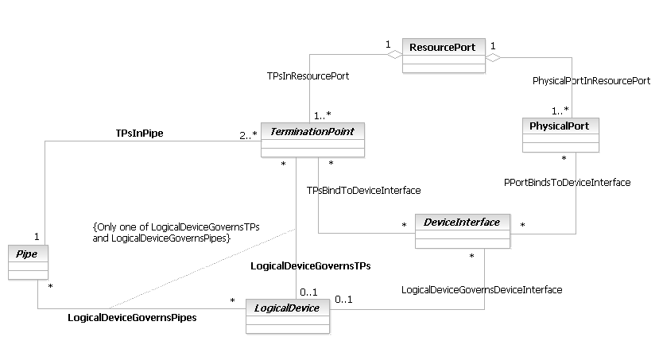
Figure LR.41 - Classes related to the PTP
Figure LR.41 show a number of SID 8 classes that will be relevant in the next stage of harmonization of the SID with MTNM/MTOSI PhysicalTerminationPoint. ResourcePort serves as a bridge to enable the physical and logical domains to interact. DeviceInterface is used to program the logical aspects of the ResourcePort. LogicalDevice is used to setup the DeviceInterface, which then serves as the control point for programming the TerminationPoint using the combination of the LogicalDeviceGovernsDeviceInterfaces (for the LogicalDevice to control the DeviceInterface) and the TPBindsToDeviceInterfaces (for the DeviceInterface to control the TerminationPoint) associations.. Note the use of OCL in Figure LR.41 - Classes related to the PTP – this means that either a LogicalDeviceGovernsTPs or LogicalDeviceGovernsPipes association can be instantiated, but not both. This is because a TerminationPoint is also related to a Pipe, and if both the LogicalDeviceGovernsPipes and LogicalDeviceGovernsTPs associations are instantiated, a circular reference would be produced. The entirety of the above consideration is encapsulated in the MTNM/MTOSI PTP.

ManagedTransmissionEntities
A ManagedTransmissionEntity is an abstract base class for describing different types of logical entities that are or help to form connections that transmit and/or receive information. Note that these entities are often called transmission entities (or path entities). Its high-level classes are shown in Figure LR.42 - below.
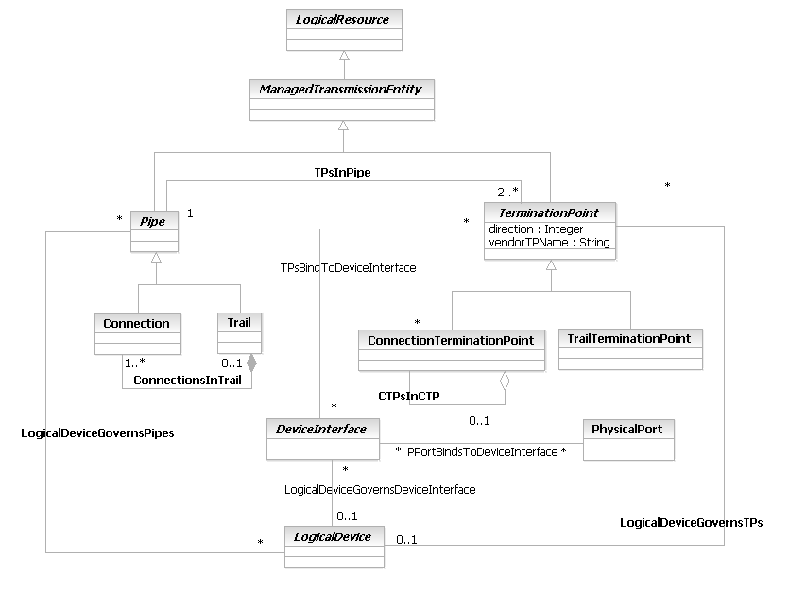
Figure LR.42 - Top-Level ManagedTransmissionEntity Class Hierarchy

A CTP is an actual or potential end point of a Network connection. For example, this can represent a logical channel or a timeslot on a physical link. All PhysicalPorts can connect to at least one type of CTP.
A TTP is an actual or potential end point of a Trail. All PhysicalPorts can connect to at least one type of TTP.
A TerminationPoint is an abstract class whose purpose is to group different types of TrailTerminationPoints and ConnectionTerminationPoints. This enables a single composition (TPsInPipe) to be run to this class, which is then inherited by its subclasses. This is deemed better than building three relationships between the (currently) three types of TrailTerminationPoints and the Pipe class. Note that each has the same containment relationship.
Information on the end point label is a common identification of the traffic flow managed in each termination point entities of a network resource. The logical resource model should be able to represent an abstraction of specific tags format that each network element vendor implements. An end point label attribute for termination points provides functionality to manage the configuration of the network resource element.
The following examples illustrate the use of this attribute:
- In an ATM DSLAM network element, a customer-side termination end point (a ConnectionTerminationPoint in SID model, that is a specialization of TerminationPoint) can have end point label in format “port-id/VPI/VCI”; for instance “1-1-1-1/8/36”, termination point for data flow of VPI 8, VCI 36 on port 1-1-1-1.
- IN an IP DSLAM network element, a customer-side termination end point (a ConnectionTerminationPoint in SID model) can have end point label in format “port-id/sVLAN-id/cVLAN-id”; for instance “1-1-1-1/108/33”: termination point for data flow of a stacked VLAN, sVLAN-id 108 and cVAN-id 33, on port 1-1-1-1.
This yields the following figure (note that some classes referenced in this figure will be defined later in this document):
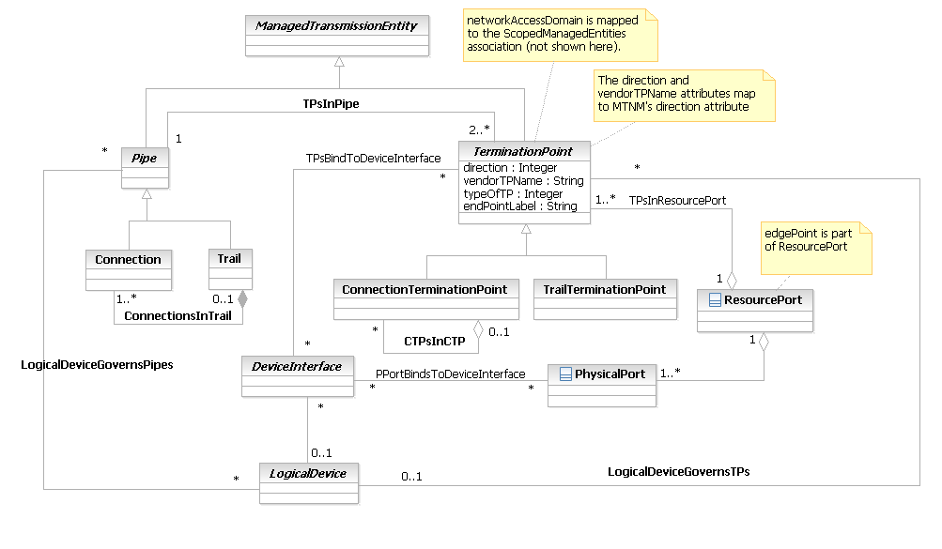
Figure LR.43 - TerminationPoint in context

Network
A Network is defined in [M.3100] as a managed object that is a collection of interconnected telecommunications and management objects (logical or physical) capable of exchanging information. The objects in a network have one or more common characteristics that define their common semantics and behavior. For example, they may be owned by a single customer or provider, or associated with a specific service network. A network may be nested within another (larger) network, thereby forming a containment relationship. An example of a network that is contained in another network is a transmission sub-network. It is owned by a single Administration (which is possibly different than the owner of its enclosing Network) and can only perform transmission functions.
This definition is implemented by subclassing the ResourceCollection class and using the composite pattern, as shown in Figure LR.44 - below:
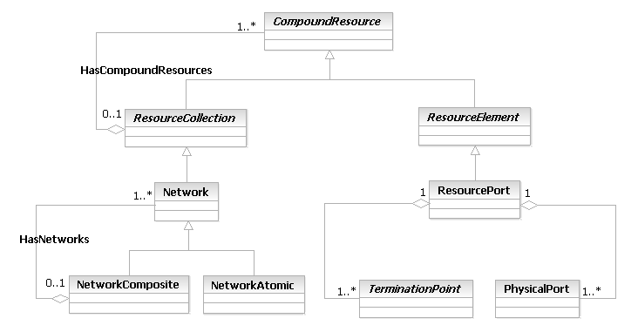
Figure LR.44 - Defining the High-Level Concept of a Network
In the following discussion, various ITU-T recommendations, as well as the TMF MTNM/MTOSI model, are used as the basis for the Network classes. It should be noted that in SID phase 9 the MTNM/MTOSI model has also been included directly (see TIP ABE on page 75) and in subsequent SID phases the network model described in this section and the MTNM/MTOSI model will converge.
In the event of a conflict between the ITU-T recommendations and the TMF MTNM/MTOSI model, the TMN MTNM/MTOSI model will be used. Note that the TMF MTNM model has been submitted to the ITU-T. In all cases, the semantics of these definitions have been enhanced to enable objects defined in the ITU to interact with objects defined in the IETF. This is one of the important design goals of the SID.
Originally, the semantics of the Network class are based on those defined from [M.3100]. Note, however, that its UML derivation is significantly different. In [M.3100], Network derives from Top (which in the SID is represented by RootEntity). In the SID, the RootEntity class (like Top) has no real semantics – it simply serves as the root of the tree, and is used in the business view to define two attributes that are common to all classes – userDefinedName and description.
Clearly, a “network” has inherent semantics of many types, such as:
- Connectivity
  - External
  - Internal (though note that every element in the network is not necessarily connected to every other network)
- Type of network (ad-hoc, fixed, mobile, …)
- Organization of its elements (e.g., structured vs. unstructured peer-to-peer)
- Topology (full-mesh, partial-mesh, hub-and-spoke, …)
- Management approach (are there multiple administrative domains? Are control protocols used? Etc.)
The above list could go on for two pages. This is why the Network (and related entities, such as SubNetwork, LayerNetwork, and so forth) has not been subclassed from Top, because many of the above semantics are shared by different types of Networks, SubNetworks, and so forth.
In examining the above semantics, networks are clearly managed, logical entities that have inherent physical characteristics. This suggests CompoundResource as a possible superclass of Network. Looking at next generation networks, ubiquitous computing, ambient networking, and other initiatives, it becomes convenient to use “network” as a term that describes a set of networks and/or network elements acting in unison.
This reflects the structure of Figure LR.44 - above – ResourceCollection represents a set of CompoundResources, which can include ResourceElements as well as ResourceCollections. A Network is therefore a type of ResourceCollection, since it consists of a set of CompoundResources. ResourceElement is used to represent important abstractions that are also part physical and part logical. One of the most important of these is the concept of a ResourcePort, which is used to map to the unqualified noun “port” used in many different specifications. Hence, atomic components of a Network (e.g., a “ResourcePort” that represents the combined physical and logical aspects of a “port”) are derived from the ResourceElement class.
A Network is a managed object that represents an aggregation of interconnected telecommunications and management objects capable of exchanging information. The reason that a Network is subclassed from ResourceCollection is that it is important that a Network is able to represent physical and logical characteristics and behavior, which is provided by the concept of CompoundResource.
The composite pattern is used to describe types of Networks. The NetworkAtomic class represents network entities that are units of functionality in their own right, while the NetworkComposite class represents network entities that are collections of other network entities. This is discussed more in the text above Figure LR.46 - .
A Network has the additional semantics (not shown in Figure LR.44 - above) of having one or more common characteristics and/or behavior. For example, a network may be owned by a single customer or provider, or be associated with the delivery of a specific set of services; alternatively, its administration may be shared among multiple people from multiple organizations that are responsible for different functions (e.g., the access layer vs. the core layer), and be used for both business-critical as well as traffic that is not business critical. Issues such as these are made straightforward by using the different patterns and abstraction mechanisms (e.g., roles) that are foundational building blocks of the SID.

Network Subclasses and a Refined Network Model
To test Figure LR.44 - to see if it is sufficient to represent different types of networks, let’s now examine several different types of networks.
A LayerNetwork is derived from [G.805], and (for the purposes of this Addendum) is defined by the complete set of information of the same type, existing at a given layer, which may be associated for the purpose of transferring information. A separate, logically distinct layer network exists for each trail termination type. The topology of a LayerNetwork is described by the SubNetworks that it contains and the Links connecting them.
(Note: many people use terms such as “Access Layer”, “Core Layer”, and others. Such terms refer to a common set of functions performed by managed entities. While this usually implies that an entire device provides this functionality, modern network design allows for portions of a device (such as a DeviceInterface) to perform this function. Hence, the SID models these terms as roles, and reserve the use of the term layer to refer specifically to common information exchanged between components of a LayerNetwork.)
The SID defines the concept of a ResourcePort, to eliminate the ambiguity as port could be considered as both a physical as well as a logical concept. This is why ResourcePort is subclassed from ResourceElement – since a ResourcePort combines physical and logical aspects, it is a type of CompoundResource.
A ResourcePort class abstracts the concept of a set of Ports from [G.805], and is a type of ResourceElement that consists only of (logical) TerminationPoints and PhysicalPorts. This enables the ResourcePort to take on the physical and logical characteristics of a "port" as defined in [G.805].
Figure LR.45 - shows how the ResourcePort semantics would be defined. Note that both the PhysicalAspectCompoundResourceDetails and the LogicalAspectCompoundResourceDetails association classes have been subclassed from a common superclass (CompoundResourceAspectDetails) to represent the specific semantics of aggregating TrailTerminationPoints and PhysicalPorts into a ResourcePort. Since they share common high-level semantics, they are subclassed from CompoundResourceAspectDetails; however, since the semantics of TPsInResourcePort and PhysicalPortsInResourcePort are significantly different at a granular level of detail, we define two subclasses of CompoundResourceAspectDetails to represent these differences. This is arguably more of a system view, but it was felt important to provide at least one example of how this works.
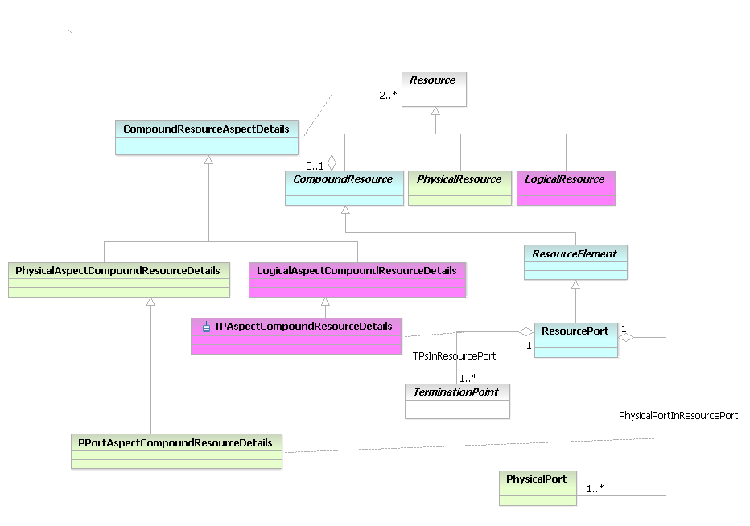
Figure LR.45 - ResourcePort Details
Given the notion of a ResourcePort, we can now define a SubNetwork, which is also derived from [G.805]. A SubNetwork exists within a single layer network, and consists of a set of ResourcePorts, which are available for the purpose of transferring characteristic information. SubNetworks may be partitioned into smaller SubNetworks interconnected by links.
Unfortunately, there are two problems with the design shown in Figure LR.45 - . First, as can be seen in the definition, while a LayerNetwork and a SubNetwork are indeed different entities, they can both be part of a Network. Second, there are other types of Networks (e.g., Manet networks, ad-hoc networks, not to mention different types of local area networks). The first problem suggests a common containment relationship that exists between the Network and the LayerNetwork and SubNetwork classes; the second problem suggests a scaling problem. Combining both of these problems leads to the obvious solution: use of the composite pattern. This is shown in Figure LR.46 - below.
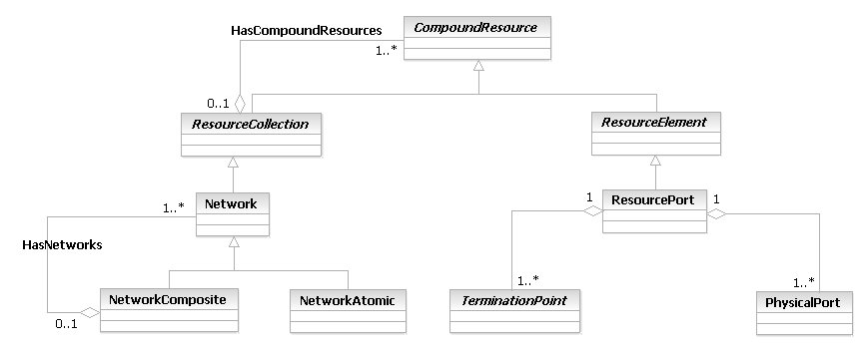
Figure LR.46 - Definition Using the Composite Pattern
In Figure LR.46 - , the NetworkAtomic class is used to represent different types of Networks, while the NetworkComposite class enables an organization to refer to a set of Networks collectively as a single unit. For example, an organization might have a wireless and a fixed network for providing service – a NetworkComposite represents this collectively as one network for the organization, which is made up of two NetworkAtomic objects (one for the fixed and one for the wireless).
There are a few additional important subclasses of Network and SubNetwork, which are used to define Networks with specific semantics. Two examples are shown in Figure LR.47 - below.
A Local Area Network is a computer network covering a specific local area, like a home, office or small group of buildings. It provides communication between computers and devices. The topology of a network dictates its physical structure. This is represented as a collection of endpoints of a common type that are all able to intercommunicate directly with each other, without the assistance of bridging or routing services.
A subnet is a portion of a network that shares a common address component. On TCP/IP networks, subnets are defined as all devices whose IP addresses have the same prefix. For example, all devices with IP addresses that start with 100.100.100 would be part of the same subnet. A Subnet represents a group of related logical endpoints, each of which is uniquely identified by a logical address, which can communicate with each other directly using a particular type of IP protocol.
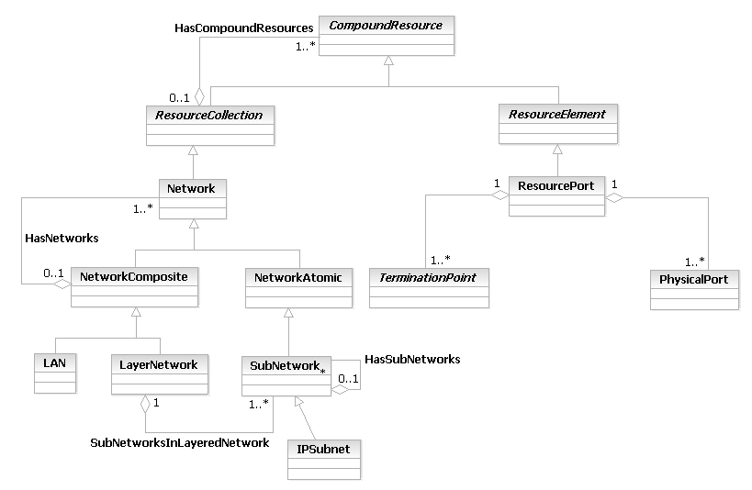
Figure LR.47 - Additional Subclasses of the Network Class
Figure LR.48 - shows how Policy is used to control CompoundResources, and hence different types of Networks.
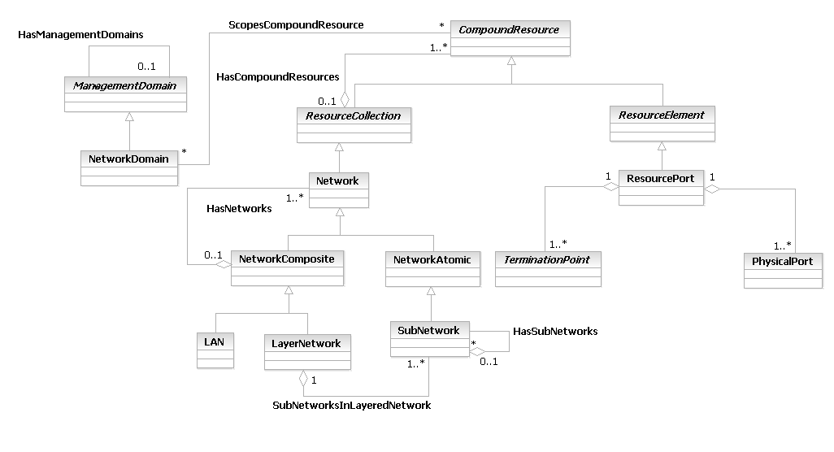
Figure LR.48 - Policy Management of Network Entities
A NetworkDomain represents a set of CompoundResources that share a common set of administrative and operational characteristics. For example, the PoliciesGoverningManagementDomain association defines a set of administrative and/or operational policies that define how some or all of the elements of a ManagementDomain are governed. An administrative policy might be used to specify when different types of configuration changes are allowed, as well as who is authorized to initiate and approve those changes, and what to do if a change fails. In contrast, an operational policy might specify different parameters to monitor as a function of the type of SLA and customer. It could also be used to specify a common naming methodology.
A NetworkDomain is used to partition CompoundResource instances into logical groupings (e.g., operational and/or administrative groups) that are controlled by a common manager and/or management philosophy. NetworkDomains provide one way to administer and control the configuration and operational characteristics of a set of CompoundResources.
One way that management applications could take advantage of this would be to match the roles of the people configuring and managing Networks to the structure of the NetworkDomain. This is illustrated using the OwnsResource and AdminstersResource associations shown in Figure LR.55 - , and will be discussed in detail later in this document. (Note that other, more granular, associations could also be defined.) PartyRole and ValueNetworkRole are defined in the Party Addendum [Add 1P], and represent different types of individuals and/or organizations that have different administrative and operational responsibilities. NetworkDomains as well as organizations can be represented as hierarchies, and bound together using these and similar associations. Furthermore, NetworkDomains can be nested, since a NetworkDomain is a CompoundResource, and the HasCompoundResources aggregation enables CompoundResources to contain other CompoundResources (i.e., ResourceElements as well as ResourceCollections).
An Autonomous System (AS) provides a structured view of routing by segregating the system that is using routing (e.g., the Internet, a corporate intranet, or a company extranet) into a set of separately administered domains that each has their own independent routing policies.
The classic definition of an AS, from RFC1771, is '...a set of routers under a single technical administration, using an interior gateway protocol (IGP) and common metrics to route packets within the AS, and using an exterior gateway protocol to route packets to other ASs. Since this classic definition was developed, it has become common for a single AS to use several interior gateway protocols and sometimes several sets of metrics within an AS. The use of the term Autonomous System here stresses the fact that, even when multiple IGPs and metrics are used, the administration of an AS appears to other ASs to have a single coherent interior routing plan and presents a consistent picture of what destinations are reachable through it.'

Roles in More Detail
Now that all of the major business entities for Resource and LogicalResource have been explained, we can return to examining the use of Roles to abstract application functionality. For example, consider a 2547bis MPLS VPN. No matter how complicated the topology of the VPN, there are basically three roles that a device can play in this scenario:
CustomerEdge (CE) – represents a router that connects the Customer’s traffic to the VPN
ProviderEdge (PE) – represents a router at the edge of the VPN to which a CE router can connect to
Provider (P) – represents a router in the core of the VPN that does not connect to a CE router
The basic VPN topology is shown in Figure LR.49 - below:
CE
CE
CE0..n

CE
PE
PE
P
P
P

Provider Backbone
Site 1
Site 2
Site 3
Site 4
RED VPN
RED VPN
GREEN VPN
GREEN VPN
Figure LR.49 - A Simple 2547bis MPLS VPN
Figure LR.49 - shows two VPNs. The “Red” VPN connects Sites 1 and 3 through the Provider backbone, while the Green VPN connects Sites 2 and 4 through the same Provider backbone. Note that these are two distinct VPNs that share a common network. The concept of Roles can be used with other parts of this model to standardize (for example) how CE routers connect to PE routers, as well as how traffic is forwarded. For example, a set of policies could be defined that determine the specific characteristics and behavior that a particular CE router will have, which could be used to constrain the protocols used controlling how it connects to different types of PE routers. Abstracting this functionality using roles enables policies to be independent of any specific device, facilitating redundancy and reuse. This example is analyzed in detail in the MPLS VPN Example Addendum (GB928).
First, note that the core of the Provider Backbone is represented by routers that play the same Role (Provider). This enables us to differentiate their configuration from the PE and CE routers shown in Figure LR.49 - above. More importantly, it means that these four routers are functionally equivalent, and once a basic template is developed to configure one, it can be applied (with simple modifications to parameterize device-specific attributes, such as name and IPAddress) to the other P routers.
This is also true of the configurations of the PE and CE routers.
Roles imply innate functionality provided by the entity playing that role which is not provided by other entities. For example, a Router playing the CE role is solely responsible for connecting the Customer to the VPN. A router playing the PE role is solely responsible for exercising import routing policies, which are used to determine whether a remote route transmitted by a CE should be installed and propagated in the VPN or not. PE roles do not connect to the Customer, and CE roles do not import routing policies.
This description of Roles is at a device level – it can involve using roles to describe physical as well as logical aspects of the device. Thus, while we have been describing LogicalResourceRoles, we could just as easily describe PhysicalResourceRoles, or even combine the two to describe CompoundResourceRoles (which would help determine the overall behavior of a CompoundResource, such as a router).
Just as a CompoundResource was defined as a mechanism to aggregate PhysicalResources as well as LogicalResources, a ComopundResourceRole can aggregate PhysicalResourceRoles as well as LogicalResourceRoles. For example, a Service Provider could decide that only certain type of connections using a particular type of media (e.g., Serial) will be supported between the CE and the PE routers. Therefore, any router playing either the CE or the PE roles must support serial connectivity. Furthermore, since the P routers are forwarding traffic in the core of the Service Provider backbone and not concerned with Customer connectivity, there is no reason for them to support serial connectivity (for connecting to Customers). Thus, roles can be used to help determine what types of PhysicalResources (e.g., Protocols) and LogicalResources (e.g., Line Cards) are used on to realize functionality required by a CompoundResource. This is explained in more detail in [GB928]. As a simple example, since a P router just connects to other P routers and PE routers, its configuration must ensure that routes aren’t leaked across the PE routers to CE routers. Thus, the role of the P router differentiates its function from the CE and PE routers.
This gives rise to the following more detailed diagram:
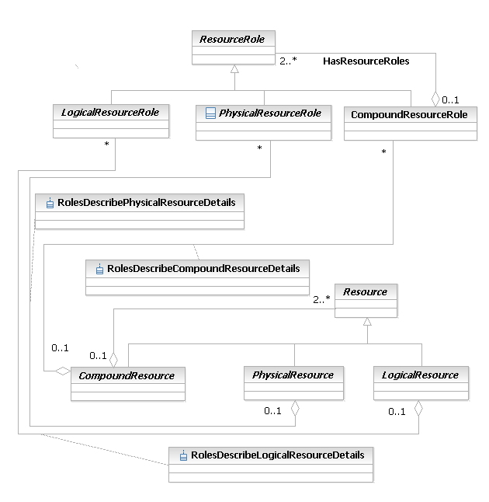
Figure LR.50 - Different Types of ResourceRoles
A CompoundResourceRole is a role that is defined to represent the functionality of a CompoundResource. Since CompoundResources are made up of PhysicalResources and LogicalResources, a CompoundResourceRole is similarly made up of PhyscialResourceRoles and LogicalResourceRoles. This enables a CompoundResourceRole to properly represent the interaction between PhysicalResourceRoles and LogicalResourceRoles. There must be at least one or more PhysicalResourceRoles and one or more LogicalResourceRoles to form a CompoundResourceRole. However, neither a PhysicalResourceRole nor a LogicalResourceRole has to belong to a CompoundResourceRole. These semantics are represented by the HasResourceRoles aggregation.
As another example, a Service Provider could decide that basic connectivity will be provided through a DeviceInterface. This is, of course, a LogicalResource. Suppose a PartyRole, such as a Technician or a NetworkAdministrator, is assigned with the task of configuring that DeviceInterface. That PartyRole needs to know the PhysicalPort that hosts the DeviceInterface that is to be configured. This task could be done by referring to two separate roles (an instance of a PhysicalResourceRole and an instance of a LogicalResourceRole). However, if there are many DeviceInterfaces to be configured, it becomes difficult to keep track of all of the different objects, as there are at least four (two roles, a PhysicalPort, and a DeviceInterface) for each configuration instance. Using CompoundResources and CompoundResourceRoles, we can immediate cut the number of objects in half. The savings become more dramatic as more PhysicalResources and LogicalResources (and their corresponding roles) become involved. In addition, the use of a CompoundResourceRole and a CompoundResource ensure that the appropriate PhysicalResources are related to the correct LogicalResources.
PhysicalResourceRole, LogicalResourceRole, and CompoundResourceRole are all subclasses of ResourceRole. The design enables the user to describe ResourceRoles in high-level terms, using the ResourceTakesOnRoles aggregation, or in more specific terms, using the RolesDescribePhysicalResource, RolesDescribeLogicalResource, and RolesDescribeCompoundResource aggregations as required.
(In the system view, each of these four aggregations – ResourceTakesOnRoles, RolesDescribePhysicalResource, RolesDescribeLogicalResource, and RolesDescribeCompoundResource – are in reality implemented using classes. The ResourceRoleDetails class, which is used to implement the semantics of the ResourceTakesOnRoles aggregation, serves as the parent class for the three classes that implement the RolesDescribePhysicalResource, RolesDescribeLogicalResource, and RolesDescribeCompoundResource aggregations (RolesDescribePhysicalResourceDetails, RolesDescribeLogicalResourceDetails, and RolesDescribeCompoundResourceDetails, respectively) These are not shown in the business view in order to provide a conceptually simpler model for the business constituency to use).
Now suppose it is desired to enable multiple Customer LANs to use a DeviceInterface. Each LAN could be assigned to a sub-interface (i.e., a type of virtual device interface). A Service Provider could then use DeviceInterfaceRoles to help standardize the otherwise very difficult naming problems that will arise if no standardized approach is taken to configuring a device. This is shown in Figure LR.51 - below.
Figure LR.51 - Different Types of LogicalResourceRoles

In Figure LR.51 - , the concept of a VPNLogicalDeviceRole is introduced as a subclass of LogicalDeviceRole. This is because any type of VPN will use the concept of a LogicalDevice to manage the functionality provided by the set of DeviceInterfaces that are provided by a given device. LogicalDeviceRole defines required logical features to implement the different roles played by different LogicalDevices that are used in a Product or Service. Here, a VPN is modeled as a set of Resources playing specific Roles. Thus, the VPN-specific Roles for controlling the behavior of the CE, PE, and P Routers can be modeled as subclasses of a LogicalDeviceRole. Previously, we defined three different roles required by an MPLS VPN. Hence, we define a superclass, VPNLogicalDeviceRole, that can be used to gather common characteristics and behavior of different subclasses; this enables the subclasses to define only specific functional behavior. This is why the CPELogicalDeviceRole, PELogicalDeviceRole, and PLogicalDeviceRole classes are subclassed from VPNLogicalDeviceRole, which is subclassed from LogicalDeviceRole. This reusing of common functionality in the LogicalDeviceRole and VPNLogicalDeviceRole superclasses enables the three subclass definitions to concentrate only on the definition of their functionality.
Note that the RoutingRole and SwitchingRole entities (and perhaps the FirewallRole entity as well) are still useful to the design of the VPN. The VPNLogicalDeviceRole captures the semantics of a LogicalDevice that is playing the role of a VPN component. That very same LogicalDevice still needs to route and forward traffic. Thus, the RoutingRole and SwitchingRole entities are also applicable to VPN components. They can be aggregated as necessary by the DeviceInterfaceRole, enabling different functionality to be cleanly abstracted through the use of different roles.
A DeviceInterfaceRole is a base class for representing different types of roles that can be associated with a particular DeviceInterface. In Figure LR.51 - , three different types of DeviceInterfaceRoles are defined: EdgeInterface, CoreInterface, and AggregationInterface. An EdgeInterface defines a DeviceInterface that is part of a device on the edge of the network. Such devices are concerned with classifying traffic, assigning traffic flows that have similar behavior to the same Class of Service, and marking the flows appropriate. The objective of this role is to enable the definition of Policies such that all EdgeInterfaces in a particular Domain can receive the same common configuration commands. This same philosophy is also applied to the CoreInterface and AggregationInterface entities, except that the functions that they perform in the network are significantly different than the functions played by an EdgeInterface. The advantage of these three roles is that they define the same type of functions that devices playing those roles must implement. This helps simplify management and configuration of not just VPN components, but any DeviceInterface playing that role.
UserNameResourceRole represent different class of LogicalResourceRole which does not represent network functionality but rather pools of resources which identify network users (such as phone numbers, IP addresses, and others). User names can be handled in a separate pool or can be shared with other pool (such as phone numbers or email addresses) in which case the role pattern is used to differentiate different uses of the same LogicalResource. UserNameResourceRole is just an example class (which is used in the modeling of Users and Roles in Common Business Entitles domain) and other examples may not be explicitly modeled as part of the Information Framework.
Finally, we must differentiate roles from specifications. Specifications define known, invariant attributes and relationships (and methods and constraints in the system view). The key concept here is “known”. One could in theory build a specification for configuring a router, except that router configurations change over time due to changing demands on the network. Thus, ResourceRoles and CompoundResourceRoles offer a means to design pieces of functionality and add them when required. Specifications defined to use Roles are a very powerful concept, and enable standard configurations (or monitoring commands, or a host of other actions) to be defined. This helps make the network more easily manageable and configurable when its environment changes, and ensures that the same functions are executed in a consistent manner.
ResourceSpecifications are extended to include CompoundResources and CompoundResourceRoles in Figure LR.52 - below.
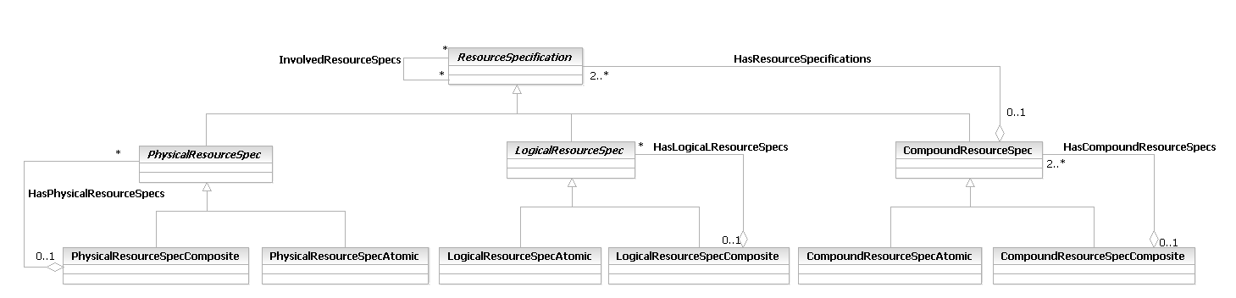
Figure LR.52 - Extending Specifications to Include CompoundResources
The similarity between Figure LR.52 - and Figure LR.31 - is evident. The HasResourceSpecification aggregation in Figure LR.52 - represents the same pattern as the CompoundResourceAspects aggregation in Figure LR.31 - . Both of these aggregations enable a CompoundResourceSpec and a CompoundResource to aggregate ResourceSpecifications and Resources, respectively. The cardinality on the Has ResourceSpecification aggregation (along with the OCL, which is not shown for simplicity) ensures that at least one PhysicalResourceSpec and at least one LogicalResourceSpec are aggregated by the CompoundResourceSpec. This is the same pattern that was used to ensure that at least one PhysicalResource and at least one LogicalResource are aggregated by the CompoundResource (in Figure LR.31 - ).
Figure LR.53 - below shows how CompoundResourceSpecs can be used to specify CompoundResourceRoles.
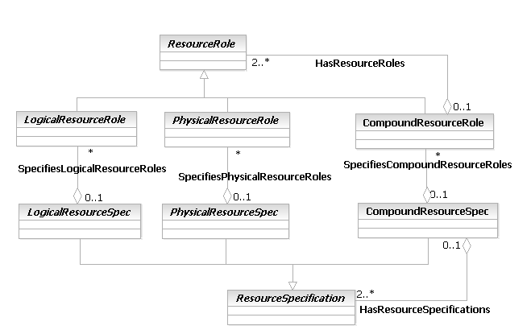
Figure LR.53 - Extending Roles to Include CompoundResourceRoles

Gathering Management Information
Resource is a subclass of ManagedEntity. However, if we are to manage and control ManagedEntities, then we need two additional things: (1) a means to manage ManagedEntities, and (2) a means to represent management information. These concepts are shown in Figure LR.54 - below.
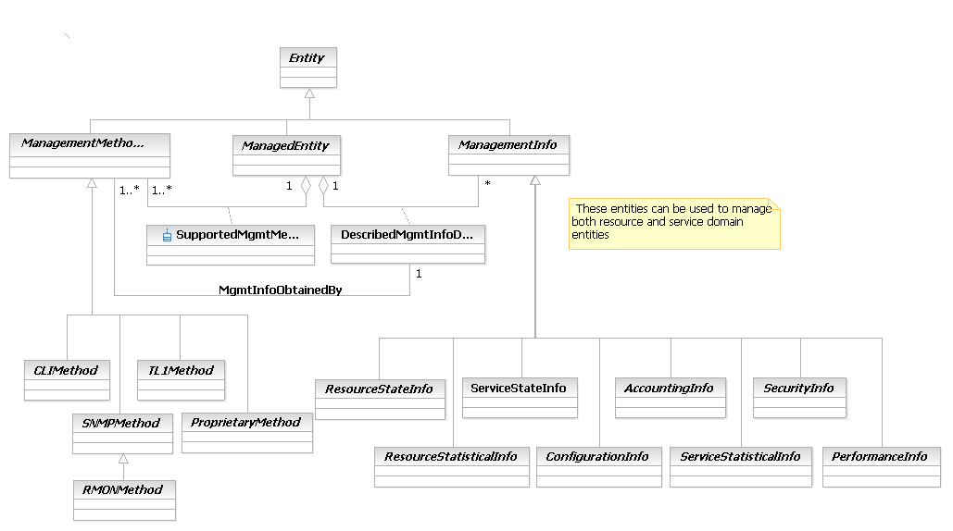
Figure LR.54 - Concepts of ManagementInfo and ManagementMethodEntity

A ManagedEntity is an abstract base class that is used to represent entities in a managed environment that have the following semantics in common: (1) a PartyRole owns or is otherwise responsible for them, (2) management of the entity is critical for providing a service and/or maintaining the environment, and (3) the entity is "important" from a management point-of-view. Thus, ManagedEntity is the base class for representing manageable parts of a Product (such as PhysicalResources and CustomerFacingServices, as shown in Figure LR.07 - ).
ManagementInfo is an abstract base class that is used to represent management information obtained from one or more managed entities in a managed environment. Specifically, in the process of managing an entity, information of various forms is created. A ManagementInfo entity represents different types of management information that describes the state of a particular Resource or Service. A Finite State Machine management model is used to represent the lifecycle of a managed entity. This class represents one state of that Finite State Machine. Note that the Finite State Machine is derived from the UML Metamodel State Machine metaclass.
ManagementMethodEntity is an abstract base class for representing the different types of management methods that can be used to gather a particular type of management information. For example, this enables configuration setting classes to be defined as using CLI, while configuration monitoring classes could be defined as using a different method, such as SNMP. The subclasses of ManagementMethodEntity are system concepts, and are shown for illustrative purposes only.
Thus, ManagementMethodEntities can be defined to produce specific types of ManagementInfo for a particular ManagedEntity. This is done through the use of three relationships that tie these concepts together. The SupportedMgmtMethods aggregation defines the set of different management methods that can be used to manage and control a particular ManagedEntity. The DescribedByManagementInfo aggregation is used to define the different types of management information that a particular ManagedEntity can produce. Finally, the MgmtInfoObtainedBy association defines which set of ManagementMethodEntities were used to obtain a particular type of management data.
There are four primary subclasses of ManagementMethodEntity – CLIMethod, SNMPMethod, TL1Method, and ProprietaryMethod. (These are not inclusive, but rather representative, of the most popular methods of managing Resources and Services that are currently available.) CLIMethod is an abstract base class for using a device-specific CLI to obtain management information. Similarly, the SNMPMethod, TL1Method, and ProprietaryMethod entities are abstract base classes for using device-specific SNMP, TL1, and proprietary methods to obtain management method. RMONMethod uses SNMP, and thus is a subclass of SNMPMethod.
It should be noted that these are all abstract base classes. While there are standard objects defined for SNMP, RMON, and TL1, the majority of information obtained using these approaches (with the possible exception of TL1) comes in the form of proprietary objects. In addition, CLI is essentially proprietary, so no standard exists to define information obtainable from CLI.
The nine subclasses of ManagementInfo are also exemplary in nature, and are not meant to be all-inclusive.
ResourceStateInfo is an abstract base class for representing different types of management information that describes the state of a particular Resource. A Finite State Machine management model is used to represent the lifecycle of a managed entity. This class represents one state of that Finite State Machine. (Note that the Finite State Machine is derived from the UML Metamodel State Machine metaclass.) Subclasses of this class include classes to represent Faults, Outages, Alarms, the usage of this Resource, and its current operational state.
ResourceStatisticalInfo is an abstract base class for representing different types of statistical information that describes the state of a particular Resource or set of Resources (or a particular Service or set of Services). Subclasses of this class represent domain-specific information, including:
specific LogicalResource statistics, such as those for a DeviceInterface (e.g., number of packets dropped)
specific PhysicalResource statistics, such as a fiber cut
ServiceStateInfo is an abstract base class for representing different types of management information that describes the state of a particular Service. This can be a CustomerFacingService or a ResourceFacingService. As with a ResourceStateInfo, this represents the lifecycle of a Service as one state of the Finite State Machine.
ServiceStatisticalInfo is an abstract base class for representing different types of statistical information that describes the state of a particular Resource or set of Resources (or a particular Service or set of Services). Subclasses of this class represent domain-specific information, including:
generic Service statistics (e.g., uptime and current status)
specific Service statistics (e.g., number of SLA violations, current QoS data, etc.)
generic Customer statistics (e.g., number of Customers using a particular network, number of Subscribers and their subscription levels)
The remaining five entities are generic in nature, and apply to Resources and Services.
FaultInfo is the base class for all fault classes. Faults can be associated with both PhysicalResources (e.g., a PhysicalPort or a malfunctioning Card) as well as LogicalResources (e.g., a LogicalDevice or a DeviceInterface). Subclasses of this class define the detailed characteristics and behavior of a particular type of Fault. Faults are reported by associating the parent of this class, ManagementInfo, with the appropriate ManagementMethodEntity class through a combination of the DescribedByMgmtInfo and the MgmtInfoObtainedBy aggregation.
ConfigurationInfo is the base class for defining how a ManagedEntity is configured. Configurations are associated with a particular LogicalDevice using the DescribedByMgmtInfo aggregation. Configurations can define how a Resource or a Service is to be set up, and control the behavior of that Resource or Service. In general, both Resources and Services need to be configured in order to operate. (Note that this can be done at the factory or dynamically as the entity is operating.) Subclasses of the Configuration class define the detailed characteristics and behavior of how a configuration is built and deployed. Configurations are implemented by associating the parent of this class, ManagementInfo, with the ManagementMethodEntity class through a combination of the DescribedByMgmtInfo and the MgmtInfoObtainedBy aggregation.
AccountingInfo is the base class for defining how accounting is performed for a particular ManagedEntity. AccountingInfo keeps track of how a Resource or Service is being used (both quantity as well as by which PartyRole). Accounting is associated with a particular Resource or Service using the DescribedByMgmtInfo aggregation. Subclasses of the Accounting class define the detailed characteristics and behavior of how accounting is performed. Accounting is implemented by associating the parent of this class, ManagementInfo, with the appropriate ManagementMethodEntity class through a combination of the DescribedByMgmtInfo and the MgmtInfoObtainedBy aggregation.
PerformanceInfo is the base class for all performance monitoring classes. Resource Performance is the act of collecting, correlating, consolidating, and validating various performance statistics and other operational characteristics of PhysicalResource, LogicalResource, CompoundResource, and Network entities. Service Performance is similar, except that it applies to CustomerFacingServices and ResourceFacingServices. Both of these entities also include specific subclasses for conducting network performance assessment against planned goals, performs various aspects of trend analysis, including error rate and cause analysis and Resource degradation. Different types of performance indicators are associated with a particular Resource or Service using the DescribedByMgmtInfo aggregation. Performance information Subclasses of this class define the detailed characteristics and behavior of this class. Performance monitors are reported by associating the parent of this class, ManagementInfo, with the ManagementMethodEntity class through a combination of the DescribedByMgmtInfo and the MgmtInfoObtainedBy aggregation.
SecurityInfo is the base class for all security classes. Different types of security settings and semantics are associated with a particular Resource or Service using the DescribedByMgmtInfo aggregation. Subclasses of this class define the detailed characteristics and behavior of this class. Examples of security subclasses include AuthenticationEntity, AuthorizationEntity, and AuditingEntity. Security settings are implemented and reported on by associating the parent of this class, ManagementInfo, with the ManagementMethodEntity class through a combination of the DescribedByMgmtInfo and the MgmtInfoObtainedBy aggregation.

Interaction with Other SID Business Entities

Introduction
This part of this Addendum will briefly describe the other SID business entities that have been identified that can interact with classes and relationships in the LogicalResource Domain. The principal types of entities that can interact with a LogicalResource are:
Policy
BusinessInteraction
PartyRole
Product
Service
Location

Policy
Policy is used to define the semantics of how a LogicalResource is managed and controlled. Some of the tasks that Policy governs include the following:
define what LogicalResources are needed for a particular task
define how to manage and control a set of LogicalResources
define when a set of LogicalResources need to be reconfigured, and any additional semantics (e.g., sequence of changes)
define which PartyRoles can manage a particular LogicalResource
define where a LogicalResource can be installed or used

As can be seen, the interactions between Policy and LogicalResource are varied and complex. This will be one of the areas that will be explored in detail in the SID system view (GB926). The Policy model is defined in [Add 1Pol].

BusinessInteraction
A BusinessInteraction describes how different entities interact with each other. Business interactions take the form of requests, responses, notifications, and agreements. This set of relationships will be explored in detail in GB926 after more of the Policy interactions for LogicalResource have been defined.

PartyRole
A PartyRole defines the function that a Party takes on. PartyRoles can represent the ability to manage, configure, use, and perform other types of interactions with LogicalResources. A simple starting model is shown in Figure LR.55 - below. One can see that the Service and Resource management methods are symmetrical.
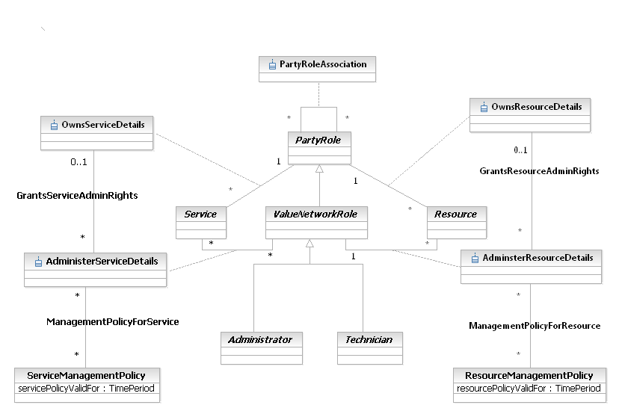
Figure LR.55 - Interaction between PartyRole and LogicalResource
The OwnsResource association defines the set of Resources (PhysicalResources and/or LogicalResources) that a particular PartyRole owns. Note that this is a very different relationship than the AdministersResource association. The OwnsResource association defines the PartyRole that is the owner of the Resource. Here, “owner” is the person or group that is responsible (e.g., organizational, financial, and so forth) for the Resource. Note that the cardinality of the OwnsResource association on the PartyRole side is 1 - this means that a Resource MUST have at least one PartyRole to manage it. Furthermore, the cardinality of this association on the Resource side is 0..n, which ensures that a PartyRole doesn’t have to own a Resource.
The AdministersResource association defines the set of Resources (PhysicalResources and/or LogicalResources) that a particular Party, playing the role of ValueNetworkRole, administers. From a business perspective, the Owner has to either appoint or give permission to the Administrator to administer the Resource that is owned. This is done using the GrantsServiceAdminRights association. Note that a ValueNetworkRole, not just a PartyRole, is required to administer the Service. This is because a ValueNetworkRole possesses additional skills that a PartyRole doesn’t necessarily have.
The GrantsResourceAdminRights association defines which ValueNetworkRoles are allowed to administer a particular owned Resource. Different ValueNetworkRoles will in general have different administration rights for the same Resource. For example, different types of Administrators will in general each have the ability to make more changes than different types of Technicians.
Policies can be defined for controlling the specific rights of administering a Resource. This is the function of the ResourceManagementPolicy class. Since this is the business view of this relationship, only a simple single attribute is shown.
The ResourceManagementPolicy class defines the particular policies that are used to define how different aspects of the Resource are managed and maintained. For example, assume that a Resource is made up of several different Equipment entities. One of these Equipment entities might require multiple PartyRoles to approve changes to its configuration, whereas another Equipment entity might not require any approvals to change its configuration. Since Policy also uses the composite pattern, if a set of Policies are needed, these can be aggregated into a single Policy).
Note the power of this pattern - the ManagementPolicyForResource association, along with its ResourceManagementPolicy class, provide a generic template for defining which set of PartyRoles can perform which type of management function for which type of Resource. Figure 5LR-40 shows that Services and Resources can be managed using the same pattern, even though the contents of the classes will be different.
There is a lot more to this model; it will be further discussed in the System View.

Product
For now, the basic relationship between Product and LogicalResource (as defined in Figure LR.05 - and also in Figure LR.07 - ) are deemed sufficient. These are combined and shown in Figure LR.56 - below.
Note that a ProductSpecification is not directly associated with either a LogicalResource or a CompoundResource. This is to keep the focus of Products on PhysicalResources. All LogicalResources need a PhysicalResource to host them. This parallels the lack of a direct association between ProductSpecification and ResourceFacingService – only CustomerFacingServices are associated with ProductSpecifications.
Since a CustomerFacingServiceSpec defines which ResourceFacingServiceSpecs are required, the ResourceFacingServiceSpec can be used to determine which ResourceSpecifications are required for a given Product. This information, combined with the set of PhysicalResourceSpecs required by the ProductSpecification, define which LogicalResources must be hosted on the specified PhysicalResources.
A CompoundResourceSpec can of course be used as “shorthand” to refer to the appropriate set of PhysicalResourceSpecs and LogicalResourceSpecs, if desired.
Although Figure LR.56 - doesn’t show specific PhysicalResources, LogicalResources, and CompoundResources, these entities are defined by the appropriate PhysicalResourceSpecs, LogicalResourceSpecs, and CompoundResourceSpecs that are defined through the ProductSpecification and the ResourceFacingServiceSpecs.
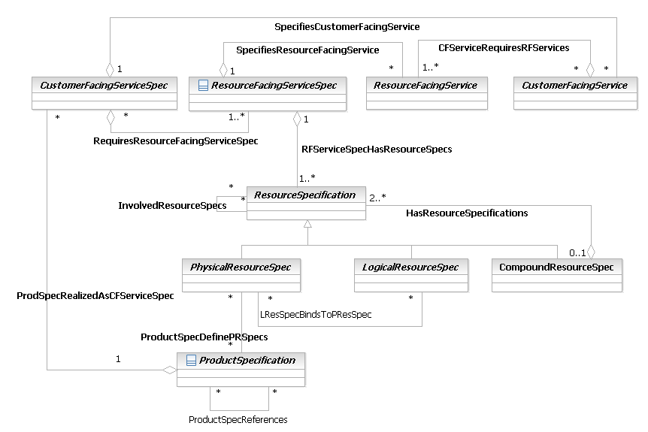
Figure LR.56 - Interaction between ProductSpecification and ResourceSpecification

Service
For now, the basic relationship between Service and LogicalResource (as defined inFigure LR.06 - and Figure LR.07 - ) is sufficient. Note that the SID QoS Addendum [Add 4QoS] defines further detail on the relationships defined in the above figures. This set of relationships will be continuously re-evaluated as the above areas are more fully defined.

Place
In the SID, different types of Place have different types of semantics associated with them. For example, a Wireless Access Point has an associated coverage area. Only applications within that coverage area can use the services associated with the Wireless Access Point. As another example, subscribers will access different POPs (Points of Presence, the Service Provider term for an access network) as they travel nationally and internationally. Services may vary, and additional peering relationships may come into effect. A simple starting model is shown in Figure LR.57 - below.
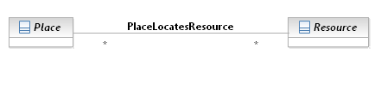
Figure LR.57 - Interaction between LogicalResource and Place
Clearly, policies can be used to define the semantics of a particular Place..

References
The following table provides a list of references used in this Addendum.
DEN-ng | Directory Enabled Networks New Generation by John Strassner, et. al., (not published).  Note that the book “Policy-based network management: solutions for the next generation” by John Strassner ISBN 1-55860-859-1 includes the following text in chapter 1 - The Foundation of Policy Management: "This book describes a unique object-oriented information model, called DEN-ng (Directory Enabled Networks-new generation). It is being developed in the TM Forum". This implies that DEN-ng is the SID.
DEN | Directory Enabled Networks by John Strassner ISBN 1-57870-140-6
ITU | This is a general reference to the M, G, and X series of recommendations by the ITU-T
CIM | Common Information Model, DMTF  http://www.dmtf.org/standards/standard_cim.php
[GB922] | This is the Concept and Principles introduction to the SID.
eTOM | GB921 version 3.5
[Add 3] | The Product Addendum of the SID, which is GB922, Addendum 3
[Add 4SO] | The Service Overview Addendum of the SID, which is GB922, Addendum 4SO
[SD1-18] | Functional Modelling Concepts. A supporting document I the MTNM and MTOSI deliverables.
[Add 5PR] | The PhysicalResource Addendum of the SID, which is GB922, Addendum 5PR
[Add 4S-MPLSVPN] | The MPLS VPN Addendum of the SID, which is GB922, Addendum 4S-MPLSVPN
[Add 4S-QoS] | The Quality of Service Addendum of the SID, which is GB922, Addendum 4S-QoS
[CompPtn] | E. Gamma, et. al., “Design Patterns”, pp 163-173
[Bäumer] | The Role Object (Design) Pattern. Download PDF from  http://www.riehle.org/computer-science-research/1997/plop-1997-role-object.pdf
[Fowler-Role] | Dealing with Roles  http://www.awl.com/cseng/titles/0-201-89542-0/apsupp/roles2-1.html
[G.805] | Generic Functional Architecture of Transport Networks, ITU-T G.805 Recommendation
[M.3100] | Generic Network Information Model, ITU-T M.3100 Recommendation
[Add 1Pol] | Policy Model, the business view of which is GB922, Addendum 1Pol
[Add 1NI] | The BusinessInteraction Addendum of the SID, which is GB922, Addendum 1BI
[Add 4QoS] | QoS model, the business view of which is GB922, Addendum 4QoS

Business Entity Data Dictionary Definitions
The following sections will define the business entities referred to in the preceding portion of this Addendum. This section will consist of a business entity definition, definition of any attributes and relationships appropriate for the business level, and finally provide a business model in UML of that entity and its main relationships.
Note that this Addendum is a business view of a system model. Thus, in most cases, classes have more attributes and relationships that what are shown in this section. Furthermore, all classes have get and set methods defined for all attributes. Finally, most classes also have methods and constraints that are really only pertinent to the system view.
For this release, the classes are organized into two groups. The first group of classes consists of (business) classes that make up the LogicalResource ABE. The second group consists of classes that are required to understand the LogicalResource classes, but are not actually part of the LogicalResource model per se. In other words, they are not part of the LogicalResource ABE; rather, they are part of the Resource Domain. This group includes classes such as Resource and ResourceSpecification. Please note that these classes will be moved into a separate Addendum, called the Resource Overview Addendum, in the next release of the SID.
Entity and attribute definitions can be found in all available Information Framework (SID) model formats. The next release of the SID will move all entity and attribute definitions from domain/ABE addenda to a single addendum containing all definitions. The definitions will be generated from the SID UML model. All model formats will continue to contain definitions.

NOTE: This section was produced using a model-driven technique which is still being refined and which results in the loss of some dictionary properties. The same section from the previous major release of the Information Framework is included here as an embedded archive. For conformance purposes, attributes that are not listed there can be assumed to be optional rather than required.

Classes that are part of the LogicalResourceABE

ATMInterface Business Entity Definition
Business Entity Name | ATMInterface
Description | ATM, or Asynchronous Transfer Mode, is a network technology based on transferring data in cells of a fixed size. The cell used with ATM is relatively small compared to that used with older technologies. In principle, the small, constant cell size allows ATM equipment to transmit video, audio, and computer data over the same network, and helps prevent any single type of data source from dominating network traffic.  ATM creates a fixed route between two points whenever data transfer begins. This differs from TCP/IP, in which messages are divided into packets and each packet can take a different route from source to destination. This difference makes it easier to track and bill data usage across an ATM network, but it makes it less adaptable to sudden surges in network traffic.
Sources | DEN-ng
Cross-References
Synonyms / Aliases | This concept is not present in either the ITU recommendations or the DMTF CIM.
Related Business Entities | ManagedEntity, ResourceSpecification, LogicalResourceSpec, PhysicalResourceSpec, CompoundResourceSpec, Product, ProductComponent, ProductBundle, Resource, PhysicalResource, LogicalResource, CompoundResource, LogicalDevice, DeviceInterface, MediaInterface (superclass), LogicalInterface, EthernetInterface (sibling), SerialInterface (sibling), TokenRingInterface (sibling), Software, SoftwareAtomic, SoftwareComposite, SoftwareCommand, SoftwareFeatureSets, OperatingSystem, ResourceLogic, ResourceSpecVersion, LogicalResourceSpecVersion, ResourceSpecType, ResourceCharacteristic, ResourceCharacteristicValue, ResourceSpecCharacteristic, ResourceSpecCharacteristicValue, ResourceRole, LogicalResourceRole, PhysicalResourceRole, Service, ResourceFacingService, CustomerFacingService, ServiceSpecification, ResourceFacingServiceSpec, CustomerFacingServiceSpec
Business Rules | To be determined

ATMInterface Business Entity Attributes Definition
Business Entity Name | ATMInterface

Attribute Name | Description | Data Type | Notes (used to map to other models; blank is other models don’t have it)
bitRateType | This is an enumerated integer, and defines the transmission philosophy used. Values include:  0: not yet configured  1: constant bit rate (CBR)  2: variable bit rate (VBR)  3: available bit rate (ABR)  4: unspecified bit rate (UBR)  CBR specifies a fixed bit rate so that data is sent in a steady stream. This is analogous to a leased line.  VBR provides a specified throughput capacity but data is not sent evenly. This is often used for voice and video data.  ABR provides a guaranteed minimum capacity but allows data to be bursted at higher capacities when the network is free.  UBR does not guarantee any throughput levels. This is used for applications, such as file transfer, that can tolerate delays. | Integer | Not defined in the CIM; next release will add in MTNM information

Business Entity Model – ATMInterface
The model of an ATMInterface is the same as that for MediaInterface, and is shown in Figure LR.79 below.

AutonomousSystem Business Entity Definition
Business Entity Name | AutonomousSystem
Description | An Autonomous System (AS) provides a structured view of routing by segregating the system that is using routing (e.g., the Internet, a corporate intranet, or a company extranet) into a set of separately administered domains that each has their own independent routing policies.  The classic definition of an AS, from RFC1771, is '...a set of routers under a single technical administration, using an interior gateway protocol and common metrics to route packets within the AS, and using an exterior gateway protocol to route packets to other ASs. Since this classic definition was developed, it has become common for a single AS to use several interior gateway protocols and sometimes several sets of metrics within an AS. The use of the term Autonomous System here stresses the fact that, even when multiple IGPs and metrics are used, the administration of an AS appears to other ASs to have a single coherent interior routing plan and presents a consistent picture of what destinations are reachable through it.'
Sources | DEN-ng; G.805, Telstra
Cross-References
Synonyms / Aliases | This concept is not present in the ITU specs. CIM has a similarly named class with slightly different semantics, mainly caused by the different class hierarchy. Plus, it lacks the DEN-ng added semantics.
Related Business Entities | ManagedEntity, ResourceSpecification, LogicalResourceSpec, PhysicalResourceSpec, CompoundResourceSpec, Product, ProductComponent, ProductBundle, Resource, PhysicalResource, LogicalResource, CompoundResource, ResourceCollection, ResourceElement, Network, NetworkDomain (superclass), LayerNetwork, SubNetwork, IPSubnet, LAN, ResourcePort, LogicalDevice, DeviceInterface, MediaInterface, Software, SoftwareAtomic, SoftwareComposite, SoftwareCommand, SoftwareFeatureSets, Protocol, ManagedTransmissionEntity, OperatingSystem, ResourceLogic, ResourceSpecVersion, LogicalResourceSpecVersion, ResourceSpecType, ResourceCharacteristic, ResourceCharacteristicValue, ResourceSpecCharacteristic, ResourceSpecCharacteristicValue, ResourceRole, LogicalResourceRole, PhysicalResourceRole, Service, ResourceFacingService, CustomerFacingService, ServiceSpecification, ResourceFacingServiceSpec, CustomerFacingServiceSpec, ManagementDomain, NetworkDomain
Business Rules | To be determined

AutonomousSystem Business Entity Attributes Definition
Note: this version of the SID moved three attributes (requiresIGPSync, routeAggregationMethod, and routingUpdateMethod) to the business view of the SID, as it was felt that these attributes were not appropriate for business users.
Business Entity Name | AutonomousSystem

Attribute Name | Description | Data Type | Notes (used to map to other models; blank is other models don’t have it)
asNumber | This is an integer between 1 and 65535, with the range 64512 through 65535 reserved for private use. Every AS has a unique AS number, which is assigned to it by an Internet Registry or a provider. IANA assigns and administers AS numbers. | Integer | Not present in the ITU specs; derived from RFC1771. Same attribute in the CIM.
isSingleHomed | This is a boolean that, when its value is TRUE, indicates that this AS reaches networks outside of its domain through a single exit point. Whether a given AS is single-homed or not has important ramifications for BGP configuration. | Boolean | Not present in the ITU specs; almost identical definition in the CIM.
isTransitRouter | This is a boolean that, when its value is TRUE, indicates that this AS will advertise routes that it learns from other ASs. A non-transit AS will only advertise its own routes. | Boolean | Not present in the ITU specs; in the CIM, but attribute is called isTransit.
requiresIGPSync | This is a boolean that, when its value is TRUE, indicates that this AS must obey the following BGP rule: a BGP router should not advertise destinations learned from internal BGP neighbors to external BGP destinations unless those destinations are also known via some internal gateway protocol. Otherwise, a BGP router may receive traffic that cannot yet be routed. However, since this is a costly choice, it is common practice to allow this rule to be broken under certain carefully controlled circumstances. | Boolean
routingUpdateMethod | This defines how routing information is to be injected. Statically injected routes are maintained by the routing table and are independent of the status of the networks that they refer to. This is done by defining static routes in the routing table. Dynamically injected routes are of two types. Dynamic routes refer to distributing all of the IGP routes into the AS. Semi-dynamic routes define a set of specific IGP routes that will be injected into the AS. Values include:  0: Unknown  1: Static  2: Dynamic  3: Semi-Dynamic | Integer
routeAggregationMethod | This refers to summarizing ranges of routes into one or more aggregate routes. This is done to minimize the number of routes in the global routing table. A potential drawback is that specific path information (e.g., AS_Path attribute value) is lost, which may lead to potential routing loops. There are a variety of ways to ensure that this does not happen. Note, however, that BGP4 is required to do this.  There are many ways to form aggregate routes. The following are the most popular: 'Aggregate only', where only the aggregate is advertised, and all of its more specific routes are suppressed; 'Aggregate and Include Specific Routes', where both the aggregate as well as its more specific routes are advertised (e.g., send the aggregate to the NAP, but send the more specific routes to providers); 'Aggregate Based on a Subset of Specific Routes', where the aggregate route is formed by looking at certain more specific routes and forming an aggregate on them, suppressing all others. Values include:  0: Unknown  1: None  2: Aggregate Only  3: Aggregate and Include Specific Routes  4: Aggregate Based on Subset of Specific Routes | Integer

Business Entity Model – AutonomousSystem
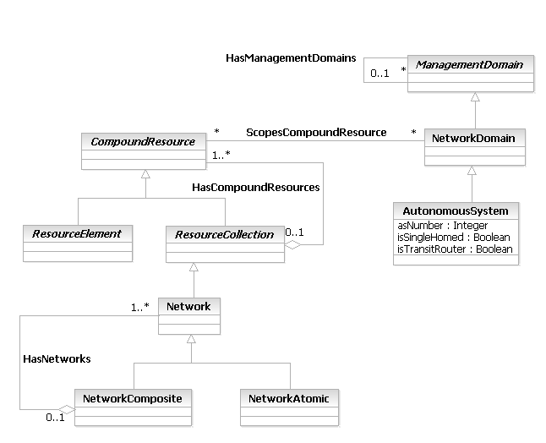
Figure 5LR- 58. AutonomousSystem Business Entity Model

BridgingProtocol Business Entity Definition
Business Entity Name | BridgingProtocol
Description | Bridging Protocols operate at the data link layer of the OSI model, and are used to define communications over different types of homogeneous and heterogeneous local area networks.  The DEN-ng model defines RSRBridging, SRBridging, SRTBridging, and TransparentBridging as examples of subclasses of this class.
Sources | DEN-ng
Cross-References
Synonyms / Aliases | This concept is not present in the ITU or DMTF CIM specifications.
Related Business Entities | ManagedEntity, ResourceSpecification, LogicalResourceSpec, PhysicalResourceSpec, CompoundResourceSpec, Product, ProductComponent, ProductBundle, Resource, PhysicalResource, LogicalResource, CompoundResource, LogicalDevice, DeviceInterface, MediaInterface, Software, SoftwareAtomic, SoftwareComposite, SoftwareCommand, SoftwareFeatureSets, Protocol (superclass), LANProtocol (sibling), RoutedProtocol (sibling), RoutingProtocol (sibling), SignalingProtocol (sibling), SwitchingProtocol (sibling), WANProtocol (sibling), ManagementProtocol (sibling), OperatingSystem, ResourceLogic, ResourceSpecVersion, LogicalResourceSpecVersion, ResourceSpecType, ResourceCharacteristic, ResourceCharacteristicValue, ResourceSpecCharacteristic, ResourceSpecCharacteristicValue, ResourceRole, LogicalResourceRole, PhysicalResourceRole, Service, ResourceFacingService, CustomerFacingService, ServiceSpecification, ResourceFacingServiceSpec, CustomerFacingServiceSpec
Business Rules | To be determined

BridgingProtocol Business Entity Attributes Definition
There are no attributes of BridgingProtocol that are appropriate for a business view.

Business Entity Model – BridgingProtocol
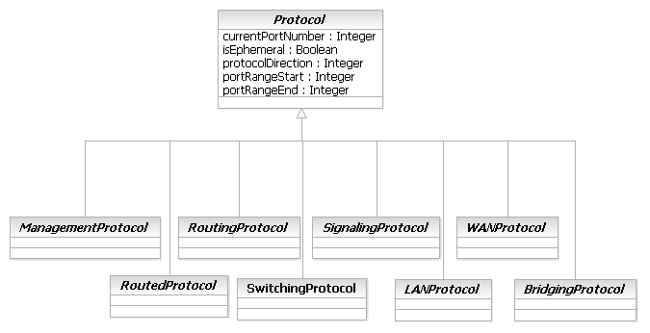
Figure 5LR- 59. BridgingProtocol Business Entity Model

CompoundResource Business Entity Definition
Business Entity Name | CompoundResource
Description | This is the abstract base class for all composite entities that are inherently manageable and make up a Product. The key difference between Resource and CompoundResource is that Resource describes either a Physical or a Logical entity. In contrast, CompoundResource is used to describe managed entities that are collections of other managed entities. A key point is that each managed entity that is part of a CompoundResource can be individually managed as either a PhysicalResource or a LogicalResource.
Sources | DEN-ng, Telstra
Cross-References
Synonyms / Aliases | This concept is not present in the ITU or CIM specs.
Related Business Entities | ManagedEntity, ResourceSpecification, LogicalResourceSpec, PhysicalResourceSpec, CompoundResourceSpec, Product, ProductComponent, ProductBundle, Resource (superclass), PhysicalResource, LogicalResource, ResourceElement (subclass), ResourceCollection (subclass), LogicalDevice, DeviceInterface, MediaInterface, Software, SoftwareAtomic, SoftwareComposite, SoftwareCommand, SoftwareFeatureSets, Protocol, ManagedTransmissionEntity, OperatingSystem, ResourceLogic, ResourceSpecVersion, LogicalResourceSpecVersion, ResourceSpecType, ResourceCharacteristic, ResourceCharacteristicValue, ResourceSpecCharacteristic, ResourceSpecCharacteristicValue, ResourceRole, LogicalResourceRole, PhysicalResourceRole, Service, ResourceFacingService, CustomerFacingService, ServiceSpecification, ResourceFacingServiceSpec, CustomerFacingServiceSpec
Business Rules | To be determined

CompoundResource Business Entity Attributes Definition
There are no attributes of CompoundResource that are appropriate for a business view.

Business Entity Model – CompoundResource
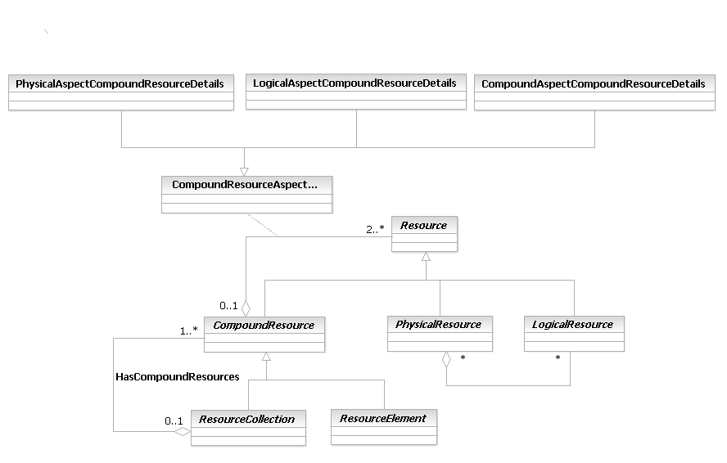
Figure 5LR- 60. CompoundResource Business Entity Model

CompoundResourceRole Business Entity Definition
Business Entity Name | CompoundResourceRole
Description | A CompoundResourceRole is a role that is defined by the interaction between PhysicalResourceRoles and LogicalResourceRoles. There must be at least one or more PhysicalResourceRoles and one or more LogicalResourceRoles to form a CompoundResourceRole. However, neither a PhysicalResourceRole nor a LogicalResourceRole has to belong to a CompoundResourceRole.
Sources | DEN-ng
Cross-References
Synonyms / Aliases | This concept is not present in either the ITU recommendations or the DMTF CIM.
Related Business Entities | ManagedEntity, ResourceSpecification, LogicalResourceSpec, PhysicalResourceSpec, CompoundResourceSpec, Product, ProductComponent, ProductBundle, Resource, PhysicalResource, LogicalResource, CompoundResource, LogicalDevice, DeviceInterface, DeviceSubInterface, MediaInterface, LogicalInterface, Software, SoftwareAtomic, SoftwareComposite, SoftwareCommand, SoftwareFeatureSets, OperatingSystem, ResourceLogic, ResourceSpecVersion, LogicalResourceSpecVersion, ResourceSpecType, ResourceCharacteristic, ResourceCharacteristicValue, ResourceSpecCharacteristic, ResourceSpecCharacteristicValue, Role, ResourceRole (superclass), LogicalResourceRole, PhysicalResourceRole, Service, ResourceFacingService, CustomerFacingService, ServiceSpecification, ResourceFacingServiceSpec, CustomerFacingServiceSpec
Business Rules | To be determined

CompoundResourceRole Business Entity Attributes Definition
There are no attributes of CompoundResourceRole that are appropriate for a business view.

Business Entity Model – CompoundResourceRole
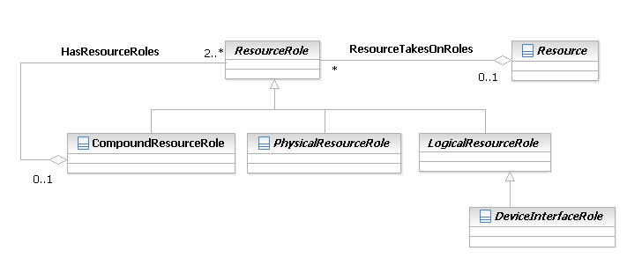
Figure 5LR- 61. - CompoundResourceRole Business Entity Model

CompoundResourceSpec Business Entity Definition
Business Entity Name | CompoundResourceSpec
Description | This is a concrete class for describing specific attributes, behavior, relationships, constraints, and semantics for building CompoundResource objects. The purpose of this class is to be able to track specifications of CompoundResources separately from other types of ResourceSpecifications. Note that this class inherits the ModifiesResourceSpec aggregation, and therefore can be used with the corresponding CompoundResource class.  The key difference between a CompoundResourceSpec and either a PhysicalResourceSpec and a LogicalResourceSpec is that a PhysicalResourceSpec and LogicalResourceSpec define templates for specifying the invariant characteristics and behavior of PhysicalResources and LogicalResources, respectively. In contrast, a CompoundResourceSpec is used to describe templates that contain at least one PhysicalResourceSpec and at least one LogicalResourceSpec. Optionally, one or more CompoundResourceSpecs may also be specified.  The difference between a CompoundResourceSpecAtomic entity and a CompoundResourceSpecComposite entity is that a CompoundResourceSpecAtomic entity is designed to be a stand-alone entity. (Note that it still aggregates at least one PhysicalResourceSpec and at least one LogicalResourceSpec; however, the end result is that this CompoundResourceSpecAtomic entity can be used by itself. In contrast, a CompoundResourceSpecComposite entity is made up of one or more CompoundResourceSpecs, one of which must be a CompoundResourceSpecAtomic entity.
Sources | DEN-ng
Cross-References
Synonyms / Aliases | The concept of a template for specifying the invariant characteristics and behavior of a managed object is not part of the ITU or CIM specs.
Related Business Entities | ManagedEntity, Specification, ResourceSpecification, LogicalResourceSpec, LogicalResourceSpecAtomic, LogicalResourceSpecComposite, PhysicalResourceSpec, PhysicalResourceSpecAtomic, PhysicalResourceSpecComposite, CompoundResourceSpec (superclass), CompoundResourceComposite (sibling), Product, ProductComponent, ProductBundle, Resource, PhysicalResource, LogicalResource, CompoundResource, ResourceSpecVersion, LogicalResourceSpecVersion, ResourceSpecType, ResourceCharacteristic, LogicalResourceCharacteristic, ResourceCharacteristicValue, ResourceSpecCharacteristic, ResourceSpecCharacteristicValue, ResourceRole, LogicalResourceRole, PhysicalResourceRole, Service, ResourceFacingService, CustomerFacingService, ServiceSpecification, ResourceFacingServiceSpec, CustomerFacingServiceSpec
Business Rules | To be determined

CompoundResourceSpec Business Entity Attributes Definition
There are no attributes of CompoundResourceSpecAtomic that are appropriate for a business view. The intent of this class is instead to serve as a common point to define relationships to other managed business objects. Subclasses of this class should be designed to add their own application-specific attributes to help constrain the values that the associated CompoundResource entity can take on.

Business Entity Model – CompoundResourceSpec
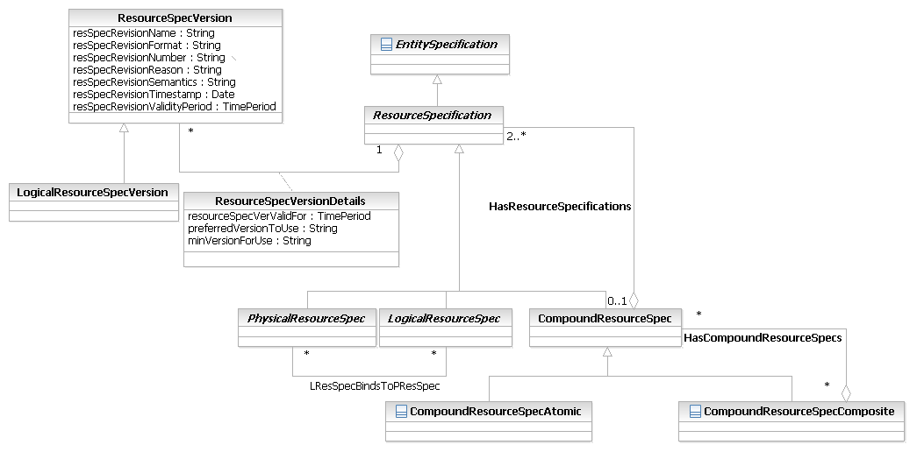
Figure LR.63 - Business Entity Model of CompoundResourceSpec Subclasses

CompoundResourceSpecAtomic Business Entity Definition
Business Entity Name | CompoundResourceSpecAtomic
Description | This is a concrete class for describing specific attributes, behavior, relationships, constraints, and semantics for building CompoundResource objects. The purpose of this class is to be able to track specifications of CompoundResources separately from other types of ResourceSpecifications. Note that this class inherits the ModifiesResourceSpec aggregation, and therefore can be used with the corresponding CompoundResource class.  The key difference between a CompoundResourceSpec and either a PhysicalResourceSpec and a LogicalResourceSpec is that a PhysicalResourceSpec and LogicalResourceSpec define templates for specifying the invariant characteristics and behavior of PhysicalResources and LogicalResources, respectively. In contrast, a CompoundResourceSpec is used to describe templates that contain at least one PhysicalResourceSpec and at least one LogicalResourceSpec. Optionally, one or more CompoundResourceSpecs may also be specified.  The difference between a CompoundResourceSpecAtomic entity and a CompoundResourceSpecComposite entity is that a CompoundResourceSpecAtomic entity is designed to be a stand-alone entity. (Note that it still aggregates at least one PhysicalResourceSpec and at least one LogicalResourceSpec; however, the end result is that this CompoundResourceSpecAtomic entity can be used by itself. In contrast, a CompoundResourceSpecComposite entity is made up of one or more CompoundResourceSpecs, one of which must be a CompoundResourceSpecAtomic entity.
Sources | DEN-ng, MetaSolv
Cross-References
Synonyms / Aliases | The concept of a template for specifying the invariant characteristics and behavior of a managed object is not part of the ITU or CIM specs.
Related Business Entities | ManagedEntity, Specification, ResourceSpecification, LogicalResourceSpec, LogicalResourceSpecAtomic, LogicalResourceSpecComposite, PhysicalResourceSpec, PhysicalResourceSpecAtomic, PhysicalResourceSpecComposite, CompoundResourceSpec (superclass), CompoundResourceAtomic (sibling), Product, ProductComponent, ProductBundle, Resource, PhysicalResource, LogicalResource, CompoundResource, ResourceSpecVersion, LogicalResourceSpecVersion, ResourceSpecType, ResourceCharacteristic, LogicalResourceCharacteristic, ResourceCharacteristicValue, ResourceSpecCharacteristic, ResourceSpecCharacteristicValue, ResourceRole, LogicalResourceRole, PhysicalResourceRole, Service, ResourceFacingService, CustomerFacingService, ServiceSpecification, ResourceFacingServiceSpec, CustomerFacingServiceSpec
Business Rules | To be determined

CompoundResourceSpecAtomic Business Entity Attributes Definition
There are no attributes of CompoundResourceSpecAtomic that are appropriate for a business view. The intent of this class is instead to serve as a common point to define relationships to other managed business objects. Subclasses of this class should be designed to add their own application-specific attributes to help constrain the values that the associated CompoundResource entity can take on.

Business Entity Model – CompoundResourceSpecAtomic
Figure LR.63 - Business Entity Model of CompoundResourceSpec Subclasses

CompoundResourceSpecComposite Business Entity Definition
Business Entity Name | CompoundResourceSpecComposite
Description | This is a concrete class for describing specific attributes, behavior, relationships, constraints, and semantics for building composite CompoundResource objects. The purpose of this class is to be able to track specifications of CompoundResources separately from other types of ResourceSpecifications. Note that this class inherits the ModifiesResourceSpec aggregation, and therefore can be used with the corresponding CompoundResource class.  The key difference between a CompoundResourceSpec and either a PhysicalResourceSpec and a LogicalResourceSpec is that a PhysicalResourceSpec and LogicalResourceSpec define templates for specifying the invariant characteristics and behavior of PhysicalResources and LogicalResources, respectively. In contrast, a CompoundResourceSpec is used to describe templates that contain at least one PhysicalResourceSpec and at least one LogicalResourceSpec. Optionally, one or more CompoundResourceSpecs may also be specified.  The difference between a CompoundResourceSpecAtomic entity and a CompoundResourceSpecComposite entity is that a CompoundResourceSpecAtomic entity is designed to be a stand-alone entity. (Note that it still aggregates at least one PhysicalResourceSpec and at least one LogicalResourceSpec; however, the end result is that this CompoundResourceSpecAtomic entity can be used by itself.) In contrast, a CompoundResourceSpecComposite entity is made up of one or more CompoundResourceSpecs, one of which must be a CompoundResourceSpecAtomic entity.
Sources | DEN-ng, MetaSolv
Cross-References
Synonyms / Aliases | The concept of a template for specifying the invariant characteristics and behavior of a managed object is not part of the ITU or CIM specs.
Related Business Entities | ManagedEntity, Specification, ResourceSpecification, LogicalResourceSpec, LogicalResourceSpecAtomic, LogicalResourceSpecComposite, PhysicalResourceSpec, PhysicalResourceSpecAtomic, PhysicalResourceSpecComposite, CompoundResourceSpec (superclass), CompoundResourceAtomic (sibling), Product, ProductComponent, ProductBundle, Resource, PhysicalResource, LogicalResource, CompoundResource, ResourceSpecVersion, LogicalResourceSpecVersion, ResourceSpecType, ResourceCharacteristic, LogicalResourceCharacteristic, ResourceCharacteristicValue, ResourceSpecCharacteristic, ResourceSpecCharacteristicValue, ResourceRole, LogicalResourceRole, PhysicalResourceRole, Service, ResourceFacingService, CustomerFacingService, ServiceSpecification, ResourceFacingServiceSpec, CustomerFacingServiceSpec
Business Rules | To be determined

CompoundResourceSpecComposite Business Entity Attributes Definition
There are no attributes of CompoundResourceSpecComposite that are appropriate for a business view. The intent of this class is instead to serve as a common point to define relationships to other managed business objects. Subclasses of this class should be designed to add their own application-specific attributes to help constrain the values that the associated CompoundResource entity can take on.

Business Entity Model – CompoundResourceSpecComposite
The business entity model for a CompoundResourceSpecComposite is the same as that of a LogicalResourceSpecAtomic, and is shown in Figure LR.63 above.

Connection Business Entity Definition
Business Entity Name | Connection
Description | This is a class of managed objects responsible for the transparent transfer of information between ConnectionTerminationPoints. A Connection is a component of a Trail.  Several connections can be bundled into a higher rate trail. A sequence of one or more Connections are linked together to form a Trail. A Connection may be either uni- or bi-directional.  This object is taken from M.3100. DEN-ng integrates it into the ManagedTransmissionEntity hierarchy so that it can interact with managed objects defined by the TMF, IETF, and other fora.
Sources | DEN-ng, M.3100
Cross-References
Synonyms / Aliases | This concept is not present in CIM.
Related Business Entities | ManagedEntity, ResourceSpecification, LogicalResourceSpec, PhysicalResourceSpec, CompoundResourceSpec, Product, ProductComponent, ProductBundle, Resource, PhysicalResource, LogicalResource, CompoundResource, LogicalDevice, DeviceInterface, MediaInterface, Software, SoftwareAtomic, SoftwareComposite, SoftwareCommand, SoftwareFeatureSets, Protocol, ManagedTransmissionEntity, TerminationPoint, Pipe (superclass), Trail (sibling), OperatingSystem, ResourceLogic, ResourceSpecVersion, LogicalResourceSpecVersion, ResourceSpecType, ResourceCharacteristic, ResourceCharacteristicValue, ResourceSpecCharacteristic, ResourceSpecCharacteristicValue, ResourceRole, LogicalResourceRole, PhysicalResourceRole, Service, ResourceFacingService, CustomerFacingService, ServiceSpecification, ResourceFacingServiceSpec, CustomerFacingServiceSpec
Business Rules | To be determined

Connection Business Entity Attributes Definition
There are no attributes of Connection that are appropriate for a business view.

Business Entity Model – Connection
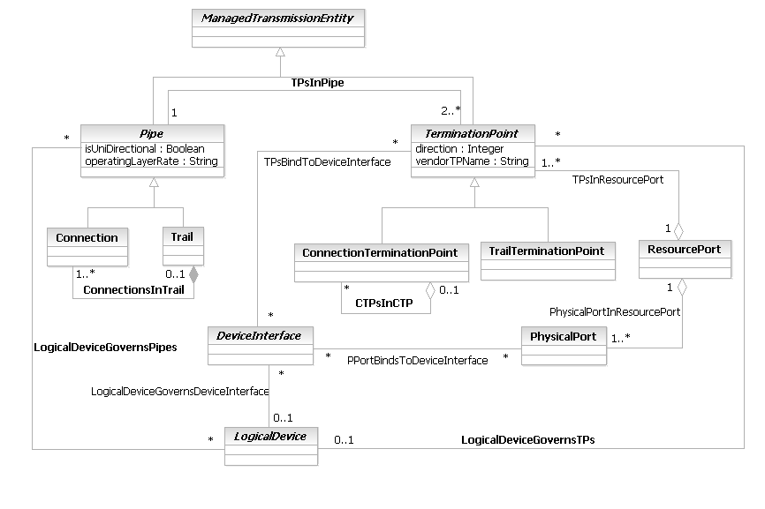
Figure LR.64 - Business Entity Model of Pipe Subclasses

ConnectionTerminationPoint Business Entity Definition
Business Entity Name | ConnectionTerminationPoint
Description | This is an actual or potential end point of a Network connection. For example, this can represent a logical channel or a timeslot on a physical link.  All PhysicalPorts connect to at least one CTP if they are supporting communication.  This object is derived from MTNM (see TMF 608). DEN-ng integrates it into the ManagedTransmissionEntity hierarchy so that it can interact with managed objects defined by the TMF, IETF, and other fora.
Sources | DEN-ng, MTNM
Cross-References
Synonyms / Aliases | This concept is not present in CIM. M.3100 defines three classes that are similar in nature but lack the semantics of the MTNM definition.
Related Business Entities | ManagedEntity, ResourceSpecification, LogicalResourceSpec, PhysicalResourceSpec, CompoundResourceSpec, Product, ProductComponent, ProductBundle, Resource, PhysicalResource, LogicalResource, CompoundResource, LogicalDevice, DeviceInterface, MediaInterface, Software, SoftwareAtomic, SoftwareComposite, SoftwareCommand, SoftwareFeatureSets, Protocol, ManagedTransmissionEntity, Pipe, Connection, Trail, TerminationPoint (superclass), TrailTerminationPoint (sibling), OperatingSystem, ResourceLogic, ResourceSpecVersion, LogicalResourceSpecVersion, ResourceSpecType, ResourcePort, ResourceCharacteristic, ResourceCharacteristicValue, ResourceSpecCharacteristic, ResourceSpecCharacteristicValue, ResourceRole, LogicalResourceRole, PhysicalResourceRole, Service, ResourceFacingService, CustomerFacingService, ServiceSpecification, ResourceFacingServiceSpec, CustomerFacingServiceSpec
Business Rules | To be determined

ConnectionTerminationPoint Business Entity Attributes Definition
Please note that the MTNM attributes below are the result of a mapping from MTNM into the SID.
Business Entity Name | ConnectionTerminationPoint

Attribute Name | Description | Data Type | Notes (used to map to other models; blank is other models don’t have it)
mappingMode | This is an enumerated integer that defines the current mapping mode of this CTP. This defines how this CTP will support connections - at its maximum layer rate, at lower layer rates, or both. Values include:  0: Unknown  1: Neither terminated nor available for mapping  2: Terminated but unavailable for mapping  3: Mappable at lower rates  4: Mappable at its maximum layer rate | Integer | Implied in M.3100, but not defined as an attribute; no equivalent in CIM. MTNM has an equivalent definition in a different format.
ctpState | This is an enumerated integer that specifies the particular type of connection that this CTP has. Values include:  0: Unknown  1: Not applicable  2: Source-Connected  3: Sink-Connected  4: Bi-Directionally-Connected | Integer | No equivalent in the ITU specs or in the DMTF CIM. MTNM has an equivalent definition in a different format.
supportedConnectionRates | This attribute consists of a sequence of strings in the form of comma-separated values. Each string defines a supported layer connection rate of the CTP. | String | No equivalent in the ITU specs or in the DMTF CIM. This attribute does not appear in MTNM’s CTP class; it appears in MTNM’s ManagedElement class.

Business Entity Model – ConnectionTerminationPoint
Please note that this part of the model is still preliminary and subject to change. This is because the business view is really not appropriate for this level of detail. However, considering the importance of integrating MTNM into the SID, it was decided that for this release, we would include the three attributes shown.
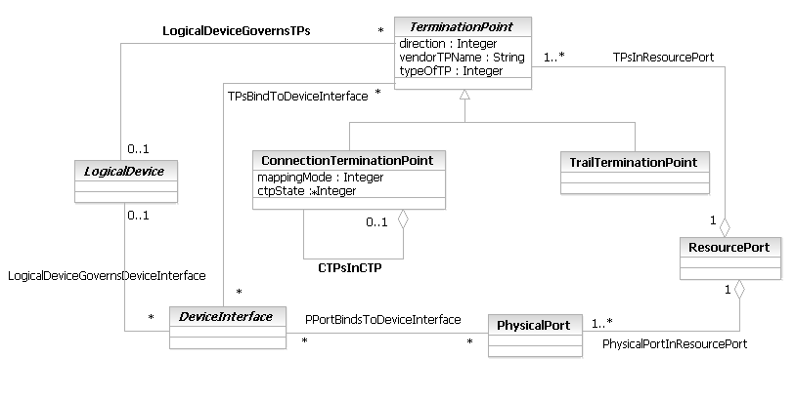
Figure LR.65 - Business Entity Model of a ConnectionTerminationPoint

DeviceInterface Business Entity Definition
Business Entity Name | DeviceInterface
Description | This is a concrete class that represents the (logical) interface or sub-interface of a device. This is not a transmission entity; rather, DeviceInterfaces are used to program Services and LogicalResources on a Device. Put another way, DeviceInterfaces can be used to model interface-specific commands which are used to bind an appropriate set of TPs.  For example, it is used to program a logical connection from a device to a network medium. Different types of DeviceInterfaces exist for the different types of network media (e.g., IP vs. ATM) that are used in a network to enable such media to be programmed. The combination of a LogicalDevice and a DeviceInterface is what a developer programs to define Services that run on the device. In this case, a LogicalDevice serves to orchestrate the functionality of the set of DeviceInterfaces that are used.  Please note that this is an architecturally significant entity. In reality, it is a System/Implementation View entity, as its purpose is to administer the creation and configuration of other entities using one or more languages (e.g., CLI, SNMP, or TL1). Hence, it is defined in the business view, as it is used to provide a basic configuration pattern. Additional work in the system view will expand upon this pattern, and help focus the SID-MTNM/MTOSI harmonization activities.
Sources | DEN-ng
Cross-References
Synonyms / Aliases | This concept is not present in either the ITU recommendations or the DMTF CIM.
Related Business Entities | ManagedEntity, ResourceSpecification, LogicalResourceSpec, PhysicalResourceSpec, CompoundResourceSpec, Product, ProductComponent, ProductBundle, Resource, PhysicalResource, LogicalResource (superclass), CompoundResource, LogicalDevice, MediaInterface (subclass), LogicalInterface (subclass), Software, SoftwareAtomic, SoftwareComposite, SoftwareCommand, SoftwareFeatureSets, OperatingSystem, ResourceLogic, ResourceSpecVersion, LogicalResourceSpecVersion, ResourceSpecType, ResourceCharacteristic, ResourceCharacteristicValue, ResourceSpecCharacteristic, ResourceSpecCharacteristicValue, ResourceRole, LogicalResourceRole, PhysicalResourceRole, Service, ResourceFacingService, CustomerFacingService, ServiceSpecification, ResourceFacingServiceSpec, CustomerFacingServiceSpec, DeviceSubInterface
Business Rules | To be determined

DeviceInterface Business Entity Attributes Definition
The following table contains the business attributes for this release of the SID Logical Addendum. Note that previous releases of this Addenda contained additional attributes; please note that all class attributes except those shown below have been moved to the system view model for DeviceInterface.
Business Entity Name | DeviceInterface

Attribute Name | Description | Data Type | Notes (used to map to other models; blank is other models don’t have it)
customerInterfaceNumber | This is the number of this particular device interface using a naming methodology defined by the Customer. | String | Not present in the ITU or CIM specifications.
deviceConfigMethod | This is an enumerated integer that defines how this interface is to be configured. Values include:  0 - not configured  1 - using the CONSOLE port  2 - using the AUXILIARY port  3 - using a virtual terminal interface  4 - download through a TFTP server  5 - download through an FTP server  6 - download through a NMS  If the value of this attribute is 3, then the vtyNumber attribute must be filled in with the particular vty interface that is being used. | Integer | Not present in the ITU or CIM specifications.
hasCarrierDetect | This is a Boolean attribute that, if TRUE, represents that the physical carrier detect signal has been received. | Boolean
hasDataLink | This is a Boolean attribute that, if TRUE, represents that the data link framing is operational. This is usually triggered by correct operation of the line protocol. | Boolean
isInterfaceEnabled | This is a Boolean attribute that, if TRUE, means that this device is logically enabled and can send and receive transmissions. If the value of this attribute is FALSE, then it is disabled and cannot send or receive transmissions. | Boolean | Not present in the ITU or CIM specifications.
vendorInterfaceNumber | This is the number of this particular device interface using vendor specific naming. This attribute is required, because this is the how the vendor refers to this attribute. | String | Not present in the ITU or CIM specifications.

Business Entity Model – DeviceInterface
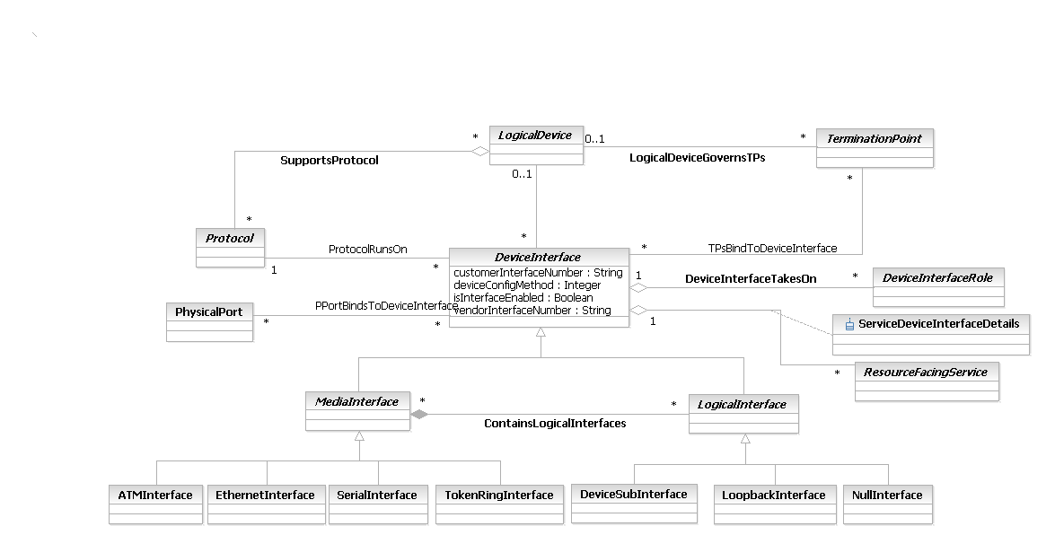
Figure LR.66 - Business Entity Model of a DeviceInterface

DeviceInterfaceRole Business Entity Definition
Business Entity Name | DeviceInterfaceRole
Description
Sources | DEN-ng
Cross-References
Synonyms / Aliases | This concept is not present in either the ITU recommendations or the DMTF CIM.
Related Business Entities | ManagedEntity, ResourceSpecification, LogicalResourceSpec, PhysicalResourceSpec, CompoundResourceSpec, Product, ProductComponent, ProductBundle, Resource, PhysicalResource, LogicalResource, CompoundResource, LogicalDevice, DeviceInterface, DeviceSubInterface, MediaInterface, LogicalInterface, Software, SoftwareAtomic, SoftwareComposite, SoftwareCommand, SoftwareFeatureSets, OperatingSystem, ResourceLogic, ResourceSpecVersion, LogicalResourceSpecVersion, ResourceSpecType, ResourceCharacteristic, ResourceCharacteristicValue, ResourceSpecCharacteristic, ResourceSpecCharacteristicValue, Role, ResourceRole, LogicalResourceRole (superclass), PhysicalResourceRole, CompoundResourceRole, Service, ResourceFacingService, CustomerFacingService, ServiceSpecification, ResourceFacingServiceSpec, CustomerFacingServiceSpec
Business Rules | To be determined

DeviceInterfaceRole Business Entity Attributes Definition
There are no attributes of DeviceInterfaceRole that are appropriate for a business view.

Business Entity Model – DeviceInterfaceRole
The business entity model of DeviceInterfaceRole is the same as that of LogicalResourceRole, and is defined in Figure LR.61 above.

DeviceSubInterface Business Entity Definition
Business Entity Name | DeviceSubInterface
Description | This is a concrete class that represents sub-interfaces. These are virtual interfaces that are bound to a single physical interface.
Sources | DEN-ng
Cross-References
Synonyms / Aliases | This concept is not present in either the ITU recommendations or the DMTF CIM.
Related Business Entities | ManagedEntity, ResourceSpecification, LogicalResourceSpec, PhysicalResourceSpec, CompoundResourceSpec, Product, ProductComponent, ProductBundle, Resource, PhysicalResource, LogicalResource, CompoundResource, LogicalDevice, MediaInterface, DeviceInterface, LogicalInterface (superclass), NullInterface (sibling), LoopbackInterface (sibling), Software, SoftwareAtomic, SoftwareComposite, SoftwareCommand, SoftwareFeatureSets, OperatingSystem, ResourceLogic, ResourceSpecVersion, LogicalResourceSpecVersion, ResourceSpecType, ResourceCharacteristic, ResourceCharacteristicValue, ResourceSpecCharacteristic, ResourceSpecCharacteristicValue, ResourceRole, LogicalResourceRole, PhysicalResourceRole, Service, ResourceFacingService, CustomerFacingService, ServiceSpecification, ResourceFacingServiceSpec, CustomerFacingServiceSpec
Business Rules | To be determined

DeviceSubInterface Business Entity Attributes Definition
Business Entity Name | DeviceSubInterface

Attribute Name | Description | Data Type | Notes (used to map to other models; blank is other models don’t have it)
numberOfSubInterface | This is a non-negative integer, and is the number of this particular sub-interface. The combination of sub-interface number and interface number must be unique. | String | Not present in the ITU or CIM specifications.

Business Entity Model – DeviceSubInterface
The business entity model of SubInterface is the same as that of DeviceInterface, and is defined in Figure LR.66 above.

EthernetInterface Business Entity Definition
Business Entity Name | EthernetInterface
Description | This is a concrete class for modeling various types of Ethernet interfaces. Ethernet is a local area network protocol, which allows multiple devices that are on the local area network to transfer information and communicate with each other. It defines a specific implementation of the Physical and Data Link layers in the OSI model, and is governed by the IEEE 802.3 family of standards.
Sources | DEN-ng
Cross-References
Synonyms / Aliases | This concept is not present in either the ITU recommendations or the DMTF CIM.
Related Business Entities | ManagedEntity, ResourceSpecification, LogicalResourceSpec, PhysicalResourceSpec, CompoundResourceSpec, Product, ProductComponent, ProductBundle, Resource, PhysicalResource, LogicalResource, CompoundResource, LogicalDevice, DeviceInterface, MediaInterface (superclass), LogicalInterface, ATMInterface (sibling), SerialInterface (sibling), TokenRingInterface (sibling), Software, SoftwareAtomic, SoftwareComposite, SoftwareCommand, SoftwareFeatureSets, OperatingSystem, ResourceLogic, ResourceSpecVersion, LogicalResourceSpecVersion, ResourceSpecType, ResourceCharacteristic, ResourceCharacteristicValue, ResourceSpecCharacteristic, ResourceSpecCharacteristicValue, ResourceRole, LogicalResourceRole, PhysicalResourceRole, Service, ResourceFacingService, CustomerFacingService, ServiceSpecification, ResourceFacingServiceSpec, CustomerFacingServiceSpec
Business Rules | To be determined

EthernetInterface Business Entity Attributes Definition
Business Entity Name | EthernetInterface

Attribute Name | Description | Data Type | Notes (used to map to other models; blank is other models don’t have it)
duplexSetting | This is an enumerated integer that specifies whether duplex operation should be used or not. Values include:  0: auto-negotiate duplex speed  1: full-duplex  2: half-duplex | Integer | Defined in CIM’s Device model. Next release will integrate with MTNM’s definitions.
ethernetCurrentSpeed | This is an integer attribute that defines the current speed of this Ethernet interface. Note that this may be different than the maximum speed of this interface (which is defined in the ethernetSpeed attribute) because the interface may be rate-limited through software. | Integer | Not defined in the CIM. Next release will integrate with MTNM’s definitions.
ethernetSpeed | This is an enumerated integer that defines the type of media that this device interface can support. Values include:  0 - 10M (Ethernet)  1 - 100M (FastEthernet, only)  2 - auto-sensing between 10M and 100M  3 - 1000M (Gigabit Ethernet only) | Integer | Not defined in the CIM. Next release will integrate with MTNM’s definitions.
maxEthernetDataSize | This is an integer attribute that corresponds to the dot1dTpPortMaxInfo variable defined in the Bridge MIB.  It defines the maximum size of the INFO (non-MAC) field that will be transmitted or received on this interface. | Integer | This is defined in CIM’s Device model. Next release will integrate with MTNM’s definitions.

Business Entity Model – EthernetInterface
The model of an EthernetInterface is the same as that for MediaInterface, and is shown in Figure LR.79 below.

IPAddress Business Entity Definition
Business Entity Name | IPAddress
Description | This class represents an IP address. It can be either in v4 or v6 form, and can be formatted as dotted decimal or CIDR. One or more host aliases can also be supplied.
Sources | DEN-ng
Cross-References
Synonyms / Aliases | This concept is not present in either the ITU recommendations or the DMTF CIM.
Related Business Entities | ManagedEntity, ResourceSpecification, LogicalResourceSpec, PhysicalResourceSpec, CompoundResourceSpec, Product, ProductComponent, ProductBundle, Resource, PhysicalResource, LogicalResource, CompoundResource, LogicalDevice, DeviceInterface, MediaInterface, LogicalInterface, ATMInterface , SerialInterface, TokenRingInterface, NetworkAddress (superclass), IPv4Address (subclass), Software, SoftwareAtomic, SoftwareComposite, SoftwareCommand, SoftwareFeatureSets, OperatingSystem, ResourceLogic, ResourceSpecVersion, LogicalResourceSpecVersion, ResourceSpecType, ResourceCharacteristic, ResourceCharacteristicValue, ResourceSpecCharacteristic, ResourceSpecCharacteristicValue, ResourceRole, LogicalResourceRole, PhysicalResourceRole, Service, ResourceFacingService, CustomerFacingService, ServiceSpecification, ResourceFacingServiceSpec, CustomerFacingServiceSpec
Business Rules | To be determined

IPAddress Business Entity Attributes Definition
Business Entity Name | IPAddress

Attribute Name | Description | Data Type | Notes (used to map to other models; blank is other models don’t have it)
networkNumber | This contains the network number portion of the IP Address. | String | Not in the CIM or ITU specs.
hostNumber | This contains the host number portion of the IP Address. | String | Not in the CIM or ITU specs.
subnetMask | This is a string attribute that defines the subnet mask for the IP Address of this instance. The IP Address is constructed by concatenating the networkNumber and the hostNumber, forming a dotted decimal IP Address. The subnetMask is formatted according to the appropriate convention as defined in the addressFormat attribute of this object. | String | Not in the CIM or ITU specs.
performanceipaddress |  | PerformanceIPAddress

Business Entity Model – IPAddress
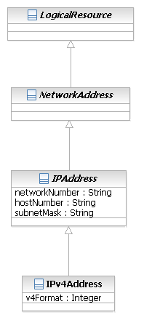
Figure LR.67 - Business Entity Model of an IPAddress

IPSubnet Business Entity Definition
Business Entity Name | IPSubnet
Description | A portion of a network that shares a common address component. On TCP/IP networks, subnets are defined as all devices whose IP addresses have the same prefix. For example, all devices with IP addresses that start with 100.100.100 would be part of the same subnet.  In DEN-ng, an IPSubnet represents a group of related logical endpoints, each of which is uniquely identified by a logical address, that can communicate with each other directly using a particular type of IP protocol.
Sources | DEN-ng, BT
Cross-References
Synonyms / Aliases | This concept is not present in the ITU specs. CIM deprecated IPSubnet and replaced with a class called IPConnectivitySubnet that has slightly different semantics than this one.
Related Business Entities | ManagedEntity, ResourceSpecification, LogicalResourceSpec, PhysicalResourceSpec, CompoundResourceSpec, Product, ProductComponent, ProductBundle, Resource, PhysicalResource, LogicalResource, CompoundResource, NetworkAtomic, NetworkComposite, ResourceCollection, ResourceElement, Network, NetworkDomain, AutonomousSystem, LayerNetwork, SubNetwork (superclass), LAN, ResourcePort, LogicalDevice, DeviceInterface, MediaInterface, Software, SoftwareAtomic, SoftwareComposite, SoftwareCommand, SoftwareFeatureSets, Protocol, ManagedTransmissionEntity, OperatingSystem, ResourceLogic, ResourceSpecVersion, LogicalResourceSpecVersion, ResourceSpecType, ResourceCharacteristic, ResourceCharacteristicValue, ResourceSpecCharacteristic, ResourceSpecCharacteristicValue, ResourceRole, LogicalResourceRole, PhysicalResourceRole, Service, ResourceFacingService, CustomerFacingService, ServiceSpecification, ResourceFacingServiceSpec, CustomerFacingServiceSpec
Business Rules | To be determined

IPSubnet Business Entity Attributes Definition
Business Entity Name | IPSubnet

Attribute Name | Description | Data Type | Notes (used to map to other models; blank is other models don’t have it)
addressType | This is an enumerated integer that defines the format of the IPAddress. Values include:  0: Unknown  1: Dotted Decimal (i.e., Address and Mask)  2: CIDR | Integer | Not present in the ITU specs; derived from RFC1771. Same attribute in the CIM but very different semantics; no CIDR capability.
addressVersion | This is an enumerated integer that describes the format of the address of this IPSubnet. Values include:  0: Unknown  1: IPv4  2: IPv6 | Integer | Not present in the ITU specs; identical definition to CIM’s addressType attribute.
addressRange | This is a string format that contains the range of IP Addresses of this IPSubnet. The format is determined by the AddressType attribute, and is either CIDR or dotted decimal. | String | Not present in the ITU specs; this corresponds to CIM’s SubnetMask and SubnetNumber attributes (except that CIDR isn’t defined in the CIM).

Business Entity Model – IPSubnet
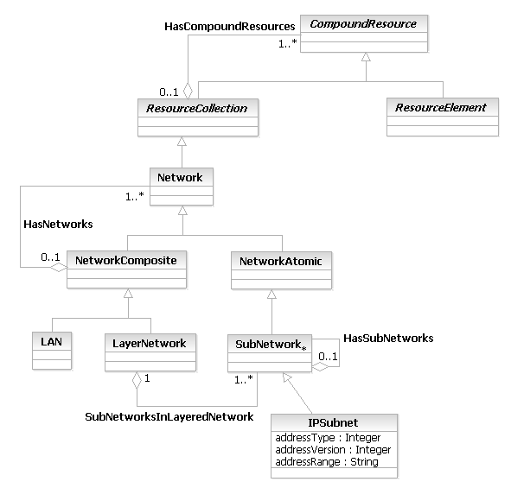
Figure LR.68 - Business Entity Model of an IPSubnet

IPv4Address Business Entity Definition
Business Entity Name | IPv4Address
Description | This class refines the generic IP Address class to add formatting capabilities that are specific to IPv4.
Sources | DEN-ng
Cross-References
Synonyms / Aliases | This concept is not present in either the ITU recommendations or the DMTF CIM.
Related Business Entities | ManagedEntity, ResourceSpecification, LogicalResourceSpec, PhysicalResourceSpec, CompoundResourceSpec, Product, ProductComponent, ProductBundle, Resource, PhysicalResource, LogicalResource, CompoundResource, LogicalDevice, DeviceInterface, MediaInterface, LogicalInterface, ATMInterface , SerialInterface, TokenRingInterface, NetworkAddress, IPAddress (superclass), Software, SoftwareAtomic, SoftwareComposite, SoftwareCommand, SoftwareFeatureSets, OperatingSystem, ResourceLogic, ResourceSpecVersion, LogicalResourceSpecVersion, ResourceSpecType, ResourceCharacteristic, ResourceCharacteristicValue, ResourceSpecCharacteristic, ResourceSpecCharacteristicValue, ResourceRole, LogicalResourceRole, PhysicalResourceRole, Service, ResourceFacingService, CustomerFacingService, ServiceSpecification, ResourceFacingServiceSpec, CustomerFacingServiceSpec
Business Rules | To be determined

IPv4Address Business Entity Attributes Definition
Business Entity Name | IPv4Address

Attribute Name | Description | Data Type | Notes (used to map to other models; blank is other models don’t have it)
v4Format | This is an enumerated integer that defines the format of the IPv4 address. Values are:  0: dotted decimal  1: CIDR | Integer | Not in the CIM or ITU specs.

Business Entity Model – IPv4Address
The business entity model of IPv4Address is the same as that of IPAddress, and is defined in Figure LR.67 above.

LAN Business Entity Definition
Business Entity Name | LAN
Description | A Local Area Network is a computer network covering a specific local area, like a home, office or small group of buildings. It provides communication between computers and devices.  The topology of a network dictates its physical structure. In DEN-ng, this is represented as a collection of endpoints of a common type that are all able to intercommunicate directly with each other, without the assistance of bridging or routing services.
Sources | DEN-ng, BT
Cross-References
Synonyms / Aliases | This concept is not present in the ITU specs; the CIM 2.7 LANConnectivitySegment is a similar concept in CIM but again has different semantics than those of this class.
Related Business Entities | ManagedEntity, ResourceSpecification, LogicalResourceSpec, PhysicalResourceSpec, CompoundResourceSpec, Product, ProductComponent, ProductBundle, Resource, PhysicalResource, LogicalResource, CompoundResource, ResourceCollection, ResourceElement, Network, NetworkDomain, AutonomousSystem, LayerNetwork (sibling), NetworkAtomic, NetworkComposite (superclass), SubNetwork, IPSubnet, ResourcePort, LogicalDevice, DeviceInterface, MediaInterface, Software, SoftwareAtomic, SoftwareComposite, SoftwareCommand, SoftwareFeatureSets, Protocol, ManagedTransmissionEntity, OperatingSystem, ResourceLogic, ResourceSpecVersion, LogicalResourceSpecVersion, ResourceSpecType, ResourceCharacteristic, ResourceCharacteristicValue, ResourceSpecCharacteristic, ResourceSpecCharacteristicValue, ResourceRole, LogicalResourceRole, PhysicalResourceRole, Service, ResourceFacingService, CustomerFacingService, ServiceSpecification, ResourceFacingServiceSpec, CustomerFacingServiceSpec
Business Rules | To be determined

LAN Business Entity Attributes Definition
Business Entity Name | LAN

Attribute Name | Description | Data Type | Notes (used to map to other models; blank is other models don’t have it)
lanID | This is a label or identifier for the LAN. | String | Not present in the ITU specs; same attribute in the CIM.
lanType | This is an enumerated integer, and is an indication of the kind of technology used on the LAN. Values include:  0: Unknown  1: Ethernet  2: FastEthernet  3: GigabitEthernet  4: 10 GigabitEthernet  5: TokenRing  6: FDDI  Note that FastEthernet is also able to run at Ethernet speeds if CanAutoSense is TRUE. | Integer | Not present in the ITU specs; CIM’s ConnectivityType attribute contains a subset of the LAN types compared to this attribute. Theoretically could use the OtherConnectivityType attribute to remedy this, but would have to make new definitions.
canAutoSense | This is a Boolean that, if TRUE, means that every ManagedElement in the LAN can sense what speed the LAN is running at and adjust accordingly. FALSE means that this capability is NOT shared by every element, and so a speed must be chosen at startup time. | Boolean | Not present in the ITU or CIM specs.

Business Entity Model – LAN
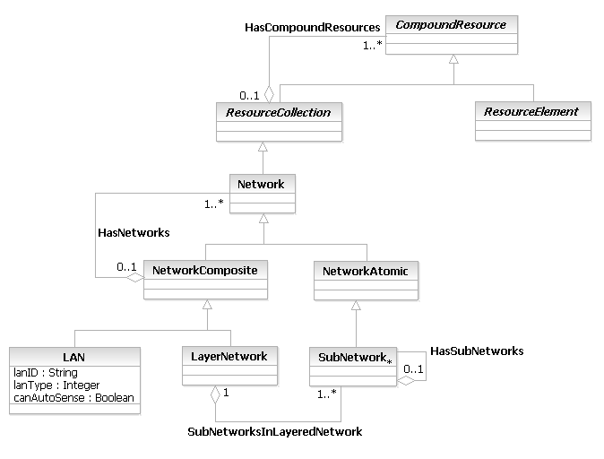
Figure LR.69 - Business Entity Model of a LAN

LANProtocol Business Entity Definition
Business Entity Name | LANProtocol
Description | LAN Protocols operate at the lowest two levels of the OSI model (i.e., physical and data link) and are used to define communications over different types of local area media.  The DEN-ng model defines Ethernet, FDDI, and TokenRing as examples of subclasses of this class.
Sources | DEN-ng
Cross-References
Synonyms / Aliases | This concept is not present in the ITU or DMTF CIM specifications.
Related Business Entities | ManagedEntity, ResourceSpecification, LogicalResourceSpec, PhysicalResourceSpec, CompoundResourceSpec, Product, ProductComponent, ProductBundle, Resource, PhysicalResource, LogicalResource, CompoundResource, LogicalDevice, DeviceInterface, MediaInterface, Software, SoftwareAtomic, SoftwareComposite, SoftwareCommand, SoftwareFeatureSets, Protocol (superclass), BridgingProtocol (sibling), RoutedProtocol (sibling), RoutingProtocol (sibling), SignalingProtocol (sibling), SwitchingProtocol (sibling), WANProtocol (sibling), ManagementProtocol (sibling), OperatingSystem, ResourceLogic, ResourceSpecVersion, LogicalResourceSpecVersion, ResourceSpecType, ResourceCharacteristic, ResourceCharacteristicValue, ResourceSpecCharacteristic, ResourceSpecCharacteristicValue, ResourceRole, LogicalResourceRole, PhysicalResourceRole, Service, ResourceFacingService, CustomerFacingService, ServiceSpecification, ResourceFacingServiceSpec, CustomerFacingServiceSpec
Business Rules | To be determined

LANProtocol Business Entity Attributes Definition
There are no attributes of LANProtocol that are appropriate for a business view.

Business Entity Model – LANProtocol
The business entity model of LANProtocol is the same as that of BridgingProtocol, and is defined in Figure LR.59 above.

LayerNetwork Business Entity Definition
Business Entity Name | LayerNetwork
Description | The LayerNetwork class is derived from G.805; DEN-ng has enhanced this definition by providing additional semantics that enable objects defined in the ITU to interact with objects defined in the TMF, IETF, and other fora. (These semantics are present in the DEN-ng system view, not in the business view).  A LayerNetwork is defined by the complete set of AccessGroups of the same type that may be associated for the purpose of transferring information. The information transferred is characteristic of the layer network and is termed characteristic information. The associations of the trail terminations (that form a trail) in a layer network may be made and broken by a layer network management process thus changing its connectivity. A separate, logically distinct layer network exists for each trail termination type. The topology of a layer network is described by access groups, subnetworks and the links between them.
Sources | DEN-ng, G.805, Telstra
Cross-References
Synonyms / Aliases | This concept is not present in the CIM.
Related Business Entities | ManagedEntity, ResourceSpecification, LogicalResourceSpec, PhysicalResourceSpec, CompoundResourceSpec, Product, ProductComponent, ProductBundle, Resource, PhysicalResource, LogicalResource, CompoundResource, ResourceCollection, ResourceElement, Network, NetworkAtomic, NetworkComposite (superclass), LAN (sibling), SubNetwork, IPSubnet, ResourcePort, LogicalDevice, DeviceInterface, MediaInterface, Software, SoftwareAtomic, SoftwareComposite, SoftwareCommand, SoftwareFeatureSets, Protocol, ManagedTransmissionEntity, OperatingSystem, ResourceLogic, ResourceSpecVersion, LogicalResourceSpecVersion, ResourceSpecType, ResourceCharacteristic, ResourceCharacteristicValue, ResourceSpecCharacteristic, ResourceSpecCharacteristicValue, ResourceRole, LogicalResourceRole, PhysicalResourceRole, Service, ResourceFacingService, CustomerFacingService, ServiceSpecification, ResourceFacingServiceSpec, CustomerFacingServiceSpec
Business Rules | To be determined

LayerNetwork Business Entity Attributes Definition
There are no attributes of LayerNetwork that are appropriate for a business view.

Business Entity Model – LayerNetwork
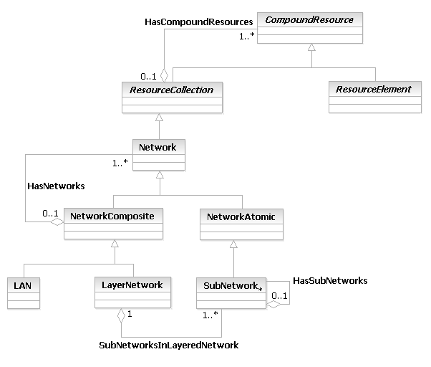
Figure LR.70 - Business Entity Model of a LayerNetwork

LogicalDevice Business Entity Definition
Business Entity Name | LogicalDevice
Description | This is an abstract base class for representing logical concepts and services that can be managed that are associated with the device as a whole. This class represents a convenient aggregation point for combining different aspects of a device (e.g., software contained in the device, protocols that the devices runs, the set of services that it offers, and so forth). It also enables the device itself to have a single logical manifestation.  Conceptually, this represents the "brains" of the Device. For example, it represents the set of entities required for a Router to know how to route packets.
Sources | DEN-ng
Cross-References
Synonyms / Aliases | This concept is not present in the ITU recommendations; CIM defines a LogicalDevice class but its functionality is significantly different. The functionality of the DEN-ng LogicalDevice is not represented in CIM, even using multiple CIM classes.
Related Business Entities | ManagedEntity, ResourceSpecification, LogicalResourceSpec, LogicalResourceSpecAtomic, LogicalResourceSpecComposite, PhysicalResourceSpec, PhysicalResourceSpecAtomic, PhysicalResourceSpecComposite, CompoundResourceSpec, CompoundResourceSpecAtomic, CompoundResourceSpecComposite, Product, ProductComponent, ProductBundle, Resource, PhysicalResource, LogicalResource (superclass), CompoundResource, LogicalDeviceAtomic (subclass), LogicalDeviceComposite (subclass), DeviceInterface, Software, OperatingSystem, ResourceLogic, ResourceSpecVersion, LogicalResourceSpecVersion, ResourceSpecType, ResourceCharacteristic, ResourceCharacteristicValue, ResourceSpecCharacteristic, ResourceSpecCharacteristicValue, ResourceRole, LogicalResourceRole, PhysicalResourceRole, Service, ResourceFacingService, CustomerFacingService, ServiceSpecification, ResourceFacingServiceSpec, CustomerFacingServiceSpec
Business Rules | To be determined

LogicalDevice Business Entity Attributes Definition
The following table contains the business attributes for this release of the SID Logical Addendum. Note that previous releases of this Addenda contained additional attributes; please note that all class attributes except those shown below have been moved to the system view model for LogicalDevice.
Business Entity Name | LogicalDevice

Attribute Name | Description | Data Type | Notes (used to map to other models; blank is other models don’t have it)
configBackupLocation | This is an enumerated integer, and specifies the following options for locating the current backup configuration:  0 - RAM  1 - NVRAM  2 - FLASH  3 - On-board memory requiring an external access  4 - Stored in an external network location | Integer
configRunningLocation | This is an enumerated integer, and specifies the following options for locating the current running configuration:  0 - RAM  1 - NVRAM  2 - FLASH  3 - On-board memory requiring an external access  4 - stored in an external network location | Integer
configurationMethod | This is an enumerated integer that defines the type of method(s) that are used to configure this Resource. Defined values include:  0: Unknown  1: None Available  2: SNMP  3: CLI  4: CMIP  5: TL1  6: Custom  This is a REQUIRED attribute. | String | Not present in the ITU or CIM specs.
configurationMode | This is an enumerated attribute that defines what mode the Resource is currently in. Note that some manufacturers require the device to be put into a particular mode in order to issue specific commands. Values include:  0 - not applicable (device doesn't use modes)  1 - User EXEC mode  2 - Privileged EXEC mode  3 - SETUP mode  4 - Global CONFIG mode  5 - Specific CONFIG SUB-MODE  6 - BOOT mode  User EXEC mode is a read-only mode in which the user can view, but not change, the configuration. Privileged EXEC mode supports access to configuration modes, debugging and testing of commands, and detailed examination of the device and manipulation of its config files. SETUP mode is used to help the user create an initial basic configuration; it is usually interactive. Global configuration mode is the main configuration driver interface that enables the user to issue one-line configuration commands. This includes accessing other configuration modes. Specific Config SUB-MODE is a specific sub-mode that supports more complex configuration commands that are limited to a particular type of function. Finally, BOOT mode is a general-purpose maintenance mode. | Integer
isLoopbackSet | This is a Boolean attribute that, if TRUE, means that a loopback has been set. This attribute occurs at the LogicalDevice level, and not at the DeviceInterface level, because the purpose of a LoopbackInterface is to forward traffic received on it directly to the Device itself. The LoopbackInterface is a virtual interface and has no hardware associated with it. | Boolean
isNullInterfaceSet | This is a Boolean attribute that, if TRUE, means that a null interface has been set. This attribute occurs at the LogicalDevice level, and not at the DeviceInterface level, because the purpose of a NullInterface is to drop traffic received on The NullInterface is a virtual interface and has no hardware associated with it. | Boolean
monitorMethod | This is an enumerated integer that defines the type of method(s) that are used to manage this Resource. Defined values include:  0: Unknown  1: None Available  2: SNMP  3: CLI  4: CMIP  5: TL1  6: Custom  This is an optional attribute. | String | Not present in the ITU or CIM specs.
numberOfConfigurationsPresent | This is an integer attribute that defines the total number of configurations that are stored in this particular Resource (NOT in the management system). | Integer
protocolsRunning | This is an array of strings, one for each protocol that is currently running on this Resource. | String
isMultiBootSystem | The isMultiBootSystem is a Boolean attribute. If its value is TRUE, then this LogicalDevice can have multiple OperatingSystems running concurrently. | Boolean
currentRunningOS | The currentRunningOS is a String Array that defines which OperatingSystems are currently running. While network devices usually cannot have multiple running OperatingSystems, servers and hosts can. | String
hasMultipleInstalledOSs | The hasMultipleInstalledOSs is a Boolean attribute. If its value is TRUE, then this LogicalDevice has multiple OperatingSystems installed. This doesn't necessarily mean that the LogicalDevice is running multiple OperatingSystems - that fact is defined by the isMultiBootSystem attribute having a value of TRUE. Rather, this attribute is used as a simple way to know if the device has more than one OperatingSystem installed. Note that servers, computers and network devices in particular are often loaded with multiple OperatingSystems. | Boolean
policydecisionpoint |  | PolicyDecisionPoint

Business Entity Model – LogicalDevice
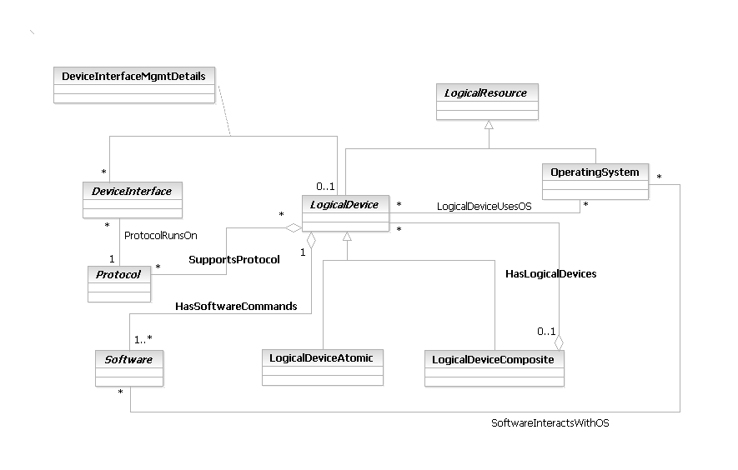
Figure LR.71 - Business Entity Model of a LogicalDevice

LogicalDeviceAtomic Business Entity Definition
Business Entity Name | LogicalDeviceAtomic
Description | This is a concrete base class for representing logical concepts and services that can be managed which are associated with the device as a whole. This class represents a convenient aggregation point for combining different aspects of a device (e.g., software contained in the device, protocols that the devices runs, the set of services that it offers, and so forth). It also enables the device itself to have a single logical manifestation.  This class represents all logical devices that are atomic in nature (e.g., not made up of multiple distinct logical devices that can be separately managed).
Sources | DEN-ng
Cross-References
Synonyms / Aliases | This concept is not present in the ITU or CIM specs.
Related Business Entities | ManagedEntity, ResourceSpecification, LogicalResourceSpec, LogicalResourceSpecAtomic, LogicalResourceSpecComposite, PhysicalResourceSpec, PhysicalResourceSpecAtomic, PhysicalResourceSpecComposite, CompoundResourceSpec, CompoundResourceSpecAtomic, CompoundResourceSpecComposite, Product, ProductComponent, ProductBundle, Resource, PhysicalResource, LogicalResource, CompoundResource, LogicalDevice (superclass), LogicalDeviceComposite (sibling), DeviceInterface, Software, OperatingSystem, ResourceLogic, ResourceSpecVersion, LogicalResourceSpecVersion, ResourceSpecType, ResourceCharacteristic, ResourceCharacteristicValue, ResourceSpecCharacteristic, ResourceSpecCharacteristicValue, ResourceRole, LogicalResourceRole, PhysicalResourceRole, Service, ResourceFacingService, CustomerFacingService, ServiceSpecification, ResourceFacingServiceSpec, CustomerFacingServiceSpec
Business Rules | To be determined

LogicalDeviceAtomic Business Entity Attributes Definition
There are no attributes of LogicalDeviceAtomic that are appropriate for a business view. The intent of this class is instead to serve as a common point to define relationships to other managed business objects. Subclasses of this class should be designed to add their own application-specific attributes to help constrain the values that the associated LogicalDevice entity can take on.

Business Entity Model – LogicalDeviceAtomic
The business entity model of a LogicalDeviceAtomic is the same as that for a LogicalDevice, and is shown in Figure LR.71 above.

LogicalDeviceComposite Business Entity Definition
Business Entity Name | LogicalDeviceComposite
Description | This is a concrete base class for representing logical concepts and services that can be managed which are associated with the device as a whole. This class represents a convenient aggregation point for combining different aspects of a device (e.g., software contained in the device, protocols that the devices runs, the set of services that it offers, and so forth). It also enables the device itself to have a single logical manifestation.  This class represents all logical devices that are composite in nature (e.g., made up of multiple distinct logical devices that can be separately managed). The composite pattern is used to enable LogicalDeviceComposite objects to be made up of LogicalDevice objects (i.e., either LogicalDeviceAtomic and/or LogicalDeviceComposite objects).
Sources | DEN-ng
Cross-References
Synonyms / Aliases | This concept is not present in the ITU or CIM specs.
Related Business Entities | ManagedEntity, ResourceSpecification, LogicalResourceSpec, LogicalResourceSpecAtomic, LogicalResourceSpecComposite, PhysicalResourceSpec, PhysicalResourceSpecAtomic, PhysicalResourceSpecComposite, CompoundResourceSpec, CompoundResourceSpecAtomic, CompoundResourceSpecComposite, Product, ProductComponent, ProductBundle, Resource, PhysicalResource, LogicalResource, CompoundResource, LogicalDevice (superclass), LogicalDeviceAtomic (sibling), DeviceInterface, Software, OperatingSystem, ResourceLogic, ResourceSpecVersion, LogicalResourceSpecVersion, ResourceSpecType, ResourceCharacteristic, ResourceCharacteristicValue, ResourceSpecCharacteristic, ResourceSpecCharacteristicValue, ResourceRole, LogicalResourceRole, PhysicalResourceRole, Service, ResourceFacingService, CustomerFacingService, ServiceSpecification, ResourceFacingServiceSpec, CustomerFacingServiceSpec
Business Rules | To be determined

LogicalDeviceComposite Business Entity Attributes Definition
There are no attributes of LogicalDeviceComposite that are appropriate for a business view. The intent of this class is instead to serve as a common point to define relationships to other managed business objects. Subclasses of this class should be designed to add their own application-specific attributes to help constrain the values that the associated LogicalDevice entity can take on.

Business Entity Model – LogicalDeviceComposite
The business entity model of a LogicalDeviceComposite is the same as that for a LogicalDevice, and is shown in Figure LR.71 above.

LogicalInterface Business Entity Definition
Business Entity Name | LogicalInterface
Description | This is an abstract class that serves as the superclass for all virtual interfaces. LogicalInterfaces are also called virtual interfaces. This is because a LogicalInterface has no hardware associated with it, and it is not physically connected to a network. It serves as a convenient aggregation point for running different relationships that affect its subclasses, thereby avoiding having to instantiate multiple relationships that are essentially the same.
Sources | DEN-ng
Cross-References
Synonyms / Aliases | This concept is not present in either the ITU recommendations or the DMTF CIM.
Related Business Entities | ManagedEntity, ResourceSpecification, LogicalResourceSpec, PhysicalResourceSpec, CompoundResourceSpec, Product, ProductComponent, ProductBundle, Resource, PhysicalResource, LogicalResource, CompoundResource, LogicalDevice, DeviceInterface (superclass), MediaInterface (sibling), SubInterface (subclass), LoopbackInterface (subclass), NullInterface (subclass), Software, SoftwareAtomic, SoftwareComposite, SoftwareCommand, SoftwareFeatureSets, OperatingSystem, ResourceLogic, ResourceSpecVersion, LogicalResourceSpecVersion, ResourceSpecType, ResourceCharacteristic, ResourceCharacteristicValue, ResourceSpecCharacteristic, ResourceSpecCharacteristicValue, ResourceRole, LogicalResourceRole, PhysicalResourceRole, Service, ResourceFacingService, CustomerFacingService, ServiceSpecification, ResourceFacingServiceSpec, CustomerFacingServiceSpec
Business Rules | To be determined

LogicalInterface Business Entity Attributes Definition
There are no attributes of LogicalInterface that are appropriate for a business view.

Business Entity Model – LogicalInterface
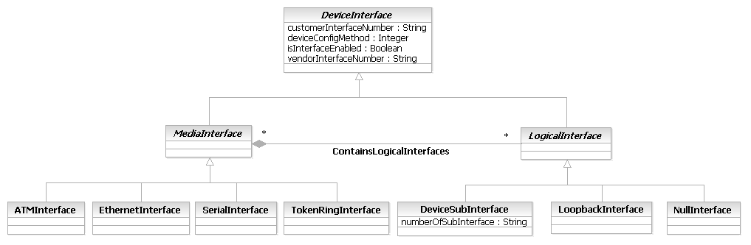
Figure LR.72 - Business Entity Model of a LogicalInterface

LogicalResource Business Entity Definition
Business Entity Name | LogicalResource
Description | This is an abstract base class for describing different logical aspects of devices (e.g., services) that constitute a Product. It has two main purposes: (1) to collect common attributes and relationships for all logical entities, and (2) to provide a convenient, single point where relationships with other managed objects can be defined.
Sources | DEN-ng, MetaSolv, BT
Cross-References
Synonyms / Aliases | LogicalResource doesn’t exist in the ITU-T models, which talk only about subclasses of LogicalResource. The purpose of LogicalResource is roughly the same as the CIM’s LogicalElement, but the hierarchies and relationships are very different.
Related Business Entities | ManagedEntity, ResourceSpecification, LogicalResourceSpec, LogicalResourceSpecAtomic, LogicalResourceSpecComposite, PhysicalResourceSpec, PhysicalResourceSpecAtomic, PhysicalResourceSpecComposite, CompoundResourceSpec, CompoundResourceSpecAtomic, CompoundResourceSpecComposite, Product, ProductComponent, ProductBundle, Resource (superclass), PhysicalResource (sibling), CompoundResource (sibling), ResourceSpecVersion, LogicalResourceSpecVersion, ResourceSpecType, ResourceCharacteristic, LogicalResourceCharacteristic, ResourceCharacteristicValue, ResourceSpecCharacteristic, ResourceSpecCharacteristicValue, ResourceRole, LogicalResourceRole, PhysicalResourceRole, Service, ResourceFacingService, CustomerFacingService, ServiceSpecification, ResourceFacingServiceSpec, CustomerFacingServiceSpec
Business Rules | To be determined

LogicalResource Business Entity Attributes Definition
Business Entity Name | LogicalResource

Attribute Name | Description | Data Type | Notes (used to map to other models; blank is other models don’t have it)
lrStatus | This is an enumerated integer whose value indicates the current status of the object.  Stopped indicates that the LogicalResource is known to still exist, but it is no longer operational. However, it has not failed.  Stressed indicates that the LogicalResource is functioning, but needs attention (e.g., it may be overheating, or overloaded in some way). This is similar to Predicted Failure, which indicates that this LogicalResource is functioning properly, but is predicting a failure in the near future.  In Maintenance indicates that this LogicalResource is being configured, maintained, or otherwise administered and is NOT available for service.  Unable To Contact indicates that the monitoring system has knowledge of this LogicalResource but has never been able to establish communications with it. In contrast, Lost Commmunications indicates that the LogicalResource has been contacted successfully in the past and is known to still exist; however, it is currently unreachable. | Integer | Not present in the ITU or the CIM.
serviceState | This is an enumerated integer that defines the availability and usage (i.e., the service state) of this LogicalResource. | Integer | Not present in the ITU or the CIM.
isOperational | This attribute is used to define the operational status of the object, and is implemented as a Boolean: TRUE means that the object is currently operational, and FALSE means that the object is not currently operational. | Boolean | Not present in the ITU or the CIM.

Business Entity Model – LogicalResource
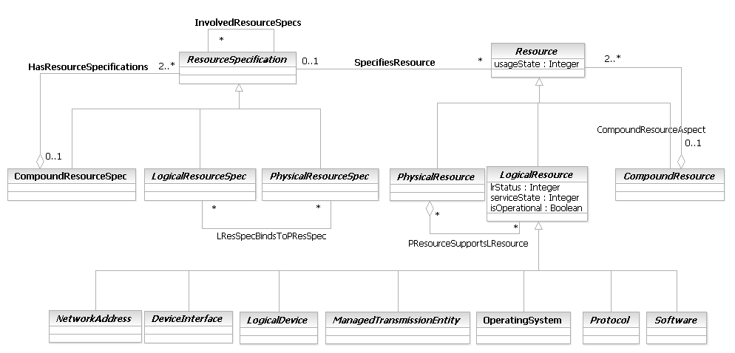
Figure LR.73 - Business Entity Model of a LogicalResource

LogicalResourceCharacteristic Business Entity Definition
Business Entity Name | LogicalResourceCharacteristic
Description | This is a concrete base class for defining the characteristic features and behavior of a LogicalResource. This subclass exists because the system viewpoint requires additional implementation details that aren't in a ResourceCharacteristic, and because it forms a convenient point for application-specific subclassing. This pattern can also be used to add new attributes to application-specific subclasses, as documented in GB922-1U.  Note that there is no need to define a composition between either of the LogicalResource specification classes (i.e., LogicalResourceSpecAtomic and LogicalResourceSpecComposite), because there aren't any different semantics. The ResourceCharacterizedBy composition can be used as is.
Sources | DEN-ng, MetaSolv
Cross-References
Synonyms / Aliases | No concept of this categorization in CIM or the ITU specs.
Related Business Entities | ManagedEntity, ResourceSpecification, LogicalResourceSpec, LogicalResourceSpecAtomic, LogicalResourceSpecComposite, PhysicalResourceSpec, PhysicalResourceSpecAtomic, PhysicalResourceSpecComposite, CompoundResourceSpec, CompoundResourceSpecAtomic, CompoundResourceSpecComposite, Product, ProductComponent, ProductBundle, Resource, PhysicalResource, CompoundResource, ResourceSpecVersion, LogicalResourceSpecVersion, ResourceSpecType, ResourceCharacteristic (superclass), ResourceCharacteristicValue, ResourceSpecCharacteristic, ResourceSpecCharacteristicValue, ResourceRole, LogicalResourceRole, PhysicalResourceRole, Service, ResourceFacingService, CustomerFacingService, ServiceSpecification, ResourceFacingServiceSpec, CustomerFacingServiceSpec
Business Rules | To be determined

LogicalResourceCharacteristic Business Entity Attributes Definition
There are no attributes of LogicalResourceCharacteristic that are appropriate for a business view. The intent of this class is instead to serve as a common point to define relationships to other managed business objects. Subclasses of this class should be designed to add their own application-specific attributes to help constrain the values that the associated ResourceCharacteristic entity can take on.

Business Entity Model – LogicalResourceCharacteristic
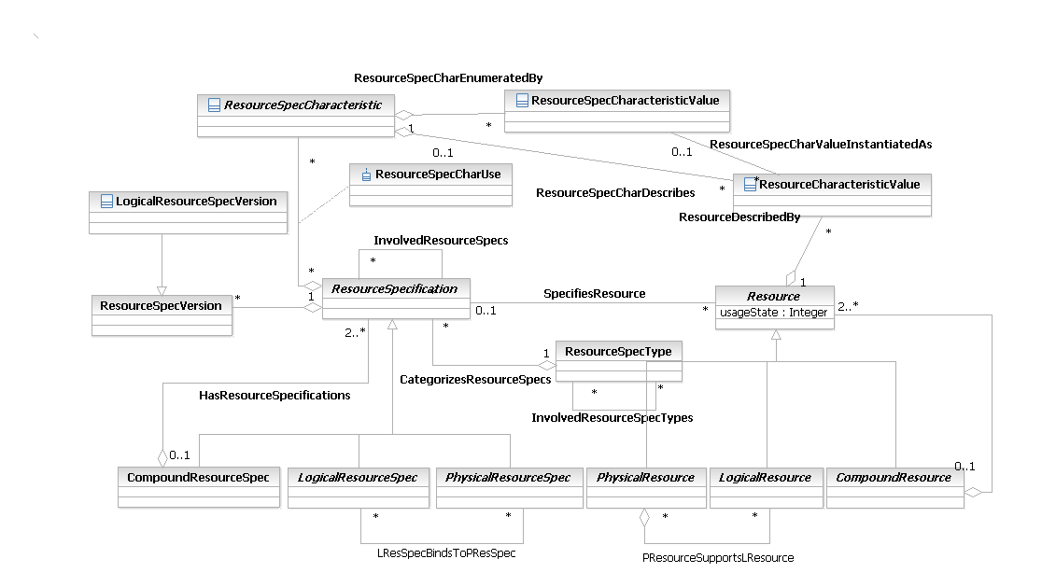
Figure LR.74 - Business Entity Model of Other LogicalResource Entities

LogicalResourceRole Business Entity Definition
Business Entity Name | LogicalResourceRole
Description | A CompoundResourceRole is a role that is defined by the interaction between PhysicalResourceRoles and LogicalResourceRoles. There must be at least one or more PhysicalResourceRoles and one or more LogicalResourceRoles to form a CompoundResourceRole. However, neither a PhysicalResourceRole nor a LogicalResourceRole has to belong to a CompoundResourceRole.
Sources | DEN-ng
Cross-References
Synonyms / Aliases | This concept is not present in either the ITU recommendations or the DMTF CIM.
Related Business Entities | ManagedEntity, ResourceSpecification, LogicalResourceSpec, PhysicalResourceSpec, CompoundResourceSpec, Product, ProductComponent, ProductBundle, Resource, PhysicalResource, LogicalResource, CompoundResource, LogicalDevice, DeviceInterface, DeviceSubInterface, MediaInterface, LogicalInterface, Software, SoftwareAtomic, SoftwareComposite, SoftwareCommand, SoftwareFeatureSets, OperatingSystem, ResourceLogic, ResourceSpecVersion, LogicalResourceSpecVersion, ResourceSpecType, ResourceCharacteristic, ResourceCharacteristicValue, ResourceSpecCharacteristic, ResourceSpecCharacteristicValue, Role, ResourceRole (superclass), CompoundResourceRole, PhysicalResourceRole, Service, ResourceFacingService, CustomerFacingService, ServiceSpecification, ResourceFacingServiceSpec, CustomerFacingServiceSpec
Business Rules | To be determined

LogicalResourceRole Business Entity Attributes Definition
There are no attributes of LogicalResourceRole that are appropriate for a business view.

Business Entity Model – LogicalResourceRole
The business entity model of LogicalResourceRole is the same as that of ResourceRole, and is defined in Figure LR.61 above.

LogicalResourceRoleSpec Business Entity Definition
Business Entity Name | LogicalResourceRoleSpec
Description | A Rack is a type of SecureHolder that represents an enclosure in which EquipmentHolders, such as Chassis, are placed. Typically a Rack is nothing more than the enclosure, and all the functioning componentry is packaged in the Chassis.  Note that the logical identifier of a Rack is NOT typically associated with the Device (i.e., the NetworkElement). Compare this to either a Bay or a Shelf, whose logical identifier IS associated with the Device. This means that the Rack is explicitly NOT a part of the logical model of a network.  The Rack typically serves as the "master enclosure" for Chassis, Shelves and Bays. In addition, Racks can have multiple instances of multiple Devices mounted in them.
Sources | DEN-ng
Cross-References
Synonyms / Aliases | This is a DEN-ng class, based on the original DEN spec. No direct analog in M.3100. The DMTF CIM has a Rack class, but its semantics are slightly different.
Related Business Entities | Resource, LogicalResource, LogicalDevice, Hardware, ManagedHardware, LogicalContainer (superclass), Equipment, Card, EquipmentHolderAtomic, EquipmentHolderComposite, SecureHolder (superclass), Chassis (sibling), Slot, Shelf, Bay, LogicalHolderRole, LogicalResourceRole, LogicalDeviceRole, HardwareRole
Business Rules | To be determined

LogicalResourceRoleSpec Business Entity Attributes Definition
There are no attributes of LogicalResourceRoleSpec that are appropriate for a business view.

Business Entity Model – LogicalResourceRoleSpec
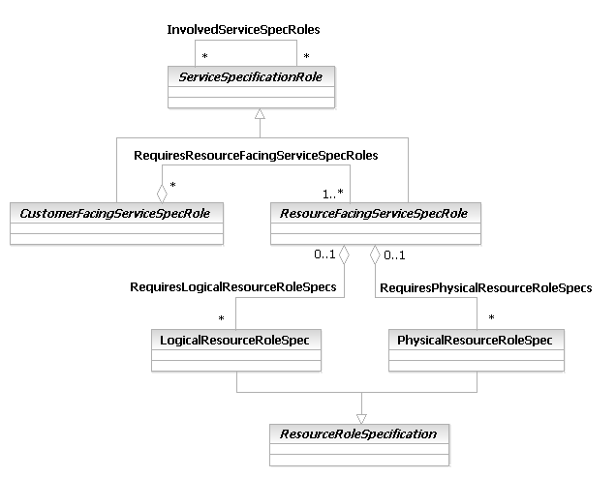
Figure LR.75 - Business Entity Model of a LogicalResourceRoleSpec

LogicalResourceSpec Business Entity Definition
Business Entity Name | LogicalResourceSpec
Description | A LogicalResourceSpec is an abstract base class that is used to define the invariant characteristics and behavior (attributes, methods, constraints, and relationships) of a LogicalResource.
Sources | DEN-ng
Cross-References
Synonyms / Aliases | The concept of a template for specifying the invariant characteristics and behavior of a managed object is not part of the ITU or CIM specs.
Related Business Entities | ManagedEntity, Specification, ResourceSpecification (superclass), PhysicalResourceSpec (sibling), CompoundResourceSpec (sibling), PhysicalResourceSpecAtomic, PhysicalResourceSpecComposite, LogicalResourceSpecAtomic, LogicalResourceSpecComposite, CompoundResourceSpecAtomic, CompoundResourceSpecComposite, Product, ProductComponent, ProductBundle, Resource, PhysicalResource, LogicalResource, CompoundResource, ResourceSpecVersion, ResourceSpecType, ResourceCharacteristic, ResourceCharacteristicValue, ResourceSpecCharacteristic, ResourceSpecCharacteristicValue, ResourceRole, LogicalResourceRole, PhysicalResourceRole, Service, ResourceFacingService, CustomerFacingService, ServiceSpecification, ResourceFacingServiceSpec, CustomerFacingServiceSpec
Business Rules | To be determined

LogicalResourceSpec Business Entity Attributes Definition
There are no attributes of LogicalResourceSpec that are appropriate for a business view. The intent of this class is instead to serve as a common point to define relationships to other managed business objects. Subclasses of this class should be designed to add their own application-specific attributes to define invariant characteristics and behavior of the entities being modeled.

Business Entity Model – LogicalResourceSpec
The business entity model of a LogicalResourceSpec is the same as that for a LogicalResource, and is shown in Figure LR.73 above.

LogicalResourceSpecAtomic Business Entity Definition
Business Entity Name | LogicalResourceSpecAtomic
Description | A LogicalResourceSpecAtomic is a concrete class for describing specific attributes, behavior, relationships, constraints, and semantics for building LogicalResource objects. The purpose of this class is to be able to track specifications of LogicalResources separately from other types of ResourceSpecifications. Note that this class inherits the ModifiesResourceSpec aggregation, and therefore can be used with the corresponding LogicalResource class.  The difference between this class and the LogicalResourceSpecComposite class is that this class represents stand-alone specifications of LogicalResource objects. The LogicalResourceSpecComposite class represents a hierarchy of specifications of LogicalResource objects.
Sources | DEN-ng, MetaSolv
Cross-References
Synonyms / Aliases | The concept of a template for specifying the invariant characteristics and behavior of a managed object is not part of the ITU or CIM specs.
Related Business Entities | ManagedEntity, Specification, ResourceSpecification, LogicalResourceSpec (superclass), LogicalResourceSpecComposite (sibling), PhysicalResourceSpec, PhysicalResourceSpecAtomic, PhysicalResourceSpecComposite, CompoundResourceSpec, CompoundResourceSpecAtomic, CompoundResourceComposite, Product, ProductComponent, ProductBundle, Resource, PhysicalResource, LogicalResource, CompoundResource, ResourceSpecVersion, LogicalResourceSpecVersion, ResourceSpecType, ResourceCharacteristic, LogicalResourceCharacteristic, ResourceCharacteristicValue, ResourceSpecCharacteristic, ResourceSpecCharacteristicValue, ResourceRole, LogicalResourceRole, PhysicalResourceRole, Service, ResourceFacingService, CustomerFacingService, ServiceSpecification, ResourceFacingServiceSpec, CustomerFacingServiceSpec
Business Rules | To be determined

LogicalResourceSpecAtomic Business Entity Attributes Definition
There are no attributes of LogicalResourceSpecAtomic that are appropriate for a business view. The intent of this class is instead to serve as a common point to define relationships to other managed business objects. Subclasses of this class should be designed to add their own application-specific attributes to define invariant characteristics and behavior of the entities being modeled.

Business Entity Model – LogicalResourceSpecAtomic
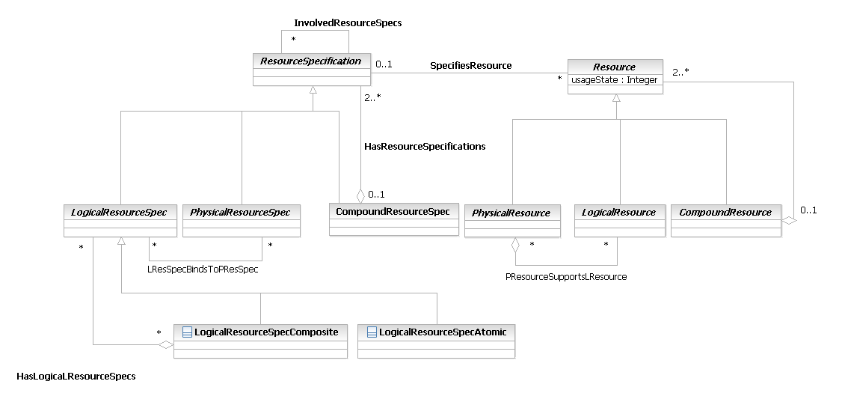
Figure LR.76 - Business Entity Model of the LogicalResourceSpec Subclasses

LogicalResourceSpecComposite Business Entity Definition
Business Entity Name | LogicalResourceSpecComposite
Description | This is a concrete class for describing specific attributes, behavior, relationships, constraints, and semantics for building LogicalResource objects. The purpose of this class is to be able to track specifications of LogicalResource separately from other types of ResourceSpecifications. Note that this class inherits the ModifiesResourceSpec aggregation, and therefore can be used with the corresponding LogicalResource class.  The difference between this class and the LogicalResourceSpecAtomic class is that this class represents a hierarchy of specifications for LogicalResources. The LogicalResourceSpecAtomic class represents a single stand-alone specification of a LogicalResource.
Sources | DEN-ng, MetaSolv
Cross-References
Synonyms / Aliases | The concept of a template for specifying the invariant characteristics and behavior of a managed object is not part of the ITU or CIM specs.
Related Business Entities | ManagedEntity, Specification, ResourceSpecification, LogicalResourceSpec (superclass), LogicalResourceSpecAtomic (sibling), PhysicalResourceSpec, PhysicalResourceSpecAtomic, PhysicalResourceSpecComposite, CompoundResourceSpec, CompoundResourceSpecAtomic, CompoundResourceComposite, Product, ProductComponent, ProductBundle, Resource, PhysicalResource, LogicalResource, CompoundResource, ResourceSpecVersion, LogicalResourceSpecVersion, ResourceSpecType, ResourceCharacteristic, LogicalResourceCharacteristic, ResourceCharacteristicValue, ResourceSpecCharacteristic, ResourceSpecCharacteristicValue, ResourceRole, LogicalResourceRole, PhysicalResourceRole, Service, ResourceFacingService, CustomerFacingService, ServiceSpecification, ResourceFacingServiceSpec, CustomerFacingServiceSpec
Business Rules | To be determined

LogicalResourceSpecComposite Business Entity Attributes Definition
There are no attributes of LogicalResourceSpec that are appropriate for a business view. The intent of this class is instead to serve as a common point to define relationships to other managed business objects. Subclasses of this class should be designed to add their own application-specific attributes to define invariant characteristics and behavior of the entities being modeled.

Business Entity Model – LogicalResourceSpecComposite
The business entity model for a LogicalResourceSpecComposite is the same as that of a LogicalResourceSpecAtomic, and is shown in Figure LR.76 above.

LogicalResourceSpecVersion Business Entity Definition
Business Entity Name | LogicalResourceSpecVersion
Description | The purpose of this class is to be able to track LogicalResourceSpecifications separately from other types of ResourceSpecifications. Note that this class inherits the modifiesResourceSpec aggregation, and therefore can be used with the corresponding LogicalResourceSpecification class.
Sources | DEN-ng, MetaSolv
Cross-References
Synonyms / Aliases | No concept of this categorization in CIM or the ITU specs.
Related Business Entities | ManagedEntity, Specification, ResourceSpecification, LogicalResourceSpec, PhysicalResourceSpec, CompoundResourceSpec, PhysicalResourceSpecAtomic, PhysicalResourceSpecComposite, LogicalResourceSpecAtomic, LogicalResourceSpecComposite, CompoundResourceSpecAtomic, CompoundResourceSpecComposite, Product, ProductComponent, ProductBundle, Resource, PhysicalResource, LogicalResource, CompoundResource, ResourceSpecType, ResourceCharacteristic, ResourceCharacteristicValue, ResourceSpecCharacteristic, ResourceSpecCharacteristicValue, ResourceSpecVersion (superclass), ResourceRole, LogicalResourceRole, PhysicalResourceRole, Service, ResourceFacingService, CustomerFacingService, ServiceSpecification, ResourceFacingServiceSpec, CustomerFacingServiceSpec
Business Rules | To be determined

LogicalResourceSpecVersion Business Entity Attributes Definition
There are no attributes of LogicalResourceSpecVersion that are appropriate for a business view. The intent of this class is instead to serve as a common point to define relationships to other managed business objects. Subclasses of this class should be designed to add their own application-specific attributes to define invariant characteristics and behavior of the entities being modeled.

Business Entity Model – LogicalResourceSpecVersion
The business entity model of a LogicalResourceSpecVersion is the same as that for a ResourceSpecVersion, and is shown above in Figure LR.75.

LoopbackInterface Business Entity Definition
Business Entity Name | LoopbackInterface
Description | A LoopbackInterface is a virtual interface (what DEN-ng calls a LogicalInterface). Traffic sent to the LoopbackInterface is forwarded to the Device itself for further processing.  A LoopbackInterface is commonly used to guarantee reachability in networks with multiple paths. it is also used to test IP software without worrying about broken or corrupted drivers or hardware.
Sources | DEN-ng
Cross-References
Synonyms / Aliases | This concept is not present in either the ITU recommendations or the DMTF CIM.
Related Business Entities | ManagedEntity, ResourceSpecification, LogicalResourceSpec, PhysicalResourceSpec, CompoundResourceSpec, Product, ProductComponent, ProductBundle, Resource, PhysicalResource, LogicalResource, CompoundResource, LogicalDevice, MediaInterface, DeviceInterface, LogicalInterface (superclass), NullInterface (sibling), DeviceInterface (sibling), Software, SoftwareAtomic, SoftwareComposite, SoftwareCommand, SoftwareFeatureSets, OperatingSystem, ResourceLogic, ResourceSpecVersion, LogicalResourceSpecVersion, ResourceSpecType, ResourceCharacteristic, ResourceCharacteristicValue, ResourceSpecCharacteristic, ResourceSpecCharacteristicValue, ResourceRole, LogicalResourceRole, PhysicalResourceRole, Service, ResourceFacingService, CustomerFacingService, ServiceSpecification, ResourceFacingServiceSpec, CustomerFacingServiceSpec
Business Rules | To be determined

LoopbackInterface Business Entity Attributes Definition
There are no attributes of LoopbackInterface that are appropriate for a business view.

Business Entity Model – LoopbackInterface
The business entity model of LoopbackInterface is the same as that of DeviceInterface, and is defined in Figure LR.66 above.

ManagementInfo Business Entity Definition
Business Entity Name | ManagementInfo
Description | This is an abstract base class that is used to represent entities that represent management information obtained in a managed environment. Specifically, in the process of managing an entity, information of various forms is created. This class is the base class for defining different types of management information.  The design of how management information is obtained uses this class to gather specific type of information, and the ManagementMethodEntity class to obtain the desired data using an appropriate method. This combination of class hierarchies enables different management methods (e.g., CLI vs. SNMP) to be used for two purposes: (1) to correlate the same type of management data that was gathered by different protocols, and (2) to relate different types of management data to each other (e.g., verify that a configuration command fixed a problem noticed by monitoring data), and is unique to the DEN-ng information model.
Sources | DEN-ng, BT
Cross-References
Synonyms / Aliases | This concept is not in the ITU or CIM specs.
Related Business Entities | ManagedEntity, ResourceSpecification, LogicalResourceSpec, PhysicalResourceSpec, CompoundResourceSpec, Product, ProductComponent, ProductBundle, Resource, PhysicalResource, LogicalResource, CompoundResource, ResourceCollection, ResourceElement, Network, NetworkDomain, AutonomousSystem, LayerNetwork, SubNetwork, IPSubnet, LAN, ResourcePort, LogicalDevice, DeviceInterface, MediaInterface, Software, SoftwareAtomic, SoftwareComposite, SoftwareCommand, SoftwareFeatureSets, Protocol, ManagedTransmissionEntity, OperatingSystem, ResourceLogic, ResourceSpecVersion, LogicalResourceSpecVersion, ResourceSpecType, ResourceCharacteristic, ResourceCharacteristicValue, ResourceSpecCharacteristic, ResourceSpecCharacteristicValue, ResourceRole, LogicalResourceRole, PhysicalResourceRole, Service, ResourceFacingService, CustomerFacingService, ServiceSpecification, ResourceFacingServiceSpec, CustomerFacingServiceSpec, ManagementMethodEntity, ResourceStateInfo (subclass), ResourceStatisticalInfo (subclass), ServiceStateInfo (subclass), ServiceStatisticalInfo (subclass), FaultInfo (subclass), ConfigurationInfo (subclass), AccountingInfo (subclass), PerformanceInfo (subclass), SecurityInfo (subclass)
Business Rules | To be determined

ManagementInfo Business Entity Attributes Definition
Business Entity Name | ManagementInfo

Attribute Name | Description | Data Type | Notes (used to map to other models; blank is other models don’t have it)
mgmtInfoValidFor | This attribute defines the time period that this management information is valid for. A TimePeriod is a complex datatype, that has a starting time and an ending time. | TimePeriod | Not present in the ITU or CIM specs.
retrievalMethodCurrent | This is an enumerated integer that defines the particular type of method that is currently being used to retrieve the management information. Values include:  0: Unknown  1: None  2: CLI  3: SNMP  4: TL1  5: CMIP  6: RMON  7: Proprietary  None could mean that this ManagedEntity performs a set function and is not configurable, as well as mean that this ManagedEntity is not configurable except by the factory. | Integer | Not present in the ITU or CIM specs.
retrievalMethodsSupported | This is an array of integers that define the different means of retrieving management methods that are supported by this object. Values include:  0: Unknown  1: None  2: CLI  3: SNMP  4: TL1  5: CMIP  6: RMON  7: Proprietary  None could mean that this ManagedEntity performs a set function and is not configurable, as well as mean that this ManagedEntity is not configurable except by the factory. | String | Not present in the ITU or CIM specs.

Business Entity Model – ManagementInfo
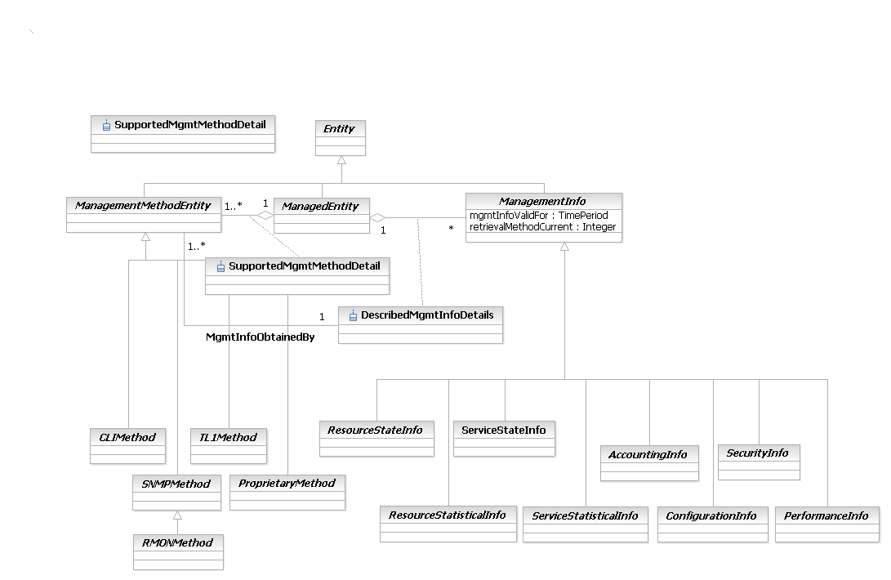
Figure LR.77 - Business Entity Model of Management Information Data and Retrieval

ManagementMethodEntity Business Entity Definition
Business Entity Name | ManagementMethodEntity
Description | This is an abstract base class for representing the different types of management methods that can be used to gather a particular type of management information. For example, this enables configuration setting classes to be defined as using CLI, while configuration monitoring classes could be defined as using a different method, such as SNMP.  The design of how management information is obtained uses this class to obtain the desired data using an appropriate method, and the ManagementInfo class to gather specific types of management data. This combination of class hierarchies enables different management methods (e.g., CLI vs. SNMP) to be used for two purposes: (1) to correlate the same type of management data that was gathered by different protocols, and (2) to relate different types of management data to each other (e.g., verify that a configuration command fixed a problem noticed by monitoring data), and is unique to the DEN-ng information model.
Sources | DEN-ng
Cross-References
Synonyms / Aliases | This concept is not in the ITU or CIM specs.
Related Business Entities | ManagedEntity, ResourceSpecification, LogicalResourceSpec, PhysicalResourceSpec, CompoundResourceSpec, Product, ProductComponent, ProductBundle, Resource, PhysicalResource, LogicalResource, CompoundResource, ResourceCollection, ResourceElement, Network, NetworkDomain, AutonomousSystem, LayerNetwork, SubNetwork, IPSubnet, LAN, ResourcePort, LogicalDevice, DeviceInterface, MediaInterface, Software, SoftwareAtomic, SoftwareComposite, SoftwareCommand, SoftwareFeatureSets, Protocol, ManagedTransmissionEntity, OperatingSystem, ResourceLogic, ResourceSpecVersion, LogicalResourceSpecVersion, ResourceSpecType, ResourceCharacteristic, ResourceCharacteristicValue, ResourceSpecCharacteristic, ResourceSpecCharacteristicValue, ResourceRole, LogicalResourceRole, PhysicalResourceRole, Service, ResourceFacingService, CustomerFacingService, ServiceSpecification, ResourceFacingServiceSpec, CustomerFacingServiceSpec, ManagementInfo, CLIMethod (subclass), SNMPMethod (subclass), RMONMethod, TL1Method (subclass), ProprietaryMethod (subclass)
Business Rules | To be determined

ManagementMethodEntity Business Entity Attributes Definition
There are no attributes of ManagementMethodEntity that are appropriate for a business view.

Business Entity Model – ManagementMethodEntity
The business entity model of a ManagementMethodEntity is the same as that for a ManagementInfo, and is shown above in Figure LR.77.

ManagedTransmissionEntity Business Entity Definition
Business Entity Name | ManagedTransmissionEntity
Description | This is an abstract base class for describing different types of logical entities that are or help to form connections that transmit and/or receive information. These logical entities are also called transmission entities or path entities. This represents a superclass to various TMF specs (e.g., SID and MTNM), ITU specs (e.g., G.805 and M.3100) as well as IETF concepts (such as those found in various RFCs) so that it can unite TMF, ITU and IETF concepts into a single class hierarchy.
Sources | DEN-ng
Cross-References
Synonyms / Aliases | This concept is not present in the ITU or the CIM.
Related Business Entities | ManagedEntity, ResourceSpecification, LogicalResourceSpec, PhysicalResourceSpec, CompoundResourceSpec, Product, ProductComponent, ProductBundle, Resource, PhysicalResource, LogicalResource, CompoundResource, LogicalDevice, DeviceInterface, MediaInterface, Software, SoftwareAtomic, SoftwareComposite, SoftwareCommand, SoftwareFeatureSets, Protocol, Pipe (subclass), TerminationPoint (subclass), OperatingSystem, ResourceLogic, ResourceSpecVersion, LogicalResourceSpecVersion, ResourceSpecType, ResourceCharacteristic, ResourceCharacteristicValue, ResourceSpecCharacteristic, ResourceSpecCharacteristicValue, ResourceRole, LogicalResourceRole, PhysicalResourceRole, Service, ResourceFacingService, CustomerFacingService, ServiceSpecification, ResourceFacingServiceSpec, CustomerFacingServiceSpec
Business Rules | To be determined

ManagedTransmissionEntity Business Entity Attributes Definition
Business Entity Name | ManagedTransmissionEntity
Attribute Name | Description | Data Type | Notes (used to map to other models; blank is other models don’t have it)
additionalInfo | This is a free-form string that is used to contain additional vendor-specific information about the managed element., such as a vendor-specific asset tracking number or special installation notes. This can be NULL. | String | Not present in the ITU or DMTF CIM
mteAdministrativeState | This attribute is an enumerated integer that defines the administrative state of the Equipment. This is an enhanced version of the ITU equivalent. Values include locked and unlocked, starting up and shutting down, testing, and maintenance. | Integer | Defined in X.721 as administrativeState. No equivalent in the DMTF CIM.
logicalAlarmReporting  Enabled | This is a Boolean attribute, and defines whether alarm reporting for this object instance is enabled or not. TRUE means that reporting is allowed, and FALSE means that reporting is inhibited. | Boolean | No equivalent in the ITU specs (though they do have alarm attributes). No equivalent in the DMTF CIM.
logicalAlarmStatus | This is an enumerated integer that indicates the occurrence of an abnormal condition relating to an object. This attribute may also function as a summary indicator of alarm conditions associated with a specific resource. It is used to indicate the existence of an alarm condition, a pending alarm condition such as threshold situations, or (when used as a summary indicator) the highest severity of active alarm conditions. | Integer | Enhanced version of alarmStatus defined in X.721. No equivalent in the DMTF CIM.
isMTEOperational | This attribute is used to define the operational status of the object, and is implemented as a Boolean: TRUE means that the object is currently operational, and FALSE means that the object is not currently operational. | Boolean | No equivalent in the ITU specs (though X.721 defines an operationalState); no equivalent in CIM
operationalState | This attribute is based on X.721, and defines the current operationalState of its containing managed object. | Integer | Enhanced version of the operationalState attribute defined in X.721; no equivalent in CIM.
typeOfMTE | This attribute is an enumerated integer. It defines the type of ManagedTransmissionEntity that this instance is. | Integer | No equivalent in the ITU or CIM specs.

Business Entity Model – ManagedTransmissionEntity
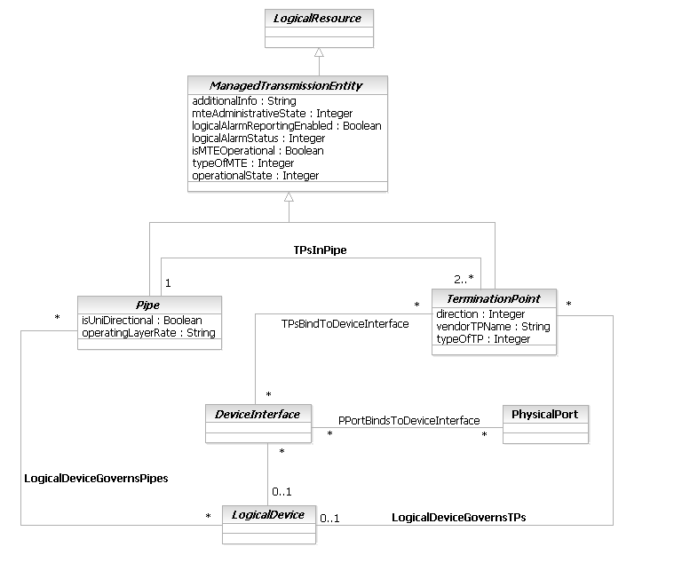
Figure LR.78 - Business Entity Model of a ManagedTransmissionEntity

ManagementProtocol Business Entity Definition
Business Entity Name | ManagementProtocol
Description | A ManagementProtocol is an abstract superclass for protocols that are dedicated to exchanging management information between network devices. This type of protocol is an application layer protocol, and is used for configuring, monitoring, and gathering information about devices.  The DEN-ng model defines SNMP and a framework for proprietary management protocols as examples of subclasses of this class.
Sources | DEN-ng
Cross-References
Synonyms / Aliases | This concept is not present in the ITU or DMTF CIM specifications.
Related Business Entities | ManagedEntity, ResourceSpecification, LogicalResourceSpec, PhysicalResourceSpec, CompoundResourceSpec, Product, ProductComponent, ProductBundle, Resource, PhysicalResource, LogicalResource, CompoundResource, LogicalDevice, DeviceInterface, MediaInterface, Software, SoftwareAtomic, SoftwareComposite, SoftwareCommand, SoftwareFeatureSets, Protocol (superclass), BridgingProtocol (subclass), LANProtocol (subclass), RoutedProtocol (subclass), RoutingProtocol (subclass), SignalingProtocol (subclass), SwitchingProtocol (subclass), WANProtocol (subclass), OperatingSystem, ResourceLogic, ResourceSpecVersion, LogicalResourceSpecVersion, ResourceSpecType, ResourceCharacteristic, ResourceCharacteristicValue, ResourceSpecCharacteristic, ResourceSpecCharacteristicValue, ResourceRole, LogicalResourceRole, PhysicalResourceRole, Service, ResourceFacingService, CustomerFacingService, ServiceSpecification, ResourceFacingServiceSpec, CustomerFacingServiceSpec
Business Rules | To be determined

ManagementProtocol Business Entity Attributes Definition
There are no attributes of ManagementProtocol that are appropriate for a business view.

Business Entity Model – ManagementProtocol
The business entity model of ManagementProtocol is the same as that of Protocol, and is defined in Figure LR.59 above.

MediaInterface Business Entity Definition
Business Entity Name | MediaInterface
Description | This is an abstract class that serves as the superclass for all physical interfaces (physical in the sense that they are real interfaces that can be instantiated - they are still logical entities) whose functionality is dependent on a particular transmission medium (e.g., Ethernet vs. ATM). It serves as a convenient aggregation point for running different relationships that affect its subclasses, thereby avoiding having to instantiate multiple relationships that are essentially the same.
Sources | DEN-ng
Cross-References
Synonyms / Aliases | This concept is not present in either the ITU recommendations or the DMTF CIM.
Related Business Entities | ManagedEntity, ResourceSpecification, LogicalResourceSpec, PhysicalResourceSpec, CompoundResourceSpec, Product, ProductComponent, ProductBundle, Resource, PhysicalResource, LogicalResource, CompoundResource, LogicalDevice, DeviceInterface (superclass), LogicalInterface (sibling), ATMInterface (subclass), EthernetInterface (subclass), SerialInterface (subclass), TokenRingInterface (subclass), Software, SoftwareAtomic, SoftwareComposite, SoftwareCommand, SoftwareFeatureSets, OperatingSystem, ResourceLogic, ResourceSpecVersion, LogicalResourceSpecVersion, ResourceSpecType, ResourceCharacteristic, ResourceCharacteristicValue, ResourceSpecCharacteristic, ResourceSpecCharacteristicValue, ResourceRole, LogicalResourceRole, PhysicalResourceRole, Service, ResourceFacingService, CustomerFacingService, ServiceSpecification, ResourceFacingServiceSpec, CustomerFacingServiceSpec
Business Rules | To be determined

MediaInterface Business Entity Attributes Definition
This class has no business attributes. Its system attributes are defined in GB926 5LR.
Business Entity Model – MediaInterface
This class has no business attributes. Its system attributes are defined in GB926 5LR.
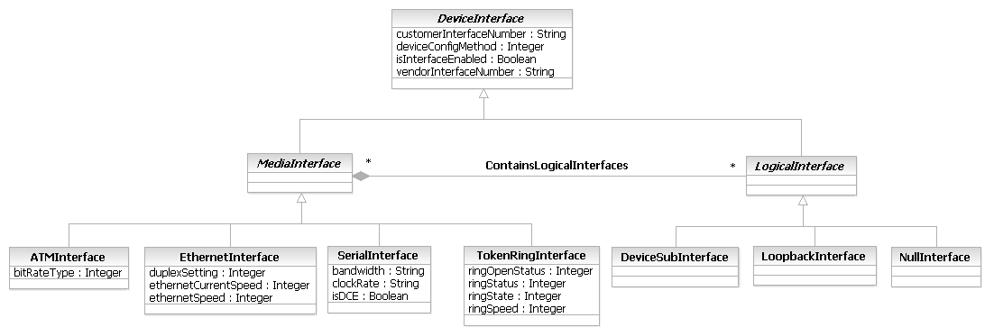
Figure LR.79 - Business Entity Model of a MediaInterface

Network Business Entity Definition
Business Entity Name | Network
Description | The Network class is derived from M.3100; DEN-ng has enhanced this definition by providing additional semantics that enable objects defined in the ITU to interact with objects defined in the IETF and the TMF. A Network is a managed object that represents an aggregation of interconnected telecommunications and management objects capable of exchanging information. The reason that a Network is subclassed from ResourceCollection is that it is important that a Network be able to represent physical and logical characteristics and behavior of this collection of telecommunications and management objects.  A Network has the additional semantics of having one or more common characteristics and/or behavior. For example, a network may be owned by a single customer or provider, or be associated with the delivery of a specific set of services. A network may be nested within another (larger) network, thereby forming a containment relationship. An example of a network that is contained in another network is a transmission sub-network. It is owned by a single Administration and can only perform transmission functions.
Sources | DEN-ng, M.3100, Telstra
Cross-References
Synonyms / Aliases | Not present in CIM before v2.7; the CIM v2.7 network class doesn’t match the M.3100 semantics.
Related Business Entities | ManagedEntity, ResourceSpecification, LogicalResourceSpec, PhysicalResourceSpec, CompoundResourceSpec, Product, ProductComponent, ProductBundle, Resource, PhysicalResource, LogicalResource, CompoundResource, ResourceCollection (superclass), ResourceElement, NetworkComposite (subclass), NetworkAtomic (subclass), LayerNetwork, SubNetwork, LAN, IPSubnet, ResourcePort, LogicalDevice, DeviceInterface, MediaInterface, Software, SoftwareAtomic, SoftwareComposite, SoftwareCommand, SoftwareFeatureSets, Protocol, ManagedTransmissionEntity, OperatingSystem, ResourceLogic, ResourceSpecVersion, LogicalResourceSpecVersion, ResourceSpecType, ResourceCharacteristic, ResourceCharacteristicValue, ResourceSpecCharacteristic, ResourceSpecCharacteristicValue, ResourceRole, LogicalResourceRole, PhysicalResourceRole, Service, ResourceFacingService, CustomerFacingService, ServiceSpecification, ResourceFacingServiceSpec, CustomerFacingServiceSpec
Business Rules | To be determined

Network Business Entity Attributes Definition
Business Entity Name | Network

Attribute Name | Description | Data Type | Notes (used to map to other models; blank is other models don’t have it)
networkAdministrativeState | This attribute is an enumerated integer that defines the administrative state of the Network. Values include:  0: Unknown  1: Unlocked  2: Locked  3: Shutting Down  4: Starting Up  5: Testing  6: Maintenance | Integer | DEN-ng definition enhances the M.3100 definition; no equivalent in the CIM spec.
networkAlarmStatus | This is an enumerated integer that indicates the occurrence of an abnormal condition relating to one or more managed objects that are contained in this Network. This attribute may also function as a summary indicator of alarm conditions associated with a specific resource. It is used to indicate the existence of an alarm condition, a pending alarm condition such as threshold situations, or (when used as a summary indicator) the highest severity of active alarm conditions. Values include:  0: unknown error  1: active - Critical  2: active - Major  3: active - Minor  4: active - Indeterminate  5: active - Warning  6: active - PendingDecision  7: active - UnderRepair  8: active - BeingReplaced  9: cleared | Integer | DEN-ng definition enhances the M.3100 definition; no equivalent in the CIM spec.
isNetworkOperational | This attribute is used to define the operational status of the Network, and is implemented as a Boolean: TRUE means that the Network is currently operational, and FALSE means that the Network is not currently operational. | Boolean | No equivalent in the ITU specs or in the DMTF CIM.
layerRates | This is a comma-separated Sequence of string attributes. Each string identifies a communication rate that is supported by this Network. | String | Implied in the ITU specs; no equivalent in the CIM spec.

Business Entity Model – Network
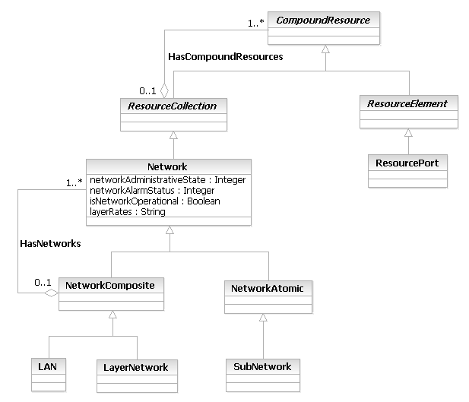
Figure LR.80 - Business Entity Model of a Network and its Subclasses

NetworkAddress Business Entity Definition
Business Entity Name | NetworkAddress
Description | This class represents the generic concept of a network address. Its subclasses define different types of addresses of different technologies, such as an IPAddress vs. an IPXAddress. Its utility lies in its ability to serve as a convenient point for sourcing and terminating relationships. This eliminates undue duplication of relationships that interact with the subclasses of NetworkAddress.
Sources | DEN-ng
Cross-References
Synonyms / Aliases | This concept is not present in the ITU or DMTF CIM specifications.
Related Business Entities | ManagedEntity, ResourceSpecification, LogicalResourceSpec, PhysicalResourceSpec, CompoundResourceSpec, Product, ProductComponent, ProductBundle, Resource, PhysicalResource, LogicalResource (superclass), CompoundResource, IPAddress (subclass), LogicalDevice, DeviceInterface, MediaInterface, Software, SoftwareAtomic, SoftwareComposite, SoftwareCommand, SoftwareFeatureSets, Protocol, BridgingProtocol, LANProtocol, RoutedProtocol, RoutingProtocol, SignalingProtocol, SwitchingProtocol, WANProtocol, OperatingSystem, ResourceLogic, ResourceSpecVersion, LogicalResourceSpecVersion, ResourceSpecType, ResourceCharacteristic, ResourceCharacteristicValue, ResourceSpecCharacteristic, ResourceSpecCharacteristicValue, ResourceRole, LogicalResourceRole, PhysicalResourceRole, Service, ResourceFacingService, CustomerFacingService, ServiceSpecification, ResourceFacingServiceSpec, CustomerFacingServiceSpec
Business Rules | To be determined

NetworkAddress Business Entity Attributes Definition
There are no attributes of NetworkAddress that are appropriate for a business view.

Business Entity Model – NetworkAddress
The business entity model of NetworkAddress is the same as that of IPAddress, and is defined in Figure LR.67 above.

NetworkAtomic Business Entity Definition
Business Entity Name | NetworkAtomic
Description | This class represents a stand-alone Network. NetworkAtomics may be combined into larger Networks by aggregating them into an appropriate NetworkComposite object.
Sources | DEN-ng
Cross-References
Synonyms / Aliases | Not present in the CIM or the ITU.
Related Business Entities | ManagedEntity, ResourceSpecification, LogicalResourceSpec, PhysicalResourceSpec, CompoundResourceSpec, Product, ProductComponent, ProductBundle, Resource, PhysicalResource, LogicalResource, CompoundResource, ResourceCollection, ResourceElement, Network (superclass), NetworkComposite (sibling), LayerNetwork, SubNetwork, LAN, IPSubnet, ResourcePort, LogicalDevice, DeviceInterface, MediaInterface, Software, SoftwareAtomic, SoftwareComposite, SoftwareCommand, SoftwareFeatureSets, Protocol, ManagedTransmissionEntity, OperatingSystem, ResourceLogic, ResourceSpecVersion, LogicalResourceSpecVersion, ResourceSpecType, ResourceCharacteristic, ResourceCharacteristicValue, ResourceSpecCharacteristic, ResourceSpecCharacteristicValue, ResourceRole, LogicalResourceRole, PhysicalResourceRole, Service, ResourceFacingService, CustomerFacingService, ServiceSpecification, ResourceFacingServiceSpec, CustomerFacingServiceSpec
Business Rules | To be determined

NetworkAtomic Business Entity Attributes Definition
There are no attributes of NetworkAtomic that are appropriate for a business view.

Business Entity Model – NetworkAtomic
The business entity model for a NetworkAtomic is the same as that for a Network, and is shown in Figure LR.80 above.

NetworkComposite Business Entity Definition
Business Entity Name | NetworkComposite
Description | This class represents an aggregation of NetworkAtomic and possibly NetworkComposite objects. Each NetworkAtomic object represents a stand-alone Network; these can be combined to build larger Networks by choosing the appropriate type of NetworkComposite object to aggregate NetworkAtomic objects. Note that a NetworkComposite object can also aggregate NetworkComposite objects.
Sources | DEN-ng
Cross-References
Synonyms / Aliases | Not present in the CIM or the ITU.
Related Business Entities | ManagedEntity, ResourceSpecification, LogicalResourceSpec, PhysicalResourceSpec, CompoundResourceSpec, Product, ProductComponent, ProductBundle, Resource, PhysicalResource, LogicalResource, CompoundResource, ResourceCollection, ResourceElement, Network (superclass), NetworkAtomic (sibling), LayerNetwork, SubNetwork, LAN, IPSubnet, ResourcePort, LogicalDevice, DeviceInterface, MediaInterface, Software, SoftwareAtomic, SoftwareComposite, SoftwareCommand, SoftwareFeatureSets, Protocol, ManagedTransmissionEntity, OperatingSystem, ResourceLogic, ResourceSpecVersion, LogicalResourceSpecVersion, ResourceSpecType, ResourceCharacteristic, ResourceCharacteristicValue, ResourceSpecCharacteristic, ResourceSpecCharacteristicValue, ResourceRole, LogicalResourceRole, PhysicalResourceRole, Service, ResourceFacingService, CustomerFacingService, ServiceSpecification, ResourceFacingServiceSpec, CustomerFacingServiceSpec
Business Rules | To be determined

NetworkComposite Business Entity Attributes Definition
There are no attributes of NetworkComposite that are appropriate for a business view.

Business Entity Model – NetworkComposite
The business entity model for a NetworkComposite is the same as that for a Network, and is shown in Figure LR.80 above.
NetworkDomain Business Entity Definition
Business Entity Name | NetworkDomain
Description | A NetworkDomain represents a set of ManagedPhysicalEntities that share a common set of administrative and operational characteristics. Primary among these is the use of a common naming methodology. A NetworkDomain is used to partition ManagedEntity instances into logical groupings (e.g., operational and/or administrative groups) that are controlled by one or more common managers. NetworkDomains provide one way to administer and control the operational characteristics of a set of ManagedEntities.
Sources | DEN-ng, Telstra, BT
Cross-References
Synonyms / Aliases | This concept is not present in the ITU specs. CIM defines an “AdminDomain” but it has different semantics.
Related Business Entities | ManagedEntity, ResourceSpecification, LogicalResourceSpec, PhysicalResourceSpec, CompoundResourceSpec, Product, ProductComponent, ProductBundle, Resource, PhysicalResource, LogicalResource, CompoundResource, ResourceCollection, ResourceElement, Network, ManagementDomain (superclass), AutonomousSystem (subclass), PolicyDomain, LayerNetwork, SubNetwork, IPSubnet, LAN, ResourcePort, LogicalDevice, DeviceInterface, MediaInterface, Software, SoftwareAtomic, SoftwareComposite, SoftwareCommand, SoftwareFeatureSets, Protocol, ManagedTransmissionEntity, OperatingSystem, ResourceLogic, ResourceSpecVersion, LogicalResourceSpecVersion, ResourceSpecType, ResourceCharacteristic, ResourceCharacteristicValue, ResourceSpecCharacteristic, ResourceSpecCharacteristicValue, ResourceRole, LogicalResourceRole, PhysicalResourceRole, Service, ResourceFacingService, CustomerFacingService, ServiceSpecification, ResourceFacingServiceSpec, CustomerFacingServiceSpec
Business Rules | To be determined

NetworkDomain Business Entity Attributes Definition
There are no attributes of NetworkDomain that are appropriate for a business view.

Business Entity Model – NetworkDomain
The business entity model for a NetworkDomain is the same as that for an AutonomousSystem, and is shown in Figure LR.58 above.

NullInterface Business Entity Definition
Business Entity Name | NullInterface
Description | A NullInterface is a virtual interface. Traffic sent to the NullInterface is discarded automatically. Conceptually, it can be thought of as a virtual sink – the NullInterface is always enabled, and traffic sent to it is simply discarded. This acts as a convenient way to handle undesired traffic.
Sources | DEN-ng
Cross-References
Synonyms / Aliases | This concept is not present in either the ITU recommendations or the DMTF CIM.
Related Business Entities | ManagedEntity, ResourceSpecification, LogicalResourceSpec, PhysicalResourceSpec, CompoundResourceSpec, Product, ProductComponent, ProductBundle, Resource, PhysicalResource, LogicalResource, CompoundResource, LogicalDevice, MediaInterface, DeviceInterface, LogicalInterface (superclass), DeviceSubInterface (sibling), LoopbackInterface (sibling), Software, SoftwareAtomic, SoftwareComposite, SoftwareCommand, SoftwareFeatureSets, OperatingSystem, ResourceLogic, ResourceSpecVersion, LogicalResourceSpecVersion, ResourceSpecType, ResourceCharacteristic, ResourceCharacteristicValue, ResourceSpecCharacteristic, ResourceSpecCharacteristicValue, ResourceRole, LogicalResourceRole, PhysicalResourceRole, Service, ResourceFacingService, CustomerFacingService, ServiceSpecification, ResourceFacingServiceSpec, CustomerFacingServiceSpec
Business Rules | To be determined

NullInterface Business Entity Attributes Definition
There are no attributes of NullInterface that are appropriate for a business view.

Business Entity Model – NullInterface
The business entity model of NullInterface is the same as that of DeviceInterface, and is defined in Figure LR.66 above.

OperatingSystem Business Entity Definition
Business Entity Name | OperatingSystem
Description | An OperatingSystem is a concrete entity that represents either software and/or firmware that runs the LogicalResource. This entity implements and/or manages the resources, tasks, file systems, security, and data available on the LogicalResource.  Note that an OperatingSystem is distinct from software applications that are run on the Resource. All applications and software must communicate with the OperatingSystem for all operations that they need.
Sources | DEN-ng
Cross-References
Synonyms / Aliases | This concept is not present in the ITU recommendations; CIM defines Software but its functionality is a subset of the DEN-ng functionality.
Related Business Entities | ManagedEntity, ResourceSpecification, LogicalResourceSpec, PhysicalResourceSpec, CompoundResourceSpec, Product, ProductComponent, ProductBundle, Resource, PhysicalResource, LogicalResource (superclass), CompoundResource, LogicalDevice, DeviceInterface, SoftwareAtomic (subclass), SoftwareComposite (subclass), ResourceLogic, ResourceSpecVersion, LogicalResourceSpecVersion, ResourceSpecType, ResourceCharacteristic, ResourceCharacteristicValue, ResourceSpecCharacteristic, ResourceSpecCharacteristicValue, ResourceRole, LogicalResourceRole, PhysicalResourceRole, Service, ResourceFacingService, CustomerFacingService, ServiceSpecification, ResourceFacingServiceSpec, CustomerFacingServiceSpec
Business Rules | To be determined

OperatingSystem Business Entity Attributes Definition
The following table contains the business attributes for this release of the SID Logical Addendum. Note that previous releases of this Addenda contained many additional attributes; please note that all class attributes except those shown below have been moved to the system view model for OperatingSystem.
Business Entity Name | OperatingSystem

Attribute Name | Description | Data Type | Notes (used to map to other models; blank is other models don’t have it)
categoryOfOS | This is an enumerated integer that defines the category that this OperatingSystem resides in. Values include:  0: Custom (i.e., a mix of categories)  1: Server (e.g., Unix, Windows)  2: Language-Based (e.g., Java)  3: NetworkDevice (e.g., Cisco IOS, Juniper Junos)  4: Host (e.g., a Laptop or PDA)  5: Other | Integer | Not present in the ITU. Not present in CIM 2.6; In 2.7, CIM has mined this concept but the implementation isn’t compliant with DEN-ng and is restricted in its functionality.
lastBootTime | This is a TimeStamp that defines the last time that this OperatingSystem instance was booted.  A TimeStamp is a complex attribute that contains a Date and a Time. | Date | Not present in the ITU. This is equivalent to the CIM’s LastBootUpTime attribute.
dateValue | This attribute contains the value of the current date. | Date
timeValue | This attribute contains the value of the current Time. | Long
isUTCTime | This is a Boolean attribute that, if TRUE, means that this OperatingSystem instance uses absolute (or UTC) time. If FALSE, then it uses LOCAL time. | Boolean
numberProcessActiveTotal | This is an integer attribute that defines the maximum number of total processes that this OperatingSystem instance can support at any given time. | Integer
numberProcessesActiveCurrent | This is an integer attribute that defines the current number of total processes that this OperatingSystem instance can support at any given time. | Integer
swapSpaceAvailableTotal | This defines the total swap space available in Kbytes. If this OperatingSystem instance doesn't distinguish swap space from space used for paging files, then the value of this attribute should be 0. | Integer
swapSpaceUsedCurrent | This defines the current swap space in Kbytes that is being used. If this OperatingSystem instance doesn't distinguish swap space from space used for paging files, then the value of this attribute should be 0. | Integer
virtualMemorySpaceTotal | This defines the number of Kbytes of virtual memory that can be used by this particular OperatingSystem instance. This is usually the amount of total RAM plus the amount of paging space. | Integer
virtualMemorySpaceUsedCurrent | This defines the number of Kbytes of virtual memory that is currently being used by this particular OperatingSystem instance. | Integer
physicalMemoryTotal | This defines the number of Kbytes of physical memory that this particular OperatingSystem instance can use. | Integer
physicalMemoryAvailableCurrent | This defines the number of Kbytes of physical memory that are currently available for this particular OperatingSystem instance to use. | Integer
pagingFileSizeTotal | This defines the total number of KBytes that can be stored in the paging files of this particular OperatingSystem instance. If this instance doesn't support paging files, then the value of this attribute should be 0. | Integer
pagingFileSizeCurrent | This defines the current number of KBytes that are stored in the paging files of this particular OperatingSystem instance. If this instance doesn't support paging files, then the value of this attribute should be 0. | Integer
processMemorySizeMax | This defines the maximum number of Kbytes of memory that can be allocated to a Process. For Operating Systems with no virtual memory, this value is typically equal to the total amount of physical Memory minus memory used by the BIOS and OS. | Integer
processMemorySizeCurrent | This defines the current number of Kbytes of memory that have been allocated to a Process. | Integer
isDistributable | This is a Boolean attribute that, if TRUE, designates this OperatingSystem instance as being able to be distributed across multiple physically distinct Resources. | Boolean
isDistributedCurrent | This is a Boolean attribute that, if TRUE, defines this OperatingSystem instance as being currently distributed across several Resource nodes. | Boolean
numUsersCurrent | This is a non-negative integer that defines the current number of users of this OperatingSystem instance. | Integer | Not present in the ITU. This is equivalent to the CIM’s NumberOfUsers attribute.
numUsersMax | This is a non-negative integer that defines the maximum number of users of this OperatingSystem instance. | Integer | Not present in the ITU or the CIM.

Business Entity Model – OperatingSystem
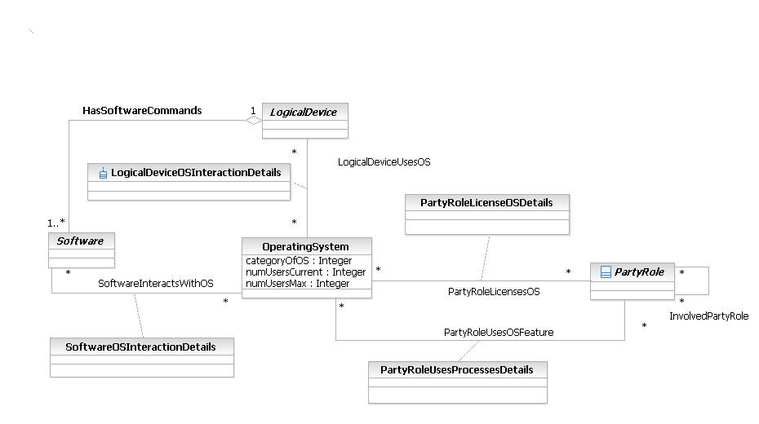
Figure LR.81 - Business Entity Model of an OperatingSystem

Pipe Business Entity Definition
Business Entity Name | Pipe
Description | The Pipe object class is a class of managed objects, which ensures the transfer of information between two TerminationPoints. This is derived from the m.3100 specification.  The Pipe object class is not instantiable because the transfer is effected via the client-server relationship of trail and connection. Connectivity direction is determined by the directionality of the a and z termination points.  If an instance of this class is bidirectional, the a- and z-termination points shall also be bidirectional. If an instance of this class is unidirectional, the a-point shall be the source TP and the z-termination point shall be the sink TP.  This object is taken from M.3100. DEN-ng integrates it into the ManagedTransmissionEntity hierarchy so that it can interact with IETF and other TMF managed objects.
Sources | DEN-ng, M.3100
Cross-References
Synonyms / Aliases | CIM defines a Pipe that is not compliant with M.3100.
Related Business Entities | ManagedEntity, ResourceSpecification, LogicalResourceSpec, PhysicalResourceSpec, CompoundResourceSpec, Product, ProductComponent, ProductBundle, Resource, PhysicalResource, LogicalResource, CompoundResource, LogicalDevice, DeviceInterface, MediaInterface, Software, SoftwareAtomic, SoftwareComposite, SoftwareCommand, SoftwareFeatureSets, Protocol, ManagedTransmissionEntity (superclass), TerminationPoint (sibling), Connection (subclass), Trail (subclass), OperatingSystem, ResourceLogic, ResourceSpecVersion, LogicalResourceSpecVersion, ResourceSpecType, ResourceCharacteristic, ResourceCharacteristicValue, ResourceSpecCharacteristic, ResourceSpecCharacteristicValue, ResourceRole, LogicalResourceRole, PhysicalResourceRole, Service, ResourceFacingService, CustomerFacingService, ServiceSpecification, ResourceFacingServiceSpec, CustomerFacingServiceSpec
Business Rules | To be determined

Pipe Business Entity Attributes Definition
Business Entity Name | Pipe
Attribute Name | Description | Data Type | Notes (used to map to other models; blank is other models don’t have it)
isUniDirectional | This is a Boolean attribute that, if TRUE, defines this Pipe to be UniDirectional. If FALSE, it is by definition BiDirectional. | Boolean | Implied in M.3100 but not identified as an attribute; no equivalent in CIM
operatingLayerRate | This is a string attribute that defines the current operating layer rate of this Trail or Connection. | String | Based on M.3100; no equivalent in CIM

Business Entity Model – Pipe
The business entity model for a Pipe is the same as that for Figure LR.64 above, which is a model of a Pipe and its subclasses.

Protocol Business Entity Definition
Business Entity Name | Protocol
Description | A protocol is a formal set of rules and conventions that governs how two entities exchange information (usually over one or more types of network media).  This is an abstract base class for representing protocols that can be managed. This class represents a convenient aggregation point for defining how protocols are managed and used.
Sources | DEN-ng
Cross-References
Synonyms / Aliases | This concept is not present in the ITU or DMTF CIM specifications ( ProtocolEndpoint does not model a Protocol, just how it interacts)
Related Business Entities | ManagedEntity, ResourceSpecification, LogicalResourceSpec, PhysicalResourceSpec, CompoundResourceSpec, Product, ProductComponent, ProductBundle, Resource, PhysicalResource, LogicalResource (superclass), CompoundResource, LogicalDevice, DeviceInterface, MediaInterface, Software, SoftwareAtomic, SoftwareComposite, SoftwareCommand, SoftwareFeatureSets, ManagementProtocol (subclass), BridgingProtocol (subclass), LANProtocol (subclass), RoutedProtocol (subclass), RoutingProtocol (subclass), SignalingProtocol (subclass), SwitchingProtocol (subclass), WANProtocol (subclass), OperatingSystem, ResourceLogic, ResourceSpecVersion, LogicalResourceSpecVersion, ResourceSpecType, ResourceCharacteristic, ResourceCharacteristicValue, ResourceSpecCharacteristic, ResourceSpecCharacteristicValue, ResourceRole, LogicalResourceRole, PhysicalResourceRole, Service, ResourceFacingService, CustomerFacingService, ServiceSpecification, ResourceFacingServiceSpec, CustomerFacingServiceSpec
Business Rules | To be determined

Protocol Business Entity Attributes Definition
Business Entity Name | Protocol
Attribute Name | Description | Data Type | Notes (used to map to other models; blank is other models don’t have it)
currentPortNumber | This is a non-negative integer that defines the port number used by this protocol. | Integer | No equivalent in the ITU; CIM defines port numbers on a per-ProtocolEndpoint basis, so coverage varies
isEphemeral | This is a Boolean attribute. If its value is TRUE, then this protocol can use ephemeral port numbers. If its value is FALSE, then this protocol will only use well-defined port numbers. | Boolean | No equivalent in the ITU or CIM.
protocolDirection | This is an enumerated integer that defines the direction of this protocol. | Integer | No equivalent in the ITU or CIM.
portRangeStart | This non-negative integer defines the lower range of allowable port numbers to use. | Integer | No equivalent in the ITU or CIM.
portRangeEnd | This non-negative integer defines the upper range of allowable port numbers to use. | Integer | No equivalent in the ITU or CIM.

Business Entity Model – Protocol
The business entity model of a Protocol was shown earlier in Figure LR.59.

ResourceCollection Business Entity Definition
Business Entity Name | ResourceCollection
Description | A ResourceCollection is an entity that is individually manageable. It is an aggregate entity consisting of ResourceElement and optionally ResourceCollection entities. As such, a ResourceCollection represents a set of PhysicalResources and LogicalResources that collectively represent a managed entity.  For example, a Network is a subclass of ResourceCollection. A Network can be made up of other Networks and/or SubNetworks (the latter is defined in the ITU-T's G.805 Recommendation). Each Network or SubNetwork can, in the DEN-ng model, be made up of physical and logical components, gathered together and represented by a ResourceCollection. Each node in the network can be represented by a ResourceElement. The HasCompoundResources aggregation enables a ResourceCollection to aggregate ResourceElements and optionally ResourceCollections as well.
Sources | DEN-ng
Cross-References
Synonyms / Aliases | This concept is not present in the ITU or CIM specs.
Related Business Entities | ManagedEntity, ResourceSpecification, LogicalResourceSpec, PhysicalResourceSpec, CompoundResourceSpec, Product, ProductComponent, ProductBundle, Resource, PhysicalResource, LogicalResource, CompoundResource (superclass), ResourceElement (sibling), Network (subclass), ResourcePort, LogicalDevice, DeviceInterface, MediaInterface, Software, SoftwareAtomic, SoftwareComposite, SoftwareCommand, SoftwareFeatureSets, Protocol, ManagedTransmissionEntity, OperatingSystem, ResourceLogic, ResourceSpecVersion, LogicalResourceSpecVersion, ResourceSpecType, ResourceCharacteristic, ResourceCharacteristicValue, ResourceSpecCharacteristic, ResourceSpecCharacteristicValue, ResourceRole, LogicalResourceRole, PhysicalResourceRole, Service, ResourceFacingService, CustomerFacingService, ServiceSpecification, ResourceFacingServiceSpec, CustomerFacingServiceSpec
Business Rules | To be determined

ResourceCollection Business Entity Attributes Definition
There are no attributes of ResourceCollection that are appropriate for a business view.

Business Entity Model – ResourceCollection
The business entity model for a ResourceCollection was shown earlier in Figure LR.70 above.

ResourceElement Business Entity Definition
Business Entity Name | ResourceElement
Description | A ResourceElement is an entity that is individually manageable. It is an aggregate entity consisting of both physical and logical aspects of a managed resource. For example, a Router is a ResourceElement. Different PhysicalResource objects can model the physical aspects of the Router in detail (e.g., its Cards, the number and type of PhysicalPorts that are on each Card, and so forth), and different LogicalResource objects can model the logical aspects of the Router in detail (e.g., what Software it is running, how many DeviceInterfaces of what type are currently enabled, if there are any outstanding Faults or Alarms, and so forth). ReourceElement aggregates all PhysicalResource and LogicalResource objects, enabling a high-level view of the physical and logical aspects of the Resource to be provided.
Sources | DEN-ng
Cross-References
Synonyms / Aliases | This concept is not present in the ITU or CIM specs.
Related Business Entities | ManagedEntity, ResourceSpecification, LogicalResourceSpec, PhysicalResourceSpec, CompoundResourceSpec, Product, ProductComponent, ProductBundle, Resource, PhysicalResource, LogicalResource, CompoundResource (superclass), ResourceCollection (sibling), Network, ResourcePort (subclass), LogicalDevice, DeviceInterface, MediaInterface, Software, SoftwareAtomic, SoftwareComposite, SoftwareCommand, SoftwareFeatureSets, Protocol, ManagedTransmissionEntity, OperatingSystem, ResourceLogic, ResourceSpecVersion, LogicalResourceSpecVersion, ResourceSpecType, ResourceCharacteristic, ResourceCharacteristicValue, ResourceSpecCharacteristic, ResourceSpecCharacteristicValue, ResourceRole, LogicalResourceRole, PhysicalResourceRole, Service, ResourceFacingService, CustomerFacingService, ServiceSpecification, ResourceFacingServiceSpec, CustomerFacingServiceSpec
Business Rules | To be determined

ResourceElement Business Entity Attributes Definition
There are no attributes of ResourceElement that are appropriate for a business view.

Business Entity Model – ResourceElement
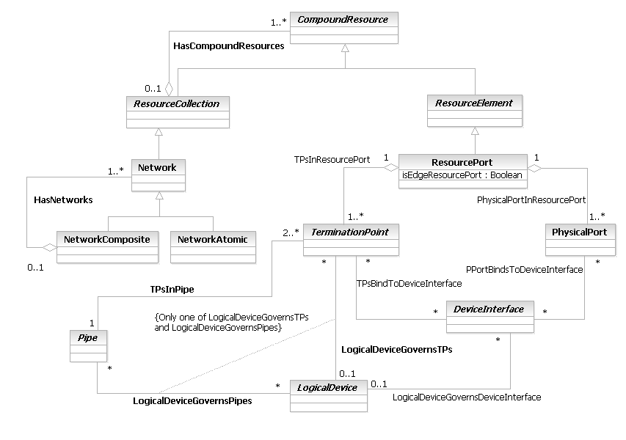
Figure LR.82 - Business Entity Model of a ResourceElement

ResourcePort Business Entity Definition
Business Entity Name | ResourcePort
Description | This is an abstract class that serves as the superclass for all physical interfaces (physical in the sense that they are real interfaces that can be instantiated - they are still logical entities) whose functionality is dependent on a particular transmission medium (e.g., Ethernet vs. ATM). It serves as a convenient aggregation point for running different relationships that affect its subclasses, thereby avoiding having to instantiate multiple relationships that are essentially the same.
Sources | DEN-ng
Cross-References
Synonyms / Aliases | This concept is not present in either the ITU recommendations or the DMTF CIM.
Related Business Entities | ManagedEntity, ResourceSpecification, LogicalResourceSpec, PhysicalResourceSpec, CompoundResourceSpec, Product, ProductComponent, ProductBundle, Resource, PhysicalResource, LogicalResource, CompoundResource, LogicalDevice, DeviceInterface (superclass), LogicalInterface (sibling), ATMInterface (subclass), EthernetInterface (subclass), SerialInterface (subclass), TokenRingInterface (subclass), Software, SoftwareAtomic, SoftwareComposite, SoftwareCommand, SoftwareFeatureSets, OperatingSystem, ResourceLogic, ResourceSpecVersion, LogicalResourceSpecVersion, ResourceSpecType, ResourceCharacteristic, ResourceCharacteristicValue, ResourceSpecCharacteristic, ResourceSpecCharacteristicValue, ResourceRole, LogicalResourceRole, PhysicalResourceRole, Service, ResourceFacingService, CustomerFacingService, ServiceSpecification, ResourceFacingServiceSpec, CustomerFacingServiceSpec
Business Rules | To be determined

ResourcePort Business Entity Attributes Definition
Business Entity Name | ResourcePort
Attribute Name | Description | Data Type | Notes (used to map to other models; blank is other models don’t have it)
isEdgeResourcePort | This is a Boolean attribute. If the value of this attribute is TRUE, then this ResourcePort is located at the edge of a Network or SubNetwork. | Boolean | No equivalent in the ITU or the CIM

Business Entity Model – ResourcePort
The business entity model for a ResourcePort is the same as that for a ResourceElement, and is shown in Figure LR.82 above.

RoutedProtocol Business Entity Definition
Business Entity Name | RoutedProtocol
Description | This is an abstract base class for representing different types of routed protocols that can be managed. Routed protocols are those protocols that can be routed by a router. Specifically, the router must be able to interpret the logical internetwork as specified by that routed protocol. This class represents a convenient aggregation point for defining how routed protocols are managed and used.  The DEN-ng model defines AppleTalk, DecNET, IP, and IPX as examples of subclasses of this class.
Sources | DEN-ng
Cross-References
Synonyms / Aliases | This concept is not present in the ITU or DMTF CIM specifications.
Related Business Entities | ManagedEntity, ResourceSpecification, LogicalResourceSpec, PhysicalResourceSpec, CompoundResourceSpec, Product, ProductComponent, ProductBundle, Resource, PhysicalResource, LogicalResource, CompoundResource, LogicalDevice, DeviceInterface, MediaInterface, Software, SoftwareAtomic, SoftwareComposite, SoftwareCommand, SoftwareFeatureSets, Protocol (superclass), BridgingProtocol (sibling), LANProtocol (sibling), ManagementProtocol (sibling), RoutingProtocol (sibling), SignalingProtocol (sibling), SwitchingProtocol (sibling), WANProtocol (sibling), OperatingSystem, ResourceLogic, ResourceSpecVersion, LogicalResourceSpecVersion, ResourceSpecType, ResourceCharacteristic, ResourceCharacteristicValue, ResourceSpecCharacteristic, ResourceSpecCharacteristicValue, ResourceRole, LogicalResourceRole, PhysicalResourceRole, Service, ResourceFacingService, CustomerFacingService, ServiceSpecification, ResourceFacingServiceSpec, CustomerFacingServiceSpec
Business Rules | To be determined

RoutedProtocol Business Entity Attributes Definition
There are no attributes of RoutedProtocol that are appropriate for a business view.

Business Entity Model – RoutedProtocol
The business entity model of RoutedProtocol is the same as that of BridgingProtocol, and is defined in Figure LR.59 above.

RoutingProtocol Business Entity Definition
Business Entity Name | RoutingProtocol
Description | This is an abstract base class for representing different types of routing protocols that can be managed. Routing protocols are used to determine how information is routed (e.g., how it traverses an intermediate system). This class represents a convenient aggregation point for defining how routing protocols are managed and used.  The DEN-ng model defines LinkStateRoutingProtocols (e.g., OSPF and IS-IS), DistanceVectorRoutingProtocols (e.g., RIP and IGRP), PathVectorRoutingProtocols (e.g., BGP) and HybridRoutingProtocols (e.g., EIGRP) as examples of subclasses of this class.
Sources | DEN-ng
Cross-References
Synonyms / Aliases | This concept is not present in the ITU or DMTF CIM specifications.
Related Business Entities | ManagedEntity, ResourceSpecification, LogicalResourceSpec, PhysicalResourceSpec, CompoundResourceSpec, Product, ProductComponent, ProductBundle, Resource, PhysicalResource, LogicalResource, CompoundResource, LogicalDevice, DeviceInterface, MediaInterface, Software, SoftwareAtomic, SoftwareComposite, SoftwareCommand, SoftwareFeatureSets, Protocol (superclass), BridgingProtocol (sibling), LANProtocol (sibling), ManagementProtocol (sibling), RoutedProtocol (sibling), SignalingProtocol (sibling), SwitchingProtocol (sibling), WANProtocol (sibling), OperatingSystem, ResourceLogic, ResourceSpecVersion, LogicalResourceSpecVersion, ResourceSpecType, ResourceCharacteristic, ResourceCharacteristicValue, ResourceSpecCharacteristic, ResourceSpecCharacteristicValue, ResourceRole, LogicalResourceRole, PhysicalResourceRole, Service, ResourceFacingService, CustomerFacingService, ServiceSpecification, ResourceFacingServiceSpec, CustomerFacingServiceSpec
Business Rules | To be determined

RoutingProtocol Business Entity Attributes Definition
There are no attributes of RoutingProtocol that are appropriate for a business view.

Business Entity Model – RoutingProtocol
The business entity model of RoutingProtocol is the same as that of BridgingProtocol, and is defined in Figure LR.59 above.

SerialInterface Business Entity Definition
Business Entity Name | SerialInterface
Description | This is a concrete class that is the base class for defining different types of Serial Interfaces. A serial interface is an electronic connection between two devices in which digital data is transferred one bit after another, rather than several bits at a time.
Sources | DEN-ng
Cross-References
Synonyms / Aliases | This concept is not present in either the ITU recommendations or the DMTF CIM.
Related Business Entities | ManagedEntity, ResourceSpecification, LogicalResourceSpec, PhysicalResourceSpec, CompoundResourceSpec, Product, ProductComponent, ProductBundle, Resource, PhysicalResource, LogicalResource, CompoundResource, LogicalDevice, DeviceInterface, MediaInterface (superclass), LogicalInterface, EthernetInterface (sibling), ATMInterface (sibling), TokenRingInterface (sibling), Software, SoftwareAtomic, SoftwareComposite, SoftwareCommand, SoftwareFeatureSets, OperatingSystem, ResourceLogic, ResourceSpecVersion, LogicalResourceSpecVersion, ResourceSpecType, ResourceCharacteristic, ResourceCharacteristicValue, ResourceSpecCharacteristic, ResourceSpecCharacteristicValue, ResourceRole, LogicalResourceRole, PhysicalResourceRole, Service, ResourceFacingService, CustomerFacingService, ServiceSpecification, ResourceFacingServiceSpec, CustomerFacingServiceSpec
Business Rules | To be determined

SerialInterface Business Entity Attributes Definition
Business Entity Name | SerialInterface

Attribute Name | Description | Data Type | Notes (used to map to other models; blank is other models don’t have it)
bandwidth | This defines the bandwidth of this interface. | String | Not defined in the CIM.
clockRate | This defines the clock rate of a DCE device. If this is a DTE device, then this attribute should be NULL. | String | Not defined in the CIM.
isDCE | This is a Boolean attribute that, if TRUE, defines this as a DCE device (i.e., one that supplies a clocking signal). If the value of this attribute is FALSE, then it is a DTE device (one that uses clocking). | Boolean | Not defined in the CIM.

Business Entity Model – SerialInterface
The model of an SerialInterface is the same as that for MediaInterface, and is shown in Figure LR.79 above.

SignalingProtocol Business Entity Definition
Business Entity Name | SignalingProtocol
Description | This is an abstract base class for representing different types of signaling protocols that can be managed. Signaling protocols are used to convey information along a specific path. This class represents a convenient aggregation point for defining how signaling protocols are managed and used.  The DEN-ng model defines COPS and RSVP as examples of subclasses of this class.
Sources | DEN-ng
Cross-References
Synonyms / Aliases | This concept is not present in the ITU or DMTF CIM specifications.
Related Business Entities | ManagedEntity, ResourceSpecification, LogicalResourceSpec, PhysicalResourceSpec, CompoundResourceSpec, Product, ProductComponent, ProductBundle, Resource, PhysicalResource, LogicalResource, CompoundResource, LogicalDevice, DeviceInterface, MediaInterface, Software, SoftwareAtomic, SoftwareComposite, SoftwareCommand, SoftwareFeatureSets, Protocol (superclass), BridgingProtocol (sibling), LANProtocol (sibling), ManagementProtocol (sibling), RoutedProtocol (sibling), RoutingProtocol (sibling), SwitchingProtocol (sibling), WANProtocol (sibling), OperatingSystem, ResourceLogic, ResourceSpecVersion, LogicalResourceSpecVersion, ResourceSpecType, ResourceCharacteristic, ResourceCharacteristicValue, ResourceSpecCharacteristic, ResourceSpecCharacteristicValue, ResourceRole, LogicalResourceRole, PhysicalResourceRole, Service, ResourceFacingService, CustomerFacingService, ServiceSpecification, ResourceFacingServiceSpec, CustomerFacingServiceSpec
Business Rules | To be determined

SignalingProtocol Business Entity Attributes Definition
There are no attributes of SignalingProtocol that are appropriate for a business view.

Business Entity Model – SignalingProtocol
The business entity model of SignalingProtocol is the same as that of BridgingProtocol, and is defined in Figure LR.59 above.

Software Business Entity Definition
Business Entity Name | Software
Description | This is an abstract base class for representing software. The HasSoftware association is used to define software that is associated in some way with a ManagedPhysicalEntity, such as programs and operating systems. Since this software can be associated with either complete devices or components of device, this association is defined between the roots of the two classes.  Software may be nested within other software, thereby creating a containment relationship.  Currently, the subclasses of this class reflect user-facing features (e.g., features that are manageable, configurable, and executable by users and applications).  The composite pattern is used to model Software that is usable on a stand-alone basis versus Software that depends on other Software to implement its functionality. Subclasses of these classes are beyond the scope of this Addendum, but exist to model concepts such as the software installed on a device. Taking as an example a Cisco router running IOS, a subclass of SoftwareComposite would be used to model the functionality of IOS, while subclasses of SoftwareAtomic would be used to model individual Commands and FeatureSets (groups of Commands).  Internationalization and Language functionality are supported using UsesLanguage association to the Language classes (which is shown in the system view model).
Sources | DEN-ng
Cross-References
Synonyms / Aliases | This concept is not present in the ITU recommendations; CIM defines Software but its functionality is a subset of the DEN-ng functionality.
Related Business Entities | ManagedEntity, ResourceSpecification, LogicalResourceSpec, PhysicalResourceSpec, CompoundResourceSpec, Product, ProductComponent, ProductBundle, Resource, PhysicalResource, LogicalResource (superclass), CompoundResource, LogicalDevice, DeviceInterface, SoftwareAtomic (subclass), SoftwareComposite (subclass), OperatingSystem, ResourceLogic, ResourceSpecVersion, LogicalResourceSpecVersion, ResourceSpecType, ResourceCharacteristic, ResourceCharacteristicValue, ResourceSpecCharacteristic, ResourceSpecCharacteristicValue, ResourceRole, LogicalResourceRole, PhysicalResourceRole, Service, ResourceFacingService, CustomerFacingService, ServiceSpecification, ResourceFacingServiceSpec, CustomerFacingServiceSpec
Business Rules | To be determined

Software Business Entity Attributes Definition
The following table contains the business attributes for this release of the SID Logical Addendum. Note that previous releases of this Addenda contained additional attributes; please note that all class attributes except those shown below have been moved to the system view model for Software.
Business Entity Name | Software

Attribute Name | Description | Data Type | Notes (used to map to other models; blank is other models don’t have it)
buildNumber | This is a string attribute that defines the internal identifier for the compilation of this unit of software. | String
category | This is an enumerated integer that is used to simplify searching for related types of SoftwareElements. For example, a QoSSoftwareElement may have many different subclasses (e.g., classification, queuing, dropping, etc.). Each of these would have a similar Category that would facilitate their identification and distinction from other types (i.e., Categories) of SoftwareElements.  The specific enumerated values will be defined in the next version of the DEN-ng specification. | Integer | Not present in the ITU or the CIM.
isExperimental | This is a Boolean attribute. If the value of this attribute is TRUE, then this represents a special build (perhaps as a trial to suit specific customer needs). | Boolean | Not present in the ITU or in CIM.
maintenanceVersion | This a string attribute that defines the maintenance number component of the version of software being used. For example, if the version of software was 3.1.10, the maintenance version is 10. | String | Not present in the ITU. Not present in CIM 2.6; this is called “revisionNumber” in CIM 2.7 but is defined as an Integer. Changed to Version in 2.10.1, and lumps major, minor and maintenance numbers together in a string.
majorVersion | This a string attribute that defines the major number component of the version of software being used. For example, if the version of software was 3.1.10, the major version is 3. | String | Not present in the ITU. Not present in CIM 2.6; called “MajorVersion” in CIM 2.7 but is defined as an Integer. Changed to Version in 2.10.1, and lumps major, minor and maintenance numbers together in a string.
minorVersion | This a string attribute that defines the minor number component of the version of software being used. For example, if the version of software was 3.1.10, the minor version is 1. | String | Not present in the ITU. Not present in CIM 2.6; called “MinorVersion” in CIM 2.7 but is defined as an Integer. Changed to Version in 2.10.1, and lumps major, minor and maintenance numbers together in a string.
otherDesignator | This is a string attribute, and enables the manufacturer to label this software as having some set of special restrictions (e.g., early or limited deployment, end of life, or targeted at a specific type of market. | String
targetPlatform | This is an enumerated integer that defines the target platform that this Software will be deployed on. Values include:  0: Independent of Platform  1: Other  2: Network Device (specified in subclasses)  3: Server  4: Desktop Computer  5: Laptop Computer  6: PDA  7: Phone  8: Other Mobile Device | Integer | Not present in the ITU or the CIM specs.

Business Entity Model – Software
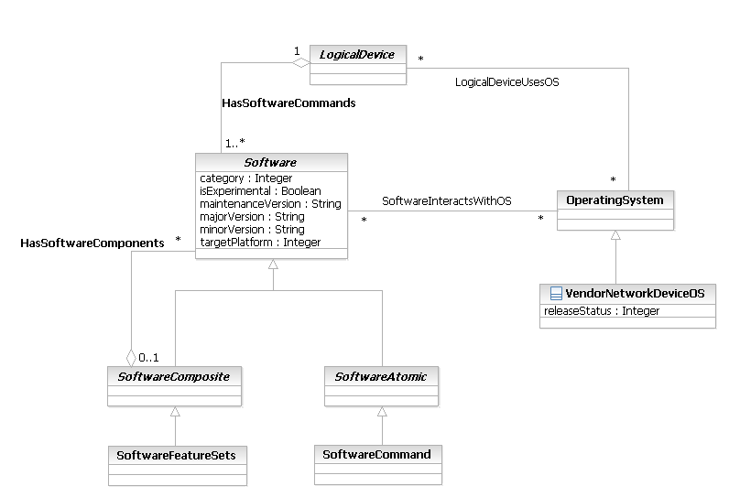
Figure LR.83 - Business Entity Model of Software

SoftwareAtomic Business Entity Definition
Business Entity Name | SoftwareAtomic
Description | This is an abstract class for representing atomic units of software that are individually manageable and do NOT form composite, or nested, software units.  From a finite state machine view, each SoftwareAtomic element is not just individually manageable, but is also installable, executable, and runnable. In addition, each SoftwareAtomic element can be a FRU.  This is the super-class for creating concrete subclasses that define particular functionality (e.g., a device driver, or software that implements MPLS as part of a larger routing software package).
Sources | DEN-ng
Cross-References
Synonyms / Aliases | This concept is not present in the ITU or CIM specs.
Related Business Entities | ManagedEntity, ResourceSpecification, LogicalResourceSpec, PhysicalResourceSpec, CompoundResourceSpec, Product, ProductComponent, ProductBundle, Resource, PhysicalResource, LogicalResource, CompoundResource, LogicalDevice, DeviceInterface, Software (superclass), SoftwareComposite (sibling), SoftwareFeatureSets, SoftwareCommand, OperatingSystem, ResourceLogic, ResourceSpecVersion, LogicalResourceSpecVersion, ResourceSpecType, ResourceCharacteristic, ResourceCharacteristicValue, ResourceSpecCharacteristic, ResourceSpecCharacteristicValue, ResourceRole, LogicalResourceRole, PhysicalResourceRole, Service, ResourceFacingService, CustomerFacingService, ServiceSpecification, ResourceFacingServiceSpec, CustomerFacingServiceSpec
Business Rules | To be determined

SoftwareAtomic Business Entity Attributes Definition
There are no attributes of SoftwareAtomic that are appropriate for a business view.

Business Entity Model – SoftwareAtomic
The business model for SoftwareAtomic is the same as that for Software, and is shown in Figure LR.83 above.

SoftwareCommand Business Entity Definition
Business Entity Name | SoftwareCommand
Description | SoftwareCommands describe the sets of features that are programmable by a particular PartyRole (e.g., a Developer, or NetworkOperator, and in rare cases, an EndUser).  This should not be confused with Capabilities. Capabilities define what features and functions are available at a given moment for the Resource. Thus, SoftwareCommands represent the specific commands that are available in a device, whereas Capabilities represent higher-level generic functions available in a Resource. For example, the ability to perform BGP routing is a Capability, whereas the actual commands used to implement BGP routing are SoftwareCommands.
Sources | DEN-ng
Cross-References
Synonyms / Aliases | This concept is not present in the ITU or CIM specs.
Related Business Entities | ManagedEntity, ResourceSpecification, LogicalResourceSpec, PhysicalResourceSpec, CompoundResourceSpec, Product, ProductComponent, ProductBundle, Resource, PhysicalResource, LogicalResource, CompoundResource, LogicalDevice, DeviceInterface, Software, SoftwareAtomic (superclass), SoftwareFeatureSets, SoftwareCommand, OperatingSystem, ResourceLogic, ResourceSpecVersion, LogicalResourceSpecVersion, ResourceSpecType, ResourceCharacteristic, ResourceCharacteristicValue, ResourceSpecCharacteristic, ResourceSpecCharacteristicValue, ResourceRole, LogicalResourceRole, PhysicalResourceRole, Service, ResourceFacingService, CustomerFacingService, ServiceSpecification, ResourceFacingServiceSpec, CustomerFacingServiceSpec
Business Rules | To be determined

SoftwareCommand Business Entity Attributes Definition
There are no attributes of SoftwareCommand that are appropriate for a business view.

Business Entity Model – SoftwareCommand
The business model for SoftwareCommand is the same as that for Software, and is shown in Figure LR.83 above.

SoftwareComposite Business Entity Definition
Business Entity Name | SoftwareComposite
Description | This is an abstract class for representing software units that are made up of other software units (i.e., instances of this class as well as the SoftwareAtomic base class). This provides the semantics of collecting a set of components, each of which is individually manageable, and being able to manage the set of objects as a whole. An example is an operating system - this is manageable as a unit, but consists of individually manageable components. This containment is modeled using the ContainsSoftwareComponents composition.  From a finite state machine view, each SoftwareComposite element is manageable, installable, executable, and runnable. In addition, each SoftwareComposite element can be a FRU.  This is the super-class for creating concrete subclasses that define groups of functionality (e.g., a set of features that work together to provide application-level functionality to the end-user).
Sources | DEN-ng, MetaSolv
Cross-References
Synonyms / Aliases | This concept is not present in the ITU recommendations; CIM defines Software but its functionality is a subset of the DEN-ng functionality.
Related Business Entities | ManagedEntity, ResourceSpecification, LogicalResourceSpec, PhysicalResourceSpec, CompoundResourceSpec, Product, ProductComponent, ProductBundle, Resource, PhysicalResource, LogicalResource, CompoundResource, LogicalDevice, DeviceInterface, Software (superclass), SoftwareAtomic (sibling), SoftwareFeatureSets (subclass), SoftwareCommand, OperatingSystem, ResourceLogic, ResourceSpecVersion, LogicalResourceSpecVersion, ResourceSpecType, ResourceCharacteristic, ResourceCharacteristicValue, ResourceSpecCharacteristic, ResourceSpecCharacteristicValue, ResourceRole, LogicalResourceRole, PhysicalResourceRole, Service, ResourceFacingService, CustomerFacingService, ServiceSpecification, ResourceFacingServiceSpec, CustomerFacingServiceSpec
Business Rules | To be determined

SoftwareComposite Business Entity Attributes Definition
There are no attributes of SoftwareComposite that are appropriate for a business view.

Business Entity Model – SoftwareComposite
The business model for SoftwareComposite is the same as that for Software, and is shown in Figure LR.83 above.

SoftwareFeatureSets Business Entity Definition
Business Entity Name | SoftwareFeatureSets
Description | SoftwareFeatureSets describe the groups of SoftwareCommands that distinguish a particular release of Software. The SoftwareCommands contained in the SoftwareFeatureSets are programmable by a particular PartyRole (e.g., a Developer, or NetworkOperator, and in rare cases and EndUser).  Often, SoftwareFeatureSets are used by the manufacturer to define a custom or semi-custom build of software, or are provided as a set of options that are orderable by the Customer.  This should not be confused with Capabilities. Capabilities define what features and functions are available at a given moment for the Resource. Thus, SoftwareFeatureSets represent groups of commands that are available in a device, whereas Capabilities represent higher-level generic functions available in a Resource. For example, the ability to perform BGP routing is a Capability, whereas the actual commands used to implement BGP routing are SoftwareCommands that reside in one or more SoftwareFeatureSets. Hence, SoftwareFeatureSets may or may not offer BGP as a programmable feature.
Sources | DEN-ng
Cross-References
Synonyms / Aliases | This concept is not present in the ITU or CIM specs.
Related Business Entities | ManagedEntity, ResourceSpecification, LogicalResourceSpec, PhysicalResourceSpec, CompoundResourceSpec, Product, ProductComponent, ProductBundle, Resource, PhysicalResource, LogicalResource, CompoundResource, LogicalDevice, DeviceInterface, Software, SoftwareAtomic, SoftwareComposite (superclass), SoftwareCommand, OperatingSystem, ResourceLogic, ResourceSpecVersion, LogicalResourceSpecVersion, ResourceSpecType, ResourceCharacteristic, ResourceCharacteristicValue, ResourceSpecCharacteristic, ResourceSpecCharacteristicValue, ResourceRole, LogicalResourceRole, PhysicalResourceRole, Service, ResourceFacingService, CustomerFacingService, ServiceSpecification, ResourceFacingServiceSpec, CustomerFacingServiceSpec
Business Rules | To be determined

SoftwareFeatureSets Business Entity Attributes Definition
There are no attributes of SoftwareFeatureSets that are appropriate for a business view.

Business Entity Model – SoftwareFeatureSets
The business model for SoftwareFeatureSets is the same as that for Software, and is shown in Figure LR.83 above.

SubNetwork Entity Definition
Business Entity Name | SubNetwork
Description | The SubNetwork class is derived from MTNM; please note that this definition is subtlely different than that of G.805. DEN-ng has mapped this definition into a form that can be represented using the SID and DEN-ng modeling philosophy. By including this mapping in the Network fragment and adding some additional semantics, objects defined in the TMF and ITU are able to interact with objects defined in the IETF.  MTNM defines a subnetwork as an abstraction provided by the EMS to the NMS that describes the potential for subnetwork connections. (An MTNM SubNetworkConnection relates end-point TerminationPoints. It provides a transparent end-to-end connection or a trail (closed or half-open) through a Subnetwork according to the roles associated to its end points.)  DEN-ng uses the above MTNM definition and expands on it. It defines a SubNetwork as existing within a single layer network. It is defined by the set of ResourcePorts that are available for the purpose of transferring characteristic information. The associations between the ResourcePorts at the edge of a SubNetwork may be made and broken by a LayerNetwork management process, thus changing its connectivity. When a SubNetwork connection is established, the reference points are also created by binding the ports to input and output of the SubNetwork connection. In general, SubNetworks may be partitioned into smaller SubNetworks interconnected by links.
Sources | DEN-ng, G.805, MTNM
Cross-References
Synonyms / Aliases | This concept is not present in the CIM.
Related Business Entities | ManagedEntity, ResourceSpecification, LogicalResourceSpec, PhysicalResourceSpec, CompoundResourceSpec, Product, ProductComponent, ProductBundle, Resource, PhysicalResource, LogicalResource, CompoundResource, ResourceCollection, ResourceElement, Network, NetworkComposite, NetworkAtomic (superclass), LayerNetwork, IPSubnet, ResourcePort, LogicalDevice, DeviceInterface, MediaInterface, Software, SoftwareAtomic, SoftwareComposite, SoftwareCommand, SoftwareFeatureSets, Protocol, ManagedTransmissionEntity, OperatingSystem, ResourceLogic, ResourceSpecVersion, LogicalResourceSpecVersion, ResourceSpecType, ResourceCharacteristic, ResourceCharacteristicValue, ResourceSpecCharacteristic, ResourceSpecCharacteristicValue, ResourceRole, LogicalResourceRole, PhysicalResourceRole, Service, ResourceFacingService, CustomerFacingService, ServiceSpecification, ResourceFacingServiceSpec, CustomerFacingServiceSpec
Business Rules | To be determined

SubNetwork Business Entity Attributes Definition
Note that not all of the MTNM attributes defined for a SubNetwork (included those inherited by the SubNetwork class) are shown in the table below. This is because (1) such attributes are not appropriate for a business view (so they will be defined in the System View of the SID), and (2) sometimes, the attributes in the MTNM SubNetwork class are mapped to other attributes and relationships that exist in other SID classes.
Business Entity Name | SubNetwork

Attribute Name | Description | Data Type | Notes (used to map to other models; blank is other models don’t have it)
connectionRates | This is a comma-separated Sequence of string attributes. Each string identifies a connection rate that is supported by this Network. Connection rates can operate at a speed that is different from the overall rate of the network that contains this SubNetwork.  Values are defined by the LayerRates supporting document in the MTNM specification. | String | This definition is taken from MTNM; no equivalent in the CIM spec.
subNetworkType | This is an enumerated integer that defines the specific type of SubNetwork that this instance is.  The following values are defined by TMF608:  0: Singleton  1: CHAIN  2: PSR  3: SPRING  4: OPEN_PSR  5: OPEN_SPRING  6: MESH | Integer | This definition is taken from MTNM; no equivalent in the CIM spec.

Business Entity Model – SubNetwork
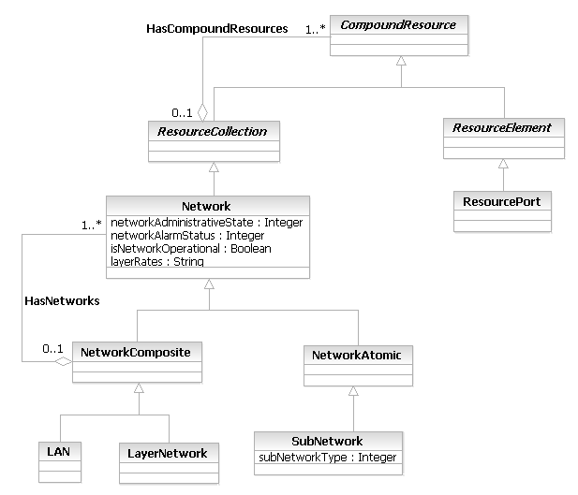
Figure LR.84 - Business Entity Model of a SubNetwork

SwitchingProtocol Business Entity Definition
Business Entity Name | SwitchingProtocol
Description | In a network that uses standard routing, frames pass from a source to a destination in a hop-by-hop basis. Transit routers look at each frame's Layer 3 header and perform a route table lookup determine the next hop toward the destination. This means that layer 2 information is effectively ignored.  A SwitchingProtocol replaces the above hop-by-hop method with a method to specify a path in the network. This path may be based on any number of different attributes, such as cost of the path and QoS. The most popular implementation of this approach is MPLS.
Sources | DEN-ng
Cross-References
Synonyms / Aliases | This concept is not present in the ITU or DMTF CIM specifications.
Related Business Entities | ManagedEntity, ResourceSpecification, LogicalResourceSpec, PhysicalResourceSpec, CompoundResourceSpec, Product, ProductComponent, ProductBundle, Resource, PhysicalResource, LogicalResource, CompoundResource, LogicalDevice, DeviceInterface, MediaInterface, Software, SoftwareAtomic, SoftwareComposite, SoftwareCommand, SoftwareFeatureSets, Protocol (superclass), BridgingProtocol (sibling), LANProtocol (sibling), ManagementProtocol (sibling), RoutedProtocol (sibling), RoutingProtocol (sibling), SignalingProtocol (sibling), WANProtocol (sibling), OperatingSystem, ResourceLogic, ResourceSpecVersion, LogicalResourceSpecVersion, ResourceSpecType, ResourceCharacteristic, ResourceCharacteristicValue, ResourceSpecCharacteristic, ResourceSpecCharacteristicValue, ResourceRole, LogicalResourceRole, PhysicalResourceRole, Service, ResourceFacingService, CustomerFacingService, ServiceSpecification, ResourceFacingServiceSpec, CustomerFacingServiceSpec
Business Rules | To be determined

SwitchingProtocol Business Entity Attributes Definition
There are no attributes of SwitchingProtocol that are appropriate for a business view.

Business Entity Model – SwitchingProtocol
The business entity model of SwitchingProtocol is the same as that of BridgingProtocol, and is defined in Figure LR.59 above.

TerminationPoint Business Entity Definition
Business Entity Name | TerminationPoint
Description | This is an abstract class that terminates transport entities, such as trails and connections. This object class is a basic object class from which subclasses, such as TrailTerminationPoint and ConnectionTerminationPoint, are derived.  This object is taken from the MTNM definition. DEN-ng integrates it into the ManagedTransmissionEntity hierarchy so that it can interact with other TMF and IETF managed objects.
Sources | DEN-ng, MTNM
Cross-References
Synonyms / Aliases | This concept is not present in CIM.
Related Business Entities | ManagedEntity, ResourceSpecification, LogicalResourceSpec, PhysicalResourceSpec, CompoundResourceSpec, Product, ProductComponent, ProductBundle, Resource, PhysicalResource, LogicalResource, CompoundResource, LogicalDevice, DeviceInterface, MediaInterface, Software, SoftwareAtomic, SoftwareComposite, SoftwareCommand, SoftwareFeatureSets, Protocol, ManagedTransmissionEntity (superclass), Pipe, Connection, Trail, ConnectionTerminationPoint (subclass), TrailTerminationPoint (subclass), OperatingSystem, ResourceLogic, ResourceSpecVersion, LogicalResourceSpecVersion, ResourceSpecType, ResourceCharacteristic, ResourceCharacteristicValue, ResourceSpecCharacteristic, ResourceSpecCharacteristicValue, ResourceRole, LogicalResourceRole, PhysicalResourceRole, Service, ResourceFacingService, CustomerFacingService, ServiceSpecification, ResourceFacingServiceSpec, CustomerFacingServiceSpec
Business Rules | To be determined

TerminationPoint Business Entity Attributes Definition
Note that not all of the MTNM attributes defined for a TerminationPoint (included those it inherits) are shown in the table below. This is because (1) such attributes are not appropriate for a business view (so they will be defined in the System View of the SID), and (2) sometimes, the attributes in the MTNM TerminationPoint class are mapped to other attributes and relationships that exist in other SID classes.
Business Entity Name | TerminationPoint

Attribute Name | Description | Data Type | Notes (used to map to other models; blank is other models don’t have it)
direction | This is an enumerated integer, and defines whether this object instance carries traffic uni-directionally or bi-directionally. Values include:  0: Unknown  1: Sources Traffic  2: Sinks Traffic  3: Carries Traffic Bi-directionally | Integer | This represents part of the mapping to MTNM.direction; no equivalent in CIM.
vendorTPName | This is a string that contains the vendor-specific name of this TerminationPoint. This is different from the CommonName attribute, which represents a system-wide naming structure for all ManagedObjects. For example, an Alcatel CTP might be identified as LG1-STS12CA-13 (line group 1, STS-12,  concatenated, side A, time slot 13). | String | No equivalent in either the ITU or the CIM specs.
typeOfTP | This is an enumerated integer that is used to define the type of this particular TP. Values include:  0: unknown  1: uni-directional, source  2: uni-directional, sink  3: bi-directional, source  4: bi-directional, sink | Integer | No equivalent in the CIM; ITU uses explicit subclassing. This is the other part of the MTNM.direction mapping
endPointLabel | This is a string that contains specific identifier information about the data flow managed on each TerminationPoint, for example ATM VP and/or VC, stacked Ethernet VLAN identifiers and so on. | String

Business Entity Model – TerminationPoint
The business entity model for a TerminationPoint was shown earlier in Figure LR.78 above.

TokenRingInterface Business Entity Definition
Business Entity Name | TokenRingInterface
Description | A Token Ring interface is a type of local area network in which all computers are connected in a ring or star topology. A special bit pattern, called a token, travels around the ring. When a device wishes to send a message, it catches the token, attaches a message to it and then lets it continue to travel around the network to be collected by the destination device. It is defined by the IEEE 802.5 series of standards.
Sources | DEN-ng
Cross-References
Synonyms / Aliases | This concept is not present in either the ITU recommendations or the DMTF CIM.
Related Business Entities | ManagedEntity, ResourceSpecification, LogicalResourceSpec, PhysicalResourceSpec, CompoundResourceSpec, Product, ProductComponent, ProductBundle, Resource, PhysicalResource, LogicalResource, CompoundResource, LogicalDevice, DeviceInterface, MediaInterface (superclass), LogicalInterface, EthernetInterface (sibling), ATMInterface (sibling), SerialInterface (sibling), Software, SoftwareAtomic, SoftwareComposite, SoftwareCommand, SoftwareFeatureSets, OperatingSystem, ResourceLogic, ResourceSpecVersion, LogicalResourceSpecVersion, ResourceSpecType, ResourceCharacteristic, ResourceCharacteristicValue, ResourceSpecCharacteristic, ResourceSpecCharacteristicValue, ResourceRole, LogicalResourceRole, PhysicalResourceRole, Service, ResourceFacingService, CustomerFacingService, ServiceSpecification, ResourceFacingServiceSpec, CustomerFacingServiceSpec
Business Rules | To be determined

TokenRingInterface Business Entity Attributes Definition
Business Entity Name | TokenRingInterface

Attribute Name | Description | Data Type | Notes (used to map to other models; blank is other models don’t have it)
ringOpenStatus | This is an integer attribute that indicates the success, or the reason for failure, of the device's most recent attempt to enter the ring. This is based on the IEEE's 802.5 Token Ring MIB's dot5RingOpenStatus variable. Values include:  0: No Open Attempted  1: Bad Parameter  2: Lobe Failed  3: Signal Loss  4: Insertion Timeout  5: Ring Failed  6: Beaconing  7: Duplicate MAC  8: Request Failed  9: Remove Received  10: Last Open Successful  MappingStrings {  "MIB.IETF|IEEE 802.5 Token Ring MIB.dot5RingOpenStatus"} | Integer | Not defined in the CIM. This is taken from IEEE 802.5 Token Ring MIB.dot5RingOpenStatus
ringStatus | This is an integer attribute that defines the current status which can be used to diagnose fluctuating problems that can occur on token rings, after a station has successfully been added to the ring. These values are taken from the IEEE 802.5 Token Ring MIB's dot5RingStatus attribute. Values include:  0: No Problems Detected  32: Ring Recovery  64: Single Station  256: Remove Received  512: Reserved  1024: Auto-Removal Error  2048: Lobe Wire Fault  4096: Transmit Beacon  8192: Soft Error  16384: Hard Error  32768: Signal Loss  131072: No Status | Integer | Not defined in the CIM. These values are taken from the IEEE 802.5 Token Ring MIB's dot5RingStatus attribute.
ringState | This is an integer attribute that defines the state of the current Device with respect to entering or leaving the ring. Its values are taken from the IEEE 802.5 Token Ring MIB's dot5RingState variable. Values include:  0: Opened  1: Closed  2: Opening  3: Closing  4: Open Failure  5: Ring Failure | Integer | Not defined in the CIM. This is taken from IEEE 802.5 Token Ring MIB.dot5RingState variable.
ringSpeed | This is an enumerated integer that specifies the ring speed of the TokenRing network that this device interface is connected to. This information is based on the IEEE 802.5 Token Ring MIB's dot5RingSpeed variable. Values include:  0 - not connected  1 - 1MBPS  2 - 4MBPS  3 - 16 MBPS  4 - Other | Integer | Not defined in the CIM. This is taken from IEEE 802.5 Token Ring MIB.dot5RingSpeed variable.

Business Entity Model – TokenRingInterface
The model of a TokenRingInterface is the same as that for MediaInterface, and is shown in Figure LR.79 above.

Trail Business Entity Definition
Business Entity Name | Trail
Description | Trail is a class of managed objects in layer networks which is responsible for the integrity of transfer of characteristic information from one or more other layer networks. A Trail is composed of two TrailTerminationPoints and one or more Connections and associated ConnectionTerminationPoints.  This object is taken from M.3100. DEN-ng integrates it into the ManagedTransmissionEntity hierarchy so that it can interact with managed objects defined by the TMF, IETF, and other fora.
Sources | DEN-ng, M.3100
Cross-References
Synonyms / Aliases | This concept is not present in CIM.
Related Business Entities | ManagedEntity, ResourceSpecification, LogicalResourceSpec, PhysicalResourceSpec, CompoundResourceSpec, Product, ProductComponent, ProductBundle, Resource, PhysicalResource, LogicalResource, CompoundResource, LogicalDevice, DeviceInterface, MediaInterface, Software, SoftwareAtomic, SoftwareComposite, SoftwareCommand, SoftwareFeatureSets, Protocol, ManagedTransmissionEntity, TerminationPoint, Pipe (superclass), Connection (sibling), OperatingSystem, ResourceLogic, ResourceSpecVersion, LogicalResourceSpecVersion, ResourceSpecType, ResourceCharacteristic, ResourceCharacteristicValue, ResourceSpecCharacteristic, ResourceSpecCharacteristicValue, ResourceRole, LogicalResourceRole, PhysicalResourceRole, Service, ResourceFacingService, CustomerFacingService, ServiceSpecification, ResourceFacingServiceSpec, CustomerFacingServiceSpec
Business Rules | To be determined

Trail Business Entity Attributes Definition
There are no attributes of Trail that are appropriate for a business view.

Business Entity Model – Trail
The business entity model for a Trail is the same as that for a ManagedTransmissionEntity, and is shown in Figure LR.64 above.

TrailTerminationPoint Business Entity Definition
Business Entity Name | TrailTerminationPoint
Description | A TTP is an actual or potential end point of a Trail. All PhysicalPorts can connect to at least one type of TTP.  DEN-ng integrates this object into the ManagedTransmissionEntity hierarchy so that it can interact with other TMF, ITU, and IETF managed objects.
Sources | DEN-ng, M.3100
Cross-References
Synonyms / Aliases | This concept is not present in CIM.
Related Business Entities | ManagedEntity, ResourceSpecification, LogicalResourceSpec, PhysicalResourceSpec, CompoundResourceSpec, Product, ProductComponent, ProductBundle, Resource, PhysicalResource, LogicalResource, CompoundResource, LogicalDevice, DeviceInterface, MediaInterface, Software, SoftwareAtomic, SoftwareComposite, SoftwareCommand, SoftwareFeatureSets, Protocol, ManagedTransmissionEntity, Pipe (sibling), Connection, Trail, TerminationPoint (superclass), ConnectionTerminationPoint (sibling), OperatingSystem, ResourceLogic, ResourceSpecVersion, LogicalResourceSpecVersion, ResourceSpecType, ResourceCharacteristic, ResourceCharacteristicValue, ResourceSpecCharacteristic, ResourceSpecCharacteristicValue, ResourceRole, LogicalResourceRole, PhysicalResourceRole, Service, ResourceFacingService, CustomerFacingService, ServiceSpecification, ResourceFacingServiceSpec, CustomerFacingServiceSpec
Business Rules | To be determined

TrailTerminationPoint Business Entity Attributes Definition
There are no attributes of TrailTerminationPoint that are appropriate for a business view.

Business Entity Model – TrailTerminationPoint
The business entity model for a TrailTerminationPoint is the same as that for a TerminationPoint, and is shown in Figure LR.64 above.

UserNameResourceRole Business Entity Definition
Business Entity Name | UserNameResourceRole
Description | UserNameResourceRole represents the role of a logical resource as user name in a system. User names can be managed in a dedicated specific pool or can be shared with other resource pools in which case phone number or email address can also be used as user names in the system.
Sources
Cross-References
Synonyms / Aliases
Related Business Entities | Derived from LogicalResourceRole
Business Rules

VendorNetworkDeviceOS Business Entity Definition
Business Entity Name | VendorNetworkDeviceOS
Description | This is an abstract base class for representing software. The HasSoftware association is used to define software that is associated in some way with a ManagedPhysicalEntity, such as programs and operating systems. Since this software can be associated with complete devices or components of device, this association is defined between the roots of the two classes.  Currently, the subclasses of this class reflect user-facing features (e.g., features that are manageable, configurable, and executable by users and applications).
Sources | DEN-ng
Cross-References
Synonyms / Aliases | This concept is not present in the ITU recommendations; CIM defines Software but its functionality is a subset of the DEN-ng functionality.
Related Business Entities | ManagedEntity, ResourceSpecification, LogicalResourceSpec, PhysicalResourceSpec, CompoundResourceSpec, Product, ProductComponent, ProductBundle, Resource, PhysicalResource, LogicalResource, CompoundResource, LogicalDevice, DeviceInterface, SoftwareAtomic, SoftwareComposite, OperatingSystem (superclass), ResourceLogic, ResourceSpecVersion, LogicalResourceSpecVersion, ResourceSpecType, ResourceCharacteristic, ResourceCharacteristicValue, ResourceSpecCharacteristic, ResourceSpecCharacteristicValue, ResourceRole, LogicalResourceRole, PhysicalResourceRole, Service, ResourceFacingService, CustomerFacingService, ServiceSpecification, ResourceFacingServiceSpec, CustomerFacingServiceSpec
Business Rules | To be determined

VendorNetworkDeviceOS Business Entity Attributes Definition
Business Entity Name | VendorNetworkDeviceOS

Attribute Name | Description | Data Type | Notes (used to map to other models; blank is other models don’t have it)
releaseStatus | This attribute is an enumerated integer that defines the particualr release status of this software. Values include:  0: alpha  1. beta  2: FCS (First Customer Shipment)  3. GD (General Deployment)  4: SV (Special Version for 1 or more customers)  5: EOE (end of engineering)  6: EOS (end of sale)  7: EOL (end of life)  FCS marks the beginning of the limited deployment phase. In this phase, the software is usually certified on a few platforms but not all platforms.  GD marks the certification of stable software on all major platforms.  SV is a special build for a particular customer that needs special fixes or features.  EOE means that no new engineering fixes will be applied, but the software can still be ordered. EOS means that the software can no longer be ordered, but will still be supported. EOL means that the software can no longer be supported, and cannot be ordered. | Integer | Not present in the ITU. Not present in CIM 2.6; In 2.7, CIM has mined this concept but the implementation isn’t compliant with DEN-ng and is restricted in its functionality. In the CIM 2.10.1 this attribute is not defined for an OS.

Business Entity Model – VendorNetworkDeviceOS
The business entity model for a VendorNetworkDeviceOS is the same as that for an OperatingSystem, and is shown in Figure LR.83 above.

WANProtocol Business Entity Definition
Business Entity Name | WANProtocol
Description | WAN Protocols operate at the lowest three levels of the OSI model (i.e., physical, data link, and network) and are used to define communications over different types of wide-area media.  The DEN-ng model defines ATM, FrameRelay, HDLC, ISDN, PPP, SLIP, SMDS, and X.25 as examples of subclasses of this class.
Sources | DEN-ng
Cross-References
Synonyms / Aliases | This concept is not present in the ITU or DMTF CIM specifications.
Related Business Entities | ManagedEntity, ResourceSpecification, LogicalResourceSpec, PhysicalResourceSpec, CompoundResourceSpec, Product, ProductComponent, ProductBundle, Resource, PhysicalResource, LogicalResource, CompoundResource, LogicalDevice, DeviceInterface, MediaInterface, Software, SoftwareAtomic, SoftwareComposite, SoftwareCommand, SoftwareFeatureSets, Protocol (superclass), BridgingProtocol (sibling), LANProtocol (sibling), ManagementProtocol (sibling), RoutedProtocol (sibling), RoutingProtocol (sibling), SignalingProtocol (sibling), SwitchingProtocol (sibling), OperatingSystem, ResourceLogic, ResourceSpecVersion, LogicalResourceSpecVersion, ResourceSpecType, ResourceCharacteristic, ResourceCharacteristicValue, ResourceSpecCharacteristic, ResourceSpecCharacteristicValue, ResourceRole, LogicalResourceRole, PhysicalResourceRole, Service, ResourceFacingService, CustomerFacingService, ServiceSpecification, ResourceFacingServiceSpec, CustomerFacingServiceSpec
Business Rules | To be determined

WANProtocol Business Entity Attributes Definition
There are no attributes of WANProtocol that are appropriate for a business view.

Business Entity Model – WANProtocol
The business entity model of WANProtocol is the same as that of BridgingProtocol, and is defined in Figure LR.59 above.

Classes that are part of the Resource Domain, not part of the Logicalresource ABE

Resource Business Entity Definition
Business Entity Name | Resource
Description | A Resource is the abstract base class for all entities that are inherently manageable and make up a Product. Examples that are not Manageable include legacy Hubs that don't support any type of management protocol; rather, they must be manually managed. Entities like Policy are of course manageable, but do not make up or are found packaged inside of a Product.
Sources | DEN-ng, MetaSolv, BT
Cross-References
Synonyms / Aliases | LogicalResource doesn’t exist in the ITU-T models. The closest match to this class in the CIM hierarchy would be ManagedSystemElement, but its superclasses and their content are very different. Hence, the semantics of this class do not really match that of the ManagedSystemElement class.
Related Business Entities | ManagedEntity (superclass), Product, ProductComponent, ProductBundle, PhysicalResource (subclass), LogicalResource (subclass), CompoundResource (subclass), ResourceSpecification, PhysicalResourceSpec, LogicalResourceSpec, CompoundResourceSpec, ResourceSpecVersion, ResourceCharacteristic, ResourceCharacteristicValue, ResourceRole, LogicalResourceRole, PhysicalResourceRole, Service, ResourceFacingService, CustomerFacingService, ServiceSpecification, ResourceFacingServiceSpec, CustomerFacingServiceSpec
Business Rules | To be determined

Resource Business Entity Attributes Definition
Business Entity Name | Resource
Attribute Name | Description | Data Type | Notes (used to map to other models; blank is other models don’t have it)
usageState | This is an enumerated integer that defines the current usage of the object. | Integer | Not present in the ITU or the CIM.

Business Entity Model – Resource
Figure LR.85 - Business Entity Model of a Resource and ResourceSpecification

ResourceSpecCharacteristic Business Entity Definition
Business Entity Name | ResourceSpecCharacteristic
Description | A characteristic quality or distinctive feature of a ResourceSpecification. The characteristic can be take on a discrete value, such as color, can take on a range of values, (for example, sensitivity of 100-240 mV), or can be derived from a formula (for example, usage time (hrs) = 30 – talk time *3). Certain characteristics, such as color, may be configured during the ordering or some other process.
Sources | MetaSolv, Fowler
Cross-References
Synonyms / Aliases | ResourceSpecificationProperty
Related Business Entities | enumeratedBy ResourceSpecCharacteristicValue  references ResourceSpecificationCharacteristic
Business Rules | To be determined

ResourceSpecCharacteristic Business Entity Attributes Definition
Business Entity Name | ResourceSpecCharacteristic

Attribute Name | Description | Data Type | Notes (used to map to other models; blank is other models don’t have it)
ID | A unique identifier for the CharacteristicSpecification. | String
name | A word, term, or phrase by which the CharacteristicSpecification is known and distinguished from other CharacteristicSpecifications. | String
description | A narrative that explains the CharacteristicSpecification. | String
unique | An indicator that specifies if a value is unique for the specification.  Possible values are; "unique while value is in effect" and "unique whether value is in effect or not" | String
valueType | A kind of value that the characteristic can take on, such as numeric, text, and so forth. | String
minCardinality | The minimum number of instances a CharacteristicValue can take on. For example, zero to five phone numbers in a group calling plan, where zero is the value for the minCardinality. | Integer
maxCardinality | The maximum number of instances a CharacteristicValue can take on. For example, zero to five phone numbers in a group calling plan, where five is the value for the maxCardinality. | Integer
extensible | An indicator that specifies that the values for the characteristic can be extended by adding new values when instantiating a characteristic for an Entity. | Boolean
derivationFormula | A rule or principle represented in symbols, numbers, or letters, often in the form of an equation used to derive the value of a characteristic value. | String
validFor | The period of time for which a characteristic is applicable. | TimePeriod

ResourceSpecCharRelationship Business Entity Definition
Business Entity Name | ResourceSpecCharRelationship
Description | A aggregation, migration, substitution, dependency, or exclusivity relationship between/among ServiceSpecCharacteristics.
Sources | MetaSolv
Cross-References
Synonyms / Aliases
Related Business Entities
Business Rules | To be determined

ResourceSpecCharRelationship Business Entity Attributes Definition
Business Entity Name | ResourceSpecCharRelationship

Attribute Name | Description | Data Type | Notes (used to map to other models; blank is other models don’t have it)
charRelationshipType | A categorization of the relationship, such as aggregation, migration, substitution, dependency, exclusivity. | String
charSpecSeq | The order in which a ResourceSpecCharacteristic appears within another CharacteristicSpecification that defines a grouping of ResourceSpecCharacteristics.  For example, a grouping may represent the name of an individual. The given name is first, the middle name is second, and the last name is third. | Integer
validFor | The period for which the relationship is applicable. | TimePeriod

ResourceSpecCharacteristicValue Business Entity Definition
Business Entity Name | ResourceSpecCharacteristicValue
Description | A number or text that can be assigned to a ResourceSpecCharacteristic.
Sources | SID team
Cross-References
Synonyms / Aliases | ResourceSpecPropertyValue
Related Business Entities | enumerates by ResourceSpecCharacteristic  describes ResourceSpecification  assignedTo Resource
Business Rules | To be determined

ResourceSpecCharacteristicValue Business Entity Attributes Definition
Business Entity Name | ResourceSpecCharacteristicValue

Attribute Name | Description | Data Type | Notes (used to map to other models; blank is other models don’t have it)
valueType | A kind of value that the characteristic can take on, such as numeric, text, and so forth. | String
default | Indicates if the value is the default value for a characteristic. | String
value | A discrete value that the characteristic can take on. | String | Either value or valueFrom and/or valueTo are required
unitOfMeasure | A length, surface, volume, dry measure, liquid measure, money, weight, time, and the like. In general, a determinate quantity or magnitude of the kind designated, taken as a standard of comparison for others of the same kind, in assigning to them numerical values, as 1 foot, 1 yard, 1 mile, 1 square foot. | String
valueFrom | The low range value that a characteristic can take on. | String
valueTo | The upper range value that a characteristic can take on. | String
rangeInterval | An indicator that specifies the inclusion or exclusion of the valueFrom and valueTo attributes.  Possible values are "open", "closed", "closedBottom" and "closedTop". | String
validFor | The period of time for which a value is applicable. | TimePeriod

ResourceCharacteristicValue Business Entity Definition
Business Entity Name | ResourceCharacteristicValue
Description | A value of a ResourceSpecCharacteristic chosen for a Resource that further defines what the Resource is.
Sources | SID team
Cross-References
Synonyms / Aliases | This concept is not present in either the ITU recommendations or the DMTF CIM.
Related Business Entities | chosenFor Resource  describedBy ResourceSpecCharacteristic  instantiationOf ResourceSpecCharacteristicValue
Business Rules | To be determined

ResourceCharacteristicValue Business Entity Attributes Definition
Business Entity Name | ResourceCharacteristicValue
Attribute Name | Description | Data Type | Notes (used to map to other models; blank is other models don’t have it)
value | A fact that describes a Resource. | String | Required if the association there is an association with ResourceSpecCharacteristic only.
validFor | The period for which the characteristic value is applicable. | Time Period

Business Entity Model – ResourceCharacteristicValue
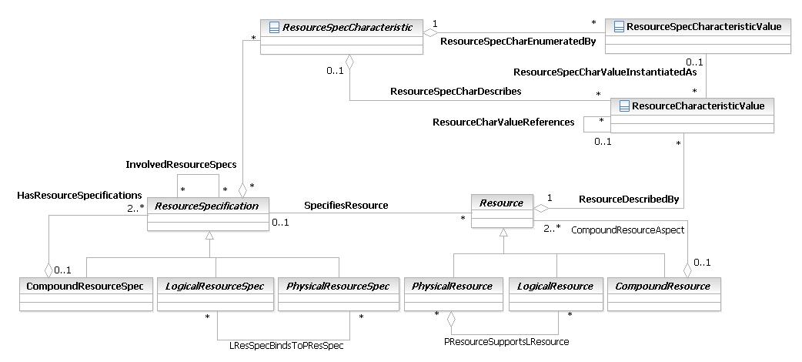
Figure LR.86 - Business Entity Model of a ResourceCharacteristicValue

ResourceRole Business Entity Definition
Business Entity Name | ResourceRole
Description | A CompoundResourceRole is a role that is defined by the interaction between PhysicalResourceRoles and LogicalResourceRoles. There must be at least one or more PhysicalResourceRoles and one or more LogicalResourceRoles to form a CompoundResourceRole. However, neither a PhysicalResourceRole nor a LogicalResourceRole has to belong to a CompoundResourceRole.
Sources | DEN-ng
Cross-References
Synonyms / Aliases | This concept is not present in either the ITU recommendations or the DMTF CIM.
Related Business Entities | ManagedEntity, ResourceSpecification, LogicalResourceSpec, PhysicalResourceSpec, CompoundResourceSpec, Product, ProductComponent, ProductBundle, Resource, PhysicalResource, LogicalResource, CompoundResource, LogicalDevice, DeviceInterface, DeviceSubInterface, MediaInterface, LogicalInterface, Software, SoftwareAtomic, SoftwareComposite, SoftwareCommand, SoftwareFeatureSets, OperatingSystem, ResourceLogic, ResourceSpecVersion, LogicalResourceSpecVersion, ResourceSpecType, ResourceCharacteristic, ResourceCharacteristicValue, ResourceSpecCharacteristic, ResourceSpecCharacteristicValue, Role, ResourceRole (superclass), CompoundResourceRole, PhysicalResourceRole, Service, ResourceFacingService, CustomerFacingService, ServiceSpecification, ResourceFacingServiceSpec, CustomerFacingServiceSpec
Business Rules | To be determined

ResourceRole Business Entity Attributes Definition
There are no attributes of ResourceRole that are appropriate for a business view.

ResourceSpecification Business Entity Definition
The business entity model of ResourceRole is the same as that of LogicalResourceRole, and is defined in Figure LR.61 above.
Business Entity Name | ResourceSpecification
Description | A ResourceSpecification is an abstract base class that is used to define the invariant characteristics and behavior (attributes, methods, constraints, and relationships) of a ManagedResource.
Sources | DEN-ng, MetaSOlv, BT
Cross-References
Synonyms / Aliases | The concept of a template for specifying the invariant characteristics and behavior of a managed object is not part of the ITU or CIM specs.
Related Business Entities | ManagedEntity, Specification (superclass), PhysicalResourceSpec (subclass), LogicalResourceSpec (subclass), CompoundResourceSpec (subclass), Product, ProductComponent, ProductBundle, Resource, PhysicalResource, LogicalResource, CompoundResource, ResourceSpecVersion, ResourceSpecType, ResourceCharacteristic, ResourceCharacteristicValue, ResourceSpecCharacteristic, ResourceSpecCharacteristicValue, ResourceRole, LogicalResourceRole, PhysicalResourceRole, Service, ResourceFacingService, CustomerFacingService, ServiceSpecification, ResourceFacingServiceSpec, CustomerFacingServiceSpec
Business Rules | To be determined

ResourceSpecification Business Entity Attributes Definition
Business Attributes for this class will be defined in Phase IV, when additional examples of ResourceSpecifications will be defined.

Business Entity Model – ResourceSpecification
The business entity model of Resource is the same as that of ResourceSpecification, and is defined in Figure LR.86 above.

ResourceSpecType Business Entity Definition
Business Entity Name | ResourceSpecType
Description | A ResourceSpecType entity is used to categorize sets of ResourceSpecifications. Multiple ResourceSpecTypes can be related to each other using the InvolvedResourceSpecTypes association.
Sources | DEN-ng
Cross-References
Synonyms / Aliases | No concept of this categorization in CIM or the ITU specs.
Related Business Entities | Entity (superclass), ManagedEntity, Specification, ResourceSpecification, LogicalResourceSpec, PhysicalResourceSpec, CompoundResourceSpec, PhysicalResourceSpecAtomic, PhysicalResourceSpecComposite, LogicalResourceSpecAtomic, LogicalResourceSpecComposite, CompoundResourceSpecAtomic, CompoundResourceSpecComposite, Product, ProductComponent, ProductBundle, Resource, PhysicalResource, LogicalResource, CompoundResource, ResourceSpecVersion, ResourceCharacteristic, ResourceCharacteristicValue, ResourceSpecCharacteristic, ResourceSpecVersion, ResourceRole, LogicalResourceRole, PhysicalResourceRole, Service, ResourceFacingService, CustomerFacingService, ServiceSpecification, ResourceFacingServiceSpec, CustomerFacingServiceSpec
Business Rules | To be determined

ResourceSpecType Business Entity Attributes Definition
There are no attributes of ResourceSpecType that are appropriate for a business view. The intent of this class is instead to serve as a common point to define relationships to other managed business objects. Subclasses of this class are designed to add their own application-specific attributes to help constrain the values that the associated ResourceSpecCharacteristic entity can take on.

Business Entity Model – ResourceSpecType
The business entity model of ResourceSpecType is the same as that of ResourceSpecification, and is defined in Figure LR.74 above.

ResourceSpecVersion Business Entity Definition
Business Entity Name | ResourceSpecVersion
Description | This class represents the ability to distinguish between different instances of ResourceSpecifications. It represents a particular form or variety of a ResourceSpecification that is different from others or from the original. The form represents differences in attributes, methods, relationships, and/or constraints that characterize this particular ResourceSpecification, but which are not enough to warrant creating a new ResourceSpecification.
Sources | DEN-ng, MetaSolv
Cross-References
Synonyms / Aliases | No concept of this categorization in CIM or the ITU specs.
Related Business Entities | Entity (superclass), ManagedEntity, Specification, ResourceSpecification, LogicalResourceSpec, PhysicalResourceSpec, CompoundResourceSpec, PhysicalResourceSpecAtomic, PhysicalResourceSpecComposite, LogicalResourceSpecAtomic, LogicalResourceSpecComposite, CompoundResourceSpecAtomic, CompoundResourceSpecComposite, Product, ProductComponent, ProductBundle, Resource, PhysicalResource, LogicalResource, CompoundResource, ResourceSpecType, ResourceCharacteristic, ResourceCharacteristicValue, ResourceSpecCharacteristic, ResourceSpecCharacteristicValue, LogicalResourceSpecVersion (subclass), ResourceRole, LogicalResourceRole, PhysicalResourceRole, Service, ResourceFacingService, CustomerFacingService, ServiceSpecification, ResourceFacingServiceSpec, CustomerFacingServiceSpec
Business Rules | To be determined

ResourceSpecVersion Business Entity Attributes Definition
Business Entity Name | ResourceSpecVersion

Attribute Name | Description | Data Type | Notes (used to map to other models; blank is other models don’t have it)
resSpecRevisionName | This defines the name of this revision of this ServiceSpecification. | String | Not present in the ITU or CIM specs.
resSpecRevisionFormat | This attribute defines the specific revision format used in this version. Each field of the revision is separated by a period. For example, if the desired format is <major number><.><minor number>, then the value of this string could be:  major-number.minor-number  The semantics of the format should be described in the revisionSemantics attribute of this class. | String | Not present in the ITU or CIM specs.
resSpecRevisionNumber | This is the revision number of this instance. This includes subfields such as major number, minor number, and so forth. The subfields are separated by a period delimited. The format of the subfields is provided in the revisionFormat attribute of this class. | String | Not present in the ITU or CIM specs.
resSpecRevisionReason | This is a string that describes the reason for creating this version. | String | Not present in the ITU or CIM specs.
resSpecRevisionSemantics | This is a string that is used to define the particular semantics of this version. This string should include as a minimum a description of the format of the revisionNumber. | String
resSpecRevisionTimestamp | This defines the date and time of the revision. | Date | Not present in the ITU or CIM specs.
resSpecRevisionValidityPeriod | This defines the time period in which this revision is valid for. | TimePeriod | Not present in the ITU or CIM specs.

Business Entity Model – ResourceSpecVersion
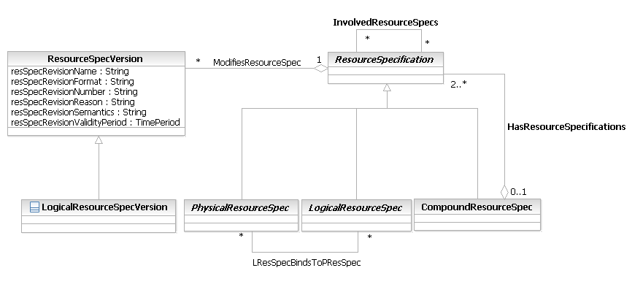
Figure LR.87 - Business Entity Model of a ResourceSpecVersion

Resource Business Entity Definition
Business Entity Name | Resource
Description | A Resource is the abstract base class for all entities that are inherently manageable and make up a Product. Examples that are not Manageable include legacy Hubs that don't support any type of management protocol; rather, they must be manually managed. Entities like Policy are of course manageable, but do not make up or are found packaged inside of a Product.
Sources | DEN-ng, MetaSolv, BT
Cross-References
Synonyms / Aliases | LogicalResource doesn’t exist in the ITU-T models. The closest match to this class in the CIM hierarchy would be ManagedSystemElement, but its superclasses and their content are very different. Hence, the semantics of this class do not really match that of the ManagedSystemElement class.
Related Business Entities | ManagedEntity (superclass), Product, ProductComponent, ProductBundle, PhysicalResource (subclass), LogicalResource (subclass), CompoundResource (subclass), ResourceSpecification, PhysicalResourceSpec, LogicalResourceSpec, CompoundResourceSpec, ResourceSpecVersion, ResourceCharacteristic, ResourceCharacteristicValue, ResourceRole, LogicalResourceRole, PhysicalResourceRole, Service, ResourceFacingService, CustomerFacingService, ServiceSpecification, ResourceFacingServiceSpec, CustomerFacingServiceSpec
Business Rules | To be determined
Resource Business Entity Attributes Definition
Business Entity Name | Resource

Business Entity Model – Resource
Figure LR.85 - Business Entity Model of a Resource and ResourceSpecification

ResourceInvolvementRole Business Entity Definition
Business Entity Name | ResourceInvolvementRole
Description | A role a business entity (such as PartyRole, ResourceRole or CustomerAccount) plays in the relationship for a Resource. For example: user, owner, and so forth.
Sources
Cross-References
Synonyms / Aliases
Related Business Entities | InvolvementRole (superclass), Resource
Business Rules | To be determined
ResourceSpecCharacteristic Business Entity Definition
Business Entity Name | ResourceSpecCharacteristic
Description | A characteristic quality or distinctive feature of a ResourceSpecification. The characteristic can be take on a discrete value, such as color, can take on a range of values, (for example, sensitivity of 100-240 mV), or can be derived from a formula (for example, usage time (hrs) = 30 – talk time *3). Certain characteristics, such as color, may be configured during the ordering or some other process.
Sources | MetaSolv, Fowler
Cross-References
Synonyms / Aliases | ResourceSpecificationProperty
Related Business Entities | enumeratedBy ResourceSpecCharacteristicValue  references ResourceSpecificationCharacteristic
Business Rules | To be determined

ResourceSpecCharacteristic Business Entity Attributes Definition
Business Entity Name | ResourceSpecCharacteristic

Attribute Name | Description | Data Type | Notes (used to map to other models; blank is other models don’t have it)
ID | A unique identifier for the CharacteristicSpecification. | String
name | A word, term, or phrase by which the CharacteristicSpecification is known and distinguished from other CharacteristicSpecifications. | String
description | A narrative that explains the CharacteristicSpecification. | String
unique | An indicator that specifies if a value is unique for the specification.  Possible values are; "unique while value is in effect" and "unique whether value is in effect or not" | String
valueType | A kind of value that the characteristic can take on, such as numeric, text, and so forth. | String
minCardinality | The minimum number of instances a CharacteristicValue can take on. For example, zero to five phone numbers in a group calling plan, where zero is the value for the minCardinality. | Integer
maxCardinality | The maximum number of instances a CharacteristicValue can take on. For example, zero to five phone numbers in a group calling plan, where five is the value for the maxCardinality. | Integer
extensible | An indicator that specifies that the values for the characteristic can be extended by adding new values when instantiating a characteristic for an Entity. | Boolean
derivationFormula | A rule or principle represented in symbols, numbers, or letters, often in the form of an equation used to derive the value of a characteristic value. | String
validFor | The period of time for which a characteristic is applicable. | TimePeriod

ResourceSpecCharRelationship Business Entity Definition
Business Entity Name | ResourceSpecCharRelationship
Description | A aggregation, migration, substitution, dependency, or exclusivity relationship between/among ServiceSpecCharacteristics.
Sources | MetaSolv
Cross-References
Synonyms / Aliases
Related Business Entities
Business Rules | To be determined

ResourceSpecCharRelationship Business Entity Attributes Definition
Business Entity Name | ResourceSpecCharRelationship

Attribute Name | Description | Data Type | Notes (used to map to other models; blank is other models don’t have it)
charRelationshipType | A categorization of the relationship, such as aggregation, migration, substitution, dependency, exclusivity. | String
charSpecSeq | The order in which a ResourceSpecCharacteristic appears within another CharacteristicSpecification that defines a grouping of ResourceSpecCharacteristics.  For example, a grouping may represent the name of an individual. The given name is first, the middle name is second, and the last name is third. | Integer
validFor | The period for which the relationship is applicable. | TimePeriod
attribute1

ResourceSpecCharacteristicValue Business Entity Definition
Business Entity Name | ResourceSpecCharacteristicValue
Description | A number or text that can be assigned to a ResourceSpecCharacteristic.
Sources | SID team
Cross-References
Synonyms / Aliases | ResourceSpecPropertyValue
Related Business Entities | enumerates by ResourceSpecCharacteristic  describes ResourceSpecification  assignedTo Resource
Business Rules | To be determined

ResourceSpecCharacteristicValue Business Entity Attributes Definition
Business Entity Name | ResourceSpecCharacteristicValue

Attribute Name | Description | Data Type | Notes (used to map to other models; blank is other models don’t have it)
valueType | A kind of value that the characteristic can take on, such as numeric, text, and so forth. | String
default | Indicates if the value is the default value for a characterisitc. | String
value | A discrete value that the characteristic can take on. | String
unitOfMeasure | A length, surface, volume, dry measure, liquid measure, money, weight, time, and the like. In general, a determinate quantity or magnitude of the kind designated, taken as a standard of comparison for others of the same kind, in assigning to them numerical values, as 1 foot, 1 yard, 1 mile, 1 square foot. | String
valueFrom | The low range value that a characteristic can take on. | String
valueTo | The upper range value that a characteristic can take on. | String
rangeInterval | An indicator that specifies the inclusion or exclusion of the valueFrom and valueTo attributes.  Possible values are "open", "closed", "closedBottom" and "closedTop". | String
validFor | The period of time for which a value is applicable. | TimePeriod

ResourceCharacteristicValue Business Entity Definition
Business Entity Name | ResourceCharacteristicValue
Description | A value of a ResourceSpecCharacteristic chosen for a Resource that further defines what the Resource is.
Sources | SID team
Cross-References
Synonyms / Aliases | This concept is not present in either the ITU recommendations or the DMTF CIM.
Related Business Entities | chosenFor Resource  describedBy ResourceSpecCharacteristic  instantiationOf ResourceSpecCharacteristicValue
Business Rules | To be determined

ResourceCharacteristicValue Business Entity Attributes Definition
Business Entity Name | ResourceSpecCharacteristicValue

Business Entity Model – ResourceCharacteristicValue
Figure LR.86 - Business Entity Model of a ResourceCharacteristicValue

ResourceRole Business Entity Definition
Business Entity Name | ResourceRole
Description | A CompoundResourceRole is a role that is defined by the interaction between PhysicalResourceRoles and LogicalResourceRoles. There must be at least one or more PhysicalResourceRoles and one or more LogicalResourceRoles to form a CompoundResourceRole. However, neither a PhysicalResourceRole nor a LogicalResourceRole has to belong to a CompoundResourceRole.
Sources | DEN-ng
Cross-References
Synonyms / Aliases | This concept is not present in either the ITU recommendations or the DMTF CIM.
Related Business Entities | ManagedEntity, ResourceSpecification, LogicalResourceSpec, PhysicalResourceSpec, CompoundResourceSpec, Product, ProductComponent, ProductBundle, Resource, PhysicalResource, LogicalResource, CompoundResource, LogicalDevice, DeviceInterface, DeviceSubInterface, MediaInterface, LogicalInterface, Software, SoftwareAtomic, SoftwareComposite, SoftwareCommand, SoftwareFeatureSets, OperatingSystem, ResourceLogic, ResourceSpecVersion, LogicalResourceSpecVersion, ResourceSpecType, ResourceCharacteristic, ResourceCharacteristicValue, ResourceSpecCharacteristic, ResourceSpecCharacteristicValue, Role, ResourceRole (superclass), CompoundResourceRole, PhysicalResourceRole, Service, ResourceFacingService, CustomerFacingService, ServiceSpecification, ResourceFacingServiceSpec, CustomerFacingServiceSpec
Business Rules | To be determined
ResourceRole Business Entity Attributes Definition
There are no attributes of ResourceRole that are appropriate for a business view.

ResourceSpecification Business Entity Definition
The business entity model of ResourceRole is the same as that of LogicalResourceRole, and is defined in Figure LR.61 above.
Business Entity Name | ResourceSpecification
Description | A ResourceSpecification is an abstract base class that is used to define the invariant characteristics and behavior (attributes, methods, constraints, and relationships) of a ManagedResource.
Sources | DEN-ng, MetaSOlv, BT
Cross-References
Synonyms / Aliases | The concept of a template for specifying the invariant characteristics and behavior of a managed object is not part of the ITU or CIM specs.
Related Business Entities | ManagedEntity, Specification (superclass), PhysicalResourceSpec (subclass), LogicalResourceSpec (subclass), CompoundResourceSpec (subclass), Product, ProductComponent, ProductBundle, Resource, PhysicalResource, LogicalResource, CompoundResource, ResourceSpecVersion, ResourceSpecType, ResourceCharacteristic, ResourceCharacteristicValue, ResourceSpecCharacteristic, ResourceSpecCharacteristicValue, ResourceRole, LogicalResourceRole, PhysicalResourceRole, Service, ResourceFacingService, CustomerFacingService, ServiceSpecification, ResourceFacingServiceSpec, CustomerFacingServiceSpec
Business Rules | To be determined
ResourceSpecification Business Entity Attributes Definition
Business Attributes for this class will be defined in Phase IV, when additional examples of ResourceSpecifications will be defined.
Business Entity Model – ResourceSpecification
The business entity model of Resource is the same as that of ResourceSpecification, and is defined in Figure LR.86 above.

ResourceSpecType Business Entity Definition
Business Entity Name | ResourceSpecType
Description | A ResourceSpecType entity is used to categorize sets of ResourceSpecifications. Multiple ResourceSpecTypes can be related to each other using the InvolvedResourceSpecTypes association.
Sources | DEN-ng
Cross-References
Synonyms / Aliases | No concept of this categorization in CIM or the ITU specs.
Related Business Entities | Entity (superclass), ManagedEntity, Specification, ResourceSpecification, LogicalResourceSpec, PhysicalResourceSpec, CompoundResourceSpec, PhysicalResourceSpecAtomic, PhysicalResourceSpecComposite, LogicalResourceSpecAtomic, LogicalResourceSpecComposite, CompoundResourceSpecAtomic, CompoundResourceSpecComposite, Product, ProductComponent, ProductBundle, Resource, PhysicalResource, LogicalResource, CompoundResource, ResourceSpecVersion, ResourceCharacteristic, ResourceCharacteristicValue, ResourceSpecCharacteristic, ResourceSpecVersion, ResourceRole, LogicalResourceRole, PhysicalResourceRole, Service, ResourceFacingService, CustomerFacingService, ServiceSpecification, ResourceFacingServiceSpec, CustomerFacingServiceSpec
Business Rules | To be determined
ResourceSpecType Business Entity Attributes Definition
There are no attributes of ResourceSpecType that are appropriate for a business view. The intent of this class is instead to serve as a common point to define relationships to other managed business objects. Subclasses of this class are designed to add their own application-specific attributes to help constrain the values that the associated ResourceSpecCharacteristic entity can take on.
Business Entity Model – ResourceSpecType
The business entity model of ResourceSpecType is the same as that of ResourceSpecification, and is defined in Figure LR.74 above.

ResourceSpecVersion Business Entity Definition
Business Entity Name | ResourceSpecVersion
Description | This class represents the ability to distinguish between different instances of ResourceSpecifications. It represents a particular form or variety of a ResourceSpecification that is different from others or from the original. The form represents differences in attributes, methods, relationships, and/or constraints that characterize this particular ResourceSpecification, but which are not enough to warrant creating a new ResourceSpecification.
Sources | DEN-ng, MetaSolv
Cross-References
Synonyms / Aliases | No concept of this categorization in CIM or the ITU specs.
Related Business Entities | Entity (superclass), ManagedEntity, Specification, ResourceSpecification, LogicalResourceSpec, PhysicalResourceSpec, CompoundResourceSpec, PhysicalResourceSpecAtomic, PhysicalResourceSpecComposite, LogicalResourceSpecAtomic, LogicalResourceSpecComposite, CompoundResourceSpecAtomic, CompoundResourceSpecComposite, Product, ProductComponent, ProductBundle, Resource, PhysicalResource, LogicalResource, CompoundResource, ResourceSpecType, ResourceCharacteristic, ResourceCharacteristicValue, ResourceSpecCharacteristic, ResourceSpecCharacteristicValue, LogicalResourceSpecVersion (subclass), ResourceRole, LogicalResourceRole, PhysicalResourceRole, Service, ResourceFacingService, CustomerFacingService, ServiceSpecification, ResourceFacingServiceSpec, CustomerFacingServiceSpec
Business Rules | To be determined

ResourceSpecVersion Business Entity Attributes Definition
Business Entity Name | ResourceSpecVersion

Attribute Name | Description | Data Type | Notes (used to map to other models; blank is other models don’t have it)
resSpecRevisionName | This defines the name of this revision of this ServiceSpecification. | String
resSpecRevisionFormat | This attribute defines the specific revision format used in this version. Each field of the revision is separated by a period. For example, if the desired format is <major number><.><minor number>, then the value of this string could be:  major-number.minor-number  The semantics of the format should be described in the revisionSemantics attribute of this class. | String
resSpecRevisionNumber | This is the revision number of this instance. This includes subfields such as major number, minor number, and so forth. The subfields are separated by a period delimited. The format of the subfields is provided in the revisionFormat attribute of this class. | String
resSpecRevisionReason | This is a string that describes the reason for creating this version. | String
resSpecRevisionSemantics | This is a string that is used to define the particular semantics of this version. This string should include as a minimum a description of the format of the revisionNumber. | String
resSpecRevisionTimestamp | This defines the date and time of the revision. | Date
resSpecRevisionValidityPeriod | This defines the time period in which this revision is valid for. | TimePeriod

Business Entity Model – ResourceSpecVersion
Figure LR.87 - Business Entity Model of a ResourceSpecVersion

Additional classes added for MTOSI harmonization
The following section defines additional classes that were added during SID-MTOSI harmonization.

CommonObjectInfo Business Entity Definition
Business Entity Name | CommonObjectInfo
Description | This object class defines the common attributes for all addressable object classes used in the MTOSI/MTNM interface. This class should “merge up” into its parent class. There is currently no merge-up stereotype to direct the implementation so the class has not been decorated.
Sources
Cross-References
Synonyms / Aliases
Related Business Entities
Business Rules | To be determined
CommonObjectInfo Business Entity Attributes Definition
Business Entity Name | CommonObjectInfo

Attribute Name | Description | Data Type | Notes (used to map to other models; blank is other models don’t have it)
userLabel | This attribute represents a provisionable, user friendly name for the object. The userLabel attribute is owned and may be set by the requesting OS or the naming OS.  The difference between the userLabel and the name is that the userLabel is an attribute of the object that may be "set" by the requesting OS or the naming OS.  This attribute may be unique amongst all instances of this object in the target OS. | String
owner | This attribute represents an identifier for the owner of the object.  Used and controlled (write-access) by the requesting OS only.  See R_TMF518_FMW_I_0001. | String
nativeEmsName | This attribute contains the native EMS Name of the object. It represents how an EMS user addresses an object on the EMS GUI. Its aim is to provide a "nomenclature bridge" for relating information presented on NMS displays and EMS displays (via GUI cut through).  The EMS may or may not support changing this value. | String
namingOsRef | This attribute represents an identifier for the steward of the object.  See R_TMF518_FMW_I_0001. | String
name | This attribute represents a unique identifier for the object on the CCV within the context of the OS that creates the object.  See R_TMF518_FMW_I_0001, R_TMF518_FMW_I_0002, R_TMF518_FMW_I_0003 and R_TMF518_FMW_I_0006. | ObjectName
discoveredName | This attribute contains the name of the object when its existence is first published on the CCV.  See R_TMF518_FMW_I_0001 and R_TMF518_FMW_I_0003. | String
aliasNameList | This attribute contains a list of aliases for the network entity.  See R_TMF518_FMW_I_0001. | AttributeValuePair
additionalInfo | This attribute is a vendor specific attribute that contains additional specific information about the object. This list can be empty.  The attribute, when present, can be used to convey information from the target OS to the requesting OS, and vice versa, of additional information that isn't explicitly modelled, except that some parameter names and values may be predefined.  Any information encoded in the additionalInfo is optional: target OS need not fill out this information and the requesting OS need not interpret this information.  See R_TMF518_FMW_I_0001. | AttributeValuePair

ManagementDomain Business Entity Definition
Business Entity Name | ManagementDomain
Description | One or more ManagementDomains are used to represent the managed network of a service provider (i.e., a portion of a network) in the context of a given CCV. Each network resource is contained under exactly one ManagementDomain. Each OS on the CCV may store part or whole inventory associated with one or more ManagementDomains.  A top-level OS may manage part or all of one or more ManagementDomains.  See R_TMF518_FMW_I_0004 and R_TMF518_FMW_I_0006.
Sources
Cross-References
Synonyms / Aliases
Related Business Entities
Business Rules | To be determined
ManagementDomain Business Entity Attributes Definition
There are no attributes of ManagementDomain that are appropriate for a business view.

ConnectionTerminationPoint Business Entity Definition
Business Entity Name | ConnectionTerminationPoint
Description | This object class is an actual or potential end point of a Subnetwork Connection or Flow Domain Fragment. For example, the ConnectionTerminationPoint (CTP) can represent a logical channel or a timeslot on a physical link.  Note regarding naming: Wherever multiple layers are applicable to a particular CTP, the connectable layer is used as a basis for the name. When the CTP has no connectable layer, any layer that ensures name unicity can be used. See R_TMF518_NRF_I_0009 and R_TMF518_NRF_I_0010. For Flow Points in connectionless networks see R_TMF518_NRF_I_0018.
Sources
Cross-References
Synonyms / Aliases
Related Business Entities
 | To be determined

ConnectionTerminationPoint Business Entity Attributes Definition
Business Entity Name | ConnectionTerminationPoint
Business Rules
Attribute Name | Description | Data Type | Notes (used to map to other models; blank is other models don’t have it)
connectionState | The values that this attribute may take are constrained by the value of the "direction" attribute of the CTP. There is also a dependency on the value of the "tpMappingMode" attribute of the CTP.  See R_TMF518_NRF_I_0037. | TerminationPointConnectionState
tpMappingMode | Within the façade definition, the CTP/FTP can act as an aggregate of associated G.805 TCPs, G.805 Termination Functions and G.805 CPs at one or more LayerRates. The CTP is contained within a PTP or FTP. The tpMappingMode attribute indicates and controls the connection of the named CP at a specified LayerRate to the dedicated G.805 TCP and associated G.805 Termination Function at the same LayerRate within the CTP/FTP. | TerminationMode

FloatingTerminationPoint Business Entity Definition
Business Entity Name | FloatingTerminationPoint
Description | This object class represents a TP without a physical layer that behaves both like a PTP and a CTP.  Floating Termination Points (FTPs) are contained in managed elements as PTPs.  Note: The value of tpMappingMode for FTPs considers exclusively mapping on the server side.  See R_TMF518_NRF_I_0011.
Sources
Cross-References
Synonyms / Aliases
Related Business Entities
Business Rules | To be determined
FloatingTerminationPoint Business Entity Attributes Definition
There are no attributes of FloatingTerminationPoint that are appropriate for a business view.

FlowDomain Business Entity Definition
Business Entity Name | FlowDomain
Description | This object class represents a network grouping of zero or more Matrix Flow Domains (MFDs) and zero or more Connectionless Port Termination Points (CPTPs) that are assigned to these MFDs.  See R_TMF518_NRF_I_0049 and R_TMF518_NRF_I_0050.
Sources
Cross-References
Synonyms / Aliases
Related Business Entities
Business Rules | To be determined

FlowDomain Business Entity Attributes Definition
Business Entity Name | FlowDomain

Attribute Name | Description | Data Type | Notes (used to map to other models; blank is other models don’t have it)
transmissionParameterList | This attribute contains the technology-specific parameters associated with the different connectionless layers that are supported by the FD.  Refer to chapter “Connectionless Technology Parameters” of the attached supporting document SD1-16_LayeredParameters for details of the currently defined Transmission Parameters. | TransmissionParameterList
connectivityState | This attribute provides an indication about the server layer connectivity between the Matrix Flow Domains associated to the FlowDomain. | ConnectivityState
type | This attribute provides an indication of the type of the Flow Domain. | FlowDomainType
ituArcStateAndStatusList | See R_TMF518_NRB_I_0001 and R_TMF518_NRB_I_0004.  See supporting document SD1-8_encodingX731M3100. | ItuArcStateAndStatusList

FlowDomainFragment Business Entity Definition
Business Entity Name | FlowDomainFragment
Description | This object class is a logical entity that represents a transparent end-to-end connectivity between two or more Flow Points.
Sources
Cross-References
Synonyms / Aliases
Related Business Entities
Business Rules | To be determined
FlowDomainFragment Business Entity Attributes Definition
Business Entity Name | FlowDomainFragment

Attribute Name | Description | Data Type | Notes (used to map to other models; blank is other models don’t have it)
direction | This attribute represents the directionality of the FDFr. | ConnectionDirection
transmissionParameterList | This attribute contains the technology-specific parameters associated with the different connectionless layers that are supported by the FDFr.  Refer to chapter “Connectionless Technology Parameters” of the attached supporting document SD1-16_LayeredParameters for details of the currently defined Transmission Parameters. | TransmissionParameterList
aEndTpDataList | This attribute lists all A End Flow Point names together with their TP data (TP Mapping Mode, Transmission Parameters). | TerminationPointData
zEndTpDataList | This attribute lists all Z End Flow Point names together with their TP data (TP Mapping Mode, Transmission Parameters). | TerminationPointData
isFlexible | This attribute indicates whether the FDFr is fixed (= True) or is flexible (= False). | Boolean
administrativeState | This attribute defines administratively the role that the Route shall play for the belonging SNC. There is not any relationship with the actualState attribute of the Route.  It can have the following values:  - "locked", the route is not allowed to be active  - "unlocked", the route is allowed to be active.  This attribute indicates whether the FDFr is locked (i.e., traffic units cannot flow through the FDFr) or unlocked (i.e., traffic units are allowed to flow through the FDFr). | ControlState
state | This attribute indicates if the FDFr is active or partial. | SubnetworkConnectionState
type | This attribute indicates the type of the FDFr. | FlowDomainFragmentType
ituArcStateAndStatusList | See R_TMF518_NRB_I_0001 and R_TMF518_NRB_I_0004.  See supporting document SD1-8_encodingX731M3100. | ItuArcStateAndStatusList

GroupTerminationPoint Business Entity Definition
Business Entity Name | GroupTerminationPoint
Description | This object class represents simply a list of CTPs in the same Managed Element. GroupTerminationPoints (GTPs) can be cross connected. All CTPs in a GTP are either bidirectional or unidirectional. A GTP can serve as an end point as well as an interior point of an SNC. However, a GTP is not a CTP.  For further information refer to attached supporting document SD1-3_BundledSNC.  See R_TMF518_NRF_I_0012 and R_TMF518_NRF_I_0013.
Sources
Cross-References
Synonyms / Aliases
Related Business Entities
 | To be determined
GroupTerminationPoint Business Entity Attributes Definition
Business Entity Name | GroupTerminationPoint
Business Rules
Attribute Name | Description | Data Type | Notes (used to map to other models; blank is other models don’t have it)
connectionState | This attribute indicates the connectionState of the associated CTPs. All CTPs associated to a GTP shall have the same connectionState.  See R_TMF518_NRF_I_0037. | TerminationPointConnectionState
isReportingAlarms | This attribute provides an indication of whether alarm reporting for this GTP is administratively activated or de-activated.  True = alarm reporting is activated; False = alarm reporting is de-activated. | Boolean
ituArcStateAndStatusList | See R_TMF518_NRB_I_0001 and R_TMF518_NRB_I_0004.  See supporting document SD1-8_encodingX731M3100. | ItuArcStateAndStatusList

ManagedElement Business Entity Definition
Business Entity Name | ManagedElement
Description | This object class represents an abstraction of a set of co-located physical resources managed as a single entity.  See R_TMF518_NRF_I_0004.
Sources
Cross-References
Synonyms / Aliases
Related Business Entities
Business Rules | To be determined
ManagedElement Business Entity Attributes Definition
There are no attributes of ManagedElement that are appropriate for a business view.

MatrixFlowDomain Business Entity Definition
Business Entity Name | MatrixFlowDomain
Description | This object class is contained within a Managed Element (ME) and represents a grouping of assigned Connectionless Port Termination Points (CPTPs).  See R_TMF518_NRF_I_0047 and R_TMF518_NRF_I_0048.
Sources
Cross-References
Synonyms / Aliases
Related Business Entities
Business Rules | To be determined
MatrixFlowDomain Business Entity Attributes Definition
Business Entity Name | MatrixFlowDomain

Attribute Name | Description | Data Type | Notes (used to map to other models; blank is other models don’t have it)
transmissionParameterList | This attribute contains the technology-specific parameters associated with the different connectionless layers that are supported by the MFD.  Refer to chapter “Connectionless Technology Parameters” of the attached supporting document SD1-16_LayeredParameters for details of the currently defined Transmission Parameters. | TransmissionParameterList
isFlexible | This attribute indicates whether the MFD is fixed and cannot be configured by the NMS (= False) or is flexible (= True). | Boolean
tmdState | This attribute contains the state of consistency between a TP and its associated egress TransmissionDescriptor. | TransmissionDescriptorState
ituArcStateAndStatusList | See R_TMF518_NRB_I_0001 and R_TMF518_NRB_I_0004.  See supporting document SD1-8_encodingX731M3100. | ItuArcStateAndStatusList

MultiLayerSubNetwork Business Entity Definition
Business Entity Name | MultiLayerSubNetwork
Description | This object class is an abstraction of the topology provided by the target OS which describes the potential for SubNetwork Connections. Top-level Multi Layer Subnetworks are subnetworks contained directly under either the target OS or a Management Domain.  See R_TMF518_NRF_I_0021 and R_TMF518_NRF_I_0021.
Sources
Cross-References
Synonyms / Aliases
Related Business Entities
Business Rules | To be determined
MultiLayerSubNetwork Business Entity Attributes Definition
Business Entity Name | MultiLayerSubNetwork

Attribute Name | Description | Data Type | Notes (used to map to other models; blank is other models don’t have it)
type | This attribute identifies the type of the Subnetwork.  See R_TMF518_NRF_I_0023. | Topology
supportedRateList | This attribute identifies the supported connection layer rates of the subnetwork. | LayerRate
ituArcStateAndStatusList | See R_TMF518_NRB_I_0001 and R_TMF518_NRB_I_0004.  See supporting document SD1-8_encodingX731M3100. | ItuArcStateAndStatusList

PhysicalTerminationPoint Business Entity Definition
Business Entity Name | PhysicalTerminationPoint
Description | This object class is an actual or potential end point of a Topological (physical) Link. The PTP does participate in associations unique to the PTP class (i.e., associations which do not apply to CTPs and therefore cannot be captured via the TP superclass).  See R_TMF518_NRF_I_0007.
Sources
Cross-References
Synonyms / Aliases
Related Business Entities
Business Rules | To be determined
PhysicalTerminationPoint Business Entity Attributes Definition
There are no attributes of PhysicalTerminationPoint that are appropriate for a business view.

Route Business Entity Definition
Business Entity Name | Route
Description | This object class represents a partially ordered list of Cross-Connects defining the route for a Subnetwork Connection.  See R_TMF518_NRF_I_0035 and R_TMF518_NRF_I_0036.
Sources
Cross-References
Synonyms / Aliases
Related Business Entities
Business Rules | To be determined
Route Business Entity Attributes Definition
Business Entity Name | Route

Attribute Name | Description | Data Type | Notes (used to map to other models; blank is other models don’t have it)
routeIdentifier | This attribute contains the unique identifier within the SNC name. | ObjectName
crossConnectList | This attribute represents a route for a Subnetwork Connection. The Cross-Connects are listed from the NE on which the SNC starts (first entry) to the NE on which the SNC ends (last entry) and the aEnd(G)TpList and zEnd(G)TpList will name CTPs of the same or equivalent layer rate only. | CrossConnect
isIntendedRoute | This attribute defines the purpose of the route. | Boolean
actualState | This attribute defines the actual summary state of the Cross-Connects (CCs) associated to the Route. | ActualState
administrativeState | This attribute defines administratively the role that the Route shall play for the belonging SNC. There is not any relationship with the actualState attribute of the Route.  It can have the following values:  - "locked", the route is not allowed to be active  - "unlocked", the route is allowed to be active. | ControlState
isInUseBy | This attribute defines if at least one of the routes Cross-Connects or CTPs is carrying traffic of another SNC (True). | Boolean
isExclusive | This attribute defines that not any other routes of other SNCs can share any of the routes Cross Connects or CTPs, even in pending state (True). | Boolean
additionalInformation | This attribute allows the communication from the target OS to the requesting OS of additional information which is not explicitly modelled. | AttributeValuePair

SubNetworkConnection Business Entity Definition
Business Entity Name | SubNetworkConnection
Description | This object class represents the relationship between Termination Points.  All end point TPs related by an Subnetwork Connection (SNC) must support the same or an equivalent layer rate which is also the SNC's layer rate.  In pending state, generic Connection Termination Point(s) of the SNC could be replied.  Refer to the associated supporting document SD1-36_SNCTypes for explanation of SNC Properties, SNC Parameters, unidirectional SNCs, Point-to-Multipoint SNC, Routing Constraints and Route Discovery.  See R_TMF518_NRF_I_0024 and R_TMF518_NRF_I_0025.  For bundled SNCs see R_TMF518_NRF_I_0032.
Sources
Cross-References
Synonyms / Aliases
Related Business Entities
Business Rules | To be determined
SubNetworkConnection Business Entity Attributes Definition
Business Entity Name | SubNetworkConnection

Attribute Name | Description | Data Type | Notes (used to map to other models; blank is other models don’t have it)
state | This attribute identifies the SNC connection state.  See R_TMF518_NRF_I_0028. | SubnetworkConnectionState
direction | This attribute identifies the directionality of the SNC. | ConnectionDirection
layerRate | This attribute identifies the layer rate of the SNC. It is specified by the requesting OS upon object creation.  Note: In case of a bundled SNC the value LR_Not_Applicable is used. The requesting OS can determine the layer rate by looking at the CTPs contained in the aEnd and zEnd GTPs. | LayerRate
staticProtectionLevel | This attribute indicates the degree of internal resilience/protection of the SNC. | StaticProtectionLevel
type | This attribute indicates the external traffic flow through the SNC.  See R_TMF518_NRF_I_0029. | SubnetworkConnectionType
aEndTpDataList | This attribute lists all A End TP names together with their TP data (TP Mapping Mode, Transmission Parameters). | TerminationPointData
zEndTpDataList | This attribute lists all Z End TP names together with their TP data (TP Mapping Mode, Transmission Parameters). | TerminationPointData
rerouteAllowed | This attribute specifies if the target OS/MEs are allowed and/or required to reroute this SNC if there is a failure on this SNC, periodically to optimize the routes, of for any other reason. It is an target OS/ME implementation whether this is done using network routing protocols or if the target OS/MEs detect the failure and take appropriate action to attempt to fix the SNC.  The NO value means that the target OS/MEs are not allowed to reroute the SNC.  The YES value means that the target OS/MEs are allowed to reroute the SNC and are required to attempt to reroute it upon failure.  The NA value is used when the requesting OS does not want to specify the exact target OS behavior. In this case it is left up to the target OS to decide whether rerouting will be provided. It is also used if the target OS/MEs are allowed to reroute the SNC but not required to attempt to reroute it upon failure. | RerouteAllowed
networkRouted | This attribute specifies if the route for this SNC is computed by the network.  If rerouting is allowed, this attribute tells who last rerouted the SNC, the network (YES) or the EMS (NO). | NetworkRouted
networkReroute | This attribute indicates if the reroute (if allowed) should be computed by the network (YES), by the EMS (NO), or if it does not matter (NOT_SET).  Changes in the value of this attribute lead to an AVC notification. | Reroute
revertive | This attribute defines if the SNC can be switched back to its original (intended) route.  In case the SNC is "revertive" (True), the restoration process will always switch to the intended route if possible, i.e. if there are no failures or if the intended route is not locked.  Changes in the value of this attribute lead to an AVC notification. | Boolean
isReportingAlarms | This attribute identifies whether alarm reporting for this subnetwork connection is administratively activated or de-activated.  Changes in the value of this attribute lead to an AVC notification.  True = alarm reporting is activated; False = alarm reporting is de-activated. | Boolean
correlationIdentifier | This attribute contains information about relationships that this subnetwork connection may have to other objects.  Changes in the value of this attribute lead to an AVC notification. | String
isBundledSnc | This attribute indicates if the SNC is a bundled SNC. | Boolean
mustRemoveGtps | This attribute defines that the target OS has to delete all the interior GTPs supporting the bundled SNC when the SNC is deleted. It is only used for bundled SNCs.  It can take on two possible values:  - TRUE (the target OS must make a best-effort attempt to remove the interior GTPs that once belonged to the SNC) and  - FALSE (the requesting OS doesn't care if the target OS removes the interior GTPs or not).  In the case that mustRemoveGTPs is set to "TRUE" and the target OS cannot remove all the interior GTPs, the target OS should return a list of the GTPs that could not be removed in the errorReason field of the deactivateAndDeleteSNC and deleteSNC operations. The errorReason will be "not all interior GTPs could be deleted" - this will be followed by the names of the GTPs that could not be deleted. | Boolean
isFixed | This attribute identifies if the SubnetworkConnection is fixed (i.e. cannot be deleted by the requesting OS).  A fixed SNC is defined a SNC whose all cross connects are fixed. | Boolean
mustRetainOldSnc | This attribute identifies if an original route of the SNC is maintained and that it is possible to swap back this route.  Changes in the value of this attribute lead to an AVC notification. | Boolean
priority | This attribute identifies the priority of the SNC.  Allowed values are = "0" , "1" , "2" , ... where zero (0) is the highest priority.  Changes in the value of this attribute lead to an AVC notification. | Integer
aEndPointsRole | This attribute indicates the end point role of the aEndTPs of the SNC.  At a connection matrix (CM) end point the span of the SNC starts at a G.805 CP with a fixed or flexible connection through the ME at the SNC layer, i.e. the connectable layer of the end point. At a link connection (LC) end point connectivity is adapted from a server layer and the span of the SNC starts with a G.805 TCP.  See R_TMF518_NRF_I_0026. | EndPointRole
zEndPointsRole | This attribute indicates the end point role of the zEndTPs of the SNC.  At a connection matrix (CM) end point the span of the SNC starts at a G.805 CP with a fixed or flexible connection through the ME at the SNC layer, i.e. the connectable layer of the end point. At a link connection (LC) end point connectivity is adapted from a server layer and the span of the SNC starts with a G.805 TCP.  See R_TMF518_NRF_I_0026. | EndPointRole
routeGroupLabel | This attribute represents the Route Group the Subnetwork Connection is associated to. When a target OS creates a Call with diverse Route Groups, it assigns a Route Group label (which may be a number) to each SNC. SNCs in the same Route Group will be assigned the same value for routeGroupLabel. SNCs in different Route Groups will be assigned different values for routeGroupLabel. | String
ituArcStateAndStatusList | See R_TMF518_NRB_I_0001 and R_TMF518_NRB_I_0004.  See supporting document SD1-8_encodingX731M3100. | ItuArcStateAndStatusList

TerminationPoint Business Entity Definition
Business Entity Name | TerminationPoint
Description | This object class is the superclass of the CTP (ConnectionTerminationPoint) and PTP (PhysicalTerminationPoint) object classes.  TP encapsulates object characteristics common to both CTPs and PTPs (i.e., common to end points (actual or potential) of Subnetwork Connections, Topological Links and Flow Domain Fragments).  The layer rate of the TP is expressed in terms of the Transmission Parameters list attribute.  See R_TMF518_NRF_I_0005 and R_TMF518_NRF_I_0006.  For Connectionless Port Termination Points (CPTP) in connectionless network see R_TMF518_NRF_I_0016.
Sources
Cross-References
Synonyms / Aliases
Related Business Entities
Business Rules | To be determined
TerminationPoint Business Entity Attributes Definition
Business Entity Name | TerminationPoint

Attribute Name | Description | Data Type | Notes (used to map to other models; blank is other models don’t have it)
direction | This attribute represents a static, inherent capability of the TP. | Directionality
tpProtectionAssociation | This attribute indicates whether the TP has an associated protection TP and, if so, what kind of protection association exists. | TerminationPointProtectionAssociation
isEdgePoint | This attribute indicates if the TP is an edge point of at least one Subnetwork or Flow Domain, i.e. if it is an end point of a potential inter-Subnetwork/inter-FlowDomain Topological Link.  See R_TMF518_NRF_I_0008. | Boolean
isEquipmentProtected | This attribute indicates whether or not the TP is supported by a protected Equipment. | Boolean
egressTmdState | This attribute contains the state of consistency between a TP and its associated egress TransmissionDescriptor. | TransmissionDescriptorState
ingressTmdState | This attribute contains the state of consistency between a TP and its associated ingress TransmissionDescriptor. | TransmissionDescriptorState
transmissionParameterList | This attribute contains the layered Transmission Parameters associated with the different layers that are encapsulated within the TP.  Refer to attached supporting document SD1-16_LayeredParameters for details of the currently defined Transmission Parameters. | TransmissionParameterList
ituArcStateAndStatusList | See R_TMF518_NRB_I_0001 and R_TMF518_NRB_I_0004.  See supporting document SD1-8_encodingX731M3100. | ItuArcStateAndStatusList

TerminationPointPool Business Entity Definition
Business Entity Name | TerminationPointPool
Description | This object class represents a set of Termination Points or Group Termination Points that are grouped. Properties that are common for all the TPs/GTPs in the TPPool are identified in the multiple associated commonTransmissionParameters.  See R_TMF518_NRF_I_0014 and R_TMF518_NRF_I_0015.
Sources
Cross-References
Synonyms / Aliases
Related Business Entities
Business Rules | To be determined
TerminationPointPool Business Entity Attributes Definition
Business Entity Name | TerminationPointPool

Attribute Name | Description | Data Type | Notes (used to map to other models; blank is other models don’t have it)
numberOfMembers | This attribute identifies the total number of TPs or GTPs currently contained in the TPPool. | Integer
numberOfIdleMembers | This attribute identifies the number of currently contained idle TPs or GTPs in the TPPool. | Integer
commonTransmissionParameterList | This attribute contains the common layers and Transmission Parameters associated with the TPs grouped by the associated TpPool (or contained by the GTPs that are grouped by the associated TPPool).  Refer to attached supporting document SD1-16_LayeredParameters for details of the currently defined Transmission Parameters. | TransmissionParameterList
descriptionOfUse | This attribute contains a description of the specific use of the TPPool.  The description of use of an ATM VP TPPool would be "VirtualUNI", if all its VP CTPs are contained in the same real user network interface (UNI) (i.e., a tributary ATM NI CTP) that is partitioned into virtual UNIs (i.e., VP TPPools). | String

TopologicalLink Business Entity Definition
Business Entity Name | TopologicalLink
Description | This object class represents a physical link between two or more (usual case two; more than two e.g., for representing RPR transport connectivity) PTPs or a trail between two TPs.  A Topological Link (TL) may traverse through DWDM equipment and optical transport networks managed by another target OS. The TL reported by the first target OS in that case could correspond to a (regenerator) section under its management domain. It is up to the requesting OS user to put together the exact topology of the network in such cases, based on the reported Managed Elements and TLs.  For unidirectional TLs the aEndTP marks the traffic source whereas the zEndTP marks the traffic sink.  See R_TMF518_NRF_I_0019 and R_TMF518_NRF_I_0020.
Sources
Cross-References
Synonyms / Aliases
Related Business Entities
Business Rules | To be determined
Topological Link Business Entity Attributes Definition
Business Entity Name | TopologicalLink

Attribute Name | Description | Data Type | Notes (used to map to other models; blank is other models don’t have it)
direction | This attribute identifies the direction of the Topological Link. | ConnectionDirection
layerRate | This attribute identifies the layer and bandwidth (rate) of the Topological Link (TL).  The Layer Rate of a TL is determined by the lowest common Layer Rate of the end point TPs, about which the target OS has knowledge (with the physical layer being the very lowest). | LayerRate
isReportingAlarms | This attribute provides an indication of whether alarm reporting for this Topological Link is administratively activated or de-activated.  True = alarm reporting is activated; False = alarm reporting is de-activated. | Boolean
ituArcStateAndStatusList | See R_TMF518_NRB_I_0001 and R_TMF518_NRB_I_0004.  See supporting document SD1-8_encodingX731M3100. | ItuArcStateAndStatusList

TrafficConditioningProfile Business Entity Definition
Business Entity Name | TrafficConditioningProfile
Description | This object class represents a collection of attributes, which are used to define the traffic conditioning parameters (e.g., bandwidth characteristics) on a Termination Point (TP).  See R_TMF518_NRF_I_0052, R_TMF518_NRF_I_0053 and R_TMF518_NRF_I_0054.
Sources
Cross-References
Synonyms / Aliases
Related Business Entities
Business Rules | To be determined
TrafficConditioningProfile Business Entity Attributes Definition
Business Entity Name | TrafficConditioningProfile

Attribute Name | Description | Data Type | Notes (used to map to other models; blank is other models don’t have it)
isDefaultProfile | This attribute defines the TC Profile as a non-deleteable profile. | Boolean
layeredTrafficConditioningParameterList | This attribute represents a list of traffic conditioning parameters which can be set and/or retrieved at a specified connectionless layer on a Termination Point (TP) having this TC Profile assigned. Refer to chapter "Traffic conditioning parameters" of the supporting document SD1-16_LayeredParameters for details of the currently defined traffic conditioning parameters. | TransmissionParameterList

TransmissionDescriptor Business Entity Definition
Business Entity Name | TransmissionDescriptor
Description | This object class is a collection of attributes which are used to define multi-layered transmission parameters and additional info parameters on a resource; e.g., a TP.  See R_TMF518_NRF_I_0042 and R_TMF518_NRF_I_0043.
Sources
Cross-References
Synonyms / Aliases
Related Business Entities
Business Rules | To be determined
TransmissionDescriptor Business Entity Attributes Definition
Business Entity Name | TransmissionDescriptor

Attribute Name | Description | Data Type | Notes (used to map to other models; blank is other models don’t have it)
transmissionParameterList | This attribute contains the layered Transmission Parameters associated with the different layers that are encapsulated within the Transmission Descriptor.  Refer to attached supporting document SD1-16_LayeredParameters for details of the currently defined Transmission Parameters. | TransmissionParameterList
additionalObjectInfoList | This attribute contains additional parameters which can be set and/or retrieved on an object having this Transmission Descriptor (TMD) assigned as (egress or ingress) TMD. | AttributeValuePair
externalRepresentationReference | This attribute provides a means to store at the target OS a reference to the external representation of the Transmission Descriptor. | String

AlarmSeverityAssignmentProfile Business Entity Definition
Business Entity Name | AlarmSeverityAssignmentProfile
Description | This object class models the (flexible) severity assignment to specified probable causes. So the ASAP object includes a table, with each row specifying the probable cause (plus optionally the probableCauseQualifier and / or the nativeProbableCause) and the assigned severity for "service affecting", "non service affecting" and "service independent or unknown" alarms.  Probable cause, probableCauseQualifier and nativeProbableCause are the coordinates of the ASAP entries, so there must not be two ASAP entries with the same coordinates. It is the responsibility of the EMS to enforce this.  Alarms against entities that are not modeled by the interface are reported using the "AID" objectType. For these "AID" alarms the ASAP mechanism is not applicable.  Typically the ASAP function is implemented in the OS or NE where the alarm is originated. I. e. the severity will usually be assigned directly by the NE, so it is up to the EMS to download the defined ASAP to the NE. Other alarms, e.g. on arcs like SNCs, may be generated by the target OS.  An alarm becomes reportable by NE/target OS:  - when for PTP, CTP, FTP: AlarmReporting changes from "off" to "on"  - when for SNC, TopologicalLink, Equipment, EquipmentHolder, GTP: alarmReportingIndicator changes from false to true.  Alarms are always reportable for all other objects as they do not have any alarm reporting attribute.  When an alarm becomes reportable the ASAPs are applied (accessed via the asapPointer). The severity of the alarm is adopted from the ASAP entry that matches for all of the following:  - same probableCause  - same probableCauseQualifier (an empty string is a match)  - same nativeProbableCause (an empty string is a match).  For example, if the reportable alarm has LOS probableCause and an ASAP entry is found with LOS probableCause and both probableCauseQualifier and nativeProbableCause are empty strings, then the search is successful.  If there is a matching ASAP, then the severities are adopted on the following basis:  - the alarm is service affecting: the severity specified in the serviceAffecting field is assigned  - the alarm is service non affecting: the severity specified in the serviceNonAffecting field is assigned  - the alarm is service independent or NE/target OS is not equipped to determine if the alarm affects service or not:  the severity specified in the serviceIndependentOrUnknown field is assigned.  If the assigned severity specified in the ASAP is:  - "FREE_CHOICE" then the NE/target OS are free to determine the severity. If there is no local mechanism on  the ME/EMS to determine severity then the severity "INDETERMINATE" should be assigned.  - "NOTALARMED" then the EMS should not emit an alarm over the EML-NML interface.  If there is no ASAP that matches, then the NE/target OS is free to determine the severity. If there is no local mechanism on the NE/target OS to determine severity then the severity "INDETERMINATE" should be assigned.  Once a severity has been assigned, the alarm notification is emitted (other than for "NOTALARMED").  Note: Any operation of alarm retrieval will not include "NOTALARMED" alarms.  See R_TMF518_NRA_I_0001 and R_TMF518_NRA_I_0002.
Sources
Cross-References
Synonyms / Aliases
Related Business Entities
Business Rules | To be determined
AlarmSeverityAssignmentProfile Business Entity Attributes Definition
There are no attributes of AlarmSeverityAssignmentProfile that are appropriate for a business view.

CommonResourceInfo Business Entity Definition
Business Entity Name | CommonResourceInfo
Description | This object class defines the attributes that are common to all resource objects used in the MTOSI/MTNM interface. This class should “merge up” into its parent class. There is currently no merge-up stereotype to direct the implementation so the class has not been decorated.
Sources
Cross-References
Synonyms / Aliases
Related Business Entities
Business Rules | To be determined
CommonResourceInfo Business Entity Attributes Definition
Business Entity Name | CommonResourceInfo

Attribute Name | Description | Data Type | Notes (used to map to other models; blank is other models don’t have it)
source | See R_TMF518_NRB_I_0001 and R_TMF518_NRB_I_0002. | ObjectSource
resourceState | See R_TMF518_NRB_I_0001.  See SD2-17_EnhancedResourceStates supporting document. | ResourceState
networkAccessDomain | This attribute contains a free-format string used to associate the resource to a Network Access Domain. | String
ituStateAndStatusList | See R_TMF518_NRB_I_0001 and R_TMF518_NRB_I_0004.  See supporting document SD1-8_encodingX731M3100. | ItuStateAndStatusList

Administrative Appendix
This Appendix provides additional background material about the TeleManagement Forum and this document. In general, sections may be included or omitted as desired; however, a Document History must always be included.

3.1 About this document
This is a TM Forum Guidebook. The guidebook format is used when:
- The document lays out a ‘core’ part of TM Forum’s approach to automating business processes. Such guidebooks would include the Telecom Operations Map and the Technology Integration Map, but not the detailed specifications that are developed in support of the approach.
- Information about TM Forum policy, or goals or programs is provided, such as the Strategic Plan or Operating Plan.
- Information about the marketplace is provided, as in the report on the size of the OSS market.

3.2 Document History

3.2.1. Version History
This section records the changes between this and the previous Official document release.

Version Number | Date Modified | Modified by: | Description of changes
6.1 | 01 December 2005 | J. Strassner | This is a point release to NGOSS Release 6.0 and NGOSS SID Release 6.0.
7.0 | 20 March 2008 | John Reilly | Updated Characteristic pattern application and provided example developed by Telecom Italia.
7.1 | July 23, 2008 | Tina O’Sullivan | Minor corrections.
7.2 | May 27, 2009 | Alicja Kawecki | Minor updates to reflect TM Forum Approved status
8.0 | 17/July/2008 | John Reilly | Updated Characteristic pattern application and provided example developed by Telecom Italia
9.0 | 26 Mar 2010 | John Wilmes | Generated business entity section using BIRT
9.1 | 23 Apr 2010 | Alicja Kawecki | Minor cosmetic corrections for web posting and ME
9.2 | 25 Jun 2010 | Alicja Kawecki | Updated Notice
9.3 | 22 Oct 2010 | Alicja Kawecki | Updated to reflect TM Forum Approved status
9.4 | 9 Feb 2011 | Josh Salomon | Updated with approved change requests
9.5 | 23 Mar 2011 | Alicja Kawecki | Updated Notice, minor formatting corrections prior to web posting and ME
9.6 | 30 Sep 2011 | John Wilmes | Updates to document
9.7 | 4 Oct 2011 | Alicja Kawecki | Updated cover page and footer to reflect TM Forum Approved status
9.8 | 29 Jan 2012 | Josh Salomon | Changed notice to member evaluation and added UserName resource role.
9.9 | 15 Mar 2012 | Alicja Kawecki | Minor formatting corrections prior to web posting and ME
9.10 | 26 Oct 2012 | Alicja Kawecki | Updated to reflect TM Forum Approved status

3.2.2. Release History

Release Number | Date Modified | Modified by: | Description of changes
9.0 | 28 Dec 2009 | Nigel Davis | Addition of TIP model and various adjustments/corrections
9.0 | 26 Mar 2010 | John Wilmes | Generated business entity section using BIRT
9.5 | 9 Feb 2011 | Josh Salomon | Updated with approved change requests
12.0 | 29 Jan 2012 | Josh Salomon | Added UserName resource role, and updated Figure LR.51

3.3 Company Contact Details
Company | Team Member Representative
Amdocs | Name: Josh Salomon  Title: Senior Billing architect,  Email: joshs@amdocs.com  Phone: +972 9 7764422  Fax
Progress Software | Name: John Wilmes  Title: Chief Technical Architect  Email: jwilmes@progress.com  Phone: +1 650 302 5198  Fax

3.4 Acknowledgments
This document was prepared by the members of the TM Forum SID team:
The Shared Information/Data Model is a genuinely collaborative effort. The TM Forum would like to thank the following people for contributing their time and expertise to the production of the current and previous versions of this document. It is just not possible to recognize all the organizations and individuals that have contributed or influenced the introduction. We apologize to any person or organization we inadvertently missed in these acknowledgments.
Key individuals that reviewed, provided input, managed, and determined how to utilize inputs coming from all over the world, and really made this document happen were:

Name | Affiliation
Elena Baldino | Telecom Italia
Irena Bartkowska | Nortel
Ian Best | TM Forum
Fabrizio Bobbio | Telecom Italia
Giuseppe Covino | Telecom Italia
Mike Courtney | Intelliden
Nigel Davis | Nortel
Keith Dorking | Ciena
Cliff Faurer | AutoMagic
Bruno Foresi | Telecom Italia
Stephen Gaito | TM Forum
Ram Garg | MetaSolv Software
Chris Hartley | Cisco (and formerly of Telstra)
Helen Hepburn | British Telecom
Matt Izzo | Agilent
Paul Levine | Telcordia
Mike McLoughlin | British Telecom
Dave Raymer | Motorola Labs
John Reilly | TM Forum
Giuseppe Ricucci  Josh Salomon | Telecom Italia  Amdocs
Wayne Sigley | Telstra
John Strassner | Motorola Labs
Wayne Tackabury | Intelliden
Jeff Wheeler | Cisco
John Wilmes | Progress Software
Lianhui Xiang | Huawei
Bernd Zeuner | Deutsch Telekom

This is an area of continual advancement. Elements of the model that are expected to change in future releases are highlighted.
Not present in the SID information model at this point.
Note that this is in the Framework but has not been developed in the model.
See section CompoundResource, ResourceCollection, and ResourceElement for a definition of CompoundResource.
Note that this is in the Framework but has not been developed in the model.
Note that this is in the Framework but has not been developed in the model.
Refer to GB922-1U for further information on Composite pattern and Entity-EntitySpecification pattern.
A user who is interested in tracking the changes should contact TM Forum Technical Program team.
Again recognise that these attributes do not apply to the MTNM/MTOSI interface.
To provide a robust and enabling standard it will be necessary to publish instance forms of specification covering common cases minimally for guidance and in many cases to constrain usage. The MTNM/MTOSI solution uses pictorial forms of specification and has many example instances published that serve this purpose. As the model convergence progresses it is intended that formal specifications for cases covered by MTNM/MTOSI will be developed in the SID.
Used to indicate that the attribute is used for only MTNM or only MTOSI
These classes have no attributes other than those representing their associations
This addendum is currently under construction.

