Information Framework (SID)

Physical Resource Business Entity Definitions

GB922 Addendum 5PR
TM Forum Approved Version 9.5


September, 2011

Notice

This material, including documents, code and models, has been through review cycles; however, due to the inherent complexity in the design and implementation of software and systems, no liability is accepted for any errors or omissions or for consequences of any use made of this material.
Under no circumstances will the TM Forum be liable for direct or indirect damages or any costs or losses resulting from the use of this specification. The risk of designing and implementing products in accordance with this specification is borne solely by the user of this specification.
This material bears the copyright of TM Forum and its use by members and non-members of TM Forum is governed by all of the terms and conditions of the Intellectual Property Rights Policy of the TM Forum (http://www.tmforum.org/Bylaws/1094/home.html) and may involve a claim of patent rights by one or more TM Forum members or by non-members of TM Forum.

Direct inquiries to the TM Forum office:

240 Headquarters Plaza,
East Tower – 10th Floor,
Morristown, NJ 07960 USA
Tel No. +1 973 944 5100
Fax No. +1 973 944 5110
TM Forum Web Page: www.tmforum.org

Table of Contents
Notice 2
Table of Contents 3
Table of Figures 4
1. Business Entities 6
1.1. Physical Resource Domain 6
Introduction 6
Overview of “Physical Resource” 9
Use Cases 10
A Starting Point – Supporting Basic Inventory Concepts 11
Equipment Requirements In More Detail 13
Device Roles 26
1.2. PhysicalResource Business Entities in More Detail 28
Filling in the Details 28
PhysicalResource 29
PhysicalDevice in More Detail 33
Hardware in More Detail 34
PhysicalConnector 35
ManagedHardware 36
PhysicalPort 38
PhysicalContainer 40
PhysicalRoles in More Detail 42
EquipmentHolder in More Detail 44
Adapter and Holder Roles 50
Equipment in More Detail 52
Types of Cards 54
AuxiliaryComponents 55
PhysicalComponents 56
1.3. Basic Business Entities That Interact with PhysicalResources 57
Party and PartyRole 57
Location 60
Capacity and Redundancy 62
Product 63
Additional Examples 68
1.4. References 69
1.5. Business Entity Definitions 70
2. Administrative Appendix 200
2.1. About this document 200
2.2. Document History 200
Version History 200
Release History 201
2.3. Company Contact Details 202
2.4. Acknowledgments 202

Table of Figures
Figure PR.01 - eTOM Level 0 Concepts and Domains 7
Figure PR.02 - Level One of the Resource Domain of the SID Framework 8
Figure PR.03. Different Aspects of a Device 15
Figure PR.04 - Relating the Physical and Logical Aspects of a Device to Each Other 17
Figure PR.05 - The Makeup of a Device 20
Figure PR.06 - The Concept of “Holding” Hardware 22
Figure PR.07. - Our Simple Example Router 24
Figure PR.08 - The Concept of a DeviceRole 27
Figure PR.9 - Attributes of a PhysicalResource 29
Figure PR.10 - The Relationship Between PhysicalResource and PhysicalResourceSpecification 30
Figure PR.11 - Specifying the PhysicalDevice and Hardware Classes in More Detail 33
Figure PR.12 - Hardware in More Detail 34
Figure PR.13 - Physical Connector 35
Figure PR.14 - ManagedHardware in More Detail 36
Figure PR.15 - PhysicalPort in More Detail 38
Figure PR.16 - PhysicalContainer in More Detail 40
Figure PR.17 - PhysicalDeviceRole and HardwareRole 42
Figure PR.18 - Examples of PhysicalDeviceRoles 43
Figure PR.19 - Specifying Different Types of EquipmentHolders 44
Figure PR.20 - HolderAtomic in More Detail 46
Figure PR.21 - HolderComposite in More Detail 48
Figure PR.22 - AdapterRoles and HolderRoles 50
Figure PR.23 - Equipment in More Detail 52
Figure PR.24 - Relating PhysicalPorts to Cards and Chassis 53
Figure PR.25 - Types of Cards 54
Figure PR.26 - Exemplary Subclasses of AuxiliaryComponent 55
Figure PR.27 - Example Subclasses of PhysicalComponent 56
Figure PR.28 - Overview of Party and PartyRole 58
Figure PR.29 - Representing Administering and Owning a Resource 61
Figure PR.29 - Simplified Product Model 63
Figure PR.30 - Relationship Between ProductSpec, ResourceSpec and ServiceSpec 64
Figure PR.31 - Relationship Between Product, Service and Resource 66
Figure 5PR- 35. PhysicalResource Business Entity Model 73
Figure 5PR- 36. PhysicalResourceSpecification Business Entity Model 76
Figure 5PR- 37. PhysicalResourceRole Business Entity Model 79
Figure 5PR- 38. PhysicalHolderRole Business Entity Model 82
Figure 5PR- 39. Hardware Business Entity Model 89
Figure 5PR- 40. ManagedHardware Business Entity Model 94
Figure 5PR- 41. PhysicalContainer Business Entity Model 97
Figure 5PR- 42. PhysicalDevice Business Entity Model 100
Figure 5PR- 43. PhysicalConnector Business Entity Model 110
Figure 5PR- 44. PhysicalPort Business Entity Model 114
Figure 5PR- 45. Equipment Business Entity Model 121
Figure 5PR- 46. Card Business Entity Model 127
Figure 5PR- 47. EquipmentHolder Business Entity Model 145
Figure 5PR- 48. HolderAtomic Business Entity Model 148
Figure 5PR- 49. Slot Business Entity Model 152
Figure 5PR- 50. HolderComposite Business Entity Model 156
Figure 5PR- 51. SecureHolder Business Entity Model 160
Figure 5PR- 52. Rack and Chassis Business Entity Model 163
Figure 5PR- 53. AuxiliaryComponent Business Entity Model 170
Figure 5PR- 54. CoolingDevice and Fan Business Entity Model 173
Figure 5PR- 55. PowerSupply Business Entity Model 180
Figure 5PR- 56. PhysicalComponent Business Entity Model 183
Figure PR.57 - Chip, ASIC, and MemoryComponent Business Entity Model 189

Business Entities

Physical Resource Domain

Introduction
One of the goals of the SID model is to enable a seamless transition from business concepts and definitions to other domains, such as networking. This addendum covers the definition of physical resources.
In looking at ‘”Physical Resource” for the SID model, the modelers used the notion of physical devices and equipment, as defined in the Resource domain of the eTOM [eTOM], as the basis for defining the appropriate business entities. This domain is concerned with the management of equipment. While this Addendum concentrates on using network entities as examples of its concepts, it should be noted that these concepts are generic in nature and all but the network-specific classes apply to other physical entities, such as laptops, servers, and printers. Physical resources can also represent things that are sold, leased, and so forth, like a phone and SIM card, and don’t in general have any dependency to network entities. However, this version concentrates on network entities, and will use network entities as examples, in order to better illustrate a complete worked example and to explain some of the more subtle parts of the model.
Network entities are described at the physical network level. The eTOM provides a process model that defines functionality to manage the physical inventory, plan and control physical changes to the network, and provide mechanisms to (for example) measure performance, notify alarms / events and cater for routine administration. Clearly, most of these functions are logical concepts, but equally clearly, appropriate entities need to be available in the physical model to enable it to support these functions. While the initial physical model is aimed at describing networking resources, it contains generic elements that will enable it to be used to represent other types of physical entities as well.
The eTOM [eTOM] implies this separation in its Level 0 Domain map, shown below.
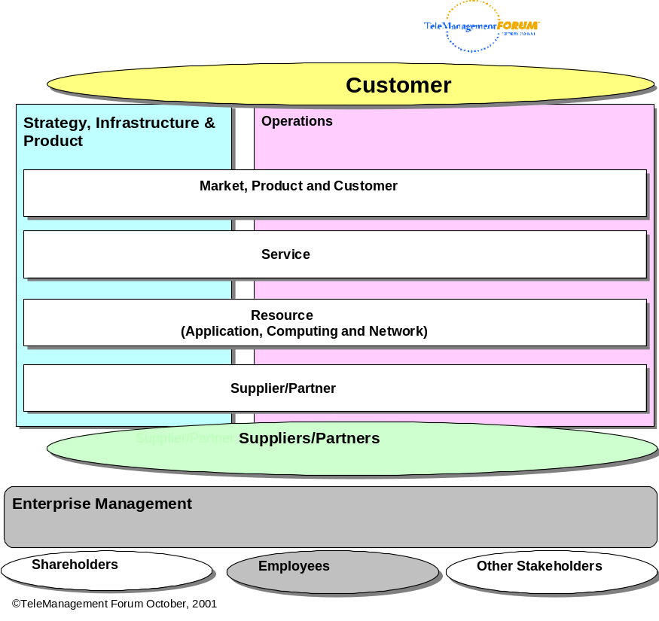
Figure PR.0 - eTOM Level 0 Concepts and Domains
The reader is encouraged to refer to the eTOM for an explanation of the various business processes that are defined to support the concepts in the above domains.
The SID uses the SID Framework, as defined in [GB922], to link the eTOM to the SID. Level 1 of the Resource Domain of the SID Framework is shown in Figure PR.0 below. Please note that this is subject to change over time..
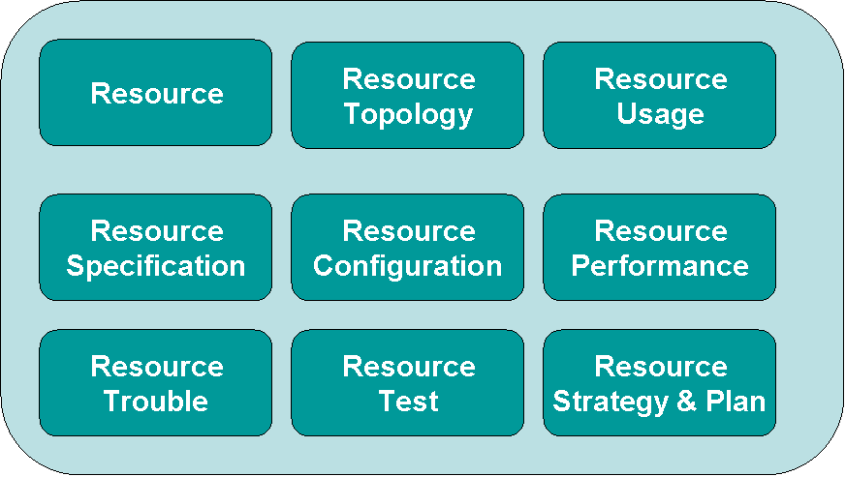
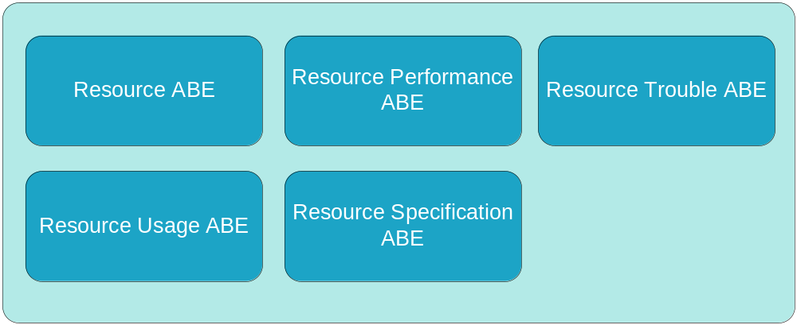
Figure PR.0 - Level One of the Resource Domain of the SID Framework

This Addendum will concentrate on the Resource and Resource Specification ABEs, and set the stage for further work on other ABEs shown in Figure PR.0 in subsequent phases of the SID.
The key concepts looked at were the support of inventory and capacity management functions, as well as support for planning equipment installation and maintenance. Rudimentary ties to related processes defined in the eTOM, as well as relation to other major SID entities (e.g., Product, Party, and others) are also included. This model represents physical resource entities from a business-oriented point-of-view, and uses the best of standard modeling patterns for this area to build in extensibility. For example, patterns are used to capture common relationships and occurrences of physical connections and structures, thereby making the model inherently extensible.
Three important examples of patterns that will be developed in this document are:
- Composite pattern, which provides a common structure for stand-alone and aggregate objects of a given type.
- Entity-EntitySpecification pattern, which separates the invariant characteristics and behavior of an object from its changeable characteristics and behavior.
- Role Object pattern, which uses the notion of roles to extend the use and application of an object.

Overview of “Physical Resource”
This section outlines the approach taken to build the SID physical resource model. The approach used in this document is to build up pieces of the model gradually due to the complexity of the domain and resulting model.
An important goal of the SID effort is to reuse standards (as opposed to reinventing the same concepts) wherever possible. There are several important sources of information for these concepts. The most important of these are [M.3100], [DEN-ng], [DEN], and [CIM]. Since this model is a federated model that draws from different standards, we need a starting point for resolving the naming conflicts that inevitably arise. We have elected to start with [M.3100]. This has a number of ramifications, the most important of which is that we will use names directly from [M.3100], or names that are compatible with the names found in [M.3100], wherever possible. The final section of this document contains a detailed data dictionary that defines where classes, attributes, relationships (e.g., associations, aggregations and compositions) presented in this model were derived. Note that this section has a special “synonyms / aliases” section to provide easy correlation to these external documents.
Consistent terminology in a federated model is critical. This terminology, as the model itself, will be introduced in stages. This enables more complex ideas to build on simpler concepts, thereby enabling both an easier as well as a more thorough understanding of the Physical Resource domain.
Regarding terminology, it is important to be able to relate this view (i.e., the “business” view) of the Physical Resource model to other views (e.g., the “system” and the “implementation” views) of these same concepts. By doing this, we achieve the important goal of being able to connect the business requirements to the system representation to how the system is implemented. Thus, we will establish at the outset two important mappings. First, we will map business concepts to system concepts, and organize the system view in a way that facilitates various implementations. (Note that the reverse mapping is also possible – the one chosen is based on the viewpoint of the modeler.)
Second, we will establish a mapping of terminology. For example, business people might think of a “Device” and types of Devices, such as Routers and Switches. The eTOM [eTOM] refers to the term “resource” in its most general sense as something that can represent physical equipment as well as other types of entities.
(Note: we define “Device” as a synonym for Equipment and PhysicalResource. “Device” implicitly means the hardware characteristics of a “Network Device”, such as a router or firewall. Furthermore, a guiding assumption of all SID Addenda is that we will only model objects that we want or need to manage. While a bolt is a useful and needed object, you won’t find an object corresponding to a bolt in this Addendum)
We will over the course of this document define different types of Equipment. As we will see, we need to differentiate between entities that are Equipment and entities that hold, or contain, Equipment. Therefore, we will also develop a suitable class hierarchy to enable these and other concepts to be extended.

Use Cases
The primary use case that drove the design of this model is physical inventory. In this use case, it is important to be able to represent how a particular physical device (equipment) is constructed. For example, for a specific router, we are interested in the number and type of line cards installed in that router, which slots they occupy; whether it has a backup power supply, and other important features that, taken together, describe completely the physical characteristics of this device. We are also interested in being able to describe any spares that exist for the different components of the device being modeled.
There are many different uses of physical inventory as described above. For example, one important use is to be able to understand how different components in a system are physically connected together. Another example is to relate the physical infrastructure and topology to the logical topology of the system.
Another closely related use case is the ability to describe the composition and structure of a physical device as a Bill of Materials. This use case demands a complete listing of all physical components that make up the device, as well as descriptions of where they are located, so that the equipment may be constructed correctly.
There are many other use cases that require a detailed or partial knowledge of physical inventory. These will be explored in future versions of this and other Addenda to GB922.

A Starting Point – Supporting Basic Inventory Concepts
Let’s start by categorizing the key entities that need to be modeled:
- Equipment, such as Routers and Switches (for now, this document is focused on chassis-based devices)
- Equipment components, such as line cards
- Equipment “containers”, such as racks and chassis
- Location of the Equipment (e.g., a Router is in this rack in this wiring closet…)
- Location of a physical item within an Equipment (e.g., ability to distinguish between different physical ports on different cards of a Router)
- Important auxiliary Equipment (e.g., cables, connectors, and power supplies) that are necessary for the correct operation of the Equipment

The idea of Equipment containers that can contain Equipment is modeled using three concepts. Fundamental to this is the need to have separate classes to model Equipment and containers of Equipment. We accomplish this by defining two separate classes, called Equipment and EquipmentHolder. While this models the different type of object categories that we need, what we haven’t yet done is model how Equipment is contained in an EquipmentHolder. This is done using the EquipmentInHolder aggregation.
It is important to know and keep separate the different states that Equipment can exist in. For example, consider the LineCard mentioned above. The function of the LineCard is (for example) to provide routing and forwarding of packets. This means that a LineCard can not exist in the ether – it must interact with other elements (e.g., the other components of a Router, of which the LineCard is but one component) and therefore must be contained by a type of EquipmentHolder. However, LineCards can exist outside of being installed in an EquipmentHolder – as spares or as part of a kit that is yet to be built in inventory storage, for example. This model is concerned solely with modeling the physical composition of Network Devices. Thus, it will view Equipment and EquipmentHolders in this light, and concentrate on developing a model of physical equipment that satisfies the use cases mentioned earlier. While identifying a spare LineCard is of course very important, that identification is not done as a formal part of this model. However, it can be easily constructed as an extension of this model (or as part of a new model) using this model and the Location model (and possibly others as needed). Note that the Location model (Addendum 1L) can be used to provide a physical description of where an object is.
Back to the EquipmentInHolder relationship, the multiplicity of this relationship is 0 or 1 on the aggregate side, and 0 or more on the component side. The “0” on the aggregate side means that this aggregation is an optional relationship and does not need to be instantiated. This makes sense, because it is certainly possible to have a rack (a type of EquipmentHolder, as we will see) and a Router (a type of Equipment) that are both sitting in an inventory shelf prior to installation. In this case, the router is not yet installed into the Rack, and therefore this aggregation does not yet exist. However, if the EquipmentHolder is being used (the “1” part of its cardinality) then it may contain 0 or more Equipment. The cardinality of 0 or more is important, because it reflects the process of first installing the EquipmentHolder and then populating it with one or more Equipment.
(Note that we could have implemented this as 0..* on both sides of the relationship. The motivation for this, of course, is to be able to use the model to represent time variances (past, present and future states). Remember, however, that this represents a “current state” model. Time variance can be accommodated by providing multiple instances of this state model, one each to represent different time periods. The other problem with 0..* on the EquipmentHolder side of the relationship is that this means that any Equipment can be put in any EquipmentHolder, which is clearly wrong. We can constrain the relationship using EquipmentSpecifications, which will be described later in this document.)
When Equipment, such as our LineCard above, are not installed in an EquipmentHolder, then the EquipmentInHolder relationship is not instantiated, and the Location model takes over, driving the description of where the LineCard is currently located. When the LineCard is installed in an EquipmentHolder, then the position of the LineCard relative to its containing EquipmentHolder is determined by this model. The Location model is still useful, and for example provides the physical location of the Equipment that the LineCard is a part of. However, it does not provide the physical location of the LineCard within its containing EquipmentHolder.
We notice that the multiplicity of EquipmentHolder, Equipment, and EquipmentComponent on the HolderLocatedAt, EquipmentLocatedAt, and ComponentLocatedAt associations, respectively, is 0..n. This reflects the fact that each of these objects can exist at multiple locations. The cardinality at the Location end for each of these three associations is 0..1, meaning that if this (optional) association is instantiated, it specifies a particular Location that an EquipmentHolder, Equipment, or EquipmentComponent is located at. Again, it is important to remember that if the respective cardinalities of these associations was “1” instead of “0..1”, then that would mean that this entity must be instantiated. That is why these cardinalities all have a “0” component (to indicate their optional behavior).
The above is a lot of detail. It was felt that one example was needed to orient the reader. Note that for brevity, this version of this Addendum will not provide the amount of detail on each relationship and object as was just provided above. However, similar thinking processes were used to construct these other relationships and objects.
Examples of EquipmentHolders include Racks and Chassis. Each of these can have other components attached to them (e.g., fans, cable ducts, cards, and so forth). We’ll represent this set of entities by the generic name “EquipmentComponent” for now – the real class hierarchy is more complicated and will be developed later in this Addendum. Given this type of Equipment, we see that it can be attached to EquipmentHolders as well as Equipment. Thus, we need two additional compositions – ComponentInHolder and ComponentInEquipment – to represent these relationships. Since EquipmentComponent is the entity that is being associated with another entity, both of these relationships define the cardinality on the EquipmentComponent side to be *. Similar to the above reasoning, both of these relationships define the cardinality on the EquipmentHolder and Equipment side to be 0..1.
Note that other parts of Error: Reference source not found have also been simplified. For example, in reality, EquipmentHolders can of course contain Equipment as well as other EquipmentHolders – think of the case where a Chassis is contained inside of a Rack. Both a Chassis and a Rack are EquipmentHolders. Details such as these were deliberately left off of Error: Reference source not found in order to keep the diagram at this introductory stage of this Addendum as simple as possible. These details will be added into the final model later in this document.
The final part of this first preliminary model is to realize that every object has a physical location. Some applications do care about the exact physical location of every physical object, while others are content to abstract this into a physical location for the overall Equipment and perhaps physical references to key components of the Equipment (e.g., this physical Port is on this physical Card located in this Slot). Therefore, we’ve identified three generic associations – HolderLocatedAt, EquipmentLocatedAt, and ComponentLocatedAt – that represent this capability. We’ll consolidate this as we develop the class hierarchy throughout the remainder of this section.

Equipment Requirements In More Detail
Equipment is at the core of the overall SID model. As such, there are two distinct requirements that Equipment must meet. First, it must be easy to differentiate who owns and administers the Equipment. Otherwise, the Equipment will not be properly accounted for, let alone managed. Second, it is important that customers as well as Service Providers be able to express their needs clearly in order to determine which Equipment can support their requirements.
In the SID, the Party Model (defined in Addendum 1P) is used to describe people as well as organizations. Ownership is represented by a Party playing a particular role. Thus, we will use an association to relate an instance of the PartyRole class to an instance of the Equipment class.
However, this brings us up against a conceptual problem: how do we classify Equipment? Remember that the business person wants to use concepts such as Router, Switch, Firewall in addition to different types of cards, chips, and auxiliary components, such as fans, cables, and power supplies. Clearly, we need to start working on a hierarchy that supports the concept of different types of Equipment.
The objects that we’ve just described lend themselves to classification using three different categories:
- “Devices”, such as Routers, Switches and Firewalls, that perform one or more end-user functions
- “Device Components”, such as LineCards and chips, that fit into the Device and are managed components; these objects are directly needed by the Device to perform its primary end-user function(s)
- “Auxiliary Components”, such as power supplies, fans and cables; that are required for proper operation of the Device but have a function that is different than the primary end-user function(s) of the Device.
In the above, a “Device” is a managed entity that exists in a single physical structure, or “box”. Clearly, a managed entity such as a Router can be a very complicated device, having its functionality supplied by multiple LineCards that it contains. However, it is still important to be able to refer to either the “Device” as a whole or to individual components of the Device (e.g., a PhysicalPort of a particular LineCard in the Device).
Device Components and Auxiliary Components don’t form a complete function on their own – rather, their purpose is to support the function(s) performed by their containing Device. However, the functionality of Device Components is directly related to the primary purpose of the device, whereas the functionality of the Auxiliary Component isn’t. For example, a LineCard is a type of DeviceComponent because it supplies routing and forwarding functions, which are related to why one uses a router and not some other type of device. A power supply is an AuxiliaryComponent because while power is clearly required by a router, power is not one of the salient characteristics that differentiate a router from other types of Devices.
The SIM tends to define Devices, as described above, as logical components. However, from an inventory point-of-view, a Device usually corresponds to a single physical “box” that is located somewhere. (Alternatively, a Device could correspond to multiple physical boxes. This gets interesting, because oftentimes such a Device appears as a single logical entity, even though it consists of multiple physical entities. An example is a “stackable” switch, which consists of multiple physical switches that can be connected so that they appear to be a single Device to the network). The challenge is to be able to assign one or more locations to the physical box(es) that correspond to the Device.
By providing an entity to represent the physical manifestation of the Device, we can not only track changes to its location, but we can also directly relate the physical manifestation of a router with its logical components (we need the System View of the Physical Resource model to do this)..
An example will help to make this clearer. Consider a Router. People think of a Router as a Device in its own right. However, a Router is in actuality a very complex object, having many components and concepts that exist as managed objects.
Some of these objects are shown conceptually in Figure PR.0. The reader will notice that all but Hardware and AuxiliaryComponent (which represents the “Device Components” and “Auxiliary Components” categories, respectively, from the above description) are logical in nature. The focus of this Addendum is, of course, on the physical aspects of a Device. However, we must be cognizant of the other major entities, so that we have the correct set of classes defined to facilitate relating these logical concepts to the appropriate objects in the physical model. The logical concept of a “Router” is really the collection of the different aspects of a Router, some of which are shown below (note that “Device” in the figure below represents physical and logical components).
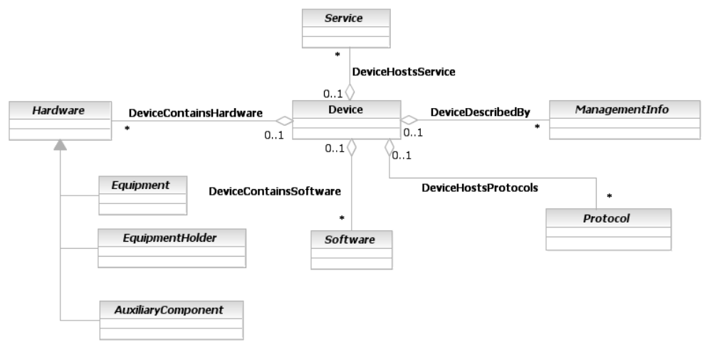
Note: these three inheritance relationships are for illustrative purposes only. The real inheritance will be shown later in this Addendum.
Note: these three inheritance relationships are for illustrative purposes only. The real inheritance will be shown later in this Addendum.
Note: these three inheritance relationships are for illustrative purposes only. The real inheritance will be shown later in this Addendum.
Figure PR.0. Different Aspects of a Device

In the above figure, the “Device” is the “center of the universe”. It is the entity that provides functionality. From the point-of-view of this Addendum, this functionality takes the form of being the physical basis for:
- hosting services (conceptually represented by the DeviceHostsService aggregation – this is developed more in this Addendum and in Addendum 4SO)
- containing (not running!) software (represented by the DeviceContainsSoftware aggregation)
- hosting protocols (represented by the DeviceHostsProtocols aggregation)
- containing hardware, which is the main subject of this Addendum
The first three aggregations represent that services, software, and protocols (which are all logical entities) all require a physical medium to run on. The fourth aggregation enables us to focus on the the physical composition and characteristics of a device.
Devices also are the physical basis for hosting different types of management information, such as alarms, statistics, and so forth. This is represented by the DeviceDescribedBy aggregation. ManagementEntity is the superclass for representing entities that represent management information obtained in a managed environment. Specifically, in the process of managing an entity, information of various forms are created. ManagementEntity is the base class for defining and representing different types of management information.
If we remember that a “Device” is really just a type of Resource that can be managed, we can make it more extensible. This is done by defining two classes – PhysicalResource and LogicalResource – that show the inherent correlation between the physical and logical aspects of a given Resource. Then, we can represent particular physical and logical aspects of a resource as subclasses of either PhysicalResource or LogicalResource. This also enables us to define a more accurate and rigorous class structure for the various types of managed objects that are aggregated by a “Device”. This is illustrated in Figure PR.0 below.
Note that this enables the physical and logical description of managed entities to be decoupled from each other. This enables different subject matter experts to work on the areas that they are interested in. The description of PhysicalResources is the subject of this Addendum. The description of LogicalResources is the subject of Addendum 5LR..
Please see Addendum 4SO for an overview of Service entities, and how they interact with Resource entities.
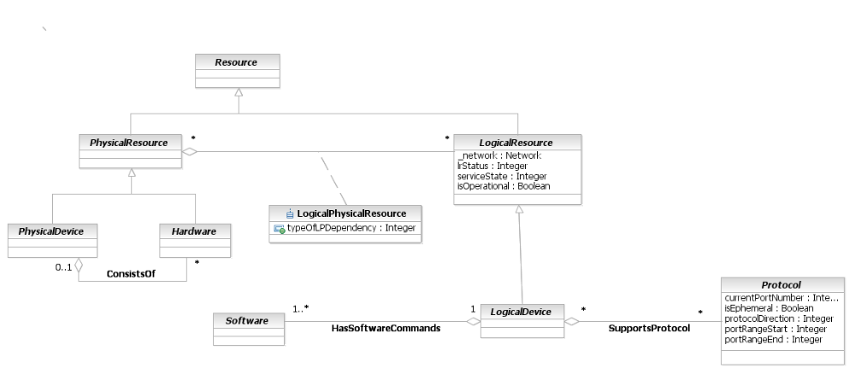
Figure PR.0 - Relating the Physical and Logical Aspects of a Device to Each Other
Note that PhysicalDevice is a subclass of PhysicalResource. PhysicalResource will be used to gather the common management characteristics of “Devices” (which are represented by the PhysicalDevice class) and components of a “Device” (which are represented by subclasses of the Hardware class). Similarly, the logical features seen in Figure PR.0 are grouped under a common base class, called LogicalResource. Note that LogicalResource is explained further in Addendum 5LR (for Logical Resource), which is a separate Addendum. This Addendum also describes managed entities that are associated with a LogicalResource, such as Software and Protocol. Similarly, Service is in a separate Addendum (Addendum 4SO). Management information is not shown in Figure PR.0 above in order to keep the model as simple as possible for right now.
This structure enables us to focus on specific relationships between PhysicalResource and other entities and LogicalResource and other entities. It is imprecise to say that a Device hosts a Service (as we did in Figure PR.0) – there are in reality several relationships that describe this. A PhysicalResource supports LogicalResources, as indicated by the LogicalPhysicalResource aggregation in Figure PR.0 above. But the actual running of the Service is a logical concept, and hence is associated with a LogicalResource. The value of this Addendum is that it describes all physical entities that are used to host or support logical entities, and corresponds to viewing a Resource as consisting of physical and logical aspects that each needs to be managed.
At this point, we need to be cognizant of existing standards. M.3100 has defined the Equipment and EquipmentHolder classes, as previously mentioned. Unfortunately, it defined those classes mostly from a logical point-of-view, and failed to take into account important physical characteristics that we need. Therefore, we’re going to use the concept of “Hardware” to represent Equipment, EquipmentHolders and AuxiliaryComponents.
This will pay dividends in the future, and enable us to assign common physical attributes, such as weight, length, and others, to the Hardware class so that its subclasses can inherit them. Note that such aspects are missing from M.3100.
Other applicable standards include the original DEN specification, the DMTF’s CIM specification (which included some, but not all, of the DEN work) and the new DEN-ng specification, from which this specification is based. There are similarities and differences between the DEN and CIM specifications and this specification. These will be covered in detail in the Business Entity definitions in the last part of this Addendum. At this point, it is appropriate to bring up two important points. First, the original DEN specification defined a class called NetworkPackage that has the same function as the PhysicalDevice class shown above. This class was deleted when the original DEN specification was incorporated into the CIM specification. Thus, CIM has no concept of a PhysicalDevice. Second, both DEN and CIM have similar concepts to the Equipment and EquipmentHolder classes, though their class structures were different. These will serve to enhance the resulting class structure of this Addendum.
DEN-ng is a holistic combination of the original DEN specification and M.3100. Its aim is to integrate the heretofore separate modeling concepts fostered in the ITU world with those of the original DEN specification. It should also be noted that the DEN-ng physical model will be updated to match this specification as it changes. Currently, the DEN-ng physical model is a system view; this Addendum, which is a business view, is a subset of the complete DEN-ng physical model.
Error: Reference source not foundA Device, such as a Router, is in reality represented by a PhysicalDevice, which is made up of different Hardware entities. This enables different users having different use cases to represent the router as either a single physical entity, or as a rich collection of interconnected entities.
PhysicalDevice enables the router to be thought of as a single atomic object. This is necessary for a variety of different use cases. For example, many types of resource planning processes require a single object to represent one or more complex sets of objects. Even though each object in a group of objects can be individually manageable, the group of objects as a whole has meaning. This enables us to refer to the router as, for example, the “Internet Gateway Router”.
The individual line cards that are contained within the Router are represented (as we will see) by subclasses of Equipment. Equipment are particular types of Hardware objects, and are related to a particular PhysicalDevice using the consistsOf aggregation. The following will expand on these concepts.
It is important to be able to manage the individual components of a higher-level object. This is the purpose of the Hardware base class. Hardware consists of Equipment (e.g., a LineCard that performs routing), EquipmentHolders (e.g., a Chassis or some other managed entity whose purpose is to “hold” Equipment), and AuxiliaryComponents (physical components that are required by the “Device” to operate correctly, but whose individual purposes are orthogonal to the main purpose of the device). This is shown in Figure PR.0 below.
The difference between Equipment and AuxiliaryComponents are whether or not the physical object performs a function intrinsic to the main function of the Device. This is best understood by way of example. The main function of a Router is to route and forward packets. A PowerSupply is an AuxiliaryComponent, because while it is needed for the proper operation of the Router, it does not directly help in routing and forwarding packets. A LineCard (that provides routing functionality) is an Equipment component, because its purpose is to route and forward packets. Similar examples exist for different types of equipment, where their criteria may be different. For example, instead of whether it routes or forwards packets, the criterion “does it carry signal” may be useful to appropriately classify components.
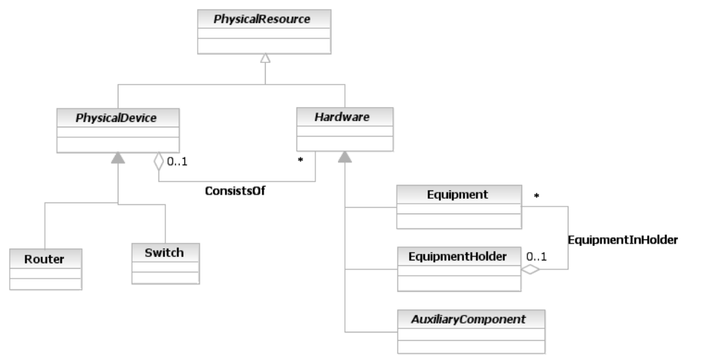
Example classes only
These are for illustrative purposes only. Such classes are modeled using roles but roles haven’t been introduced to the reader yet.
Example classes only
Figure PR.0 - The Makeup of a Device
Figure PR.0 shows that what people conceptually think of a Router or a Switch is in reality a set of managed entities. (Again, it is important to remember that while this Addendum uses network device examples for consistency, the principles and models described in this Addendum apply to other types of physical entities as well.) The physical entity that one can pick up and refer to as a Router or a Switch is represented in Figure PR.0 by an instance of the PhysicalDevice class, which is a specific type of PhysicalResource. The PhysicalDevice may consist of zero or more Hardware components, depending on the needs of the user. That is, it is perfectly reasonable for users of this model to use all or parts of it to suit their needs.
Note that the cardinality of the ConsistsOf aggregation is a “may”, not a “must”, as indicated by the 0..1 cardinality of the composite end and the 0..n on the parts end of the aggregation).
Hardware is an abstract base class for defining managed components that are part of a PhysicalDevice. At this level of abstraction, it consists of three principal classes - EquipmentHolder, Equipment, and AuxiliaryComponent. This enables us to satisfy one of our main requirements, in that we can refer to the Network Device as a whole (using the PhysicalDevice object), or specifically to the components of a Network Device (using entities that are subclasses of Equipment, EquipmentHolder, and AuxiliaryComponent). This latter ability is the basis for constructing Bill of Materials, Spare Inventory, and other applications that require a robust physical component model.
Note that AuxiliaryComponent, Equipment, and EquipmentHolder are all subclasses (i.e., children) of the Hardware entity. This enables these objects to inherit the attributes and relationships of their superclasses (i.e., parents). Thus, instead of having to define three relationships (one each between PhysicalDevice and Equipment, EquipmentHolder and AuxiliaryComponent), all we need to do is to define a single relationship between PhysicalDevice and Hardware. This relationship, ConsistsOf, is inherited by the three subclasses of Hardware, and enables each of these subclasses to be “contained in” (or, more precisely, be a part of) a device.
The above model also lays the groundwork for modeling the physical properties of different types of devices. Think again about a Router. A Router is what we refer to as a particular type of “Device”. A Switch is another type of Device. Thus, we have the notion that a “Device” can be a Router or a Switch. This is fortunate, because we don’t want to have to go through this entire procedure again for each new type of Device!
Almost all such Devices are Chassis-based Devices, meaning that the Router functionality is based around a chassis that holds Hardware. The AuxiliaryComponents (e.g., a PowerSupply) are necessary for the Router to operate properly, while the Hardware components supply functionality that directly contributes to the basic functions of the Router (i.e., routing and forwarding packets).
Note that there are many different types of Cards – LineCards, SystemCards, MemoryCards, and so forth. Not all of these Card types are Equipment from the Router’s point-of-view, because not all of them do routing and forwarding functions. A MemoryCard is a good example of this. We’ll deal with this added bit of complexity later in the model by more fully developing the difference between Equipment, EquipmentHolder, and AuxiliaryComponent.
Neither the LineCard nor the PowerSupply can simply exist in the ether, disconnected from the Router! Clearly, both need to be physically contained in the Chassis, which is associated with the Router. Now the question is, are they contained in the same EquipmentHolder, or are there different EquipmentHolders for different types of Equipment and AuxiliaryComponents?
The answer depends on the manufacturer as well as the type and complexity of the device. Some use a single Chassis as a “frame” into which other components plug into, and others use a set of nested EquipmentHolders. Therefore, we must provide the ability for both options to be modeled.
What’s an example of nested EquipmentHolders? For large Routers and Switches, it is quite common to see a Chassis with a number of Slots into which different types of Cards are plugged in. The Slot functions as a type of EquipmentHolder. Therefore, we can define a single relationship, HoldsHardware, to enable an EquipmentHolder to hold any type of Hardware. This is exactly analogous to our earlier use of the ContainsHardware relationship. This is shown in Figure PR.0 below.
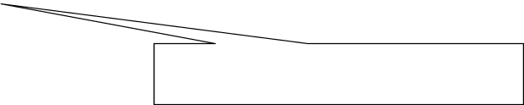
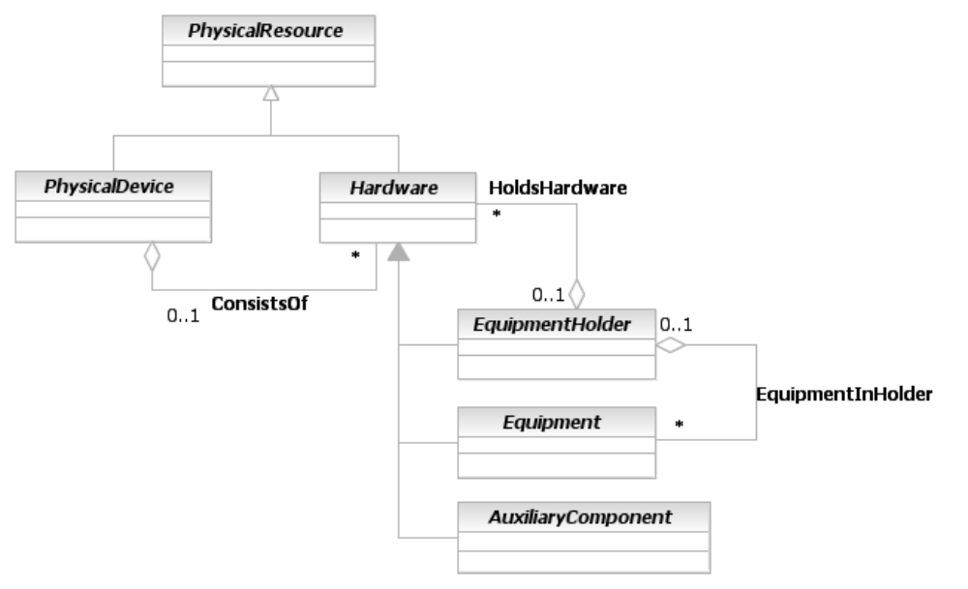
Note: these three inheritance relationships are for illustrative purposes only. The real inheritance will be shown later in this Addendum.

Figure PR.0 - The Concept of “Holding” Hardware
(Before we celebrate too early, we must also realize that certain Cards have connectors on them into which “DaughterCards” can attach. This, however, is too complicated for where we’re at in our model, so we’ll deal with that later in this document.)
Recapping, this is what we know:
- A Router is-a type of Device
- There are two types of EquipmentHolders, Slots and Chassis
- A PowerSupply is-a type of AuxiliaryComponent
- A LineCard is-a type of Card, which is-a type of Hardware (for a more concrete illustration, we are substituting different types of cards that are part of the “real” model that is being developed; a LineCard is a synonym for a NetworkCard, but Figure PR.0 shows other types of Cards as well)
- A NetworkCard fits into a Slot of a Chassis
- A PowerSupply fits directly into the Chassis
- The physical part of the Router consists of all of the above Equipment and EquipmentHolders
Thus, what we conceptually have is the following model of our simple Router (note that not all subclasses are shown; rather, this is a simple example to define the concepts that we have developed to date):
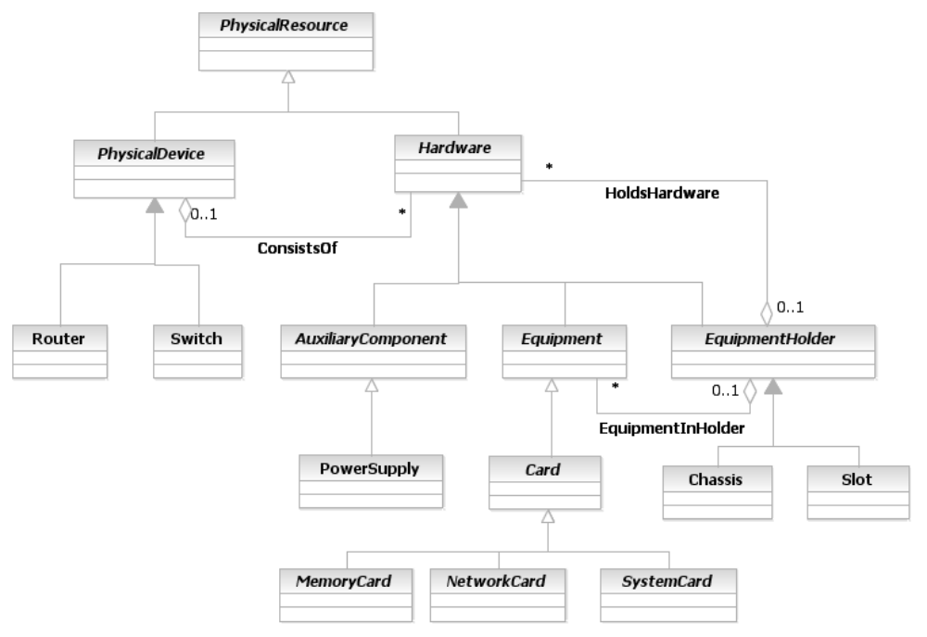
Note: these three inheritance relationships are for illustrative purposes only. The real inheritance will be shown later in this Addendum.

These are for illustrative purposes only. Such classes are modeled using roles but roles haven’t been introduced to the reader yet.

Note: these three inheritance relationships are for illustrative purposes only. The real inheritance will be shown later in th
is Addendum.

Figure PR.0. - Our Simple Example Router
The power of inheritance works well for us. Since PowerSupply and NetworkCard both ultimately inherit from Hardware, they also inherit the attributes and relationships that Hardware participates in. Thus, both a PowerSupply as well as a LineCard can be contained in an EquipmentHolder (not necessarily the same one) via the HoldsHardware aggregation. Similarly, both can be used to build a Router via the ConsistsOf aggregation.
As for the two EquipmentHolders, we’ve chosen to make them siblings. That is, they are two separate objects that are derived from a common superclass (EquipmentHolder). This is an example of the object-oriented concept of specialization. Specialization is used to take a single concept and add detail to it. The added detail is in the form of subclasses that inherit all of the attributes and relationships (and, in the System view, methods and constraints as well) of their parent superclasses, but add their own characteristics and behavior (in the form of attributes and relationships, as well as methods and constraints in the System view).
In this case, there is a fundamental difference between a Slot and a Chassis. However, since both of these classes are subclasses (i.e., types) of EquipmentHolder, we can simply reuse the HoldsHardware composition to enable a Chassis to contain Slots. Finally, the HoldsHardware aggregation can also be used to nest EquipmentHolders, as previously discussed.
We’ve also added some additional detail, showing that there are (for now) three different types of Cards – MemoryCards, NetworkCards, and SystemCards. A MemoryCard is a type of Card that is dedicated to providing additional memory for use by other components of a Resource. Such Cards can be used to expand memory, or provide different types of memory.
A NetworkCard is a type of Card that is dedicated to providing networking functions, such as routing and forwarding. Line cards and port adapter cards are examples of this type of card.
Finally, a SystemCard is a type of Card that is dedicated to providing system functions. Main processor boards and controller boards are examples of this type of Card.
Given this introduction, we will now introduce the concept of Roles. Roles are a fundamental means of providing an extensible model. An innovative feature of DEN-ng is that it has physical as well as logical roles.

Device Roles
Before we dive deeper, let’s clear up one thing that we previously hinted at. Figure PR.0 defined a Switch and a Router as types of Devices. We all know the basic difference between a Switch and a Router – the former forwards traffic, while the latter routes and forwards traffic. But what about the so-called “Layer 3” switches, which are Switches that have Routing capability?
Assume that our model actually did implement a router and a switch subclass of PhysicalDevice. One would then be tempted to invent a new subclass, called Layer3Switch, which subclasses a Switch and adds routing capabilities, to handle this new type of device. However, this is a poor solution, because now every time routing changes, we have to update the Router and the Layer3Switch class. Besides, this implies that a Layer3Switch can do everything that a full-blown Router can do, which is almost never the case. There are other problems too, but this is enough for now.
One may then be tempted to use multiple inheritance to solve this problem. However, this creates a new problem – one of extensibility. What if there is a “Layer4Switch” (unfortunately, some vendors do define such an animal!)? What if we want to differentiate between the type of routing done in a Router vs. those done in the Layer3Switch vs. those done in the Layer4Switch? What if there is a Router that has firewalling capabilities? The list is endless. Multiple inheritance cannot be used to solve all of these problems, and besides, many implementations don’t support multiple inheritance. We don’t want to compromise our ability to build a system view out of this business view!
Instead, a much more elegant and extensible solution is available – we can use the notion of roles. In fact, one of the strengths of a good model is to be able to reuse the same set of patterns over and over. Roles form a core part of the Party model, which (among other things) describes People, Organizations, and the functions (i.e., roles) that they play. This is documented in Addendum 1P (the Common Business Entity Addendum that defines Party and PartyRole).
Our approach is now simplified. Instead of trying to either define many subclasses or introduce multiple inheritance, we can instead define a set of roles that the device is meant to play. (It should be noted that this is another reason why the concept of a managed device is a good one – now, we can define a base concept of a managed device, and model its functionality by associating one or more roles to it as appropriate). This solves the mess of having the same generic function (such as routing) assigned to two different types of devices that implement that same generic function in different ways, producing different subsets of functionality.
Since the networking industry has shown to be ever-evolving, inheritance is not appropriate for capturing this behavior, as the behavior itself changes over time. In addition, by capturing the key functional concepts as roles, we can model present and future Devices as entities that can play many roles at one time.
Thus, by modeling DeviceRole as a separate concept from Device, we can represent these complex behaviors in an extensible manner.
Figure PR.0 shows a simple model introducing the concept of a DeviceRole:
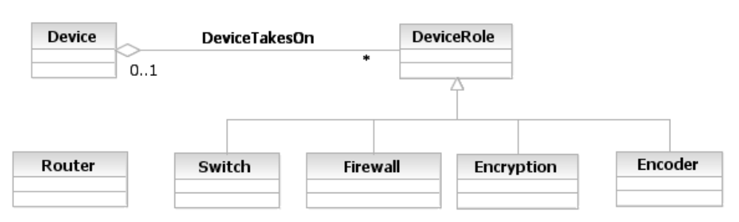
Figure PR.0 - The Concept of a DeviceRole
It should be noted that Figure PR.0 does not define all of the different types of roles that a Device can take on. This concept is clearly not a physical one, but rather a logical one, and will show up in other Addenda. It is brought up in this Addendum because this is a critical concept for modeling different types of devices, and the Physical Resource model must be able to interface with this concept. It also inspires us to see if there isn’t a similar concept that can be used to abstract similar differences in the physical world. In fact, there is a similarity, and is defined in the section titled EquipmentHolder in More Detail later in this Addendum.

PhysicalResource Business Entities in More Detail
The purpose of this section is to take the basic model presented in Figure PR.0 and expand it to add more detail.

Filling in the Details
We’re now at the stage where we can add some detail. Given that we are building a Business Model, we will simply strive to identify certain essential attributes and relationships for PhysicalDevice as well as Hardware. We will not define methods, low-level attributes, association classes, and in general all of the detail that fully describe these entities. This detail will be provided in an accompanying System model. This model has already been built and is currently being refined. It will be formalized as part of a future phase of the SID work.
The following rules were used to define the set of attributes and relationships for this model:
- Keep to high-level, business-oriented concepts (e.g., while some applications might need to know specific details about a physical object, the purpose of this model is to simply identify the key concepts necessary for the purposes specified in our use cases)
- Note that these entities represent business concepts in a Service Provider that conforms to the eTOM process model [eTOM] (specifically, the Resource Development and Operations processes).
- This is intended as a “minimalist” model. Subtypes and attributes should be added as required to suit the needs of a particular application. The attributes shown should be considered as suggested, not required, unless they are specified as mandatory.
- Parent attributes are not repeated in their subclasses
- Only significant entities are shown in the “related business entities” cells
- Entities that are outside the scope of this model facet are shown with a white fill color.

PhysicalResource
We already introduced the notion of this entity as a superclass of our two main categories of physical objects: Device and Hardware. Hardware defined three types of objects – Equipment, EquipmentHolder, and AuxiliaryComponent. We abstracted this set of entities into a single entity, called PhysicalResource. This is defined as an abstract base class for describing different types of hardware that constitute a Product. It has two main purposes: (1) to collect common attributes and relationships for all hardware, and (2) to provide a convenient, single point where relationships with other managed objects can be defined.
Now, it’s time to see if we can discover common attributes that these three types of entities have in common. We’ll tie this into the concept of a PhysicalResourceSpecification in a minute.
The most obvious types of attributes that physical objects have in common are the set of attributes that define specific characteristics about a given physical object. These include who manufactured it and when, and what the model number of the object is. To this, inventory encourages us to add part number, SKU number, and serial number. This gives us the following preliminary picture of a PhysicalResource:
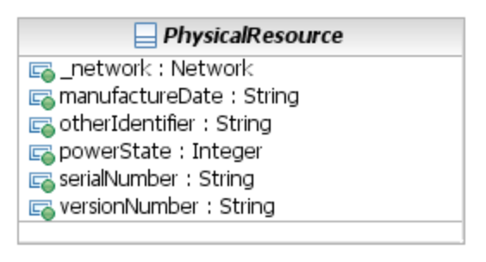
Figure PR. - Attributes of a PhysicalResource
These six attributes are inherited by all subclasses of PhysicalResource.
The key in making the above model extensible and reusable is to use the concept of a Specification. A Specification is a way of defining the invariant characteristics and behavior (attributes and relationships in the Business View, along with methods and constraints in the System View) of a managed entity.
Now, if we look at these attributes, we see that some of them lend themselves to being templatized, while some don’t. That is, we can use the concept of a PhysicalResourceSpecification to supply the ModelNumber, PartNumber, SKUNumber, and VendorName attributes, because these correspond to a generic specification describing a particular type of PhysicalResource. The other two attributes (ManufactureDate and SerialNumber) are specific to a particular instance of a PhysicalResource object, and therefore are not contained in the PhysicalResourceSpecification. Adding in the class inheritance from the DEN-ng system view, we get the following revised picture:
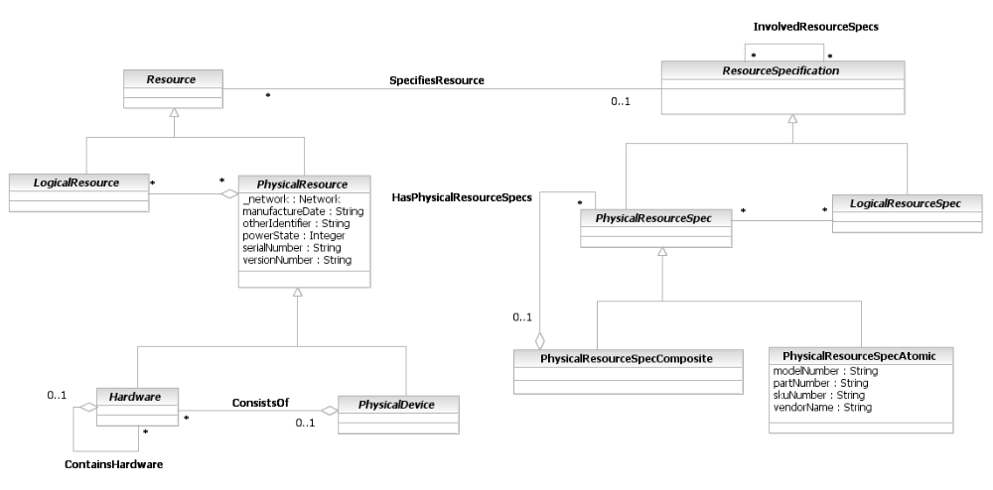
Figure PR. - The Relationship Between PhysicalResource and PhysicalResourceSpecification
We separate PhysicalResourceSpecs from LogicalResourceSpecs because they are fundamentally different in nature. In addition, they have different attributes, methods, constraints, and relationships in the System view.
Both PhysicalResourceSpecs and LogicalResourceSpecs use the composite pattern for extensibility. Only the PhysicalResourceSpec classes are shown in Figure PR. above for simplicity.
A PhysicalResourceSpecAtomic class is a concrete class for describing specific attributes, behavior, relationships, constraints, and semantics for building PhysicalResource objects. The purpose of this class is to be able to track PhysicalResourceSpecifications separately from other types of ResourceSpecifications. Note that this class inherits the SpecifiesResource aggregation, and therefore can be used with the corresponding PhysicalResource class.
The difference between this class and the PhysicalResourceSpecComposite class is that this class represents stand-alone PhysicalResourceSpecifications. The PhysicalResourceSpecComposite class represents a specification that is in reality made up of a set (usually a hierarchy) of PhysicalResourceSpecifications.
The composite pattern is completed by defining the HasPhysicalResourceSpecs aggregation. This aggregation defines the set of PhysicalResourceSpecs that are contained by this particular PhysicalResourceSpecComposite entity.
The SpecifiesResource aggregation defines the particular ResourceSpecification that is used to provide the invariant characteristics (i.e., attributes and relationships, as well as methods and constraints in the System View) of a given Resource. This enables multiple Resources that each use a common set of attributes, methods, constraints, and/or relationships to be related to a single invariant specification of those characteristics and behavior. This facilitates their updating.
The cardinality of the SpecifiesResource aggregation is 1 on the ResourceSpecification side and 0..n on the Resource side. This means that a ResourceSpecification can be written that isn't related to any specific Resources, but if a Resource is built, it must be derived from a ResourceSpecification. Furthermore, this is an aggregation because this is a whole-part relationship: the ResourceSpecification defines the invariant attributes and behavior of zero or more Resources, and each Resource derived from the ResourceSpecification uses all of thee invariant attributes and behavior (and presumably adds its own instance-specific attributes and behavior).
Since this aggregation is defined at the Resource and ResourceSpecification level, each of the subclasses of Resource and ResourceSpecification inherit its use. This is why (for example) there isn’t a relationship connecting a PhysicalResourceSpec to a PhysicalResource.
The LResSpecBindsToPResSpec association represents the binding between a set of LogicalResourceSpecifications and a set of PhysicalResourceSpecifications. The semantics of this binding are represented by the LogicalPhysicalResourceSpec association class.
A convenient way to view the Entity-EntitySpecification pattern is that EntitySpecifications represent templates for building an Entity, while Entities themselves represent instances of managed objects.
The various subclasses of the PhysicalResource class shown in earlier figures still inherit all of the attributes and relationships that were shown in, for example, Figure PR.0, because the SpecifiesResource association is used to add the attributes and relationships of a ResourceSpecification to a Resource. In fact, inheritance means that each subclass now inherits the ability to have its own PhysicalResourceSpecification (or subclass of PhysicalResourceSpecification). This enables any specific needs of one of the various subclasses of PhysicalResource to be met by subclassing the PhysicalResourceSpecification corresponding to that object.
We’ll look at the definitions of each of these major entities in the following sections.

PhysicalDevice in More Detail
PhysicalDevice represents the completed physical assembly, including all components, of the network device. There are two important aspects to a PhysicalDevice – its physical components and the role(s) that these components play in the network.
A PhysicalDevice may itself be a set of devices. This can become quite complex and will be treated in the next version of this Addendum – the interested reader is referred to the system view of the DEN-ng Physical Resource model. Therefore, we will use the composite pattern to model PhysicalDevices within PhysicalDevices. As an aid to applications, a special attribute (deviceGroupID) is used to signify this.
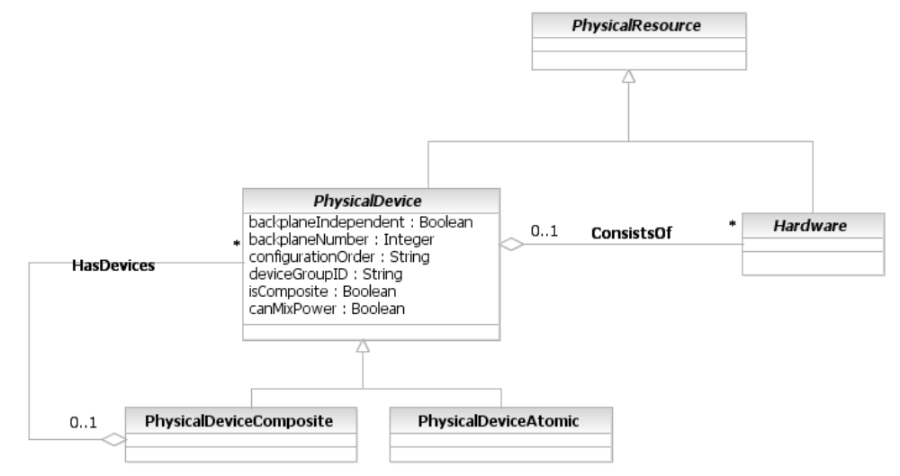
Figure PR. - Specifying the PhysicalDevice and Hardware Classes in More Detail

Hardware in More Detail
The various physical components that make up a PhysicalDevice have so far been grouped into a single class called Hardware. In looking for common attributes for these three very different types of entities, we find that dimensions and weight are all common attributes of these three entities. Therefore, we can add these attributes to the Hardware class (not to PhysicalDevice, since we can derive these attributes for a PhysicalDevice from the Hardware entities that make up a PhysicalDevice). Figure PR. shows these changes to the Hardware class.
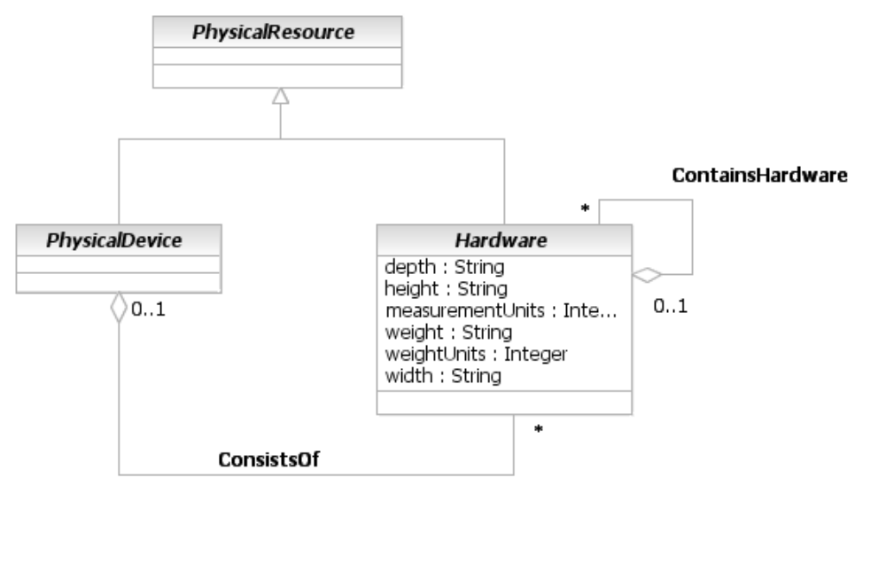
Figure PR. - Hardware in More Detail
The ContainsHardware aggregation defines the ability for a given Hardware object to contain other Hardware objects. This enables the different managed hardware components that make up a device to be explicitly defined.

PhysicalConnector
A PhysicalConnector is a concrete class that represents any type of hardware unit that is used to connect to other hardware units and transmit signals and/or power between them. The attributes of this entity are described in more detail in the Data Dictionary Section of this Addendum.
PhysicalConnector is a subclass of Hardware, as is shown in Figure PR. below.
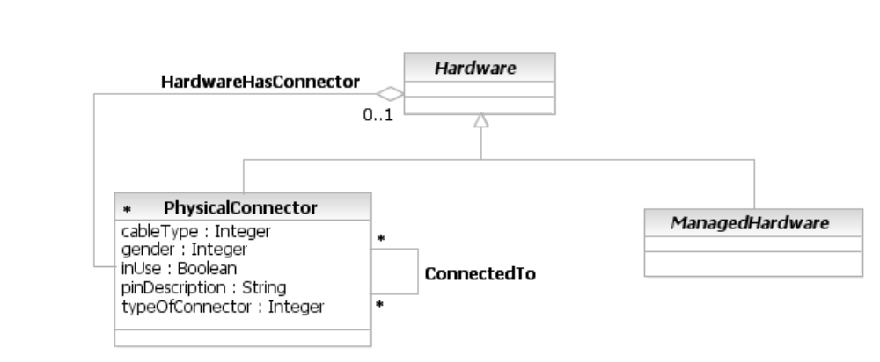
Figure PR. - Physical Connector
The cableType and gender attributes define the type of connector and the type of cable that is attached to this connector (if any). The pinDescription attribute is a free-form string describing the pin configuration and signal usage of a PhysicalConnector.
The ConnectedTo association indicates that two or more PhysicalConnectors are connected together.
Note that a PhysicalConnector is a sibling to the ManagedHardware class, which is discussed in the next section. Thus, a PhysicalConnector is a type of Hardware, but is not a type of ManagedHardware.

ManagedHardware
ManagedHardware is a subclass of Hardware, and is an abstract base class that adds additional semantics to the Hardware base class. These semantics are used to provide management information on the hardware. For example, attributes defined by this class can provide the administrative and operational state of the entity, and tell whether it has any alarms. Such attributes are physical in nature, and indicate physical things (e.g., a fiber cut). For most physical administrative and operational states, there is one or more corresponding logical administrative and operational states. ManagedHardware is shown in Figure PR. below.
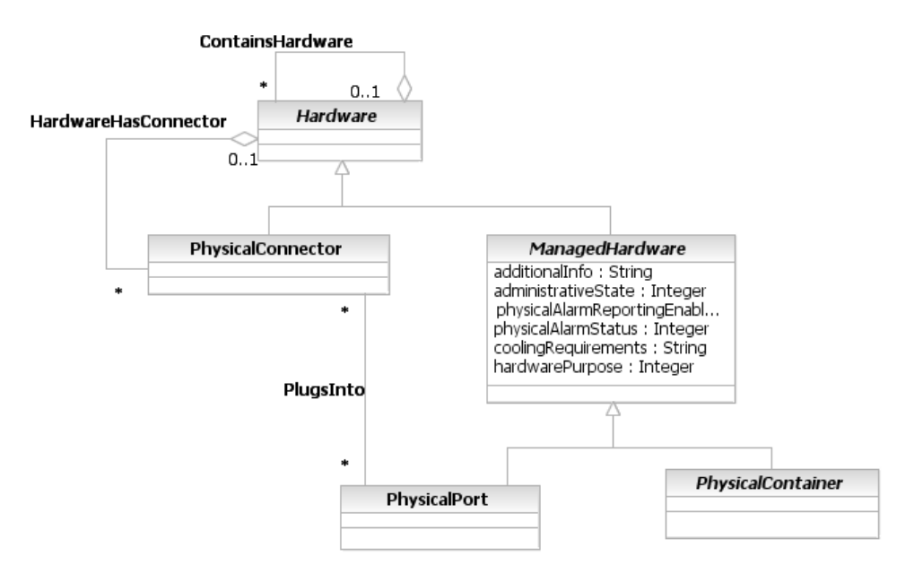
Figure PR. - ManagedHardware in More Detail
The main difference between ManagedHardware and Hardware is that ManagedHardware entities have more than just a physical presence – they also have physical semantics that describe how the entity is managed. This is why PhysicalConnector is not a type of ManagedHardware – a PhysicalConnector is managed by physically inserting and removing it.
So, what is meant by physically managing a hardware entity? This is best explained by briefly examining the three attributes of the ManagedHardware class.
The administrativeState attribute is an enumerated integer that describes the current physical state of the ManagedHardware. Examples of this include starting up, shutting down, and in test.
The physicalAlarmReportingEnabled attribute is a Boolean, and defines whether physical alarm reporting for this object instance is enabled or not. Note that some physical entities are not capable of reporting physical alarms, while some are. In most cases, there are corresponding logical alarms. The ManagementEntity class hierarchy (which is described in Addendum 5LR) defines logical alarms, and correlates them to physical alarms.
The physicalAlarmStatus attribute is an enumerated integer that indicates the occurrence of an abnormal physical condition relating to an object. This attribute may also function as a summary indicator of alarm conditions associated with a specific resource. This attribute expands on the standard ITU semantics and updates them to include eTOM concepts.
The ManagedHardware class has two important subclasses, called PhysicalPort and PhysicalContainer. These are described in the next two sections, respectively.

PhysicalPort
PhysicalPorts are an important type of object to keep track of. This is where communication begins and/or ends on a PhysicalDevice. PhysicalPorts also play a prominent role in topology and FCAPS applications, and enable Service Providers to determine what Customers are running what Services where in the network. Unfortunately, the M.3100 Equipment class is oriented towards PhysicalDevices, and doesn’t have the concept of a PhysicalPort. The DMTF CIM also doesn’t have this concept. However, the DEN-ng model does.
A PhysicalPort represents an actual or potential end point of a topological (physical) link, and corresponds directly to a physical port on a topology map. PhysicalPorts are always contained by another physical object - they can't exist by themselves. The two most common examples are PhysicalPorts on a Card and on a Chassis. These are represented using separate aggregations, and will be described in the sections that explain Card and Chassis. Figure PR. illustrates the concept of a PhysicalPort.
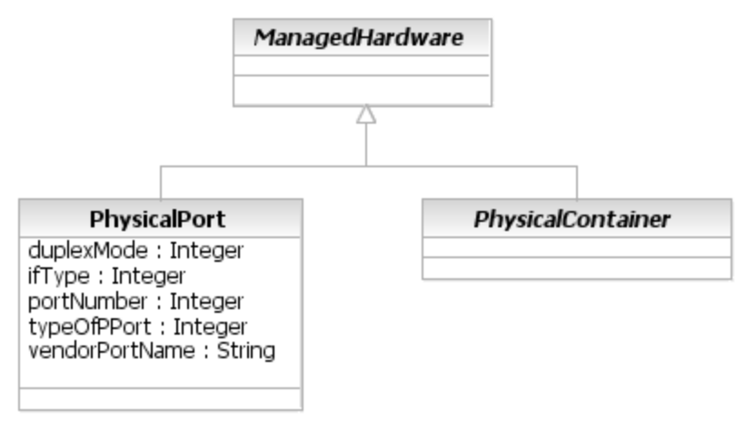
Figure PR. - PhysicalPort in More Detail
PhysicalContainer, as we will see in the next section, is the superclass for Equipment, EquipmentHolders, PhysicalComponents, and AuxiliaryComponents. Note that a PhysicalPort is not a type of PhysicalContainer. This is because a PhysicalPort contains logical components. This is described in more detail in Addendum 5LR.
The ifType attribute is an enumerated integer, and specifies the particular media type of the link. This is closely related to the typeOfPort attribute, which is an enumerated integer that defines the particular type of PhysicalPort this instance is (e.g., Ethernet vs. ATM). The portNumber attribute is the number of this physical port as defined by the application, and the vendorPortName is a critical attribute that contains the name of the port according to the vendor. This enables an enterprise-wide naming scheme to be correlated with vendor-specific names, which are necessary for configuring the port.
For example, an enterprise may need to assign either special strings, or a monotonically increasing number to distinguish all of their PhysicalPorts. Or, an enterprise may want to reuse PhysicalPort numbers, so that “port 1” on any device has special significance. Both of these schemes are very common, and must be accommodated in the model.
However, if an enterprise chooses to use their own naming scheme, then this makes it difficult, if not impossible, to program the device. This is because a (logical) DeviceInterface is contained within a PhysicalPort, as described in Addendum 5LR. Programming a device also means programming its device interfaces.
To achieve these diametrically opposite goals, the DEN-ng model provides a private (portNumber) and a vendor-specific (vendorPortName) name for a PhysicalPort. This enables configuration management software to correlate between the two different names of the same PhysicalPort.

PhysicalContainer
A PhysicalContainer is an abstract class that is used to add additional semantics to the ManagedHardware class. Its attributes define whether a ManagedHardware object can be removed and/or replaced, and whether this action requires power to be removed or not when the action is performed. It is shown in Figure PR. below.
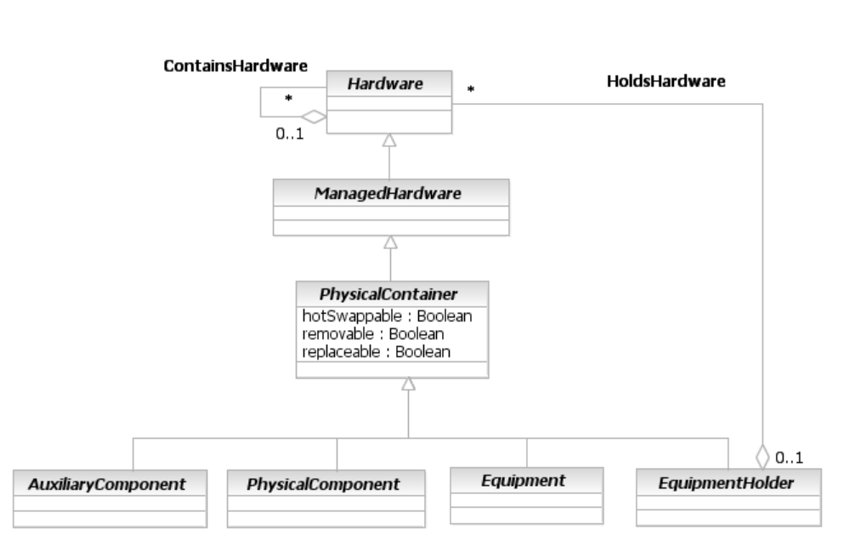
Figure PR. - PhysicalContainer in More Detail
The removable attribute is a Boolean that defines whether it is possible to insert and remove this object instance from the Equipment in which it is installed, without impairing the function or packaging of the Equipment. TRUE means that it is HotSwappable, and FALSE means that it is not.
The replaceable attribute is a Boolean that defines whether it is possible to replace this object instance with a physically different instance of the same type. For example, some types of device allow various Chips to be upgraded. TRUE means that it is HotSwappable, and FALSE means that it is not.
The hotSwappable attribute is a Boolean that defines whether it is possible to replace this object instance with a physically different, but equivalent, object instance while the containing Equipment has power applied to it. TRUE means that it is HotSwappable, and FALSE means that it is not. All HotSwappable PhysicalComponents are inherently Removable and Replaceable.
Thus, the purpose of the PhysicalContainer object is to add the removable, replaceable, and hotSwappable semantics to ManagedHardware entities. By doing this, it serves as the subclass for our four remaining types of objects: PhysicalComponents (such as chips and ASICs), AuxiliaryComponents (such as PowerSupplies), EquipmentHolders (such as Racks, Chassis and Slots) and Equipment (such as Cards). These will be described in subsequent subsections of this section.

PhysicalRoles in More Detail
We’ve talked about the different roles that a given device can have, and graphically represented this in Figure PR.0. Most of the attributes (and all of the methods) defined for a PhysicalDevice are not appropriate for the business view – it is enough simply to be able to refer to a PhysicalDevice, such as a router, as a complete, atomic unit. Please refer to the Physical Resource System View Addendum for more information on non-business characteristics and behavior of this entity.
Physical roles, however, are appropriate for discussion in this Addendum. There are two types of physical roles that are defined in the DEN-ng model. These are called PhysicalDeviceRole and HardwareRole.
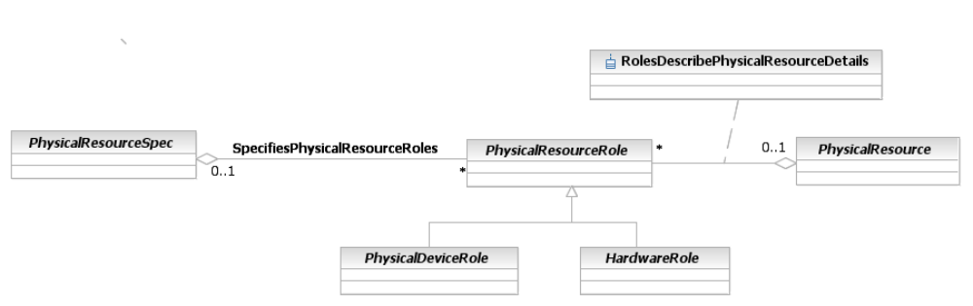
Figure PR. - PhysicalDeviceRole and HardwareRole
There is a profound difference between the SpecifiesPhysicalResourceRoles aggregation and the RolesDescribePhysicalResource aggregation. The former defines the set of PhysicalResourceRoles that a particular PhysicalResource must have (since it is defined by the specification for that PhysicalResource). This enables functionality to be specified for a particular physical component. The latter aggregation defines the set of physical roles that are used to describe an instance of a particular PhysicalResource.
In other words, the difference between the SpecifiesPhysicalResourceRoles aggregation and the RolesDescribePhysicalResource aggregation is that the former defines functionality of a PhysicalResource using PhysicalResourceRoles. In contrast, the RolesDescribePhysicalResource describes functionality using PhysicalResourceRoles.
The purpose of the PhysicalDeviceRole class is to define the different types of physical roles that a PhysicalDevice can take on. This enables us to correlate different logical roles to specific physical devices. For example, there are different logical characteristics that differentiate a CustomerPremise router from a ProviderEdge router, even though they are both “edge” routers. Depending on the type of connection, different PhysicalDevices are often needed to support these logical functions. Figure PR. shows some example subclasses of PhysicalDeviceRole. The PhysicalRouterRole and its subclasses are explained in more detail in the MPLS VPN Addendum.
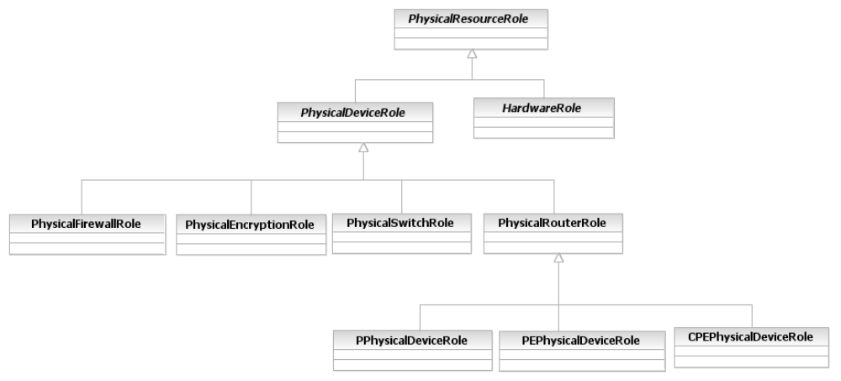
Figure PR. - Examples of PhysicalDeviceRoles

EquipmentHolder in More Detail
EquipmentHolder represents a specific category of physical objects. This means that it has its own hierarchy of objects. Specifically, we’ve already differentiated between Slots and Chassis (which are both subclasses of EquipmentHolder). The M.3100 definition of this class describes it as representing physical objects that are both manageable as well as able to host, hold, or contain other physical objects. Examples of physical objects that can be represented by instances of this object class are Racks, Chassis, Shelfs, Cards, and Slots. (Note that M.3100 does not define all of these different types of EquipmentHolder.)
Some devices are built in such a way as to enable other devices to be mounted inside them. This can be modeled using the composite pattern, which divides an entity into two subclasses. One subclass is used to model stand-alone objects, and the other subclass is used to model objects that can contain more objects of that type. We can apply this pattern to the EquipmentHolder class to obtain the following:
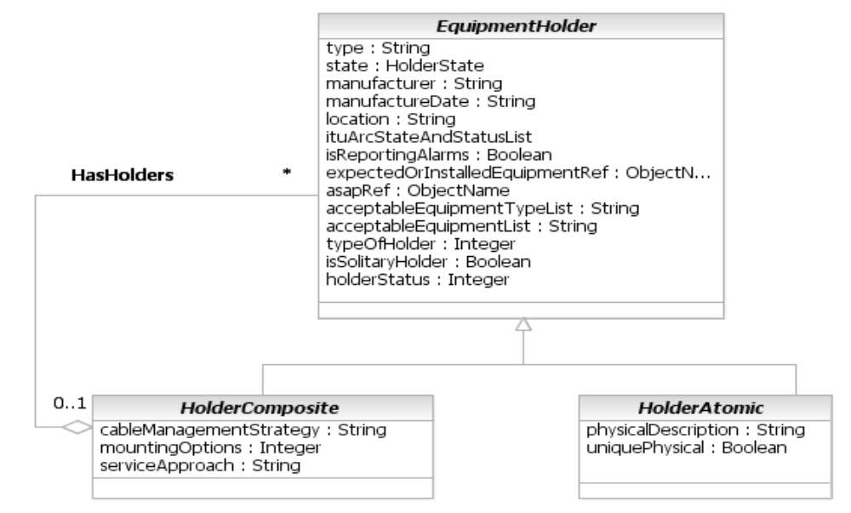
Figure PR. - Specifying Different Types of EquipmentHolders
The acceptableEquipmentList attribute is an array of strings, based on M.3100, which identifies the types of equipment objects that can be supported by this object. This attribute is defined for backwards compatibility with M.3100.
The typeOfHolder attribute is an enumerated integer that identifies the type of the Holder that this object instance is. It is based on M.3100 but includes additional values.
The holderStatus attribute is also based on M.3100 (DEN-ng adds values to those defined in M.3100). It indicates the status of the EquipmentHolder (e.g., is it installed).
The above figure has now formalized what we knew all along – there are really two different types of EquipmentHolders. One type, designated by the AtomicHolder class, is meant to be used in a stand-alone way. This doesn’t mean that a Slot exists by itself; rather, the Slot cannot be used to form another type of EquipmentHolder. Contrast this to either a Rack or a Chassis. Both of these are subclasses of the CompositeHolder class, because both of them can be used to form more complex types of EquipmentHolders. For example, a Chassis can contain either another Chassis or a Slot, and a Rack can contain either a set of Chassis or a “sub-Rack”.

HolderAtomic
The HolderAtomic class represents atomic holders of Equipment that are individually manageable and do NOT form composite, or nested, Equipment Holders. Each HolderAtomic object can be a Field Replaceable Unit.
The physicalDescription attribute is a free-form string that defines the physically unique characteristics of this holder. The uniquePhysical and uniqueLogical attributes are Boolean attributes that signify that this holder is physically or logically different from other holders.
A model of the HolderAtomic class is shown in Figure PR. below.
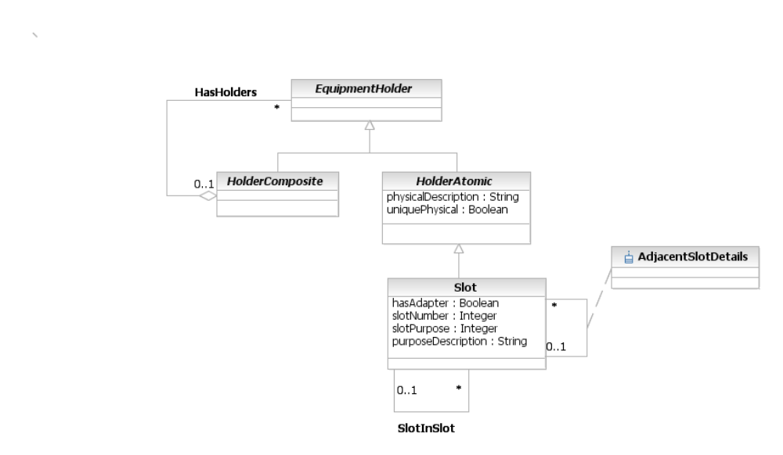
Figure PR. - HolderAtomic in More Detail
A Slot is a concrete class that has two main purposes. One is to model the ability of a hosting board to accept a daughter card to add or complete the base functionality of the hosting board. The second is to represent the different expansion slots supported by a Chassis.
All Slots have a unique number – this is represented by the slotNumber attribute. The slotPurpose is an enumerated integer that defines the purpose of this Slot. This enables Slots to be easily identified according to their functional purpose.
This leaves the hasAdapter attribute. This attribute is a Boolean attribute that, if TRUE, indicates that this slot has an adapter installed that enables it to accept other types of cards (e.g., fitting an adapter on two Slots enable them to accept a Card that otherwise could not be accommodated).
Adapters are very important, as they enable an organization to keep its investment in expensive line Cards. This is represented in more detail using the SlotInSlot association. This association represents the ability of a special adapter to extend the existing Slot structure to enable otherwise incompatible Cards to be plugged into an EquipmentHolder. The adapter effectively creates a new Slot and can be thought of (conceptually) as a Slot in a Slot.
The AdjacentSlots association describes the layout of Slots in an EquipmentHolder. In order to do this effectively, the System view of the DEN-ng model implements this association as a class. This association class includes attributes that are used to provide general layout information describing the Slots in the EquipmentHolder. An important use of this association is to signal when two Slots are so close to each other that. if one of these Slots is populated by an adapter Card, the other Slot must be left empty.

HolderComposite
The HolderComposite class represents EquipmentHolders that are made up of other EquipmentHolders (i.e., instances of this class as well as the HolderAtomic base class). This provides the semantics of collecting a set of components, each of which is individually manageable, and being able to manage the set of objects as a whole. This containment is modeled using the HasHolders aggregation.
Each HolderComposite element can be a FRU.
A characteristic of this class is that its subclasses are physical objects that have complex cabling and mounting options. This class is meant to differentiate complex holders, like a Chassis, from simple holders, like a Slot. Thus, the cableManagementStrategy attribute is a free-form string that contains information on how the various cables contained in the Chassis, Rack, or other type of HolderComposite object are connected and bundled.
The mountingOptions attribute defines how Equipment in this entity is mounted (e.g., rack-mounted, free-standing, or enclosed in another Chassis). Similarly serviceApproach defines how the entity is serviced (e.g., from the top or front), whether it has sliding trays or removable sides, and/or whether the Frame is moveable (e.g., it has rollers).
Figure PR. shows the prominent subclasses of a HolderComposite entity.

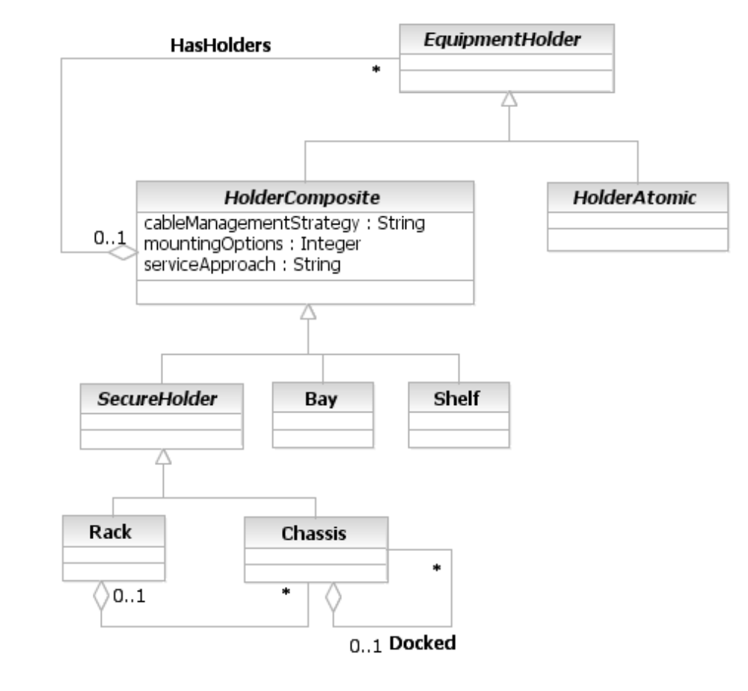
Figure PR. - HolderComposite in More Detail
The SecureHolder is a type of HolderComposite that serves as the parent for the Rack and Chassis classes. This class generalizes common properties that apply to Racks and Chassis. This class defines various types of locks and alarms, and adds the semantics of being able to indicate if a breach of this entity has been made.
A Bay is a type of EquipmentHolder that is usually found in optical devices. It has a logical identifier, usually a component of port AIDs in TL1 based switches. A Bay is usually built as a pre-wired hardware assembly that contains a set of shelves and accompanying ancillary equipment.
A Shelf is a type of EquipmentHolder that is usually found in optical devices. It has a logical identifier that is often relative to the Bay that contains the Shelf (i.e., the unique identifier for a Shelf is often a concatenation of the network element identifier, the Bay identifier, and the Shelf identifier). Often, a Shelf is used to contain not just pluggable components (e.g., Cards, Power Supplies, etc.) but also cabling (e.g., both fiber and wire), with optional connections to external fuse, alarm, and other types of panels.
A Rack is a type of SecureHolder that represents an enclosure in which EquipmentHolders, such as Chassis, are placed. Typically a Rack is nothing more than the enclosure, and all the functioning componentry is packaged in the Chassis. The Rack typically serves as the "master enclosure" for Chassis, Shelves and Bays. In addition, Racks can have multiple instances of multiple Devices mounted in them.
A Chassis is a type of SecureHolder that encloses other ManagedPhysicalEntities and provides a definable functionality in its own right, such as a desktop or a network device (e.g., a router or a switch).

Adapter and Holder Roles
While this is a workable model, it still isn’t capable of modeling some important cases. For example, think of a Card that has a physical connector on it that accepts either another (daughter) Card or even a Chip (e.g., Memory, or a routing or encryption ASIC). The model shown in Figure PR. above mandates the use of a Holder. However, in the above example, there is no explicit EquipmentHolder – we are forced to either make a physical connector a holder, or insert an artificial holder. Both are incorrect.
Recall the HardwareRole from Figure PR. above. The purpose of the PhysicalHardwareRole class is to represent the different types of roles that various types of Hardware components can take on. For this first iteration, two specialized roles have been defined: HolderRole and AdapterRole. Their purpose is to cover situations where an Equipment also acts like an EquipmentHolder. Without these classes, such common situations are very difficult to model. We can use the PhysicalConnector class to connect appropriate Hardware entities together, which transmit signals and/or power between them. Thus, our previous model is modified as follows:
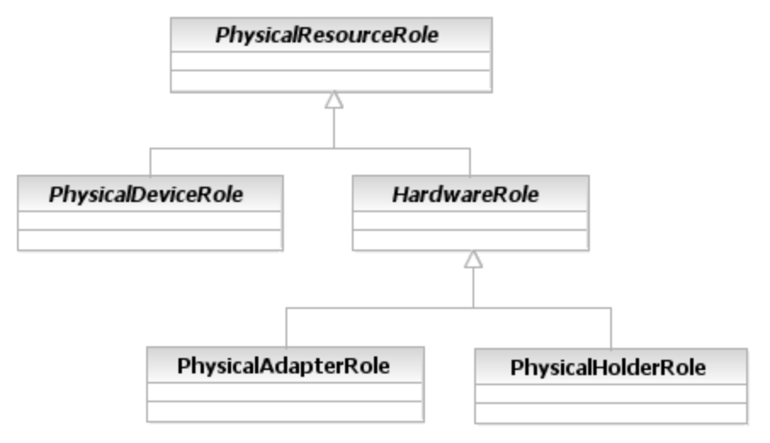
Figure PR. - AdapterRoles and HolderRoles
The HolderRole enables different types of PhysicalResources, such as a Card, to take on the role of holding other Equipment. This addresses the problem that we described above, where a Card took on the additional role of holding another Card. This enables a single managed entity, such as a NetworkCard, to have multiple roles - it can function as a Route Processor as well as a Holder of Equipment.
The Adapter role enables a piece of Hardware to adapt its use. For example, sometimes Cards and Chassis evolve along separate paths, causing future versions of one to no longer be physically compatible with present and/or future versions of the other. The solution to this is to use an intermediate piece of Hardware, called an Adapter, to extend the existing physical structure of an EquipmentHolder to enable otherwise incompatible Equipment to be plugged into an EquipmentHolder. The Adapter conceptually creates a new type of EquipmentHolder that fits into the existing EquipmentHolder. This enables Cards that would otherwise be physically and/or electrically incompatible with the existing EquipmentHolder to be supported, by interfacing to the old EquipmentHolder via the new Adapter.
The additional semantics provided by the Adapter can be captured as a second type of PhysicalResourceRole. This represents the common practice of vendors providing special adapters that enable old Equipment or EquipmentHolders to be used with new EquipmentHolders or Equipment, respectively.

Equipment in More Detail
Equipment represents a specific category of physical objects. This means that it has its own hierarchy of objects. For example, we’ve already identified Cards as a type of Equipment, and differentiated between Equipment and AuxiliaryComponents (which are both subclasses of Hardware).
The M.3100 specification defines Equipment as a class of managed objects that represents physical components of a managed element, including replaceable components. An instance of this object class is present in a single geographic location. Equipment may be nested within another Equipment, thereby creating a containment relationship. Equipment, and other sibling classes, are shown in Figure PR. below.
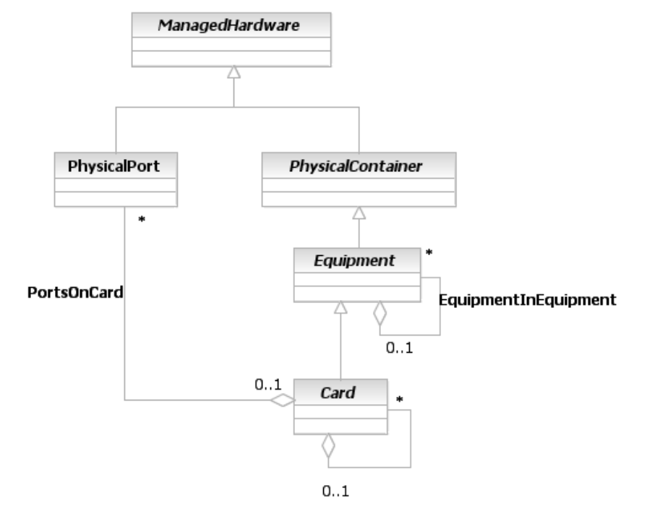
Figure PR. - Equipment in More Detail
PhysicalPorts can be placed on either a Card or a Chassis. Thus, we end up with:
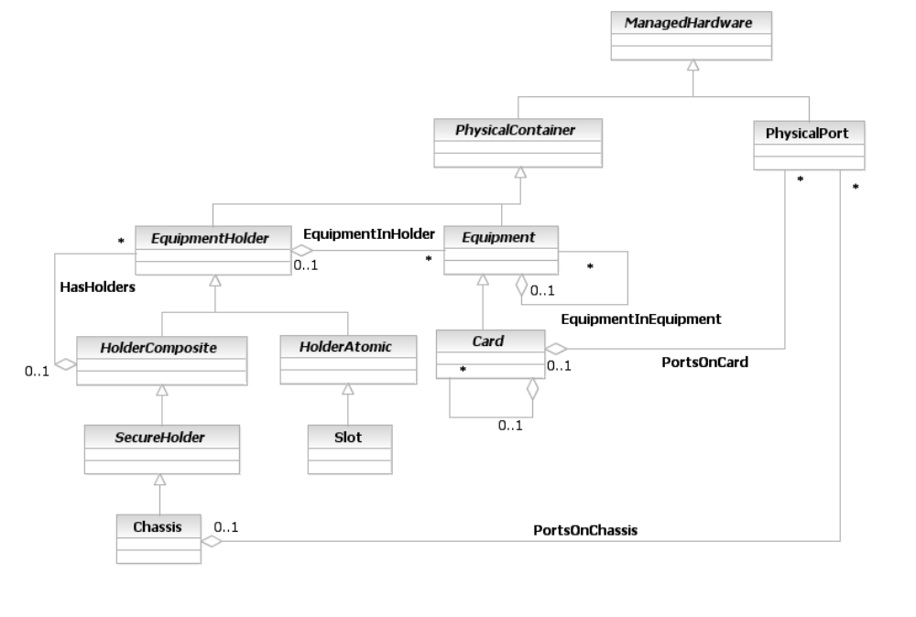
Figure PR. - Relating PhysicalPorts to Cards and Chassis
Note that the EquipmentInHolder relationship enables a LineCard to be attached to a Slot. We made two distinct relationships to model the containment of Ports (PortsOnCard and PortsOnChassis) because the common superclass of LineCard and Chassis is Hardware. If we had run a relationship between Hardware and PhysicalPort, then PhysicalPorts could contain PhysicalPorts, which is not correct. In addition, this differentiation will help us in the System view, since the semantics of a PhysicalPort on a Chassis are different than those of a PhysicalPort on a Card.

Types of Cards
Figure PR. below illustrates the superclasses for defining different types of Cards.
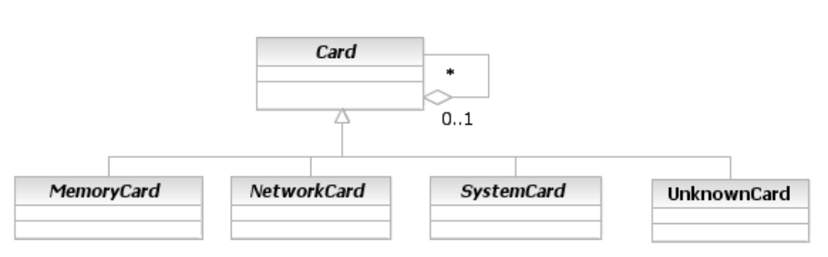
Figure PR. - Types of Cards
MemoryCards are dedicated to providing additional memory for use by other components of a Resource. NetworkCards are dedicated to providing networking functions, such as routing and forwarding. SystemCards are dedicated to providing system functions (e.g., controller cards). Finally, the UnknownCard object is used as a generic placeholder to represent Cards that are known to exist but are not yet identifiable via Software means.

AuxiliaryComponents
Figure PR. showed a third important subclass of PhysicalContainer, called AuxiliaryComponent. As stated previously, an AuxiliaryComponent is an abstract base class that represents managed entities, such as power supplies, fans and cables, wihch are required for the proper operation of the Device but have a primary function that is different than the primary end-user function(s) of the Device. Two exemplary subclasses of AuxiliaryComponent are shown in below.
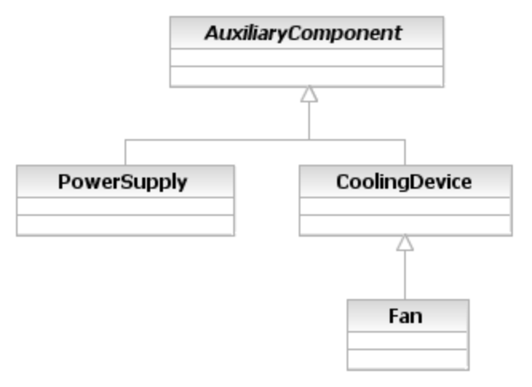
Figure PR. - Exemplary Subclasses of AuxiliaryComponent
The difference between AuxiliaryComponents and other subclasses of Equipment are whether or not the physical object performs a function intrinsic to the main function of the Device. For example, a PowerSupply is an AuxiliaryComponent, because even though it is needed for the proper operation of the Router, it does not directly help in routing and forwarding packets. A LineCard (that provides routing functionality) is a subclass of Equipment because its purpose is to route and forward packets.

PhysicalComponents
A PhysicalComponent was also shown in Figure PR.. A PhysicalComponent is a managed entity that can reside either in an Equipment or an EquipmentHolder object, but cannot be used as a stand-alone object. From a management point-of-view, this object either cannot or does not need to be split into its constituent parts. Any piece of hardware that is not a PhysicalLink, PhysicalConnector, Equipment, or EquipmentHolder, is a subclass of this class. Some important subclasses of PhysicalComponent are shown below in Figure PR..
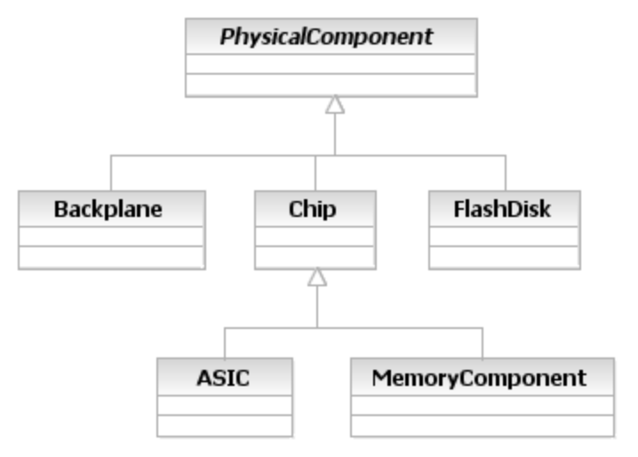
Figure PR. - Example Subclasses of PhysicalComponent
The example subclasses are exemplified by the following description of the Chip class. A Chip is a concrete class that models different types of Chips that are either directly configurable by the end-user (e.g., a programmable device) and/or represent FRUs (e.g., a special ASIC that can be upgraded by replacing it with a new version of that same ASIC).
For complete definitions of each of these objects, please see the data dictionary section of this document.

Basic Business Entities That Interact with PhysicalResources
This section will outline some of the business entities that interact with business entities defined in the PhysicalResource model. This section will of course be added to in every phase of the SID as appropriate.

Party and PartyRole
This has already been referenced briefly above. To recap, Party and PartyRole are needed for a number of important reasons, including:
- Identification of an owner of the Device or Hardware
- Identification of the manufacturer of the Device and possibly the manufacturer of some or all of its components
- Identification of who is responsible to administer the Device or Hardware
- Identification of who installed the device
- Identification of what management domain the Device or Hardware is in
- Identification of who in a particular management domain can administer the Resource
- Identification of who last changed the device
The above are exemplary, and identify some of the links between these classes and the physical resource model. The above is not meant to imply that these are the only links between these models.
It is important to realize that the owner of a Device or Hardware is not the same as the person or group that is responsible for administering the Device or Hardware.
The existing PartyRole definition is driven by a section of the eTOM that defines the concept of a value network role [eTOM]. However, this definition is very high-level. Furthermore, while the eTOM talks about the need to administer different types of managed objects, it doesn’t identify the concepts of owner and administrator. These are needed to support the inventory and other use cases we introduced at the start of this document. Every effort will be made to take this data and feed it back to the eTOM team.
Referring to the SID Party model (Addendum 1P), there is an 0..n to 0..n association (implemented as an association class) with a PartyInvolvement attribute that define what responsibility the PartyRole (e.g., customer, provider, employee, management domain) plays. Example responsibilities are owner, lessee, lessor, and administrator. Note that this involvement does not have to be established via an Interaction; there can be a direct relationship that defines this involvement. It is important that the SID not dictate this, so that applications are free to implement the precise semantics of this relationship according to their own needs. This is shown in Figure PR..
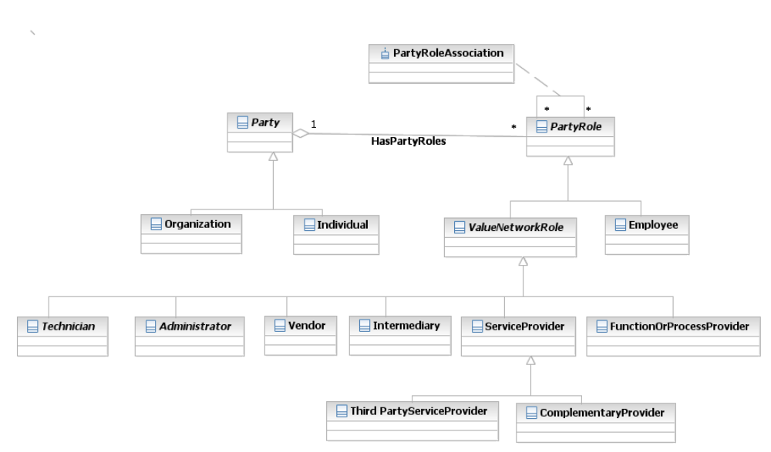
Figure PR. - Overview of Party and PartyRole
Given this background, we can define additional relationships needed to represent administration and ownership of PhysicalResources.
Briefly, the owner of the Resource is the person or group that is responsible (e.g., organizational, financial, and so forth) for the Resource. This is a different concept than the person or group that administers the Resource. From a business perspective, the owner has to either appoint or give permission to the administrator to administer the Resource that is owned. This is shown in Error: Reference source not found below.
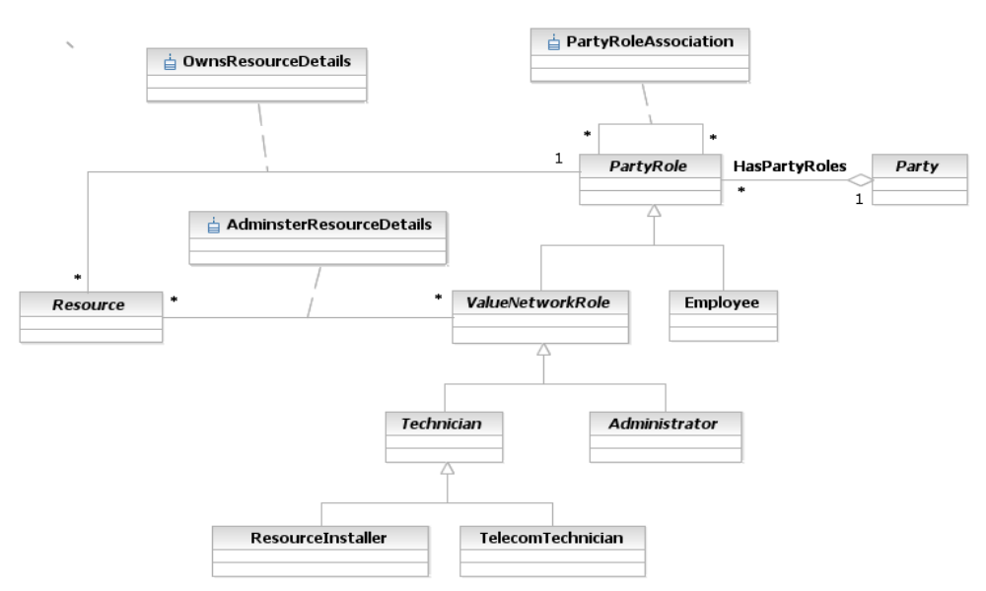
The modeling of an Owner and an Administrator is not as straightforward as it would first appear. First, while one could construct new PartyRole subclasses for representing an Owner and an Adminstrator, this will be very limiting. This is because any PartyRole can own a Resource, but only ValueNetworkRoles can administer a Resource. Thus, if separate subclasses were constructed, they would have to have relationships to PartyRole and ValueNetworkRole, respectively.
A simpler alternative is to define two associations, called OwnsResource and AdministersResource, to serve these roles. Note that the OwnsResource aggregation defines the set of Resources (physical and/or logical) that a particular Party, playing the role of ValueNetworkRole, can administer (through the AdministersResource association). The owner of the Resource is the person or group that is responsible (e.g., organizational, financial, and so forth) for the Resource.
In contrast, the AdministersResource association defines the set of Resources (physical and/or logical) that a particular Party, playing the role of ValueNetworkRole, administers. From a business perspective, the owner has to either appoint or give permission to the administrator to administer the Resource that is owned. This is shown in the system view, by first implementing each of these two associations as classes, and then associating the classes with each other. However, this is beyond the scope of this Addendum.
The third item, ManagementDomain, is fundamental to how network management is done. Addendum 1-POL defines a ManagementDomain as follows: A ManagementDomain class represents a special grouping of ManagedEntities that has two important properties. First, it is used to partition managed objects into a meaningful logical grouping. One important use of such a grouping is to provide a means to define which EMS (as well as which NMS) manages, monitors, etc. which set of devices. It also provides a means to show how management functions are distributed and scaled. Second, it defines a common administrative domain that is used to administer the managed objects that it contains. This implies that all of the managed objects contained in this ManagementDomain are administered similarly - either by the same user, group of users or policy.
ManagementDomains often have a direct correlation with DeviceRoles. For example, in an MPLS VPN, there is a fundamental difference between routers that are operating as customer premise, provider edge, and provider core routers. (For those not familiar with MPLS VPNs, a customer premise device provides customer access to the Service Provider network over a data link to one or more provider edge routers; provider edge routers function as the ingress and egress routers of the Service Provider network; provider core routers provide connectivity between the provider edge routers. An example of a high-level MPLS VPN model is provided in part of Addendum 4). This can be done by associating a type of PartyRole (representing a ManagementDomain) with a type of DeviceRole. Note that in this use case, there are specific hardware as well as software requirements of the different types of routers playing the CustomerPremise, ProviderEdge, and ProviderCore roles. This is where the concepts of PhysicalDeviceRole and LogicalDeviceRole will pay dividends in the overall model.
Thus, ManagementDomains are intelligent containers of managed entities, where different container represent different domains of control that reflect one or more appropriate management structures, such as organizational structure. PhysicalResources within a particular domain are administered by a particular person or group of people. While it is easy enough to define a relationship between ManagementDomain and PartyRole, the management of PhysicalResources in ManagementDomains by Party and PartyRole entities should be represented and controlled using policies. Thus, this topic will be deferred to the Policy Addendum.

Location
Location is used in two different ways and has two very different semantics:
- The place of a Device (or perhaps an Equipment or EquipmentHolder)
- The position of a physical component
These are in reality two different concepts, though people tend to combine their meanings into one.
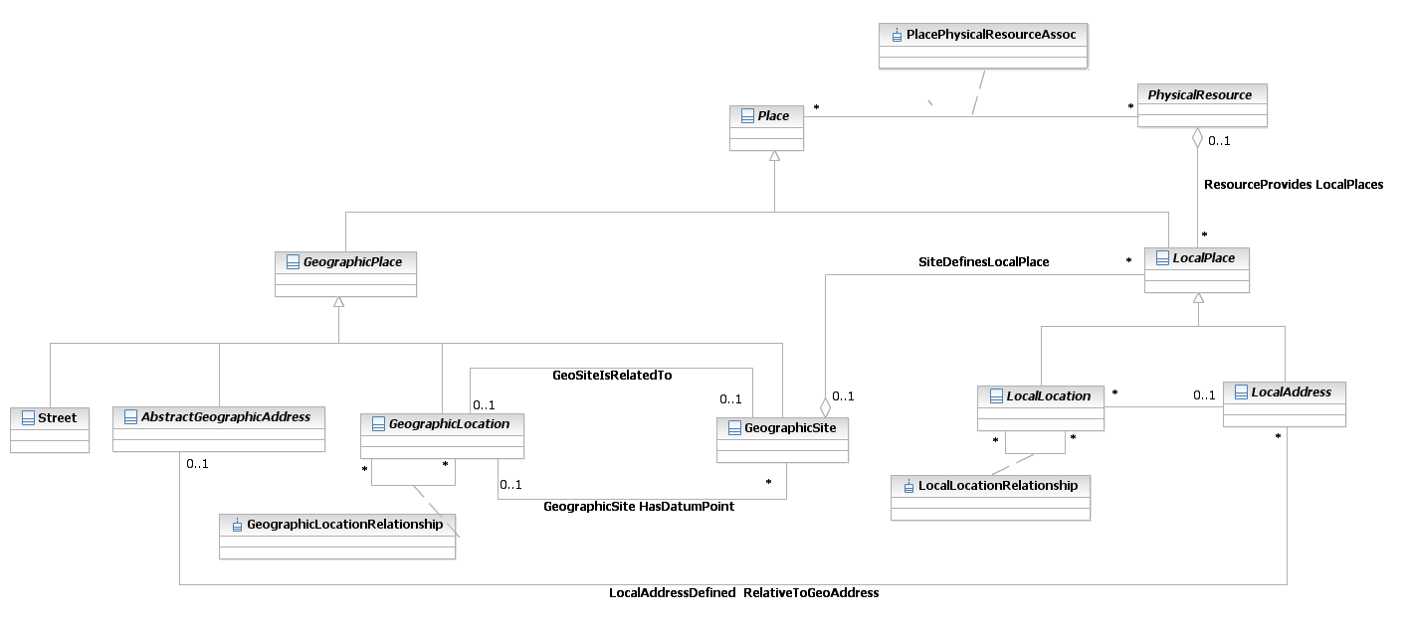
Figure PR.29 - Representing Administering and Owning a Resource
The PlacePhysicalResourceAssociation association defines the location(s) that a particular PhysicalResource can be found at. Note that there can be multiple locations assigned for a particular PhysicalResource. For example, a router can be installed in a POSITION in a Rack, which is in a particular PLACE (e.g., a Room in a Floor), which is in a particular STRUCTURE (e.g., a building) at a particular ADDRESS (e.g., the postal address that the main building is located at). The PhysicalLocationDetails association class is used to help disambiguate these overlapping locations.
Figure PR 29 shows that “Place” is broken into two levels of granularity, represented by the two subclasses of Place.
- LocalPlace.
- GeographicPlace

Capacity and Redundancy
In theory, any physical entities can have one or both of these. However, in practice, Capacity and Redundancy are restricted in this model to apply only to entities that have Roles. This enables us to maximize the ability to carry out performance corrections. When Devices are identified that are negatively impacting management items of interest, such as network performance and Service quality, the close association between Roles and Capacity / Redundancy will allow Capacity and Redundancy associated with these Devices to be easily addressed.
Capacity implies a range of values – from a minimum acceptable level to a maximum permitted level – that a physical object can hold, store or accommodate. For example, a Device may require a minimum of 128MB of RAM to operate correctly, prefer 256MB, and accommodate up to 512MB.
Often, manufacturers make Devices using the same overall Chassis or frame and vary the number and type of cards that can be installed. Different cards have different power, cooling, memory and other requirements. Therefore, it is often economically easier to build one master frame and enable multiple variations of certain components, such as memory, to have a minimum and maximum capacity.
Redundancy connotes additional entities of identical capabilities that can be used in case the primary entity fails or is no longer able to provide its full capabilities. For example, Devices often have multiple power supplies to ensure that if one fails, the Device can use a backup power supply and continue to operate. Again, most manufacturers plan for physically housing one or more redundant components for essential physical hardware as part of the overall physical device.
It is recommended that the concepts of capacity and redundancy be further developed in SID phase IV. They will both require extensions to the SID that are not currently in this release, as well as require a deeper understanding of both the business and system views of physical objects.

Product
The SID Product business entities are defined in Addendum 3. The most important of these (from the point-of-view of the Physical Resource model) are the Product, ProductOffering, and ProductSpecification entities.
A ProductSpecification defines the requirements of physical and logical objects that collectively are accessed via a Product. Products are derived from ProductSpecifications, and Products can be wholly or partly physical objects. Products may define the use of various Physical Resources, as shown in the following excerpt from Addendum 3:
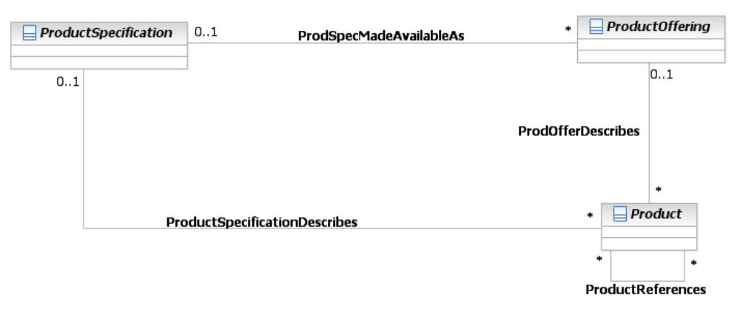
Figure PR. - Simplified Product Model
The Product model has two obvious attachments to Resources in general and PhysicalResources in particular. These are at the ProductSpecification and Product classes.
A ProductSpecification is a template for defining various ProductOfferings. Therefore, it is natural for a ProductSpecification to specify ServiceSpecifications as well as ResourceSpecifications. This is shown in Figure PR. below.
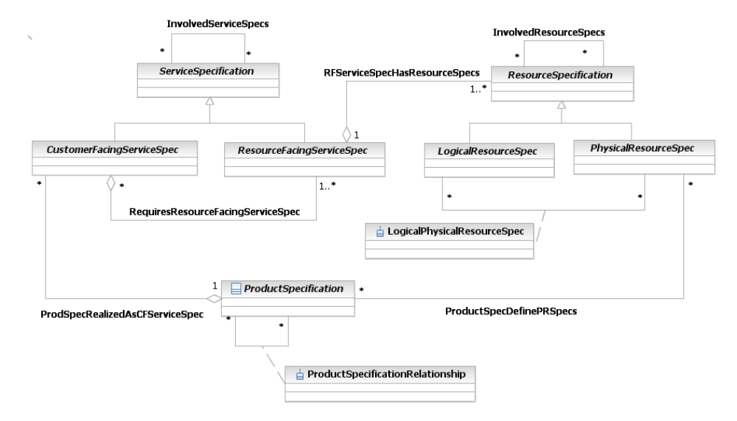
Figure PR. - Relationship Between ProductSpec, ResourceSpec and ServiceSpec
The key idea that we can take from the Product Addendum (Addendum 3) of the SID is the concept of a Specification that is used to define an object. This can be used to determine the essential physical characteristics of the PhysicalResource that can later be customized for a particular ProductOffering. The PhysicalResourceSpecification helps integrate the otherwise diverse worlds of Product and Physical Resources.
The ProductSpecDefinesCFSSpecs and ProductSpecDefinesPRSpecs enable a ProductSpecification to templatize the definition of CustomerFacingServiceSpecs and PhysicalResourceSpecs, respectively.
The LResSpecBindsToPResSpec association represents the binding between a set of LogicalResourceSpecifications and a set of PhysicalResourceSpecifications. The semantics of this binding are represented by the LogicalPhysicalResourceSpec association class (not shown to keep Figure PR. as simple as possible).
Thus, we may make the following important observations concerning the relationship between a ProductSpecification and PhysicalResourceSpecs and Services:
- A PhysicalResource is visible to a customer; therefore, a PhysicalResourceSpec can be directly aggregated by a ProductSpecification
- A LogicalResourceSpec is not directly visible to a customer
- LogicalResources require PhysicalResources to host them, which is done using the LResSpecBindsToPResSpec association
- A CustomerFacingServiceSpec is visible to a customer; therefore, a CustomerFacingServiceSpec can be directly aggregated by a ProductSpecification
- A ResourceFacingServiceSpec is not directly visible to a customer
- ResourceFacingServices are contained in CustomerFacingServices, which is done using the RequiresResourceFacingServiceSpec aggregation
Thus, the goals of separating PhysicalResources from LogicalResources (and also CustomerFacingServices from ResourceFacingServices) through Products has been enforced at the Specification level.
Similarly, Products are related to Services and Resources as shown in Figure PR. below.
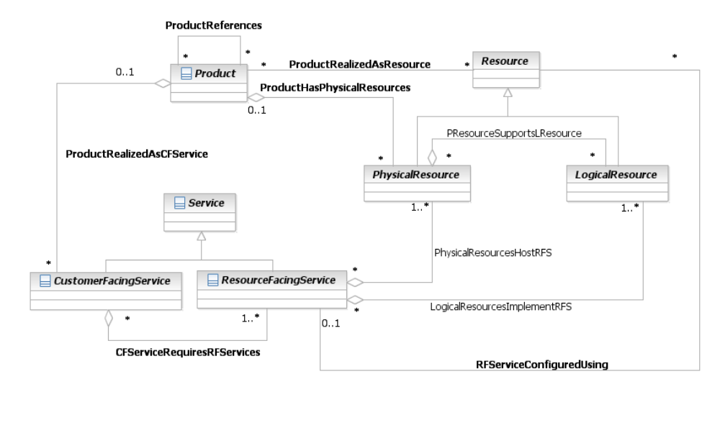
Figure PR. - Relationship Between Product, Service and Resource
The logic at the instance level (shown in Figure PR. above) mirrors the logic at the specification level (shown in Figure PR. above). PhysicalResources and CustomerFacingServices are directly visible to a Product, using the ProductHasPhysicalResources and ProductHasCustomerFacingServices aggregations, respectively. A set of PhysicalResources supports a set of LogicalResources as defined by the PResourceSupportsLResource aggregation. This enables Products to indirectly specify LogicalResources, though the Customer is not aware of this.
Similarly, a set of CustomerFacingServices requires one or more ResourceFacingServices to be implemented, as defined by the CFServiceRequiresRFServices aggregation. Note that the cardinality of this aggregation is 0..n to 1..n, whereas the cardinality of the PResourceSupportsLResource aggregation is 0..n to 0..n. This is because a CustomerFacingService must have at least one ResourceFacingService in order for it to be implemented, whereas a PhysicalResource can exist independent of any LogicalResources.
Note that a ResourceFacingService can specify the set of LogicalResources and PhysicalResources that it requires using the LogicalResourcesImplementRFS and PhysicalResourcesHostRFS aggregations, respectively. This enables Services that are visible to the Customer (i.e., CustomerFacingServices) to be specified in terms of the Resources (physical and logical) that they need.

Policy
Policy is pervasive, even in the physical domain. For example, one can imagine policies for controlling:
- physical access to ManagedPhysicalDevices
- policies that define installation, power-up and power-down instructions for physical entities
- policies that define maintenance and service instructions
Clearly, there are many more types of policies that can be defined. There are several ways to implement policy for physical objects. The Behavior and Control Team, a sub-team of the RedTeam, has elected to use the DEN-ng policy model. Phase 3 of the SID work will include flushing out and approving this model, and tying it to existing SID models such as this one.
The interaction between entities in the Policy domain and entities in the PhysicalResource domain are many. Numerous of these interactions are rich in nature. Some of these relationships will be specified in the Policy Addendum (1-POL), because they require an understanding of the Policy model.

Network
Modeling a network (and other similar concepts) is out of scope for the first release of the SID. It is one of the key target areas in the third phase of SID, and has already been modeled in DEN-ng.

Service
The start of the work on the Service model is taking place in SID phase 2. An example of how Service and Physical Resources interact using an MPLS VPN will be provided as a separate Addendum.

Interaction
The Interaction model will be used to model the various types of interactions between physical resources and other SID entities (e.g., a PartyRole acting as an administrator that is performing maintenance on a particular Device). This is partially defined in SID phase 2, but the details are a matter for the System view.

Additional Examples

To Be Determined and Added if Necessary

References

[053Main] | TMF053, “The NGOSS Technology Neutral Architecture”, TMF
[Add 3] | SID Product Model, GB922, Addendum 3
[Add 4SO] | SID Service Overview Model, GB922, Addendum 4SO
[Add 5LR] | SID LogicalResource Model, GB922, Addendum 5LR
[GB922] | SID Concepts and Principles, GB922 (main document)
m.3100 | Generic Network Information Model, ITU-T recommendation
CIM | Common Information Model, DMTF  http://www.dmtf.org/standards/standard_cim.php
[CIMPROB] | Mining Information from the DMTF CIM into the TMF SID, ed by John Strassner (This was a deliverable from the TMF-DMTF liaison)
Zachman | Zachman Framework  http://www.zifa.com/frmwork2.htm
Larman | Applying UML and Patterns, Second Edition, ISBN 0-13-095004-1  http://www.craiglarman.com/book_applying_2nd/Applying_2nd.htm
Baumer | The Role Object (Design) Pattern. Download PDF from  http://www.riehle.org/computer-science-research/1997/plop-1997-role-object.pdf
[eTOM] | Enhanced Telecoms Operations Map

Business Entity Definitions
The following sections will define the business entities referred to in the preceding portion of this Addendum. This section will consist of a business entity definition, definition of any attributes appropriate for the business level, and finally provide a business model in UML of that entity and its main relationships.

NOTE: This section was produced using a model-driven technique which is still being refined and which results in the loss of some dictionary properties. The same section from the previous major release of the Information Framework is included here as an embedded archive. For conformance purposes, attributes that are not listed there can be assumed to be optional rather than required.

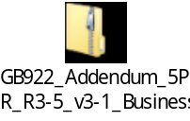

PhysicalResource Business Entity Definition
Business Entity Name | PhysicalResource
Description | This is an abstract base class for describing different types of hardware that constitute a Product. It has two main purposes: (1) to collect common attributes and relationships for all hardware, and (2) to provide a convenient, single point where relationships with other managed objects can be defined.
Sources | DEN-ng, OSS/J
Cross-References
Synonyms / Aliases | This is a DEN-ng class. It is called PhysicalElement in the DMTF CIM (this is not a direct match with this class, although the concepts are similar); no direct analog in M.3100
Related Business Entities | Resource (superclass), LogicalResource (sibling), PhysicalDevice (subclass), Hardware (subclass), PhysicalResourceSpec (template)
Business Rules | To be determined

PhysicalResource Business Entity Attributes Definition
Business Entity Name | PhysicalResource

Attribute Name | Description | Data Type | Notes (used to map to other models; blank is other models don’t have it)
manufactureDate | This is a string attribute that defines the date of manufacture of this item in the fixed format "dd/mm/yyyy". This is an optional attribute. | String | This is a DEN-ng attribute. It is called ManufactureDate in the PhysicalElement class of the DMTF CIM. No analog in M.3100.
otherIdentifier | This is a string that is used to contain other important identifying data, such as a bar code, of the hardware item. This is an optional attribute. | String
powerState | This is an enumerated integer that defines the current power status of the hardware item. Values include:  0: Unknown  1: Not Applicable  2: No Power Applied  3: Full Power Applied  4: Power Save - Normal  5: Power Save - Degraded  6: Power Save - Standby  7: Power Save - Critical  8: Power Save - Low Power Mode  9: Power Save - Unknown  10: Power Cycle  11: Power Warning  12: Power Off  Value 1 means that the hardware item doesn't require the direct application of power (e.g., a but or bolt). If the value for this item is 3, then the PowerCapability class will describe the particular power requirements of this item through the HasPower association.  This is an optional attribute. | Integer | This is a DEN-ng attribute. CIM defines a PoweredOn attribute, but it is a Boolean. No analog in M.3100
serialNumber | This is a string that represents a manufacturer-allocated number used to identify different instances of the same hardware item. The ModelNumber and PartNumber attributes are used to identify different types of hardware items. This is a REQUIRED attribute. | String | This is a DEN-ng attribute. It is called SerialNumber in the PhysicalElement class of the DMTF CIM, but it is not required. No analog in M.3100.
versionNumber | This is a string that identifies the version of this object. This is an optional attribute. | String

Business Entity Model – PhysicalResource
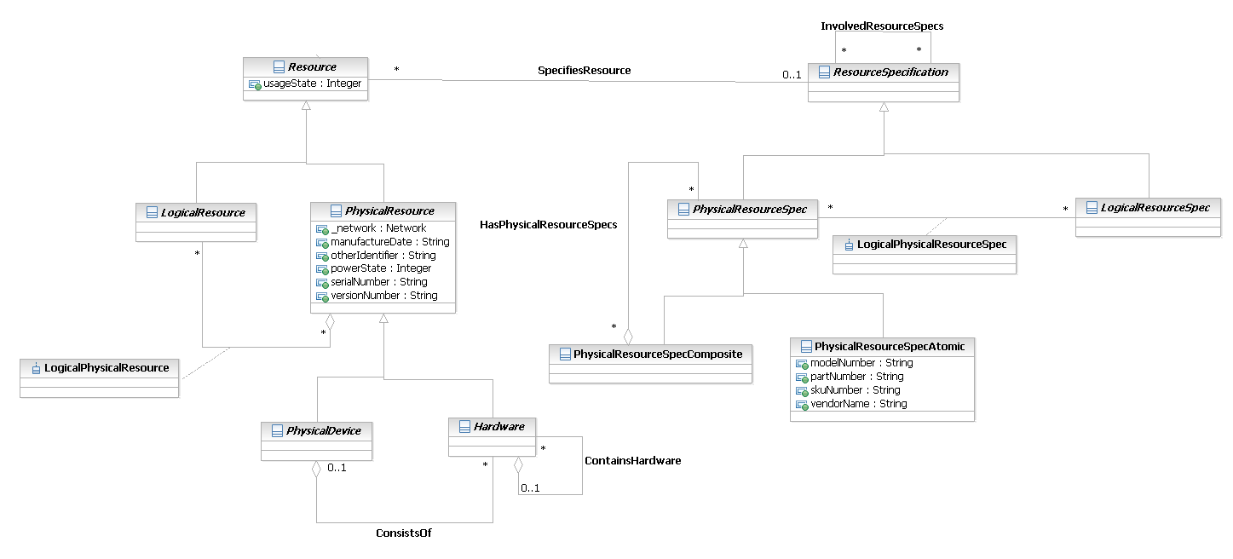
Figure 5PR- 35. PhysicalResource Business Entity Model
PhysicalResourceSpecification Business Entity Definition
Business Entity Name | PhysicalResourceSpecification
Description | This is a concrete class for describing specific attributes, behavior, relationships, constraints, and semantics for building PhysicalResource objects.
Sources | DEN-ng, OSS/J, MetaSolv model
Cross-References
Synonyms / Aliases | This is a DEN-ng class. No direct analogs in the DMTF CIM or M.3100, though analogs of some of the attributes can be found in the DMTF PhysicalElement class.
Related Business Entities | PhysicalResource (subject), ResourceSpecification (superclass), PhysicalResourceSpecAtomic (subclass), PhysicalResourceSpecComposite (subclass), LogicalResourceSpec, LogicalResourceSpecAtomic, LogicalResourceSpecComposite
Business Rules | To be determined

PhysicalResourceSpecification Business Entity Attributes Definition
Business Entity Name | PhysicalResourceSpecification

Attribute Name | Description | Data Type | Notes (used to map to other models; blank is other models don’t have it)
modelNumber | This is a string that represents a manufacturer-allocated number used to identify the general type and/or category of the hardware item. This, in combination with the PartNumber and the VendorName, identify different types of hardware items. The SerialNumber can then be used to differentiate between different instances of the same type of hardware item. This is an optional attribute. | String | This is a DEN-ng attribute; no direct equivalent in the DMTF CIM; could be represented by either the Tag or the OtherIdentifyingInfo attributes of PhysicalElement. No analog in M.3100.
partNumber | This is a string that defines a manufacturer-allocated part number assigned by the organization that manufactures the hardware item. This, in combination with the ModelNumber and the VendorName, identify different types of hardware items. The SerialNumber can then be used to differentiate between different instances of the same type of hardware item. This is a REQUIRED attribute. | String | This is a DEN-ng attribute; it is called PartNumber in the PhysicalElement class of the DMTF CIM, but it isn’t required. No analog in M.3100.
skuNumber | This is a string that defines the manufacturer-allocated Stock Keeping Unit (SKU) number of the hardware item. This is an optional attribute. | String | This is a DEN-ng attribute; it is called SKU in the PhysicalElement class of the DMTF CIM. No analog in M.3100.
vendorName | This is a string that defines the name of the manufacturer. This, in combination with the ModelNumber and the PartNumber, identify different types of hardware items. The SerialNumber can then be used to differentiate between different instances of the same type of hardware item. This is a REQUIRED attribute. | String | This is a DEN-ng attribute; called Manufacturer in the PhysicalElement class of the DMTF CIM, but it isn’t required. No analog in M.3100.

Business Entity Model – PhysicalResourceSpecification
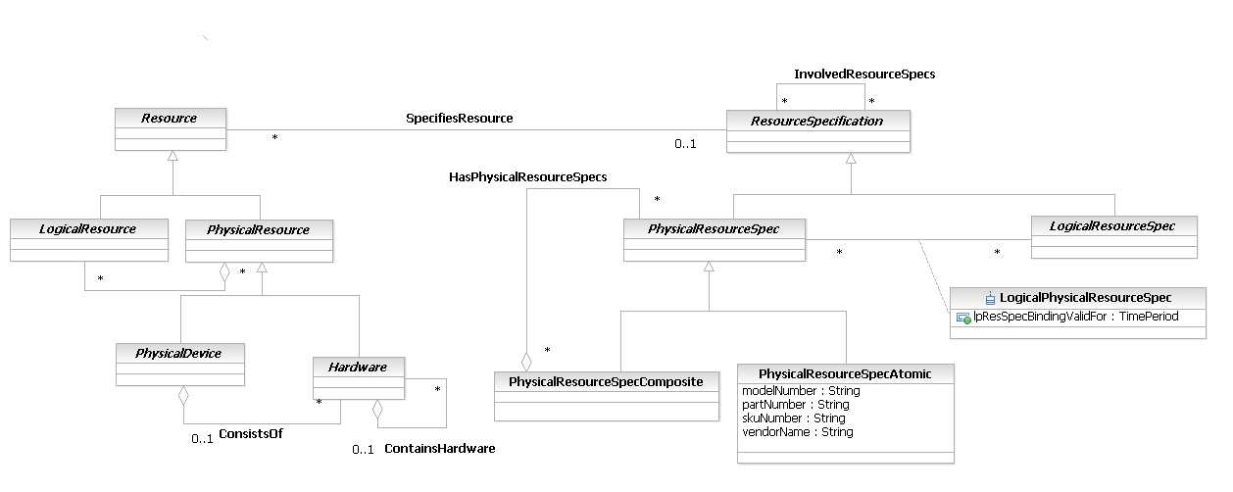
Figure 5PR- 36. PhysicalResourceSpecification Business Entity Model
PhysicalResourceRole Business Entity Definition
Business Entity Name | PhysicalResourceRole
Description | This is an abstract base class for representing the different types of roles that various physical resources can take on. For this first iteration, two specialized roles have been defined: holder and adapter. This enables a single object, such as a Card, to have additional functions. For example, a Card may also serve as a motherboard or hosting board for another Card. In this situation, there isn’t a separate EquipmentHolder – rather, the Card acts as a holder in addition to providing its normal functions. This class is the base class for defining different types of physical resource roles.
Sources | DEN-ng
Cross-References
Synonyms / Aliases | This is a DEN-ng class. No direct analogs in the DMTF CIM or M.3100.
Related Business Entities | PhysicalResource, LogicalResource, PhysicalDevice, Hardware, ManagedHardware, PhysicalContainer, EquipmentHolder, Equipment, AuxiliaryComponent, PhysicalComponent
Business Rules | To be determined

PhysicalResourceRole Business Entity Attributes Definition
Business Entity Name | PhysicalResourceRole

Attribute Name | Description | Data Type | Notes (used to map to other models; blank is other models don’t have it)

Business Entity Model – PhysicalResourceRole
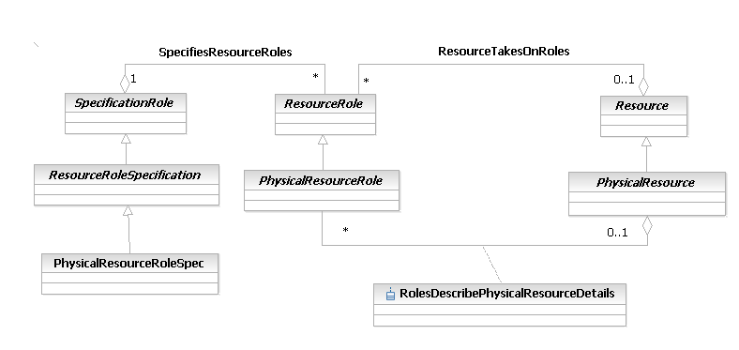
Figure 5PR- 37. PhysicalResourceRole Business Entity Model
PhysicalHolderRole Business Entity Definition
Business Entity Name | PhysicalHolderRole
Description | This is a concrete class that represents any type of physical resource that can play a holding role. A common example is a Card that can also serve as a motherboard, or a Card that can serve as a daughter card that attaches to a motherboard.
Sources | DEN-ng
Cross-References
Synonyms / Aliases | This is a DEN-ng class. No direct analogs in the DMTF CIM or M.3100.
Related Business Entities | PhysicalDevice, PhysicalResource, Equipment, EquipmentHolder, AuxiliaryComponent, HardwareRole (superclass), PhysicalAdapterRole, PhysicalDeviceRole, PhysicalResourceRole
Business Rules | To be determined

PhysicalHolderRole Business Entity Attributes Definition
Business Entity Name | PhysicalHolderRole

Attribute Name | Description | Data Type | Notes (used to map to other models; blank is other models don’t have it)
typeOfHolderRole | This is an enumerated integer that defines the various types of holding roles that this object can play. Values include:  0: undefined;  1: host (e.g., a motherboard)  2: client (e.g., a daughterboard)  This is a REQUIRED attribute. | Integer | This is a DEN-ng attribute; no analog in the DMTF CIM or M.3100.

Business Entity Model – PhysicalHolderRole
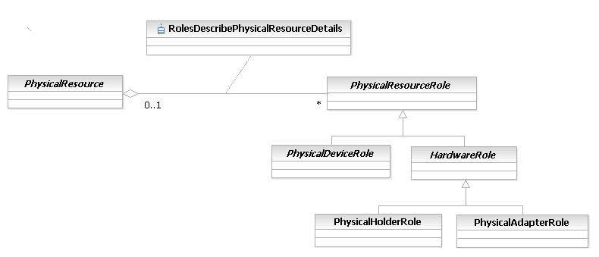
Figure 5PR- 38. PhysicalHolderRole Business Entity Model
PhysicalAdapterRole Business Entity Definition
Business Entity Name | PhysicalAdapterRole
Description | This is a concrete class that represents any type of physical resource that can play a physical adapter role. The Adapter role enables a piece of Hardware to adapt its use. For example, sometimes Cards and Chassis evolve along separate paths, causing future versions of one to no longer be physically compatible with present and/or future versions of the other. The solution to this is to use an intermediate piece of Hardware, called an Adapter, to extend the existing physical structure of an EquipmentHolder to enable otherwise incompatible Equipment to be plugged into an EquipmentHolder. The Adapter conceptually creates a new type of EquipmentHolder that fits into the existing EquipmentHolder. This enables Cards that would otherwise be physically and/or electrically incompatible with the existing EquipmentHolder to be supported, by interfacing to the old EquipmentHolder via the new Adapter.
Sources | DEN-ng
Cross-References
Synonyms / Aliases | This is a DEN-ng class. No direct analogs in the DMTF CIM or M.3100.
Related Business Entities | PhysicalDevice, PhysicalResource, Equipment, EquipmentHolder, AuxiliaryComponent, HardwareRole (superclass), PhysicaHolderRole, PhysicalDeviceRole, PhysicalResourceRole
Business Rules | To be determined

PhysicalAdapterRole Business Entity Attributes Definition
Business Entity Name | PhysicalAdapterRole

Attribute Name | Description | Data Type | Notes (used to map to other models; blank is other models don’t have it)
typeOfAdapterRole | This is an enumerated integer that defines the various types of adapter roles that this object can play. Values include:  0: undefined;  1: host (e.g., a motherboard)  2: client (e.g., a daughterboard)  This is a REQUIRED attribute. | Integer | No analog in the DMTF CIM or M.3100.

Business Entity Model – PhysicalAdapterRole
The business entity model for the PhysicalAdapterRole is the same as that of the PhysicalHolderRole, and was shown in Figure PR.37 above.
Hardware Business Entity Definition
Business Entity Name | Hardware
Description | This is an abstract base class that represents any type of hardware unit that exists as an atomic unit that is not a PhysicalLink or a PhysicalConnector. Its principal subclasses are Equipment, PhysicalDevice, and PhysicalPort.
Sources | DEN-ng
Cross-References
Synonyms / Aliases | This is a DEN-ng class; no direct analogs in the DMTF CIM or M.3100; some parts of the CIM PhysicalPackage can be mapped to this class, but that destroys the separation achieved by splitting PhysicalResource, Hardware, ManagedHardware, and PhysicalContainer
Related Business Entities | Resource, PhysicalResource (superclass), LogicalResource (sibling), PhysicalDevice (which consists of a set of Hardware), ManagedHardware (subclass), PhysicalConnector (subclass), PhysicalResourceRole, PhysicalDeviceRole
Business Rules | To be determined

Hardware Business Entity Attributes Definition
Business Entity Name | Hardware

Attribute Name | Description | Data Type | Notes (used to map to other models; blank is other models don’t have it)
depth | This attribute defines the depth of the ManagedComponent using the units specified in the MeasurementUnits attribute. This is an optional attribute. | String | This is a DEN-ng attribute; called Depth in the PhysicalPackage class of the DMTF CIM; datatype is real32. No analog in M.3100.
height | This attribute defines the height of the ManagedComponent using the units specified in the MeasurementUnits attribute. This is an optional attribute. | String | This is a DEN-ng attribute; called Height in the PhysicalPackage class of the DMTF CIM; datatype is real32. No analog in M.3100.
measurementUnits | This attribute defines the MeasurementUnits for the Depth, Height, and Width attributes of this object. Values include:  0: Unknown (or not measured)  1: inches  2: feet  3: millimeters  4: centimeters  5: meters  This is an optional attribute. However, if any of the Depth, Height, or Width attributes are defined, then this attribute is REQUIRED. | Integer | This is a DEN-ng attribute; not present in the DMTF CIM.
weight | This attribute defines the weight of the ManagedComponent using the units specified in the WeightUnits attribute. This is an optional attribute. | String | This is a DEN-ng attribute; called Weight in the PhysicalPackage class of the DMTF CIM; datatype is real32. No analog in M.3100.
weightUnits | This attribute defines the Units for the Weight attribute of this object. Values include:  0: Unknown (Not Measured)  1: ounces  2: pounds  3: grams  4: kilograms  This is an optional attribute. However, if Weight attribute is defined, then this attribute is REQUIRED. | Integer | This is a DEN-ng attribute; not present in the DMTF CIM.
width | This attribute defines the width of the ManagedComponent using the units specified in the MeasurementUnits attribute. This is an optional attribute. | String | This is a DEN-ng attribute; called Width in the PhysicalPackage class of the DMTF CIM; datatype is real32. No analog in M.3100.

Business Entity Model – Hardware
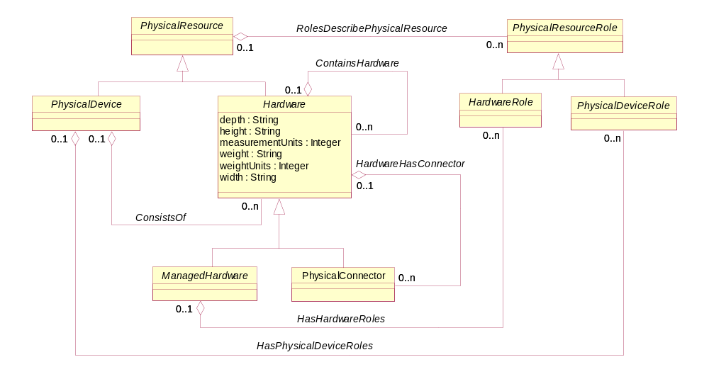
Figure 5PR- 39. Hardware Business Entity Model
ManagedHardware Business Entity Definition
Business Entity Name | ManagedHardware
Description | This is an abstract base class that adds additional semantics to the Hardware base class. These semantics are used to provide management information on the hardware. For example, attributes defined by this class can provide the administrative and operational state of the entity, and tell whether it has any alarms.
Sources | DEN-ng
Cross-References
Synonyms / Aliases | This is a DEN-ng class. No direct analog in the DMTF CIM or M.3100.
Related Business Entities | Resource, PhysicalResource, PhysicalDevice, Hardware (superclass), PhysicalContainer (subclass), Equipment, EquipmentHolder, PhysicalResourceRole, PhysicalDeviceRole, HardwareRole
Business Rules | To be determined

ManagedHardware Business Entity Attributes Definition
Business Entity Name | ManagedHardware

Attribute Name | Description | Data Type | Notes (used to map to other models; blank is other models don’t have it)
additionalInfo | This is a free-form string that is used to contain additional vendor-specific information about the managed element., such as a vendor-specific asset tracking number or special installation notes. It can also be used to map vendor-specific naming (e.g., Port 1 is the same as E0/2/1). This can be NULL.  This is an optional attribute. | String
administrativeState | This attribute is an enumerated integer that describes the current physical state of the ManagedHardware. Values include:  0: Unknown  1: Unlocked  2: Locked  3: Shutting Down  4: Starting Up  5: Testing  6: Maintenance  7: Not Applicable  8: Not able to inform  This is a REQUIRED attribute. | Integer | This is based on similar M.3100 concepts, but extends their semantics. No real analog in the DMTF CIM.
physicalAlarmReportingEnabled | This is a Boolean attribute, and defines whether alarm reporting for this object instance is enabled or not. TRUE means that reporting is allowed, and FALSE means that reporting is inhibited.  Note that some physical entities are not capable of reporting physical alarms, while some are. For those that are not capable of reporting physical alarms, this value MUST be set to FALSE.  Remember that this is for physical alarm reporting. In most cases, there are corresponding logical alarms. The ManagementEntity class hierarchy describes and correlates these.  This is a REQUIRED attribute. | Boolean | No concept of this in either M.3100 or the DMTF CIM.
physicalAlarmStatus | This is an enumerated integer that indicates the occurrence of an abnormal physical condition relating to an object. This attribute may also function as a summary indicator of alarm conditions associated with a specific resource. It is used to indicate the existence of an alarm condition, a pending alarm condition such as threshold situations, or (when used as a summary indicator) the highest severity of active alarm conditions.  This attribute expands on the standard ITU semantics and updates them to include eTOM concepts. Values include:  0: unknown  1: activeReportable-Critical  2: activeReportable-Major  3: activeReportable-Minor  4: activeReportable-Indeterminate  5: activeReportable-Warning  6: activePendingDecision  7: active-underRepair  8: active-beingReplaced  9: cleared  This is a REQUIRED attribute. | Integer | This attribute expands on the standard ITU semantics and updates them to include eTOM concepts.  No concept of this in the DMTF CIM.
coolingRequirements | This is a free-form string that specifies the cooling requirements for this ManagedComponents. Specific cooling information is defined by the Cooling association. This is an optional attribute. | String
hardwarePurpose | This is an enumerated integer that defines the purpose of the ManagedHardware. Values include:  1: Required  2: Optional  3: Redundant  4: Fail-Over  5: Other  This is an optional attribute. | Integer

Business Entity Model – ManagedHardware
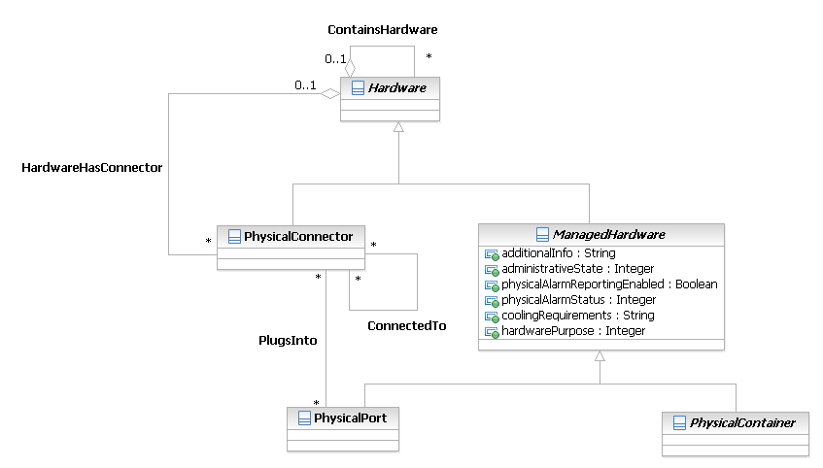
Figure 5PR- 40. ManagedHardware Business Entity Model
PhysicalContainer Business Entity Definition
Business Entity Name | PhysicalContainer
Description | This is an abstract class that is used to add additional semantics to the ManagedHardware class. Its attributes define whether a ManagedHardware object can be removed and/or replaced, and whether this action requires power to be removed or not when the action is performed.
Sources | DEN-ng
Cross-References
Synonyms / Aliases | This is a DEN-ng class. No direct analog in the DMTF CIM or M.3100.
Related Business Entities | Resource, PhysicalResource, PhysicalDevice, Hardware, ManagedHardware (superclass), Equipment (subclass), EquipmentHolder (subclass), AuxiliaryComponent (subclass), PhysicalComponent (subclass), PhysicalResourceRole, PhysicalDeviceRole, HardwareRole
Business Rules | To be determined

PhysicalContainer Business Entity Attributes Definition
Business Entity Name | PhysicalContainer

Attribute Name | Description | Data Type | Notes (used to map to other models; blank is other models don’t have it)
hotSwappable | This is a Boolean attribute that defines whether it is possible to replace this object instance with a physically different, but equivalent, object instance while the containing Equipment has power applied to it. TRUE means that it is HotSwappable, and FALSE means that it is not.  All HotSwappable PhysicalComponents are inherently Removable and Replaceable.  This is a required attribute. | Boolean | This is a DEN attribute, and is also present in the DMTF CIM PhysicalComponent class. Not present in M.3100.
removable | This is a Boolean that defines whether it is possible to insert and remove this object instance from the Equipment in which it is installed, without impairing the function or packaging of the Equipment. TRUE means that it is removable, and FALSE means that it is not.  A Package can still be Removable if power must be 'off' in order to perform the removal. If power can be 'on' and this object instance can still be removed, then this object instance is both Removable and HotSwappable.  This is a required attribute. | Boolean | This is a DEN attribute, and is also present in the DMTF CIM PhysicalComponent class. Not present in M.3100.
replaceable | This is a Boolean that defines whether it is possible to replace this object instance with a physically different instance of the same type. For example, some types of device allow various Chips to be upgraded. TRUE means that it is replaceable, and FALSE means that it is not.  All Removable packages are inherently Replaceable.  This is a required attribute. | Boolean | This is a DEN attribute, and is also present in the DMTF CIM PhysicalComponent class. Not present in M.3100.

Business Entity Model – PhysicalContainer
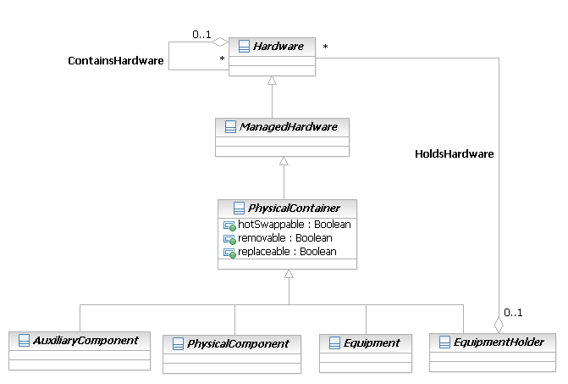
Figure 5PR- 41. PhysicalContainer Business Entity Model
PhysicalDevice Business Entity Definition
Business Entity Name | PhysicalDevice
Description | This is an abstract base class for representing hardware devices that can be managed. This class represents a convenient aggregation point for combining different aspects of a device (e.g., its physical composition as well as the set of services that it offers). It also enables the device itself to have a physical manifestation. Examples of this class include routers and switches, computers, and other end-devices that are managed.
Sources | DEN-ng
Cross-References
Synonyms / Aliases | This is a DEN-ng class. No direct analogs in the DMTF CIM or M.3100; this is similar to the DEN NetworkPackage class.
Related Business Entities | Resource, PhysicalResource (superclass), LogicalResource, PhysicalDeviceAtomic (subclass) , PhysicalDeviceComposite (subclass), Hardware, PhysicalResourceRole, PhysicalDeviceRole
Business Rules | To be determined

PhysicalDevice Business Entity Attributes Definition
Business Entity Name | PhysicalDevice

Attribute Name | Description | Data Type | Notes (used to map to other models; blank is other models don’t have it)
backplaneIndependent | This is a boolean attribute that, if TRUE, indicates that this ManagedDevice has independent backplanes that can be managed separately. This is an optional attribute. | Boolean
backplaneNumber | This is an integer that defines the number of backplanes that this device has. This is an optional attribute. | Integer
configurationOrder | This is a free-form string that provides any order-specific instructions for configuring the set of components that together constitute this PhysicalDevice. This is an optional attribute. | String | This is a DEN-ng attribute; not present in the DMTF CIM or in M.3100.
deviceGroupID | This is a string, and is used to uniquely identify this device as a member of a group of devices. This is an optional attribute. | String | This is a DEN-ng attribute; not present in the DMTF CIM or in M.3100.
isComposite | This is a Boolean attribute that, if TRUE, means that this physical device is in reality made up of a set of physical devices, each of which can be individually managed. This is an optional attribute. | Boolean
canMixPower | This is a Boolean attribute that, if TRUE, means that AC and/or DC power supplies can be used in this device. If it is false, then only one or the other can be used. | Boolean

Business Entity Model – PhysicalDevice
Figure 5PR- 42. PhysicalDevice Business Entity Model
PhysicalDeviceAtomic Business Entity Definition
Business Entity Name | PhysicalDeviceAtomic
Description | This is a concrete base class for representing hardware devices that can be managed that contains no sub-ordinate devices. In other words, this physical device is a stand-alone physical device.  This class represents a convenient aggregation point for combining different aspects of a device (e.g., its physical composition as well as the set of services that it offers). It also enables the device itself to have a physical manifestation. Examples of this class include routers and switches, computers, and other end-devices that are managed.
Sources | DEN-ng
Cross-References
Synonyms / Aliases | This is a DEN-ng class. No direct analogs in the DMTF CIM or M.3100.
Related Business Entities | Resource, PhysicalResource, LogicalResource, PhysicalDevice (superclass) , PhysicalDeviceComposite (sibling), Hardware, PhysicalResourceRole, PhysicalDeviceRole
Business Rules | To be determined

PhysicalDeviceAtomic Business Entity Attributes Definition
Business Entity Name | PhysicalDeviceAtomic

Attribute Name | Description | Data Type | Notes (used to map to other models; blank is other models don’t have it)

Business Entity Model – PhysicalDeviceAtomic
The business entity model for the PhysicalDeviceAtomic class is the same as that for the PhysicalDevice class, which was shown in Figure PR.42 above.
PhysicalDeviceComposite Business Entity Definition
Business Entity Name | PhysicalDeviceComposite
Description | This is a concrete base class for representing hardware devices that can be managed that contains one or more sub-ordinate devices. In other words, this physical device is not a stand-alone physical device; rather, it represents an aggregation of physical devices. Each physical device in this aggregation can be managed.  This class represents a convenient aggregation point for combining different aspects of a device (e.g., its physical composition as well as the set of services that it offers). It also enables the device itself to have a physical manifestation. Examples of this class include routers and switches, computers, and other end-devices that are managed.
Sources | DEN-ng
Cross-References
Synonyms / Aliases | This is a DEN-ng class. No direct analogs in the DMTF CIM or M.3100.
Related Business Entities | Resource, PhysicalResource, LogicalResource, PhysicalDevice (superclass) , PhysicalDeviceAtomic (sibling), Hardware, PhysicalResourceRole, PhysicalDeviceRole
Business Rules | To be determined

PhysicalDeviceComposite Business Entity Attributes Definition
Business Entity Name | PhysicalDeviceComposite

Attribute Name | Description | Data Type | Notes (used to map to other models; blank is other models don’t have it)
numberOfDevicesTotal | This attribute defines the total number of PhysicalDevices aggregated by this PhysicalDeviceComposite object. Note that this aggregation is for that particular level of aggregation. Thus, if a PhysicalDeviceComposite, called A, contains another PhysicalDeviceComposite, called B, then B's instance of this attribute will define how many PhysicalDevices are aggregated by B, whereas A's instance of this attribute will defined how many PhysicalDevices are aggregated by A (which includes those aggregated by B). | Integer
numberOfDevicesCurrent | This attribute defines the current number of PhysicalDevices aggregated by this PhysicalDeviceComposite object that are active and manageable.  Note that this aggregation is for that particular level of aggregation. Thus, if a PhysicalDeviceComposite, called A, contains another PhysicalDeviceComposite, called B, then B's instance of this attribute will define how many PhysicalDevices are aggregated by B, whereas A's instance of this attribute will defined how many PhysicalDevices are aggregated by A (which includes those aggregated by B). | Integer

Business Entity Model – PhysicalDeviceComposite
The business entity model for the PhysicalDeviceComposite class is the same as that for the PhysicalDevice class, which was shown in Figure PR.42 above.
PhysicalConnector Business Entity Definition
Business Entity Name | PhysicalConnector
Description | This is a concrete class that represents any type of hardware unit that is used to connect to other hardware units and transmit signals and/or power between them.
Sources | DEN-ng
Cross-References
Synonyms / Aliases | This is a DEN-ng class. Not present in M.3100.
Related Business Entities | Resource, PhysicalResource, PhysicalDevice, Hardware, Equipment, EquipmentHolder, AuxiliaryComponent, PhysicalComponent, PhysicalPort
Business Rules | To be determined

PhysicalConnector Business Entity Attributes Definition
Business Entity Name | PhysicalConnector

Attribute Name | Description | Data Type | Notes (used to map to other models; blank is other models don’t have it)
cableType | This is an enumerated integer, and defines the particular type of cable that is attached to this connector. Values include:  0: Unknown  1: RS-232  2: RS-422  3: RS-423  4: RS-449  5: RS-485  6: RS-530  7: V.35  8: X.21  9: 9 um single-mode  10: 62.5/125 um multi-mode  11: USB  to be continued, not done!  This is a REQUIRED attribute. | Integer | This is a DEN-ng attribute. It is similar to the ConnectorType attribute of the DMTF CIM PhysicalConnector class. Main difference is that the DMTF attribute was an array that combined this, gender, and other attributes into one. Also, this was not a required attribute in the DMTF CIM. Not present in M.3100.
gender | This is an enumerated integer that defines the gender type of the connector. Values are:  0: Unknown  1: Not Applicable  2: Male  3: Female  This is a REQUIRED attribute. | Integer | This is a DEN-ng attribute. It is similar to the ConnectorType attribute of the DMTF CIM PhysicalConnector class. Main difference is that the DMTF attribute was an array that combined this, gender, and other attributes into one. This was not a required attribute in the DMTF CIM. Not present in M.3100.
inUse | This is a boolean attribute that, if TRUE, indicates that this PhysicalConnector is in use by some other component of the system. This is an optional attribute. | Boolean | This is a DEN-ng attribute; not present in the DMTF CIM or M.3100.
pinDescription | This is a free-form string describing the pin configuration and signal usage of a PhysicalConnector.  This is a REQUIRED attribute. | String | This is a DEN-ng attribute; it is similar to the ConnectorPinout of the DMTF CIM PhysicalConnector class. Not present in M.3100.
typeOfConnector | This is an enumerated integer that defines the type of connector that this instance is. Values include:  0: Unknown  1: DB-9  2: DB-15  3: DB-25  4: DB-36  5: DB-60  6: SC  7: SG  to be continued, not done!  This is a REQUIRED attribute. | Integer | This is a DEN-ng attribute; it is similar to the ConnectorType attribute of the DMTF CIM PhysicalConnector class. Main difference is that the DMTF attribute was an array that combined this, gender, and other attributes into one. This was not a required attribute in the DMTF CIM. Not present in M.3100.

Business Entity Model – PhysicalConnector
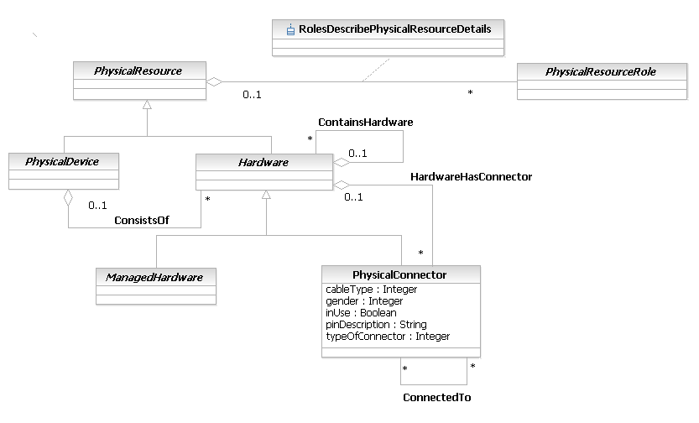
Figure 5PR- 43. PhysicalConnector Business Entity Model
PhysicalPort Business Entity Definition
Business Entity Name | PhysicalPort
Description | This class represents an actual or potential end point of a topological (physical) link, and corresponds directly to a physical port on a topology map. PhysicalPorts are always contained by another physical object - they can't exist by themselves. The two most common examples are PhysicalPorts on a Card and on a Chassis.
Sources | DEN-ng
Cross-References
Synonyms / Aliases | This is a DEN-ng class. No direct analogs in the DMTF CIM or M.3100.
Related Business Entities | Resource, PhysicalResource, PhysicalDevice, Hardware, ManagedHardware, Equipment, EquipmentHolder, Card, Chassis, ResourceRole, PhysicalResourceRole, PhysicalDeviceRole, HardwareRole
Business Rules | To be determined

PhysicalPort Business Entity Attributes Definition
Business Entity Name | PhysicalPort

Attribute Name | Description | Data Type | Notes (used to map to other models; blank is other models don’t have it)
duplexMode | This is an enumerated integer that defines the duplex mode of this port. Values are:  0: Unknown  1: Full Duplex  2: Half Duplex  This is a REQUIRED attribute. | Integer | This is a DEN-ng attribute; no analog in the DMTF CIM or M.3100 since no PhysicalPort exists.
ifType | This is an enumerated integer, and specifies the particular media type of the link. This attribute provides additional detail beyond that provided in the ifType of an ifEntry of a MIB (e.g., distinguishing between 10Base and 100Base ethernet). Values include:  0: Unknown  1: 10BaseT  2: 100BaseT  3: 10-100BaseT  4: 1000BaseT  5: 10000BaseT  6: DS-0  7: DS-1  8: DS-3  9: OC-3  10: OC-12  11: OC-48  12: OC-192  This is a REQUIRED attribute. | Integer | This is a DEN-ng attribute; no analog in the DMTF CIM or M.3100 since no PhysicalPort exists.
portNumber | This is a non-zero integer that uniquely identifies this PhysicalPort instance from all other instances. This is a REQUIRED attribute. | Integer | This is a DEN-ng attribute; no analog in the DMTF CIM or M.3100 since no PhysicalPort exists.
typeOfPPort | This is an enumerated integer that defines the particular type of PhysicalPort this instance is. Values include:  0: Unknown  1: Ethernet  2: FastEthernet  3: Auto-Sensing  4: GigabitEthernet  5: FastGigabitEthernet  6: DS-0  7: DS-1  8: DS-3  9: T1  10: T3  11: E1  12: E3  13: OC-3  14: OC-12  15: OC-48  16: OC-192  17: RS-232C  This is a REQUIRED attribute. | Integer | This is a DEN-ng attribute; no analog in the DMTF CIM or M.3100 since no PhysicalPort exists.
vendorPortName | This is a string that contains the vendor-specific name of this port. This is different from the commonName attribute, which represents a system-wide naming structure for all ManagedEntities. | String | This is a DEN-ng attribute; no analog in the DMTF CIM or M.3100 since no PhysicalPort exists.

Business Entity Model – PhysicalPort
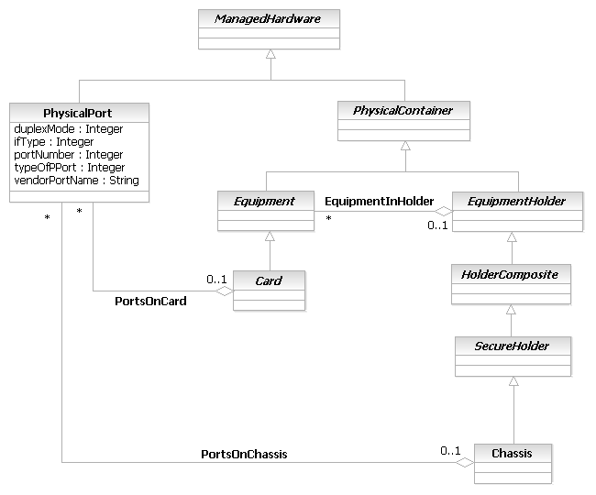
Figure 5PR- 44. PhysicalPort Business Entity Model
Equipment Business Entity Definition
Business Entity Name | Equipment
Description | This class is based on the M.3100 specification, and represents a class of managed objects that represents physical components of a Resource, including replaceable components. An instance of this object class is present in a single geographic location. An Equipment may be nested within another Equipment, thereby creating a containment relationship. The Equipment type shall be identified by sub-classing this object class. Either the name of the sub-class or an attribute may be used for identifying the Equipment type.
Sources | DEN-ng
Cross-References
Synonyms / Aliases | This is an M.3100 class that has been modified in DEN-ng. No direct analog in the DMTF CIM.
Related Business Entities | Resource, PhysicalResource, PhysicalDevice, Hardware, ManagedHardware, PhysicalContainer, EquipmentHolder, Card, Chassis, AuxiliaryComponent, PhysicalComponent, PhysicalResourceRole, PhysicalDeviceRole, HardwareRole
Business Rules | To be determined

Equipment Business Entity Attributes Definition
Business Entity Name | Equipment

Attribute Name | Description | Data Type | Notes (used to map to other models; blank is other models don’t have it)
resourceFulfillmentState | This attribute supports basic administration of plug-ins. | ResourceFulfillmentState
protectionSchemeState | This attribute identifies the individual lock of this equipment. In case the equipment is not protected, the value "UNKNOWN" shall also be used. | ProtectionSchemeState
protectionRole | This attribute defines the protection role that this equipment plays. In case the equipment is not protected, the value "NOT_APPLICABLE" shall be used. | ProtectionRole
manufacturer | This attribute identifies the equipment manufacturer name. It is defined as a non-empty free format string with no semantics. | String
ituArcStateAndStatusList | See R_TMF518_NRB_I_0001 and R_TMF518_NRB_I_0004.  See supporting document SD1-8_encodingX731M3100. | ItuArcStateAndStatusList
isReportingAlarms | This attribute provides an indication of whether alarm reporting for this Equipment is enabled (true) or disabled (false). | Boolean
installedVersion | This attribute identifies the vendor's resource version of the installed equipment. | String | This is a DEN-ng attribute; no analog in the DMTF CIM or M.3100.
installedSerialNumber | This attribute contains the vendor's serial number of the installed equipment. Unique, if no default is provided. At least one serial number has to be provided. | String
installedPartNumber | This attribute identifies the vendor's resource Part Number (PN) of the installed equipment. If PN is not available empty string shall be used. If the part and serial number are both non-null then the part+serial number together shall be unique. | String
installedEquipmentObjectType | This attribute identifies the type of the installed resource. For example, "Fan" or "STM16" for the Equipment class and "Line Shelf" for the Equipment Holder class.) The installed equipment type is invariant for the lifetime of the hardware. This is an empty string if there is no expected equipment. | String
expectedEquipmentObjectType | This attribute identifies the type of the expected resource. For example, "Fan" or "STM16" for the Equipment class and "Line Shelf" for the Equipment Holder class.) This is an empty string if there is no expected equipment. | String
installStatus | This is an m.3100 attribute that represents the availability of the type of Equipment that this object represents. Its semantics are as follows.  The attribute availability status is used to indicate whether the correct physical piece of equipment (in m.3100, it is called a "circuit pack") is isntalled or not. This is a set valued attribute and includes the values notInstalled and empty. If the type of the inserted physical circuit pack matches the value of the circuitPackType attribute (relating to the circuitPack instance) then the value of the availabilityStatus is an empty set. Otherwise, the value of the availabilityStatus attribute is notInstalled even if it is one of the acceptable circuit pack type  This is implemented as an enumerated integer. The values will include at least the following:  0: Unknown  1: Operational (installed and matches expected type)  2: Installed (buit does not match expected type)  3: Not Installed  4: In Maintenance  5: Failed  6: Not operational  This is an optional attribute. | Integer
expectedEquipmentType | This attribute identifies the type of the expected resource. For example, "Fan" or "STM16" for the Equipment class and "Line Shelf" for the Equipment Holder class. This is an empty string if there is no expected equipment. This is an optional attribute. | String | This is a DEN-ng attribute; no analog in the DMTF CIM or M.3100.
installedEquipmentType | This attribute identifies the type of the installed resource. For example, "Fan" or "STM16" for the Equipment class and "Line Shelf" for the Equipment Holder class. The installed equipment type is invariant for the lifetime of the hardware. This is an empty string if there is no installed equipment. This is an optional attribute. | String | This is a DEN-ng attribute; no analog in the DMTF CIM or M.3100.
redundancy | This is an enumerated integer that describes the redundancy capabilities of this particular Equipment. Values include:  0: Unknown  1: Primary (supported by a Redundant Equipment)  2: Redundant (supports a Primary Equipment)  3: Stand-alone (no Redundancy possible)  This is an optional attribute. | Integer | This is a DEN-ng attribute; no analog in the DMTF CIM or M.3100.
asapRef |  | ObjectName

Business Entity Model – Equipment
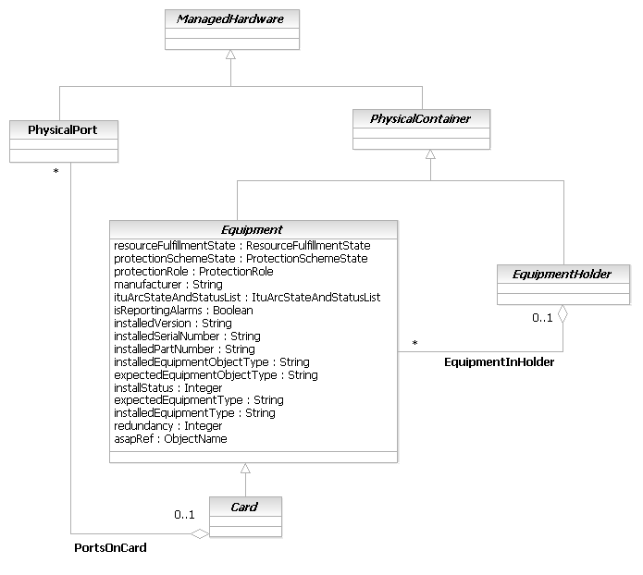
Figure 5PR- 45. Equipment Business Entity Model
Card Business Entity Definition
Business Entity Name | Card
Description | This class is based on the M.3100 specification, and represents a class of managed objects that represents physical components of a Resource, including replaceable components. An instance of this object class is present in a single geographic location. An Equipment may be nested within another Equipment, thereby creating a containment relationship. The Equipment type shall be identified by sub-classing this object class. Either the name of the sub-class or an attribute may be used for identifying the Equipment type.
Sources | DEN-ng
Cross-References
Synonyms / Aliases | This is an M.3100 class that has been modified in DEN-ng. No direct analog in the DMTF CIM.
Related Business Entities | Resource, PhysicalResource, PhysicalDevice, Hardware, ManagedHardware, PhysicalContainer (superclass), EquipmentHolder, MemoryCard (subclass), NetworkCard (subclass), SystemCard (subclass), UnknownCard (subclass), Chassis, AuxiliaryComponent, PhysicalComponent, PhysicalResourceRole, PhysicalDeviceRole, HardwareRole
Business Rules | To be determined

Card Business Entity Attributes Definition
Business Entity Name | Card

Attribute Name | Description | Data Type | Notes (used to map to other models; blank is other models don’t have it)
cardCompatibilityResults | This is an attribute that is used to store the result of the negotiation process between a Card and its EquipmentHolder to see if they are compatible. This is the result of the isCompatible() method, with the Card being the source and the EquipmentHolder being the target, translated into a textual description. | String
daughterCardInstallStatus | This is an enumerated integer that defines the current installation status of this Card's daughter Cards. Note that this defines the status of daughter Cards as viewed by the hosting Card. Status values of individual daughter Cards are defined by attributes in the daughter card itself. Values include:  0: Not Applicable (doesn't have any DaughterCards)  1: All Daughter Cards are installed  2: Some Daughter Cards are installed  3: No Daughter Cards are installed | Integer | This is a DEN-ng attribute; no analog in the DMTF CIM or M.3100.
daughterCardOperatingStatus | This is an enumerated integer that defines the current operating status of this Card's daughter Cards. Note that this defines the operating status of daughter Cards as viewed by the hosting Card. Status values of individual daughter Cards are defined by attributes in the daughter card itself.  This attribute only defines the physical operating characteristics of the daughter card. It does not say whether the daughter Card is functioning correctly, as that is a logical attribute.  Values include:  0: Not Applicable (doesn't have any DaughterCards)  1: All Daughter Cards are operating correctly  2: Some Daughter Cards are operating incorrectly  3: No Daughter Cards are operating correctly | Integer | This is a DEN-ng attribute; no analog in the DMTF CIM or M.3100.
daughterCardRequirements | This is an enumerated integer that defines the relationship between this Card and all DaughterCards. Values include:  1: No DaughterCard can be attached  2: Requires 1 or more DaughterCards to function correctly  3: Can optionally use 1 or more DaughterCards | Integer | This is a DEN-ng attribute; no analog in M.3100. Called RequiresDaughterBoard in the CIM, but lacks the semantics of the DEN-ng attribute.
isConfigurablePhysically | This is a boolean attribute that, if TRUE, indicates that this Card has one or more options that can be physically configured. Each of these options has a distinct physical manifestation (e.g., additional memory, or faster CPU) that usually (but not always) results in occupying more room in the Card. | Boolean | This is a DEN-ng attribute; no analog in the DMTF CIM or M.3100.
isMotherBoard | This is a Boolean attribute that, if TRUE, defines this Card as either a motherboard or another type of hosting board. When FALSE, it isn't. | Boolean | This is a DEN-ng attribute; no analog in M.3100. Called HostingBoard in the CIM, though the semantics are slightly different.
isUniquePhysical | This is a boolean attribute that, if TRUE, defines this Card to be physically different from other Cards of the same type and therefore requires a special slot. The unique aspects of this Card are described in the UniqueRequirementsPhysical attribute. An example might be a different form factor than other Cards of its type, or the ability to set jumpers on the Card to control its functionality (e.g., clocking). | Boolean | This is a DEN-ng attribute; no analog in M.3100. The CIM has a similar attribute called SpecialRequirements but there is a bug in the text.
maxDataWidth | This is an integer that defines the maximum bus width of this Card. Values include:  0: Unknown  1: Special  8: 8 bit data bus  16: 16 bit data bus  24: 24 bit data bus  32: 32 bit data bus  64: 64 bit data bus  128: 128 bit data bus  The value "1" can be used for any non-standard data bus width. | Integer
slotLayout | This is a free-form string that describes the positioning, spacing, typical usage, restrictions, and any other pertinent information that defines how the Card is to be positioned into the Slot. | String | This is a DEN-ng attribute; no analog in M.3100. Called SlotLayout in the CIM.
slotsRequired | This is an integer that defines the number of slots required to hold this Card. Since this is usually 1, that value is assigned as its default value. | Integer | This is a DEN-ng attribute; no analog in the DMTF CIM or M.3100.
uniqueRequirementsPhysical | This is a free-form string that contains the physically unique requirements of this Card. For example, it must go in a certain slot number because it has special dimensions. This attribute should only be filled in if the value of the IsUniquePhysical attribute is TRUE; otherwise, it should be NULL. | String | This is a DEN-ng attribute; no analog in M.3100. Called RequirementsDescription in the CIM
hardwareVersion | This is a string attribute that contains the hardware version number of this Card. | String

Business Entity Model – Card
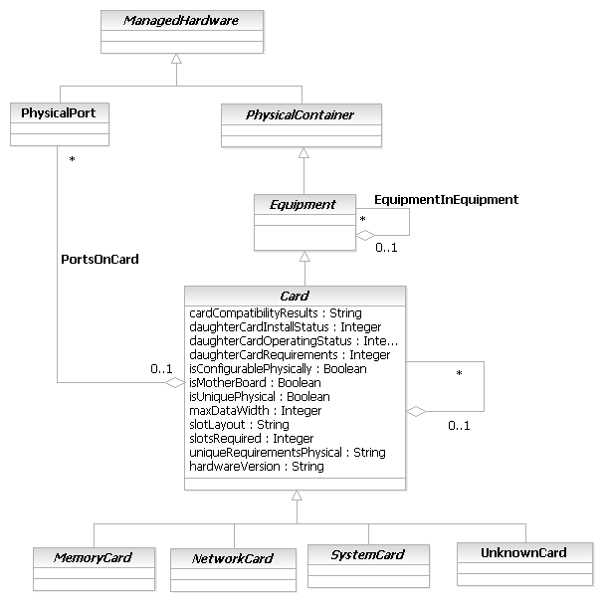
Figure 5PR- 46. Card Business Entity Model
MemoryCard Business Entity Definition
Business Entity Name | MemoryCard
Description | This is a type of Card that is dedicated to providing additional memory for use by other components of a Resource. Cards that are used to expand memory, or provide different types of memory, are examples of this type of Card. DEN-ng differentiates between this and other types of Cards, such as NetworkCards and MemoryCards.
Sources | DEN-ng
Cross-References
Synonyms / Aliases | This is a DEN-ng class. No direct analog in the DMTF CIM or M.3100.
Related Business Entities | Resource, PhysicalResource, PhysicalDevice, Hardware, ManagedHardware, PhysicalContainer, EquipmentHolder, Card, NetworkCard, SystemCard, UnknownCard, Chassis, AuxiliaryComponent, PhysicalComponent, PhysicalResourceRole, PhysicalDeviceRole, HardwareRole
Business Rules | To be determined

MemoryCard Business Entity Attributes Definition
Currently, no attributes have been defined for this object since it is there primarily for classification purposes. Attributes may be added to this object in the next phase of the SID once a more complete survey of MemoryCards has been completed.
Business Entity Name | MemoryCard

Attribute Name | Description | Data Type | Notes (used to map to other models; blank is other models don’t have it)

Business Entity Model – MemoryCard
The MemoryCard business entity model is the same as that of the Card business entity model, which was shown in Figure PR.46 above.
NetworkCard Business Entity Definition
Business Entity Name | NetworkCard
Description | This is a type of Card that is dedicated to providing networking functions, such as routing and forwarding. Line cards and port adapter cards are examples of this type of card. DEN-ng differentiates between this and other types of Cards, such as NetworkCards and MemoryCards.
Sources | DEN-ng
Cross-References
Synonyms / Aliases | This is a DEN-ng class. No direct analog in the DMTF CIM or M.3100.
Related Business Entities | Resource, PhysicalResource, PhysicalDevice, Hardware, ManagedHardware, PhysicalContainer, EquipmentHolder, Card, MemoryCard, SystemCard, UnknownCard, Chassis, AuxiliaryComponent, PhysicalComponent, PhysicalResourceRole, PhysicalDeviceRole, HardwareRole
Business Rules | To be determined

NetworkCard Business Entity Attributes Definition
Currently, no attributes have been defined for this object since it is there primarily for classification purposes. Attributes may be added to this object in the next phase of the SID once a more complete survey of NetworkCards has been completed. However, since NetworkCards are so diverse (both in form as well as in function), it is highly likely that this class will remain as is and function as a means to classify different types of Cards.
Business Entity Name | NetworkCard

Attribute Name | Description | Data Type | Notes (used to map to other models; blank is other models don’t have it)

Business Entity Model – NetworkCard
The NetworkCard business entity model is the same as that of the Card business entity model, which was shown in Figure PR.46 above.
SystemCard Business Entity Definition
Business Entity Name | SystemCard
Description | This is a type of Card that is dedicated to providing system functions. Main processor boards and controller boards are examples of this type of Card. DEN-ng differentiates between this and other types of Cards, such as NetworkCards and MemoryCards.
Sources | DEN-ng
Cross-References
Synonyms / Aliases | This is a DEN-ng class. No direct analog in the DMTF CIM or M.3100.
Related Business Entities | Resource, PhysicalResource, PhysicalDevice, Hardware, ManagedHardware, PhysicalContainer, EquipmentHolder, Card, MemoryCard, NetworkCard, UnknownCard, Chassis, AuxiliaryComponent, PhysicalComponent, PhysicalResourceRole, PhysicalDeviceRole, HardwareRole
Business Rules | To be determined

SystemCard Business Entity Attributes Definition
Currently, no attributes have been defined for this object since it is there primarily for classification purposes. Attributes may be added to this object in the next phase of the SID once a more complete survey of SystemCards has been completed. However, since SystemCards are so diverse (both in form as well as in function), it is highly likely that this class will remain as is and function as a means to classify different types of Cards
Business Entity Name | SystemCard

Attribute Name | Description | Data Type | Notes (used to map to other models; blank is other models don’t have it)

Business Entity Model – SystemCard
The SystemCard business entity model is the same as that of the Card business entity model, which was shown in Figure PR.46 above.
UnknownCard Business Entity Definition
Business Entity Name | UnknownCard
Description | This object is used as a generic placeholder to represent Cards that are known to exist but are not yet identifiable via Software means.
Sources | DEN-ng
Cross-References
Synonyms / Aliases | This is a DEN-ng class. No direct analog in the DMTF CIM or M.3100.
Related Business Entities | Resource, PhysicalResource, PhysicalDevice, Hardware, ManagedHardware, PhysicalContainer, EquipmentHolder, Card, MemoryCard, SystemCard, UnknownCard, Chassis, AuxiliaryComponent, PhysicalComponent, PhysicalResourceRole, PhysicalDeviceRole, HardwareRole
Business Rules | To be determined

UnknownCard Business Entity Attributes Definition
Currently, no attributes have been defined for this object since it is there primarily for classification purposes. It is unlikely that any business attributes will be added to this object, since the purpose of this Card is to serve as a placeholder to log unknown Cards as part of an inventory process. Thus, it is highly likely that this class will remain as is and function as a means to classify different types of unknown Cards.
Business Entity Name | UnknownCard

Attribute Name | Description | Data Type | Notes (used to map to other models; blank is other models don’t have it)

Business Entity Model – UnknownCard
The UnknownCard business entity model is the same as that of the Card business entity model, which was shown in Figure PR.46 above.
EquipmentHolder Business Entity Definition
Business Entity Name | EquipmentHolder
Description | This class is based on the M.3100 specification, and is a base class that represents physical objects that are both manageable as well as able to host, hold, or contain other physical objects. Examples of physical objects that can be represented by instances of this object class are Racks, Chassis, Shelfs, Cards, and Slots.
Sources | DEN-ng
Cross-References
Synonyms / Aliases | This is a DEN-ng class, based on an M.3100 class. No direct analog in the DMTF CIM.
Related Business Entities | Resource, PhysicalResource, PhysicalDevice, Hardware, ManagedHardware, PhysicalContainer (superclass), Equipment, Card, EquipmentHolderAtomic (subclass), EquipmentHolderComposite (subclass), SecureHolder, Chassis, Rack, Slot, Shelf, Bay, PhysicalHolderRole, PhysicalResourceRole, PhysicalDeviceRole, HardwareRole
Business Rules | To be determined

EquipmentHolder Business Entity Attributes Definition
Business Entity Name | EquipmentHolder

Attribute Name | Description | Data Type | Notes (used to map to other models; blank is other models don’t have it)
type | This attribute identifies the type of the Holder (e.g., Rack (or Bay), Shelf, Sub-shelf, Slot, Subslot, Remote-unit or Remote-subslot). | String
state | This attribute identifies the state of the Equipment Holder. | HolderState
manufacturer | This attribute identifies the Equipment Holder manufacturer name. It is defined as a non-empty free format string with no semantics. | String
manufactureDate | The manufactureDate attribute identifies the production date of the Equipment Holder. | String
location | This attribute identifies the geographical location of the Equipment Holder. | String
ituArcStateAndStatusList | See R_TMF518_NRB_I_0001 and R_TMF518_NRB_I_0004.  See supporting document SD1-8_encodingX731M3100. | ItuArcStateAndStatusList
isReportingAlarms | This attribute provides an indication of whether alarm reporting for this Equipment Holder is enabled (true) or disabled (false). | Boolean
expectedOrInstalledEquipmentRef | This attribute identifies the equipment object expected or installed in the equipment holder, if any. Null if the equipment holder is empty or if it only contains other equipment holders. | ObjectName
asapRef | This attribute indicates the assignment of an Alarm Severity Assignement Profile (ASAP) to the EquipmentHolder. | ObjectName
acceptableEquipmentTypeList | This attribute identifies the types of equipment that can be supported by the Equipment Holder. | String
acceptableEquipmentList | This is an array of strings, based on M.3100, that identifies the types of equipment objects that can be supported by this object. This is an optional attribute. | String | This is a DEN-ng attribute, based on an M.3100 class; no analog in the DMTF CIM.
typeOfHolder | This is an enumerated integer that identifies the type of the Holder that this object instance is. It is based on M.3100 but includes additional values:  0: Unknown  1: Rack  2: Bay  3: Chassis  4: Shelf  5: Slot  6: Sub-Slot  7: Sub-Rack  This is a REQUIRED attribute. | Integer | This is a DEN-ng attribute, based on an M.3100 class; no analog in the DMTF CIM.
isSolitaryHolder | This is a Boolean attribute that, if TRUE, defines this EquipmentHolder as containing only one ManagedComponent. If this is FALSE, then this EquipmentHolder contains nested ManagedComponents. This is a REQUIRED attrinbute. | Boolean
holderStatus | This attribute, based on M.3100, indicates the status of the EquipmentHolder. Values include:  0: Unknown  1: Installed And Acceptable  2: Installed And Not Acceptable  3: Not Installed  4: Mismatch Of Installed and Acceptable  5: Unavailable  This is an optional attribute. | Integer | This is a DEN-ng attribute, based on an M.3100 class; no analog in the DMTF CIM.

Business Entity Model – EquipmentHolder
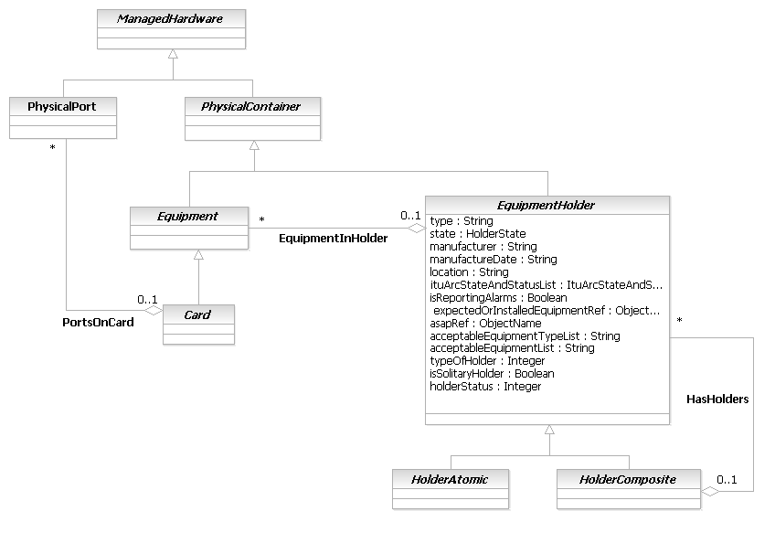
Figure 5PR- 47. EquipmentHolder Business Entity Model
HolderAtomic Business Entity Definition
Business Entity Name | HolderAtomic
Description | This class represents atomic holders of Equipment that are individually manageable and do NOT form composite, or nested, Equipment Holders.  Each HolderAtomic object can be a FRU.
Sources | DEN-ng
Cross-References
Synonyms / Aliases | This is a DEN-ng class, based on an M.3100 class. No direct analog in the DMTF CIM, because there is no difference between HolderAtomic and HolderComposite objects.
Related Business Entities | Resource, PhysicalResource, PhysicalDevice, Hardware, ManagedHardware, PhysicalContainer, Equipment, Card, EquipmentHolder (superclass), EquipmentHolderComposite (sibling), SecureHolder, Chassis, Rack, Slot (subclass), Shelf, Bay, PhysicalHolderRole, PhysicalResourceRole, PhysicalDeviceRole, HardwareRole
Business Rules | To be determined

HolderAtomic Business Entity Attributes Definition
Business Entity Name | HolderAtomic

Attribute Name | Description | Data Type | Notes (used to map to other models; blank is other models don’t have it)
physicalDescription | This is a free-form string that defines the physically unique characteristics of this holder. This is an optional attribute. | String | This is a DEN-ng attribute, based on an M.3100 class; no analog in the DMTF CIM.
uniquePhysical | This is a Boolean attribute that, if TRUE, means that this holder is physically different from other holders, and is intended to hold a special type of equipment (e.g., a doublewide card, or a longer card than normal). This is an optional attribute. | Boolean | This is a DEN-ng attribute, based on an M.3100 class; no analog in the DMTF CIM.

Business Entity Model – HolderAtomic
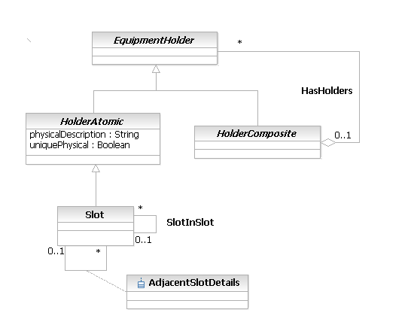
Figure 5PR- 48. HolderAtomic Business Entity Model
Slot Business Entity Definition
Business Entity Name | Slot
Description | This is a concrete class that has two main purposes. One is to model the ability of a hosting board to accept a daughter card to add or complete the base functionality of the hosting board. The second is to represent the different expansion slots supported by a Chassis.
Sources | DEN-ng
Cross-References
Synonyms / Aliases | This is a DEN-ng class. No counterpart in M.3100; the DMTF CIM has a Slot class but the semantics are different.
Related Business Entities | Resource, PhysicalResource, PhysicalDevice, Hardware, ManagedHardware, PhysicalContainer, Equipment, Card, EquipmentHolder, EquipmentHolderAtomic (superclass), EquipmentHolderComposite, SecureHolder, Chassis, Rack, Shelf, Bay, PhysicalHolderRole, PhysicalResourceRole, PhysicalDeviceRole, HardwareRole
Business Rules | To be determined

Slot Business Entity Attributes Definition
Business Entity Name | Slot

Attribute Name | Description | Data Type | Notes (used to map to other models; blank is other models don’t have it)
hasAdapter | This is a Boolean attribute that, if TRUE, indicates that this slot has an adapter installed that enables it to accept other types of cards (e.g., fitting an adapter on two Slots enable them to accept a Card that otherwise could not be accommodated). If its value is FALSE, then no adapter is present. This is an optional attribute. | Boolean | This is a DEN-ng; no analog in the DMTF CIM or M.3100.
slotNumber | This is a 16-bit unsigned integer attribute that represents an index into the system slot table. For example, this could be the hardware ID number (starting with 1) for each expansion slot. The number is independent of whether or not the Slot is occupied. This is a REQUIRED attribute. | Integer | This is a DEN-ng attribute; no analog in M.3100. The DMTF CIM has an attribute named SlotNumber; however, the semantics of the Slot class are different.
slotPurpose | This is an enumerated integer that defines the purpose of this Slot. A specific value below, such as System, means that the Slot is intended only to accept System cards. Values include:  0: Unknown  1: System  2: Networking  3: Port Adapter  4: Memory  5: Hardware Assist  6: Video  7: General Computing  8: General Purpose  Hardware assist is a generic category for specialty boards that provide hardware functionality to assist in the processing of one or more functions. Examples are special cards for processing IPsec-based encryption.  General computing boards represent cards that have additional and/or auxiliary computing power that can be used for a variety of tasks (not just video rendering or encryption).  General purpose boards represent cards that have a variety of features (e.g., memory and computing).  This is an optional attribute. | Integer | This is a DEN-ng attribute; no analog in M.3100. The DMTF CIM has an attribute called SpecialPurpose, but it is only a Boolean and thus has more restricted semantics.
purposeDescription | This is a free-form string that defines the physically unique characteristics of this Slot. This is an optional attribute. | String | This is a DEN-ng attribute; no analog in M.3100. The DMTF CIM has an attribute called PurposeDescription, but the Slot class has different semantics.

Business Entity Model – Slot
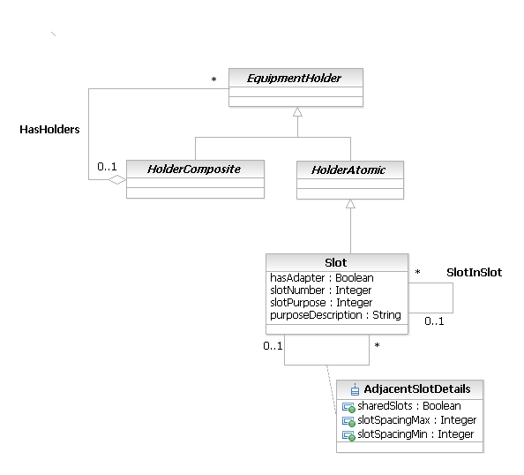
Figure 5PR- 49. Slot Business Entity Model
HolderComposite Business Entity Definition
Business Entity Name | HolderComposite
Description | This class represents EquipmentHolders that are made up of other EquipmentHolders (i.e., instances of this class as well as the HolderAtomic base class). This provides the semantics of collecting a set of components, each of which is individually manageable, and being able to manage the set of objects as a whole. This containment is modeled using the HasHolders aggregation.  Each HolderComposite element can be a FRU.  A characteristic of this class is that its subclasses are physical objects that have complex cabling and mounting options. This class is meant to differentiate complex holders, like a Chassis, from simple holders, like a Slot.
Sources | DEN-ng
Cross-References
Synonyms / Aliases | This is a DEN-ng class, based on an M.3100 class. No direct analog in the DMTF CIM, because there is no difference between HolderAtomic and HolderComposite objects.
Related Business Entities | Resource, PhysicalResource, PhysicalDevice, Hardware, ManagedHardware, PhysicalContainer, Equipment, Card, EquipmentHolder (superclass), EquipmentHolderAtomic (sibling), SecureHolder (subclass), Chassis, Rack, Slot, Shelf, Bay, PhysicalHolderRole, PhysicalResourceRole, PhysicalDeviceRole, HardwareRole
Business Rules | To be determined

HolderComposite Business Entity Attributes Definition
Business Entity Name | HolderComposite

Attribute Name | Description | Data Type | Notes (used to map to other models; blank is other models don’t have it)
cableManagementStrategy | This is a free-form string that contains information on how the various cables contained in the Chassis, Rack, or other type of HolderComposite object are connected and bundled. This property contains information to aid in the assembly and service of the cables contained in a SecureHolder object. This is an optional attribute. | String | This is a DEN-ng attribute; no analog in M.3100. The DMTF CIM has a similarly named attribute in its PhysicalFrame class, though the semantics are slightly different.
mountingOptions | This is an enumerated 16-bit unsigned integer that defines how Equipment in this entity is mounted. Values include:  0: Unknown  1: Stand-alone  2: Rack-mounted, free access  3: Rack-mounted, restricted access  4: Enclosed in another chassis  This is an optional attribute. | Integer | This is a DEN-ng class; no analog in the DMTF CIM or M.3100.
serviceApproach | This is an enumerated, integer-valued array that defines how this entity is serviced (e.g., from the top or front), whether it has sliding trays or removable sides, and/or whether the Frame is moveable (e.g., it has rollers). Values include:  0: Unknown  1: Custom  2: Service From Top  3: Service From Front  4: Service From Back  5: Service From Side  6: Sliding Trays  7: Removable Sides  8: Moveable  This is an optional attribute. | String | This is a DEN-ng class; no analog in the DMTF CIM or M.3100.

Business Entity Model – HolderComposite
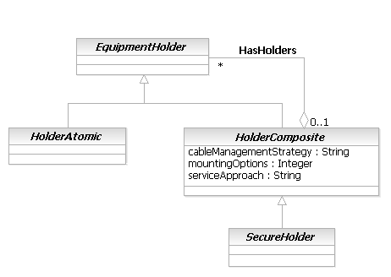
Figure 5PR- 50. HolderComposite Business Entity Model
SecureHolder Business Entity Definition
Business Entity Name | SecureHolder
Description | This class is a type of HolderComposite that serves as the parent for the Rack and Chassis classes. This class generalizes common properties that apply to Racks and Chassis.
Sources | DEN-ng
Cross-References
Synonyms / Aliases | This is a DEN-ng class, based on the original DEN spec. No direct analog in M.3100. The DMTF CIM defines similar attributes, but as part of the PhysicalFrame class, and lacks the semantics and classification of the DEN-ng hierarchy.
Related Business Entities | Resource, PhysicalResource, PhysicalDevice, Hardware, ManagedHardware, PhysicalContainer, Equipment, Card, EquipmentHolderAtomic, EquipmentHolderComposite (superclass), Chassis (subclass), Rack (subclass), Slot, Shelf, Bay, PhysicalHolderRole, PhysicalResourceRole, PhysicalDeviceRole, HardwareRole
Business Rules | To be determined

SecureHolder Business Entity Attributes Definition
Business Entity Name | SecureHolder

Attribute Name | Description | Data Type | Notes (used to map to other models; blank is other models don’t have it)
audibleAlarm | This is a boolean attribute that, if TRUE, indicates that this SecureHolder is equipped with an audible alarm. This is an optional attribute. | Boolean | No analog in M.3100; the DMTF CIM has a similarly named attribute in PhysicalFrame.
audibleAlarmDescription | This is a free-form string that provides supplementary information for the AudibleAlarm attribute. It should only be filled in when the value of the AudibleAlarm attribute is TRUE. This is an optional attribute. | String | No analog in M.3100; the DMTF CIM defines an array called ServiceDescriptions in PhysicalFrame to do the same thing.
lockPresent | This is a boolean attribute that, if TRUE, indicates that this SecureHolder is protected by some type of lock. This is an optional attribute. | Boolean | No analog in M.3100; the DMTF CIM has a similarly named attribute in PhysicalFrame.
securityBreach | This is an enumerated 16-bit unsigned integer attribute indicating whether a breach of the Rack was attempted. Values include:  0: Unknown  1: Other  2: No Breach  3: Unsuccessful Breach (but attempted)  4: Successful Breach  This is an optional attribute. | Integer | No analog in M.3100; the DMTF CIM has a similarly named attribute in PhysicalFrame.
securityBreachDescription | This is a free-form string attribute that provides supplementary information for the SecurityBreach attribute. It should only be filled in when the value of SecurityBreach is 1 ("Other").  This is an optional attribute. | String | No analog in M.3100; the DMTF CIM has a similarly named attribute in PhysicalFrame.
visibleAlarm | This is a boolean attribute that, if TRUE, indicates that the SecureHolder is equipped with one or more visible alarms (e.g., LEDs or gauges). This is an optional attribute. | Boolean | No analog in M.3100; the DMTF CIM has a similarly named attribute in PhysicalFrame.
visibleAlarmDescription | This is a free-form string attribute that provides supplementary information for the VisibleAlarm attribute. It should only be filled in when the value of VisibleAlarm is TRUE.  This is an optional attribute. | String | No analog in M.3100; the DMTF CIM defines an array called ServiceDescriptions in PhysicalFrame to do the same thing.

Business Entity Model – SecureHolder
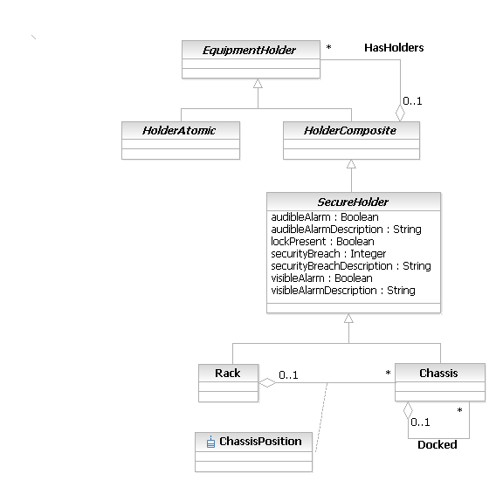
Figure 5PR- 51. SecureHolder Business Entity Model
Rack Business Entity Definition
Business Entity Name | Rack
Description | A Rack is a type of SecureHolder that represents an enclosure in which EquipmentHolders, such as Chassis, are placed. Typically a Rack is nothing more than the enclosure, and all the functioning componentry is packaged in the Chassis.  Note that the logical identifier of a Rack is NOT typically associated with the Device (i.e., the NetworkElement). Compare this to either a Bay or a Shelf, whose logical identifier IS associated with the Device. This means that the Rack is explicitly NOT a part of the logical model of a network.  The Rack typically serves as the "master enclosure" for Chassis, Shelves and Bays. In addition, Racks can have multiple instances of multiple Devices mounted in them.
Sources | DEN-ng
Cross-References
Synonyms / Aliases | This is a DEN-ng class, based on the original DEN spec. No direct analog in M.3100. The DMTF CIM has a Rack class, but its semantics are slightly different.
Related Business Entities | Resource, PhysicalResource, PhysicalDevice, Hardware, ManagedHardware, PhysicalContainer (superclass), Equipment, Card, EquipmentHolderAtomic, EquipmentHolderComposite, SecureHolder (superclass), Chassis (sibling), Slot, Shelf, Bay, PhysicalHolderRole, PhysicalResourceRole, PhysicalDeviceRole, HardwareRole
Business Rules | To be determined

Rack Business Entity Attributes Definition
Business Entity Name | Rack

Attribute Name | Description | Data Type | Notes (used to map to other models; blank is other models don’t have it)
country | This is the designation of the country for which the Rack is designed. Country code strings are as defined by ISO/IEC 3166. This is an optional attribute. | String | No analog in M.3100; the DMTF CIM has a similar attribute named CountryDesignation.
heightInUs | This is the height of the Rack in 'U's. A 'U' is a standard unit of measure for the height of a Rack or rack-mountable components. It is equal to 1.75 inches or 4.445 cm. This is an optional attribute. | Integer | No analog in M.3100; the DMTF CIM has a height attribute higher in the hierarchy and overrides that attribute in the Rack class.
typeOfRack | This is an enumerated integer that defines the type of Rack. Values include:  0: Unknown  1: Standard 19 Inch  2: Telco  3: Equipment Shelf  4: Non-Standard  This is an optional attribute. | Integer | No analog in M.3100; the DMTF CIM has a similarly name attribute.

Business Entity Model – Rack
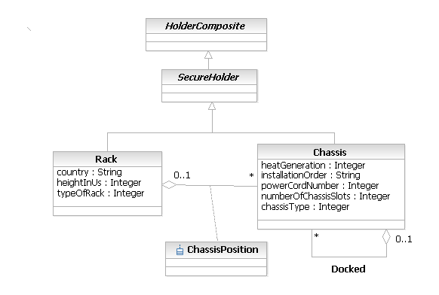
Figure 5PR- 52. Rack and Chassis Business Entity Model
Chassis Business Entity Definition
Business Entity Name | Chassis
Description | A Chassis is a type of SecureHolder that encloses other ManagedPhysicalEntities and provides a definable functionality in its own right, such as a desktop or a network device (e.g., a router or a switch).
Sources | DEN-ng
Cross-References
Synonyms / Aliases | A Chassis is a type of SecureHolder that encloses other ManagedPhysicalEntities and provides a definable functionality in its own right, such as a desktop or a network device (e.g., a router or a switch).
Related Business Entities | Resource, PhysicalResource, PhysicalDevice, Hardware, ManagedHardware, PhysicalContainer (superclass), Equipment, Card, EquipmentHolderAtomic, EquipmentHolderComposite, SecureHolder (superclass), Rack (sibling), Slot, Shelf, Bay, PhysicalHolderRole, PhysicalResourceRole, PhysicalDeviceRole, HardwareRole
Business Rules | To be determined

Chassis Business Entity Attributes Definition
Business Entity Name | Chassis

Attribute Name | Description | Data Type | Notes (used to map to other models; blank is other models don’t have it)
heatGeneration | This is an integer that defines the amount of heat generated by the Chassis in BTU/hour. This is an optional attribute. | Integer | No analog in M.3100; the DMTF CIM has a similarly name attribute.
installationOrder | This is a free-form string that defines the order of installation of components into the Chassis. This is an optional attribute. | String | No analog in M.3100 or the DMTF CIM.
powerCordNumber | This is an integer that defines the number of power cords which must be connected to the Chassis in order for all of its contained ManagedEntities to operate correctly. This is an optional attribute. | Integer
numberOfChassisSlots | This defines the number of Slots that are in the Chassis. This does NOT account for any SlotAdapters used - these are described by the CardInSlot association. This is an optional attribute. | Integer | No analog in M.3100 or the DMTF CIM.
chassisType | This is an enumerated integer that defines the type of Chassis that this object is. Values include:  0: Unknown  1: Desktop  2: Low Profile Desktop  3: Pizza Box  4: Mini Tower  5: Tower  6: Portable  7: LapTop  8: Notebook  9: Sub-Notebook  10: Hand Held  11: Docking Station  12: Main System Chassis  13: Expansion Chassis  14: Bus Expansion Chassis  15: Peripheral Chassis  16: Storage Chassis  17: Rack Mount Chassis  This is an optional attribute. | Integer

Business Entity Model – Chassis
The Chassis business entity model is the same as the Rack business entity model, which was shown in Figure PR.52 above.
AuxiliaryComponent Business Entity Definition
Business Entity Name | AuxiliaryComponent
Description | This is an abstract base class that represents managed entities, such as power supplies, fans and cables, wihch are required for the proper operation of the Device but have a primary function that is different than the primary end-user function(s) of the Device.  The difference between AuxiliaryComponents and other subclasses of Equipment are whether or not the physical object performs a function intrinsic to the main function of the Device. This is best understood by way of example. Consider a Router. Its main function is to route and forward packets. A PowerSupply is an AuxiliaryComponent, because even though it is needed for the proper operation of the Router, it does not directly help in routing and forwarding packets. A LineCard (that provides routing functionality) is a subclass of Equipment because its purpose is to route and forward packets. Similar examples exist for different types of equipment, where their criteria may be different. For example, instead of whether it routes or forwards packets, the criterion "does it carry signal" may be useful to appropriately classify components.
Sources | DEN-ng
Cross-References
Synonyms / Aliases | This is a DEN-ng class. No direct analog in the DMTF CIM or M.3100.
Related Business Entities | Resource, PhysicalResource, PhysicalDevice, Hardware, ManagedHardware, PhysicalContainer (superclass), PowerSupply, CoolingDevice, Equipment, Card, EquipmentHolder, Chassis, Rack, Slot, Shelf, Bay, PhysicalResourceRole, PhysicalDeviceRole, HardwareRole
Business Rules | To be determined

AuxiliaryComponent Business Entity Attributes Definition
The purpose of this class is to serve as a base class for defining different types of AuxiliaryComponents. Thus, it is primarily used for classification purposes, and has no business attributes. Additional types of AuxiliaryComponents will be added in a future phase of the SID.
Business Entity Name | AuxiliaryComponent

Attribute Name | Description | Data Type | Notes (used to map to other models; blank is other models don’t have it)

Business Entity Model – AuxiliaryComponent
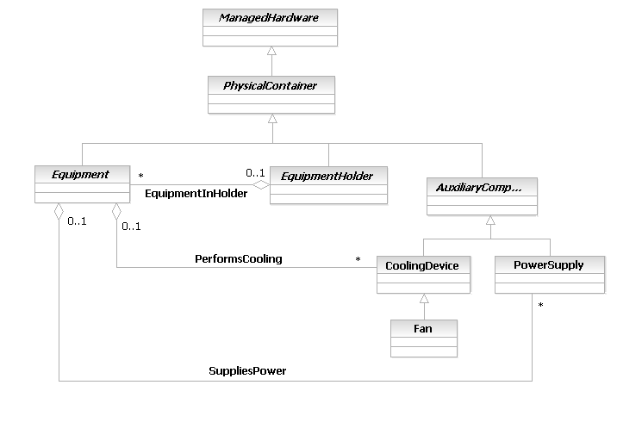
Figure 5PR- 53. AuxiliaryComponent Business Entity Model
CoolingDevice Business Entity Definition
Business Entity Name | CoolingDevice
Description | This class represents the capabilities of a generic cooling device.  Additional detail will be supplied in a later version of the SID. It is present to provide an example of a type of AuxiliaryComponent.
Sources | DEN-ng
Cross-References
Synonyms / Aliases | No direct analog in M.3100. (Note that the CIM has a completely different class hierarchy).
Related Business Entities | Resource, PhysicalResource, PhysicalDevice, Hardware, ManagedHardware, PhysicalContainer, AuxiliaryComponent (superclass), PowerSupply, Fan, Equipment, Card, EquipmentHolder, Chassis, Rack, Slot, Shelf, Bay, PhysicalResourceRole, PhysicalDeviceRole, HardwareRole
Business Rules | To be determined

CoolingDevice Business Entity Attributes Definition
Business Entity Name | CoolingDevice

Attribute Name | Description | Data Type | Notes (used to map to other models; blank is other models don’t have it)
hasActiveCooling | This is a Boolean that, if TRUE, means that this CoolingDevice provides active cooling. If it is false, then cooling is provided by a passive means. | Boolean | Not present in M.3100. Present in the CoolingDevice class of the CIM, and called ActiveCooling. However, this class is in the LogicalDevice model. Thus, the class hierarchy and semantics are completely different than those of DEN-ng.

Business Entity Model – CoolingDevice
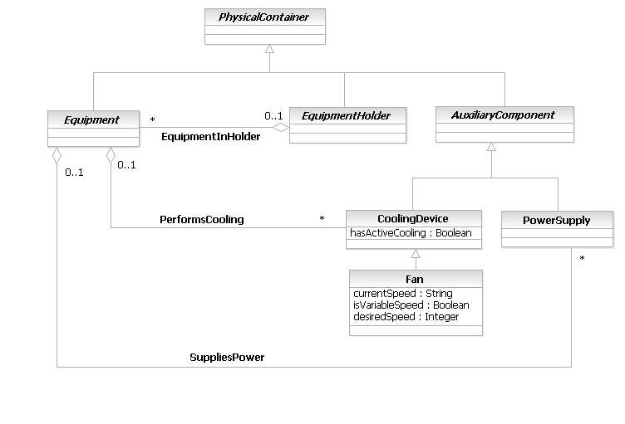
Figure 5PR- 54. CoolingDevice and Fan Business Entity Model
Fan Business Entity Definition
Business Entity Name | Fan
Description | This class represents the capabilities of a generic Fan.  Additional detail will be supplied in a later version of the SID. It is present to provide an example of a type of AuxiliaryComponent.
Sources | DEN-ng, CIM
Cross-References
Synonyms / Aliases | No direct analog in M.3100. (Note that the CIM has a completely different class hierarchy).
Related Business Entities | Resource, PhysicalResource, PhysicalDevice, Hardware, ManagedHardware, PhysicalContainer, AuxiliaryComponent, PowerSupply, CoolingDevice (superclass), Equipment, Card, EquipmentHolder, Chassis, Rack, Slot, Shelf, Bay, PhysicalResourceRole, PhysicalDeviceRole, HardwareRole
Business Rules | To be determined

Fan Business Entity Attributes Definition
Business Entity Name | Fan

Attribute Name | Description | Data Type | Notes (used to map to other models; blank is other models don’t have it)
currentSpeed | This is the current speed of the Fan in revolutions per minute. | String | Not present in M.3100. The CIM derives this attribute through an association with a tachometer.
isVariableSpeed | This is a Boolean attribute that, if TRUE, means that this fan supports variable cooling speeds. If it is FALSE, then this fan only provides a single cooling speed. | Boolean | Not present in M.3100. Present in the Fan class of the CIM. However, this class is in the LogicalDevice model. Thus, the class hierarchy and semantics are completely different than those of DEN-ng.
desiredSpeed | This is an integer attribute that defines the currently requested fan speed, defined in revolutions per minute.  For non-variable speed Fans, this attribute has the same semantics as turning the Fan on or off. For variable-speed Fans, this attribute represents the desired speed of the Fan. | Integer | Not present in M.3100. Present in the Fan class of the CIM. However, this class is in the LogicalDevice model. Thus, the class hierarchy and semantics are completely different than those of DEN-ng. In addition, the CIM only allows this attribute for variable speed Fans.

Business Entity Model – Fan
The Fan business entity model is the same as the CoolingDevice business entity model, which was shown in Figure PR.54 above.
PowerSupply Business Entity Definition
Business Entity Name | PowerSupply
Description | This class represents the capabilities of a generic PowerSupply.  Additional detail will be supplied in a later version of the SID. It is present to provide an example of a type of AuxiliaryComponent.
Sources | DEN-ng, CIM
Cross-References
Synonyms / Aliases | No direct analog in M.3100. (Note that the CIM has a completely different class hierarchy).
Related Business Entities | Resource, PhysicalResource, PhysicalDevice, Hardware, ManagedHardware, PhysicalContainer, AuxiliaryComponent (superclass), CoolingDevice, Equipment, Card, EquipmentHolder, Chassis, Rack, Slot, Shelf, Bay, PhysicalResourceRole, PhysicalDeviceRole, HardwareRole
Business Rules | To be determined

PowerSupply Business Entity Attributes Definition
Note: the CIM has a similarly named class. However, it is in the LogicalDevice model. Thus, the class hierarchy, attributes, and semantics are completely different than those of DEN-ng.
Business Entity Name | PowerSupply

Attribute Name | Description | Data Type | Notes (used to map to other models; blank is other models don’t have it)
acFrequencyLow | This defines the low value of the AC Frequency range in Hertz. If this is a DC PowerSupply, this value is not applicable and should be set to NULL.  This is an optional attribute. | String | Not present in M.3100. The CIM has two attributes for defining two ranges, which are Integer datatypes.
acFrequencyHigh | This defines the high value of the AC Frequency range in Hertz. If this is a DC PowerSupply, this value is not applicable and should be set to NULL.  This is an optional attribute. | String | Not present in M.3100. The CIM has two attributes for defining two ranges, which are Integer datatypes.
isAC | This is a Boolean attribute that, if TRUE, signifies this to be an AC PowerSupply. If FALSE, then it is a DC PowerSupply.  This is a required attribute. | Boolean | Not present in M.3100 or the CIM (it can be derived by examining various other attributes).
isSwitching | This is a Boolean attribute that, if TRUE, indicates that this PowerSupply is a switching (vs linear) PowerSupply.  This is a required attribute. | Boolean | Not present in M.3100. The CIM calls this IsSwitchngSupply.
inputVoltageLow | This is a string that defines the low value for the Input Voltage Range for this PowerSupply.  This is an optional attribute. | String | Not present in M.3100. The CIM has two attributes for defining two ranges, which are Integer datatypes.
inputVoltageHigh | This is a string that defines the high value for the Input Voltage Range for this PowerSupply.  This is an optional attribute. | String | Not present in M.3100. The CIM has two attributes for defining two ranges, which are Integer datatypes.
inputCurrentMax | This is a string that defines the input current rating in amperes for a fully populated chassis. For a DC PowerSupply, this is the maximum current drawn when operating at the lowest permissible value of its input voltage range. For an AC PowerSupply, the value of this attribute is the same as the value of the InputCurrentMin attribute.  This is an optional attribute. | String | Not present in M.3100 or the CIM.
inputCurrentMin | This is a string that defines the input current rating in amperes for a fully populated chassis. For a DC PowerSupply, this is the minimum current drawn when operating at the lowest permissible value of its input voltage range. For an AC PowerSupply, the value of this attribute is the same as the value of the InputCurrentMax attribute.  This is an optional attribute. | String | Not present in M.3100 or the CIM.
dcOutputPower | This is the maximum value of the output power of the DC PowerSupply. If this is an AC PowerSupply, then this attribute must be set to NULL.  This is an optional attribute. | String | Not present in M.3100. The CIM calls this TotalOutputPower.
isRedundant | This is a Boolean attribute that, if TRUE, signifies this PowerSupply as a redundant PowerSupply.  This is a required attribute. | Boolean | Not present in M.3100 or the CIM.

Business Entity Model – PowerSupply
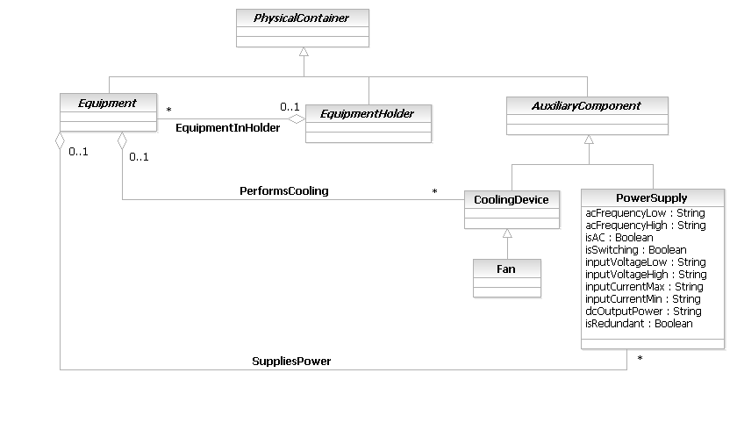
Figure 5PR- 55. PowerSupply Business Entity Model
PhysicalComponent Business Entity Definition
Business Entity Name | PhysicalComponent
Description | This is the base class for different types of PhysicalComponents that can reside either in an Equipment or an EquipmentHolder object. They can NOT be used as a stand-alone object.  From a management point-of-view, this object either can not or does not need to be split into its constituent parts. For example, an ASIC (or Chip) can not , and a tape for data storage does not, need to be split up into their constituent parts. Any piece of hardware that is not a PhysicalLink, PhysicalConnector, Equipment, or EquipmentHolder, is a subclass of this class.
Sources | DEN-ng
Cross-References
Synonyms / Aliases | No direct analog in M.3100. (Note that the CIM has a similarly named class, but its function is different. The DEN-ng PhysicalContainer class contains those attribute. There is no configuration notion in the current version of the CIM, and hence there is no counterpart in the CIM to this class.
Related Business Entities | Resource, PhysicalResource, PhysicalDevice, Hardware, ManagedHardware, PhysicalContainer (superclass), Equipment, Card, EquipmentHolder, Chassis, Rack, Slot, Shelf, Bay, AuxiliaryComponent, PhysicalResourceRole, PhysicalDeviceRole, HardwareRole
Business Rules | To be determined

PhysicalComponent Business Entity Attributes Definition
Business Entity Name | PhysicalComponent

Attribute Name | Description | Data Type | Notes (used to map to other models; blank is other models don’t have it)
isConfigurable | This is a Boolean attribute that, if TRUE, means that this PhysicalComponent is configurable by the end-user. This is an optional attribute. | Boolean | No analog in either the M.3100 or the DMTF CIM.

Business Entity Model – PhysicalComponent
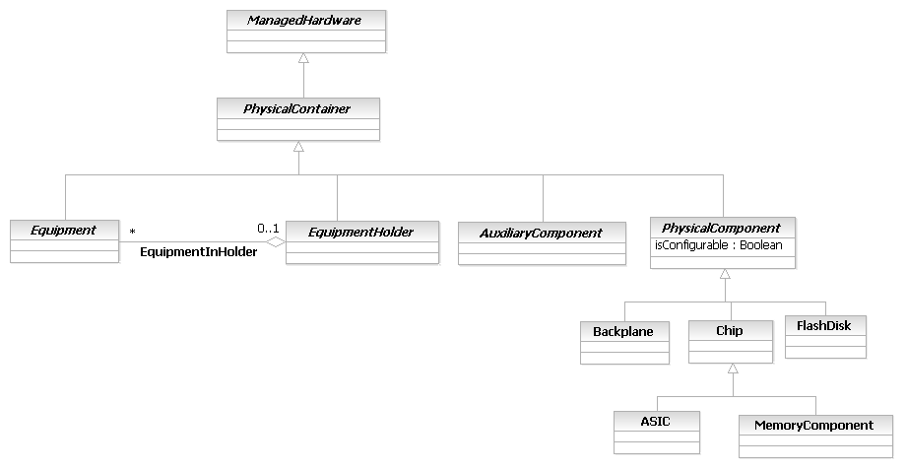
Figure 5PR- 56. PhysicalComponent Business Entity Model
Backplane Business Entity Definition
Business Entity Name | Backplane
Description | This class models the backplane that is present in devices.  The current version of this class is serving as a placeholder to illustrate different types of PhysicalComponents. It will be further developed in the next version of the SID.
Sources | DEN-ng
Cross-References
Synonyms / Aliases | This class models the backplane that is present in devices.  The current version of this class is serving as a placeholder to illustrate different types of PhysicalComponents. It will be further developed in the next version of the SID.
Related Business Entities | Resource, PhysicalResource, PhysicalDevice, Hardware, ManagedHardware, PhysicalContainer, Equipment, Card, EquipmentHolder, Chassis, Rack, Slot, Shelf, Bay, AuxiliaryComponent, PhysicalComponent (superclass), PhysicalResourceRole, PhysicalDeviceRole, HardwareRole
Business Rules | To be determined

Backplane Business Entity Attributes Definition
Business Entity Name | Backplane

Attribute Name | Description | Data Type | Notes (used to map to other models; blank is other models don’t have it)

Business Entity Model – Backplane
The Backplane Business Entity Model is the same as that for PhysicalComponent, and is shown in Figure PR.56 above.
Chip Business Entity Definition
Business Entity Name | Chip
Description | This is a concrete class that models different types of chips that are either directly configurable by the end-user (e.g., a programmable device) and/or represent FRUs (e.g., a special ASIC that can be upgraded by replacing it with a new version of that same ASIC).  Note that capacity characteristics (e.g., how much memory can a Flash chip hold) are defined through the PhysicalCapacity association.
Sources | DEN-ng
Cross-References
Synonyms / Aliases | No direct analog in M.3100. The CIM has a similarly named class, but its position in the CIM class hierarchy is different than the position of this class in the DEN-ng class hierarchy. Therefore, the semantics are different.
Related Business Entities | Resource, PhysicalResource, PhysicalDevice, Hardware, ManagedHardware, PhysicalContainer, Equipment, Card, EquipmentHolder, Chassis, Rack, Slot, Shelf, Bay, AuxiliaryComponent, PhysicalComponent (superclass), ASIC, MemoryComponent, Backplane, PhysicalResourceRole, PhysicalDeviceRole, HardwareRole
Business Rules | To be determined

Chip Business Entity Attributes Definition
Business Entity Name | Chip

Attribute Name | Description | Data Type | Notes (used to map to other models; blank is other models don’t have it)
formFactor | This is an enumerated integer that defines the form factor of this PhysicalComponent. Values include:  0: Unknown  1: Other  2: Custom  3: SIP  4: DIP  5: ZIP  6: SOJ  7: SIMM  8: DIMM  9: PGA  10: RIMM  11: SRIMM  12: SODIMM  13: SOIC  14: LCC  15: PLCC  This is an optional attribute. | Integer | No analog in M.3100; this is a subset of the DMTF CIM attributes.

Business Entity Model – Chip
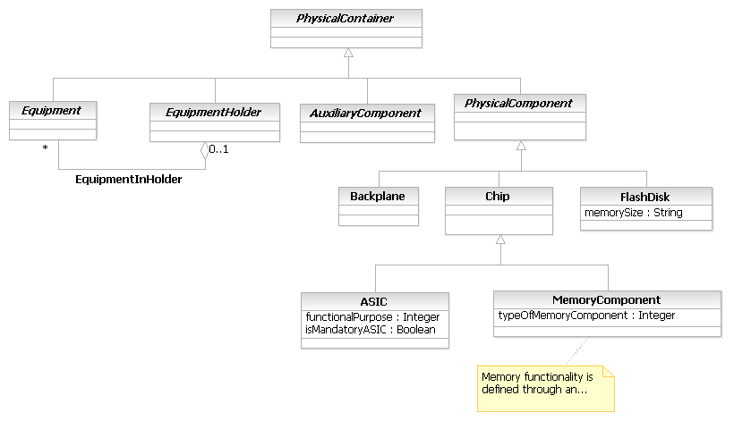
Figure PR.57 - Chip, ASIC, and MemoryComponent Business Entity Model
ASIC Business Entity Definition
Business Entity Name | ASIC
Description | An ASIC is an Application Specific Integrated Circuit.  This class represents a special type of Chip that is used to upgrade the functionality of a networking device. Examples include upgrading the modem function of a device, increasing the processing capability of a Card or Device, and implementing some type of networking functionality, such as fast switching, directly in hardware (as opposed to emulating it in software).
Sources | DEN-ng
Cross-References
Synonyms / Aliases | No direct analog in M.3100 or the CIM.
Related Business Entities | Resource, PhysicalResource, PhysicalDevice, Hardware, ManagedHardware, PhysicalContainer, PhysicalComponent, Chip (superclass), MemoryComponent, Equipment, Card, EquipmentHolder, Chassis, Rack, Slot, Shelf, Bay, AuxiliaryComponent, PhysicalResourceRole, PhysicalDeviceRole, HardwareRole
Business Rules | To be determined

ASIC Business Entity Attributes Definition
Business Entity Name | ASIC

Attribute Name | Description | Data Type | Notes (used to map to other models; blank is other models don’t have it)
functionalPurpose | This is an enumerated integer that defines the functional purpose of this ASIC. Values include:  0: Unknown  1: Routing Traffic  2: Forwarding Traffic  3: Encrypting Traffic  4: Firewalling  5: Encoding  6: General Computational Functions  Additional values will be added in the next release of DEN-ng. | Integer | No analog in either the M.3100 or the DMTF CIM.
isMandatoryASIC | This is a Boolean attribute that, if TRUE, signifies that this ASIC is mandatory for the correct operation of the PhysicalResource that contains it. | Boolean | No analog in either the M.3100 or the DMTF CIM.

Business Entity Model – ASIC
The ASIC Business Entity Model is the same as that for Chip, and is shown in Figure PR.57 above.
MemoryComponent Business Entity Definition
Business Entity Name | MemoryComponent
Description | This class represents memory devices that are implemented as Chips. Note that this only represents the physical packaging of the Memory Chip – the logical functionality is defined in a separate class, called Memory, that is part of the LogicalResource model.  The current version of this class is serving as a placeholder to illustrate different types of PhysicalComponents. It will be further developed in the next version of the SID.
Sources | DEN-ng
Cross-References
Synonyms / Aliases | No direct analog in M.3100 or the CIM. (Note that the CIM has a class named Memory, but its (class) derivation is different. Hence, there is no counterpart in the CIM to this class.
Related Business Entities | Resource, PhysicalResource, PhysicalDevice, Hardware, ManagedHardware, PhysicalContainer, PhysicalComponent, Chip (superclass), ASIC, Backplane, Equipment, Card, EquipmentHolder, Chassis, Rack, Slot, Shelf, Bay, AuxiliaryComponent, PhysicalResourceRole, PhysicalDeviceRole, HardwareRole
Business Rules | To be determined

MemoryComponent Business Entity Attributes Definition
Business Entity Name | MemoryComponent

Attribute Name | Description | Data Type | Notes (used to map to other models; blank is other models don’t have it)
typeOfMemoryComponent | This is an enumerated integer that defines the type of memory that this Chip is. Values include:  0: Unknown  1: Proprietary  2: RAM  3: DRAM  4: Synchronous DRAM  5: Cache DRAM  6: EDRAM  7: VRAM  8: SRAM  9: EDO  10: ROM  11: PROM  12: EPROM  13: EEPROM  14: FEPROM  15: Flash  16: CDRAM  17: 3DRAM  18: SDRAM  19: SGRAM  20: RDRAM  21: DDR  This is an optional attribute. | Integer | No analog in either the M.3100 or the DMTF CIM.

Business Entity Model – MemoryComponent
The MemoryComponent Business Entity Model is the same as that for Chip, and is shown in Figure PR.57 above.
FlashDisk Business Entity Definition
Business Entity Name | FlashDisk
Description | FlashDisk are memory-based devices that conform to the PC Card (formerly PCMCIA) standard, and that present an ATA (AT Attachment) interface to the device. The Flash Disk has controller circuitry that allows it to emulate a hard disk and that automatically maps out bad blocks and performs automatic block erasure. Furthermroe, the Flash Disk provides the capability to allocate noncontiguous sectors, which a Flash memory device can't.
Sources | DEN-ng
Cross-References
Synonyms / Aliases | No direct analog in M.3100 or the CIM.
Related Business Entities | Resource, PhysicalResource, PhysicalDevice, Hardware, ManagedHardware, PhysicalContainer, PhysicalComponent (superclass), Chip, ASIC, MemoryComponent, Backplane, Equipment, Card, EquipmentHolder, Chassis, Rack, Slot, Shelf, Bay, AuxiliaryComponent, PhysicalResourceRole, PhysicalDeviceRole, HardwareRole
Business Rules | To be determined

FlashDisk Business Entity Attributes Definition
Business Entity Name | FlashDisk

Attribute Name | Description | Data Type | Notes (used to map to other models; blank is other models don’t have it)
memorySize | This is the size of the Flash disk in MBytes. | String | No analog in either the M.3100 or the DMTF CIM.

Business Entity Model – FlashDisk
The FlashDisk Business Entity Model is the same as that for Chip, and is shown in Figure PR.57 above.

Administrative Appendix
This Appendix provides additional background material about the TeleManagement Forum and this document. In general, sections may be included or omitted as desired, however a Document History must always be included.

About this document
This is a TM Forum Guidebook. The guidebook format is used when:
- The document lays out a ‘core’ part of TM Forum’s approach to automating business processes. Such guidebooks would include the Telecom Operations Map and the Technology Integration Map, but not the detailed specifications that are developed in support of the approach.
- Information about TM Forum policy, or goals or programs is provided, such as the Strategic Plan or Operating Plan.
- Information about the marketplace is provided, as in the report on the size of the OSS market.

Document History

Version History
This section records the changes between this and the previous Official document release
Version Number | Date Modified | Modified by | Description of changes
0.1 | January 2002 | J. Strassner | GB915 Addendum Template created from TMF407 v1.1 Guidebook template
0.2 | February 2002 | J. Strassner | Initial population using DEN-ng physical model, which contains mined information from DEN, CIM, and M.3100
0.3 | March 2002 | J. Strassner | Revisions and publication to Resource team
0.4 | April 2002 | J. Strassner | Revisions from JohnR and Wayne incorporated
0.45 | April 2002 | J. Strassner | Revisions to build closer link to Location model; additional business entity definitions
0.5 | May 2002 | J. Strassner | Final revisions per SID conference call
1.0 | June 2002 | TMF | Formatted for Member Evaluation release
1.1 | August 2002 | J. Strassner | Incorporation of review comments from Phase 2 work
1.5 | September 2002 | J. Strassner | Incorporated final review comments from Phase 2 work and implementation experience comments
1.6 | October 2002 | J. Strassner | Minor revisions incorporated from final review
2.0 | October 2002 | TMF | Formatted for Member Evaluation release
2.1 | May 2003 | J. Strassner | Revisions to sync this model to other Addenda that are part of NGOSS release 3.5
2.2 | June 2003 | J. Strassner | Final submission to team
2.3 | June 2003 | J. Strassner | Minor corrections to PartyRole interaction
3.0 | July 2003 | TMF | Formatted for Member Review with NGOSS R3.5
3.1 | Aug 2004 | TMF | To reflect TMF Approved status
9.0 | 1 Mar 2010 | John Wilmes | Generated business entity section
9.1 | 28 Apr 2010 | Alicja Kawecki | Minor cosmetic corrections for web posting and ME
9.2 | 31 Dec 2010 | John Reilly | Updated Notice
9.3 | 23 Mar 2011 | Alicja Kawecki | Minor formatting corrections for web posting and ME
9.4 | 30 Sep 2011 | John Wilmes | Updates to document
9.5 | 4 Oct 2011 | Alicja Kawecki | Updated cover page and footer to reflect TM Forum Approved status

Release History
Release Number | Date Modified | Modified by: | Description of changes
9.0 | 28 Dec 2009 | Keith Dorking | Addition of TIP model and various adjustments/corrections
9.0 | 1 Mar 2010 | John Wilmes | Generated business entity section
9.5 | 31 Dec 2010 | John Reilly | Updated Notice

Company Contact Details
Company | Team Member Representative
Amdocs | Name: Josh Salomon  Title: Senior Billing architect,  Email: joshs@amdocs.com  Phone: +972 9 7764422  Fax
Progress Software | Name: John Wilmes  Title: Chief Technical Architect  Email: jwilmes@progress.com  Phone: +1 650 302 5198  Fax

Acknowledgments
This document was prepared by the members of the TeleManagement Forum SID team:
The Shared Information/Data Model is a genuinely collaborative effort. The TM Forum would like to thank the following people for contributing their time and expertise to the production of this document. It is just not possible to recognize all the organizations and individuals that have contributed or influenced the introduction. We apologize to any person or organization we inadvertently missed in these acknowledgments.
Key individuals that reviewed, provided input, managed, and determined how to utilize inputs coming from all over the world, and really made this document happen were:

Name | Affiliation
Cliff Faurer | TeleManagement Forum
Ram Garg | MetaSolv Software
Chris Hartley | Telstra
Helen Hepburn | British Telecom
Jenny Huang | AT&T
Matt Izzo | Agilent
Mike McLoughlin | British Telecom
John Reilly | MetaSolv Software
Wayne Sigley | Telstra
John Strassner | Intelliden (editor)

