Shared Information/Data (SID) Model
Enterprise Domain Revenue Assurance Business Entities

GB922 Addendum 7RA
TM Forum Approved Version 1.5


September, 2011

Notice
This material, including documents, code and models, has been through review cycles; however, due to the inherent complexity in the design and implementation of software and systems, no liability is accepted for any errors or omissions or for consequences of any use made of this material.
Under no circumstances will the TM Forum be liable for direct or indirect damages or any costs or losses resulting from the use of this specification. The risk of designing and implementing products in accordance with this specification is borne solely by the user of this specification.
This material bears the copyright of TM Forum and its use by members and non-members of TM Forum is governed by all of the terms and conditions of the Intellectual Property Rights Policy of the TM Forum (http://www.tmforum.org/Bylaws/1094/home.html) and may involve a claim of patent rights by one or more TM Forum members or by non-members of TM Forum.

Direct inquiries to the TM Forum office:
240 Headquarters Plaza,
East Tower – 10th Floor,
Morristown, NJ 07960 USA
Tel No. +1 973 944 5100
Fax No. +1 973 944 5110
TM Forum Web Page: www.tmforum.org

Table of Contents
Notice 2
Table of Contents 3
List of Figures 4
Executive Summary 5
1. Business Entities 7
1.1 Revenue Assurance Control and Revenue Assurance Key Performance Indicator (KPI) 8
1.2Revenue Assurance Violation 17
1.3 Revenue Assurance Trouble Ticket 20
1.4 Revenue Assurance Action/Response 23
1.5 Revenue Assurance Assessment 29
1.6Business Entity Definitions – Revenue Assurance Control 33
1.6.1 RevenueAssuranceParameter 33
1.6.2 RevenueAssuranceControl 34
1.6.3 RevenueAssuranceKPI 35
1.6.4 RevenueAssuranceParmValue 35
1.6.5 RevenueAssuranceObjective 37
1.6.6 RevenueAssuranceConsequence 39
1.6.7 RevenueAssuranceControlConsequence 40
1.6.8 RevenueAssuranceKPIConsequence 40
1.6.9 RevenueAssuranceApplicability 41
1.7 Business Entity Definitions – Revenue Assurance Violation 42
1.7.1 RevenueAssuranceViolationSpec 42
1.7.2 RevenueAssuranceViolation 44
1.8 Business Entity Definitions – Revenue Assurance Trouble Ticket 44
1.8.1 RevenueAssuranceTroubleTicketSpec 44
1.8.2 RevenueAssuranceTroubleTicket 46
1.9 Business Entity Definitions – Revenue Assurance Action_Response 46
1.9.1 RevenueAssuranceActionSpec 46
1.9.2 RevenueAssuranceAction 47
1.9.3 RevenueAssuranceResponseSpec 47
1.9.4 RevenueAssuranceResponse 48
1.10 Business Entity Definitions – Revenue Assurance Assessment 49
1.10.1 RevenueAssuranceAssessment 49
1.10.2 RevenueAssuranceAssessmentIItem 50
1.10.3 RevenueAssuranceAssessmentResult 52
1.10.4 RevenueAssuranceRecommendation 53
1.10.5 RevenueAssuranceTrend 53
2.Administrative Appendix 55
2.1 About this document 55
2.2 Document Life Cycle 55
2.3 Document History 56
2.4 Acknowledgments 56

List of Figures
Figure RA.01 – Revenue Assurance ABEs 5
Figure RA.02 – Revenue Assurance Processes 8
Figure RA.03 – Revenue Assurance Parameter 9
Figure RA.04 – Revenue Assurance Objective 10
Figure RA.05 – Revenue Assurance and Policy Rule 12
Figure RA.06 – Revenue Assurance and Policy Statement 13
Figure RA.07 – Revenue Assurance Consequence 15
Figure RA.08 – Revenue Assurance Consequence Subclasses 17
Figure RA.09 – Revenue Assurance Violation 18
Figure RA.10 – Revenue Assurance and Business Interaction 19
Figure RA.11 – Revenue Assurance Trouble Ticket 21
Figure RA.12 – Revenue Assurance Parameters and Entities 22
Figure RA.13 – Revenue Assurance Action 23
Figure RA.14 – Revenue Assurance Action and Trouble Ticket 25
Figure RA.15 – Revenue Assurance Action and Response 26
Figure RA.16 – Revenue Assurance Trouble Ticket Root Cause 28
Figure RA.17 - Revenue Assurance Assessment 31
Figure RA.18 – Revenue Assurance Assessment Result 32

Executive Summary
Revenue leakage is considered a cost of doing business in the telecom industry. Revenues are lost due to several reasons such as network provisioning, mediation and CDR errors, billing and interconnect inconsistencies, lost of data and corrupted files, fragmented support systems and manual or fuzzy business processes. Revenue Assurance research reports estimations are that the degree of exposure varies in the range of the 3% to 15% percent of the carriers' revenue depending on factors such as services type, geography, carrier type, and RA maturity level.

The main question for any business is how much leakage is acceptable and how to improve the operations and systems in such a way that minimizes those leakages. Effective Revenue Assurance (RA) process must ensure the data integrity and synchronization across all the disparate systems and the network itself, in order to ensure operational and financial efficiency. Such process provide analysis of the relationship between network resources, services, customers, and generated revenue, and will enable the service provider to detect revenue leakage (e.g. un-billed customers, mis-billed customers), stranded assets, and operational inefficiencies.

In addition, a process management layer is required to allow RA managers and Financial Directors to enjoy the benefits of their achievements, track the revenue leakage identification, quantification and reclamation processes and easily report the results. A big challenge for RA and communications business in general is to move gradually the focus of process management away from resolving and reacting to problems that repeatedly occur, and towards the prevention of problems before they occur.

The Revenue Assurance area of the SID provides revenue assurance controls, revenue assurance violations, revenue assurance key performance indicators (KPIs), revenue assurance objectives, and rules that map revenue assurance KPIs and threshold violations to revenue assurance trouble tickets. Additionally, the scope of Revenue Assurance includes revenue assurance actions/responses that reconcile revenue assurance trouble tickets and bring the trouble tickets to closure.

Figure RA..01 depicts the Revenue Assurance Aggregate Business Entities (ABEs) within the SID Framework.

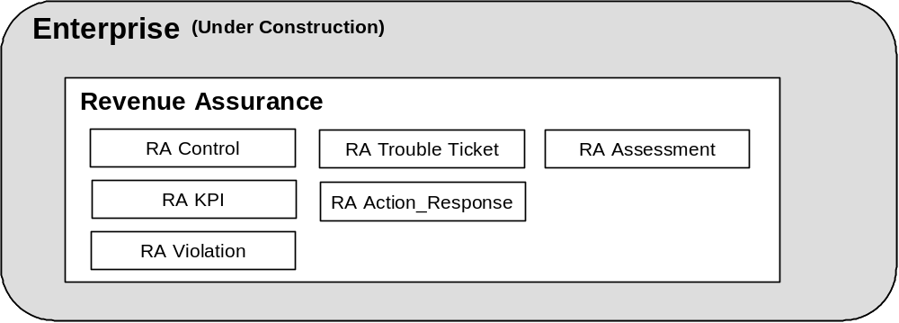
Figure RA.01 – Revenue Assurance ABEs
The Revenue Assurance Control ABE defines policy-based rules that represent the logical definition of comparisons performed on entities, such as bills and call detail records (CDRs), to identify Revenue Assurance Violations. The Revenue Assurance Violation ABE models discrepancies identified based on applying the rules defined by Revenue Assurance Control entities.
Revenue Assurance KPI ABE models KPIs and Revenue Assurance Objectives whose violation trigger Revenue Assurance Trouble Tickets. KPIs are defined on Revenue Assurance Violations and on other revenue assurance related entities, such as bills and CDRs. Revenue Assurance Trouble Ticket ABE entities represent trouble tickets opened to resolve one or several causes (for example, Revenue Assurance Violations) that resulted in a Revenue Assurance KPI not meeting a Revenue Assurance Objective.
Revenue Assurance Action/Response ABE entities represent the result of reconciling Revenue Assurance Trouble Tickets by initiating and performing a series of one or more activities. Revenue Assurance Action/Response ABE entities also model the root cause for Revenue Assurance Trouble Tickets based on rules that trigger root cause analysis.
Revenue Assurance Assessment ABE entities measure the effectiveness of Revenue Assurance Controls, Revenue Assurance Objectives, and Revenue Assurance KPIs. Revenue Assurance Assessment ABE entities include recommendations of refining controls, objectives, and KPIs.

Business Entities
Revenue Assurance (RA) business entities support the complete RA lifecycle. These processes range from creating RA controls, KPIs and RA objectives, identifying RA violations and trouble tickets, resolving trouble tickets to assessing an enterprise’s RA program. RA eTOM processes are shown in Figure RA.02.
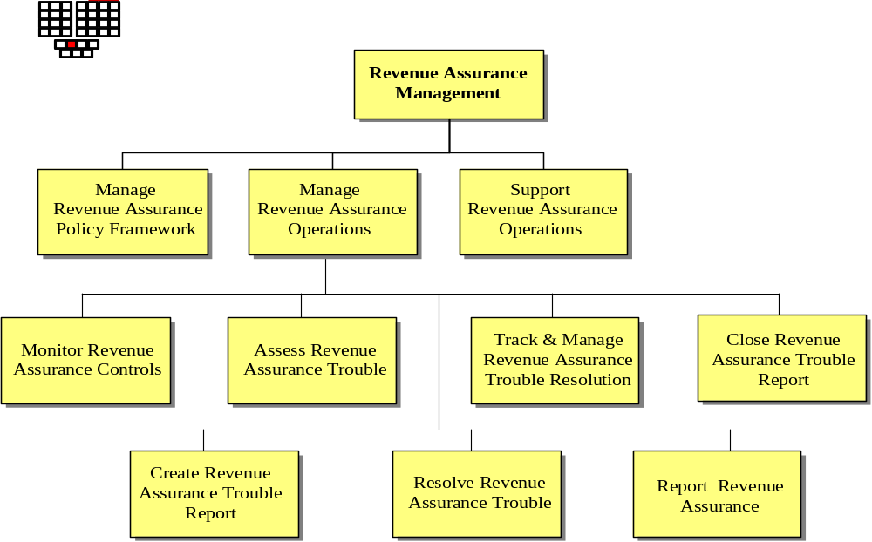
Figure RA.02 – Revenue Assurance Processes

1.1 Revenue Assurance Control and Revenue Assurance Key Performance Indicator (KPI)
The Revenue Assurance Control ABE defines rules that represent the logical definition of comparisons, validations, reconciliation’s, and so forth performed on entities, such as bills and call detail records (CDRs), to identify Revenue Assurance Violations. Simple rules can be stated using RevenueAssuranceObjectives; complex rules can be stated using PolicySets. tRevenue Assurance KPI ABE models KPIs and Revenue Assurance Objectives whose violation trigger Revenue Assurance Trouble Tickets.
Revenue Assurance Controls and Revenue Assurance KPIs serve similar purposes; violating thresholds or other rules associated with them create a discrepancy. In the case of a Revenue Assurance Control, the discrepancy is a Revenue Assurance Violation; in the case of a Revenue Assurance KPI the discrepancy is a Revenue Assurance Trouble Ticket. The identification of discrepancies begins with calculating a value for the control or KPI.
An example of a simple rule expressed as a RevenueAssuranceObjectiive is a value (true [1] or false [0]) determined every day for each customer to be billed that day, that has services and associated usage, but the usage has not been rated and will therefore not appear on the bill. The values are calculated by a defined algorithm, at a specified frequency, and are valid for a certain period of time. In this case the parameter is a RevenueAssuranceControl. If the value is true a RevenueAssuranceViolation is created that identifies the customer as not being billed for services used.
An example of a complex rule expressed as a PolicySet is billing for a higher or lower bandwidth than provided on a circuit. This rule requires an “or” condition not available via RevenueAssuranceObjective.
From a SID perspective controls and KPIs can be viewed as types of RevenueAssuranceParameters as shown in Figure RA.03.

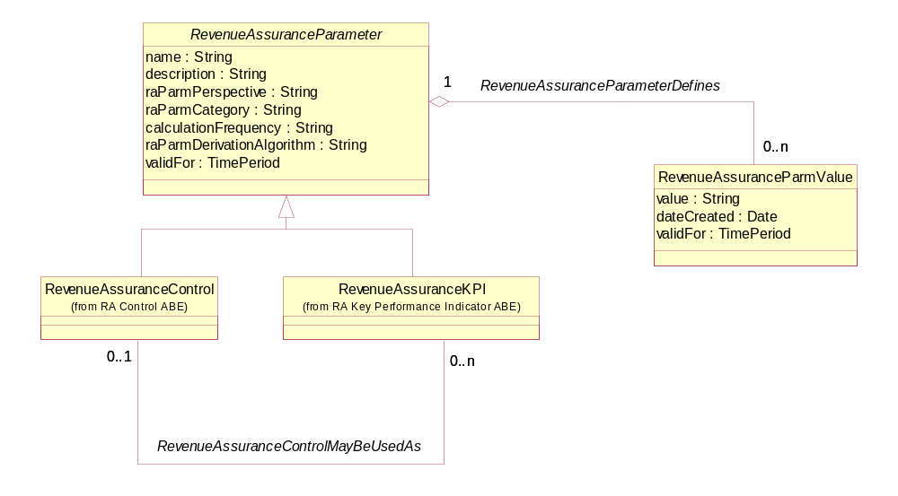
Figure RA.03 – Revenue Assurance Parameter
Figure RA.03 also reveals that RevenueAssuranceControls can also serve as a base for RevenueAssuranceKPIs. For example, if a control exceeds a certain threshold, the action taken may be that the control is considered to be a KPI also.
Thresholds for the RevenueAssuranceParameters are characteristics of RevenueAssuranceObjectives as shown in Figure RA.04.

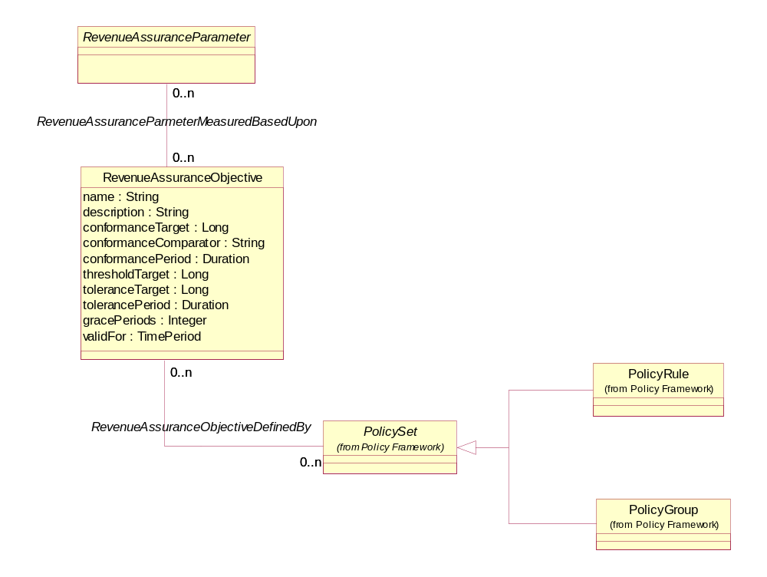
Figure RA.04 – Revenue Assurance Objective
At times the simple rules defined by the attributes of RevenueAssuranceObjectives are not sufficient to determine if a discrepancy should be created based on the RevenueAssuranceParameterValue. In these cases the rules would be defined by a PolicySet, which could be a PolicyRule or a PolicyGroup.

A PolicyGroup is a collection of rules used to define a related set of PolicyRules or other PolicyGroups. The PolicyRule entity acts as the heart of the Policy model and is shown in Figure RA.05. The rule is triggered by an event and comprised of one or more PolicyConditions and one or more PolicyActions. If a PolicyCondition(s) is met then one or more PolicyActions result. The PolicyRule is characterized further by a PolicyRuleSpec.
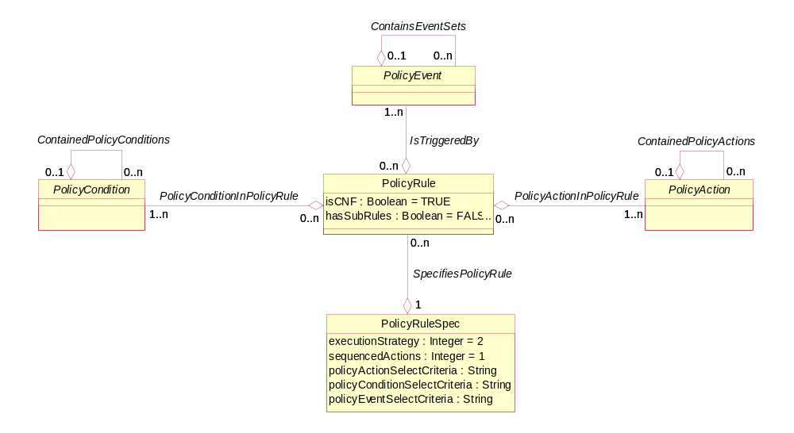
Figure RA.05 – Revenue Assurance and Policy Rule
Each PolicyCondition and PolicyAction is defined by a PolicyStatement as shown in Figure RA.06. A PolicyStatement is structured like a conventional “IF” statement, with a variable, operator, and value.

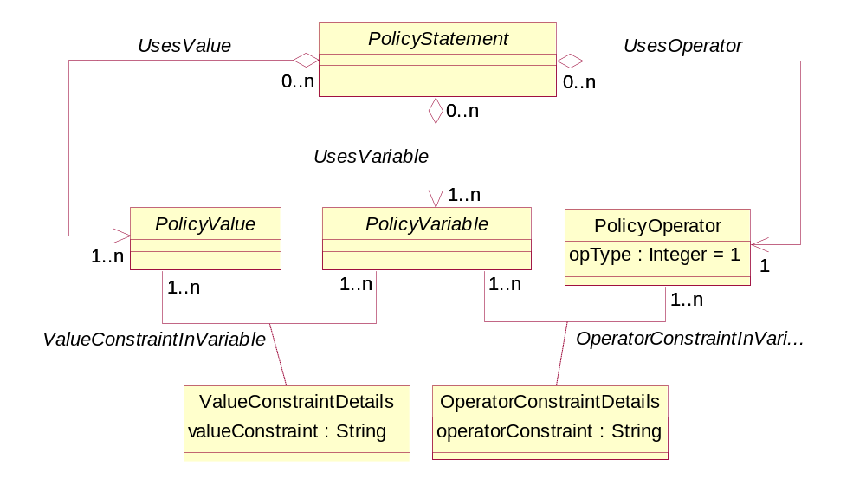
Figure RA.06 – Revenue Assurance and Policy Statement
In the complex rule example, where a bill was generated for higher or lower bandwidth than provided, there would be a complex condition composed as “IF BilledBandwidth > ProvidedBandwidth” “OR” “IF BIlledBandwidth< ProvidedBandwidth”. These three attributes would be derived using a derivation algorithm defined in an existing subclass (ProdOfferPricePolicyVariable) of PolicyVariable. The action would be composed as “SET BandwidthBilledError to true”.
See GB922 Addendum 1POL for details of the Policy ABE.
If the RevenueAssurranceObjective is not met then a consequence results as shown in figure RA.07. The RevenueAssuranceConsequence is characterized by a prescribedAction attribute. This simple attribute may not be sufficient to specify the consequence. If so, then the association to PolicyAction allows for a more complex action to be specified. For example, …Note that the prescribed action may also result in the creation of a RevenueAssuranceViolation or a RevenueAssuranceTroubleTicket as shown in Figure RA.08.
Additionally, parameters, objectives and consequences may be applicable, or not, at certain times. For example, if objectives may be checked during the week, but not on the weekend; consequences may be less severe during the day than during the evening. These scenarios are handled by the RevenueAssuranceApplicability business entity, also shown in Figure RA.07.

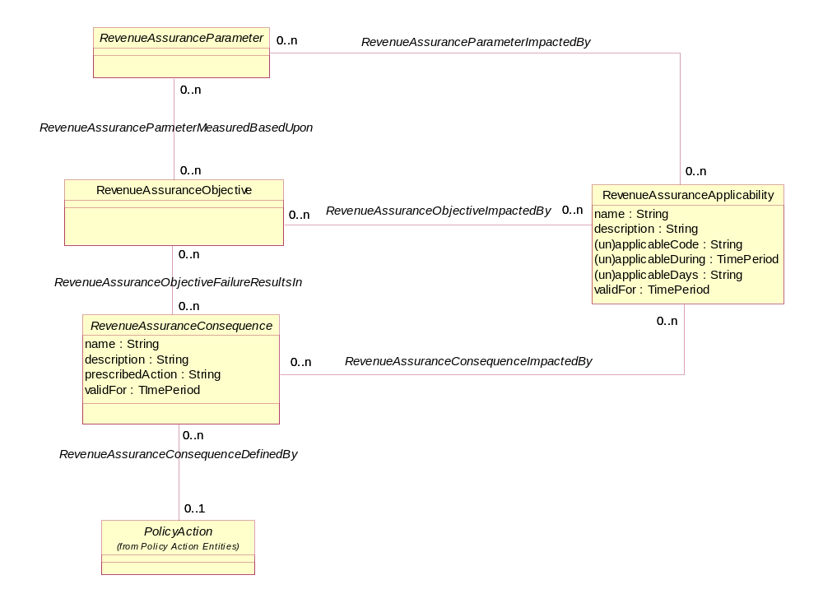
Figure RA.07 – Revenue Assurance Consequence
Some type (modeled as a specification) of RevenueAssuranceViolation or some type (modeled as a specification) of RevenueAssuranceTroubleTicket is created if a RevenueAssuranceObjective is not met. This is based on whether the RevenueAssuranceParameter is a RevenueAssuranceControl or a RevenueAssuranceKPI. Figure RA.08 depicts RevenueAssuranceConsequence subclasses that trigger the creation of a RevenueAssuranceViolation or a RevenueAssuranceTroubleTIcket.

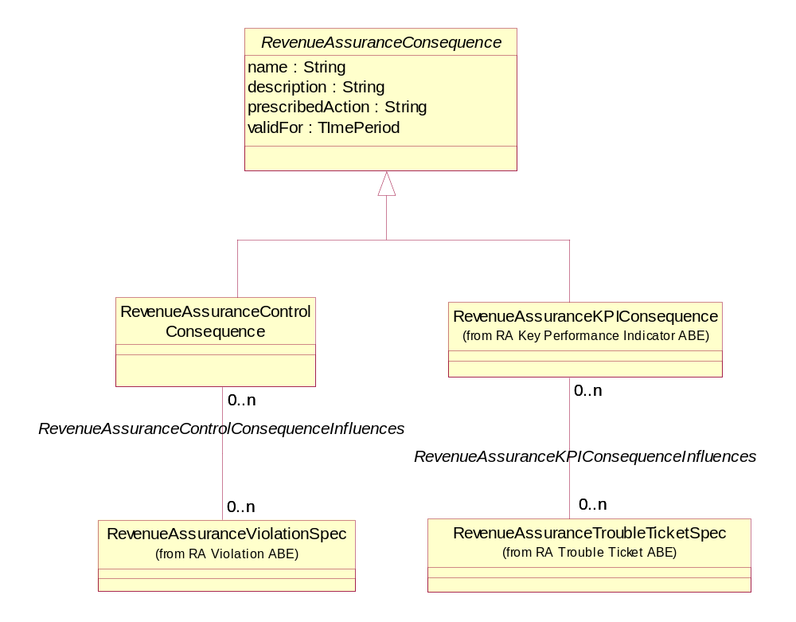
Figure RA.08 – Revenue Assurance Consequence Subclasses
The actual RevenueAssuranceViolation or RevenueAssuranceTroubleTicket is created based on the specification related to the consequence. For example, in previous example, if a customer is not to be billed for services used, then the consequence is related to a RevenueAssuranceViolationSpec instance that classifies and characterizes the RevenueAssuanceViolation as one for unbilled customer services.

1.2Revenue Assurance Violation
The Revenue Assurance Violation ABE models discrepancies identified based on applying the rules defined by Revenue Assurance Control entities as described in the section on Revenue Assurance Controls.
Figure RA.09 depicts how a RevenueAssuranceParameterValue that does not meet a RevenueAssuranceObjective results in a RevenueAssuranceConsequence. The consequence influences the selection of a RevenueAssuranceViolationSpec that results in a RevenueAssuranceViolation, which is also associated to the parameter value that triggered its creation.
In the customer billing control the value of true (1) means that the objective has not been met and results in a consequence named “Customer Service Not Billed”. The consequence is related to a RevenueAssuranceViolationSpec named “Discrepancy in Customer Services Billed”. The consequence describes the RevenueAssuranceViolation named “Customer X Billing Violation”, which is also related to the control value of true.

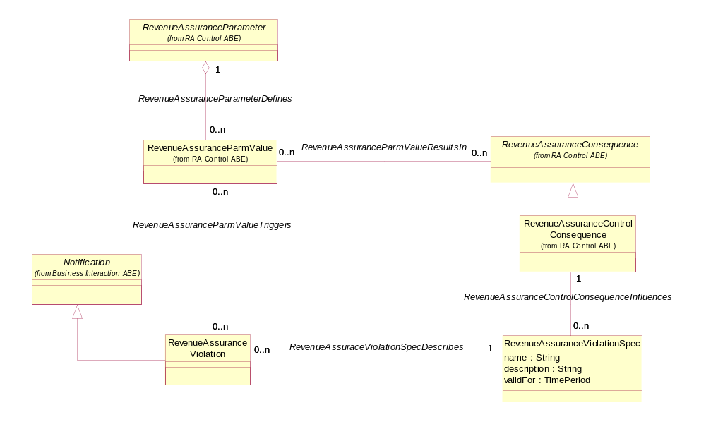
Figure RA.09 – Revenue Assurance Violation
A RevenueAssuranceViolation is a type of Notification, which in turn is a type of BusinessInteraction. As such it inherits a number of characteristics from BusinessInteraction, such as the date, description, status, an association with Location and association with PartyRole, for example, to whom the violation is assigned. Figure RA.10 shows the key entities that make up the BusinessInteraction ABE. Addendum 1BI - Business Interaction fully describes the BusinessInteraction ABE.

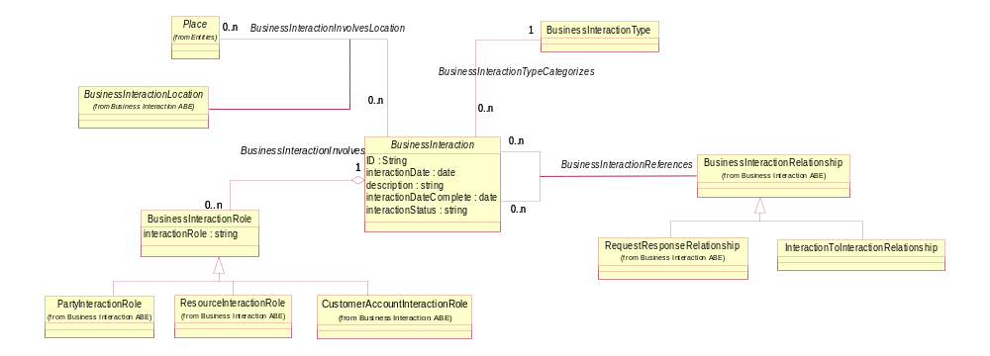
Figure RA.10 – Revenue Assurance and Business Interaction

1.3 Revenue Assurance Trouble Ticket
Revenue Assurance Trouble Ticket ABE entities represent trouble tickets opened to resolve one or several causes (for example, Revenue Assurance Violations) that resulted in a Revenue Assurance KPI not meeting a Revenue Assurance Objective.
Just as the model for controls and KPIs were similar, so are the models for RevenueAssuranceViolations and RevenueAssuranceTroubleTickets as shown in figure RA.11. There are two primary differences in the two models.
First, a RevenueAssuranceTroubleTicket is a type of TroubleTicket, which in turn is a type of BusinessInteraction. Therefore, the TroubleTicket inherits the same characteristics from BusinessInteraction as RevenueAssuranceViolation.
Second, RevenueAssurranceViolations may be used in the derivation of a RevenueAssuranceKPI, which then may trigger a RevenueAssuranceTroubleTicket. For example, if more than “X” number of customers are not billed in a given billing cycle for services used, a trouble ticket is generated. This KPI is a sum of all the “true” parameters that were RevenueAssuranceControl parameter values representing a single unbilled customer. For this reason the RevenueAssuranceViolationSpec may influence the creation of a RevenueAssuranceTroubleTicket via the specification’s association with a RevenueAssuranceTroubleTicketSpec.

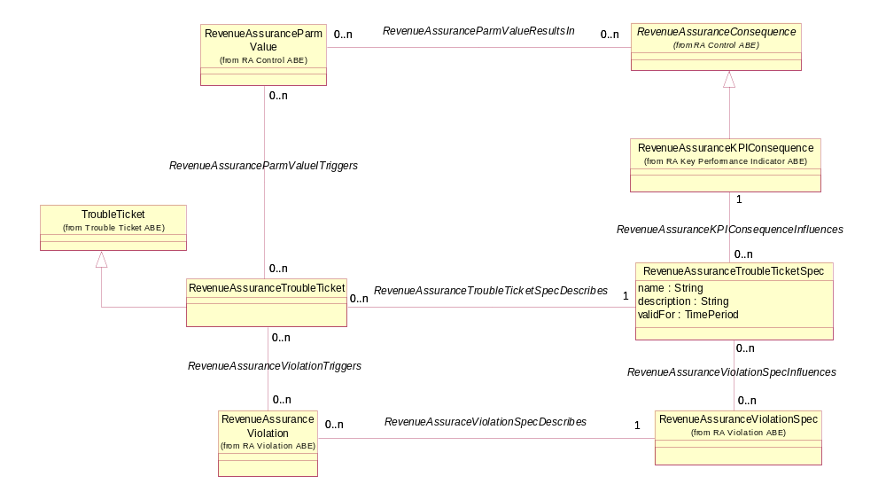
Figure RA.11 – Revenue Assurance Trouble Ticket
The example presented up to this point references a business entity (ServiceUsage) for which the RevenueAssuranceParameter is calculated and the business entity instance (voice mail service for customer X). This implies that associations should be created from the parameter and parameter values to some other entities. The corresponding entities in the SID are RootBusinessEntityType and RootBusinessEntity.
A RootBusinessEntityType represents each occurrence of a business entity within the SID. For example, Customer, Service, Product, Service Usage are all instances of RootBusinessEntityType. The RevenueAssuranceParameter is associated with this entity as shown in Figure RA.12. In the example the “service billed” instance of parameter would be related to the “ServiceUsage” instance of RootEntityType.
A RootEntity represents the each occurrence of a business entity instance in the SID. In the example, the “1” instance of parameter value would be related to the ServiceUsage instance of Customer X’s voice mail usage. This association puts the parameter value into context.

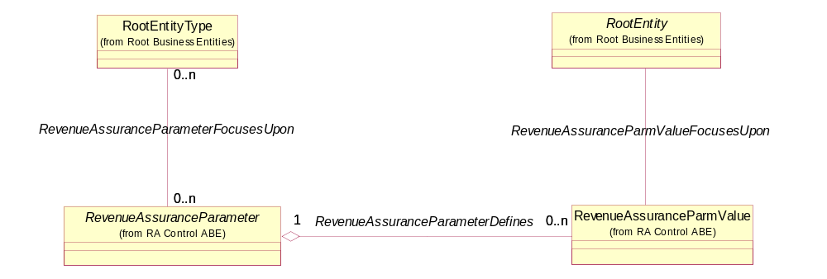
Figure RA.12 – Revenue Assurance Parameters and Entities

1.4 Revenue Assurance Action/Response
Revenue Assurance Action/Response ABE entities represent the result of reconciling Revenue Assurance Trouble Tickets by initiating and performing a series of one or more activities. Revenue Assurance Action/Response ABE entities also model the root cause for Revenue Assurance Trouble Tickets based on rules that trigger root cause analysis.
The actions taken as a result of a RevenueAssuranceTroubleTicket being created are shown in Figure RA.13. Both the RevenueAssuranceActionSpec and the RevenueAssuranceAction entities inherit from existing activity entities that are part of the Project ABE in the Common Business Entities domain. RevenueAssuranceActionSpec and RevenueAssuranceAction represent an application of the EntitySpecification/Entity pattern used throughout the SID.
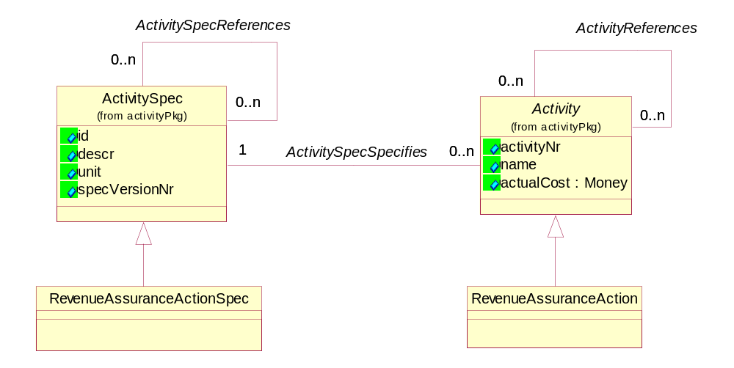
Figure RA.13 – Revenue Assurance Action
Note that there is no explicit association shown between RevenueAssuranceActionSpec and RevenueAssuranceAction. Since RevenueAssuranceActivitySpec is a subclass of ActivitySpec and RevenueAssuranceAction is a subclass of Activitythe the association between ActivitySpec and Activity is inherited.
The set of actions that may be performed to resolve a RevenueAssuranceTroubleTicket are modeled using the association between a RevenueAssuranceTroubleTicketSpec and RevenueAssuranceActionSpec. The association is shown in Figure RA.14.
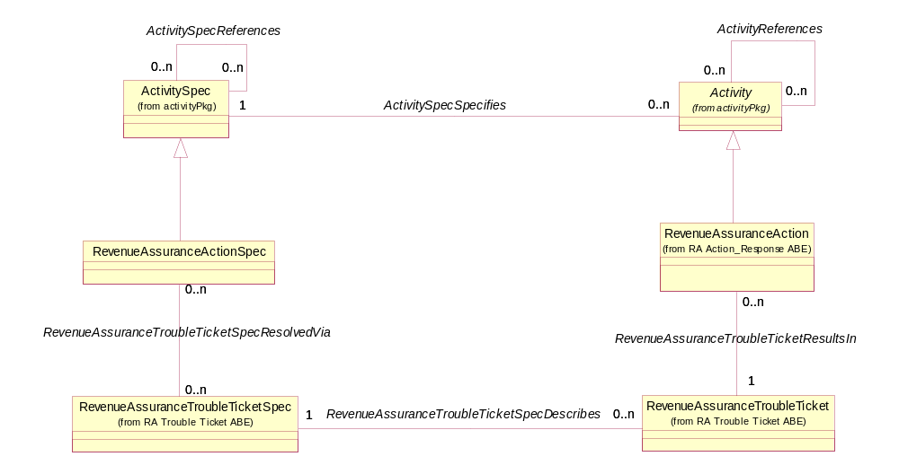
Figure RA.14 – Revenue Assurance Action and Trouble Ticket
The RevenueAssuranceTroubleTicketSpec enables one or more RevenueAssuranceActionSpecs to be selected for which instances of RevenueAssuranceAction are created and associated to the applicable RevenueAssuranceTroubleTicket. In the service usage example, the types of activities may include reviewing the customer account, checking the rating software, requesting a bug fix, close out the trouble ticket, and so forth.
Once the RevenueAssuranceTroubleTicket is resolved, or during the course of taking one or more actions, a RevenueAssuranceResponse may be created. Figure RA.15 depicts the model for RevenueAssuranceResponseSpec and RevenueAssuranceResponse.
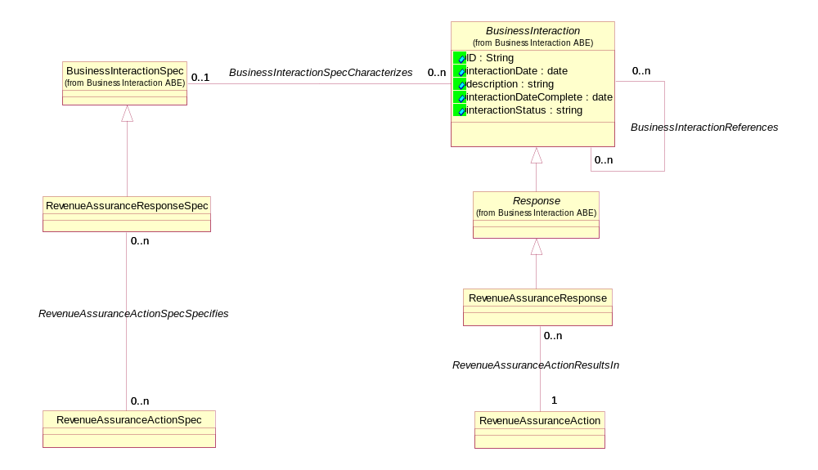
Figure RA.15 – Revenue Assurance Action and Response
The RevenueAssuranceRepsonseSpec represents the different types of responses that can be created as part of a RevenueAssuranceAction. The type of responses is governed by the association between RevenueAssuranceActionSpec and RevenueAssuranceResponseSpec. The RevenueAssuranceResponseSpec describes the invariant characteristics of a RevenueAssuranceResponse. The response is a subclass of BusinessInteraction, and as such, inherits the characteristics of BusinessInteraction, including the ability to relate one response to another.
As the RevenueAssuranceTroubleTicket is being investigated or after it is closed, a root cause for it and other trouble tickets may be found. The root causes can be created as an instance of RevenueAssuranceTroubleTicket and related, using the BusinessInteractionRelationship entity, to the associated RevenueAssuranceTroubleTIckets for which it is the root cause. This is shown in figure RA.16.
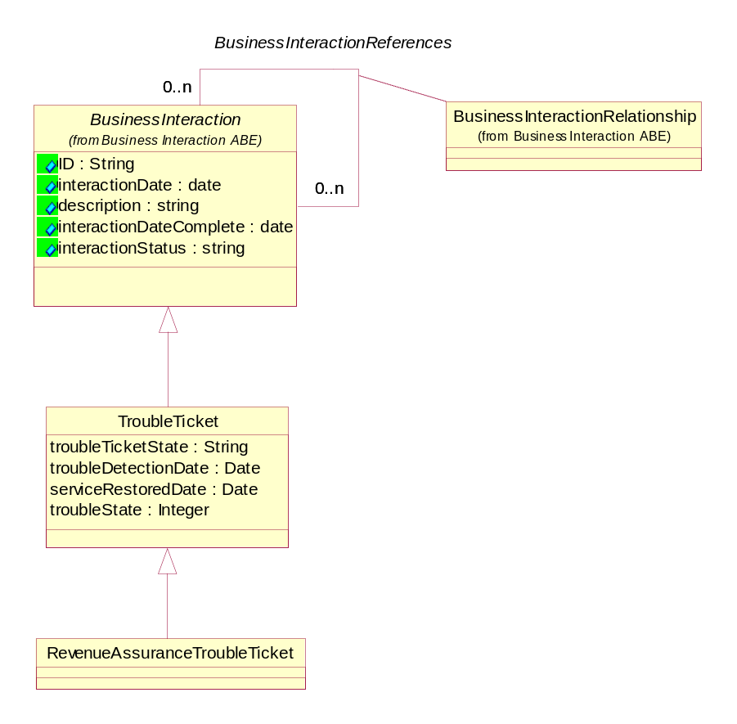
Figure RA.16 – Revenue Assurance Trouble Ticket Root Cause

1.5 Revenue Assurance Assessment
Revenue Assurance Assessment ABE entities measure the effectiveness of Revenue Assurance Controls, Revenue Assurance Objectives, and Revenue Assurance KPIs. Revenue Assurance Assessment ABE entities include recommendations of refining controls, objectives, and KPIs.
The RevenueAssuranceAssessement entity and its related entities support periodic assessments of a Revenue Assurance program as shown in Figure RA.17. One or more individuals and/or organizations (SID Party entity) playing a PartyRole, such as employee, can be involved in an assessment as shown in the figure. A RevenueAssuranceAssessment may target a number of different aspects of a Revenue Assurance program, such as KPIs, objective, consequences, and applicability. The RevenueAssuranceAssessmentItem enables this. Additionally, one or more KPIs, objectives, consequences, and/or applicability can be associated with a single item as shown in the figure.
Both RevenueAssuranceAssessment and RevenueAssuranceAssessmentItem are characterized by a basic set of attributes which include a description, date started, and date completed.
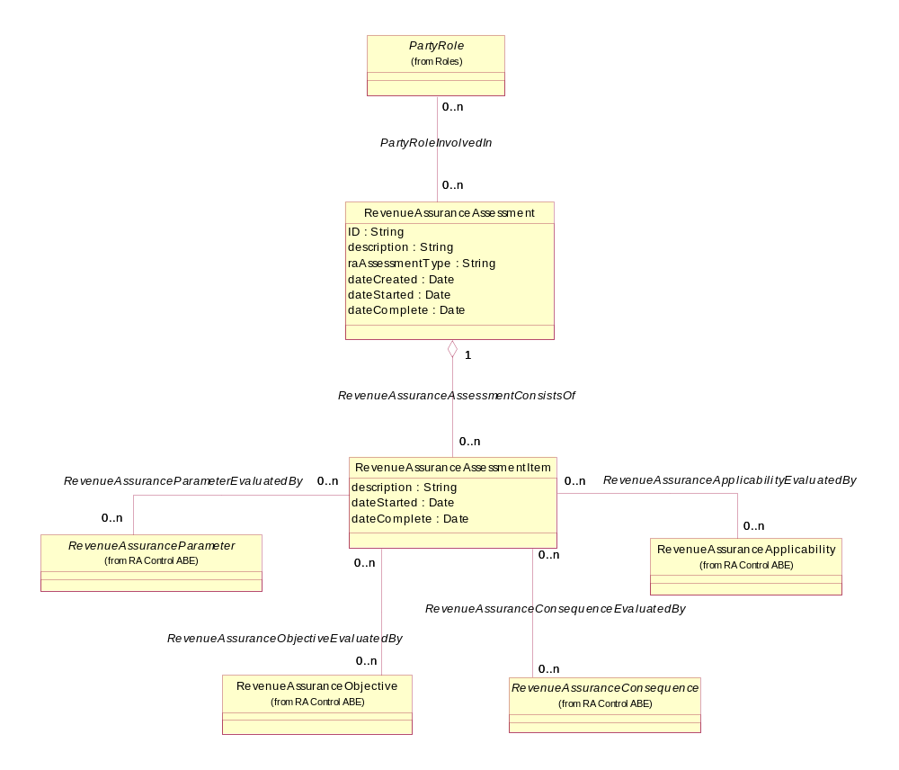
Figure RA.17 - Revenue Assurance Assessment

The outcome of an assessment is defined by the RevenueAssuranceAssessmentResult business entity as shown in Figure RA.18. A result may be a RevenueAssuranceRecommendation or may be an identified RevenueAssuranceTrend. A trend is defined by its associated RevenueAssuranceParmValues and a RevenueAssuranceParameter as shown in the figure. For example, a recommendation may be to expand the time period during with a KPI is applicable; a trend may show an increasing number of customers not billed over a month long period.
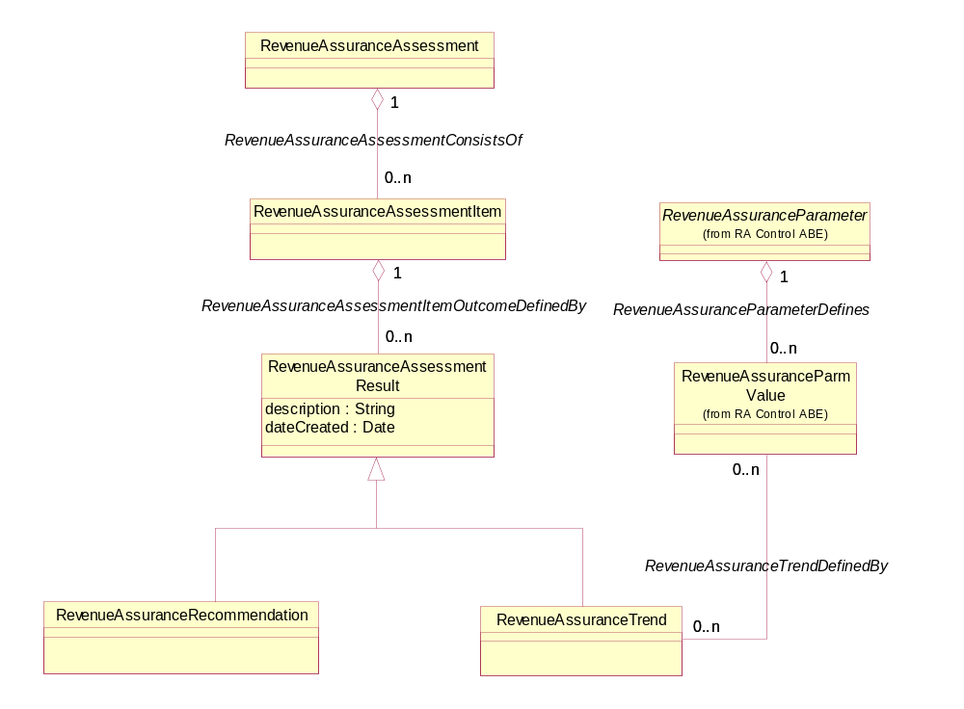
Figure RA.18 – Revenue Assurance Assessment Result

1.6Business Entity Definitions – Revenue Assurance Control

1.6.1 RevenueAssuranceParameter

Business Entity Definition
Business Entity Name | RevenueAssuranceParameter
Description | A variable whose value is used to determine compliance with a RevenueAssuranceObjective.
Sources | Revenue Assurance team | Cross- References |  |  | Synonyms / Aliases
Related Business Entities | Defines RevenueAssuranceParmValue  FocusesUpon RootEntityType  MeasuredBasedUpon RevenueAssuranceObjective  EvaluatedBy RevenueAssureanceAssessmentItem  ImpactedBy RevenueAssuranceApplicability
Business Rules

Business Entity Attributes Definition
Business Entity Name | RevenueAssuranceParameter
Attribute Name | Description | Data Type | Characteristics, Permitted Values & Units | Required/  Optional | Notes
name | A word, term, or phrase by which a parameter is known and distinguished from other RevenueAssuranceParameters. | String |  | Required
description | A narrative that explains in detail what the parameter is. | String |  | Optional
raParmPerspective | The point of view for the parameter, such as a single user instance or an aggregation. | String |  | Optional
raParmCategory | A grouping or set of parameters that are classified together because of common characteristics, such as technology specific, service specific, or technology/service independent. | String |  | Optional
calculationFrequency | The rate of occurrence that a value for a parameter is determined. For example, hourly, daily, weekly. | String |  | Optional
raParmDerivationAlgorithm | A step-by-step procedure used to calculate the parameter. | String |  | Optional
validFor | The period of time during which the parameter is applicable. | String |  | Optional

1.6.2 RevenueAssuranceControl

Business Entity Definition
Business Entity Name | RevenueAssuranceControl
Description | A Policy-based rule that represents the logical definition of comparisons performed on entities, such as CustomerBills and CallDetailRecords, to identify RevenueAssuranceViolations.
Sources | Revenue Assurance Team | Cross- References |  |  | Synonyms / Aliases
Related Business Entities | A type of RevenueAssuranceParameter  MayBeUsedAs RevenueAssuranceKPI
Business Rules

1.6.3 RevenueAssuranceKPI

Business Entity Definition
Business Entity Name | RevenueAssuranceKPI
Description | A measure of a specific aspect of the Revenue Assurance performance of an entity, such as a CustomerBill or CallDetailRecord, defined on a RevenueAssuranceViolation that may trigger the creation of a RevenueAssuranceTroubleTicket.
Sources | Revenue Assurance Team | Cross- References |  |  | Synonyms / Aliases
Related Business Entities | A type of RevenueAssuranceParameter  MayBeDefinedBy RevenueAssuranceControl
Business Rules

1.6.4 RevenueAssuranceParmValue

Business Entity Definition
Business Entity Name | RevenueAssuranceParmValue
Description | A numerical value or text determined for a RevenueAssuranceParameter. For example, a value of 10 determined for the number of Customers not billed in a given day.
Sources | Revenue Assurance Team | Cross- References |  |  | Synonyms / Aliases
Related Business Entities | FocusesUpon RootEntity  Triggers RevenueAssuranceTroubleTicket  ResultsIn RevenueAssuranceConsequence  Triggers RevenueAssuranceViolation
Business Rules

Business Entity Attributes Definition
Business Entity Name | RevenueAssuranceParmValue
Attribute Name | Description | Data Type | Characteristics, Permitted Values & Units | Required/  Optional | Notes
value | A discrete value determined for the parameter. | String |  | Required
dateCreated | The date on which the value was created. | Date |  | Optional
validFor | The period for which the parameter value is valid. | Time Period |  | Optional

1.6.5 RevenueAssuranceObjective

Business Entity Definition
Business Entity Name | RevenueAssuranceObjective
Description | Goal for a RevenueAssuranceParameter defined in terms of metrics, thresholds, and tolerances.
Sources | Revenue Assurance Team | Cross- References |  |  | Synonyms / Aliases
Related Business Entities | DefinedBy PolicySet  FailureResultsIn RevenueAssuranceConsequence  ImpactedBy RevenueAssuranceApplicability  Measures RevenueAssuranceParmValue  EvaluatedBy RevenueAssuranceAssessmentItem
Business Rules

Business Entity Attributes Definition
Business Entity Name | RevenueAssuranceObjective
Attribute Name | Description | Data Type | Characteristics, Permitted Values & Units | Required/  Optional | Notes
name | A word, term, or phrase by which an objective is known and distinguished from other RevenueAssuranceObjectives. | String |  | Required
description | A narrative that explains in detail what the objective is. | String |  | Optional | This and the following attributes are all optional because the objective can be stated in terms of a Policy.
conformanceTarget | A value used to determine if the objective is met. | String |  | Optional
conformanceComparator | An operator that specifies whether an objective is violated above or below the conformanceTarget. | String |  | Optional
conformancePeriod | An interval of time during which the conformanceTarget must be measured. | Duration |  | Optional
thresholdTarget | A percent that is used to specify when a warning should be used that indicates an objective is in danger of not being met. | Long |  | Optional
toleranceTarget | A percent that specifies the allowable variation of a conformanceTarget. | Long |  | Optional
tolerancePeriod | An interval of time over which the toleranceTarget is acceptable before indication of an objective violation. | Duration |  | Optional
gracePeriods | The number of times an parameter value can remain un-updated in reference to the conformancePeriod without an objective violation being created. | Integer |  | Optional
validFor | The period of time during which the objective is applicable. | Time Period |  | Optional

1.6.6 RevenueAssuranceConsequence

Business Entity Definition
Business Entity Name | RevenueAssuranceConsequence
Description | An action taken if a RevenueAssuranceObjective is not met.
Sources | Revenue Assurance team | Cross- References |  |  | Synonyms / Aliases
Related Business Entities | DefinedBy PolicyAction  ImpactedBy RevenueAssuranceApplicability  ResultsFrom RevenueAssuranceParmValue  ResultOfFailureOf RevenueAssuranceObjective  EvaluatedBy RevenueAssuranceAssessmentItem
Business Rules

Business Entity Attributes Definition
Business Entity Name | RevenueAssuranceConsequence
Attribute Name | Description | Data Type | Characteristics, Permitted Values & Units | Required/  Optional | Notes
name | A word, term, or phrase by which an consequence is known and distinguished from other RevenueAssuranceConsequences. | String |  | Required
description | A narrative that explains in detail what the consequence is. | String |  | Optional
prescribedAction | Recommended remedy for a violated RevenueAssuranceControl or RevenueAssuranceKPI. | String |  | Optional
validFor | The period for which a consequence applies. | Time Period |  | Optional

1.6.7 RevenueAssuranceControlConsequence

Business Entity Definition
Business Entity Name | RevenueAssuranceControlConsequence
Description | An action taken if a RevenueAssuranceObjective is not met for a RevenueAssuranceControl.
Sources | Revenue Assurance Team | Cross- References |  |  | Synonyms / Aliases
Related Business Entities | A type of RevenueAssuranceConsequence  Influences RevenueAssuranceViolationSpec
Business Rules

1.6.8 RevenueAssuranceKPIConsequence

Business Entity Definition
Business Entity Name | RevenueAssuranceKPIConsequence
Description | An action taken if a RevenueAssuranceObjective is not met for a RevenueAssuranceKPI.
Sources | Revenue Assurance team | Cross- References |  |  | Synonyms / Aliases
Related Business Entities | A type of RevenueAssuranceConsequence  Influences RevenueAssuranceTroubleTicketSpec
Business Rules

1.6.9 RevenueAssuranceApplicability

Business Entity Definition
Business Entity Name | RevenueAssuranceApplicability
Description | The time of day or days during which a RevenueAssuranceObjective or RevenueAssuranceConsequence is relevant or not.
Sources | Revenue Assurance team | Cross- References |  |  | Synonyms / Aliases
Related Business Entities | Impacts RevenueAssuranceParameter  Impacts RevenueAssuranceObjective  Impacts RevenueAssuranceConsequence  EvaluatedBy RevenueAssuranceAssessmentItem
Business Rules

Business Entity Attributes Definition
Business Entity Name | RevenueAssuranceApplicability
Attribute Name | Description | Data Type | Characteristics, Permitted Values & Units | Required/  Optional | Notes
name | A word, term, or phrase by which an applicability is known and distinguished from other RevenueAssuranceApplicabilities. | String |  | Required
description | A narrative that explains in detail what the applicability is. | String |  | Optional
(un)applicableCode | Indicator that specifies whether an instance represents applicability or un-applicability. | String |  | Optional
(un)applicableDuring | A period of time representing applicability or un-applicability. For example, from 8AM to 12PM. | Time Period |  | Optional
(un)applicableDays | A day or days representing applicability or un-applicability. For example 2, 3 represents Monday and Tuesday. | String |  | Optional
validFor | The period of time during which the applicability is in force. | Time Period |  | Optional

1.7 Business Entity Definitions – Revenue Assurance Violation

1.7.1 RevenueAssuranceViolationSpec

Business Entity Definition
Business Entity Name | RevenueAssuranceViolationSpec
Description | The invariant characteristics of a RevenueAssuranceViolation. Each related RevenueAssuranceViolation instance will have the same invariant characteristics. However, the values associated with other characteristics of the instantiated RevenueAssuranceViolation are specific to each instance.
Sources | Revenue Assurance team | Cross- References |  |  | Synonyms / Aliases
Related Business Entities | Describes RevenueAssuranceViolation  Influences RevenueAssuranceTroubleTicketSpec  InfluenceBy RevenueAssuranceControlConsequence
Business Rules

Business Entity Attributes Definition
Business Entity Name | RevenueAssuranceViolationSpec
Attribute Name | Description | Data Type | Characteristics, Permitted Values & Units | Required/  Optional | Notes
name | A word, term, or phrase by which a violation specification is known and distinguished from other RevenueAssuranceViloationSpecs. | String |  | Required
description | A narrative that explains in detail what the violation spec is. | String |  | Optional
validFor | The period for which the specification is valid. | Time Period |  | Optional

1.7.2 RevenueAssuranceViolation

Business Entity Definition
Business Entity Name | RevenueAssuranceViolation
Description | A descrepency identified by applying RevenueAssuranceObjectives and/or Policies to Revenue Assurance related entities, such as Products and ResourecUsage.
Sources | Revenue Assurance team | Cross- References |  |  | Synonyms / Aliases
Related Business Entities | Is a Type of Notification, which is a type of Business Interaction  DefinedBy RevenueAssuranceViolationSpec  Triggers RevenueAssuranceTroubleTicket  TriggeredBy RevenueAssuranceParmValue
Business Rules

1.8 Business Entity Definitions – Revenue Assurance Trouble Ticket

1.8.1 RevenueAssuranceTroubleTicketSpec

Business Entity Definition
Business Entity Name | RevenueAssuranceTroubleTicketSpec
Description | The invariant characteristics of a RevenueAssuranceTroubleTicket. Each of these instances will have the same invariant characteristics. However, the values associated with other characteristics of the instantiated RevenueAssuranceTroubleTicket will be specific to each instance.
Sources | Revenue Assurance team | Cross- References |  |  | Synonyms / Aliases
Related Business Entities | Defines RevenueAssuranceTroubleTicket  ResolvedVia RevenueAssuranceActionSpec  InfluencedBy RevenueAssuranceKPIConsequence  InfluencedBy RevenueAssuranceViolationSpec
Business Rules

Business Entity Attributes Definition
Business Entity Name | RevenueAssuranceTroubleTicketSpec
Attribute Name | Description | Data Type | Characteristics, Permitted Values & Units | Required/  Optional | Notes
name | A word, term, or phrase by which a violation specification is known and distinguished from other RevenueAssuranceViolationSpecs. | String |  | Required
description | A narrative that explains in detail what the violation spec is. | String |  | Optional
validFor | The period for which the specification is valid. | Time Period |  | Optional

1.8.2 RevenueAssuranceTroubleTicket

Business Entity Definition
Business Entity Name | RevenueAssuranceTroubleTicket
Description | A trouble ticket opened to resolve one or server causes (for example, RevenueAssuranceViolations) that resulted in a RevenueAssuranceKPI exceeding one or more Revenue AssuranceObjective thresholds.
Sources | Revenue Assurance team | Cross- References |  |  | Synonyms / Aliases
Related Business Entities | Is a type of TroubleTicket, which is a type of BusinessInteraction  DescribedBy RevenueAssuranceTroubleTicketSpec  ResultsIn RevenueAssuranceAction  TriggeredBy RevenueAssuranceParmValue  TriggeredBy RevenueAssuranceViolation
Business Rules

1.9 Business Entity Definitions – Revenue Assurance Action_Response

1.9.1 RevenueAssuranceActionSpec

Business Entity Definition
Business Entity Name | RevenueAssuranceActionSpec
Description | The invariant characteristics of a RevenueAssuranceAction. Each related RevenueAssuranceAction instance will have the same invariant characteristics. However, the values associated with other characteristics of the instantiated RevenueAssuranceAction are specific to each instance.
Sources | Revenue Assurance team | Cross- References |  |  | Synonyms / Aliases
Related Business Entities | Is a type of ActivitySpec  Resolves RevenueAssuranceTroubleTickedSpec  Specifies RevenueAssuranceResponseSpec
Business Rules

1.9.2 RevenueAssuranceAction

Business Entity Definition
Business Entity Name | RevenueAssuranceAction
Description | A step towards developing a RevenueAssuranceResponse.
Sources | Revenue Assurance team | Cross- References |  |  | Synonyms / Aliases
Related Business Entities | Is a type of Activity  ResultsFrom RevenueAssuranceTroubleTicket  ResultsIn RevenueAssuranceResponse
Business Rules

1.9.3 RevenueAssuranceResponseSpec

Business Entity Definition
Business Entity Name | RevenueAssuranceResponseSpec
Description | The invariant characteristics of a RevenueAssuranceResponse. Each related RevenueAssuranceResponse instance will have the same invariant characteristics. However, the values associated with other characteristics of the instantiated RevenueAssuranceResponse are specific to each instance.
Sources | Revenue Assurance team | Cross- References |  | Synonyms / Aliases
Related Business Entities | Is a type of BusinessInteractionSpec  SpecifiedBy RevenueAssuranceActionSpec
Business Rules

1.9.4 RevenueAssuranceResponse

Business Entity Definition
Business Entity Name | RevenueAssuranceResponse
Description | The result of reconciling a RATroubleTicket represented by a series of one or more activities being initiated and performed. The RAResponse can also determine the root cause for RATroubleTickets based on rules that trigger the analysis.
Sources | Revenue Assurance team | Cross- References |  |  | Synonyms / Aliases
Related Business Entities | Is a type of Response, which is a type of BusinessInteraction  ResultsFrom RevenueAssuranceAction
Business Rules

1.10 Business Entity Definitions – Revenue Assurance Assessment

1.10.1 RevenueAssuranceAssessment

Business Entity Definition
Business Entity Name | RevenueAssuranceAssessment
Description | A measure of the effectiveness of RevenueAssuranceControls, RevenueAssuranceObjectives, and RevenueAssuranceKPIs. RevenueAssuranceAssessment include recommendations for refining RevenueAssuranceControls, RevenueAssuranceObjectives and RevenueAssuranceKPIs.
Sources | Revenue Assurance team | Cross- References |  |  | Synonyms / Aliases
Related Business Entities | Involves PartyRole  ConsistsOf RevenueAssuranceAssessmentItem
Business Rules

Business Entity Attributes Definition
Business Entity Name | RevenueAssuranceAssessment
Attribute Name | Description | Data Type | Characteristics, Permitted Values & Units | Required/  Optional | Notes
ID | Unique identifier for the RevenueAssuranceAssessment. | String |  | Required
description | A narrative that explains in detail the purpose of the RevenueAssuranceAssessment. | String |  | Required
raAssessementType | A category that groups assessments that have strongly marked and readily defined similarities. For example, effectivness, trend analysis, and so forth. | String |  | Optional
dateCreated | The date on which the RevenueAssuranceAssessment was created. | Date |  | Optional
dateStarted | The date on which the RevenueAssuranceAssessement was started. | Date |  | Optional
dateComplete | The date on which the RevenueAssuranceAssessment was completed. | Date |  | Optional

1.10.2 RevenueAssuranceAssessmentIItem

Business Entity Definition
Business Entity Name | RevenueAssuranceAssessmentItem
Description | The purpose of a RevenueAssuranceAssessment expressed in terms of one or more RevenueAssuranceParameters, RevenueAssuranceObjectives, RevenueAssuranceConsequences, RevenueAssuranceApplicability.
Sources | Revenue Assurance team | Cross- References |  | Synonyms / Aliases
Related Business Entities | MakesUp RevenueAssuranceAssessement  Evaluates RevenueAssuranceParameter  Evaluates RevelueAssuranceObjective  Evaluates RevenueAssuranceConsequence  Evaluates RevenueAssuranceApplicability  OutcomeDefinedBy RevenueAssuranceAssessmentResult
Business Rules

Business Entity Attributes Definition
Business Entity Name | RevenueAssuranceAssessmentItem
Attribute Name | Description | Data Type | Characteristics, Permitted Values & Units | Required/  Optional | Notes
description | A narrative that explains in detail the purpose of the RevenueAssuranceAssessmentItem. | String |  | Required
dateStarted | The date on which the assessment was started for a RevenueAssuranceAssessmentItem. | Date |  | Optional
dateComplete | The date on which the assessment on the RevenueAssuranceAssessmentItem was completed. | Date |  | Optional

1.10.3 RevenueAssuranceAssessmentResult

Business Entity Definition
Business Entity Name | RevenueAssuranceAssessmentResult
Description | The outcome of a RevenueAssuranceAssessment. The outcome may be a recommendation to refine a RevenueAssuranceParameter, a RevenueAssuranceObjective, RevenueAssuranceConsequence, RevenueAssuranceApplicability or the identification of a RevenueAssuranceTrend.
Sources | Revenue Assurance team | Cross- References |  |  | Synonyms / Aliases
Related Business Entities | DefinesTheOutcomeFor RevenueAssuranceAssessmentItem
Business Rules

Business Entity Attributes Definition
Business Entity Name | RevenueAssuranceAssessmentResult
Attribute Name | Description | Data Type | Characteristics, Permitted Values & Units | Required/  Optional | Notes
description | A narrative that explains in detail the the RevenueAssuranceAssessmentResult. | String |  | Required
dateCreated | The date on which the RevenueAssuranceAssessmentResult was created. | Date |  | Optional

1.10.4 RevenueAssuranceRecommendation

Business Entity Definition
Business Entity Name | RevenueAssuranceRecommendation
Description | A type of RevenueAssuranceAssessmentResult that represents a suggestion to refine a RevenueAssuranceParameter, RevenueAssuranceObjective, Revenue AssuranceConsequence, or RevenueAssuranceApplicability.
Sources | Revenue Assurance team | Cross- References |  |  | Synonyms / Aliases
Related Business Entities | Is a type of RevenueAssuranceResult
Business Rules

1.10.5 RevenueAssuranceTrend

Business Entity Definition
Business Entity Name | RevenueAssuranceTrend
Description | A type of RevenueAssuranceAssessment Result that represents a general tendency, movement, or direction of a Revenue Assurance KPI or Revenue Assurance KPI. For example, a variance from week to week of the number of unbilled customers.
Sources | Revenue Assurance team | Cross- References |  |  | Synonyms / Aliases
Related Business Entities | Is a type of RevenueAssuranceResult
Business Rules

2.Administrative Appendix
This Appendix provides additional background material about the TeleManagement Forum and this document.

2.1 About this document
This is a TM Forum Guidebook. The guidebook format is used when:
- The document lays out a ‘core’ part of TM Forum’s approach to automating business processes. Such guidebooks would include the Telecom Operations Map and the Technology Integration Map, but not the detailed specifications that are developed in support of the approach.
- Information about TM Forum policy, or goals or programs is provided, such as the Strategic Plan or Operating Plan.
- Information about the marketplace is provided, as in the report on the size of the OSS market.

2.2 Document Life Cycle
The Enterprise Domain – Revenue Assurance Business Entities Addendum is being issued as Member Evaluation Version 1.0 It can be considered valid until June 2006. The purpose of an Evaluation Version is to encourage input based on experience of members and the public as they begin to use the document. Following the Evaluation Period, documents that are seen to deliver value are candidates for formal approval by the TM Forum. All documents approved by the TM Forum undergo a formal review and approval process.
This document will continue under formal change control. Supporting work will be issued as companions to this document. A document of this type is a “living document,” capturing and communicating current knowledge and practices. Further inputs will be made because of detailed work ongoing in the TM Forum and the industry.

2.3 Document History
Version Number | Date Modified | Modified by: | Description of changes
1.0 | 10/18/2005 | John Reilly | First issue of document
1.0d | 08/09/2006 | John Reilly | Edits based on team review
1.1 | 20 January 2007 | Tina O'Sullivan | Updates prior to ME
1.2 | 28 May 2009 | Alicja Kawecki | Minor updates to reflect TM Forum Approved status
1.3 | 30 December 2010 | John Reilly | Update Notice
1.4 | 23 March 2011 | Alicja Kawecki | Minor formatting correction prior to web posting and ME
1.5 | 27 September 2011 | Alicja Kawecki | Updated to reflect TM Forum Approved status

2.4 Acknowledgments
This document was prepared by the members of the TeleManagement Forum Revenue Assurance team.

