Shared Information/Data (SID) Model
SID XML Schema (XSDs) Overview

GB922 Addendum X
TM Forum Approved Version 1.6


September, 2011

Notice
This material, including documents, code and models, has been through review cycles; however, due to the inherent complexity in the design and implementation of software and systems, no liability is accepted for any errors or omissions or for consequences of any use made of this material.
Under no circumstances will the TM Forum be liable for direct or indirect damages or any costs or losses resulting from the use of this specification. The risk of designing and implementing products in accordance with this specification is borne solely by the user of this specification.
This material bears the copyright of TM Forum and its use by members and non-members of TM Forum is governed by all of the terms and conditions of the Intellectual Property Rights Policy of the TM Forum (http://www.tmforum.org/Bylaws/1094/home.html) and may involve a claim of patent rights by one or more TM Forum members or by non-members of TM Forum.

Direct inquiries to the TM Forum office:
240 Headquarters Plaza,
East Tower – 10th Floor,
Morristown, NJ 07960 USA
Tel No. +1 973 944 5100
Fax No. +1 973 944 5110
TM Forum Web Page: www.tmforum.org

Table of Contents
Notice 2
Table of Contents 3
List of Figures 4
Executive Summary 5
1. XML Schema Design Considerations 7
1.1 XML Schema Structure 7
1.2 XML Schema Content 9
2. Using the SID XML Schema 12
2.1 SIS as Part of an Application Integration Strategy 12
3. Administrative Appendix 16
3.1 About this document 16
3.2 Document Life Cycle 16
3.3 Document History 17
3.3.1 Version History 17
3.3.2 Release History 17
3.4 Acknowledgments 17

List of Figures
Figure X.1 – Integration Framework Information Schema 5
Figure X.2 – Strongly Typed Schema Fragment 7
Figure X.3 – Using Strongly Typed Schema as a SID Navigation Aid 8
Figure X.4 – Weakly Typed Schema Fragment 9
Figure X.5 – Multiple Associations Between Two Entities 10
Figure X.6 – Association Between an Entity and Itself 10
Figure X.6 – Associations in an Association Class 10
Figure X.7 – Importing Other Schema Into a Domain’s Schema 11
Figure X.8 – SID Within an Application Integration Framework 12
Figure X.9 – SID Party XSD Example 13
Figure X.10 – Application Specific SID XSD Extension 14
Figure X.11 – Message Payload XSD Using Application Specific SID Extension XSDs 15

Executive Summary
One challenge faced when integrating applications is reconciling different terms used for the same concepts in the applications being integrated. A second challenge is reconciling the structure of each application’s information model. Being a common vocabulary and an information model framework makes the SID an ideal candidate to be used to meet these integration challenges. A third challenge is how to implement the SID within a legacy environment. Enterprises with an embedded software application base sometimes include migrating existing databases to a SID-like structure as part of a migration strategy. This strategy is not necessary from an application interoperability perspective. One key to SID conformance from an interoperability perspective is to expose an application’s data using API’s with a SID-like structure.
Defining the SID in terms of XML schemas, or XSDs, is an approach that can be used to create an integration framework. Messages that are interchanged between applications are defined using the SID model components (business entities, attributes, and their associations) along with application specific extensions to the SID.
Since the SID model is a framework, applications are expected to extend the SID model. These extensions complete the definition of business entities that are to be used by an application. Extensions can include objects such as additional business entities, attributes, and/or associations. The SID model and extensions to the SID form the basis of the XML information schema as shown in the figure below.
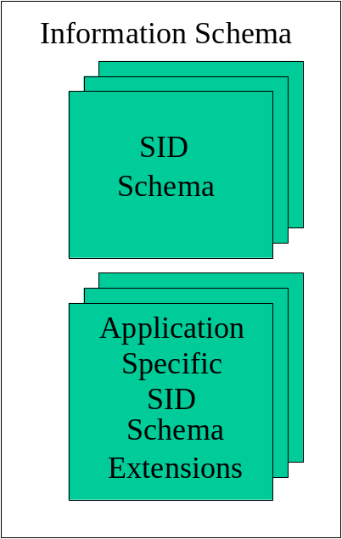
Figure X.1 – Integration Framework Information Schema
The resulting information schema is used as the basis to form XML message payloads exchanged by interoperating applications.
This guidebook provides an overview of the SID XML schema, including design considerations, an introduction to the schema, and an example of their use within an application integration framework.

XML Schema Design Considerations
This chapter describes the design considerations that became the guidelines for the structure, content, format, and generation of the schema.

1.1 XML Schema Structure
This section describes the structure of the SID XML schema.
The organization of the schema follows the SID framework. There is a separate schema for each SID domain. This organization may be modified if a particular domain’s schema becomes too unwieldy. Two large domains, Service and Resource, are already quite large. Each domain’s schema follows the ABE structure for that domain.
There are two sets of schema
- Strongly typed
- Weakly typed
The strongly typed schema has the “type” attribute specified for associations and attributes. The type specified for an association is the related entity; the type specified for an attribute is its UML type from the SID model, such as “string”. It is envisioned that at some point these schema will be used to test conformance to the SID. Before conformance testing is possible with XML schema, a method for indicating whether an attribute is optional or not will have to be developed within the SID UML model. The figure below shows a portion of a strongly typed schema.
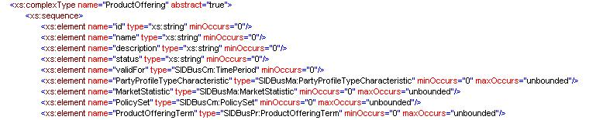
Figure X.2 – Strongly Typed Schema Fragment

A strongly typed schema can be used now as a way to navigate from one entity to entities related to it using a tool such as XMLSPY as shown in the figure below.
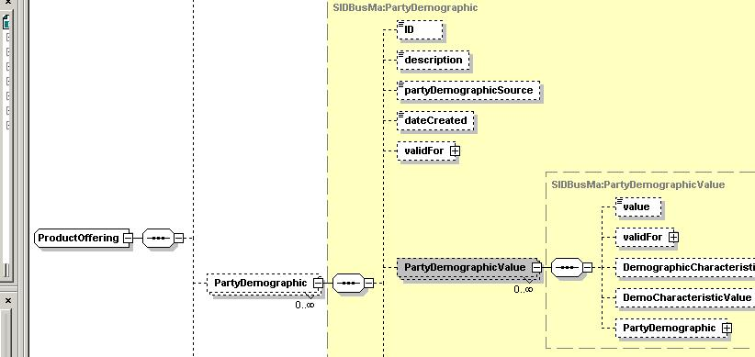
Figure X.3 – Using Strongly Typed Schema as a SID Navigation Aid

The weakly typed schema can be used within an application integration framework. Associations and attributes do not normally have a “type” specified, except for attributes, such as validFor, which represent a composites or “non-primitive data types” made up of other attributes. Associations and attributes can be implemented in a number of ways. For example, an association may be implemented as a reference (via a key) to a related entity or may be implemented as the complete set of related entity’s attributes and associations. Similarly, an implemented attribute may be of a different type than that in the SID UML model. The implementation is often dependent upon the operation/method using the entities. This will be illustrated in a later chapter in this guidebook. The figure below shows a portion of a weakly typed schema.
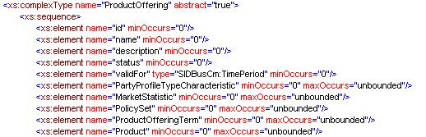
Figure X.4 – Weakly Typed Schema Fragment

1.2 XML Schema Content
The schema represents the current contents of the SID UML model (from a working draft available on the SID collaboration workspace). As such the schema provides primarily the business view of the SID, but where system view SID artifacts are present, the system view is represented.
The names for all entities, attributes, and associates represent those in the SID UML model. All attributes and associations are present for each entity.
Attribute names follow those used in the SID.
Association names use the name of the associated entity. The reason for this is that there is not a consistent naming pattern for associations in the SID; using the names as-is would not always be sufficient to identify the related entity. There are some exceptions to this rule
- When more than one association existed between two different entities (there are fewer than ten of these in the model) the name of the association in the SID was used; if the association from the SID does not include the names of each entity involved in the association, then one or both are added to the name in the schema. An example is shown in the figure below.
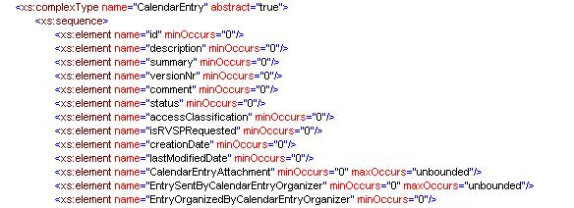
Figure X.5 – Multiple Associations Between Two Entities
- When there is an association between an entity and itself and for an association class the words two associations are created, one suffixed by “for” and another by “has” to differentiate between the two associations; this is helpful in parent/child type associations. And example is shown in the figures below.
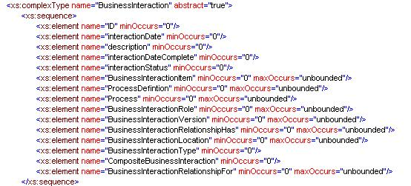
Figure X.6 – Association Between an Entity and Itself

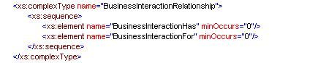
Figure X.6 – Associations in an Association Class

Documentation, such as entity descriptions and attribute descriptions, is not duplicated. The SID model contains the set of full documentation for the content of the schema.

Since most entities in one domain are related to entities in other domains, each schema is imported into a domain’s schema. This is illustrated in the figure below.
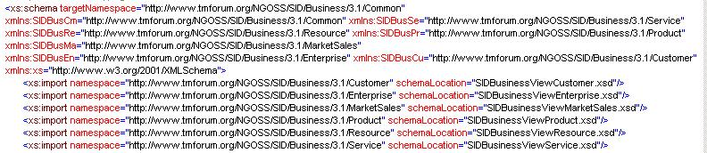
Figure X.7 – Importing Other Schema Into a Domain’s Schema
The SID team initially envisioned hand coding or using one of a number of SID team member company’s software products to develop the SID XML schema. However, a commercially available software product was naturally desired. Pantero's software products were used to generated the SID XML schema directly from the XMI representation of the SID (www.pantero.com). We anticipate continuing to use Pantero's software to ensure timely availability of the XSDs corresponding to future releases of the SID.

Using the SID XML Schema
This chapter provides an example of how to use the SID as part of an application integration framework.

2.1 SIS as Part of an Application Integration Strategy
The figure below shows three key steps when using the SID as part of an application integration strategy.
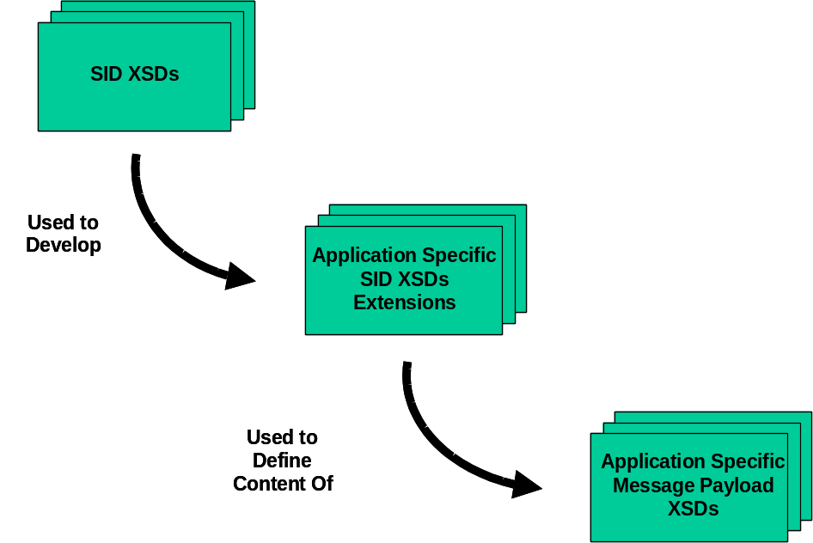
Figure X.8 – SID Within an Application Integration Framework
The first step is to adopt the SID XML schema (XSDs) and use them to develop application-specific XSDs. An example of a fragment of the SID Party entity XSD is shown in the figure below. The figure shows the Party entity and its attributes along with a LanguageAbility entity (and its attributes) a Party may possess and the Language (and its attributes) to which the LanguageAbility pertains.

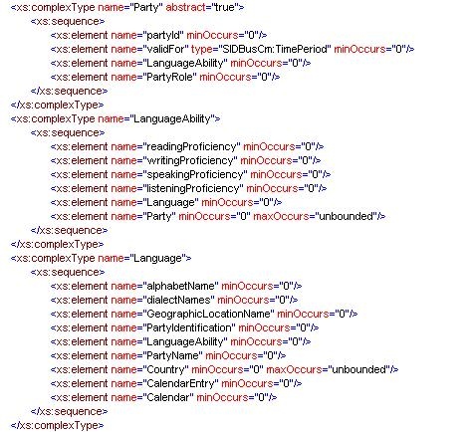
Figure X.9 – SID Party XSD Example
Notice that all elements are specified with a minimum number of occurrences of zero, which means that an entity’s attributes and associations are optional from a value and presence perspective. This may be in opposition to an entity’s attributes and associations within the SID model. The reason for this will become clearer when message payloads are discussed. The optional characteristics of attributes and associations can be changed when defining message payloads as will be described later in this section.
The SID is a framework model, and, as such, extending the SID is expected. The next step is to use the SID to develop application-specific extensions to it. The figure below provides an example of an extension to the SID Party XSD.
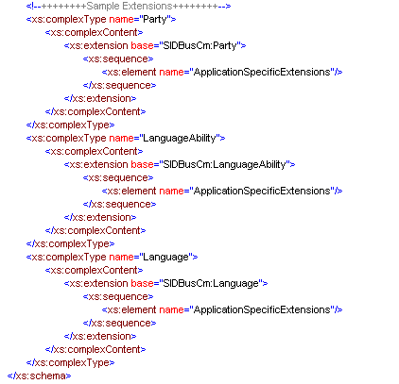
Figure X.10 – Application Specific SID XSD Extension
Notice that the XML “extension” attribute is used to include the SID entity within the application specific extension. The SID XSDs should not be changed to develop application specific extensions. If a future release of SID XSDs is desired to be used, these extensions would have to be reapplied. However, a restriction base of SID entities can be used to define another set of SID-like schema that are devoid of un-needed (by an application) attributes and associations.
A restriction base provides a copy of attributes from the base entity (in this example, Party). Unnecessary attributes and associations can be deleted and the types of remaining attributes and association can be further restricted from those in the base entity. For example, an attribute whose minimum number of occurrences is zero in the base can be changed to one (to make it mandatory) in the application specific extension entity that restricts the base entity. For example, the Party attribute validFor could be made mandatory in the application specific extension. W3C.org provides more information on the use of extension and restriction bases.

The third step is to use the application specific SID XSD extensions to form the basis for API message payloads as shown in the figure below.
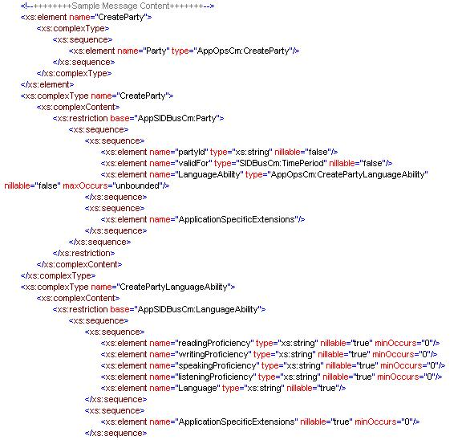
Figure X.11 – Message Payload XSD Using Application Specific SID Extension XSDs
The message payloads use the extended SID XSDs as an XML restriction base. This allows attributes and associations to be further restricted from their full optionality defined in the original SID XSDs. For example, in the sample XSD above the partyID and validFor attributes have been changed to required (minimum occurrences equals one) and there is a requirement for at least one LanguageAbility. This is because the operation that creates a Party requires values for partyID, validFor, and at least one LanguageAbility to be present.

Administrative Appendix
This Appendix provides additional background material about the TeleManagement Forum and this document.

3.1 About this document
This is a TM Forum Guidebook. The guidebook format is used when:
- The document lays out a ‘core’ part of TM Forum’s approach to automating business processes. Such guidebooks would include the Telecom Operations Map and the Technology Integration Map, but not the detailed specifications that are developed in support of the approach.
- Information about TM Forum policy, or goals or programs is provided, such as the Strategic Plan or Operating Plan.
- Information about the marketplace is provided, as in the report on the size of the OSS market.

3.2 Document Life Cycle
The SID XML Schema (XSDs) Overview is being issued as Member Evaluation Version 1.0. It can be considered valid until December 2005. The purpose of an Evaluation Version is to encourage input based on experience of members and the public as they begin to use the document. Following the Evaluation Period, documents that are seen to deliver value are candidates for formal approval by the TM Forum. All documents approved by the TM Forum undergo a formal review and approval process.
This document will continue under formal change control. Supporting work will be issued as companions to this document. A document of this type is a “living document,” capturing and communicating current knowledge and practices. Further inputs will be made because of detailed work ongoing in the TM Forum and the industry.

3.3 Document History

3.3.1 Version History
<This section records the changes between this and the previous document version as it is edited by the team concerned. Note: this is an incremental number which does not have to match the release number>

Version Number | Date Modified | Modified by: | Description of changes
1.0 | July 2005 | John Reilly | First issue of document
1.1 | November 2005 | Tina O'Sullivan | Template and other minor corrections.
1.2 |  | Tina O'Sullivan | Updated notices & document status
1.3 | May 2009 | Alicja Kawecki | Minor updates to reflect TM Forum Approved status
1.4 | December 2010 | John Reilly | Updated Notice
1.5 | March 2011 | Alicja Kawecki | Minor formatting corrections prior to web posting and ME
1.6 | September 2011 | Alicja Kawecki | Updated to reflect TM Forum Approved status

3.3.2 Release History
<This section records the changes between this and the previous Official document release>

Release Number | Date Modified | Modified by: | Description of changes
NGOSS Release 6.0 | November 2005 | John Reilly | First issue of document
Release 9.5 | December 2010 | John Reilly | Updated Notice

3.4 Acknowledgments
This document was prepared by the members of the TeleManagement Forum SID Model team:
- John Reilly, MetaSolv Software
- Frank Koh, Pantero
- Jerome Hannebelle, Microsoft
- John Strassner, Motorola
- Martin Huddleston, QinetiQ
- Pierre Gauthier, MetaSolv Software
Additional input was provided by the following people:
- Dave Raymer, Motorola
- Josh Salomon, Amdocs
- Michel Besson, Cramer
- Francesco Caruso, Telcordia
- Andrew Criswick, QinetiQ

