TM Forum Frameworx
Implementation Methodology

Release 8.1
GB945-M
Version 0.6


March, 2010

Notice

No recipient of this document shall in any way interpret this document as representing a position or agreement of TM Forum or its members. This document is a draft working document of TM Forum and is provided solely for comments and evaluation. It is not a Forum Approved Document and is solely circulated for the purposes of assisting TM Forum in the preparation of a final document in furtherance of the aims and mission of TM Forum.
Although it is a copyrighted document of TM Forum:
- Members of TM Forum are only granted the limited copyright waiver to distribute this document within their companies and may not make paper or electronic copies for distribution outside of their companies.
- Non-members of the TM Forum are not permitted to make copies (paper or electronic) of this draft document other than for their internal use for the sole purpose of making comments thereon directly to TM Forum.
- If this document forms part of a supply of information in support of an Industry Group Liaison relationship, the document may only be used as part of the work identified in the Liaison and may not be used or further distributed for any other purposes
Any use of this document by the recipient, other than as set forth specifically herein, is at its own risk, and under no circumstances will TM Forum be liable for direct or indirect damages or any costs or losses resulting from the use of this document by the recipient.
This document is governed, and all recipients shall be bound, by all of the terms and conditions of the Agreement on Intellectual Property Rights between TM Forum and its members (http://www.tmforum.org/IPRAgreement/2211/home.html) and may involve a claim of patent rights by one or more TM Forum members or by non-members of TM Forum.

Direct inquiries to the TM Forum office:

240 Headquarters Plaza,
East Tower – 10th Floor,
Morristown, NJ 07960 USA
Tel No. +1 973 944 5100
Fax No. +1 973 944 5110
TM Forum Web Page: www.tmforum.org

Table of Contents

Notice 2
Table of Contents 3
List of Figures 4
Executive Summary 5
1. Business Context 6
1.1. The Dynamic Industry Landscape 6
1.2. The Service-Oriented Enterprise 7
2. Implementing TM Forum Frameworx 10
2.1. Exploiting the Relationships among the Frameworks 10
2.2. TM Forum’s Approach 13
2.3. The Enterprise Architecture Evolutionary Phases 13
2.4. The Importance of Implementation Planning 15
3. Enterprise Architecture Evolutionary Phases 1-3 21
3.1. Evolutionary Phase 1 – Application Silos 21
3.2. Evolutionary Phase 2 – Application Standardization 21
3.3. Evolutionary Phase 3 – Process and Information Standardization 22
4. Phase 4 – Service Oriented Enterprise 24
4.1. Business Service 25
4.2. Platform Architecture 27
5. Culture Change Issues 37
5.1. Executive champions 37
5.2. Communication 37
5.3. Role of Standards 38
6. Appendix 1 – MIT Study Summary & Relation to the Methodology 39
7. Administrative Appendix 42
7.1. About this document 42
7.2. Document History 42
7.2.1. Version History 42
7.2.2. Release History 42
7.3. Acknowledgments 43

List of Figures
Figure ‎1-1 – Converging Industry Sectors 7
Figure ‎1-2 - Distributed Value Chain 8
Figure ‎2-1 - TM Forum Frameworx 10
Figure ‎2-2 - Sample eTOM and SID Relationship 11
Figure ‎2-3 - Application, Process, and Information Frameworks Relationships Example 12
Figure ‎2-4 - Leveraging Industry Frameworks and Guides 14
Figure ‎2-5 - Converging Product Inventories 18
Figure ‎4-1 – Phase 4 of the Frameworx Methodology 24
Figure ‎4.5 – Frameworx Concepts 26
Figure ‎4-2 - Platform Views 28
Figure ‎4-3 Enterprise Blueprint Service Sets 29
Figure ‎4-4 Example of Filtering Enterprise Business Services 30
Figure ‎4-5 - Enterprise Platform Specific View of Services 31
Figure ‎4-6 Example simple swim lane analysis 32
Figure ‎4-7 Platform formed from Services and Roles 32
Figure ‎4-8 - Services Grouped into Platforms 33
Figure ‎4-9 - Enterprise Specific Platforms Architecture 33
Figure ‎4-10 Example Organizationally constrained swim lane analysis 34
Figure ‎4-11 Example Platform Design 35
Figure ‎4-12 - Interacting Enterprise Specific Platform Architectures 36

Executive Summary
This document is resulted from a TM Forum Board initiated project called ‘Blueprint’. It targets companies who operate solutions (Information, Communications and Entertainment) businesses. It addresses the questions how to apply the TM Forum frameworks in those environments and how they work together with the Service Oriented Architecture.
This document presents a Methodology for implementing the TM Forum Frameworx. This guide is intended for anyone who is planning to or applying the TM Forum Solutions Framework in the enterprise. An equivalent knowledge to the TM Forum Frameworx primers (GB921-P, GB922 0 P, GB929 introduction), which provides an overview of the TM Forum Frameworx, is expected prior reading this document.
The Methodology is demonstrated using an Enterprise Architecture phased model.
The TM Forum Frameworx Implementation Methodology can be viewed as a blueprint to guide in progressively moving towards service-orientation over a series of evolutionary phases (covered in Chapters 3 and 4 of this document). The TM Forum Frameworx basic structures support service orientation; from the Business Process Framework’s set of highly cohesive, loosely coupled process elements, to their companion groups of entities/objects modeled by the Information Framework, to the implementation of the processes by reusable business services (also known as NGOSS Contracts) to the cataloging of services by the Application Framework.
Contained within this document are:
- Business context for this evolution
- The TM Forum approach to Implementing the Frameworx
- Evolutionary phases of implementation
- Culture change issues.

Business Context
It is useful to understand the business context underlying any methodology. There are a number of underlying issues, such as complexity and lack of strategic agility and the need to participate efficiently in distributed value chains, which have driven the development of the Frameworx Methodology. The methodology is underpinned by a model that can be used by an enterprise to move through a series of evolutionary phases. Each phase supports a customer-centric business model and ends with an enterprise’s emergence as a Service-Oriented enterprise.

The Dynamic Industry Landscape
The provision of new wave digital services now involves players from a good number of previously discrete industries. An end user may enjoy a service which involves many varied players like News services, Search engines, Insurance Companies, Health Service Providers, Entertainment, and market places as well as device manufacturers, SW as service and telecommunication companies. An increasingly sophisticated mesh of revenue models (both direct and indirect) will direct the commercial flows across the value network. Content creators, aggregators, distributors, and device manufacturers are all now playing in spaces that have converged.
Figure ‎1-1 – Converging Industry Sectors shows how these sectors are starting to converge on each other. The small green circle represents Communications Providers, an area which historically has been the epicenter of TM Forum’s work. The Forum’s scope is now represented by the much larger envelope depicted in the figure below: it now spans aspects of content creation, packaging, distribution, and consumption.
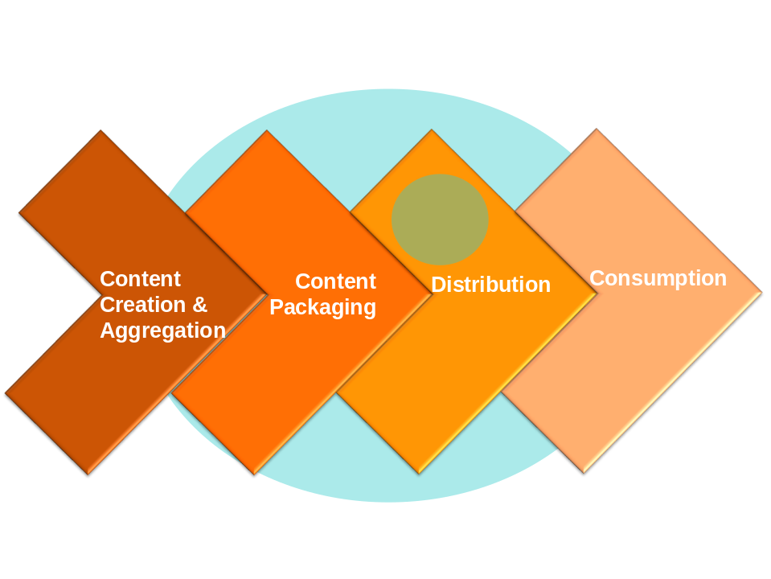
Figure ‎1-1 – Converging Industry Sectors
Five key industry trends were identified as driving the dynamic industry landscape:
- The convergence of service
- Customer Centric Experience
- The move from monolithic supplier to distributed value networks
- The rise in expectations of end-to-end service
- The impact of Service Oriented Architectures (SOA).
An enterprise facing those challenging trends needs to be agile in responding to this dynamic industry landscape. This is what we call here Service-Oriented Enterprise.

The Service-Oriented Enterprise
A Service-Oriented Enterprise is a modular organization, where process, information, systems, and people are grouped to provide reusable business services with which the enterprise operates. The business services are designed to support the enterprise’s portfolio of products (they are not product-specific). Business and IT are converged based on the business service model to achieve business goals in the most efficient way for a given market.
That gives an enterprise strategic agility, allowing organizations to adapt quickly to new business models, new technologies, and new partnering agreements. To achieve these benefits, the underpinning architecture must be enterprise wide. Standardization of process and IT is needed to tackle the proliferation of complexity in most organizations, where the landscape is often a collection of product specific stove pipes.
The key concept which delivers the benefits of an SOE is called the platform architecture that will be explained in more detail later in section 4.1. It is the device which moves an organization towards being service driven.
Up to now the SOE benefits have been focussed internal to an enterprise. The real benefit to enterprises can be expressed by looking at the distributed value chains in which enterprises must now operate as shown in Figure ‎1-2 - Distributed Value Chain.
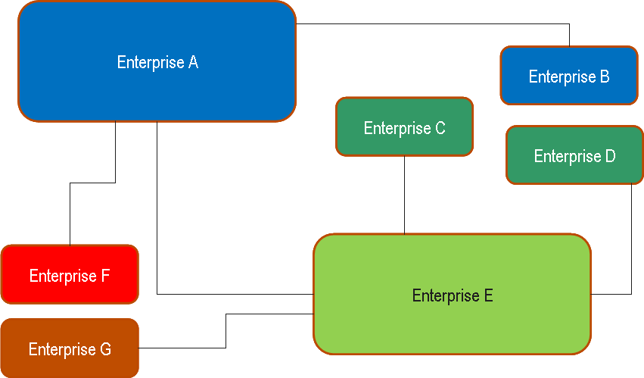
Figure ‎1-2 - Distributed Value Chain
In the modern world enterprises cannot survive as big monolithic suppliers who offer ‘soup to nuts’ service. In the modern world, success depends on the ability to assemble and disassemble collaborative eco-systems with real velocity. Speed of integration is the new competitive advantage.
This is where SOEs come into play. Modular organizations are designed to operate across value chains. Their service oriented approach to business process and IT assumes that reusable process elements can connect using standard, zero-touch and often real-time interfaces. The imposition of business boundaries between these connected services reduces integration/service assembly to the (not insignificant) questions of SLAs and security. However, the real costs in the integration game have already been dealt with by an SOE.
The need for standards which work at scale is dramatically increased by the move to distributed value chains. In Figure ‎1-2, the only way Enterprise A can run fast is if its interactions with other enterprises are standardised. Without standards, Enterprise A is doomed to march at the same rate as B-G.

Implementing TM Forum Frameworx
The TM Forum approach to implementation exploits the frameworks and their relationships among the Frameworks through each evolutionary phase (further explained in Chapters 3 and 4). This importance of this approach is employed is also evident during implementation planning that identifies progressive, phased use of the frameworks.

Exploiting the Relationships among the Frameworks
Figure ‎2-3 - TM Forum depicts the associations among the frameworks.
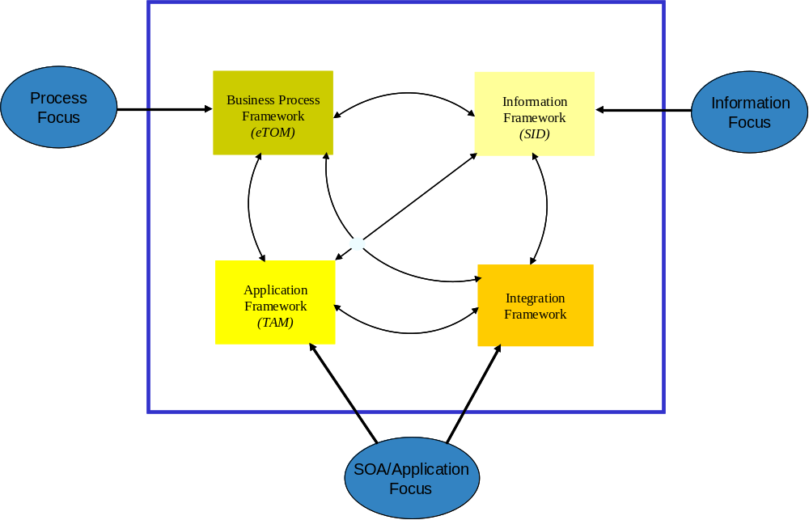
Figure ‎2-3 - TM Forum Frameworx
The Process Framework and Information Framework are naturally related. Processes act on entities defined within the Information Framework. The Integration Framework defines the interaction between processes and entities in more detail by describing the interaction in terms of details that characterize the entities, contained within Business Service (aka Contract) and interface specifications and their implementations. The Application Framework, composed of application areas, describes the processes and entities supported by the application areas and also serves as an application oriented catalog of Business Services, also referred to as Services in this guide book, and interfaces.
There are various entry points in to the frameworks based upon focus/needs of the frameworks’ user. For example, if focus is on a reusable set of web services, the entry point would lead into the Application Framework and/or the Integration Framework.
The relationship between the Process Framework and the Information Framework does not end with the general statement about their relationship. The relationship is further detailed at the upper levels of the frameworks as shown in Figure ‎2-4 - Sample eTOM and SID Relationship. This relationship has many uses as will be described later in this chapter.
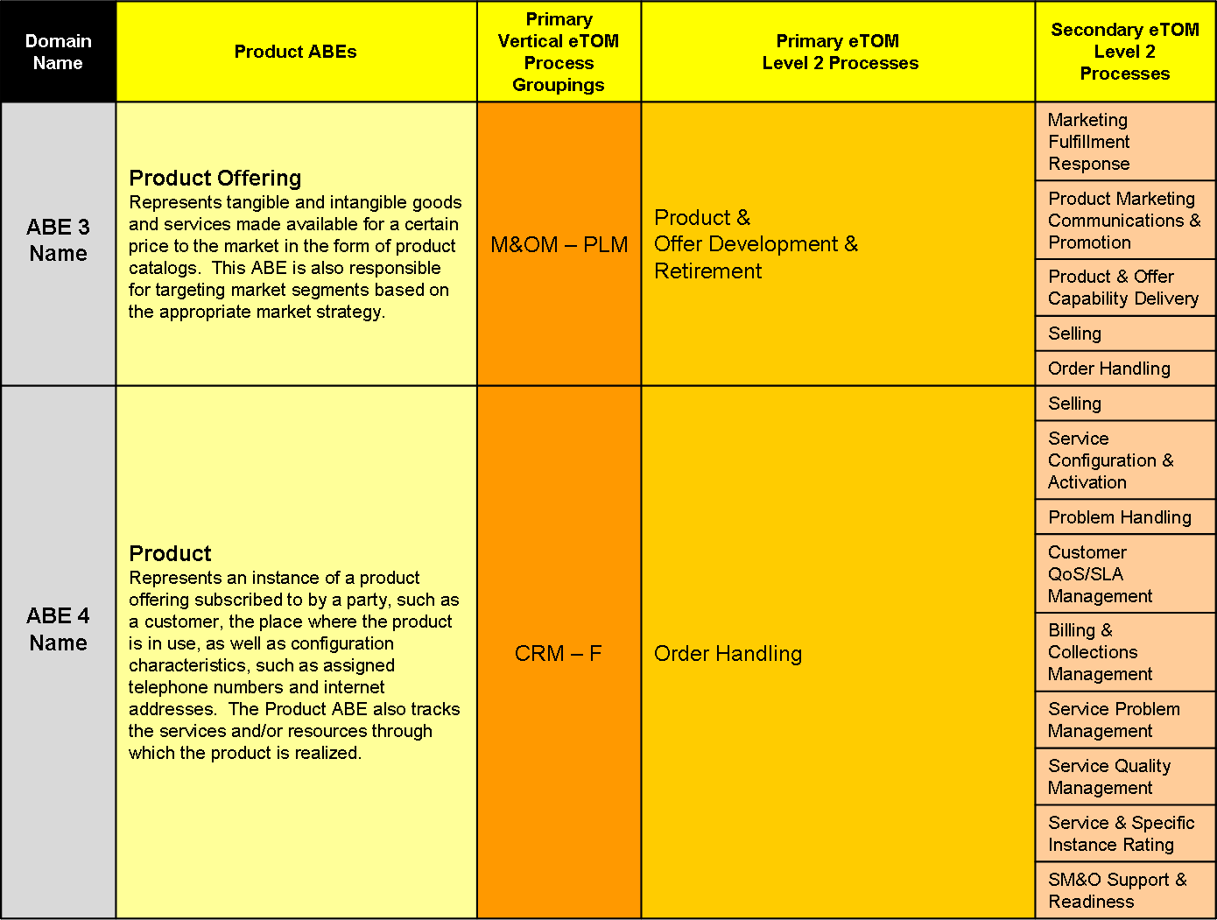
Figure ‎2-4 - Sample eTOM and SID Relationship
Figure 2.2 shows a sample relationship between Level 1 groups of entities, called Aggregate Business Entities (ABEs) and Level 2 Processes. A primary process is one that manages the entire life cycle of the associated ABE’s entities. In other words, it creates, reads, updates, and deletes (CRUD) the entities. This characteristic of the process is what is used in affinity analysis to cluster a group of entities into an ABE. There should be only one primary process; otherwise functionality is duplicated. A secondary process is one that only reads (uses) the ABE’s entities. Shown in the mapping tables are examples of secondary processes, not the complete list.
Further details of the relationship are currently being defined by a joint Business Process Framework and Information work effort at the lower levels of each framework. This defines the relationship between task level processes and individual entities within the Information Framework.
Continuing to describe the more detailed relationships among the frameworks is an example of the relationship among the Application, Process, and Information frameworks shown in Figure ‎2-5 - Application, Process, and Information Frameworks Relationships Example.
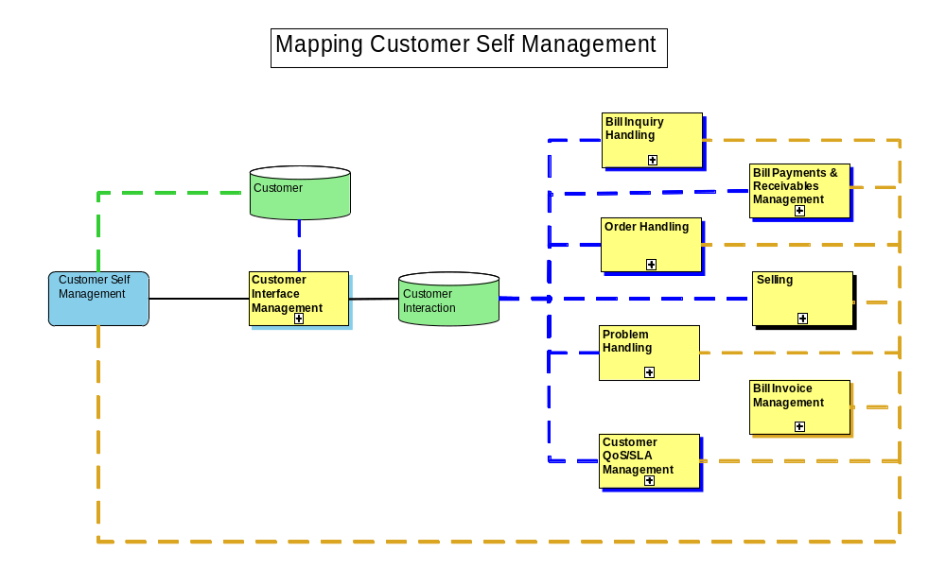
Figure ‎2-5 - Application, Process, and Information Frameworks Relationships Example
In this example, the Customer Self Management application area primarily (solid line) supports the Customer Interface Management level-2 process in the Process Framework. It also supports (secondary) the processes (using the dashed line). Customer Interface Management is primary for the Customer Interaction level 1 Aggregate Business Entity (ABE) in the Information Framework. Customer Interaction is used (secondary) by the processes mapped to it (dashed lines). Customer Self Management and Customer Interface Management also use (dashed line) the Customer level 1 ABE.
These relationships have a number of uses as will be described later in this chapter.

TM Forum’s Approach
The comprehensiveness of the Frameworx calls for a methodology. This methodology will guide framework implementers through the evolutionary phases (described in section 2.3.) by describing how the frameworks can be used during each phase.
The integrating driver for these programs is a services oriented approach. Put simply this expresses an enterprise architecture as a number of reusable capabilities (or functionalities as described in the Application Framework - TAM) that can be assembled to meet any particular business purpose. These reusable capabilities (called Business Services) have known behavior (derived from the Business Process Framework - eTOM) and known information attributes (derived from the Information Framework - SID). Just like Lego bricks, there can be a wide range of such Business Services, covering the entire landscape of needs of various types of service provider. Also like Lego bricks, each has a defined se of compatible interfaces, allowing assembly of a choice of Business Services. This solves a long term issue of standardization – allowing each service provider’s enterprise architecture to be different, allowing for different business models and competitive differentiation, but built from standard ‘building block’ components that can be sourced as commercial-off-the shelf software technologies.

The Enterprise Architecture Evolutionary Phases
Standards need to be a help to companies at whatever evolutionary phase they are at. The four phases are:
- Application Silos
- Application Standardization
- Process and Information Standardization
- Service Oriented Enterprise
If a company is till treating architecture as a procurement checklist, then something like the Application Framework is a useful thing. Companies which start to launch process harmonization initiatives should be able to turn to something like the Process Framework. IT departments which find the courage to tackle data diversity will train their solution designers in the Information Framework. These early phase approaches to architecture progressively use all or parts of the frameworks in a phased implementation do generate significant benefit – reducing complexity, increasing speed, and starting to codify process within the organization so that organisational learning is streamlined. The use of these standards is shown in Figure ‎2-6 - Leveraging Industry Frameworks and Guides .
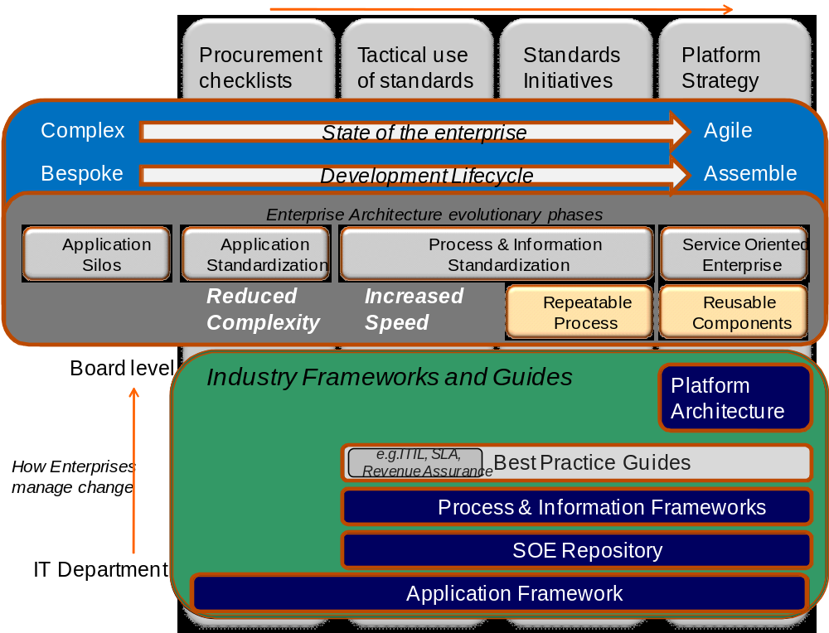
Figure ‎2-6 - Leveraging Industry Frameworks and Guides
However companies which want to transform themselves into an SOE will need a new generation of standards, what we have called the Integration Framework. The Integration Framework is not a new architecture. It is a re-expression of the Process and Information frameworks for a service-oriented world.
Not every enterprise will get to the latter phases. The level of executive sponsorship must increase when moving from one phase to the next. If phase two is sponsored by the CIO, then phase 4 has to be sponsored by the COO or even CEO.

The Importance of Implementation Planning
Having a plan is crucial to a successful implementation of the frameworks, as is identification and commitment from sponsor(s). An implementation workshop can be used to develop an implementation plan containing immediate, short term, and long term uses of the frameworks. A plan most often includes uses of all the frameworks. Typical uses are included in an example plan described here.
Sponsors can be at any level of the organization, but the sponsor must be able to effect the change across the organization. For example, a development manager may sponsor the use of the Process Framework to assist in the identification and definition of requirements for an application. But this role would most likely not be successful in mandating the use of the Process Framework for an entire company. This type of implementation would typically require the sponsorship of a high level executive in the company, such as the Chief Operating Officer.
A progressive, incremental implementation works well. A progressive implementation means defining immediate, short term, and long term uses for the framework. An incremental implementation of the frameworks, such as only Operations processes, based on requirements, pain points, and/or challenges faced. An incremental implementation can be guided by the methodology’s evolutionary phases. Remember that success breeds success! One key to success is to start simple, so that initial uses of the framework are easy to explain and easy to understand.
There are a number of ways that an implementation plan can be developed. One effective technique combines Business Process Framework training (possibly with Information Framework [SID] and Application Framework [TAM] training) with gathering process-related requirements. This technique enables attendees to utilize their newly acquired knowledge to identify how all the frameworks can be used within their organization. The training does not have to be extremely detailed, but should be sufficient for attendees to understand the frameworks, how they can be used, and the benefit of their use.
All stakeholders who have pain points, requirements, or planned or in-process projects, should attend. For example, an organization may be embarking on the introduction of new network technologies. The ”as is” processes used to accomplish this may be out of date, non-existent, or may be based on current technologies. The Business Process Framework can be used as a starting point for defining an industry standard based process framework for Strategy Infrastructure and Product and Operations Support & Readiness processes, or for a checklist to ensure that all the steps necessary to introduce a new technology are considered.
Once requirements are gathered they should be categorized as immediate uses, short term uses, or long term uses of the frameworks. To accomplish this, the attendees may prioritize the potential uses of the framework.
Possible uses of the frameworks can divided into the three categories discussed previously:
- Immediate uses
- Short term uses (3 – 6 months)
- Longer term uses (6 months plus).
A question may arise as to the timeframes selected for implementation. Immediate uses bring immediate value to a company and demonstrate the value of using the frameworks. The three to six month time frame is used to time-box short term uses because most sponsors will expect to begin to see benefits within this time frame.
Example Implementation Plan
Service providers/operators often follow the approach to implementation planning described in the following example.
Immediate uses identified during the implementation planning workshop included:
- IMS (IP Multimedia Subsystem) planning
- Next generation network planning
- New service planning
- Fixed-mobile convergence planning.
IMS planning, next generation network planning, and new service planning can be facilitated by employing both the Process Framework and the Information Framework. Applicable level 3 processes within the Product Lifecycle Management, Infrastructure Lifecycle Management, and Operations Support & Readiness and their descriptions will be used as check list in the planning process to assist the IMS planning and to ensure that all processes are enabled for the new networks and/or services. Similarly, the Information Framework that supports these Level 1 vertical processes will be used to ensure that all information areas are considered during the planning process and that information is available to support operational processes.
During the discussion that surrounded the frameworks’ support of the planning process, it is often found that a service provider does not have a complete process model that could be used to support planning.
As the first step, the TM forum Application Framework (TAM) can be used as a reference map for mapping the enterprise application inventory. The mapping process surveys the deployed product and solutions functionality against the functionality description in the Application Framework. This step allows the discovery of overlapped functionality between deployed applications or domain complementary applications. In our example of fixed and mobile line of business convergence it is likely that we will find two applications handling product inventory. One application is used for mobile product inventory management and another application for fixed product inventory management. Function wise, the two applications are carrying similar processes for inventory management on two domains. The next step would be to harmonize the information models in support of the two domains.
The Information Framework’s Unified Modeling Language (UML) model can be used to support the convergence of fixed and mobile lines of business from a database convergence perspective. One example used during the planning workshop was the use of the Information Framework to support the convergence of fixed and mobile product inventories. (Note: This use could be extended to other areas of convergence.) The use of the framework is illustrated in Figure ‎2-7 - Converging Product Inventories.

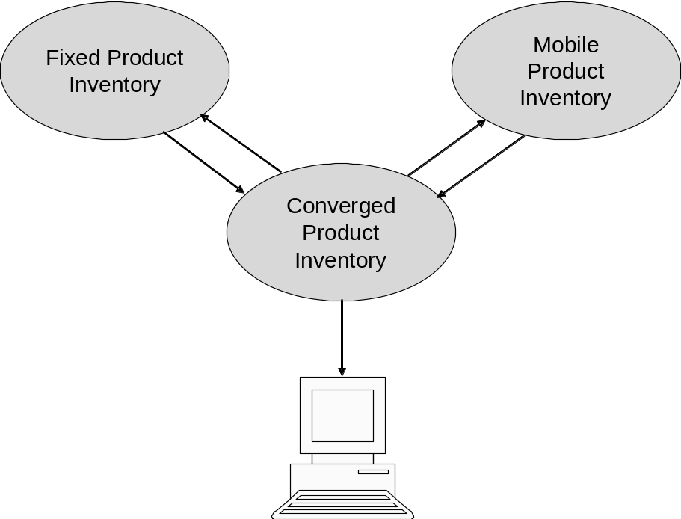
Figure ‎2-7 - Converging Product Inventories
The Information Framework can support a migration strategy to a converged Product Inventory. The first step is to develop a converged Product Inventory Operational, or Object, Data Store (ODS) that would contain pointers to the Fixed and Mobile Product Inventories.
An operational data store (ODS) is a type of database often used as an interim area for a data warehouse. Unlike a data warehouse, which contains static data, the contents of the ODS are updated through the course of business operations. An ODS is designed to quickly perform relatively simple queries on small amounts of data (such as finding the status of a customer order), rather than the complex queries on large amounts of data typical of the data warehouse. An ODS is similar to your short term memory in that it stores only very recent information; in comparison, the data warehouse is more like long term memory in that it stores relatively permanent information.
The converged database will support queries that provide a consolidated view of the Fixed and Mobile Product Inventories using Information Framework based APIs which are part of the Integration Framework into each inventory.
Next step begins to fully develop the Converge Product Inventory based on the Information Framework. Then, either the Mobile or Fixed Product Inventory database could be migrated to the Converged Product Inventory. Queries would then access the Converged Product Inventory and the remaining Mobile or Fixed Product Inventory. The final step involves the migration of remaining the database to the Converged Product Inventory database.
This migration strategy provides a step-wise migration that should not cause major impact to the service provider’s operations.
Short term (three to six month project duration) uses identified during the implementation planning workshop included:
- Application inventory – Process and Information frameworks
- Process mapping – Process Framework
- Process, Information, and Service frameworks for new process automation projects.
An inventory of applications mapped to the Process and Information frameworks can be used to identify possible duplicate functionality and can be used to perform impact analysis when making changes to related applications. It can also be used to identify possible areas for process automation.
Mapping current processes that are documented to the Process Framework can be used to show gaps in current process documentation where the frameworks’ processes can be used as a starting point.
Using the frameworks for new process automation projects probably has the largest benefit. Rather than starting from scratch, applicable frameworks can be used as a starting point for projects. This use of the frameworks is also easy to justify quantitatively by estimating the cost to develop what already exists and that can be used.
Long term (six month plus project duration) uses identified during the implementation planning workshop included:
- Revenue Assurance, along application contents of the Process Framework and the Information Framework
- Data warehouse for Customer, Product, and Billing - use of Information Framework and model
- Converged business lines and applications, for example fixed and mobile
- Integration Framework (APIs from the Integration Framework) combined with an Information Framework based integration hub.
Revenue Assurance is of great interest to the service provider. There is a wealth of information available from the TM Forum regarding this topic. Rather than starting this effort from scratch, but should use existing TM Forum documentation.
The convergence of business lines and their associated applications is also of interest to the service provider. An example of how the Information Framework can be used to support this was provided in the “Immediate Uses” section of this chapter. In addition to the Information Framework, the Process and Integration frameworks can be used to support this effort. Quantitative benefits can easily be calculated based on the amount of time it would take for the service provider to begin developing converged information and process models from scratch.
As new applications are developed and existing applications are enhanced, the service provider should consider using the Information Framework as part of an application integration framework.

Enterprise Architecture Evolutionary Phases 1-3
The Solutions Framework Implementation Methodology will be demonstrated through an Enterprise Architecture Evolutionary Phased model. The evolutionary phases through which an enterprise moves in the model use MIT Sloan School of Managementas a paradigm. MIT’s corresponding phase is shown in parenthesis below.
The first three evolutionary phases are:
- Phase 1 – Application Silos (Business Silos)
- Phase 2 – Application Standardization (Standardized Technology)
- Phase 3 – Process and Information Standardization (Optimized Core)
The fourth phase – Service Oriented Enterprise (Business Modularity) is presented in the next chapter.
Note that a framework implementer does not have to move through each phase sequentially.

Evolutionary Phase 1 – Application Silos
This phase is referred to a Business Silos in the MIT study. This phase is where IT organizations investment focus is in localized applications. This is often influenced by historical investment patterns were focuses on applications that address local business needs. During this phase there is little or no use of the frameworks/

Evolutionary Phase 2 – Application Standardization
This phase is referred to Standardized Technology in the MIT study. From a framework perspective this is where the Application Framework can be used to develop standardized application procurement checklists by a requesting organization. It can also be used as a way to respond to requests for applications by the provider of applications, or as a tool for Line of Business Consolidations or Merger and Acquisitions where systems from disparate sources need to be aligned.
The Application Framework’s relationship to the Process Framework and Information Framework can also be leveraged to develop standardized procurement checklists. It is often useful to state the business processes that are supported by an application and information entities that are used by an application. Additionally, the Integration Framework’s business services and APIs come into play in support of integration with other applications.

Evolutionary Phase 3 – Process and Information Standardization
This phase is referred to Optimized Core in the MIT study. The frameworks role during this phase is in support of tactical use of them and in standards initiatives.
The frameworks may be employed for both tactical purposes and standards initiatives, several of which are included here. Other uses can be found in the implementation plan case study in the previous chapter and on the TM Forum web site’s case study pages. Notice that the uses of the frameworks include those outside their primary purpose.
Tactical uses may include:
- Using any of the frameworks to define project scope (boundaries), such as the scope of an application development project
- Using the frameworks to focus discussion
- Using the frameworks as a source for application development requirements
- Using the Business Process Framework to perform organizational analysis
- Using the Business Process Framework to show points of interoperability between applications
- Using the Application Framework to catalog SOA Services
- Using the Information Framework as a starting point for database design
- Using Integration Framework APIs and business services to support application interoperability.
From a standards initiative perspective, uses may include:
- Using the Business Process Framework as a enterprise wide or business unit wide process model specialized where necessary to support organizational, technology, geographical, or market requirements
- Using the Information Framework as a enterprise wide information reference model and starting point for any project that contains information requirements
- Mandating the use of the Integration Framework’s APIs and business service structure and content.
Note that the uses are cumulative as an enterprise’s progresses through the evolutionary phases. For example, during this phase the frameworks can also be used as procurement checklists, to focus discussion, and in support of application development.

Phase 4 – Service Oriented Enterprise
The Frameworx Methodology provides a process and techniques assist an enterprise in making the journey through the enterprise architecture evolutionary phases that employ the Frameworx. The fourth phase uses the Integration Framework to develop enterprise specific platforms. Figure ‎4-8 – Phase 4 of the Frameworx Methodology contains a summary of how this fourth phase works.
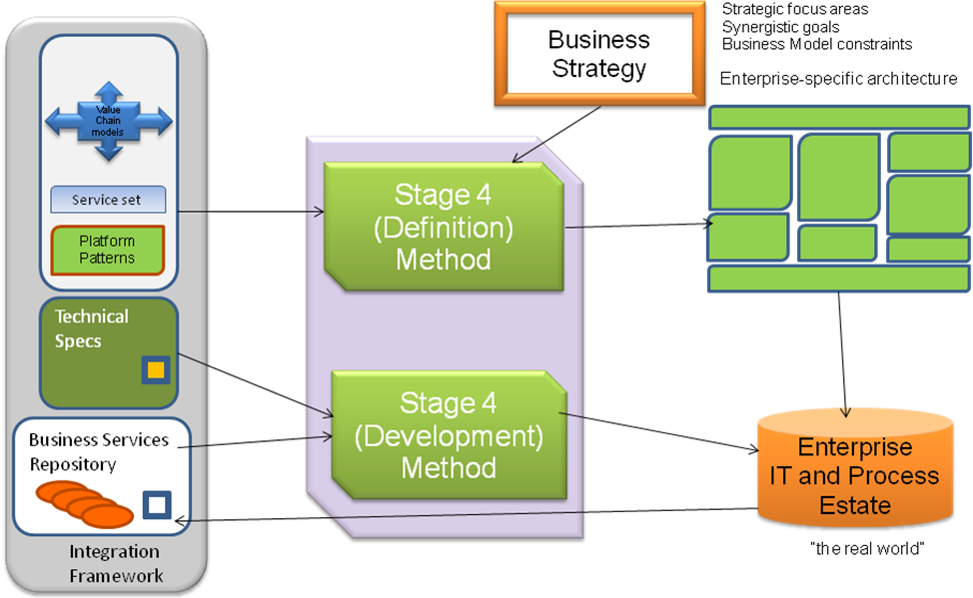
Figure ‎4-8 – Phase 4 of the Frameworx Methodology
- The methodology in phase 4 is comprised from two steps: Definition and Development. The first step in the Frameworx Methodology Phase 4 is the Definition Method. It uses sets of composite and entity-centric business services shown in the left hand side of the figure to identify the relevant services to the enterprise. Next strategic focus areas for and synergistic goals for the enterprise are identified.
- Then value chain models in the platform template shown in the left hand side of the figure are used to describe the value chains in which the enterprise participates. It can be modified based on the enterprise actual value chain descriptors. This will give critical groupings of business services and identify platform boundaries shown on the right hand side of the figure. Identify topological constraints on the organization such as regulatory decision to de-construct an organization into lines of business. Then group the business services in platforms using focal points, goals, and constraints shown at the top of the figure along with platform patterns shown on the left hand side of the figure.
- Lastly, describe the key scenarios in the value chains as orchestrations of the reusable business services.
- The second step in Phase 4 Development Method is used to express solution designs in terms of reusable business services which make up the enterprise’s platform architecture using existing SOE services from the repository and technical specifications shown on the left hand side of the figure. There may be a requirement to develop new business services or enhance existing ones using the Technical Specifications. It is hoped that new and enhanced business services specifications and possibly the reference implementation(s) will be contributed back to the TM Forum for team review and for others to use.

Business Service
A business service (aka NGOSS Contract) is an element of functionality. It may be task centric, such as Allocate Resource or Identify Customer, or entity-centric, such as Resource Service or Customer Service. The technical specifications within the Integration Framework define how the services are described using common models.
A task-centric service’s context represents a service modeled to encapsulate process logic or use case steps. In this case, the thread that ties together the grouped logic or steps is a specific activity being automated by the service logic. Therefore, the use of verbs in service names is common. An entity-centric service’s context represents a specific business entity or group of entities. The focus of the service is on the entity or group of entities, but may act on other entities. The labeling of entity-centric business services is often predetermined by the entity name.
Another type of service is a utility-centric. A utility-centric service’s context is found in application services involving operations that encapsulate cross-cutting functions, such as event logging, exception handling, or notification. These reusable services need to be labeled according to a specific processing context, agnostic in terms of any particular solution environment. For example, a utility service might be named Notify.
The relationship between a business service and the Process Framework and the Information Framework is shown in Figure ‎4.9 – Frameworx Concepts. Services that represent a combination are referred to as composite business services. Composite services can also be made up of other services. This is shown in the figure as Octagon 2. Additional information about services and types of services can be found in GB942CP – Business Services Concepts and Principles and GB942U – Business Service User Guidelines.
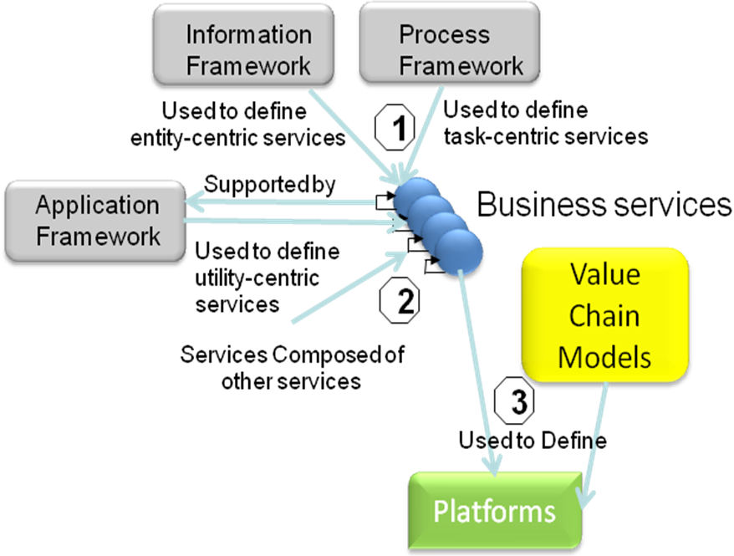
Figure ‎4.9 – Frameworx Concepts
The figure, as indicated by octagon 1, shows that business services can be sourced from the Process Framework and the Information Framework. Task-centric services can be derived from Process Framework level 3 and below processes, which represent the task level(s) of the framework. Entities from the Information Framework provided the “things” upon which the tasks act and use. Entity-centric services implement the complete set of tasks or a subset of the tasks, representing the decomposition of a core level 2 process, that manage the life of a cohesive group of business entities, called Aggregate Business Entities (ABE). For example, Product & Offering Development & Retirement manages the entire life of a Product Offering, from the time it is first envisioned by a Product Manager until the Offering is retired.
It should be noted that many of these L1 ABEs are quite comprehensive and decompose into lower level groups of entities (ABEs). Therefore, a L1 entity-centric service may be composed of lower level entity-centric services. For example, within the Resource L1 ABE, there are a number of L2 and L3 ABEs that represent entity-centric services, such as Alarm, Equipment, and so forth.
Utility-centric services can be identified by analyzing an application map of the Application Framework. Whenever a common or repetitive service is being identified, the service can be generalized as a utility. This is a continuous process between consequent versions of the Application Framework. The analysis process extends the Utility-centric services base and crystallizes the application map.
For example: The Application Framework 2.1 analysis identified a repetitive functionality across the customer layer. The functionality has been generalized as a one way communication transaction from the service provider to the customer in various business flows using a predefined template through different media (paper, email etc.). Such communications can be found in invoices, promotions and collection letters. Application Framework 3.0 introduced a generalized application function named “Transactional Document Production” that exposes utility-centric services for the management of those transactional documents. This use of the application has been demonstrated in the Application Framework 3.0 model for the bill formatting application in version 2.1.
The Application Framework’s level 1 application areas will be used as groupings of business services, a sample of which are contained on the next figures. For example the Customer Management composite entity-centric service maps directly to the Customer Management application area. The Product Lifecycle Management composite maps to the Product/Service Catalog and Product Lifecycle Management application areas. This mapping may reveal adjustments that may need to be made to both the Integration Framework’s services and the Application Framework’s application areas. This will demonstrate how the application areas support the platform architecture, which is described below.
A platform is a grouping of business services, people and roles. Platforms are the building blocks of an enterprise architecture. Platforms are groupings of services, indicated by octagon 3, which reflect the focus of an enterprise, set out its top-level approach to service delivery, clarify the constraints imposed by the value chains in which the enterprise operates. The platform concept is discussed in details through the following section.

Platform Architecture
A platform is a grouping of services, people and roles. The key thing about a platform is that it is a “real” implementable thing. It has managerial significance. Its definition reflects the focus of an enterprise and its top-level approach to delivering service within the constraints imposed by a specific business model. A platform is a device to manage the complexity of an organization’s processes and IT infrastructure.
Platforms are the building blocks of an enterprise architecture. Platforms reflect the focus of an enterprise, set out its top-level approach to service delivery, and clarify the constraints imposed by the value chains in which the enterprise operates. Figure ‎4-10 - Platform Views depicts two ways of viewing a platform.

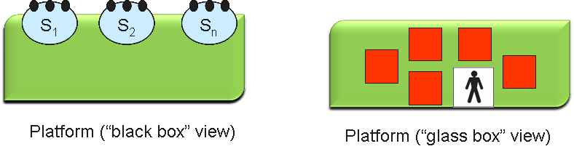
Figure ‎4-10 - Platform Views
The “black box” provides the ability to only see the services that comprise the platform. The “glass box” provides the ability to see the applications and people roles involved in the business services.
There is no ‘standard’ platform architecture. Each enterprise will have its own platform architecture based on the business model under which it operates.
Conformance to TM Forum frameworks in part would be based on its use of services that make up the Integration Framework services repository, and if it is derived using the Frameworx methodology.
The next series of figures show how an enterprise specific platform architecture can be developed starting with Blueprint service sets. For this example we will be working with a fictitious Mobile Virtual Operator (MVO). The MVO starts by examining the library of existing Business Services.
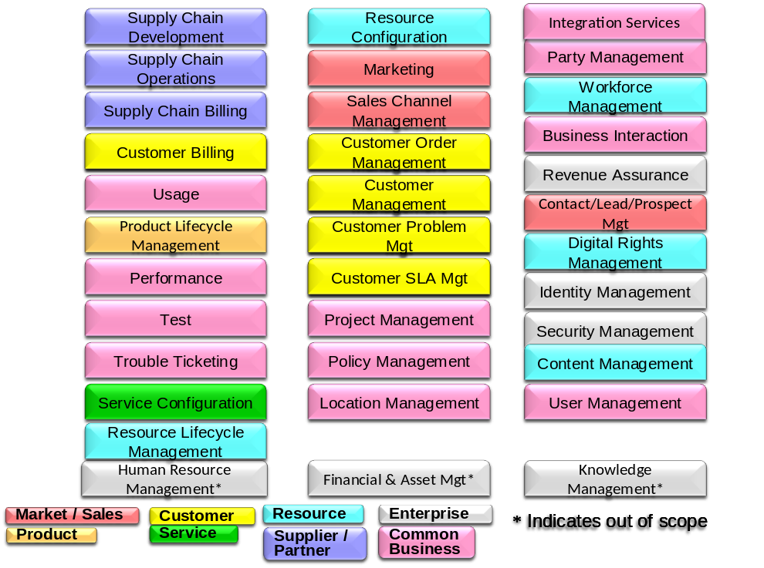
Figure ‎4-11 Enterprise Blueprint Service Sets

Based on the business model of the MVO a number of Business Services are eliminated, in Figure ‎4-12 Example of Filtering Enterprise Business Services the MVO removes the services related to management of Resources and Service Configuration and they also remove other services not applicable to their business model such as Location and Project Management to reflect the business and engagement model of the enterprise. It should be noted that this is an example only and the services selected or excluded will vary based on the specific business model an operator is using.

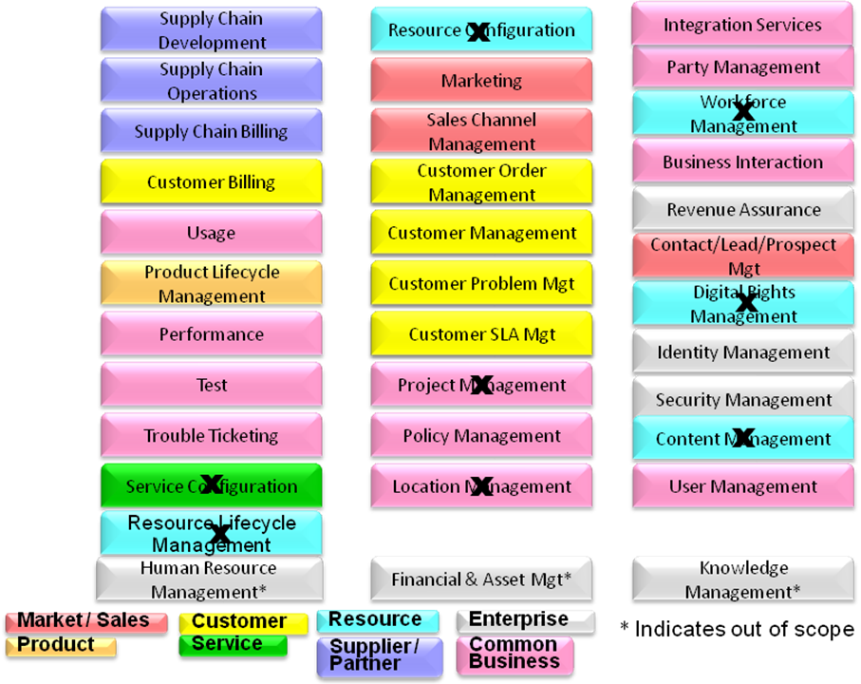
Figure ‎4-12 Example of Filtering Enterprise Business Services
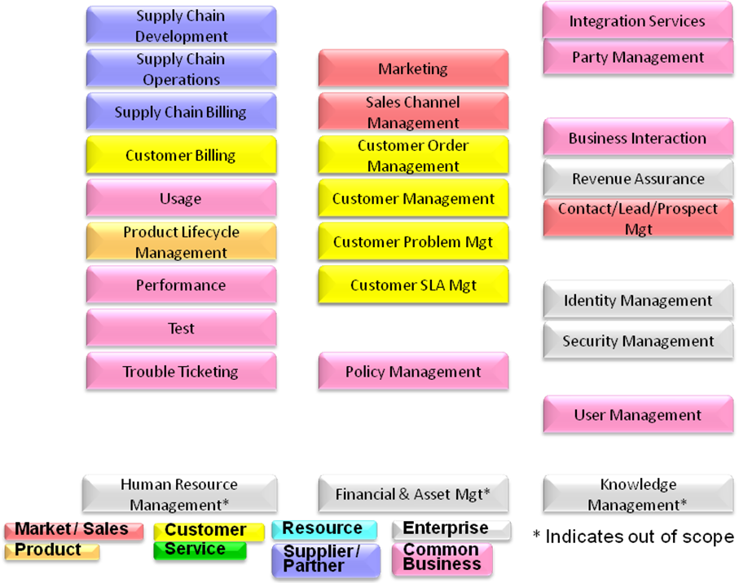
Figure ‎4-13 - Enterprise Platform Specific View of Services

The result is an Enterprise Platform Specific view of the services. This selection of services when combined with the organizational constraints, roles and business goals become the building blocks of the platform architecture.

At this point it is important to have a very good understanding of the value chains models, business goals of the organization and roles within the organization.

Roles can be indentified refined by using well know industry techniques such as Responsible Accountable Consulted Informed (RACI) matrix. Process and value chain interaction can be examined using swim lane analysis techniques. This coupled with an understanding of regulatory requirements and organizational limitations will reveal logical clustering of services that can be group together to create a platform.

A general guideline is attempt to map roles and given Business Services to only one platform. There may be exceptions to this based on regulatory constraints, organization constraints or legacy system constraints. These exceptions should be considered for future optimization.

For example using Swim lane analysis the MVO determines that their current organization has three roles that are involved in customer order and service management and expose external services to the customer that require close coordination.

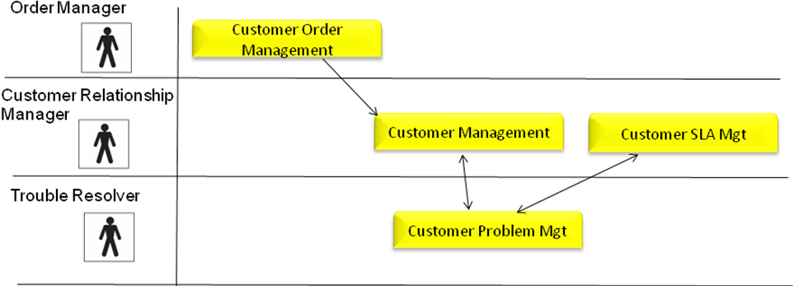
Figure ‎4-14 Example simple swim lane analysis

The result of this analysis is the grouping of these functions and roles into a “platform” This is reflected in Figure ‎4-15 Platform formed from Services and Roles. (This analysis has been greatly simplified for illustrative purposes and may require several iterations before the logical platform grouping and boundaries become clear.)

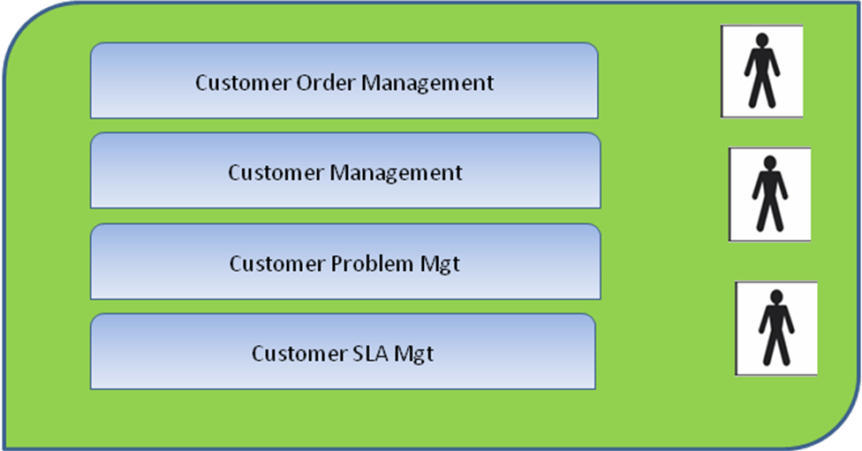
Figure ‎4-15 Platform formed from Services and Roles
Figure ‎4-16 - Services Grouped into Platforms shows how the services have been grouped into a complete enterprise specific platform.
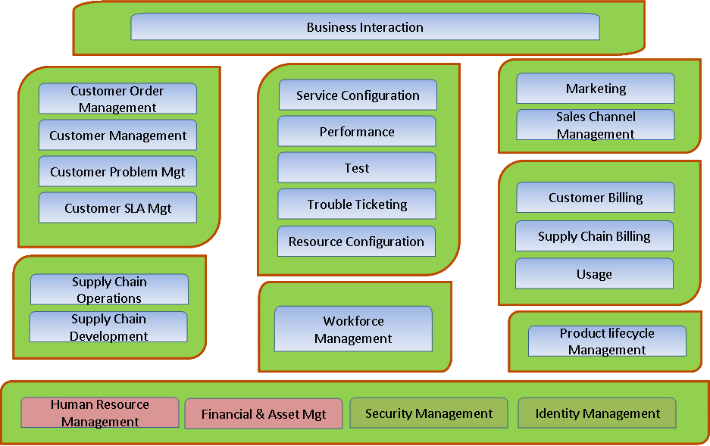
Figure ‎4-16 - Services Grouped into Platforms
Figure ‎4-17 - Enterprise Specific Platforms Architecture shows the resultant enterprise specific platform architecture.
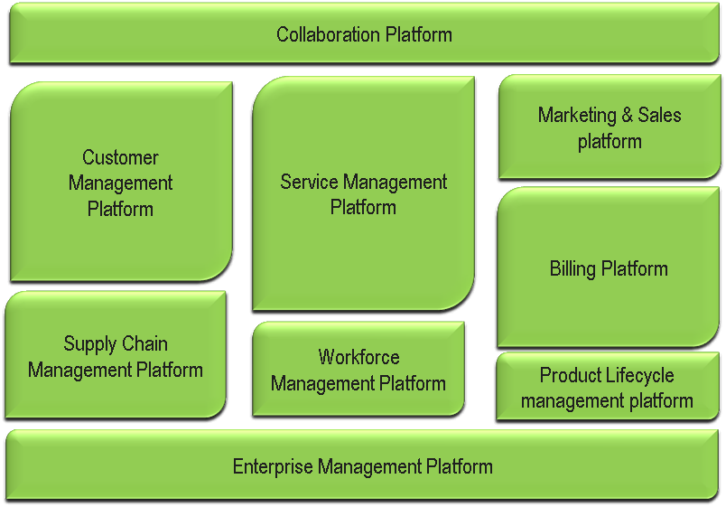
Figure ‎4-17 - Enterprise Specific Platforms Architecture
The real power of an SOE lies in its ability to play a role in a collaborative eco-system quickly and at low cost. The Collaboration platform shown in Figure ‎4-17 - Enterprise Specific Platforms Architecture will forge and monitor inter-enterprise business services.
At this point let us examine another scenario that would result in a different set of platforms being constructed. In this example we will use a service provider that has multiple lines of business and regulatory constraints around separation of domestic customers and international customers.
The swim lane analysis is done
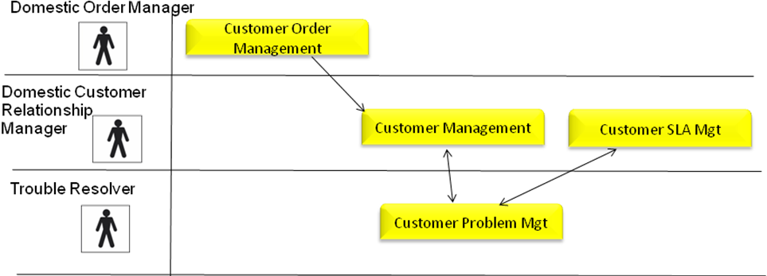
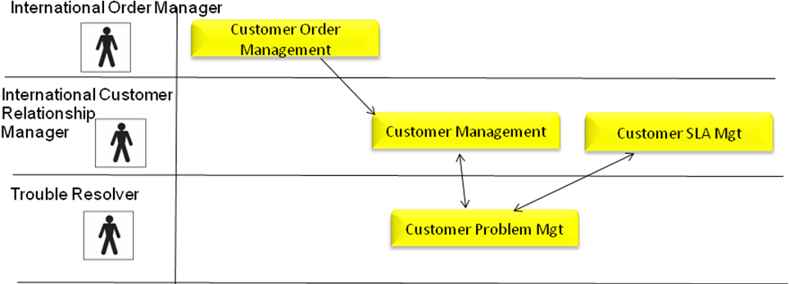
Figure ‎4-18 Example Organizationally constrained swim lane analysis
At this point it is recognized that the Trouble Resolver Role and Customer Problem Mgt. is the same independent of the whether the origin of the problem is domestic or international.
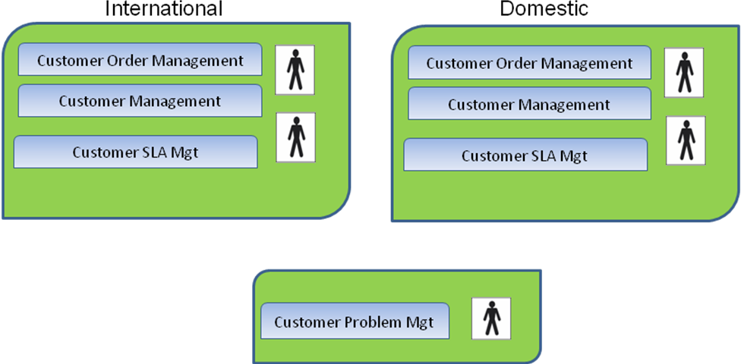
Figure ‎4-19 Example Platform Design
Figure ‎4-19 Example Platform Design is the resulting platforms determined by the operator based on their business model and regulatory constraints. Again this has been greatly simplified for illustrative purposes.

The advantage of this approach is while reflecting the realities of the business constraints the platforms and the underlying business services are built from common components and easy of reuse and flexibility is greatly enhanced.

That gives an enterprise strategic agility, allowing organizations to adapt quickly to new business models, new technologies, and new partnering agreements. To achieve these benefits, the underpinning architecture must be enterprise wide. Standardization of process and IT is needed to tackle the proliferation of complexity in most organizations, where the landscape is often a collection of product specific stove pipes.

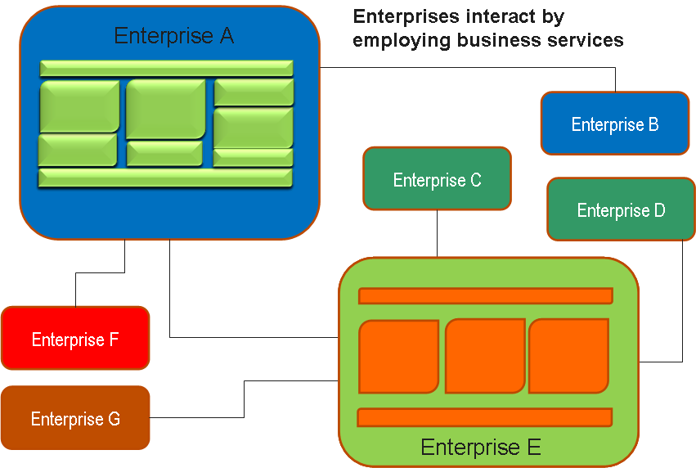
Figure ‎4-20 - Interacting Enterprise Specific Platform Architectures
The need for standards which work at scale is dramatically increased by the move to distributed value chains. In Figure ‎4-20 - Interacting Enterprise Specific Platform Architectures the only way Enterprise A can run fast is if its interactions with other enterprises are standardised. Without standards, Enterprise A is doomed to march at the same rate as B-G.
Companies which want to transform themselves into an SOE will need a new generation of standards, what we have called the Integration Framework. The Integration Framework is not a new architecture. It is a re-expression of the Process and Information frameworks for a service-oriented world.

Culture Change Issues
As was touched on in section 3 it is also very important to note the organization and culture in any attempt to conduct major transformation efforts. First and foremost is the need to maintain the focus on the business drivers of the organization and how the business interacts with its customers. It is easy for organizations to become very introverted and focus only on interdepartmental issues, process optimization or application optimizations. All of these are good things but must be examined and optimized in the context of the broader business goals and objectives and most importantly how they impact the customer.

Executive champions
It is key to have executive level champions for any transformation that is targeting becoming a Service Oriented Enterprise. This is not just an IT systems issue, (in fact one big challenge will be to get IT to focus on enterprise level position versus departmental optimization) this addresses the fundamental approach a company takes in doing business. There is a keen need for the business to be able to see the big picture and why certain organization and systems decisions are taken. It is extremely difficult to avoid negative departmental optimization unless the total enterprise goals and interactions are well understood by the executive staff and can be communicated easily, both internally and externally.

Communication
Communication is essential in any large scale transformation effort. One of the key tools indentified in this methodology is the use of a single architectural picture to express a company’s service oriented enterprise. This picture allows the company to have a single unified vision of how their organization should interact. It also allows the organization to define how it expects to interact with other enterprises in any value chain business models it engages in.
The TM Forum believes there is added value in not only having this picture but by adding the additional discipline of a methodology in constructing the picture. Using well understood business services to construct the platforms creates not only a picture that understandable but also creates a common vocabulary that can be used within the organization but externally as well. Using the TM Forum Frameworx as a basis for creating the Business Services gives the creation of a common vocabulary a jump start by building upon the industry up take the Business Process Framework (eTOM), the Information Framework (SID) and the Application Framework (TAM). Not only is common vocabulary established but there is a well understood method to decompose the high level Business Services necessary to support this Service Oriented Enterprise view into information, process and application as they maybe ultimately realized by the enterprise.

Role of Standards
As Enterprises transform to Service Oriented Enterprises the role of standards changes. Standards no longer are just a tool to allow applications and equipment to interact; they become the key enablers to allow business process and services to interact on a much broader level. Business Services and their agreed definition will be key to allowing enterprises to participate in a value chain and then quickly adapt that value chain as the business model and market conditions change.
TM Forum believes is will be key to develop and refine this library of Business Services derived from the Frameworx and is launch several efforts to validate the current content and identify gaps.
The Forum also believes a set of templates will emerge around lines of business and business model. The Forum will work with its members to collect information and populate a library of templates to further aid companies in the transformation to service oriented enterprises.
New business models and value chains will patterns will also emerge. The Forum will plans on documenting best practice in implementing these value chains and best usage of business services in meeting the needs of the value chain.
All of these goals rely on the continued feedback and participation of the TM Forum membership. With the reward of being a Service Oriented enterprise being:
- Services driven - An enterprise that operates using a business services model
- Platform driven - Business processes, information, IT & people grouped to deliver a set of business services. ((called a “platform”)
- Enterprise wide -Business services are designed to support the enterprise’ portfolio of products (i.e. they are not product-specific)
- Flexible- The business services can be aggregated to support different organizational and business models
- Modular- A service oriented enterprise is a modular organization, which has strategic agility and minimal complexity, giving it operational excellence.
The rewards for participation just went up.

Appendix 1 – MIT Study Summary & Relation to the Methodology
In April of 2006 Massachusetts Institute of Technology Center for Information Systems Research, Sloan School of Management, released a set of studies regarding “Enterprise Architecture: Driving Business Benefits from IT”. In a study on IT operating Model from December 2005 they proposed that to make IT proactive rather than a reactive force in creating business value it is necessary to concentrate on defining their operating model. Operating model is defined as “the necessary level of business process integration and standardization for delivering goods and services to customers”.
The study proposes there are four alternative operating models for a company:
- Diversification – (low standardization, low integration)
- Unification – (high standardization, high integration)
- Coordination – (low standardization, high integration)
- Replication – (high standardization, low integration).
It is important to note that a company may successfully operate at using any one of these models. Standardization promotes flexibility and agility within an organization, low integration is similar to loose coupling and allows systems to be viewed as building blocks and be assembled to meet changing systems demand. The TM Forum believes is Frameworx can be used to support any of these models and can be especially beneficial as a company moves to models where standardization is high and coupling low and business agility and flexibility is maximized.
MIT also conducted a survey of a 103 firms where they collected data on IT management practices and architecturally maturity. The findings resulted in determining there are four major stages of architectural maturity that directly correspond to a firm’s ability to deliver low cost, flexible solutions resulting in increased customer intimacy, product leadership and strategic agility. The four stages are:
- Business Silos – local application, no shared resources
- Shared Technology – shared infrastructure
- Optimized Core – shared infrastructure and business processes
- Business Modularity – smaller reusable application and process components.
The methodology TM Forum in this document shows how the Frameworx support and make the transition through these stages easier. Again it is important to realize that a firm may choose to stop at any stage of architectural maturity depending on their business model and strategic direction.
The communications and digital media industry are under increased pressure to be flexible, agile and adaptable to many business models. It is key for firms to be positioned as “Service Oriented Enterprises”, possessing both the characteristics of the Replication business model and having a Business Modularity stage architecture. The methodology contained within lays out how one can use the TM Forum Frameworx to achieve that goal.
The MIT study measured the following four key strategic benefits:
- Operational Excellence, low cost provider emphasizing efficient, reliable and predictable operations
- Customer Intimacy, extraordinary customer service, responsiveness and relationships, based on deep customer knowledge
- Product/Service Innovation, first to market with innovative products and services
- Strategic Agility, ability to respond to rapidly to competitor initiatives and new market initiatives.

The MIT study found a positive correlation between the enterprise architecture maturity stage and the perceived strategic benefits stemming out of their IT systems. It also identified key mechanisms for generating strategic benefits. The most important mechanism was a clear statement of the enterprise architecture guiding principles. Another key communication mechanism to achieving this goal; a one page high-level architectural picture that articulates expectations defined in the guiding principles and putting emphasis on methodology. It provides a key communication mechanism between executive management and IT.
The TM Forum believes there is a fifth benefit that is especially relevant in today environment.
- Value Chain Agility, ability to assemble new product and service offerings across an extended Value Chain/Network.
This benefit facilitates communication with business partners in an extended value chain.
To facilitate the development of this architecture the TM Forum has introduced the concept of a platform, described in this guide book. By placing certain constraints on how platform are constructed using Business Services the architecture not only provides an effective communications tool but also provides a path to becoming an Service Oriented Enterprise by focusing on reusable Business Services. The added discipline is expected to have major benefits not only within the enterprise but facilitate the agility of the external value chains as well.

Administrative Appendix

About this document
This document was prepared as the result of a TM Forum Board initiated work item to examine the Frameworx and move them towards a Service Oriented Architecture Approach.

Document History

Version History

Version Number | Date Modified | Modified by: | Description of changes
Version 0.2 | Jul/2009 | Kenneth Dilbeck | first issue of document
Version 0.3 | 28 Jul 2009 | Alicja Kawecki | Minor updates and reposting after ME
Version 0.4 | 20 Nov 2009 | Alicja Kawecki | Updated to reflect TM Forum Approved status
Version 0.5 | 27 Jan 2010 | Ken Dilbeck | Solution Frameworks updated to Frameworx per Marketing
Version 0.6 | 11 March 2010 | Tina O’Sullivan | Updated Release number and other cosmetic changes

Release History

Release Number | Date Modified | Modified by: | Description of changes
1.0 |  |  | Initial version
8.1 | 11 March 2010 | Tina O’Sullivan | As per Product management – aligning the release number to match the overall Frameworx pre-launch release.

Acknowledgments
This document was prepared by the members of the TM Forum team:
- Kenneth Dilbeck, TM Forum, Editor
- John Reilly, TM Forum
Additional input was provided by the following people:
- Jim Crookes, Subject Matter Expert
- Review and comments by the Blueprint Team
  - Special thanks to Yishai Brown, Amdocs

Ross, Jeanne W., Enterprise Architecture: Driving Business Benefits from IT(April 2006). MIT Sloan Research Paper No. 4614-06; CISR Working Paper No. 359. Available at SSRN: http://ssrn.com/abstract=920666
MIT Sloan Forget Strategy: Focus IT on your Business Model, Jeanne Ross, Principal Research Scientist
MIT Sloan Maturity Matters: How Firms Generate Value from Enterprise Architecture, Jeanne Ross, Principal Research Scientist
MIT Sloan Generating Strategic Benefits from Enterprise Architecture, Jeanne Ross, Principal Research Scientist

