Fraud Operations Management Guide

Release 1.0
GB947
Version 1.2


December, 2011

Notice

No recipient of this document and code shall in any way interpret this material as representing a position or agreement of TM Forum or its members. This material is draft working material of TM Forum and is provided solely for comments and evaluation. It is not “Forum Approved” and is solely circulated for the purposes of assisting TM Forum in the preparation of final material in furtherance of the aims and mission of TM Forum.
Although it is copyrighted material of TM Forum:
- Members of TM Forum are only granted the limited copyright waiver to distribute this material within their companies and may not make paper or electronic copies for distribution outside of their companies.
- Non-members of the TM Forum are not permitted to make copies (paper or electronic) of this draft material other than for their internal use for the sole purpose of making comments thereon directly to TM Forum.
- If this material forms part of a supply of information in support of an Industry Group Liaison relationship, the document may only be used as part of the work identified in the Liaison and may not be used or further distributed for any other purposes
Any use of this material by the recipient, other than as set forth specifically herein, is at its own risk, and under no circumstances will TM Forum be liable for direct or indirect damages or any costs or losses resulting from the use of this material by the recipient.
This material is governed, and all recipients shall be bound, by all of the terms and conditions of the Intellectual Property Rights Policy of the TM Forum (http://www.tmforum.org/Bylaws/1094/home.html) and may involve a claim of patent rights by one or more TM Forum members or by non-members of TM Forum.

Direct inquiries to the TM Forum office:

240 Headquarters Plaza,
East Tower – 10th Floor,
Morristown, NJ 07960 USA
Tel No. +1 973 944 5100
Fax No. +1 973 944 5110
TM Forum Web Page: www.tmforum.org

Table of Contents
Notice 2
Table of Contents 3
List of Figures 4
Executive Summary 5
1. Fraud Definition 6
2. Fraud Management 7
2.1. Fraud Management 7
2.2. Fraud Policy Management 8
2.2.1. Fraud Policy Management 8
2.2.2. Tool Policy Management 9
2.2.3. Analysis and Identification Policies 10
2.2.4. Fraud Classification Management 10
2.2.5. Internal Process Policies 11
2.2.6. LEA (Law Enforcement Agency) Interaction Policies 12
2.2.7. External Operator Interaction Policies 12
2.2.8. Internal Ethics Policies 13
2.3. Fraud Operations Management 14
2.3.1. Fraud Operations Management 14
2.3.2. Information and Data Processing 15
2.3.3. Fraud Analysis 16
2.3.4. Fraud Actions 17
2.4. Fraud Operations Support 19
2.4.1. Fraud Operations Support 19
2.4.2. Intelligence Gathering 20
2.4.3. Threat Reduction and Avoidance 21
2.4.4. System Configuration Management 22
2.5. Overall Process Flow 23
2.6. Fraud Management Summary 23
3. Administrative Appendix 24
3.1. About this document 24
3.2. Document History 24
3.2.1. Version History 24
3.2.2. Release History 24
3.3. Company Contact Details 25
3.4. Acknowledgments 25

List of Figures
Figure 1: Fraud Management extrapolated into Level 3 processes
Figure 2: Level 3 Fraud Policy and supporting Level 4 processes
Figure 3: Level 3 Fraud Operations and supporting Level 4 processes
Figure 4: Level 3 Fraud Support and supporting Level 4 processes
Figure 5: Overall Fraud Process Flow

Executive Summary
This guide is developed to define and address the Level 3 and Level 4 Fraud Management processes associated with an operator’s fraud management program. Diagrammatic representations of processes and subsequent detailed definitions are included within this document. Questions, comments, and additional recommendations should be forwarded to the Fraud Team Leader via the TM Forum website (Revenue Management >> Fraud Team).

Fraud Definition
Fraud has been defined many ways, depending on the industry and the particular segments within a given industry. For purposes of this guide and applying the information within it, the following fraud definition should be considered:

Communications Fraud: The intentioned action(s) by an individual, group (e.g. syndicate), or enterprise (e.g. partner) to receive, through deception, products, services and/or revenues from the target service provider(s) without remitting expected value for those products or services.

Fraud Management

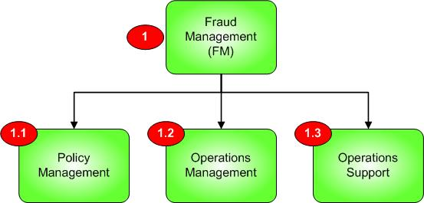

Figure 1: Fraud Management extrapolated into Level 3 processes

Fraud Management
Process Identifier: 1.0

Process Context
This process element represents the entry point to the overall Fraud Management program within an operator’s business.
Brief Description
The Fraud Management process entry point is further disseminated into 3 sub functions (described within the following sections): Policy Management, Operations, and Support.

Extended Description
Fraud Management is chartered within an operator to conduct 3 primary functions within the operator’s business model: Create and maintain a fraud policy (enabling methods, activities, and other procedures to detect, prevent, and manage discovered fraud instances within the operator), conduct Fraud Operations (daily fraud detection, investigation, and response activities), and support of fraud operations (creation and management of rules, lists, tools/solutions used for detections, staff education, etc.).
The objective of the Fraud Management in general is to detect fraud risks, activities, and other violations, as well as to detect and prevent the re-surfacing of known fraudulent activities, individuals, and syndicates. Proactive detection processes are preferable to reactive mitigation and management of existing fraud, hence the importance of policy and support functions to provide tools to the operational component to prevent fraud before it becomes harmful to the business. Inevitably, reactive processes must also be supported, as fraud tactics are in a continual state of change, posing a constant threat to operators.

Fraud Policy Management
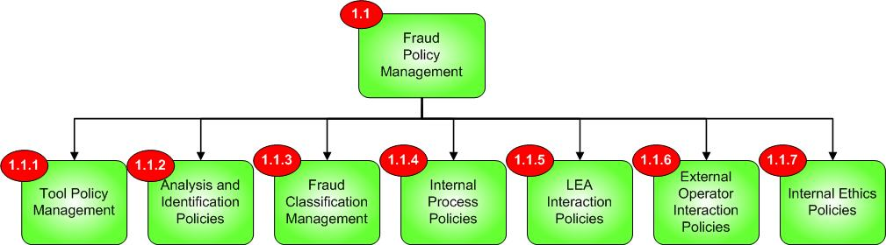

Figure 2: Level 3 Fraud Policy and supporting Level 4 processes

Fraud Policy Management

Process Identifier: 1.1

Process Context
This process element serves as a business process within the operator, within the overall Fraud Management program function.
Brief Description
Establish and manage all intra-team, enterprise-wide, and external facing policies to facilitate detection, management, and prevention of fraudulent activities

Extended Description
The objective of Fraud Policy Management is to manage and maintain all policies necessary for successful fraud program operations within a carrier. Depending on the product offerings, geographic region served, demographics of the subscriber base, partner (e.g., wholesale) environment, internal network structure, budget, and other factors, fraud policies will vary across operators, with unique requirements for fraud policies prevalent in each case. Practices and processes for detection, investigation, ongoing education, tool uses, feedback of identified frauds, external interactions (partners, LEAs), etc. comprise areas within scope of Fraud Policy Management.

Tool Policy Management
Process Identifier: 1.1.1

Process Context
This process element serves as a business process within the operator, within the overall Fraud Management program function.

Brief Description
Establish and manage all policies related to the employment, use, and maintenance of tools and/or solution platforms used in fraud detection, investigation, and management.

Extended Description
The objective of Tool Policy Management is to provide oversight to the entire lifecycle of a fraud tool or solution within the organization. This includes several key components:

- Identification of the need for a tool or solution. This will include the creation of business case materials needed to support the need for investment in technology to replace manual operations or enhance volumes of data being analyzed, etc. This process will also be the origination point for requirements vetting, collecting, and aggregation into RFx issuance, and the subsequent review and scoring of responses received.
- Deployment scope and project management of any tool or solution. While the operator often contains an internal PMO for deployment activities/oversight, actual requirements needed by the Fraud program must be represented and ensured by the policy process.
- Staff preparation. Use of technology requires training in both the use of the technology and the fraud domain itself to understand rules and processes being employed by tools. The policy process must identify and maintain the necessary staff requirements to operate tools to the full extent of their deployed capabilities.
- Ongoing process and rule enhancement. Tools are subject to modifications and enhancements necessary to address constant changes within the fraud environment. The policy process must maintain guidelines on when rules and processes may be enhanced or updated.
- Access to fraud tools and systems. Tools within the fraud environment have access to particularly sensitive information that require increased levels of security. Policies must be in place to determine who is allowed access to these tools, and specifically, what actions they are allowed to perform within these fraud tools. For example, configuration of rules for detection should be performed by appropriate staff to ensure fair yet thorough application of any given rule. General staff within an organization should not have access to this information or configuration capability.
- Roadmap development. As needs of the fraud program change, tool support inevitably must also evolve. In cases where tool capabilities do not meet the needs for growth, requirements for enhancements must be maintained within the policy process, and made available to tool developers and/or to subsequent RFx issuing. It is important to examine existing tools within other departments for possible integration or re-use as part of this process.

Analysis and Identification Policies
Process Identifier: 1.1.2

Process Context
This process element serves as a business process within the operator, within the overall Fraud Management program function.
Brief Description
This process serves as a repository of M&P (Methods and Procedures) information that maintains best practices for fraud analysis and identification work.

Extended Description
Within the fraud practice, certain processes are formulated to provide consistency and control around analysis of suspected fraud and the supporting investigative work to determine whether a given case is, in fact, fraud. Analysis and identification procedure policies may include M&P information covering:

- When an issue is eligible for investigation (e.g., meeting certain alarming criteria, having a high enough financial value, etc.).
- How issues are prioritized once deemed eligible for investigation (ranking in work queue, assignment to rapid teams vs. longer term investigation teams, etc.)
- What investigative processes are involved (e.g., internal process investigation, external agency investigation, internal network or system investigation, etc.)
- Which individuals should conduct specific investigative steps (some steps may involve managerial levels for information access, etc.)
- What supporting information may be necessary to conduct investigative analysis
- What criteria should be met to deem an incident as actual fraud
- What follow-up actions or steps are taken at the close of an incident (rules changes, policy changes, process changes, etc.)

The Analysis and Identification policies should not only contain this information, but also be able to provide this information as a guide to analysts, readily available and easily employed.

Fraud Classification Management
Process Identifier: 1.1.3

Process Context
This process element serves as a business process within the operator, within the overall Fraud Management program function.
Brief Description
This process serves as a repository of all fraud classifications pertinent to the operator’s business model.

Extended Description
The management and control of fraud classification information is an ongoing effort within any operator. Not only is this information constantly growing internally within any given operator, but the available information externally is growing even more rapidly (other operators, industry standards and bodies, LEAs, etc.). Management of this information is critical to the success and efficiency of any fraud protection program.

Internal management tasks:
- Collection and version control of detected and confirmed frauds
- Management of M&Ps (Methods and Procedures) around each fraud type to:
  - Detect (e.g., applicable rules)
  - Investigate
  - Resolve (external interactions with LEAs, service interruptions, etc.)

External management tasks:
- Access to fraud classifications and detection practices within the industry
- Access to fraud types that do not match the operator’s business model - fraud appearing in mobile technology may soon arrive in varied form in IPTV, for instance. Access to a “library” of other fraud information will only benefit an operator over time. Examples that may be shared within a library include:
  - Hotlist B Database
  - New fraud patterns
  - New security and/or business loopholes exploited by fraudsters

Internal Process Policies
Process Identifier: 1.1.4

Process Context
This process element serves as a business process within the operator, within the overall Fraud Management program function.
Brief Description
This process serves as a repository of M&P (Methods and Procedures) information that maintains best practices for internal process navigation.

Extended Description
Through the course of fraud program operations, other areas within the business will often need to be engaged as part of investigative actions, corrective actions, etc. This process serves as the set of guidelines needed to understand at what points external support (outside of a fraud core team) is necessary, and what actions could be expected to be performed by those external teams. This process will also contain pertinent contact information of trusted, qualified individuals within those external teams that may be used for fraud program work.

LEA (Law Enforcement Agency) Interaction Policies
Process Identifier: 1.1.5

Process Context
This process element serves as a business process within the operator, within the overall Fraud Management program function.
Brief Description
This process serves as a repository of M&P (Methods and Procedures) information for interactions with Law Enforcement Agencies (LEAs).

Extended Description
Fraud teams will, from time to time, find it necessary to interact with LEAs for the purposes of investigating suspected fraud, understanding the scope of a fraud, understanding the legality of a fraud, assisting LEAs in placing a financial value on a fraud (to determine level of prosecution available), and to understand the syndicated network that may be involved. Several pieces of information must be maintained within this process, including:

- Criteria for when LEAs should be involved in fraud response activities, including materials that may be supplied to support investigations without breaching confidentiality, etc.
- Criteria under which the operator can and should assist LEAs in their investigations (not initiated by the operator), including materials that may be supplied, confidentiality restrictions, SLAs, cost sharing, etc.
- Specific contacts within LEAs that may be utilized as liaisons
- Cases under which certain LEA jurisdictions should be contacted (e.g., city, regional, national, or international LEAs)
- Cases under which multiple levels of LEAs may be required to be engaged

In situations where simple service interruption or collection actions are not enough to resolve the magnitude of a fraud case, LEAs serve as a valuable asset to not only compel fraudsters to cease activities and provide restitution, but to also prosecute more serious offenses and seize equipment, technology, and information that may have been used to perpetrate the fraud.

External Operator Interaction Policies
Process Identifier: 1.1.6
Process Context
This process element serves as a business process within the operator, within the overall Fraud Management program function.
Brief Description
This process serves as a repository of M&P (Methods and Procedures) information for interactions with External Operators.

Extended Description
One of the key preventative measures available to any operator is information sharing with other operators. Considering the number of operators globally today, there is a vast amount of information around fraud types, methods, detection practices, etc, that (if available between operators) could save considerable time, money, and effort within any given operator. However, policies do need to be in place to guard against the sharing of sensitive information that could, in fact, harm the sharing operator. This may include information that could benefit a competitor or trading partner, causing financial loss, decrease in market share, or exposure of competitive advantage.

Internal Ethics Policies
Process Identifier: 1.1.7

Process Context
This process element serves as a business process within the operator, within the overall Fraud Management program function.
Brief Description
This process contains specific policies relating to internal staff conduct, and outlines what may be determined as a breach of that conduct and associated penalties.

Extended Description
The success of an operator is determined by many factors. One of the key factors relates to the experience and conduct of the internal staff. Certain actions by internal staff could result in harm to the operator in terms of financial loss, loss of customers, or loss of sensitive internal information. Policies need to be constructed and maintained within the operator that outline the conduct that is expected of employees, and also what is considered a breach, or violation, of that conduct. Additionally, penalties associated with breach or violation should also be explained within these policies (e.g., prosecution, termination, etc.). Specific policy areas to address include, but are not limited to:

- Internal communications
- Partner communications
- Customer communications
- System access and use

This overall set of policies should be in the form of a document signed by all employees, and maintained within their employee records.

Additional policies should also be maintained for Fraud Team members within the operator. These policies should be included within an addendum document, signed by each Fraud Team member. While all employees will have signed conduct agreements, staff working within a Fraud department will have access to particularly sensitive systems and information relating to internal and external fraud issues, which will require an increased level of confidentiality, privacy, and most importantly, security, beyond what general staff will be held accountable.

Fraud Operations Management

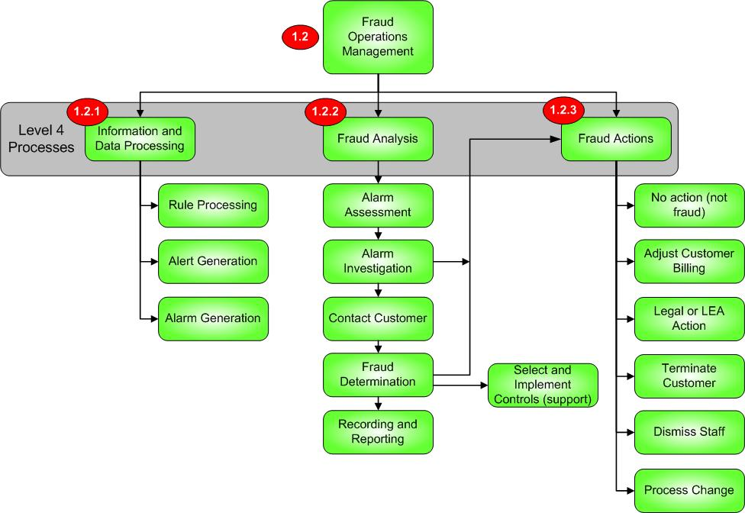

Figure 3: Level 3 Fraud Operations and supporting Level 4 processes

Fraud Operations Management
Process Identifier: 1.2

Process Context
This process element serves as a business process within the operator, within the overall Fraud Management program function.
Brief Description
Fraud Operations is the core functional team tasked with the detection, investigation, resolution, quantification, and prevention actions to deal with suspicious and fraudulent activities and entities.

Extended Description
While fraud operations is responsible for the 24x7 actions associated with protecting the business from existing and future fraud threats, the team also will provide communications to additional audiences of fraud activities, including:

- Internal audiences: Other departments as necessary to support fraud investigations and corrective actions, and senior business owners, stakeholders, and executives to illustrate progress, risks, and needs to increase effective protection around the business
- External audiences: Other operators through the course of information sharing (e.g., fraud types and tactics to protect, investigative needs, etc.), and LEAs for purposes of managing more significant threats and fraud generating individuals and syndicates.

Fraud Operations is divided into 3 primary functional groups: Information and Data Processing, Fraud Analysis, and Fraud Actions. Each functional group will be defined further in the following process sections.

Information and Data Processing
Process Identifier: 1.2.1

Process Context
This process element serves as a business process within the operator, within the overall Fraud Management program function.
Brief Description
This process is the ongoing processing of information and data against rules designed to detect threats, and the subsequent alerts and alarms resulting from rule violations and other detection processes.

Extended Description
Fraud operations in general should be receiving data almost continuously, and analysis of the received data should take place without delay where possible. Earlier processing and/or analysis of datasets enables not only more rapid detection of fraud, but also the subsequent ability to take meaningful action to stop fraudulent activities before (any) damage is incurred by the business. There are 3 primary functional areas within this process to address and define:

- Rule Processing: During rule processing activities, information and data is passed through rules either through automated (technology-based) means or other manual processes. Depending on the volume of data and the complexity of the rules (interdependencies, aggregated or weighted triggering, etc.), increasing levels of technology will be necessary to quickly implement rules against data and determine the results.
- Alert Generation: Configuration of alerts. Alerts may be generated when certain expected conditions are not met, including missing dataset delivery, failure to act on investigation requests (escalations), etc. Alerts may also be issued when certain conditions are exceeded, including excessive alarm quantities resulting from “loose” rules producing false positive results.
- Alarm Generation: Configuration of alarms. Alarms are typically the result of detected events or activities that are suspicious and should be investigated as possible fraud. Alarms may be the result of single rule violations, or of multiple rule violations that contribute to weighted levels of suspicion (more complex scenario) etc.

Other functions may also include the configuration of supplementary reports for scenarios not configured through rules and alarms as listed above.

The configuration of rules, alerts, and alarms should be governed by policies as described in the 1.1.x processes for Fraud Management. Additionally, the procedures that should be followed as a result of the issuance of an alert or alarm should be governed by policies as described within the 1.1.x processes for Fraud Management.

Fraud Analysis
Process Identifier: 1.2.2

Process Context
This process element serves as a business process within the operator, within the overall Fraud Management program function.
Brief Description
This process is the ongoing activity of investigating, diagnosing, and implementing controls to both prevent fraud and minimize existing fraud impacts.

Extended Description
Fraud Analysis is comprised of a series of sub processes that act as guidelines for activities conducted by the analysis team. Each sub process is part of a linear flow that also includes feedback into action and support processes, as described below.

- Alarm Assessment: As data processing triggers alarms of suspected fraud, the assessment activity is the first point at which initial triage of the alarm(s) is conducted. During the assessment, the analyst should determine, based on business rules, the initial validity of the alarm, a priority of the alarm (based on value, affected systems, or other criteria), and the appropriate team that would need to address the alarm (e.g., billing, wholesale partner, network, etc.).
- Alarm Investigation: Once initial assessment has occurred, the alarm is then forwarded to an investigation activity that typically begins as an internal function. During investigation additional data may be accessed, scope of the issue may be ascertained, and an overall understanding of the issue will need to be achieved before determining whether the issue is, in fact, fraud. During this process initial actions may be invoked (e.g., disrupted service) to prevent further loss/risk prior to customer contact and/or fraud determination work.
- Contact Customer: Once internal investigations have gathered all information available, a customer contact may be necessary to understand customer intention, validity of the subscriber, etc. This is the final process performed prior to reaching a fraud decision. If no customer is directly involved, this step may not be necessary (e.g., Dealer Fraud, Internal Fraud).
- Fraud Determination: Once all information is collected from internal and external investigations, a fraud determination is made. If the decision is that the issue is not fraud, all investigative materials and findings are then passed onto the Fraud Actions process (1.2.3) for closure, and the Support process (1.3.3) for enhancement of rules and configurations to possibly avoid recurrence of this alarm condition. If the decision is that the issue is, in fact fraud, similar subsequent activities will occur: First, the issue is referred to the Fraud Actions (1.2.3) process to properly handle actions to stop the fraud, initiate collections and legal actions, etc. Second, all investigative materials and findings are then passed onto the Support process (1.3.3) for enhancement of rules and configurations to hotlists, blacklists, and any refinement needed to possibly capture the issue more rapidly.
- Recording and Reporting: After the determination is made as fraud or not fraud, activities associated with the analysis are finally passed into recording of actions, and reporting of recoveries, time to capture and correct, and preventative actions now in process.

Fraud Actions
Process Identifier: 1.2.3

Process Context
This process element serves as a business process within the operator, within the overall Fraud Management program function.
Brief Description
This process contains all possible actions necessary to manage an issue following determination as fraud or not fraud.

Extended Description
Fraud Actions is comprised of a series of sub processes that act as guidelines for activities to be performed based on the issue being determined as fraud or not fraud. Each sub process is capable of being a stand-alone process (not dependent on other Actions sub processes), however more than one of these Actions may be used to help bring any given issue to appropriate closure.

- No Action: If an issue is determined to not be fraud, the issue is closed and archived as part of this process. Concurrent flows to Support and Reporting have also occurred to adjust rules, etc, as a result. No further action is required. Note: A feedback to the System Configuration Management process should be considered in this case, for possible alarm threshold adjustment, whitelist updates, etc. This process path is denoted in Figure 5: “Overall Process”.
- Adjust Customer Billing: Certain fraud instances result in customers being the victim in addition to the operator. In these cases, extent of customer damage needs to be quickly ascertained and corrected in the customer’s billing and/or services. While the determination of the damage is typically performed by the fraud team, the actual Customer Billing corrective action is usually performed by a Customer Care Team, based on information forwarded by the Fraud Team.
- Legal or LEA (Law Enforcement Agency) Action: If an issue is determined to be fraud and significant financial loss, contract breach, or other illegal activities have occurred, the operator may seek recourse via the legal system. This may be via civil reparations and/or criminal charges. This sub process will utilize the operator’s policies (1.1.5) to determine whether attorney, law enforcement, or other assistance is needed. This sub process will also use the same policies to determine and collect supporting information that will be necessary for those external agencies to properly pursue their activities.
- Terminate Customer: If an issue is determined to be fraud and the operator deems the issue to be of enough magnitude to warrant termination, this process will conduct the termination of the customer (e.g., initiate the disconnect order).
- Dismiss Staff: If an issue is determined to be fraud and/or a substantial violation of internal operator policies and internal staff have been found responsible, termination of the staff may be initiated at this step. Fraud team findings for ethics policy violations, fraud investigative results, etc, should be forwarded to Human Resources, where appropriate actions will be initiated. Of important note: Staff negligence resulting in fraud is sometimes inappropriately diagnosed as intentional when, in fact, accidental actions may have exposed the operator to the fraud. Care should be taken to fully understand the circumstances around which the internal employee’s actions caused or help cause the fraud.
- Process Change: If an issue is determined to be fraud, future preventative steps may include business process change in addition to fraud detection rule enhancements. Business process may have, in fact, allowed the fraud to occur, therefore the first step in prevention should happen well before a rule should capture the condition. This process will need to interface with the business to identify candidates for process change and present those to the appropriate business stakeholders.

Fraud Operations Support
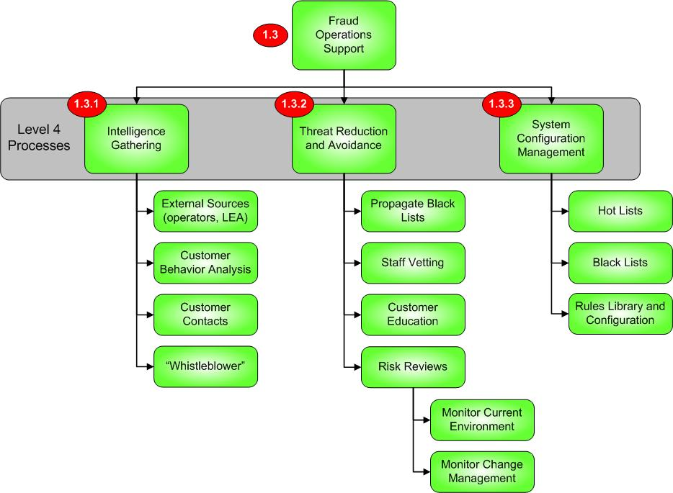

Figure 4: Level 3 Fraud Operations Support and
supporting Level 4 processes

Fraud Operations Support
Process Identifier: 1.3

Process Context
This process element serves as a business process within the operator, within the overall Fraud Management program function.
Brief Description
Fraud Operations Support serves as the enabling function for fraud prevention, ongoing fraud detection, and overall threat reduction practices.

Extended Description
Fraud Operations Support is has a primary role as a preventative entity within Fraud Operations overall. The Support process is comprised of three sub process groupings that all are designed to collect preventative information, monitor the business for changes (and counsel the business when those changes expose a threat for fraud), and to manage fraud learnings back into the business via list management, rule enhancements, etc.

Intelligence Gathering
Process Identifier: 1.3.1

Process Context
This process element serves as a business process within the operator, within the overall Fraud Management program function.
Brief Description
Intelligence Gathering is the process by which threats to the business are understood via information analysis from a variety of sources, both internal and external.

Extended Description
Intelligence Gathering is one of two primary proactive process groups by which fraud management practices are able to aggressively address fraud issues, preferably before those issues are executed against the operator. Intelligence gathering processes and methods serve as one of the operator’s first lines of defense to fraud attacks, and are a critical path to understanding threats currently outside the operator’s business. Four sub processes comprise Intelligence Gathering:

- External Sources: Intelligence about fraud attacks, methods to detect, methods to correct, and possible legality issues are collected and managed within this process step. Sources may include:
  - Other operators: Collective information about fraud attacks is frequently shared between operators as a best practice to help protect everyone
  - LEAs: Law Enforcement Agencies – where information about legality of the threats, punishment available by law, methods to detect, etc., may be obtained
  - Industry support bodies: Fraud protection forums including TM Forum, GSM Fraud Forum, CFCA, FIINA; Credit bureaus
  - Other industries: General utilities, healthcare, insurers, etc., where identity theft practices and other frauds also occur
- Customer Behavior Analysis: By understanding behaviors that lead to fraud activity, patterns associated with these behaviors can be identified and isolated. Once isolated, patterns of activities across all customers may be monitored for similar patterning that would lead to alarms and analysis much earlier in an attempted fraud activity.
- Customer Contacts: Frequently fraud activities conducted by an individual or syndicate (defined for this instance as an organized group) will also involve other parties that may not be directly associated with the fraud, but are knowledgeable of the activity. While the individual(s) initiating the fraud may be isolated and the attack halted, care should be taken to understand the associated parties within the communications patterns of the initiating fraudsters. Attacks may resume via these individuals, and therefore close monitoring of this chain of parties is warranted. Note that none of these individuals (that either started the attack or were part of the communications patterns) may be direct customers of the targeted operator.
- Whistleblower: A “Whistleblower” is defined as an individual that identifies fraud activity to an operator. This individual is most often an internal employee (revealing internal fraud activity), but may also be an external party otherwise unaffiliated with the operator. Several operators have encouraged internal whistle blowing by offering incentives as part of normal operator policy to reward those people that bring fraud attacks to the attention of the fraud management team.

Threat Reduction and Avoidance
Process Identifier: 1.3.2

Process Context
This process element serves as a business process within the operator, within the overall Fraud Management program function.
Brief Description
Threat Reduction and Avoidance is the process by which threats are identified in a proactive manner, to minimize risk to the business prior to an attempted attack.

Extended Description
Threat Reduction and Avoidance is the second of two primary proactive processes (along with the aforementioned Intelligence Gathering) to minimize the risk of possible fraud attacks. Within this process several protective steps are taken to ensure risk to the business is mitigated as much as possible as an ongoing practice. Three sub processes comprise the carrier’s ability to reduce and avoid threats:

- Propagate Black Lists: As fraud attacks are identified and confirmed, those individual(s) and any aliases are collected and managed within black lists. These lists should be used as a tool to protect the operator against re-issue of services to those on the list. Understanding that the list will be in a constant state of growth over time, an operator will undoubtedly encounter a black listed name belonging to a completely unassociated and innocent individual. Consequently, operators should consider investigation of those cases prior to denial of services, in hopes of not excluding legitimate, non-fraud customers.
- Staff Vetting: Operators should conduct thorough background and security checks on individuals that will have access to sensitive and otherwise vulnerable areas within the operator’s business (access to network systems, billing systems, customer records and accounts, financial data, etc.). Internal fraud is a substantial threat to every operator, and depending on the employee’s area of access, periodic re-checks of backgrounds of existing employees is not unreasonable.
- Customer Education: Certain fraud types are often unable to be blocked by operators, and may victimize an operator’s customer base while also causing loss to the operator (e.g., customer credits given). In these situations, proactive steps should be initiated by the operator to educate their customer base on behavioral changes and/or methods that will help to prevent these fraud types from occurring. This may be in the form of press releases, PSAs (Public Service Announcements), and even direct customer contacts.
- Risk Reviews: Risk Reviews are conducted throughout the business on recurring, non-standard intervals. Risk reviews should focus on threats and vulnerabilities across (at least) the following targets within the operator’s business:
  - Current operations and processes
  - Proposed new operational processes
  - Current products
  - Proposed new products
  - New systems within the network
  - Etc.

System Configuration Management
Process Identifier: 1.3.3

Process Context
This process element serves as a business process within the operator, within the overall Fraud Management program function.
Brief Description
System Configuration Management serves as the support process to maintain critical reference and configuration data. This process applies to operators with manual and automated fraud management data analysis capabilities.

Extended Description
System Configuration Management is responsible for generating, implementing, and maintaining all critical lists and rules libraries. This process must remained tightly interfaced with the fraud analysis and determination activities to ensure lists are maintained as current, and that rules are properly deployed and utilized. Three primary sub processes are driven within System Configuration Management:

- Hot Lists: Hot lists contain patterns of activity and behavior of past fraudsters. These patterns may be analyzed against current patterns of activities within the network to detect re-emergence of fraud activity.
- Black Lists: These list(s) contain names/identities of prior known fraudsters, and should be continually checked against new subscribers. This should also include altered identities through a variety of methods.
- Rules Library and Configurations: All rules associated with fraud detection are maintained within this sub process. The challenge facing operators with rules management goes beyond the simple configuration of rules; an operator must also continue to review rule performance (ability to capture fraud, sensitivity to capture fraud vs. creating “false positive” alerting, etc.). Additionally, rules are constantly changing and growing based on changing dynamics in networks, products, systems, internal processes, subscriber base, etc.
- Alarm threshold management: Based on results of Fraud Determination (within process identifier 1.2.2), threshold adjustments will need to made to either correct for “false positive” alarming, or to increase threshold sensitivity to detect additional suspected fraud situations. This process connection is illustrated within figure 5 “Overall Process Diagram”.

Overall Process Flow
The following diagram illustrates the complete process flow across all Level 3 and Level 4 processes, including cross-process linkages:

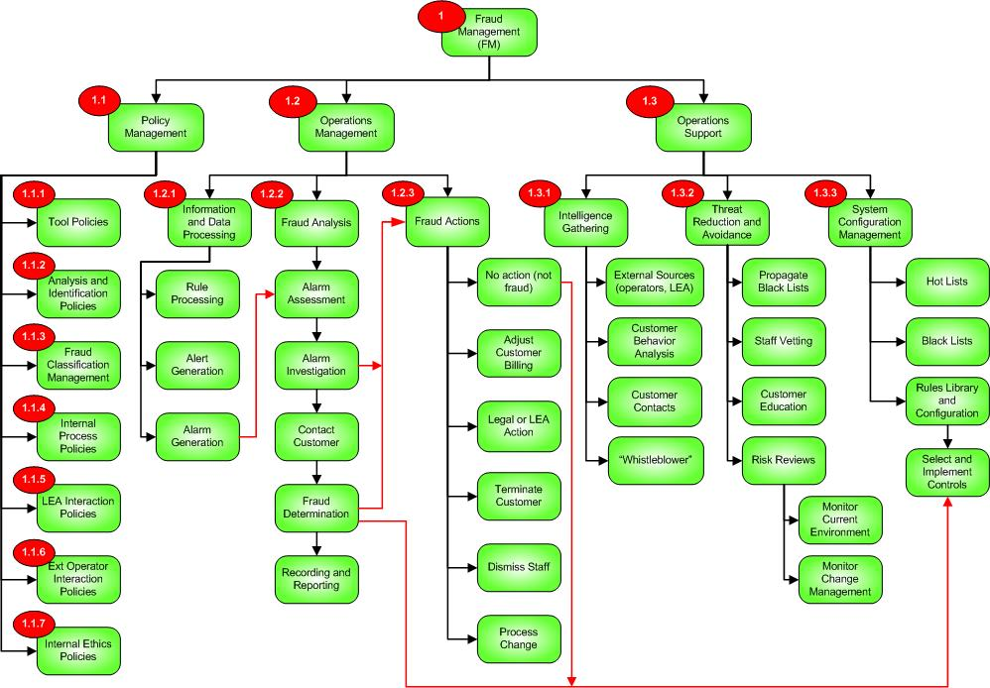

Figure 5: Overall Fraud Process Flow

Fraud Management Summary

Fraud Management involves monitoring of all internal and external influences and activity within an operator’s business. This document should be used as a reference guide for operators to structure fraud practices within their operations, while also integrating fraud processes into their overall Revenue Management organization.

Administrative Appendix
This Appendix provides additional background material about the TM Forum and this document.

About this document
This is a TM Forum Guidebook. The guidebook format is used when:
- The document lays out a ‘core’ part of TM Forum’s approach to automating business processes. Such guidebooks would include the Telecom Operations Map and the Technology Integration Map, but not the detailed specifications that are developed in support of the approach.
- Information about TM Forum policy, or goals or programs is provided, such as the Strategic Plan or Operating Plan.
- Information about the marketplace is provided, as in the report on the size of the OSS market.

Document History

Version History

Version Number | Date Modified | Modified by: | Description of changes
Version 1.0 | 14/Feb/11 | John Brooks | Document reformatted to adopt TMF template
Version 1.1 | 1/Mar/11 | Alicja Kawecki | Minor cosmetic corrections prior to web posting and ME
Version 1.2 | 7/Dec/11 | Mary Amalfitano | Minor cosmetic corrections prior to web posting and ME

Release History

Release Number | Date Modified | Modified by: | Description of changes
Release 1.0 | 14/Feb/11 | John Brooks | Initial Release

Company Contact Details
Company | Team Member Representative
Subex, Inc. | Name: John Brooks  Title: Vice President  Email: John.Brooks@subexworld.com  Phone: +1 303 301 6212  Fax: +1 303 301-6201

Acknowledgments
This document was prepared by the members of the TM Forum Fraud Management team:
- John Brooks, Subex, Editor
Additional input was provided by the following people:
- Santhosh Gopalan, Emirates Integrated Telecommunications Company
- Krista Saarinen, Rogers Communications
- David Stuart, Qatar Telecom
- Estevan Santiago, Claro Brazil

