Reference Guide: Cable Goal Alignment Strategy

GB948-B
TM Forum Approved Version 0.3


May, 2012

Notice

This material, including documents, code and models, has been through review cycles; however, due to the inherent complexity in the design and implementation of software and systems, no liability is accepted for any errors or omissions or for consequences of any use made of this material.
Under no circumstances will the TM Forum be liable for direct or indirect damages or any costs or losses resulting from the use of this specification. The risk of designing and implementing products in accordance with this specification is borne solely by the user of this specification.
This material bears the copyright of TM Forum and its use by members and non-members of TM Forum is governed by all of the terms and conditions of the Intellectual Property Rights Policy of the TM Forum (http://www.tmforum.org/Bylaws/1094/home.html) and may involve a claim of patent rights by one or more TM Forum members or by non-members of TM Forum.

Direct inquiries to the TM Forum office:
240 Headquarters Plaza,
East Tower – 10th Floor,
Morristown, NJ 07960 USA
Tel No. +1 973 944 5100
Fax No. +1 973 944 5110
TM Forum Web Page: www.tmforum.org

Table of Contents
Notice 2
Table of Contents 3
List of Figures 4
Executive Summary 5
1. The Goal Alignment Strategy Process Flow 6
2. The Executive Strategy 7
3. The Players 7
4. The Measurements 7
5. The Techniques 8
5.1. Cost Per Defect 8
5.2. Measurement Technique 8
5.3. Measurement Barriers 8
5.4. Performance Levels 8
5.5. Performance Optimization 8
5.6. Consequences 9
5.7. External Event Triggers 9
6. Summary 10
7. Glossary of Terms 11
8. Administrative Appendix 12
8.1. About this document 12
8.2. Document History 12
8.2.1. Version History 12
8.2.2. Release History 12
8.3. Company Contact Details 13
8.4. Acknowledgments 13

List of Figures

Figure 1 : The Goal Alignment Strategy Process Flow 6

Executive Summary
Getting started on a transformation project that includes Business Intelligence (BI) features can be a daunting task. Successful achievement of the strategic requirements of the executive suites of the business require processes for driving that message down through the levels of management all the way to the individual workers who apply specific tactics. Then measurements of the efficacy of those tactics need to be calculated, aggregated, and communicated back up the management chain.
In order to align the goals from the executive strategies with those specific tactics of the individual contributors, a methodology should be created and adopted that increases the probability of success. This document outlines one such methodology.

The Goal Alignment Strategy Process Flow
At a high level, the goal alignment strategy is relatively easy to communicate. An executive strategy is stated, various levels of management are involved, and individual contributors actually carry out the tactical elements of the strategy.

This flow is demonstrated below:
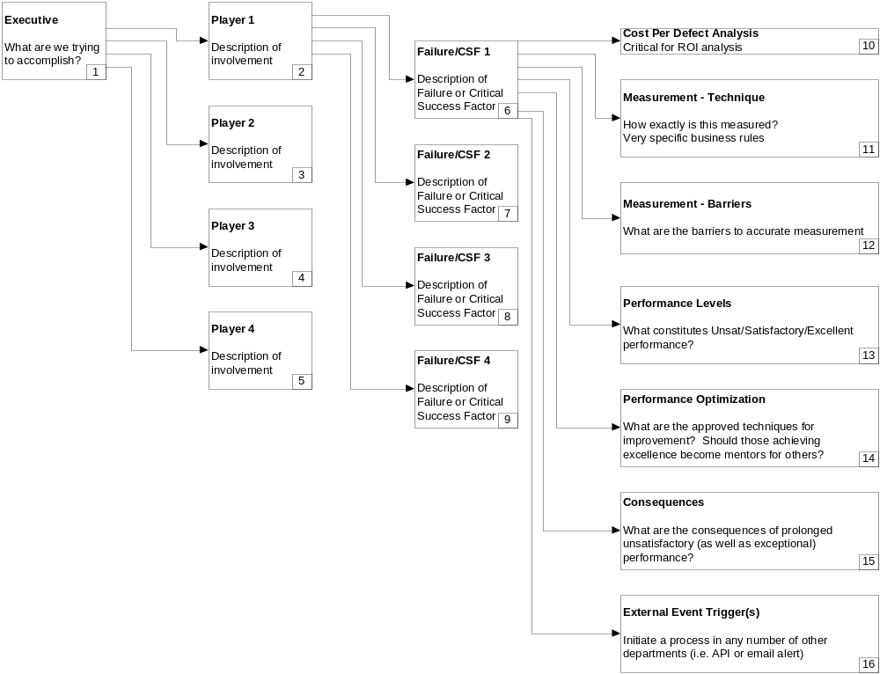
Figure 1 : The Goal Alignment Strategy Process Flow

This flow has 4 major components:
- The Executive Strategy (cell 1)
- The Players who execute the tactics (cells 2-5)
- The Measurements (cells 6-9)
- The Techniques (cells 10-17)

Clearly this is a simplified view of the process, and is intended to connect the very high level strategy with the individuals responsible for carrying out the tactical elements of execution.

The Executive Strategy
One example of an executive strategy is to ‘Optimize the Customer Experience’. Certainly this is critical in today’s super-competitive environment. But this strategy must be decomposed into specific and very granular tactical elements in order to become actionable.

Executives may not need to know the detailed specifics of each and every tactical execution point, but they certainly need to know that their organization has a plan for executing their strategies. Executives also want to know that the plan is scalable, extensible, and strategy agnostic so that it can be reused, developed, and extremely effective.

The Players
The individuals responsible for carrying out the execution of the plan are portrayed in cells 2-5 in the Goal Alignment Strategy work flow example. There could be any number of players for a given Strategic Initiative, each of which will have some number of measurements (cells 6-9) associated with them.

For a Strategic Initiative like ‘Optimize Customer Experience’, there will be many players responsible for individual contributions. For example:
- Marketing contributes to Customer Experience (CE) by creating and delivering compelling messages that convert potential consumers into customers.
- Call Center Representatives contribute to CE by answering the phone quickly, being polite, resolving issues on the first try, etc.
- Technicians contribute to CE by being on time, polite, knowledgeable, fast, etc.
- Plant and Network workers contribute to CE by ensuring that services are highly available.
- And of course many other players contribute in various ways.

The point is that each of these players needs to understand the specific ways that they should be contributing.

The Measurements
Players know exactly how they should be contributing to the strategic initiative when they have been given clear direction, tightly coupled with accurate and timely measurement, and fully supported with training.

‘Inspect what you expect’ is a time-tested management philosophy; measuring very specific and actionable components forces a detailed look at components that contribute to the overall strategy.

Any individual player may have one to many measurements that impact their scorecard, and can therefore be aggregated into an overall performance score.

The Techniques
Cells 10-16 in the Goal Alignment Strategy flow identify the most critical elements related to each measurement. These 8 concepts should be applied to each of the measurements for each of the players.

Cost per Defect
The cost per defect in cell 10 helps managers identify the most financially beneficial measurement to prioritize. Cost per defect multiplied by the number of opportunities generates an overall value of solution. This is a critical component of an effective ROI analysis.

Measurement Technique
Understanding the very specific business rules of any given measurement is required before the business intelligence partners can create the metric. And these rules must be well understood by the players before they can be expected to achieve positive results. These measurement techniques are identified in cell 11.

Measurement Barriers
It is common for a desirable measurement to have some barriers to accurate measurement. Actively discussing possible barriers (cell 12) allows for identification of these barriers and prioritization of solution of those problems.

Performance Levels
Creating and enforcing accountability requires establishment of desired performance levels. What are the performance minimums required to satisfy the executive strategy? Is the goal to continuously drive performance upward, or are upper and lower control boundaries more applicable?

Performance Optimization
A critical component of successful Goal Alignment Strategies is having a plan for specific techniques to help individuals improve performance (cell 14). Without a corporate view on improving performance on each and every measurement, remediation becomes hit or miss, with the potential that individuals will not attempt to improve. Another negative outcome of missing optimization techniques is that individuals invent their own techniques that either do not work and therefore waste time, or actually negatively impact performance locally in their own area or on a greater scale.

Consequences
If performance consistently exceeds expectations, what kind of positive consequences (cell 15) can be held out as motivators? On the negative side, what happens to individuals who consistently perform below expectations, and also do not respond to optimization attempts?

External Event Triggers
Successful performance management from a BI system usually generates a great deal of interest, and a desire to propagate the information to other systems. This can be as simple as an email to notify interested and responsible parties of a breach of SLA, or exporting of performance data to compliance systems. These triggers are identified in cell 16.

Summary
There are many challenges of bridging the considerable gap between an executive strategy (that tends to be relatively broad in nature) and the many tactical elements (very detailed in nature) that are needed to satisfy that strategy. Driving success calls for repeatable structures and processes that align the goals of executives with the goals of the individual contributors.

Glossary of Terms
KPI | Key Performance Indicator
BI | Business Intelligence
CE | Customer Experience
SLA | Service Level Agreement, or expected performance level

Administrative Appendix
This Appendix provides additional background material about the TM Forum and this document. In general, sections may be included or omitted as desired, however a Document History must always be included.

About this document
This is a TM Forum Guidebook. The guidebook format is used when:
- The document lays out a ‘core’ part of TM Forum’s approach to automating business processes. Such guidebooks would include the Telecom Operations Map and the Technology Integration Map, but not the detailed specifications that are developed in support of the approach.
- Information about TM Forum policy, or goals or programs is provided, such as the Strategic Plan or Operating Plan.
- Information about the marketplace is provided, as in the report on the size of the OSS market.

Document History

Version History
<This section records the changes between this and the previous document version as it is edited by the team concerned. Note: this is an incremental number which does not have to match the release number>

Version Number | Date Modified | Modified by: | Description of changes
0.1 | 30/09/2011 | Paul Ousterhout – BATMANN Analytics | draft
0.2 | 25/10/2011 | Alicja Kawecki | Minor cosmetic and formatting corrections prior to web posting and Member Evaluation
0.3 | 11/05/2012 | Alicja Kawecki | Updated to reflect TM Forum Approved status

Release History
<This section records the changes between this and the previous Official document release>

Release Number | Date Modified | Modified by: | Description of changes
<<Release Number >> | DD/MMM/YY | <<name>> | Description e.g. first issue of document

Company Contact Details
Company | Team Member Representative
BATMANN Analytics | Paul Ousterhout  CTO  Paul@BATMANNAnalytics.com
Time Warner Communications | Jon Anderson  VP Process Operations  jonathan.anderson@twcable.com

Acknowledgments
This document was prepared by the members of the TM Forum Cable Business Intelligence team:
- Paul Ousterhout, BATMANN Analytics, Editor and Team Leader
Additional input was provided by the following people:
- Dan Coffman from Brighthouse
- Steve Madden from Charter Communications
- Hans Hedstrom from Comhem
- Gary Bonneau, Brett Brock, and Chad Quayle from Cox Communications
- Rob Bailey and Jeff Palmatier from Time Warner Cable
- Marek Stawinski and Zoran Gligorevic from UPC
- Alex Bruce from Oracle
- Scot Loach from Sandvine
- Vincent Fung from Netcracker

