Information Framework (SID)

Workforce Business Entities

GB922 Addendum 7 Workforce

TM Forum Approved Version 1.2



October, 2012

# Notice

This material, including documents, code and models, has been through review cycles; however, due to the inherent complexity in the design and implementation of software and systems, no liability is accepted for any errors or omissions or for consequences of any use made of this material.

Under no circumstances will the TM Forum be liable for direct or indirect damages or any costs or losses resulting from the use of this specification. The risk of designing and implementing products in accordance with this specification is borne solely by the user of this specification.

This material bears the copyright of TM Forum and its use by members and non-members of TM Forum is governed by all of the terms and conditions of the Intellectual Property Rights Policy of the TM Forum (<http://www.tmforum.org/Bylaws/1094/home.html>) and may involve a claim of patent rights by one or more TM Forum members or by non-members of TM Forum.

Direct inquiries to the TM Forum office:

240 Headquarters Plaza,

East Tower – 10th Floor,

Morristown, NJ  07960 USA

Tel No.  +1 973 944 5100

Fax No.  +1 973 944 5110

TM Forum Web Page: [www.tmforum.org](http://www.tmforum.org/)

# Table of Contents

Notice 2

Table of Contents 3

List of Figures 5

1 Workforce Business Entities 6

1.1 WorkSpecificationABE 7

1.1.1 WorkSpecification 8

1.1.2 WorkSpecfulfillmentRate 9

1.2 Work ABE 10

1.3 Workforce Resource ABE 12

1.3.1 Roles 12

1.3.2 Skill 13

1.3.3 Pool and Pool Assignment 14

1.4 Work Order ABE 17

1.5 WorkScheduleABE 18

1.5.1 Appointment 18

1.5.2 Reservation and Assignment (Dispatch) 19

1.5.3 Work Schedule 21

1.6 Business Entity Definition: Workforce ABE 23

1.6.1 WorkSpecification 23

1.6.2 WorkSpecRelationship 25

1.6.3 WorkSpecificationType 26

1.6.4 WorkSpecificationCost 27

1.6.5 WorkSpecificationVersion 28

1.6.6 WorkSpecFulfillmentRate 29

1.6.7 Work 31

1.6.8 WorkRole 32

1.6.9 WorkSpecificationRole 33

1.6.10 WorkforceEmployeeRole 34

1.6.11 WorkforceOrganizationRole 35

1.6.12 WorkforceResourceRole 36

1.6.13 WorkforceResourceTool 37

1.6.14 WorkforceEmployeePool 37

1.6.15 WorkforceResourcePool 38

1.6.16 WorkforcePoolAssignment 39

1.6.17 WorkforceEmployeePoolAssignment 40

1.6.18 WorkforceResourcePoolAssignment 41

1.6.19 WorkSchedule 41

1.6.20 WorkforceEmployeeReservation 43

1.6.21 WorkforceEmployeeAssignment 44

1.6.22 WorkforceResourceReservation 45

1.6.23 WorkforceResourceAssignment 46

2 Model Alignment Opportunities 48

2.1 TAM Mapping 48

2.2 eTOM Mapping 49

2.3 Future Revision for SID 50

3 Administrative Appendix 51

3.1 Document Lifecycle 51

3.2 Document History 51

3.3 Release History 51

3.4 Company Contact Details 52

3.5 Acknowledgments 52

# List of Figures

Figure WFM.00: L1 Information Framework with Workforce Entities 6

Figure WFM.01: L1 Information Framework with Workforce 7

Figure WFM.02: WorkSpecification 8

Figure WFM.03: WorkFulfillmentRate 9

Figure WFM.04: Work/WorkSpecification Pattern 10

Figure WFM.05: WorkforceOrganizationRole and WorkforceEmployeeRole 12

Figure WFM.06: Workforce Resource Role 13

Figure WFM.07: Skill Model 13

Figure WFM.08: Workforce Pool 15

Figure WFM.09: Workforce Assignment to Pool 16

Figure WFM.10: Work Order Model 17

Figure WFM.11: Appointment 18

Figure WFM.12: Employee Assignment and Reservation 19

Figure WFM.13: Resource Assignment and Reservation 20

Figure WFM.14: Work Schedule and WorkforceOrganizationRole 21

# Workforce Business Entities

This addendum describes the SID Workforce Management ABE. This Workforce Management Model can support the Common’s Project ABE and Common’s Party ABE. These ABEs were developed based on the SID principle of inherent extensibility by employing SID modeling patterns.

The scope of this phase focuses only on dispatchable Field Force Management, not call center workforce (customer facing) or NOC (network facing). The gap analysis and revision of this Field Force model for these areas should be a candidate for improvement in a future release.

**Note:** This model is the first result of a multi-phase work that follows the Chapter, “Business Agreement, Comment to TAM, and eTOM CR”. Naturally, it will progress to the remaining Integration Framework. However, many detailed aspects of the model need revision and additions in order to cover a broader scope of requirements in CSP business. Chapter 5 of this addendum that summarizes the other opportunities for extension to be introduced into the next version of SID, before moving to Integration Framework.

Figure WFM.00 shows the SID Framework with Workforce and related ABEs highlighted.

Figure WFM.00: L1 Information Framework with Workforce Entities

The Workforce ABE models the human and other field resources with their roles, skills, calendar, and other characteristics. It also models the work description and reservation and assignment of a technician to a task. Workforce ABEs reuse, via association, other ABEs in other domains such as Party, Project, and Time.

Figure WFM.01 represents the structure of the Workforce ABE. It contains four L2 ABEs: Work, Work Specification, WorkforceResource, and WorkforceSchedule. Other related ABEs belong to Project, Party, Business Interaction, Location, Agreement, and Time.

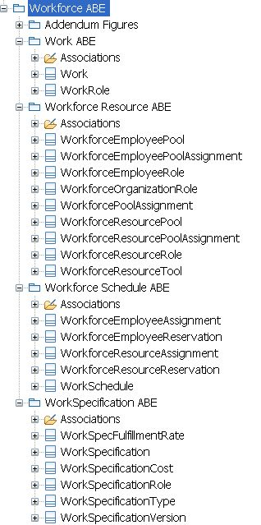

Figure WFM.01: L1 Information Framework with Workforce

## WorkSpecificationABE

The WorkSpecification ABE is a new addition to SID. It specifies a kind of work that can be performed manually by a technician.

Two key entities that comprise the WorkSpecification ABE are WorkSpecification and WorkSpecFulfillmentRate.

### WorkSpecification

Figure WFM.02 represents WorkSpecification, its attributes, and related entities.

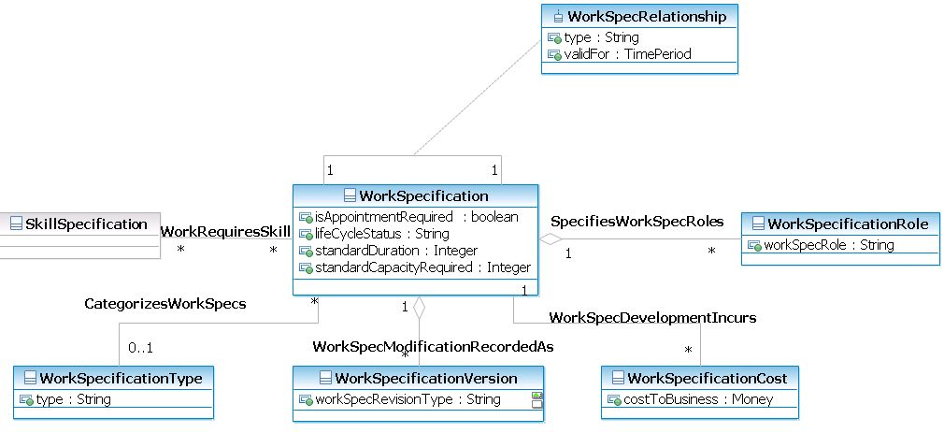

Figure WFM.02: WorkSpecification

WorkSpecification and its related specification entities provide the definition of a work task to be performed manually, such as instructions and requirements to do fiber installation or equipment repair. Like a template with invariant characteristics of a work task, WorkSpecification is used to instantiate a particular instance of Work description (for example, the repair of a router at a particular location). For Work, see the Work ABE section on page 10.

Some work requires an Appointment to be agreed on with a customer or location owner; some work does not (for example, work required for an internal network build). The need for an Appointment is indicated by the isAppointmentRequired attribute. See the Appointments section on page 18. The standardDuration attribute is the approximate time the Work is to be performed. The standardCapacityRequired attribute is the effort required to do the Work. These attributes are used as input for Scheduling.

WorkSpecifications have a relationship with each other. The relationship can be dependency, mutual exclusion, being performed at the same time, etc. Work specification requires skills (for example, GPON service installation requires drop cable running, patch panel connection, ONT set up, activation, and test skills). One WorkSpecification can play one or more WorkSpecificationRoles. For example, Cable layout work can have the role of Installation for a new network infrastructure build, or the role of Installation for a service delivery.

The other entities define other typical data about the work. WorkSpecificationType is used to classify WorkSpecification. Work Specifications can then be grouped into categories to make a Work Catalog. WorkSpecificationCost specifies the multiple monetary cost of doing the work (not including the human cost of using a technician’s time). WorkSpecificationVersion specifies the versions after changes.

**Note:** Project ABE can interact with Workforce ABE via Work Order. Work Order Item involves WorkSpecification. For more information, see the WorkOrder ABE section on page 17.

### WorkSpecfulfillmentRate

WorkFufillmentRate is used in planning and WorkSpecification configuration. It represents a particular effort (“consumptionCapacity” attribute) to do a given amount of particular work (“quantity” attribute) in a given location which can be done by a given organization. For example, a fiber installation team for the New York serving area (having a capacity, say, of 100 man days per week) can fulfill 200 fiber layouts.

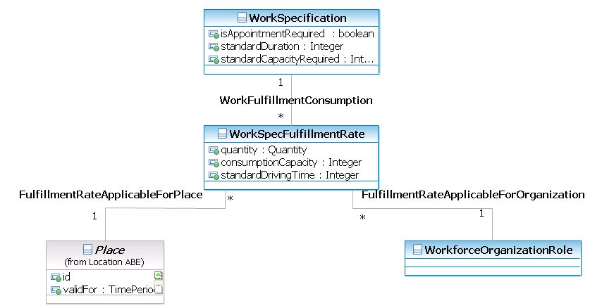

Figure WFM.03: WorkFulfillmentRate

**Note:** the rate of work that can be performed may not be linear with the quantity of work. It is calculated based on many inputs. For example:

* The skill qualification of the Pools that the Organization has (senior engineers, interns, testers, etc.)
* The specification of the Work (such as its standard duration)
* The Specification of the Place or Serving Area (e.g. installation in Rural areas consumes 50% more effort than in Urban areas) and the standardDriving time
* The same location grouping effect (e.g. it takes 2 hours to install the first 10 fibers, but for the next 20, it would take only one hour. Or, it costs the same effort to install two phone lines instead of one.)

**Note:** Via WorkSpecFulfillmentRate, the relationship between WorkSpecification, WorkforceOrganizationRole, and Place is M–M, given that there are many variants in fulfillment rates.

## Work ABE

Following the Entity/EntitySpecification pattern, with WorkSpecification we also introduce the Work ABE. It contains the entities of Work and WorkRole.

Work is instantiated from WorkSpecification, with template invariant characteristics, and the addition of specific attributes with values of the work for a specific context.

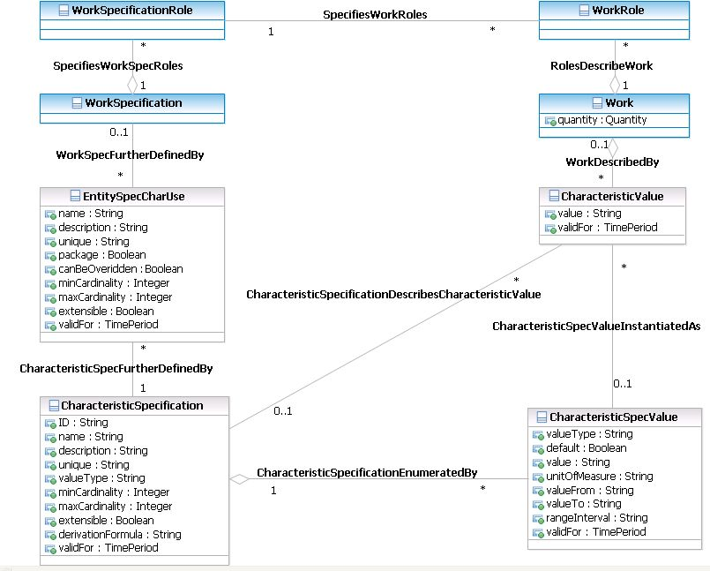Figure WFM04 depicts the Work and WorkSpecification entities, along with their related instance entities, WorkRole and WorkSpecificationRole. They represent an application of the SID EntitySpecification/Entity pattern, CharacteristicUse, etc.

Figure WFM.04: Work/WorkSpecification Pattern

**Note:** Instead of modeling WorkSpecificationCharacteristic, WorkSpecCharacteristicValue, and WorkCharacteristicValue as new classes, we relate WorkSpecification to EntitySpecCharUse, and relate Work with CharacteristicValue.

Role class model can be used to simplify the modeling of different types of WorkSpecification and Work, to make the model inherently more extensible.

Instead of trying to define many subclasses (one for each different type of Work) or introduce multiple inheritances (so that a new Work would derive from a set of existing Works), we can instead define a set of roles that a Work is meant to play. For example, a Work of fiber rollout at a location on a date can be a build task in an infrastructure project, or a role of installation task in a service fulfillment project. So the specification of these variants of the work can be a bit different. Instead of making sub-classes of this work to cover these cases, two roles of fiber rollout for network build, and fiber rollout for service delivery, can be introduced.

The Cardinality is 1-* because Work can have more than one role with different characteristics in different contexts.

Similarly, WorkSpecficationRole can extend the invariant characteristics of a WorkSpecification (a set of roles is used to characterize different sets of functionalities of the WorkSpecification) in different contexts. For example, a CPE installation work specification may have in addition, via WorkSpecificationRoles, the specifications of ONT installation, Cable modem installation, or DSL modem installation.

**Note:** Project ABE can interact with Workforce ABE via Work Order. WorkOrderItem is associated with Work.

## Workforce Resource ABE

WorkforceResource ABE represents the employees and other non-human resources involved in field operations.

### Roles

Figure WFM.05 represents the WorkforceEmployeeRole and WorkforceOrganizationRole entities and their relation with PartyRole. Using the role model, it is possible to describe more details of the entities without creating more sub-classes.

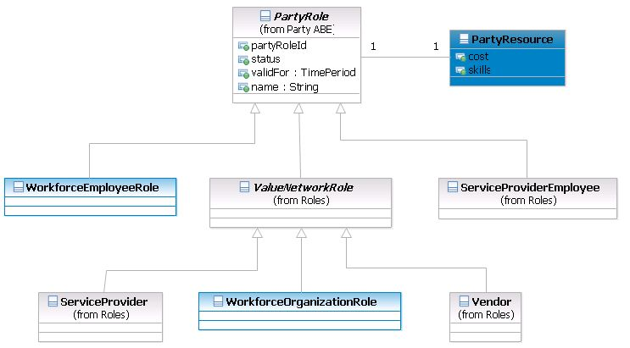

Figure WFM.05: WorkforceOrganizationRole and WorkforceEmployeeRole

The WorkforceEmployeeRole class represents an individual field technician. Or, more exactly, because of the use of Role instead of Entity, a person or employee, which can be a field technician in addition to his/her other responsibility (like manager, network engineer, etc.), presented by other designated Roles. As with any other PartyRole, WorkforceEmployeeRole has a Calendar of working days/hours, as well as a link to Skill sets, which need to be considered to create availability Pool(s) and WorkSchedule(s) for the Organization.

The class of WorkforceOrganizationRole represents an organization or team, like a department, in a Service Provider company, or a 3rd-party contractor team, involved in field operations. This class is extended from ValueNetworkRole. Through this extension, WorkforceOrganizationRole is involved in the value chain of service supply–consumption. WorkforceOrganizationRole also contains one or more pools of employees, ready to provide field services with particular skill sets for a service area.

Similarly, WorkforceOrganizationRole has a Calendar of working availability, which needs to be considered to create availability Pool(s) and WorkSchedule(s) for the Organization.

In Figure WFM.06, the class of WorkforceResourceRole represents other non-human resources that are involved in field work. Tool is an example class. Other examples are truck, accessories, materials, etc.

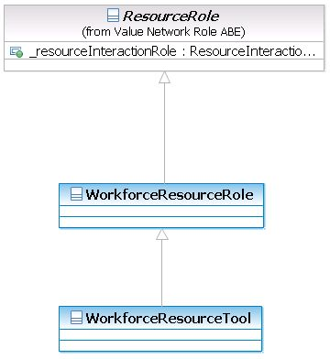

Figure WFM.06: Workforce Resource Role

### Skill

To be assignable to work, technicians must have certain skills. In SID, the Skill and SkillSpecification are modeled in Party ABE. They are modeled using the atomic/composite pattern, and categorized using SkillCatalog. Refer to Party ABE for more details.

Its association to Party and PartyRole, which generalizes Workforce roles, is explained in Figure WFM.07.

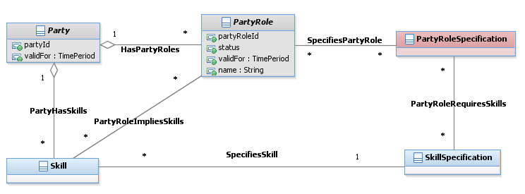

Figure WFM.07: Skill Model

The association between a PartyRole and Skill(s) implies requirement. For example, to be classified as a fiber repair technician, for planning or training purposes, the role must have the following skills: signal strength test or measurement, equipment diagnostics, equipment reconfiguration, and equipment installation.

The association between Party and Skill(s) means a particular person or group/organization already has a particular skill(s).

### Pool and Pool Assignment

For workforce planning and scheduling purposes, the capacity of individual human and non-human resources must be organized in Pools. A Pool is a group of people or resources, grouped by some criteria, such as Skills or Location, for a period of time. Pool also facilitates the assignment of a group of people to a work task. Pools may not always be equal to a physical organization, but rather a logical holder of workforce capacity. In fact, a Workforce organization can have more than one Pool, and vice versa, a pool can contain technicians from more than one organization.

For this SID release, the capacity represented by or associated with a Pool is high-level — just the count of people with certain skills for locations. In a future release, we will consider defining more details on capacity down to a time slot (of a day), the capacity unit (man hours, maximal number of orders of certain Work types that can be processed), time granularity (like 1 hour, 2 hours, etc. — i.e. the unit time period the workforce organization can give resources for), and others. For example, an EmployeePool’s Capacity, on a particular working day, from 8 am to 12 pm, with Fiber installation skills can be 40 man hours (available capacity).

The WorkforceEmployeePool has the flag of isWFSupplierEmployeePool, to distinguish whether the pool is managed by an external Supplier (3rd-party contractor). Such a pool may be transparent to the Service Provider in terms of particular employee booking and assignment; as such functions are outsourced to the contractor company. Nevertheless, the Service Provider may want to know the capacity of the pool, for its own planning purposes.

An example of a WorkforceResourcePool is the group of trucks and tools (like network testers) that the field force department for the New York area can use to serve a Fiber installation project.

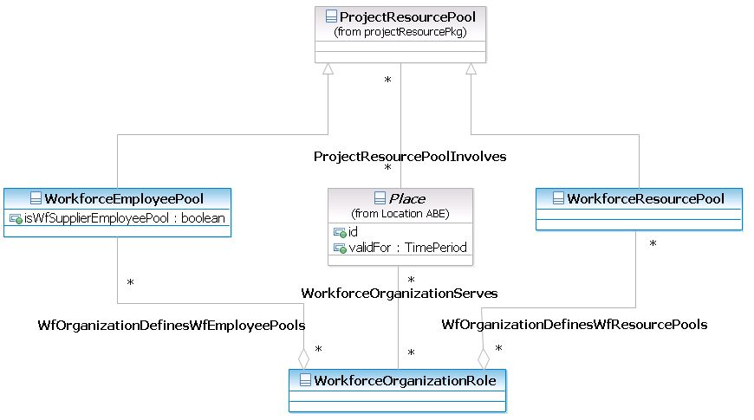

Figure WFM.08: Workforce Pool

Figure WFM.09 represents the assignments of Employees or Resources to Pools.

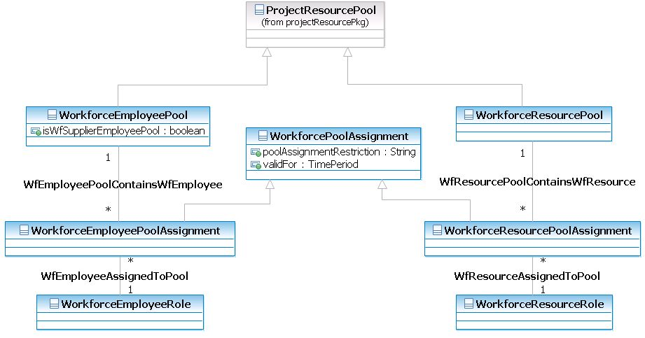

Figure WFM.09: Workforce Assignment to Pool

The assignment of Employee and Resource to a pool is recorded in an assignment class — WorkforcePoolAssignment. Its subclasses are WorkforceEmployeePoolAssignment and WorkforceResourcePoolAssignment. The parent class of WorkforcePoolAssignment has the attributes for the validity period, as well as the restriction of this assignment. The restriction is any rule that keeps the assignment valid other than time period. For example, this employee to Pool assignment can be 50% of his capacity during that period only.

The assignment of employees to an organization’s Pool must correspondingly update the WorkFulfillmentRate of the organization. See the WorkSpecFulfillmentRate section on page 29 for these classes.

## Work Order ABE

Work Order is a request for manual work that can be sent to a workforce management solution to process. WorkOrder ABE is modeled in Project ABE of the Enterprise domain. Here we describe the association between Word Order ABE and the Work/WorkSpecification Entities.

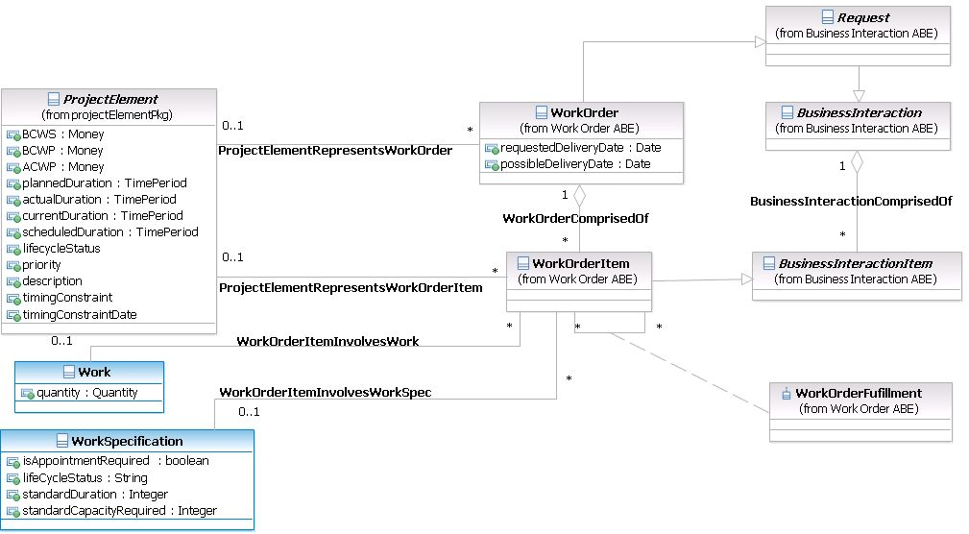

Figure WFM.10: Work Order Model

WorkOrder comprises one or more work items. To be recognized properly by the work force management solution, a work item must refer to the same WorkSpecification that the WFM solution can accept. Correspondingly, the work order item is to describe the work.

WorkOrderFulfillment specifies the execution dependency between WorkOrderItem, like start-to-finish, start-to-start, etc.

**Note:** The association between Project Element and WorkOrder or WorkOrderItem is 0..1 to M. The cardinality 0..1 means that it is not necessary to have a project, to issue or associate a WorkOrder.

## WorkScheduleABE

The scheduling process involves planning available workforce capacity, handling the appointment request (booking), and reservation and assignment (dispatch) of the workforce. These processes are supported by the workforce business calendar, appointment, workforce pool, reservation, and assignment entities.

Correspondingly, we introduce the Appointment, Reservation (Booking), and Assignment (Dispatch) entities along with WorkSchedule. Though Appointment is defined in Project ABE, we present its association with WF entities here too.

### Appointment

To deliver a service, a specific Work Order, with its WorkItems and the associated Work tasks, is generated. Some work is to be performed onsite and needs an agreement about time and other terms (e.g. in the form of a letter of authorization). Appointment is an agreement between service representatives and the customer about the time and terms to do the work.

In SID, the Appointment entity is modeled in the Time ABE of the Common Business Entity domain. It results from an Agreement, a business interaction between the service provider and the customer, about terms of the services to be ordered. The Appointment is associated with a Calendar Entry of a WorkSchedule (described below), to model the start–end time of the visit.

Figure WFM.11 represents Appointment and its association to Work and Calendar Entry (in Time ABE).

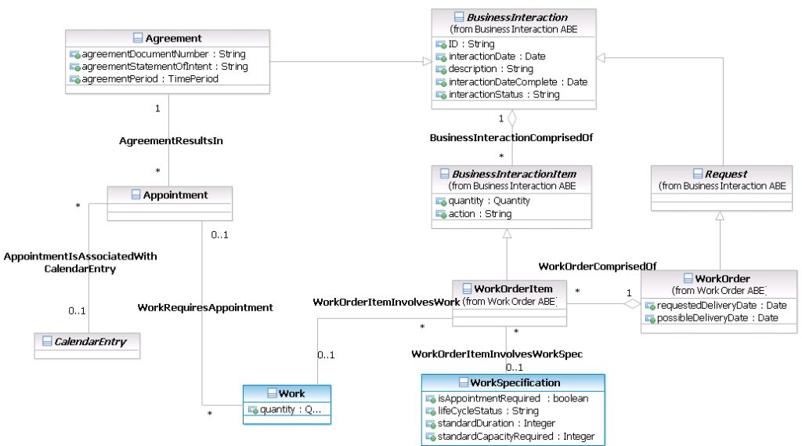

Figure WFM.11: Appointment

The appointment of a Work task to be done in a certain time period is defined by considering the available capacity of a WorkforceEmployeePool, which shows the availability of the work force. Various other criteria can be also considered for making an appointment, like the WorkSpecFulfillmentRate of an organization, priority of the work order, etc.

In real life, the appointment times, when agreed on with the customer by a call, can be flexible (at a date, in the morning, afternoon, evening, etc.). The exact time of the visit will be defined during a particular technician reservation and then dispatched, considering many optimization factors or preferences of the technician (for example, driving distance to the site).

**Note:** In some cases, a particular technician is assigned to an Appointment. That is done either on request from a customer, or because of a CSP’s approach to simplify the reservation and assignment rules. In this case, the Reservation and Assignment records can be created at the same time as the creation of the Appointment.

### Reservation and Assignment (Dispatch)

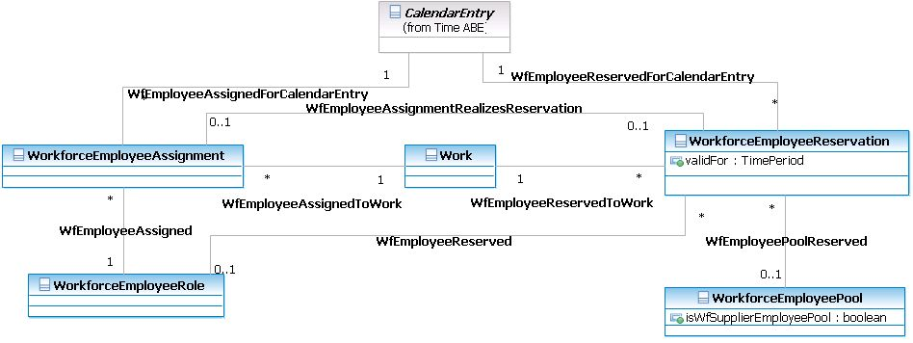During the investigation of resource availability and agreement with the customer about the appointment (time of visit), the WFM solution needs to reserve the technician and other resources for the Work. This is represented in Figure WFM.12.

Figure WFM.12: Employee Assignment and Reservation

The WorkforceEmployeeReservation records associate a whole Pool or an individual Employee with a Work. Reservation for the time to perform the work is reflected in the association with a Calendar Entry of a WorkSchedule (described below), which can be synchronized with the Appointment’s Calendar Entry.

With or without an appointment, the employee or pool can generally be reserved for future work tasks for an approximate time period. This is modeled by the validFor attribute.

When it comes to the moment of dispatch, the dispatcher will decide the order of the work tasks assigned to the technician, like optimization of the driving time to enhance the fulfillment rate or the dependency between the work tasks. Then the particular time of the visit will be decided. This is represented by the WorkforceEmployeeAssignment entity, which realizes the WorkforceEmployeeReservation, associating the WorkforceEmployeeRole with Work and Calendar Entry for the exact time of the visit.

Once the Work and its related WorkOrderItem are completed, the available capacity of the pool is updated.

The cardinality of the associations here means an Employee (or Pool) can be reserved or assigned to multiple Works and Calendar Entries. The association from WorkforceEmployeeReservation to WorkforceEmployeePool has a cardinality of 0..1 because one or none of Workforce Employees or Pools can be reserved. In case none is reserved, the record just states that Work can have reservation with a Calendar Entry, meaning a general capacity is reserved for a time slot, without a specific employee or pool yet.

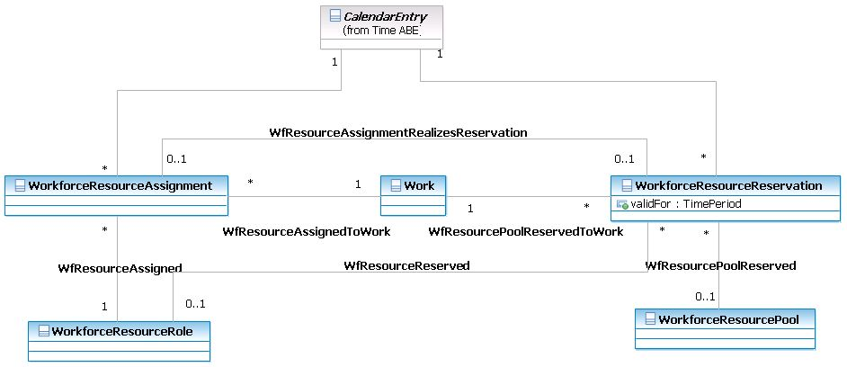Figure WFM.13 represents similar support for non-human resource reservation and assignment.

Figure WFM.13: Resource Assignment and Reservation

### Work Schedule

There is a need to model an entity that can show the current schedules of an organization. The schedules are to show customer support agents, dispatchers, and managers what work requests with what skills, time, and location have been received, what employees or pools are reserved for the requests, and what employees are assigned to do the work tasks. Besides the Pools of available capacity, the schedules support CSR, Workforce managers, and dispatchers, allowing them to have an overall view of current assignments, to make decisions about further reservations and assignments, or the planning of future capacity.

For this purpose we introduce WorkSchedule, which can hold Reservation (booking) and Assignment. An example of WorkSchedule is when a contractor team responsible for the New York market has been receiving 100 appointment requests for fiber installation during July and currently reserves employees to perform 80 of them in particular timeslots.

The explicit modeling of WorkSchedule and its association with other entities like Pools, Reservation, and Assignment is a subject of a future revision of this Workforce Management addendum. In this version, following the model of ProjectSchedule, we propose that WorkSchedule is also to be a type of SimpleCalendar, defined in TimeABE.

Figure WFM.14 represents the WorkSchedule entity.

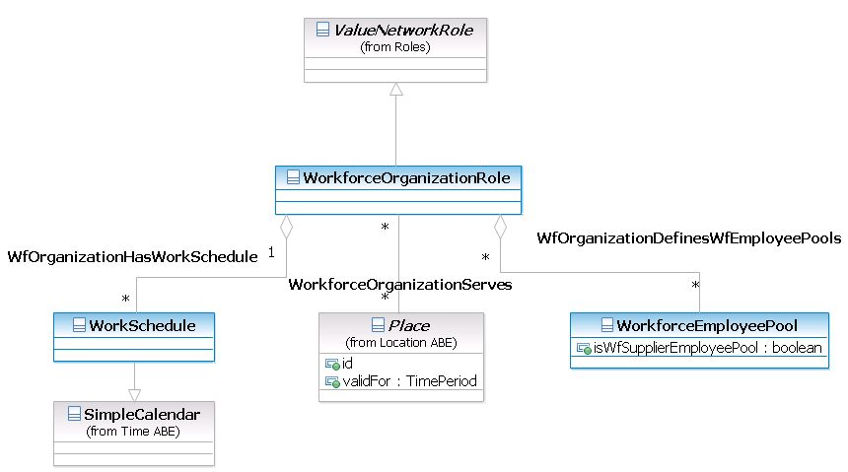

Figure WFM.14: Work Schedule and WorkforceOrganizationRole

Being an extension of Simple Calendar, WorkSchedule inherently contains CalendarEntry (start–end time, or time slot). We can use CalendarEntry to associate it with the Appointment, Reservation, and Assignment records.

An organization can have more than one WorkSchedule for various purposes (e.g. for a time period, some work types, or serving areas).

## Business Entity Definition: Workforce ABE

### WorkSpecification

#### Business Entity Definition

|  |  |  |
| --- | --- | --- |
| Business Entity Name | WorkSpecification | |
| Description | WorkSpecification describes the characteristics of a type of (manual) work. The characteristic/characteristic value pattern may be applied for WorkSpecification (and work as an instance). For example, WorkSpecification could be “Assembly of server blade in a shelf”. | | | | | |
| Sources | NetCracker | Cross-References | |  | Synonyms / Aliases |  |
| Related Business Entities |  | | | | | |
| Business Rules |  | | | | | |

#### Business Entity Attribute Definition

| Business Entity Name | WorkSpecification |
| --- | --- |
| Attribute Name | Description | Data Type | Characteristics, Permitted Values & Units | Required/  Optional | Notes |
| lifeCycleStatus | Status of the Work Specification, such as planned, approved, active, inactive | String |  | Required | The type represents a status code |
| isAppointmentRequired | Specifies if this kind of work requires an appointment with the customer/owner to be performed at their location | Boolean |  | Required |  |
| standardDuration | Standard duration of time, under normal condition and assumptions, that the work can take to be completed | integer |  | Required |  |
| standardCapacityRequired | Standard workforce capacity (man hour, man day) under normal condition and assumptions that the work requires to be completed | integer |  | Required |  |

### WorkSpecRelationship

#### Business Entity Definition

|  |  |  |
| --- | --- | --- |
| Business Entity Name | WorkSpecRelationship | |
| Description | This association class specifies the relationship between WorkSpecifications. For example, an equipment maintenance work task requires a service re-routing work task. **Note:** this Relationship will affect the Relationship between corresponding WorkItems, i.e. WorkOrderFulfillment (start-to-start, start-to-finish, etc.) in Project ABE, as well as the Scheduling mechanism. | | | | | |
| Sources | NetCracker | Cross-References | |  | Synonyms / Aliases |  |
| Related Business Entities |  | | | | | |
| Business Rules |  | | | | | |

#### Business Entity Attribute Definition

| Business Entity Name | WorkSpecRelationship |
| --- | --- |
| Attribute Name | Description | Data Type | Characteristics, Permitted Values & Units | Required/  Optional | Notes |
| type | Type of relationship, can be dependent, substitution, exclusive, etc. | String |  | Required |  |
| validFor | The time period for which the Relationship is valid. | TimePeriod |  | Required |  |

### WorkSpecificationType

#### Business Entity Definition

|  |  |  |
| --- | --- | --- |
| Business Entity Name | WorkSpecificationType | |
| Description | A classification that groups WorkSpecifications that share common characteristics. For example, Equipment maintenance work type, or network trouble shooting type. This class can be used to present a “Catalog” of work specifications. | | | | | |
| Sources | NetCracker | Cross-References | |  | Synonyms / Aliases |  |
| Related Business Entities |  | | | | | |
| Business Rules |  | | | | | |

#### Business Entity Attribute Definition

| Business Entity Name | WorkSpecificationType |
| --- | --- |
| Attribute Name | Description | Data Type | Characteristics, Permitted Values & Units | Required/  Optional | Notes |
| type | The name of the type of WorkSpecification, used to group or catalog the works. For example, type can be ServiceInstallation Works, Infrastructure Works, etc. | String |  | Required |  |
| description | A narrative that explains in detail what the work spec is. | String |  | Required |  |

### WorkSpecificationCost

#### Business Entity Definition

|  |  |  |
| --- | --- | --- |
| Business Entity Name | WorkSpecificationCost | |
| Description | A monetary amount assigned to a WorkSpecification that represents the cost to the business to plan, develop, and implement the WorkSpecification. | | | | | |
| Sources | NetCracker | Cross-References | |  | Synonyms / Aliases |  |
| Related Business Entities |  | | | | | |
| Business Rules |  | | | | | |

#### Business Entity Attribute Definition

| Business Entity Name | WorkSpecificationCost |
| --- | --- |
| Attribute Name | Description | Data Type | Characteristics, Permitted Values & Units | Required/  Optional | Notes |
| costToBusiness | Monetary amount of the cost to do work | Money |  | Required |  |

### WorkSpecificationVersion

#### Business Entity Definition

|  |  |  |
| --- | --- | --- |
| Business Entity Name | WorkSpecificationVersion | |
| Description | A particular form or variety of a WorkSpecification that is different from others or from the original. The form represents differences in properties that characterize a WorkSpecification that are not enough to justify the creation of a new WorkSpecification. | | | | | |
| Sources | NetCracker | Cross-References | |  | Synonyms / Aliases |  |
| Related Business Entities |  | | | | | |
| Business Rules |  | | | | | |

#### Business Entity Attribute Definition

| Business Entity Name | WorkSpecificationVersion |
| --- | --- |
| Attribute Name | Description | Data Type | Characteristics, Permitted Values & Units | Required/  Optional | Notes |
| workSpecRevisionType | The significance of the revision. | String | Major, Minor | Required |  |
| workSpecRevisionNumber | A number that represents the occurrence of the version in the sequence of versions. | String |  | Required |  |
| description | A narrative that explains the reason for the version’s creation. | String |  | Optional |  |
| workSpecRevisionDate | The date the version was created. | Date |  | Required |  |
| validFor | The period during which the version is applicable. | Time Period |  | Required |  |

### WorkSpecFulfillmentRate

#### Business Entity Definition

|  |  |  |
| --- | --- | --- |
| Business Entity Name | WorkFullfillmentRate | |
| Description | Entity that is used in Planning and WorkSpecification configuration. Represents a rate that shows how many particular work tasks (quantity attribute) can be performed by a given organization in a given location (or serving areas) with a given capacity (Consumption Capacity attribute). For example, with 100 man hours of Fiber layout skills, 200 works of “Dig a trench for Underground Cable, 200m length” can be performed in an urban area by an organization. | | | | | |
| Sources | NetCracker | Cross-References | |  | Synonyms / Aliases |  |
| Related Business Entities |  | | | | | |
| Business Rules |  | | | | | |

#### Business Entity Attributes Definition

| Business Entity Name | WorkFullfillmentRate |
| --- | --- |
| Attribute Name | Description | Data Type | Characteristics, Permitted Values & Units | Required/  Optional | Notes |
| consumptionCapacity | Workforce capacity that is required by the work to be done for the location, and that the organization can supply | Integer | Man hour, man day, number of work orders | Required |  |
| quantity | Maximal number of identical work tasks (defined by WorkSpecification) that the organization can do for the location, using the available capacity, at the same time | Quantity |  | Required |  |
| standardDrivingTime | Standard driving time for the organization’s technicians to drive to and between work places in the serving area | Integer |  | Optional |  |

### Work

#### Business Entity Definition

|  |  |  |
| --- | --- | --- |
| Business Entity Name | Work | |
| Description | The Work entity is used to record actual executed work, i.e. an instance of that entity is created for the actual work described by the WorkSpecification. If there are characteristics defined for the WorkSpecification, the work instance has a distinct value assigned for those characteristics. Instances of Work are associated to the WorkOrderItem. The quantity attribute can be used if the same work has been done more than once identically (based on the similar attribute in WorkOrderItem). | | | | | |
| Sources | NetCracker | Cross-References | |  | Synonyms / Aliases |  |
| Related Business Entities |  | | | | | |
| Business Rules |  | | | | | |

#### Business Entity Attributes Definition

| Business Entity Name | Work |
| --- | --- |
| Attribute Name | Description | Data Type | Characteristics, Permitted Values & Units | Required/  Optional | Notes |
| quantity | Represents how many times the same work task has been done identically. | Quantity |  | Optional | Default is 1 |

### WorkRole

#### Business Entity Definition

|  |  |  |
| --- | --- | --- |
| Business Entity Name | WorkRole | |
| Description | This is an abstract base class that defines a Work task in terms of a set of roles which are then used to characterize the functionality of the Work. For example, a particular work of fiber rollout at a location at a certain date can play the role of a build task of an infrastructure project or the role of an installation task in a service fulfillment project. | | | | | |
| Sources | NetCracker | Cross-References | |  | Synonyms / Aliases |  |
| Related Business Entities |  | | | | | |
| Business Rules |  | | | | | |

#### Business Entity Attributes Definition

| Business Entity Name | WorkRole |
| --- | --- |
| Attribute Name | Description | Data Type | Characteristics, Permitted Values & Units | Required/  Optional | Notes |
| workRole | Name of the role that this work plays | String |  | Required |  |

### WorkSpecificationRole

#### Business Entity Definition

|  |  |  |
| --- | --- | --- |
| Business Entity Name | WorkSpecificationRole | |
| Description | This is an abstract base class that defines a WorkSpecification in terms of a set of roles which are then used to characterize the invariant functionality of the Work. For example, a specification of cable layout work can have the role of network build, or the role of a service fulfillment task. | | | | | |
| Sources | NetCracker | Cross-References | |  | Synonyms / Aliases |  |
| Related Business Entities |  | | | | | |
| Business Rules |  | | | | | |

#### Business Entity Attributes Definition

| Business Entity Name | WorkSpecificationRole | |
| --- | --- | --- |
| Attribute Name | Description | Data Type | | Characteristics, Permitted Values & Units | Required/  Optional | Notes |
| workSpecRole | Name of the role that this work specification can play, or name of the sub-type of this specification | String | |  | Required |  |

### WorkforceEmployeeRole

#### Business Entity Definition

|  |  |  |
| --- | --- | --- |
| Business Entity Name | WorkforceEmployeeRole | |
| Description | This is a PartyRole that represents individuals who are involved in the workforce process as employees with particular skills. For example, Field Technician, Network Engineer, Supervisor, etc. | | | | | |
| Sources | NetCracker | Cross-References | |  | Synonyms / Aliases |  |
| Related Business Entities |  | | | | | |
| Business Rules |  | | | | | |

#### Business Entity Attributes Definition

| Business Entity Name | WorkforceEmployeeRole |
| --- | --- |
| Attribute Name | Description | Data Type | Characteristics, Permitted Values & Units | Required/  Optional | Notes |
| skillLevel | Indicates the qualification level of the technician: for example, intern, entry level, senior/highly qualified | String |  | Required |  |

### 

### WorkforceOrganizationRole

#### Business Entity Definition

|  |  |  |
| --- | --- | --- |
| Business Entity Name | WorkforceOrganizationRole | |
| Description | This is a PartyRole that represents organizations involved in field operations. It can be the CSP Field Technician department itself, or a 3rd-party contractor company. Note that OrganizationRole has Calendar, inherited from Calendar of PartyRole. | | | | | |
| Sources | NetCracker | Cross-References | |  | Synonyms / Aliases |  |
| Related Business Entities |  | | | | | |
| Business Rules |  | | | | | |

#### Business Entity Attributes Definition

| Business Entity Name | WorkforceOrganizationRole | |
| --- | --- | --- |
| Attribute Name | Description | Data Type | | Characteristics, Permitted Values & Units | Required/  Optional | Notes |
| organizationRoleName | Name of the Organization Role | String | |  | Required |  |

### WorkforceResourceRole

#### Business Entity Definition

|  |  |  |
| --- | --- | --- |
| Business Entity Name | WorkforceResourceRole | |
| Description | Defines the concept of various types of roles associated with WorkforceResources (both physical and logical). For example, tools (meter, ladder), Truck, GPS, Handheld, etc. | | | | | |
| Sources | NetCracker | Cross-References | |  | Synonyms / Aliases |  |
| Related Business Entities |  | | | | | |
| Business Rules |  | | | | | |

#### Business Entity Attributes Definition

| Business Entity Name | WorkforceResourceRole | |
| --- | --- | --- |
| Attribute Name | Description | Data Type | | Characteristics, Permitted Values & Units | Required/  Optional | Notes |
| workingStatus | Indicates the working status of the resource | String | |  | Required |  |

### WorkforceResourceTool

#### Business Entity Definition

|  |  |  |
| --- | --- | --- |
| Business Entity Name | WorkforceResourceTool | |
| Description | An example class that represents the specific role of workforce resources. Examples are tester kits, GPS, Trucks, etc. | | | | | |
| Sources | NetCracker | Cross-References | |  | Synonyms / Aliases |  |
| Related Business Entities |  | | | | | |
| Business Rules |  | | | | | |

### WorkforceEmployeePool

#### Business Entity Definition

|  |  |  |
| --- | --- | --- |
| Business Entity Name | WorkforceEmployeePool | |
| Description | Represents an employee pool, as a set or group of employees available for assignment to work tasks. A WorkforceOrganizationRole can have many workforce pools, and vice versa, a pool can contain employees from more than one organization. Examples of a Pool are Fiber installation team, service repair team, etc. A Pool contains people/resources with particular skills, availability, location, other restrictions, and preferences. Pool is associated with Capacity. For example, a WorkForceEmpolyeePool shows that on July 1, from 8 am to 12 pm there are 100 man hours available with the skill of fiber layout for the New York area. A detailed model of the capacity of the pool down to timeslot, skill/work level is a subject for a future SID release. | | | | | |
| Sources | NetCracker | Cross-References | |  | Synonyms / Aliases |  |
| Related Business Entities |  | | | | | |
| Business Rules |  | | | | | |

#### Business Entity Attributes Definition

| Business Entity Name | WorkforceEmployeePool |
| --- | --- |
| Attribute Name | Description | Data Type | Characteristics, Permitted Values & Units | Required/  Optional | Notes |
| isWfSupplierEmployeePool | Indicates whether this pool is managed by the workforce provider company, or by a 3rd-party contractor | Boolean |  | Optional |  |

### WorkforceResourcePool

#### Business Entity Definition

|  |  |  |
| --- | --- | --- |
| Business Entity Name | WorkforceResourcePool | |
| Description | Represents a resource pool as a set of resources (both physical and logical) available for assignment to work tasks. For example, the Dallas pool for fiber rollout for a weekday contains X number of trucks, Y number of test kits, etc. | | | | | |
| Sources | NetCracker | Cross-References | |  | Synonyms / Aliases |  |
| Related Business Entities |  | | | | | |
| Business Rules |  | | | | | |

#### Business Entity Attributes Definition

| Business Entity Name | WorkforceResourcePool |
| --- | --- |
| Attribute Name | Description | Data Type | Characteristics, Permitted Values & Units | Required/  Optional | Notes |
| isWfSupplierResourcePool | Indicates whether this pool is managed by the workforce provider company, or by a 3rd-party contractor | Boolean |  | Optional |  |

### WorkforcePoolAssignment

#### Business Entity Definition

|  |  |  |
| --- | --- | --- |
| Business Entity Name | WorkforcePoolAssignment | |
| Description | An abstract class representing assignment of an employee or other resource to a pool. An employee can be assigned to more than one pool. The attribute poolAssignmentRestriction is a place holder that represents any limitation of the assignment other than time period. Pool assignment will update available capacity WorkSchedule of some organization. | | | | | |
| Sources | NetCracker | Cross-References | |  | Synonyms / Aliases |  |
| Related Business Entities |  | | | | | |
| Business Rules |  | | | | | |

#### Business Entity Attributes Definition

| Business Entity Name | WorkforcePoolAssignment | |
| --- | --- | --- |
| Attribute Name | Description | Data Type | | Characteristics, Permitted Values & Units | Required/  Optional | Notes |
| poolAssignmentRestriction | Represents any limitation of the assignment other than time period. For example, this employee’s assignment to the pool has the highest priority compared to other assignments. | String | |  | Optional |  |
| validFor | The period of time during which the Assignment is Valid. | Time Period | |  | Optional |  |

### WorkforceEmployeePoolAssignment

#### Business Entity Definition

|  |  |  |  |
| --- | --- | --- | --- |
| Business Entity Name | WorkforceEmployeePoolAssignment | | |
| Description | Represents an association class and defines specific characteristics for the assignment of an employee to a pool. For example, assignment of fiber technicians to the Installation and Repair team pools, serving the New York Area in the first quarter. | | | | | |
| Sources | NetCracker | Cross-References |  | | Synonyms / Aliases |  |
| Related Business Entities |  | | | | | |
| Business Rules |  | | | | | |

### WorkforceResourcePoolAssignment

#### Business Entity Definition

|  |  |  |  |
| --- | --- | --- | --- |
| Business Entity Name | WorkforceResourcePoolAssignment | | |
| Description | Represents an association class and defines specific characteristics for the assignment of a resource to a pool. For example, assign a fiber test kit to the Dallas Pool for July. | | | | | |
| Sources | NetCracker | Cross-References |  | | Synonyms / Aliases |  |
| Related Business Entities |  | | | | | |
| Business Rules |  | | | | | |

### 

### WorkSchedule

#### Business Entity Definition

|  |  |  |
| --- | --- | --- |
| Business Entity Name | WorkSchedule | |
| Description | Being a subclass of SimpleCalendar, WorkSchedule and its variants describes various appointment, reservation, and assignment schedules of an organization. For example, a WorkSchedule shows that a contractor team responsible for the New York area has been receiving 100 requests for fiber installation during July and is currently scheduled to perform 80 of them. | | | | | |
| Sources | NetCracker | Cross-References | |  | Synonyms / Aliases |  |
| Related Business Entities |  | | | | | |
| Business Rules |  | | | | | |

#### Business Entity Attributes Definition

| Business Entity Name | WorkSchedule | |
| --- | --- | --- |
| Attribute Name | Description | Data Type | | Characteristics, Permitted Values & Units | Required/  Optional | Notes |
| granularity | Represents the granularity of the timeslots in the WorkSchedule. For example, with granularity = 2 hours, a work task that lasts 1 hour should take the whole two hours. | Integer | | Hour | Optional | This is to accommodate business rules of certain organizations about the granularity of work windows. It is to be considered with the granularity of employee pools (not introduced in this release). This attribute is optional, since there can be irregular or mixed granularity. For example, work should take 4 hours during business hours, and 2 hours after business hours. |

### 

### WorkforceEmployeeReservation

#### Business Entity Definition

|  |  |  |  |
| --- | --- | --- | --- |
| Business Entity Name | WorkforceEmployeeReservation | | |
| Description | Represents an implementation of a request for reservation of work time in some human resource pool. It is also possible to reserve the work time of an individual employee. **Note:** the reservation, or booking according to appointment, is associated to Calendar Entry. The CalendarEntry here can belong to a reservation WorkSchedule. This Calendar entry may be floating. Once the Reservation becomes an Assignment (to be dispatched), a particular time slot (Calendar Entry) can be fixed in the WorkSchedule. | | | | | |
| Sources | NetCracker | Cross-References |  | | Synonyms / Aliases |  |
| Related Business Entities |  | | | | | |
| Business Rules |  | | | | | |

#### Business Entity Attributes Definition

| Business Entity Name | WorkforceEmployeeReservation | |
| --- | --- | --- |
| Attribute Name | Description | Data Type | Characteristics, Permitted Values & Units | Required/  Optional | Notes |
| validFor | The period of time during which an employee or a pool is reserved for the work. | Time Period |  | Required | **Note:** This validFor reservation time may be different from the CalendarEntry defining when exactly the work must be performed. For example, because it considers variables involved in completing the work task (such as preparation), the reservation time frame may be longer than the time specified by CalendarEntry. |

### 

### WorkforceEmployeeAssignment

#### Business Entity Definition

|  |  |  |  |
| --- | --- | --- | --- |
| Business Entity Name | WorkforceEmployeeAssignment | | |
| Description | Represents an assignment of a particular WorforceEmployeeRole for a particular work task in a specific timeframe. For example, assignment of a person in a network engineer role to a troubleshooting work task for at least 2 hours. The assignment is associated with a CalendarEntry of an Assignment WorkSchedule. | | | | | |
| Sources | NetCracker | Cross-References |  | | Synonyms / Aliases |  |
| Related Business Entities |  | | | | | |
| Business Rules |  | | | | | |

#### Business Entity Attributes Definition

| Business Entity Name | WorkforceEmployeeAssignment | |
| --- | --- | --- |
| Attribute Name | Description | Data Type | | Characteristics, Permitted Values & Units | Required/  Optional | Notes |
| assignmentStatus | Completion status of the assignment, like started, in-progress, uncompleted, completed. **Note:** this is not always the same as the status of the work, as there can be more than one employee assigned to the work. | String | |  | Required |  |

### WorkforceResourceReservation

#### Business Entity Definition

|  |  |  |  |
| --- | --- | --- | --- |
| Business Entity Name | WorkforceResourceReservation | | |
| Description | Represents an implementation of a request for the reservation of usage time in some resource pool (tools, trucks, materials, etc.). It is also possible to reserve usage time of a particular resource. | | | | | |
| Sources | NetCracker | Cross-References |  | | Synonyms / Aliases |  |
| Related Business Entities |  | | | | | |
| Business Rules |  | | | | | |

#### Business Entity Attributes Definition

| Business Entity Name | WorkforceResourceReservation | |
| --- | --- | --- |
| Attribute Name | Description | Data Type | Characteristics, Permitted Values & Units | Required/  Optional | Notes |
| validFor | The period of time during which a Resource or a pool is reserved for the work. | Time Period |  | Required |  |

### WorkforceResourceAssignment

#### Business Entity Definition

|  |  |  |  |
| --- | --- | --- | --- |
| Business Entity Name | WorkforceResourceAssignment | | |
| Description | Represents an assignment of a particular resource for particular work in a specific timeframe. For example, assignment of a fiber test kit (or, additional example, a role of a test kit) to a fiber rollout work for a date. | | | | | |
| Sources | NetCracker | Cross-References |  | | Synonyms / Aliases |  |
| Related Business Entities |  | | | | | |
| Business Rules |  | | | | | |

#### Business Entity Attributes Definition

| Business Entity Name | WorkforceResourceAssignment | |
| --- | --- | --- |
| Attribute Name | Description | Data Type | Characteristics, Permitted Values & Units | Required/  Optional | Notes |
| actualCost | Actual Cost of the assignment of the resource (tools) to the work. | Money |  | Required |  |

# Model Alignment Opportunities

This work on the WFM information model is the result of previous framework collaboration.

## TAM Mapping

In TAM 4.5, WFM is a Level 2 application in the Resource Management Domain:

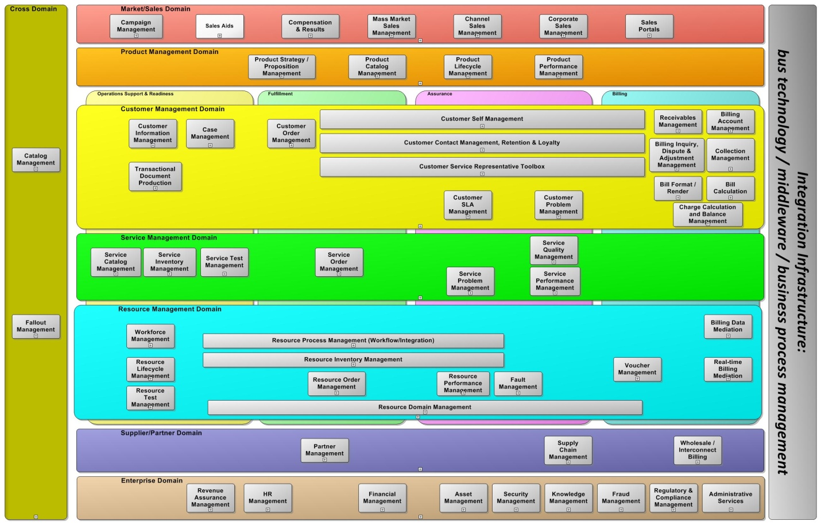

Workforce Management application currently has the current decomposition structure illustrated below. **Note:** In comparison with the previous version of TAM, the application of Work Order Issue and Closing is grouped together with Tracking and Management.

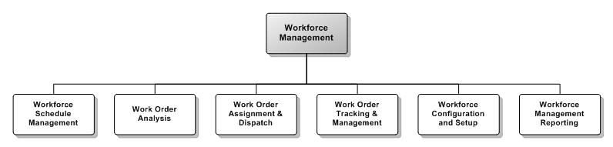For a future release, it has been proposed that WFM be moved to the Enterprise domain, to be aligned with the Enterprise domain in SID.

## eTOM Mapping

In Business Framework version 9, Manage Workforce is an L2 process in RM&O (according to its position as Level 1 ABE in SID’s Enterprise domain).



The following illustration shows its decomposition to L3 processes. Similarly with TAM, compared with the previous version of eTOM, the most notable change is that this proposal moves the L3 process of Issue Work Order, Assign Work Order (now changed to Assign Task and Dispatch Task), Close Work Order, and Track and Manage Work Order to L4 under the process of “Manage Work Order Lifecycle”.



## Future Revision for SID

This release outlines the most basic entities that support WFM processes. Many classes are not yet introduced or detailed. It is proposed that in a future release the following tasks will be considered:

* Introduction of business Calendar to support:
  + Detailed Working Hours planning for each organization, department, and individual
  + Absence Management
  + Shift Planning
* Revision on WorkSchedule to better show its relationship to Pool, Appointment, Reservation, and Assignment records
* Revision on WorkforceEmployeePool & WorkforceResourcePool if they can detail available capacity to the time slot and skills
* Consider the possibility of combining WorkforceResourcePool & WorkforceEmployeePool into one Pool (since resources and employees both depend on skills and location, and usually are both required for work fulfillment)
* Consider the possibility of combining WorkforceResourceReservation & WorkforceEmployeeReservation into one Reservation
* Scheduling Business Rules, such as consumption rules, concurrency (more than one work task done at the same time), restriction, etc.

# Administrative Appendix

This Appendix provides additional background material about this document.

## Document Lifecycle

WFM Entities is being issued as team contribution version 1.0.

This document will continue under formal change control. Supporting work will be issued as companions to this document. A document of this type is a “living document,” capturing and communicating current knowledge and practices.

## Document History

|  |  |  |  |
| --- | --- | --- | --- |
| **Version Number** | **Date Modified** | **Modified by:** | **Description of changes** |
| 1.0 | 9/06/2011 | Anh Le | First draft |
| 1.1 | 3/19/2012 | Alicja Kawecki | Minor formatting corrections prior to web posting and ME |
| 1.2 | 10/26/2012 | Alicja Kawecki | Updated to reflect TM Forum Approved status |
|  |  |  |  |
|  |  |  |  |

## Release History

|  |  |  |  |
| --- | --- | --- | --- |
| **Release Number** | **Date Modified** | **Modified by:** | **Description of changes** |
| 12.0 | 01/03/2012 | Anh Le | First version for SID 12 |
|  |  |  |  |

## Company Contact Details

|  |  |
| --- | --- |
| **Company** | **Team Member Representative** |
| NetCracker | *Name: Anh Le*  *Title: Director of Research*  *Email: anhle@NetCracker.com*  *Phone: +1-781-419-3300*  *Fax* |
| Mediaan Av | *Name:* Dirk Rejhal  *Title:* Director  *Email:* [*Dirk.rejahl@mediaan.nl*](mailto:Dirk.rejahl@mediaan.nl)  *Phone: +491721033200*  *Fax* |

## Acknowledgments

This document was prepared with great support of the following TM Forum members and leaders of TM Forum Frameworks teams:

* John Reilly, TM Forum
* John Wilmes, TM Forum
* Mike Kelly, TM Forum
* Alexander Spirin, NetCracker
* Maxim Volkov, NetCracker
* Konstantin Mukhametsin, NetCracker
* Alexander Semelit, NetCracker
* Steve Orobec, BT
* Radley Phill, BT