Information Framework (SID)

Supplier/Partner Business Entity Definitions

GB922 Addendum 8

Version 2.3



October, 2012

Notice

No recipient of this document and code shall in any way interpret this material as representing a position or agreement of TM Forum or its members. This material is draft working material of TM Forum and is provided solely for comments and evaluation. It is not “Forum Approved” and is solely circulated for the purposes of assisting TM Forum in the preparation of final material in furtherance of the aims and mission of TM Forum.

Although it is copyrighted material of TM Forum:

* Members of TM Forum are only granted the limited copyright waiver to distribute this material within their companies and may not make paper or electronic copies for distribution outside of their companies.
* Non-members of the TM Forum are not permitted to make copies (paper or electronic) of this draft material other than for their internal use for the sole purpose of making comments thereon directly to TM Forum.
* If this material forms part of a supply of information in support of an Industry Group Liaison relationship, the document may only be used as part of the work identified in the Liaison and may not be used or further distributed for any other purposes

Any use of this material by the recipient, other than as set forth specifically herein, is at its own risk, and under no circumstances will TM Forum be liable for direct or indirect damages or any costs or losses resulting from the use of this material by the recipient.

This material is governed, and all recipients shall be bound, by all of the terms and conditions of the Intellectual Property Rights Policy of the TM Forum (<http://www.tmforum.org/Bylaws/1094/home.html>) and may involve a claim of patent rights by one or more TM Forum members or by non-members of TM Forum.

Direct inquiries to the TM Forum office:

240 Headquarters Plaza,

East Tower – 10th Floor,

Morristown, NJ  07960 USA

Tel No.  +1 973 944 5100

Fax No.  +1 973 944 5110

TM Forum Web Page: [www.tmforum.org](http://www.tmforum.org/)

Table of Contents

Notice 2

Table of Contents 3

List of Figures 5

Business Entities 6

1. SUPPLIER/PARTNER Domain 6

1.1. Introduction 7

1.2. Supplier/Partner 8

1.2.1. Overview of S/P party roles 8

1.2.2. Overview of business objectives 9

1.3. S/P Agreement 11

1.3.1. Commitment 11

1.3.2. Commitments and deliverables 14

1.3.3. Commitment approval 15

1.4. Community 17

1.4.1. Committing to a community as a community member 17

1.4.2. Contributing to a community 20

1.4.3. Consuming assets from a community 22

1.5. Business Entity Definitions – Supplier/Partner 24

1.5.1. Supplier 24

1.5.2. Buyer 25

1.5.2.1. Partner 26

1.6. Business Entity Definitions – Business Objective 27

1.6.1. BusinessObjectiveSpecification 27

1.6.2. BusinessObjective 28

1.6.3. AtomicBusinessObjective 29

1.6.4. CompositeBusinessObjective 30

1.7. Business Entity Definitions – Commitment 31

1.7.1. Commitment 31

1.7.2. CommitmentFulfilmentRole 32

1.7.3. CommitmenProcurementRole 33

1.7.4. CommitmentTermOrCondition 34

1.8. Business Entity Definitions – Commitment Approval 35

1.8.1. CommitmentApproverRole 35

1.9. Business Entity Definitions – Community 36

1.9.1. Community 36

1.9.2. CommunityMember 37

1.9.3. CommunityAdministrator 38

1.9.4. Contribution 39

1.9.5. ContributionProviderRole 40

1.9.6. ContributionReceiverRole 41

1.9.7. AssetConsumption 42

1.9.8. AssetConsumerRole 43

1.9.9. AssetProviderRole 44

Administrative Appendix 45

2.1 About this document 45

2.2 Document History 45

Version History 45

Release History 46

2.3 Company Contact Details 46

2.4 Acknowledgments **Error! Bookmark not defined.**

List of Figures

Figure SP 1: Consuming assets from a community 8

Figure SP 2: Business Objective entities 10

Figure SP 3: Commitment 13

Figure SP 4: Commitment & Deliverables 14

Figure SP 5: Commitment Approval 16

Figure SP 6: Commiting to a Community 18

Figure SP 7: Example for Community Commitment 19

Figure SP 8: Contributing to a Community 21

Figure SP 9: Consuming assets from a community 23

# Business Entities

## SUPPLIER/PARTNER Domain

The supplier/partner domain defines all required entities, which are necessary, to model the interaction of the enterprise with suppliers and partners.

The following level 1 ABEs are defined for the supplier/partner domain:

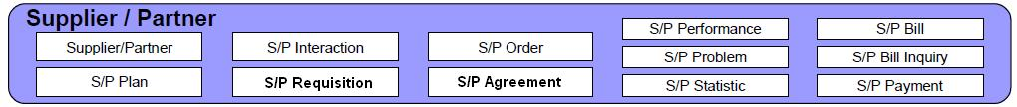

S/P Agreement

S/P Order

Community

Within the level 1 S/P Agreement ABE the level 2 ABEs S/P SLA and S/P Commitment are defined:

**S/P Agreement**

**S/P SLA**

**S/P Commitment**

## Introduction

In today’s telecommunications ecosystem business models are changing from a traditional value creation chain to more complex value networks. This has a strong impact on various domains of the enterprise such as infrastructure and product lifecycle management – i.e. undertaking projects together with partners and suppliers to launch a new product or to build up new capabilities within the enterprises infrastructure – or providing and operating product and services for the customer – i.e. providing, aggregating or consuming products and services within a cloud ecosystem.

Therefore entities to model partner and supplier relationships, their business objectives and Commitments the parties agree on to execute governance on their interactions, playing these role, are required for all these areas within the enterprise.

The business entity modeling for supplier/partner is driven by business processes, which are relevant for the enterprise to interact with suppliers and partner – as well for the strategy, infrastructure and product domain as well as for the operations domain. Due to the tight coupling of business entities defined for the Information Framework and the process elements, defined for the Business Process Framework, these process elements are referenced if needed to understand the semantics of the business entities.

The model for supplier/partner is reflecting the inside-out-view from an enterprise perspective. Accordingly beside roles, relevant for such relationship, the relevant business entities from the enterprise domain reflecting the strategy and derived business objectives together with entities relevant for the operation are in scope of this addendum.

The SID model reflects partner/supplier related entities from a business-oriented point-of-view and uses the best of standard modeling patterns for this area.

## Supplier/Partner

### Overview of S/P party roles

An overview of the relevant party roles that are relevant for supplier/partner domain is outlined in the figure below.

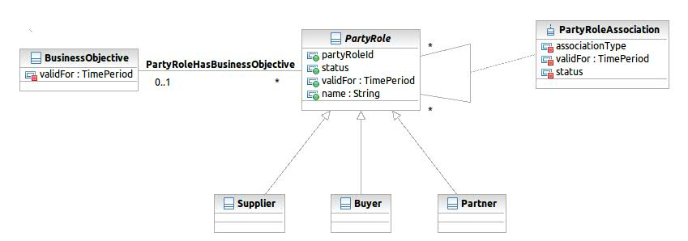

Figure SP : Consuming assets from a community

A party, involved in a project or in a cloud ecosystem together with other enterprises can play either the role of a supplier, buyer or a partner – or a combination of those.

Usually the main difference between supplier and partner role is, that partners either share some of their business objectives with the enterprise or have business objectives that are complementary to those of the enterprise – I.e. there are no conflicting (key) business objectives between partners.

The business objectives of a supplier are not relevant for the relationship between the supplier and the enterprise playing the role of a buyer. Such kind of relationship needs strong governance, established by mutual agreed Commitments, controlled by KPIs.

The type of relationship (supplier/buyer or partner/partner) will be decided before the tender within the “Supply Chain Development & Management” process grouping.

### Overview of business objectives

The enterprise and the party roles interacting with the enterprise usually have business objectives for playing these specific roles.

Business objectives are composites – i.e. a composite business objective may contain business objectives on a lower level.

Atomic business objectives are measurable objectives a party is trying to achieve, playing a party role. Such objective could be (but are not limited to): customer satisfaction, profit or providing quality. The type of a Business Objective is modeled as an attribute.

Usually a party has different business objectives for the roles they are playing. For example a party may have other business objectives for playing the role of a customer than playing the role of a partner or supplier.

The level of achievement of a business objective can be measured for a KPI, defined specific for that business objective. Usually the KPI for measuring the level of achievement of a business objective of a supplier is not relevant for the enterprise, but in a partner relationship it can be relevant for an enterprise to know such KPIs to ensure stability of the partnership.

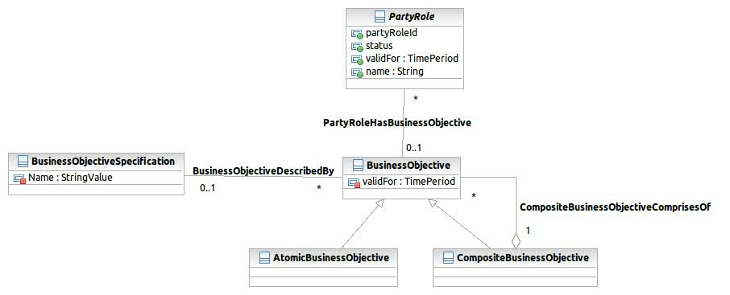

Figure SP : Business Objective entities

## S/P Agreement

S/P Agreements are defining all kinds of agreements between supplier/buyer or between partners. Such agreements can be service level agreements, to ensure a defined level of quality of a service provided by a supplier, or Commitments which reflect a mutual agreement between supplier and buyer or between two or more partners about contributing to the partnership or supplier-buyer-relationship by providing defined deliverables (or types of deliverables), measurable by a defined KPI.

### Commitment

Managing value creation in a value network is much more complex than it used to be with the traditional value creation chain.

A key entity to establish governance processes on the cooperation between parties on a value network is Commitment, derived from BusinessInteraction which reflects the mutual agreement between supplier/buyer or partner/partner about services, products, resources or some other kind of deliverable that has to be provided by the party playing the role of a Commitment fulfiller to the party, playing the role of a Commitment procurer.

**Example 1:**

The enterprise plans to launch a new product to the market that requires new capabilities of its billing infrastructure. Because the implementation of such infrastructure capabilities is not the core competence of the enterprise it is decided to get this capability realized by a supplier. Because the key business objectives of the enterprise is to save costs rather than to fasten time market to maximize gross margin, a tender process will be initiated to find a supplier providing the lowest price. For this supplier/buyer relationship the business objectives of the supplier are not relevant – the governance process for the supply process will be established by agreeing tightly measured Commitments with the supplier, regarding functionality and quality of the capabilities together with Commitment to deliver these capabilities according to the overall schedule.

**Example 2:**

The enterprise plans to launch a set of “communication services in a cloud” to the SoHo market. Because the enterprise is to capable to provide a web mail service of high quality and availability in time and provide such as service is not the core business of the enterprise, it is decided to look for a partner for re-selling an email service, operated as managed service by the partner, to be integrated in the set of cloud services, the enterprise offers to the end customer. For such a partner relationship it is essential to assess the business objectives of potential partners to ensure a reliable and sustainable partnership. Such a partner must share same business objectives like providing high quality services with a fast time to market (to avoiding the partner being a time-to-market bottle neck for future extensions of the service). At the same time the partner must not have conflicting business objectives, like provide the same service to the same market segment on its own. If the partner is targeting another market segment like large business customers, the partnership agreement might include that the partner markets the cloud to this market segment. Again, the mutual agreement between the enterprise and the partner is reflected by Commitments. In such kinds of partnership, the enterprise might play the role of a Commitment fulfiller for some Commitments and at the same time play the role of a Commitment procurer for others. These Commitments are defined to establish a governance to ensure that the common business objectives of both partners are achieved in this partnership and to ensure adoption of Commitments in case of changing business objectives.

**Example 3:**

The enterprise plans to source out IT (infrastructure) capabilities – e.g. services for network planning – to a supplier, who operates these services as managed services. The services, which are required to be provided by the supplier, are specified from a functional perspective as business services and KPIs are defined, to measure the required SLAs. The enterprise initiates a tender process, to find a cost-efficient supplier, who is capable to extend these business services for future requirements. Providing the services with the agreed service level is ensured by defining Commitments accordingly and to establish a governance model based on these.

How Commitments are defined as business entities and how the involved roles are associated to Commitments is shown in figure SP.3:

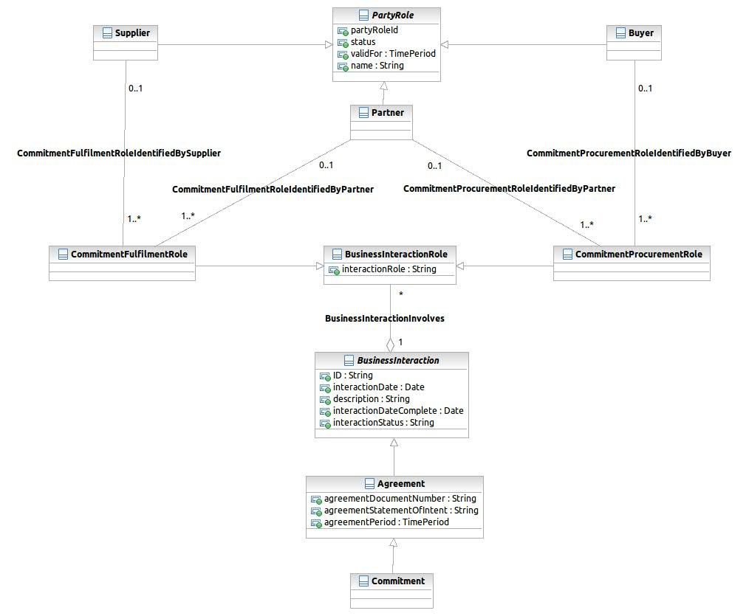

Figure SP : Commitment

### Commitments and deliverables

As mentioned earlier, Commitment can be associated with a concrete deliverable. The CommitmentTermOrDeliverable is inherited from BusinessInteractionItems and so inherits the associations to ProductSpecification, ServiceSpecification, ServiceSpecification and ResourceSpecification.

So if the supplier/partner is obligated to provide a product, service or resource, the Commitment is associated to the corresponding specification.

If any other kind of project deliverable is the Commitment of a supplier/partner this can be modeled CommitmentTermOrCondition, which inherits from AgreementTermOrCondition. CommitmentTermOrCondition is associated to ProjectDeliverable, defined in the Project ABE.

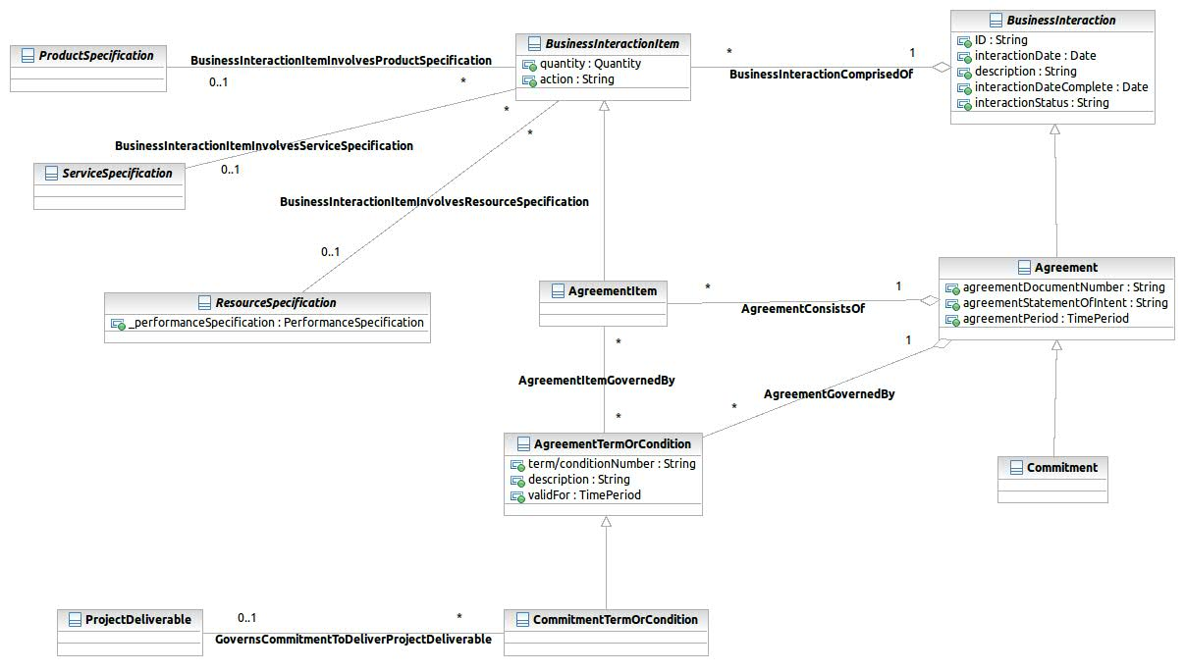

Figure SP : Commitment & Deliverables

### Commitment approval

As Commitment is a mutual agreement between a party playing the CommitmentFulfilmentRole and a party playing the CommitmentProcurementRole, the Commitment must be approved by those.

This approval is modeled, applying the AgreementApproval. In case of a Commitment there will be usually be two instances of AgreementAuthorization – one signed by a CommitmentApproverRole from “procurer side”, the other signed by a CommitmentApproverRole from “fulfillment side”.

This model is shown in Figure SP.5:

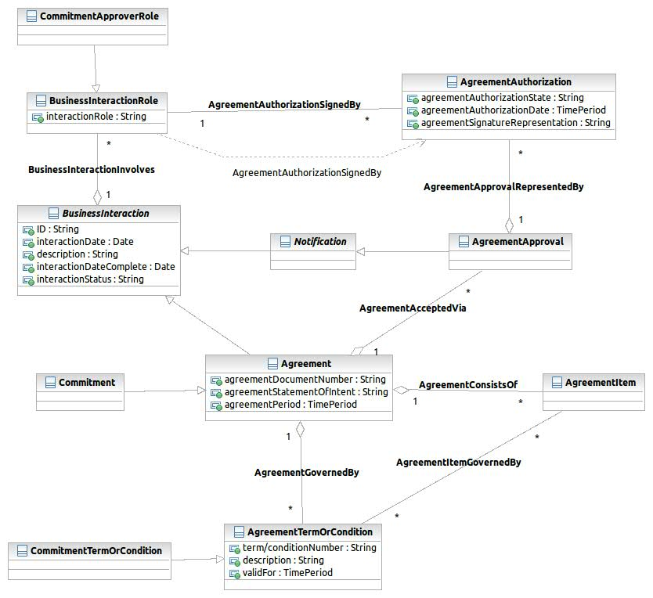

Figure SP : Commitment Approval

## Community

### Committing to a community as a community member

First of all a Community is a PartyRole, played by a Party of type organization. Parties of type Individual can play the PartyRole of a CommunityMember. The “plain membership” may be expressed by a PartyRoleAssociation between those both PartyRoles.

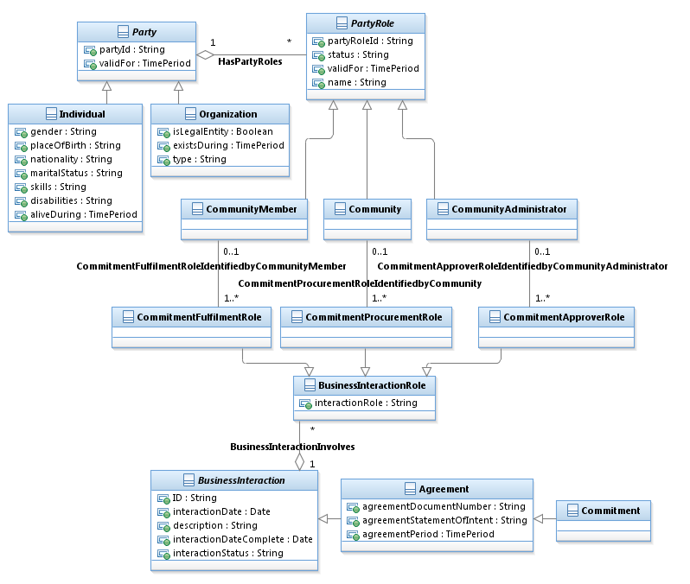

Figure SP : Committing to a Community

An essential concept for so called “community based delivery models” is the commitment between the Community and the CommunityMember. Commitment is a sub-class of Agreement (BusinessInteraction). This concept is applied here and the BusinessInteractionRoles CommitmentFulfilmentRole, CommitmentProcurementRole and CommitmentApproverRole are associated with the types of PartyRole CommunityMember, Community and CommunityAdministrator.

The figure below shows an example of a community commitment.

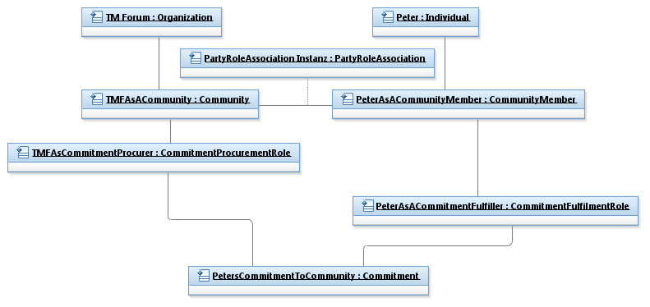

Figure SP : Example for Community Commitment

### Contributing to a community

A Contribution to a community is a sub-class of BusinessInteraction with CommunityMember and Community as involved PartyRoles. For this new type of BusinessInteraction, two new BusinessInteractionRoles are introduced: ContributionProviderRole, associated with the CommunityMember who is contributing, and the ContributionReceiverRole, associated with the Community.

A Contribution might consist of BusinessInteraction item, a Resource, Service or Product is associated to, which is contributed to the Community.

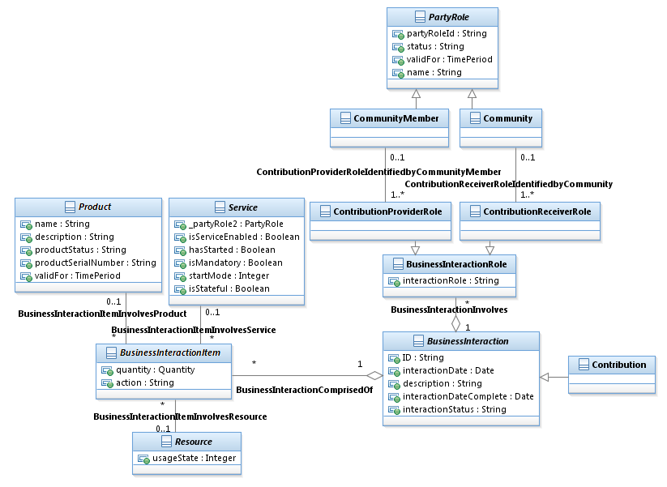

Figure SP : Contributing to a Community

### Consuming assets from a community

Contributions are assembled to Assets by the community – i.e. multiple Contributions, contributed by different CommunityMembers may be assembled together to one consumable asset.

Examples for assets are open source software; in that case the source code might be contributions of various CommunityMembers. Another example is Facebook; the original post and the comments are contributions, provided by different CommunityMembers, a whole discussion thread is an asset that can be consumed by other CommunityMembers.

Consuming an Asset from a Community, again, is a BusinessInteraction, which items are associated to Products, which is the consumed asset. That product might be instantiated from a ProductOffering and associated to a ProductPrice, so it possible to model Assets with a price, too.

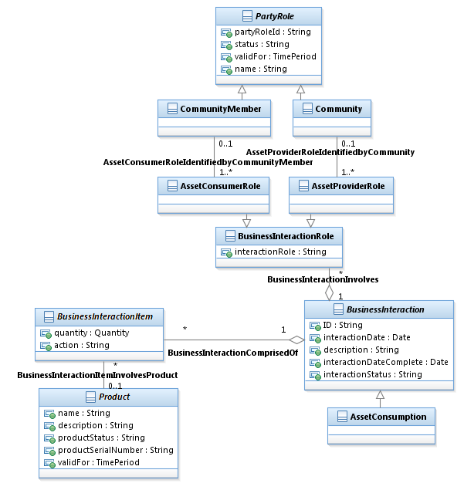

Figure SP : Consuming assets from a community

## Business Entity Definitions – Supplier/Partner

The attributes of the entities below are not yet elaborated. The elaboration of the detailed attributes will be done in the next phase.

### Supplier

**Business Entity Definition**

|  |  |  |  |  |  |  |
| --- | --- | --- | --- | --- | --- | --- |
| Business Entity Name | Supplier | |  | | | |
| Description | A PartyRole played by a Party, who commits to provide a deliverable to a Buyer by a formal Agreement (Commitment). | | | | | | |
| Sources | C2M Best Practices (C2MBP) team | Cross- References | | PartyRole | Synonyms / Aliases |  | |
| Related Business Entities | SubclassOf PartyRole | | | | | | |
| Business Rules |  | | | | | | |

**Business Entity Attributes Definition**

| Business Entity Name | Supplier | |  | | | |
| --- | --- | --- | --- | --- | --- | --- |
| Attribute Name | Description | Data Type | | Characteristics, Permitted Values & Units | Required/  Optional | Notes | |
|  |  |  | |  |  |  | |
|  |  |  | |  |  |  | |
|  |  |  | |  |  |  | |
|  |  |  | |  |  |  | |

### Buyer

**Business Entity Definition**

|  |  |  |  |  |  |  |
| --- | --- | --- | --- | --- | --- | --- |
| Business Entity Name | Buyer | |  | | | |
| Description | A PartyRole a Party plays, who imposed a Supplier to provide a deliverable by a formal Agreement (Commitment). | | | | | | |
| Sources | C2M Best Practices (C2MBP) team | Cross- References | | PartyRole | Synonyms / Aliases |  | |
| Related Business Entities | subclassOf PartyRole | | | | | | |
| Business Rules |  | | | | | | |

**Business Entity Attributes Definition**

| Business Entity Name | Buyer | |  | | | |
| --- | --- | --- | --- | --- | --- | --- |
| Attribute Name | Description | Data Type | | Characteristics, Permitted Values & Units | Required/  Optional | Notes | |
|  |  |  | |  |  |  | |
|  |  |  | |  |  |  | |
|  |  |  | |  |  |  | |
|  |  |  | |  |  |  | |

### Partner

**Business Entity Definition**

|  |  |  |  |  |  |  |
| --- | --- | --- | --- | --- | --- | --- |
| Business Entity Name | Partner | |  | | | |
| Description | A PartyRole, played by a Party being an equitable partner in a business interaction with other parties, playing the Partner role. Usually all Partner have the same (or even compatible) business objectives. | | | | | | |
| Sources | C2M Best Practices (C2MBP) team | Cross- References | | PartyRole | Synonyms / Aliases |  | |
| Related Business Entities | SubclassOf PartyRole | | | | | | |
| Business Rules |  | | | | | | |

**Business Entity Attributes Definition**

| Business Entity Name | Partner | |  | | | |
| --- | --- | --- | --- | --- | --- | --- |
| Attribute Name | Description | Data Type | | Characteristics, Permitted Values & Units | Required/  Optional | Notes | |
|  |  |  | |  |  |  | |
|  |  |  | |  |  |  | |
|  |  |  | |  |  |  | |
|  |  |  | |  |  |  | |

## Business Entity Definitions – Business Objective

The attributes of the entities below are not yet elaborated. The elaboration of the detailed attributes will be done in the next phase.

### BusinessObjectiveSpecification

**Business Entity Definition**

|  |  |  |  |  |  |  |
| --- | --- | --- | --- | --- | --- | --- |
| Business Entity Name | BusinessObjectiveSpecification | |  | | | |
| Description | Detailed description of a BusinessObjective. The composite and entity characteristic pattern may be applied for BusinessEntitySpecifications if applicable. | | | | | | |
| Sources | C2M Best Practices (C2MBP) team | Cross- References | |  | Synonyms / Aliases |  | |
| Related Business Entities | Describes BusinessObjective | | | | | | |
| Business Rules |  | | | | | | |

**Business Entity Attributes Definition**

| Business Entity Name | BusinessObjectiveSpecification |  | | | |
| --- | --- | --- | --- | --- | --- |
| Attribute Name | Description | Data Type | Characteristics, Permitted Values & Units | Required/  Optional | Notes | |
| name | The name of the BusinessObjectiveSpecification | Text |  | Required |  | |
|  |  |  |  |  |  | |
|  |  |  |  |  |  | |
|  |  |  |  |  |  | |

### BusinessObjective

**Business Entity Definition**

|  |  |  |  |  |  |  |
| --- | --- | --- | --- | --- | --- | --- |
| Business Entity Name | BusinessObjective | |  | | | |
| Description | A formal and measurable objective a Party, playing a PartyRole, has regarding that respective role. A BusinessObjective may represent an atomic business objective or consists of other business objectives. | | | | | | |
| Sources | C2M Best Practices (C2MBP) team | Cross- References | |  | Synonyms / Aliases |  | |
| Related Business Entities | IsDescribedBy BusinessObjectiveSpecification  IsBusinessObjectiveOf PartyRole  IsPartOf CompositeProductOffering | | | | | | |
| Business Rules |  | | | | | | |

**Business Entity Attributes Definition**

| Business Entity Name | BusinessObjective | |  | | | |
| --- | --- | --- | --- | --- | --- | --- |
| Attribute Name | Description | Data Type | | Characteristics, Permitted Values & Units | Required/  Optional | Notes | |
| validFor | the time period that the PartyRole is valid for | TimePeriod | | Refer Time Period class | Required |  | |
|  |  |  | |  |  |  | |
|  |  |  | |  |  |  | |
|  |  |  | |  |  |  | |

### AtomicBusinessObjective

**Business Entity Definition**

|  |  |  |  |  |  |  |
| --- | --- | --- | --- | --- | --- | --- |
| Business Entity Name | AtomicBusinessObjective | |  | | | |
| Description | A type of BusinessObjective that does not have any subordinate BusinessObjectives, that is, an AtomicBusinessObjective is a leaf-level BusinessObjective. | | | | | | |
| Sources | C2M Best Practices (C2MBP) team | Cross- References | |  | Synonyms / Aliases |  | |
| Related Business Entities | SubclassOf BusinessObjective | | | | | | |
| Business Rules |  | | | | | | |

**Business Entity Attributes Definition**

| Business Entity Name | AtomicBusinessObjective | |  | | | |
| --- | --- | --- | --- | --- | --- | --- |
| Attribute Name | Description | Data Type | | Characteristics, Permitted Values & Units | Required/  Optional | Notes | |
|  |  |  | |  |  |  | |
|  |  |  | |  |  |  | |
|  |  |  | |  |  |  | |
|  |  |  | |  |  |  | |

### CompositeBusinessObjective

**Business Entity Definition**

|  |  |  |  |  |  |  |
| --- | --- | --- | --- | --- | --- | --- |
| Business Entity Name | CompositeBusinessObjective | |  | | | |
| Description | A type of BusinessObjective that is formed by aggregating other BusinessObjectives, which may be composite or atomic BusinessObjectives. | | | | | | |
| Sources | C2M Best Practices (C2MBP) team | Cross- References | |  | Synonyms / Aliases |  | |
| Related Business Entities | SubclassOf BusinessObjective  ComprisesOf BusinessObjective | | | | | | |
| Business Rules |  | | | | | | |

**Business Entity Attributes Definition**

| Business Entity Name | BusinessObjectiveComposite | |  | | | |
| --- | --- | --- | --- | --- | --- | --- |
| Attribute Name | Description | Data Type | | Characteristics, Permitted Values & Units | Required/  Optional | Notes | |
|  |  |  | |  |  |  | |
|  |  |  | |  |  |  | |
|  |  |  | |  |  |  | |
|  |  |  | |  |  |  | |

## Business Entity Definitions – Commitment

The attributes of the entities below are not yet elaborated. The elaboration of the detailed attributes will be done in the next phase.

### Commitment

**Business Entity Definition**

|  |  |  |  |  |  |  |
| --- | --- | --- | --- | --- | --- | --- |
| Business Entity Name | Commitment | |  | | | |
| Description | A detailed description of the mutual agreement between two parties, playing the role of equal Partners or one playing the role of a Supplier and the other playing the role of a Buyer. A Commitment may be associated to a KPI to govern the Commitment. | | | | | | |
| Sources | C2M Best Practices (C2MBP) team | Cross- References | | Agreement, BusinessInteraction | Synonyms / Aliases |  | |
| Related Business Entities | SubclassOf Agreement | | | | | | |
| Business Rules |  | | | | | | |

**Business Entity Attributes Definition**

| Business Entity Name | Commitment | |  | | | |
| --- | --- | --- | --- | --- | --- | --- |
| Attribute Name | Description | Data Type | | Characteristics, Permitted Values & Units | Required/  Optional | Notes | |
|  |  |  | |  |  |  | |
|  |  |  | |  |  |  | |
|  |  |  | |  |  |  | |
|  |  |  | |  |  |  | |

### CommitmentFulfilmentRole

**Business Entity Definition**

|  |  |  |  |  |  |  |
| --- | --- | --- | --- | --- | --- | --- |
| Business Entity Name | CommitmentFulfilmentRole | |  | | | |
| Description | A role a party plays in a relationship to a Commitment as a Partner or Supplier – i.e. in that role the party has to fulfill the commitment. | | | | | | |
| Sources | C2M Best Practices (C2MBP) team | Cross- References | | Agreement, BusinessInteraction | Synonyms / Aliases |  | |
| Related Business Entities | IdentifiedBy Supplier  IdentifiedBy Partner  SubclassOf BusinessInteractionRole | | | | | | |
| Business Rules |  | | | | | | |

**Business Entity Attributes Definition**

| Business Entity Name | CommitmentFulfilmentRole | |  | | | |
| --- | --- | --- | --- | --- | --- | --- |
| Attribute Name | Description | Data Type | | Characteristics, Permitted Values & Units | Required/  Optional | Notes | |
|  |  |  | |  |  |  | |
|  |  |  | |  |  |  | |
|  |  |  | |  |  |  | |
|  |  |  | |  |  |  | |

### CommitmenProcurementRole

**Business Entity Definition**

|  |  |  |  |  |  |  |
| --- | --- | --- | --- | --- | --- | --- |
| Business Entity Name | CommitmentProcurementRole | |  | | | |
| Description | A role a party plays in a relationship to a Commitment as a Buyer or Supplier – i.e. in that role the party has procured the commitment of another Partner or Supplier. | | | | | | |
| Sources | C2M Best Practices (C2MBP) team | Cross- References | | Agreement, BusinessInteraction | Synonyms / Aliases |  | |
| Related Business Entities | IdentifiedBy Buyer  IdentifiedBy Partner  SubclassOf BusinessInteractionRole | | | | | | |
| Business Rules |  | | | | | | |

**Business Entity Attributes Definition**

| Business Entity Name | CommitmentProcurementRole |  | | | |
| --- | --- | --- | --- | --- | --- |
| Attribute Name | Description | Data Type | Characteristics, Permitted Values & Units | Required/  Optional | Notes | |
|  |  |  |  |  |  | |
|  |  |  |  |  |  | |
|  |  |  |  |  |  | |
|  |  |  |  |  |  | |

### CommitmentTermOrCondition

**Business Entity Definition**

|  |  |  |  |  |  |  |
| --- | --- | --- | --- | --- | --- | --- |
| Business Entity Name | CommitmentTermOrContition | |  | | | |
| Description | A formal term or condition to govern a commitment. | | | | | | |
| Sources | C2M Best Practices (C2MBP) team | Cross- References | | Agreement, BusinessInteraction | Synonyms / Aliases |  | |
| Related Business Entities | SubclassOf AgreementTermOrCondition | | | | | | |
| Business Rules |  | | | | | | |

**Business Entity Attributes Definition**

| Business Entity Name | Commitment | |  | | | |
| --- | --- | --- | --- | --- | --- | --- |
| Attribute Name | Description | Data Type | | Characteristics, Permitted Values & Units | Required/  Optional | Notes | |
|  |  |  | |  |  |  | |
|  |  |  | |  |  |  | |
|  |  |  | |  |  |  | |
|  |  |  | |  |  |  | |

## Business Entity Definitions – Commitment Approval

The attributes of the entities below are not yet elaborated. The elaboration of the detailed attributes will be done in the next phase.

### CommitmentApproverRole

**Business Entity Definition**

|  |  |  |  |  |  |  |
| --- | --- | --- | --- | --- | --- | --- |
| Business Entity Name | CommitmentApproverRole | |  | | | |
| Description | A role a party plays when approving a commitment – i.e. Buyer, Supplier or Partner | | | | | | |
| Sources | C2M Best Practices (C2MBP) team | Cross- References | | Agreement, BusinessInteraction | Synonyms / Aliases |  | |
| Related Business Entities | SubclassOf BusinessInteractionRole | | | | | | |
| Business Rules |  | | | | | | |

**Business Entity Attributes Definition**

| Business Entity Name | CommitmentApproverRole | |  | | | |
| --- | --- | --- | --- | --- | --- | --- |
| Attribute Name | Description | Data Type | | Characteristics, Permitted Values & Units | Required/  Optional | Notes | |
|  |  |  | |  |  |  | |
|  |  |  | |  |  |  | |
|  |  |  | |  |  |  | |
|  |  |  | |  |  |  | |

## Business Entity Definitions – Community

The attributes of the entities below are not yet elaborated. The elaboration of the detailed attributes will be done in the next phase.

### Community

**Business Entity Definition**

|  |  |  |  |  |  |  |
| --- | --- | --- | --- | --- | --- | --- |
| Business Entity Name | Community | |  | | | |
| Description | A Community is a PartyRole, played by an Organization. CommunityMembers can commit to a Community, contribute Contributions to the Community and consume Assets from a Community. | | | | | | |
| Sources | C2M QSP team | Cross- References | | PartyRole | Synonyms / Aliases |  | |
| Related Business Entities | SubclassOf PartyRole  AssetProviderRoleIdentifiedbyCommunity  ContributionReceiverRoleIdentifiedbyCommunity  CommitmentProcurementRoleIdentifiedbyCommunity | | | | | | |
| Business Rules |  | | | | | | |

**Business Entity Attributes Definition**

| Business Entity Name | Community | |  | | | |
| --- | --- | --- | --- | --- | --- | --- |
| Attribute Name | Description | Data Type | | Characteristics, Permitted Values & Units | Required/  Optional | Notes | |
| description | A short description of the purpose of the community | String | |  | Required |  | |
| nbrOfMembers | The number of members committed to the community | UnlimitedNatural | |  | Optional |  | |
| totalAssets | Total number of assets provided to the Community | UnlimitedNatural | |  | Optional |  | |
| sourcedAssets | Number of assets sourced from the Community | UnlimitedNatural | |  | Optional |  | |

### CommunityMember

**Business Entity Definition**

|  |  |  |  |  |  |  |
| --- | --- | --- | --- | --- | --- | --- |
| Business Entity Name | CommunityMember | |  | | | |
| Description | A CommunityMember is a PartyRole, played by an Individual, who is committing to a Community, contributes to it and consumed Assets from the Community. | | | | | | |
| Sources | C2M QSP team | Cross- References | | PartyRole | Synonyms / Aliases |  | |
| Related Business Entities | SubclassOf PartyRole  AssetConsumerRoleIdentifiedbyCommunityMember  ContributionProviderRoleIdentifiedbyCommunityMember  CommitmentFulfilmentRoleIdentifiedbyCommunityMember | | | | | | |
| Business Rules |  | | | | | | |

**Business Entity Attributes Definition**

| Business Entity Name | CommunityMember | |  | | | |
| --- | --- | --- | --- | --- | --- | --- |
| Attribute Name | Description | Data Type | | Characteristics, Permitted Values & Units | Required/  Optional | Notes | |
| dateJoined | The initial date of committing to the community | UnlimitedNatural | |  | Required |  | |
| nbrRelatedMembers | Number of associated CommunityMembers | UnlimitedNatural | |  | Optional |  | |
| nbrContributions | Number of assets provided to the Community | UnlimitedNatural | |  | Optional |  | |
| nbrConsumedAssets | Number of assets consumed from the Community | UnlimitedNatural | |  | Optional |  | |

### CommunityAdministrator

**Business Entity Definition**

|  |  |  |  |  |  |  |
| --- | --- | --- | --- | --- | --- | --- |
| Business Entity Name | CommunityAdministrator | |  | | | |
| Description | A CommunityAdministrator is a PartyRole, played by a Party, who administers a Community. | | | | | | |
| Sources | C2M QSP team | Cross- References | | PartyRole | Synonyms / Aliases |  | |
| Related Business Entities | SubclassOfPartyRole  CommitmentApproverRoleIdentifiedbyCommunityAdministrator | | | | | | |
| Business Rules |  | | | | | | |

**Business Entity Attributes Definition**

| Business Entity Name | CommunityAdministrator | |  | | | |
| --- | --- | --- | --- | --- | --- | --- |
| Attribute Name | Description | Data Type | | Characteristics, Permitted Values & Units | Required/  Optional | Notes | |
|  |  |  | |  |  |  | |
|  |  |  | |  |  |  | |
|  |  |  | |  |  |  | |
|  |  |  | |  |  |  | |

### Contribution

**Business Entity Definition**

|  |  |  |  |  |  |  |
| --- | --- | --- | --- | --- | --- | --- |
| Business Entity Name | Contribution | |  | | | |
| Description | A Contribution is a BusinessInteraction, containing items, associated to Resource, Service or Product that is contributed to a Community by a CommunityMember. | | | | | | |
| Sources | C2M QSP team | Cross- References | | BusinessInteraction | Synonyms / Aliases |  | |
| Related Business Entities | SubclassOfBusinessInteraction | | | | | | |
| Business Rules |  | | | | | | |

**Business Entity Attributes Definition**

| Business Entity Name | Contribution | |  | | | |
| --- | --- | --- | --- | --- | --- | --- |
| Attribute Name | Description | Data Type | | Characteristics, Permitted Values & Units | Required/  Optional | Notes | |
|  |  |  | |  |  |  | |
|  |  |  | |  |  |  | |
|  |  |  | |  |  |  | |
|  |  |  | |  |  |  | |

### ContributionProviderRole

**Business Entity Definition**

|  |  |  |  |  |  |  |
| --- | --- | --- | --- | --- | --- | --- |
| Business Entity Name | ContributionProviderRole | |  | | | |
| Description | A ContributionProviderRole is a BusinessInteractionRole a party (identified by a CommunityMember) plays when contributing to a Community. | | | | | | |
| Sources | C2M QSP team | Cross- References | | BusinessInteractionRole | Synonyms / Aliases |  | |
| Related Business Entities | SubclassOfBusinessInteractionRole  ContributionProviderRoleIdentifiedbyCommunityMember | | | | | | |
| Business Rules |  | | | | | | |

**Business Entity Attributes Definition**

| Business Entity Name | ContributionProviderRole | |  | | | |
| --- | --- | --- | --- | --- | --- | --- |
| Attribute Name | Description | Data Type | | Characteristics, Permitted Values & Units | Required/  Optional | Notes | |
|  |  |  | |  |  |  | |
|  |  |  | |  |  |  | |
|  |  |  | |  |  |  | |
|  |  |  | |  |  |  | |

### ContributionReceiverRole

**Business Entity Definition**

|  |  |  |  |  |  |  |
| --- | --- | --- | --- | --- | --- | --- |
| Business Entity Name | ContributionReceiverRole | |  | | | |
| Description | A ContributionReceiverRole is a BusinessInteractionRole a party (identified by a Community) plays when receiving a contribution from a CommunityMember. | | | | | | |
| Sources | C2M QSP team | Cross- References | | BusinessInteractionRole | Synonyms / Aliases |  | |
| Related Business Entities | SubclassOfBusinessInteractionRole  ContributionReceiverRoleIdentifiedbyCommunity | | | | | | |
| Business Rules |  | | | | | | |

**Business Entity Attributes Definition**

| Business Entity Name | ContributionReceiverRole | |  | | | |
| --- | --- | --- | --- | --- | --- | --- |
| Attribute Name | Description | Data Type | | Characteristics, Permitted Values & Units | Required/  Optional | Notes | |
|  |  |  | |  |  |  | |
|  |  |  | |  |  |  | |
|  |  |  | |  |  |  | |
|  |  |  | |  |  |  | |

### AssetConsumption

**Business Entity Definition**

|  |  |  |  |  |  |  |
| --- | --- | --- | --- | --- | --- | --- |
| Business Entity Name | AssetConsumption | |  | | | |
| Description | An AssetConsumption is a BusinessInteraction, containing items, associated to a Product, that is consumed from a Community as an Asset, by a CommunityMember. | | | | | | |
| Sources | C2M QSP team | Cross- References | | BusinessInteraction | Synonyms / Aliases |  | |
| Related Business Entities | SubclassOfBusinessInteraction | | | | | | |
| Business Rules |  | | | | | | |

**Business Entity Attributes Definition**

| Business Entity Name | AssetConsumption | |  | | | |
| --- | --- | --- | --- | --- | --- | --- |
| Attribute Name | Description | Data Type | | Characteristics, Permitted Values & Units | Required/  Optional | Notes | |
|  |  |  | |  |  |  | |
|  |  |  | |  |  |  | |
|  |  |  | |  |  |  | |
|  |  |  | |  |  |  | |

### AssetConsumerRole

**Business Entity Definition**

|  |  |  |  |  |  |  |
| --- | --- | --- | --- | --- | --- | --- |
| Business Entity Name | AssetConsumerRole | |  | | | |
| Description | An AssetConsumerRole is a BusinessInteractionRole a party (identified by a CommunityMember) plays when consuming assets from a Community. | | | | | | |
| Sources | C2M QSP team | Cross- References | | BusinessInteractionRole | Synonyms / Aliases |  | |
| Related Business Entities | SubclassOfBusinessInteractionRole  AssetConsumerRoleIdentifiedbyCommunityMember | | | | | | |
| Business Rules |  | | | | | | |

**Business Entity Attributes Definition**

| Business Entity Name | AssetConsumerRole | |  | | | |
| --- | --- | --- | --- | --- | --- | --- |
| Attribute Name | Description | Data Type | | Characteristics, Permitted Values & Units | Required/  Optional | Notes | |
|  |  |  | |  |  |  | |
|  |  |  | |  |  |  | |
|  |  |  | |  |  |  | |
|  |  |  | |  |  |  | |

### AssetProviderRole

**Business Entity Definition**

|  |  |  |  |  |  |  |
| --- | --- | --- | --- | --- | --- | --- |
| Business Entity Name | AssetProviderRole | |  | | | |
| Description | An AssetProviderRole is a BusinessInteractionRole a party (identified by a Community) plays when providing assets to a CommunityMember. | | | | | | |
| Sources | C2M QSP team | Cross- References | | BusinessInteractionRole | Synonyms / Aliases |  | |
| Related Business Entities | SubclassOfBusinessInteractionRole  AssetProviderRoleIdentifiedbyCommunity | | | | | | |
| Business Rules |  | | | | | | |

**Business Entity Attributes Definition**

| Business Entity Name | AssetProviderRole | |  | | | |
| --- | --- | --- | --- | --- | --- | --- |
| Attribute Name | Description | Data Type | | Characteristics, Permitted Values & Units | Required/  Optional | Notes | |
|  |  |  | |  |  |  | |
|  |  |  | |  |  |  | |
|  |  |  | |  |  |  | |
|  |  |  | |  |  |  | |

# Administrative Appendix

This Appendix provides additional background material about the TM Forum and this document. In general, sections may be included or omitted as desired, however a Document History must always be included.

## 2.1 About this document

This is a TM Forum Guidebook. The guidebook format is used when:

* The document lays out a ‘core’ part of TM Forum’s approach to automating business processes. Such guidebooks would include the Telecom Operations Map and the Technology Integration Map, but not the detailed specifications that are developed in support of the approach.
* Information about TM Forum policy, or goals or programs is provided, such as the Strategic Plan or Operating Plan.
* Information about the marketplace is provided, as in the report on the size of the OSS market.

## 2.2 Document History

### Version History

<This section records the changes between this and the previous document version as it is edited by the team concerned. Note: this is an incremental number which does not have to match the release number>

| Document Version | Date | Modified By | Purpose |
| --- | --- | --- | --- |
| 0.1 | April 2010 | Dirk Rejahl | GB922 Addendum 8 created |
| 0.2 | June 2010 | Dirk Rejahl | Adoptions per SID team discussions |
| 1.0 | November 2010 | Dirk Rejahl | Doc update for contributing to SID 9,5 |
| 1.1 | March 2011 | Alicja Kawecki | Minor formatting corrections prior to web posting and ME |
| 1.2 | September 2011 | Alicja Kawecki | Updated to reflect TM Forum Approved status |
| 2.0 | September 2012 | Christian Kämmerer | Added Community ABE |
| 2.1 | September 2012 | Christian Kämmerer | Added attributes to Community ABE |
| 2.2 | October 2012 | Christian Kämmerer | Added new notice & minor changes |
| 2.3 | October 2012 | Alicja Kawecki | Minor style/cosmetic corrections prior to web posting and Member Evaluation |

### Release History

N/A

|  |  |  |  |
| --- | --- | --- | --- |
| **SID Release Number** | **Date Modified** | **Modified by:** | **Description of changes** |
| 1.0 | November 2010 | C2M Team | Initial content |
| 12.5 | September 2012 | C2M Team | Added Community |
|  |  |  |  |

## 2.3 Company Contact Details

|  |  |
| --- | --- |
| **Company** | **Team Member Representative** |
| Mediaan/abs bv | *Dirk Rejahl*  *Director*  *dirk.rejahl@mediaanabs.de*  *+49-172-1033200* |

## 2.4 Acknowledgments

This document was prepared by the members of the TeleManagement Forum SID team:

The Shared Information/Data Model is a genuinely collaborative effort. The TM Forum would like to thank the following people for contributing their time and expertise to the production of this document. It is just not possible to recognize all the organizations and individuals that have contributed or influenced the introduction. We apologize to any person or organization we inadvertently missed in these acknowledgments.

Key individuals that reviewed, provided input, managed, and determined how to utilize inputs coming from all over the world, and really made this document happen were:

|  |  |
| --- | --- |
| **Name** | **Affiliation** |
| Christian Kämmerer | Mediaan/abs bv |
| Jan Singer | Singer-TC GmbH |
| Elmar Rode | Oracle Inc. |