J4600 — Amphenol 10102166A812A
microSD Express | EMI & Desense Mitigation Summary
System: WiFi + BT Only | SD CLK 104MHz | 6mm Antenna Proximity | Rev 3.0

WiFi + BT Only  No cellular, no GPS  Desense concern = 2.4GHz only | SD CLK 104MHz  24th harmonic = 2496MHz  Dead center WiFi ch1 + BT band | PCIe RefClk 100MHz  24th harmonic = 2400MHz  BT lower band edge | Primary Constraint  FCC Part 15 emissions  + 2.4GHz self-interference

SDC Only  Filter: CLK harmonics | SDC / PCIe  Dual-mode — filter differs per mode | PCIe Only  Filter: 2.5/5GHz differential | Power  3-stage decoupling + ferrite | GND  Domain: GND_SD not GND_ANT | Mech  RC debounce only

Pin | Signal | Mode | Add to Schematic | Value | Package | EMI / Desense Rationale
PIN 5 — CLK | SDC MODE ONLY | 22Ω + 22pF C0G (updated from 208MHz design)
5 | CLK | SDC | Series RC LPF at SoC output  22Ω + 22pF C0G shunt to GND | 22Ω series  22pF to GND | 0201 / 50V  0201 C0G 50V | 104MHz CLK — 24th harmonic lands at 2496MHz, dead center in WiFi ch1 (2412MHz) and BT band (2402-2480MHz). This is the primary self-interference source in your system. RC LPF fc=330MHz: passes 104MHz at -0.3dB, attenuates 2496MHz by -18dB. NOTE: Changed from 33Ω+10pF used in 208MHz designs — lower series R preserves signal integrity at 104MHz while larger shunt cap gives better HF rejection. C0G mandatory: X7R loses 50% capacitance under 1.8V VDDIO bias, shifting fc to ~470MHz and leaving the 24th harmonic almost unfiltered. SDC mode only — benign in PCIe Express mode.
PIN 3 — CMD / Response | SDC Only
3 | CMD / CR | SDC | 22Ω series + 47k pull-up to VDDIO  + 10pF C0G shunt across pull-up | 22Ω series  47k to VDDIO  10pF to GND | 0201 / 50V  0402 / 10V  0201 C0G 10V | Open-drain bidirectional. 22Ω slews edge, cutting harmonics above 500MHz by >10dB. 47k pull-up holds CMD at VDDIO when SoC tristates — floating CMD near 6mm antenna resonates at GHz. 10pF C0G shunt across the 47k is the most commonly missed component: kills stub RF susceptibility above 300MHz, prevents the 47k-terminated trace from receiving 2.4GHz energy and injecting into the SoC. C0G mandatory.
PINS 7 + 8 — DATA0/DATA1 (SDC) | PCIe REFERENCE CLOCK +/- (PCIe Express) ← DUAL MODE
7 | DATA0 (SDC)  RefClk+ (PCIe) | SDC/PCIe | SDC: 22Ω + 47k pull-up + 10pF C0G  PCIe: CMC on RefClk pair  + FB + 3-term cap on RefClk VDD | SDC: 22Ω + 47k + 10pF  PCIe RefClk:  CMC 470Ω@100MHz  FB 1800Ω@100MHz  3-term cap 470nF | SDC: 0201+0402+C0G  CMC: 0805 100Ω diff  FB: 0402 100mA  Cap: 0402 X7R 10V | DUAL MODE — most filter-critical pin on J4600. SDC: standard DATA0 network — 22Ω slew + 10pF C0G shunt kills 2.4GHz stub susceptibility. PCIe EXPRESS: this pin becomes RefClk+. 100MHz RefClk 24th harmonic at 2400MHz is 2MHz below BT lower band edge — BT frequency hopping hits this spur on every sweep through lower channels causing BT throughput degradation. CMC (Murata DLW21SN471SQ2L) provides >20dB CM rejection while adding <0.3dB differential insertion loss — purely common-mode, transparent to the RefClk differential signal. 1800Ω FB + 470nF 3-terminal cap on RefClk VDD supply: >60dB supply rejection — prevents PMIC noise adding phase noise to RefClk, which would spread the harmonic and widen the interference window into BT channels. Do NOT use a series R in PCIe RefClk mode — it degrades phase noise.
8 | DATA1 (SDC)  RefClk- (PCIe) | SDC/PCIe | SDC: 22Ω + 47k pull-up + 10pF C0G  PCIe: shares CMC with Pin 7  (symmetric placement mandatory) | SDC: 22Ω + 47k + 10pF  PCIe: shares  CMC_REFCLK with Pin 7 | SDC: 0201+0402+C0G  Shared CMC — 0805 | DUAL MODE — mirror of Pin 7. PCIe EXPRESS: RefClk- shares the 2-line CMC. Must mirror Pin 7 component placement within 5 mils — any asymmetry converts differential RefClk to common-mode, completely negating the CMC and spreading harmonic energy into both 2.4GHz WiFi and BT simultaneously.
PIN 1 — DATA2 (SDC) | PCIe CLKREQ# / L1 PM Sub-states (PCIe)
1 | DATA2 (SDC)  CLKREQ# (PCIe) | SDC/PCIe | SDC: 22Ω + 47k pull-up + 10pF C0G  PCIe: 4.7k pull-up + 10pF C0G  (no series R in PCIe mode — open-drain) | SDC: 22Ω+47k+10pF  PCIe: 4.7k+10pF | 0201/50V + 0402  + 0201 C0G 10V | DUAL MODE — filter topology changes per mode. SDC: standard DATA2 filter. PCIe: CLKREQ# is open-drain active-low. The 22Ω series R from SDC mode must NOT be in the CLKREQ# path — it slows the assertion edge, directly impacting PCIe L1.2 power state exit latency. Use 4.7k pull-up per PCIe spec. The 10pF C0G shunt is mandatory in both modes: without it the 4.7k-terminated CLKREQ# stub near the 6mm antenna receives 2.4GHz energy and causes spurious L1 exit events, manifesting as intermittent link failures during WiFi/BT activity nearby.
PIN 2 — DATA3 / CD (SDC) | Power Enable / Functional Reset (PCIe)
2 | DATA3/CD (SDC)  PwrEn/FnRST (PCIe) | SDC/PCIe | SDC: 22Ω + 47k pull-up + 10pF C0G  PCIe: 100Ω + 100nF slew control  (larger cap — power switching transient) | SDC: 22Ω+47k+10pF  PCIe: 100Ω+100nF | 0201/50V + 0402  + C0G / X7R 10V | DUAL MODE — filter values differ significantly. SDC: standard DATA3 filter, also debounces mechanical card-detect bounce (broadband burst to 100MHz without the 10pF shunt). PCIe: Power Enable / Functional Reset — fast reset edge <1ns generates broadband harmonics 1MHz-1GHz on this trace 6mm from antenna. 100Ω+100nF (fc=16kHz) slows edge to ~10µs, eliminating all harmonic content while remaining transparent to PCIe reset timing (spec allows up to 100ms). 100nF shunt (not 10pF) needed here — higher current power-enable transient requires larger damping cap.
POWER RAILS — 3.3V (Pin 4), 1.8V VDDIO (Pin 9), 1.2V PCIe (Pin 17)
4 | 3.3V Supply | Power | Ferrite on rail  + 3-stage decoupling | 600Ω@100MHz ferrite  10µF bulk  100nF mid  100pF HF (C0G) | 0402 500mA  0402 X5R 10V  0201 X7R 10V  0201 C0G 10V | PMIC switching harmonics (1-25MHz) ride the 3.3V rail to the connector and radiate 6mm from antenna. Ferrite blocks PMIC harmonics before they reach the connector. Three decoupling stages mandatory: 10µF handles card-insertion surge current (prevents 50-200MHz droop oscillation); 100nF kills CLK-synchronous supply ripple at 100-300MHz; 100pF C0G kills sub-ns spikes above 300MHz. All three show up as spurs on FCC Part 15 scan without mitigation. C0G mandatory for 100pF. PLACEMENT: Place ferrite (FB_3V3) close to the connector — within 3mm of pin 4. Topology: PMIC/system 3.3V rail → 10µF bulk (near PMIC) → 600Ω ferrite → 100nF → 100pF C0G → connector pin 4. The 10µF goes on the dirty side of the ferrite (PMIC side) to handle surge. The 100nF and 100pF go on the clean side (connector side) — do not place them before the ferrite or they have no effect on connector-radiated emissions.  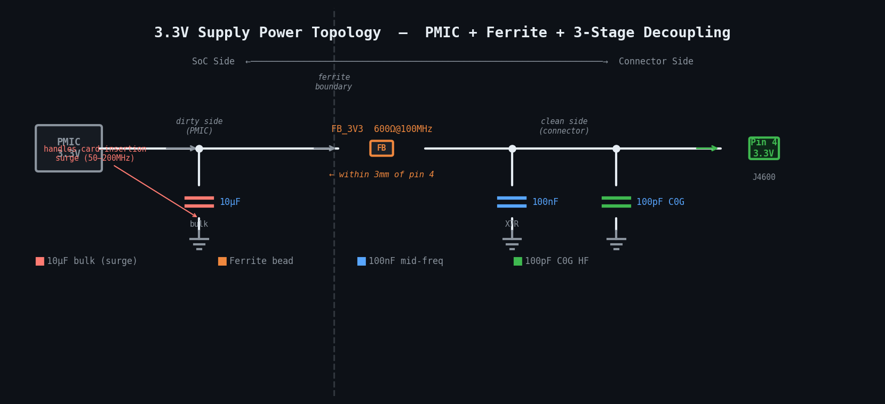
9 | 1.8V VDDIO | Power | Dedicated switchable LDO  + ferrite + 2-stage decoupling | Switchable LDO 1.8V/3.3V  600Ω@100MHz ferrite  100nF mid  100pF HF (C0G) | SOT23/LGA  0402 300mA  0201 X7R 10V  0201 C0G 10V | VDDIO powers DATA/CLK/CMD I/O buffers. MUST be a dedicated switchable LDO — sharing with any other domain means a 3.3V-to-1.8V mode switch glitches all signal levels simultaneously. Ferrite breaks CLK feedback loop: CLK switching → VDDIO ripple → CLK jitter → harmonic spreading into 2.4GHz WiFi/BT band. Without it the 2496MHz spur widens in frequency and is harder to filter. PLACEMENT & TOPOLOGY (voltage regulator IC on 1.8V line): Place the LDO IC close to the SoC side — it is a noise source and must be isolated from the connector early. Topology: LDO output → 600Ω ferrite (FB_1V8) → connector pin 9. Place the ferrite within 2mm of the connector pin, not at the LDO output — the ferrite must block harmonics on the PCB trace segment closest to the antenna, not at the source. Place the 100nF decoupling cap at the LDO output (after the LDO, before the ferrite) to handle mid-frequency ripple from the LDO switching node. Place the 100pF C0G cap on the connector side of the ferrite (between ferrite and pin 9) — this cap kills sub-ns spikes that pass through the ferrite and would otherwise radiate from the connector shell directly into the 6mm antenna gap. Do NOT place both caps on the same side of the ferrite — that defeats the pi-filter effect and leaves the connector-side trace unfiltered above 300MHz.  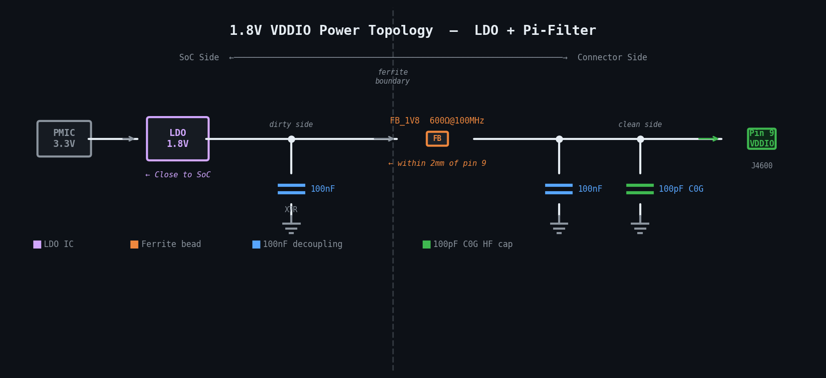
17 | 1.2V PCIe | Power | Ferrite + 2-stage decoupling  (DNP if PCIe mode not used)  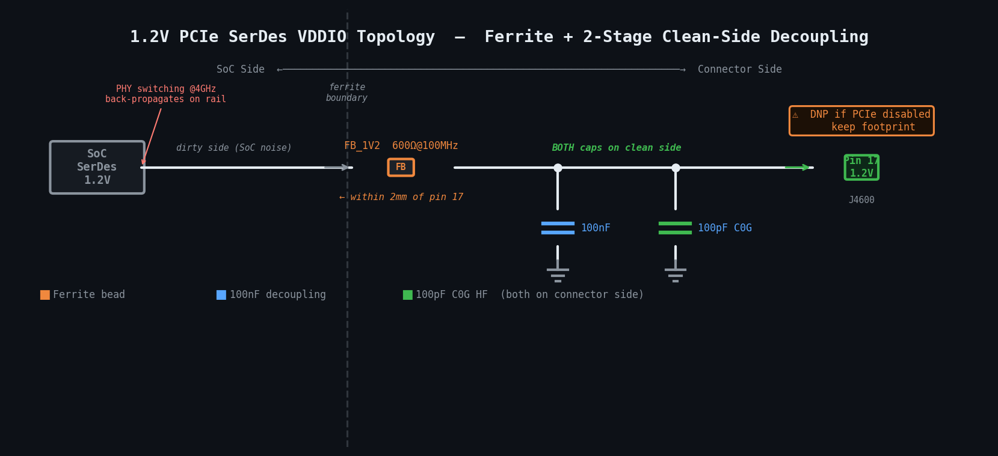 | 600Ω@100MHz ferrite  100nF mid  100pF HF (C0G) | 0402 500mA  0201 X7R 10V  0201 C0G 10V | PCIe Express SerDes VDDIO. PHY switching at 2.5GHz back-propagates through this rail. Your schematic shows Pin 17 with X (no-connect) — if PCIe Express is disabled for this slot, 1.2V may be unused. Still place DNP footprints for all three components — costs nothing, avoids a board spin if Express mode is enabled later. PLACEMENT: Place ferrite (FB_1V2) close to connector pin 17 — within 2mm. Topology: SoC 1.2V SerDes supply → 600Ω ferrite → 100nF → 100pF C0G → connector pin 17. Both decoupling caps go on the connector side of the ferrite to maximize HF suppression at the antenna-proximate pin.
GROUND PINS — VSS_1 to VSS_4 | Pins 6, 10, 13, 16
6  10  13  16 | VSS Ground  (×4 pins) | GND | ALL VSS → GND_SD only  NOT GND_ANT  Test point on Pin 6 | 0Ω to GND_SD  Via stitch ≤1.5mm | 0402 test point  4× vias per pad | All VSS pins carry SD and PCIe return current. MUST connect to GND_SD (digital ground domain), NEVER GND_ANT. If any VSS touches GND_ANT copper, SD CLK harmonics and PCIe RefClk harmonics flow through the antenna return path and couple directly into your WiFi/BT antenna feed — this is the conducted interference path and is the hardest failure mode to debug because it shows no obvious radiated source. Add test point on one VSS pin for current-probe measurement during lab characterization.
CONNECTOR SHELL — MTB Pads | Right-side shield tabs
MTB  1-5 | Shell GND | GND | Solder ALL MTB pads → GND_SD  1.0mm via pitch: antenna-facing tab  1.2mm via pitch: remaining tabs | Solder all tabs  Via fence GND_SD  RF absorber optional | PCB vias all layers  1.0mm pitch (antenna side)  1.2mm pitch (others) | Metal connector shell is the largest broadband radiating surface in the assembly — directly relevant to FCC Part 15 emissions. Unsoldered tab leaves a gap >6mm acting as a slot antenna at 2.4GHz, which in your system means direct radiation into your WiFi/BT band. All tabs to GND_SD (not GND_ANT). Optional: TDK IFL10 or Laird Eccosorb absorber tile (3mm × 1mm) placed in the 6mm physical gap between connector shell and antenna connector — adds 8-12dB attenuation above 2.4GHz beyond what via fence alone provides.
GND DOMAIN ISOLATION — GND_SD ↔ GND_ANT Bridge (most critical placeholder)
GND  Bridge | GND_SD  → GND_ANT | GND | 0Ω bridge (populated) in series with  DNP ferrite — separate footprints  Between GND_SD and GND_ANT | 0Ω (populated)  600Ω@100MHz 1A  (DNP default) | 0201 / cuttable  0603 / 1A rated | Default: R_GND_BRIDGE = 0Ω populated, FB_GND_BRIDGE = DNP. Lab debug: cut R_GND_BRIDGE pad, populate ferrite. Ferrite = 0Ω DC (WiFi/BT antenna DC ground remains valid) + >20dB RF isolation at 100MHz+, blocking SD/PCIe switching transients from reaching the antenna return path. Zero PCB rework needed — this is the single most useful debug tool in the design. MUST be two separate footprints in series: a single 0Ω pad cannot be swapped for a ferrite without a board spin.
SW, DE — Mechanical Card Detect (NOT mode-switching signals)
SW  DE | Card Detect  (Mechanical) | Mech | 10k pull-up to VDDIO  + 100pF C0G debounce shunt | 10k to VDDIO  100pF to GND | 0402 / 10V  0201 C0G 10V | SW and DE are mechanical insertion-detection switches only — NOT mode-switching signals (corrected from Rev 1.0). Simple RC debounce: 10k pull-up holds the line defined when no card is present; 100pF C0G shunt kills RF susceptibility of the pull-up stub (same principle as DAT pull-up shunts). No series R needed — these are slow mechanical signals with no edge-rate concern.
PCIe DIFFERENTIAL PAIRS — TX_P/TX_N (Pins 11,12) | RX_P/RX_N (Pins 14,15)
11  12 | PCIe TX  (+/-) | PCIe | 100nF AC coupling cap (×2)  + CMC on TX pair  Pin 11: C_TX_P | Pin 12: C_TX_N | 100nF AC couple (×2)  360Ω@100MHz CMC | 0201 X7R 16V (×2)  0805 100Ω diff | PCIe Gen3 at 8 GT/s (4GHz fundamental). At 6mm from WiFi/BT antenna, the TX common-mode radiates directly into 5GHz WiFi band. AC coupling caps mandatory per PCIe spec — block DC offset from driving common-mode current. CMC provides >20dB CM rejection while adding <0.5dB differential IL. CRITICAL: 0201 mandatory for AC caps — 0402 resonates at 3-4GHz, creating an emission peak directly in the signal band rather than suppressing. Place CMC within 3mm of connector pins. Mirror TX_P and TX_N cap placement within 5 mils — asymmetry converts differential to CM, negating the CMC.
14  15 | PCIe RX  (+/-) | PCIe | 100nF AC coupling cap (×2)  + CMC on RX pair | 100nF AC couple (×2)  360Ω@100MHz CMC | 0201 X7R 16V (×2)  0805 100Ω diff | RX pair picks up SD CLK 24th harmonic at 2496MHz as common-mode ingress — this is the same spur that desenses your WiFi. CMC on RX prevents this from entering the PCIe RX as a noise floor elevation and also prevents 2.4GHz WiFi energy from coupling back into the RX pair via common-mode.

104MHz SD CLK — Harmonic Map for WiFi + BT System
With no cellular or GPS in the system, only harmonics that land in the WiFi (2.4GHz / 5GHz) and Bluetooth (2.402–2.480GHz) bands are operationally relevant. FCC Part 15 emissions remain a constraint for all harmonics regardless.

Harmonic | Frequency | Band Impact | Concern | Mitigation
2nd–23rd | 208–2392 MHz | No WiFi/BT bands impacted | FCC emissions only — no receiver in system affected | Standard power rail ferrites + CLK RC LPF handles this range. No specific action needed for WiFi/BT.
23rd | 2392 MHz | 8MHz below BT lower edge (2402MHz) | LOW RISK — BT lower band adjacent | RC LPF on CLK (fc=330MHz) provides -17dB at 2392MHz. Acceptable.
24th ⚠ | 2496 MHz | WiFi ch1 (2412MHz) + BT band center | CRITICAL — primary WiFi/BT self-interference source | 22Ω + 22pF C0G LPF (fc=330MHz) → -18dB at 2496MHz. GND_SD/GND_ANT isolation. Via fence on MTB shell tabs.
25th | 2600 MHz | WiFi ch11–13 upper edge | MEDIUM — partially inside 2.4GHz band | Same CLK LPF provides -19dB. Covered.
48th | 4992 MHz | 5GHz WiFi (4915–5825MHz) | MEDIUM — inside 5GHz WiFi band | PCIe TX CMC (TDK ACM2012-361) provides >20dB CM rejection at 4GHz. AC coupling caps on TX/RX pairs.

100MHz PCIe RefClk — Harmonic Map for WiFi + BT System
RefClk runs continuously while a PCIe Express card is inserted — sustained always-on interference source unlike SD CLK which only runs during transfers.

Harmonic | Frequency | Band Impact | Concern | Mitigation
2nd–23rd | 200–2300 MHz | No WiFi/BT bands impacted | FCC emissions scan only | Power rail ferrites + FB_REFCLK_VDD 1800Ω covers this range.
24th ⚠ | 2400 MHz | BT lower band edge (2402MHz)  2MHz separation | HIGH — BT freq hopping sweeps directly across this spur every cycle | CMC on RefClk pair (Murata DLW21SN471SQ2L) + 1800Ω FB + 470nF 3-terminal cap on RefClk VDD supply. >60dB total supply rejection.
25th | 2500 MHz | WiFi ch2 (2417MHz) adjacent | MEDIUM — close to WiFi 2.4GHz lower channels | CMC on RefClk pair covers. -20dB CM rejection at 2.5GHz.
50th | 5000 MHz | 5GHz WiFi band | LOW — 50th harmonic is typically low amplitude | PCIe TX CMC covers 4GHz Gen3 fundamental and harmonics. Unlikely to be a compliance issue.

Components Removed vs Previous LTE/GPS Designs — WiFi+BT System

REMOVED FROM BOM — Not Needed for WiFi + BT Only System
FB_GPS_VDD (1800Ω GPS LNA supply ferrite)
Reason: No GPS receiver in system. Was protecting GPS L1 at 1575.42MHz — irrelevant without GPS LNA.

LTE band harmonic analysis and LTE-specific filter constraints
Reason: No cellular receiver. However NOTE: the same CLK harmonics that would hit LTE bands still appear
as out-of-band spurs on FCC Part 15 emissions scans — filters still needed for certification.

1800Ω FB_PCIE_REF (second ferrite on PCIe RefClk supply for GPS L1 protection)
Reason: Was specifically for GPS L1 at 1575MHz (16th RefClk harmonic). Not needed.
Keep the standard 1800Ω FB_REFCLK_VDD — that is for general supply noise and BT protection.

The 3 Components You Cannot Skip — WiFi + BT System

① CLK Pin 5  22Ω + 22pF C0G at SoC output  24th harmonic at 2496MHz is dead center in your WiFi ch1 and BT band. This single component is your primary 2.4GHz self-interference fix. Place within 1mm of SoC CLK output pin. C0G mandatory. | ② CMC on RefClk Pins 7+8  Murata DLW21SN471SQ2L + 1800Ω FB  100MHz RefClk 24th harmonic at 2400MHz is 2MHz below BT lower band edge — BT frequency hopping hits this spur constantly. Sustained always-on interference while card is inserted, not just during transfers. | ③ GND Bridge Placeholder  R_GND_BRIDGE (0Ω) + FB_GND_BRIDGE (DNP)  Two separate footprints in series between GND_SD and GND_ANT. Default 0Ω. Lab fix: cut and populate 600Ω 1A ferrite — zero rework. The single most valuable debug tool if conducted interference reaches your WiFi/BT antenna port.

Quick Reference BOM — All Components for J4600 (WiFi + BT System)
GPS LNA ferrite removed vs LTE/GPS designs. All other components unchanged.

Ref Des | Pin(s) | Part Number | Value | Package | Function
R_CLK | 5 | Vishay CRCW020122R0FK | 22Ω | 0201 | CLK series R — LPF with C_CLK. fc=330MHz. Updated for 104MHz CLK (was 33Ω in 208MHz designs).
C_CLK | 5 | Murata GRM0335C1H220J | 22pF C0G | 0201 50V | CLK shunt cap — LPF. C0G mandatory. Updated to 22pF (was 10pF in 208MHz designs) for better 2.4GHz rejection.
R_CR | 3 | Vishay CRCW020122R0FK | 22Ω | 0201 | CMD series slew resistor.
RPU_CR | 3 | Vishay CRCW040247K0FK | 47k | 0402 10V | CMD open-drain pull-up to VDDIO.
C_CR | 3 | Murata GRM0335C1H100J | 10pF C0G | 0201 10V | CMD pull-up shunt — kills 2.4GHz stub susceptibility.
R_D0–R_D3 | 7,8,1,2 | Vishay CRCW020122R0FK | 22Ω (×4) | 0201 50V | DATA0-3 series slew resistors. Independent for each line — never shared.
RPU_D0–D3 | 7,8,1,2 | Vishay CRCW040247K0FK | 47k (×4) | 0402 10V | DATA0-3 pull-ups to VDDIO. SD spec mandatory.
C_D0–D3 | 7,8,1,2 | Murata GRM0335C1H100J | 10pF C0G (×4) | 0201 10V | DATA pull-up shunt caps — kills 2.4GHz stub susceptibility on each line. C0G mandatory.
CMC_REFCLK | 7+8 | Murata DLW21SN471SQ2L | 470Ω@100MHz | 0805 100Ω diff | PCIe RefClk pair CMC. Suppresses 24th harmonic (2400MHz) from reaching BT band. Transparent to RefClk differential signal.
FB_REFCLK_VDD | RefClk VDD | Murata BLM15PX182SN1D | 1800Ω@100MHz | 0402 100mA | RefClk VDD supply ferrite. Prevents PMIC noise from adding phase noise to RefClk — widens harmonic and hits more BT channels.
C_REFCLK_VDD | RefClk VDD | Murata NFM18CC474R1H3D | 470nF 3-term | 0402 X7R 10V | 3-terminal cap on RefClk VDD. Pi-filter topology — no resonance. >60dB supply rejection combined with FB.
C_TX_P,TX_N  C_RX_P,RX_N | 11,12  14,15 | Murata GRM033R71C104K | 100nF (×4) | 0201 X7R 16V | PCIe differential pair AC coupling caps. Mandatory per PCIe spec. 0201 mandatory — 0402 resonates at 3-4GHz.
CMC_TX  CMC_RX | 11+12  14+15 | TDK ACM2012-361-2P-T002 | 360Ω@100MHz (×2) | 0805 100Ω diff | PCIe TX and RX pair CMCs. >20dB CM rejection at 4GHz — suppresses 5GHz WiFi interference from Gen3 TX fundamental.
FB_3V3  FB_1V8  FB_1V2 | 4, 9, 17 | Murata BLM15PX601SN1D | 600Ω@100MHz (×3) | 0402 500mA | Power rail ferrites on 3.3V, 1.8V, 1.2V. Block PMIC switching harmonics. Appear as FCC emission spurs without mitigation.
C_xV_BULK | 4 (3.3V) | Murata GRM188R60J106M | 10µF X5R | 0402 10V | 3.3V bulk decoupling. Handles card-insertion surge. Prevents 50-200MHz droop oscillation.
C_xV_MID (×3) | 4,9,17 | Murata GRM033R71A104K | 100nF X7R (×3) | 0201 10V | Mid-freq decoupling on all three rails. 0201 mandatory — 0402 SRF=80MHz, misses 100-300MHz target.
C_xV_HF (×3) | 4,9,17 | Murata GRM0335C1H101J | 100pF C0G (×3) | 0201 10V | HF decoupling. C0G mandatory on all three — X7R degrades under bias and fails above 300MHz.
R_GND_BRIDGE | GND bridge | Vishay CRCW02010000Z0ED | 0Ω | 0201 | GND domain bridge — populated by default. Cut and replace with FB_GND_BRIDGE if conducted interference found in lab.
FB_GND_BRIDGE | GND bridge | Murata BLM18PG601SN1D | 600Ω@100MHz 1A (DNP) | 0603 1A | GND bridge ferrite — DNP by default. Provides >20dB RF isolation GND_SD↔GND_ANT while maintaining 0Ω DC.
RPU_SW  RPU_DE | SW, DE | Vishay CRCW040210K0FK | 10k (×2) | 0402 10V | Card detect pull-ups. Mechanical switch — no edge rate concern. Holds line defined when no card present.
C_SW  C_DE | SW, DE | Murata GRM0335C1H101J | 100pF C0G (×2) | 0201 10V | Card detect debounce shunt. Kills RF susceptibility of mechanical switch stub near antenna.

