Frame by Block Site Plan

Luke Archibald

WDD 130

Overview

Purpose
Provide information to help people get into stop-motion for the first time without overwhelming them. Give them information about the minimum requirements to start animating and give some animating tips.

Audience
Lego fans and adventurous artists

Branding

Website Logo
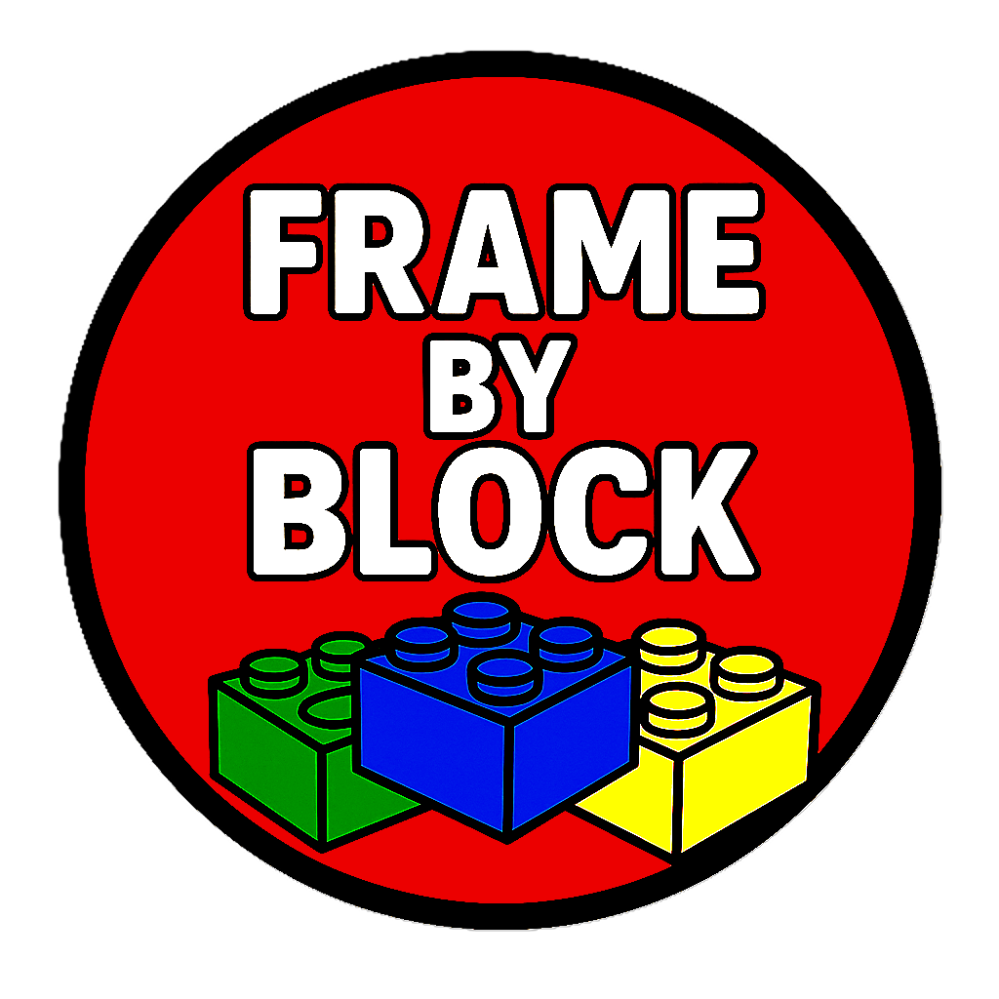

Style Guide

Color Palette

https://coolors.co/5bc0be-008f00-c03221-0016e0-f2d0a4
Primary | Secondary | Accent 1 | Accent 2
#5BC0BE | #008F00 | # C03221 | #0016E0 and #F2D0A4
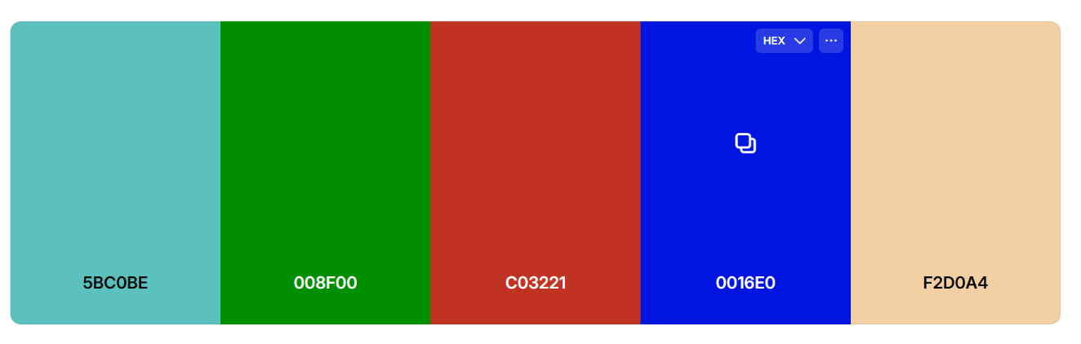

Typography

Selection - Google Fonts

Heading Font: Revalia

Paragraph titles: Archivo Black

Paragraph Font: Roboto

Navigation
Home Materials Animating

Content

Home page

(subtitle) A Starter's Guide

(p1) Welcome to Frame by Block, the ultimate beginner’s guide to LEGO stop-motion animation! Our website helps aspiring creators or curious Lego fans bring their brick-built stories to life with easy, step-by-step tutorials. You’ll learn everything from setting up your camera and lighting to creating smooth motion, adding sound effects, and editing your final video. Frame by Block also includes gear recommendations, directing advice, and helpful tips for beginner animators. What makes our site unique is its focus on simplicity and creativity, with no expensive equipment or advanced software required. Whether you’re a child, hobbyist, or first-time filmmaker, Frame by Block gives you all the tools and inspiration to turn your LEGO ideas into mini masterpieces.

(p2) Stop-motion animation can seem very overwhelming at first, but if you focus on having fun before making your animations into professional masterpieces, you will be more likely to stick with it and make better and better animations as time goes on. This website will go over two basic steps to help you get started on your stop-motion journey.

(p3) Once you complete the basics, you can start filming and editing your first animations! Don’t be afraid to experiment with everything as you continue, and you will surprise yourself with what you will accomplish.

Materials page

(title) Materials

(p1) To get started, you are going to need a couple of things. There are only a few things that are actually required, which include Legos, a camera, and editing software. I want to touch on the most important materials to use when first starting out and give some tips on how to use them.

Tripod:
(p2) Some beginner stop-motion animators just prop up their phones against some Legos to film, but in order to minimize the shaking in the video as much as possible, a tripod is recommended. Luckily, there are some cheap tripod options to choose from. It’s important to choose a flexible leg tripod so you can keep it on the table and get the angles you want.

Putty:
(p3) You need to find a way to keep your sets still while you film, so using putty is recommended. This can also help with positioning the mini-figures exactly where you want them without them falling over.

Editing software:
(p4) There are plenty of stop-motion apps you can use to put all your photos together, and you should look for one that works for you. I use Stop Motion Studio, which is free and works well. You can also use multiple editing software to handle different effects you want in your movie, like adding sound.

Animation Page

(title) Animation

(p1) Now for the fun part. Once you have all the materials necessary, you can start to animate. Note that animation is time-consuming, so making a goal to make a 30-minute video as your first project is probably not a good idea. It's best to start off with a small test project, which might look janky and will be anywhere from 30 seconds to 4 minutes, depending on your story and patience.

How to move a character:
(p2) Using a tile plate when starting out is recommended because it allows you to pick up a character or prop at any time and place it back in the exact position you found it. Picking up a character is very important when moving a character's limb without accidentally moving its other limbs or even the whole set. When you have your pieces loosely placed or stuck to the ground with putty, it can be hard to position them back exactly where you need them if you pick them up.

Walking:
(p3) Walking is an easy thing to mess up and can be fairly noticeable in your animation. It's best to practice animating a walking cycle that helps you remember which leg to move next. One of the strategies I use is moving the arms in a pattern that lets me see which leg needs to move based on whether the arm is swinging forward or backward. You can also practice a running cycle.

Freezing frames:
(p4) When first starting out, it's ok to film at a lower frame rate, like 12 or 8 frames per second, or even freeze the frame for a second to allow the viewer to take in the scene for a second. Freezing frames can be very useful when you don’t know how long you want to linger on a shot when animating, and will speed up the animating process a ton. When animating, I plan what shots I want to use freeze frames on by making sure every object has completed its motion, so a character doesn't freeze up while walking.
Home page

Colorful pic
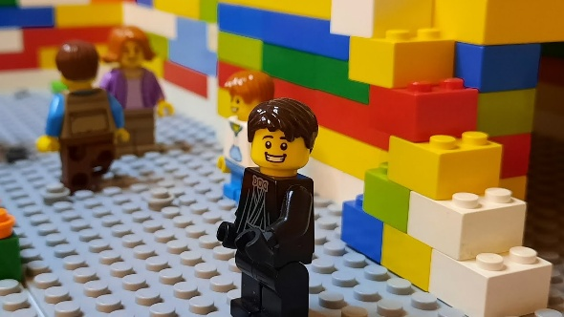

Cars
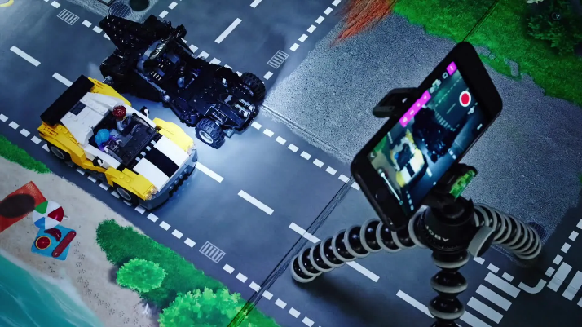

Phone
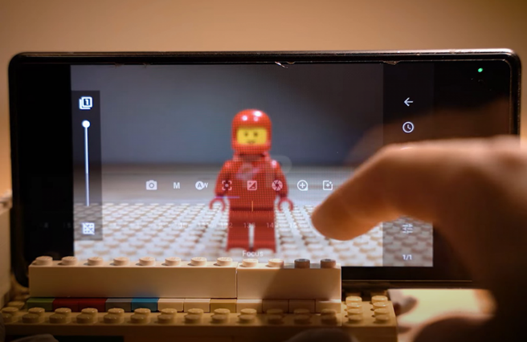

Materials page

Cars
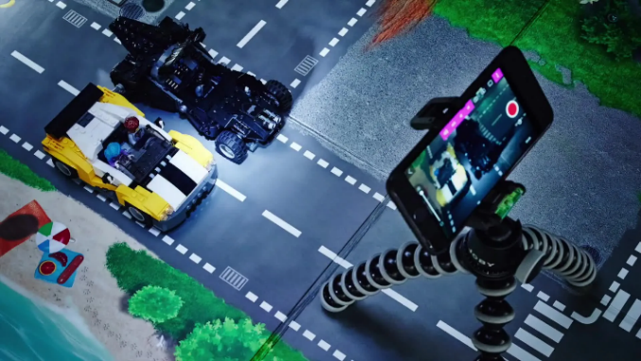

Tripod
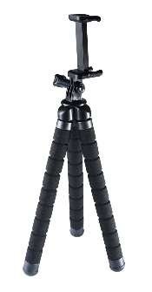

Putty
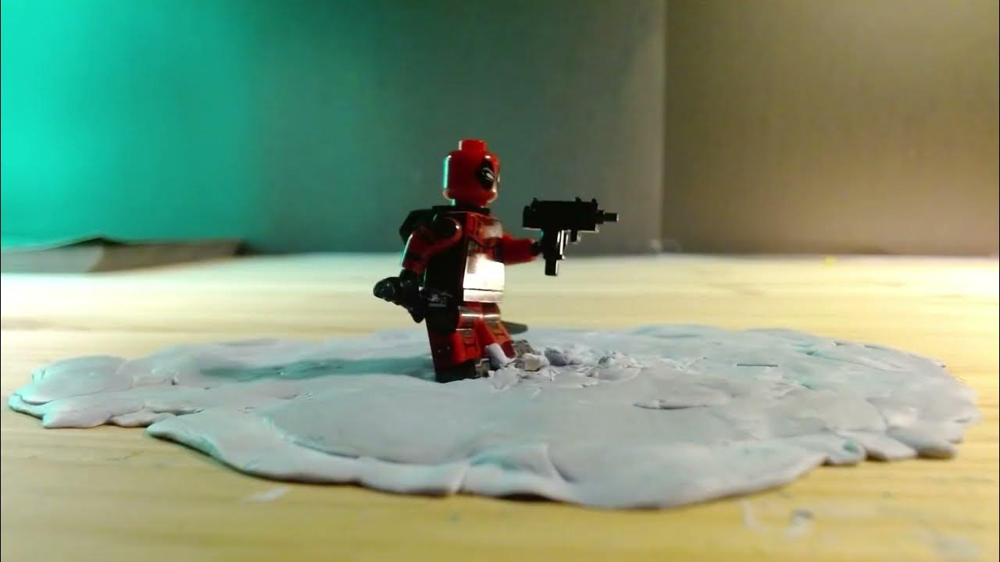

Editing
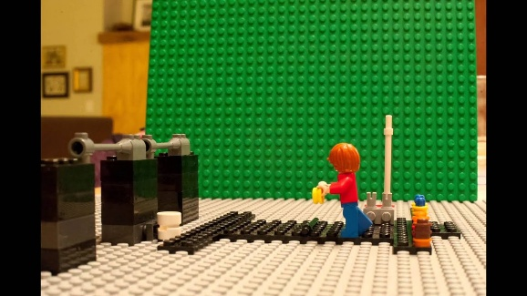

Animation Page

Phone

Minecraft
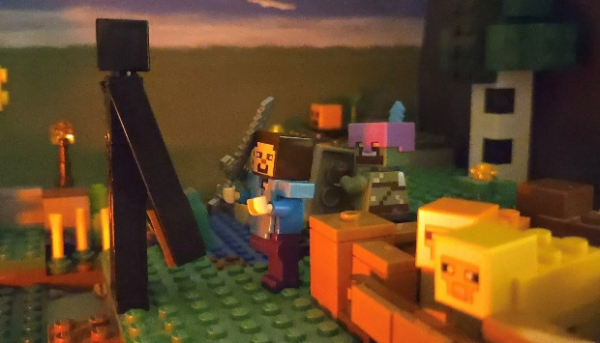

Jones
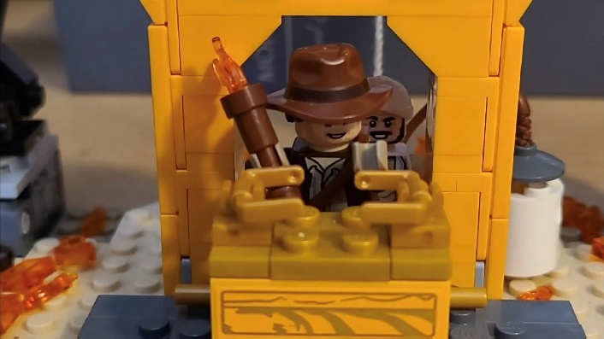

Freeze
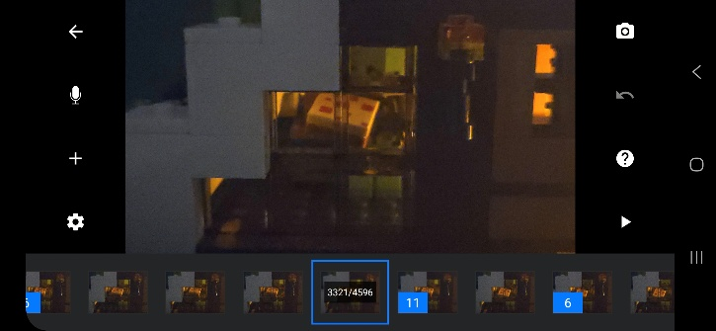

Wireframes

Home page
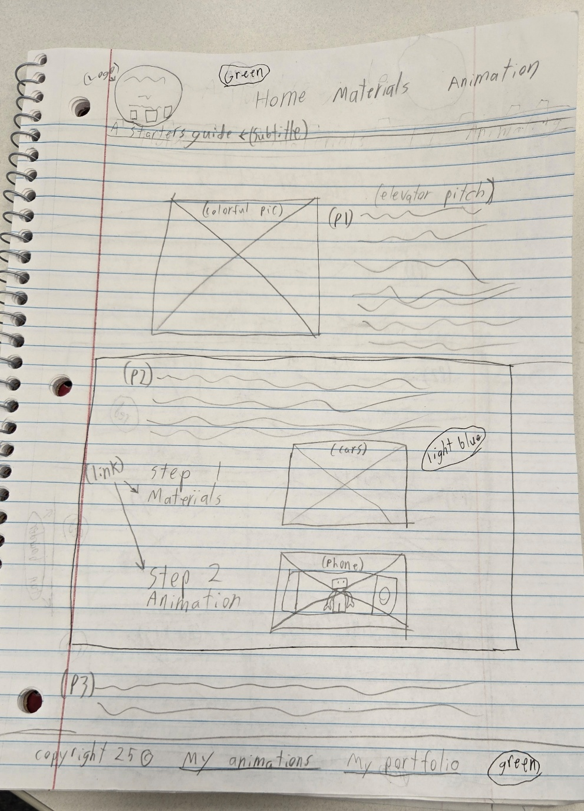

Materials page
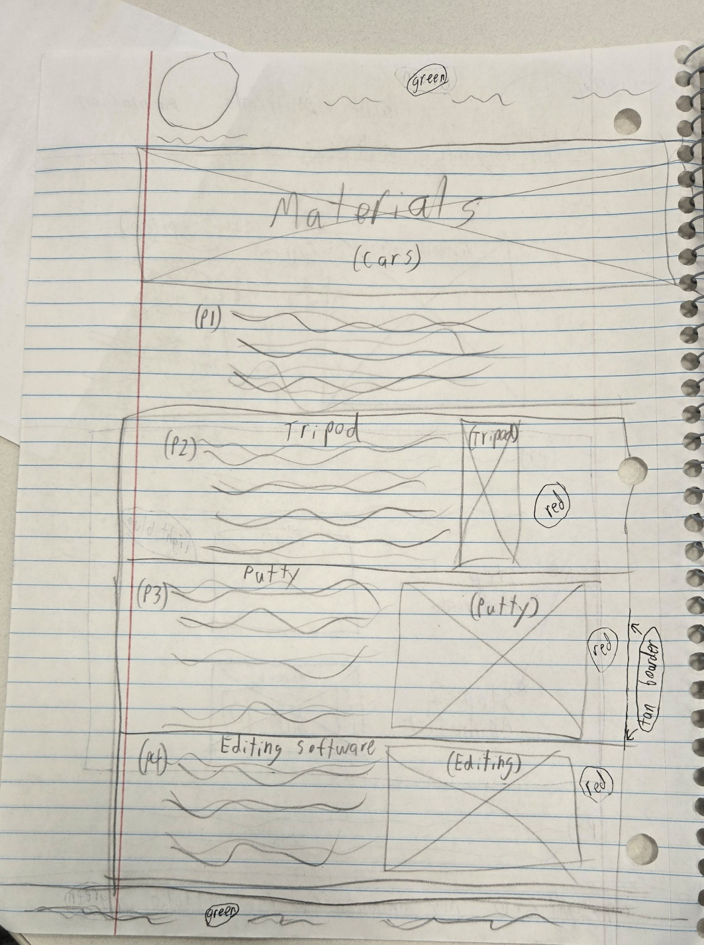

Animation Page

