“Another Fine Gif” Site Plan

Elijah Larson

WDD 130

Overview

Purpose
To provide internet users with easy access to a great variety of reaction images/gifs that will be easy to send to friends.

Audience
Anyone who uses the internet to chat casually with friends & family.

Branding

Website Logo

Style Guide

Color Palette
Primary | Secondary | Accent 1 | Accent 2
#222222 | #000000 | #68a055 | #329664

Typography

Heading Font: Hobbiton Brush Hand

Paragraph Font: Assassin$

Navigation
Home Page2 Page3

Content
One page to search memes & gifs
Second to search meme templates
Third to edit images.

Wireframes

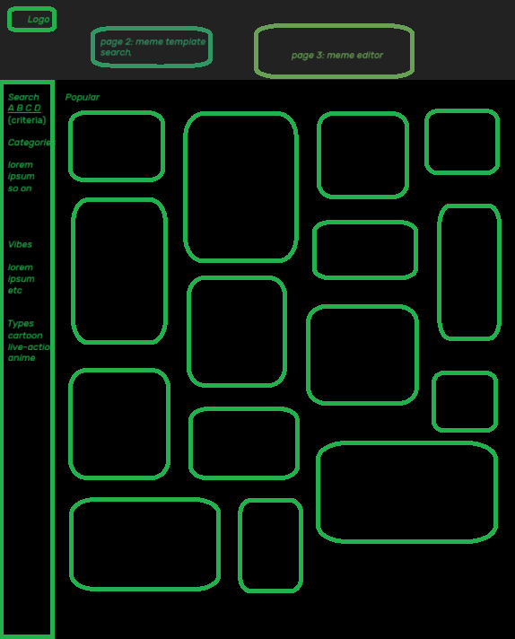
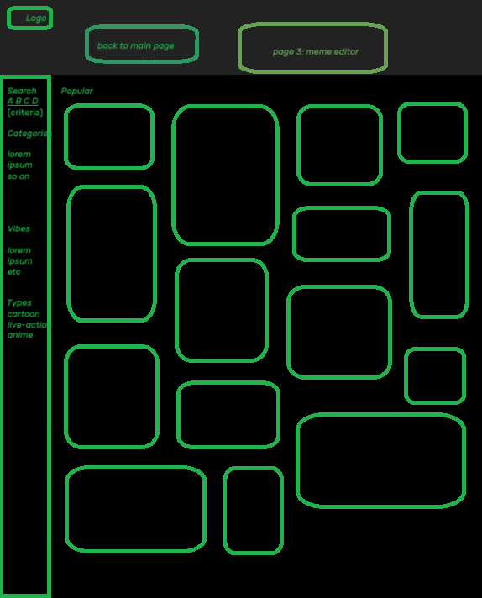
Home
