Project: Assignment 4.2
Course: CSD-380 DevOps
Description: Testing Business Requirements on the Todo App
Date: November 10, 2025
To complete the test case plan, fill out the information for Project, Course, Description and Date in the header below.

TABLE OF CONTENTS
View List of Todo Task Items 2
Edit a Todo Task Item 2
Prevent Empty Task Submission 3
Mobile View Compatibilty 3
Create a new Todo Task Item 4

For each test, the developer should: provide a test description, a test objective, the developer name and date tested. For each step, fill out the actions to be taken and describe the expected results, and indicate yes or no for each step depending upon the result. The peer tester should provide their name, date tested, indicate yes or no for each step depending upon the result, and a screenshot (thumbnail) of the result.

Test 1 | View List of Todo Task Items
 | Test Objective: Ensure the task list displays correctly and updates dynamically | Developer:  Date tested: 2025/11/10 | Peer tester: Nardos Gebremedhin  Date tested: 2025/11/14
Step | Action | Expected results: | Developer pass/fail | Tester pass/fail
1 | Add multiple tasks (i.e. “Buy Milk”, “Call Mom”, etc) | All tasks appear in the list | yes | pass  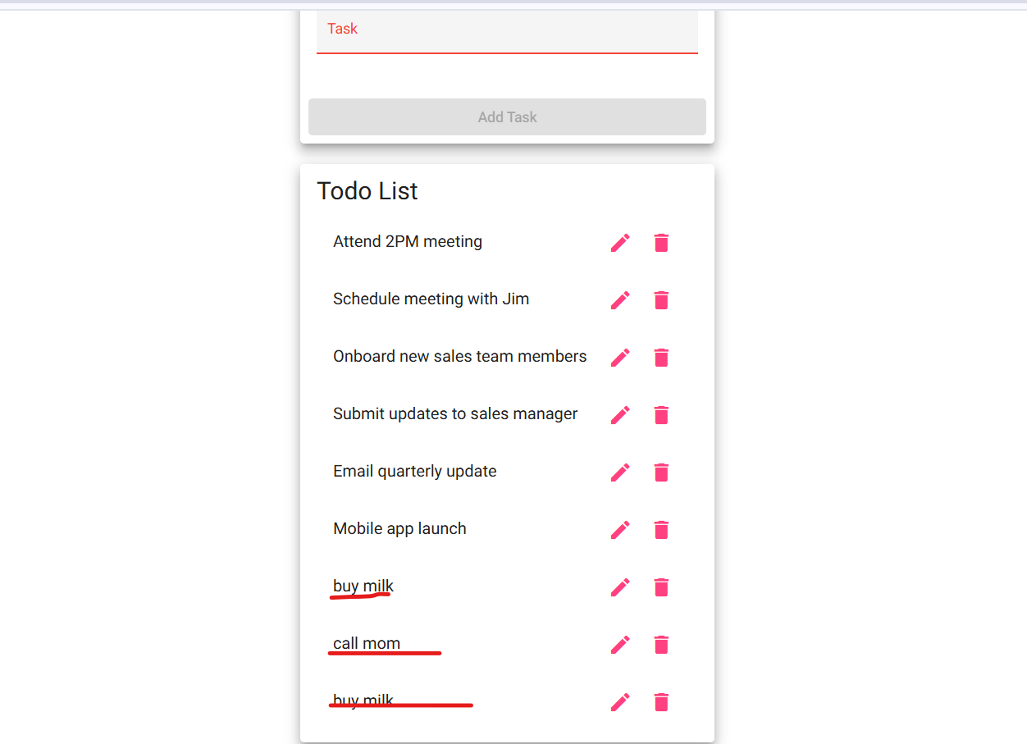
2 | Scroll through the list | Tasks remain visible and correctly ordered | yes | Pass  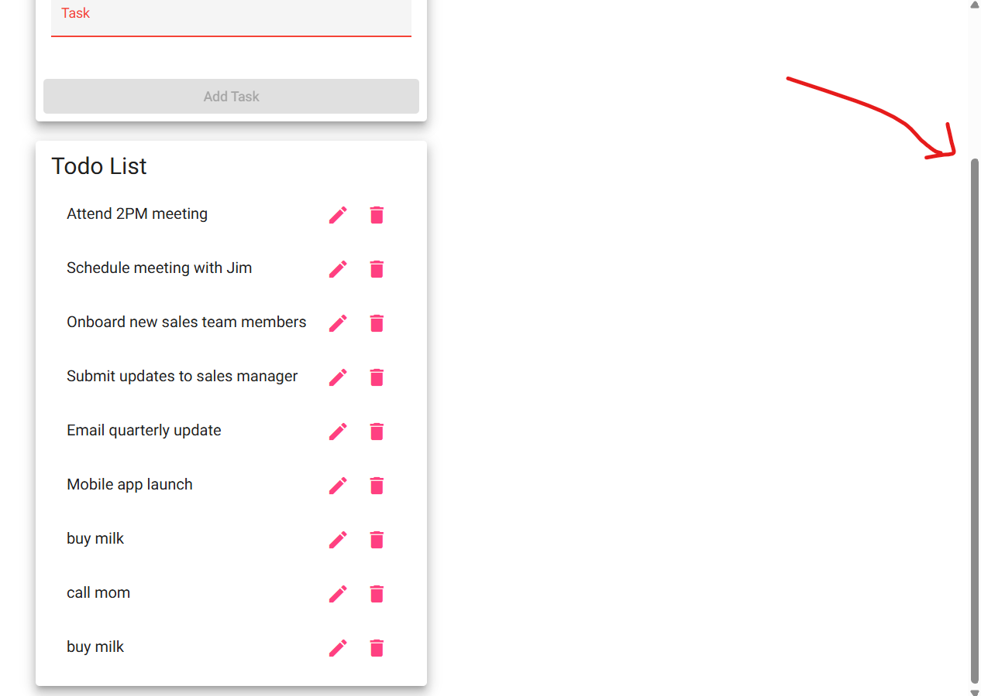
Comments | This test confirms that the task list is visible, updates correctly, and maintains order. It ensures that users can rely on the interface to track their progress and manage their responsibilities effectively.

Test 2 | Edit a Todo Task Item
 | Test Objective: Ensure task updates are saved and displayed. | Developer:  Date tested: 2025/11/10 | Peer tester: Nardos Gebremedhin  Date tested: 2025/11/14
Step | Action | Expected results: | Developer pass/fail | Tester pass/fail
1 | Click “Edit” on an existing task | Edit form appears | yes | Pass  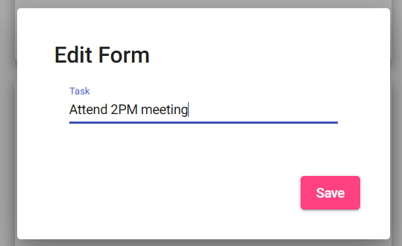
2 | Change task text to “Buy milk” and save | Task updates in list | yes | Pass  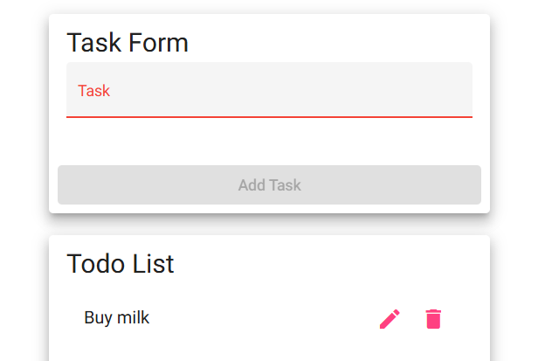
Comments | This test confirms that the edit functionality is intuitive and that changes are reflected immediately. It also checks that the system prevents empty edits, aligning with input validation requirements.

Test 3 | Prevent Empty Task Submission
 | Test Objective: Validate form input validation | Developer:  Date tested: 2025/11/10 | Peer tester: Nardos Gebremedhin  Date tested: 2025/11/14
Step | Action | Expected results: | Developer pass/fail | Tester pass/fail
1 | Leave input field blank | “Add” button disabled or error shown | yes | Pass  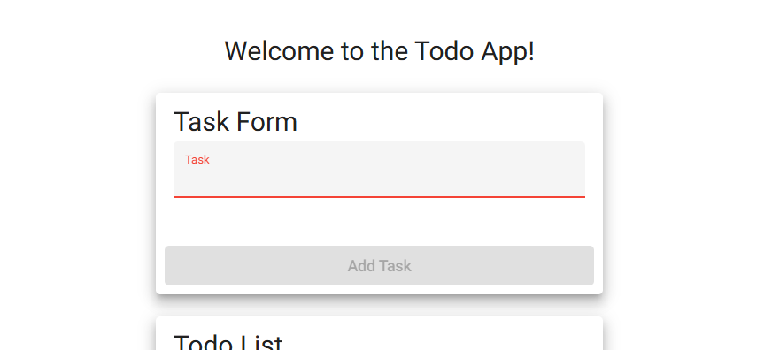
2 | Try to submit form | Task not added | yes | Pass- can’t submit since its greyed out  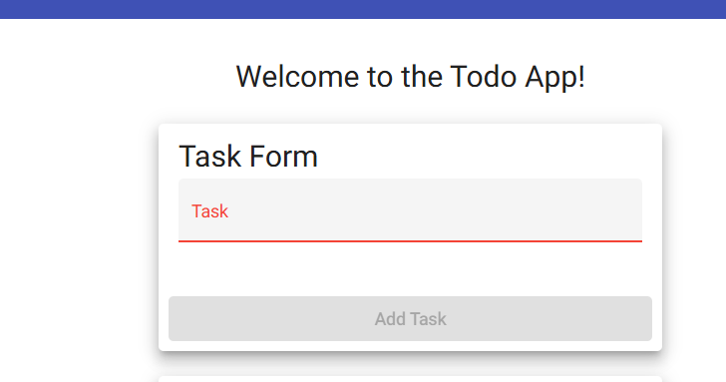
Comments | This test ensures that users cannot submit blank tasks, which could clutter the interface or cause confusion. It also verifies that the application disables the submission button when the input is empty.

Test 4 | Mobile View Compatibilty
 | Test Objective: Ensure responsive design and usability | Developer:  Date tested: 2025/11/10 | Peer tester: Nardos Gebremedhin  Date tested: 2025/11/14
Step | Action | Expected results: | Developer pass/fail | Tester pass/fail
1 | Open app on mobile or simulate mobile view | UI adjusts to screen size | yes | Pass  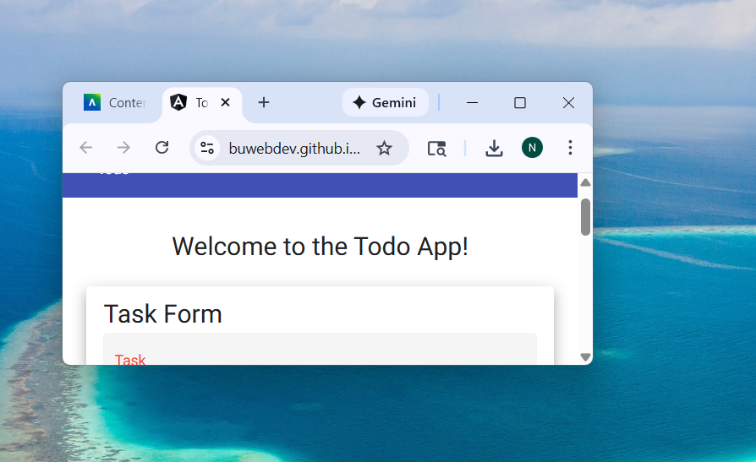
2 | Add and delete a task | Functionality works on mobile | yes | Yes  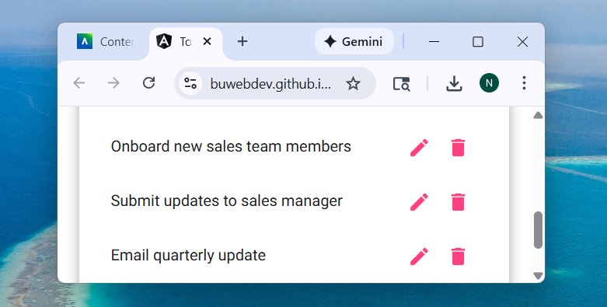
Comments | This test confirms that the Todo app adapts to mobile screens and remains fully functional. It ensures that buttons, forms, and task lists are accessible and usable on smaller displays.

Test 5 | Create a new Todo Task Item
 | Test Objective: Validate task creation functionality | Developer:  Date tested: 2025/11/10 | Peer tester:  Date tested: <yyyy/mm/dd>
Step | Action | Expected results: | Developer pass/fail | Tester pass/fail  + Screenshot
1 | Enter “Buy groceries” in input field | Task appears in list | yes | Fail  Task hasn’t been saved so its only in the task form field so the expected results should be ( Task appears in the text field)  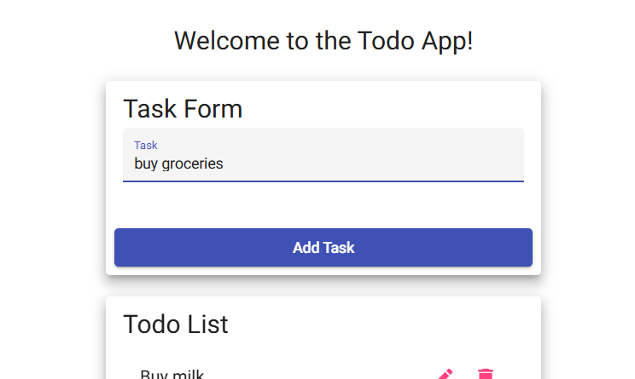
2 | Click “Add Task” button | Task is added | yes | Pass  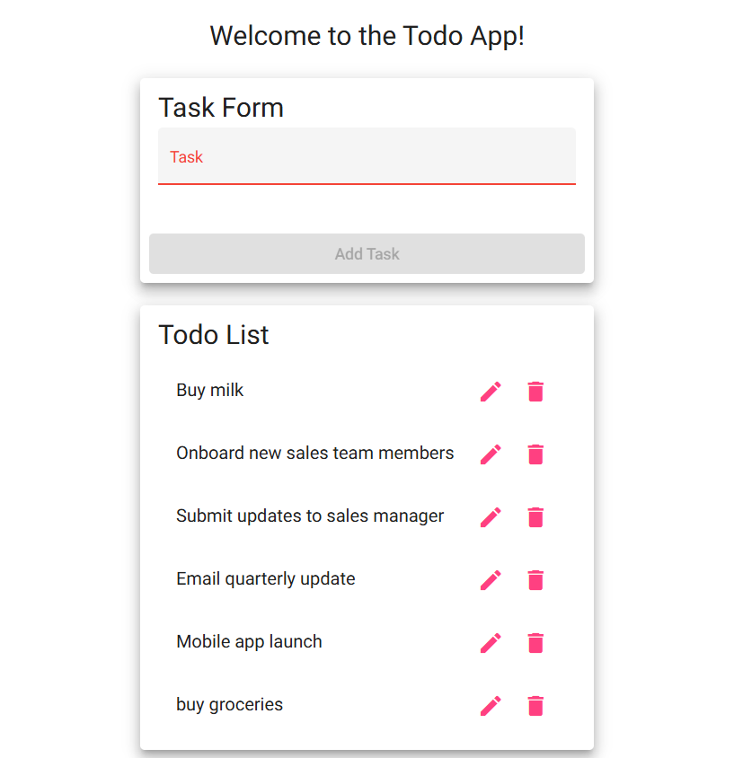
Comments | This test validates that users can interact with the input form and successfully add items to their list. It also confirms that the UI responds appropriately to user input and updates dynamically.

