Purpose of the application
The aim of this project is to display a knowledge of Gesture User Interfaces. To begin we decided to use the Kinect to display the range of functions for this technology. Due to the limited nature of the V1 and no access to the V2 we decided to change the hardware and use the Myo instead. We did however begin programing the Kinect a will discuss later the pros and cons of this technology.
We decided to create a game in unity that displays a variety of different gestures to implement different effects. The learning outcome is that we become familiar with the abilities of Gesture Based Interfaces and display a range of utilities that this technology as. It is

Gestures identified as appropriate for this application
The user can take advantage of the Myo’s gyroscope to hit the enemys. They may also take advantage of the gestures to use bonus features like bombs and such. By closing the fist the player will activate a long vibration and drop a bomb on the enemy assets. Other effects include waving to change the colour of the hammer head.

Hardware used in creating the application
During the development of this project we got the chance to try out both the Kinect and the Myo arm band. S mentioned earlier the original hope was to develop this application using the Kinect in visual studio. The Kinect offered a range of applications that could be used. With the skeletal tracking and depth frames it would have been possible to do this application a third person view. The Kinect also has the added bonus of utilising the whole body rather than just one arm like the My arm band.
After testing some code and setting up the Kinect with visual studio we felt that in this case the kinect V1 was maybe a little out dated when compared to the new V2 which we did not have available to us. For this reason we changed to the Myo arm band and decided to develop in Unity game engine.

Architecture for the solution
The myo contains a number of standard gestures which were all utilised for this project. The game is set up using standard assets from the unity game store. The monsters are spawned from a series of sites that are activated using the spawn.cs. As the monsters approach the user takes control of the hammer using the myo armband. The hammer has the JointOrientation.cs attached to it. This script is responsible for detecting the gestures that the user makes. By storing information on the previous hand position and comparing it to the current position the scripts determines what the gesture is and passes it to the ColorBoxByPose.cs which in turn carry’s out the set instructions for that gesture. The Figure below is a snippet of the JointOrientation script.
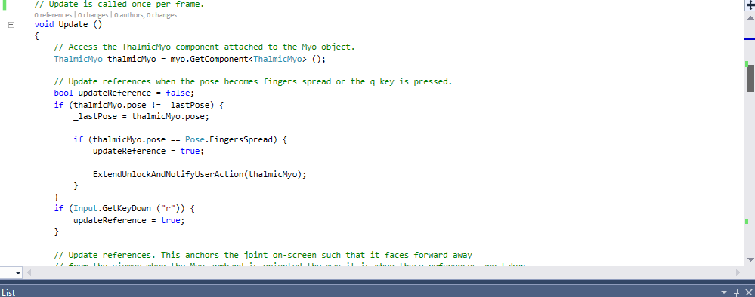

Conclusions & Recommendations
It is in my opinion that like most Gesture Based Interfaces there is a limited number of possibilities in developing this technology on its own for games. The gestures offer a different control but on the same turn it also limits what a user can do in game.
The possibilities outside of gaming are similar in that the possibilities for this kind of technology on its own has limited uses. With the new found hype surrounding other technologies such as VR there may well be a new market for Gesture Based Interfaces if they merge with these new technologies. By merging technologies like VR and GBI it can bring us closer to a fully augmented reality.
In relation to the application that we have done, I feel that if we were to do anything differently and give a recommendation it would be to use the Myo to develop with some hardware like lego. As I mentioned the Myo is a limited and almost pointless technology in gaming, so developing with a device that can give a physical response might be a more accurate representation of where the technology is going.

