**MAIN:**

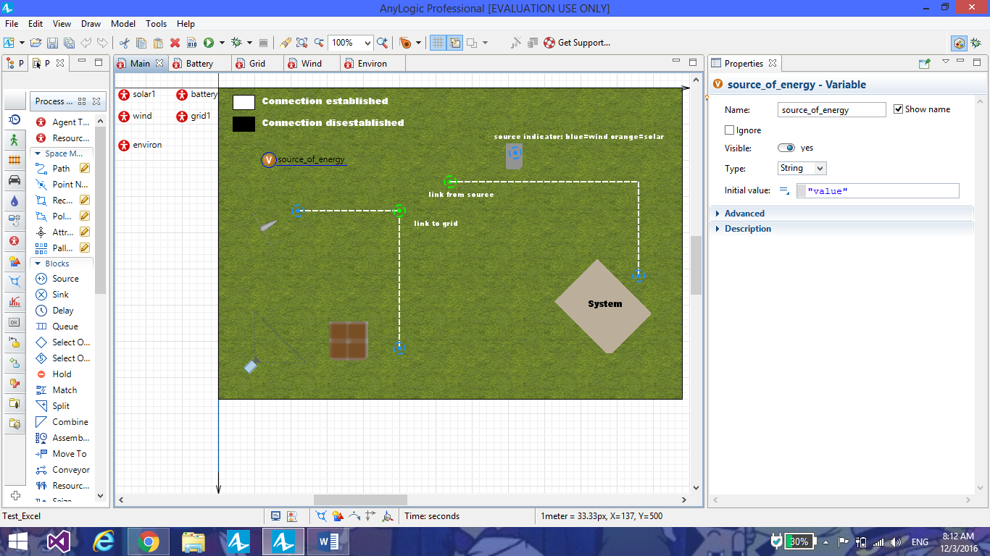

**Consists of the following:**

**Agents:**

*Solar1*- Solar panel which represents “solar” input (Convenience purpose).

*Wind*- A wind turbine which represents “wind” input (Convenience purpose).

*Grid1/battery*- The heart of the model, consists of the entire logic which helps cast the incoming inputs, prioritizes one input over the other (solar over wind) and establishes/disestablishes connections to required sources (wind/solar).

Grid and battery are under a single system, even though they are represented by separate agents.

*Environ*- Simple representation of a system/environment, which make use of the energy stored (Convenience purpose).

**GUI:**

*Solar1/Wind* – As before, represents a source of solar and wind energy respectively.

*Grid/battery* – Simple representation of the grid/battery system

*System*- the GUI of “environ”.

**Dashed lines** represent connection between systems/agents. White lines represent an established connection and Black thee opposite.

**Nodes** have been provided at every initial, end or connecting point.

*Green nodes* – 2 – Indicates the presence of a link between the 2 nodes.

*Orange nodes*- A status node which provides visual representation about the source (solar) in use.

*Blue nodes* – A status node which provides visual representation about the source (wind) in use.

*Red nodes* – Indicates disestablished connection.

**“Source_of_energy” variable**- Provides a string value which represents the source currently in use.

**Plot**- A plot of the current source against the time under which it is active, is provided, where, 0, 1 and 2 corresponds to no source, solar and wind respectively.

**GRID:**

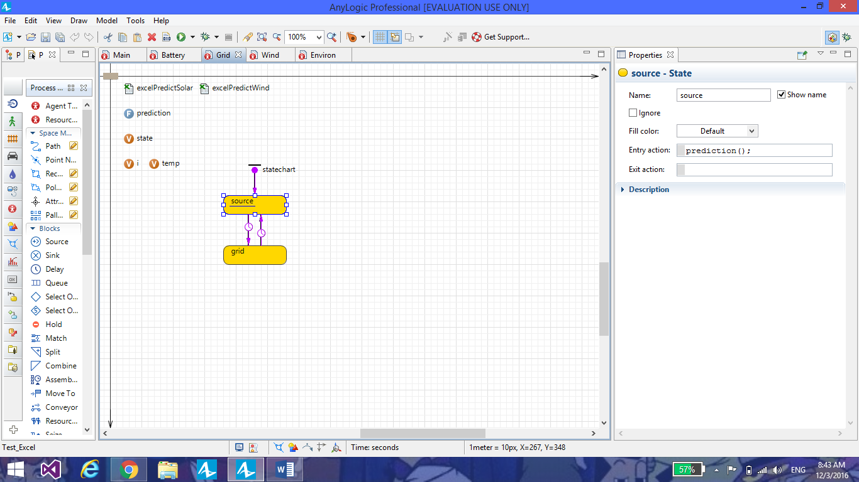

**Consists of the following:**

**State chart:**

*Source*- Calls the function prediction.

*Grid*- sends a message (value of state variable) to all agents (in this case, to the battery) via send() method. [ send(state,ALL); ]

Transitions between source and grid are timed. (Time out transitions).

**Excel file connectivity:**

Connectivity functionality, which defines the presence of excel sheets excelPredictSolar and excelPredictWind.

The 2 files contain the paths of the original excel file being referred to.

**Function “prediction”: (Code)**

**while**(**true**){

state=(**int**)excelPredictSolar.getCellNumericValue(1,i,1);

**if**(temp==state && temp==1){i=i+1;**continue**;}

**if**(state==1){temp=state;i=i+1;**break**;}

**else**{

state=(**int**)excelPredictWind.getCellNumericValue(1,i,1);

**if**(temp==state){i=i+1;**continue**;}

temp=state;i=i+1;**break**;

}

}

*Explanation*-

An infinite loop is initiated, under which, the variable state, is provided with the value acquired from the excelPredictSolar first, since solar is prioritized over wind.

Temp variable represents the previous value of state and “i” is used to represent varying index.

The loop continues to ignore input, until there is change in the solar or wind excel sheet values.

It would follow;

If solar=1 and wind=0 or solar=1 and wind=1; solar

If solar=0 and wind=1; wind

If solar=0 and wind=0; no source

If there is a change in value, under solar and wind, to bring about a change in any of the conditions shown above, the loop breaks, with the state variable set at the latest value acquired.

**BATTERY:**

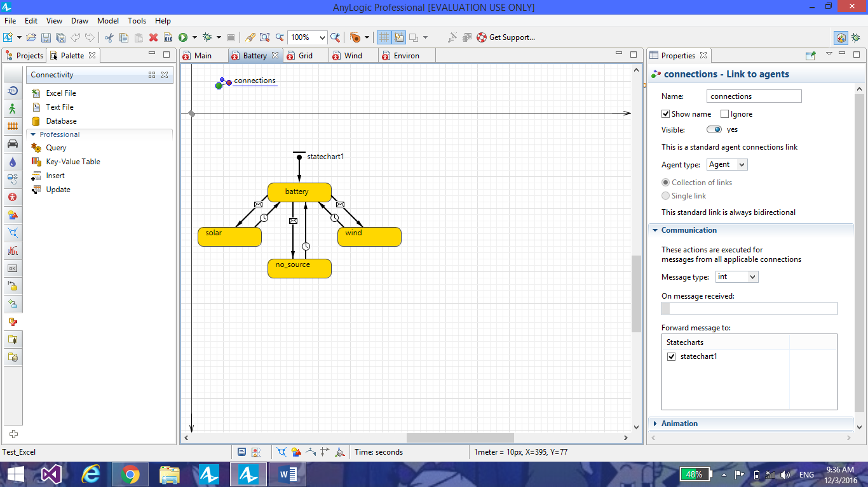

**Consists of the following:**

**State chart1:-**

*Battery*- This is where the message received by the grid (state value),is forwarded to.

*Solar/Wind/no_source*- These represent the paths taken, with respect to the message received.

The message received represents binary code of either 0 or 1 (in the above case, considered an analogy of 1 and 2).

If the message received is 1, the message triggers a transition to solar, which represents a connection between the battery (being charged) and the source, solar.The same happens with wind, when the message received is 0.On receiving any other signal, the system’s inactive (no source).

To represent charging, solar/wind/no_source, changes the value the variable source_of_energy in main (main-source_f_energy=”solar”/”wind”/”value”).

*Agents solar wind and environ are used for the purpose of providing visual representation of the entire operation, via an animation.*

SIMULATION SCREENSHOTS:

