https://www.pes.edu/wp-content/uploads/2019/09/pes_logo.png

## END SEMESTER ASSESSMENT (ESA) B.TECH. (CSE)

**IV SEMESTER**

## UE20CS252 – MICROPROCESSOR AND COMPUTER ARCHITECTURE LABORATORY

**PROJECT REPORT ON**

# Weather station

SUBMITTED BY

**NAME SRN**

1. **Navtej Reddy PES2UG20CS218**
2. **Naren C PES2UG20CS216**
3. **Nitin J PES2UG20CS231**

**JANUARY – MAY 2022**

**DEPARTMENT OF COMPUTER SCIENCE & ENGINEERING**

**ELECTRONIC CITY CAMPUS, BENGALURU** – **560100, KARNATAKA, INDIA**

|  |  |  |
| --- | --- | --- |
| TABLE OF CONTENTS | | |
| Sl.No | TOPIC | PAGE No |
| 1. | ABSTRACT OF THE  PROJECT | 3 |
| 2. | CIRCUIT  DIAGRAM | 4 |
| 3. | ARDUINO CODE | 5,6 |
| 4. | SCREEN SHOTS  OF THE OUTPUT | 7,8 |

# ABSTRACT OF THE PROJECT:

A weather station can be described as **an instrument or device, which provides us with the information of the weather in our neighbouring environment**.

Project is implemented using Arduino UNO.

Dht 11 sensor used to measure temperature and humidity.

An ldr sensor to check whether it is sunny or night. Using the information from the sensors displaying it onto an lcd screen.

The lcd screen makes use of an i2c module which makes the connections simpler.

All the connections are made on a breadboard using jumper wires.

# CIRCUIT DIAGRAM:

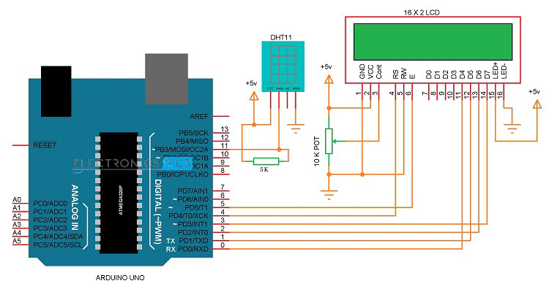

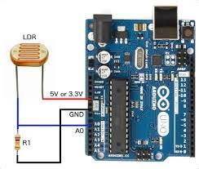

**ARDUINO CODE:**

#include <Wire.h>

#include <LiquidCrystal_I2C.h>

LiquidCrystal_I2C lcd(0x27,16,2);

void setup() {

// put your setup code here, to run once:

Serial.begin(9600);

lcd.begin();

lcd.backlight();

pinMode(4, OUTPUT);

}

void loop() {

// put your main code here, to run repeatedly:

int value = analogRead(A3);//read value

Serial.print("Value : ");

Serial.println(value);

if (value < 300) {//check condition

Serial.print("Heavy rain LED on ");

}

unsigned int AnalogValue;

AnalogValue = analogRead(A0);

Serial.println(AnalogValue);

lcd.clear();

lcd.setCursor(0,0);

lcd.print("light:");

lcd.print(AnalogValue);

lcd.setCursor(0,1);

lcd.print("rain: ");

unsigned int rain_value;

rain_value = (value-300)/800;

lcd.print(rain_value);

delay(500);

}

SCREEN SHOTS OF THE OUTPUT:

