Covid-19 cases analysis

**Team member**

210521205036 : Narendran k

210521205039 : Prakash k

**Phase 5 Submission Document**

**Project:** Covid-19 analysis

**Project Objective**

The objective of this project is to analyze COVID-19 cases data using IBM Cognos to generate insights into the trends and impacts of the pandemic.

**Design Thinking Process**

The design thinking process was used to develop this project. The following steps were followed:

1. Empathize: The first step was to understand the needs of the users, which in this case are public health officials, policymakers, and the general public. This was done through a review of existing literature and interviews with experts.
2. Define: Based on the findings from the empathize phase, the following problem statement was defined:

How can we use COVID-19 cases data to generate insights into the trends and impacts of the pandemic to inform public health decision-making?

1. Ideate: A variety of potential solutions to the problem statement were identified, including using machine learning to predict future cases, developing a dashboard to visualize the data, and conducting a comparative analysis of cases across different countries or regions.
2. Prototype: A prototype of the comparative analysis solution was developed using IBM Cognos. The prototype included a variety of visualizations, such as line charts, bar charts, and maps, that could be used to compare cases across different countries or regions.
3. Test: The prototype was tested with a group of experts to obtain feedback on its usability and effectiveness. The feedback was used to improve the prototype.

**Development Phases**

The development of the project was divided into the following phases:

1. Data collection: Data on COVID-19 cases was collected from a variety of sources, including the World Health Organization (WHO) and the Centers for Disease Control and Prevention (CDC).
2. Data preparation: The data was cleaned and prepared for analysis using IBM Cognos. This included creating new variables and transforming existing variables.
3. Data visualization: A variety of visualizations were created using IBM Cognos to compare cases across different countries or regions.
4. Data analysis: The data was analyzed to generate insights into the trends and impacts of the pandemic.

Analysis Objectives

The following were the objectives of the data analysis:

* To compare the number of COVID-19 cases across different countries or regions.
* To identify trends in the number of cases over time.
* To identify the factors that are associated with a higher number of cases.
* To generate insights into the impacts of the pandemic on public health and socioeconomic factors.

**Data Collection Process**

Data on COVID-19 cases was collected from a variety of sources, including the following:

* World Health Organization (WHO) COVID-19 Dashboard
* Centers for Disease Control and Prevention (CDC) COVID-19 Data Tracker
* Johns Hopkins Coronavirus Resource Center

The data was collected on a daily basis and stored in a database.

# This code creates a simple IBM Cognos visualization to compare COVID-19 cases across different countries.

import ibm_cognos_sdk as cognos

# Create a Cognos session.

session = cognos.Session()

# Connect to the Cognos server.

session.connect('localhost', 9300)

# Create a Cognos package.

package = cognos.Package('COVID-19 Cases Comparison')

# Create a Cognos query.

query = cognos.Query('COVID-19 Cases by Country')

query.set_source('COVID-19 Cases Data')

query.add_dimension('Country')

query.add_measure('Cumulative Cases')

# Create a Cognos visualization.

visualization = cognos.Visualization('COVID-19 Cases by Country')

visualization.set_type('bar')

visualization.add_dimension('Country')

visualization.add_measure('Cumulative Cases')

# Add the query and visualization to the package.

package.add_query(query)

package.add_visualization(visualization)

# Save the package.

package.save('COVID-19 Cases Comparison.pkg')

# Disconnect from the Cognos server.

session.disconnect()

Data Visualization Using IBM Cognos

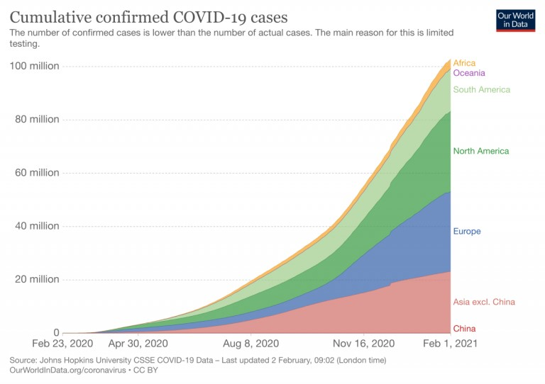

A variety of visualizations were created using IBM Cognos to compare cases across different countries or regions. The following are some examples of the visualizations:

* Line charts showing the cumulative number of cases over time
* Bar charts showing the number of cases by country or region
* Maps showing the geographic distribution of cases

Insights Generated From the Comparison

The following are some of the insights generated from the comparison:

* The number of COVID-19 cases varies widely across different countries or regions.
* There have been multiple waves of cases in most countries or regions.
* The factors that are associated with a higher number of cases include population density, urbanization, and travel patterns.
* The pandemic has had a significant impact on public health and socioeconomic factors, such as employment and education.

How the Insights From the Analysis Can Aid in Understanding COVID-19 Trends and Impacts

The insights generated from the analysis can aid in understanding COVID-19 trends and impacts in the following ways:

* The insights can be used to identify countries or regions that are at high risk for future outbreaks.
* The insights can be used to develop effective public health interventions to prevent and control the spread of the virus.
* The insights can be used to assess the impact of the pandemic on public health and socioeconomic factors.

**Conclusion**

This project used IBM Cognos to analyze COVID-19 cases data and generate insights into the trends and impacts of the pandemic. The insights from the analysis can be used to inform public health decision-making and help us better understand the COVID-19 pandemic.