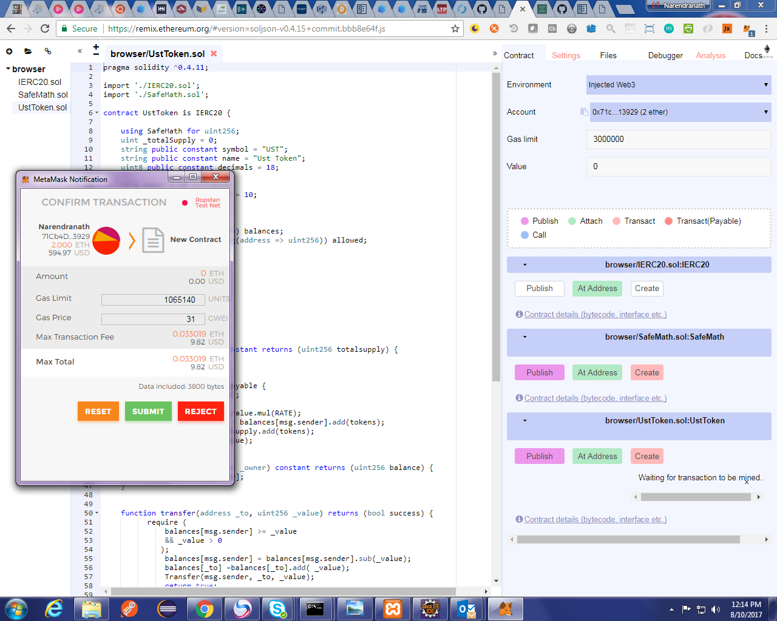

UST Token address : 0x8a9c0ffd7e8908702328367c091a7042cb74c141

